**Name of journal: World Journal of Gastroenterology**

**ESPS Manuscript NO: 18166**

**Columns: Case Report**

**Pancreatic paraganglioma with draining vessels**

Misumi Y *et al*. Pancreatic paraganglioma with draining vessels

Yoshitsugu Misumi, Toshio Fujisawa, Hirotsugu Hashimoto, Koichi Kagawa, Tamaki Noie, Hideyuki Chiba, Hajime Horiuchi, Yasushi Harihara, Nobuyuki Matsuhashi

**Yoshitsugu Misumi, Toshio Fujisawa, Koichi Kagaw, Nobuyuki Matsuhashi,** Department of Gastroenterology, NTT Medical Center Tokyo, Tokyo 141-8625, Japan

**Hirotsugu Hashimoto, Hajime Horiuchi,** Department of Pathology, NTT Medical Center Tokyo, Tokyo 141-8625, Japan

**Tamaki Noie, Yasushi Harihara,** Department of Surgery, NTT Medical Center Tokyo, Tokyo 141-8625, Japan

**Hideyuki Chiba**, Department of Gastroenterology, Omori Red Cross Hospital, Tokyo 141-8625, Japan

**Author contributions:** Misumi Y, Fujisawa T, Kagaw K, Chiba H and Matsuhashi N contributed to examinations for the disease; Hashimoto H and Horiuchi H contributed to pathological diagnosis; Noie T and Harihara Y contributed to tumour resection by surgery; Misumi Y, Fujisawa T and Matsuhashi N contributed to writing the manuscript; all authors finally approved the authorship.

**Institutional review board statement:** The study was reviewed and approved by the NTT Medical Center Tokyo Institutional Review Board.

**Informed consent statement:** All study participants, or their legal guardian, provided informed written consent prior to study enrollment.

**Conflict-of-interest statement:** All authors have no known conflicts of interest associated with this case report.

**Open-Access:** This article is an open-access article which was selected by an in-house editor and fully peer-reviewed by external reviewers. It is distributed in accordance with the Creative Commons Attribution Non Commercial (CC BY-NC 4.0) license, which permits others to distribute, remix, adapt, build upon this work non-commercially, and license their derivative works on different terms, provided the original work is properly cited and the use is non-commercial. See: http://creativecommons.org/licenses/by-nc/4.0/

**Correspondence to: Toshio Fujisawa, MD, PhD,** Department of Gastroenterology, NTT Medical Center Tokyo, 5-9-22 Higashi-Gotanda, Shinagawa, Tokyo 141-8625, Japan. toshio.fujisawa@east.ntt.co.jp

**Telephone:** +81-3-34486111

**Fax:** +81-3-34486541

**Received:** April 9, 2015

**Peer-review started:** April 9, 2015

**First decision:** April 23, 2015

**Revised:** May 11, 2015

**Accepted:** June 26, 2015

**Article in press:**

**Published online:**

**Abstract**

A pancreatic paraganglioma is a rare neoplasm that is difficult to distinguish from a pancreatic neuroendocrine tumour. Here we present a case of pancreatic paraganglioma that was surgically resected following preoperative diagnosis of a pancreatic neuroendocrine tumour. Careful evaluation of the endoscopic ultrasonography findings revealed abundant draining vessels, which could have led to a correct preoperative diagnosis of pancreatic paraganglioma.

**Key words**: Paraganglioma; Neuroendocrine tumour; Draining vessels; Pancreatic tumour

**© The Author(s) 2015.** Published by Baishideng Publishing Group Inc. All rights reserved.

**Core tip:** Pancreatic paraganglioma is a rare disease, which has been reported only in 24 cases ever. Invasive procedures toward paragangliomas carry the potential risk of catastrophic complications due to unexpected release of large quantities of catecholamines. An accurate diagnosis of paraganglioma, therefore, is important before invasive procedures. Draining vessels from the tumour are sometimes observed in a general paraganglioma. However, it is still unclear in the pancreatic paraganglioma. In the present report, usefulness of draining vessels for a diagnosis of pancreatic paraganglioma was investigated by reviewing past cases.

Misumi Y, Fujisawa T, Hashimoto H, Kagawa K, Noie T, Chiba H, Horiuchi H, Harihara Y, Matsuhashi N. Pancreatic paraganglioma with draining vessels. *World J Gastroenterol* 2015; In press

**Introduction**

Paragangliomas are rare catecholamine-secreting neuroendocrine tumours that arise from neuroendocrine cells of the extra-adrenal autonomic paraganglia and affect about 1 in 2000000 of the population[1]. The head, neck, and retroperitoneum are the most commonly affected sites, but pancreatic paragangliomas are extremely rare[2]. To our knowledge, only 24 cases of pancreatic paraganglioma have been previously reported in the English literature (see Table 1)[1-20]. In these previous reports, the pancreatic paragangliomas were often preoperatively misdiagnosed as pancreatic neuroendocrine tumours (pNETs) because the radiological characteristics of pancreatic paragangliomas resemble those of pNETs. We herein report a patient with a pancreatic paraganglioma, which was surgically resected following a preoperative diagnosis of a pNET, and discuss features associated with the disorder.

**Case Report**

An asymptomatic 47-year-old woman with a pancreatic tumour that was detected by ultrasonography was referred to our hospital. The patient’s past medical history and physical examination were unremarkable. Initial laboratory studies, including levels of tumour markers such as carcinoembryonic antigen, carbohydrate antigen 19-9, and α-fetoprotein, showed no abnormalities. An examination of pancreatic endocrine hormones showed that the insulin level was slightly elevated [14.6 µU/ml (5-10 µU/ml)], but the elevation was considered non-specific because blood glucose (108 mg/dl) and C-peptide levels [3.30 (0.78-5.19) ng/dl] were within normal levels. Levels of other hormones were also within their normal ranges. Transabdominal ultrasonography showed a 1.5-cm low-echoic tumour at the pancreas head. Dynamic computed tomography (CT) also revealed a 1.5-cm well demarcated tumour at the pancreas head (Figures 1A and B). The tumour was very strongly enhanced in the arterial phase and still faintly enhanced in the portal vein phase. Maximum intensity projection of the arterial phase in a coronal view clearly revealed the tumour feeding artery from the inferior pancreaticoduodenal artery and the draining vein into the portal vein (Figure 1C). No abnormalities were found in the bile duct, pancreatic duct, or liver. Compared with contiguous pancreatic parenchyma, the tumour appeared as a low-intensity lesion in a T1-weighted magnetic resonance image (MRI) and as a high-intensity lesion in a T2-weighted MRI (Figures 1D and E, respectively). Endoscopic ultrasonography (EUS) showed a well demarcated, low, and uneven echoic tumour surrounded by draining vessels emanating from the tumour (Figures 1F and G). We did not attempt EUS-guided fine needle aspiration (FNA) for a pathological examination because of the possible risk of bleeding due to the extremely abundant vascularity of the tumour. On the basis of these imaging findings, we made a preoperative diagnosis of a nonfunctional pNET. Pancreaticoduodenectomy was performed. The resected specimen included a tumour measuring 1.5 cm × 1.2 cm (Figure 2A). The tumour was located at the caudal part of pancreas head and partially adjacent to the second portion of duodenum. The tumour was isolated from major arteries and veins. Histological examination revealed a classical Zellballen pattern, with nests of cells surrounded by thick capsules (Figures 2B and C). The tumour was surrounded by normal pancreatic parenchyma. Immunohistochemistry examination of the tumour cells showed positive staining for CD56, synaptophysin, and chromogranin A and negative staining for insulin, glucagon, gastrin, and somatostatin. The tumour cells were surrounded by S-100 protein-positive sustentacular cells (Figure 2D). These results suggested that the tumour cells were differentiated toward neuroendocrine cells, but did not express any islet hormones. Epithelial membrane antigen staining was negative in the tumour cells but positive in the pancreatic ducts remaining within the tumour (Figure 2E). This result indicated that branches of the pancreatic duct were within the tumour. Taking into consideration the tumour location and pancreatic ducts remaining within the tumour, we inferred that the tumour arose from the pancreas. On the basis of these pathological findings, a diagnosis of pancreatic paraganglioma was established. The patient was followed for more than one year after surgery, but no recurrence was confirmed.

**Discussion**

Pancreatic paragangliomas are radiologically similar to pNETs. In fact, the case reported here and six of the 24 other cases reported in the literature were preoperatively misdiagnosed as pNETs[1,8-12]. Fortunately, no complications occurred during the preoperative examinations or surgical procedures in the present case. However, invasive examinations and surgery of paragangliomas carry the potential risk of catastrophic complications due to unexpected release of large quantities of catecholamines. For example, a patient with pancreatic paraganglioma, who was misdiagnosed preoperatively as having pancreatic cancer, died 34 h after surgery because of unanticipated catecholamine release[17]. The use of EUS-guided FNA without preparations against catecholamine release could also be dangerous. These dangers highlight the importance of an accurate diagnosis of pancreatic paraganglioma.

Preoperative imaging may provide guidance for an accurate diagnosis. Areas of signal flow void (referred to as a “salt and pepper” pattern[21]) are often observed on MRIs of highly vascularized paragangliomas. Additionally, enlarged feeding arteries and early contrast filling of the draining veins are observed on dynamic CT images. This feature of draining veins has been reported to be useful in distinguishing pancreatic paraganglioma from pNET[12]. In the present case, the draining vein was confirmed by dynamic CT, but “salt and pepper” pattern was absent on the MRI. In the 24 other cases (Table 1), one has been reported to have draining veins[12], and one has been reported to be devoid of such veins[15]. The presence or absence of draining veins was not mentioned in the text of the reports of the remaining 22 cases, but examination of images presented in the reports suggest that two cases[13,18] had and three cases[2,9,11] did not have draining veins (presented material did not allow evaluation of draining veins in the remaining 17 cases). Formation of the tumour draining vasculature is supposed to depend on a variety of growth factors secreted from the tumour itself[22]. Most pancreatic paragangliomas seem to have a characteristic to induce abundant draining veins, although details of the mechanism of the vessel induction remain to be elucidated. In summary, draining veins could be observed in 50% (four of eight) of evaluable cases. We conclude that evaluation of imaging findings, especially identifying draining veins around the tumour, may be useful in making a correct preoperative diagnosis of pancreatic paraganglioma.

**COMMENTS**

***Case characteristics***

A 47-year-old woman with a pancreatic tumour detected by ultrasonography was referred to our hospital**.**

***Clinical diagnosis***

The patient showed no symptom.

***Differential diagnosis***

Solid tumors (adenocarcinoma, neuroendocrine tumours, Solid-pseudopapillary tumor, acinar cell carcinoma, and paraganglioma), cystic tumors (serous cystic neoplasm).

***Laboratory diagnosis***

Laboratory studies, including levels of tumour markers such as carcinoembryonic antigen, carbohydrate antigen 19-9, and α-fetoprotein, showed no abnormalities, but insulin level was slightly elevated [14.6 µU/ml].

***Imaging diagnosis***

Computed tomography showed a 1.5-cm well demarcated tumour at the pancreas head, which was very strongly enhanced in the arterial phase and still faintly enhanced in the portal vein phase.

***Pathological diagnosis***

Histological examination showed a classical Zellballen pattern, and tumour cells of positive staining for CD56, synaptophysin, and chromogranin A, that were surrounded by S-100 protein-positive sustentacular cells.

***Treatment***

The patient received pancreaticoduodenectomy.

***Related reports***

Pancreatic paraganglioma has been reported only in 24 cases ever**.**

***Term explanation***

Paraganglioma is rare catecholamine-secreting neuroendocrine tumour that arises from neuroendocrine cells of the extra-adrenal autonomic paraganglia

***Experiences and lessons***

Identifying draining veins around the tumour is useful in making a correct preoperative diagnosis of pancreatic paraganglioma.

***Peer-review***

The authors have summarized 25 cases of pancreatic paraganglioma including the present case and reported usefulness of tumour draining vessels for distinguishing pancreatic paraganglioma from pancreatic neuroendocrine tumour.

**References**

1 **Tsukada A**, Ishizaki Y, Nobukawa B, Kawasaki S. Paraganglioma of the pancreas: a case report and review of the literature. *Pancreas* 2008; **36**: 214-216 [PMID: 18376320 DOI: 10.1097/01.MPA.0000311841.35183.45]

2 **Lightfoot N**, Santos P, Nikfarjam M. Paraganglioma mimicking a pancreatic neoplasm. *JOP* 2011; **12**: 259-261 [PMID: 21546704]

3 **Goodof I**, Lischer C. Tumor of the carotid body and the pancreas. *Arch Pathol* 1943; **35**: 6

4 **Bartley O**, Ekdahl PH, Hultén L. Paraganglioma simulating pancreatic cyst. *Acta Chir Scand* 1966; **132**: 289-297 [PMID: 5929097]

5 **Cope C**, Greenberg SH, Vidal JJ, Cohen EA. Nonfunctioning nonchromaffin paraganglioma of the pancreas. *Arch Surg* 1974; **109**: 440-442 [PMID: 4368962]

6 **Zamir O**, Amir G, Lernau O, Ne'eman Z, Nissan S. Nonfunctional paraganglioma of the pancreas. *Am J Gastroenterol* 1984; **79**: 761-763 [PMID: 6486113]

7 **Howard JM**, Jordan JL, Reber HA. Surgical disease of the pancreas. Philadelphia, Lea and Febiger 1987

8 **Malthouse SR**, Robinson L, Rankin SC. Ultrasonic and computed tomographic appearances of paraganglioma simulating pancreatic mass. *Clin Radiol* 1992; **45**: 271-272 [PMID: 1395386]

9 **Fujino Y**, Nagata Y, Ogino K, Watahiki H, Ogawa H, Saitoh Y. Nonfunctional paraganglioma of the pancreas: report of a case. *Surg Today* 1998; **28**: 209-212 [PMID: 9525014]

10 **Parithivel VS**, Niazi M, Malhotra AK, Swaminathan K, Kaul A, Shah AK. Paraganglioma of the pancreas: literature review and case report. *Dig Dis Sci* 2000; **45**: 438-441 [PMID: 10711464]

11 **Ohkawara T**, Naruse H, Takeda H, Asaka M. Primary paraganglioma of the head of pancreas: contribution of combinatorial image analyses to the diagnosis of disease. *Intern Med* 2005; **44**: 1195-1196 [PMID: 16357461]

12 **Kim SY**, Byun JH, Choi G, Yu E, Choi EK, Park SH, Lee MG. A case of primary paraganglioma that arose in the pancreas: the Color Doppler ultrasonography and dynamic CT features. *Korean J Radiol* 2008; **9** Suppl: S18-S21 [PMID: 18607119 DOI: 10.3348/kjr.2008.9.s.s18]

13 **Sangster G**, Do D, Previgliano C, Li B, LaFrance D, Heldmann M. Primary retroperitoneal paraganglioma simulating a pancreatic mass: a case report and review of the literature. *HPB Surg* 2010; **2010**: 645728 [PMID: 21188160 DOI: 10.1155/2010/645728]

14 **Zengel B**, Alacacioglu A, Yagci A, Postaci H, Erdinc I, Ozguzer A, Denecli A. Primary paraganglioma of the pancreas: Review of literature and a case report. *Firat Tip Dergisi* 2010; **15**: 3

15 **He J**, Zhao F, Li H, Zhou K, Zhu B. Pancreatic paraganglioma: A case report of CT manifestations and literature review. *Quant Imaging Med Surg* 2011; **1**: 41-43 [PMID: 23256053 DOI: 10.3978/j.issn.2223-4292.2011.08.02]

16 **Higa B**, Kapur U. Malignant paraganglioma of the pancreas. *Pathology* 2012; **44**: 53-55 [PMID: 22157694 DOI: 10.1097/PAT.0b013e32834e42b6]

17 **Wang ZL**, Fu L, Zhang Y, Babu SR, Tian B. An asymptomatic pheochromocytoma originating from the tail of the pancreas. *Pancreas* 2012; **41**: 165-167 [PMID: 22173833 DOI: 10.1097/MPA.0b013e31822362d0]

18 **Al-Jiffry BO**, Alnemary Y, Khayat SH, Haiba M, Hatem M. Malignant extra-adrenal pancreatic paraganglioma: case report and literature review. *BMC Cancer* 2013; **13**: 486 [PMID: 24138700 DOI: 10.1186/1471-2407-13-486]

19 **Borgohain M**, Gogoi G, Das D, Biswas M. Pancreatic paraganglioma: An extremely rare entity and crucial role of immunohistochemistry for diagnosis. *Indian J Endocrinol Metab* 2013; **17**: 917-919 [PMID: 24083178 DOI: 10.4103/2230-8210.117217]

20 **Zhang L**, Liao Q, Hu Y, Zhao Y. Paraganglioma of the pancreas: a potentially functional and malignant tumor. *World J Surg Oncol* 2014; **12**: 218 [PMID: 25030833 DOI: 10.1186/1477-7819-12-218]

21 **Wieneke JA**, Smith A. Paraganglioma: carotid body tumor. *Head Neck Pathol* 2009; **3**: 303-306 [PMID: 20016787 DOI: 10.1007/s12105-009-0130-5]

22 **Ruddell A**, Croft A, Kelly-Spratt K, Furuya M, Kemp CJ. Tumors induce coordinate growth of artery, vein, and lymphatic vessel triads. *BMC Cancer* 2014; **14**: 354 [PMID: 24886322 DOI: 10.1186/1471-2407-14-354]

**P-Reviewer:** Koike Y, Sinha R, Takahashi T, Verbeke CS **S-Editor:** Ma YJ **L-Editor:** **E-Editor:**

**Table 1 Summary of reports of 25 cases of pancreatic paragangliomas**



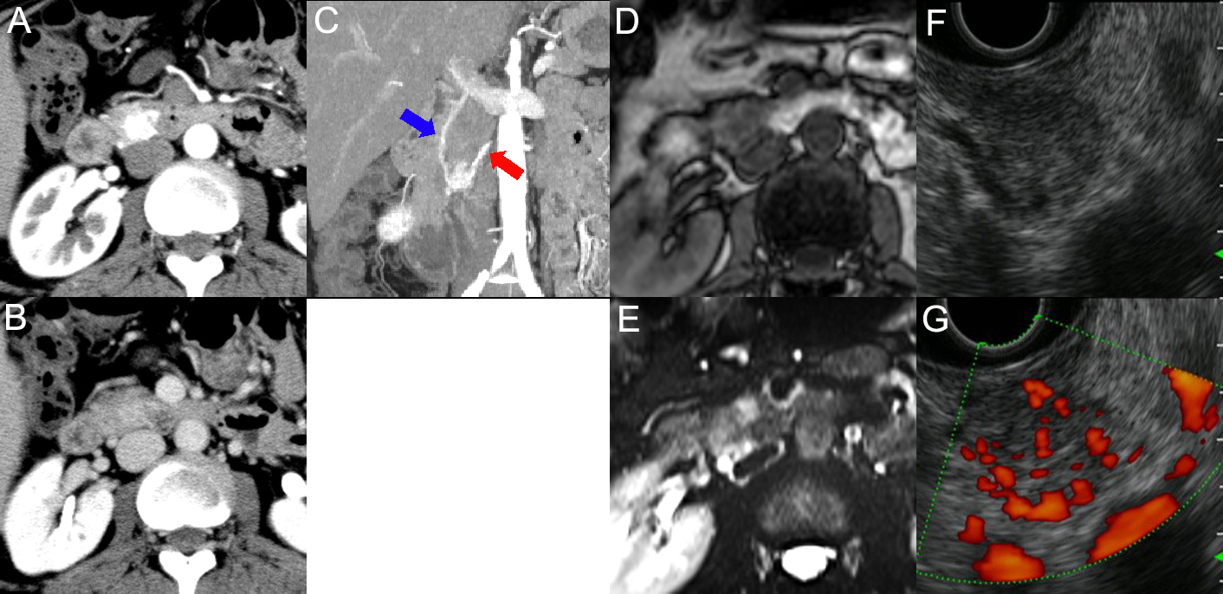

**Figure 1 Images of the pancreatic tumour.** A: dynamic computed tomography (CT) in the arterial phase; B: dynamic CT in the portal phase. 1.5-cm well demarcated tumour at the pancreas head was very strongly enhanced in the arterial phase and still faintly enhanced in the portal phase; C: Maximum intensity projection of the arterial phase in a coronal view. Red arrow indicates the feeding artery from the inferior pancreaticoduodenal artery and blue arrow indicates the draining vein into the portal vein; D: T1-weighted (T1W) magnetic resonance image (MRI); E: T2-weighted (T2W) MRI. The tumour appeared as a low-intensity lesion in T1W and as a high-intensity lesion in T2W; F: Endoscopic ultrasonography (EUS) images without power flow scanning; G: EUS images with power flow scanning. The low and uneven echoic tumour was surrounded by draining vessels.

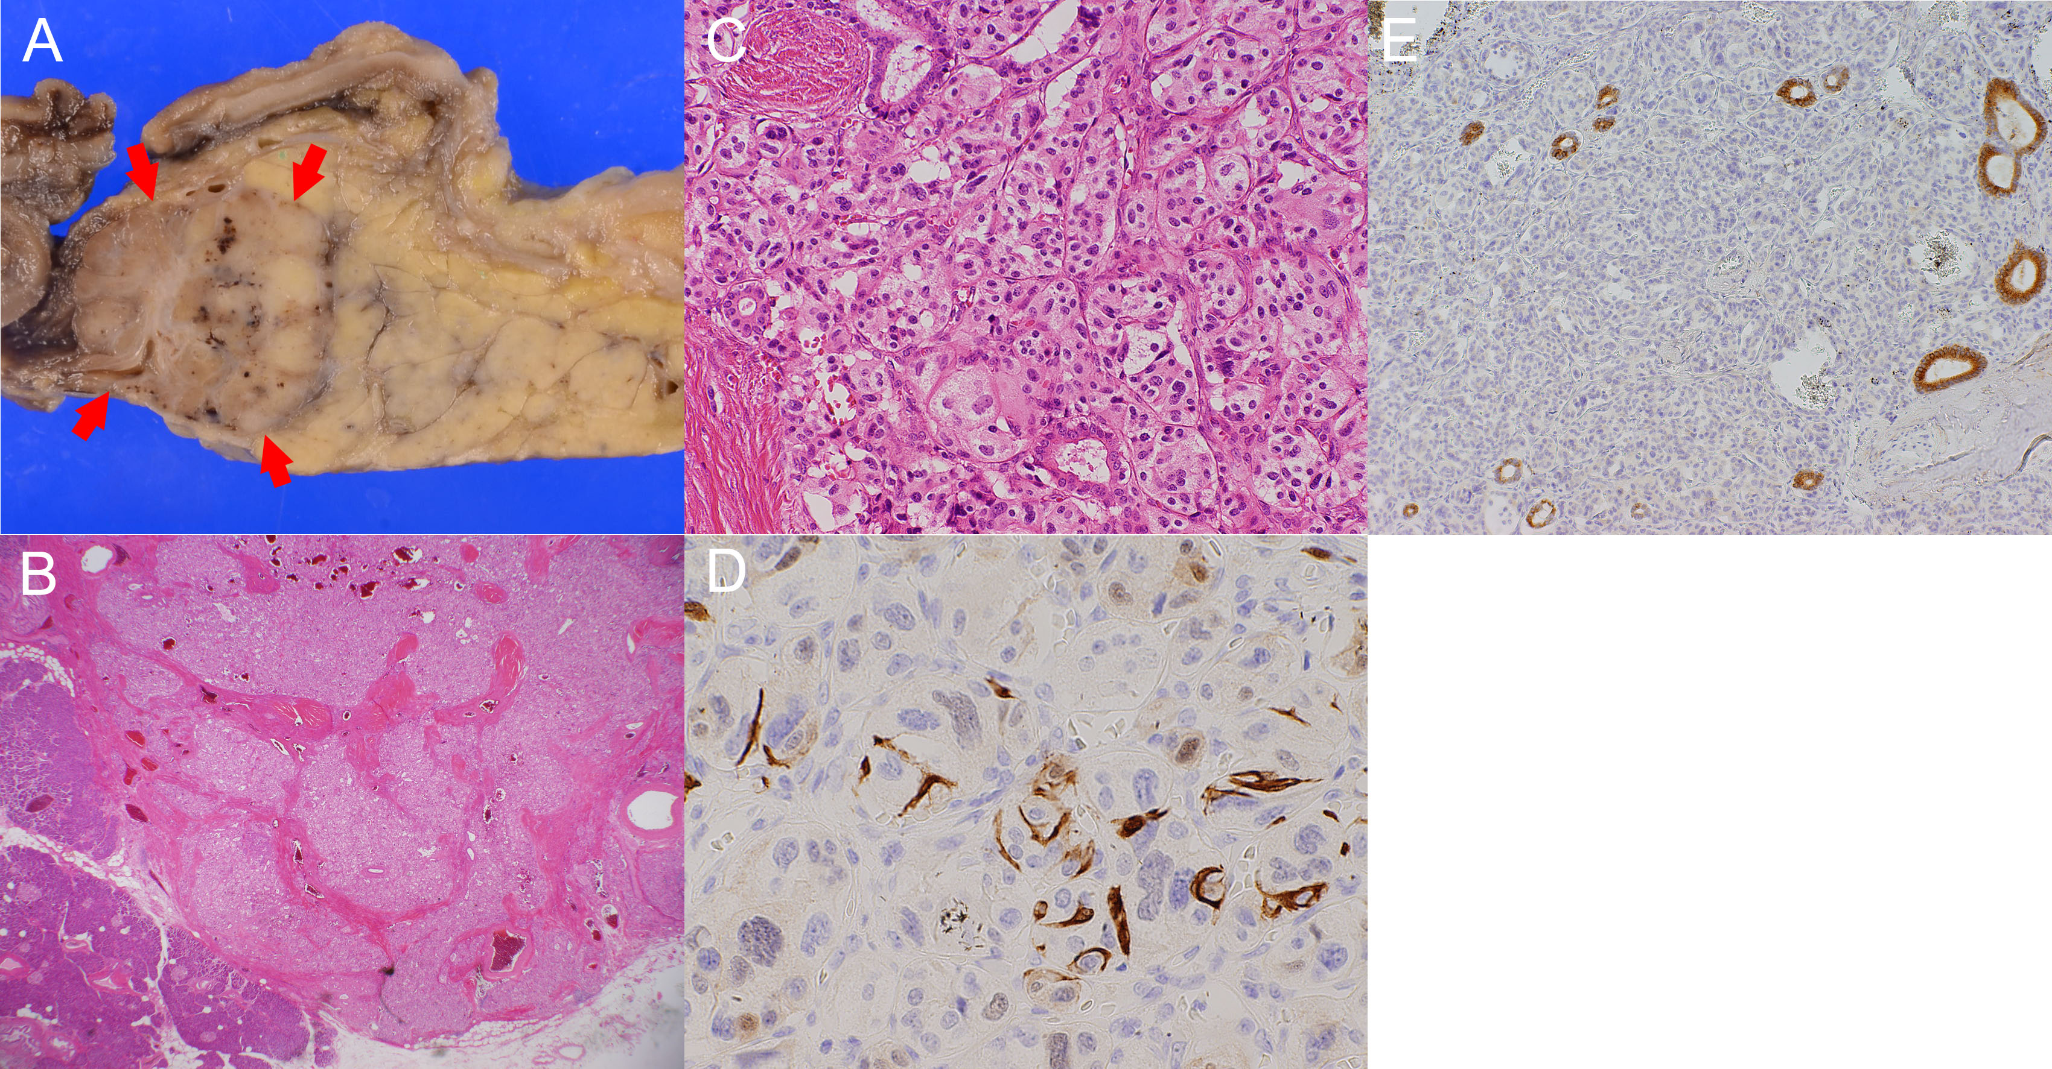

**Figure 2** **Histological examinations of the pancreatic tumour.** A: Macroscopic findings of the resected specimen. Arrows indicate the tumour in the pancreas head; B, C: Hematoxylin and eosin staining showing tumour cells in a Zellballen pattern at magnifications of x 10 (B) and x 200 (C); D: Immunohistochemistry of S-100 protein displaying S-100 protein-positive sustentacular cells surrounding the tumour cells (x 200); E: Immunohistochemistry of epithelial membrane antigen displaying pancreatic duct branches remaining within the tumour (x 100).