**Name of journal:** ***World Journal of Gastroenterology***

**ESPS Manuscript NO: 25054**

**Manuscript Type: ORIGINAL ARTICLE**

***Basic Study***

**MicroRNA-21 promotes phosphatase gene and** **protein kinase B/phosphatidylinositol 3-kinase in** **colorectal cancer**

Sheng WZ *et al*. MicroRNA-21 promotes PTEN, AKT and PI3K

**Wei-Zhong Sheng, Yu-Sheng Chen, Chuan-Tao Tu, Juan He, Bo Zhang, Wei-Dong Gao**

**Wei-Zhong Sheng, Yu-Sheng Chen, Bo Zhang, Wei-Dong Gao,** Department of general surgery, Fudan University affiliated zhongshan Hospital, Shanghai 200032, China

**Chuan-Tao Tu, Juan He,** Department of digestion, Fudan University affiliated zhongshan Hospital, Shanghai 200032, China

**Author contributions:** Sheng WZ and Chen YS contributed equally to this study, Sheng WZ, Chen YS and Gao WD designed research; Sheng WZ, Chen YS, Gao WD, Tu CT, He J and Zhang B performed research; Gao WD, Tu CT, He J and Zhang B contributed new reagents or analytic tools; Sheng WZ and Chen YS analyzed data; Sheng WZ and Gao WD wrote the paper.

**Institutional review board statement:** The study was reviewed and approved by the Fudan University affiliated zhongshan Hospital Institutional review board.

**Conflict-of-interest statement:** We declare that there are no conflicts of interest to disclose.

**Data sharing statement:** No additional data are available.

**Open-Access:** This article is an open-access article which was selected by an in-house editor and fully peer-reviewed by external reviewers. It is distributed in accordance with the Creative Commons Attribution Non Commercial (CC BY-NC 4.0) license, which permits others to distribute, remix, adapt, build upon this work non-commercially, and license their derivative works on different terms, provided the original work is properly cited and the use is non-commercial. See: <http://creativecommons.org/licenses/by-nc/4.0/>

**Correspondence to**: **Wei-Dong Gao, MD, Associate professor**, Department of general surgery, Fudan University affiliated zhongshan Hospital, NO. 180 Fenglin Road, Shanghai 200032, China. gao.weidong@zs-hospital.sh.cn

**Telephone:** +86-21-64041990

**Fax:** +86-21-64041990

**Received:** February 19, 2016

**Peer-review started:** February 20, 2016

**First decision:** March 21, 2016

**Revised:** April 11, 2016

**Accepted:** May 4, 2016

**Article in press:**

**Published online:**

**Abstract**

**AIM:** to explore the regulatory mechanism of miR-21 target gene to Phosphatase gene (PTEN) and its downstream protein protein kinase B (AKT) and phosphatidylinositol 3-kinase (PI3K) in colorectal cancer (CRC).

**METHODS**: Quantitative real-time PCR (qRT-PCR) and western blot were used to detect the expression levels of microRNA-21 and its downstream protein AKT and PI3K in CRC. as well as the expression of microRNA-21 and phosphatase gene mRNA and protein in HCT116 cells after downregulating microRNA-21. The expression of phosphatase gene and its downstream AKT and PI3K in HCT116 cells after reducing miR-21 expression were also been detected by quantitative real-time PCR and western blot.

**RESULTS**: Compared to microRNA-21 expression in CRC cells, the expression levels of microRNA-21were highest in HCT116 cells, but the expression levels ofmicroRNA-21were lowest in SW480 cells. In comparing microRNA-21 and phosphatase gene expression in CRC cells, we found that the protein expression levels of microRNA-21 and phosphatase gene were inversely correlated (*P* < 0.05); and when microRNA-21 expression was reduced, mRNA expression levels of phosphatase gene did not significantly change (*P* > 0.05), but the expression levels of its protein significantly increased (*P* < 0.05). In comparing the levels of phosphatase gene protein and downstream AKT and PI3K HCT116 cells after downregulation of microRNA-21 expression, the levels of AKT and PI3K protein expression significantly decreased (*P* < 0.05).

**CONCLUSION:** MicroRNA-21 is one of the target genes of phosphatase gene. Thus, phosphatase gene and its downstream AKT and PI3K expression levels can be regulated by regulating the expression levels of microRNA-21, which in turn regulate the development of CRC.

**Key words:** Colorectal cancer; miR-21; phosphatase and tensin homolog; protein kinase B; phosphatidylinositol 3-kinasein

**© The Author(s) 2016.** Published by Baishideng Publishing Group Inc. All rights reserved.

**Core tip:** RT-PCR and western blot were applied to detect the expression level of miR-21 and Phosphatase gene (PTEN), including its downstream protein protein kinase B (AKT) and phosphatidylinositol 3-kinase (PI3K) in colorectal cancer (CRC) cell lines, and explore the regulatory mechanism of the expression of miR-21 in inhibiting CRC, respectively. Their associations were investigated to clarify whether one of the direct target genes of PTEN is miR-21. The expression levels of miR-21, PTEN and its downstream protein AKT and PI3K were regulated and controlled to manage the occurrence and progression of CRC.

Sheng WZ, Chen YS, Tu CT, He J, Zhang B, Gao WD. MicroRNA-21 promotes phosphatase gene and protein kinase B/phosphatidylinositol 3-kinase in colorectal cancer. *World J Gastroenterol* 2016; In press

**INTRODUCTION**

MicroRNA (miRNA) is a kind of non-coding macromolecule RNA that include nearly 22 nucleotides, and is able to conjugate the 3’UTR of mRNA to facilitate target mRNA degradation and inhibit the translation process by virtue of lowering gene expression[1-4]. The research of Calin *et al* indicated that approximately 50% of mRNA was located in tumor related regions. This also revealed aberrant expression levels in a number of tumors, which was probably on the account of the oncogenic and tumor suppressing gene functions of miRNA molecules. In addition, this would be involved in the occurrence and progression of human tumors[5-8]. Phosphatase gene (PTEN) is a phosphatase and tensin homologue gene derived from chromosome ten, which belong to phosphohydrolase; and its inactivation induce tumor occurrence in the human body[9-11]. In recent years, the protein kinase B/phosphatase gene/phosphatidylinositol 3-kinase (AKT/PTEN/PI3K) signaling pathway has raised increasing concern, and a number of studies found that the atypical AKT/PTEN/PI3K signaling pathway was intimately linked with numerous tumor occurrences and progression, immunity, drugs resistance, metastasis, angiogenesis, *etc.*[12-16]. In addition, the AKT/PTEN/PI3K signaling pathway has been reported in pulmonary, nasopharyngeal, gastric and renal tumors, as well as in neuroglioma[17-21]. However, literatures on colorectal cancer (CRC) is rare. Moreover, there were reports that revealed that miR-21 could regulate the AKT/PTEN/PI3K signaling pathway to promote tumor occurrence and progression, and even tumor invasion[22-25]. Hence, Quantitative real-time PCR (qRT-PCR) and western blot were applied to detect the expression level of miR-21 and PTEN, including its downstream protein AKT and PI3K, in CRC cell lines. Furthermore, the mechanism of miR-21 expression in inhibiting CRC and their correlation were also explored. This study would provide theoretical and experimental basis for the early diagnosis and therapy of CRC.

**Materials and Methods**

***Experimental materials***

**Primary reagents and equipment:** PTEN antibody, PI3K mouse anti-human monoclonal antibody, immunohistochemistry (IHC) kit and AKT rabbit anti-human polyclonal antibody were purchased from Beijing Zhongshan Golden Bridge Biotechnology Company. Quantitative RT-PCR kit and miR-21 primer were purchased from Takara. Fluorescent quantitative PCR detection system was purchased from ABI (United States). The PCR instrument was purchased from Bio-Rad (United States). The inverted microscope was purchased from Olympus (Japan). The refrigerated centrifuge was purchased from Thermo Scientific (United States). HCT116, HT29, Colo32 and SW480 CRC cell strains were all purchased from the Cell Bank of the Chinese Academy of Sciences.

**Preparation of primary reagents:** Requisite reagents: phosphate buffer solution (PBS), bovine serum albumin (BSA) solution, Tris-buffered saline and Tween-20 (TBST) buffer, BSA blocking buffer, 0.25% trypsin solution, sodium dodecyl sulfate polyacrylamide gel electrophoresis (SDS-PAGE) electrophoresis buffer, transmembrane buffer, SDS-PAGE separation and stacking gel.

***Experimental methods***

**CRC cell culture and transfection:** A Dulbecco's modified Eagle's medium (DMEM) high glucose medium with 10% calf serum was used to culture HCT116, Ht29, Colo32 and SW480 CRC cell strains in 5% CO2 at 37 °C. Cells in the logarithmic phase were used in experiments. All cells were sorted into three groups: miR-21 inhibition group (IG), negative control (NC) and blank control (BC). HCT116 cells were inoculated in 500 μL of medium (no antibiotics) to 30%-60% degree to spare. Then, 20 pmol/L of miR-21 inhibitor was diluted with 50 mL of DMEM medium (no serum) and incubated for five minutes in room temperature after mixing. Next, 1 μL of mixing Lipofectamine 2000 was diluted in 50 μL of DMEM (no antibiotics and serum) and incubated in room temperature for five minutes. The diluted miR-21 inhibitor was mixed with Lipofectamine 2000 and incubated in room temperature for 20 min. Then, a 100-μL transfection buffer was added, mixed and incubated for six hours in an incubator (5% CO2 at 37 °C). Afterward, the medium was changed to normal medium and cells were incubated for another 48-72 hours for detection.

**Transwell assay:** Pre-cooling non-serum DMEM was used to dilute the Matrigel matrix gel. Then, it was paved on the chamber of the polycarbonate filtering membrane followed by inoculation of diluted HCT116 cells (100 μL). Afterwards, 10% fetal calf serum was added to the lower chamber. After 24 h of culture in 5% CO2 at 37 °C, the chamber was washed twice, stained with 0.1% crystal violet for five minutes, and washed again. Cells were randomly counted in five views at 100 × objective and the average was calculated. This was performed in three replicates for each group.

**Real-time quantitative RT-PCR detected miR-21 and PTEN mRNA levels:** Total RNA was extracted using Trizol RNA extraction methods, based on the Molecular Clone Technique Experimental Manual. One mL of Trizol reagent could be added to approximately 100-mg tissues. A mortar was used to grind the tissues to powder, which eventually reached complete decomposition. The lysate was drawn into a 1.5-mL tube and incubated for 10 min on ice. After centrifuging at 12000 rpm for 10 min at 4 °C, the supernatant was drawn into a new 1.5-mL tube. Isopropanol in equal volume was added and mixed, plated on ice for 10 min, and centrifuged at 12000 rpm for another 10 min at 4 °C. The supernatant was discarded, 1 mL of 75% ethanol was added, the precipitate was washed, and centrifuged for another five minutes. Afterwards, the supernatant was discarded, placed into a tube in room temperature for 10 min, waited until the residue entirely volatilized, 100 μL of diethyl pyrocarbonate H2O was added to dissolve the precipitate, and stored in liquid nitrogen for use. Extracted RNA purity and concentration was detected using a spectrophotometer. The normal value of optical density (OD) OD260/OD280 was between 1.8 and 2.1, respectively. Then, cDNA was synthesized by reverse transcription reaction. RT-PCR was used to detect miR-21 reaction conditions: 95 °C for 10 s, one cycle, 95 °C for 5 s, 60 °C for 34 s, 45 cycles; computational formula: relative amount = 2-△△CT, where -△△CT= (CTmiR-21-CTu6) tumor-(CTmiR-21-CTu6) normal tissue. RT-PCR was used to detect PTEN mRNA reaction conditions: 95 °C for 10 s, one cycle, 95 °C for 5 s, 60 °C for 20 s, 45 cycle; and PTEN mRNA expression level was calculated on the basis of △Ct = Ct(PTEN)- Ct(β-actin), where Folds = 2-△△CT, and the average result was used with three repeats.

**Western blot**: After 48-72 h of transfection, the medium was discarded and 100 μL of RIPA lysate was added into each well. The lysate was mixed for five minutes, centrifuged at 12000 rpm for 15 min at 4 °C, and the supernatant was stored for use. Samples mixed with 5 × loading were boiled for 10 min at 95 °C and loaded after centrifugation. Eight μL of purified and desalted antibody was loaded, and 2-3 μl of the marker was loaded. The antibody was confirmed according to the marker position. Electrophoresis: stacking gel in 80 V for 20-30 min, and separation gel in 120 V for 40 min. Transmembrane: 300 mA for 90 min. After transmembrane, the membrane was blocked with non-fat milk, washed with PBS for three times, and incubated with the primary antibody (PTEN antibody, PI3K antibody, AKT antibody and β-actin antibody; 1:500 dilution) overnight at 4 °C. On the next day, cells were washed with TBST for seven times and incubated with the secondary antibody (horseradish peroxidase-labeled goat-anti rabbit secondary antibody, 1:2500 dilution) for one hour. Then, cells were washed with TBST for another six times. Chemiluminescencereagent A and B solution were mixed and added on the membrane based on a 1:1 proportion, and β-actin protein was used as an internal reference.

***Statistic analysis***

SPSS 19.0 was used to analyze all data, measurement data were presented as mean ± SD. The *t*-test was used to compare miR-21 and PTEN expression levels, and the variance analysis method was used to compare the mean value of transfection in the IG, NC and BC groups. *P* < 0.05 was considered statistically significant.

**Results**

***MiR-21 and PTEN expression in CRC cells***

MiR-21 had the highest protein expression in HCT116 cells, but had the lowest expression in SW480 cells (Figure 1). In contrast, PTEN protein expression was the lowest in HCT116 cells, but had the highest expression in SW480 cells (Figure 2). The protein expression level between miR-21 and PTEN was inversely related, and the difference was statistically significant (*P* < 0.01).

***Invasive ability changes in cells after transfection***

In counting the cells that crossed after transfection in the Transwell assay, we found that cells transfected with miR-21 in IG was reduced by 39.1% compared to BC and 36.9% compared to NC. However, the difference between BC and NC was not statistically significant (Figure 3).

***RT-PCR detection of miR-21 expression after transfection***

MiR-21 expression levels after transfection in IG, NC and BC are shown in Figure 4. It can be observed that miR-21 expression levels in BC and NC were higher than in IG, and the difference was statistically significant (*P* < 0.05).

***PTEN mRNA and protein expression in HCT116 cells after downregulation of miR-21***

As shown in Figure 5A, after reducing the expression of miR-21, PTEN mRNA expression levels in HCT116 cells revealed no statistical significance after transfection in IG, NC and BC (*P* > 0.05). As illustrated in Figure 5B, when miR-21 was downregulated, PTEN protein expression levels were markedly elevated; and the difference was statistically significant (*P* < 0.05). The difference between BC and NC was not statistically significant (*P* > 0.05)

***PTEN and its downstream protein AKT and PI3K expression in HCt116 cells after downregulating miR-21***

As shown in Figure 6, PTEN protein expression levels in HCT116 cells were elevated in IG, and the difference was statistically significant (*P*<0.05). However, AKT and PI3K expression levels in HCT116 cells in IG decreased; and the difference was statistically significant (*P*<0.05).

**Discussion**

Numerous researches have indicated that CRC occurrence in patients is a complicated process, which is combined with multiple stages and factors. One momentous feature is its oncogenic activation and tumor suppressing gene expression dysregulation or absence[26,27]. In recent years, it has been found miRNA possessed oncogenic and tumor suppressing gene functions[22]. One representative miRNA, miR-21, possess a crucial oncogenic function that exhibit high expression levels in a number of tumors; and was closely associated with tumor occurrence and chemotherapy sensitivity[28,29]. PTEN is derived from chromosome ten, and acts as a tumor suppressing gene. PTEN exerts vital effects in cell growth, proliferation, migration, signal transmission, invasion and apoptosis; which has an inhibitory role in tumor cell growth, invasion, proliferation, metastasis and apoptosis[30]. The AKT/PTEN/PI3K signaling pathway plays a significant part in regulating cell growth, metabolism, differentiation and apoptosis; and is closely associated with tumor occurrence and progression[31-36]. PTEN protein phosphatase activity dephosphorylation could inhibit AKT function, leading to cell apoptosis. Furthermore, the deletion or mutation of PTEN was able to enhance AKT activity to increase PI3K expression[37]. AKT/PTEN/PI3K signaling pathway activation was capable of inhibiting cell apoptosis to facilitate cell differentiation and proliferation. This also exerts a crucial role in tumor occurrence and progression, and participates in tumor metastasis and invasion[38-44].

***MiR21 and PTEN expression in CRC cells***

MiR-21 and PTEN protein expression was detected in HCT116, HT29, Colo32 and SW480 CRC cell lines through RT-PCR and western blot. Results revealed that miR-21 expression level was highest in HCT116 cells and lowest in SW480 cells. Furthermore, PTEN expression level was lowest in HCT116 cells and highest in SW480 cells. The protein expression level between miR-21 and PTEN was inversely correlated. These indicate that miR-21 could be involved in the regulation of PTEN protein expression. In addition, due to the high expression level of miR-21 in HCT116 cells, HCT116 cells were selected for this study. Transwell invasion assay revealed that the invasive capacity of tumor cells was obviously reduced after inhibiting CRC cell miR-21 expression, which in turn indicate that miR-21 probably plays a promoting role in cell malignancy transformation.

***MiR-21 and PTEN mRNA and protein expression in HCT116 cells after downregulating miR-21***

After downregulating the expression of miR-21, the expression level of miR-21 in HCT116 cells in IG was obviously lower compared to NC and BC; which illustrate the successful inhibition of miR-21. As a known miR-21 target gene, PTEN has been verified to be a target gene to miR-21 by western blot. When we inhibited the expression of miR-21, PTEN mRNA expression levels did not reveal apparent change, but protein levels were obviously elevated; which indicate that miR-21 could regulate PTEN expression in the post-transcriptional level and that PTEN was a target gene for miR-21. Meng *et al*[45]recently found that miR-21 targeted tumor suppressing gene PTEN in liver and bile duct cancer cells promote tumor growth, invasion and migration, manifesting that PTEN was a target gene of miR-21.

***PTEN and its downstream AKT and PI3K expression in HCT116 cells after reducing miR-21 expression***

After inhibiting the expression of miR-21, PTEN protein level was significantly elevated, but its downstream AKT and PI3K expression obviously decreased; indicating that miR-21 could regulate and control PTEN and the expression level of its downstream AKT and PI3K in terms of its effects in tumor cell invasion and migration. Certain studies have shown that change in miR-21 expression level was able to induce PTEN downstream molecule AKT phosphorylation, metalloproteinase 2 and focal adhesion kinaseexpression; altering to restrain tumor cell invasion and migration[45-50].

In conclusion, our study revealed that PTEN is one of the direct target genes of miR-21, which could regulate and control its downstream AKT and PI3K expression level through altering miR-21 expression, and control CRC occurrence and progression. Nevertheless, the mechanism of miR-21 and PTEN function, as well as their effects in tumors, needs to be further investigated. As more in-depth researches on mRNA are being undertaken, especially tumor cell regulatory mechanisms, more roles and targets of miR-21 would probably be unraveled.

**comments**

***Background***

Colorectal cancer (CRC) is complicated and combines multiple stages and factors. In recent years, we found that miRNA possessed oncogenic and tumor suppressing gene functions. One representative miRNA, miR-21, possess a crucial oncogenic function that show high expression levels in a number of tumors; and this was closely associated with tumor occurrence and chemotherapy sensitivity. PTEN acts as a tumor suppressing gene derived from chromosome ten. PTEN exerts vital effects in cell growth, proliferation, migration, signal transmission, invasion and apoptosis; which has an inhibitory role in tumor cell growth, invasion, proliferation, metastasis and apoptosis. The AKT/PTEN/PI3K signaling pathway plays a significant part in regulating cell growth, metabolism, differentiation, and apoptosis; and is closely associated with tumor occurrence and progression.

***Research frontiers***

In addition, the AKT/PTEN/PI3K signaling pathway has been reported in pulmonary, nasopharyngeal, gastric and renal tumors, as well as in neuroglioma; however, literatures in CRC are rare. Moreover, there were reports that revealed that miR-21 could regulate the AKT/PTEN/PI3K signaling pathway, in order to promote tumor occurrence and progression, and even tumor invasion. Hence, RT-PCR and western blot were applied to detect the expression levels of miR-21 and PTEN, including its downstream protein AKT and PI3K in CRC cell lines, as well as the inhibition of miR-21 expression in CRC cell lines. Furthermore, their association was also explored. This study hopes to provide theoretical and experimental basis for the early diagnosis and therapy of CRC.

***Innovations and breakthroughs***

RT-PCR and western blot were applied to detect the expression level of miR-21 and PTEN including its downstream protein AKT and PI3K in CRC, and the inhibition of miR-21 expression in CRC cell lines, respectively. This association was also investigated to reveal that PTEN was one of the direct target genes of miR-21. Through regulating and controlling the expression level of miR-21, PTEN and its downstream protein AKT and PI3K expression level were regulated to control the occurrence and progression of CRC.

***Applications***

Our study revealed that PTEN was one of the direct target genes of miR-21, and that its downstream AKT and PI3K expression level could be regulated and controlled through altering miR-21 expression, in order to control CRC occurrence and progression. Nevertheless, the mechanism of miR-21 and PTEN function, as well as their effects in tumors, needs to be further investigated. As in-depth researches on mRNA are currently being implemented, particularly in the regulatory mechanism of tumor cells, more roles and targets of miR-21 would probably be unraveled.

***Peer-review***

This is an interesting manuscript about the microRNA-21 promotes PTEN and its downstream protein AKT and PI3K in CRC. Over all, this study is well designed and the manuscript is will written.

**REFERENCES**

1 **Lewis BP**, Burge CB, Bartel DP. Conserved seed pairing, often flanked by adenosines, indicates that thousands of human genes are microRNA targets. *Cell* 2005; **120**: 15-20 [PMID: 15652477 DOI: 10.1016/j.cell.2004.12.035]

2 **Janssen HL**, Reesink HW, Lawitz EJ, Zeuzem S, Rodriguez-Torres M, Patel K, van der Meer AJ, Patick AK, Chen A, Zhou Y, Persson R, King BD, Kauppinen S, Levin AA, Hodges MR. Treatment of HCV infection by targeting microRNA. *N Engl J Med* 2013; **368**: 1685-1694 [PMID: 23534542 DOI: 10.1056/NEJMoa1209026]

3 **Iorio MV**, Croce CM. MicroRNA dysregulation in cancer: diagnostics, monitoring and therapeutics. A comprehensive review. *EMBO Mol Med* 2012; **4**: 143-159 [PMID: 22351564 DOI: 10.1002/emmm.201100209]

4 **Pritchard CC**, Cheng HH, Tewari M. MicroRNA profiling: approaches and considerations. *Nat Rev Genet* 2012; **13**: 358-369 [PMID: 22510765 DOI: 10.1038/nrg3198]

5 **Wang B**, Zhang Q. The expression and clinical significance of circulating microRNA-21 in serum of five solid tumors. *J Cancer Res Clin Oncol* 2012; **138**: 1659-1666 [PMID: 22638884 DOI: 10.1007/s00432-012-1244-9]

6 **Liu ZL**, Wang H, Liu J, Wang ZX. MicroRNA-21 (miR-21) expression promotes growth, metastasis, and chemo- or radioresistance in non-small cell lung cancer cells by targeting PTEN. *Mol Cell Biochem* 2013; **372**: 35-45 [PMID: 22956424 DOI: 10.1007/s11010-012-1443-3]

7 **Kumarswamy R**, Volkmann I, Jazbutyte V, Dangwal S, Park DH, Thum T. Transforming growth factor-β-induced endothelial-to-mesenchymal transition is partly mediated by microRNA-21. *Arterioscler Thromb Vasc Biol* 2012; **32**: 361-369 [PMID: 22095988 DOI: 10.1161/ATVBAHA.111.234286]

8 **Parikh VN**, Jin RC, Rabello S, Gulbahce N, White K, Hale A, Cottrill KA, Shaik RS, Waxman AB, Zhang YY, Maron BA, Hartner JC, Fujiwara Y, Orkin SH, Haley KJ, Barabási AL, Loscalzo J, Chan SY. MicroRNA-21 integrates pathogenic signaling to control pulmonary hypertension: results of a network bioinformatics approach. *Circulation* 2012; **125**: 1520-1532 [PMID: 22371328 DOI: 10.1161/circulationaha.111.060269]

9 **Song MS**, Salmena L, Pandolfi PP. The functions and regulation of the PTEN tumour suppressor. *Nat Rev Mol Cell Biol* 2012; **13**: 283-296 [PMID: 22473468 DOI: 10.1038/nrm3330]

10 **Shrestha S**, Yang K, Guy C, Vogel P, Neale G, Chi H. Treg cells require the phosphatase PTEN to restrain TH1 and TFH cell responses. *Nat Immunol* 2015; **16**: 178-187 [PMID: 25559258 DOI: 10.1038/ni.3076]

11 **Carver BS**, Chapinski C, Wongvipat J, Hieronymus H, Chen Y, Chandarlapaty S, Arora VK, Le C, Koutcher J, Scher H, Scardino PT, Rosen N, Sawyers CL. Reciprocal feedback regulation of PI3K and androgen receptor signaling in PTEN-deficient prostate cancer. *Cancer Cell* 2011; **19**: 575-586 [PMID: 21575859 DOI: 10.1016/j.ccr.2011.04.008]

12 **Zhang BG**, Li JF, Yu BQ, Zhu ZG, Liu BY, Yan M. microRNA-21 promotes tumor proliferation and invasion in gastric cancer by targeting PTEN. *Oncol Rep* 2012; **27**: 1019-1026 [PMID: 22267008 DOI: 10.3892/or.2012.1645]

13 **McCubrey JA**, Steelman LS, Chappell WH, Abrams SL, Franklin RA, Montalto G, Cervello M, Libra M, Candido S, Malaponte G, Mazzarino MC, Fagone P, Nicoletti F, Bäsecke J, Mijatovic S, Maksimovic-Ivanic D, Milella M, Tafuri A, Chiarini F, Evangelisti C, Cocco L, Martelli AM. Ras/Raf/MEK/ERK and PI3K/PTEN/Akt/mTOR cascade inhibitors: how mutations can result in therapy resistance and how to overcome resistance. *Oncotarget* 2012; **3**: 1068-1111 [PMID: 23085539 DOI: 10.18632/oncotarget.659]

14 **Hafsi S**, Pezzino FM, Candido S, Ligresti G, Spandidos DA, Soua Z, McCubrey JA, Travali S, Libra M. Gene alterations in the PI3K/PTEN/AKT pathway as a mechanism of drug-resistance (review). *Int J Oncol* 2012; **40**: 639-644 [PMID: 22200790 DOI: 10.3892/ijo.2011.1312]

15 **Hemmings BA**, Restuccia DF. The PI3K-PKB/Akt pathway. *Cold Spring Harb Perspect Biol* 2015; **7**: pii: a026609 [PMID: 25833846 DOI: 10.1101/cshperspect.a026609]

16 **Janku F**, Wheler JJ, Westin SN, Moulder SL, Naing A, Tsimberidou AM, Fu S, Falchook GS, Hong DS, Garrido-Laguna I, Luthra R, Lee JJ, Lu KH, Kurzrock R. PI3K/AKT/mTOR inhibitors in patients with breast and gynecologic malignancies harboring PIK3CA mutations. *J Clin Oncol* 2012; **30**: 777-782 [PMID: 22271473 DOI: 10.1200/jco.2011.36.1196]

17 **Shih MC**, Chen JY, Wu YC, Jan YH, Yang BM, Lu PJ, Cheng HC, Huang MS, Yang CJ, Hsiao M, Lai JM. TOPK/PBK promotes cell migration via modulation of the PI3K/PTEN/AKT pathway and is associated with poor prognosis in lung cancer. *Oncogene* 2012; **31**: 2389-2400 [PMID: 21996732 DOI: 10.1038/onc.2011.419]

18 **Qu C**, Liang Z, Huang J, Zhao R, Su C, Wang S, Wang X, Zhang R, Lee MH, Yang H. MiR-205 determines the radioresistance of human nasopharyngeal carcinoma by directly targeting PTEN. *Cell Cycle* 2012; **11**: 785-796 [PMID: 22374676 DOI: 10.4161/cc.11.4.19228]

19 **Wang F**, Li T, Zhang B, Li H, Wu Q, Yang L, Nie Y, Wu K, Shi Y, Fan D. MicroRNA-19a/b regulates multidrug resistance in human gastric cancer cells by targeting PTEN. *Biochem Biophys Res Commun* 2013; **434**: 688-694 [PMID: 23603256 DOI: 10.1016/j.bbrc.2013.04.010]

20 **Wang KF**, Yang H, Jiang WQ, Li S, Cai YC. Puquitinib mesylate (XC-302) induces autophagy via inhibiting the PI3K/AKT/mTOR signaling pathway in nasopharyngeal cancer cells. *Int J Mol Med* 2015; **36**: 1556-1562 [PMID: 26499488 DOI: 10.3892/ijmm.2015.2378]

21 **Mueller S**, Phillips J, Onar-Thomas A, Romero E, Zheng S, Wiencke JK, McBride SM, Cowdrey C, Prados MD, Weiss WA, Berger MS, Gupta N, Haas-Kogan DA. PTEN promoter methylation and activation of the PI3K/Akt/mTOR pathway in pediatric gliomas and influence on clinical outcome. *Neuro Oncol* 2012; **14**: 1146-1152 [PMID: 22753230 DOI: 10.1093/neuonc/nos140]

22 **Xiong B**, Cheng Y, Ma L, Zhang C. MiR-21 regulates biological behavior through the PTEN/PI-3 K/Akt signaling pathway in human colorectal cancer cells. *Int J Oncol* 2013; **42**: 219-228 [PMID: 23174819 DOI: 10.3892/ijo.2012.1707]

23 **Han M**, Liu M, Wang Y, Chen X, Xu J, Sun Y, Zhao L, Qu H, Fan Y, Wu C. Antagonism of miR-21 reverses epithelial-mesenchymal transition and cancer stem cell phenotype through AKT/ERK1/2 inactivation by targeting PTEN. *PLoS One* 2012; **7**: e39520 [PMID: 22761812 DOI: 10.1371/journal.pone.0039520]

24 **Yang SM**, Huang C, Li XF, Yu MZ, He Y, Li J. miR-21 confers cisplatin resistance in gastric cancer cells by regulating PTEN. *Toxicology* 2013; **306**: 162-168 [PMID: 23466500 DOI: 10.1016/j.tox.2013.02.014]

25 **Wei J**, Feng L, Li Z, Xu G, Fan X. MicroRNA-21 activates hepatic stellate cells via PTEN/Akt signaling. *Biomed Pharmacother* 2013; **67**: 387-392 [PMID: 23643356 DOI: 10.1016/j.biopha.2013.03.014]

26 **Elez E**, Argilés G, Tabernero J. First-Line Treatment of Metastatic Colorectal Cancer: Interpreting FIRE-3, PEAK, and CALGB/SWOG 80405. *Curr Treat Options Oncol* 2015; **16**: 52 [PMID: 26374340 DOI: 10.1007/s11864-015-0369-x]

27 **Vasen HF**, Watson P, Mecklin JP, Lynch HT. New clinical criteria for hereditary nonpolyposis colorectal cancer (HNPCC, Lynch syndrome) proposed by the International Collaborative group on HNPCC. *Gastroenterology* 1999; **116**: 1453-1456 [PMID: 10348829 DOI: 10.1016/s0016-5085(99)70510-x]

28 **Witwer KW**. Circulating microRNA biomarker studies: pitfalls and potential solutions. *Clin Chem* 2015; **61**: 56-63 [PMID: 25391989 DOI: 10.1373/clinchem.2014.221341]

29 **Yang JS**, Li BJ, Lu HW, Chen Y, Lu C, Zhu RX, Liu SH, Yi QT, Li J, Song CH. Serum miR-152, miR-148a, miR-148b, and miR-21 as novel biomarkers in non-small cell lung cancer screening. *Tumour Biol* 2015; **36**: 3035-3042 [PMID: 25501703 DOI: 10.1007/s13277-014-2938-1]

30 **Fragoso R**, Barata JT. Kinases, tails and more: regulation of PTEN function by phosphorylation. *Methods* 2015; **77-78**: 75-81 [PMID: 25448482 DOI: 10.1016/j.ymeth.2014.10.015]

31 **Wang G**, Shi Y, Jiang X, Leak RK, Hu X, Wu Y, Pu H, Li WW, Tang B, Wang Y, Gao Y, Zheng P, Bennett MV, Chen J. HDAC inhibition prevents white matter injury by modulating microglia/macrophage polarization through the GSK3β/PTEN/Akt axis. *Proc Natl Acad Sci U S A* 2015; **112**: 2853-2858 [PMID: 25691750 DOI: 10.1073/pnas.1501441112]

32 **Yang X**, Cheng Y, Li P, Tao J, Deng X, Zhang X, Gu M, Lu Q, Yin C. A lentiviral sponge for miRNA-21 diminishes aerobic glycolysis in bladder cancer T24 cells via the PTEN/PI3K/AKT/mTOR axis. *Tumour Biol* 2015; **36**: 383-391 [PMID: 25266796 DOI: 10.1007/s13277-014-2617-2]

33 **He C**, Dong X, Zhai B, Jiang X, Dong D, Li B, Jiang H, Xu S, Sun X. MiR-21 mediates sorafenib resistance of hepatocellular carcinoma cells by inhibiting autophagy via the PTEN/Akt pathway. *Oncotarget* 2015; **6**: 28867-28881 [PMID: 26311740 DOI: 10.18632/oncotarget.4814]

34 **Paul-Samojedny M**, Pudełko A, Suchanek-Raif R, Kowalczyk M, Fila-Daniłow A, Borkowska P, Kowalski J. Knockdown of the AKT3 (PKBγ), PI3KCA, and VEGFR2 genes by RNA interference suppresses glioblastoma multiforme T98G cells invasiveness in vitro. *Tumour Biol* 2015; **36**: 3263-3277 [PMID: 25501707 DOI: 10.1007/s13277-014-2955-0]

35 **Xu J**, Cai J, Jin X, Yang J, Shen Q, Ding X, Liang Y. PIG3 plays an oncogenic role in papillary thyroid cancer by activating the PI3K/AKT/PTEN pathway. *Oncol Rep* 2015; **34**: 1424-1430 [PMID: 26133772 DOI: 10.3892/or.2015.4096]

36 **Malemud CJ**. The PI3K/Akt/PTEN/mTOR pathway: a fruitful target for inducing cell death in rheumatoid arthritis? *Future Med Chem* 2015; **7**: 1137-1147 [PMID: 26132523 DOI: 10.4155/fmc.15.55]

37 **McCarroll JA**, Gan PP, Erlich RB, Liu M, Dwarte T, Sagnella SS, Akerfeldt MC, Yang L, Parker AL, Chang MH, Shum MS, Byrne FL, Kavallaris M. TUBB3/βIII-tubulin acts through the PTEN/AKT signaling axis to promote tumorigenesis and anoikis resistance in non-small cell lung cancer. *Cancer Res* 2015; **75**: 415-425 [PMID: 25414139 DOI: 10.1158/0008-5472.can-14-2740]

38 **Hevner RF**. Brain overgrowth in disorders of RTK-PI3K-AKT signaling: a mosaic of malformations. *Semin Perinatol* 2015; **39**: 36-43 [PMID: 25432429 DOI: 10.1053/j.semperi.2014.10.006]

39 **Sarbassov DD**, Guertin DA, Ali SM, Sabatini DM. Phosphorylation and regulation of Akt/PKB by the rictor-mTOR complex. *Science* 2005; **307**: 1098-1101 [PMID: 15718470 DOI: 10.1126/science.1106148]

40 **Franke TF**, Yang SI, Chan TO, Datta K, Kazlauskas A, Morrison DK, Kaplan DR, Tsichlis PN. The protein kinase encoded by the Akt proto-oncogene is a target of the PDGF-activated phosphatidylinositol 3-kinase. *Cell* 1995; **81**: 727-736 [PMID: 7774014 DOI: 10.1016/0092-8674(95)90534-0]

41 **Brunet A**, Bonni A, Zigmond MJ, Lin MZ, Juo P, Hu LS, Anderson MJ, Arden KC, Blenis J, Greenberg ME. Akt promotes cell survival by phosphorylating and inhibiting a Forkhead transcription factor. *Cell* 1999; **96**: 857-868 [PMID: 10102273 DOI: 10.1016/S0092-8674(00)80595-4]

42 **Li J**, Yen C, Liaw D, Podsypanina K, Bose S, Wang SI, Puc J, Miliaresis C, Rodgers L, McCombie R, Bigner SH, Giovanella BC, Ittmann M, Tycko B, Hibshoosh H, Wigler MH, Parsons R. PTEN, a putative protein tyrosine phosphatase gene mutated in human brain, breast, and prostate cancer. *Science* 1997; **275**: 1943-1947 [PMID: 9072974 DOI: 10.1126/science.275.5308.1943]

43 **Liaw D**, Marsh DJ, Li J, Dahia PL, Wang SI, Zheng Z, Bose S, Call KM, Tsou HC, Peacocke M, Eng C, Parsons R. Germline mutations of the PTEN gene in Cowden disease, an inherited breast and thyroid cancer syndrome. *Nat Genet* 1997; **16**: 64-67 [PMID: 9140396 DOI: 10.1038/ng0597-64]

44 **Maehama T**, Dixon JE. The tumor suppressor, PTEN/MMAC1, dephosphorylates the lipid second messenger, phosphatidylinositol 3,4,5-trisphosphate. *J Biol Chem* 1998; **273**: 13375-13378 [PMID: 9593664 DOI: 10.1074/jbc.273.22.13375]

45 **Meng F**, Henson R, Wehbe-Janek H, Ghoshal K, Jacob ST, Patel T. MicroRNA-21 regulates expression of the PTEN tumor suppressor gene in human hepatocellular cancer. *Gastroenterology* 2007; **133**: 647-658 [PMID: 17681183 DOI: 10.1053/j.gastro.2007.05.022]

46 **Bao L**, Yan Y, Xu C, Ji W, Shen S, Xu G, Zeng Y, Sun B, Qian H, Chen L, Wu M, Su C, Chen J. MicroRNA-21 suppresses PTEN and hSulf-1 expression and promotes hepatocellular carcinoma progression through AKT/ERK pathways. *Cancer Lett* 2013; **337**: 226-236 [PMID: 23684551 DOI: 10.1016/j.canlet.2013.05.007]

47 **Vinciguerra M**, Sgroi A, Veyrat-Durebex C, Rubbia-Brandt L, Buhler LH, Foti M. Unsaturated fatty acids inhibit the expression of tumor suppressor phosphatase and tensin homolog (PTEN) via microRNA-21 up-regulation in hepatocytes. *Hepatology* 2009; **49**: 1176-1184 [PMID: 19072831 DOI: 10.1002/hep.22737]

48 **Ye JJ**, Cao J. MicroRNAs in colorectal cancer as markers and targets: Recent advances. *World J Gastroenterol* 2014; **20**: 4288-4299 [PMID: 24764666 DOI: 10.3748/wjg.v20.i15.4288]

49 **Gayral M**, Jo S, Hanoun N, Vignolle-Vidoni A, Lulka H, Delpu Y, Meulle A, Dufresne M, Humeau M, Chalret du Rieu M, Bournet B, Sèlves J, Guimbaud R, Carrère N, Buscail L, Torrisani J, Cordelier P. MicroRNAs as emerging biomarkers and therapeutic targets for pancreatic cancer. *World J Gastroenterol* 2014; **20**: 11199-11209 [PMID: 25170204 DOI: 10.3748/wjg.v20.i32.11199]

50 **Iliopoulos D**, Jaeger SA, Hirsch HA, Bulyk ML, Struhl K. STAT3 activation of miR-21 and miR-181b-1 via PTEN and CYLD are part of the epigenetic switch linking inflammation to cancer. *Mol Cell* 2010; **39**: 493-506 [PMID: 20797623 DOI: /dx.doi.org/10.1016/j.molcel.2010.07.023]

**P-Reviewer:** Imai K, Mangiola F **S-Editor:** Gong ZM

**L-Editor:** **E-Editor:**

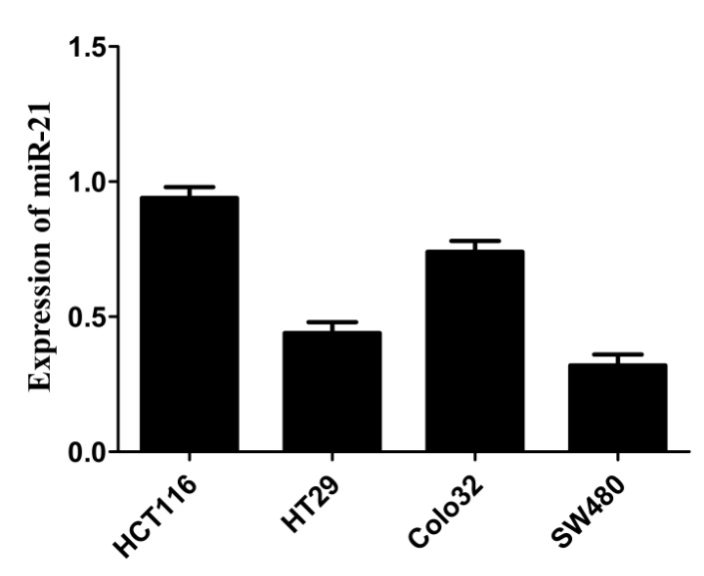

**Figure 1 The expression of miR-21 in colorectal cancer cell lines (*n* = 3).**

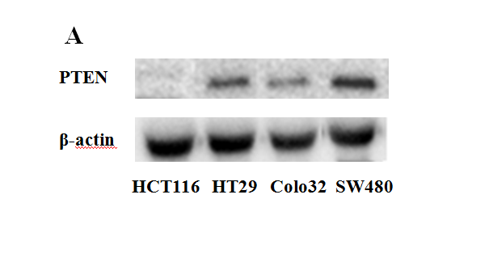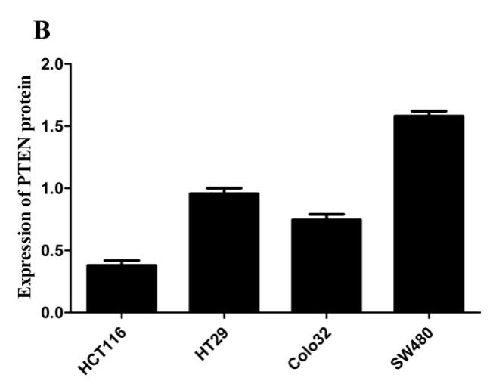

Figure 2 **The expression of PTEN protein in colorectal cancer cell lines.** A: Western blot assay; B: the expression of PTEN in colorectal cancer cell lines (*n* = 3).

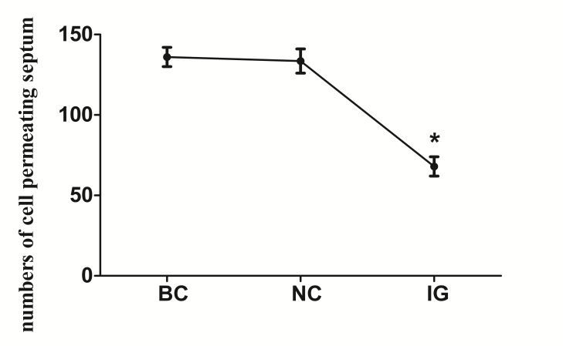

**Figure 3 Changes in cell invasion ability after transfection (a*P* < 0.05, *n* = 3).**

a

a

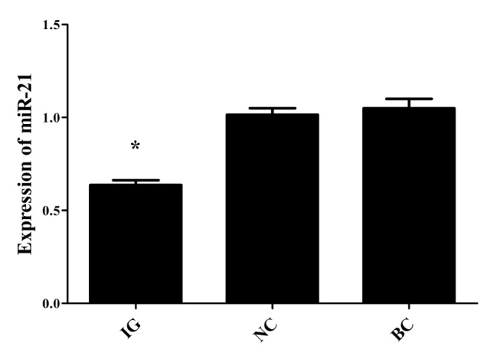

**Figure 4 Effect of the miR-21 inhibitor on miR-21 expression in HCT116 cells (a*P* < 0.05, *n* = 3).**

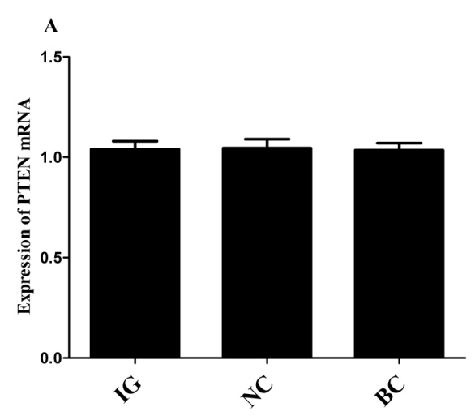

a

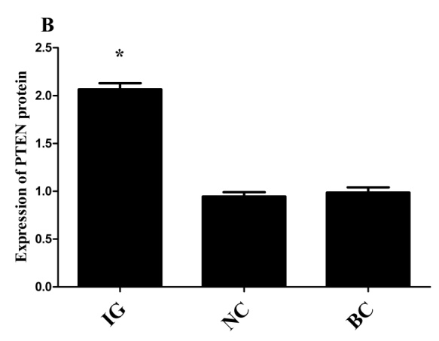

**Figure 5 The expression of the miR-21 inhibitor on PTEN mRNA (A) and protein (B) expression in HCT116 cells (a*P* < 0.05, *n* = 3).**

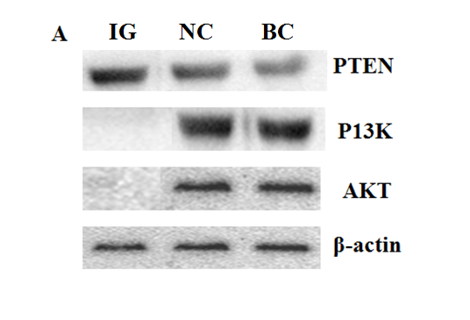

a

a

a

a

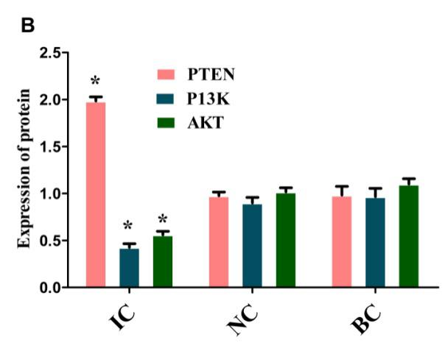

**Figure 6 The protein expression of PTEN/AKT/PI3K in colorectal cancerHCT116 cell lines**. A: Western blot assay; B: protein expression in HCT116 cell lines (a*P* < 0.05, *n* = 3).