**Name of Journal:** *World Journal of Clinical Cases*

**Manuscript NO:** 85606

**Manuscript Type:** CASE REPORT

**Nasopharyngeal carcinoma with synchronous breast metastasis: A case report**

Lei YY *et al.* Concurrent nasopharyngeal carcinoma with breast metastasis

Ye-Yan Lei, Dong-Mei Li

**Ye-Yan Lei, Dong-Mei Li,** Department of Surgery, Guangdong Chinese Medicine Hospital Zhuhai Branch, Zhuhai 519015, Guangdong Province, China

**Author contributions:** Lei YY and Li DM designed the research study; Lei YY performed the research; Lei YY wrote the manuscript; All authors have read and approve the final manuscript.

**Supported by** The High-level Health Team Project introduced in Zhuhai (Second batch).

**Corresponding author: Dong-Mei Li, MM, Chief Physician,** Department of Surgery, Guangdong Chinese Medicine Hospital Zhuhai Branch, No. 53 Jingle Road, Zhuhai 519015, Guangdong Province, China. 896184582@qq.com

**Received:** May 19, 2023

**Revised:** June 10, 2023

**Accepted:** July 21, 2023

**Published online:** August 16, 2023

**Abstract**

BACKGROUND

Recent reports have described cases of metachronous breast metastasis in patients with nasopharyngeal carcinoma. However, no similar cases of synchronous breast metastasis have been reported, and evidence that can be used to support the clinical diagnosis of stage IV nasopharyngeal carcinoma in patients with concurrent breast metastasis remains lacking. Therefore, additional evidence is required to elucidate the clinical characteristics of this condition and aid in the development of optimal management strategies.

CASE SUMMARY

We report the case of a 46-year-old woman who visited our hospital with a right breast mass as the first symptom. The first pathological biopsy report suggested triple-negative breast invasive carcinoma. Subsequent imaging revealed a nasopharyngeal mass. Further puncture biopsy of the nasopharyngeal mass, molecular pathological Epstein–Barr virus *in situ* hybridization, and immunohistochemistry confirmed the diagnosis of nasopharyngeal carcinoma with breast metastasis. The patient did not undergo a mastectomy and achieved complete remission after chemotherapy and radiotherapy. She continued to receive oral chemotherapy as maintenance therapy and experienced no recurrence or metastasis during the 6-month follow-up period.

CONCLUSION

This case report suggests that breast specialists should carefully rule out secondary breast cancers when diagnosing and treating breast masses. Furthermore, clinicians should aim to identify the pathological type of the tumor to obtain the most accurate diagnosis and prevent excessive diagnosis and treatment.

**Key Words:** Nasopharyngeal carcinoma; Concurrent breast metastasis; Chemoradiotherapy; Cancer; Pathology; Case report

**©The** **Author(s) 2023.** Published by Baishideng Publishing Group Inc. All rights reserved.

**Citation:** Lei YY, Li DM. Nasopharyngeal carcinoma with synchronous breast metastasis: A case report. *World J Clin Cases* 2023; 11(23): 5573-5579

**URL:** <https://www.wjgnet.com/2307-8960/full/v11/i23/5573.htm>

**DOI:** https://dx.doi.org/10.12998/wjcc.v11.i23.5573

**Core Tip:** The most common sites of distant metastasis in patients with nasopharyngeal carcinoma (NPC) are the bones, lungs, liver, and distant lymph nodes; metastasis to the breast is rare. To date, only a few cases of NPC metastasis to the breast have been reported in the literature, and all occurred secondary to the diagnosis and treatment of NPC. Here, we present the clinical characteristics, treatment strategies, and follow-up information for a patient with newly diagnosed stage IV NPC who developed synchronous breast metastasis. Furthermore, we conducted a literature review to provide evidence for comprehensive management of this condition.

**INTRODUCTION**

Nasopharyngeal carcinoma (NPC) is a type of head and neck cancer with a distinct geographical distribution, representing a significant public health problem in Eastern and Southeast Asia[1]. In 2013, there were approximately 42100 new cases of nasopharyngeal cancer and 21320 related deaths in China, accounting for 1.14% of all new cancer cases and 0.96% of all tumor-related deaths in that year[2]. Advancements in screening and treatment strategies have resulted in a gradual decline in the incidence and mortality of these diseases in recent decades[3,4]. However, approximately 30% of patients with NPC continue to experience a poor prognosis, mostly due to distant metastasis[5].

Distant metastasis is among the leading causes of death in patients with NPC, including both synchronous distant metastases identified at diagnosis and metachronous distant metastases identified after systematic therapy[5,6]. The most common sites of distant metastasis of NPC are the bone, lungs, liver, and distant lymph nodes, while metastasis to the breast is rare[7]. To date, only a few cases reports have described metastasis of NPC to the breast[8-10], all of which occurred secondary to the diagnosis and treatment of NPC.

In this report, we discuss a newly diagnosed case of stage IV NPC with synchronous breast metastasis in terms of clinical characteristics, treatment strategies, and follow-up. Furthermore, we summarize the findings from a review of the relevant literature to provide evidence that can aid in the comprehensive management of this condition.

**CASE PRESENTATION**

***Chief complaints***

A 46-year-old female patient visited Sun Yat-sen University Affiliated Cancer Hospital because of advanced NPC with synchronous breast metastasis.

***History of present illness***

On 28 September 2020, the patient visited the Guangdong Chinese Medicine Hospital Zhuhai Branch because of a breast mass.

***History of past illness***

Breast ultrasonography revealed a solid mass (57 × 25 × 51 mm) in the right breast with a breast imaging reporting and data system score of 4C (suspicious of breast cancer)[11,12] and an enlarged and abnormal structure in the right axillary lymph node. A core needle biopsy (CNB) was performed for the right breast lesions (Figure 1) and right axillary lymph nodes. Subsequent pathological examination revealed that the tissue within the right breast mass was consistent with invasive breast carcinoma. Immunohistochemical results were as follows: ER (-), PR (-), HER-2 (-), Ki67 (approximately 60% +), CK (+), GATA3 (-), P63 (partial +), Calponin (deletion of myoepithelium), CD68 (-), E-cad (+), P120 (cell membrane +), and CK7 (-). Metastatic cancer was detected in the biopsy sample of the right axillary lymph node tissue. Immunohistochemical results were as follows: GATA3 (scattered/weak +) and S-100 (scattered +). Given these findings, right invasive breast cancer with right axillary lymph node metastasis was considered.

Since the breast tumor was accompanied by lymph node metastasis, a detailed general examination was subsequently performed. Subsequent magnetic resonance imaging (MRI) of the head revealed thickening of the nasopharyngeal lateral wall and a shallow pharyngeal recess on the right side (Figure 2). Breast MRI (Figure 1) and breast ultrasound (Figure 3) revealed suspicious bilateral masses. Based on the MRI results, nasopharyngeal endoscopy plus biopsy (Figure 4), *in situ* hybridization Epstein–Barr virus (EBV) examination of the breast tumor specimen obtained *via* CNB, and whole-body positron emission tomography/computerized tomography (PET-CT) were performed. Nasopharyngeal endoscopic biopsy of tissues obtained from the top of the right nasopharynx revealed undifferentiated non-keratinizing carcinoma (Figure 4) and a positive *in situ* hybridization result for EBV in some cells of the breast and lymph node tissue, while immunohistochemical examination for Ki67 indicated 80% positivity. Whole-body PET-CT revealed thickening of the right nasopharyngeal wall.

Based on these findings, stage IV NPC with bilateral breast and axillary metastases was the primary diagnosis. The investigators recommended chemotherapy and follow-up radiotherapy. However, the patient visited Guangzhou for further diagnosis and treatment after being discharged for personal reasons.

***Personal and family history***

The patient had no history of infectious diseases, family history of breast cancer, or history of other malignancies.

***Physical examination***

Physical examination revealed that the patient’s right supraclavicular lymph node was swollen, with a hard mass (approximately 1.0 × 1.0 cm in size, clear boundaries, and poor activity). There was no palpable mass in the left breast or axillary area. Furthermore, there were no palpable masses in the neck lymph nodes, and general physical examination revealed no obvious abnormalities.

***Imaging examinations***

The breast mass, bilateral axillary lymph nodes, and right cervical lymph nodes were re-biopsied. The pathological findings were consistent with those of nasopharyngeal undifferentiated non-keratinizing cancer metastasis to the breast. In addition, *in situ* hybridization of EBV was positive in all examined tissues.

**FINAL DIAGNOSIS**

The breast mass, bilateral axillary lymph nodes, and right cervical lymph nodes were re-biopsied. The pathological findings were consistent with those of nasopharyngeal undifferentiated non-keratinizing cancer metastasis to the breast. In addition, *in situ* hybridization of EBV was positive in all examined tissues.

**TREATMENT**

The patient received six cycles of paclitaxel plus carboplatin chemotherapy (albumin-paclitaxel, 200 mg, Day1 and Day7+; carboplatin, 40 mg, Day1-Day3) from 26 October 2020 to 10 February 2021. The chemotherapy dose was determined based on the patient’s skin area. Tomo-direct radiotherapy was initiated on 26 March 2021, with a planned radiotherapy dose of PGTVnx69 Gy/30 F and PGTVnd63 Gy/30 F in the neck and face areas, respectively. The planned number of radiotherapy sessions was 30. However, only 26 radiotherapy sessions were completed at the patient’s discretion.

After completing six cycles of chemotherapy and radiotherapy, the patient underwent CNB for both breast nodules. MRI (Figures 2C) and nasopharyngeal endoscopy (Figure 4C and D) performed after treatment revealed complete remission of the tumor in the nasopharynx. In addition, breast MRI (Figure 2C and D) and ultrasound (Figure 3C and D) performed after six cycles of chemotherapy revealed remission of the breast lesions. No cancer was found on pathological examination, and complete remission had been achieved. As the patient had advanced NPC, oral maintenance therapy was continued with capecitabine at 1000 mg bid. Each cycle included a two-week treatment, followed by a one week off treatment.

**OUTCOME AND FOLLOW-UP**

Follow-ups were scheduled every 3 mo. During the follow-up visit, in addition to the physical examination, ultrasound examinations of the breast and axillary areas, bilateral supraclavicle, uterus, and abdomen were performed. Furthermore, chest computed tomography and nasopharyngeal MRI scans were reviewed every 6 mo. A systemic examination in December 2021 revealed no recurrence or metastasis.

**DISCUSSION**

Malignant tumors rarely metastasize to the breast, with a reported incidence of merely 0.5%–2.0% worldwide[13-15]. These tumors include malignant lymphoma; malignant melanoma; and lung, gastric, prostate, and ovarian cancers[15-17]. In recent years, cases of NPC metastases to the breast have been occasionally reported[8-10,15,18,19]. However, these reports described cases of metachronous breast metastases that developed after the diagnosis and treatment of NPC. Given this rare incidence, no systematic clinical studies have been conducted to date.

In the present case, the patient had a breast mass as the first sign, and CNB examination revealed invasive breast carcinoma and axillary lymph node metastasis. Primary NPC was detected by MRI and PET-CT, and repeated biopsies with immunohistochemical and EBV tests confirmed that the breast tumors were secondary to the NPC, thereby avoiding overtreatment. In the present case, lymphatic metastasis and obstruction may have been caused by lymphatic reflux to the breast[20].

The present case differs from metachronous breast metastases reported previously[8-10]. Based on our experience, patients with locally advanced tumors should first undergo a systematic examination, including craniocerebral CT/MR, to ensure better understanding of the patient’s condition and prevent omissions. Second, it is essential to clarify the specific pathological type of breast cancer. When the pathological type is unclear or results suggest triple-negative breast cancer, attention should be paid to the possibility of secondary breast metastasis.

No studies have definitively indicated that patients with breast metastases from NPC can benefit from modified radical mastectomy for breast cancer. Therefore, in the present case, systemic treatment of the metastatic tumors and radical radiotherapy for the primary NPC were performed. Efficacy evaluation at the six-month follow-up revealed complete remission. However, the short follow-up time represents a limitation of the present report. While regular reviews and follow-ups are being undertaken to monitor changes in the patient’s condition, further evidence is required to determine the optimal management strategies for this condition.

**CONCLUSION**

This case report suggests that breast specialists should carefully rule out secondary breast cancer during diagnosis and treatment. Furthermore, for patients with malignant tumors, the pathological type of the tumor should be identified to obtain the most accurate diagnosis and prevent excessive diagnosis and treatment.

**REFERENCES**

1 **Chen YP**, Chan ATC, Le QT, Blanchard P, Sun Y, Ma J. Nasopharyngeal carcinoma. *Lancet* 2019; **394**: 64-80 [PMID: 31178151 DOI: 10.1016/S0140-6736(19)30956-0][](https://sci-hub.wf/10.1016/S0140-6736(19)30956-0)

2 **Wei KR**, Zheng RS, Zhang SW, Liang ZH, Li ZM, Chen WQ. Nasopharyngeal carcinoma incidence and mortality in China, 2013. *Chin J Cancer* 2017; **36**: 90 [PMID: 29122009 DOI: 10.1186/s40880-017-0257-9]

3 **Xu HF,** Chen Q, Liu Y, Liu SZ, Guo LW, Zheng LY, Kang RH, Zhang SK. Incidence and mortality of nasopharyngeal carcinoma in Henan Province in 2016. *Zhongguo Aizheng Fangzhi Zazhi* 2021; **13**: 262-266 [DOI: 10.3969/j.issn.1674-5671.2021.03.07]

4 **Carioli G**, Negri E, Kawakita D, Garavello W, La Vecchia C, Malvezzi M. Global trends in nasopharyngeal cancer mortality since 1970 and predictions for 2020: Focus on low-risk areas. *Int J Cancer* 2017; **140**: 2256-2264 [PMID: 28224615 DOI: 10.1002/ijc.30660]

5 **Li AC**, Xiao WW, Shen GZ, Wang L, Xu AA, Cao YQ, Huang SM, Lin CG, Han F, Deng XW, Zhao C. Distant metastasis risk and patterns of nasopharyngeal carcinoma in the era of IMRT: long-term results and benefits of chemotherapy. *Oncotarget* 2015; **6**: 24511-24521 [PMID: 26087194 DOI: 10.18632/oncotarget.4312]

6 **Liao W**, Tian M, Chen N. Characteristic And Novel Therapeutic Strategies Of Nasopharyngeal Carcinoma With Synchronous Metastasis. *Cancer Manag Res* 2019; **11**: 8431-8442 [PMID: 31571998 DOI: 10.2147/CMAR.S219994]

7 **Ahmad A**, Stefani S. Distant metastases of nasopharyngeal carcinoma: a study of 256 male patients. *J Surg Oncol* 1986; **33**: 194-197 [PMID: 3773537 DOI: 10.1002/jso.2930330310]

8 **Zhao JH**, Pan Y, Gao B, Li YK, Wang M. Bilateral breast metastasis from nasopharyngeal carcinoma. *Breast J* 2020; **26**: 1045-1046 [PMID: 31788911 DOI: 10.1111/tbj.13700]

9 **Albasri AM**. Nasopharyngeal carcinoma metastasis to the breast. *Saudi Med J* 2020; **41**: 1130-1134 [PMID: 33026055 DOI: 10.15537/smj.2020.10.25420]

10 **Sham JS**, Choy D. Breast metastasis from nasopharyngeal carcinoma. *Eur J Surg Oncol* 1991; **17**: 91-93 [PMID: 1995364]

11 **Liberman L,** Menell JH. Breast imaging reporting and data system (BI-RADS). *Radiol Clin North Am* 2002; **40**: 409-430 [DOI: 10.1016/S0033-8389(01)00017-3]

12 **Magny SJ,** Shikhman R, Keppke AL. Breast Imaging Reporting and Data System. Treasure Island (FL): StatPearls Publishing. 2023 [PMID: 29083600]

13 **Vergier B**, Trojani M, de Mascarel I, Coindre JM, Le Treut A. Metastases to the breast: differential diagnosis from primary breast carcinoma. *J Surg Oncol* 1991; **48**: 112-116 [PMID: 1921396 DOI: 10.1002/jso.2930480208]

14 **Bitencourt AGV**, Gama RRM, Graziano L, Negrão EMS, Sabino SMPS, Watanabe AHU, Guatelli CS, Souza JA, Mauad EC, Marques EF. Breast metastases from extramammary malignancies: multimodality imaging aspects. *Br J Radiol* 2017; **90**: 20170197 [PMID: 28485985 DOI: 10.1259/bjr.20170197]

15 **Klingen TA**, Klaasen H, Aas H, Chen Y, Akslen LA. Secondary breast cancer: a 5-year population-based study with review of the literature. *APMIS* 2009; **117**: 762-767 [PMID: 19775345 DOI: 10.1111/j.1600-0463.2009.02529.x]

16 **Jones GE**, Strauss DC, Forshaw MJ, Deere H, Mahedeva U, Mason RC. Breast cancer metastasis to the stomach may mimic primary gastric cancer: report of two cases and review of literature. *World J Surg Oncol* 2007; **5**: 75 [PMID: 17620117 DOI: 10.1186/1477-7819-5-75]

17 **Yuan JL,** Jiang K. Ovarian cancer breast metastasis: A case report. *Dalian Yike Daxue Xuebao* 2019; **41**: 472-475

18 **Pai T**, Nair N, Pantvaidya G, Deodhar K, Shet T. Metastatic nasopharyngeal carcinoma presenting as an isolated breast mass: A diagnostic pitfall and a review of literature. *Indian J Pathol Microbiol* 2017; **60**: 119-121 [PMID: 28195109 DOI: 10.4103/0377-4929.200058]

19 **Driss M**, Abid L, Mrad K, Dhouib R, Charfi L, Bouzaein A, Ben Romdhane K. Breast metastases from undifferentiated nasopharyngeal carcinoma. *Pathologica* 2007; **99**: 428-430 [PMID: 18416334]

20 **Pavlista D**, Eliska O. Analysis of direct oil contrast lymphography of upper limb lymphatics traversing the axilla -- a lesson from the past -- contribution to the concept of axillary reverse mapping. *Eur J Surg Oncol* 2012; **38**: 390-394 [PMID: 22336143 DOI: 10.1016/j.ejso.2012.01.010]

**Footnotes**

**Informed consent statement:** Written informed consent was obtained from the patient for the publication of clinical details and/or clinical images. A copy of the consent form is available for review by the journal’s editor.

**Conflict-of-interest statement:** Dr. Li reports grants from The High-level Health Team Project introduced in Zhuhai (Second batch) during the conduct of the study.

**CARE Checklist (2016) statement:** The authors have read the CARE Checklist (2016), and the manuscript was prepared and revised according to the CARE Checklist (2016).

**Open-Access:** This article is an open-access article that was selected by an in-house editor and fully peer-reviewed by external reviewers. It is distributed in accordance with the Creative Commons Attribution NonCommercial (CC BY-NC 4.0) license, which permits others to distribute, remix, adapt, build upon this work non-commercially, and license their derivative works on different terms, provided the original work is properly cited and the use is non-commercial. See: https://creativecommons.org/Licenses/by-nc/4.0/

**Provenance and peer review:** Unsolicited article; Externally peer reviewed.

**Peer-review model:** Single blind

**Peer-review started:** May 19, 2023

**First decision:** June 1, 2023

**Article in press:** July 21, 2023

**Specialty type:** Medicine, research and experimental

**Country/Territory of origin:** China

**Peer-review report’s scientific quality classification**

Grade A (Excellent): 0

Grade B (Very good): 0

Grade C (Good): C, C

Grade D (Fair): 0

Grade E (Poor): 0

**P-Reviewer:** Simmons DG, Australia; Stenina-Adognravi O, United States **S-Editor:** Lin C **L-Editor:** A **P-Editor:** Cai YX

**Figure Legends**

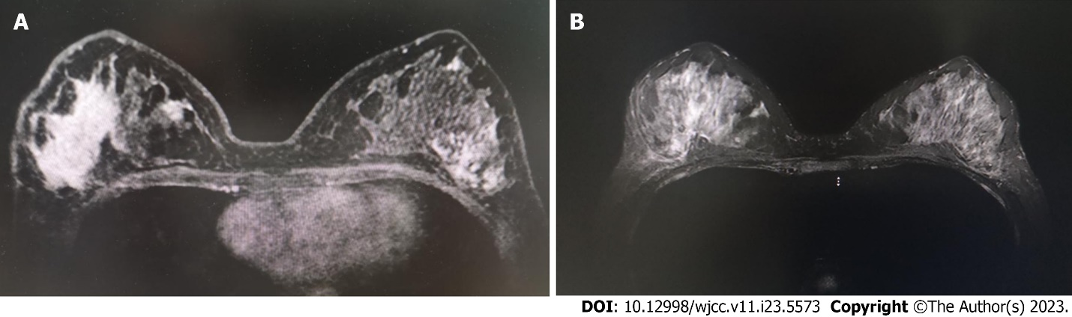

**Figure 1 Nasopharyngeal magnetic resonance imaging.** A and B: Images of the nasopharynx at admission. The right wall of the nasopharynx appeared thickened, and nasopharyngeal carcinoma was considered.

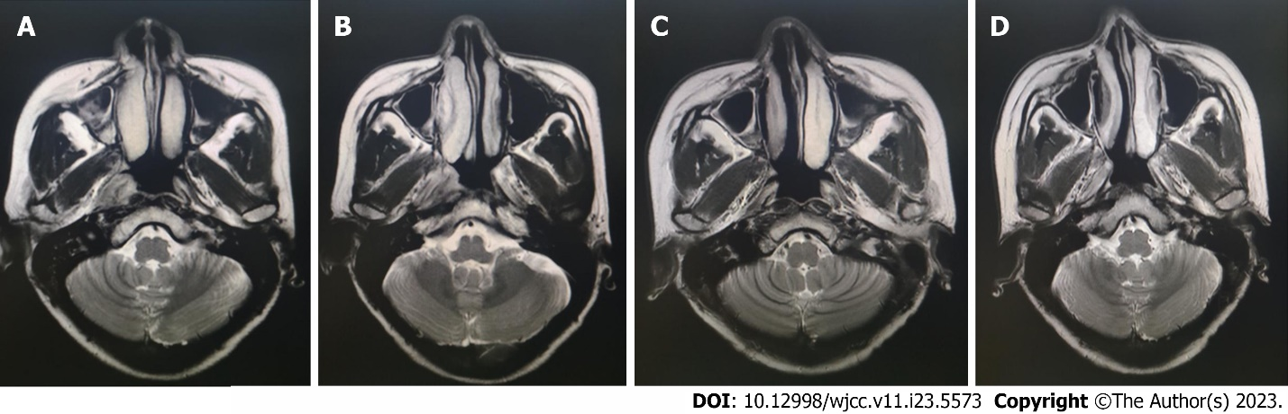

**Figure 2** **Breast magnetic resonance imaging.** A and B: Images of the breasts at admission. The masses in the upper quadrant of the right breast and outer quadrant of the left breast were obviously enhanced, and the time-signal intensity curve was continuously rising; C and D: Images of the breasts after six cycles of chemotherapy showing mild-to-moderate, uneven enhancement of the right breast. However, no enhancement was observed in the left breast, and the time-signal intensity curve for both breasts was type I.

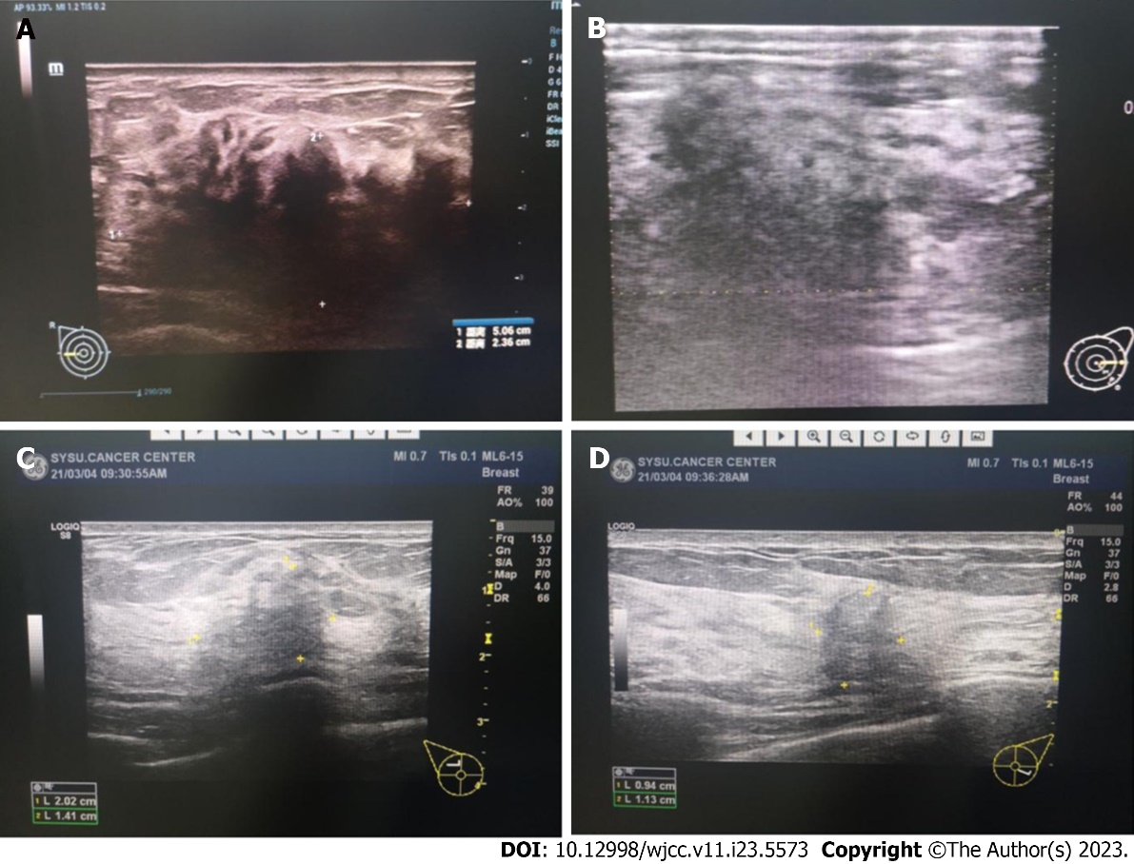

**Figure 3 Breast color Doppler ultrasound images.** A and B: Images of the breasts at admission showing irregular masses on both sides, with incomplete margins, angulation, and burrs; C and D: Images of the breasts after six cycles of chemotherapy showing that the masses had significantly decreased in size, with uneven internal echo and no point-like strong echo.

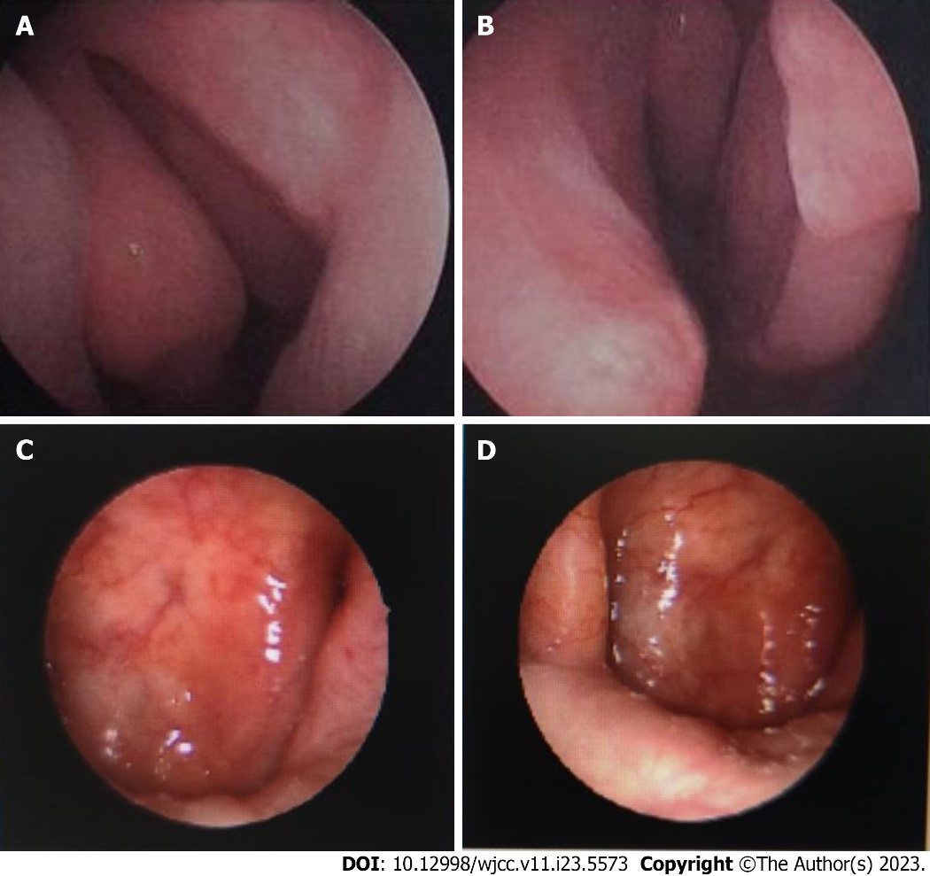

**Figure 4 Images obtained *via* nasopharyngeal endoscopy.** A and B: Images at admission indicated that the right nasopharyngeal mucosa appeared rough and bulging, and the pharyngeal recesses were shallow; C and D: Images obtained after six cycles of chemotherapy revealed that the nasopharyngeal walls were smooth, without an obvious tumor.



Published by **Baishideng Publishing Group Inc**

7041 Koll Center Parkway, Suite 160, Pleasanton, CA 94566, USA

**Telephone:** +1-925-3991568

**E-mail:** bpgoffice@wjgnet.com

**Help Desk:** https://www.f6publishing.com/helpdesk

https://www.wjgnet.com



**© 2023 Baishideng Publishing Group Inc. All rights reserved.**