**Name of Journal: *World Journal of Radiology***

**Manuscript NO: 50100**

**Manuscript Type: CASE REPORT**



**Chest pain without a clue—ultrasound to rescue occult multiple myeloma: A case report**

Chawla G *et al*. Ultrasound to diagnose occult multiple myeloma

**Gopal Chawla, Naveen Dutt,** **Kunal Deokar,** **Virender Kumar Meena**

**Gopal Chawla, Naveen Dutt, Kunal Deokar,** Pulmonary, Critical Care and Sleep Medicine, All India Institute of Medical Sciences, Jodhpur 342008, Rajasthan, India

**Virender Kumar Meena,** Department of Radiodiagnosis, Geetanjali Medical College and Hospital, Udaipur 342005, India

**ORCID number:**Gopal Chawla (0000-0002-8735-9774); Naveen Dutt (0000-0002-9517-4999); Kunal Deokar (0000-0003-2603-1633); Virender Kumar Meena (0000-0002-1824-3671).

**Author contributions:** All authors conceived the idea; Chawla G, Deokar K, Meena VK collected the data; Chawla G, and Dutt N performed the literature search; Chawla G, and Deokar K wrote the manuscript; Deokar K, Dutt N, Meena VK critically reviewed the manuscript.

**Informed consent statement:** Informed consent was obtained from the patient.

**Conflict-of-interest statement:** The authors state they have no conflicts of interest.

**CARE Checklist (2016) statement:** Guidelines of the CARE checklist (2016) have been adopted.

**Open-Access:** This article is an open-access article which was selected by an in-house editor and fully peer-reviewed by external reviewers. It distributed in accordance with the Creative Commons Attribution Non Commercial (CC BY-NC 4.0) license, which permits others to distribute, remix, adapt, build upon this work non-commercially, and license their derivative works on different terms, provided the original work is properly cited and the use is non-commercial. See: http://creativecommons.org/licenses/by-nc/4.0/

**Manuscript source:** Unsolicited manuscript

**Corresponding author: Gopal Chawla, DNB, FCCP, MBBS, MD, Academic Fellow, DM Fellow,** Pulmonary, Critical Care and Sleep Medicine, All India Institute of Medical Sciences, Jodhpur 342005, Rajasthan, India. dr.gopalchawla@gmail.com

**Telephone:** +91-7982283553

**Received:** July 3, 2019

**Peer-review started:** July 16, 2019

**First decision:** September 21, 2019

**Revised:** October 11, 2019

**Accepted:** November 7, 2019

**Article in press:** November 7, 2019

**Published online:** December 28, 2019

**Abstract**

***BACKGROUND***

Chest pain is one of the most common symptoms with which a patient presents to a doctor. Differentials include, but are not limited to, cardiac pulmonary, gastrointestinal, psychosomatic and musculoskeletal causes. In our case, ultrasound of the chest wall paved the way for the diagnosis of multiple myeloma, which occultly presented with chronic chest pain.

***CASE SUMMARY***

Here we report a case of 50-year-old man with chronic chest pain without anemia or renal failure who was diagnosed with multiple myeloma, despite negative bence jones protein and M band electrophoresis. An ultrasound of the chest wall showed cortical irregularities along with a hypoechoic mass in the sternum and left 5th rib, which helped us in clinching the diagnosis.

***CONCLUSION***

Ultrasound of bone can often aid in reaching a diagnosis indirectly if not directly.

**Key words:** Case report; Ultrasound; Multiple myeloma; Chest pain

**© The Author(s) 2019.** Published by Baishideng Publishing Group Inc. All rights reserved.

**Core tip:** Multiple myeloma is notorious for presenting in atypical ways, and one should have a high index of suspicion for the same. Ultrasounds of bone can often aid in reaching a diagnosis indirectly if not directly.



**Citation**: Chawla G, Dutt N, Deokar K, Meena VK. Chest pain without a clue—ultrasound to rescue occult multiple myeloma: A case report. *World J Radiol* 2019; 11(12): 0000-0000

URL: https://www.wjgnet.com/1949-8470/full/v11/i12/0000.htm

DOI: https://dx.doi.org/10.4329/wjr.v11.i12.0000

**INTRODUCTION**

Chest pain is one of the most common symptoms with which a patient presents to a doctor. Etiology is wide, and ranges from acute and life-threatening diseases like acute coronary syndrome and pulmonary embolism to conditions with favorable prognosis like myalgia and costochondritis[1]. It is important to know the relevant etiologies and their respective frequencies.

Bone pain is one of the most common presentations of multiple myeloma (70%-80%), and 90% of cases will present with lumbar spine or rib pain. Plain films are only 80%-90% sensitive at detecting lytic bone lesions, due to an inability to detect lesions with less than 30%-50% trabecular bone loss. By the time this degree of sternal/rib bone loss occurs, patients are at high risk for fracture, which can result in serious complications such as flail chest and acute hypoxic respiratory failure[2].

Since early treatment with chemotherapy and zoledronic acid reduces vertebral fractures and skeletal events, multiple myeloma is an important disease to keep on a differential for persistent atypical chest pain, especially when anemia and renal injury is present.

**CASE PRESENTATION**

***Chief complaints***

A 50-year-old banker presented with complaints of chest pain for 2 mo.

***History of present illness***

Chest pain was parasternal, non-radiating and continuous in nature. There was no history of trauma, cough, breathlessness, loss of weight, loss of appetite or fever.

***History of past illness***

There was no major medical or surgical illness in the past.

***Physical examination***

Results of chest examination were within normal limits, apart from left parasternal tenderness.

***Laboratory examinations***

The patient had normal hemogram, and erythrocyte sedimentation rate was 35 mm in the first hour. He was worked up for metabolic causes of chest pain, his vitamin D level was within normal limits, and serum calcium was 10.42 mg/dL. Urine examination showed trace proteins. Urine for Bence jones proteins and blood electrophoresis were found to be negative for multiple myeloma.

***Imaging examinations***

The chest X-ray was within normal limits. The electrocardiograph, 2D echocardiography and treadmill test were also within normal limits. The patient even underwent coronary angiography due to the troublesome nature of his chest pain, which was also normal. Upper gastrointestinal endoscopy was done to rule out reflux disease and gastroesophageal ulcers, which was once again normal. The patient was referred to psychiatry, and underwent cognitive behavior therapy, however this too was of no avail. He was also being worked up for musculoskeletal causes and was started on non-steroidal anti-inflammatory drugs suspecting costochondritis, but he remained uncomfortable (Table 1).

To rule out sternal and rib lesions, he was screened with an ultrasound of the chest wall, which showed cortical irregularities along with a hypoechoic mass in the sternum and left 5th rib (Figure 1). Considering the cortical irregularities, differential of bone neoplasms, metastasis and multiple myeloma were kept in consideration. He underwent magnetic resonance imaging (MRI) of the spine, which showed multiple well-defined T1/T2 hypointense lesions of varying sizes in the dorso lumber vertebra at multiple levels, including the body of the sternum and posterior aspect of the left 4th rib. A whole body positron emission tomogram (PET scan) was done to rule out any primary, which showed multiple fluorodeoxyglucose avid lesions in the axial and appendicular skeleton (Figure 2). To confirm the diagnosis, bone marrow aspiration and biopsy were performed, which showed increased immature and mature plasma cells. Marrow was slightly hypercellular for age and showed all hematopoietic components. There was a marked interstitial prominence of plasma cells along with a definitive presence of sheets of plasma cells.

This is a very rare case where chest pain was the only initial symptom of multiple myeloma, and shows how screening ultrasonography helped in leading us to the diagnosis. There is no evidence reported in the literature of any such case where multiple myeloma was diagnosed using ultrasonography.

**FINAL DIAGNOSIS**

Multiple myeloma.

**TREATMENT**

He was started on bortezomib, leflunomide and dexamethasone.

**OUTCOME AND FOLLOW-UP**

After a mere two cycles of chemotherapy, he showed drastic improvement in painwherein his Visual Analogue Score dropped from 7/10 to 2/10.

**DISCUSSION**

Chronic chest pain has been broadly classified as cardiogenic and non-cardiogenic chest pain (NCP). The etiology of NCP can be pulmonary, gastrointestinal, musculoskeletal or psychosomatic. At times it becomes very difficult to search the etiology of chest pain[3,4].

Multiple myeloma is a clonal condition of B cells that involves uncontrolled proliferation of abnormal plasma cells. Clinical features can either be directly due to proliferation or indirectly due to substances released by these cells. It results in suppression of erythropoiesis along with multiple osteolytic lesions, which results in hypercalcemia, skeletal pain and pathological fractures. It also causes the accumulation of monoclonal immunoglobulins (Igs) along with other regulating substances. These circulating monoclonal Igs or their subunits are the reason behind proteinuria, renal tubular damage and amyloid deposition[5].

They have varied presentation, 10%-40% are asymptomatic and 50%-70% have bone pain due to lytic lesions and pathological fractures. About 1%-5% cases may not demonstrate Igs or their subunits in serum or urine (non-secretory multiple myeloma)[6].

This is a unique case where initial work-up, consisting of a complete hemogram, serum calcium, erythrocyte sedimentation rate, chest radiology, urine bence jones proteins and serum electrophoresis, was normal. This misguided us to search for other causes of chest pain. However, during later ultrasound screening for a musculoskeletal cause, we came across multiple cortical irregularities over the ribs that helped us in clinching the diagnosis.

Ultrasound of bone has not been frequently used in the past. It has been used as a diagnostic tool in the evaluation of costochondral cartilage deformities in children of the anterior chest wall mass where there was negative radiography[7], and has been used in bone tumors like chondrosarcoma and fractures where a painful area shows fragmented cortical bone and at times subperiosteal hematoma[8].

The chest wall is known to get involved either by direct extension of a tumor mass, metastases or hematologic malignancy like multiple myeloma. In this region, metastases are mainly from breast, thyroid, kidney, lung and prostate cancer along with plasma cell myeloma. The vast majority of such tumors are osteolytic. Ultrasound detection of osseous defects is possible only after the damage of the anterior compact substance[9].

Paik *et al*[10] has shown ultrasonography to be better than conventional radiography (39%) for the diagnosis of such tumors. These were characterized by cortical defects or an irregular cortical edge or a mass invading local soft tissues, including pleura in some cases.Lee *et al*[11] compared a group of patients with rib metastases from renal cancer and prostate cancer metastases, and they showed that the irregular surface of the costal cortex in the absence of fracture or the presence of masses within the soft tissue represented the only sonographic feature of osteoblastic foci of prostate cancer.

While for multiple myeloma it has never been used in the literature, we found cortical irregularities along with focal bone destruction (Figure 1), which was later confirmed with MRI by the presence of multiple osteolytic lesions. PET computed tomography ruled out any contribution from the kidney, thyroid or lung and also helped in assessing disease burden and the identification of extramedullary involvement. Bone marrow biopsy sealed the diagnosis. Apart from atypical presentation and an unconventional way of diagnosing, our case was unique as the patient had normal hemoglobin, absent bence jones proteins and a negative M band on electrophoresis, *i.e*. the patient was having non-secretory multiple myeloma, which is even difficult to diagnose.

**CONCLUSION**

Multiple myeloma is notorious to present in atypical ways, and therefore one should have a high index of suspicion for the same. Ultrasound of bone can often help in reaching the diagnosis indirectly if not directly. As a non-invasive, bedside and easily available investigation, it is truly a patient-friendly approach to finding clues in difficult cases.

**ACKNOWLEDGEMENTS**

I would like to thank Dr. Govind Patel from Clinical Hematology for his valuable inputs and Dr. Nupur Abrol for Pain and Palliative care.

**REFERENCES**

1 **Hurst JW**, Morris DC. Chest pain. Armonk, NY, United States: Futura Pub, 2001

2 **Dimopoulos M**, Terpos E, Comenzo RL, Tosi P, Beksac M, Sezer O, Siegel D, Lokhorst H, Kumar S, Rajkumar SV, Niesvizky R, Moulopoulos LA, Durie BG; IMWG. International myeloma working group consensus statement and guidelines regarding the current role of imaging techniques in the diagnosis and monitoring of multiple Myeloma. *Leukemia* 2009; **23**: 1545-1556 [PMID: 19421229 DOI: 10.1038/leu.2009.89]

3 **Campbell KA**, Madva EN, Villegas AC, Beale EE, Beach SR, Wasfy JH, Albanese AM, Huffman JC. Non-cardiac Chest Pain: A Review for the Consultation-Liaison Psychiatrist. *Psychosomatics* 2017; **58**: 252-265 [PMID: 28196622 DOI: 10.1016/j.psym.2016.12.003]

4 **Fass R**, Achem SR. Noncardiac chest pain: epidemiology, natural course and pathogenesis. *J Neurogastroenterol Motil* 2011; **17**: 110-123 [PMID: 21602987 DOI: 10.5056/jnm.2011.17.2.110]

5 **Dash NR**, Mohanty B. Multiple myeloma: a case of atypical presentation on protein electrophoresis. *Indian J Clin Biochem* 2012; **27**: 100-102 [PMID: 23277721 DOI: 10.1007/s12291-011-0178-3]

6 **Middela S**, Kanse P. Nonsecretory multiple myeloma. *Indian J Orthop* 2009; **43**: 408-411 [PMID: 19838394 DOI: 10.4103/0019-5413.55979]

7 **Supakul N**, Karmazyn B. Ultrasound evaluation of costochondral abnormalities in children presenting with anterior chest wall mass. *AJR Am J Roentgenol* 2013; **201**: W336-W341 [PMID: 23883250 DOI: 10.2214/AJR.12.9792]

8 **Zarqane H**, Viala P, Dallaudière B, Vernhet H, Cyteval C, Larbi A. Tumors of the rib. *Diagn Interv Imaging* 2013; **94**: 1095-1108 [PMID: 24007770 DOI: 10.1016/j.diii.2013.05.006]

9 **Smereczyński A**, Kołaczyk K, Bernatowicz E. Chest wall - a structure underestimated in ultrasonography. Part III: Neoplastic lesions. *J Ultrason* 2017; **17**: 281-288 [PMID: 29375904 DOI: 10.15557/JoU.2017.0041]

10 **Paik SH**, Chung MJ, Park JS, Goo JM, Im JG. High-resolution sonography of the rib: can fracture and metastasis be differentiated? *AJR Am J Roentgenol* 2005; **184**: 969-974 [PMID: 15728626 DOI: 10.2214/ajr.184.3.01840969]

11 **Lee KS**, De Smet AA, Liu G, Staab MJ. High resolution ultrasound features of prostatic rib metastasis: a prospective feasibility study with implication in the high-risk prostate cancer patient. *Urol Oncol* 2014; **32**: 24.e7-24.11 [PMID: 23481369 DOI: 10.1016/j.urolonc.2012.08.014]

**P-Reviewer:** Armellini E, Iovino P, Li CH **S-Editor:** Yan JP

**L-Editor:** Filipodia **E-Editor:** Li X

**Specialty type:** Radiology, nuclear medicine and medical imaging  
**Country of origin:** India   
**Peer-review report classification**  
**Grade A (Excellent):** 0  
**Grade B (Very good):** 0  
**Grade C (Good):** C, C, C  
**Grade D (Fair):** 0 **Grade E (Poor):** 0

**Table 1 Timeline**

|  |  |  |  |  |
| --- | --- | --- | --- | --- |
| **Presentation, day 0-2 mo** | **3rd month** | **4th month** | **4th month** | **5th month** |
| Worked up for various causes of chest pain | Tread mill test, coronary angiography, upper gastrointestinal endoscopy | Metabolic causes ruled out | Ultrasonography chest, clue to Bone lesion | Magnetic resonance imaging, positron emission technology, bone marrow biopsy |

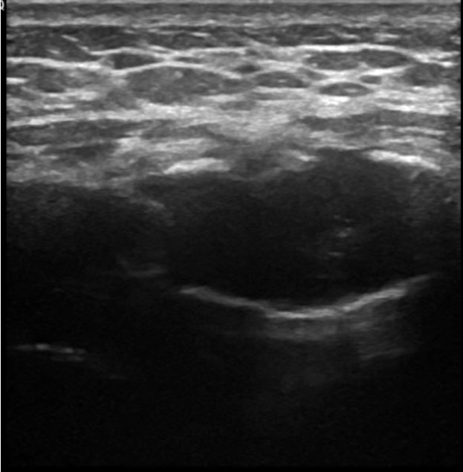



**Figure 1 Ultrasound of sternum showing cortical irregularities (arrow) with central hypoechoic area (arrow head).**



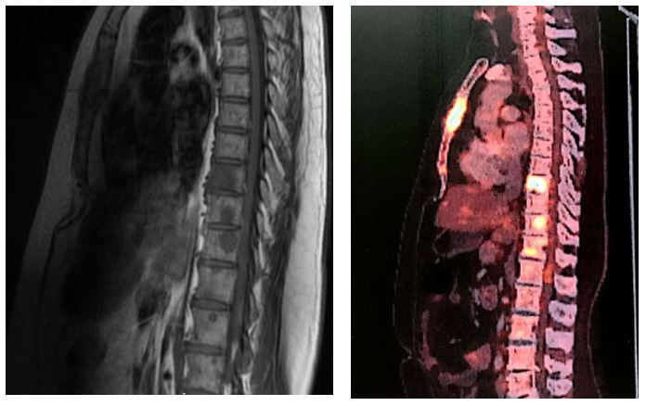

A B

**Figure 2 Magnetic resonance imaging and positron emission technology scan.** A: Magnetic resonance imaging showing multiple osteolytic lesions (arrows); B: Positron emission technology scan showing multiple osteolytic lesions with high fluorodeoxyglucose avidity (arrows).