**Language certificate**

**Name of Journal:** World Journal of Gastroenterology

**ESPS Manuscript NO:** 35716

**Title:** Characteristics of Fecal Microbial Communities in Patients with Non-anastomotic Biliary Strictures after Liver Transplantation

**Authors List:** Jing Zhang, Fenggang Ren, Peng Liu, Hongke Zhang, Haoyang Zhu, Zhe Feng, Xufeng Zhang, Xueming Liu , **Rongqian Wu**, Yi Lv

**Correspondence to:** Yi Lv, MD, PhD, Doctor, Department of Hepatobiliary Surgery, the First Affiliated Hospital of Xi’an Jiaotong University, 277 West Yanta Road, Xi’an, China, Xi’an 710061, Shan Xi Province, China. [luyi169@126.com](mailto:luyi169@126.com).

This is to certify that RONG-QIAN WU has worked through the manuscript “Characteristics of Fecal Microbial Communities in Patients with Non-anastomotic Biliary Strictures after Liver Transplantation” with language amendment, as well as the data presentation and organization.

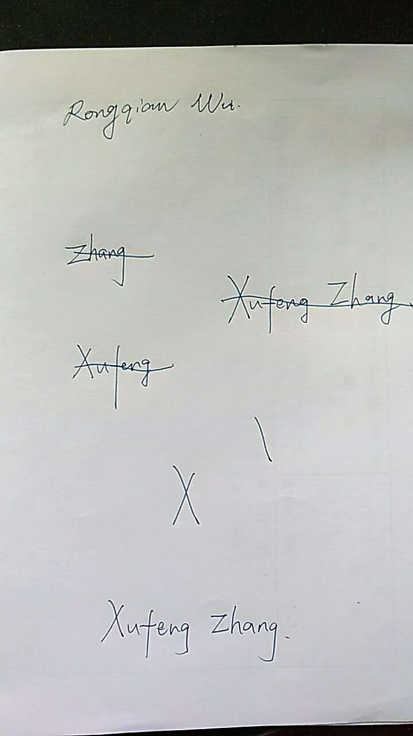

Thanks very much,

Yours sincerely,

Yi Lv, MD, PhD, Doctor

Xi’an Jiaotong University,

Xi’an, Shaanxi Province, China

