**Name of journal: World Journal of Gastroenterology**

**ESPS Manuscript NO: 12206**

**Columns: META-ANALYSIS**

**Sorafenib for the peri-operative treatment of liver transplantation: A time-to-event meta-analysis**

Qi HL *et al.* Treatment with sorafenib in liver transplantation

Hao-Long Qi, Bing-Jie Zhuang, Chang-Sheng Li, Quan-Yan Liu

**Hao-Long Qi, Bing-Jie Zhuang, Chang-Sheng Li, Quan-Yan Liu,**Department of General Surgery, Research Center of Digestive Diseases, Zhongnan Hospital, Wuhan University, Wuhan 430071, Hubei Province, China

**Author contributions:** Qi HL and Zhuang BJ performed the information retrieval and screened the potential subjects, the data were extracted and integrated by the two authors independently at the same time; Liu QY and Li CS designed the study and wrote the manuscript.

**Supported by** National Natural Science Foundation of China NO.81172349 and NO.30872491

**Correspondence to: Quan-Yan Liu, Professor**, Department of General Surgery, Research Center of Digestive Diseases, Zhongnan Hospital, Wuhan University, 299 Ba Yi Road, Wuhan 430071, Hubei Province, China. 1459195529@qq.com

**Telephone:** +86-27-67812588 **Fax:** +86-27-87336735

**Received:** June 27, 2014 **Revised:** August 9, 2014

**Accepted:** September 18, 2014

**Published online:**

**Abstract**

**AIM:** To evaluate whether the application of sorafenib during the peri-operational period of liver transplantation could improve liver cancer patients’ prognosis.

**METHODS:** We searched PubMed, EMBASE and MEDLINE for eligible literature. A total of 4 studies were found that fulfilled the previously agreed-upon standards.We then performed a systematic review and meta-analysis on the enrolled trials that met the inclusion criteria.

**RESULTS:** Out of the 104 studies identified in the database, 82 were not clinical experiments, and 18 did not fit the inclusion standards. Among the remaining 4 articles, only 1 was related to the preoperative use of sorafenib, whereas the other 3 related to its postoperative use. As the heterogeneity among the 4 papers was high, with an *I*2 of 86%, a randomized effect model was applied to perform the integration. The application of sorafenib before liver transplantation had an HR of 3.29 with a 95%CI of 0.33-32.56. The use of sorafenib after liver transplantation had an HR of 1.44, with a 95%CI: 0.27-7.71. The HR integrated pre- and post-transplantation was 1.68, with a 95%CI: 0.41-6.91.

**CONCLUSION:** The results showed that the use of sorafenib during the peri-operational period of liver transplantation did not improve patient survival significantly. In fact, sorafenib could even lead to a worse prognosis, as its use may increase the HR of patients who have ever taken it.

© 2014 Baishideng Publishing Group Inc. All rights reserved.

**Key words****:** Liver transplantation; Sorafenib; Peri-operational period; Kaplan-Meier curve; Hazard ratio

**Core tip:** The data were extracted from the K-M curves of every study identified and then input into an HR calculations spreadsheet. The HRs generated from the sheet were integrated with the help of RevMan5.0. Generally speaking, this is the first meta-analysis concerning the use of sorafenib in the peri-operative period of liver transplantation.

Qi HL, Zhuang BJ, Li CS, Liu QY. Sorafenib for the peri-operative treatment of liver transplantation: A time-to-event meta-analysis. *World J Gastroenterol* 2014; In press

**INTRODUCTION**

Liver cancer is the sixth most common cancer in the world and represents the third most common cause of cancer-related death[1]. Surgical resection and liver transplantation have been considered the most potentially curative treatments up to now. Especially for patients with a solitary lesion of < 5 cm or three nodules < 3 cm that are not suitable for resection [III, A], liver transplantation is the ultimate best choice. Still, sufficient improvements in 5-year disease-free and overall survival rates for patients receiving transplantations have not been obtained, as the post-transplantation reoccurrence rate of carcinoma is as high as 66.7%[2]. As a result, there is an urgent need for an effective method to decrease the post-transplantation recurrence rate.

Sorafenib is a type of multi-kinase inhibitor that is able to block the Raf/mitogen-activated protein kinase extracellular signal-regulated kinase (MEK)/extracellular signal-regulated kinase (ERK) pathway[3]. Due to this pathway’s involvement in tumorigenesis, including liver cancer, sorafenib could be used to restrain the proliferation and survival of tumor cells. Consequently, sorafenib has been introduced for the treatment of liver cancer.

Up to now, there have been several clinical experiments focusing on the peri-operational utility of sorafenib concerning liver transplantation, rating its validity as an adjuvant therapy for cancer patients. However, a sufficiently large sample undergoing multi-center experiments to provide an overall evaluation of sorafenib in the peri-operational period of liver transplantation is still lacking. The present meta-analysis was intended to integrate all of the relevant literature to assess the curative effect of sorafenib as an adjuvant therapy.

**MATERIALS AND METHODS**

***Literature search***

Articles were identified by an electronic search on PubMed, EMBASE, and MEDLINE using the keywords “liver transplantation” and "sorafenib", and the personal bibliographies of two of the authors were also included. The bibliographies reported in any of the studies identified were used for further trial identification.

The articles are limited to published trials with at least an abstract given in English. No contact was made with the authors to obtain unpublished data.

***Selection of trials***

A total of 104 articles was obtained, spanning November 2008 to September 2013.

Before determining the targets, several standards were decided. The potential literature to be included had to fulfill the following criteria: (1) the experiment was carried out on humans who were going to or had received a liver transplantation; (2) sorafenib was compared with a placebo or other non-sorafenib treatment during the peri-operative period of liver transplantation; (3) randomized controlled trails were the first choice, followed by cohort and then case-control studies; (4) all of the studies had to have a common end point, which was defined as the time of patient death or the last time of follow up; and (5) all potentially included studies should provide survival curves or HRs with corresponding confidence intervals of 95%.

Out of the 104 studies identified, none were randomized controlled trials; 82 were not clinical experiments; and 18 did not fulfill the inclusion standards. Among the remaining 4 articles, only 1 was related to the preoperative use of sorafenib, whereas the other 3 were related to its postoperative use. As a result, only 4 retrospective cohort trials[5-8] were included in this meta-analysis.

***Data extraction***

Except for one study, the remaining three articles did not directly provide the HRs and corresponding confidence intervals, although the survival curves were available. Using widely proven, accepted scientific methods[9,10].The data were extracted from the survival curves with Engauge 4.0. Then, the data were input into the HR calculations spreadsheet, which was created by Dr. Jayne F Tierney[4]. Using the methodology stated above, the HRs, SEs and their corresponding confidence intervals were estimated from the curves. The detailed process is shown in Figures 2 and 3.

***Statistical analysis***

The HRs and their SEs were analyzed as a whole with the software Review Manager 5.0, and statistical heterogeneity was defined as *P* < 0.10 or *I*2 > 50%. As the potential heterogeneity was determined using the standard above, a randomized effect model was used to measure the outcomes.

**RESULTS**

As was shown in the forest figure, the HRs, as extracted from the Kaplan-Meier curves using the formula recommended by Mahesh K. B. Parmar, Jayne F Tierney and their colleagues, were transformed to In (HR) to make the data fulfill a normal distribution.

Among the four studies identified, one was related to sorafenib use before liver transplantation, whereas the other three articles investigated the use of sorafenib after liver transplantation.

The present integrated analysis showed that the use of sorafenib during liver transplantation did not significantly improve the overall survival. Based on the chart, the use of sorafenib before liver transplantation had an HR of 3.29 with a 95%CI: 0.33-32.56, and the therapy used after liver transplantation had an HR of 1.44, with a 95%CI: 0.27-7.71. The HR of an integrated pre- and post-transplantation usage was 1.68, with a 95%CI: 0.41-6.91. Based on the funnel plot, publication bias might have been detected.

**DISICUSSION**

To the best of our knowledge, this is the first meta-analysis to examine the use of sorafenib. As a targeted drug, it was first used to treat renal cell carcinoma. Then, it only took a few years before sorafenib was first applied as a novel adjuvant treatment for hepatocellular carcinoma, especially for patients requiring liver transplantation[11].

Although, theoretically, sorafenib has anti-tumor potentiality, at present, the outcomes of multi-center cohort or case-control trials indicate that sorafenib does not have any apparent effect on improving overall patient survival. Moreover, sorafenib therapy may lead to a poor prognosis, as it can increase the HR of all patients who have ever taken it.

Considerable side effects have been observed among patients receiving sorafenib[12]. Based on the published literature[13], higher grade toxicities were reported in 25%–30% (Yoon *et al* 4/13 patients, Pfiffer *et al* 2/8patients) of patients under sorafenib/calcineurin inhibitor (CNI) combination therapy and in 55% (Kim *et al* 5/9 patients) in another series using sorafenib in combination with mTORi.

From the authors’ perspective, the following reasons may account for the present discouraging conclusions. Sorafenib, as a newly developed targeted drug, has been used for too a short time for true analysis, and its popularization and application have been constricted due to its prices, which are too high for patients. Furthermore, liver transplantation, as the final treatment for liver cancer, is not available for all cancer patients. As a result, the number of participants that could have been included in the experiments is small, and we here may have underestimated the potential of sorafenib.

In conclusion, sorafenib should not be recommended for patients suffering from liver cancer or those waiting for or having received liver transplantation.

Unfortunately, only 4 eligible articles were included in the manuscript; sorafenib has not yet been applied in the liver transplantation for very long. Because of the limited data, we could only consider the overall survival rates and the estimated HRs in our analysis, making the results of this manuscript not very persuasive. However, the present study represents the first effort in this new area, and our work could provide some suggestive advice.

More cohort trials and, optimally, RCTs are needed to verify our conclusions. Research on sorafenib and any other targeted drug should be encouraged, as such drugs may have as-yet-underestimated anti-tumor abilities.

**COMMENTS**

***Background***

Liver cancer is the sixth most common cancer in the world, and liver transplantation is the ultimate best option. However, there is a low overall survival rate for patients after receiving transplantations, as the post-transplantation reoccurrence rate of carcinoma can be as high as 66.7%. As a multi-kinase inhibitor, sorafenib has the potential to take part in the treatment of liver cancer.

***Research frontiers***

Sorafenib is a multi-kinase inhibitor that has the potential to restrain the proliferation and survival of tumor cells. This research hotpot investigates whether sorafenib can improve the prognosis of patients who are going to receive or already have received liver transplantation due to liver cancer.

***Innovations and breakthroughs***

The data were extracted from the survival curves using Engauge 4.0 software. Next, the data were input into the HR calculations spreadsheet to generate the HRs, SEs and confidential intervals. This approach represents the first effort in this new area of research, and our data may provide some useful advice.

***Applications***

Our research has indicated that sorafenib does not have any apparent effect on overall patient survival. Moreover, sorafenib therapy might lead to a worse prognosis.

***Terminology***

Sorafenib: a multi-kinase inhibitor that can block the Raf/mitogen-activated protein kinase-extracellular signal-regulated kinase/extracellular signal-regulated kinase pathway.

***Peer review***

The concept and methodology used is appropriate and interesting. This is a very important issue because in the literature recently some researchers have wondered whether sorafenib can improve patient survival during the perioperational period of liver transplantation. Thus, this meta-analysis provides us with a clear answer.

**REFERENCES**

1 **Verslype C**, Rosmorduc O, Rougier P. Hepatocellular carcinoma: ESMO-ESDO Clinical Practice Guidelines for diagnosis, treatment and follow-up. *Ann Oncol* 2012; **23** Suppl 7: vii41-vii48 [PMID: 22997453 DOI: 10.1093/annonc/mds225]

2 **Jia N**, Liou I, Halldorson J, Carithers R, Perkins J, Reyes J, Yeh M, Stohr E, Rao S, Lin EH. Phase I adjuvant trial of sorafenib in patients with hepatocellular carcinoma after orthotopic liver transplantation. *Anticancer Res* 2013; **33**: 2797-2800 [PMID: 23749944]

3 **Staufer K**, Fischer L, Seegers B, Vettorazzi E, Nashan B, Sterneck M. High toxicity of sorafenib for recurrent hepatocellular carcinoma after liver transplantation. *Transpl Int* 2012; **25**: 1158-1164 [PMID: 22882364 DOI: 10.1111/j.1432-2277.2012.01540.x]

4 **Tierney JF**, Stewart LA, Ghersi D, Burdett S, Sydes MR. Practical methods for incorporating summary time-to-event data into meta-analysis. *Trials* 2007; **8**: 16 [PMID: 17555582 DOI: 10.1186/1745-6215-8-16]

5 **Waghray A**, Balci B, El-Gazzaz G, Kim R, Pelley R, Narayanan Menon KV, Estfan B, Romero-Marrero C, Aucejo F. Safety and efficacy of sorafenib for the treatment of recurrent hepatocellular carcinoma after liver transplantation. *Clin Transplant* 2013; **27**: 555-561 [PMID: 23758296 DOI: 10.1111/ctr.12150]

6 **Sposito C**, Mariani L, Germini A, Flores Reyes M, Bongini M, Grossi G, Bhoori S, Mazzaferro V. Comparative efficacy of sorafenib versus best supportive care in recurrent hepatocellular carcinoma after liver transplantation: a case-control study. *J Hepatol* 2013; **59**: 59-66 [PMID: 23500153 DOI: 10.1016/j.jhep.2013.02.026]

7 **Tan WF**, Qiu ZQ, Yu Y, Ran RZ, Yi B, Lau WY, Liu C, Qiu YH, Feng FL, Wang JH, Yan PN, Zhang BH, Wu MC, Luo XJ, Jiang XQ. Sorafenib extends the survival time of patients with multiple recurrences of hepatocellular carcinoma after liver transplantation. *Acta Pharmacol Sin* 2010; **31**: 1643-1648 [PMID: 21102481 DOI: 10.1038/aps.2010.124]

8 **Frenette CT**, Boktour M, Burroughs SG, Kaseb A, Aloia TA, Galati J, Gaber AO, Monsour H, Ghobrial RM. Pre-transplant utilization of sorafenib is not associated with increased complications after liver transplantation. *Transpl Int* 2013; **26**: 734-739 [PMID: 23701126 DOI: 10.1111/tri.12117]

9 **de Oliveira IR**, Santos-Jesus R, Po AL, Poolsup N. Extracting numerical data from published reports of pharmacokinetics investigations: method description and validation. *Fundam Clin Pharmacol* 2003; **17**: 471-472 [PMID: 12914550 DOI: 10.1046/j.1472-8206.2003.00180.x]

10 **Parmar MK**, Torri V, Stewart L. Extracting summary statistics to perform meta-analyses of the published literature for survival endpoints. *Stat Med* 1998; **17**: 2815-2834 [PMID: 9921604]

11 **Weinmann A**, Niederle IM, Koch S, Hoppe-Lotichius M, Heise M, Düber C, Schuchmann M, Otto G, Galle PR, Wörns MA. Sorafenib for recurrence of hepatocellular carcinoma after liver transplantation. *Dig Liver Dis* 2012; **44**: 432-437 [PMID: 22265328 DOI: 10.1016/j.dld.2011.12.009]

12 **Zavaglia C**, Airoldi A, Mancuso A, Vangeli M, Viganò R, Cordone G, Gentiluomo M, Belli LS. Adverse events affect sorafenib efficacy in patients with recurrent hepatocellular carcinoma after liver transplantation: experience at a single center and review of the literature. *Eur J Gastroenterol Hepatol* 2013; **25**: 180-186 [PMID: 23044808 DOI: 10.1097/MEG.0b013e328359e550]

13 **Yoon DH**, Ryoo BY, Ryu MH, Lee SG, Hwang S, Suh DJ, Lee HC, Kim TW, Ahn CS, Kim KH, Moon DB, Kang YK. Sorafenib for recurrent hepatocellular carcinoma after liver transplantation. *Jpn J Clin Oncol* 2010; **40**: 768-773 [PMID: 20494947 DOI: 10.1093/jjco/hyq055]

**P-Reviewer:** **Fisher RA, Ramsay M, Yan LN S-Editor:**Qi Y

**L-Editor: E-Editor:**

**Figure1 Study flow.**

Excluded as not clinical experiments (*n*=82)

Potentially relevant studies identified and screened for retrieval based on search strategy (*n*=104)

Studies not meeting  
inclusion criteria(*n*=18)

Abstract review(*n*=22)

Studies suitable for meta-analysis or  
systematic review (*n*= 4)

**Figure2 This is an example of how to extract the data from the K-M curves.**

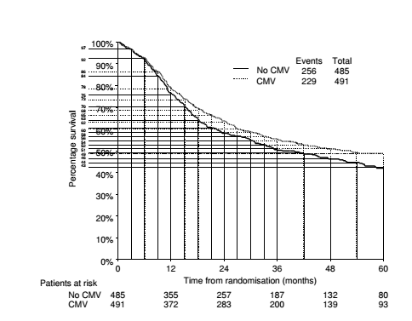

**Figure 3 Example depicts the process by which the data extracted from the K-M curves were input into the HR calculations spreadsheet, step by step.**

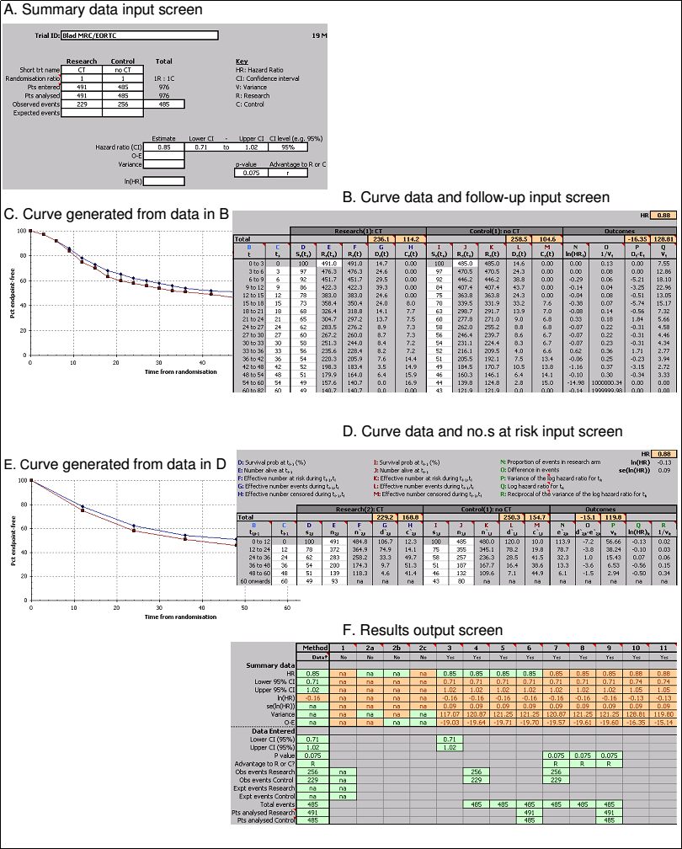

**Figure 4 Meta-analysis of the cohort trials comparing the effects of sorafenib in improving survival time during liver transplantation.**



**Figure 5 Funnel plot of the included studies.**

