**Name of journal: *World Journal of Gastroenterology***

**Manuscript NO: 40284**

**Manuscript type:** **ORIGINAL ARTICLE**

# *Basic Study*

# Sex-specific effects of *Eugenia punicifolia* extract on gastric ulcer healing in rats

Périco LL *et al.* Rat model of gastric ulcer

**Larissa Lucena Périco, Vinícius Peixoto Rodrigues, Rie Ohara, Gabriela Bueno, Vânia Vasti Alfieri Nunes, Raquel de Cássia dos Santos, Ana Carolina Lima Camargo, Luis Antônio Justulin Júnior, Sérgio Faloni de Andrade, Viviane Miranda Bispo Steimbach, Luísa Mota da Silva,Lúcia Regina Machado da Rocha, Wagner Vilegas, Catarina dos Santos, Clélia Akiko Hiruma-Lima**

**Larissa Lucena Périco, Vinícius Peixoto Rodrigues, Rie Ohara, Gabriela Bueno, Vânia Vasti Alfieri Nunes, Lúcia Regina Machado da Rocha, Clélia Akiko Hiruma-Lima,** Department of Physiology, Institute of Biosciences, São Paulo State University (UNESP), São Paulo 18618-970, Brazil

**Raquel de Cássia dos Santos,** Laboratory of Bioactive Compounds, São Francisco University, São Paulo 12916-900, Brazil

**Ana Carolina Lima Camargo,** **Luis Antônio Justulin Júnior,** Department of Morphology, Institute of Biosciences, São Paulo State University (UNESP), São Paulo 18618-970, Brazil

**Sérgio Faloni de Andrade, Viviane Miranda Bispo Steimbach, Luísa Mota da Silva,**Center for Chemical-Pharmaceutical Research, Center for Health Sciences, University of Vale do Itajaí, Santa Catarina 88302-202, Brazil

**Wagner Vilegas,**Coastal Campus of São Vicente, São Paulo State University (UNESP), São Paulo 11330-900 São, Brazil

**Catarina dos Santos,**Department of Biological Science, Faculty of Sciences and Languages, São Paulo State University (UNESP), São Paulo 19806-900, Brazil

**ORCID number:** Larissa Lucena Périco (0000-0002-0888-9911); Vinícius Peixoto Rodrigues (0000-0002-9312-2431); Rie Ohara (0000-0003-4430-0016); Gabriela Bueno (0000-0003-0502-3415); Vânia Vasti Alfieri Nunes (0000-0001-7354-471X);Raquel de Cássia dos Santos (0000-0002-3195-8188);Ana Carolina Lima Camargo (0000-0003-4993-2573); Luis Antônio Justulin Júnior (0000-0001-6142-3515); Sérgio Faloni de Andrade (0000-0001-9294-7290); Viviane Miranda Bispo Steimbach (0000-0002-2248-2464); Luísa Mota da Silva (0000-0001-5329-7301);Lúcia Regina Machado da Rocha (0000-0002-7911-3862); Wagner Vilegas (0000-0003-3032-2556); Catarina dos Santos (000-0002-9881-527X); Clélia Akiko Hiruma-Lima (0000-0002-8645-377).

**Author contributions:** Périco LL, Rodrigues VP, Ohara R, Bueno G, dos Santos RC, Camargo ACL, Justulin LA Jr, de Andrade SF, Steimbach VMB, da Silva LM performed most of the experiments; Nunes VVA and dos Santos C prepared the extract of *Eugenia punicifolia*; Périco LL, dos Santos RC, da Rocha LRM, Vilegas W and Hiruma-Lima CA, contributed to the conception, design and coordinated the study; Périco LL, Rodrigues VP, Ohara R, da Rocha LRM and Hiruma-Lima CA participated in writing the manuscript; all authors approved the final version of the article to be published.

**Supported by** the São Paulo Research Foundation (FAPESP), No. 2015/14797-3 to Périco LL and No. 2009/52237-9 to Laboratory of Biological Assays with Natural Products.

**Institutional animal care and use committee statement:** All the experimental practices related to animal care and use agreed with the protocols approved by the Ethics Committee on the Use of Animals of the Institute of Biosciences, UNESP, Botucatu, São Paulo, Brazil (No. 675-CEUA).

**Conflict-of-interest statement:** The authors declare that they have no commercial, personal, political, intellectual, or religious interests related to the work presented herein.

**Data sharing statement:** All data are available from the corresponding author upon reasonable request.

**ARRIVE guidelines statement:** The ARRIVE Guidelines have been adopted.

**Open-Access:** This article is an open-access article which was selected by an in-house editor and fully peer-reviewed by external reviewers. It is distributed in accordance with the Creative Commons Attribution Non Commercial (CC BY-NC 4.0) license, which permits others to distribute, remix, adapt, build upon this work non-commercially, and license their derivative works on different terms, provided the original work is properly cited and the use is non-commercial. See: http://creativecommons.org/licenses/by-nc/4.0/

**Manuscript source:** Unsolicited manuscript

**Correspondence to:** **Clélia Akiko Hiruma-Lima, PhD, Postdoc,** Department of Physiology, Institute of Biosciences, Botucatu, São Paulo 18618-970, Brazil. hiruma@ibb.unesp.br

**Telephone:** +55-14-38800312

**Fax:** +55-14-3815-3744

**Received:** June 13, 2018

**Peer-review started:** June 13, 2018

**First decision:** July 6, 2018

**Revised:** July 11, 2018

**Accepted:** August 1, 2018

**Article in press:**

**Published online:**

Abstract

***AIM***

To evaluate the sex-specific effects of a hydroalcoholic extract from *Eugenia punicifolia* (HEEP) leaves on gastric ulcer healing.

***METHODS***

In this rat study involving males, intact (cycling) females, and ovariectomized females, gastric ulcers were induced using acetic acid. A vehicle, lansoprazole, or HEEP was administered for 14 d after ulcer induction. Body weight was monitored throughout the treatment period. At the end of treatment, the rats were euthanized and the following *in vivo* and *in vitro* investigations were performed: macroscopic examination of lesion area and organ weights, biochemical analysis, zymography, and evaluation of protein expression levels. Additionally, the concentration-dependent effect of HEEP was evaluated in terms of subacute toxicity and cytotoxicity.

***RESULTS***

Compared to the vehicle, HEEP demonstrated a great healing capacity by substantially reducing the ulcerative lesion area in males (52.44%), intact females (85.22%), and ovariectomized females (65.47%), confirming that HEEP accelerates the healing of acetic acid-induced gastric lesions and suggesting that this effect is modulated by female sex hormones. The antiulcer effect of HEEP was mediated by prostaglandin E2 only in male rats. Overall, the beneficial effect of HEEP was the highest in intact females. Notably, HEEP promoted the expression of vascular endothelial growth factor (intact *vs* ovariectomized females) and decreased the expression of Caspase-8 and Bcl-2 (intact female *vs* male or ovariectomized female). Additionally, HEEP enhanced fibroblast proliferation and migration into a wounded area *in vitro*, confirming its healing effect. Finally, no sign of subacute toxicity or cytotoxicity of HEEP was observed.

***CONCLUSION***

In gastric ulcer, HEEP-induced healing (modulated by female sex hormones; in males, mediated by prostaglandin) involves extracellular matrix remodeling, with gastric mucosa cell proliferation and migration.

**Key words:** *Eugenia punicifolia*; Gastric ulcer healing; Acetic acid; Sex difference; Myrtaceae; Toxicity

**© The Author(s) 2018.** Published by Baishideng Publishing Group Inc. All rights reserved.

Core tip**:** Gastric ulcer, which occurs due to an imbalance between protective and aggressive agents at the gastric mucosa surface, is a chronic disease with high rates of relapse, which affects millions worldwide. The conventional treatment for gastric ulcer is associated with several side effects and poor healing of the gastric mucosa. *Eugenia punicifolia* is a medicinal plant used to treat inflammation and wounds. The present study in rats with gastric ulcer confirms the healing effect of *Eugenia punicifolia* extract and clarifies its differential effect in males and females. These findings are useful for developing novel and safe therapies for gastric ulcer.

# Périco LL, Rodrigues VP, Ohara R, Bueno G, Nunes VVA, dos Santos RC, Camargo ACL, Justulin LA Jr, de Andrade SF, Steimbach VMB, da Silva LM, da Rocha LRM, Vilegas W, dos Santos C, Hiruma-Lima CA.Sex-specific effects of *Eugenia punicifolia* extract on gastric ulcer healing in rats. *World J Gastroenterol* 2018; In press

INTRODUCTION

Gastric ulcer, which results from an imbalance between the protective and aggressive agents at the surface of the gastric mucosa, is a chronic disease with high relapse rates, which affects millions around the world[1,2]. Alcohol consumption, prolonged treatment with non-steroidal anti-inflammatory drugs (NSAIDs), stress, and *Helicobacter pylori* (*H. pylori*) infection favor such an imbalance and represent key etiological factors of gastric ulcer[3]. Current treatment strategies for gastric ulcer involve the use of anti-secretory drugs, including antagonists of histamine receptor type 2 (*e.g.*, ranitidine) and proton pump inhibitors [*e.g.*, lansoprazole (LZ)], as well as antibiotics for the eradication of *H. pylori*. While such treatments are effective, prolonged use of anti-secretory drugs, especially ranitidine and proton pump inhibitors, is associated with several side effects[4] and poor healing of the gastric mucosa[5].

In 1991, Tarnawski *et al*[6] proposed the concept of quality of ulcer healing (QOUH), which takes into consideration the fact that tissue regeneration within the ulcer scar is often incomplete. Within the QOUH concept, the evaluation of gastric ulcer healing is focused on whether the structure and function of the mucosal and submucosal tissue have recovered completely, in addition to endoscopic examination and evaluation of ulcer size. It has been shown that ulcer recurrence is closely related to the QOUH[7].

Ulcers frequently recur following treatment with anti-secretory drugs[7,8]. Therefore, alternative therapies for gastric ulcer are desirable[9]. Herbal combination preparations are popular among traditional herbal medicine practitioners. The rationale behind such combinations is frequently questioned, and it remains challenging to assess the individual contribution of each component to the overall activity of the herbal combination preparation. This holds especially true when the preparation is used in the treatment of a chronic multifactorial disease such as gastric ulcer[10].

*Eugenia punicifolia* (Kunth) DC (Myrtaceae), popularly known as pedra-ume-caá, pedra-ume, murta, or muta, is a shrub found mainly in the Savanna biome and in the Amazon region. The leaves of *E. punicifolia* are popularly used as a natural remedy for inflammation[11], wounds, infections[12], diabetes[13], fever, and flu[14,15]. While the gastroprotective activity of the hydroalcoholic extract of *E. punicifolia* (Kunth) DC leaves (HEEP) against ethanol- or NSAID-induced ulcer in rodents has been reported[16], it remains unclear whether HEEP has any beneficial effect in the healing of installed gastric ulcers, once the gastroprotective activities of a extract do not ensure their gastric healing effects in installed gastric ulcers[17]. Therefore, the present study aimed to evaluate the sex-specific effects of HEEP in the healing of gastric ulcers in rat model. For this purpose, we employed a rat model of acetic acid-induced gastric ulcer, and analyzed the curative action of HEEP in males, intact females, and ovariectomized females.

MATERIALS AND METHODS

*Chemicals and reagents*

# The following chemicals and reagents were used: acetic acid, methanol (Dinamica Contemporary Chemicals™, Diadema, São Paulo, Brazil), LZ (Cruz Vermelha Pharmacy of Manipulation, Botucatu, São Paulo, Brazil), RIPA buffer, protease inhibitor cocktail, Ethylenediaminetetraacetic acid (EDTA), *N*,*N*,*N*′,*N*′-Tetramethylethylenediamine (TEMED), ammonium persulfate (APS), sodium chloride, 400 g/L acrylamide/bis-acrylamide solution, Triton X-100, Tris-HCl, calcium chloride, zinc chloride, coomassie brilliant blue, tris base, glycine, sodium dodecyl sulfate (SDS), glycerol, Tween 20, β-mercaptoethanol, bromophenol blue, Ponceau (Sigma Chemical Co., St. Louis, MO, United States) gelatin (Merck KGaA, Darmstadt, Germany). Saline solution (9 g/L NaCl) was used to dilute the hydroalcoholic extract from the leaves of *E. punicifolia*. The same saline solution used as a vehicle served as a negative control.

## 

## *Plant material*

In December 2009, Dr. Catarina dos Santos collected the leaves of *E. punicifolia* from a site in Assis State Forest (latitude, 22º33' to 22º37' S; longitude, 50º21' to 50º24' W) located near one of the experimental stations of the Forestry Institute, Assis, state of São Paulo, Brazil. Dr. Antônio CG Melo identified the species and a voucher (No. 43322) was deposited in the Herbarium D Bento Pickel, available at the Forestry Institute in Assis, São Paulo, Brazil.

## 

## *Preparation of the plant extract*

The dried and crushed leaves (10 g of plant material) were dissolved in 100 mL of solvent consisting of a 70:30 mix of ethanol and water (v/v). Dynamic maceration of the solution was performed for 2 h at room temperature (25 ºC ± 2 ºC). Thereafter, the solution was filtered, and the residue was extracted twice more. The solution was dried using a rotary evaporator (40 °C). The extract yield was 45% (4.49 g) of the original plant material.

## 

## *Animals*

The animal protocol was designed to minimize pain or discomfort to the animals. The *in vivo* experiments used male (280 g) and female (220 g) Wistar albino rats obtained from the breeding facility of the State University of Campinas (Multidisciplinary Center for Biological Research). The HEEP dose (125 mg/kg) for the *in vivo* experiments was determined based on a dose-response curve previously obtained in a gastric injury induction test[16]. Male and female rats were kept in separate rooms, allocated in 5 animals per cage, fed with Presence® (Paulínia, SP, Brazil) rodents diet, and allowed free access to filtered water. The animals were kept in cages with raised, wide-mesh floors to prevent coprophagy. The cages were kept under controlled conditions of illumination (12 h/12 h light/dark cycle) and temperature (22 ºC ± 2 ºC).

The estrous cycle was verified through a vaginal smear performed daily starting on postnatal day 60. The material was observed under an optical microscope, and the estrous cycle phase was determined by cytology[18-20]. The duration of the estrous cycle was calculated as the number of days between one estrus phase and the next. Only female rats that showed two consecutive regular cycles of 4-5 d were included in the experiment. Additionally, ovariectomized (OVZ) females were included. We performed bilateral ovariectomy in female ten-week-old rats and after 2 wk we verified the absence of estrous cycle through a vaginal smear. The experiments were performed in males, intact OVZ female rats with 90 d old.

The 84 animals included in the study (30 males, 30 intact females, 24 ovariectomized females) were divided into nine groups with 7-10 individuals each. Group allocation was performed according to sex (male *vs* female), hormonal status in females (intact *vs* OVZ), and treatment (negative control *vs* positive control *vs* HEEP). All subsequent analyses (except for the cell viability and migration assays) were performed in each of the nine groups. The nine groups were compared to assess the sex-specific effects of HEEP *vs* vehicle and *vs* LZ.

## 

## *Establishing the rat model of acetic acid-induced gastric ulcer*

After being fasted for 16 h, the animals were anesthetized with a solution of ketamine (80 mg/kg) and xylazine (8 mg/kg) injected intraperitoneally and received laparotomy through a midline epigastric incision. A plastic tube with an internal diameter of 4.2 mm was firmly applied to the serosal surface of the stomach wall, and 70 µL of concentrated acetic acid solution (80%) were delivered to the gastric mucosa through the tube. The acetic acid was left to act for 20 s and then completely removed. The stomach was bathed with saline to avoid adherence to the external surface of the ulcerated region, and the abdomen was closed. Subsequently, all animals were fed normally.

## *Treatment protocols*

In order to determine the healing effect of HEEP, three 14-d treatment protocols were evaluated in this study. The three groups of negative controls (males, intact females, and OVZ females) received 0.9% NaCl solution dosed at 10 mL/kg. The three groups of positive controls (males, intact females, and OVZ females) received LZ dosed at 30 mg/kg. The remaining three groups (males, intact females, and OVZ females) received HEEP dosed at 125 mg/kg. All treatments were delivered orally once daily beginning one day after surgery and continuing for 14 d. One day after the last drug administration, the rats were euthanized through decapitation and the stomachs were removed to evaluate the lesions. The ulcer tissue was also removed and analyzed. The affected area, expressed in mm2, was determined using the AvSoft Bioview™ Spectra 4.0 software, according to a previously established protocol[21,22]. The organs were removed and weighted. Additionally, analysis of blood collected upon euthanasia was performed. The animals were not anesthetized prior to decapitation, since anesthetics may interfere with the results of the biochemical parameters evaluated.

## 

## *Cell viability assay (MTT assay)*

L929 cells (1 × 105) were cultured in 96-well plates (in triplicate) in the presence of 10% DMSO (control), a vehicle (culture medium with 0.1% DMSO), or HEEP (0.3-30 μg/mL) at 37 °C for 24 h. MTT (0.5 mg/mL) was added to the cultures, the cells were incubated for 3 h at 37 °C, and the absorbance at 570 nm was analyzed after solubilization of reduced formazan crystals with pure DMSO[23]. The percentage of viable cells was calculated as (Abs.sample - Abs.blank/ Abs.vehicle × 100), where Abs. represents the absorbance.

## 

## *Cell proliferation activity*

The proliferation ability of fibroblasts exposed to HEEP was assessed using the scratch-wound assay, according to a protocol previously described by Balekar *et al*[24], with a few modifications. The scratch test measures the expansion of a cell population on surfaces. Monolayers of L929 cells were allowed to form in a 24-well plate containing enriched DMEM supplemented with 10% FBS. When nearly confluent, the plate was taken out and artificial wounds were created in the monolayers by making a linear scratch in the center of each well using the tip of a sterile 200-µL plastic pipette. Any cellular debris created while making the scratch was removed by gently washing the wells with PBS. The wells with scratch wounds were divided into 3 well per groups and treated with HEEP at low (3 µg/mL), intermediate (10 µg/mL), or high (30 µg/mL) concentration. DMEM supplemented with 5% FBS was used as a negative control. The plates were then incubated at 37 °C in a humidified incubator with 5% CO2 atmosphere. The plates were evaluated after 24 h and 48 h of incubation to assess the closure of the scratch wounds. Micrographs were used to record the wound closure activity, which was captured using an inverted microscope (Olympus CK40; Olympus, Melville, NY, United States) with 100 × magnification. All experiments were performed in triplicate.

## 

## *Determination of prostaglandin E2 (PGE2) levels*

Serum samples were obtained from all animals at the end of the 14-d treatment with either vehicle, LZ, or HEEP. The serum PGE2 levels were quantified using a suitable enzyme-linked immunosorbent assay kit (R&D Systems, Minneapolis, MN, United States).

## 

## *Extraction of total protein from the ulcer tissue*

Tissue containing the gastric ulcer was used to extract total protein. The extraction was carried out by crushing the tissue using a homogenizer (Polytron Benchtop Homogenizers, Daigger Scientific, Vernon Hills, IL, United States) in a RIPA buffer and protease inhibitor cocktail (1:5 ratio). The homogenate was centrifuged at 18620 g for 45 min at 4 °C. The supernatant was collected and then centrifuged again at 13680 g for 15 min at 4 °C. Finally, the protein content was quantified using the biuret method[25,26].

## *Zymography-based evaluation of matrix remodeling activity*

The complete protocol for gelatin zymography was previously described by Justulin *et al*[27]. Briefly, samples containing extracted proteins (35 μg) obtained from the gastric ulcer tissue were subjected to non-reducing electrophoresis on 8% polyacrylamide gel copolymerized with 0.1% purified gelatin. After electrophoresis, the gels were subjected to two washes of 15 min in a solution of 2.5% Triton X-100 to remove SDS, and to two washes of 5 min in 50 mmol/L Tris–HCl buffer (pH 8.0). Subsequently, the gels were incubated for 20 h at 37 °C in 50 mmol/L Tris–HCl buffer (pH 8.0) containing 5 mmol/L CaCl2 and 1 μmol/L ZnCl2. Finally, the gels were stained with Coomassie Brilliant Blue R-250. The relative molecular weight of the bands was determined according to the molecular weight standard (Precision Plus Protein™; Bio-Rad Laboratories, Hercules, CA, United States) used in electrophoresis. The bands obtained through zymography were scanned and analyzed by densitometry. The bands representative of the gelatinase activity of matrix metalloproteinase (MMP)-2 and MMP-9 were analyzed in terms of the integrated optical density (IOD) of the bands. Specifically, the band IODs were obtained using the Image J software (National Institutes of Health, Bethesda, MA, United States). The IOD values were then plotted in a histogram showing the IOD of the treated groups (LZ, HEEP) and control group (vehicle).

## 

## *Evaluation of protein expression using western blots*

For this test, the protein extracts were obtained as described above for zymography. After extraction, the samples were treated with Laemmili buffer (0.5 mol/L PB buffer; pH 6.8; glycerol, 10% SDS, 0.1% bromophenol, β-mercaptoethanol) in a ratio of 1:1. Equal amounts of protein (70 μg) were separated on 10% acrylamide gel using SDS-PAGE. In the next step, the proteins were electrophoretically transferred onto a nitrocellulose membrane or PVDF membrane (for epidermal growth factor, EGF), blocked with 5% non-fat milk diluted in PBS, and incubated with the following primary antibodies: anti-cyclooxygenase (COX)-1 (1:10.000, ab133319); anti-COX-2 (1:1000, ab52237); anti-vascular endothelial growth factor (VEGF) (1:1.000, ab46154); anti-EGF (1:800, ab77851), anti-Bcl-2 (1:800, ab59348), anti-caspase-3 (1:10.000, ab32499), anti-caspase-8 (1:2.000, ab25901), and anti-caspase-9 (1:5.000, ab32539) (all from Abcam, Cambridge, MA, United States). The membranes were washed with PBS and incubated with a specific secondary antibody for 2 h (horseradish peroxidase, 1:10.000, ab 97051; Abcam). After washing, the reactions were detected using an enhanced chemiluminescence kit (Amersham Biosciences, Westborough, MA, United States) and the signals were captured using a G:BOX system (Syngene, Cambridge, England). The IODs of the targeted protein bands were measured using Image J. The expression levels were normalized to that of actin (1:10000; ab179467; Abcam).

## 

## *Toxicological evaluation*

Body weight was recorded daily throughout the experimental period. Macroscopic analyses and weighing of the vital organs (liver, kidneys, heart, spleen, and lungs) were performed at the end of the treatment. Additionally, analysis of blood collected upon euthanasia was performed. The blood samples were centrifuged (at 3000 g for 15 min), and the serum obtained was frozen at -80°C until biochemical analysis. Serum biochemical parameters including glucose, urea, creatinine, γ-glutamyl transpeptidase (γ-GT), aspartate aminotransferase (AST), and alanine amino transferase (ALT) were measured using an automated biochemical analyzer.

## 

## *Statistical analysis*

The statistical methods of this study were reviewed by Dr. Clélia Akiko Hiruma-Lima from the Institute of Biosciences, UNESP. The results were expressed as the mean ± standard error of the mean. Two-group comparisons were performed using Student’s *t*-test, while comparisons of three or more groups were performed using one-way analysis of variance (ANOVA) followed by Dunnett's or Tukey’s test, or using two-way ANOVA followed by Bonferroni´s test. The minimal significance level considered was *P* < 0.05.

RESULTS

## *Healing effect of HEEP on acetic acid-induced gastric lesions*

To evaluate the HEEP-mediated healing effect of gastric ulcer, we measured the gastric lesion area at the end of treatment. In male rats, 14-d treatment with HEEP was associated with significantly decreased lesion area (52.44%, *P* < 0.01 *vs* vehicle); the same effect, though less pronounced, was noted for LZ treatment (40.81%, *P* < 0.05 *vs* vehicle) (Figure 1). Among females, HEEP was associated with a very significant reduction in lesion area, both in cycling rats (85.22%, *P* < 0.0001 *vs* vehicle) and in OVZ rats (65.47%, *P* < 0.001 *vs* vehicle); the same effect was noted for LZ treatment (*P*-value *vs* vehicle: 84.21%, < 0.0001 and 49.40%, < 0.01, respectively) (Figure 1).

Compared to males, intact females showed higher benefit in terms of gastric lesion area reduction following treatment with HEEP or LZ (*P* < 0.01 for both comparisons), whereas no significant difference in lesion area reduction was noted between males and OVZ females treated with HEEP or LZ (*P* > 0.05). Compared to OVZ females, intact females had greater reduction in the lesion area (*P* < 0.01 for HEEP; *P* < 0.001 for LZ) (Figure 1).

## *Cell viability of L929 fibroblasts treated with HEEP*

The cytotoxic potential of HEEP was evaluated in an MTT assay of L929 fibroblasts. No cytotoxicity signal was found after 24 h of incubation with HEEP, regardless of concentration (0.3-30 µg/mL) (*P* > 0.05 *vs* vehicle) (Figure 2).

## 

## *Cell proliferation activity of L929 fibroblasts treated with HEEP*

We performed an *in vitro* scratch-wound test to determine whether HEEP possesses cell proliferation activity. Indeed, HEEP promoted proliferation and migration of the cells to cover the scratch wounds made on the L929 cell monolayer (Figure 3A). The HEEP-induced enhancement of proliferation and coverage of the scratch wounds was found to decrease with increasing HEEP concentration (coverage achieved for HEEP concentration of 3 µg/mL, 10 µg/mL, and 30 µg/mL: 92.14%, 74.31%, and 75.25%, respectively; all significantly higher *vs* time-matched vehicle) (Figure 3B).

## 

## *Involvement of PGE2* *in HEEP-mediated healing of gastric ulcer*

To gauge whether PGE2 plays a role in HEEP-mediated healing of gastric ulcer, we measured the levels of PGE2 at the end of treatment. In males, 14-d treatment with HEEP or LZ was associated with elevation of serum PGE2 levels (*P*-values *vs* vehicle: < 0.05 for HEEP, < 0.001 for LZ) (Figure 4). However, no increase in PGE2 levels was noted in intact or OVZ females treated with HEEP or LZ (*P* > 0.05 *vs* vehicle).

## 

## *Matrix remodeling in HEEP-mediated healing of gastric ulcer*

To clarify the nature of the HEEP-mediated healing process of gastric ulcer, we performed zymography analysis of the gastric ulcer tissue and evaluated the activities of MMP-2 and MMP-9 on the gastric mucosa after treatment with vehicle, LZ, and HEEP. No band corresponding to MMP-9 was observed, indicating that MMP-9 activity is absent in all rats. In contrast, MMP-2 activity was present in all rats. Specifically, males (Figure 5), intact females (Figure 6), and OVZ females (Figure 7) exhibited pro-MMP-2, intermediate MMP-2, and active MMP-2 activities. There is no difference regarding MMP-2 activity between rats treated with vehicle and those treated with HEEP or LZ (*P* > 0.05 *vs* vehicle).

## 

## *Protein expression levels in HEEP-mediated healing of gastric ulcer*

To determine the protein expression profiles associated with HEEP-mediated healing of gastric ulcer, we examined the western blotting gels for several important contributors to cell growth and cell death. Western blotting revealed that oral treatment with HEEP or LZ for 14 d after gastric exposure to absolute acetic acid does not affect the expression of COX-1 (Figure 8) or COX-2 (Figure 9) in males, intact females, or OVZ females (*vs* corresponding vehicle).

LZ treatment was associated with increased EGF expression in males and in OVZ females (*P* < 0.01 *vs* corresponding to the respective vehicle; *P* < 0.05 *vs* intact females) (Figure 10). No effect on EGF expression was noted for HEEP treatment.

Western blot analysis revealed that male rats and OVZ rats had low VEGF expression at 14 d after induction of gastric ulcer, regardless of treatment (low-signal band; Figure 11). Neither HEEP nor LZ treatment induced significant change in VEGF expression (*P* > 0.05 *vs* corresponding vehicle); however, higher VEGF expression was noted in intact females than in OVZ females treated with HEEP or LZ (*P* < 0.05).

In addition to growth factors, we evaluated apoptotic factors including caspase-8 (Figure 12), caspase-9 (Figure 13), and caspase-3 (Figure 14), as well as the anti-apoptotic factor Bcl-2 (Figure 15). Neither HEEP nor LZ treatment altered the expression of the apoptotic factors (*P* > 0.05 *vs* corresponding vehicle). However, expression of caspase-8 (Figure 12) was significantly lower in intact females than in males treated with HEEP or LZ. Furthermore, compared to intact females, OVZ females had higher expression of caspase-8 for all treatments (*P* < 0.01). Similarly, neither HEEP nor LZ treatment altered the expression of the non-apoptotic factor Bcl-2 (*P* > 0.05 *vs* corresponding vehicle). However, HEEP treatment was associated with higher expression of BCl-2 in OVZ females than in intact females (Figure 15).

## 

## Toxicological potential of HEEP in rats with gastric ulcer

In male rats, oral administration of HEEP was not associated with any deaths or significant change in body weight throughout the 14 d of treatment (Figure 16). Additionally, no significant changes in organ weights or biochemical parameters were noted for HEEP-treated males (*P* > 0.05 *vs* vehicle), whereas significantly higher glucose levels were noted in males treated with LZ (*P* < 0.05 *vs* vehicle) (Table 1).

Oral administration of HEEP (125 mg/kg) did not cause any sign of acute toxicity in intact females (Figure 16, Table 2) or OVZ females (Figure 16, Table 3). None of the female animals died during the treatment period, and no significant changes body weight were noted. Finally, no differences in organ weights, hepatic enzyme levels (γ-GT, AST, and ALT), renal function (creatinine and urea levels), or glucose levels were observed in female rats at the end of the 14-d treatment period (*P* > 0.05 *vs* corresponding vehicle).

DISCUSSION

The acetic acid-induced gastrointestinal ulcer model is a classical model that has proven suitable for investigating the effect of treatment on the healing process of chronic gastrointestinal ulcers[28], provided that the wounds resemble human ulcers that do not heal naturally[29,30,31] and such data can also help in the discovery of new anti-ulcer drugs or treatment targets. This ulcer-induction model provides an easy and reliable technique for producing round, deep ulcers in the stomach of rats, and such ulcers do not heal naturally. Furthermore, ulcers obtained using this model resemble human ulcers, and this model was successfully used to assess agents with potential therapeutic effects in chronic gastric ulcer.

One of the least understood aspects of gastric ulcer is the chronicity of the disease, which is characterized by repeated episodes of healing and re-exacerbation, posing a challenge to physicians and a burden for patients[31]. The healing process of ulcers can be divided into three phases: ulcer development phase (0-3 d), involving tissue necrosis, ulcer implantation, inflammatory infiltration, and ulcer margin formation; rapid healing phase (3-10 d), involving migration of epithelial cells and contraction of the ulcer base; slow healing phase (10-20 d), involving angiogenesis, remodeling of granulation tissues, and complete re-epithelialization of the ulcer[32].

To the best of our knowledge, the present study is the first to show that 14-d treatment with HEEP achieves healing of established gastric ulcer in all groups of rats studied (males, females, and OVZ females - Figure 1). Specifically, HEEP treatment achieved lesion area reduction of 52.44% in males, compared to 85.22% and 65.47% in intact and OVZ females, respectively (all *P* < 0.05 *vs* corresponding vehicle) (Figure 1). A significant decrease in lesion area was also noted for LZ treatment in females (84.21%), OVZ females (49.40%), and males (40.81%) (Figure 1). Intact females treated with HEEP or LZ showed significantly greater healing effect than that noted in males or OVZ females who received the same treatment. This beneficial effect of HEEP in intact females is confirmed by the increase in VEGF expression associated with HEEP treatment in this group. Furthermore, there was no significant difference in lesion area between males and OVZ females who received the same treatment (Figure 1), suggesting that the absence of female sex hormones diminishes healing. Our results corroborate with the findings of Günal *et al*[33] who demonstrated that the severity of gastric ulcers induced by the application of acetic acid is attenuated by the effect of estrogen. The protective role of female sex hormones likely accounts for the higher incidence of gastric ulcer in men than in women[34]. The anti-ulcerogenic activity of estrogen was previously explained by its stimulating effect on parietal cell activity and maintenance of mucus integrity[34]. The protective effect of estrogens on endothelial function includes antioxidant properties, vasodilator action, prevention of the formation of platelet thrombi, and angiogenesis promotion[35]. Results from several studies support the idea that the estrogen-induced vasoprotective effect may be due to the release of nitric oxide from the vascular endothelium[36].

Gastric ulcer healing is a complex and genetically programmed dynamic process[37]. It is well-established that myofibroblasts are an important component of wound healing[38], responsible for extracellular matrix production, morphogenesis, and the inflammatory process involved in tissue repair[38-40]. Previous studies confirmed that fibroblasts play an important role in gastric and esophageal ulcer healing in mice and rats[37,41-42]. Similar to da Silva *et al*[43] (2015), the murine fibroblast L929 (NCTC clone 929) cells were used as a complementary *in vitro* model to confirm the cell proliferative effect of HEEP. Fibroblast cell culturing has been proposed as a useful method for testing wound healing activity *in vitro*[44]. We found that incubation with HEEP led to adequate coverage of the scratch-wound areas on the L929 cell monolayer after only 24 h (Figure 3), with no sign of cytotoxicity in the MTT assay (Figure 2). Thus, the HEEP effect of enhancing cell proliferation and migration to cover the scratch wounds reinforces the healing potential of HEEP.

Another step taking place in this process is the mucosal reconstruction by formation of granulation tissue at the base of the ulcer, formation of new vessels and restoration of the glandular architecture[45]. The integrity of the gastric mucosa is highly dependent on the continuous generation of prostaglandins by COX-1 and COX-2[46]. COX-1 is expressed constitutively in the gastric mucosa and mediates the synthesis of prostaglandins, which regulate blood flow in the mucosa and promote the secretion of mucus and bicarbonate. COX-2 also plays an important role in the healing of gastric ulcers, by initiating cell proliferation, promoting angiogenesis, and restoring mucosal integrity[47,48]; COX-2 inhibition is associated with delayed healing. Upon evaluating PGE2 levels in the present model of acetic acid-induced gastric ulcer, we found increased PGE2 levels following HEEP or LZ treatment in male rats (*P* < 0.05 *vs* vehicle; Figure 4) but not in female rats. This finding demonstrates the participation of PGE2 in the healing process of gastric ulcers in male rats treated with HEEP for 14 consecutive days.

The injection of acetic acid into the gastric mucosa induces the development of deep gastric ulceration and gastric mucosal damage directly associated with extracellular matrix degradation, in which zinc-dependent MMPs play a crucial role. Several animal studies of gastric ulcer have focused on the role of MMPs, mainly MMP-2 and MMP-9[49]. MMPs are divided into several groups based on their substrate specificity and cellular localization; such groups include collagenases, gelatinases, stromelysins, membrane-type MMPs, and others[50]. MMP-2 (72 kDa) and MMP-9 (92 kDa) are gelatinases that function in wound formation and subsequent healing[51,52]. Wound formation and subsequent healing represent dynamic processes of extracellular matrix remodeling, mainly influenced by MMP-2 and MMP-9

Li *et al*[49] reported enhanced expression of MMP-9 in the margin of the ulcer and suggested that this finding may be indicative of inflammation and poor wound healing. Our results suggest that treatment with HEEP or LZ may inhibit MMP-9 activity, as no band corresponding to MMP-9 was detected in males (Figure 5), intact females (Figure 6) and OVZ females (Figure 7). This finding may also be explained by the fact that, at 14 d after induction with acetic acid, the ulcers were in the slow healing phase, whereas MMP-9 is important in the early phase of gastric ulcer[49]. Neither HEEP nor LZ treatment affected MMP-2 activity in this model of acetic acid-induced gastric ulcer in rats. These results corroborate with the findings of Baragi *et al*[53], namely that the expression of MMP-2 remained constant throughout the ulcer healing phase. Fini and Girard[54] reported that the expression of MMP-2 was the same in controls and in animals injected with acetic acid, concluding that this MMP-2 may not have a direct role in the formation or healing phase of the ulcer, and may rather help in maintaining the integrity of the matrix structure by aiding in the proper assembly of new collagen fibrils.

Ulcer healing requires filling of the defect with cells and connective tissue, which is accomplished by cell migration, proliferation (mediated by EGF), apoptosis (mediated by caspases and Bcl-2), angiogenesis (mediated by VEGF) and remodeling (mediated by MMPs), ultimately leading to scar formation. All these processes are controlled by growth factors (prostaglandins produced by COX-1 and COX-2), which stimulate cell proliferation and division. At the ulcer margin, epithelial cells proliferate and migrate to the granulation tissue to cover (re-epithelialize) the ulcer and initiate reconstruction of the glands within the ulcer scar[55,56]. Hence, we performed western blotting to evaluate the expression levels of COX-1, COX-2, EGF, VEGF, caspase-8, caspase-9, caspase-3, and Bcl-2 after 14 d of treatment with HEEP or LZ in animals with gastric ulcer induced by acetic acid (Figures 8-15). While HEEP did not alter the levels of these proteins (*P* > 0.05 *vs* vehicle), VEGF expression was higher in intact females than in OVZ females treated with HEEP. On the other hand, LZ treatment was associated with increased expression of EGF in males and OVZ females (*P* < 0.05 *vs* corresponding vehicle) (Figure 10). Growth factors such as EGF activate epithelial cell migration and proliferation, accelerating wound and ulcer healing *in vivo* and *in vitro*[57,37]. The increased expression of EGF in rats treated with LZ may reflect the ongoing healing of gastric ulcer in these animals, with intact females having progressed further than males and OVZ females. Since no significant increase in EGF levels was noted in rats treated with HEEP, we may infer that healing had progressed further and potentially stabilized in such rats; on the other hand, rats treated with LZ may have experienced re-exacerbation, which represents the main challenge in the treatment of lesions in poorly vascularized and epithelialized gastric tissue.

The results of western blotting analysis revealed that HEEP treatment was not associated with altered expression of cell growth and death factors at 14 d after ulcer induction, suggesting rather that the expression levels of such factors had already normalized. Furthermore, we found that female sex hormones interfered with the expression of EGF, VEGF, caspase-8, and Bcl-2 (Figures 10-12 and 15). Compared to males and OVZ females receiving the same treatment, intact females showed a greater healing effect, decreased expression of EGF, apoptotic factors such as caspase-8, and anti-apoptotic factors such as Bcl-2, as well as increased VEGF expression.

Little is known about gender differences in the gastrointestinal tract because the studies that correlate anti and pro-apoptotic protein expression with female sex hormones in normal gastric mucosa tissue are limited. Qin *et al*[58] shows, in gastric cancer cells, that estrogen could induce apoptosis in the cells and Bcl-2 might be involved in this effect.

Despite the lack of studies that provide an explanation about the gastric healing action related with female sex hormones, Kumtepe *et al*[59] showed the beneficial effect of acute and chronic administration of progesterone, estrogen, FSH and LH in rat gastric tissue indicating the interference of the hormonal factor in this process.

In this model of acetic acid-induced gastric ulcer, we also evaluated the safety of HEEP treatment. No deaths or changes in body mass were noted throughout the treatment (Figures 16). The weights of the organs were not detrimentally affected by HEEP administration (Tables 1-3). In addition, evaluation of biochemical parameters indicated no detrimental effect of HEEP administration on hepatic integrity (AST, ALT, and γ-GT), renal integrity (urea and creatinine), or glucose levels (Tables 1-3). We found that, while HEEP treatment (125 mg/kg daily) did not alter any of the biochemical parameters analyzed (*P* > 0.05 *vs* vehicle) and LZ treatment (30 mg/kg daily) was associated with significantly higher elevated serum glucose levels (*P* < 0.05 *vs* vehicle) but within the normal reference values[60]. According to the Clinical Laboratory Parameters for Crl:WI (Han) Rats, the reference values for glucose levels in male rats aged 8 wk to 16 wk range from 70 to 208 mg/dL. Thus, despite the variations between the groups (LZ *vs* vehicle), the values were within the normal range. Taken together, these findings indicate that 14-d oral treatment with HEEP (125 mg/kg daily) has no subacute toxicity in male or female (intact or OVZ) rats.

In conclusion, our findings suggest that HEEP treatment during 14 consecutive days can achieve healing of gastric ulcer lesions in all groups defined in terms of sex (male *vs* female) and hormonal status (intact *vs* OVZ females). This healing effect is reinforced with the enhancement of cell proliferation and migration. The anti-ulcer effect of HEEP is mediated by PGE2 only in males. Compared to OVZ females and to males treated with HEEP, intact females treated with HEEP are expected to have improved healing (higher reduction in lesion area), higher VEGF expression, and decreased expression of caspase-8 and Bcl-2. Finally, HEEP treatment is safe, unlikely to exhibit subacute toxicity or cytotoxicity.

ARTICLE HIGHLIGHTS

***Research background***

Gastric ulcer refers to acid injury to the digestive tract, resulting in a mucosal break that reaches to the submucosa layer. Acid peptic disorders are very common in the United States, with 4 million individuals (new cases and recurrences) affected per year. This disease occurs more often in men than in women, but these sex differences are less pronounced after the age of 45 years, probably because the incidence of ulcers in menopausal women increases.

***Research motivation***

The conventional treatment of gastric ulcer is based on inhibition of gastric acid secretion. However, this therapy is associated with several side effects and poor quality of ulcer healing. Therefore, alternative therapies are desirable. We investigated the effects of extracts from the leaves of *E. punicifolia* (HEEP),whichis a medicinal plant popularly used to treat inflammation and wounds.

***Research objectives***

We evaluated the sex-specific effects of HEEP in the healing of gastric ulcers induced by acetic acid in rats.

***Research methods***

We used a rat model of acetic acid-induced gastric ulcer to evaluate the healing effect of HEEP. We measured prostaglandin levels, analyzed the extracellular matrix by zymography, evaluated the quality of ulcer healing by western blot, and assessed the healing activity by scratch assay. Subacute toxicity (*in vivo*) and cytotoxicity (*in vitro*) were also investigated.

***Research results***

HEEP demonstrated a high healing capacity, with substantial reduction of lesion area in all groups studied (males, intact females, ovariectomized females). HEEP accelerated the healing of gastric lesions, and this effect was modulated by female sex hormones. The curative role of HEEP is due to an increase in PGE2 (only in males), as well as to inhibition (MMP-9) and maintenance (MMP-2) of the extracellular matrix in the gastric mucosa. The HEEP healing properties also were confirmed by enhancement of proliferation and coverage of scratched wounds in a fibroblast monolayer (*in vitro*). No sign of toxicity was observed in this study.

***Research conclusions***

This was the first study to prove the healing activity of HEEP in acetic acid-induced gastric ulcer for both sexes (males *vs* females) and irrespective of hormonal status (cycling *vs* ovariectomized females), and that this effect is modulated by female sex hormones. The curative effect of HEEP is also mediated by prostaglandin, remodelling of the extracellular matrix, and cell proliferation and migration in the gastric mucosa. Additionally, HEEP is safe in relation of subacute toxicity and cytotoxicity.

***Research perspectives***

The present findings support the popular use of *E. punicifolia* in the treatment of gastrointestinal ulcers, and contribute to the search for new therapies for diseases of the gastrointestinal tract.

ACKNOWLEDGMENTS

We are grateful for the technical support kindly provided by the members of the Laboratory of Extracellular Matrix of the Department of Morphology, Institute of Biosciences, UNESP, Botucatu, São Paolo, Brazil.

REFERENCES

1 **Gurusamy KS**, Pallari E. Medical versus surgical treatment for refractory or recurrent peptic ulcer. *Cochrane Database Syst Rev* 2016; **3**: CD011523 [PMID: 27025289 DOI: 10.1002/14651858.CD011523.pub2]

2 **Venzon L**, Mariano LNB, Somensi LB, Boeing T, de Souza P, Wagner TM, Andrade SF, Nesello LAN, da Silva LM. Essential oil of Cymbopogon citratus (lemongrass) and geraniol, but not citral, promote gastric healing activity in mice. *Biomed Pharmacother* 2018; **98**: 118-124 [PMID: 29248831 DOI: 10.1016/j.biopha.2017.12.020]

3 **Monici LT**, Zeitune JMR, Lorena SLS, Mesquita MA, Magalhães AFN de Úlcera péptica. RBM - *Rev Bras Med* 2003; 60: 25-32

4 **Yu LY**, Sun LN, Zhang XH, Li YQ, Yu L, Yuan ZQ, Meng L, Zhang HW, Wang YQ. A Review of the Novel Application and Potential Adverse Effects of Proton Pump Inhibitors. *Adv Ther* 2017; **34**: 1070-1086 [PMID: 28429247 DOI: 10.1007/s12325-017-0532-9]

5 **Young Oh T**, Ok Ahn B, Jung Jang E, Sang Park J, Jong Park S, Wook Baik H, Hahm KB. Accelerated Ulcer Healing and Resistance to Ulcer Recurrence with Gastroprotectants in Rat Model of Acetic Acid-induced Gastric Ulcer. *J Clin Biochem Nutr* 2008; **42**: 204-214 [PMID: 18545642 DOI: 10.3164/jcbn.2008030]

6 **Tarnawski A**, Stachura J, Krause WJ, Douglass TG, Gergely H. Quality of gastric ulcer healing: a new, emerging concept. *J Clin Gastroenterol* 1991; **13 Suppl 1**: S42-S47 [PMID: 1719066]

7 **Kangwan N**, Park JM, Kim EH, Hahm KB. Quality of healing of gastric ulcers: Natural products beyond acid suppression. *World J Gastrointest Pathophysiol* 2014; **5**: 40-47 [PMID: 24891974 DOI: 10.4291/wjgp.v5.i1.40]

8 **Fornai M**, Colucci R, Antonioli L, Awwad O, Ugolini C, Tuccori M, Fulceri F, Natale G, Basolo F, Blandizzi C. Effects of esomeprazole on healing of nonsteroidal anti-inflammatory drug (NSAID)-induced gastric ulcers in the presence of a continued NSAID treatment: Characterization of molecular mechanisms. *Pharmacol Res* 2011; **63**: 59-67 [PMID: 20969958 DOI: 10.1016/j.phrs.2010.10.013]

9 **Yang RQ**, Mao H, Huang LY, Su PZ, Lu M. Effects of hydrotalcite combined with esomeprazole on gastric ulcer healing quality: A clinical observation study. *World J Gastroenterol* 2017; **23**: 1268-1277 [PMID: 28275307 DOI: 10.3748/wjg.v23.i7.1268]

10 **Abdel-Aziz H**, Kelber O, Lorkowski G, Storr M. Evaluating the Multitarget Effects of Combinations through Multistep Clustering of Pharmacological Data: the Example of the Commercial Preparation Iberogast. *Planta Med* 2017; **83**: 1130-1140 [PMID: 28859216 DOI: 10.1055/s-0043-116852]

11 **Estrella E.** Plantas Medicinales Amazonicas: realidad y perspectivas. Lima, Peru. *Secretaria Pro Tempore* 1995; 1995: 302

12 **de Oliveira RN**, Dias IJM, Câmara CAG. Estudo comparativo do óleo essencial de Eugenia punicifolia (HBK) DC. *de diferentes localidades de Pernambuco* 2005; **15**: 39-43 [DOI: 10.1590/S0102-695X2005000100009]

13 **Maia JGS**, Zoghbi MGB, Andrade EHA. Plantas aromáticas na Amazônia e seus óleos essenciais. *Belém: Museu Paraense Emílio Goeldi* 2001; 1-173

14 **Chaves EMF**, Barros RFM. Diversidade e uso de recursos medicinais do carrasco na APA da Serra da Ibiapaba, Piauí, Nordeste do Brasil. *Rev Bras Plantas Med* 2012; **14**: 476-486 [DOI: 10.1590/S1516-05722012000300009]

15 **Silva S**. Plantas do cerrado utilizadas pelas comunidades da região do Grande Sertão Veredas. *Funatura* 1998; 1-109

16 **Basting RT**, Nishijima CM, Lopes JA, Santos RC, Lucena Périco L, Laufer S, Bauer S, Costa MF, Santos LC, Rocha LR, Vilegas W, Santos AR, Dos Santos C, Hiruma-Lima CA. Antinociceptive, anti-inflammatory and gastroprotective effects of a hydroalcoholic extract from the leaves of Eugenia punicifolia (Kunth) DC. in rodents. *J Ethnopharmacol* 2014; **157**: 257-267 [PMID: 25311275 DOI: 10.1016/j.jep.2014.09.041]

17 **Périco LL**, Heredia-Vieira SC, Beserra FP, de Cássia Dos Santos R, Weiss MB, Resende FA, Dos Santos Ramos MA, Bonifácio BV, Bauab TM, Varanda EA, de Gobbi JI, da Rocha LR, Vilegas W, Hiruma-Lima CA. Does the gastroprotective action of a medicinal plant ensure healing effects? An integrative study of the biological effects of Serjania marginata Casar. (Sapindaceae) in rats. *J Ethnopharmacol* 2015; **172**: 312-324 [PMID: 26099637 DOI: 10.1016/j.jep.2015.06.025]

18 **Long JA**, Evans HM. The oestrous cycle in the rat and its associated phenomena. Memories of University of California. *University of California Press* 1922; **6**: 1-148.

19 **Mandl AM**. The Phases of the Oestrous Cycle in the Adult White Rat. *J Exp Biol* 1951; **28**: 576-584

20 **Marcondes FK**, Bianchi FJ, Tanno AP. Determination of the estrous cycle phases of rats: some helpful considerations. *Braz J Biol* 2002; **62**: 609-614 [PMID: 12659010 DOI: 10.1590/S1519-69842002000400008]

21 **Okabe S**, Roth JL, Pfeiffer CJ. A method for experimental, penetrating gastric and duodenal ulcers in rats. Observations on normal healing. *Am J Dig Dis* 1971; **16**: 277-284 [PMID: 5554507]

22 **Konturek SJ**, Dembinski A, Warzecha Z, Brzozowski T, Gregory H. Role of epidermal growth factor in healing of chronic gastroduodenal ulcers in rats. *Gastroenterology* 1988; **94**: 1300-1307 [PMID: 2896137]

23 **Chen W**, Wang Z, Zhang Y. The effect of zinc on the apoptosis of cultured human retinal pigment epithelial cells. *J Huazhong Univ Sci Technolog Med Sci* 2003; **23**: 414-417 [PMID: 15015650]

24 **Balekar N**, Katkam NG, Nakpheng T, Jehtae K, Srichana T. Evaluation of the wound healing potential of Wedelia trilobata (L) leaves. *J Ethnopharmacol* 2012; **141**: 817-824 [PMID: 22465731 DOI: 10.1016/j.jep.2012.03.019]

25 **PARVIN R**, PANDE SV, VENKITASUBRAMANIAN TA. ON THE COLORIMETRIC BIURET METHOD OF PROTEIN DETERMINATION. *Anal Biochem* 1965; **12**: 219-229 [PMID: 14340012 DOI: 10.1016/0003-2697(65)90085-0]

26 **Brooks SP**, Lampi BJ, Sarwar G, Botting HG. A comparison of methods for determining total body protein. *Anal Biochem* 1995; **226**: 26-30 [PMID: 7785775 DOI: 10.1006/abio.1995.1186]

27 **Justulin LA Jr**, Della-Coleta HH, Taboga SR, Felisbino SL. Matrix metalloproteinase (MMP)-2 and MMP-9 activity and localization during ventral prostate atrophy and regrowth. *Int J Androl* 2010; **33**: 696-708 [PMID: 20059586 DOI: 10.1111/j.1365-2605.2009.01016.x]

28 **Takagi K**, Okabe S, Saziki R. A new method for the production of chronic gastric ulcer in rats and the effect of several drugs on its healing. *Jpn J Pharmacol* 1969; **19**: 418-426 [PMID: 5307474]

29 **Okabe S**, Amagase K. An overview of acetic acid ulcer models--the history and state of the art of peptic ulcer research. *Biol Pharm Bull* 2005; **28**: 1321-1341 [PMID: 16079471]

30 **Okabe S**, Roth JL, Pfeiffer CJ. Differential healing periods of the acetic acid ulcer model in rats and cats. *Experientia* 1971; **27**: 146-148 [PMID: 5544720]

31 **Adinortey MB**, Ansah C, Galyuon I, Nyarko A. In Vivo Models Used for Evaluation of Potential Antigastroduodenal Ulcer Agents. *Ulcers* 2013; **2013**: 1-12 [DOI: 10.1155/2013/796405]

32 **Schmassmann A**. Mechanisms of ulcer healing and effects of nonsteroidal anti-inflammatory drugs. *Am J Med* 1998; **104**: 43S-51S; discussion 79S-80S [PMID: 9572320 DOI: 10.1016/S0002-9343(97)00211-8]

33 **Günal O**, Oktar BK, Ozçinar E, Sungur M, Arbak S, Yeğen B. Estradiol treatment ameliorates acetic acid-induced gastric and colonic injuries in rats. *Inflammation* 2003; **27**: 351-359 [PMID: 14760943 DOI: 10.1023/B:IFLA.0000006703.53427.da]

34 **Aguwa CN**. Effects of exogenous administration of female sex hormones on gastric secretion and ulcer formation in the rat. *Eur J Pharmacol* 1984; **104**: 79-84 [PMID: 6542018 DOI: 10.1016/0014-2999(84)90371-6]

35 **Lindh A**, Carlström K, Eklund J, Wilking N. Serum steroids and prolactin during and after major surgical trauma. *Acta Anaesthesiol Scand* 1992; **36**: 119-124 [PMID: 1532279]

36 **Shan J**, Resnick LM, Liu QY, Wu XC, Barbagallo M, Pang PK. Vascular effects of 17 beta-estradiol in male Sprague-Dawley rats. *Am J Physiol* 1994; **266**: H967-H973 [PMID: 8160845 DOI: 10.1152/ajpheart.1994.266.3.H967]

37 **Tarnawski AS**. Cellular and molecular mechanisms of gastrointestinal ulcer healing. *Dig Dis Sci* 2005; **50** Suppl 1: S24-S33 [PMID: 16184417 DOI: 10.1007/s10620-005-2803-6]

38 **Chai J**, Norng M, Tarnawski AS, Chow J. A critical role of serum response factor in myofibroblast differentiation during experimental oesophageal ulcer healing in rats. *Gut* 2007; **56**: 621-630 [PMID: 17068115 DOI: 10.1136/gut.2006.106674]

39 **Hinz B**. The myofibroblast: paradigm for a mechanically active cell. *J Biomech* 2010; **43**: 146-155 [PMID: 19800625 DOI: 10.1016/j.jbiomech.2009.09.020]

40 **Mutoh H**, Sashikawa M, Hayakawa H, Sugano K. Monocyte chemoattractant protein-1 is generated via TGF-beta by myofibroblasts in gastric intestinal metaplasia and carcinoma without H. pylori infection. *Cancer Sci* 2010; **101**: 1783-1789 [PMID: 20557309 DOI: 10.1111/j.1349-7006.2010.01609.x]

41 **Konturek SJ**, Brzozowski T, Majka J, Szlachcic A, Bielanski W, Stachura J, Otto W. Fibroblast growth factor in gastroprotection and ulcer healing: interaction with sucralfate. *Gut* 1993; **34**: 881-887 [PMID: 8344573]

42 **Nishida T**, Tsuji S, Kimura A, Tsujii M, Ishii S, Yoshio T, Shinzaki S, Egawa S, Irie T, Yasumaru M, Iijima H, Murata H, Kawano S, Hayashi N. Endothelin-1, an ulcer inducer, promotes gastric ulcer healing via mobilizing gastric myofibroblasts and stimulates production of stroma-derived factors. *Am J Physiol Gastrointest Liver Physiol* 2006; **290**: G1041-G1050 [PMID: 16384872 DOI: 10.1152/ajpgi.00462.2005]

43 **da Silva LM**, Boeing T, Somensi LB, Cury BJ, Steimbach VM, Silveria AC, Niero R, Cechinel Filho V, Santin JR, de Andrade SF. Evidence of gastric ulcer healing activity of Maytenus robusta Reissek: In vitro and in vivo studies. *J Ethnopharmacol* 2015; **175**: 75-85 [PMID: 26364940 DOI: 10.1016/j.jep.2015.09.006]

44 **Abe Y**, Inagaki K, Fujiwara A, Kuriyama K. Wound healing acceleration of a novel transforming growth factor-beta inducer, SEK-1005. *Eur J Pharmacol* 2000; **408**: 213-218 [PMID: 11080528 DOI: 10.1016/S0014-2999(00)00766-4]

45 **Perini RF**, Ma L, Wallace JL. Mucosal repair and COX-2 inhibition. *Curr Pharm Des* 2003; **9**: 2207-2211 [PMID: 14529401 DOI: 10.2174/1381612033454027]

46 **Laine L**, Takeuchi K, Tarnawski A. Gastric mucosal defense and cytoprotection: bench to bedside. *Gastroenterology* 2008; **135**: 41-60 [PMID: 18549814 DOI: 10.1053/j.gastro.2008.05.030]

47 **Brzozowski T**, Konturek PC, Konturek SJ, Sliwowski Z, Pajdo R, Drozdowicz D, Ptak A, Hahn EG. Classic NSAID and selective cyclooxygenase (COX)-1 and COX-2 inhibitors in healing of chronic gastric ulcers. *Microsc Res Tech* 2001; **53**: 343-353 [PMID: 11376495 DOI: 10.1002/jemt.1102]

48 **Tatsuguchi A**, Sakamoto C, Wada K, Akamatsu T, Tsukui T, Miyake K, Futagami S, Kishida T, Fukuda Y, Yamanaka N, Kobayashi M. Localisation of cyclooxygenase 1 and cyclooxygenase 2 in Helicobacter pylori related gastritis and gastric ulcer tissues in humans. *Gut* 2000; **46**: 782-789 [PMID: 10807888 DOI: 10.1136/GUT.46.6.782]

49 **Li SL**, Zhao JR, Ren XY, Xie JP, Ma QZ, Rong QH. Increased expression of matrix metalloproteinase-9 associated with gastric ulcer recurrence. *World J Gastroenterol* 2013; **19**: 4590-4595 [PMID: 23901237 DOI: 10.3748/wjg.v19.i28.4590]

50 **Parks WC**, Mecham RP. Matrix metalloproteinase. *Academic Press* 1998

51 **Lempinen M**, Inkinen K, Wolff H, Ahonen J. Matrix metalloproteinases 2 and 9 in indomethacin-induced rat gastric ulcer. *Eur Surg Res* 2000; **32**: 169-176 [PMID: 10878458 DOI: 10.1159/000008759]

52 **Gyenge M**, Amagase K, Kunimi S, Matsuoka R, Takeuchi K. Roles of pro-angiogenic and anti-angiogenic factors as well as matrix metalloproteinases in healing of NSAID-induced small intestinal ulcers in rats. *Life Sci* 2013; **93**: 441-447 [PMID: 23900029 DOI: 10.1016/j.lfs.2013.07.021]

53 **Baragi VM**, Qiu L, Gunja-Smith Z, Woessner JF Jr, Lesch CA, Guglietta A. Role of metalloproteinases in the development and healing of acetic acid-induced gastric ulcer in rats. *Scand J Gastroenterol* 1997; **32**: 419-426 [PMID: 9175201]

54 **Fini ME**, Girard MT. The pattern of metalloproteinase expression by corneal fibroblasts is altered by passage in cell culture. *J Cell Sci* 1990; **97** (Pt 2): 373-383 [PMID: 2177480]

55 **Tarnawski A**, Tanoue K, Santos AM, Sarfeh IJ. Cellular and molecular mechanisms of gastric ulcer healing. Is the quality of mucosal scar affected by treatment? *Scand J Gastroenterol Suppl* 1995; **210**: 9-14 [PMID: 8578218 DOI: 10.3109/00365529509090261]

56 **Sánchez-Fidalgo S**, Martín-Lacave I, Illanes M, Motilva V. Angiogenesis, cell proliferation and apoptosis in gastric ulcer healing. Effect of a selective cox-2 inhibitor. *Eur J Pharmacol* 2004; **505**: 187-194 [PMID: 15556152 DOI: 10.1016/j.ejphar.2004.10.019]

57 **Tarnawski AS**, Jones MK. The role of epidermal growth factor (EGF) and its receptor in mucosal protection, adaptation to injury, and ulcer healing: involvement of EGF-R signal transduction pathways. *J Clin Gastroenterol* 1998; **27 Suppl 1**: S12-S20 [PMID: 9872493]

58 **Qin J**, Liu M, Ding Q, Ji X, Hao Y, Wu X, Xiong J. The direct effect of estrogen on cell viability and apoptosis in human gastric cancer cells. *Mol Cell Biochem* 2014; **395**: 99-107 [PMID: 24934239 DOI: 10.1007/s11010-014-2115-2]

59 **Kumtepe Y**, Borekci B, Karaca M, Salman S, Alp HH, Suleyman H. Effect of acute and chronic administration of progesterone, estrogen, FSH and LH on oxidant and antioxidant parameters in rat gastric tissue. *Chem Biol Interact* 2009; **182**: 1-6 [PMID: 19729004 DOI: 10.1016/j.cbi.2009.08.016]

60 **Giknis ML**, Clifford CB. Clinical laboratory parameters For Crl : WI (Han) rats. *Charles River Press* 2008; 1-17

**P-Reviewer:** Nakajima N, Soriano-Ursua MA **S-Editor:** Wang XJ

**L-Editor:** **E-Editor:**

**Specialty type:** Gastroenterology and hepatology

**Country of origin:** Brazil

**Peer-review report classification**

Grade A (Excellent): 0

Grade B (Very good): B

Grade C (Good): 0

Grade D (Fair): D

Grade E (Poor): 0

**Ovariectomized**

**Females**

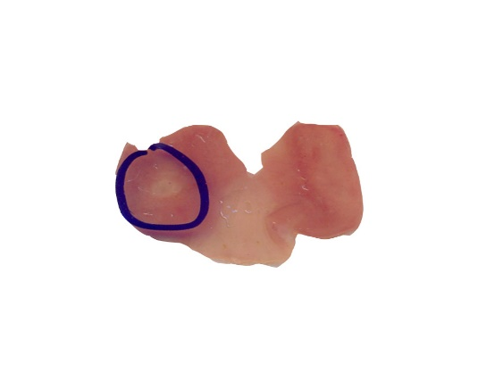

Lansoprazole

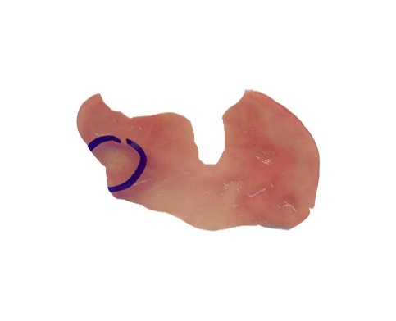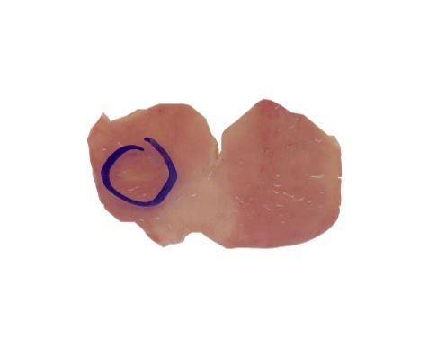

HEEP

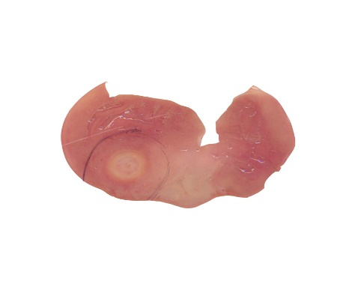

Vehicle

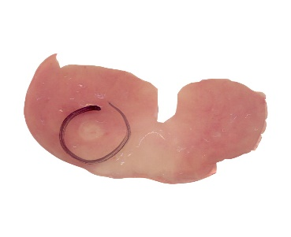

Lansoprazole

**Males**

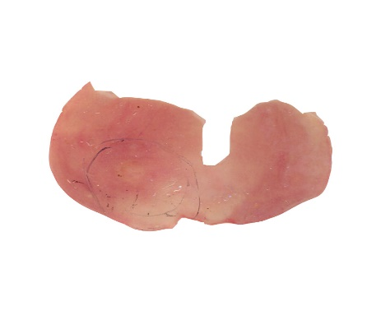

HEEP



**Intact**

**Females**

Vehicle

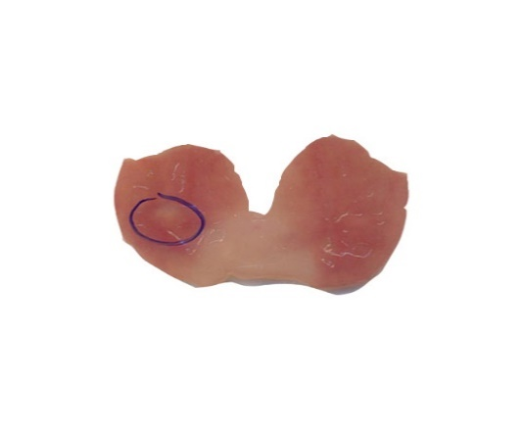

Vehicle

Lansoprazole

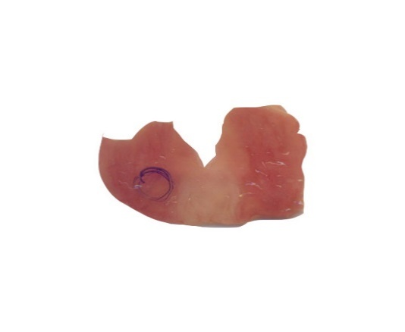

HEEP

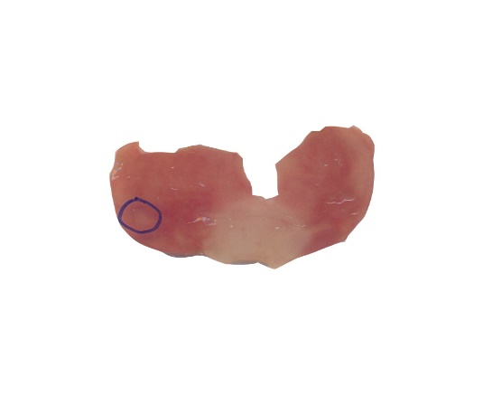



**Figure 1 Effects of 14-d treatment with hydroalcoholic extract from the leaves of *Eugenia punicifolia* (HEEP) and lansoprazole on gastric ulcer healing in a rat model.** Results were expressed as mean ± standard error of the mean in each group (*n* = 8-10). Values given as percentage indicate healing relative to the corresponding vehicle group. Statistical significance was determined using one-way ANOVA followed by Dunnett's test or Student’s *t*-test. a*P* < 0.05 and b*P* < 0.01 *vs* vehicle in males; c*P* < 0.0001 *vs* vehicle in intact females (cycling); d*P* < 0.01 and e*P* < 0.0001 *vs* vehicle in ovariectomized females; f*P* < 0.01 for HEEP and lansoprazole in intact females *vs* males; g*P* < 0.01 and h*P* < 0.001 for HEEP and lansoprazole in intact *vs* ovariectomized females; NS: Not significant.



**Figure 2 Effects of hydroalcoholic extract from the leaves of *Eugenia punicifolia* (HEEP) on the viability of L929 fibroblasts.** L929 cells were treated with vehicle, DMSO, or HEEP of different concentrations and incubated for 24 h. Cell viability was measured using the MTT assay. The results represent mean ± standard error of the mean in triplicate experiments. Statistical significance was determined using one-way ANOVA followed by Dunnett's test. a*P* < 0.001 *vs* vehicle.

A

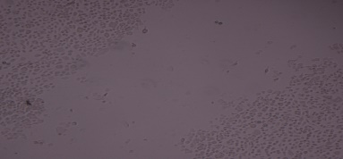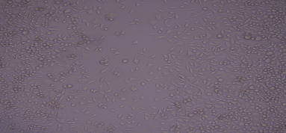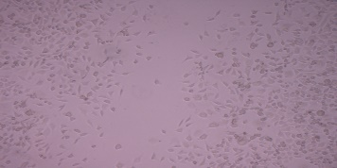

24 h

50 µm

50 µm

50 µm

50 µm

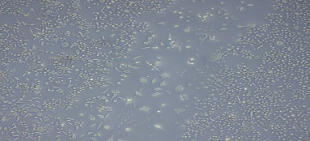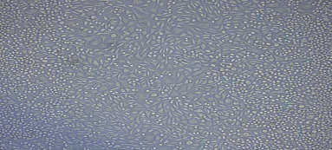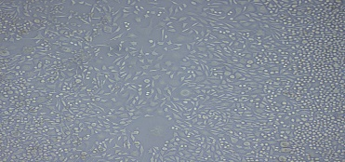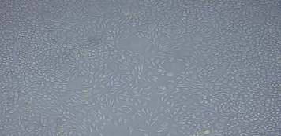

48 h

50 µm

50 µm

50 µm

50 µm

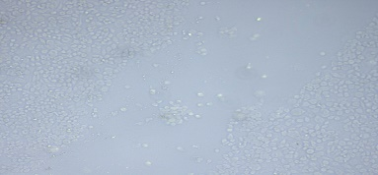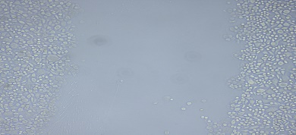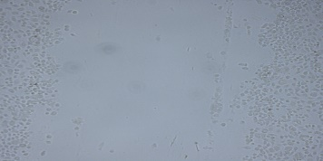

Vehicle

HEEP 3 µg/mL

HEEP 10 µg/mL

HEEP 30 µg/mL

0 h

50 µm

50 µm

50 µm

50 µm



**Figure 3 Effects of hydroalcoholic extract from the leaves of *Eugenia punicifolia* (HEEP) on cell proliferation and migration to the scratch-wound area.** A monolayer of L929 fibroblasts was scratched and treated with vehicle or HEEP at different concentrations (3, 10, and 30 µg/mL). A: Images captured at 100× magnification at 0, 24, and 48 h after incubation; B: Rate of migration, evaluated in terms of the total distance that the cells moved from the edge of the scratch toward the center. The results represent mean ± standard error of the mean in triplicate experiments. Statistical significance was established using analysis of variance (two-way ANOVA) followed by Bonferroni’s test. a*P* < 0.001 *vs* time-matched vehicle.



**Figure 4 Prostaglandin E2 (PGE2) levels in rats with acetic acid-induced gastric ulcer treated for 14 d with vehicle, lansoprazole, or hydroalcoholic extract from the leaves of *Eugenia punicifolia* (HEEP).** The results are expressed as mean ± standard error of the mean in each group (*n* = 6-8). Statistical significance was determined using one-way ANOVA followed by Dunnett's test. a*P* < 0.05 and b*P* < 0.001 *vs* vehicle in males; ns, not significant.



**A)**

**B)**

**72 kDa (Pro-MMP-2)**

**64 kDa (Intermediate MMP-2)**

**57 kDa (Active MMP-2)**

**Veh LZ HEEP**



**92 kDa (Pro-MMP-9)**

**Figure 5 Representative zymography results of gastric ulcer tissue from male rats treated with vehicle (Veh), lansoprazole (LZ), or hydroalcoholic extract from the leaves of *Eugenia punicifolia* (HEEP) for 14 d**. A: Zymography gel showing the typical clear bands of matrix metalloproteinase-2 (MMP-2) in its proenzyme (72 kDa), intermediate (64 kDa), and active form (57 kDa); B: Gelatinolytic activity of MMP-2 in the gastric mucosa after 14 d of treatment. The results represent mean ± standard error of the mean of the integrated optical density (IOD) for each group (*n* = 6). Statistical significance was determined using one-way ANOVA followed by Dunnett's test.



**A)**

**B)**

**72 kDa (Pro-MMP-2)**

**64 kDa (Intermediate MMP-2)**

**57 kDa (Active MMP-2)**

**Veh LZ HEEP**



**92 kDa (Pro-MMP-9)**

**Figure 6 Representative zymography results of gastric ulcer tissue from intact female rats treated with vehicle (Veh), lansoprazole (LZ), or hydroalcoholic extract from the leaves of *Eugenia punicifolia* (HEEP) for 14 d**. A: Zymography gel showing the typical clear bands of matrix metalloproteinase-2 (MMP-2) in its proenzyme (72 kDa), intermediate (64 kDa), and active form (57 kDa); B: Gelatinolytic activity of MMP-2 in the gastric mucosa after 14 d of treatment. The results represent mean ± standard error of the mean of the integrated optical density (IOD) for each group (*n* = 6). Statistical significance was determined using one-way ANOVA followed by Dunnett's test.



**A)**

**B)**

**72 kDa (Pro-MMP-2)**

**64 kDa (Intermediate MMP-2)**

**57 kDa (Active MMP-2)**

**Veh LZ HEEP**

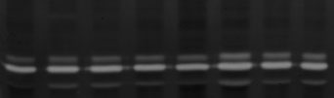

**92 kDa (Pro-MMP-9)**

**Figure 7 Representative zymography results of gastric ulcer tissue from ovariectomized rats treated with vehicle (Veh), lansoprazole (LZ), or hydroalcoholic extract from the leaves of *Eugenia punicifolia* (HEEP) for 14 d**. A: Zymography gel showing the typical clear bands of matrix metalloproteinase-2 (MMP-2) in its proenzyme (72 kDa), intermediate (64 kDa), and active form (57 kDa); B: Gelatinolytic activity of MMP-2 in the gastric mucosa after 14 d of treatment. The results represent mean ± standard error of the mean of the integrated optical density (IOD) for each group (*n* = 6). Statistical significance was determined using one-way ANOVA followed by Dunnett's test.

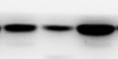

**Actin**

**42 kDa**

**COX – 1**

**68 kDa**

**Figure 8 COX-1 expression in the gastric mucosa of rats with acetic acid-induced gastric ulcer treated with oral administration of vehicle, lansoprazole, or hydroalcoholic extract from the leaves of *Eugenia punicifolia* (HEEP) for 14 d.** Data represent relative expression of COX-1 normalized to the expression of housekeeping genes (actin). The results represent mean ± standard error of the mean for each group (*n* = 6). Statistical significance was determined using one-way ANOVA followed by Dunnett's test. No statistically significant differences were found.

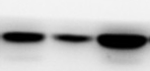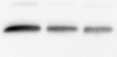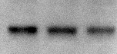

**COX – 2**

**69 kDa**

**Figure 9 COX-2 expression in the gastric mucosa of rats with acetic acid-induced gastric ulcer treated with oral administration of vehicle, lansoprazole, or hydroalcoholic extract from the leaves of *Eugenia punicifolia* (HEEP) for 14 d.** Data represent relative expression of COX-2 normalized to the expression of housekeeping genes (actin). The results represent mean ± standard error of the mean for each group (*n* = 6). Statistical significance was determined using one-way ANOVA followed by Dunnett's test. No statistically significant differences were found.

**Figure 10 Epidermal growth factor expression in the gastric mucosa of rats with acetic acid-induced gastric ulcer treated with oral administration of vehicle, lansoprazole, or hydroalcoholic extract from the leaves of *Eugenia punicifolia* (HEEP) for 14 d.** Data represent relative expression of EGF normalized to the expression of housekeeping genes (actin). The results represent mean ± standard error of the mean for each group (*n* = 6). Statistical significance was determined using one-way ANOVA followed by Dunnett's test or Student’s t-test. a*P* < 0.01 *vs* vehicle in males; b*P* < 0.01 *vs* vehicle in ovariectomized females; c*P* < 0.05 for lansoprazole in males *vs* intact females; d*P* < 0.05 for lansoprazole in intact *vs* ovariectomized females.

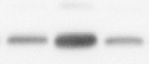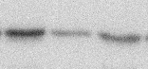

**Actin**

**42 kDa**

**EGF**

**6,2 kDa**

**Figure 11 Vascular endothelial growth factor expression in the gastric mucosa of rats with acetic acid-induced gastric ulcer treated with oral administration of vehicle, lansoprazole, or hydroalcoholic extract from the leaves of *Eugenia punicifolia* (HEEP) for 14 d.** Data represent relative expression of VEGF normalized to the expression of housekeeping genes (actin). The results represent mean ± standard error of the mean for each group (*n* = 6). Statistical significance was determined using one-way ANOVA followed by Dunnett's test or Student’s *t*-test. a*P* < 0.05 for lansoprazole and HEEP in intact *vs* ovariectomized females.

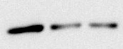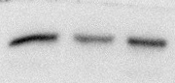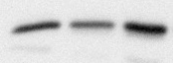

**VEGF**

**43 kDa**

**Actin**

**42 kDaActin**

**42 kDa**

**Figure 12 Caspase-8 expression in the gastric mucosa of rats with acetic acid-induced gastric ulcer treated with oral administration of vehicle, lansoprazole, or hydroalcoholic extract from the leaves of *Eugenia punicifolia* (HEEP) for 14 d.** Data represent relative expression of caspase-8 normalized to the expression of housekeeping genes (actin). The results represent mean ± standard error of the mean for each group (*n* = 6). Statistical significance was determined using one-way ANOVA followed by Dunnett's test or Student’s *t*-test. a*P* < 0.05 and b*P* < 0.01 for lansoprazole and HEEP in intact females *vs* males. c*P* < 0.01 and d*P* < 0.001 for vehicle, lansoprazole, and HEEP in intact *vs* ovariectomized females.

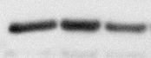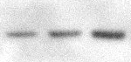

**Actin**

**42 kDa**

**Caspase – 8**

**18 kDa**

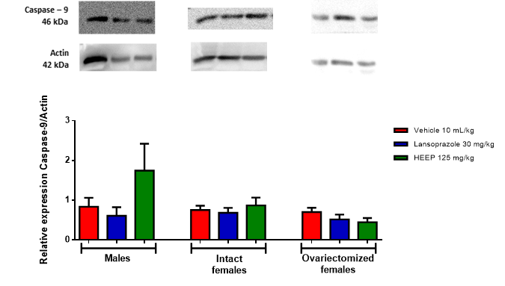

**Figure 13 Caspase-9 expression in the gastric mucosa of rats with acetic acid-induced gastric ulcer treated with oral administration of vehicle, lansoprazole, or hydroalcoholic extract from the leaves of *Eugenia punicifolia* (HEEP) for 14 d.** Data represent relative expression of caspase-9 normalized to the expression of housekeeping genes (actin). The results represent mean ± standard error of the mean for each group (*n* = 6). Statistical significance was determined using one-way ANOVA followed by Dunnett's test. No statistically significant differences were found.

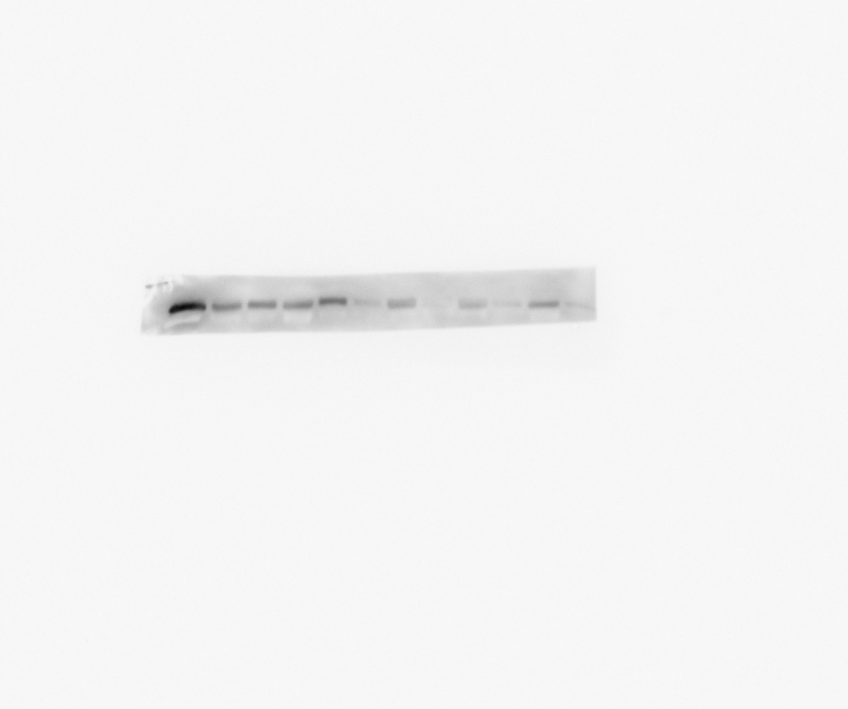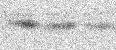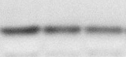

**Actin**

**42 kDa**

**Caspase – 3**

**31 kDa**

**Figure 14 Caspase-3 expression in the gastric mucosa of rats with acetic acid-induced gastric ulcer treated with oral administration of vehicle, lansoprazole, or hydroalcoholic extract from the leaves of *Eugenia punicifolia* (HEEP) for 14 d.** Data represent relative expression of caspase-3 normalized to the expression of housekeeping genes (actin). The results represent mean ± standard error of the mean for each group (*n* = 6). Statistical significance was determined using one-way ANOVA followed by Dunnett's test. No statistically significant differences were found.

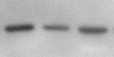

**Actin**

**42 kDa**

**Bcl – 2**

**26 kDa**

**Figure 15 Bcl-2 expression in the gastric mucosa of rats with acetic acid-induced gastric ulcer treated with oral administration of vehicle, lansoprazole, or hydroalcoholic extract from the leaves of *Eugenia punicifolia* (HEEP) for 14 d.** Data represent relative expression of Bcl-2 normalized to the expression of housekeeping genes (actin). The results represent mean ± standard error of the mean for each group (*n* = 6). Statistical significance was determined using one-way ANOVA followed by Dunnett's test or Student’s *t*-test. a*P* < 0.05 for lansoprazole in intact *vs* ovariectomized females.

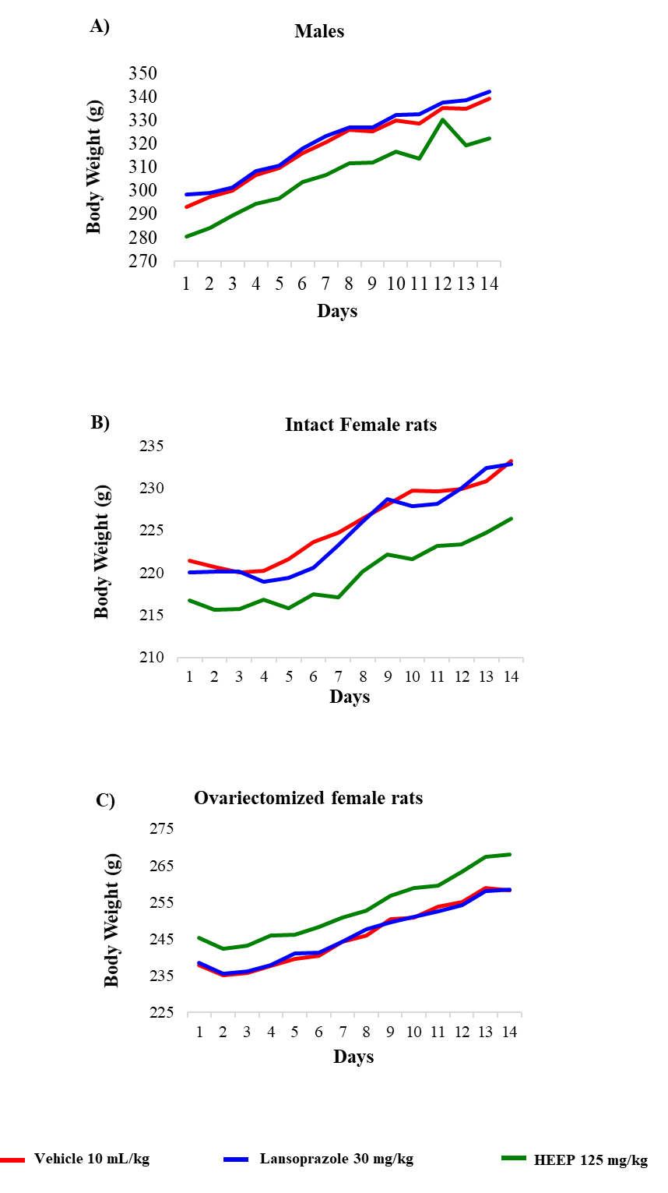

**Figure 16 Body weight evolution in rats with acetic acid-induced gastric ulcer treated with oral administration of vehicle, lansoprazole, or hydroalcoholic extract from the leaves of *Eugenia punicifolia* (HEEP) for 14 d.** A: Male rats; B: Intact female rats; C: Ovariectomized female rats. Results are expressed as the means of body weight (g) in each group (*n* = 8-10). Statistical significance was determined using one-way ANOVA followed by Dunnett's test. No statistically significant differences were found.

**Table 1 Organ weight effects of 14-d treatment with lansoprazole and hydroalcoholic extract from the leaves of *Eugenia punicifolia* (HEEP) of male rats with acetic acid-induced gastric ulcer**

|  |  |  |  |
| --- | --- | --- | --- |
|  | **Treatment** | | |
| **Effect** | **Vehicle** | **Lansoprazole** | **HEEP** |
| Organ weights, g |  |  |  |
| Heart | 3.15 ± 0.03 | 3.13 ± 0.03 | 3.14 ± 0.06 |
| Kidneys | 4.81 ± 0.05 | 4.79 ± 0.04 | 4.84 ± 0.05 |
| Lung | 3.62 ± 0.08 | 3.73 ± 0.10 | 3.59 ± 0.06 |
| Liver | 11.56 ± 0.18 | 11.55 ± 0.10 | 11.26 ± 0.13 |
| Spleen | 2.94 ± 0.,02 | 2.98 ± 0.05 | 2.99 ± 0.04 |
| Biochemical parameters |  |  |  |
| Glucose, mg/dL | 150.10 ± 6.04 | 170.90 ± 4.73a | 154.70 ± 3.80 |
| Creatinine, mg/dL | 0.34 ± 0.02 | 0.34 ± 0.02 | 0.33 ± 0.01 |
| Urea, mg/dL | 54.75 ± 3.15 | 52.13 ± 1.71 | 54.13 ± 1.94 |
| γ-GT, U/L | < 1.0 | < 1.0 | < 1.0 |
| AST, U/L | 137.80 ± 18.43 | 163.60 ± 22.33 | 144.50 ± 10.76 |
| ALT, U/L | 42.88 ± 3.55 | 48.88 ± 3.67 | 46.25 ± 3.09 |

Vehicle, lansoprazole, or HEEP was administered for 14 d after ulcer induction. Data were collected at the end of treatment. Results are expressed as the means ± standard error of the mean for each group (*n* = 7-8). Statistical significance was determined using one-way ANOVA followed by Dunnett's test. a*P* < 0.05 *vs* vehicle; ALT: Alanine aminotransferase; AST: Aspartate aminotransferase; γ-GT: Gamma-glutamyl transpeptidase.

**Table 2 Organ weight effects of 14-d treatment with lansoprazole and hydroalcoholic extract from the leaves of *Eugenia punicifolia* (HEEP) of intact female rats with acetic acid-induced gastric ulcer**

|  |  |  |  |
| --- | --- | --- | --- |
|  | **Treatment** | | |
| **Effect** | **Vehicle** | **Lansoprazole** | **HEEP** |
| Organ weights, g |  |  |  |
| Heart | 3.43 ± 0.05 | 3.50 ± 0.03 | 3.44 ± 0.06 |
| Kidneys | 4.74 ± 0.03 | 4.81 ± 0.04 | 4.69 ± 0.06 |
| Lung | 4.23 ± 0.07 | 4.53 ± 0.06 | 4.01 ± 0.30 |
| Liver | 10.67 ± 0.14 | 10.90 ± 0.10 | 10.61 ±0.09 |
| Spleen | 2.56 ± 0.06 | 2.56 ± 0.07 | 2.48 ± 0.06 |
| Biochemical parameters |  |  |  |
| Glucose, mg/dL | 119.10 ± 3.27 | 116.90 ± 3.21 | 122.30 ± 3.34 |
| Creatinine, mg/dL | 0.45 ± 0.02 | 0.41 ± 0.02 | 0.45 ± 0.01 |
| Urea, mg/dL | 49.50 ± 3.36 | 53.29 ± 1.11 | 53.70 ± 3.20 |
| γ-GT, U/L | < 1.0 | < 1.0 | < 1.0 |
| AST, U/L | 202.70 ± 12.73 | 198.40 ± 18.84 | 162.10 ± 7.24 |
| ALT, U/L | 57.00 ± 3.40 | 60.57 ± 3.59 | 65.86 ± 2.79 |

Vehicle, lansoprazole, or HEEP was administered for 14 d after ulcer induction. Data were collected at the end of treatment. Results are expressed as the means ± standard error of the mean for each group (*n* = 7-8). Statistical significance was determined using one-way ANOVA followed by Dunnett's test. No significant differences *vs* vehicle were noted; ALT: Alanine aminotransferase; AST: Aspartate aminotransferase; γ-GT: Gamma-glutamyl transpeptidase.

**Table 3 Organ weights effects of 14-d treatment with lansoprazole and hydroalcoholic extract from the leaves of *Eugenia punicifolia* (HEEP) of ovariectomized rats with acetic acid-induced gastric ulcer**

|  |  |  |  |
| --- | --- | --- | --- |
|  | **Treatment** | | |
| **Effect** | **Vehicle** | **Lansoprazole** | **HEEP** |
| Organ weights, g |  |  |  |
| Heart | 3.35 ± 0.04 | 3.39 ± 0.05 | 3.49 ± 0.09 |
| Kidneys | 4.52 ± 0.07 | 4.56 ± 0.07 | 4.61 ± 0.05 |
| Lung | 4.28 ± 0.11 | 4.30 ± 0.10 | 4.47 ± 0.17 |
| Liver | 10.56 ± 0.16 | 10.61 ± 0.10 | 10.60 ± 0.11 |
| Spleen | 2.59 ± 0.06 | 2.68 ± 0.08 | 2.65 ± 0.05 |
| Biochemical parameters |  |  |  |
| Glucose, mg/dL | 117.30 ± 4.36 | 126.70 ± 4.48 | 119.00 ± 5.46 |
| Creatinine, mg/dL | 0.42 ± 0.00 | 0.43 ± 0.01 | 0.43 ± 0.01 |
| Urea, mg/dL | 55.08 ± 2.24 | 48.97 ± 1.67 | 55.37 ± 2.92 |
| γ-GT, U/L | < 1.0 | < 1.0 | < 1.0 |
| AST, U/L | 176.80 ± 15.37 | 192.70 ± 14.77 | 191.00 ± 21.04 |
| ALT, U/L | 62.17 ± 3.68 | 57.57 ± 2.36 | 56.43 ± 1.92 |

Vehicle, lansoprazole, or HEEP was administered for 14 d after ulcer induction. Data were collected at the end of treatment. Results are expressed as the means ± standard error of the mean for each group (*n* = 7-8). Statistical significance was determined using one-way ANOVA followed by Dunnett's test. No significant differences *vs* vehicle were noted; ALT: Alanine aminotransferase; AST: Aspartate aminotransferase; γ-GT: Gamma-glutamyl transpeptidase.