**Name of journal:** **World Journal of Gastroenterology**

**ESPS Manuscript No: 9030­**

**Columns: CASE REPORT**

**Intra-abdominal inflammatory myofibroblastic tumor: Spontaneous regression**

Zhao JJ *et al*. Spontaneous regression of inflammatory myofiblastic tumor

Jun-Jie Zhao, Jia-Qian Ling, Yong Fang, Xiao-Dong Gao, Ping Shu, Kun-Tang Shen, Jing Qin, Yi-Hong Sun, Xin-Yu Qin

**Jun-Jie Zhao, Jia-Qian Ling, Yong Fang, Xiao-Dong Gao, Ping Shu, Kun-Tang Shen, Jing Qin, Yi-Hong Sun, Xin-Yu Qin,** Department of General Surgery, Zhong Shan Hospital, Fudan University, Shanghai 200032, China

**Author contributions:** Zhao JJ and Ling JQ contributed equally to this work; Zhao JJ, Ling JQ, Shen KT, Qin J, Sun YH and Qin XY treated the two patients; Fang Y, Gao XD and Shu P collected the clinical data; Zhao JJ and Ling JQ reviewed the published articles and analyzed data; Zhao JJ and Ling JQ wrote the paper; and Shen KT critically revised the paper with an important conceptual and editorial input.

**Correspondence to: Kun-Tang Shen, MD, Professor**, Department of General Surgery, Zhong Shan Hospital, Fudan University, 180 Fenglin Road, Xuhui District, Shanghai 200032, China. shen.kuntang@zs-hospital.sh.cn

**Telephone:** +86-21-64038472  **Fax:** +86-21-64038472

**Received:** January 16, 2014 **Revised:** April 1, 2014

**Accepted:** May 29, 2014

**Published online:**

**Abstract**

Inflammatory myofibroblastic tumors are usually treated by surgical resection. We herein report two cases of intra-abdominal inflammatory myofibroblastic tumors that were unresectable and underwent spontaneous regression without any treatment. Our cases plus a literature review showed that regression is more common in middle-aged and older male populations. Abdominal discomfort and fever were the most common symptoms, and the majority of patients had no obvious physical signs. There was no specific indicator for diagnosis. The majority of the lesions regressed within 3 months, and nearly all of the masses completely resolved in 1 year.We conclude that the clinical characteristics of inflammatory myofibroblastic tumors are variable and, accordingly, the disease needs to be subdivided and treated individually. Surgery is always the first-line treatment; however, for those masses assessed as unresectable, conservative therapy with intense follow-up should be considered.

© 2014 Baishideng Publishing Group Inc. All rights reserved.

**Key words:** Inflammatory myofibroblastic tumor; Inflammatory pseudotumor; Abdominal cavity; Spontaneous regression

**Core tip:** This article reports two rare cases involving the spontaneous regression of an unresectable intra-abdominal inflammatory myofibroblastic tumor (IMT) and summarizes the clinical characteristics of all published cases. The clinical characteristics of IMT are not clear, and the treatment is controversial. By analyzing published papers, we discovered some common features of the disease and potential reasons for this unusual phenomenon. Our findings may be useful for the clinical diagnosis and treatment of IMT.

Zhao JJ, Ling JQ, Fang Y, Gao XD, Shu P, Shen KT, Qin J, Sun YH, Qin XY. Intra-abdominal inflammatory myofibroblastic tumor: Spontaneous regression. *World J Gastroenterol* 2014; In press

**INTRODUCTION**

Inflammatory myofibroblastic tumor (IMT), also called inflammatory pseudotumor (IPT), is a rare disease commonly found in children and adolescents[1].

The etiology of IMT remains unclear, but is most likely associated with inflammation, trauma[2], viral infection[3], chromosome translocation[4] and gene fusion[5]. Although IMT has long been profiled as a benign lesion, it has presented aggressive behavior in some cases, due to local spread, recurrence and metastasis[6,7]. In 2003, IMT was classified as an intermediate neoplasm in the current World Health Organization (WHO) histologic typing[7] and characterized by a mixture of myofibroblasts, fibroblasts, lymphocytes, and plasma cells[8].

Surgery has long been regarded as the most effective and radical treatment. However, there were sporadic cases which reported the effectiveness of using antibiotics[9], corticosteroids[10], nonsteroidal anti-inflammatory drugs (NSAIDs)[2] and even non-intervention[11], which may provide new insights into the therapeutic approach for IMT, especially for unresectable lesions.

Herein, we present two cases of unresectable IMT arising from the abdominal cavity, both eventually resolving completely without any treatment. We also reviewed the relevant literature with an emphasis on the spontaneous regression of intra-abdominal IMT and summarized the clinical characteristics of these patients.

**CASE REPORT**

***Case*** *1*

A 49-year-old male sought medical treatment with symptoms including paroxysmal abdominal pain, nausea and vomit, which recurred over 2 wk. A large mass was palpated in the epigastrium. Laboratory tests showed elevated neutrophil count (6.7 x 109/L), C-reactive protein (CRP) (27.9 mg/L) and lactic dehydrogenase (383 U/L). Tumor markers were normal except for CA125 (44.8 IU/mL). A computed tomography (CT) scan of the abdomen revealed the presence of a very large nodular mass in the upper quadrant of the peritoneum (Figure 1a and b). Although the diagnosis was not confirmed, the clinical evidence indicated that the lesions were likely to be a malignant tumor. Based on this diagnosis, the patient was admitted to surgery. During exploration, a 15 cm x 8 cm large mass was discovered in the retro-peritoneum and was attached to the posterior wall of the abdomen (Figure 2). We performed an incisional biopsy of the mass at different sites. The histological diagnosis was of a fibroinflammatory proliferation, and the immunohistochemistry staining results showed negative expression of CD34, desmin and anaplastic lymphoma kinase (ALK) as well as positive expression of SMA, which is consistent with IMT (Figure 3a). Because the mass was unresectable, we only performed gastrojejunostomy to relieve the obstruction. After surgery, the patient presented with delayed gastric empting and was completely symptom-free 3 wk later. Before discharging, the patient was reexamined by CT scan, which showed the apparent and spontaneous regression of the mass without a residual small tumor or inflammation remaining (Figure 1c). A CT scan three months later showed no indication of relapse (Figure 1d).

***Case*** *2*

A 59-year-old man was hospitalized with a 1-mo history of abdominal distension, poor appetite and weight loss of more than 5 kg. He was addicted to alcohol and tobacco and had uncontrolled diabetes mellitus. Clinical examination was unremarkable other than mild abdominal tenderness. Laboratory tests, including a routine test, a hepatic function test, C-reactive protein and tumor markers were all within normal range. Gastroscopy detected an elevated lesion at the pylorus, which was likely from the extra-cavity. We twice performed an endoscopic biopsy, but both findings were superficial gastritis. A CT scan and a PET-CT scan both demonstrated that a presumptive malignant mass was located between the gastric antrum and the neck of pancreas (Figure 4a, b). Although we did not acquire a pathological diagnosis, we performed an exploratory laparotomy. During the surgery, we confirmed that the mass was located at the posterior wall of the gastric antrum and had invaded the pancreas, transverse mesocolon and mesentery, which resulted in an inability to perform an en bloc resection. We only removed the subpyloric lymph nodes for a pathological assay. The histological examination showed conspicuous proliferation of myofibroblasts admixed with abundant inflammatory cells (Figure 3b), and the immunohistochemistry results demonstrated that CD34, desmin and ALK were negative while SMA was positive. Based on these findings, the diagnosis of IMT was made. The patient did not receive any treatment and became symptom-free one month later. The tumor mass regression was verified using a CT scan (Figure 4c). After discharging, the patient underwent a CT scan every three months at a local hospital and did not have any indication of recurrence during a one-year follow-up.

***Literature review***

A systematic search of PubMed and Embase was performed. We listed 20 reports published from 1992 to date in Table 1, with a sum of 36 intra-abdominal IMT or IPT patients who had spontaneous regression without surgical excision[1,2,7-24]. In an effort to assess the biological behavior of IMT, we summarized the clinical characteristics of a total number of 38 patients, including 36 reported cases as well as our two cases.

**Age and gender:** Including our two cases, the median age of patients was 44 years (range from few months to 79 years). The largest population was the middle-aged and elderly, with a percentage of 60.6%. There were 25 male patients, nearly twice as many as female.

**Symptoms:** Twenty-five of 31 patients were symptomatic at presentation (no data were available for 7 cases). The most common symptoms were abdominal pain (58.1%), fever (45.2%), weight loss (22.6%), appetite loss (12.9%) and nausea and vomit (12.9%). Nearly 19.4% of patients were completely asymptomatic.

**Physical examination:** The majority of 27 available cases did not have obvious signs (70.4%). As the liver was the most frequent location, palpable enlargement of the liver was the most common sign (14.8%), followed by abdominal mass (7.4%) and tenderness (7.4%).

**Laboratory examination:** Nearly one in five patients had no aberrant findings (26 case files were available). Elevated white blood cell (WBC) count accounted for the highest percentage of findings (34.6%); liver function abnormity (30.8%), elevated CRP (19.2%) and erythrocyte sedimentation rate (ESR) (19.2%) were also frequent. Other abnormalities included hypoalbuminemia (15.4%), elevated tumor markers (15.4%) and anemia (15.4%).

**Location:** Liver was the most common location, making up 71.8% of all the reported cases. Retro-peritoneum, mesentery, gastrointestinal tract and pancreas were also reported.

**Size:** The maximum diameter of the tumor was reported in 21 cases, ranging from 1 cm to 15 cm. The average size was 6.1 cm.

**Diagnosis:** A total of 31 cases were diagnosed before treatment. Among them, 25 cases were diagnosed as IMT or IPT (80.6%) and led to conservative therapy. Nevertheless, 5 cases were diagnosed as malignant tumors, and therefore, abdominal exploration was performed. All hepatic lesions were diagnosed before treatment, and the accuracy reached 95.7%. However, only 77.8% of the masses located at the retro-peritoneum and mesentery could be diagnosed, and more than half of the masses were misdiagnosed as malignant tumors.

**Management:** Seventeen out of 38 cases did not receive any intervention versus 21 out of 38 cases that were managed medically. The most commonly used therapy was NSAIDs (15.8%), followed by steroids (13.2%) and antibiotics (10.5%). Of the remaining cases, 3 patients received combinations of medicines.

**Outcome:** All 38 patients were reported as thriving during the follow-up period. Thirty reports described the specific time that the tumor regressed, ranging from days to 3 years (Figure 5).

**DISCUSSION**

Although IMT and IPT were formerly regarded as the same disease, some authors argue they are distinct entities. As there is no uniform view at present, the use of these two terms synonymously in the literature has led to confusion in understanding the incidence and behavior of the disease. In this article, we still attribute IMT to the broad category of IPT for now. IMT was initially identified in the lungs in 1937. Since then, it has been described at various sites[12]. As a result of various origins, IMT may present with diverse clinical symptoms, physical signs and laboratory findings, which makes it difficult to differentiate from other neoplasms[21]. Radiological appearance is also nonspecific and is insufficient to make a correct diagnosis. At present, percutaneous biopsy is considered the most useful tool. Meis *et al*[25] reported that most cases of IMT expressed actin, vimentin and keratin. Chan *et al*[26] speculated that the expression of ALK may be a specific marker for IMT. However, a biopsy is unable to provide an absolutely certain diagnosis[21], especially for tumors located at the retro-peritoneum. Therefore, we recommend laparoscopic exploration first for these undiagnosed cases. Large samples taken during a laparoscopic biopsy may increase the reliability of the histopathology results.

The reasons for the spontaneous regression of IMT have not been clearly elucidated; however, by analyzing the published cases, we can generate some hypotheses for further investigation.

First, different tumor locations might influence the prognosis of IMT. The hepatic lesions have the most favorable outcome; in contrast, tumors occurring in the abdomen, pelvis and retro-peritoneum tend to show more aggressive behavior and have a poor prognosis[6,27]. Location is also associated with age and gender. The mean age of patients with IMT is reported as low as 9.7 years, and females account for approximately 60% of patients. By contrast, liver lesions usually develop in men of middle or advanced ages[22].

Second, the regression cases are more frequently observed in middle-aged and older patients. Therefore, age may have an impact on prognosis. Studies showed that ALK positivity was detected in 36% to 60% of cases and was associated with cytogenetic abnormalities[28] and local recurrence[27]. Interestingly, the *ALK* gene was expressed selectively in younger patients[26] and may contribute to the unfavorable prognosis of children and adolescents.

Third, recurrence is related to a number of factors, such as aneuploidy, atypia and ganglion-like cells. Coffin *et al*[29] demonstrated that nearly 75% of aneuploid IMT had recurrence and malignant transformation. Hussong *et al*[30] reported that atypia and ganglion-like cells were detected much more in cases with recurrence and malignant transformation.

As discussed above, we conclude that the prognosis of IMT is closely related to location, age and ALK positivity. This is also the dispute regarding the diagnosis of IMT and IPT. Vecchio suggested the IPT rather than IMT should be seriously considered when managing ALK-negative spindle cell lesions in adult patients[31]. Gleason also agreed that one should be wary of making the diagnosis of IMT in these populations and recommended taking many factors into consideration, including age, location, histological pattern and ALK expression[32]. We deem that both IPT and IMT must be subdivided into different types according to location, age, histology, gene expression and chromosome condition. Different types may have dramatically different outcomes, and as a result, the therapeutic approach should be determined accordingly.

Complete resection has been widely accepted as the mainstay treatment, although surgery could be destructive to adjacent structures and increase morbidity[2]. Adjuvant chemotherapy in conjunction with radiation therapy is also controversial[8,33].

With more spontaneous regression cases being described, there is an increasing realization of conservative management[10,13,34]. Although some articles have reported the recurrence[6] or the malignant transformation[35,36] of IMT, Goldsmith *et al*[23] compared the mortality rate of 215 liver IMT patients between medical management and resection surgery and found no significant difference. In terms of conservative options, there is no obvious difference in overall outcome between patients receiving antibiotics, steroids or no treatment[23].

Although conservative therapies have been effective for a number of patients, these treatments are all empirical, and the mechanisms are not well understood. Recently, some studies[8,34] reported the majority of IMT tissues were positive for COX-2 and VEGF staining and proposed that NSAIDs could have an anti-angiogenic effect via the inhibition of COX2. Others[22] found that many plasma cells infiltrating at IMT lesions were positive for IgG4 and speculated that IMT was associated with an immune process. Therefore, the administration of steroids might prevent an immune response and reduce systemic symptoms[10].

To date, the optimal treatment of IMT is far from conclusive and needs to be further studied. We agree that resection should be the initial treatment for those patients with mass effect symptoms, those where the tumor mass tends to increase or is easily excised and those in which a certain diagnosis cannot be made by biopsy[21,22]. However, when the mass is assessed as unresectable by a CT scan or laparoscopic exploration, surgical procedures should be avoided and conservative therapy with either antibiotics, steroids, NSAIDs or observation along with intense follow-up should be taken into consideration[2].

**ACKNOWLEDGMENTS**

We thank the pathologists and the radiologists in our hospital for technical assistance.

**COMMENTS**

***Case characteristics***

The symptoms of two middle-aged male patients were variable; one presented with abdominal pain and vomit, and the other presented with abdominal distension, poor appetite and weight loss.

***Clinical diagnosis***

The physical signs of the two cases were also variable. A large mass was palpated in the epigastrium for the first patient, and a mild abdominal tenderness was observed during the examination for the second.

***Differential diagnosis***

Malignant tumors (angiosarcoma, cystadenocarcinoma and metastatic tumors), benign neoplasms (focal nodular hyperplasia, hemangioma and adenoma) and abscesses.

***Laboratory diagnosis***

The first patient had an elevated neutrophil count (6.7 x 109/L), C-reactive protein (CRP) (27.9 mg/L), lactic dehydrogenase (383 U/L) and CA125 (44.8 IU/mL), while the second had no remarkable abnormal laboratory results.

***Imaging diagnosis***

A computed tomography scan showed a large mass located in the abdominal cavity in both cases.

***Pathological diagnosis***

Histological examination showed a proliferation of myofibroblasts and infiltration of inflammation cells. IHC staining showed CD34, desmin and anaplastic lymphoma kinase (ALK) were negative, while SMA was positive in both cases.

***Treatment***

Neither patient received a curative resection or further treatment.

***Related reports***

Spontaneous regression of an intra-abdominal inflammatory myofibroblastic tumor is seldom reported. The clinical and pathological characteristics of inflammatory myofibroblastic tumor are unclear, and the treatment is controversial.

***Experiences and lessons***

This case report represents the clinical characteristics of intra-abdominal inflammatory myofibroblastic tumors and also discusses the treatment of inflammatory myofibroblastic tumor. We recommend that conservative therapy should be considered when the tumor is unresectable, especially for middle-aged patients with negative ALK expression.

***Peer review***

The authors have described two cases of intra-abdominal inflammatory myofibroblastic tumor which showed spontaneous resolution without intervention. The article highlights an important point which has important therapeutic implications.

**REFERENCES**

1 **Shatzel J**, Wooten K, Ankola A, Cheney RT, Morrison CD, Skitzki JJ. Inflammatory myofibroblastic tumor of the mesentery: a clinical dilemma. *Int J Clin Oncol* 2012; **17**: 380-384 [PMID: 21823041 DOI: 10.1007/s10147-011-0297-0]

2 **Su W**, Ko A, O'Connell T, Applebaum H. Treatment of pseudotumors with nonsteroidal antiinflammatory drugs. *J Pediatr Surg* 2000; **35**: 1635-1637 [PMID: 11083441 DOI: 10.1053/jpsu.2000.18340]

3 **Arber DA**, Kamel OW, van de Rijn M, Davis RE, Medeiros LJ, Jaffe ES, Weiss LM. Frequent presence of the Epstein-Barr virus in inflammatory pseudotumor. *Hum Pathol* 1995; **26**: 1093-1098 [PMID: 7557942 DOI: 10.1016/0046-8177(95)90271-6]

4 **Sirvent N**, Hawkins AL, Moeglin D, Coindre JM, Kurzenne JY, Michiels JF, Barcelo G, Turc-Carel C, Griffin CA, Pedeutour F. ALK probe rearrangement in a t(2; 11; 2)(p23; p15; q31) translocation found in a prenatal myofibroblastic fibrous lesion: toward a molecular definition of an inflammatory myofibroblastic tumor family? *Genes Chromosomes Cancer* 2001; **31**: 85-90 [PMID: 11284039 DOI: 10.1002/gcc.1121]

5 **Milne AN**, Sweeney KJ, O'Riordain DS, Pauwels P, Debiec-Rychter M, Offerhaus GJ, Jeffers M. Inflammatory myofibroblastic tumor with ALK/TPM3 fusion presenting as ileocolic intussusception: an unusual presentation of an unusual neoplasm. *Hum Pathol* 2006; **37**: 112-116 [PMID: 16360423 DOI: 10.1016/j.humpath.2005.09.012]

6 **Lopez-Tomassetti Fernandez EM**, Luis HD, Malagon AM, Gonzalez IA, Pallares AC. Recurrence of inflammatory pseudotumor in the distal bile duct: lessons learned from a single case and reported cases. *World J Gastroenterol* 2006; **12**: 3938-3943 [PMID: 16804988 DOI: 10.3748/wjg.v12.i24.3938]

7 **Fragoso AC**, Eloy C, Estevão-Costa J, Campos M, Farinha N, Lopes JM. Abdominal inflammatory myofibroblastic tumor a clinicopathologic study with reappraisal of biologic behavior. *J Pediatr Surg* 2011; **46**: 2076-2082 [PMID: 22075336 DOI: 10.1016/j.jpedsurg.2011.07.009]

8 **Mattei P**, Barnaby K. Rapid regression of duodenal inflammatory myofibroblastic tumor after intravenous ketorolac: case report and review of the literature. *J Pediatr Surg* 2008; **43**: 1196-1199 [PMID: 18558206 DOI: 10.1016/j.jpedsurg.2008.01.012]

9 **Tsou YK**, Lin CJ, Liu NJ, Lin CC, Lin CH, Lin SM. Inflammatory pseudotumor of the liver: report of eight cases, including three unusual cases, and a literature review. *J Gastroenterol Hepatol* 2007; **22**: 2143-2147 [PMID: 18031372 DOI: 10.1111/j.1440-1746.2006.04514.x]

10 **Koea JB**, Broadhurst GW, Rodgers MS, McCall JL. Inflammatory pseudotumor of the liver: demographics, diagnosis, and the case for nonoperative management. *J Am Coll Surg* 2003; **196**: 226-235 [PMID: 12595051 DOI: 10.1016/S1072-7515(02)01495-3]

11 **Jerraya H**, Jarboui S, Daghmoura H, Zaouche A. A new case of spontaneous regression of inflammatory hepatic pseudotumor. *Case Rep Med* 2011; **2011**: 139125 [PMID: 21541218 DOI: 10.1155/2011/139125]

12 **Gollapudi P**, Chejfec G, Zarling EJ. Spontaneous regression of hepatic pseudotumor. *Am J Gastroenterol* 1992; **87**: 214-217 [PMID: 1734701]

13 **Jaïs P**, Berger JF, Vissuzaine C, Paramelle O, Clays-Schouman E, Potet F, Mignon M. Regression of inflammatory pseudotumor of the liver under conservative therapy. *Dig Dis Sci* 1995; **40**: 752-756 [PMID: 7720466]

14 **Biecker E**, Zimmermann A, Dufour JF. Spontaneous regression of an inflammatory pseudotumor of the liver. *Z Gastroenterol* 2003; **41**: 991-994 [PMID: 14562196 DOI: 10.1055/s-2003-42928]

15 **Thompson RJ**, Barrett AM, Dildey P. Congenital multifocal inflammatory pseudotumor: a case report. *J Pediatr Surg* 2003; **38**: E17-E19 [PMID: 14577098 DOI: 10.1016/S0022-3468(03)00523-2]

16 **Tanikawa G**, Takaha N, Nonomura N, Okuyama A. [Periureteral inflammatory pseudotumor: a case report]. *Hinyokika Kiyo* 2003; **49**: 595-597 [PMID: 14655603]

17 **Przkora R**, Bolder U, Schwarz S, Jauch KW, Spes J, Andreesen R, Mackensen A. Regression of nonresectable inflammatory myofibroblastic tumours after treatment with nonsteroidal anti-inflammatory drugs. *Eur J Clin Invest* 2004; **34**: 320-321 [PMID: 15086369 DOI: 10.1111/j.1365-2362.2004.01333.x]

18 **Colakoglu O**, Unsal B, Haciyanli M, Tunakan M, Buyrac Z, Yorukoglu G, Yazicioglu N, Genc H. A succesfully managed inflammatory pseudotumour of liver without surgery: report of a case. *Acta Gastroenterol Belg* 2005; **68**: 382-384 [PMID: 16268428]

19 **Koide H**, Sato K, Fukusato T, Kashiwabara K, Sunaga N, Tsuchiya T, Morino S, Sohara N, Kakizaki S, Takagi H, Mori M. Spontaneous regression of hepatic inflammatory pseudotumor with primary biliary cirrhosis: case report and literature review. *World J Gastroenterol* 2006; **12**: 1645-1648 [PMID: 16570364 DOI: 10.3748/wjg.v12.i10.1645]

20 **Yamaguchi J**, Sakamoto Y, Sano T, Shimada K, Kosuge T. Spontaneous regression of inflammatory pseudotumor of the liver: report of three cases. *Surg Today* 2007; **37**: 525-529 [PMID: 17522777 DOI: 10.1007/s00595-006-3433-0]

21 **Vassiliadis T**, Vougiouklis N, Patsiaoura K, Mpoumponaris A, Nikolaidis N, Giouleme O, Evgenidis N. Inflammatory pseudotumor of the liver successfully treated with nonsteroidal anti-inflammatory drugs: a challenge diagnosis for one not so rare entity. *Eur J Gastroenterol Hepatol* 2007; **19**: 1016-1020 [PMID: 18049174 DOI: 10.1097/MEG.0b013e32821acdd2]

22 **Motojuku M**, Oida Y, Morikawa G, Hoshikawa T, Nakamura T, Tajima T, Mukai M, Otsuka H, Akieda K, Hirabayashi K, Makuuchi H, Inokuchi S. Inflammatory pseudotumor of the liver: case report and review of literature. *Tokai J Exp Clin Med* 2008; **33**: 70-74 [PMID: 21318970]

23 **Goldsmith PJ**, Loganathan A, Jacob M, Ahmad N, Toogood GJ, Lodge JP, Prasad KR. Inflammatory pseudotumours of the liver: a spectrum of presentation and management options. *Eur J Surg Oncol* 2009; **35**: 1295-1298 [PMID: 19515527 DOI: 10.1016/j.ejso.2009.04.003]

24 **Brage-Varela A**, Estévez-Boullosa P, Pombo-Otero J, Blanco-Rodríguez M, Lago-Novoa M, Arnal-Monreal F. Multifocal hepatic inflammatory pseudotumor: spontaneous regression in a diabetic patient. *Rev Esp Enferm Dig* 2010; **102**: 507-509 [PMID: 20670076 DOI: 10.4321/S1130-01082010000800012]

25 **Meis JM**, Enzinger FM. Inflammatory fibrosarcoma of the mesentery and retroperitoneum. A tumor closely simulating inflammatory pseudotumor. *Am J Surg Pathol* 1991; **15**: 1146-1156 [PMID: 1746682 DOI: 10.1097/00000478-199112000-00005]

26 **Chan JK**, Cheuk W, Shimizu M. Anaplastic lymphoma kinase expression in inflammatory pseudotumors. *Am J Surg Pathol* 2001; **25**: 761-768 [PMID: 11395553 DOI: 10.1097/00000478-200106000-00007]

27 **Coffin CM**, Hornick JL, Fletcher CD. Inflammatory myofibroblastic tumor: comparison of clinicopathologic, histologic, and immunohistochemical features including ALK expression in atypical and aggressive cases. *Am J Surg Pathol* 2007; **31**: 509-520 [PMID: 17414097 DOI: 10.1097/01.pas.0000213393.57322.c7]

28 **Saleem MI**, Ben-Hamida MA, Barrett AM, Bunn SK, Huntley L, Wood KM, Yelbuz TM. Lower abdominal inflammatory myofibroblastic tumor -an unusual presentation- a case report and brief literature review. *Eur J Pediatr* 2007; **166**: 679-683 [PMID: 17109166 DOI: 10.1007/s00431-006-0305-y]

29 **Coffin CM**, Patel A, Perkins S, Elenitoba-Johnson KS, Perlman E, Griffin CA. ALK1 and p80 expression and chromosomal rearrangements involving 2p23 in inflammatory myofibroblastic tumor. *Mod Pathol* 2001; **14**: 569-576 [PMID: 11406658 DOI: 10.1038/modpathol.3880352]

30 **Hussong JW**, Brown M, Perkins SL, Dehner LP, Coffin CM. Comparison of DNA ploidy, histologic, and immunohistochemical findings with clinical outcome in inflammatory myofibroblastic tumors. *Mod Pathol* 1999; **12**: 279-286 [PMID: 10102613]

31 **Vecchio GM**, Amico P, Grasso G, Vasquez E, La Greca G, Magro G. Post-traumatic inflammatory pseudotumor of the breast with atypical morphological features: A potential diagnostic pitfall. Report of a case and a critical review of the literature. *Pathol Res Pract* 2011; **207**: 322-326 [PMID: 21371828 DOI: 10.1016/j.prp.2011.01.009]

32 **Gleason BC**, Hornick JL. Inflammatory myofibroblastic tumours: where are we now? *J Clin Pathol* 2008; **61**: 428-437 [PMID: 17938159 DOI: 10.1136]

33 **Kovach SJ**, Fischer AC, Katzman PJ, Salloum RM, Ettinghausen SE, Madeb R, Koniaris LG. Inflammatory myofibroblastic tumors. *J Surg Oncol* 2006; **94**: 385-391 [PMID: 16967468 DOI: 10.1002/jso.20516]

34 **Applebaum H**, Kieran MW, Cripe TP, Coffin CM, Collins MH, Kaipainen A, Laforme A, Shamberger RC. The rationale for nonsteroidal anti-inflammatory drug therapy for inflammatory myofibroblastic tumors: a Children's Oncology Group study. *J Pediatr Surg* 2005; **40**: 999-1003; discussion 1003 [PMID: 15991185 DOI: 10.1016/j.jpedsurg.2005.03.016]

35 **Pecorella I**, Ciardi A, Memeo L, Trombetta G, de Quarto A, de Simone P, di Tondo U. Inflammatory pseudotumour of the liver--evidence for malignant transformation. *Pathol Res Pract* 1999; **195**: 115-120 [PMID: 10093831 DOI: 10.1016/S0344-0338(99)80083-1]

36 **Zavaglia C**, Barberis M, Gelosa F, Cimino G, Minola E, Mondazzi L, Bottelli R, Ideo G. Inflammatory pseudotumour of the liver with malignant transformation. Report of two cases. *Ital J Gastroenterol* 1996; **28**: 152-159 [PMID: 8789826]

**P-Reviewers:** Magro G, Park SB, Prabhu SM **S-Editor:** Ma YJ **L-Editor:** **E-Editor:**

A B

C D

**Figure 1 Computed tomography imaging changes of patient No. 1.** A: A plain computed tomography (CT) scan on admission showed a large nodular mass (white lines mark the maximum and minimum diameter) located in the upper quadrant of the peritoneum and encasing the surrounding soft tissues; B: An enhancement CT scan showed the mass was multinodular. Some parts of the mass were mildly enhanced, while others were cystic degenerated; C: A CT scan obtained 3 wk after the operation identified the spontaneous regression of the tumor; D: A CT scan obtained 3 mo later did not show any indication of relapse.

|  |
| --- |
| **Transverse mesocolon**  **The solid part of mass**  **The cystic part of mass**  **Incisional biopsy site** |

**Figure 2 Intraoperative photograph of patient No. 1.** A solid-cystic mass was discovered invading adjacent organs and tissues during exploration. The mass was approximately 15 cm x 8 cm in size and could not be entirely removed.

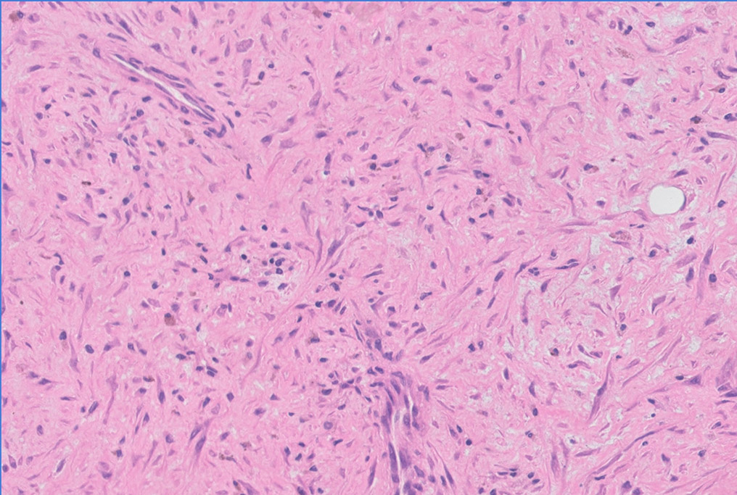 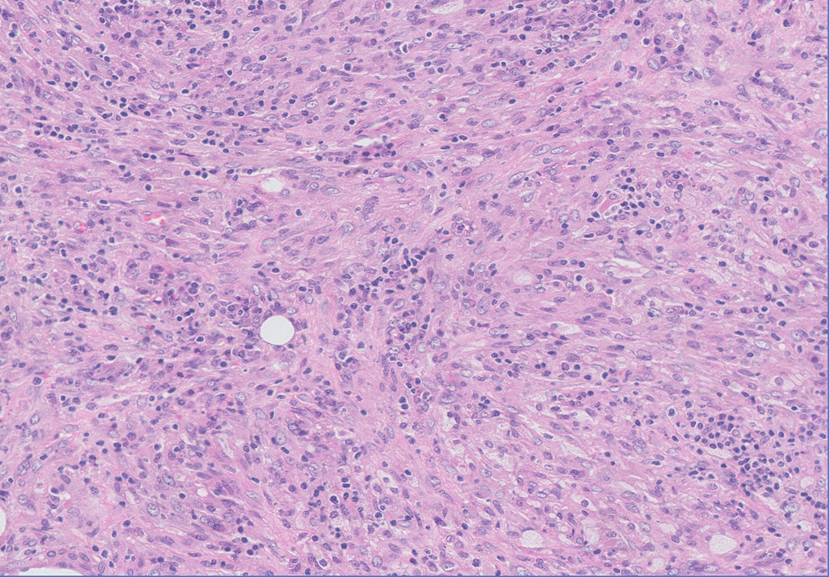

A B

**Figure 3 Pathological images of two patients.** a: Histological examination showing a proliferation of myofibroblasts and infiltration of inflammation cells (HE stain, 200 x); B: Histological examination showing a proliferation of spindled cells, likely myofibroblasts, mixed with abundant lymphocytes and plasma cells (HE stain, 200 x).

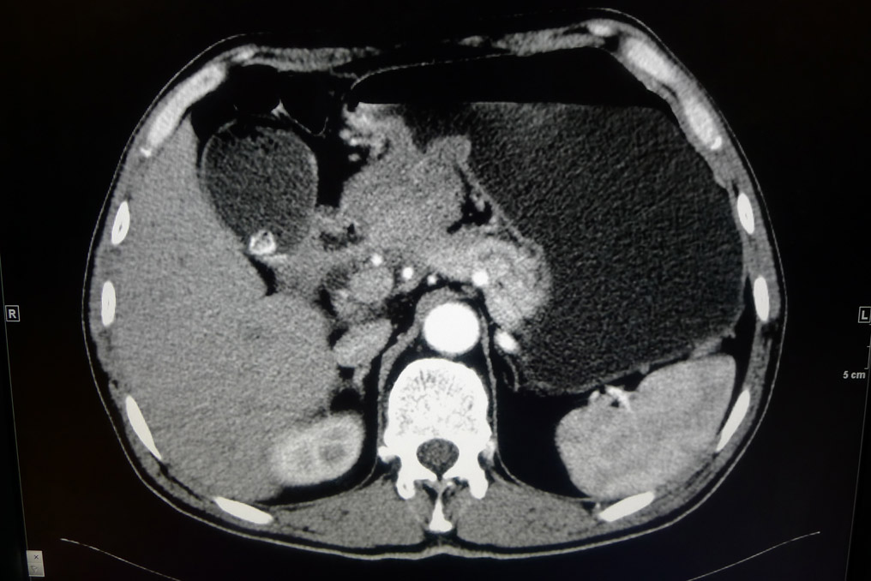 **QQ截图20140330010821.jpg**

A B

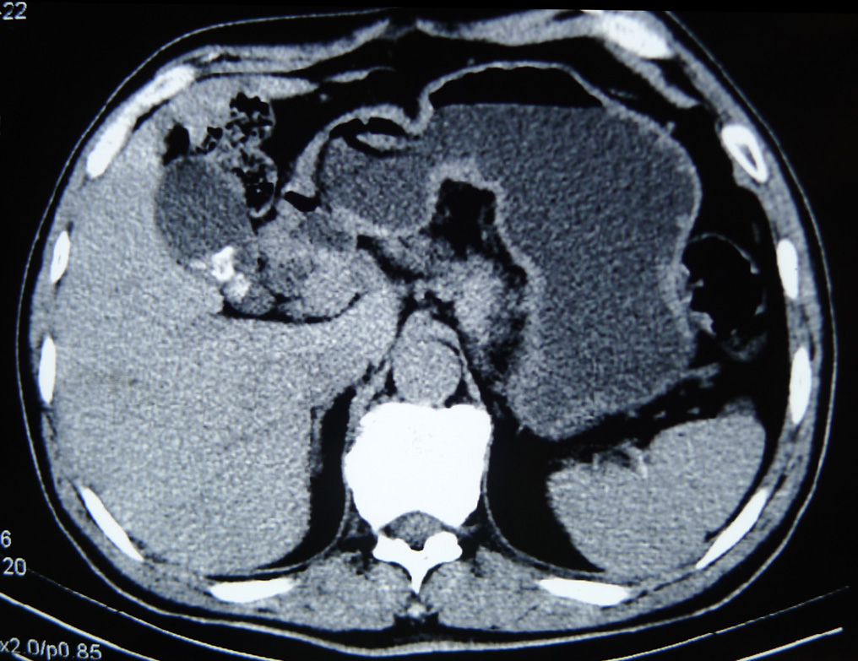

C

**Figure 4 Computed tomography/positron emission tomography-computer tomography imaging changes of patient No. 2.** a: A computed tomography (CT) scan on admission showed that the gastric wall at the antrum was clearly thickened and enhanced (white arrow) in the arterial phase. Several lymph nodes could also be observed, the biggest one being approximately 3.9 cm in diameter; b: A positron emission tomography-computer tomography on admission showed a high FDG uptake mass located at the interval between the antrum and pancreas (white arrow). The maximum standardized uptake value (SUV max) was 11.7, and the retention index was 21.8%; c: A CT scan obtained 1 mo after discharge identified the spontaneous regression of the tumor.

|  |
| --- |
| **Time of complete regression (month)**  **N0. of cases** |

**Figure 5 Time of complete regression of reported cases.** The majority of cases reported that the mass shrunk within 3 mo, and almost all patients had complete resolution in 1 year.

|  |  |  |  |
| --- | --- | --- | --- |
| **Table 1 Published reports about spontaneous regression of intra-abdominal Inflammatory myofibroblastic tumor** | | | |
| **Ref.** | **Year** | **No. of cases** | **Location** |
| Gollapudi *et al*[12] | 1992 | 1 | Liver |
| Jais *et al*[13] | 1995 | 1 | Liver |
| Su *et al*[2] | 2000 | 1 | Mesentery |
| Koea *et al*[10] | 2003 | 6 | Liver |
| Biecker *et al*[14] | 2003 | 1 | Liver |
| Thompson *et al*[15] | 2003 | 1 | Mesentery |
| Tanikawa *et al*[16] | 2003 | 1 | Peri-ureter |
| Przkora *et al*[17] | 2004 | 2 | Retro-peritoneum |
| Colakoglu *et al*[18] | 2005 | 1 | Liver |
| Koide *et al*[19] | 2006 | 1 | Liver |
| Tsou *et al*[9] | 2007 | 4 | Liver |
| Yamaguchi *et al*[20] | 2007 | 3 | Liver |
| Vassiliadis *et al*[21] | 2007 | 1 | Liver |
| Motojuku *et al*[22] | 2008 | 1 | Liver |
| Mattei *et al*[8] | 2008 | 1 | Retro-peritoneum |
| Goldsmith *et al*[23] | 2009 | 5 | Liver |
| Brage-Varela *et al*[24] | 2010 | 1 | Liver |
| Jerraya *et al*[11] | 2011 | 1 | Liver |
| Fragoso *et al*[7] | 2011 | 2 | Liver and Pancreas |
| Shatzel *et al*[1] | 2012 | 1 | Mesentery |