**Name of Journal:** *World Journal of Gastrointestinal Oncology*

**Manuscript NO:** 86202

**Manuscript Type:** ORIGINAL ARTICLE

***Basic Study***

**Hsa_circ_0136666 mediates the antitumor effect of curcumin in colorectal carcinoma by regulating *CXCL1* *via* miR-1301-3p**

Chen S *et al.* Curcumin axis on colorectal carcinoma cells

Shi Chen, Wei Li, Chen-Gong Ning, Feng Wang, Li-Xing Wang, Chen Liao, Feng Sun

**Shi Chen, Chen-Gong Ning, Feng Wang, Li-Xing Wang, Chen Liao, Feng Sun,** Department of Gastrointestinal Surgery, The Second Affiliated Hospital of Kunming Medical University, Kunming 650101, Yunnan Province, China

**Wei Li,** Department of Blood Transfusion, The Second Affiliated Hospital of Kunming Medical University, Kunming 650101, Yunnan Province, China

**Co-first authors:** Shi Chen and Wei Li.

**Author contributions:** Chen S and Li W contributed equally to this work and are co-first authors, including design of the study, acquiring and analyzing data from experiments, and writing of the actual manuscript.Chen S, Li W, Li W and Wang F conceived and designed the experiments; Liao C, Chen S, Wang F and Ning CG performed the research; Ning CG, Wang LX, and Sun F contributed to the statistical analysis; Chen S, Li W, Wang F and Ning CG wrote the paper; including design of the study, acquiring and analyzing data from experiments, and writing of the actual manuscript. All authors read and approved the final manuscript.

**Supported by** National Natural Science Foundation of China, No. 81960508; Yunnan Province Wang Bin Expert Workstation, No. 202205AF150011.

**Corresponding author:** **Feng Sun, PhD, Doctor,** Department of Gastrointestinal Surgery, The Second Affiliated Hospital of Kunming Medical University, No. 374 Yunnan-Myanmar Avenue, Wuhua District, Kunming 650101, Yunnan Province, China. sunfeng1971@163.com

**Received:** July 27, 2023

**Revised:** September 22, 2023

**Accepted:** October 16, 2023

**Published online:**

**Abstract**

BACKGROUND

This study investigate the anti-tumor effect of curcumin and whether its mediated by hsa_circ_0136666 through miR-1301-3p/*CXCL1* in colorectal carcinoma (CRC). Through multiple experiments, we have drawn the conclusion that curcumin inhibited CRC development through the hsa_circ_0136666/miR-1301-3p/*CXCL1* axis, hinting at a novel treatment option for curcumin to prevent CRC development.

AIM

To determine whether hsa_circ_0136666 involvement in curcumin-triggered CRC progression was mediated by sponging miR-1301-3p.

METHODS

Cell counting kit-8, colony-forming cell, 5-ethynyl-2’-deoxyuridine, and flow cytometry assays were carried out to determine cell proliferation, apoptosis, and cell cycle progression. Real-time quantitative polymerase chain reaction quantified hsa_circ_0136666, miR-1301-3p, and chemokine (C-X-C motif) ligand 1 (*CXCL1*), and western blot analysis determined *CXCL1*, B-cell lymphoma-2 (Bcl-2), and Bcl-2 related X protein (Bax) protein levels. CircBank or [starbase](http://starbase.sysu.edu.cn/agoClipRNA.php?source=circRNA) software was first used for the prediction of miR-1301-3p binding with hsa_circ_0136666 and *CXCL1*, followed by RNA pull-down, RNA immunoprecipitation, and dual-luciferase reporter assay validation. *In vivo* experiments were implemented in a murine xenograft model.

RESULTS

Curcumin blocked CRC cell proliferation but boosted apoptosis. Moreover, elevated hsa_circ_0136666 Levels were observed in CRC cells, which were reduced by curcumin. *In vitro*, hsa_circ_0136666 overexpression abolished the antitumor activity of CRC cells. Mechanical analysis revealed the ability of hsa_circ_0136666 to sponge miR-1301-3p to modulate *CXCL1* levels.

CONCLUSION

Curcumin inhibited CRC development through the hsa_circ_0136666/miR-1301-3p/*CXCL1* axis, hinting at a novel treatment option for curcumin to prevent CRC development.

**Key Words:** Curcumin; Hsa_circ_0136666; MiR-1301-3p; *CXCL1*; Colorectal carcinoma

Chen S, Li W, Ning CG, Wang F, Wang LX, Liao C, Sun F. Hsa_circ_0136666 mediates the antitumor effect of curcumin in colorectal carcinoma by regulating *CXCL1* *via* miR-1301-3p. *World J Gastrointest Oncol* 2023; In press

**Core Tip:** This study investigate the anti-tumor effect of curcumin and whether its mediated by hsa_circ_0136666 through miR-1301-3p/*CXCL1* in colorectal carcinoma (CRC). Through multiple experiments, we have drawn the conclusion that curcumin inhibited CRC development through the hsa_circ_0136666/miR-1301-3p/*CXCL1* axis, hinting at a novel treatment option for curcumin to prevent CRC development.

**INTRODUCTION**

Colorectal carcinoma (CRC), afflicting an estimated 104270 new cases and causing 52980 deaths in 2021 in the United States, is still considered the prime reason for cancer-related death in the United States[1,2]. Clinically, despite substantial advances made in surgical resection and adjuvant chemoradiotherapy, the conventional treatment method for CRC, the overall patient prognosis is still unfavorable[3,4]. Hence, it is urgent to find a more effective therapy that has high clinical significance for CRC patients. Currently, the chemo-preventive properties of traditional Chinese medicine have drawn great attention in cancer therapeutics. As a naturally occurring medicine, curcumin is derived from the medicinal plant *Curcuma longa L*.[5]. The salient features of curcumin include chemical stability, low toxicity, and extensive distribution, so the application of curcumin in the management of various diseases has gradually been understood[6,7]. Of note, curcumin exhibited powerful antitumor activity in diverse cancers[8-10], including CRC[11]. However, further investigation is needed regarding the mechanism through which curcumin affects CRC development.

Over the last decade, circular RNAs (circRNAs) have been identified as a novel noncoding RNA subgroup that are produced by exon or intron back-splicing and have a closed continuous loop[12,13]. CircRNAs are correlated with the initiation and development of various tumors, including CRC. For example, circ-FARSA aggravates malignant behavior by promoting CRC cell growth[14]. Consistently, circRNA_0000392 exerted oncogenic properties in CRC by regulating PIK3R3/AKT[15]. Hsa_circ_0136666 has been identified as a highly circRNA that is a carcinogenic factor in breast cancer and osteosarcoma[16,17]. Moreover, it facilitated CRC progression by enhancing cell growth and metastasis[18,19]. Interestingly, some studies indicated that curcumin could participate in the regulation of tumor progression by interacting with noncoding RNAs, including circRNAs[20,21]. However, the exact role played by hsa_circ_0136666 in curcumin-mediated CRC progression is still unclear.

Currently, the increasing focus on the competing endogenous RNA (ceRNA) hypothesis is that circRNAs serve as microRNA (miRNA) sponges to derepress target mRNA levels[22,23]. Here, some binding sites between hsa_circ_0136666 and miR-1301-3p were identified by bioinformatics analysis. In addition, miR-1301-3p has been suggested to dampen CRC cell growth ability[24]. Hence, this article aims to illuminate whether hsa_circ_0136666 involvement in curcumin-triggered CRC progression is mediated by sponging miR-1301-3p.

**MATERIALS AND METHODS**

***Cultivation of cells***

Under a consistent temperature (37 °C) and humidified atmosphere containing 5% CO2, a normal human colon mucosal epithelial cell line (NCM460, ATCC, Manassas, VA, United States) and two CRC cell strains (SW480 and SW620, ATCC) were cultivated in DMEM (PAN Biotech, Aidenbach, Germany) that was mixed with FBS (10%; HyClone, Logan, UT, United States) and penicillin/streptomycin (1%; KeyGen, Nanjing, China). In addition, 20 μM curcumin (Sigma‒Aldrich, St. Louis, MO, United States) was added to CRC cells for 24 h after dilution with dimethyl sulfoxide (DMSO, Sigma‒Aldrich).

***Cell counting kit-8 assay***

Cell viability assessment was performed as per the cell counting kit (CCK)-8 reagent (Dojindo, Osaka, Japan) guidebook. A total of 2000 cells were plated into a 96-well culture plate for curcumin (20 μM) treatment, followed by the addition of CCK-8 solution (0 μL) into each well for another 4 h after 24 h of curcumin treatment. At 450 nm, the absorbance value was determined with the use of a microplate reader.

**Colony-forming cell assay**

After incubation for 2 wk, 5 × 102 treated or untreated cells in 6-well plates were mixed with paraformaldehyde (4%) and dyed with crystal violet (0.1%). After an incubation period of 30 min, the colony number was observed using a microscope.

***Cell apoptosis assay***

Apoptosis assessment was implemented based on the Annexin V-FITC/PI Apoptosis kit (Bender Med System, Vienna, Austria) manuals. In short, tumor cells were trypsinized, followed by resuspension in binding buffer. After the addition of Annexin V-FITC and PI at volumes of 5 μL and 10 μL, respectively, a FACSCalibur (BD Biosciences, Heidelberg, Germany) was applied for apoptosis detection according to the operation manual.

***Real-time quantitative polymerase chain reaction***

In this assay, total cellular RNAs prepared by TRIzol reagent (Invitrogen, Carlsbad, CA, United States) were quantified with a NanoDrop 2000 instrument (Thermo Scientiﬁc, Waltham, MA, United States) spectrophotometer, followed by synthesis into cDNA with a PrimeScript RT reagent kit (Takara, Tokyo, Japan) and the subsequent determination of the relative gene expression with the use of a SYBR Green PCR Kit (TaKaRa). After normalization against GAPDH (for circRNA and mRNA) and U6 (for miRNA), the relative fold changes were counted with the 2–ΔΔCt formula. See Table 1 for primers.

***Cell transfection***

For hsa_circ_0136666 stable upregulation, CRC cells were transfected with hsa_circ_0136666 overexpression vector (oe-hsa_circ_0136666, Geenseed Biotech, Guangzhou, China). In addition, 40 nM each of miR-1301-3p mimic and inhibitor, as well as chemokine (C-X-C motif) ligand 1 (*CXCL1*) small interfering RNA (si-*CXCL1*) and their corresponding controls (mimic NC, inhibitor NC, si-NC), were transfected. These oligonucleotides were provided by RiboBio (Guangzhou, China). Lipofectamine 3000 reagent (Invitrogen) was utilized for transfection, and further analysis was conducted after a 48-hour incubation.

***5-Ethynyl-2’-deoxyuridine assay***

Briefly, 5-Ethynyl-2’-deoxyuridine (EdU) (50 μM, RiboBio) was placed into CRC cells (4 × 104 cells/well), followed by a 2-hour incubation. After immobilization in a formaldehyde solution (4%), the cells were treated with Apolloand 4',6-diamidino-2-phenylindole (DAPI). Finally, EdU-positive cells were counted by imaging five random fields using a fluorescence microscope (Olympus, Tokyo, Japan). Cell proliferation was calculated after normalizing the EdU-positive cell (red) count against the DAPI-stained cell (blue) count.

***Cell cycle assay***

In brief, CRC cells were trypsinized, followed by fixation in ice-cold ethanol overnight. The PBS-rinsed cells were then resuspended in PI (Bender Med System) for 30 min at 37 °C. Referring to the operation manual of FACSCalibur (BD Biosciences), the cell cycle distribution was assessed in this assay.

***Western blot analysis***

Cell lysates were prepared from 5 × 106 treated or untreated CRC cells in 6-well plates following the RIPA buffer (Beyotime, Nantong, China) instructions. After that, the specimens were subjected to SDS‒PAGE (10%) and electrotransfer onto nitrocellulose membranes (Millipore, Molsheim, France). After being probed using the primary antibodies (Abcam, Cambridge, MA, United States): B-cell lymphoma-2 (Bcl-2; ab59348, 1:1000), Bcl-2 related X protein (Bax; ab53154, 1:1000), *CXCL1* (1:100, ab206411), and β-actin (1:1000, ab8227) overnight, the immune complexes were treated with a 2-hour incubation with a secondary antibody (ab6721, 1:10000), followed by visualization with an ECL reagent (Amersham Biosciences, Pittsburg, PA, Sweden).

***RNA pull-down assay***

In short, probe-coated beads, generated by 2 h of room temperature incubation of the biotinylated hsa_circ_0136666 or NC probe (GenePharma, Shanghai, China) with magnetic beads, were incubated with SW480 and SW620 Lysates that were collected after sonication. Finally, the bead-bound RNA complexes were subjected to real-time quantitative PCR (RT-qPCR) analysis.

***RNA immunoprecipitation assay***

Briefly, SW480 and SW620 cells were cultured to 80% confluency through overnight incubation, followed by immersion in complete RNA immunoprecipitation (RIP) lysis buffer (Millipore). Then, the cell lysates were incubated with anti-Argonaute2 (Ago2) or immunoglobulin G (IgG) and 2 h of treatment with magnetic protein A/G beads. At length, the samples were isolated for RT-qPCR quantification of hsa_circ_0136666 and miR-1301-3p.

***Dual-luciferase reporter assay***

In brief, hsa_circ_0136666 and *CXCL1* 3’ untranslated region (3’UTR) segments possessing miR-1301-3p-matched regions or mismatches were introduced into the psiCHECK2 vector (Promega, Madison, WI, United States) to generate hsa_circ_0136666 wild-type (wt)/mutant-type (mut) and *CXCL1* 3’UTR wt/mut reporter vectors. Subsequently, the indicated reporter vector (50 ng) was transfected into 293T cells (Sigma‒Aldrich) with miR-1301-3p mimic or mimic NC (20 nM), followed by luciferase activity detection with the use of a dual-luciferase reporter (DLR) assay system (Promega).

***Tumor xenograft assay***

After obtaining the approval of the Animal Ethics Committee of the Second Affiliated Hospital of Kunming Medical University, we used BALB/C nude mice (Vital River Laboratory, Beijing, China) raised under a specific-pathogen-free environment for experiments. Male mice aged 5 wk were arranged in 4 groups (vector + DMSO, oe-hsa_circ_0136666 + DMSO, vector + curcumin, and oe-hsa_circ_0136666 + curcumin) with 6 mice in each group. SW480 cells (1 × 105) were transfected with vector or oe-hsa_circ_0136666, followed by subcutaneous inoculation into nude mice. Seven days later, these groups were treated with intraperitoneal DMSO or curcumin (25 mg/kg) injection twice a week. Additionally, a caliper was used to examine the tumor size once a week. All mice were euthanized on day 35 after inoculation, and their tumors were resected and weighed for further analysis. Additionally, immunohistochemical staining (IHCS) was executed in xenograft tissue sections as per the prior description[25], with Ki67- and proliferating cell nuclear antigen (PCNA)-specific antibodies to assess proliferation. In addition, section observation and image recording were performed using a BX51 system microscope (Olympus) and a digital microscope camera (DP70; Olympus), respectively.

***Enzyme-linked immunosorbent assay***

A *CXCL1*-dedicated enzyme-linked immunosorbent assay (ELISA) kit was used to quantify *CXCL1*. After curcumin (20 μM, 24 h) treatment, the culture media of SW480 and SW620 cells were collected and measured using a human *CXCL1* ELISA kit (ab190805, Abcam) according to the manufacturer’s instructions.

***Statistical methods***

Data were obtained from experiments run independently in triplicate at least with the results analyzed using GraphPad Prism 7 (GraphPad Prism software, San Diego, CA, United States), and statistical significance was indicated by *P* < 0.05. Meanwhile, the mean ± SD was used for statistical description of the data. Intergroup and multigroup differences were identified by two-tailed Student’s *t* test and one-way analysis of variance (ANOVA) with Tukey’s tests, respectively.

**RESULTS**

***Curcumin repressed CRC cell proliferation and boosted apoptosis***

First, CRC SW480 and SW620 cells were treated with 20 μM curcumin to investigate the functional role played by curcumin in CRC. The CCK-8 results showed that 20 μM curcumin intervention was not toxic to NCM460, a normal human colon mucosal epithelial cell line (Supplementary Figure 1). As presented in Figure 1A, decreased cell viability was observed due to curcumin intervention compared to both the control and DMSO-treated groups. Consistently, curcumin treatment distinctly reduced the colony number of SW480 and SW620 cells relative to their control groups (Figure 1B and C). Furthermore, the apoptosis rate in the curcumin group was markedly improved in comparison with that in the other groups (Figure 1D and E). In addition, previous studies indicated the involvement of hsa_circ_0000392, hsa_circ_0000896, and hsa_circ_0136666 in the regulation of CRC progression[26]. Interestingly, curcumin treatment significantly decreased hsa_circ_0136666 expression in SW480 and SW620 cells but had no effect on hsa_circ_0000392 or hsa_circ_0000896 expression (Figure 1F). Therefore, follow-up studies were conducted on hsa_circ_0136666. Together, these data indicated the suppressive role of curcumin in CRC development.

***Overexpression of hsa_circ_0136666 reversed curcumin-mediated CRC cell growth and apoptosis in vitro***

Subsequently, the influence of hsa_circ_013666 and curcumin on CRC cell malignant biological behaviors was determined. First, the overexpression efficiency of hsa_circ_0136666 was successful (Supplementary Figure 2A). The data suggested that hsa_circ_0136666 upregulation could abrogate the inhibition of SW480 and SW620 cell viability and colony counts by curcumin (Figure 2A-C). Similarly, the reduction in EdU-positive cells caused by curcumin was also evidently ameliorated by hsa_circ_0136666 overexpression (Figure 2D and E). In addition, curcumin treatment might block cell cycle progression in SW480 and SW620 cells, which was significantly counteracted by oe-hsa_circ_0136666 transfection (Figure 2F and G). In addition, elevated hsa_circ_0136666 significantly mitigated the positive effect of curcumin on the apoptosis rate in SW480 and SW620 cells (Figure 3A and B). Meanwhile, curcumin treatment induced a marked decrease in Bcl-2 (an anti-apoptosis factor) and a substantial increase in Bax (a pro-apoptosis factor), which was reversed by hsa_circ_0136666 enrichment (Figure 3C and D). Collectively, hsa_circ_0136666 upregulation abolished the impacts of curcumin on CRC cell growth and apoptosis.

***Hsa_circ_0136666 directly interacted with miR-1301-3p***

Then, we searched 3 potential target miRNAs of hsa_circ_0136666, namely, miR-34a-5p, miR-1301-3p, and miR-216-3p, from circBank. All these miRNAs were subjected to RNA pull-down analysis. In SW480 and SW620 cells, only miR-1301-3p was substantially pulled down by the biotinylated hsa_circ_0136666 probe (Figure 4A). In addition, the RIP assay showed that hsa_circ_0136666 and miR-1301-3p were both greatly enriched in Ago2 pellets *vs* the IgG control group (Figure 4B). Thus, miR-1301-3p was chosen for further research. Furthermore, their binding loci are presented in Figure 4C. Furthermore, the miR-1301-3p mimic transfection efficiency is displayed in Supplementary Figure 2B. Then, the DLR assay showed that the miR-1301-3p mimic could decrease hsa_circ_0136666 wt luciferase activity in 293T cells, whereas it had no obvious impact on the mutant group (Figure 4D). Moreover, miR-1301-3p was enhanced by curcumin exposure in SW480 and SW620 cells compared with their control groups (Figure 4E), implying the participation of miR-1301-3p in curcumin-mediated CRC development. Overall, miR-1301-3p acted as a direct target of hsa_circ_0136666.

***Hsa_circ_0136666 could reverse curcumin-triggered CRC cell proliferation and apoptosis by interacting with miR-1301-3p***

Next, the influence of hsa_circ_0136666/miR-1301-3p on curcumin-medicated proliferation and apoptosis was further explored. According to the RT‒qPCR assay, elevated hsa_circ_0136666 repressed miR-1301-3p levels in CRC cells, while miR-1301-3p mimic cotransfection counteracted these effects (Figure 5A). Functionally, miR-1301-3p upregulation weakened the cell growth ability-promoting effect of hsa_circ_0136666 in curcumin-treated SW480 and SW620 cells (Figure 5B-E). Similarly, hsa_circ_0136666 overexpression-induced enhancement of cell cycle progression was partly abated by miR-1301-3p upregulation in curcumin-induced SW480 and SW620 cells (Figure 5F). In addition, miR-1301-3p mimic introduction promoted the suppressive action of hsa_circ_0136666 overexpression against apoptosis in curcumin-stimulated CRC cells (Figure 5G and H), accompanied by lowered Bcl-2 and elevated Bax levels (Figure 5I and J). Overall, hsa_circ_0136666 could partly regulate proliferation and apoptosis by targeting miR-1301-3p in curcumin-treated CRC cells.

***miR-1301-3p directly targeted CXCL1***

According to starBase analysis, the *CXCL1* 3’UTR possessed some complementary loci with miR-1301-3p (Figure 6A). The DLR assay suggested that miR-1301-3p upregulation significantly hindered *CXCL1* 3’UTR reporter luciferase activity but not the mutant group (Figure 6B). Notably, *CXCL1* Levels were significantly downregulated by curcumin treatment in CRC cells (Figure 6C). Moreover, ELISA showed that *CXCL1* levels were obviously reduced by curcumin treatment in CRC cells (Supplementary Figure 3A). Moreover, elevated hsa_circ_0136666 could facilitate *CXCL1* protein levels in CRC cells, and miR-1301-3p upregulation distinctly attenuated this effect (Figure 6D), implying the ability of hsa_circ_0136666 to modulate *CXCL1* by sponging miR-1301-3p. Meanwhile, ELISA showed that hsa_circ_0136666 overexpression might increase *CXCL1* secretion in CRC cells, which was reversed by miR-1301-3p overexpression (Supplementary Figure 3B). Overall, *CXCL1* acted as a direct target of miR-1301-3p.

***miR-1301-3p knockdown reversed the curcumin-induced increase in CRC cell growth and decrease in apoptosis by targeting CXCL1***

The roles played by miR-1301-3p and *CXCL1* in curcumin-mediated proliferation and apoptosis were explored. Simultaneously, the introduction of miR-1301-3p inhibitor and si-*CXCL1* into SW480 and SW620 cells was performed, followed by transfection efficiency assessment (Figure 7A and B). Meanwhile, ELISA showed that the introduction of si-*CXCL1* might reduce *CXCL1* secretion in SW480 and SW620 cells (Supplementary Figure 3C). In addition, reduced miR-1301-3p could reinforce the *CXCL1* protein level, while the cotransfection of si-*CXCL1* counteracted the effect in SW480 and SW620 cells (Figure 7C). Additionally, ELISA showed that *CXCL1* downregulation might significantly abolish the promotion of *CXCL1* secretion by the miR-1301-3p inhibitor (Supplementary Figure 3D). Functionally, the augmented cell proliferative ability and cell cycle progression induced by miR-1301-3p downregulation were significantly relieved by *CXCL1* knockdown in curcumin-treated SW480 and SW620 cells (Figure 7D-H). In addition, the introduction of si-*CXCL1* abolished the negative action of miR-1301-3p knockdown against apoptosis in curcumin-exposed CRC cells (Figure 7I and J), manifested as decreased Bcl-2 and increased Bax levels (Figure 7K and L). In summary, miR-1301-3p regulated proliferation and apoptosis by interacting with *CXCL1* in curcumin-treated CRC cells.

***Curcumin repressed CRC cell growth by regulating hsa_circ_0136666 in vivo***

We established mouse xenograft models of CRC to validate the functional effect of hsa_circ_0136666 and curcumin on *in vivo* tumor growth. As indicated by Figure 8A and B, curcumin could distinctly dampen tumor growth (reduced tumor volume and weight), whereas the overexpression of hsa_circ_0136666 partially attenuated these effects in xenografts (Figure 8A and B). Furthermore, our data showed that curcumin injection could abate hsa_circ_0136666 and *CXCL1* Levels in tumor tissues derived from oe-hsa_circ_0136666-transfected SW480 cells (Figure 8C). Synchronously, miR-1301-3p displayed an opposite trend in this xenograft (Figure 8C and D). In addition, IHCS revealed that Ki-67 and PCNA (standard proliferation markers) levels were dampened by hsa_circ_0136666 deficiency in this xenograft (Figure 8E). Together, curcumin suppressed CRC cell growth by regulating hsa_circ_0136666 *in vivo*.

**DISCUSSION**

In this research, the role and mechanism of curcumin in CRC development were explored. Here, we found that curcumin repressed CRC cell proliferation and boosted apoptosis and first verified that it was associated with the hsa_circ_0136666/miR-1301-3p/*CXCL1* regulatory network.

Work in several laboratories has revealed that curcumin, a natural polyphenolic compound, presents antioxidant, anti-inflammatory, and anticancer properties[27-29]. Recently, it has become evident that curcumin can repress tumor progression in a variety of cancers[30,31]. In terms of CRC, some studies have indicated that curcumin is a novel agent to prevent cancer development[32-34]. In this regard, the present study suggested the antiproliferative and pro-apoptotic actions of curcumin on CRC, consistent with previous reports[35,36]. Notably, previous documents discovered that circRNAs might be a potential mechanism through which curcumin modulates tumor development[20,21]. In this paper, we found that curcumin could reduce hsa_circ_0136666 levels in CRC cells for the first time. Moreover, recent studies have described that hsa_circ_0136666 acts as a carcinogenic factor by accelerating proliferation and metastasis in CRC[19,37]. Functional analysis suggested that overexpressing hsa_circ_0136666 abolished the curcumin-triggered decline in CRC cell proliferative ability and augmentation of apoptosis *in vitro*. As expected, hsa_circ_0136666 upregulation also partly reversed the repressive action of curcumin on CRC cell growth *in vivo.* That is, the regulatory role of curcumin in the development of CRC might be correlated with hsa_circ_0136666.

CircRNAs are mostly stable transcripts with a large number of miRNA-binding loci, enabling them to act as miRNA sponges to repress miRNA modulation of downstream target genes in various human cancers[38,39]. In the current work, we first identified the role of miR-1301-3p as a novel miRNA target of hsa_circ_0136666. Similarly, miR-1301-3p was verified as a tumor-associated miRNA in thyroid papillary, breast, and bladder cancers[40-42]. miR-1301-3p has also been demonstrated to impede CRC cell proliferation and induce apoptosis[24]. Consistent with previous work, miR-1301-3p downregulation was also proven in CRC cells. Interestingly, we observed enhanced miR-1301-3p by curcumin. Furthermore, upregulating miR-1301-3p reversed the effects of hsa_circ_0136666 on curcumin-treated CRC cell growth and apoptosis. These findings imply that curcumin can hinder CRC development by a ceRNA effect of hsa_circ_0136666 and miR-1301-3p.

Analogously, the possible miR-1301-3p-interacting target gene was searched based on bioinformatics, and *CXCL1* was validated. *CXCL1* is a chemokine of epithelial origin in rodents and humans that elevates tumor epithelia-stromal interactions and boosts tumor growth and invasion[43]. Further studies have shown that *CXCL1* plays a tumorigenic role in multiple cancers[44,45], including CRC[46]. Meanwhile, the participation of *CXCL1* in the modulation of malignant tumor progression by curcumin has been demonstrated[47,48]. In concordance with these findings, *CXCL1* was identified to be downregulated by curcumin treatment. Synchronously, the miR-1301-3p inhibitor enhanced cell growth and repressed apoptosis in curcumin-stimulated CRC cells by targeting *CXCL1*. Additionally, hsa_circ_0136666 modulated *CXCL1* by sponging miR-1301-3p, further verifying that hsa_circ_0136666 regulation of tumor development can be mediated through miR-1301-3p/*CXCL1* signaling.

**CONCLUSION**

Hsa_circ_0136666 relieves curcumin-induced CRC cell growth and apoptosis partly *via* miR-1301-3p/*CXCL1* signaling. This study elucidates a new mechanism of curcumin and sheds light on developing a new therapeutic for CRC treatment.

**ARTICLE HIGHLIGHTS**

***Research background***

Colorectal carcinoma (CRC) is the most frequent-occurring malignant tumour in the United States. Curcumin exerts anti-tumor activity in CRC, but the underlying mechanism needs further elucidation. Meanwhile, over the last decade, circular RNAs (circRNAs) is correlated with the initiation and development of various tumors, containing CRC. Also, the increasing focus on the competing endogenous RNAs hypothesis is that circRNAs serve as microRNA sponges to derepress target mRNAs’ levels.

***Research motivation***

Clinically, it is urgent to find a more effective therapy, which has high clinical significance for CRC patients. Currently, the chemo-preventive properties of traditional Chinese medicine have drawn great attention in cancer therapeutics. As a naturally occurring medicine, curcumin is derived from the medical plant *Curcuma longa L*. However, it needs further investigation regarding the mechanism through which curcumin affects CRC development.

***Research objectives***

This study aims at illuminating whether hsa_circ_0136666 involvement on curcumin-triggered CRC progression was mediated *via* sponging miR-1301-3p.

***Research methods***

CRC cells were adopted and treated with 20 μM curcumin for 24 h. Then, for hsa_circ_0136666 stably upregulation, CRC cells were treated with hsa_circ_0136666 overexpression vector transfection or miR-1301-3p mimic and inhibitor. Real-time quantitative PCR was used to quantified the expression of hsa_circ_0136666, miR-1301-3p and *CXCL1*. Cell counting kit-8, colony-forming cell, 5-ethynyl-2’-deoxyuridine, and flow cytometry assays were carried out to determine cell proliferation, apoptosis, and cell cycle progression. The relationship between hsa_circ_0136666, miR-1301-3p and *CXCL1* were validated by RNA pull-down, RIP, and dual-luciferase reporter assay. *In vivo* experiments were implemented by the murine xenograft model.

***Research results***

Curcumin treatment could distinctly reduce the colony number of SW480 and SW620 cells relative to their control groups. Furthermore, the apoptosis rate in the curcumin group was markedly improved in comparison with other groups Interestingly, curcumin treatment significantly decreased hsa_circ_0136666 in SW480 and SW620 but had no effect on hsa_circ_0000392 and hsa_circ_0000896 expression. These data indicated the suppressive role of curcumin on CRC development. hsa_circ_0136666 upregulation could abolish the impacts of curcumin on CRC cell growth and apoptosis. Meanwhile, miR-1301-3p acted as a direct target of hsa_circ_0136666 and miR-1301-3p directly targeted *CXCL1*. Hsa_circ_0136666 could reverse curcumin-triggered CRC cell proliferation and apoptosis by interacting with miR-1301-3p while miR-1301-3p knockdown overturned curcumin-induced increase in CRC cell growth and decrease in apoptosis by targeting *CXCL1*. Curcumin repressed CRC cell growth *via* regulating hsa_circ_0136666 *in vivo.*

***Research conclusions***

Curcumin repressed CRC cell proliferation and boosted apoptosis, and first verified it was associated with the regulatory network of the hsa_circ_0136666/miR-1301-3p/*CXCL1*. Hsa_circ_0136666 relieves curcumin-induced CRC cell growth and apoptosis partly *via* the miR-1301-3p/*CXCL1* signaling.

***Research perspectives***

This study elucidates a new mechanism of curcumin and sheds light on developing a new therapeutic for CRC treatment.

**REFERENCES**

1 **Siegel RL**, Miller KD, Fuchs HE, Jemal A. Cancer statistics, 2022. *CA Cancer J Clin* 2022; **72**: 7-33 [PMID: 35020204 DOI: 10.3322/caac.21708]

2 **Siegel RL**, Jakubowski CD, Fedewa SA, Davis A, Azad NS. Colorectal Cancer in the Young: Epidemiology, Prevention, Management. *Am Soc Clin Oncol Educ Book* 2020; **40**: 1-14 [PMID: 32315236 DOI: 10.1200/EDBK_279901]

3 **Baidoun F**, Elshiwy K, Elkeraie Y, Merjaneh Z, Khoudari G, Sarmini MT, Gad M, Al-Husseini M, Saad A. Colorectal Cancer Epidemiology: Recent Trends and Impact on Outcomes. *Curr Drug Targets* 2021; **22**: 998-1009 [PMID: 33208072 DOI: 10.2174/1389450121999201117115717]

4 **Cardoso R**, Guo F, Heisser T, De Schutter H, Van Damme N, Nilbert MC, Christensen J, Bouvier AM, Bouvier V, Launoy G, Woronoff AS, Cariou M, Robaszkiewicz M, Delafosse P, Poncet F, Walsh PM, Senore C, Rosso S, Lemmens VEPP, Elferink MAG, Tomšič S, Žagar T, Marques ALM, Marcos-Gragera R, Puigdemont M, Galceran J, Carulla M, Sánchez-Gil A, Chirlaque MD, Hoffmeister M, Brenner H. Overall and stage-specific survival of patients with screen-detected colorectal cancer in European countries: A population-based study in 9 countries. *Lancet Reg Health Eur* 2022; **21**: 100458 [PMID: 35832063 DOI: 10.1016/j.lanepe.2022.100458]

5 **Ming T**, Tao Q, Tang S, Zhao H, Yang H, Liu M, Ren S, Xu H. Curcumin: An epigenetic regulator and its application in cancer. *Biomed Pharmacother* 2022; **156**: 113956 [PMID: 36411666 DOI: 10.1016/j.biopha.2022.113956]

6 **Mari M**, Carrozza D, Ferrari E, Asti M. Applications of Radiolabelled Curcumin and Its Derivatives in Medicinal Chemistry. *Int J Mol Sci* 2021; **22** [PMID: 34299029 DOI: 10.3390/ijms22147410]

7 **Abd El-Hack ME**, El-Saadony MT, Swelum AA, Arif M, Abo Ghanima MM, Shukry M, Noreldin A, Taha AE, El-Tarabily KA. Curcumin, the active substance of turmeric: its effects on health and ways to improve its bioavailability. *J Sci Food Agric* 2021; **101**: 5747-5762 [PMID: 34143894 DOI: 10.1002/jsfa.11372]

8 **Termini D**, Den Hartogh DJ, Jaglanian A, Tsiani E. Curcumin against Prostate Cancer: Current Evidence. *Biomolecules* 2020; **10** [PMID: 33182828 DOI: 10.3390/biom10111536]

9 **Ashrafizadeh M**, Najafi M, Makvandi P, Zarrabi A, Farkhondeh T, Samarghandian S. Versatile role of curcumin and its derivatives in lung cancer therapy. *J Cell Physiol* 2020; **235**: 9241-9268 [PMID: 32519340 DOI: 10.1002/jcp.29819]

10 **Rutz J**, Janicova A, Woidacki K, Chun FK, Blaheta RA, Relja B. Curcumin-A Viable Agent for Better Bladder Cancer Treatment. *Int J Mol Sci* 2020; **21** [PMID: 32466578 DOI: 10.3390/ijms21113761]

11 **Pricci M**, Girardi B, Giorgio F, Losurdo G, Ierardi E, Di Leo A. Curcumin and Colorectal Cancer: From Basic to Clinical Evidences. *Int J Mol Sci* 2020; **21** [PMID: 32235371 DOI: 10.3390/ijms21072364]

12 **Liu CX**, Chen LL. Circular RNAs: Characterization, cellular roles, and applications. *Cell* 2022; **185**: 2016-2034 [PMID: 35584701 DOI: 10.1016/j.cell.2022.04.021][](https://sci-hub.se/10.1016/j.cell.2022.04.021)

13 **Lei M**, Zheng G, Ning Q, Zheng J, Dong D. Translation and functional roles of circular RNAs in human cancer. *Mol Cancer* 2020; **19**: 30 [PMID: 32059672 DOI: 10.1186/s12943-020-1135-7]

14 **Lu C**, Fu L, Qian X, Dou L, Cang S. Knockdown of circular RNA circ-FARSA restricts colorectal cancer cell growth through regulation of miR-330-5p/LASP1 axis. *Arch Biochem Biophys* 2020; **689**: 108434 [PMID: 32473899 DOI: 10.1016/j.abb.2020.108434]

15 **Xu H**, Liu Y, Cheng P, Wang C, Liu Y, Zhou W, Xu Y, Ji G. CircRNA_0000392 promotes colorectal cancer progression through the miR-193a-5p/PIK3R3/AKT axis. *J Exp Clin Cancer Res* 2020; **39**: 283 [PMID: 33317596 DOI: 10.1186/s13046-020-01799-1]

16 **Liu LH**, Tian QQ, Liu J, Zhou Y, Yong H. Upregulation of hsa_circ_0136666 contributes to breast cancer progression by sponging miR-1299 and targeting CDK6. *J Cell Biochem* 2019; **120**: 12684-12693 [PMID: 30993801 DOI: 10.1002/jcb.28536]

17 **Zhang C**, Zhou H, Yuan K, Xie R, Chen C. Overexpression of hsa_circ_0136666 predicts poor prognosis and initiates osteosarcoma tumorigenesis through miR-593-3p/ZEB2 pathway. *Aging (Albany NY)* 2020; **12**: 10488-10496 [PMID: 32424109 DOI: 10.18632/aging.103273]

18 **Li Y**, Zang H, Zhang X, Huang G. circ_0136666 Facilitates the Progression of Colorectal Cancer *via* miR-383/CREB1 Axis. *Cancer Manag Res* 2020; **12**: 6795-6806 [PMID: 32821160 DOI: 10.2147/CMAR.S251952]

19 **Jin C**, Wang A, Liu L, Wang G, Li G. Hsa_circ_0136666 promotes the proliferation and invasion of colorectal cancer through miR-136/SH2B1 axis. *J Cell Physiol* 2019; **234**: 7247-7256 [PMID: 30370521 DOI: 10.1002/jcp.27482]

20 **Xie W**, Chu M, Song G, Zuo Z, Han Z, Chen C, Li Y, Wang ZW. Emerging roles of long noncoding RNAs in chemoresistance of pancreatic cancer. *Semin Cancer Biol* 2022; **83**: 303-318 [PMID: 33207266 DOI: 10.1016/j.semcancer.2020.11.004]

21 **Yang J**, Zhu D, Liu S, Shao M, Liu Y, Li A, Lv Y, Huang M, Lou D, Fan Q. Curcumin enhances radiosensitization of nasopharyngeal carcinoma by regulating circRNA network. *Mol Carcinog* 2020; **59**: 202-214 [PMID: 31793078 DOI: 10.1002/mc.23143]

22 **Panda AC**. Circular RNAs Act as miRNA Sponges. *Adv Exp Med Biol* 2018; **1087**: 67-79 [PMID: 30259358 DOI: 10.1007/978-981-13-1426-1_6]

23 **Verduci L**, Strano S, Yarden Y, Blandino G. The circRNA-microRNA code: emerging implications for cancer diagnosis and treatment. *Mol Oncol* 2019; **13**: 669-680 [PMID: 30719845 DOI: 10.1002/1878-0261.12468]

24 **Xu G**, Wang H, Yuan D, Yao J, Meng L, Li K, Zhang Y, Dang C, Zhu K. RUNX1-activated upregulation of lncRNA RNCR3 promotes cell proliferation, invasion, and suppresses apoptosis in colorectal cancer *via* miR-1301-3p/AKT1 axis *in vitro* and in vivo. *Clin Transl Oncol* 2020; **22**: 1762-1777 [PMID: 32239427 DOI: 10.1007/s12094-020-02335-5]

25 **Jiang G**, Wu AD, Huang C, Gu J, Zhang L, Huang H, Liao X, Li J, Zhang D, Zeng X, Jin H, Huang H, Huang C. Isorhapontigenin (ISO) Inhibits Invasive Bladder Cancer Formation In Vivo and Human Bladder Cancer Invasion In Vitro by Targeting STAT1/FOXO1 Axis. *Cancer Prev Res (Phila)* 2016; **9**: 567-580 [PMID: 27080594 DOI: 10.1158/1940-6207.CAPR-15-0338]

26 **Zhang S**, Sun J, Gu M, Wang G, Wang X. Circular RNA: A promising new star for the diagnosis and treatment of colorectal cancer. *Cancer Med* 2021; **10**: 8725-8740 [PMID: 34796685 DOI: 10.1002/cam4.4398]

27 **Hasanzadeh S**, Read MI, Bland AR, Majeed M, Jamialahmadi T, Sahebkar A. Curcumin: an inflammasome silencer. *Pharmacol Res* 2020; **159**: 104921 [PMID: 32464325 DOI: 10.1016/j.phrs.2020.104921]

28 **Fernández-Lázaro D**, Mielgo-Ayuso J, Seco Calvo J, Córdova Martínez A, Caballero García A, Fernandez-Lazaro CI. Modulation of Exercise-Induced Muscle Damage, Inflammation, and Oxidative Markers by Curcumin Supplementation in a Physically Active Population: A Systematic Review. *Nutrients* 2020; **12** [PMID: 32075287 DOI: 10.3390/nu12020501]

29 **Koroth J**, Nirgude S, Tiwari S, Gopalakrishnan V, Mahadeva R, Kumar S, Karki SS, Choudhary B. Investigation of anti-cancer and migrastatic properties of novel curcumin derivatives on breast and ovarian cancer cell lines. *BMC Complement Altern Med* 2019; **19**: 273 [PMID: 31638975 DOI: 10.1186/s12906-019-2685-3]

30 **Zhang X**, Zhang C, Ren Z, Zhang F, Xu J, Zhang X, Zheng H. Curcumin Affects Gastric Cancer Cell Migration, Invasion and Cytoskeletal Remodeling Through Gli1-β-Catenin. *Cancer Manag Res* 2020; **12**: 3795-3806 [PMID: 32547215 DOI: 10.2147/CMAR.S244384]

31 **Ohnishi Y**, Sakamoto T, Zhengguang L, Yasui H, Hamada H, Kubo H, Nakajima M. Curcumin inhibits epithelial-mesenchymal transition in oral cancer cells *via* c-Met blockade. *Oncol Lett* 2020; **19**: 4177-4182 [PMID: 32391111 DOI: 10.3892/ol.2020.11523]

32 **Weng W**, Goel A. Curcumin and colorectal cancer: An update and current perspective on this natural medicine. *Semin Cancer Biol* 2022; **80**: 73-86 [PMID: 32088363 DOI: 10.1016/j.semcancer.2020.02.011]

33 **Ruiz de Porras V**, Layos L, Martínez-Balibrea E. Curcumin: A therapeutic strategy for colorectal cancer? *Semin Cancer Biol* 2021; **73**: 321-330 [PMID: 32942023 DOI: 10.1016/j.semcancer.2020.09.004]

34 **Gupta MK**, Vadde R, Sarojamma V. Curcumin - A Novel Therapeutic Agent in the Prevention of Colorectal Cancer. *Curr Drug Metab* 2019; **20**: 977-987 [PMID: 31589120 DOI: 10.2174/1389200220666191007153238]

35 **Calibasi-Kocal G**, Pakdemirli A, Bayrak S, Ozupek NM, Sever T, Basbinar Y, Ellidokuz H, Yigitbasi T. Curcumin effects on cell proliferation, angiogenesis and metastasis in colorectal cancer. *J BUON* 2019; **24**: 1482-1487 [PMID: 31646795]

36 **Ismail NI**, Othman I, Abas F, H Lajis N, Naidu R. Mechanism of Apoptosis Induced by Curcumin in Colorectal Cancer. *Int J Mol Sci* 2019; **20** [PMID: 31108984 DOI: 10.3390/ijms20102454]

37 **Wang G**, Li Y, Zhu H, Huo G, Bai J, Gao Z. Circ-PRKDC Facilitates the Progression of Colorectal Cancer Through miR-198/DDR1 Regulatory Axis. *Cancer Manag Res* 2020; **12**: 12853-12865 [PMID: 33364834 DOI: 10.2147/CMAR.S273484]

38 **Misir S**, Hepokur C, Aliyazicioglu Y, Enguita FJ. Circular RNAs serve as miRNA sponges in breast cancer. *Breast Cancer* 2020; **27**: 1048-1057 [PMID: 32715419 DOI: 10.1007/s12282-020-01140-w]

39 **Zhou J**, Wang L, Sun Q, Chen R, Zhang C, Yang P, Tan Y, Peng C, Wang T, Jin C, Ji J, Jin K, Sun Y. Hsa_circ_0001666 suppresses the progression of colorectal cancer through the miR-576-5p/PCDH10 axis. *Clin Transl Med* 2021; **11**: e565 [PMID: 34841662 DOI: 10.1002/ctm2.565]

40 **Peng X**, Yan B, Shen Y. MiR-1301-3p inhibits human breast cancer cell proliferation by regulating cell cycle progression and apoptosis through directly targeting ICT1. *Breast Cancer* 2018; **25**: 742-752 [PMID: 29951881 DOI: 10.1007/s12282-018-0881-5]

41 **Qiao DH**, He XM, Yang H, Zhou Y, Deng X, Cheng L, Zhou XY. miR-1301-3p suppresses tumor growth by downregulating PCNA in thyroid papillary cancer. *Am J Otolaryngol* 2021; **42**: 102920 [PMID: 33454555 DOI: 10.1016/j.amjoto.2021.102920]

42 **Liu Y**, Wu G. NNT-AS1 enhances bladder cancer cell growth by targeting miR-1301-3p/PODXL axis and activating Wnt pathway. *Neurourol Urodyn* 2020; **39**: 547-557 [PMID: 31782983 DOI: 10.1002/nau.24238]

43 **Miyake M**, Lawton A, Goodison S, Urquidi V, Rosser CJ. Chemokine (C-X-C motif) ligand 1 (CXCL1) protein expression is increased in high-grade prostate cancer. *Pathol Res Pract* 2014; **210**: 74-78 [PMID: 24252309 DOI: 10.1016/j.prp.2013.08.013]

44 **Wang N**, Liu W, Zheng Y, Wang S, Yang B, Li M, Song J, Zhang F, Zhang X, Wang Q, Wang Z. CXCL1 derived from tumor-associated macrophages promotes breast cancer metastasis *via* activating NF-κB/SOX4 signaling. *Cell Death Dis* 2018; **9**: 880 [PMID: 30158589 DOI: 10.1038/s41419-018-0876-3]

45 **Yu S**, Yi M, Xu L, Qin S, Li A, Wu K. CXCL1 as an Unfavorable Prognosis Factor Negatively Regulated by DACH1 in Non-small Cell Lung Cancer. *Front Oncol* 2019; **9**: 1515 [PMID: 31998654 DOI: 10.3389/fonc.2019.01515]

46 **Wang D**, Sun H, Wei J, Cen B, DuBois RN. CXCL1 Is Critical for Premetastatic Niche Formation and Metastasis in Colorectal Cancer. *Cancer Res* 2017; **77**: 3655-3665 [PMID: 28455419 DOI: 10.1158/0008-5472.CAN-16-3199]

47 **Howells LM**, Iwuji COO, Irving GRB, Barber S, Walter H, Sidat Z, Griffin-Teall N, Singh R, Foreman N, Patel SR, Morgan B, Steward WP, Gescher A, Thomas AL, Brown K. Curcumin Combined with FOLFOX Chemotherapy Is Safe and Tolerable in Patients with Metastatic Colorectal Cancer in a Randomized Phase IIa Trial. *J Nutr* 2019; **149**: 1133-1139 [PMID: 31132111 DOI: 10.1093/jn/nxz029]

48 **Killian PH**, Kronski E, Michalik KM, Barbieri O, Astigiano S, Sommerhoff CP, Pfeffer U, Nerlich AG, Bachmeier BE. Curcumin inhibits prostate cancer metastasis *in vivo* by targeting the inflammatory cytokines CXCL1 and -2. *Carcinogenesis* 2012; **33**: 2507-2519 [PMID: 23042094 DOI: 10.1093/carcin/bgs312]

**Footnotes**

**Institutional review board statement:** This study did not involve any human studies.

**Institutional animal care and use committee statement:** The experimental protocol was approved by the Animal Care and Use Committee of The Second Affiliated Hospital of Kunming Medical University.

**Conflict-of-interest statement:** All the authors report no relevant conflicts of interest for this article.

**Data sharing statement:** No additional data are available.

**ARRIVE guidelines statement:** The authors have read the ARRIVE guidelines, and the manuscript was prepared and revised according to the ARRIVE guidelines.

**Open-Access:** This article is an open-access article that was selected by an in-house editor and fully peer-reviewed by external reviewers. It is distributed in accordance with the Creative Commons Attribution NonCommercial (CC BY-NC 4.0) license, which permits others to distribute, remix, adapt, build upon this work non-commercially, and license their derivative works on different terms, provided the original work is properly cited and the use is non-commercial. See: https://creativecommons.org/Licenses/by-nc/4.0/

**Provenance and peer review:** Unsolicited article; Externally peer reviewed.

**Peer-review model:** Single blind

**Peer-review started:** July 27, 2023

**First decision:** August 8, 2023

**Article in press:**

**Specialty type:** Cardiac and cardiovascular systems

**Country/Territory of origin:** China

**Peer-review report’s scientific quality classification**

Grade A (Excellent): 0

Grade B (Very good): B

Grade C (Good): C

Grade D (Fair): 0

Grade E (Poor): 0

**P-Reviewer:** Garcia K, Spain; Schijven MP, Netherlands **S-Editor:** Lin C **L-Editor: P-Editor:**

**Figure Legends**

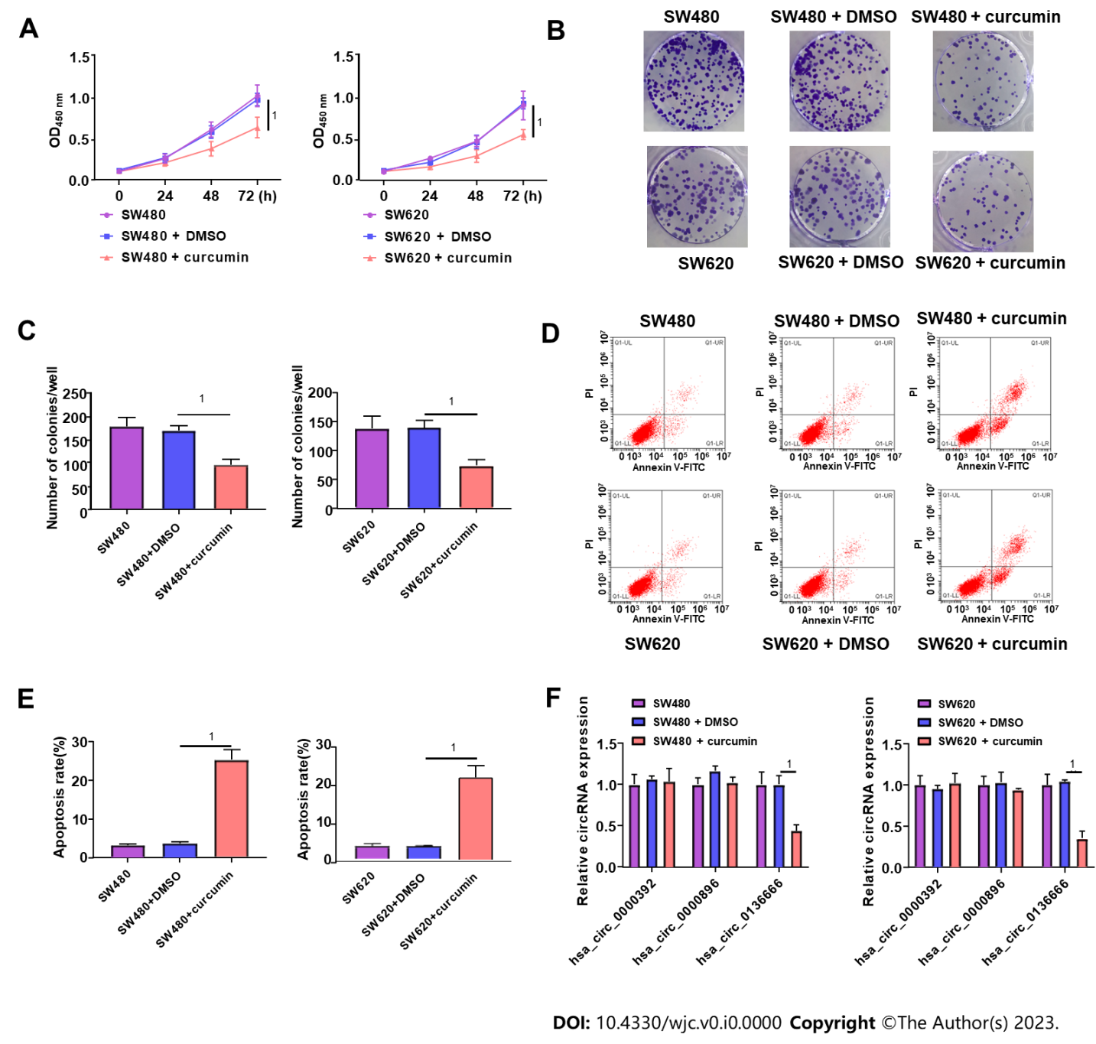

**Figure 1 The impacts of curcumin treatment on colorectal carcinoma (SW480 and SW620) cell proliferation and apoptosis.** Colorectal carcinoma (CRC) cells were treated with DMSO or curcumin (20 μM). A: Cell viability was detected in treated or untreated SW480 and SW620 using cell counting kit-8 assays; B and C: Colony number assessment by colony-forming cell assays in treated or untreated SW480 and SW620; D and E: Apoptosis rate analysis in treated or untreated CRC cells by flow cytometry assays; F: Real-time quantitative PCR analysis of hsa_circ_0000392, hsa_circ_0000896, and hsa_circ_0136666 expression in treated or untreated SW480 and SW620 cells. 1*P* < 0.05.

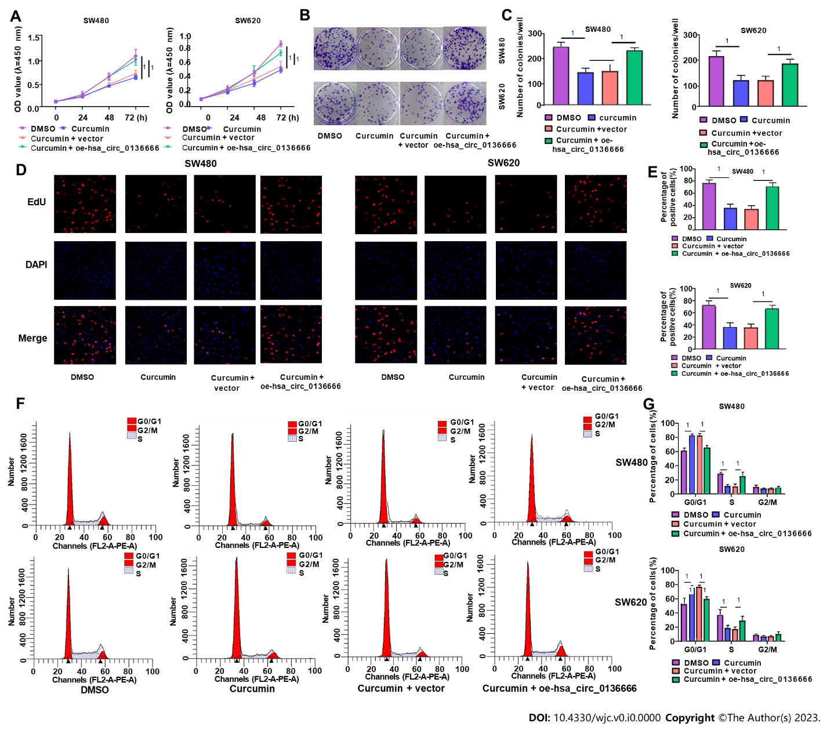

**Figure 2 Overexpressing hsa_circ_0136666 overturned the effect of curcumin on proliferation in colorectal carcinoma SW480 and SW620 cells.** Colorectal carcinoma cells were treated with DMSO, curcumin, curcumin + vector, and curcumin + oe-hsa_circ_0136666. A: Cell counting kit-8 assays examined SW480 and SW620 cell viability after treatment; B and C: Colony-forming cell assays detected colony numbers in treated SW480 and SW620; D and E: 5-Ethynyl-2’-deoxyuridine assays measured positive cells in treated SW480 and SW620; F and G: Flow cytometry assays analyzed cell cycle distribution in treated SW480 and SW620. 1*P* < 0.05.

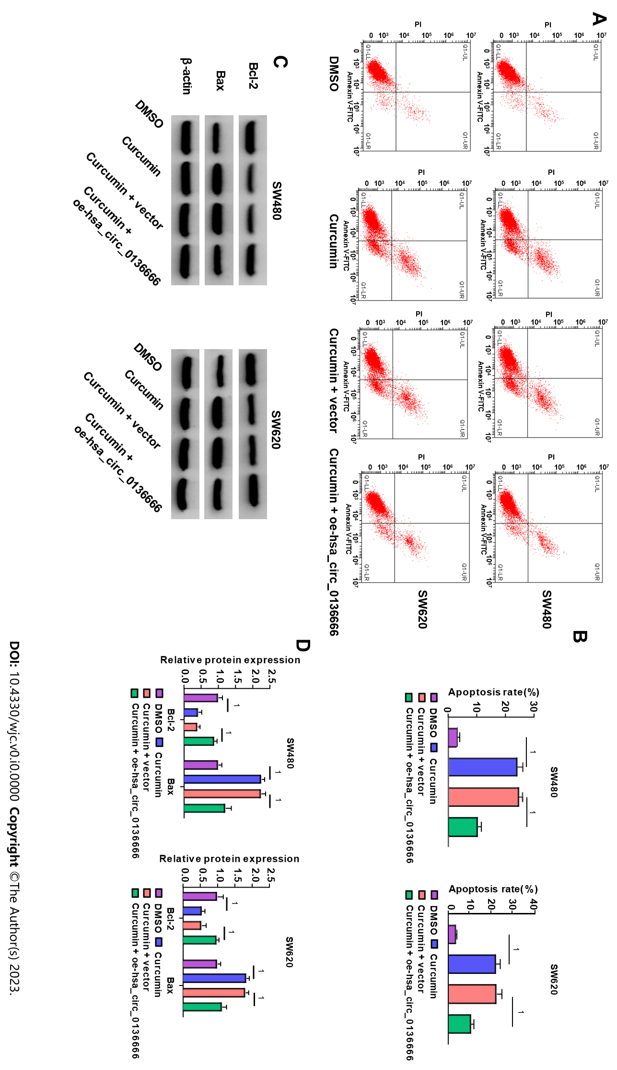

**Figure 3 Upregulating hsa_circ_0136666 overturned curcumin-mediated apoptosis promotion in colorectal carcinoma cells.** SW480 and SW620 were treated with DMSO, curcumin, curcumin + vector, and curcumin + oe-hsa_circ_0136666. A and B: Flow cytometry assays tested apoptosis rate in treated SW480 and SW620; C and D: Western blot assays determined Bcl-2 and Bax protein levels in treated SW480 and SW620. 1*P* < 0.05.

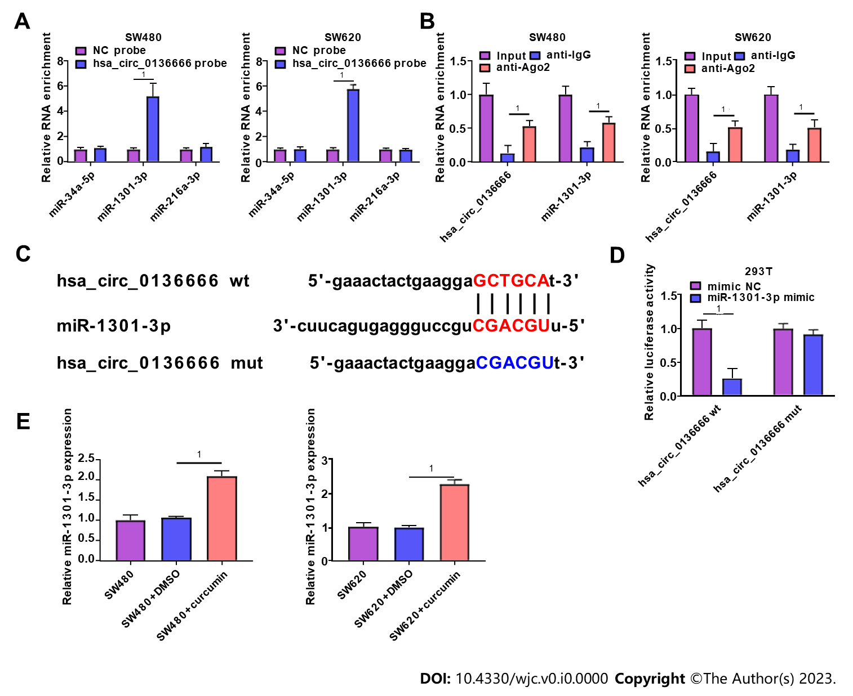

**Figure 4** **Hsa_circ_0136666 directly bound to miR-1301-3p.** A: Real-time quantitative PCR (RT-qPCR) measured relative levels of 3 miRNA candidates in SW480 and SW620 lysates; B: RNA immunoprecipitation assays assessed miR-1301-3p endogenously associated with hsa_circ_0136666 in SW480 and SW620 extracts; C: Binding loci between hsa_circ_0136666 and miR-1301-3p and the hsa_circ_0136666 mut sequence; D: The binding relationship was verified by a dual-luciferase reporter assay; E: RT-qPCR assays quantified miR-1301-3p in SW480, SW480 + DMSO, SW480 + curcumin, SW620, SW620 + DMSO, and SW620 + curcumin. 1*P* < 0.05. wt: Wild-type; mut: Mutant-type.

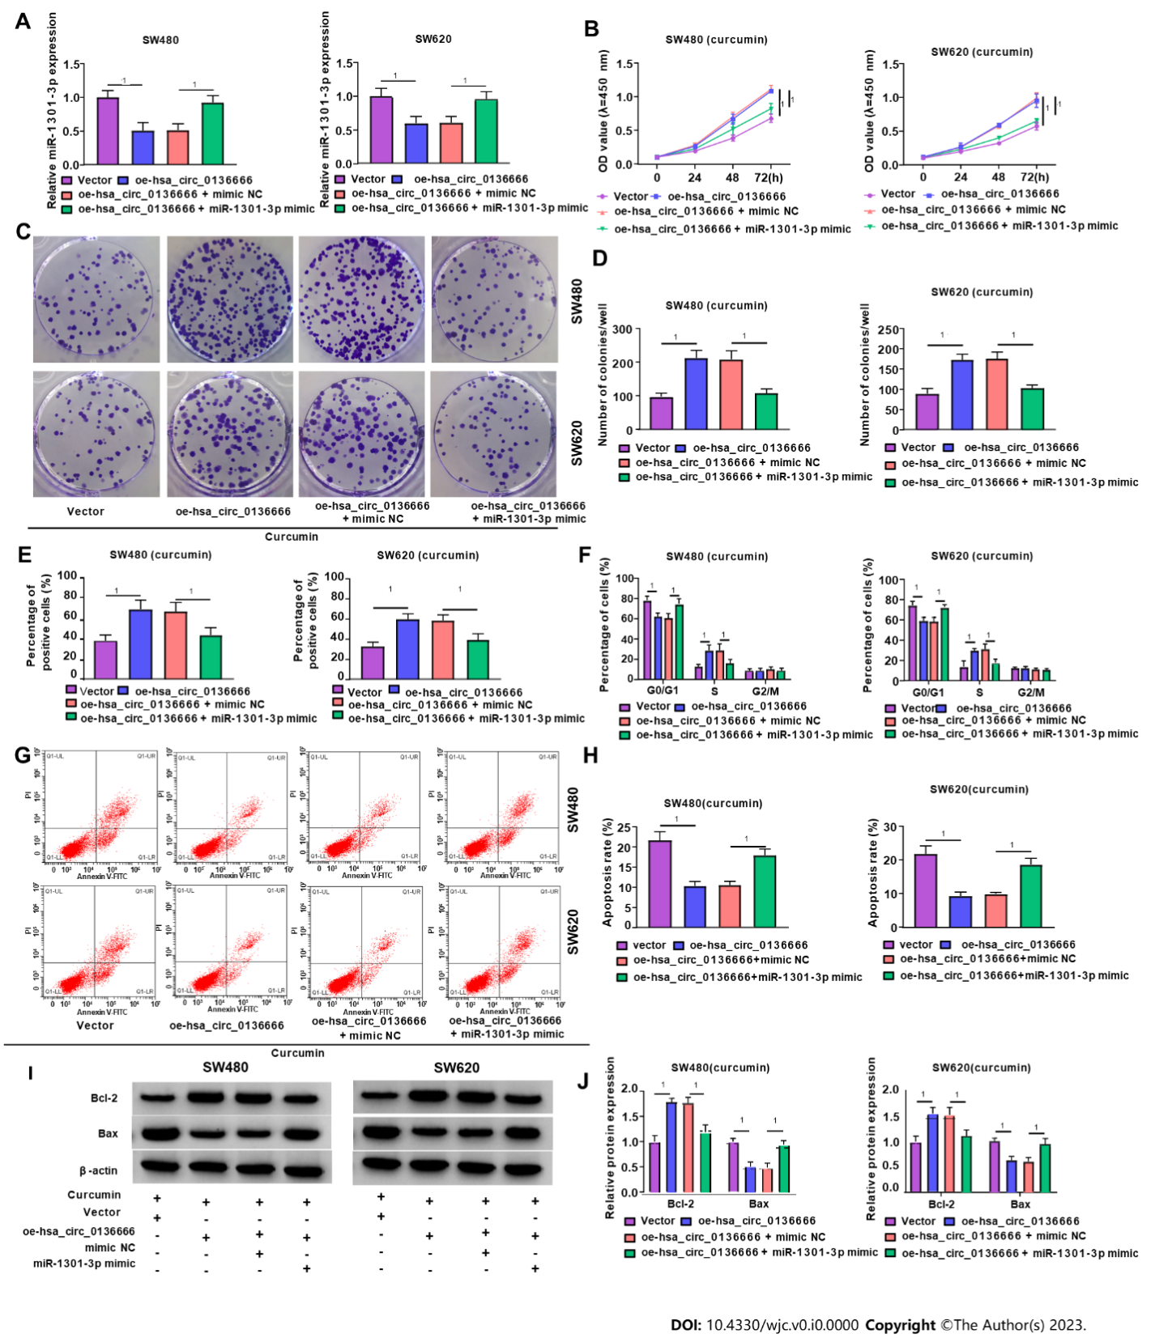

**Figure 5** **miR-1301-3p overturned the effect of hsa_circ_0136666 on growth and apoptosis in curcumin-treated colorectal carcinoma cells.** A: Real-time quantitative PCR assays quantified miR-1301-3p levels in SW480 and SW620 transfected with vector, oe-hsa_circ_0136666, oe-hsa_circ_0136666+mimic NC, and oe-hsa_circ_0136666 + miR-1301-3p mimic; B-J: Colorectal carcinoma cells were intervened by curcumin after transfection; B: Cell counting kit-8 assays measured cell viability; C and D: Colony-forming cell assays determined the colony number; E: 5-Ethynyl-2’-deoxyuridine assays examined positive cell count; F: Flow cytometry assays determined cell cycle distribution; G and H: Flow cytometry assays tested apoptosis; I and J: Western blot assays quantified Bcl-2 and Bax protein levels. 1*P* < 0.05.

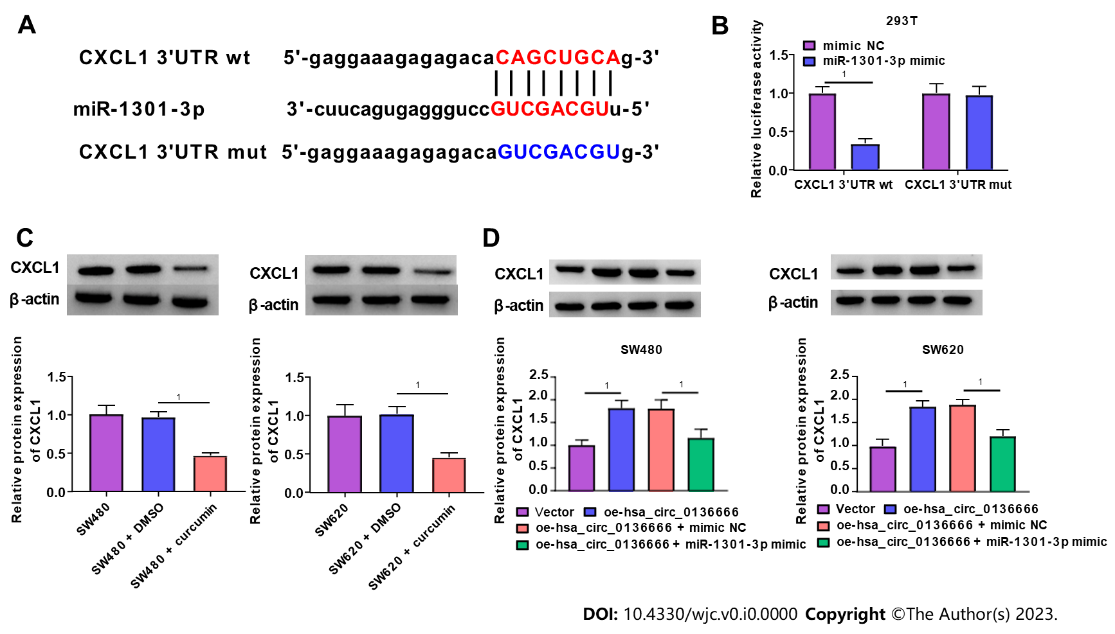

**Figure 6 *CXCL1* was miR-1301-3p’s direct target.** A: Putative binding sequences between miR-1301-3p and *CXCL1* 3’UTR, and mutant sites in *CXCL1* 3’UTR mut; B: Validation of prediction by dual-luciferase reporter assay; C: Western blot assay quantification of *CXCL1* protein in SW480, SW480 + DMSO, SW480 + curcumin, SW620, SW620 + DMSO, and SW620 + curcumin; D: Western blot assay quantification of *CXCL1* protein in SW480 and SW620 transfected with vector, oe-hsa_circ_0136666, oe-hsa_circ_0136666 + mimic NC, and oe-hsa_circ_0136666 + miR-1301-3p mimic. 1*P* < 0.05. 3’UTR: 3’ untranslated region; wt: Wild-type; mut: Mutant-type.

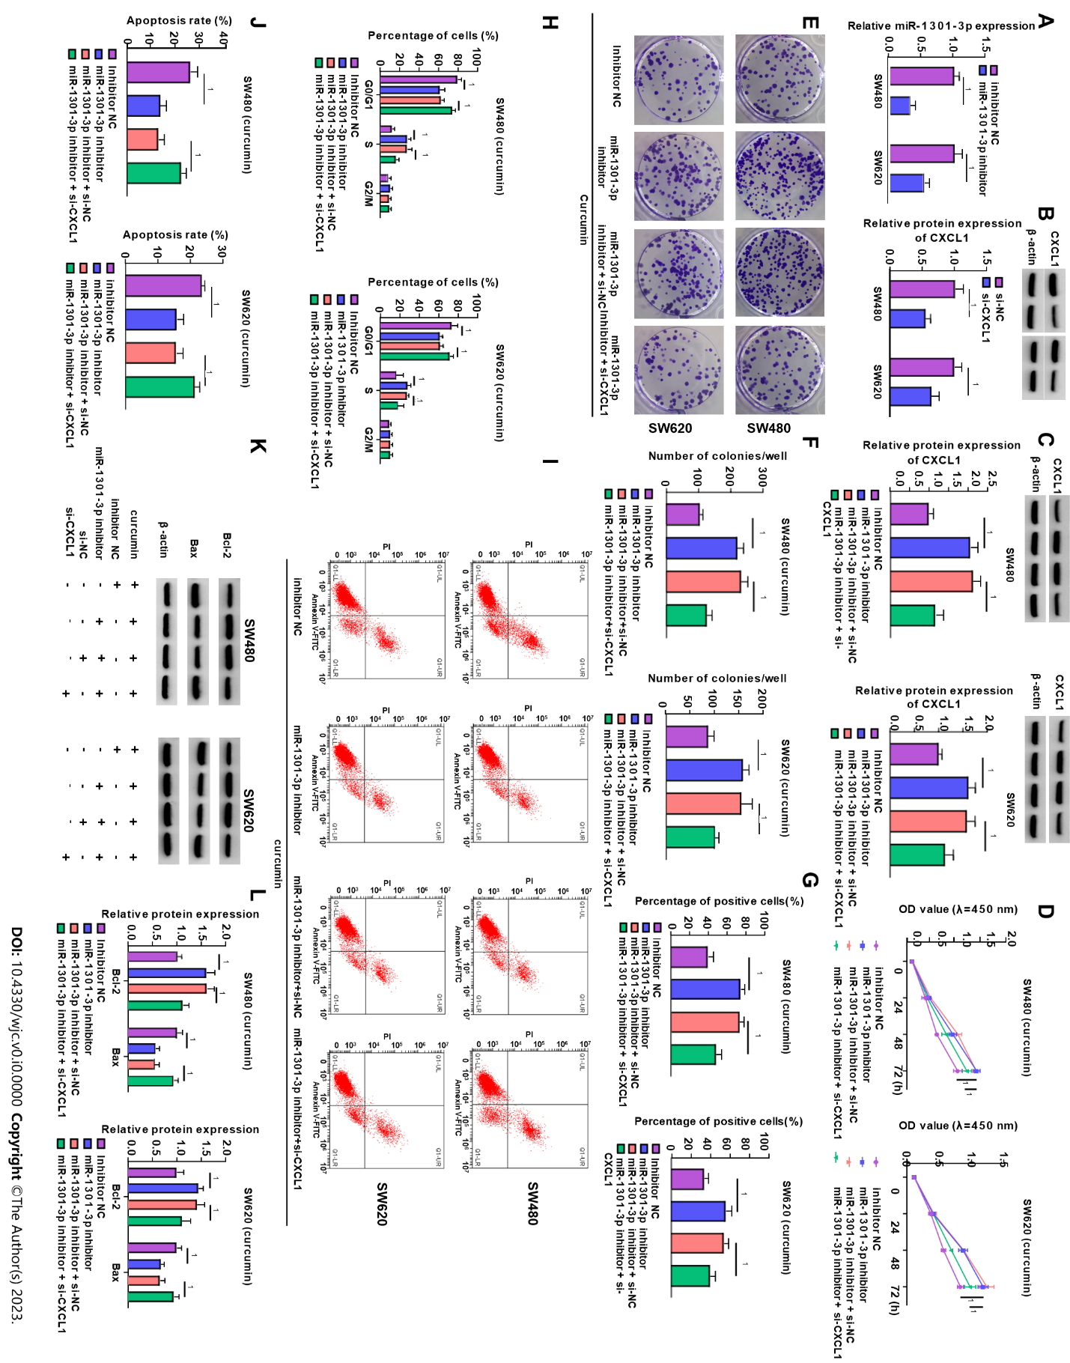

**Figure 7** **Downregulating *CXCL1* abrogated the influence of miR-1301-3p knockdown on curcumin-triggered colorectal carcinoma cell proliferation and apoptosis.** A: Real-time quantitative PCR assay measurement of miR-1301-3p in inhibitor NC and miR-1301-3p inhibitor-transfected SW480 and SW620; B: Western blot assay of *CXCL1* protein in si-NC or si-*CXCL1*-transfected SW480 and SW620; C: Western blot assay of *CXCL1* protein in SW480 and SW620 after inhibitor NC, miR-1301-3p inhibitor, miR-1301-3p inhibitor + si-NC and miR-1301-3p inhibitor + si-*CXCL1* transfection; D-L: Colorectal carcinoma cells were intervened by curcumin after transfection; D: Cell counting kit-8 assay of cell viability; E and F: Colony-forming cell assay of colony number; G: 5-Ethynyl-2’-deoxyuridine assay of positive cells; H: Flow cytometry assay of cell cycle distribution; I and J: Flow cytometry assay of apoptosis; K and L: Western blot assay of Bcl-2 and Bax protein levels. 1*P* < 0.05.

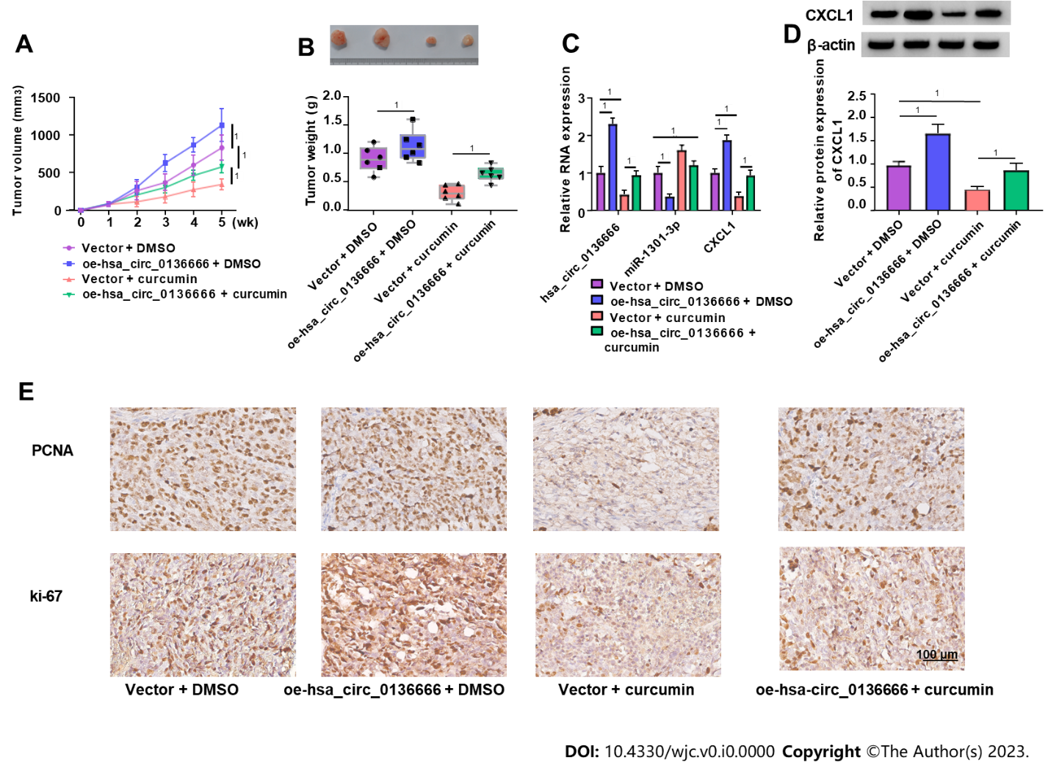

**Figure 8 Overexpressing hsa_circ_0136666 abolished the repression of curcumin on colorectal carcinoma growth *in vivo.*** The nude mice were subcutaneously inoculated with SW480 introduced with vector or oe-hsa_circ_0136666, followed by intraperitoneal curcumin (25 mg/kg) injection one week later. A and B: Tumour volume and tumour weight measurements in the xenografts; C: Real-time quantitative PCR assay quantification of hsa_circ_0136666, miR-1301-3p, and *CXCL1* in xenografts; D: Western blot assay of *CXCL1* protein in xenografts; E: Immunohistochemical staining of Ki-67 and proliferating cell nuclear antigen expression in xenografts. 1*P* < 0.05. PCNA: Proliferating cell nuclear antigen.

**Table 1 Primer sequences for real-time quantitative PCR**

|  |  |
| --- | --- |
| **Names** | **Sequences (5’-3’)** |
| hsa_circ_0136666: Forward | AGGTGCTCACTGTGCTGAAA |
| hsa_circ_0136666: Reverse | CAGATGTTCATTGGGTCCAT |
| hsa_circ_0000896: Forward | ACTTCATTGAGAGCTCCTTCTGG |
| hsa_circ_0000896: Reverse | CTTCAGAGTCCTCGAAGGAAGA |
| hsa_circ_0000392: Forward | TCAAGTTACTGAGAAGAAAAAGCTG |
| hsa_circ_0000392: Reverse | GTCCTCGAGGCACTCACAAT |
| miR-1301-3p: Forward | TTACAGCTGCCTGAGAGTGACTTA |
| miR-1301-3p: Reverse | CTCTACAGCTATATTGCCAGCCA |
| miR-34a-5p: Forward | TCCGAGTGGCAGTGTCTTAG |
| miR-34a-5p: Reverse | CTCAACTGGTGTCGTGGAG |
| miR-216a-3p: Forward | ATAGTCACAGTGGTCTCTGG |
| miR-216a-3p: Reverse | CTCAACTGGTGTCGTGGAG |
| *CXCL1*: Forward | AACCGAAGTCATAGCCACAC |
| *CXCL1*: Reverse | GTTGGATTTGTCACTGTTCAGC |
| U6: Forward | CTCGCTTCGGCAGCACA |
| U6: Reverse | AACGCTTCACGAATTTGCGT |
| GAPDH: Forward | GGTCACCAGGGCTGCTTT |
| GAPDH: Reverse | GGAAGATGGTGATGGGATT |