Name of Journal: World Journal of Transplantation
Manuscript NO: 40337
Manuscript Type: MINIREVIEWS

Early urological complications after kidney transplantation: An overview

Buttigieg J et al. Urological complications after kidney transplantation

Jesmar Buttigieg, Andrei Agius-Anastasi, Ajay Sharma, Ahmed Halawa

Jesmar Buttigieg, Renal Division, Mater Dei Hospital, Msida MSD2090, Malta

Jesmar Buttigieg, Ajay Sharma, Ahmed Halawa, Faculty of Health and Science, Institute of Learning and Teaching, University of Liverpool, Liverpool L69 3BX, United Kingdom

Andrei Agius-Anastasi, Department of Medicine, Mater Dei Hospital, Msida MSD2090, Malta

Ajay Sharma, Department of Transplantation, Royal Liverpool University Hospital, Liverpool L7 8XP, United Kingdom

Ahmed Halawa, Department of Transplantation, Sheffield Teaching Hospitals, Sheffield S10 2JF, United Kingdom

ORCID number: Jesmar Buttigieg (0000-0001-8180-0162); Andrei Agius-Anastasi (0000-0002-7143-2869); Ajay Sharma (0000-0003-4050-6586); Ahmed Halawa (0000-0002-7305-446X).

Author contributions: All authors equally contributed to this paper with conception and design of the study, literature review and analysis, drafting and critical revision and editing, and final approval of the final version.

Conflict-of-interest statement: No potential conflicts of interest.

Open-Access: This article is an open-access article which was selected by an in-house editor and fully peer-reviewed by external reviewers. It is distributed in accordance with the Creative Commons Attribution Non Commercial (CC BY-NC 4.0) license, which permits others to distribute, remix, adapt, build upon this work non-commercially, and license their derivative works on different terms, provided the original work is properly cited and the use is non-commercial. See: http://creativecommons.org/licenses/by-nc/4.0/

Manuscript source: Unsolicited manuscript

Correspondence to: Ahmed Halawa, FRCS (Gen Surg), MD, MSc, Surgeon, Consultant Transplant Surgeon, Department of Transplantation, Sheffield Teaching Hospitals, Glossop Rd, Sheffield S10 2JF, United Kingdom. ahmed.halawa@liverpool.ac.uk
Telephone: +44-114-2269696

Received: June 16, 2018
Peer-review started: June 16, 2018
First decision: July 8, 2018
Revised: July 21, 2018
Accepted: August 6, 2018
Article in press:
Published online:

Abstract
Urological complications, especially urine leaks, remain the commonest type of surgical complication in the early post-transplant period. Despite major advances in the field of transplantation, a small minority of kidney transplants are still being lost due to urological problems. Many of these complications can be traced back to the time of retrieval and implantation. Serial ultrasound examination of the transplanted graft in the early post-operative period is of key importance for early detection. The prognosis is generally excellent if recognised and managed in a timely fashion. The purpose of this narrative review is to discuss the different presentations, compare various ureterovesical anastomosis techniques and provide a basic overview for the management of post-transplant urological complications.

Key words: Anastomotic leak; Urinoma/s; Postoperative complications; Ureterostomy; Nephrostomy

© The Author(s) 2018. Published by Baishideng Publishing Group Inc. All rights reserved.

Core tip: Urological complications, especially urine leaks, remain the commonest type of surgical complication following kidney transplantation. Preservation of the peri-ureteric tissue during kidney retrieval, Lich-Gregoir ureteroneocystostomy technique and routine prophylactic ureteral stenting has been shown to decrease the incidence of these complications. Routine post-operative allograft ultrasound is important for their early detection. The majority of recipients can be effectively managed percutaneously, avoiding the morbidity associated with open surgery. The prognosis is generally excellent if recognised and treated successfully in a timely manner.

Buttigieg J, Agius-Anastasi A, Sharma A, Halawa A. Early urological complications after kidney transplantation: An overview. World J Transplant 2018; In press

INTRODUCTION
Kidney transplantation remains the best renal replacement modality for most patients with end-stage kidney disease^{[1]}. Yet, as with everything else in the medical field, it is not devoid of risk. The patients, who manage to get a kidney transplant in a timely fashion, face a constant struggle for successful long-lasting survival. The vast majority of graft failure is attributed to alloimmune mediated injury, recurrent glomerulonephritis, infections, cardiovascular mortality and malignancy^{[2,3]}. Nonetheless, a number of renal allografts are lost due to urological complications, especially in the early post-transplant period. The purpose of this review is to discuss different presentations and provide an evidence based management plan for patients who present with such complications.

OUTLINE OF SURGICAL AND UROLOGICAL COMPLICATIONS
Complications in the immediate post-transplant period can be broadly subdivided into vascular, urological, fluid collections and wound healing problems. Vascular complications encompass haemorrhage, thrombosis, aneurysm, dissection and stenosis, whilst urological complications mainly involve leaks and/or obstruction of the collecting system^{[4,5]}. In essence, haematomas form due to poor tissue handling, insecure knot tying and inadequate haemostasis. The lymphoceles result from severed lymph channels, which should be tied or clipped rather than diathermised, leading to extravasation of lymph. Urine leaks can result in formation of urinomas. These collections can compress vascular structures or urine outflow causing transplant dysfunction. In addition, urine leaks are associated with increased risk of surgical site infection which can lead to peri-nephric abscesses^{[6,7]}. Wound healing complications are generally more common when mammalian target of rapamycin (mTOR) based immunosuppression is used^{[8]}.
Ultrasonography is the first-line imaging modality for graft evaluation in the immediate post-transplant period, especially when suspecting vascular problems, fluid collections and/or obstruction^{[9,10]}. Apart from being non-invasive, it can provide some additional information on the graft function by measuring the intra-renal resistivity indices^{[11]}. Differentiating between different types of collections on ultrasound can be difficult. A urinoma usually appears as a well-defined, rapidly enlarging non-echoic fluid collection without septations, whereas a haematoma usually has a complex and echogenic appearance with numerous septations^{[9,12]}. Computed tomography may assist in the diagnosis by further elucidating the ultrasound findings such as the extent or exact relationship of the fluid collection to the transplanted kidney^{[10]}. ^{99m}TC-MAG-3 radionuclide isotope scan is useful to confirm the presence of a urine leak outside the anatomical space of the urinary tract, as the radionuclide tracer accumulates in the excreted urine as opposed to other type of fluid collections^{[13]}. A cystogram can provide additional information to establish the exact site of urine leak, especially if it is at the ureterovesical junction (Figure 1). Antegrade pyelography performed during nephrostomy tube insertion remains the investigation of choice to identify the exact site and extent of urine leak. Ultrasound and/or computed tomography guided needle aspiration followed by biochemical and bacteriological analysis is essential in diagnosing the exact aetiology of fluid collections^{[4]}. A fluid creatinine which is well above the serum level indicates a urine leak as opposed to a lymphocele which has levels similar to that of serum. Gram stain and cultures are important because any fluid collection can potentially become infected^{[6]}.

RISK FACTORS AND PRESENTATION OF URINE LEAKS
The incidence of urological complications following kidney transplantation as portrayed in early studies (i.e., including patients between 1970-1990s) ranged between 4.2% to 14.1%^{[14-18]}, whilst in later studies (i.e., including patients between 1990-2000) ranged between 3.7% to 6.0%^{[19-21]}. The incidence of urine leaks described in studies which included patients between 1990s and 2000 era ranged between 1.5% to 6.0%^{[19-23]}. This variability is probably a reflection of the different transplantation era, diagnostic tools and surgical proficiency. Indeed, the incidence of urological complications has been shown to diminish considerably with increasing centre experience^{[24]}. These complications are associated with significant patient morbidity, including graft loss and mortality^{[17,25]}.
Urine leaks generally present in the immediate or early post-transplant period (3 mo)^{[26]}. Clinical presentation can include pain and swelling in the transplant area, rising creatinine, oliguria and/or signs of systemic infection^{[27]}. In the immediate post-transplant period, urine leaks can manifest via the drains or through the wound leading to delayed healing and increased risk of infection^{[7,28]}. In addition, leaking urine can translocate into the retroperitoneal space, pelvis and occasionally in the pre-sacral and scrotal area^{[29]}. The leaking of infected urine could lead to peri-nephric infections and abscess formation. This is important considering that urinary tract infections occur in about 23% of patients receiving a kidney transplant^{[30]}.
Most urological complications can be traced back to technical errors during retrieval, bench dissection or implantation^{[28]}. The vast majority of leaks occur at the distal portion of the ureter, most commonly at the site of the ureteroneocystostomy^{[26]}. Distal ureteral ischaemia and necrosis secondary to compromised blood supply is thought to be the main culprit for early ureteral complications in most patients in the absence of technical difficulties during the transplant operation^{[31]}. In contrast to the native ureters, which derive their blood supply via both renal arteries and pelvic collaterals, the transplanted ureter depends solely on the blood supplied by the branches of the renal artery that traverse in peri-ureteric tissues. This area, also known as the “golden triangle” (Figure 2), contains important arterial branches, such as the lower polar artery, which supply the distal ureter. Indeed, the importance of preserving the peri-ureteral connective tissue in order to prevent disastrous urinary complications is well documented in the literature^{[14,32-35]}. Male donors, male recipients, African American recipients, Taguchi technique, graft arterial reconstruction, multiple renal arteries and recipient diabetes were established as independent risk factors for urinary complications^{[36-39]}. We believe that gentle handling of the ureter and peri-ureteric tissue, and keeping the length of the ureter as short as possible without tension is of key importance. A ureter which appears ischaemic after reperfusion should be resected proximally until an adequately perfused area is reached. In this situation, achieving a tension free urinary anastomosis may require special techniques such as ipsilateral uretero-ureterostomy (joining the transplant ureter to the native ureter of that side), pyelovesicostomy, psoas hitch, Boari flap or fashioning of an ileal ureter in that order of priority. In general, the risk of urinary complications following laparoscopic donor nephrectomy has decreased substantially over time, now comparable to open nephrectomy^{[40]}.
The ureterovesical anastomosis associated with the lowest rate of complications continues to be a subject of debate. The Leadbetter-Politano technique (Figure 3) was primarily used in the early days of kidney transplantation^{[41]}. This has been largely superseded by the less technically demanding Lich-Gregoir technique (Figure 4)^{[42]}. The Taguchi technique (Figure 5) has been associated with unacceptably higher incidence of complications compared to the Lich-Gregoir technique^{[43,44]}. In a recent meta-analysis which included two randomised controlled studies and 24 observational studies, the Lich-Gregoir technique was found to significantly reduce the incidence of ureteral leaks when compared to the Leadbetter-Politano and Taguchi techniques^{[45]}. The incidence of ureteral stricture and reflux, however, did not differ significantly. The use of a shorter ureter and the avoidance of a separate cystostomy are two hypothetical advantages over the Leadbetter-Politano technique^{[46]}. A modification of Lich-Gregoir technique, using a short muscular tunnel over the distal ureter, has been shown to reduce complications in two separate retrospective studies^{[46,47]}. In one Chinese study, primary termino-terminal ipsilateral ureteroureterostomy, was associated with significantly less urinary fistulas when compared to the established Lich-Gregoir technique^{[23]}.
Currently, many centres adopted the routine use of ureteric stent during kidney transplantation. A meta-analysis which included 7 randomised controlled studies, confirmed that routine prophylactic stenting is generally well tolerated and significantly reduce major urological complications^{[48]}. In a recently published Cochrane database systematic review, it was established that 13 transplant recipients need to be treated (with using JJ stent) in order to prevent one major urological complication^{[48]}. Despite some opposition due to higher incidence of urinary tract infections, current evidence recommends the routine use of prophylactic stenting.

MANAGEMENT OF URINARY LEAKS
In general, one can select between two main approaches (conservative vs. reconstructive surgery) depending on the site, cause and extent of the leak. One has to keep in mind that these treatment strategies are not based on robust scientific evidence and tend to vary between centres based on anecdotal experiences. The current best available evidence is merely based on retrospective studies.
Conservative approach typically involves insertion of a percutaneous nephrostomy followed by antegrade stenting of the collecting system (unless already performed during the transplant operation), together with a Foley catheter replacement. Retrograde stenting of a transplant ureter is technically demanding and often impossible, even by most skilled urologists, because of the atypical position of the ureteric orifice. Antegrade stenting, although generally easier, can still pose technical challenge in absence of pelvi-caliceal dilatation. Interventional radiologists and transplant surgeons can work together to manage difficult cases^{[49]}. This procedure diverts the urinary flow away from the leaking site and, thereby, fully decompresses the collecting system in order to allow for healing to take place. The Foley catheter is usually removed once the leak has resolved. Many centres report stent deployment for a period of 6-12 wk^{[14,33,35,46]}. The presence of recurrent urinary tract infection may hasten the time for stent removal.
Surgical exploration is required if urine leak fails to resolve following maximal decompression, especially when dealing with major urine extravasations or necrotic ureters. During the surgical procedure, the necrotic ureter should be resected proximally until healthy tissue is reached, followed by re-implantation. If the remaining viable ureter is short, an ipsilateral uretero-ureterostomy, pyelovesicostomy, psoas hitch, Boari flap or fashioning of an ileal ureter are alternative techniques which could be employed for tension free ureteric anastomosis^{[50]}. A psoas hitch (Figure 6) involves extensive dissection and mobilization of urinary bladder to allow mobilisation towards the transplant ureter, usually up to 5 cm. Subsequently the bladder is anchored to the ipsilateral psoas muscle. Alternatively, a Boari flap (Figure 7) can be fashioned to attain an additional 10 cm. If required, this can be used in conjunction with the psoas hitch technique in order to bridge larger gaps between the short transplant ureter and the bladder. Contracted or atrophic urinary bladders in anuric patients seriously limit these options. In this circumstance, an ipsilateral uretero-ureterostomy can be an alternative option if the cause of native kidney failure was not reflux disease. A pyelovesicostomy or an ileal ureter can be fashioned, the latter being preferred for larger gaps, in situations where no donor or recipient ureter can be salvaged^{[51]}. Both these techniques are devoid of an anti-reflux mechanism. Some patients may require more than one surgical procedure in order to correct the underlying problem^{[23]}. In all cases, serial ultrasound examinations together with close monitoring of the transplant excretory function is of chief importance in order to anticipate any secondary ureteral strictures.
Traditionally, urine leaks have been corrected by open reconstruction. Over the last two decades, advances in interventional radiology have allowed several patients to be effectively managed percutaneously, avoiding the morbidity associated with open surgery^{[49,52]}. This conservative approach has been shown to be successful in a number of retrospective studies, with a success rate varying between 30% and 87%^{[19,21,53-55]}. This considerable inter-centre variability is probably related to different baseline characteristics. We believe that the outcome largely depends on the aetiology, site and extent of the urine leak. In general, small leaks at the ureter implantation site tend to do well with conservative management, whilst extensive leaks especially if related to ureter necrosis do better with open surgery. When in doubt we treat conservatively in the first instance and then proceed to surgical reconstruction only if the patient fails to respond. The type of surgery is frequently dictated by the intra-operative findings and the overall state of the patient. Surgical reconstruction is usually successful in the majority of cases^{[19,21,23,55]}. Nonetheless, some patients required more than one surgical procedure for complete resolution^{[23]}.

LIMITATION
This narrative review is intended to provide a general overview of the early urological complications after kidney transplantation. Although we performed an extensive literature search, this review lacks the scientific rigour of article selection found in a systematic review and therefore susceptible to selection bias. In addition the selected articles have not been subjected to quality evaluation.

CONCLUSION
Urological complications, especially urine leaks, remain the commonest type of surgical complication following kidney transplantation. The preservation of peri-ureteric tissue during kidney retrieval, employing the Lich-Gregoir ureteroneocystostomy technique and routine prophylactic ureteral stenting have been associated with lower incidence of such complications. Serial ultrasound examination of the transplanted graft in the early post-operative period is of key importance for early detection of these potential complications. The first line management of urine leaks is usually percutaneous urinary decompression. Failing this approach, surgical intervention is usually required, especially if dealing with major leaks or necrotic ureters. Although urological complications are associated with significant morbidity and occasionally mortality, the prognosis is generally excellent if recognised and treated successfully in a timely manner.

REFERENCES
1 Wolfe RA, Ashby VB, Milford EL, Ojo AO, Ettenger RE, Agodoa LY, Held PJ, Port FK. Comparison of mortality in all patients on dialysis, patients on dialysis awaiting transplantation, and recipients of a first cadaveric transplant. N Engl J Med 1999; 341: 1725-1730 [PMID: 10580071 DOI: 10.1056/NEJM199912023412303]
2 Sellarés J, de Freitas DG, Mengel M, Reeve J, Einecke G, Sis B, Hidalgo LG, Famulski K, Matas A, Halloran PF. Understanding the causes of kidney transplant failure: the dominant role of antibody-mediated rejection and nonadherence. Am J Transplant 2012; 12: 388-399 [PMID: 22081892 DOI: 10.1111/j.1600-6143.2011.03840.x]
3 Opelz G, Döhler B. Association of HLA mismatch with death with a functioning graft after kidney transplantation: a collaborative transplant study report. Am J Transplant 2012; 12: 3031-3038 [PMID: 22900931 DOI: 10.1111/j.1600-6143.2012.04226.x]
4 Humar A, Matas AJ. Surgical complications after kidney transplantation. Semin Dial 2005; 18: 505-510 [PMID: 16398714 DOI: 10.1111/j.1525-139X.2005.00097.x]
5 Haberal M, Boyvat F, Akdur A, Kırnap M, Özçelik Ü, Yarbuğ Karakayalı F. Surgical Complications After Kidney Transplantation. Exp Clin Transplant 2016; 14: 587-595 [PMID: 27934557]
6 Rao PS, Ravindran A, Elsamaloty H, Modi KS. Emphysematous urinoma in a renal transplant patient. Am J Kidney Dis 2001; 38: E29 [PMID: 11684581 DOI: 10.1053/ajkd.2001.28626]
7 Capocasale E, De Vecchi E, Mazzoni MP, Dalla Valle R, Pellegrino C, Ferretti S, Sianesi M, Iaria M. Surgical site and early urinary tract infections in 1000 kidney transplants with antimicrobial perioperative prophylaxis. Transplant Proc 2014; 46: 3455-3458 [PMID: 25498071 DOI: 10.1016/j.transproceed.2014.07.071]
8 Pengel LH, Liu LQ, Morris PJ. Do wound complications or lymphoceles occur more often in solid organ transplant recipients on mTOR inhibitors? A systematic review of randomized controlled trials. Transpl Int 2011; 24: 1216-1230 [PMID: 21955006 DOI: 10.1111/j.1432-2277.2011.01357.x]
9 Kolofousi C, Stefanidis K, Cokkinos DD, Karakitsos D, Antypa E, Piperopoulos P. Ultrasonographic features of kidney transplants and their complications: an imaging review. ISRN Radiol 2012; 2013: 480862 [PMID: 24967275 DOI: 10.5402/2013/480862]
10 Vernuccio F, Gondalia R, Churchill S, Bashir MR, Marin D. CT evaluation of the renal donor and recipient. Abdom Radiol (NY) 2018 [PMID: 29508012 DOI: 10.1007/s00261-018-1508-1]
11 Schwarz C, Mühlbacher J, Böhmig GA, Purtic M, Pablik E, Unger L, Kristo I, Soliman T, Berlakovich GA. Impact of ultrasound examination shortly after kidney transplantation. Eur Surg 2017; 49: 140-144 [PMID: 28596786 DOI: 10.1007/s10353-017-0467-z]
12 Park SB, Kim JK, Cho KS. Complications of renal transplantation: ultrasonographic evaluation. J Ultrasound Med 2007; 26: 615-633 [PMID: 17460004 DOI: 10.7863/jum.2007.26.5.615]
13 Irshad A, Ackerman S, Sosnouski D, Anis M, Chavin K, Baliga P. A review of sonographic evaluation of renal transplant complications. Curr Probl Diagn Radiol 2008; 37: 67-79 [PMID: 18295078 DOI: 10.1067/j.cpradiol.2007.06.001]
14 Streeter EH, Little DM, Cranston DW, Morris PJ. The urological complications of renal transplantation: a series of 1535 patients. BJU Int 2002; 90: 627-634 [PMID: 12410737 DOI: 10.1046/j.1464-410X.2002.03004.x]
15 Jaskowski A, Jones RM, Murie JA, Morris PJ. Urological complications in 600 consecutive renal transplants. Br J Surg 1987; 74: 922-925 [PMID: 3311278 DOI: 10.1002/bjs.1800741015]
16 Loughlin KR, Tilney NL, Richie JP. Urologic complications in 718 renal transplant patients. Surgery 1984; 95: 297-302 [PMID: 6367124]
17 Rigg KM, Proud G, Taylor RM. Urological complications following renal transplantation. A study of 1016 consecutive transplants from a single centre. Transpl Int 1994; 7: 120-126 [PMID: 8179799 DOI: 10.1111/j.1432-2277.1994.tb01231.x]
18 Mäkisalo H, Eklund B, Salmela K, Isoniemi H, Kyllönen L, Höckerstedt K, Halme L, Ahonen J. Urological complications after 2084 consecutive kidney transplantations. Transplant Proc 1997; 29: 152-153 [PMID: 9122938 DOI: 10.1016/S0041-1345(96)00044-9]
19 Buresley S, Samhan M, Moniri S, Codaj J, Al-Mousawi M. Postrenal transplantation urologic complications. Transplant Proc 2008; 40: 2345-2346 [PMID: 18790231 DOI: 10.1016/j.transproceed.2008.06.036]
20 Yigit B, Tellioglu G, Berber I, Aydin C, Kara M, Yanaral F, Titiz I. Surgical treatment of urologic complications after renal transplantation. Transplant Proc 2008; 40: 202-204 [PMID: 18261587 DOI: 10.1016/j.transproceed.2007.11.024]
21 Samhan M, Al-Mousawi M, Hayati H, Abdulhalim M, Nampoory MR. Urologic complications after renal transplantation. Transplant Proc 2005; 37: 3075-3076 [PMID: 16213309 DOI: 10.1016/j.transproceed.2005.07.047]
22 Lempinen M, Stenman J, Kyllönen L, Salmela K. Surgical complications following 1670 consecutive adult renal transplantations: A single center study. Scand J Surg 2015; 104: 254-259 [PMID: 25567856 DOI: 10.1177/1457496914565419]
23 Nie ZL, Zhang KQ, Li QS, Jin FS, Zhu FQ, Huo WQ. Treatment of urinary fistula after kidney transplantation. Transplant Proc 2009; 41: 1624-1626 [PMID: 19545693 DOI: 10.1016/j.transproceed.2008.10.103]
24 Dalgic A, Boyvat F, Karakayali H, Moray G, Emiroglu R, Haberal M. Urologic complications in 1523 renal transplantations: The Baskent University experience. Transplant Proc 2006; 38: 543-547 [PMID: 16549170 DOI: 10.1016/j.transproceed.2005.12.116]
25 Thomalla JV, Leapman SB, Filo RS. The use of internalised ureteric stents in renal transplant recipients. Br J Urol 1990; 66: 363-368 [PMID: 2224430 DOI: 10.1111/j.1464-410X.1990.tb14955.x]
26 Kumar A, Verma BS, Srivastava A, Bhandari M, Gupta A, Sharma R. Evaluation of the urological complications of living related renal transplantation at a single center during the last 10 years: impact of the Double-J* stent. J Urol 2000; 164: 657-660 [PMID: 10953120 DOI: 10.1016/S0022-5347(05)67275-8]
27 Sabnis RB, Singh AG, Ganpule AP, Chhabra JS, Tak GR, Shah JH. The development and current status of minimally invasive surgery to manage urological complications after renal transplantation. Indian J Urol 2016; 32: 186-191 [PMID: 27555675 DOI: 10.4103/0970-1591.185100]
28 Hamouda M, Sharma A, Halawa A. Urine Leak After Kidney Transplant: A Review of the Literature. Exp Clin Transplant 2018; 16: 90-95 [PMID: 29409437]
29 Son H, Heiba S, Kostakoglu L, Machac J. Extraperitoneal urine leak after renal transplantation: the role of radionuclide imaging and the value of accompanying SPECT/CT - a case report. BMC Med Imaging 2010; 10: 23 [PMID: 20961409 DOI: 10.1186/1471-2342-10-23]
30 Sui W, Lipsky MJ, Matulay JT, Robins DJ, Onyeji IC, James MB, Theofanides MC, Wenske S. Timing and Predictors of Early Urologic and Infectious Complications After Renal Transplant: An Analysis of a New York Statewide Database. Exp Clin Transplant 2017 [PMID: 28697717 DOI: 10.6002/ect.2016.0357]
31 Karam G, Maillet F, Parant S, Soulillou JP, Giral-Classe M. Ureteral necrosis after kidney transplantation: risk factors and impact on graft and patient survival. Transplantation 2004; 78: 725-729 [PMID: 15371676 DOI: 10.1097/01.TP.0000131953.13414.99]
32 Zavos G, Pappas P, Karatzas T, Karidis NP, Bokos J, Stravodimos K, Theodoropoulou E, Boletis J, Kostakis A. Urological complications: analysis and management of 1525 consecutive renal transplantations. Transplant Proc 2008; 40: 1386-1390 [PMID: 18589113 DOI: 10.1016/j.transproceed.2008.03.103]
33 Shoskes DA, Hanbury D, Cranston D, Morris PJ. Urological complications in 1,000 consecutive renal transplant recipients. J Urol 1995; 153: 18-21 [PMID: 7966766 DOI: 10.1097/00005392-199501000-00008]
34 Mahdavi-Zafarghani R, Taghavi R. Urological complications following renal transplantation: assessment in 500 recipients. Transplant Proc 2002; 34: 2109-2110 [PMID: 12270332 DOI: 10.1016/S0041-1345(02)02870-1]
35 Dinckan A, Tekin A, Turkyilmaz S, Kocak H, Gurkan A, Erdogan O, Tuncer M, Demirbas A. Early and late urological complications corrected surgically following renal transplantation. Transpl Int 2007; 20: 702-707 [PMID: 17511829 DOI: 10.1111/j.1432-2277.2007.00500.x]
36 Englesbe MJ, Dubay DA, Gillespie BW, Moyer AS, Pelletier SJ, Sung RS, Magee JC, Punch JD, Campbell DA Jr, Merion RM. Risk factors for urinary complications after renal transplantation. Am J Transplant 2007; 7: 1536-1541 [PMID: 17430402 DOI: 10.1111/j.1600-6143.2007.01790.x]
37 Rahnemai-Azar AA, Gilchrist BF, Kayler LK. Independent risk factors for early urologic complications after kidney transplantation. Clin Transplant 2015; 29: 403-408 [PMID: 25683841 DOI: 10.1111/ctr.12530]
38 Slagt IK, Ijzermans JN, Visser LJ, Weimar W, Roodnat JI, Terkivatan T. Independent risk factors for urological complications after deceased donor kidney transplantation. PLoS One 2014; 9: e91211 [PMID: 24608797 DOI: 10.1371/journal.pone.0091211]
39 Mazzucchi E, Souza GL, Hisano M, Antonopoulos IM, Piovesan AC, Nahas WC, Lucon AM, Srougi M. Primary reconstruction is a good option in the treatment of urinary fistula after kidney transplantation. Int Braz J Urol 2006; 32: 398-403; discussion 403-4 [PMID: 16953905 DOI: 10.1590/S1677-55382006000400003]
40 Philosophe B, Kuo PC, Schweitzer EJ, Farney AC, Lim JW, Johnson LB, Jacobs S, Flowers JL, Cho ES, Bartlett ST. Laparoscopic versus open donor nephrectomy: comparing ureteral complications in the recipients and improving the laparoscopic technique. Transplantation 1999; 68: 497-502 [PMID: 10480406 DOI: 10.1097/00007890-199908270-00009]
41 POLITANO VA, LEADBETTER WF. An operative technique for the correction of vesicoureteral reflux. J Urol 1958; 79: 932-941 [PMID: 13539988 DOI: 10.1016/S0022-5347(17)66369-9]
42 Konnak JW, Herwig KR, Turcotte JG. External ureteroneocystostomy in renal transplantation. J Urol 1972; 108: 380-381 [PMID: 4559504 DOI: 10.1016/S0022-5347(17)60747-X]
43 Lee RS, Bakthavatsalam R, Marsh CL, Kuhr CS. Ureteral complications in renal transplantation: a comparison of the Lich-Gregoir versus the Taguchi technique. Transplant Proc 2007; 39: 1461-1464 [PMID: 17580162 DOI: 10.1016/j.transproceed.2006.11.017]
44 Zargar MA, Shahrokh H, Mohammadi Fallah MR, Zargar H. Comparing Taguchi and anterior Lich-Gregoir ureterovesical reimplantation techniques for kidney transplantation. Transplant Proc 2005; 37: 3077-3078 [PMID: 16213310 DOI: 10.1016/j.transproceed.2005.08.006]
45 Alberts VP, Idu MM, Legemate DA, Laguna Pes MP, Minnee RC. Ureterovesical anastomotic techniques for kidney transplantation: a systematic review and meta-analysis. Transpl Int 2014; 27: 593-605 [PMID: 24606191 DOI: 10.1111/tri.12301]
46 Butterworth PC, Horsburgh T, Veitch PS, Bell PR, Nicholson ML. Urological complications in renal transplantation: impact of a change of technique. Br J Urol 1997; 79: 499-502 [PMID: 9126075 DOI: 10.1046/j.1464-410X.1997.00117.x]
47 Thrasher JB, Temple DR, Spees EK. Extravesical versus Leadbetter-Politano ureteroneocystostomy: a comparison of urological complications in 320 renal transplants. J Urol 1990; 144: 1105-1109 [PMID: 2231880 DOI: 10.1016/S0022-5347(17)39669-6]
48 Wilson CH, Rix DA, Manas DM. Routine intraoperative ureteric stenting for kidney transplant recipients. Cochrane Database Syst Rev 2013; (6): CD004925 [PMID: 23771708 DOI: 10.1002/14651858.CD004925.pub3]
49 Titton RL, Gervais DA, Hahn PF, Harisinghani MG, Arellano RS, Mueller PR. Urine leaks and urinomas: diagnosis and imaging-guided intervention. Radiographics 2003; 23: 1133-1147 [PMID: 12975505 DOI: 10.1148/rg.235035029]
50 Charlesworth M, Marangoni G, Ahmad N. High ureteric injury following multiorgan recovery: successful kidney transplant with Boari flap ureterocystostomy reconstruction. Arab J Nephrol Transplant 2011; 4: 155-158 [PMID: 22026340 DOI: 10.4314/ajnt.v4i3.71028]
51 Shokeir AA, Shamaa MA, Bakr MA, el-Diasty TA, Ghoneim MA. Salvage of difficult transplant urinary fistulae by ileal substitution of the ureter. Scand J Urol Nephrol 1993; 27: 537-540 [PMID: 8159928 DOI: 10.3109/00365599309182291]
52 Iezzi R, la Torre MF, Santoro M, Dattesi R, Nestola M, Posa A, Romagnoli J, Citterio F, Bonomo L. Interventional radiological treatment of renal transplant complications: a pictorial review. Korean J Radiol 2015; 16: 593-603 [PMID: 25995689 DOI: 10.3348/kjr.2015.16.3.593]
53 Matalon TA, Thompson MJ, Patel SK, Ramos MV, Jensik SC, Merkel FK. Percutaneous treatment of urine leaks in renal transplantation patients. Radiology 1990; 174: 1049-1051 [PMID: 2305088 DOI: 10.1148/radiology.174.3.174-3-1049]
54 Campbell SC, Streem SB, Zelch M, Hodge E, Novick AC. Percutaneous management of transplant ureteral fistulas: patient selection and long-term results. J Urol 1993; 150: 1115-1117 [PMID: 8371367 DOI: 10.1016/S0022-5347(17)35701-4]
55 Alcaraz A, Bujons A, Pascual X, Juaneda B, Martí J, de la Torre P, Guirado L, Díaz JM, Ribal MJ, Solá R, Villavicencio H. Percutaneous management of transplant ureteral fistulae is feasible in selected cases. Transplant Proc 2005; 37: 2111-2114 [PMID: 15964353 DOI: 10.1016/j.transproceed.2005.03.118]

P-Reviewer: Boteon YL, Kim JS S-Editor: Ji FF L-Editor: E-Editor:

Specialty type: Transplantation
Country of origin: United Kingdom
Peer-review report classification
Grade A (Excellent): 0
Grade B (Very good): 0
Grade C (Good): C, C
Grade D (Fair): 0
Grade E (Poor): 0

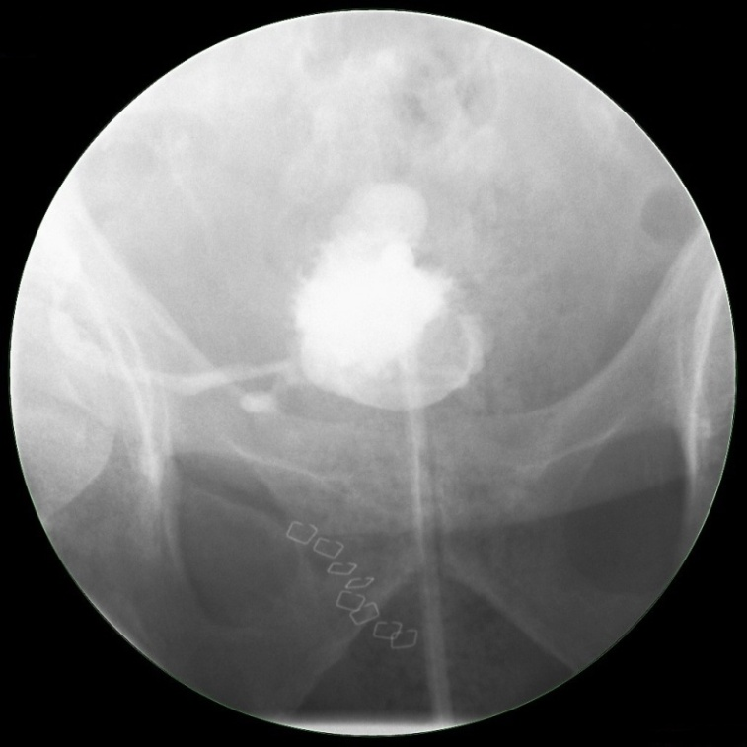
Figure 1 A cystogram showing urinary leak (arrow) at the anastomosis between newly implanted graft ureter and urinary bladder.

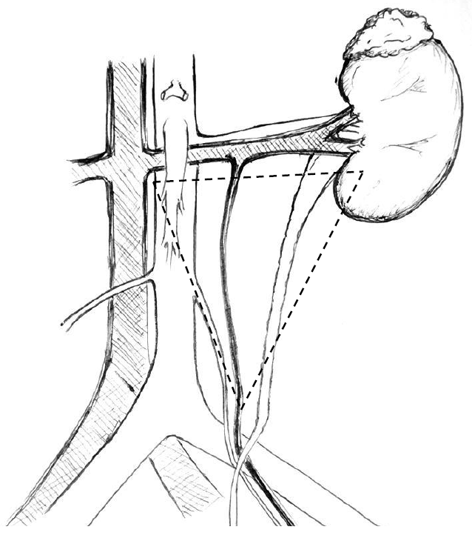
Figure 2 The golden triangle. Bordered by the lower pole of the kidney on the left, the junction between the renal vein and the inferior vena cava on the right and gonadal vein.

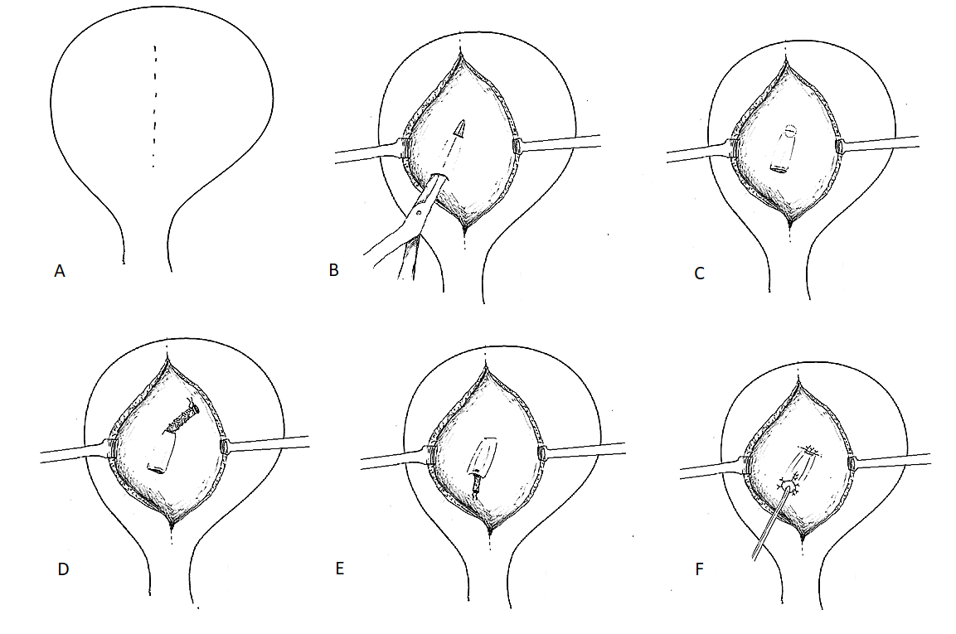

Figure 3 Leadbetter-Politano technique. A: A longitudinal bladder incision is performed to gain access to the interior of the bladder; B: A second cystotomy is done to introduce the neo-ureter in the bladder (arrow). Subsequently an Overholt is inserted from the second cystotomy and tunnelled close to the bladder wall for about 3 cm; C: A new hiatus is created at the end of the tunnel (arrow); D: The neo-ureter is pulled through the mucosal tunnel and the new mucosal hiatus using a free suture as a guide rail; E: Closure of the second cystotomy and then sub-mucosal transposition of distal neo-ureter; F: Fixation of the neo-ureter orifice and closure of the bladder mucosa.

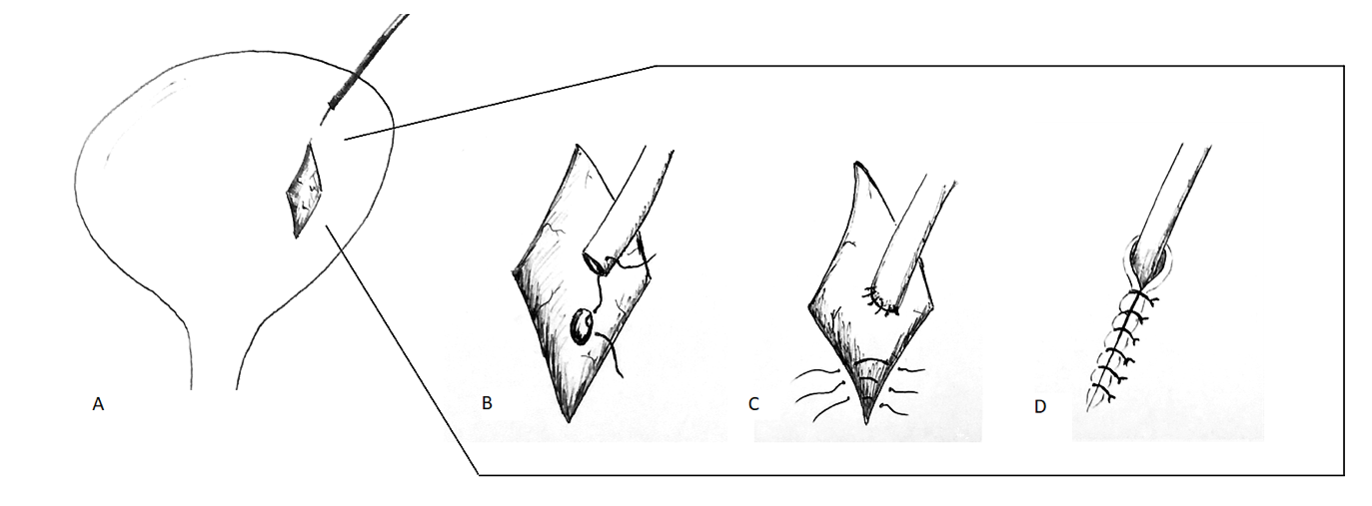

Figure 4 Lich-Gregoir technique. A: Bladder wall incision through the detrusor muscle is done, leaving a very thin layer of muscle and uroepitheliumun breached; B: The distal part is completely incised to create a neo-ureter-bladder anastomosis; C: Suturing of the neo-ureteris performed via the same access used to introduce it into the bladder; D: The ureter is positioned in the groove and in direct contact to the uroepithelium, followed by closure of the muscle over the ureter whilst carefully avoiding constriction of the neo-ureter.

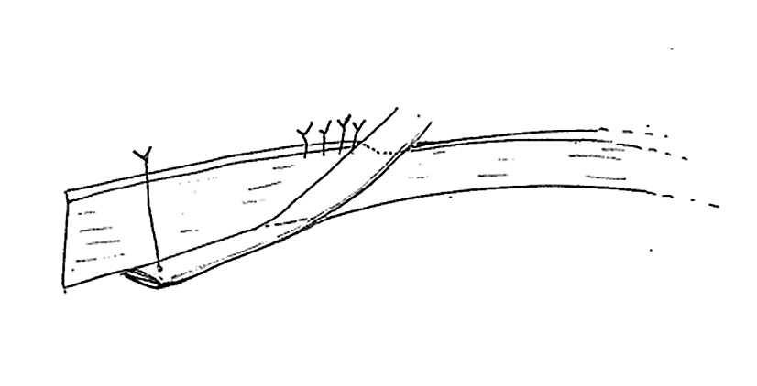
Figure 5 Taguchi technique. A suture is positioned at the distal end of the neo-ureter and subsequently introduced in the bladder via a cystotomy. The neo-ureter is later fixed to the bladder wall by bringing the suture out through the bladder wall and closed.

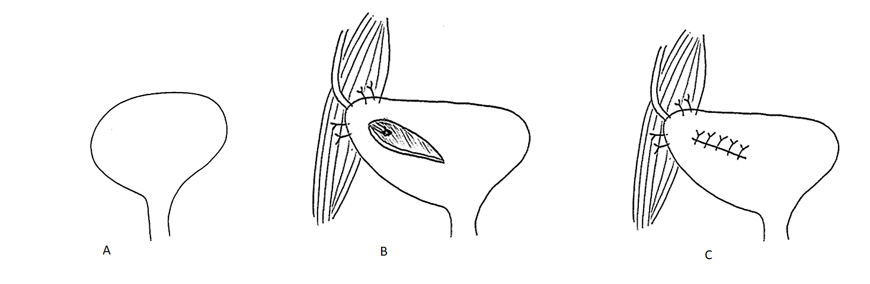
Figure 6 Psoas hitch. A: A psoas hitch procedure is used to bridge the gap between the urinary bladder and a short ureter; B: Mobilization of the urinary bladder is achieved by dissecting the attachments of the urinary bladder which is subsequently hitched to the Psoas muscle; C: Ureter implantation in performed via a transverse incision which is later closed.

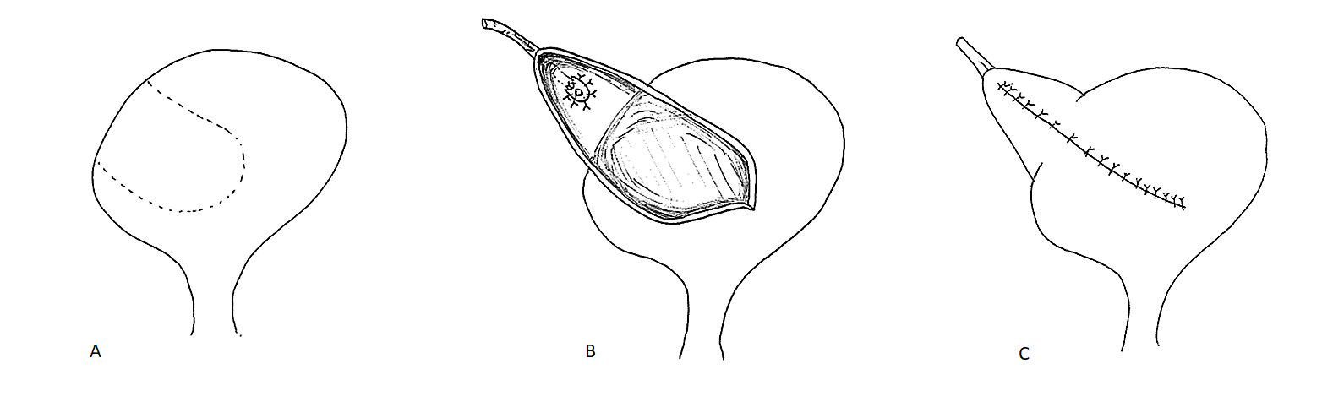
Figure 7 Boari flap. A: A Boari flap is used when a Psoas hitch is not enough to bridge the gap between the bladder and a short ureter in order to allow for a tension-free anastomosis. A U-shaped flap composed of all tissue layers is created. The base should be proportional to the length of the flap in order to avoid ischaemia; B: The ureter is implanted to the apex of the flap via end-to-end anastomosis or a sub-mucosal tunnel; C: The bladder incision together with the flap are subsequently closed.

