**Name of Journal: *World Journal of Gastroenterology***

## **Manuscript NO: 42352**

**Manuscript Type: ORIGINAL ARTICLE**

***Basic Study***

**Modulation of faecal metagenome in Crohn’s disease: Role of** **microRNAs as biomarkers**

Rojas-Feria M *et al*. Dysbiosis and miRNAs in CD

María Rojas-Feria, Teresa Romero-García, Jose Ángel Fernández Caballero-Rico, Helena Pastor Ramírez, Marta Avilés-Recio, Manuel Castro-Fernandez, Natalia Chueca Porcuna, Manuel Romero-Gόmez, Federico García,Lourdes Grande, José A Del Campo

**María Rojas-Feria, Teresa Romero-García, Marta Avilés-Recio, Manuel Castro-Fernandez, Lourdes Grande, José A Del Campo,** Department of Digestive Diseases, Valme University Hospital, UGC Digestive Disease and CIBERehd, Servicio Andaluz de Salud, Seville E-41014, Spain

**Jose Ángel Fernández Caballero-Rico, Natalia Chueca Porcuna, Federico García,** Complejo Hospitalario Universitario de Granada, Microbiology, Granada E-18016, Spain

**Helena Pastor Ramírez, Manuel Romero-Gόmez,** Institute of Biomedicine of Seville, Digestive Diseases, Hospital Universitario Virgen del Rocío and CIBERehd, Seville E-41013, Spain

**Jose Ángel Fernández Caballero-Rico,** Facultad de ciencias de la salud. Universidad Europea Miguel de Cervantes, Madrid E-28280, Spain

**ORCID number:** María Rojas-Feria(0000-0002-2661-2393); Teresa Romero-García (0000-0002-7093-5982); Jose Ángel Fernández Caballero-Rico(0000-0003-0239-961X); Helena Pastor Ramírez(0000-0003-2975-3973); Marta Avilés-Recio(0000-0002-1956-6122); Manuel Castro-Fernandez(0000-0001-9585-1593); Natalia Chueca Porcuna(0000-0002-3420-3290); Manuel Romero-Gόmez(0000-0001-8494-8947); Federico García(0000-0002-8548-1768);Lourdes Grande(0000-0001-7685-0464); José A Del Campo(0000-0002-6037-1028).

**Author contributions:** Rojas-Feria M, Romero-García T, Romero-Gómez M, García F, Grande L and Del Campo JA; designed the study and wrote the manuscript. Fernández Caballero-Rico JÁ, Pastor-Ramírez H and Avilés-Recio M; analyzed the data. Rojas-Feria M, Grande L, Castro-Fernández M, Chueca Porcuna N and Del Campo JA; contributed to perform experiments and data analysis

**Suppoted by** Instituto de Salud Carlos III grant #PI14/01349 integrated in the national I+D+i 2013-2016.

**Institutional review board statement:** The study was reviewed and approved by the Institutional Review Board of Valme Hospital of Seville University.

**Conflict of interest statement:** All authors declare there are no competing interests in this study.

**Data sharing statement:** All data regarding this manuscript will be available upon request.

**ARRIVE guidelines statement:** The manuscript was prepared according to the ARRIVE Guidelines.

**Open-Access:** This is an open-access article that was selected by an in-house editor and fully peer-reviewed by external reviewers. It is distributed in accordance with the Creative Commons Attribution Non Commercial (CC BY-NC 4.0) license, which permits others to distribute, remix, adapt, build upon this work non-commercially, and license their derivative works on different terms, provided the original work is properly cited and the use is non-commercial. See: <http://creativecommons.org/licenses/by-nc/4.0/>

**Manuscript source:** Invited manuscript

**Corresponding author to:**José A Del Campo, PhD, Senior Scientist, Department of Digestive Diseases, Valme University Hospital, UGC Digestive Disease and CIBERehd, Servicio Andaluz de Salud, Avda. Bellavista s/n, Sevilla E-41014, Spain. [jantonio.delcampo@ciberehd.org](mailto:jantonio.delcampo@ciberehd.org)

**Telephone:** +34-95-5015485

**Received:** September 19, 2018

**Peer-review started:** September 19, 2018

**First decision:** November 1, 2018

**Revised:** November 13, 2018

**Accepted:** November 16, 2018

**Article in press:**

**Published online:**

**Abstract**

***BACKGROUND***

The gut microbiota plays a key role in the maintenance of intestinal homeostasis and the development and activation of the host immune system. it has been shown that commensal bacterial species can regulate the expression of host genes. 16S rRNA gene sequencing has shown that the microbiota in inflammatory bowel disease (IBD) is abnormal and characterized by reduced diversity. MicroRNAs (miRNAs) have been explored as biomarkers and therapeutic targets, since they are able to regulate specific genes associated with Crohn’s disease (CD). In this work, we aim to investigate the composition of gut microbiota of active treatment-naïve adult CD patients, with miRNA profile from gut microbiota.

***AIM***

To investigate the composition of gut microbiota of active treatment-naïve adult CD patients, with miRNA profile from gut microbiota.

***METHODS***

Patients attending the outpatient clinics at Valme University Hospital without relevant co-morbidities were matched according to age and gender. Faecal samples of new-onset CD patients, free of treatment, and healthy controls were collected. Faecal samples were homogenized, and DNA was amplified by PCR using primers directed to the 16S bacterial rRNA gene. Pyrosequencing was performed using GS-Junior platform. For sequence analysis, MG-RAST server with the database Ribosomal Project was used. MiRNA profile and their relative abundance were analyzed by quantitative PCR.

***RESULTS***

Microbial community was characterized using 16S rRNA gene sequencing in 29 samples (*n* = 13 CD patients, and *n* = 16 healthy controls). The mean Shannon diversity was higher in the healthy control population compared to CD group (5.5 *vs* 3.7). A reduction in *Firmicutes* and an increase in *Bacteroidetes* were found. *Clostridia* class was also significant reduced in CD. Principal components analysis showed a grouping pattern, identified in most of the subjects in both groups, showing a marked difference between control and CD groups. A functional metabolic study showed that a lower metabolism of carbohydrates (*P* = 0.000) was found in CD group, while the metabolism of lipids was increased. In CD patients, three miRNAs were induced in affected mucosa: mir-144 (6.2 ± 1.3 fold), mir-519 (21.8 ± 3.1) and mir-211 (2.3 ± 0.4).

***CONCLUSION***

Changes in microbial function in active non-treated CD subjects and three miRNAs in affected *vs* non-affected mucosa have been found. miRNAs profile may serve as biomarker.

**Key words**: Crohn’s disease; Dysbiosis; microRNAs; *Firmicutes*; *Bacteroidetes*

**© The Author(s) 2018.** Published by Baishideng Publishing Group Inc. All rights reserved.

**Core tip:** In this study, we have found a shift in microbial gut community composition that supports dysbiosis in Crohn’s disease (CD) patients. The greatest interest of our work is that we have included only new-onset adult CD patients. We found that active non-treated CD patients had a low *Firmicutes*/*Bacteroidetes* ratio, less biodiversity in the structure of microbial communities and a significantly different pattern on gut microbiota distribution. Three microRNAs (miRNAs) have been found induced in affected mucosa vs non-affected mucosa in CD, indicating that miRNA profile may serve as biomarker for active disease.

Rojas-Feria M, Romero-García T, Fernández Caballero-Rico JÁ, Pastor Ramírez H, Avilés-Recio M, Castro-Fernandez M, Chueca Porcuna N, Romero-Gόmez M, García F,Grande L, Del Campo JA. Modulation of faecal metagenome in Crohn’s disease: Role of microRNAs as biomarkers.*World J Gastroenterol* 2018; In press

**INTRODUCTION**

Up to now, the pathogenesis of inflammatory bowel disease (IBD) has not been clarified. A plausible theory is that IBD develops in genetically susceptible individuals due to the abnormal immune response against luminal antigens and microbiota[1]. The targets of this response are thought to be antigens derived from constituents of the microbiota.

The gut microbiota plays a key role in the maintenance of intestinal homeostasis and the development and activation of the host immune system. The composition of microbiota community evolves during the first years of life, increasing gradually the microbial diversity. During this evolution, the host genetics and the environmental factors can shape the microbiome composition.

On the other hand, it has been shown that commensal bacterial species can regulate the expression of host genes. 16S rRNA gene sequencing has shown that the microbiota in IBD is abnormal and characterized by reduced diversity. The causality between IBD and alterations in microbiota remains incompletely understood but a theory is that altered microbiota composition and function in IBD result in increased immune stimulation or enhanced mucosal permeability.

A strong genetic component has been described in IBD, with the identification of about 200 loci associated with the development of the disease[2]. However, this can only explain a 16%-23% of the heritable of IBD[3–5]. Epigenetic factors can mediate interactions between the environment and the genome and could therefore play a central role in the pathogenesis of IBD and other diseases[6]. Epigenetic can be defined as heritable changes in gene function not explained by changes in DNA sequence. One of the main epigenetic mechanisms includes RNA interference, transmitted by microRNAs (miRNAs). MiRNAs are noncoding single stranded RNAs that regulate gene expression at the posttranscriptional level, influencing numerous biological processes, as cell proliferation, differentiation and death. A large number of miRNAs (> 1600) has been described in humans. Each miRNA can regulate multiple genes and a single gene may be targeted by many different miRNA[6]. A challenge is to identify which of the multiple miRNA that regulate a gene has an essential role.

In IBD, research focusing on miRNA has not begun until 2008. Wu *et al*[7] carried out the first study in which they identified miRNA profile in intestinal biopsies from IBD patients. Since then, and over the last decade, studies related to miRNA have increased exponentially, focusing mainly on three aspects: the alteration of miRNAs in the different IBD profiles, their therapeutic role and its pathway. Likewise, these studies have tried to identify miRNA in different tissues: colon, blood, and saliva[8], as a goal to find an effective non-invasive test for disease. MiRNAs have been involved in the pathogenesis of IBD and have been explored as biomarkers and therapeutic targets[9]. It has been shown that miRNAs regulate specific genes associated with Crohn’s disease (CD) including nucleotide-binding oligomerization domain-containing protein 2 (NOD2), interleukin (IL)-6 and tumor necrosis factor (TNF).

Cao *et al*[9] described the role of miRNA on intestinal epithelial barrier deregulation, and disruption of immune homeostasis, leading the development and progression of the disease. Apart from that, miRNAs have been proposed as biomarkers of IBD, useful in differential diagnosis of IBD, and as a tool of treatment evaluation and prognosis[10].

Identification of host and microbiota alterations in individual patients should lead to selective target interventions. In this study, we first analyzed the faecal microbiota composition in CD patients at the time of diagnosis. Secondly, we compared miRNA expression in CD gut samples obtained from endoscopically normal and affected mucosa, in order to find a marker of active IBD.

**MATERIALS AND METHODS**

***Patients***

Consecutive new-onset adult CD patients, free of treatment, that underwent colonoscopy for diagnostic purposes, were included in this study. Informed consent was obtained for all of them. Faecal samples from 13 patients (9 females, 67%; mean age 32.18 + 14.8 years old) and 16 healthy controls, matched by age and gender, were also collected. Inflammatory behaviour was present in 77% (10/13) of patients, stenotic in 23% (3/10) and fistulizing in 7.6% (1/13). None of the patients or the controls received antibiotic treatment the 10 wk before of recruitment.

A total of 35 gut biopsy samples from the subset of patients with non-fistulizing non-stenotic phenotype were taken (17 from affected mucosa and 18 from healed mucosa), immediately frozen in liquid nitrogen and submitted for miRNA study. Four patients had ileal, 3 colonic and 3 ileocolonic diseases.

***DNA extraction, quantification and pyrosequencing analysis***

Faecal samples were homogenized in a Stomacher-400 mixer. The DNA was extracted in stool using QIAamp DNA Mini Kit (QIAGEN, Barcelona, ​​Spain) as indicated by the manufacturer, with the exception that the samples were mixed with the lysis buffer and incubated at a temperature of 95 °C instead of 70 °C to ensure the lysis of Gram-positive and negative bacteria. DNA quantification was carried out by the NanoDrop ND-1000 spectrophotometer (Thermo Fisher Scientific, DE, United States). The extracted DNA was amplified by PCR using primers targeting the targets flanking the variable regions of 1 to 3 of the bacterial gene 16S rRNA (V1-3), subsequently gel-purified, and analyzed using the technology of Roche 454 GS FLX (Branford, CT, United States), being the final amplicon obtained is a 600 pb sequence belonging to the variable region V1-V3 of the 16S rRNA gene. PCR was performed in a total volume of 15 μL for each sample, which contains the forward universal primers 27F and Bif16S-F (10 μmol /L) in a ratio of 9:1 respectively, and the universal barcode 534R as primer inverse (10 μmol/L), in addition to the mixture of dNTP (10 mmol/L), FastStart 10 × buffer with 18 mmol/L of MgCl2, FastStartHiFi polymerase (5 U/ml), and 2 μl of genomic DNA. PCR were performed in a high fidelity thermocycler (Roche AppliedScience, Penzberg, Germany). PCR conditions were the following: 95 °C for 2 min, 30 cycles of 95 °C for 20 s, 56 °C for 30 s, and 72 °C for 5 min and a final stage at 4 °C. PCR products were purified using magnetic beadsAMPure XP (Beckman-Coulter, Brea, CA, United States).

DNA quality and concentration were measured using Quant-ITTM PicoGreen® dsDNAAssay Kit (ThermoFisher, Waltham, MA, United States). Finally, the amplicons are combined in equimolar ratios to create a pool of DNA (109 DNA molecules) that was used for clonal amplification (emPCR) and pyrosequencing according to the manufacturer's instructions. At the end of the massive sequencing process, all the sequences were annotated according to quality, and the sequences with poor quality and short fragments were eliminated.

Sequences were selected to estimate the total diversity of bacteria in the DNA of the samples. For this purpose, bar codes, primers, chimeras, plasmids, mitochondrial DNA, any sequence not belonging to 16S RNA and sequences < 150 pb were eliminated. For the analysis of all the sequences the MG-RAST server (meta-genomic analysis server) was used with the database Ribosomal Project (RDP), which converted the total sequences into relative abundances of microorganisms of the different taxonomic levels. Processing in MG-RAST includes demultiplexing, quality filtering, length filtering, dereplication and deletion of model organism sequences.

***miRNA screening***

Total RNA was extracted using mirVana™ miRNA Isolation Kit, with phenol (ThermoFisher Scientific, MA, United States). The commercially available Kit RT2 miRNA PCR Array System (SABiosciences-Qiagen, Hilde, Germany) was used for the relative quantification of the 88 most expressed miRNAs following the manufacturer's instructions. Individual miRNA gene expression was measured by retrotranscription with miScript II RT Kit (Qiagen, Hilde, Germany), and a quantitative PCR by miScript SYBR®Green PCR Kit (Qiagen, Hilde, Germany) by a Stratagene 3005 MxP thermocycler.

***Statistical analysis***

The MG-RAST output file was analyzed with the SPSS Statistics 20.0 software (SPSS Inc), while the STAMP software version 2.1.3 was used for the metagenomic analysis and IMG/M. The Shannon index, based on species richness (number of species present) and species abundance (number of individuals per species), was calculated for control samples and samples with CD. The differences between the two groups were compared using the Mann-Whitney *U* test. Statistical analysis was performed using the GraphPadPrism 7 and SPSS 20.0 software. Differences between means were performed with significance tests using an analysis of variance (ANOVA) and post-hoc test with less significance. Nonparametric data are expressed as median (range) and analyzed using the Mann-Whitney *U* test. Differences between proportions were analyzed by chi-square test. Significance was accepted at *P* < 0.05.

**RESULTS**

***Ecological analysis***

Microbial community was characterized using 16S *rRNA* gene sequencing in 29 samples (*n* = 13 CD participants and *n*=16 healthy controls). The mean Shannon diversity was found higher in the healthy control population compared to CD group (5.5 *vs* 3.7), indicating that there is less biodiversity in the structure of microbial communities in CD. To check this, we decided to measure the number of species in both groups (357 control group *vs* 289 CD group), which shown a decreased number of species in the CD group.

Dysbiosis was observed in CD due to increased population of *Bacteroidetes* and reductions in *Firmicutes*. *Firmicutes*/*Bacteroidetes* ratio was 1.71 in controls versus 0.80 in CD. Furthermore, the number of readings obtained using 16S massive sequencing is shown in Figure 1A. 77143 readings were obtained in control samples and 69296 reads in CD group.

***Metagenomic analysis***

To assess how the intestinal microbial community was distributed in both groups, principal components analysis (PcoA) was performed (Figure 1B). A grouping pattern was identified for most of the subjects in both groups, showing a marked difference between control samples (blue) and CD samples (green). A PERMANOVA calculated by FIRST showed statistically significant differences between groups (*P* < 0.05).

***Analysis in bacterial taxonomic groups***

Differential distributions in taxonomic categories were analyzed. Significant differences in Clostridia class were found in the analysis, being decreased in the CD group (Figure 2). Significant differences were found in *Entomoplasmataceae* (*P* = 0.001), *Bacteriaceae* (*P* = 0.002), *Lachnospiraceae* (*P* < 0.0001), *Ruminococcaceae* (*P* < 0.0001) and *Rikenellaceae* (*P* = 0.003) (Figure 3).

***Relative abundance of the most abundant bacterial genera***

Significant differences in *Ruminococus* (*P* < 0.001), *Roseburia* (*P* = 0.002), *Parabacteroides* (*P* = 0.02), *Mesoplasma* (*P* = 0.003), *Faecalibacterium* (*P* < 0.001), *Eubacterium* (*P* = 0.003) and *Alistipes* (*P* < 0.003) were observed, showing a decreased distribution in the EC group (Figure 4).

When relative abundance of each bacterial taxon was analyzed, all of them were increased in the control group EC except *Clostridium bolteae,* only present in CD while absent in the control group: *Ruminococcus albus* (*P* = 0.004), *Roseburiainulinivorans* (*P* = 0.016), *Mesoplasma lactucae* (*P* = 0.002), *Faecalibacterium prausnitzii* (*P* < 0.0001), *Eubacterium ramulus* (*P* = 0.006), *Eubacterium eligens* (*P* = 0.03), *Eubacterium coprostanoligenes* (*P* = 0.002), *Dialisterinvisus* (*P* = 0.005), *Desulfonauticus autotrophicus* (*P* = 0.01), *Clostridium* culture spenrichment clone 7-25 (*P* < 0.0001), *Clostridium bolteae* (*P* = 0.04) , *Clostridia lesgenomosp*. BVAB3 (*P* = 0.02), *Butyrivibrio fibrisolvens* (*P* = 0.04), butyrate producing bacterium ART55 / 1 (*P* = 0.006), *Bacteroides dorei* (*P* = 0.04), *Alistipes putredinis* (*P* = 0.03), *Alistipes finegoldii* (*P* = 0.02).

***Functional analysis***

A functional metabolic study of the microbiota was performed by comparison between both groups. We observed significant differences in the following functions: Biosynthesis and glycan metabolism, carbohydrate metabolism, lipid metabolism, catabolism, digestive system, amino acid metabolism, immune system. In CD group, we observed a lower metabolism of carbohydrates (*P* = 0.000) while the metabolism of lipids is increased in this group (*P* = 0.000). Data are shown on Figure 5.

***miRNAs***

In order to analyze the miRNA profile in patients with CD, we had performed an array of the 88 most abundant miRNAs in human inflammatory processes. After RNA extraction from biopsies, samples were pooled (control vs. affected mucosa). In this analysis, 4 miRNAs were found to be significantly induced (fold change > 1.5) in affected mucosa vs. non-affected: miR-144, miR-211, miR-373-3p and miR-519.

An individual analysis was performed in 10 additional samples from patients with CD, as a validation analysis, where three of them were also found induced (miR-144, miR-211 and miR-519). Results are shown on Figure 6.

**DISCUSSION**

In this study, we have found a shift in microbial gut community composition that supports dysbiosis in CD patients. The greatest interest of our work is that we have included only new-onset adult CD patients. No confounders of drug therapy, surgery or duration of the disease are present. We described a low proportion of *Firmicutes* population, and a reduction in *Firmicutes*/*Bacteroidetes* ratio in CD, respect to control samples. In healthy adults, 80% of the identified faecal microbiota belongs to 3 dominant phyla: *Bacteroidetes, Firmicutes* (principally *clostridia*)and *Actinobacteria*[11,12]. *Firmicutes* are considered beneficial and *Bacteroidetes* are considered aggressive, being implicated in the pathogenesis of IBD[13]. The *Firmicutes* to *Bacteroidetes* ratio has shown to be of significant relevance in gut microbiota composition, as an expression of the degree of dysbiosis[14]. In healthy adults, it has been measured ratios of 10.9[15], although ratios between 1 and 5.5 are considered optimum. In our population, the ratio was 1.71 in controls *vs* 0.8 in CD.

Our results are in concordance with data from other authors[16–18] , although some of them analysed mucosa microbiota instead of faecal microbiota. Interestingly, in a former study[19], the reduction in the *Firmicutes*/*Bacteroidetes* ratio was more likely to be observed in ulcerated mucosa than in non-ulcerated mucosa. Based on this, it is questionable whether the dysbiosis is not an effect instead of a cause. In an opposite way, these findings have not been confirmed in later studies[16].

We have also found less biodiversity and a significantly different pattern on microbiota distribution in active CD patients compared to controls. *Ruminococus*, *Roseburia*, *Parabacteroides*, *Mesoplasma*, *Faecalibacterium*, *Eubacterium* and *Alistipes* were significantly decreased in our CD cohort. Certain bacteria, including *Bacteroidetes*, *Bifidobacterium*, *Clostridium* clusters XIVa and IVa, *Eubacterium rectale*, *Faecalibacterium prausnitzii*, lactic acid bacteria, *Roseburia intestinalis*, and others, are closely related to gastrointestinal tract fitness[20]. Therefore, a decrease of these genera could favour the development of CD.

We have described significant differences in *Clostridia* class in the analysis, being decreased in the CD group. This finding is in agreement with other researchers that have identified 43 species of *Firmicutes* in healthy human gut microbial communities, while only 13 species were found in patients with CD. In addition, the proportion of *Clostridium prausnitzii* in CD patients was significantly lower compared to controls[21,22]. *Clostridium* species have been shown to induce the expansion of Treg cells, reducing intestinal inflammation. *Faecalibacterium* genera may protect the host from mucosal inflammation through several mechanisms, including down-regulation of inflammatory cytokines[23] or IL-10 stimulation[24],an anti-inflammatory cytokine. *Faecalibacterium prausnitzii*, a proposed member of the microbiota with anti-inflammatory properties, is under-represented in IBD, as we have reported in this study.

*Clostridium boltae* is only present in the CD group. Therefore, this organism could be a target in CD patients as a risk factor for disease development. Despite promising correlations between shifts in microbial composition and CD, the presence or absence of a single taxon has not been identified as causal or protective against the development of disease[25]. This supports the view that compositional change (dysbiosis), rather than a single putative organism, may be responsible for this disease.

Mucosal-associated microbes are uniquely positioned to influence the immune system; particularly, the porous mucus layer in the ileum has been shown to educate the immune system to develop tolerance towards commensals[26]. In fact, faecal microbial transplant (FMT) has been proposed as a potential therapeutic option for individuals with CD based on the hypothesis that changes in dysbiosis could lessen intestinal inflammation[27].

Besides the shifts in microbiota composition, we have identified significant changes in carbohydrate and lipid metabolism, the first being reduced and the second being heighten. Changes in microbial function between healthy controls and IBD appear more extensive and more consistent compared with changes in community structure[28]. Clostridium cluster XIV (*Eubacterium* *rectale)* and Clostridium cluster IV (*Clostridium leptum group and Faecalibacterium prausnitzii*) have a function in carbohydrate fermentation and short chain fatty acid (SCFA) production, particularly butyrate[18]. SCFA are the major source of energy for the gut epithelial cells and possess an anti-inflammatory activity. Butyrate has been found to decrease TNF production and proinflammatory cytokine expression in intestinal tissue in patients with CD[29]. Taking all this into account, dysbiosis leads to changes in microbiota metabolism, resulting in a permanent inflammation process for gut cells.

To find a biomarker of active CD, miRNAs expression in gut mucosa has been analyzed. We have identified differential expression of 3 miRNAs in affected colonic mucosa from patients with naive CD. These miRNAs (miR144-3p; miR-211-5p; miR-519d-3p) are induced in the diseased colonic mucosa compared to the healthy areas. The miRNAs identified in our study have not been previously described elsewhere, although multiple different miRNAs expression profile have already been identified in inflamed and non-inflamed mucosa in IBD patients. Some studies have demonstrated up-regulation of miRNAs in inflamed mucosa[30] whereas others pointed out down-regulation of miRNA in affected mucosa[31,32].It has been shown that miR-215 expression in biopsies of CD patients correlates with the likelihood of disease progression[10]. Nevertheless, it has not been defined yet the miRNA expression profile in colonic tissue. Recently, 100 miRNAs have been identified as significantly deregulated between the inflamed and normal mucosa of ascending colon[33]. Differentially expressed miRNAs identified from these studies and our results may be due to differing factors such as sample size, CD patient characteristics (age, drug history, with or without surgery, *etc.*) and subject population demographics.

It should be noted that although in all our patients we found significant over-expression of these miRNAs, depending on the patient studied we found one of these increased with respect to the others. Therefore, we hypothesized that the combined analysis of specific miRNAs (in our case, miR144-3p; miR-211-5p; miR-519d-3p) could be useful to determine disease probability indexes in patients. This idea of ​​miRNA combination analysis has already been proposed in other recent studies[9]. However, the development of a model including miRNAs combination is still pending.

Although our patient cohort is small, we have carefully selected these patients at the time of diagnosis and all of them had inflammatory phenotype and were naive for treatments. To validate our findings, we will analyze circulating miRNAs, as potential non-invasive biomarkers for diagnosis and disease progression. Some studies have already pointed out this role after infliximab therapy[34] or exclusive enteral nutrition[35].

In conclusion, we found that active non-treated CD patients had a low *Firmicutes*/*Bacteroidetes* ratio, less biodiversity in the structure of microbial communities and a significantly different pattern on gut microbiota distribution. Moreover, microbiota metabolism is altered in CD compared to healthy subjects. This data strongly suggests that dysbiosis may play a role in the pathogenesis of CD. Three miRNAs have been found induced in affected mucosa vs non-affected mucosa in CD, indicating that miRNA profile may serve as biomarker for active disease. Nevertheless, additional studies are needed to identify causative roles for the microbiota and to establish the role of miRNAs in the pathogenesis or diagnosis of IBD.

**Article Highlights**

***Research background***

Pathogenesis of inflammatory bowel disease (IBD) has not been clarified yet. The gut microbiota plays a key role in the maintenance of intestinal homeostasis and the development and activation of the host immune system. The causality between IBD and alterations in microbiota remains incompletely understood but a theory is that altered microbiota composition and function in IBD result in increased immune stimulation or enhanced mucosal permeability. On the other hand, microRNAs (miRNAs) have been involved in the pathogenesis of IBD and have been explored as biomarkers and therapeutic targets. It has been shown that miRNAs regulate specific genes associated with Crohn´s disease (CD).

***Research motivation and objectives***

Identification of host and microbiota alterations in individual patients should lead to selective target interventions. In this study, we first analyzed the faecal microbiota composition in CD patients at the time of diagnosis. Secondly, we compared miRNA expression in CD gut samples obtained from endoscopically normal and affected mucosa, in order to find a marker of active IBD.

***Research methods***

In this study, we will use deep-sequencing methods to analyze the microbiota from patients with CD and healthy controls. Moreover, a miRNAs screening will be performed to identify individual miRNA involved in inflammation process that could serve as biomarkers for disease progression on therapeutic target.

***Research results***

We found significant differences in microbiota composition when comparing patients with CD compared to control population. The major differences were found in microbial biodivertiy (Shannon Index). We also found a reduction in *Firmicutes* and an increase in *Bacteroidetes*. *Clostridia* class was also significant reduced in Crohn’s disease group.

***Research conclusions***

We found that active non-treated CD patients had a low *Firmicutes*/*Bacteroidetes* ratio, less biodiversity in the structure of microbial communities and a significantly different pattern on gut microbiota distribution. Moreover, microbiota metabolism is altered in CD patients compared to healthy subjects. This data strongly suggests that dysbiosis may play a role in the pathogenesis of CD. Three miRNAs have been found induced in affected mucosa *vs* non-affected mucosa in CD, indicating that miRNA profile may serve as biomarker for active disease.

***Research perspectives***

Additional studies are needed to validate the results obtained and to identify causative roles for the microbiota. The role of miRNAs in the pathogenesis or diagnosis of IBD, including CD must be established through deeper analysis and validation in circulating tissues.

**REFERENCES**

1 **Xavier RJ**, Podolsky DK. Unravelling the pathogenesis of inflammatory bowel disease. *Nature* 2007; **448**: 427-434 [PMID: 17653185 DOI: 10.1038/nature06005]

2 **McGovern DP**, Kugathasan S, Cho JH. Genetics of Inflammatory Bowel Diseases. *Gastroenterology* 2015; **149**: 1163-1176.e2 [PMID: 26255561 DOI: 10.1053/j.gastro.2015.08.001]

3 **Anderson CA**, Boucher G, Lees CW, Franke A, D'Amato M, Taylor KD, Lee JC, Goyette P, Imielinski M, Latiano A, Lagacé C, Scott R, Amininejad L, Bumpstead S, Baidoo L, Baldassano RN, Barclay M, Bayless TM, Brand S, Büning C, Colombel JF, Denson LA, De Vos M, Dubinsky M, Edwards C, Ellinghaus D, Fehrmann RS, Floyd JA, Florin T, Franchimont D, Franke L, Georges M, Glas J, Glazer NL, Guthery SL, Haritunians T, Hayward NK, Hugot JP, Jobin G, Laukens D, Lawrance I, Lémann M, Levine A, Libioulle C, Louis E, McGovern DP, Milla M, Montgomery GW, Morley KI, Mowat C, Ng A, Newman W, Ophoff RA, Papi L, Palmieri O, Peyrin-Biroulet L, Panés J, Phillips A, Prescott NJ, Proctor DD, Roberts R, Russell R, Rutgeerts P, Sanderson J, Sans M, Schumm P, Seibold F, Sharma Y, Simms LA, Seielstad M, Steinhart AH, Targan SR, van den Berg LH, Vatn M, Verspaget H, Walters T, Wijmenga C, Wilson DC, Westra HJ, Xavier RJ, Zhao ZZ, Ponsioen CY, Andersen V, Torkvist L, Gazouli M, Anagnou NP, Karlsen TH, Kupcinskas L, Sventoraityte J, Mansfield JC, Kugathasan S, Silverberg MS, Halfvarson J, Rotter JI, Mathew CG, Griffiths AM, Gearry R, Ahmad T, Brant SR, Chamaillard M, Satsangi J, Cho JH, Schreiber S, Daly MJ, Barrett JC, Parkes M, Annese V, Hakonarson H, Radford-Smith G, Duerr RH, Vermeire S, Weersma RK, Rioux JD. Meta-analysis identifies 29 additional ulcerative colitis risk loci, increasing the number of confirmed associations to 47. *Nat Genet*2011; **43**: 246-252 [PMID: 21297633 DOI: 10.1038/ng.764]

4 **Franke A**, McGovern DP, Barrett JC, Wang K, Radford-Smith GL, Ahmad T, Lees CW, Balschun T, Lee J, Roberts R, Anderson CA, Bis JC, Bumpstead S, Ellinghaus D, Festen EM, Georges M, Green T, Haritunians T, Jostins L, Latiano A, Mathew CG, Montgomery GW, Prescott NJ, Raychaudhuri S, Rotter JI, Schumm P, Sharma Y, Simms LA, Taylor KD, Whiteman D, Wijmenga C, Baldassano RN, Barclay M, Bayless TM, Brand S, Büning C, Cohen A, Colombel JF, Cottone M, Stronati L, Denson T, De Vos M, D'Inca R, Dubinsky M, Edwards C, Florin T, Franchimont D, Gearry R, Glas J, Van Gossum A, Guthery SL, Halfvarson J, Verspaget HW, Hugot JP, Karban A, Laukens D, Lawrance I, Lemann M, Levine A, Libioulle C, Louis E, Mowat C, Newman W, Panés J, Phillips A, Proctor DD, Regueiro M, Russell R, Rutgeerts P, Sanderson J, Sans M, Seibold F, Steinhart AH, Stokkers PC, Torkvist L, Kullak-Ublick G, Wilson D, Walters T, Targan SR, Brant SR, Rioux JD, D'Amato M, Weersma RK, Kugathasan S, Griffiths AM, Mansfield JC, Vermeire S, Duerr RH, Silverberg MS, Satsangi J, Schreiber S, Cho JH, Annese V, Hakonarson H, Daly MJ, Parkes M. Genome-wide meta-analysis increases to 71 the number of confirmed Crohn's disease susceptibility loci. *Nat Genet* 2010; **42**: 1118-1125 [PMID: 21102463 DOI: 10.1038/ng.717]

5 **Khor B**, Gardet A, Xavier RJ. Genetics and pathogenesis of inflammatory bowel disease. *Nature* 2011; **474**: 307-317 [PMID: 21677747 DOI: 10.1038/nature10209]

6 **Schaefer JS**. MicroRNAs: how many in inflammatory bowel disease? *Curr Opin Gastroenterol* 2016; **32**: 258-266 [PMID: 27138057 DOI: 10.1097/MOG.0000000000000284]

7 **Wu F**, Zikusoka M, Trindade A, Dassopoulos T, Harris ML, Bayless TM, Brant SR, Chakravarti S, Kwon JH. MicroRNAs are differentially expressed in ulcerative colitis and alter expression of macrophage inflammatory peptide-2 alpha. *Gastroenterology* 2008; **135**: 1624-1635.e24 [PMID: 18835392 DOI: 10.1053/j.gastro.2008.07.068]

8 **Schaefer JS**, Attumi T, Opekun AR, Abraham B, Hou J, Shelby H, Graham DY, Streckfus C, Klein JR. MicroRNA signatures differentiate Crohn's disease from ulcerative colitis. *BMC Immunol* 2015; **16**: 5 [PMID: 25886994 DOI: 10.1186/s12865-015-0069-0]

9 **Cao B**, Zhou X, Ma J, Zhou W, Yang W, Fan D, Hong L. Role of MiRNAs in Inflammatory Bowel Disease. *Dig Dis Sci* 2017; **62**: 1426-1438 [PMID: 28391412 DOI: 10.1007/s10620-017-4567-1]

10 **Peck BC**, Weiser M, Lee SE, Gipson GR, Iyer VB, Sartor RB, Herfarth HH, Long MD, Hansen JJ, Isaacs KL, Trembath DG, Rahbar R, Sadiq TS, Furey TS, Sethupathy P, Sheikh SZ. MicroRNAs Classify Different Disease Behavior Phenotypes of Crohn's Disease and May Have Prognostic Utility. *Inflamm Bowel Dis* 2015; **21**: 2178-2187 [PMID: 26164662 DOI: 10.1097/MIB.0000000000000478]

11 **Eckburg PB**, Bik EM, Bernstein CN, Purdom E, Dethlefsen L, Sargent M, Gill SR, Nelson KE, Relman DA. Diversity of the human intestinal microbial flora. *Science* 2005; **308**: 1635-1638 [PMID: 15831718 DOI: 10.1126/science.1110591]

12 **Lay C**, Sutren M, Rochet V, Saunier K, Doré J, Rigottier-Gois L. Design and validation of 16S rRNA probes to enumerate members of the Clostridium leptum subgroup in human faecal microbiota. *Environ Microbiol* 2005; **7**: 933-946 [PMID: 15946290 DOI: 10.1111/j.1462-2920.2005.00763.x]

13 **Bloom SM**, Bijanki VN, Nava GM, Sun L, Malvin NP, Donermeyer DL, Dunne WM Jr, Allen PM, Stappenbeck TS. Commensal Bacteroides species induce colitis in host-genotype-specific fashion in a mouse model of inflammatory bowel disease. *Cell Host Microbe* 2011; **9**: 390-403 [PMID: 21575910 DOI: 10.1016/j.chom.2011.04.009]

14 **Ley RE**, Turnbaugh PJ, Klein S, Gordon JI. Microbial ecology: human gut microbes associated with obesity. *Nature* 2006; **444**: 1022-1023 [PMID: 17183309 DOI: 10.1038/4441022a]

15 **Mariat D**, Firmesse O, Levenez F, Guimarăes V, Sokol H, Doré J, Corthier G, Furet JP. The Firmicutes/Bacteroidetes ratio of the human microbiota changes with age. *BMC Microbiol* 2009; **9**: 123 [PMID: 19508720 DOI: 10.1186/1471-2180-9-123]

16 **Kabeerdoss J**, Jayakanthan P, Pugazhendhi S, Ramakrishna BS. Alterations of mucosal microbiota in the colon of patients with inflammatory bowel disease revealed by real time polymerase chain reaction amplification of 16S ribosomal ribonucleic acid. *Indian J Med Res* 2015; **142**: 23-32 [PMID: 26261163 DOI: 10.4103/0971-5916.162091]

17 **Joossens M**, Huys G, Cnockaert M, De Preter V, Verbeke K, Rutgeerts P, Vandamme P, Vermeire S. Dysbiosis of the faecal microbiota in patients with Crohn's disease and their unaffected relatives. *Gut* 2011; **60**: 631-637 [PMID: 21209126 DOI: 10.1136/gut.2010.223263]

18 **Kang S**, Denman SE, Morrison M, Yu Z, Dore J, Leclerc M, McSweeney CS. Dysbiosis of fecal microbiota in Crohn's disease patients as revealed by a custom phylogenetic microarray. *Inflamm Bowel Dis* 2010; **16**: 2034-2042 [PMID: 20848492 DOI: 10.1002/ibd.21319]

19 **Walker AW,** Sanderson JD, Churcher C, Parkes GC, Hudspith BN, Rayment N, Brostoff J, Parkhill J, Dougan G, Petrovska L. High-throughput clone library analysis of the mucosa-associated microbiota reveals dysbiosis and differences between inflamed and non-inflamed regions of the intestine in inflammatory bowel disease. BMC Microbiol 2011; 11:7 [DOI: 10.1186/1471-2180-11-7]

20 **Hollister EB**, Gao C, Versalovic J. Compositional and functional features of the gastrointestinal microbiome and their effects on human health. *Gastroenterology* 2014; **146**: 1449-1458 [PMID: 24486050 DOI: 10.1053/j.gastro.2014.01.052]

21 **Fujimoto T**, Imaeda H, Takahashi K, Kasumi E, Bamba S, Fujiyama Y, Andoh A. Decreased abundance of Faecalibacterium prausnitzii in the gut microbiota of Crohn's disease. *J Gastroenterol Hepatol* 2013; **28**: 613-619 [PMID: 23216550 DOI: 10.1111/jgh.12073]

22 **Frank DN**, St Amand AL, Feldman RA, Boedeker EC, Harpaz N, Pace NR. Molecular-phylogenetic characterization of microbial community imbalances in human inflammatory bowel diseases. *Proc Natl Acad Sci USA* 2007; **104**: 13780-13785 [PMID: 17699621 DOI: 10.1073/pnas.0706625104]

23 **Llopis M**, Antolin M, Carol M, Borruel N, Casellas F, Martinez C, Espín-Basany E, Guarner F, Malagelada JR. Lactobacillus casei downregulates commensals' inflammatory signals in Crohn's disease mucosa. *Inflamm Bowel Dis* 2009; **15**: 275-283 [PMID: 18839424 DOI: 10.1002/ibd.20736]

24 **Sokol H**, Pigneur B, Watterlot L, Lakhdari O, Bermúdez-Humarán LG, Gratadoux JJ, Blugeon S, Bridonneau C, Furet JP, Corthier G, Grangette C, Vasquez N, Pochart P, Trugnan G, Thomas G, Blottière HM, Doré J, Marteau P, Seksik P, Langella P. Faecalibacterium prausnitzii is an anti-inflammatory commensal bacterium identified by gut microbiota analysis of Crohn disease patients. *Proc Natl Acad Sci USA* 2008; **105**: 16731-16736 [PMID: 18936492 DOI: 10.1073/pnas.0804812105]

25 **Wright EK**, Kamm MA, Teo SM, Inouye M, Wagner J, Kirkwood CD. Recent advances in characterizing the gastrointestinal microbiome in Crohn's disease: a systematic review. *Inflamm Bowel Dis* 2015; **21**: 1219-1228 [PMID: 25844959 DOI: 10.1097/MIB.0000000000000382]

26 **Shan M**, Gentile M, Yeiser JR, Walland AC, Bornstein VU, Chen K, He B, Cassis L, Bigas A, Cols M, Comerma L, Huang B, Blander JM, Xiong H, Mayer L, Berin C, Augenlicht LH, Velcich A, Cerutti A. Mucus enhances gut homeostasis and oral tolerance by delivering immunoregulatory signals. *Science* 2013; **342**: 447-453 [PMID: 24072822 DOI: 10.1126/science.1237910]

27 **Suskind DL**, Brittnacher MJ, Wahbeh G, Shaffer ML, Hayden HS, Qin X, Singh N, Damman CJ, Hager KR, Nielson H, Miller SI. Fecal microbial transplant effect on clinical outcomes and fecal microbiome in active Crohn's disease. *Inflamm Bowel Dis* 2015; **21**: 556-563 [PMID: 25647155 DOI: 10.1097/MIB.0000000000000307]

28 **Morgan XC**, Tickle TL, Sokol H, Gevers D, Devaney KL, Ward DV, Reyes JA, Shah SA, LeLeiko N, Snapper SB, Bousvaros A, Korzenik J, Sands BE, Xavier RJ, Huttenhower C. Dysfunction of the intestinal microbiome in inflammatory bowel disease and treatment. *Genome Biol* 2012; **13**: R79 [PMID: 23013615 DOI: 10.1186/gb-2012-13-9-r79]

29 **Segain JP**, Raingeard de la Blétière D, Bourreille A, Leray V, Gervois N, Rosales C, Ferrier L, Bonnet C, Blottière HM, Galmiche JP. Butyrate inhibits inflammatory responses through NFkappaB inhibition: implications for Crohn's disease. *Gut* 2000; **47**: 397-403 [PMID: 10940278]

30 **Zidar N**, Boštjančič E, Jerala M, Kojc N, Drobne D, Štabuc B, Glavač D. Down-regulation of microRNAs of the miR-200 family and up-regulation of Snail and Slug in inflammatory bowel diseases - hallmark of epithelial-mesenchymal transition. *J Cell Mol Med* 2016; **20**: 1813-1820 [PMID: 27113480 DOI: 10.1111/jcmm.12869]

31 **Chen Y**, Xiao Y, Ge W, Zhou K, Wen J, Yan W, Wang Y, Wang B, Qu C, Wu J, Xu L, Cai W. miR-200b inhibits TGF-β1-induced epithelial-mesenchymal transition and promotes growth of intestinal epithelial cells. *Cell Death Dis* 2013; **4**: e541 [PMID: 23492772 DOI: 10.1038/cddis.2013.22]

32 **Nijhuis A**, Biancheri P, Lewis A, Bishop CL, Giuffrida P, Chan C, Feakins R, Poulsom R, Di Sabatino A, Corazza GR, MacDonald TT, Lindsay JO, Silver AR. In Crohn's disease fibrosis-reduced expression of the miR-29 family enhances collagen expression in intestinal fibroblasts. *Clin Sci* (Lond) 2014; **127**: 341-350 [PMID: 24641356 DOI: 10.1042/CS20140048]

33 **Wu LY**, Ma XP, Shi Y, Bao CH, Jin XM, Lu Y, Zhao JM, Zhou CL, Chen D, Liu HR. Alterations in microRNA expression profiles in inflamed and noninflamed ascending colon mucosae of patients with active Crohn's disease. *J Gastroenterol Hepatol* 2017; **32**: 1706-1715 [PMID: 28261881 DOI: 10.1111/jgh.13778]

34 **Fujioka S**, Nakamichi I, Esaki M, Asano K, Matsumoto T, Kitazono T. Serum microRNA levels in patients with Crohn's disease during induction therapy by infliximab. *J Gastroenterol Hepatol* 2014; **29**: 1207-1214 [PMID: 24447044 DOI: 10.1111/jgh.12523]

35 **Guo Z**, Gong J, Li Y, Gu L, Cao L, Wang Z, Zhu W, Li J. Mucosal MicroRNAs Expression Profiles before and after Exclusive Enteral Nutrition Therapy in Adult Patients with Crohn's Disease. *Nutrients* 2016; **8** [PMID: 27556489 DOI: 10.3390/nu8080519]

**P-Reviewer:** Macedo G, Swaminath A, Zhang HJ

**S-Editor:** Ma RY **L-Editor:** **E-Editor:**

**Specialty type:** Gastroenterology and hepatology

**Country of origin:** Spain

**Peer-review report classification**

Grade A (Excellent): 0

Grade B (Very good): 0

Grade C (Good): C, C, C

Grade D (Fair): 0

Grade E (Poor): 0

**A**

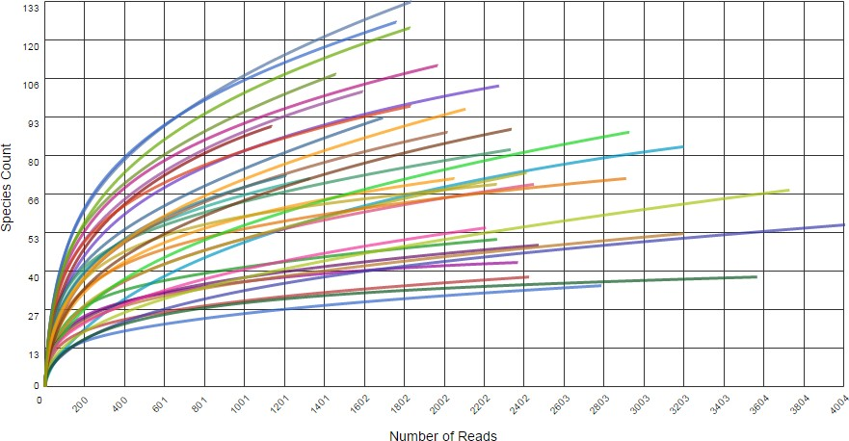

**B**

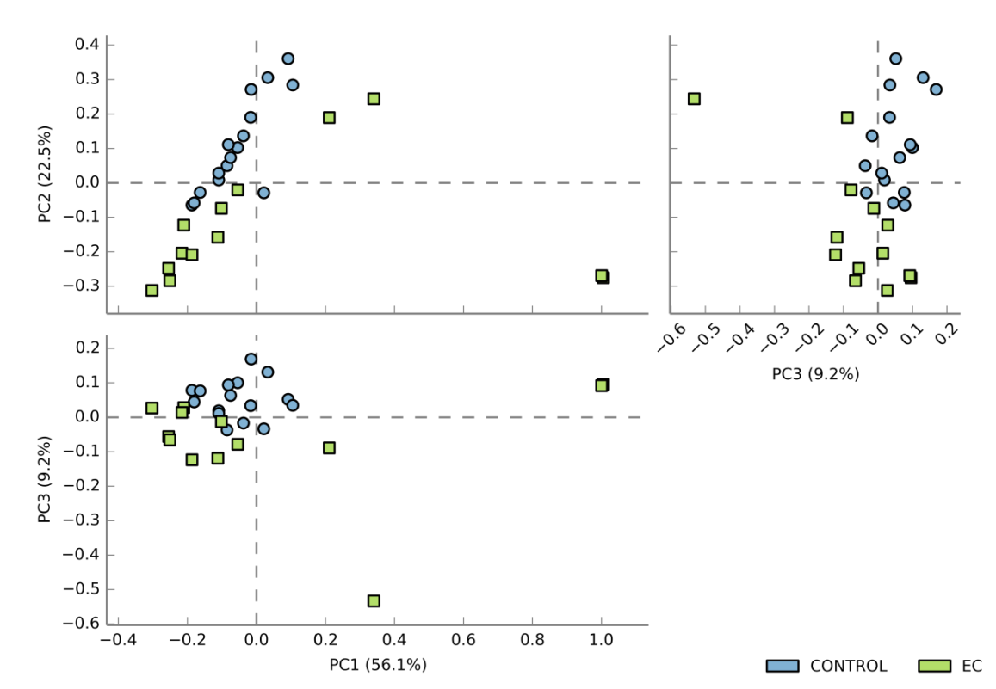**Figure 1** **Ecological and metagenomic analysis**. A: Number of readings for each sample using the 16S massive sequencing technique in GS Junior. See methods section for details. B: Principal components analysis. The control samples and Crohn’s disease are observed in well-defined groups. The data were selected with the Ribosomal Project database using a maximum e-value of 10-5, a minimum identity of 75%, and a minimum length alignment of 15 bp. PC: Principal components; EC: Crohn’s disease sample.

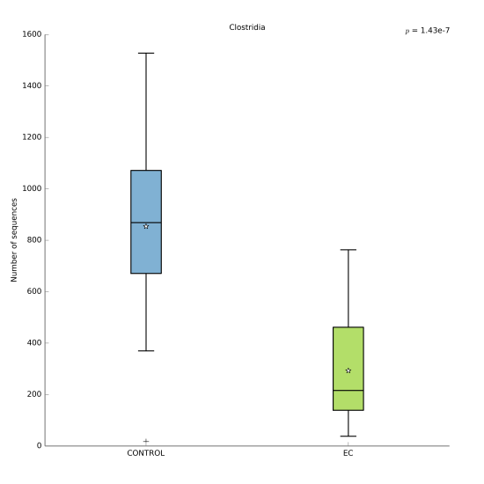**Figure 2** **Box plot showing significant difference in the *Clostridia* class between control group (blue) and Crohn’ disease (green).** EC: Crohn’s disease sample.

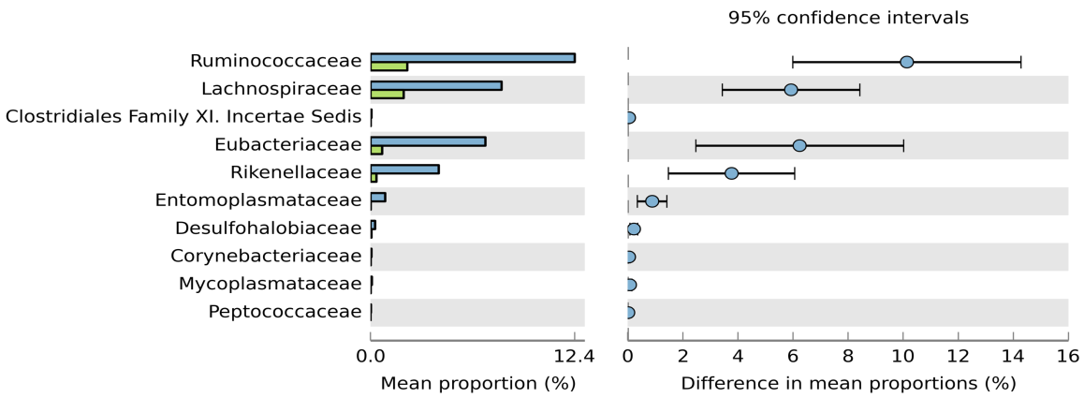**Figure 3** **Bar graph with the mean of each group (Crohn’s disease and control population) and family taxon (95% confidence level).**

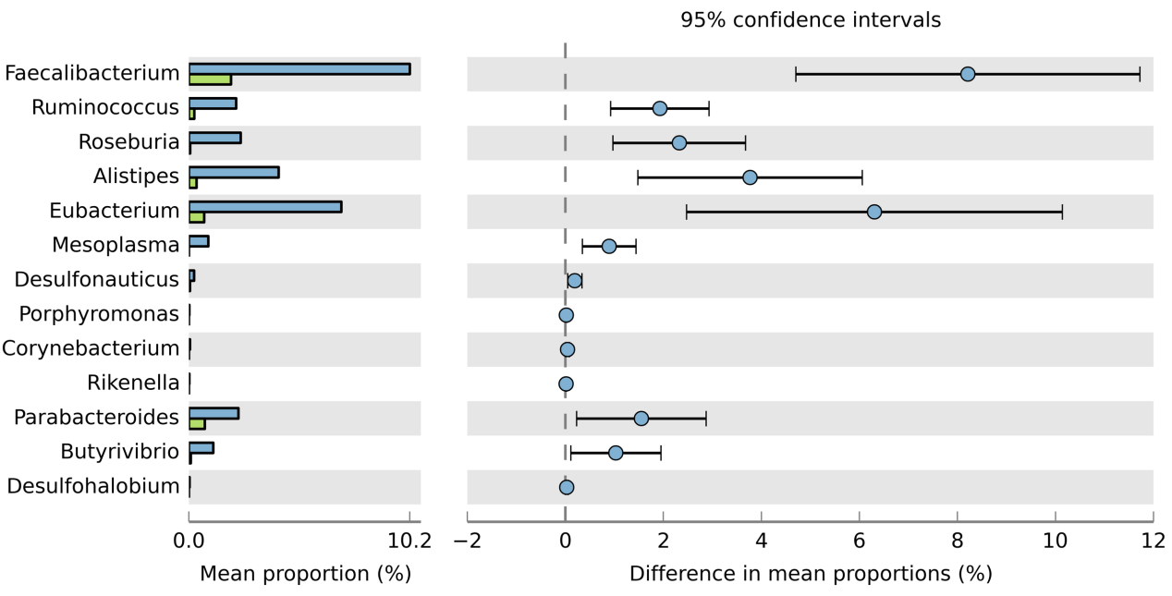**Figure 4** **Bar chart with the mean of each taxonomic group (gender) according to group (control *vs* Crohn’s disease) and differences with 95% confidence level.**

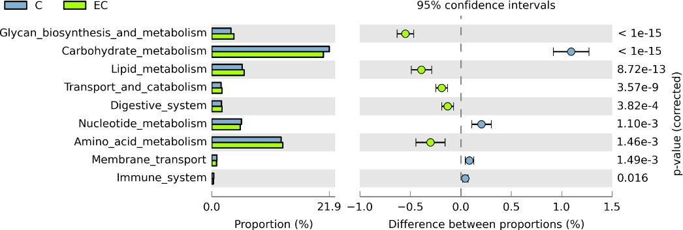**Figure 5** **Functional analysis of the microbiota.** Significant differences (*P* < 0.05) in biosynthesis and glycan metabolism, carbohydrate metabolism, lipid metabolism, catabolism, digestive system, amino acid metabolism and immune system were found. C: Control sample; EC: Crohn’s disease sample.

**Figure 6 Three microRNAs were found increased in samples from patients with Crohn’s disease.** Individual microRNA levels in 10 patients with Crohn’s disease are represented. miRNA: MicroRNA.

