Figure 1

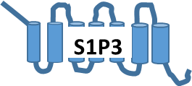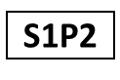

P38 MAPK

Myogenic Progenitor cells

**?**

**?**

**Activation of MIOGENIC DIFFERENTIATION**

**Inhibition of Serum-induced PROLIFERATION**

**?**

**?**

PI3K/Akt

MAPK

Erk1/2

STAT3

Figure 2



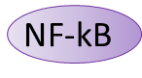

PI3K/Akt

PKC

MAPK

Erk1/2

NT3

Neural Progenitor

cells

CREB

proliferation

survival

CREB