**Name of journal: *World Journal of Gastroenterology***

**ESPS Manuscript NO: 24318**

**Manuscript Type: ORIGINAL ARTICLE**

***Basic Study***

**Contribution of mammalian target of rapamycin in pathophysiology of cirrhotic cardiomyopathy**

Saeedi Saravi SS *et al*.mTOR and cirrhotic cardiomyopathy

**Seyed Soheil Saeedi Saravi, Mahmoud Ghazi-Khansari, Shahram Ejtemaei Mehr, Maliheh Nobakht, Seyyedeh Elaheh Mousavi, Ahmad Reza Dehpour**

**Seyed Soheil Saeedi Saravi, Mahmoud Ghazi-Khansari, Shahram Ejtemaei Mehr, Seyyedeh Elaheh Mousavi, Ahmad Reza Dehpour,** Department of Pharmacology, School of Medicine, Tehran University of Medical Sciences, Tehran 13145, Iran

**Seyed Soheil Saeedi Saravi, Seyyedeh Elaheh Mousavi, Ahmad Reza Dehpour,** Experimental Medicine Research Center, Tehran University of Medical Sciences, Tehran 13145, Iran

**Seyed Soheil Saeedi Saravi,** Department of Toxicology-Pharmacology, Faculty of Pharmacy, Guilan University of Medical Sciences, Rasht, Iran

**Maliheh Nobakht,** Department of Anatomy, School of Medicine, Iran University of Medical Sciences, Tehran 13145, Iran

**Author's contributions:** Saeedi Saravi SS designed the study as his PhD thesis, wrote the protocol and the first draft of the manuscript, and managed the literature searches and statistical analyses; Ghazi-Khansari M and Ejtemaei Mehr S contributed in literature searches and analyses; Nobakht M contributed in immunohistochemical experiment; Mousavi SE contributed in experimental procedure; and Dehpour AR supervised all procedures and managed the experimental processes, manuscript writing and correction.

**supported by** Tehran University of Medical Sciences and Health Services grant, NO. 92033024196.

**Institutional animal care and use committee statement:** All experiments and manipulations were conducted in Prof. Dehpour's Hepatological Researches Laboratory in accordance with the institutional animal care and use committee (Department of Pharmacology, School of Medicine, Tehran University of Medical Sciences) guidelines. This study was approved by the Ethics Committee of Tehran University of Medical Sciences.

**Conflicts-of-interest statement:** To the best of our knowledge, no conflict of interest exists.

**Data sharing statement:** Technical appendix, statistical code, and dataset available from the corresponding author at [dehpour@yahoo.com](mailto:dehpour@yahoo.com). No additional data are available.

**Open-Access:** This article is an open-access article which was selected by an in-house editor and fully peer-reviewed by external reviewers. It is distributed in accordance with the Creative Commons Attribution Non Commercial (CC BY-NC 4.0) license, which permits others to distribute, remix, adapt, build upon this work non-commercially, and license their derivative works on different terms, provided the original work is properly cited and the use is non-commercial. See: <http://creativecommons.org/licenses/by-nc/4.0/>

**Correspondence to:** **Ahmad Reza Dehpour, PharmD, PhD, Professor**, Department of Pharmacology, School of Medicine, Tehran University of Medical Sciences, PO Box: 13145-784, Tehran 13145, Iran. dehpour@yahoo.com

**Telephone:** +98-21-66402569

**Fax:** +98-21-66402569

**Received:** January 17, 2016

**Peer-review started:** January 19, 2016

**First decision:** February 18, 2016

**Revised:** February 27, 2016

**Accepted:** March 13, 2016

**Article in press:**

**Published online:**

**Abstract**

**AIM:** To explore the role of mammalian target of rapamycin (mTOR) in pathogenesis of cirrhotic cardiomyopathy and of rapamycin in improvement of this pathologic condition.

**METHODS:** Male albino Wistar rats weighing 100-120 g were used in this investigation. Cirrhosis was induced by 8-wk tetrachloride carbon (CCl4) intoxication, and animals were administered to rapamycin (2 mg/kg/d). The QTc intervals were calculated in a 5-min electrocardiogram, and then left ventricular papillary muscles were isolated to examine inotropic responsiveness to β-adrenergic stimulation using a standard organ bath equipped by Powerlab system (Lab Chart 7 software). Phosphorylated-mTOR localization in left ventricles was immunohistochemically assessed and ventricular tumor necrosis factor (TNF)-α was measured. Western blot was applied for determining ventricular phosphorylated-mTOR protein.

**RESULTS:** Cirrhosis was confirmed by H and E staining of liver tissues and visually observation of lethargy, weight loss, jaundice, brown urine and ascites, as well as, liver stiffness and significant increase of spleen weight (*P* < 0.001). A significant prolongation in QTc intervals was occurred in cirrhotic rats which were exposed to CCl4 (*P* < 0.001), while this was decreased by rapamycin (2 mg/kg) (*P* < 0.01). CCl4-induced cirrhosis caused significant decrease of contractile responsiveness to isoproterenol stimulation, and increase in cardiac TNF-α. The findings were correlated with data resulted from western blot and immunohistochemical studies that phosphorylated-mTOR expression in left ventricles, especially endothelium, was significantly enhanced in cirrhotic rats compared to controls. Rapamycin significantly increased contractile force and myocardial localization of phosphorylated-mTOR, and decreased cardiac TNF-α concentration compared to cirrhotic rats with no treatment.

**CONCLUSION:** The study suggested potential role for cardiac mTOR in pathophysiology of cirrhotic cardiomyopathy. Rapamycin normalized inotropic effect, altered phosphorylated-mTOR expression and myocardial localization in cirrhotic rats.

**Key words:** Cirrhotic cardiomyopathy; mammalian target of rapamycin; Rapamycin; Inotropic effect; Rat

**© The Author(s) 2016.** Published by Baishideng Publishing Group Inc. All rights reserved.

**Core tip:** An enhanced cardiac mammalian target of rapamycin (mTOR) phosphorylation is contributed to impairment of electrophysiological and mechanical function induced by cirrhosis, called "cirrhotic cardiomyopathy". An mTOR inhibitor, rapamycin, normalizes the impaired inotropic responsiveness to β-adrenergic stimulation and prolonged Q-T interval in CCl4-induced cirrhotic rats.Cardiac ventricular expression of phosphorylated-mTOR is increased in rats with cirrhosis, which is ameliorated by rapamycin.CCl4-induced cirrhosis is associated with an increase in cardiac proinflammatory cytokine tumor necrosis factor-α, which is reversed by rapamycin.

Saeedi Saravi SS, Ghazi-Khansari M, Ejtemaei Mehr S, Nobakht M, Mousavi SE, Dehpour AR. Contribution of mammalian target of rapamycin in pathophysiology of cirrhotic cardiomyopathy. *World J Gastroenterol* 2016; In press

**INTRODUCTION**

For long time, cardiac dysfunction in liver cirrhosis, termed as "cirrhotic cardiomyopathy", was thought to be commonly occurred in the patients suffering from alcoholic cirrhosis[1,2]. During the last decade, non-alcoholic cirrhotic patients are also reported to demonstrate the cardiac abnormalities[3]. In cirrhosis, cardiovascular dysfunction is observed, but the responsible mechanisms are not still well understood. Despite the hyperdynamic systemic circulation and the absence of coronary artery or valvular disease and hypertension, cardiac hypertrophy and cardiomyocyte edema are observed in cirrhotic patients[3-7]. Furthermore, there is evidence for a concomitant decrease of inotropic effect along with impaired myocardial contractility[6]. The previous studies have shown that cirrhotic cardiomyopathy is contributed to both portal hypertension and cirrhosis[1,8], and is characterized by a latent heart failure with impaired contractile responsiveness to pharmacological or physiological stress and/or altered diastolic relaxation with electrophysiological abnormalities, without any diagnosed cardiac disease and causes of cirrhosis[4,6].

A variety of mechanisms are responsible for pathogenesis of cirrhotic cardiomyopathy. The major predisposing factors of cardiac contractility include alteration in ventricular receptors signal transduction (*i.e.* β-adrenergic, muscarinic and cannabinoid receptors)[9-12] and in function of some ionic channels (*i.e.* K+, L-type voltage-gated Ca2+)[13-15], cardiomyocyte plasma membrane fluidity changes[5,6], and complex role of carbon monoxide and nitric oxide[16,17]. Moreover, a rise in pro-inflammatory cytokines such as TNF-α is observed in this condition, resulting in stimulation of inducible nitric oxide synthase (iNOS) and NO overproduction[18].

Mammalian target of rapamycin (mTOR), a serine/threonine kinase component downstream of Phosphoinositide 3-kinase (PI3K)/Akt signaling pathway[19,20], is a key regulator of mRNA translation and cell growth in cardiomyocytes[21,22]. Protein synthesis, a major factor for cardiac hypertrophic growth, is regulated by PI3K/Akt/mTOR signaling pathway through inactivating eukaryotic translation initiation factor 4E-binding proteins (4E-BPs)[23], stimulating polymerase I and III transcription[24], controling ribosome biogenesis and mitochondrial metabolism[25], and suppressing autophagy[26-28]. Zhang *et al*[29] have documented an improvement in baseline cardiomyocyte survival, dilated cardiac hypertrophy and heart failure in the mTOR knockout mice. Moreover, it is confirmed that activation of PI3K/Akt/mTOR signaling may lead to development of cardiac hypertrophy[30]. Therefore, a mTOR inhibitor rapamycin seems to block the development of cardiomyocytehypertrophy[29]. Cohort studies have shown the cardioprotective effects of rapamycin on the patients after liver transplantation[31,32].

Although our current knowledge of predisposing factors of cirrhotic cardiomyopathy is somewhat understood, the role of other pathophysiological mechanisms underlying cardiac dysfunction induced by cirrhosis is remained to clarify. To this purpose, we examined the hypothesis that CCl4-induced cardiac inotropic dysfunction in response to adrenergic stimulation is associated with altered expression of cardiac phosphorylated-mTOR in a rat model of cirrhotic cardiomyopathy. Therefore, the present study for first time tried to demonstrate the positive inotropic effect of mTOR suppression by rapamycin and its ability to normalize cardiac levels of phosphorylated-mTOR, as well as, pro-inflammatory factor TNF-α in cirrhotic cardiomyopathy.

**MATERIALS AND METHODS**

***Chemicals and reagents***

The following compounds and reagents were applied in this investigation: rapamycin (Wyeth, United Kingdom/Ireland), isoproterenol hydrochloride (Sigma, St. Louis, MO, United States), carbon tetrachloride (Merck, Germany); TNF-α assay kit, polyclonal phosphorylated-mTOR antibody (pSer2448) and horseradish peroxidase (HRP)-conjugated rabbit anti-rat Immunoglobulin G antibody (Biorbyt Co. Ltd., United Kingdom).

***Animal model of cirrhosis***

Male albino Wistar rats weighing 100-120 g were used with housing facilities (environment temperature at 21-23 ◦C, 12-h regular light/dark cycle). Animals had unlimited access to food and water except for brief time of injection and the surgical procedure. The rats were divided into 4 main groups: control/drinking water, control/rapamycin, cirrhotic/drinking water and cirrhotic/rapamycin. All experiments and manipulations were conducted in Prof. Dehpour's Hepatological Researches Laboratory in accordance with the institutional animal care and use committee (Department of Pharmacology, School of Medicine, Tehran University of Medical Sciences) guidelines. This study was approved by the Ethics Committee of Tehran University of Medical Sciences.

To induce cirrhosis, CCl4 (0.4 g/kg; a solution of 1:6 in mineral oil) was intraperitonellay injected to the animals 3 times a week for a chronic 8 wk up to ascites appearance[33]. Rapamycin (2 mg/kg/d) was freshly dissolved in normal saline and daily administered in drinking water in a constant volume of 14 ml/100 g body weight during the 8-wk period[34,35]. twenty-four hours after cessation of CCl4, animals were sacrificed by guillotine decapitation. The liver was removed, sectioned and stained with hematoxylin-eosin (H&E). Light microscopy of stained liver sections confirmed the induction of cirrhosis in rats[4].

Twenty-four hours after the last administration of either CCl4 or N/S, a lead II electrocardiogram (ECG) was recorded for 15 min using three stainless steel subcutaneous electrodes attached to a bioamplifier (ADInstrument, Spain) from the anaesthetized rats. The signals were digitized at a sampling rate of 10 kHz by a Powerlab system and were displayed using Lab Chart 7 software (ADInstrument, Australia). The Q-T intervals, presented as corrected Q-T (QTc), were calculated in a 5-min ECG. The QTcwas presented using Bazett’s formula (QTc = QT/ √R-R)[36].

***Preparation of isolated papillary muscle***

Briefly, animals' hearts were excised following decapitation and left ventricular papillary muscles were dissected in cold oxygenated physiological salt solution (PSS) containing NaCl, 112; KCl, 5; CaCl2, 1.8; MgCl2, 1; NaH2PO4, 0.5; KH2PO4, 0.5; NaHCO3, 25; glucose, 10; and EDTA, 0.004 (all in mmol/L)[37,38]. The isolated papillary muscles were suspended in a 25-mL organ bath chamber containing PSS buffer solution bubbled with a gas mixture of 95% O2: 5% CO2 at 37 °C for 90 min to reach equilibrium. The contractility was induced by electrical field stimulation (Grass 88 Stimulator; Grass Instruments, MA, United States) at 1 Hz and 30 V, 20% higher than the threshold. After achievement of baseline contractile force, the muscle contraction was stimulated by addition of cumulative concentrations of isoproterenol (10-10 to 10-5 mol/L). The contractile force induced by highest concentration of isoproterenol (10-5 mol/L) was considered as maximal contractility[16]. The resulted contractile forces were expressed as percentage of the baseline papillary muscle contractility.

***Immunohistochemistry***

The ventricle samples were immediately fixed in freshly 10% formalin and paraffin-embedded blocks were prepared. After deparaffinizing in xylene and rehydrating in decreasing concentrations of ethanol, 3% hydrogen peroxidase was added for 5 min to block dual endogenous peroxidase activity. Then, the immunohistochemical staining was performed based on the Avidin-Biotin peroxidase method. Polyclonal phosphorylated-mTOR antibody (pSer2448) (1:50 dilution) was reacted for 1 h at room temperature followed by secondary HRP-conjugated rabbit anti-rat Immunoglobulin G antibody (1:50 dilution) for 30 min at room temperature. The sections were three times washed with Tris (pH 7.4), and incubated with DAB solution for 10 min and then with 5% CuSO4 for 5 min. Ultimately, the slides were washed and counterstained with hematoxylin-eosin to obtain brown-colored precipitation for examination under light microscopy.

***Ventricular TNF-α quantification***

To measure tissue TNF-α, the left ventricles were excised, rinsed in PSS, snap-frozen in liquid nitrogen, and stored at -80 °C for further analysis. Then, the samples were homogenized in ice-cold phosphate-buffered saline (PBS) and centrifuged at 14200 *g* for 30 min. 50 μL of the samples and standards were pipetted into a 96-well plate precoated with rat TNF-α specific antibody. Following addition of 50 μL of biotinylated anti–TNF-α solution, the plate of ELISA kit was incubated for 90 min at room temperature. The wells were washed, exposed to 100 μL of streptavidin-peroxidase, incubated for 45 min at room temperature and repeatedly washed for 4 times with PBS. Finally, 100 μL of both stabilized chromogen and stop solution were respectively added in two stage and incubated for 20 min for spectrophotometrically analysis at λ = 450 nm[16].

***Western blot analysis***

The dissection and snap-freezing of left ventricles were performed similar to above section. Biefly, left ventricles were homogenized in buffer (20 mmol/L Tris-HCl (pH 7.2), 0.2 mmol/L phenylmethylsulfonyl fluoride, and 1 mmol/L dithiothreitol), centrifuged at 40000 *g* and resuspended in Tris buffer containing proteinase inhibitor. 30 μg of protein samples were loaded and separated on sodium dodecyl sulfate-10% polyacrylamide gel (SDS-PAGE) by electrophoresis and were wet electroblotted onto nitrocellulose membrane at 4 °C for 12 h[39,40]. The resulted blots were blocked for 1 h at room temperature with 2% bovine serum albumin in 0.1% Tween Tris-buffered saline (TBS-T) (pH 7.5). Then, the membranes were washed and incubated overnight at 4 °C with polyclonal phosphorylated-mTOR primary antibody (pSer2448) (1:100 dilution). Those were exposed to HRP-conjugated anti-rat secondary antibody (1:1000 dilution). Subsequently, detection of blots was performed using enhanced chemiluminescence (ECL kit, Amersham) method. The levels of phosphorylated mTOR in cirrhotic, control and rapamycin-treated animals were semi-quantified using ImageJ software (National Institutes of Health, Bethesda, MD, United States) defining as the p-mTOR/GADPH densitometric ratio (%).

***Statistical analysis***

All data were expressed as mean ± SD and analyzed using GraphPad Prism software (version 5.0, GraphPad Software, Inc., San Diego, CA, United States). To examine the differences between 3 or more experimental groups, one-way ANOVA followed by Tukey'spost test was used. For two-group comparisons, Student’s *t*-test was applied. Evaluation of the effects of two variables (cirrhosis vs. control and type of treatment) was performed using two-way ANOVA followed by Bonferronipost test. A value of *P* < 0.05 was statistically considered to be significant.

**RESULTS**

Presence of CCl4-induced cirrhosis was confirmed by visually observation of lethargy, weight loss, jaundice, brown urine and ascites along with stiffness of liver and significant increase in spleen weight (1.52 ± 0.13 g *vs* 2.74 ± 0.41 g in control *vs* cirrhotic rats, *P* < 0.001), contributing to developing portal hypertension. H&E staining of liver tissues sampled from cirrhotic rats have demonstrated focal hepatocellular necrosis and apoptotic cells, as well as, enhanced inflammatory cells infiltration into the portal tract. Fatty degeneration areas and central vein dilation were also seen in histological examination (Figure 1). Moreover, a significant prolongation of QTc intervals was occurred to emphasize the appearance of cirrhosis in animals which were exposed to CCl4 (*P* < 0.001, Figure 2). The prolonged QTc interval in cirrhotic rats was decreased by rapamycin (2 mg/kg) (*P* < 0.01, Figure 2).

***Effect of rapamycin on papillary muscle contractility***

As shown in Figure 3A, baseline papillary muscle inotropic responses to isoproterenol stimulation in cirrhotic rats were significantly decreased compared to controls (*P* < 0.001). The order was in agreement with the maximum response (Rmax) to isoproterenol (76.46% ± 10.08% *vs* 117.36% ± 8.25%; *P* < 0.001, Figure 3A). Rapamycin non-significantly altered Rmax in control rats, likewise, no significant difference in EC50 of isoproterenol was observed (4.08 ± 1.35 × 10-8 and 6.59 ± 1.29 × 10-8 in N/S- and rapamycin-treated non-cirrhotic control groups, respectively; *P* > 0.05, Figure 3B). Furthermore, a significant rise in papillary muscle contractility following chronic treatment with rapamycin (2 mg/kg) in cirrhotic rats was consistent with a significant enhancement of Rmax compared to cirrhotic group treated with N/S (*P* < 0.001, Figure 3C). Subsequently, no significant differences in EC50 of isoproterenol was observed between all four studied groups (*P* > 0.05, Figure 3D).

***Effect of rapamycin treatment on ventricular TNF-α concentration***

Figure 4 demonstrates a significant increase in ventricular levels of TNF-α in cirrhotic rats compared to controls (*P* < 0.001). 8-wk treatment with rapamycin (2 mg/kg) caused no markedly enhancement in tissue TNF-α concentration of control group (*P* > 0.05). In addition, rapamycin significantly decreased the elevated concentration of tissue TNF-α in animals with cirrhosis (*P* < 0.05).

***Ventricular p-mTOR expression***

As observed in Figure 5, western blot examination has manifested an increased expression of phosphorylated-mTOR in left ventricles of cirrhotic rats compared to controls (*P* < 0.001). In contrast, rapamycin reversed the pattern and decreased p-mTOR level in animals with cirrhosis (*P* < 0.001). Moreover, treatment of cirrhotic rats with rapamycin decreased p-mTOR protein expression to the level of control animals (*P* > 0.05).

To explore which cells express p-mTOR, immunohistochemical examination was performed. Although almost no immunostaining was observed in ventricular myocytes, as well as, endothelial cells in control group without any altered localization (Figure 6A), p-mTOR immunostaining was markedly stronger in endothelial cells, but not in myocardial layer, in cirrhotic rats (Figure 6B). In cirrhosis group, rapamycin could decrease p-mTOR immunostaining and induce mTOR phosphorylation in ventricular myocytes as shown in Figure 6D.

**DISCUSSION**

The main finding of the present study is demonstration that cardiac mTOR expression and protein levels are increased in rats with cirrhotic cardiomyopathy. For first time, our study showed that altered expression of phosphorylated-mTOR in cirrhotic heart is contributed to cardiac contractile suppression. This was confirmed by immunohistochemical assay, showing strong immunostained blots in cirrhotic left ventricles, especially in endothelial cells. Interestingly, the data resulted from in vitro papillary muscle study suggested that the enhanced expression of phosphorylated-mTOR causes cardiac dysfunction. Our results are in concert with literature which indicates a relationship between changes of mTOR activity and hypertrophic cardiomyopathy and heart failure[20,30,40-44]. Moreover, an increase in cardiac tissue TNF-α was observed in cirrhotic animals, which is accompanied by cardiomyocyte contractile dysfunction. Recently, several studies have focused on the role of TNF-α in pathogenesis of heart failure and impaired cardiac contractility. They have demonstrated that the increased NO synthesis, an underlying mechanism for cirrhosis, in cardiac tissue of cirrhotic mice is contributed to elevated TNF-α level[4].

On the other hand, we showed that repeated treatment with rapamycin normalizes the cardiac contractile force defect in cirrhotic rats. To our knowledge, this is the first investigation to examine the hypothesis that rapamycin, *via* mTOR suppression, improves cardiac inotropic responsiveness to isoproterenol β-adrenergic stimulation and also shortens the prolonged QTc in rats with cirrhosis. Since mTOR phosphorylation was not obviously detectable in ventricular cardiomyocytes taken from CCl4-induced cirrhotic rats, rapamycin caused significant higher p-mTOR protein level in cardiomyocytes rather than endothelial cells. It is interestingly shown that despite abundantly expression of phosphorylated-mTOR in cardiomyocytes, but not in endothelial cells, of rapamycin-treated rats with cirrhosis, the total heart p-mTOR protein was reduced in comparison with cirrhotic rats receiving N/S. This finding was correlated with positive inotropic effects of rapamycin in this paradigm. Otherwise, decreased tissue levels of TNF-α after treatment with rapamycin confirmed the hypothesis that reduction in overproduced cytokines, such as TNF-α and IL-1β, from hepatic and systemic reticuloendothelial cells can reverse their negative inotropic effects[16,45,46].Evidence has shown that rapamycin acts as an effective agent, like isoproterenol, to raise intracellular cyclic adenosine monophosphate (cAMP) by reducing the expression and release of pro-inflammatory cytokine TNF-α from human heart tissue[47]. Also, rapamycin may inhibitnuclear factor-kappa B (NFκB) activation and TNF-α, as a potent inducer of in vascular smooth muscles[48].

During the last two decades, many investigations were performed to explore the possible manifestations and potential mechanisms underlying cirrhotic cardiomyopathy. For instance, a decrease in isolated papillary muscle contractile force was observed in response to adrenergic stimulation in bile duct-ligated rats[12,36,49-51]. The results were similar to our observation that negative inotropic responsiveness to adrenergic stimulation is resulted from CCl4-induced cirrhosis. Although most of the studies are based on the hypothesis that defects of cardiac contractile force may be resulted from down regulation of β-adrenergic receptors[10,37], as well as, increased cardiac nitric oxide synthesis[16], we tried to investigate the role of mTOR inhibition in a rat model of cirrhosis to attenuate the impaired cardiac contractile performances. Previous studies have reported the protective effects of rapamycin on development of left ventricle hypertrophy and ischemia/reperfusion injury after myocardial infarction[21,22,42-44,52]. Blockade of NFκB and PI3K/Akt/mTOR signaling pathway may play an essential role for ameliorating myocardial hypertrophy induced by p70S6K, a main component downstream of mTOR, activation in the infarcted hearts[21,22,30,43]. In addition to the role of mTOR in cardiomyocyte hypertrophy, phosphorylated mTORparticipates in the impairment of cardiac survival and structure, and also myocardial contractile dysfunction[53]. Activation of another downstream target of mTOR, 4E-BP1, is performed by mTOR inhibition, resulting in inhibition of protein synthesis, pathogenesis of cardiomyopathy and subsequent complications of cardiac hypertrophy[29,43].

Moreover, increment of autophagy and autophagosome formation upon mTOR inhibition with rapamycin is considered to be another protective mechanism in heart failure[43,54]. Regarding the requirement of ubiquitin proteasome system for activation of NFκB, rapamycin can restrict the myocardial infarction size and remodeling through inhibiting ubiquitin proteasome and subsequent NFκBactivity[43,55,56].

In addition to the observed positive effect of rapamycin on electrophysiological and mechanical cardiac function in cirrhosis, it is noteworthy that rapamycin has protective effects on human liver fibrosis, and inhibits the progression of fibrosis, especially, at early stages[35,57,58]. Rapamycin exerts this effect through inhibiting cell proliferation, deposition of extracellular matrix, and profibrogenic pathway and factors[59-62]. On the other hand, cohort studies have reported that patients receiving rapamycin after liver transplantation had no cardiovascular problems. They showed that rapamycin not only does not increase the risk of CHF and MI, but plays as a cardioprotectiveagent[31,32]. In our study, although the positive role of rapamycin on cirrhotic cardiomyopathy was attributed to a direct effect on cirrhotic heart, but it is assumed that a part of this phenomenon can be associated with anti-fibrogenic effect of this drug. This assumption is strongly amplified since a common etiology is considered for cardiac and liver diseases[6]. Although experimental and clinical investigations on cirrhotic patients revealed the latent heart failure with impaired response to provocations and subsequent mortality, no effective treatment is still found to recommend to the patients with cirrhotic cardiomyopathy and evident ventricular failure for improvement of cardiac contractility[6]. As the prolongation in QT interval is considered as an important life-threatening element in the patients with cirrhotic cardiomyopathy, early identifying and treatmentof the patients are necessary. Therefore, due to the anti-cytokine and beneficial role of rapamycinin correcting the abnormal cardiac contractile force and QT interval, rapamycinis expected to be the subject for further clinical investigations in the patients with cirrhotic cardiomyopathy.

The present study, for the first time, has provided evidence that an increase in phosphorylated mTOR is responsible for the impaired cardiac contractility in animals with CCl4-induced cirrhosis. Moreover, mTOR blockade is observed to correct the cardiac contractile dysfunction in liver cirrhosis, highlighting the possible therapeutic potential for mTOR antagonist rapamycin in this condition. This may increase survival against cirrhosis-associated heart failure until a transplant becomes available. However, this study may guide researches to utilize experimental models of cirrhotic cardiomyopathy translating to clinical benefits.

**COMMENTS**

***Background***

"Cirrhotic cardiomyopathy" has been recognized as cardiac dysfunction in liver cirrhosis, which commonly occurs in patients suffering from cirrhosis. Unfortunately, the responsible mechanisms are not still well understood. Therefore, finding the underlying mechanisms can help to declare the pathophysiology and possible treatment of this disease.

***Research frontiers***

To date, a variety of mechanisms are found to be responsible for pathogenesis of cirrhotic cardiomyopathy. The major predisposing factors of cardiac contractility include alteration in ventricular receptors signal transduction and in function of some ionic, cardiomyocyte plasma membrane fluidity changes, and complex role of carbon monoxide and nitric oxide.

***Innovations and breakthrough***

Although the current knowledge of mechanisms underlying cirrhotic cardiomyopathy is somewhat understood, the role of other pathophysiological mechanisms are remained to clarify. To this purpose, The authors examined the hypothesis that CCl4-induced cardiac inotropic dysfunction in response to adrenergic stimulation is associated with altered expression of cardiac phosphorylated-mammalian target of rapamycin (mTOR) in a rat model of cirrhotic cardiomyopathy. Therefore, the present study for first time tried to demonstrate the positive inotropic effect of mTOR suppression by rapamycin and its ability to normalize cardiac levels of phosphorylated-mTOR, as well as, pro-inflammatory factor TNF-α in cirrhotic cardiomyopathy.

***Applications***

mTOR blockade is observed to correct the cardiac contractile dysfunction in liver cirrhosis, highlighting the possible therapeutic potential for mTOR antagonist rapamycin in this condition. This may increase survival against cirrhosis-associated heart failure until a transplant becomes available. However, this study may guide researches to utilize the experimental model of cirrhotic cardiomyopathy translating to clinical benefits.

***Peer-review***

This is an interesting study about the role of mTOR on the pathogenesis of cirrhotic cardiomyopathy and the potential role of rapamycin on the improvement of cardiac dysfunction.

**REFERENCES**

1 **Zardi EM**, Abbate A, Zardi DM, Dobrina A, Margiotta D, Van Tassell BW, Afeltra A, Sanyal AJ. Cirrhotic cardiomyopathy. *J Am Coll Cardiol* 2010; **56**: 539-549 [PMID: 20688208 DOI: 10.1016/j.jacc.2009.12.075]

2 **Shorr E**, Zweifach BW, Furchgott RF, Baez S. Hepatorenal factors in circulatory homeostasis. IV. Tissue origins of the vasotropic principles, VEM and VDM, which appear during evolution of hemorrhagic and tourniquet shock. *Circulation* 1951; **3**: 42-79 [PMID: 14792729 DOI: 10.1161/01.CIR.3.1.42]

3 **Gould L**, Shariff M, Zahir M, Di Lieto M. Cardiac hemodynamics in alcoholic patients with chronic liver disease and a presystolic gallop. *J Clin Invest* 1969; **48**: 860-868 [PMID: 4180971 DOI: 10.1172/JCI106044]

4 **Bortoluzzi A**, Ceolotto G, Gola E, Sticca A, Bova S, Morando F, Piano S, Fasolato S, Rosi S, Gatta A, Angeli P. Positive cardiac inotropic effect of albumin infusion in rodents with cirrhosis and ascites: molecular mechanisms. *Hepatology* 2013; **57**: 266-276 [PMID: 22911662 DOI: 10.1002/hep.26021]

5 **Ma Z**, Lee SS. Cirrhotic cardiomyopathy: getting to the heart of the matter. *Hepatology* 1996; **24**: 451-459 [PMID: 8690419 DOI: 10.1002/hep.510240226]

6 **Møller S**, Henriksen JH. Cirrhotic cardiomyopathy: a pathophysiological review of circulatory dysfunction in liver disease. *Heart* 2002; **87**: 9-15 [PMID: 11751653 DOI: 10.1136/heart.87.1.9]

7 **Lunseth JH**, Olmstead EG, Abboud F. A study of heart disease in one hundred eight hospitalized patients dying with portal cirrhosis. *AMA Arch Intern Med* 1958; **102**: 405-413 [PMID: 13570726 DOI: 10.1001/archinte.1958.00030010405009]

8 **Donovan CL**, Marcovitz PA, Punch JD, Bach DS, Brown KA, Lucey MR, Armstrong WF. Two-dimensional and dobutamine stress echocardiography in the preoperative assessment of patients with end-stage liver disease prior to orthotopic liver transplantation. *Transplantation* 1996; **61**: 1180-1188 [PMID: 8610415 DOI: 10.1097/00007890-199604270-00011]

9 **Battarbee HD**, Farrar GE, Spears RP. Responses to hypotension in conscious rats with chronic portal venous hypertension. *Am J Physiol* 1990; **259**: G48-G55 [PMID: 2142583]

10 **Ma Z**, Meddings JB, Lee SS. Membrane physical properties determine cardiac beta-adrenergic receptor function in cirrhotic rats. *Am J Physiol* 1994; **267**: G87-G93 [PMID: 8048535]

11 **Jaue DN**, Ma Z, Lee SS. Cardiac muscarinic receptor function in rats with cirrhotic cardiomyopathy. *Hepatology* 1997; **25**: 1361-1365 [PMID: 9185753 DOI: 10.1002/hep.510250610]

12 **Gaskari SA**, Liu H, Moezi L, Li Y, Baik SK, Lee SS. Role of endocannabinoids in the pathogenesis of cirrhotic cardiomyopathy in bile duct-ligated rats. *Br J Pharmacol* 2005; **146**: 315-323 [PMID: 16025138 DOI: 10.1038/sj.bjp.0706331]

13 **Henriksen JH**, Fuglsang S, Bendtsen F, Christensen E, Møller S. Dyssynchronous electrical and mechanical systole in patients with cirrhosis. *J Hepatol* 2002; **36**: 513-520 [PMID: 11943423 DOI: 10.1016/S0168-8278(02)00010-7]

14 **Ward CA**, Ma Z, Lee SS, Giles WR. Potassium currents in atrial and ventricular myocytes from a rat model of cirrhosis. *Am J Physiol* 1997; **273**: G537-G544 [PMID: 9277435]

15 **Ward CA**, Liu H, Lee SS. Altered cellular calcium regulatory systems in a rat model of cirrhotic cardiomyopathy. *Gastroenterology* 2001; **121**: 1209-1218 [PMID: 11677214 DOI: 10.1053/gast.2001.28653]

16 **Liu H**, Ma Z, Lee SS. Contribution of nitric oxide to the pathogenesis of cirrhotic cardiomyopathy in bile duct-ligated rats. *Gastroenterology* 2000; **118**: 937-944 [PMID: 10784593 DOI: 10.1016/S0016-5085(00)70180-6]

17 **Liu H**, Song D, Lee SS. Role of heme oxygenase-carbon monoxide pathway in pathogenesis of cirrhotic cardiomyopathy in the rat. *Am J Physiol Gastrointest Liver Physiol* 2001; **280**: G68-G74 [PMID: 11123199]

18 **Kumar A**, Paladugu B, Mensing J, Kumar A, Parrillo JE. Nitric oxide-dependent and -independent mechanisms are involved in TNF-alpha -induced depression of cardiac myocyte contractility. *Am J Physiol Regul Integr Comp Physiol* 2007; **292**: R1900-R1906 [PMID: 17234961 DOI: 10.1152/ajpregu.00146.2006]

19 **Dazert E**, Hall MN. mTOR signaling in disease. *Curr Opin Cell Biol* 2011; **23**: 744-755 [PMID: 21963299 DOI: 10.1016/j.ceb.2011.09.003]

20 **Laplante M**, Sabatini DM. mTOR signaling in growth control and disease. *Cell* 2012; **149**: 274-293 [PMID: 22500797 DOI: 10.1016/j.cell.2012.03.017]

21 **McMullen JR**, Sherwood MC, Tarnavski O, Zhang L, Dorfman AL, Shioi T, Izumo S. Inhibition of mTOR signaling with rapamycin regresses established cardiac hypertrophy induced by pressure overload. *Circulation* 2004; **109**: 3050-3055 [PMID: 15184287 DOI: 10.1161/01.CIR.0000130641.08705.45]

22 **Shioi T**, McMullen JR, Tarnavski O, Converso K, Sherwood MC, Manning WJ, Izumo S. Rapamycin attenuates load-induced cardiac hypertrophy in mice. *Circulation* 2003; **107**: 1664-1670 [PMID: 12668503 DOI: 10.1161/01.CIR.0000057979.36322.88]

23 **Gingras AC**, Gygi SP, Raught B, Polakiewicz RD, Abraham RT, Hoekstra MF, Aebersold R, Sonenberg N. Regulation of 4E-BP1 phosphorylation: a novel two-step mechanism. *Genes Dev* 1999; **13**: 1422-1437 [PMID: 10364159 DOI: 10.1101/gad.13.11.1422]

24 **Kantidakis T**, Ramsbottom BA, Birch JL, Dowding SN, White RJ. mTOR associates with TFIIIC, is found at tRNA and 5S rRNA genes, and targets their repressor Maf1. *Proc Natl Acad Sci U S A* 2010; **107**: 11823-11828 [PMID: 20543138 DOI: 10.1073/pnas.1005188107]

25 **Cunningham JT**, Rodgers JT, Arlow DH, Vazquez F, Mootha VK, Puigserver P. mTOR controls mitochondrial oxidative function through a YY1-PGC-1alpha transcriptional complex. *Nature* 2007; **450**: 736-740 [PMID: 18046414 DOI: 10.1038/nature06322]

26 **Chan EY**. mTORC1 phosphorylates the ULK1-mAtg13-FIP200 autophagy regulatory complex. *Sci Signal* 2009; **2**: pe51 [PMID: 19690328 DOI: 10.1126/scisignal.284pe51]

27 **Shioi T**, Kang PM, Douglas PS, Hampe J, Yballe CM, Lawitts J, Cantley LC, Izumo S. The conserved phosphoinositide 3-kinase pathway determines heart size in mice. *EMBO J* 2000; **19**: 2537-2548 [PMID: 10835352 DOI: 10.1093/emboj/19.11.2537]

28 **Shioi T**, McMullen JR, Kang PM, Douglas PS, Obata T, Franke TF, Cantley LC, Izumo S. Akt/protein kinase B promotes organ growth in transgenic mice. *Mol Cell Biol* 2002; **22**: 2799-2809 [PMID: 11909972 DOI: 10.1128/MCB.22.8.2799-2809.2002]

29 **Zhang D**, Contu R, Latronico MV, Zhang J, Rizzi R, Catalucci D, Miyamoto S, Huang K, Ceci M, Gu Y, Dalton ND, Peterson KL, Guan KL, Brown JH, Chen J, Sonenberg N, Condorelli G. MTORC1 regulates cardiac function and myocyte survival through 4E-BP1 inhibition in mice. *J Clin Invest* 2010; **120**: 2805-2816 [PMID: 20644257 DOI: 10.1172/JCI43008]

30 **Ha T**, Li Y, Gao X, McMullen JR, Shioi T, Izumo S, Kelley JL, Zhao A, Haddad GE, Williams DL, Browder IW, Kao RL, Li C. Attenuation of cardiac hypertrophy by inhibiting both mTOR and NFkappaB activation in vivo. *Free Radic Biol Med* 2005; **39**: 1570-1580 [PMID: 16298682 DOI: 10.1016/j.freeradbiomed.2005.08.002]

31 **Weick A**, Chacra W, Kuchipudi A, Elbatta M, Divine G, Burmeister C, Moonka D. Incidence of cardiovascular and cerebrovascular events associated with sirolimus use after liver transplantation. *Transplant Proc* 2015; **47**: 460-464 [PMID: 25769591 DOI: 10.1016/j.transproceed.2014.11.036]

32 **McKenna GJ**, Trotter JF, Klintmalm E, Ruiz R, Onaca N, Testa G, Saracino G, Levy MF, Goldstein RM, Klintmalm GB. Sirolimus and cardiovascular disease risk in liver transplantation. *Transplantation* 2013; **95**: 215-221 [PMID: 23232369 DOI: 10.1097/TP.0b013e318279090c]

33 **Pérez-Vargas JE**, Zarco N, Vergara P, Shibayama M, Segovia J, Tsutsumi V, Muriel P. l-Theanine prevents carbon tetrachloride-induced liver fibrosis via inhibition of nuclear factor κB and down-regulation of transforming growth factor β and connective tissue growth factor. *Hum Exp Toxicol* 2016; **35**: 135-146 [PMID: 25852135 DOI: 10.1177/0960327115578864]

34 **Parada B**, Reis F, Figueiredo A, Nunes P, Teixeira-Lemos E, Garrido P, Sereno J, Pinto R, Cunha MF, Neto P, Santos P, Velada I, Mota A, Teixeira F. Inhibition of bladder tumour growth by sirolimus in an experimental carcinogenesis model. *BJU Int* 2011; **107**: 135-143 [PMID: 20367636 DOI: 10.1111/j.1464-410X.2010.09326.x]

35 **Kim YJ**, Lee ES, Kim SH, Lee HY, Noh SM, Kang DY, Lee BS. Inhibitory effects of rapamycin on the different stages of hepatic fibrosis. *World J Gastroenterol* 2014; **20**: 7452-7460 [PMID: 24966615 DOI: 10.3748/wjg.v20.i23.7452]

36 **Jazaeri F**, Tavangar SM, Ghazi-Khansari M, Khorramizadeh MR, Mani AR, Dehpour AR. Cirrhosis is associated with development of tolerance to cardiac chronotropic effect of endotoxin in rats. *Liver Int* 2013; **33**: 368-374 [PMID: 23311391 DOI: 10.1111/liv.12039]

37 **Ma Z**, Miyamoto A, Lee SS. Role of altered beta-adrenoceptor signal transduction in the pathogenesis of cirrhotic cardiomyopathy in rats. *Gastroenterology* 1996; **110**: 1191-1198 [PMID: 8613009 DOI: 10.1053/gast.1996.v110.pm8613009]

38 **Otani H**, Otani H, Das DK. Alpha 1-adrenoceptor-mediated phosphoinositide breakdown and inotropic response in rat left ventricular papillary muscles. *Circ Res* 1988; **62**: 8-17 [PMID: 2826043 DOI: 10.1161/01.RES.62.1.8]

39 **Markwell MA**, Haas SM, Bieber LL, Tolbert NE. A modification of the Lowry procedure to simplify protein determination in membrane and lipoprotein samples. *Anal Biochem* 1978; **87**: 206-210 [PMID: 98070 DOI: 10.1016/0003-2697(78)90586-9]

40 **Festuccia WT**, Laplante M, Brûlé S, Houde VP, Achouba A, Lachance D, Pedrosa ML, Silva ME, Guerra-Sá R, Couet J, Arsenault M, Marette A, Deshaies Y. Rosiglitazone-induced heart remodelling is associated with enhanced turnover of myofibrillar protein and mTOR activation. *J Mol Cell Cardiol* 2009; **47**: 85-95 [PMID: 19397913 DOI: 10.1016/j.yjmcc.2009.04.011]

41 **Lassaletta AD**, Elmadhun NY, Zanetti AV, Feng J, Anduaga J, Gohh RY, Sellke FW, Bianchi C. Rapamycin treatment of healthy pigs subjected to acute myocardial ischemia-reperfusion injury attenuates cardiac functions and increases myocardial necrosis. *Ann Thorac Surg* 2014; **97**: 901-907 [PMID: 24266948 DOI: 10.1016/j.athoracsur.2013.09.059]

42 **Das A**, Salloum FN, Durrant D, Ockaili R, Kukreja RC. Rapamycin protects against myocardial ischemia-reperfusion injury through JAK2-STAT3 signaling pathway. *J Mol Cell Cardiol* 2012; **53**: 858-869 [PMID: 22999860 DOI: 10.1016/j.yjmcc.2012.09.007]

43 **Buss SJ**, Muenz S, Riffel JH, Malekar P, Hagenmueller M, Weiss CS, Bea F, Bekeredjian R, Schinke-Braun M, Izumo S, Katus HA, Hardt SE. Beneficial effects of Mammalian target of rapamycin inhibition on left ventricular remodeling after myocardial infarction. *J Am Coll Cardiol* 2009; **54**: 2435-2446 [PMID: 20082935 DOI: 10.1016/j.jacc.2009.08.031]

44 **Proud CG**. Ras, PI3-kinase and mTOR signaling in cardiac hypertrophy. *Cardiovasc Res* 2004; **63**: 403-413 [PMID: 15276465 DOI: 10.1016/j.cardiores.2004.02.003]

45 **Tilg H**, Wilmer A, Vogel W, Herold M, Nölchen B, Judmaier G, Huber C. Serum levels of cytokines in chronic liver diseases. *Gastroenterology* 1992; **103**: 264-274 [PMID: 1612333]

46 **Napoli J**, Bishop GA, McCaughan GW. Increased intrahepatic messenger RNA expression of interleukins 2, 6, and 8 in human cirrhosis. *Gastroenterology* 1994; **107**: 789-798 [PMID: 8076766 DOI: 10.1016/0016-5085(94)90128-7]

47 **Adkins JR**, Castresana MR, Wang Z, Newman WH. Rapamycin inhibits release of tumor necrosis factor-alpha from human vascular smooth muscle cells. *Am Surg* 2004; **70**: 384-387; discussion 387-388 [PMID: 15156944]

48 **Giordano A**, Avellino R, Ferraro P, Romano S, Corcione N, Romano MF. Rapamycin antagonizes NF-kappaB nuclear translocation activated by TNF-alpha in primary vascular smooth muscle cells and enhances apoptosis. *Am J Physiol Heart Circ Physiol* 2006; **290**: H2459-H2465 [PMID: 16428340 DOI: 10.1152/ajpheart.00750.2005]

49 **Møller S**, Henriksen JH. Cirrhotic cardiomyopathy. *J Hepatol* 2010; **53**: 179-190 [PMID: 20462649 DOI: 10.1016/j.jhep.2010.02.023]

50 **Mani AR**, Ippolito S, Ollosson R, Moore KP. Nitration of cardiac proteins is associated with abnormal cardiac chronotropic responses in rats with biliary cirrhosis. *Hepatology* 2006; **43**: 847-856 [PMID: 16557556 DOI: 10.1002/hep.21115]

51 **Inserte J**, Perelló A, Agulló L, Ruiz-Meana M, Schlüter KD, Escalona N, Graupera M, Bosch J, Garcia-Dorado D. Left ventricular hypertrophy in rats with biliary cirrhosis. *Hepatology* 2003; **38**: 589-598 [PMID: 12939585 DOI: 10.1053/jhep.2003.50369]

52 **Khan S**, Salloum F, Das A, Xi L, Vetrovec GW, Kukreja RC. Rapamycin confers preconditioning-like protection against ischemia-reperfusion injury in isolated mouse heart and cardiomyocytes. *J Mol Cell Cardiol* 2006; **41**: 256-264 [PMID: 16769083 DOI: 10.1016/j.yjmcc.2006.04.014]

53 **Zhang B**, Turdi S, Li Q, Lopez FL, Eason AR, Anversa P, Ren J. Cardiac overexpression of insulin-like growth factor 1 attenuates chronic alcohol intake-induced myocardial contractile dysfunction but not hypertrophy: Roles of Akt, mTOR, GSK3beta, and PTEN. *Free Radic Biol Med* 2010; **49**: 1238-1253 [PMID: 20678571 DOI: 10.1016/j.freeradbiomed.2010.07.020]

54 **Nakai A**, Yamaguchi O, Takeda T, Higuchi Y, Hikoso S, Taniike M, Omiya S, Mizote I, Matsumura Y, Asahi M, Nishida K, Hori M, Mizushima N, Otsu K. The role of autophagy in cardiomyocytes in the basal state and in response to hemodynamic stress. *Nat Med* 2007; **13**: 619-624 [PMID: 17450150 DOI: 10.1038/nm1574]

55 **Palombella VJ**, Rando OJ, Goldberg AL, Maniatis T. The ubiquitin-proteasome pathway is required for processing the NF-kappa B1 precursor protein and the activation of NF-kappa B. *Cell* 1994; **78**: 773-785 [PMID: 8087845 DOI: 10.1016/S0092-8674(94)90482-0]

56 **Pye J**, Ardeshirpour F, McCain A, Bellinger DA, Merricks E, Adams J, Elliott PJ, Pien C, Fischer TH, Baldwin AS, Nichols TC. Proteasome inhibition ablates activation of NF-kappa B in myocardial reperfusion and reduces reperfusion injury. *Am J Physiol Heart Circ Physiol* 2003; **284**: H919-H926 [PMID: 12424098 DOI: 10.1152/ajpheart.00851.2002]

57 **Biecker E**, De Gottardi A, Neef M, Unternährer M, Schneider V, Ledermann M, Sägesser H, Shaw S, Reichen J. Long-term treatment of bile duct-ligated rats with rapamycin (sirolimus) significantly attenuates liver fibrosis: analysis of the underlying mechanisms. *J Pharmacol Exp Ther* 2005; **313**: 952-961 [PMID: 15769867 DOI: 10.1124/jpet.104.079616]

58 **Bridle KR**, Popa C, Morgan ML, Sobbe AL, Clouston AD, Fletcher LM, Crawford DH. Rapamycin inhibits hepatic fibrosis in rats by attenuating multiple profibrogenic pathways. *Liver Transpl* 2009; **15**: 1315-1324 [PMID: 19790156 DOI: 10.1002/lt.21804]

59 **Neef M**, Ledermann M, Saegesser H, Schneider V, Reichen J. Low-dose oral rapamycin treatment reduces fibrogenesis, improves liver function, and prolongs survival in rats with established liver cirrhosis. *J Hepatol* 2006; **45**: 786-796 [PMID: 17050028 DOI: 10.1016/j.jhep.2006.07.030]

60 **Zhu J**, Wu J, Frizell E, Liu SL, Bashey R, Rubin R, Norton P, Zern MA. Rapamycin inhibits hepatic stellate cell proliferation in vitro and limits fibrogenesis in an in vivo model of liver fibrosis. *Gastroenterology* 1999; **117**: 1198-1204 [PMID: 10535884 DOI: 10.1016/S0016-5085(99)70406-3]

61 **Gäbele E**, Reif S, Tsukada S, Bataller R, Yata Y, Morris T, Schrum LW, Brenner DA, Rippe RA. The role of p70S6K in hepatic stellate cell collagen gene expression and cell proliferation. *J Biol Chem* 2005; **280**: 13374-13382 [PMID: 15677443 DOI: 10.1074/jbc.M409444200]

62 **McKenna GJ**, Trotter JF, Klintmalm E, Onaca N, Ruiz R, Jennings LW, Neri M, O'Leary JG, Davis GL, Levy MF, Goldstein RM, Klintmalm GB. Limiting hepatitis C virus progression in liver transplant recipients using sirolimus-based immunosuppression. *Am J Transplant* 2011; **11**: 2379-2387 [PMID: 21967703 DOI: 10.1111/j.1600-6143.2011.03767.x]

**P-Reviewer:** Alexopoulou A, Karagiannakis DS **S-Editor:** Gong ZM

**L-Editor:** **E-Editor:**

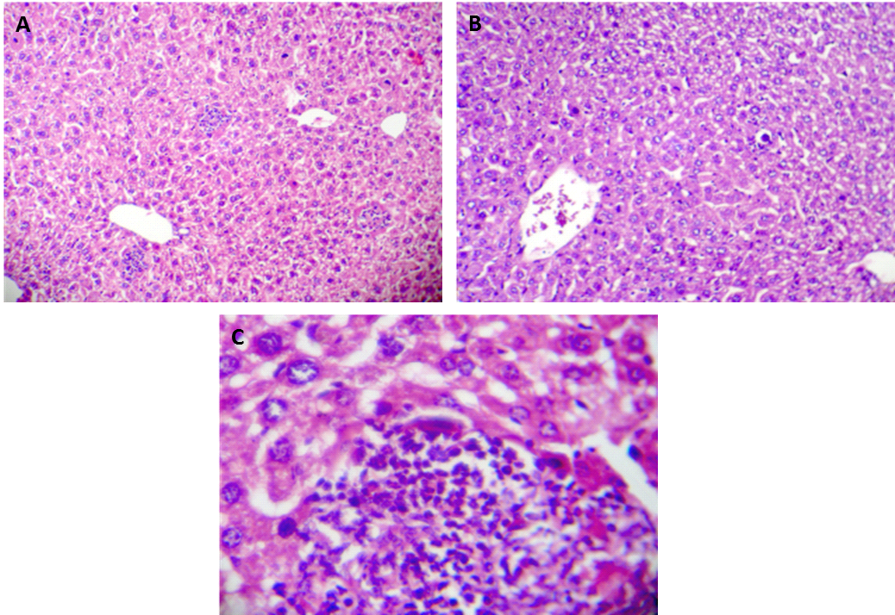

**Figure 1 Histological change in liver tissue of CCl4-induced cirrhotic rats (H&E; magnification × 100 and × 400).** A: focal hepatocellular necrosis, apoptotic cells and patchy inflammatory cells infiltration, along with, central vein dilation are observed; B: fatty degeneration areas are clearly seen; C: inflammatory cells infiltration into the portal tract.

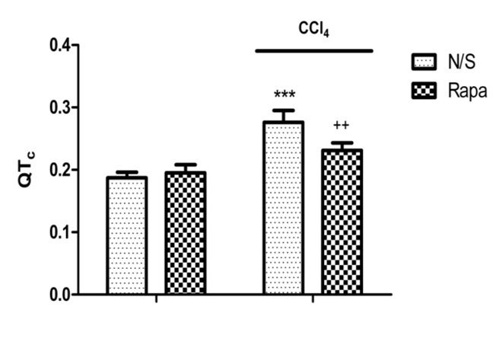

e

b

**Figure 2 The QT interval in control and CCl4-induced cirrhotic rats treated with normal saline or rapamycin (2 mg/kg).** QT intervals were defined as corrected QT (QTc) using Bazett’s formula. The data are expressed as the mean ± SD. e*P* < 0.001 *vs* control/normal saline group; b*P* < 0.01 *vs* control/rapamycinand cirrhotic/salinegroup.

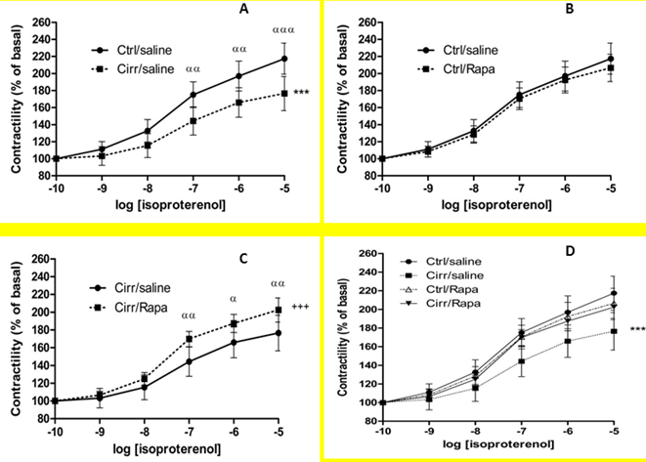

g

f

b

a

b

b

b

e

**Figure 3 Contractile force in response to β-adrenergic stimulation in the cirrhotic and control rats treated with normal saline or rapamycin (2 mg/kg).** Inotropic responsiveness to β-adrenergic stimulation with isoproterenol in the isolated papillary muscle from the cirrhotic and control rats treated with normal saline or rapamycin (2 mg/kg) was analyzed to determine the contractile force (% of basal). The data are expressed as the mean ± SD. Maximal response (Rmax) for the CCl4-induced cirrhotic rats was significantly lower than the other groups. There were no significant differences in EC50 values between the 4 studied groups. f*P* < 0.001 *vs* the control group receiving normal saline; g*P* < 0.001 *vs* the cirrhosis group receiving normal saline; a*P* < 0.05, b*P* < 0.01, e*P* < 0.001 *vs* the cirrhotic group receiving normal saline in that concentration.

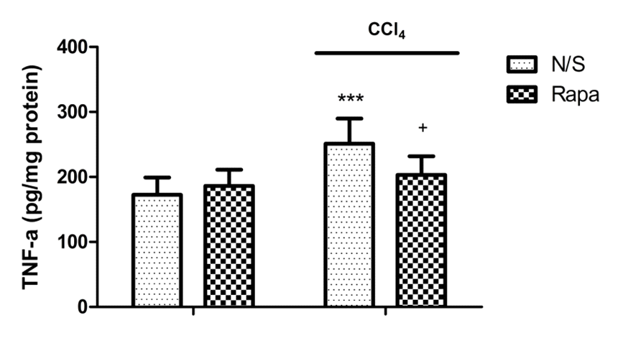

f

e

**Figure 4 The left ventricular tumor necrosis factor-α levels in control and CCl4-induced cirrhotic rats treated with normal saline or rapamycin (2 mg/kg).** The data are expressed as the mean ± SD. e*P* < 0.001 *vs* control/normal saline group; f*P* < 0.001 *vs* cirrhosis/normal saline group. TNF-α: tumor necrosis factor-α.

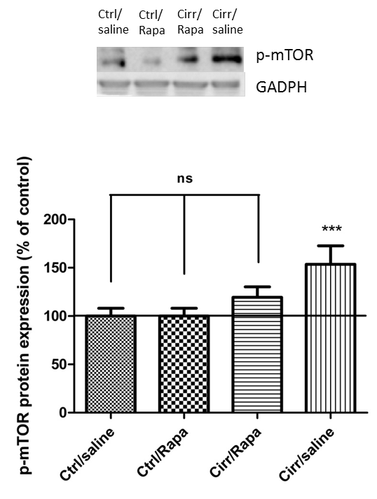

a

**Figure 5 Western blot analysis of p-mTOR protein in the left ventricles of control and CCl4-induced cirrhotic rats treated with normal saline or rapamycin (2 mg/kg).** The upper panels demonstrate the representative immunoblots of p-mTOR and GADPH proteins in the control, control + rapamycin, cirrhotic and cirrhotic + rapamycin. The lower panel shows the densitometric analysis after normalization with GAPDH. Values are expressed as p-mTOR/GAPDH ratio (%) and normalized to the control group receiving normal saline (mean±SD). a*P* < 0.05 *vs* the other 3 groups; ns: non-significant.

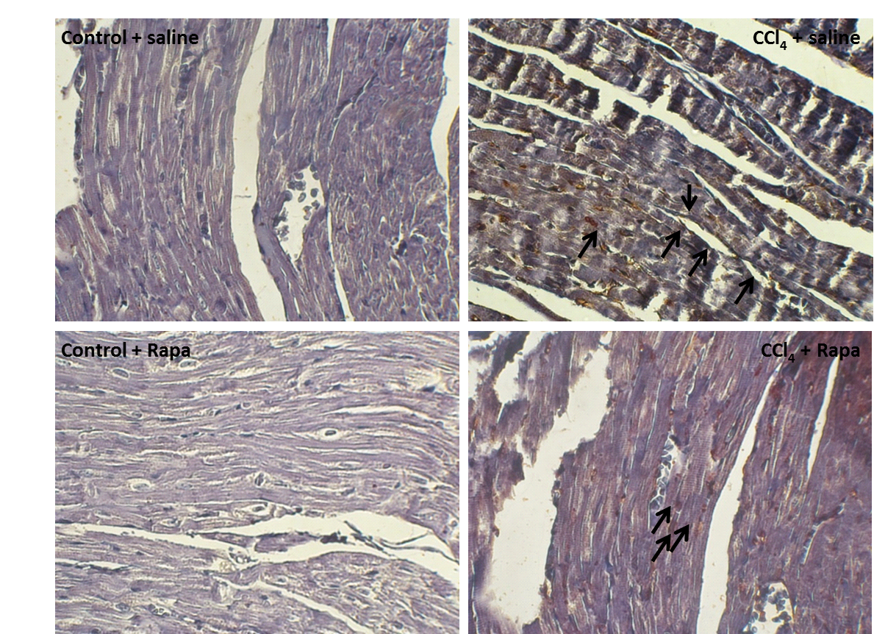

**Figure 6 Immunohistochemical staining for p-mTOR in the ventricles of the rats in the following groups: control, cirrhotic, control + rapamycin and cirrhotic + rapamycin (400 × magnification).** Human gastric tissue was used as the positive control. Note the increased immunostaining of p-mTOR in the myocytes of the rats with cirrhosis. No significant immunostaining are localized in the cardiomyocytes of the cirrhotic rats with no treatment. In contrast, treatment with rapamycin causes a significant immunostaining in the cardiomyocytes of the cirrhotic rats.