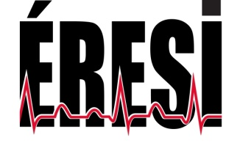

To: WJCC Editorial Office

August 26th 2016

Object: Manuscript submission (ID 03220352 Invited submission))

Dear Editor,

We are pleased to submit our manuscript “Comparison of Inhaled Milrinone, Nitric Oxide and Prostacyclin in Acute Respiratory Distress Syndrome” for publication consideration.

Acute Respiratory Distress Syndrome (ARDS) remains a life-threatening condition with limited therapies. Ventilation-perfusion mismatch is a major mechanism for hypoxemia and hypercarbia. In this paper, we tested inhaled milrinone, a potent pulmonary vasodilator, and compared it to more commonly used inhaled therapies inhaled nitric oxide (iNO) and epoprostenol. We observed that inhaled milrinone is safe in ARDS patients but failed to improve significantly oxygenation in our patients. We consider that our paper presents a relevant trial of an inhaled therapy in ARDS, reported in prior animal studies to be of benefit. It is limited by being a one center non randomised trial with a small sample size but could inspire further research with this therapy.

The paper was initially drafted by Daniel Corsilli, Martin Albert, David Williamson and Marc Brosseau. All authors contributed substantially to the conception, design, and interpretation of data. They also gave significant input and final approval of the version to be published. All authors observed strict ethical adherence and declared no conflict of interest

We strongly believe that the novelty and quality of our contribution warrants its consideration for publication.

We appreciate your consideration and look forward to hearing from you.

Sincerely.

Martin Albert, MD

ÉQUIPE DE RECHERCHE

EN SOINS INTENSIFS

Martin Albert, MD

Yannick Beaulieu, MD

Patrick Bellemare, MD

Francis Bernard, MD

Véronique Brunette, MD

Emmanuel Charbonney, MD, PhD

Sébastien Dupuis, Pharm D, M Sc

Anne Julie Frenette, B. Pharm, M Sc

Marc Giasson, MD

Anne-Marie Lagacé, inf, M Sc

Yoan Lamarche, MD

Soazig Le Guillan, MD

Pierre Marsolais, MD

Philippe Rico, MD

Karim Serri, MD

Colin Verdant, MD

Virginie Williams, PhD

David Williamson, B. Pharm, PhD

5400, boul. Gouin Ouest

Local C5115

Montréal (Québec) H4J1C5

**T** 514 338-2222 poste 3487

**F** 514 338-3557

http://soinsintensif.crhscm.ca

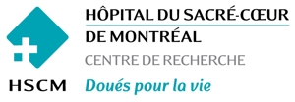

http://www.crhscm.ca/intranet/documents/Logo%20UdeM%20.jpg