Name of journal: World Journal of Gastroenterology
ESPS Manuscript NO: 30135
Manuscript Type: ORIGINAL ARTICLE

Observational Study
Association between endotoxemia and histological features of nonalcoholic fatty liver disease

Kitabatake H et al. Endotoxemia and NAFLD/NASH

Hiroyuki Kitabatake, Naoki Tanaka, Naoyuki Fujimori, Michiharu Komatsu, Ayaka Okubo, Kyogo Kakegawa, Takefumi Kimura, Ayumi Sugiura, Tomoo Yamazaki, Soichiro Shibata, Yuki Ichikawa, Satoru Joshita, Takeji Umemura, Akihiro Matsumoto, Masayoshi Koinuma, Kenji Sano, Toshifumi Aoyama, Eiji Tanaka

Hiroyuki Kitabatake, Naoki Tanaka, Toshifumi Aoyama, Department of Metabolic Regulation, Shinshu University Graduate School of Medicine, Matsumoto 390-8621, Japan

Hiroyuki Kitabatake, Naoyuki Fujimori, Michiharu Komatsu, Ayaka Okubo, Kyogo Kakegawa, Takefumi Kimura, Ayumi Sugiura, Tomoo Yamazaki, Soichiro Shibata, Yuki Ichikawa, Satoru Joshita, Takeji Umemura, Akihiro Matsumoto, Eiji Tanaka, Department of Internal Medicine, Division of Gastroenterology, Shinshu University School of Medicine, Matsumoto 390-8621, Japan

Masayoshi Koinuma, Center for Clinical Research, Shinshu University Hospital, Matsumoto 390-8621, Japan

Masayoshi Koinuma, Faculity of Pharmaceutical Sciences, Teikyo Heisei University, Tokyo 164-8530, Japan

Kenji Sano, Department of Laboratory Medicine, Shinshu University Hospital, Matsumoto 390-8621, Japan

Author contributions: Tanaka N designed research; Kitabatake H, Okubo A, Kakegawa K, Sano K and Tanaka N performed research; Kitabatake H, Fujimori N, Tanaka N and Koinuma M analyzed data; Fujimori N, Tanaka N, Komatsu M, Kimura T, Sugiura A, Yamazaki T, Shibata S, Ichikawa Y, Joshita S, Umemura T and Matsumoto A collected data; Kitabatake H and Tanaka N wrote the manuscript; Aoyama T and Tanaka E supervised the manuscript.

Institutional review board statement: The study was reviewed and approved by the Committee for Medical Ethics of Shinshu University School of Medicine Institutional Review Board.

Informed consent statement: Informed written consent was obtained from all patients.

Conflict-of-interest statement: The authors declare that no conflicts of interest exist.

Data sharing statement: No additional data are available.

Open-Access: This article is an open-access article which was selected by an in-house editor and fully peer-reviewed by external reviewers. It is distributed in accordance with the Creative Commons Attribution Non Commercial (CC BY-NC 4.0) license, which permits others to distribute, remix, adapt, build upon this work non-commercially, and license their derivative works on different terms, provided the original work is properly cited and the use is non-commercial. See: http://creativecommons.org/licenses/by-nc/4.0/

Manuscript source: Invited manuscript

Correspondence to: Naoki Tanaka, MD, PhD, Department of Metabolic Regulation, Shinshu University Graduate School of Medicine, Asahi 3-1-1, Matsumoto, Nagano 390-8621, Japan. naopi@shinshu-u.ac.jp
Telephone: +81-263-372634
Fax: +81-263-329412

Received: September 13, 2016
Peer-review started: September 16, 2016
First decision: September 20, 2016
Revised: November 14, 2016
Accepted: January 2, 2017
Article in press:
Published online:

Abstract
AIM
To assess whether surrogate biomarkers of endotoxemia were correlated with the histological features of nonalcoholic fatty liver disease (NAFLD).

METHODS
One hundred twenty-six NAFLD patients who had undergone percutaneous liver biopsy were enrolled. Serum lipopolysaccharide (LPS)-binding protein (LBP) and anti-endotoxin core immunoglobulin G (EndoCab IgG) antibody concentrations at the time of liver biopsy were measured using the enzyme-linked immunosorbent assays to examine for relationships between biomarker levels and histological scores.

RESULTS
Serum LBP concentration was significantly increased in nonalcoholic steatohepatitis (NASH) patients as compared with nonalcoholic fatty liver (NAFL) subjects and was correlated with steatosis (r = 0.38, P < 0.0001) and ballooning scores (r = 0.24, P = 0.007), but not with the severity of lobular inflammation or fibrosis. Multivariate linear regression analysis revealed that LBP was associated with steatosis score and circulating C-reactive protein, aspartate aminotransferase, and fibrinogen levels. Serum EndoCab IgG concentration was comparable between NASH and NAFL patients. No meaningful correlations were detected between EndoCab IgG and histological findings.

CONCLUSION
LBP/EndoCab IgG were not correlated with lobular inflammation or fibrosis. More accurate LPS biomarkers are required to stringently assess the contribution of endotoxemia to conventional NASH.
Key words: nonalcoholic steatohepatitis; lipopolysaccharide-binding protein; endotoxemia, EndoCab IgG; steatosis; fibrosis

© The Author(s) 2016. Published by Baishideng Publishing Group Inc. All rights reserved.

Core tip: This is the first study simultaneously measuring two surrogate endotoxemia markers, lipopolysaccharide-binding protein (LBP) and EndoCab IgG, in biopsy-proven nonalcoholic fatty liver disease (NAFLD) patients in order to assess for relationships with the histological features of NAFLD. Serum LBP/EndoCab IgG were not correlated with lobular inflammation or fibrosis. It remains elusive whether portal endotoxemia promotes hepatitis/fibrosis in human conventional NAFLD/nonalcoholic steatohepatitis.

Kitabatake H, Tanaka N, Fujimori N, Komatsu M, Okubo A, Kakegawa K, Kimura T, Sugiura A, Yamazaki T, Shibata S, Ichikawa Y, Joshita S, Umemura T, Matsumoto A, Koinuma M, Sano K, Aoyama T, Tanaka E. Association between endotoxemia and histological features of nonalcoholic fatty liver disease. World J Gastroenterol 2016; In press

INTRODUCTION
The prevalence of nonalcoholic fatty liver disease (NAFLD) is increasing worldwide. NAFLD includes a wide spectrum of disorders, ranging from nonalcoholic fatty liver (NAFL) to nonalcoholic steatohepatitis (NASH) and resultant liver cirrhosis and hepatocellular carcinoma^{[1-4]}. NASH is characterized by the presence of hepatocyte ballooning, lobular inflammation and/or various degree of fibrosis in addition to macrovesicular steatosis^{[1-3]}. Although several pathogenic factors, such as lipotoxicity, endoplasmic reticulum stress, iron accumulation, and inflammatory signaling, reportedly contribute to the progression from steatosis to steatohepatitis/steatofibrosis, the mechanism of NASH development has not been fully clarified.
Recent murine studies have demonstrated a key role of endotoxin/lipopolysaccharide (LPS) in the onset of NASH^{[5,6]}. For example, repeated LPS injection into ob/ob mice led to steatohepatitis^{[7]}, while mice lacking the gene encoding Toll-like receptor (TLR) 4, a central molecule in LPS-mediated signaling, were resistant to NASH development^{[8]}. It is generally accepted that Kupffer cells are activated when the gut mucosa becomes inflamed and fragile or when gut bacteria overgrow and LPS subsequently flows into the portal vein. However, it remains unclear whether the gut barrier is disrupted and portal LPS levels are elevated in typical obesity-, metabolic syndrome-related NAFLD patients without accompanying active inflammatory bowel disease^{[9,10]} or a history of gastrointestinal surgery, such as pancreaticoduodenectomy and blind loop construction^{[11,12]}.
Another issue requiring attention when considering the contribution of endotoxin/LPS to human NASH is the lack of appropriate systems to determine portal LPS concentration. Since portal LPS is rapidly eliminated in the liver, systemic LPS levels often do not mirror those in the portal vein, and the half-life of circulating LPS is as short as 2 h^{[13]}. These shortcomings obscure the evaluation of endotoxin/LPS contribution to NASH.
Circulating LPS-binding protein (LBP) and anti-endotoxin core immunoglobulin G (EndoCab IgG) antibody are commercially available surrogate markers of endotoxemia^{[10,14]}. LBP is a soluble acute-phase protein that binds to bacterial endotoxin. When the liver senses bacterial endotoxin, LBP is rapidly synthesized by hepatocytes to neutralize the toxin and then secreted into the circulation. The EndoCab IgG assay measures endotoxin core antibodies to reflect the immune response against persistent endotoxin exposure. Since both of these biomarkers are more stable than LPS, they represent possible indicators of endotoxemia.
In the current study, serum levels of LBP and EndoCab IgG were measured in biopsy-proven NAFLD patients and their correlation with the histological severity of NAFLD was assessed to clarify associations between endotoxemia and NASH development.

MATERIALS AND METHODS
Patients
This study was approved by the Committee for Medical Ethics of Shinshu University School of Medicine (Approval number: 2802) and conducted in accordance with the 1983 revision of the Helsinki declaration of 1975. Informed written consent was obtained from all patients. One hundred twenty-six NAFLD patients who were admitted to Shinshu University Hospital between February 2009 and April 2015 for percutaneous liver biopsy were enrolled. NAFLD had been suspected based on the following criteria: (1) the presence of hepatorenal contrast and increased hepatic echogenicity on abdominal ultrasonography; (2) ethanol consumption of < 20 g/d; and (3) the absence of other causes of liver dysfunction, such as viral hepatitis, drug-induced liver injury, autoimmune liver diseases, primary sclerosing cholangitis, Wilson’s disease, hereditary hemochromatosis, and citrin deficiency^{[15-18]}. The diagnosis of NAFLD/NASH was confirmed based on the histological findings of biopsied specimens.
Body weight and height were measured before liver biopsy performed in a fasting state. The presence of obesity was defined as a body mass index of ≥ 25 kg/m² according to criteria released by the Japan Society for the Study of Obesity^{[19]}. Medical information was also recorded, and the presence of hypertension, hyperlipidemia, and diabetes was evaluated as described previously^{[20,21]}. Blood samples were obtained on the day of the liver biopsy in a fasting state and routine examinations, such as complete blood counts, coagulation, and blood chemistry that included serum aspartate aminotransferase (AST) and alanine aminotransferase (ALT), were carried out using standard laboratory methods. The remaining sera samples were immediately frozen and kept at -80 ºC until further use.

Histopathological analysis
Biopsy specimens were obtained from liver segment 5 or 8 using a 14-gauge needle as described previously and immediately fixed in 10% neutral formalin. Sections were cut at a 4-μm thickness and stained by means of the hematoxylin and eosin and Azan-Mallory methods. The histological activity of NAFLD was assessed by an independent expert pathologist (KS) in a blinded manner for the degrees of steatosis, lobular inflammation, ballooning, and fibrosis according to the system proposed by Kleiner et al^{[22]}, as steatosis grade 1: 5%-33% of hepatocytes affected, grade 2: 33%-66% of hepatocytes affected, and grade 3: > 66% of hepatocytes affected; lobular inflammation grade 0: no inflammatory foci, grade 1: < 2 foci per 200 × ﬁeld, grade 2: 2-4 foci per 200 × ﬁeld, and grade 3: > 4 foci per 200 × ﬁeld; ballooning grade 0: no ballooned hepatocytes, grade 1: a few ballooned hepatocytes, and grade 2: many/prominent ballooned hepatocytes; and fibrosis stage (F) 0: no fibrosis, F1: perisinusoidal, perivenular, or portal/periportal fibrosis, F2: perisinusoidal and portal/periportal fibrosis, F3: bridging fibrosis, and F4: cirrhosis. NASH was defined as the presence of macrovesicular steatosis (≥ 5% of hepatocytes affected) and hepatocyte ballooning with or without lobular inflammation and fibrosis. NAFLD patients having macrovesicular steatosis without ballooning were diagnosed as having NAFL. The NAFLD activity score (NAS) was calculated as the unweighted sum of the scores for steatosis (1-3), lobular inflammation (0-3), and ballooning (0-2), ranging from 1 to 8.

Measurement of serum LBP and EndoCab IgG levels
Frozen serum samples obtained at the time of liver biopsy were diluted in 1000- and 200-fold with dilution buffer, and serum LBP and EndoCab IgG concentrations were measured in duplicates using the LBP ELISA kit (HK315-01, Hycult Biotech, Uden, the Netherlands) and the ENDOCAB ELISA kit (HK504, Hycult Biotech), respectively, according to the manufacturer’s instructions.

Measurement of serum cytokeratin 18 fragment levels
Serum concentrations of caspase-cleaved cytokeratin 18 (CK18) fragments were measured using the M30 Apoptosense® ELISA kit (VLVbio AB, Nacka, Sweden) as described previously^{[15]}.

Statistical analysis
Data are expressed as number (percentage) or median (25th, 75th percentiles). Comparisons between the groups were carried out using the Mann-Whitney U test, χ² test, or one-way ANOVA with Bonferroni’s correction. Spearman’s test was adopted to examine for correlations among LBP, EndoCab IgG, and biochemical/histological data. Multivariate linear regression analysis was conducted to search for independent predictors of LBP. Statistical analyses were performed using StatFlex Ver6.0 software (Artech Co., Ltd., Osaka, Japan). A P value of < 0.05 was considered to be statistically significant.

RESULTS
Serum LBP/EndoCab IgG levels in NAFLD patients
The clinicopathological features of the 126 NAFLD patients are summarized in Table 1. One-hundred patients (79%) were diagnosed as having NASH and 29 (23%) had advanced fibrosis of stage 3 or 4. Serum LBP concentration was significantly increased in NASH patients as compared with NAFL patients (Figure 1A), whereas serum EndoCab IgG was comparable between the groups (Figure 1B).

Relationships between LBP/EndoCab IgG levels and histological findings
We next examined whether serum LBP levels correlated with histological severity in NAFLD patients. Serum LBP was significantly higher in the steatosis grade 3 group as compared with the steatosis grade 1 or 2 groups (Figure 2A) and was positively correlated with steatosis score (Table 2). Significantly increased serum LBP was seen in the ballooning grade 2 group over the ballooning grade 0 group (Figure 2B), with a positive correlation between LBP and ballooning score (Table 2). There were no significant relationships between serum LBP and lobular inflammation grade (Figure 2C and Table 2) or fibrosis stage (Figure 2D and Table 2).
Similar analyses were carried out for serum EndoCab IgG, which yielded comparable findings among all subgroups (Figure 3) and no correlations with histological scores (Table 2). The lack of agreement between LBP and EndoCab IgG (Figure 4) may explain the discrepant results between LBP and EndoCab IgG for histological scores.

Correlations between LBP/EndoCab levels and NAS
There was a significant positive correlation for serum LBP and NAS, an indicator of histological NAFLD activity, but none for EndoCab IgG (Figure 5).

Correlations between LBP/EndoCab levels and laboratory data
Serum LBP was significantly positively correlated with AST, ALT, leukocyte count, fibrinogen (FIBG), C-reactive protein (CRP), and CK18 fragment (Table 3), while EndoCab IgG was correlated significantly with age and platelet count (Table 3). Factor analysis using several laboratory data parameters distinguished a clear separation between the LBP and EndoCab IgG groups; the former group included inflammation-related parameters, such as CRP, FIBG, and leukocyte count, whereas the latter group contained HbA1c, age, and hyaluronic acid. Multivariate linear regression analysis revealed that steatosis score (P = 0.0033), circulating CRP (P = 0.0032), AST (P = 0.0151), and FIBG (P = 0.0181) were independent predictors of LBP.

DISCUSSION
To our knowledge, this is the first study examining the relationship between two surrogate LPS markers and histological severity in NAFLD. Unexpectedly, serum EndoCab IgG did not correlate with any histological findings, nor was serum LBP associated with lobular inflammation grade or fibrosis stage. Based on these results, we could not conclude whether LPS played a crucial role in hepatitis development or fibrosis progression in NAFLD patients, which deviated from findings obtained in murine models.
Although serum LPS is reportedly elevated in NASH patients^{[23]}, the direct measurement of LPS has several flaws. First, LPS has a very short half-life and is rapidly eliminated in the liver, and thus serum LPS values rarely reflect actual endotoxemia. Second, the limulus amoebocyte lysate assay is widely used for LPS determination but may be influenced by exogenous LPS contamination due to its high sensitivity. The assay is also disrupted by detergents, urea, and pH^{[24]}. We therefore adopted the more stable biomarkers LBP and EndoCab IgG as indicators of endotoxemia.
Since LBP is rapidly induced by LPS and EndoCab IgG reflects the immune response to endotoxin core, these biomarkers measure acute/intermittent and chronic/persistent endotoxemia, respectively. Previous studies have examined either serum LBP or EndoCab IgG in NAFLD patients. LBP was similar^{[25]} between control and NAFLD subjects and increased in NAFLD/NASH patients with severe fibrosis^{[26,27]}. EndoCab IgG was comparable^{[28]} between control and NAFLD/NASH groups and higher in NASH^{[29]}. However, the number of NAFLD patients was relatively small (less than 40) in these investigations. Moreover, there have been no reports simultaneously measuring LBP and EndoCab IgG in histologically-proven NAFLD patients or examining these factors for associations with histological findings. The absence of a correlation between LBP and EndoCab IgG has been supported by a large recent study of 920 participants^{[14]}. Although LBP and EndoCab IgG were simultaneously measured in the previous study^{[14]}, histological evaluation of the liver was not performed.
In the present series, the severity of lobular inflammation and fibrosis did not correlate with either serum LBP or EndoCab IgG. EndoCab IgG tended to associate with age, hyaluronic acid, and IgG, which was indicative of the possibility of nonspecific IgG elevation due to chronic liver disease and/or aging. Thus, evidence that LPS promoted fibrosis and hepatitis in the context of conventional human NAFLD/NASH could not be demonstrated.
The degree of steatosis correlated with serum LBP level. An earlier study also demonstrated a significant correlation for serum LBP and intrahepatic triglyceride content as determined by proton-magnetic resonance spectroscopy (r = 0.366, P < 0.001)^{[14]}, but not for EndoCab IgG. These similar findings prompted us to consider that LBP might be induced independently of LPS in NAFLD patients. Indeed, the fact that disruption of the LBP-encoding gene in mice decreased basal expression levels of fatty acid-synthesizing enzymes and suppressed steatogenesis^{[30]} implied a direct link between increased LBP and hepatosteatosis. LBP is also up-regulated in hypertrophied adipocytes and acts as an adipokine^{[31]}. Along with CRP and FIBG, LBP is an acute phase reactant as well. It is noteworthy that LBP can be induced by interleukin-6 (IL-6)^{[32]}, a pro-inflammatory cytokine, in hepatocytes. IL-6 is markedly up-regulated in steatotic livers^{[33]}, indicating a possible link among steatosis, IL-6, and LBP. Although the possibility that LPS directly induced steatosis cannot be ruled out completely, the above findings corroborate a possible association between serum LBP and steatosis independently of LPS/endotoxemia.
This study uncovered a weak, but statistically significant, correlation between serum LBP level and the incidence of ballooned hepatocytes. In hepatocytes with ballooning degeneration, activated c-Jun N-terminal kinase (JNK) and ensuing lipoapoptosis have been documented^{[34]}. Escherichia coli LPS induces LBP in human oral keratinocytes through the activation of JNK in addition to nuclear factor kappa B and p38 mitogen-activated protein kinase^{[35]}. Therefore, a positive relationship between LBP expression and ballooning score might reflect activated JNK-mediated signaling in degenerated hepatocytes.
Yuan et al^{[36]} demonstrated that circulating LPS levels in pediatric NASH patients were distributed dichotomously at either high or normal levels, suggesting that endotoxemia was present in specific NASH patients only. Serum LPS levels exhibited no impact on NAS score or fibrosis stage and no meaningful relationship was detected between portal LPS and the proportion of intestinal Gram-negative bacteria. Therefore, they concluded that gut microbiome composition did not contribute to endotoxemia in NASH, nor was endotoxemia always required in the pathogenesis of NASH, which were partially consistent with our results. The observation that antibiotics/probiotics can attenuate NAFLD may not directly support a key role of LPS in NASH development since intestine-derived metabolites/toxicants other than LPS, such as deoxycholic acid and ceramides, promote NAFLD/NASH development^{[37,38]}. The therapeutic use of probiotics/prebiotics has not been supported by high-quality clinical studies^{[39]}. Additionally, the notion that increased hepatic TLR4 expression in NASH indicates an important role of portal endotoxemia may be inappropriate since TLRs are activated by several molecules other than LPS, including palmitic acid^{[40]}.
A key limitation of this study was that it did not directly measure LPS concentrations. Since the present investigation used cryogenically stored samples, we were concerned about the accuracy of LPS value measurement due to the abovementioned flaws in the LPS assay system. Future studies will benefit from assessment of LPS using freshly prepared serum samples along with improvements in LPS assay systems. Another limitation was that we could not examine the association between LBP and PNPLA3 polymorphisms, which might impact the degree of hepatic steatosis. However, a recent study showed no relationship between PNPLA3 variants and circulating LBP levels in chronic hepatitis C patients^{[41]}.
It is reasonable to consider that chronic LPS challenge to steatotic livers, such as NAFLD accompanied with severe gingivitis or inflammatory bowel disease, may be detrimental to liver condition. However, establishing a key contribution of LPS to the histological severity of human primary NASH was not possible in the current study. The lack of appropriate endotoxin markers is a major limitation at present, as is the low sensitivity/specificity of LBP/EndoCab IgG assays. Further improvements in LPS detection systems may provide novel information on the role of LPS/endotoxemia in the pathogenesis of conventional NASH.

ACKNOWLEDGEMENTS
The authors thank Mr. Trevor Ralph for his editorial assistance.

COMMENTS
Background
Recent murine studies have demonstrated a key role of endotoxin/lipopolysaccharide (LPS) in the onset of nonalcoholic steatohepatitis (NASH). The contribution of intestinal bacterial overgrowth, increased intestinal permeability, and portal endotoxemia to the progression from nonalcoholic fatty liver (NAFL) to NASH has attracted considerable recent attention. However, evaluating the LPS contribution to human NASH is challenging since LPS is rapidly eliminated in the liver, and therefore venous LPS concentrations often do not reflect portal ones.

Research frontiers
Circulating LPS-binding protein (LBP) and the anti-endotoxin core immunoglobulin G (EndoCab IgG) antibody are commercially available surrogate markers of endotoxemia that are more stable than LPS. The research hotspot is to examine whether these endotoxemia markers correlate with histological severity in nonalcoholic fatty liver disease (NAFLD).

Innovations and breakthroughs
This is the first study simultaneously measuring two surrogate endotoxemia markers, LBP and EndoCab IgG, in biopsy-proven NAFLD patients in order to assess for relationships with the histological scores of NAFLD. Serum LBP concentration was significantly increased in NASH patients and was correlated with steatosis and ballooning scores, but not with the severity of lobular inflammation or fibrosis. Serum EndoCab IgG concentration was comparable between NASH and NAFL patients. Neither endotoxin marker was correlated with lobular inflammation or fibrosis in human conventional NAFLD/NASH.

Applications
It is reasonable to consider that chronic LPS challenge to steatotic livers, such as NAFLD accompanied with severe gingivitis or inflammatory bowel disease, may be detrimental to liver condition. However, the contribution of LPS to the histological severity of human primary NASH could not be confirmed in the current study. The lack of appropriate endotoxin markers is a major limitation at present, as is the low sensitivity/specificity of LBP/EndoCab IgG assays. Further improvements in LPS detection systems may provide novel information on the role of LPS/endotoxemia in the pathogenesis of conventional NASH. This study provides important information regarding the gut-liver axis in the pathogenesis of NAFLD/NASH.

Terminology
NAFLD is a chronic liver disease increasing worldwide that includes a wide spectrum of disorders, ranging from NAFL to NASH and resultant liver cirrhosis and hepatocellular carcinoma. NASH is characterized by the presence of hepatocyte ballooning, lobular inflammation and/or various degrees of fibrosis in addition to macrovesicular steatosis. Increased intestinal permeability and ensuing portal endotoxemia is presumed to be one of the contributors to the progression of NASH.

Peer-review
This report, written by Kitabatake et al, is of an important retrospective study that has been carried out to disclose pathological mechanisms of NAFLD/NASH as well as its diagnosis. Especially, the close relationship between LBP and NASH is very interesting.
REFERENCES
1 Hashimoto E, Tokushige K, Ludwig J. Diagnosis and classification of non-alcoholic fatty liver disease and non-alcoholic steatohepatitis: Current concepts and remaining challenges. Hepatol Res 2015; 45: 20-28 [PMID: 24661406 DOI: 10.1111/hepr.12333]
2 Mishra A, Younossi ZM. Epidemiology and Natural History of Non-alcoholic Fatty Liver Disease. J Clin Exp Hepatol 2012; 2: 135-144 [PMID: 25755422 DOI: 10.1016/S0973-6883(12)60102-9]
3 Cohen JC, Horton JD, Hobbs HH. Human fatty liver disease: old questions and new insights. Science 2011; 332: 1519-1523 [PMID: 21700865 DOI: 10.1126/science.1204265]
4 Nagaya T, Tanaka N, Komatsu M, Ichijo T, Sano K, Horiuchi A, Joshita S, Umemura T, Matsumoto A, Yoshizawa K, Aoyama T, Kiyosawa K, Tanaka E. Development from simple steatosis to liver cirrhosis and hepatocellular carcinoma: a 27-year follow-up case. Clin J Gastroenterol 2008; 1: 116-121 [PMID: 26193649 DOI: 10.1007/s12328-008-0017-0]
5 Paolella G, Mandato C, Pierri L, Poeta M, Di Stasi M, Vajro P. Gut-liver axis and probiotics: their role in non-alcoholic fatty liver disease. World J Gastroenterol 2014; 20: 15518-15531 [PMID: 25400436 DOI: 10.3748/wjg.v20.i42.15518]
6 Zhu L, Baker RD, Baker SS. Gut microbiome and nonalcoholic fatty liver diseases. Pediatr Res 2015; 77: 245-251 [PMID: 25310763 DOI: 10.1038/pr.2014.157]
7 Imajo K, Fujita K, Yoneda M, Nozaki Y, Ogawa Y, Shinohara Y, Kato S, Mawatari H, Shibata W, Kitani H, Ikejima K, Kirikoshi H, Nakajima N, Saito S, Maeyama S, Watanabe S, Wada K, Nakajima A. Hyperresponsivity to low-dose endotoxin during progression to nonalcoholic steatohepatitis is regulated by leptin-mediated signaling. Cell Metab 2012; 16: 44-54 [PMID: 22768838 DOI: 10.1016/j.cmet.2012.05.012]
8 Csak T, Velayudham A, Hritz I, Petrasek J, Levin I, Lippai D, Catalano D, Mandrekar P, Dolganiuc A, Kurt-Jones E, Szabo G. Deficiency in myeloid differentiation factor-2 and toll-like receptor 4 expression attenuates nonalcoholic steatohepatitis and fibrosis in mice. Am J Physiol Gastrointest Liver Physiol 2011; 300: G433-G441 [PMID: 21233280 DOI: 10.1152/ajpgi.00163.2009]
9 Gardiner KR, Halliday MI, Barclay GR, Milne L, Brown D, Stephens S, Maxwell RJ, Rowlands BJ. Significance of systemic endotoxaemia in inflammatory bowel disease. Gut 1995; 36: 897-901 [PMID: 7615280]
10 Pasternak BA, D'Mello S, Jurickova II, Han X, Willson T, Flick L, Petiniot L, Uozumi N, Divanovic S, Traurnicht A, Bonkowski E, Kugathasan S, Karp CL, Denson LA. Lipopolysaccharide exposure is linked to activation of the acute phase response and growth failure in pediatric Crohn's disease and murine colitis. Inflamm Bowel Dis 2010; 16: 856-869 [PMID: 19924809 DOI: 10.1002/ibd.21132]
11 Tanaka N, Horiuchi A, Yokoyama T, Kaneko G, Horigome N, Yamaura T, Nagaya T, Komatsu M, Sano K, Miyagawa S, Aoyama T, Tanaka E. Clinical characteristics of de novo nonalcoholic fatty liver disease following pancreaticoduodenectomy. J Gastroenterol 2011; 46: 758-768 [PMID: 21267748 DOI: 10.1007/s00535-011-0370-5]
12 Nagaya T, Tanaka N, Kimura T, Kitabatake H, Fujimori N, Komatsu M, Horiuchi A, Yamaura T, Umemura T, Sano K, Gonzalez FJ, Aoyama T, Tanaka E. Mechanism of the development of nonalcoholic steatohepatitis after pancreaticoduodenectomy. BBA Clin 2015; 3: 168-174 [PMID: 26674248 DOI: 10.1016/j.bbacli.2015.02.001]
13 Zweigner J, Schumann RR, Weber JR. The role of lipopolysaccharide-binding protein in modulating the innate immune response. Microbes Infect 2006; 8: 946-952 [PMID: 16483818 DOI: 10.1016/j.micinf.2005.10.006]
14 Wong VW, Wong GL, Chan HY, Yeung DK, Chan RS, Chim AM, Chan CK, Tse YK, Woo J, Chu WC, Chan HL. Bacterial endotoxin and non-alcoholic fatty liver disease in the general population: a prospective cohort study. Aliment Pharmacol Ther 2015; 42: 731-740 [PMID: 26202818 DOI: 10.1111/apt.13327]
15 Tsutsui M, Tanaka N, Kawakubo M, Sheena Y, Horiuchi A, Komatsu M, Nagaya T, Joshita S, Umemura T, Ichijo T, Matsumoto A, Yoshizawa K, Aoyama T, Tanaka E, Sano K. Serum fragmented cytokeratin 18 levels reflect the histologic activity score of nonalcoholic fatty liver disease more accurately than serum alanine aminotransferase levels. J Clin Gastroenterol 2010; 44: 440-447 [PMID: 20104187 DOI: 10.1097/MCG.0b013e3181bdefe2]
16 Tsuruta G, Tanaka N, Hongo M, Komatsu M, Horiuchi A, Hamamoto K, Iguchi C, Nakayama Y, Umemura T, Ichijo T, Matsumoto A, Yoshizawa K, Aoyama T, Tanaka E. Nonalcoholic fatty liver disease in Japanese junior high school students: its prevalence and relationship to lifestyle habits. J Gastroenterol 2010; 45: 666-672 [PMID: 20084525 DOI: 10.1007/s00535-009-0198-4]
17 Hatta T, Fujinaga Y, Kadoya M, Ueda H, Murayama H, Kurozumi M, Ueda K, Komatsu M, Nagaya T, Joshita S, Kodama R, Tanaka E, Uehara T, Sano K, Tanaka N. Accurate and simple method for quantification of hepatic fat content using magnetic resonance imaging: a prospective study in biopsy-proven nonalcoholic fatty liver disease. J Gastroenterol 2010; 45: 1263-1271 [PMID: 20625773 DOI: 10.1007/s00535-010-0277-6]
18 Fujimori N, Tanaka N, Shibata S, Sano K, Yamazaki T, Sekiguchi T, Kitabatake H, Ichikawa Y, Kimura T, Komatsu M, Umemura T, Matsumoto A, Tanaka E. Controlled attenuation parameter is correlated with actual hepatic fat content in patients with non-alcoholic fatty liver disease with none-to-mild obesity and liver fibrosis. Hepatol Res 2016; 46: 1019-1027 [PMID: 27183219 DOI: 10.1111/hepr.12649]
19 Examination Committee of Criteria for 'Obesity Disease' in Japan; Japan Society for the Study of Obesity. New criteria for 'obesity disease' in Japan. Circ J 2002; 66: 987-992 [PMID: 12419927]
20 Komatsu M, Yazaki M, Tanaka N, Sano K, Hashimoto E, Takei Y, Song YZ, Tanaka E, Kiyosawa K, Saheki T, Aoyama T, Kobayashi K. Citrin deficiency as a cause of chronic liver disorder mimicking non-alcoholic fatty liver disease. J Hepatol 2008; 49: 810-820 [PMID: 18620775 DOI: 10.1016/j.jhep.2008.05.016]
21 Nagaya T, Tanaka N, Suzuki T, Sano K, Horiuchi A, Komatsu M, Nakajima T, Nishizawa T, Joshita S, Umemura T, Ichijo T, Matsumoto A, Yoshizawa K, Nakayama J, Tanaka E, Aoyama T. Down-regulation of SREBP-1c is associated with the development of burned-out NASH. J Hepatol 2010; 53: 724-731 [PMID: 20655124 DOI: 10.1016/j.jhep.2010.04.033]
22 Kleiner DE, Brunt EM, Van Natta M, Behling C, Contos MJ, Cummings OW, Ferrell LD, Liu YC, Torbenson MS, Unalp-Arida A, Yeh M, McCullough AJ, Sanyal AJ. Design and validation of a histological scoring system for nonalcoholic fatty liver disease. Hepatology 2005; 41: 1313-1321 [PMID: 15915461 DOI: 10.1002/hep.20701]
23 Thuy S, Ladurner R, Volynets V, Wagner S, Strahl S, Königsrainer A, Maier KP, Bischoff SC, Bergheim I. Nonalcoholic fatty liver disease in humans is associated with increased plasma endotoxin and plasminogen activator inhibitor 1 concentrations and with fructose intake. J Nutr 2008; 138: 1452-1455 [PMID: 18641190]
24 Cohen J, McConnell JS. Observations on the measurement and evaluation of endotoxemia by a quantitative limulus lysate microassay. J Infect Dis 1984; 150: 916-924 [PMID: 6501933]
25 Shanab AA, Scully P, Crosbie O, Buckley M, O'Mahony L, Shanahan F, Gazareen S, Murphy E, Quigley EM. Small intestinal bacterial overgrowth in nonalcoholic steatohepatitis: association with toll-like receptor 4 expression and plasma levels of interleukin 8. Dig Dis Sci 2011; 56: 1524-1534 [PMID: 21046243 DOI: 10.1007/s10620-010-1447-3]
26 Ruiz AG, Casafont F, Crespo J, Cayón A, Mayorga M, Estebanez A, Fernadez-Escalante JC, Pons-Romero F. Lipopolysaccharide-binding protein plasma levels and liver TNF-alpha gene expression in obese patients: evidence for the potential role of endotoxin in the pathogenesis of non-alcoholic steatohepatitis. Obes Surg 2007; 17: 1374-1380 [PMID: 18000721 DOI: 10.1007/s11695-007-9243-7]
27 Vespasiani-Gentilucci U, Carotti S, Perrone G, Mazzarelli C, Galati G, Onetti-Muda A, Picardi A, Morini S. Hepatic toll-like receptor 4 expression is associated with portal inflammation and fibrosis in patients with NAFLD. Liver Int 2015; 35: 569-581 [PMID: 24649857 DOI: 10.1111/liv.12531]
28 Soza A, Riquelme A, González R, Alvarez M, Pérez-Ayuso RM, Glasinovic JC, Arrese M. Increased orocecal transit time in patients with nonalcoholic fatty liver disease. Dig Dis Sci 2005; 50: 1136-1140 [PMID: 15986870]
29 Verdam FJ, Rensen SS, Driessen A, Greve JW, Buurman WA. Novel evidence for chronic exposure to endotoxin in human nonalcoholic steatohepatitis. J Clin Gastroenterol 2011; 45: 149-152 [PMID: 20661154 DOI: 10.1097/MCG.0b013e3181e12c24]
30 Jin CJ, Engstler AJ, Ziegenhardt D, Bischoff SC, Trautwein C, Bergheim I. Loss of lipopolysaccharide-binding protein attenuates the development of diet-induced non-alcoholic fatty liver disease (NAFLD) in mice. J Gastroenterol Hepatol 2016; : [PMID: 27404046 DOI: 10.1111/jgh.13488]
31 Moreno-Navarrete JM, Escoté X, Ortega F, Camps M, Ricart W, Zorzano A, Vendrell J, Vidal-Puig A, Fernández-Real JM. Lipopolysaccharide binding protein is an adipokine involved in the resilience of the mouse adipocyte to inflammation. Diabetologia 2015; 58: 2424-2434 [PMID: 26201685 DOI: 10.1007/s00125-015-3692-7]
32 Grube BJ, Cochane CG, Ye RD, Green CE, McPhail ME, Ulevitch RJ, Tobias PS. Lipopolysaccharide binding protein expression in primary human hepatocytes and HepG2 hepatoma cells. J Biol Chem 1994; 269: 8477-8482 [PMID: 7510687]
33 Wieckowska A, Papouchado BG, Li Z, Lopez R, Zein NN, Feldstein AE. Increased hepatic and circulating interleukin-6 levels in human nonalcoholic steatohepatitis. Am J Gastroenterol 2008; 103: 1372-1379 [PMID: 18510618 DOI: 10.1111/j.1572-0241.2007.01774.x]
34 Kakisaka K, Cazanave SC, Werneburg NW, Razumilava N, Mertens JC, Bronk SF, Gores GJ. A hedgehog survival pathway in 'undead' lipotoxic hepatocytes. J Hepatol 2012; 57: 844-851 [PMID: 22641094 DOI: 10.1016/j.jhep.2012.05.011]
35 Ding PH, Wang CY, Darveau RP, Jin LJ. Nuclear factor-κB and p38 mitogen-activated protein kinase signaling pathways are critically involved in Porphyromonas gingivalis lipopolysaccharide induction of lipopolysaccharide-binding protein expression in human oral keratinocytes. Mol Oral Microbiol 2013; 28: 129-141 [PMID: 23194012 DOI: 10.1111/omi.12010]
36 Yuan J, Baker SS, Liu W, Alkhouri R, Baker RD, Xie J, Ji G, Zhu L. Endotoxemia unrequired in the pathogenesis of pediatric nonalcoholic steatohepatitis. J Gastroenterol Hepatol 2014; 29: 1292-1298 [PMID: 24372861 DOI: 10.1111/jgh.12510]
37 Yoshimoto S, Loo TM, Atarashi K, Kanda H, Sato S, Oyadomari S, Iwakura Y, Oshima K, Morita H, Hattori M, Honda K, Ishikawa Y, Hara E, Ohtani N. Obesity-induced gut microbial metabolite promotes liver cancer through senescence secretome. Nature 2013; 499: 97-101 [PMID: 23803760 DOI: 10.1038/nature12347]
38 Jiang C, Xie C, Li F, Zhang L, Nichols RG, Krausz KW, Cai J, Qi Y, Fang ZZ, Takahashi S, Tanaka N, Desai D, Amin SG, Albert I, Patterson AD, Gonzalez FJ. Intestinal farnesoid X receptor signaling promotes nonalcoholic fatty liver disease. J Clin Invest 2015; 125: 386-402 [PMID: 25500885 DOI: 10.1172/JCI76738]
39 Tarantino G, Finelli C. Systematic review on intervention with prebiotics/probiotics in patients with obesity-related nonalcoholic fatty liver disease. Future Microbiol 2015; 10: 889-902 [PMID: 26000656 DOI: 10.2217/fmb.15.13]
40 Sharifnia T, Antoun J, Verriere TG, Suarez G, Wattacheril J, Wilson KT, Peek RM, Abumrad NN, Flynn CR. Hepatic TLR4 signaling in obese NAFLD. Am J Physiol Gastrointest Liver Physiol 2015; 309: G270-G278 [PMID: 26113297 DOI: 10.1152/ajpgi.00304.2014]
41 Mateos-Muñoz B, García-Martín E, Torrejón MJ, Devesa-Medina MJ, Esguevillas G, Cárdenas MC, Fernández C, Carballo M, Agúndez JA, Ladero JM. GC Gene Polymorphism and Unbound Serum Retinol-Binding Protein 4 Are Related to the Risk of Insulin Resistance in Patients With Chronic Hepatitis C: A Prospective Cross-Sectional Study. Medicine (Baltimore) 2016; 95: e3019 [PMID: 26962819 DOI: 10.1097/MD.0000000000003019]
P-Reviewer: Ikura Y, Lee HC, Tarantino G, Valenti LV S-Editor: Gong ZM
L-Editor: E-Editor:
Specialty type: Gastroenterology and hepatology
Country of origin: Japan
Peer-review report classification
Grade A (Excellent): A
Grade B (Very good): B
Grade C (Good): C
Grade D (Fair): D
Grade E (Poor): 0
Table 1 Clinicopathological features of nonalcoholic fatty liver disease patients
Parameter | All (n = 126) | NAFL (n = 26) | NASH (n = 100) | P value
Clinical findings
Age (yr) | 56 (44-65) | 52 (42-58) | 58 (45-65) | 0.17
Male, n (%) | 54 (43) | 14 (54) | 40 (40) | 0.20
BMI ≥ 25 kg/m², n (%) | 76 (60) | 12 (46) | 64 (64) | 0.10
Diabetes, n (%) | 43 (34) | 5 (19) | 38 (38) | 0.07
Hypertension, n (%) | 49 (39) | 8 (31) | 41 (41) | 0.34
Hyperlipidemia, n (%) | 82 (65) | 19 (73) | 63 (63) | 0.34
BMI (kg/m²) | 25.8 (23.6-29.4) | 24.6 (22.6-28.5) | 26.4 (23.9-29.5) | < 0.05
Ethanol (g/d) | 0 (0-5) | 0 (0-2.8) | 0 (0-5) | 0.26
Leukocytes (× 10³/μL) | 5.57 (4.73-6.82) | 5.07 (4.76-5.75) | 5.72 (4.72-6.86) | 0.24
Erythrocytes (× 10⁴/μL) | 490 (453-515) | 490 (474-512) | 489 (452-515) | 0.36
Hemoglobin (g/dL) | 14.9 (14.0-15.8) | 15.1 (14.6-15.9) | 14.8 (13.9-15.8) | 0.14
Hematocrit (%) | 44.2 (41.6-46.6) | 45.3 (43.3-46.9) | 43.9 (41.5-46.6) | 0.31
MCV (fl) | 91.2 (88.5-93.7) | 91.5 (89.1-93.0) | 91.1 (88.4-94.1) | 0.81
MCH (pg) | 30.7 (29.6-31.7) | 31 (30.2-31.6) | 30.5 (29.6-31.7) | 0.42
MCHC (%) | 33.6 (33.0-34.3) | 33.9 (33.5-34.4) | 33.4 (32.9-34.2) | 0.08
Platelets (× 10⁴/μL) | 23.8 (17.9-26.8) | 23.3 (19.1-26.7) | 23.8 (17.8-26.9) | 0.88
PT-INR | 1.00 (0.98-1.05) | 1.00 (0.98-1.03) | 1.01 (0.97-1.05) | 0.40
APTT (s) | 28.6 (26.6-31.2) | 28.6 (27.5-30.1) | 28.6 (26.3-31.3) | 0.84
FIBG (mg/dL) | 287 (243-314) | 284 (247-321) | 287 (242-313) | 0.73
Total protein (g/dL) | 7.6 (7.3-7.9) | 7.6 (7.3-7.9) | 7.6 (7.3-7.8) | 0.97
Albumin (g/dL) | 4.5 (4.3-4.7) | 4.6 (4.5-4.7) | 4.5 (4.3-4.7) | 0.14
Bilirubin (mg/dL) | 0.9 (0.7-1.1) | 0.8 (0.7-1.1) | 0.9 (0.7-1.1) | 0.30
AST (U/L) | 40 (29-63) | 27 (23-33) | 47 (33-70) | < 0.00001
ALT (U/L) | 61 (36-92) | 39 (30-56) | 69 (42-104) | 0.0002
LDH (U/L) | 214 (186-240) | 189 (165-231) | 219 (191-249) | 0.02
ALP (U/L) | 254 (214-323) | 246 (218-312) | 258 (214-323) | 0.86
γGT (U/L) | 53 (35-82) | 44 (26-70) | 54 (37-87) | 0.21
ChE (U/L) | 384 (342-429) | 399 (369-445) | 376 (340-427) | 0.12
Urea nitrogen (mg/dL) | 13 (11-15) | 13.2 (12-14.5) | 13 (11-15) | 0.65
Creatinine (mg/dL) | 0.7 (0.58-0.82) | 0.79 (0.62-0.84) | 0.66 (0.57-0.82) | 0.17
Uric acid (mg/dL) | 5.6 (4.8-6.8) | 6.0 (5.2-7.5) | 5.6 (4.8-6.6) | 0.26
eGFR (mL/min/1.73m²) | 79 (69-89) | 77 (59-88) | 79 (70-89) | 0.53
Total cholesterol (mg/dL) | 209 (181-233) | 218 (175-247) | 206 (182-230) | 0.41
Triglycerides (mg/dL) | 119 (91-156) | 122 (88-165) | 119 (93-156) | 0.95
LDL-cholesterol (mg/dL) | 134 (109-152) | 136 (103-155) | 131 (113-147) | 0.80
HDL-cholesterol (mg/dL) | 52 (45-59) | 53 (45-61) | 52 (45-57) | 0.59
Glucose (mg/dL) | 106 (97-120) | 99 (92-112) | 107 (98-122) | 0.02
Insulin (μU/mL) | 12 (7.3-17.6) | 7.5 (5.1-11.5) | 13.1 (8.2-17.9) | 0.002
HbA1c (%) | 5.8 (5.6-6.4) | 5.8 (5.4-6.0) | 5.9 (5.6-6.6) | 0.02
HOMA-IR | 3.2 (1.9-4.8) | 2.0 (1.2-3.2) | 3.5 (2.2-4.9) | 0.001
IgG (mg/dL) | 1261 (1089-1535) | 1264 (1118-1524) | 1261 (1086-1541) | 0.77
IgM (mg/dL) | 94 (65-126) | 83 (54-113) | 97 (72-129) | 0.18
IgA (mg/dL) | 269 (180-333) | 252 (185-293) | 272 (180-349) | 0.56
CRP (mg/dL) | 0.1 (0.04-0.17) | 0.05 (0.03-0.16) | 0.08 (0.05-0.17) | 0.13
Hyarulonic acid (mg/dL) | 40 (24-74) | 29 (23-52) | 47 (25-88) | 0.08
Type 4 collagen 7S (mg/dL) | 4.5 (3.7-5.5) | 3.7 (3.6-4.5) | 4.5 (3.8-6.3) | 0.003
CK18 fragment (U/L) | 298 (155-561) | 164(121-293) | 351(178-645)¹ | 0.0003
Histological findings
Steatosis 1/2/3 | 43/57/26 | 15/9/2 | 28/48/24 | 0.004
Ballooning 0/1/2 | 26/68/32 | 26/0/0 | 0/68/32 | < 0.00001
Lobular inflammation 0/1/2/3 | 7/61/53/5 | 3/19/4/0 | 4/42/49/5 | 0.0003
Fibrosis 0/1/2/3/4 | 27/56/14/22/7 | 16/10/0/0/0 | 11/46/14/22/7 | < 0.00001
¹n = 96. Data are expressed as number (percentage) or median (25th, 75th percentiles). Histological findings were scored according to the criteria proposed by Kleiner et al^{[22]} Comparisons between NAFL and NASH groups were carried out using the χ² test or Mann-Whitney U test. An item with P < 0.05 is expressed in bold. BMI: body mass index; MCV: mean corpuscular volume; MCH: mean corpuscular hemoglobin; MCHC: mean corpuscular hemoglobin concentration; PT-INR: international ratio of prothrombin time; APTT: activated partial thromboplastin test; FIBG: fibrinogen; AST: aspartate aminotransferase; NAFL: nonalcoholic fatty liver; NASH: nonalcoholic steatohepatitis; ALT: alanine aminotransferase; LDH: lactate dehydrogenase; eGFR: estimated glomerular filtration rate; ALP: alkaline phosphatase; γGT: γ-glutamyltransferase; ChE: cholinesterase; LDL: low-density lipoprotein; HDL: high-density lipoprotein; HbA1c: hemoglobin A1c; HOMA-IR: homeostasis model assessment for insulin resistance; CRP: C-reactive protein; CK18: cytokeratin 18.
Table 2 Correlations between lipopolysaccharide-binding protein/EndoCab IgG and individual pathological features
 | LBP |  | EndoCab IgG
 | r | P value | r | P value
Steatosis | 0.38 | < 0.0001 | -0.10 | 0.25
Ballooning | 0.23 | 0.01 | 0.11 | 0.22
Lobular inflammation | 0.13 | 0.14 | 0.05 | 0.94
Fibrosis | 0.03 | 0.74 | 0.13 | 0.13
Histological findings were scored according to the criteria proposed by Kleiner et al^{[22]} Correlation coefficients (r) and P values were calculated by Spearman’s test. An item with r > 0.3 and P < 0.05 is expressed in bold. LBP: lipopolysaccharide-binding protein.
Table 3 Correlations between lipopolysaccharide-binding protein/EndoCab IgG and routine clinical data
 | LBP |  | EndoCab IgG
 | r | P value | r | P value
Age | -0.10 | 0.25 | 0.34 | 0.0001
BMI | 0.11 | 0.23 | -0.02 | 0.86
Leukocyte | 0.31 | 0.0005 | -0.07 | 0.44
Erythrocyte | 0.11 | 0.23 | -0.23 | 0.01
Hemoglobin | 0.02 | 0.87 | -0.2 | 0.024
Hematocrit | 0.05 | 0.55 | -0.22 | 0.013
MCV | -0.15 | 0.10 | 0.08 | 0.37
MCH | -0.15 | 0.92 | 0.10 | 0.25
MCHC | -0.15 | 0.11 | 0.02 | 0.81
Platelet | 0.22 | 0.015 | -0.29 | 0.001
PT-INR | -0.13 | 0.15 | 0.12 | 0.18
APTT | 0.06 | 0.51 | 0.08 | 0.37
FIBG | 0.30 | 0.0009 | -0.05 | 0.59
Total protein | -0.01 | 0.91 | 0.12 | 0.18
Albumin | -0.02 | 0.84 | -0.17 | 0.06
Bilirubin | -0.23 | 0.01 | -0.03 | 0.73
AST | 0.38 | < 0.0001 | 0.07 | 0.44
ALT | 0.35 | < 0.0001 | -0.09 | 0.31
LDH | 0.24 | 0.006 | 0.13 | 0.16
ALP | 0.16 | 0.07 | 0.08 | 0.39
γGT | 0.21 | 0.02 | -0.06 | 0.53
ChE | -0.04 | 0.69 | -0.21 | 0.02
Urea nitrogen | -0.24 | 0.007 | -0.08 | 0.35
Creatinine | -0.05 | 0.60 | -0.26 | 0.004
Uric acid | 0.07 | 0.47 | -0.21 | 0.02
eGFR | 0.15 | 0.12 | -0.02 | 0.85
Total cholesterol | 0.09 | 0.31 | 0.02 | 0.86
Triglycerides | 0.07 | 0.46 | 0.11 | 0.22
LDL-cholesterol | 0.08 | 0.37 | 0.001 | 0.99
HDL-cholesterol | -0.06 | 0.54 | -0.001 | 0.99
Glucose | -0.08 | 0.35 | 0.19 | 0.04
Insulin | 0.17 | 0.07 | 0.01 | 0.96
HbA1c | 0.05 | 0.59 | 0.27 | 0.002
HOMA-IR | 0.14 | 0.14 | 0.04 | 0.65
IgG | -0.09 | 0.33 | 0.30 | 0.0009
IgM | 0.12 | 0.19 | -0.02 | 0.80
IgA | -0.10 | 0.28 | 0.25 | 0.006
CRP | 0.47 | < 0.0001 | 0.05 | 0.61
Hyaluronic acid | -0.08 | 0.42 | 0.36 | 0.0002
Type 4 collagen 7S | -0.04 | 0.65 | 0.17 | 0.08
CK18 fragment | 0.28 | 0.002 | 0.002 | 0.98
Correlation coefficients (r) and P values were calculated by Spearman’s test. Items with r > 0.3 and P < 0.05 are expressed in bold. BMI: body mass index; MCV: mean corpuscular volume; MCH: mean corpuscular hemoglobin; MCHC: mean corpuscular hemoglobin concentration; PT-INR: international ratio of prothrombin time; APTT: activated partial thromboplastin test; FIBG: fibrinogen; AST: aspartate aminotransferase; ALT: alanine aminotransferase; LDH: lactate dehydrogenase; eGFR: estimated glomerular filtration rate; ALP: alkaline phosphatase; γGT: γ-glutamyltransferase; ChE: cholinesterase; LDL: low-density lipoprotein; HDL: high-density lipoprotein; HbA1c: hemoglobin A1c; HOMA-IR: homeostasis model assessment for insulin resistance; CRP: C-reactive protein; CK18: cytokeratin 18.
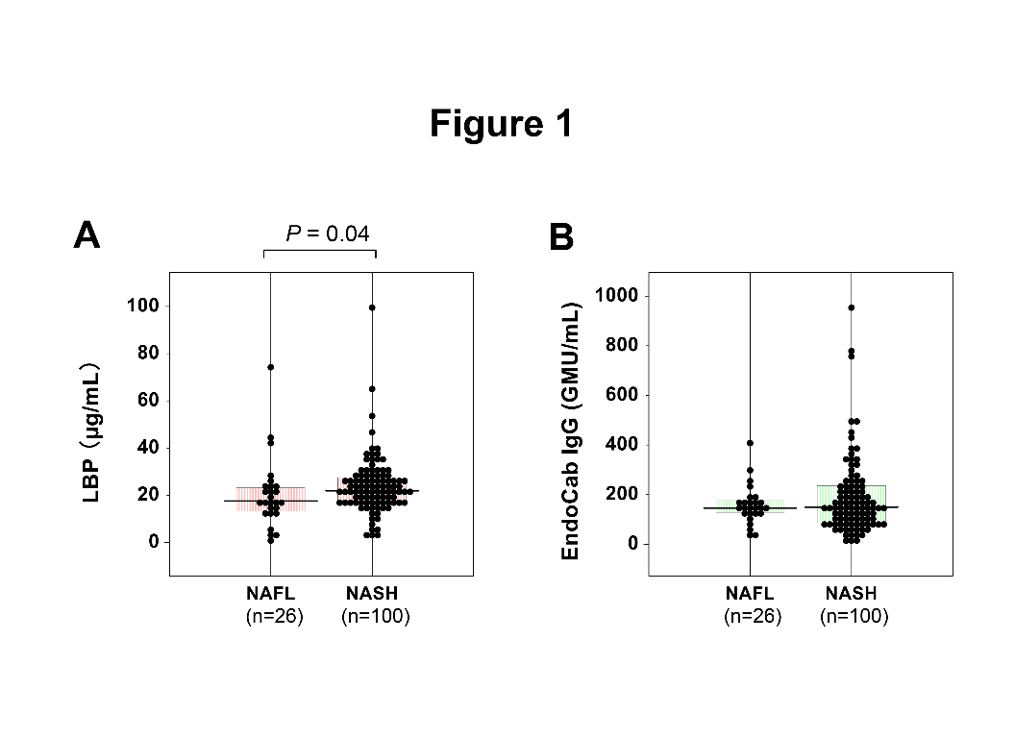
Figure 1 Comparisons of serum lipopolysaccharide-binding protein (A) and EndoCab IgG (B) between 26 nonalcoholic fatty liver and 100 nonalcoholic steatohepatitis patients. The clinicopathological features of the patients are shown in Table 1. Bars represent median values. P values were calculated using the Mann-Whitney U test. NAFL: nonalcoholic fatty liver; NASH: nonalcoholic steatohepatitis.
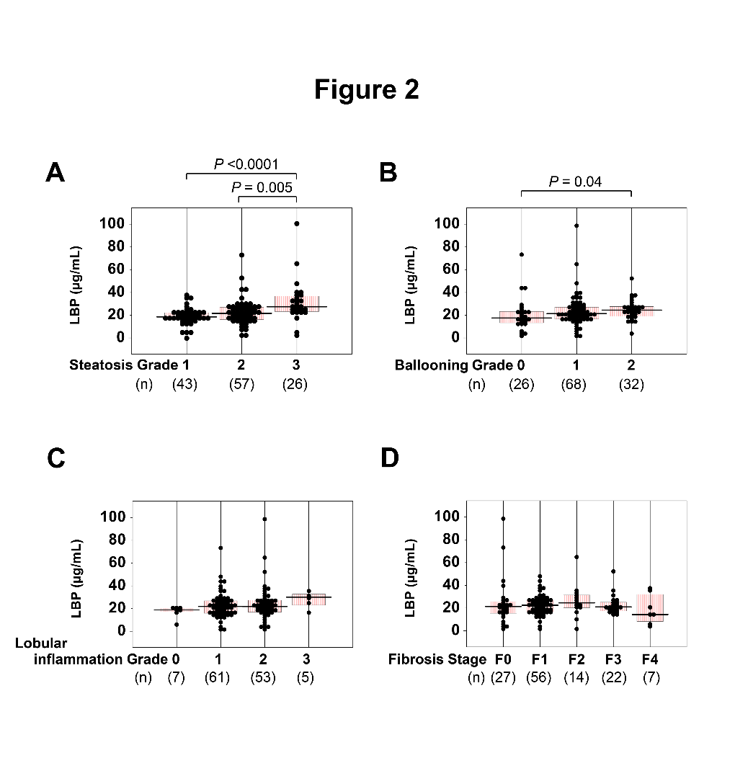
Figure 2 Relationships between serum lipopolysaccharide-binding protein and histological findings in 126 biopsy-proven nonalcoholic fatty liver disease patients. A: Steatosis (1-3), B: Ballooning (0-2), C: Lobular inflammation (0-3), and D: Fibrosis (0-4) scores. Comparisons among subgroups were conducted using one-way ANOVA with Bonferroni’s correction. LBP: lipopolysaccharide-binding protein.
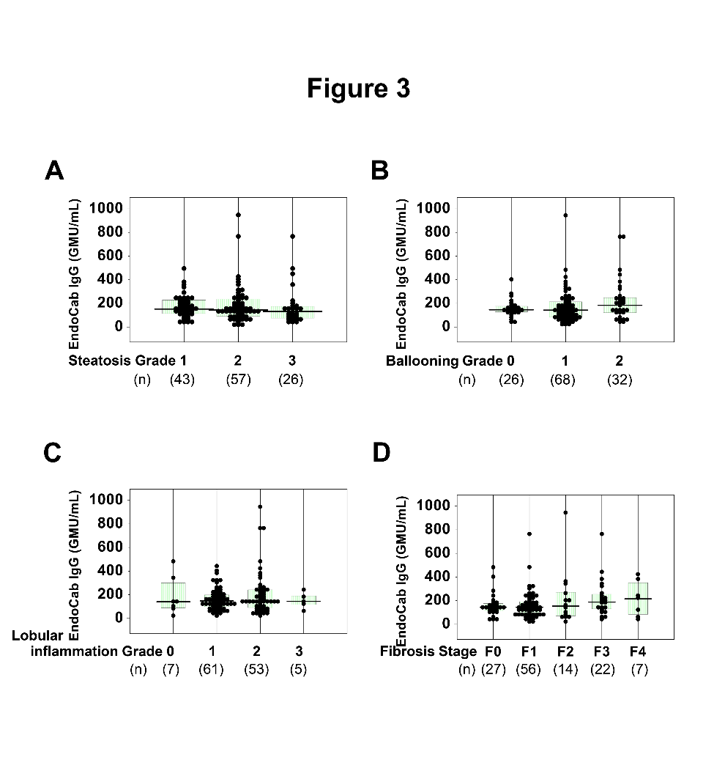
Figure 3 Relationships between serum EndoCab IgG and histological findings in 126 biopsy-proven nonalcoholic fatty liver disease patients. A: Steatosis (1-3), B: Ballooning (0-2), C: Lobular inflammation (0-3), and D: Fibrosis (0-4) scores. Comparisons among subgroups were conducted using one-way ANOVA with Bonferroni’s correction.
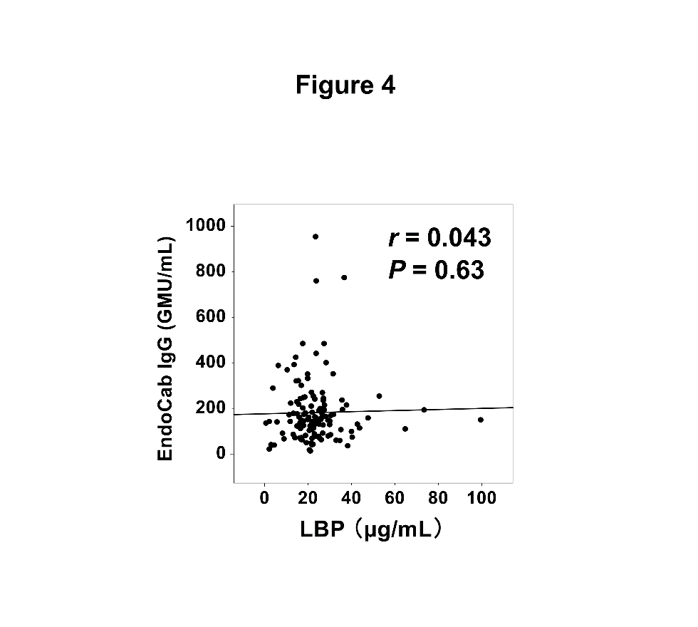
Figure 4 Correlation between serum lipopolysaccharide-binding protein and EndoCab IgG in 126 biopsy-proven nonalcoholic fatty liver disease patients. A correlation efficient (r) and P value were calculated using Spearman’s test. LBP: lipopolysaccharide-binding protein.
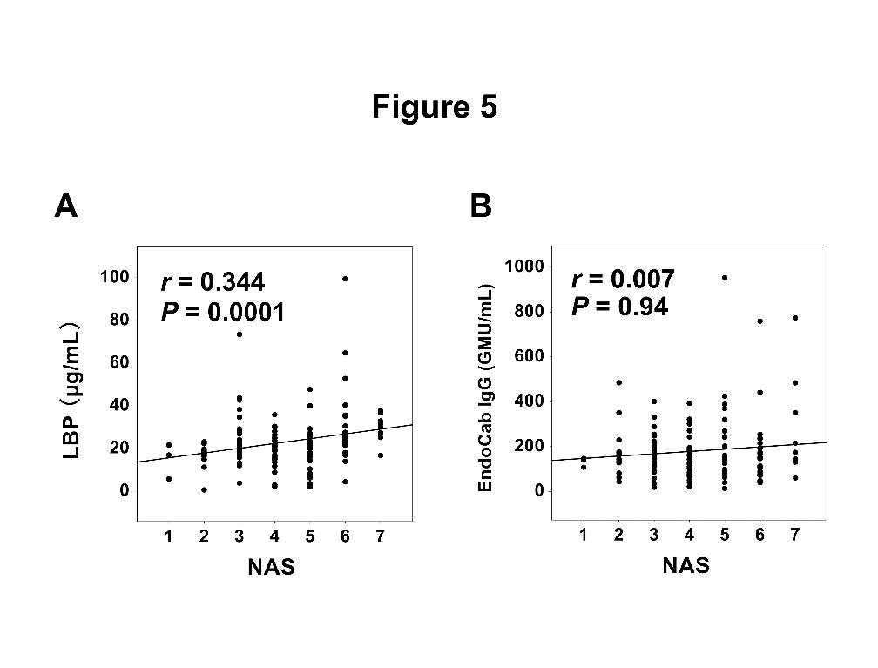
Figure 5 Correlation of nonalcoholic fatty liver disease activity score with serum lipopolysaccharide-binding protein (A) and EndoCab IgG (B) in 126 biopsy-proven nonalcoholic fatty liver disease patients. Correlation efficients (r) and P values were calculated using Spearman’s test. LBP: lipopolysaccharide-binding protein; NSA: nonalcoholic fatty liver disease activity score.

