Name of journal: World Journal of Radiology
ESPS Manuscript NO: 14504
Columns: MINIREVIEWS

Imaging and interventions in hilar cholangiocarcinoma: A Review

Madhusudhan KS et al. Hilar Cholangiocarcinoma

Kumble Sitarama Madhusudhan, Shivanand Gamanagatti, Arunkumar Gupta

Kumble Sitarama Madhusudhan, Shivanand Gamanagatti, Arunkumar Gupta, Department of Radiodiagnosis,All India Institute of Medical Sciences, New Delhi, Delhi 110029, India

Author contributions: All the authors equally contributed to this work.

Conflict-of-interest: The authors declare that they have no competing interests.

Open-Access: This article is an open-access article which selected by an in-house editor and fully peer-reviewed by external reviewers. It distributed in accordance with the Creative Commons Attribution Non Commercial (CC BY-NC 4.0) license, which permits others to distribute, remix, adapt, build upon this work non-commercially, and license their derivative works on different terms, provided the original work is properly cited and the use is non-commercial. See: http://creativecommons.org/licenses/by-nc/4.0/

Correspondence to: Shivanand Gamanagatti, Additional Professor, Department of Radiodiagnosis, All India Institute of Medical Sciences, Ansari Nagar East, Gautam Nagar, New Delhi, Delhi 110029, India. shiv223@rediffmail.com

Telephone: +91-11-26594567 Fax: +91-11-26588660
Received: October 8, 2014
Peer-review started: October 8, 2014
First decision: November 1, 2014
Revised: November 14, 2014
Accepted: December 16, 2014
Article in press:
Published online:

Abstract
Hilar cholangiocarcinoma is a common malignant tumor of the biliary tree. It has poor prognosis with very low 5-year survival rates. Various imaging modalities are available for detection and staging of the hilar cholangiocarcinoma. Although ultrasonography is the initial investigation of choice, imaging with contrast enhanced Computed Tomography scan or Magnetic Resonance Imaging is needed prior to management. Surgery is curative wherever possible. Radiological interventions play a role in operable patients in the form of biliary drainage and/or portal vein embolization. In inoperable cases, palliative interventions include biliary drainage, biliary stenting and intra-biliary palliative treatment techniques. Complete knowledge of application of various imaging modalities available and about the possible radiological interventions is important for a radiologist to play a critical role in appropriate management of such patients.We review the various imaging techniques and appearances of hilar cholangiocarcinoma and the possible radiological interventions.

© The Author(s) 2015. Published by Baishideng Publishing Group Inc. All rights reserved.

Key words: Cholangiocarcinoma; Biliary malignancy; Imaging; Biliary intervention; Computed tomography; Magnetic resonance imaging

Core tip: Poor prognosis of hilar cholangiocarcinoma mandates early diagnosis. The article outlines the performance of various imaging modalities in making a diagnosis and allows the readers to decide the appropriately modality in a given case. Further, the brief descriptions of a wide range of radiological interventions in hilar cholangiocarcinoma educate the readers about the available options and choose them judiciously.

Madhusudhan KS, Gamanagatti S, Gupta A. Imaging and interventions in hilar cholangiocarcinoma: A Review. World J Radiol 2014; In press

INTRODUCTION
Cholangiocarcinoma (CC) is a malignant tumor of the biliary tree, originating from the bile duct epithelium.It is the second most common biliary tract malignancy, after carcinoma of gall bladder and second most common primary hepatic malignancy after hepatocellular carcinoma. The occurrence of the disease is increasing worldwide with an incidence of 1-2/100000^{[1]}. The symptoms at presentation are mostly non-specific and occur late in the course of the disease. Further, hilar massesinvade adjacent vascular structures early and curative surgery is possible in less than half of the cases^{[2]}. The tumorhas very poor prognosis with 5-year survival of about 5%^{[3]}. Hence, early diagnosis and curative surgery is needed to improve survival in these patients. We describe the various imaging modalities used in the diagnosis of CC and its appearances in these modalities. We further discuss various interventional radiological procedures playing role in management of patients with CC.
Cholangiocarcinoma can arise from any part of the biliary tree and depending on the location, they have been classified in to three types -peripheral CC (or intrahepatic CC), hilar CC (or Klatskin tumor) and distalCC^{[4]}. Hilar CC is the most common variety forming about 40-60% of all cases; distal CC forms 30-42% and intrahepatic CC forms 5-10%^{[5,6]}. Intrahepatic CC typically arise from beyond second order bile ducts whereas distal CC arise from extrahepatic common bile duct. Bismuth has classified hilar cholangiocarcinoma into four types depending on the location and extent of involvement bile ducts^{[7]}. Involvement of common hepatic duct (CHD) alone is defined as Type 1, involvement of CHD and primary biliary confluence (PBC) as Type 2, involvement of CHD, PBC and right or left hepatic ducts as Type 3a or 3b respectively and involvement of CHD, PBC and both hepatic ducts or multifocal tumor as Type 4.
Hilar cholangiocarcinoma (HiCC) is the most common anatomical type of CC. Although it can involve both intrahepatic and extrahepatic bile ducts, it is considered as a type of extrahepatic CC according to WHO classification^{[8]}. The tumor may arise from primary biliary confluence, right or left hepatic ducts, secondary biliary confluence or distal second order bile ducts (which together form the hilum) (Figure 1)^{[9]}. Although, the lesion is mostly extrahepatic, it may also extend intrahepatically and thus some use the term perihilar CC for the same.Macroscopically, HiCC has been classified into three types based on the growth pattern on gross specimen^{[10]}. They include nodular, periductal infiltrating and papillary types, of which the periductal infiltrating variety is the most common type (Figure 2). The nodular type begins as a small mucosal nodule and grows beyond the walls of the bile ducts to form a mass^{[11]}. The bile duct is obstructed at an early stage. Periductal-infiltrating type grows along the walls of the bile ducts causing its thickening and irregular luminal narrowing. Associated desmoplastic reaction may show smooth stenosis of the bile ducts adjacent to the tumor. Papillary tumor arises as a mucosal polypoidal or sessile lesion remains limited to the bile duct wall till late stages. This variety has better prognosis compared to the other two types.Histologically, about 90% of HiCC are adenocarcinomas, which range from well differentiated to poorly differentiated glands^{[9]}. Microscopically, the tumor consists of glands or tubules with fibrous stroma and inflammatory cells. Perineural, perilymphatic and perivenous invasion may be seen, of which the former is characteristic.

CLINICAL FEATURES
Due to the location of the tumor, even small masses produce biliary obstruction at an early stage and most patients present with obstructive jaundice. Other symptoms at presentation include anorexia, weight loss, right upper quadrant pain and pruritus. Patients may present with high-grade fever associated with chills and rigorsdue to cholangitis. Various risk factors predispose to the development of CC. These include primary sclerosing cholangitis, hepatolithiasis, liver fluke infection (Opisthorchis viverrini and Clonorchis sinensis), choledochal cyst and inflammatory bowel disease^{[12]}. Hepatitis B and C viruses have also been associated with increased risks of CC.

RADIOLOGICAL IMAGING
Imaging evaluation of HiCC is very important for accurate staging of the tumor and possible curative surgical resection.Assessment of longitudinal and extra-ductal extent of the tumor is critical as it defines treatment planning. However, varying morphologies of HiCC may result in over or underestimation of the tumor extent along the ducts and result in failure of curative treatment^{[13]}. Local extension of the tumor which suggest non-resectability on imaging include involvement of bilateral secondary biliary confluence, portal vein of one lobe and hepatic artery of other lobe, proper hepatic artery, main portal vein, hepatic artery or portal vein of one lobe with atrophy of other lobe. Ultrasonography, computed tomography (CT) and magnetic resonance imaging (MRI) are the most common non-invasive imaging modalities which are used in the diagnosis and staging of HiCC. Other less commonly used techniques are invasive and include percutaneous transhepatic cholangiography (PTC) and endoscopic retrograde cholangiography (ERC).

ULTRASONOGRAPHY
Sonography is the initial investigation which is performed in most patients presenting with obstructive jaundice or abdominal pain. In addition to detection of CC, it helps in excluding other causes of obstructive jaundice, primarily gall stones. The most common finding is dilatation of intrahepatic bile ducts^{[14]}. The union of right and left hepatic ducts is usually not visualized. At the site of obstruction, tumormay be seen with the currently available equipments. The primary tumor is most commonly isoechoic on ultrasonography (USG) (65%), but may be hypoechoic (21%) or hyperechoic (15%) (Figure 3)^{[15]}. Thenodular and papillary varieties can be seen as ill-defined lesions at the primary biliary confluence. The infiltrating variety may be seen as irregular isoechoic wall thickening of the right or left hepatic or proximal common hepatic ducts (Figure 3C). Lobar atrophy is a less common finding and is suggested by crowding of the dilated ducts and smaller size of the lobe (Figure 3D). This occurs when there is dominant involvement of one duct than the other. Lobar atrophy is seen in about 14% of patients with CC^{[16]}. Sonography also helps in evaluation of vascular structures, regional nodes and liver.The accuracy of lesion detection on USG is about 82% and the sensitivity and specificity of portal vein involvement is75-83% and 93-100%, respectively^{[15,17]}. USG has low accuracy for hepatic artery involvement. Contrast enhanced USG is an additional technique which can be performed in arterial, venous and delayed phases for better visualization and characterization of the tumor^{[18,19]}. Administration of USG contrast agents variably improves detection of primary lesion, the sensitivity of which may reach up to 100%^{[20]}.
Endoscopic ultrasonography (EUS) is a technique where a high-frequency ultrasound probe is attached to the end of the endoscope. This helps in better visualization of hilar masses through stomach or duodenum^{[21]}. The benefits of EUS include no interference due to bowel gas (as seen with trans-abdominal USG), better visualization of mass and loco-regional lymph nodes and ability to obtain fine needle aspiration (FNA) or biopsy from the mass and nodes. The sensitivity and specificity of EUS in diagnosing and staging cholangiocarcinoma is 94% and 85% respectively^{[22]}. The diagnostic sensitivity and specificity of EUS with the use of FNAC for suspected HiCC is 89% and 100% respectively^{[23]}. Intraductal USG (IDUS) is another technique of using a high-resolution USG probe through either ERC or percutaneous transhepatic biliary drainage (PTBD) route^{[24]}. Hilar lesions are seen as hypoechoic masses around the biliary channels with irregular outline. This technique, when used with ERC has a sensitivity and specificity of 90% and 93%^{[25]}. However, visualization of deeper structures like vessels and nodes is difficult.

CT
CT scan is the most common widely used modality used for detection and staging of HiCC. Multidetector CT (MDCT) scan offers excellent spatial resolution and fast scanning and optimally depicts relation of the tumor with hepatic artery and portal vein^{[26,27]}. Multiplanar reformats (MPR) and maximum and minimum intensity projections are useful in accurately demonstrating ductal and vascular invasion (Figure 4). MDCT has an accuracy of about 86% in assessment of ductal extent of HiCC^{[28]}. The sensitivity and specificity of MDCT in evaluation of portal vein, hepatic artery and lymph node involvement are 89% and 92%, 84% and 93%, and 61% and 88%, respectively.
The routine protocol for performing a CT scan in patients with suspected HiCC includes an arterial phase (25-35s after beginning of contrast injection), portal venous phase (70-80s) and delayed phase (180s).Oral contrast is usually neutral or negative. Positive oral contrast is not given as it interferes with formation of MPRs. The arterial phase, demonstrates involvement of arteries (importantly main, right or left hepatic artery) by the tumor and also any variations in the arterial anatomy, which is useful for the surgeon.Portal venous phase reveals involvement of main portal vein or its first order branches. Further, this phase also better demonstrates primary tumor, liver metastases and extrahepatic spread (nodes, peritoneum) (Figure 5)^{[29]}. Delayed phase is useful in demonstration of primary mass which shows enhancement in delayed phase due to its scirrhous nature (Figure 6)^{[30]}. Oblique and curved MPRs show involvement of biliary tree and vessels better than the axial images and improve diagnostic accuracy^{[29]}.An additional and important role of MDCT is in assessment of volume of future liver remnant (FLR) prior to surgery. The volume of FLR can be calculated either automatically or manually (Figure 7). Depending on the FLR volume in relation to body weight, either surgery can be planned directly or portal vein embolization may be performed to increase its volume. MDCT cholangiography without administration of biliary contrast agent can be done with volume rendering after adjusting the rendering parameters^{[26]}. This technique has a sensitivity and specificity of about 94% each in diagnosis of malignant biliary obstruction.
Nodular or mass-forming CC typically show thick irregular peripheral or heterogeneous enhancement in the arterial phase images with gradual centripetal enhancement in portal venous and delayed phase images (Figure 8)^{[31]}. However, very often the mass is small and may be difficult to visualize. Periductal infiltrating lesions typically show wall thickening and enhancement, which may completely obliterate the lumen.The lesion is usually hypoenhancing and may show enhancement in the delayed phase(Figure 9); occasionally it can enhance in arterial phase^{[30]}. Intraductal papillary lesions show single or multiple intraluminal polypoidal soft tissue which show contrast enhancement and distend the lumen of the bile duct(Figure 10). Extension beyond the bile duct wall and lymph node involvement is uncommon. In addition to the primary lesion, CT scan also shows dilatation of the bile ducts upto the lesion and atrophy or hypertrophy of the lobes or segments (Figure 11). As with any other malignant tumors, vascular invasion is suggested by the presence of soft tissue encasing the vessel, large area of contact, narrowing of the calibre and complete luminal obstruction (Figure 12).

MRI
Magnetic resonance cholangio-pancreatography (MRCP) is a heavily T2-weighted sequence used for demonstration of biliary channels and is as accurate as ERCP^{[32]}. Its advantages over ERCP include its non-invasiveness, its ability to visualize ducts proximal to the obstruction and better visualization of the mass and non-requirement of contrast. Thin sections of MRCP and 3D-MRCP sequence further improve accuracy of lesion demonstration. MRI with gadolinium based contrast agents accurately depicts the mass, local extension, vascular involvement and regional metastases^{[13,33]}. The benefits of MRI over CT scan include no radiation, higher soft tissue contrast which helps in better demonstration of tumor extent and better demonstration of biliary tree. MRI has its own share of limitations including longer acquisition times, motion artifacts, lower spatial resolution and lower accuracy in the presence of stents^{[29]}. The accuracy of MRI with MRCP in the prediction of involvement of biliary confluence, hepatic artery, portal vein and lymph node is 89%, 86%, 96% and 74%, respectively^{[13]}.
Routine evaluation requires MRCP and MRI with contrast in multiple phases, similar to that of multiphase CT scan. On MRCP, the lesions cause irregular narrowing of the bile ducts, with or without obstruction, asymmetric luminal narrowing, abrupt luminal narrowing and as intraluminal filling defects (Figure 13). The appearance of the three morphological types of HiCC on contrast enhanced MRI is similar to that seen on CT scan (Figure 14 and 15). As in CT scan, the lesion shows peripheral or heterogeneous arterial enhancement with gradually increasing enhancement in the venous and delayed phases. Enhancement of ductal wall and periductal infiltration is often better seen on MRI than on CT scan due to inherent higher contrast resolution of MRI. Diffusionweighted imaging (DWI) is useful in detecting smaller lesions (Figure 16). The b-values routinely used are 0, 500 and 800 s/mm². The technique has higher sensitivity and accuracy than MRI in detection of lesions and has high positive predictive value^{[34]}. Some inflammatory and benign lesions may mimic HiCC on MRI, but short segment involvement, irregular margins,asymmetric narrowingand diffusion restriction on DWI may point towards HiCC^{[35]}. The presence of stent affects evaluation of the tumor due to difficulty in assessing the level of obstruction as the bile ducts are decompressed after stenting and due to secondary sub-clinical cholangitis which cause wall thickening (Figure 17). Thus, imaging should be done prior to biliary decompression for accurate evaluation of the tumor.

POSITRON EMISSION TOMOGRAPHY CT
Cholangiocarcinomas express glucose transporter in higher concentration and take up ¹⁸Fluoro-deoxy Glucose (FDG). The sensitivity of detection depends on the morphological type and location of the tumor with lower rates of sensitivity seen in infiltrating types and extrahepaticcholangiocarcinoma^{[36]}. Nodular lesions show better uptake but infiltrating lesions are seen as streak-like uptake, which is sometimes difficult to detect. In the detection of primary tumor, FDG positron emission tomography CT (PET-CT) has a sensitivity, specificity and accuracy of 84%, 79% and 83%, respectively^{[37]}. However, for HiCC, sensitivity of PET-CT is lower than CT scan^{[38]}. Hence, routine use of PET-CT does not offer advantage over CT scan or MRI in the detection of HiCC. However, it has higher accuracy in the detection of metastatic regional lymph nodesand distant sites than other imaging modalities.

DIRECT CHOLANGIOGRAPHY
PTC and ERC are invasive techniques which involves injection of contrast directly into the bile ducts^{[29]}. In PTC, the dilated bile ducts are directly punctured under fluoroscopic or USG guidance through transhepatic route and contrast is injected antegradely to define the level and type of obstruction (Figure 18). In ERC, the duodenal ampulla is canulated endoscopically and contrast is injected retrogradely to fill the bile ducts distal to the obstruction; proximal ducts may be visualized if obstruction is partial. Presence of short segment involvement, irregular stricture, asymmetric narrowing and nodularity suggests malignancy. Nodular type is usually seen as complete obstruction at primary biliary confluence^{[39]}. Short segment irregular or smooth narrowing is seen in case of periductal infiltrating variety and polypoidal or plaque like filling defect in case of papillary type of HiCC. Additional benefits of PTC and ERCP include drainage of the obstructed system and ability to obtain brush cytology/biopsy.
Cholangioscopy is a technique of direct visualization of the tumor either thorough ERC route or PTBD route. It can help in differentiation of benign and malignant biliary strictures on the basis of presence of nodularity and irregularity of the mucosa and mucosal vessels^{[40]}. It has good accuracy in detection and evaluation of extent of HiCC which can be improved with the use of biopsy.

CLASSIFICATION AND STAGING
Bismuth-Corlette classified cholangiocarcinoma based on the longitudinal extent of the tumor^{[41]}. MRCP has high accuracy in classification of HiCC with an accuracy of 95% when compared to findings at surgery^{[42]}. The classification has been described in Table 1. This classification alone is not sufficient for assessing resectability of the tumor as it does not define lateral extension and it has little prognostic value^{[43]}.
American Joint Committee on Cancer uses TNM classification for staging HiCC which is useful for selecting surgical candidates^{[44]}. ‘T’ stands for primary tumor stage, ‘N’ for nodal disease and ‘M’ for metastases. The classification is as follows: (1)T stage: T1 - Tumor confined to bile duct, T2 - Tumor extending beyond the bile duct, this is further divided into T2a where there is involvement of periductal fat and T2b where there is involvement of adjacent liver, T3 - Tumor involving unilateral portal vein or hepatic artery branches, T4 - Tumor involving one lobar portal vein branch and other lobar hepatic artery branch, main portal vein or common hepatic artery, second order bile ducts; (2) N stage: N0 - No lymph node involvement, N1 - Regional lymph nodes involvement (periductal or periportal nodes), N2 - Retroperitoneal nodes involvement; (3) M stage: M0 - no distant metastasis, M1 - Distant metastasis; and (4) Stages: I - T1 N0 M0, II - T2a-b N0 M0, IIIA - T3 N0 M0, IIIB - T1-3 N1 M0, IVA - T4 N0-1 M0, IVB - Any T N2 M0 or Any T Any N M1.
Imaging with multiphase CT scan and / or contrast enhanced MRI is helpful in accurately staging HiCC^{[28]}. Staging laparoscopy may rarely be needed when imaging findings are inconclusive.

RADIOLOGICAL INTERVENTIONS
Various radiological interventions are available in the management of HiCC, which could be either pre-operative (prior to definitive surgery) or palliative (in inoperable cases). Often the tumors are un-resectable at the time of presentation and palliation is the only treatment possible to improve patients’ quality of life^{[2]}. The main aim of palliation is to create a communication between the biliary system and small intestine to allow physiological drainage. This procedure reduces pain and relieves biliary obstruction and thus significantly decreases the incidence of cholangitis and prepares the patient to receive chemotherapy. If it is done as a pre-operative procedure, it improves the liver function so that the patient can be treated surgically^{[45]}.
Several safe and effective percutaneousradiological interventions are available in the management of HiCC. Although endoscopic drainage has the advantages of causing less pain, absence of an uncomfortable external drainage tube and less risk of biliary peritonitis, its success rate in too high obstructions is less and hence percutaneous technique is preferred^{[46]}. Cholangitis is seen in significantly higher number of patients as compared to percutaneous intervention as some of the obstructed ducts may not be drained^{[45]}. Various radiological interventional procedures include PTBD, biliary stenting (BS), intrabiliary tumor therapyand portal vein embolization (PVE). After the initial imaging, optimal further management is planned at the gastrointestinal-radiology meeting involving surgeons, gastroenterologists and radiologists.

PTBD
PTBD is the most common and well established interventional procedure performed in the management of HiCC. This is done either as a pre-operative procedure to improve liver functions or as a palliative procedure. Drainage of a single lobe (or atleast 20% of liver parenchyma) is sufficient to relieve jaundice and improve liver functions^{[47]}. The primary biliary confluence is most often blocked in patients with HiCC and draining either the right or left lobe is adequate. The factors determining the selection of lobe to be drained are the size of the lobe and involvement of secondary biliary confluence. Prior imaging plays a crucial role in assessing the extent and severity of biliary dilatation and location of stricture. The larger lobe and one with patent secondary biliary confluence is preferred to allow maximum drainage. However, any dilated system could be a source of infection due to stasis and an attempt must be made to drain it, especially if it is infected. When unilateral drainage, which has lower incidence of complications, is planned, cholangiogram must be carefully done to avoid filling of the non-drainable biliary system and thus subsequent infection^{[48]}. If the primary biliary confluence is patent, either left or right sided drainage can be done depending on the local practice, patient comfort and radiologist’s expertise. Bilobar or multiple system drainage may also be done. In cases where there is atrophy of a lobe due to chronic biliary obstruction, the system may not need drainage as improvement in liver function is unlikely^{[49]}. But it needs drainage if this lobe is the source of cholangitis. No absolute contraindication exists for PTBD. Relative contraindications include bleeding diathesis, contrast allergies and ascites.
Prior to the procedure, patient preparation is needed. This includes correction of coagulation profile, if deranged and administration of a dose of broad spectrum antibiotic. Ascites should be drained before PTBD. The segmental duct (preferably segment 3 for left sided and segment 6 for right sided drainage) is punctured, using ultrasonography as guidance. The puncture needle is exchanged for a dilator over a guidewire, and check cholangiogram is performed to define the biliary anatomy (Figure 24A). Subsequently a guidewire is manipulated across the stricture following which the tract is dilated and an 8.3 F internal-external drainage catheter (Ring biliary catheter, Cook, Bloomington, IN) is placed across the stricture (Figure 24B). In cases where there is difficulty in crossing the stricture, an external drainage catheter is placed in situ (Figure 24C) and internal drainage is attempted two - four days later. This approach often helps in reducing the inflammation and edema and increases the chances of negotiating the stricture.Kucukay et al^{[50]}, in their study (n = 256) on percutaneous treatment of malignant biliary obstructions found that suprahilar lesions and lesions with flat or ovoid shape had higher failure rates. They suggested that an external drainage should be done after five unsuccessful attempts of internal drainage. Mueller et al^{[51]}, reported easier catheterization of a stricture in a delayed second session due to straightened course of the guide wire directing into the lumen by decreased duct calibre above the obstruction, resolution of reactive edema at the site of obstruction and development of a tract around the catheter enabling the use of large-caliber catheters. An additional advantage of PTBD is the ability to obtain endobiliary tissue sample for histopathology using brush (for cytology) or forceps (for biopsy)^{[52]}.

BILIARY STENTING
Biliary stenting is done in inoperable cases as a palliative measure. It can be done as a primary procedure or after PTBD. In primary stenting, once the stricture is crossed with guide-wire, stent can be deployed over the guide-wire across the obstruction. This reduces the incidence of procedure related complications compared to stenting done after PTBD^{[53]}. Self-expandablemetallic stents are preferred. Metallic stents have higher patency rates, lower overall cost and shorter hospital stay than plastic stents(Figure 25)^{[54]}. Pre-stent balloon dilatation is usually avoided as it increases the risk of bleeding^{[53]}. The stent usually expands completely within 24-48 h and allows decompression of the biliary tree. If it does not adequately expand after 48 h, balloon dilatation of the stent may be done subsequently for adequate drainage. For masses involving the primary biliary confluence, two metallic stents (right and left side) can be placed in ‘Y’ shape to drain both the systems (Figure 25B).
The biliary stent may get blocked by internal biliary sludge or by the tumor. Tumor ingrowth occurs when the tumor grows into the stent lumen through the gaps between the struts of the stent. This may be dealt with endoscopically or percutaneously. Endoscopic placement of plastic stent through the blocked primary stent is often successful^{[55]}. Otherwise, percutaneous intervention in the form of balloon dilatation or placement of a smaller calibre coaxial stent or ring biliary catheter is done (Figure 26)^{[55]}. Use of covered metallic stents prevents tumor ingrowth and thus improves stent patency rates and reduces the incidence of re-intervention^{[56]}. Progression of the tumor may result in involvement of more proximal ducts and the stent may become ineffective. Such cases may need further drainage which is often is difficult to achieve. Stent migration, a very rare complication, may require repeat procedure.

INTRA-BILIARY PALLIATIVE THERAPY
Intra-biliary brachytherapy or photodynamic therapy prior to stenting improves the life expectancy of patients with HiCC and also stent patency^{[57]}. The primary advantage of intraluminal brachytherapy over external beam radiotherapy is that higher doses of irradiation can be given without damaging adjacent normal tissues^{[58]}. This procedure is usually done through PTBD route, preferably after metallic stent placement. The iridium-192 strands are intraluminally placed at the site of the tumor or stricture through PTBD catheter. Chen et al^{[59]}, found 98% success rate of intraluminal brachytherapy using Iridium-192 in 34 patients of malignant biliary obstruction and concluded that intraluminal brachytherapy is a safe palliative therapy and improves patient survival. In photodynamic therapy, a photosensitizer is injected intravenously followed by application of light to the tumor, endoscopically or through PTBD route. The photosensitizer interacts with the light releasing free radicles and causing cell death. Lee et al^{[60]} in their study (n = 33) found that photodynamic treatment prior to metallic stenting resulted in significantly longer stent patency and longer survival, with low risk of complications (17%).

RADIOFREQUENCY ABLATION
Radiofrequency ablation (RFA), a technique which causes coagulation necrosis of tissue, is well known in the treatment of hepatic tumors. Its use as a palliative procedure in unresectable HiCC has produced promising results^{[61]}. The procedure can be done either through transhepatic route with routine probes used for liver tumors or through endoscopic or PTBD route with the use of special endobiliary probe (Figure 27)^{[62,63]}. RFA in unresectable cases is a safe procedure and it improves stent patency and survival.

PVE
This procedure is done to induce hypertrophy of non-involved lobe of liver by HiCC if the remnant liver volume is insufficient to maintain normal body function. Although it is not specific for HiCC, it is done in a few such patients so that a curative surgery can be performed. Embolization of the portal vein branch of the lobe which is involved by the lesion and which would be subsequently resected is done to induce hypertrophy of the other lobe^{[64,65]}. Hypertrophy normally occurs in 2-4 wk after which surgery can be done. Various embolizing materials are used including polyvinyl alcohol (PVA) particles, gelatin sponge (gelfoam) and n-butyl cynacrylate (glue)^{[66]}. Vascular plugs can also be used in addition to these materials to increase the chance of hypertrophy.
The procedure can be performed puncturing either ipsilateral or contralateral portal vein branch under USG guidance. Once within the system, the puncture needle is exchanged for a catheter over a guide-wire. With the tip of the catheter sufficiently distal to the bifurcation, the embolizing material is injected till the flow slows down significantly (Figure 28). After embolization, the needle tract either can be left alone or can be embolized with a coil or gelatin sponge. Imaging is then usually performed after 3-4 wk and the volume of future liver remnant is measured. If it is adequate, curative surgery can be performed. The procedure has a technical success rate of 99.3%, clinical success rate of 96.1% and mean liver hypertrophy rate of 38%^{[66]}.

CONCLUSION
HiCC is a common malignancy of the biliary tract and imaging with various modalities play an important role planning appropriate management. Selection of appropriate imaging modality is important to obtain complete information needed for management. Multiphase CT scan and MRI are comparable in pre-operative diagnosis and staging. Additional modalities like EUS, IDUS, cholangioscopy and DWI are complementary. Surgery, wherever possible, is the only curative treatment available. Various percutaneous interventions are available including PTBD, stenting, intra-biliary palliation and PVE as either pre-operative or palliative procedure in such patients.

REFERENCES
1 Friman S. Cholangiocarcinoma--current treatment options. Scand J Surg 2011; 100: 30-34 [PMID: 21491796]
2 Bold RJ, Goodnight JE. Hilar cholangiocarcinoma: surgical and endoscopic approaches. Surg Clin North Am 2004; 84: 525-542 [PMID: 15062660 DOI: 10.1016/S0039-6109(03)00232-9]
3 Patel T. Worldwide trends in mortality from biliary tract malignancies. BMC Cancer 2002; 2: 10 [PMID: 11991810 DOI: 10.1186/1471-2407-2-10]
4 Suarez-Munoz MA, Fernandez-Aguilar JL, Sanchez-Perez B, Perez-Daga JA, Garcia-Albiach B, Pulido-Roa Y, Marin-Camero N, Santoyo-Santoyo J. Risk factors and classifications of hilar cholangiocarcinoma. World J Gastrointest Oncol 2013; 5: 132-138 [PMID: 23919107 DOI: 10.4251/wjgo.v5.i7.132]
5 Nakeeb A, Pitt HA, Sohn TA, Coleman J, Abrams RA, Piantadosi S, Hruban RH, Lillemoe KD, Yeo CJ, Cameron JL. Cholangiocarcinoma. A spectrum of intrahepatic, perihilar, and distal tumors. Ann Surg 1996; 224: 463-473; discussion 473-475 [PMID: 8857851 DOI: 10.1097/00000658-199610000-00005]
6 DeOliveira ML, Cunningham SC, Cameron JL, Kamangar F, Winter JM, Lillemoe KD, Choti MA, Yeo CJ, Schulick RD. Cholangiocarcinoma: thirty-one-year experience with 564 patients at a single institution. Ann Surg 2007; 245: 755-762 [PMID: 17457168 DOI: 10.1097/01.sla.0000251366.62632.d3]
7 Bismuth H, Corlette MB. Intrahepatic cholangioenteric anastomosis in carcinoma of the hilus of the liver. Surg Gynecol Obstet 1975; 140: 170-178 [PMID: 1079096]
8 Bosman FT, Carneiro F, Hruban RH, Theise ND. WHO classification of tumors of the digestive system. 4th ed. IARC: Lyon, 2010: 195-278
9 Castellano-Megías VM, Ibarrola-de Andrés C, Colina-Ruizdelgado F. Pathological aspects of so called "hilar cholangiocarcinoma". World J Gastrointest Oncol 2013; 5: 159-170 [PMID: 23919110 DOI: 10.4251/wjgo.v5.i7.159]
10 Liver Cancer Study Group of Japan. The general rules for the clinical and pathological study of primary liver cancer, 4th ed. Tokyo: Kanehara, 2000
11 Lim JH, Park CK. Pathology of cholangiocarcinoma. Abdom Imaging 2004; 29: 540-547 [PMID: 15383897 DOI: 10.1007/s00261-004-0187-2.]
12 Shin HR, Oh JK, Masuyer E, Curado MP, Bouvard V, Fang YY, Wiangnon S, Sripa B, Hong ST. Epidemiology of cholangiocarcinoma: an update focusing on risk factors. Cancer Sci 2010; 101: 579-585 [PMID: 20085587 DOI: 10.1111/j.1349-7006.2009.01458.x]
13 Park HS, Lee JM, Choi JY, Lee MW, Kim HJ, Han JK, Choi BI. Preoperative evaluation of bile duct cancer: MRI combined with MR cholangiopancreatography versus MDCT with direct cholangiography. AJR Am J Roentgenol 2008; 190: 396-405 [PMID: 18212225 DOI: 10.2214/AJR.07.2310]
14 Bloom CM, Langer B, Wilson SR. Role of US in the detection, characterization, and staging of cholangiocarcinoma. Radiographics 1999; 19: 1199-1218 [PMID: 10489176 DOI: 10.1148/radiographics.19.5.g99se081199]
15 Hann LE, Greatrex KV, Bach AM, Fong Y, Blumgart LH. Cholangiocarcinoma at the hepatic hilus: sonographic findings. AJR Am J Roentgenol 1997; 168: 985-989 [PMID: 9124155 DOI: 10.2214/ajr.168.4.9124155]
16 Choi BI, Lee JH, Han MC, Kim SH, Yi JG, Kim CW. Hilar cholangiocarcinoma: comparative study with sonography and CT. Radiology 1989; 172: 689-692 [PMID: 2549565 DOI: 10.1148/radiology.172.3.2549565]
17 Neumaier CE, Bertolotto M, Perrone R, Martinoli C, Loria F, Silvestri E. Staging of hilar cholangiocarcinoma with ultrasound. J Clin Ultrasound 1995; 23: 173-178 [PMID: 7730463 DOI: 10.1002/jcu.1870230305]
18 Xu HX. Contrast-enhanced ultrasound in the biliary system: Potential uses and indications. World J Radiol 2009; 1: 37-44 [PMID: 21160719 DOI: 10.4329/wjr.v1.i1.37]
19 Xu HX, Chen LD, Xie XY, Xie XH, Xu ZF, Liu GJ, Lin MX, Wang Z, Lu MD. Enhancement pattern of hilar cholangiocarcinoma: contrast-enhanced ultrasound versus contrast-enhanced computed tomography. Eur J Radiol 2010; 75: 197-202 [PMID: 19464836 DOI: 10.1016/j.ejrad.2009.04.060]
20 Khalili K, Metser U, Wilson SR. Hilar biliary obstruction: preliminary results with Levovist-enhanced sonography. AJR Am J Roentgenol 2003; 180: 687-693 [PMID: 12591675 DOI: 10.2214/ajr.180.3.1800687]
21 Aljiffry M, Walsh MJ, Molinari M. Advances in diagnosis, treatment and palliation of cholangiocarcinoma: 1990-2009. World J Gastroenterol 2009; 15: 4240-4262 [PMID: 19750567 DOI: 10.3748/wjg.15.4240]
22 Mohamadnejad M, DeWitt JM, Sherman S, LeBlanc JK, Pitt HA, House MG, Jones KJ, Fogel EL, McHenry L, Watkins JL, Cote GA, Lehman GA, Al-Haddad MA. Role of EUS for preoperative evaluation of cholangiocarcinoma: a large single-center experience. Gastrointest Endosc 2011; 73: 71-78 [PMID: 21067747 DOI: 10.1016/j.gie.2010.08.050]
23 Brugge WR. Advances in the endoscopic management of patients with pancreatic and biliary malignancies. South Med J 2006; 99: 1358-1366 [PMID: 17233192 DOI: 10.1097/01.smj.0000251324.81191.cd]
24 Chak A, Catanzaro A. Innovative methods of biliary tract diagnosis: intraductal ultrasound and tissue acquisition. Gastrointest Endosc Clin N Am 2003; 13: 609-622 [DOI: 10.1016/S1052-5157(03)00068-0]
25 Farrell RJ, Agarwal B, Brandwein SL, Underhill J, Chuttani R, Pleskow DK. Intraductal US is a useful adjunct to ERCP for distinguishing malignant from benign biliary strictures. Gastrointest Endosc 2002; 56: 681-687 [PMID: 12397276 DOI: 10.1016/S0016-5107(02)70117-X]
26 Ahmetoğlu A, Koşucu P, Kul S, Dinç H, Sari A, Arslan M, Alhan E, Gümele HR. MDCT cholangiography with volume rendering for the assessment of patients with biliary obstruction. AJR Am J Roentgenol 2004; 183: 1327-1332 [PMID: 15505298 DOI: 10.2214/ajr.183.5.1831327]
27 Cha JH, Han JK, Kim TK, Kim AY, Park SJ, Choi BI, Suh KS, Kim SW, Han MC. Preoperative evaluation of Klatskin tumor: accuracy of spiral CT in determining vascular invasion as a sign of unresectability. Abdom Imaging 2000; 25: 500-507 [PMID: 10931985 DOI: 10.1007/s002610000081]
28 Ruys AT, van Beem BE, Engelbrecht MR, Bipat S, Stoker J, Van Gulik TM. Radiological staging in patients with hilar cholangiocarcinoma: a systematic review and meta-analysis. Br J Radiol 2012; 85: 1255-1262 [PMID: 22919007 DOI: 10.1259/bjr/88405305]
29 Choi JY, Kim MJ, Lee JM, Kim KW, Lee JY, Han JK, Choi BI. Hilar cholangiocarcinoma: role of preoperative imaging with sonography, MDCT, MRI, and direct cholangiography. AJR Am J Roentgenol 2008; 191: 1448-1457 [PMID: 18941084 DOI: 10.2214/AJR.07.3992]
30 Ramia JM. Hilar cholangiocarcinoma. World J Gastrointest Oncol 2013; 5: 113-114 [PMID: 23919104 DOI: 10.4251/wjgo.v5.i7.115]
31 Lim JH. Cholangiocarcinoma: morphologic classification according to growth pattern and imaging findings. AJR Am J Roentgenol 2003; 181: 819-827 [PMID: 12933488 DOI: 10.2214/ajr.181.3.1810819]
32 Lee MG, Lee HJ, Kim MH, Kang EM, Kim YH, Lee SG, Kim PN, Ha HK, Auh YH. Extrahepatic biliary diseases: 3D MR cholangiopancreatography compared with endoscopic retrograde cholangiopancreatography. Radiology 1997; 202: 663-669 [PMID: 9051013 DOI: 10.1148/radiology.202.3.9051013]
33 Kim HJ, Lee JM, Kim SH, Han JK, Lee JY, Choi JY, Kim KH, Kim JY, Lee MW, Kim SJ, Choi BI. Evaluation of the longitudinal tumor extent of bile duct cancer: value of adding gadolinium-enhanced dynamic imaging to unenhanced images and magnetic resonance cholangiography. J Comput Assist Tomogr 2007; 31: 469-474 [PMID: 17538298 DOI: 10.1097/01.rct.0000238011.42060.b5]
34 Cui XY, Chen HW. Role of diffusion-weighted magnetic resonance imaging in the diagnosis of extrahepatic cholangiocarcinoma. World J Gastroenterol 2010; 16: 3196-3201 [PMID: 20593506 DOI: 10.3748/wjg.v16.i25.3196]
35 Li N, Liu C, Bi W, Lin X, Jiao H, Zhao P. MRCP and 3D LAVA imaging of extrahepatic cholangiocarcinoma at 3 T MRI. Clin Radiol 2012; 67: 579-586 [PMID: 22137873 DOI: 10.1016/j.crad.2011.10.016]
36 Jadvar H, Henderson RW, Conti PS. [F-18]fluorodeoxyglucose positron emission tomography and positron emission tomography: computed tomography in recurrent and metastatic cholangiocarcinoma. J Comput Assist Tomogr 2007; 31: 223-228 [PMID: 17414758 DOI: 10.1097/01.rct.0000237811.88251.d7]
37 Kim JY, Kim MH, Lee TY, Hwang CY, Kim JS, Yun SC, Lee SS, Seo DW, Lee SK. Clinical role of 18F-FDG PET-CT in suspected and potentially operable cholangiocarcinoma: a prospective study compared with conventional imaging. Am J Gastroenterol 2008; 103: 1145-1151 [PMID: 18177454 DOI: 10.1111/j.1572-0241.2007.01710.x]
38 Moon CM, Bang S, Chung JB, Park SW, Song SY, Yun M, Lee JD. Usefulness of 18F-fluorodeoxyglucose positron emission tomography in differential diagnosis and staging of cholangiocarcinomas. J Gastroenterol Hepatol 2008; 23: 759-765 [PMID: 17931372 DOI: 10.1111/j.1440-1746.2007.05173.x]
39 Han JK, Choi BI, Kim AY, An SK, Lee JW, Kim TK, Kim SW. Cholangiocarcinoma: pictorial essay of CT and cholangiographic findings. Radiographics 2002; 22: 173-187 [PMID: 11796906 DOI: 10.1148/radiographics.22.1.g02ja15173]
40 Nimura Y. Staging cholangiocarcinoma by cholangioscopy. HPB (Oxford) 2008; 10: 113-115 [PMID: 18773067 DOI: 10.1080/13651820801992658]
41 Bismuth H, Castaing D, Traynor O. Resection or palliation: priority of surgery in the treatment of hilar cancer. World J Surg 1988; 12: 39-47 [PMID: 2449769 DOI: 10.1007/BF01658484]
42 Vogl TJ, Schwarz WO, Heller M, Herzog C, Zangos S, Hintze RE, Neuhaus P, Hammerstingl RM. Staging of Klatskin tumours (hilar cholangiocarcinomas): comparison of MR cholangiography, MR imaging, and endoscopic retrograde cholangiography. Eur Radiol 2006; 16: 2317-2325 [PMID: 16622690 DOI: 10.1007/s00330-005-0139-4PMID: 16622690]
43 Bold RJ, Goodnight JE Jr. Hilar cholangiocarcinoma: surgical and endoscopic approaches. SurgClin North Am 2004; 84: 525-542 [PMID: 15062660 DOI: 10.1016/S0039-6109(03)00232-9]
44 Edge SB, Byrd DR, Compton CC, Fritz AG, Greene FL, Trotti A, editors. Perihilar bile ducts. AJCC Cancer Staging Manual. 7th ed. New York, NY: Springer, 2010: 219-222
45 Kloek JJ, van der Gaag NA, Aziz Y, Rauws EA, van Delden OM, Lameris JS, Busch OR, Gouma DJ, van Gulik TM. Endoscopic and percutaneous preoperative biliary drainage in patients with suspected hilar cholangiocarcinoma. J Gastrointest Surg 2010; 14: 119-125 [PMID: 19756881 DOI: 10.1007/s11605-009-1009-1]
46 Indar AA, Lobo DN, Gilliam AD, Gregson R, Davidson I, Whittaker S, Doran J, Rowlands BJ, Beckingham IJ. Percutaneous biliary metal wall stenting in malignant obstructive jaundice. Eur J Gastroenterol Hepatol 2003; 15: 915-919 [PMID: 12867803 DOI: 10.1097/00042737-200308000-00013]
47 George C, Byass OR, Cast JE. Interventional radiology in the management of malignant biliary obstruction. World J Gastrointest Oncol 2010; 2: 146-150 [PMID: 21160822 DOI: 10.4251/wjgo.v2.i3.146]
48 Chang WH, Kortan P, Haber GB. Outcome in patients with bifurcation tumors who undergo unilateral versus bilateral hepatic duct drainage. Gastrointest Endosc 1998; 47: 354-362 [PMID: 9609426 DOI: 10.1016/S0016-5107(98)70218-4]
49 van Delden OM, Laméris JS. Percutaneous drainage and stenting for palliation of malignant bile duct obstruction. Eur Radiol 2008; 18: 448-456 [PMID: 17960388 DOI: 10.1007/s00330-007-0796-6]
50 Küçükay F, Okten RS, Yurdakul M, Ozdemir E, Parlak E, Olçer T, Cumhur T. Percutaneous management of malignant biliary disease: factors influencing the ability to overcome the stricture. Diagn Interv Radiol 2011; 17: 169-173 [PMID: 20698007]
51 Mueller PR, van Sonnenberg E, Ferrucci JT. Percutaneous biliary drainage: technical and catheter-related problems in 200 procedures. AJR Am J Roentgenol 1982; 138: 17-23 [PMID: 6976698 DOI: 10.2214/ajr.138.1.17]
52 Xing GS, Geng JC, Han XW, Dai JH, Wu CY. Endobiliary brush cytology during percutaneous transhepatic cholangiodrainage in patients with obstructive jaundice. Hepatobiliary Pancreat Dis Int 2005; 4: 98-103 [PMID: 15730930]
53 Inal M, Akgül E, Aksungur E, Demiryürek H, Yağmur O. Percutaneous self-expandable uncovered metallic stents in malignant biliary obstruction. Complications, follow-up and reintervention in 154 patients. Acta Radiol 2003; 44: 139-146 [PMID: 12694096 DOI: 10.1034/j.1600-0455.2003.00049.x]
54 Lammer J, Hausegger KA, Flückiger F, Winkelbauer FW, Wildling R, Klein GE, Thurnher SA, Havelec L. Common bile duct obstruction due to malignancy: treatment with plastic versus metal stents. Radiology 1996; 201: 167-172 [PMID: 8816539 DOI: 10.1148/radiology.201.1.8816539]
55 Cho JH, Jeon TJ, Park JY, Kim HM, Kim YJ, Park SW, Chung JB, Song SY, Bang S. Comparison of outcomes among secondary covered metallic, uncovered metallic, and plastic biliary stents in treating occluded primary metallic stents in malignant distal biliary obstruction. Surg Endosc 2011; 25: 475-482 [PMID: 20602138 DOI: 10.1007/s00464-010-1196-6]
56 Hatzidakis A, Krokidis M, Kalbakis K, Romanos J, Petrakis I, Gourtsoyiannis N. ePTFE/FEP-covered metallic stents for palliation of malignant biliary disease: can tumor ingrowth be prevented? Cardiovasc Intervent Radiol 2007; 30: 950-958 [PMID: 17508236 DOI: 10.1007/s00270-007-9049-y]
57 Killeen RP, Harte S, Maguire D, Malone DE. Achievable outcomes in the management of proximal cholangiocarcinoma: an update prepared using "evidence-based practice" techniques. Abdom Imaging 2010; 33: 54-57 [PMID: 17874306 DOI: 10.1007/s00261-007-9312-3]
58 Andrašina T, Válek V, Pánek J, Kala Z, Kiss I, Tuček S, Slampa P. Multimodal oncological therapy comprising stents, brachytherapy, and regional chemotherapy for cholangiocarcinoma. Gut Liver 2010; 4 Suppl 1: S82-S88 [PMID: 21103300 DOI: 10.5009/gnl.2010.4.S1.S82]
59 Chen Y, Wang XL, Yan ZP, Cheng JM, Wang JH, Gong GQ, Qian S, Luo JJ, Liu QX. HDR-192Ir intraluminal brachytherapy in treatment of malignant obstructive jaundice. World J Gastroenterol 2004; 10: 3506-3510 [PMID: 15526374]
60 Lee TY, Cheon YK, Shim CS, Cho YD. Photodynamic therapy prolongs metal stent patency in patients with unresectable hilar cholangiocarcinoma. World J Gastroenterol 2012; 18: 5589-5594 [PMID: 23112552 DOI: 10.3748/wjg.v18.i39.5589]
61 Steel AW, Postgate AJ, Khorsandi S, Nicholls J, Jiao L, Vlavianos P, Habib N, Westaby D. Endoscopically applied radiofrequency ablation appears to be safe in the treatment of malignant biliary obstruction. Gastrointest Endosc 2011; 73: 149-153 [PMID: 21184881 DOI: 10.1016/j.gie.2010.09.031]
62 Fan WJ, Wu PH, Zhang L, Huang JH, Zhang FJ, Gu YK, Zhao M, Huang XL, Guo CY. Radiofrequency ablation as a treatment for hilar cholangiocarcinoma. World J Gastroenterol 2008; 28: 4540-4545 [PMID: 18680236 DOI: 10.3748/wjg.14.4540]
63 Alis H, Sengoz C, Gonenc M, Kalayci MU, Kocatas A. Endobiliary radiofrequency ablation for malignant biliary obstruction. Hepatobiliary Pancreat Dis Int 2013; 12: 423-427 [PMID: 23924501 DOI: 10.1016/S1499-3872(13)60066-1]
64 Giraudo G, Greget M, Oussoultzoglou E, Rosso E, Bachellier P, Jaeck D. Preoperative contralateral portal vein embolization before major hepatic resection is a safe and efficient procedure: a large single institution experience. Surgery 2008; 143: 476-482 [PMID: 18374044 DOI: 10.1016/j.surg.2007.12.006]
65 May BJ, Madoff DC. Portal vein embolization: rationale, technique, and current application. Semin Intervent Radiol 2012; 29: 81-89 [PMID: 23729977 DOI: 10.1055/s-0032-1312568PMID: 23729977]
66 van Lienden KP, van den Esschert JW, de Graaf W, Bipat S, Lameris JS, van Gulik TM, van Delden OM. Portal vein embolization before liver resection: a systematic review. Cardiovasc Intervent Radiol 2013; 36: 25-34 [PMID: 22806245 DOI: 10.1007/s00270-012-0440-y]
P-Reviewer: Cerwenka HR, Verma S, Vinh-Hung V S-Editor: Tian YL
L-Editor: E-Editor:

Table 1 Bismuth-Corlette classification of hilar cholangiocarcinoma
Stage | Description
I | Tumor involving common hepatic duct without involvement of primary biliary confluence (confluence of right and left hepatic ducts) (Figure 19)
II | Tumor involving primary biliary confluence (Figure 20)
IIIa | Tumor involving primary biliary confluence and right secondary biliary confluence (confluence of right anterior and posterior sectoral ducts) (Figure 21)
IIIb | Tumor involving primary biliary confluence and left secondary biliary confluence (confluence of left medial and lateral sectoral ducts) (Figure 22)
IV | Tumor involving primary and both secondary biliary confluence (Figure 23)

Figure 1 Schematic diagram showing structures forming hilum. chd: Common hepatic duct; ll: Left lateral segmental duct; lm: Left medial segmental duct; ls: Left secondary confluence; p: Primary biliary confluence; ra: Right anterior segmental duct; rp: Right posterior segmental duct; rs: Right secondary confluence.

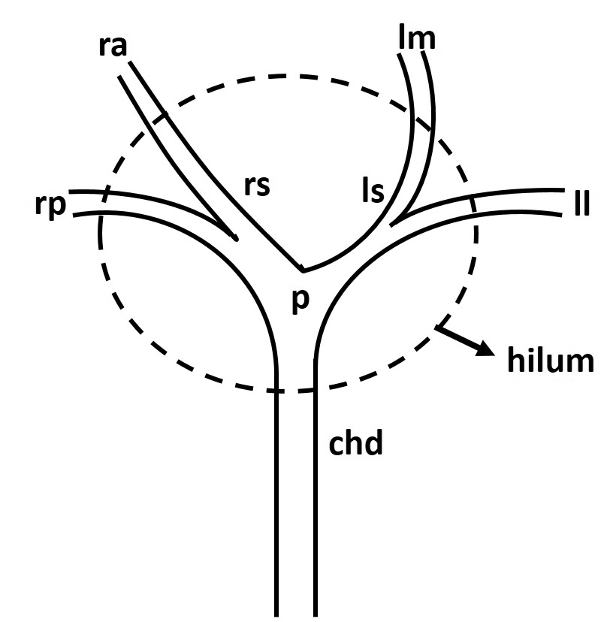

Figure 2 Schematic diagram showing three morphological types of hilar cholangiocarcinoma. A: Nodular variety; B: Periductal infiltrating; C: Intraductal papillary.

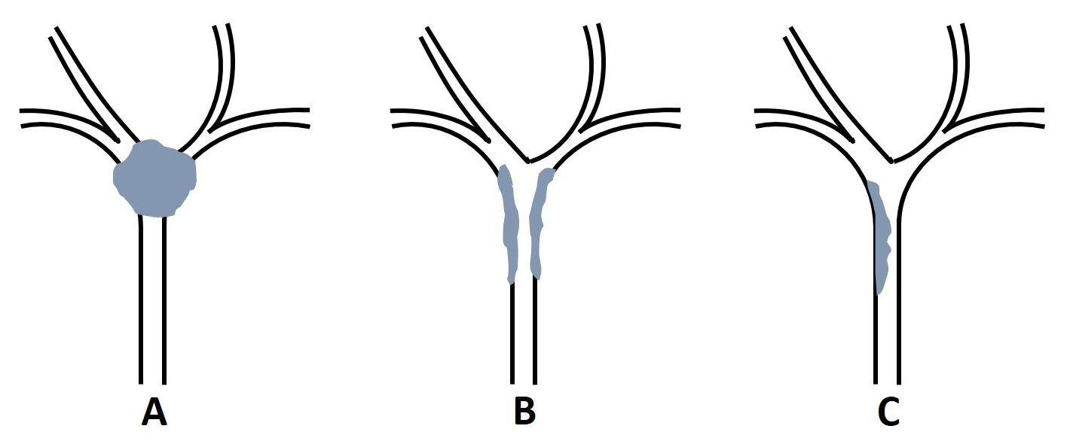

Figure 3 Ultrasonographic appearances of hilar cholangiocarcinoma. A: Isoechoic lesion (arrow) involving primary biliary confluence; B: Hyperechoic mass (arrow) involving hilum; C: Infiltrative lesion (arrow) with periductal wall thickening; D: Atrophy of left lobe with crowding of bile ducts (arrow) due to isoechoic hilar mass (arrow head).

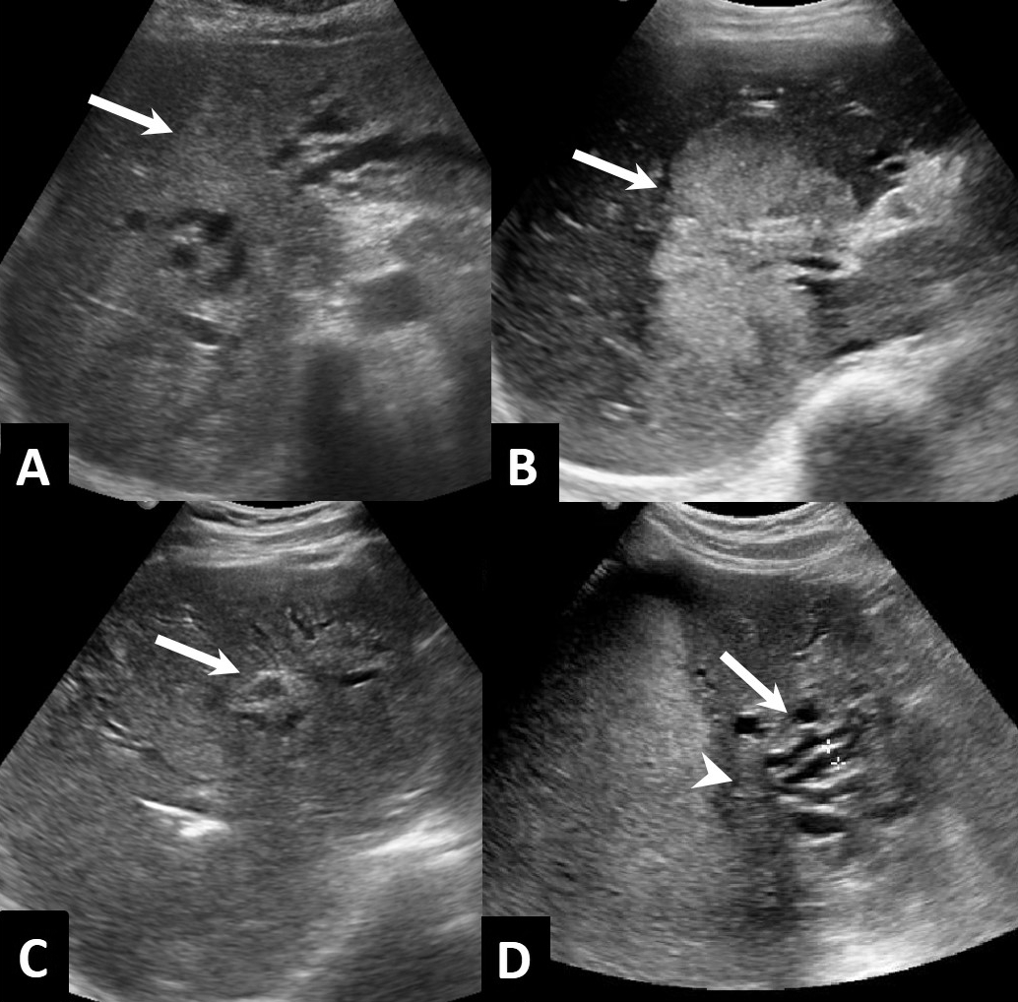

Figure 4 Post processing of computed tomography scan. A: Coronal reformat showing ill-defined enhancing mass (arrow) in relation to hilum and common hepatic duct; B: Coronal thick maximum intensity projection showing same mass as in A (short arrow) with irregularity of right posterior hepatic artery (long arrow); C: Minimum intensity projection showing the extent of biliary involvement by the mass (arrow).

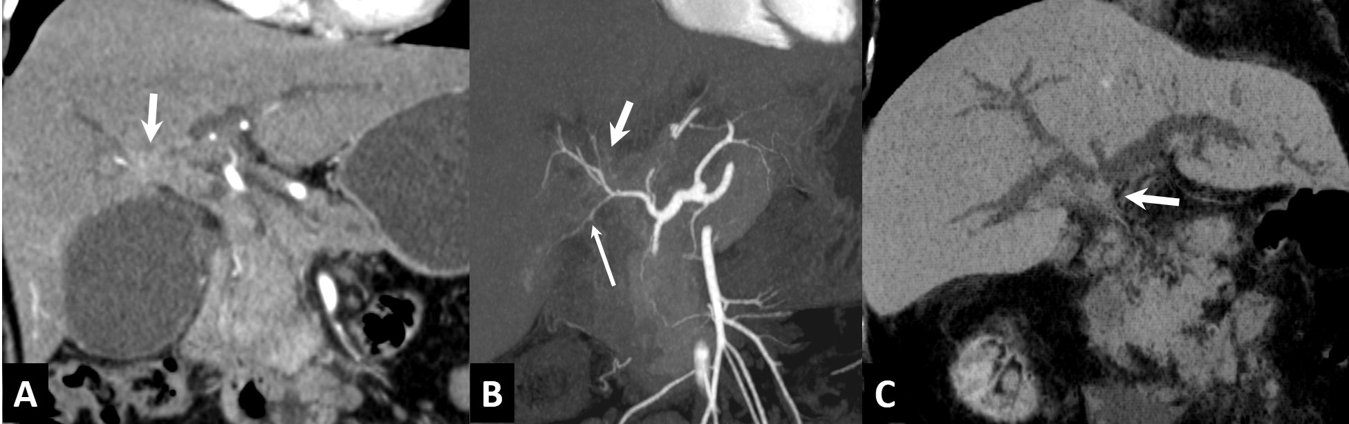

Figure 5 Axial contrast enhanced venous phase images. A: Showing hilar mass (white arrow) with multiple liver metastases (black arrows); B: Showing multiple metastatic retroperitoneal nodes (n).

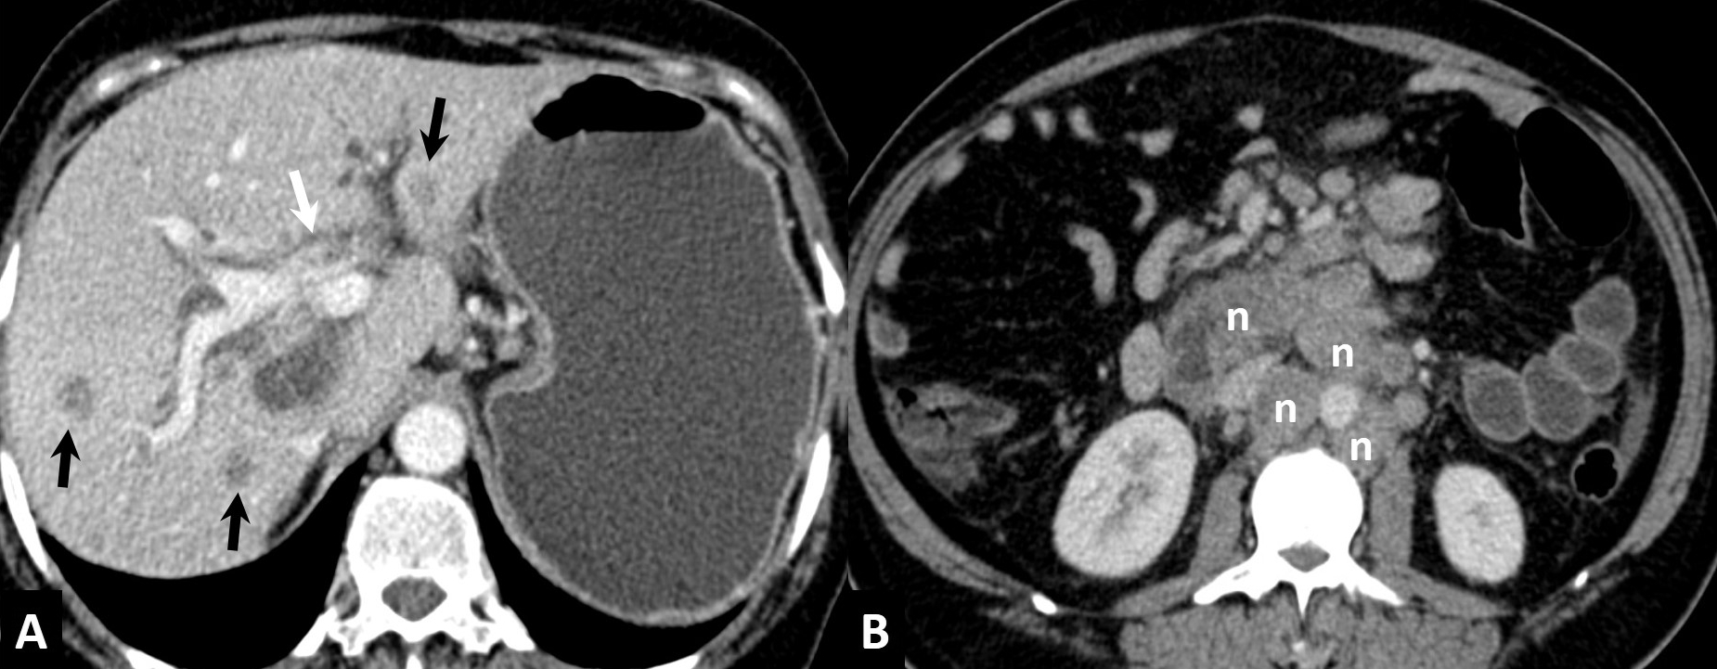

Figure 6 Axial contrast enhanced computed tomography scan in arterial (A), venous (B) and delayed (C) phases showing mild enhancement of the lesion (arrow) in arterial phase with persistence of enhancement in venous and delayed phases suggesting scirrhous nature of the lesion.

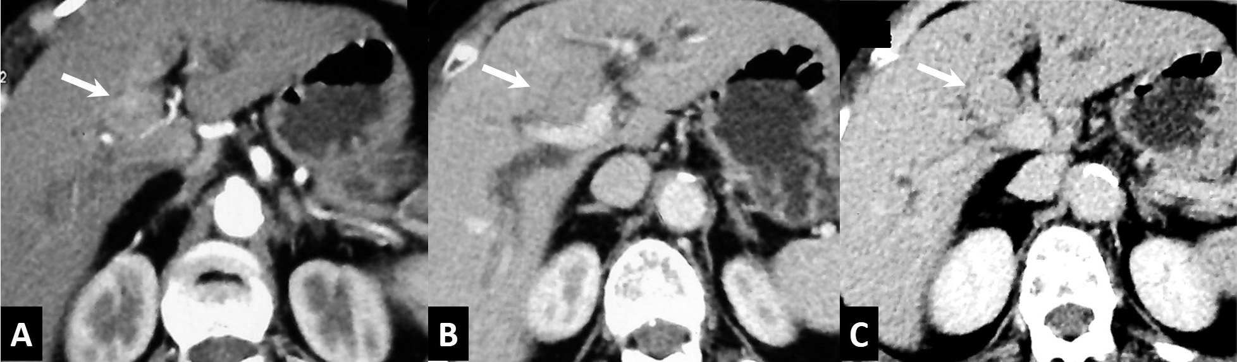

Figure 7 Axial venous phase computed tomography images (A & B) showing automated volumetry map with colour coding indicating the volume of future liver remnant (arrow).

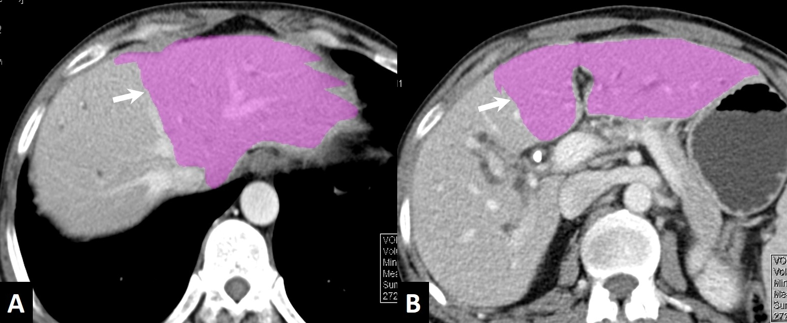

Figure 8 Axial contrast enhanced computed tomography scan in arterial (A), venous (B) and delayed (C) phases of nodular variety of hilar cholangiocarcinoma (arrow) showing mildly enhancing ill-defined mass lesion in arterial phase with increasing enhancement in venous and delayed phases.

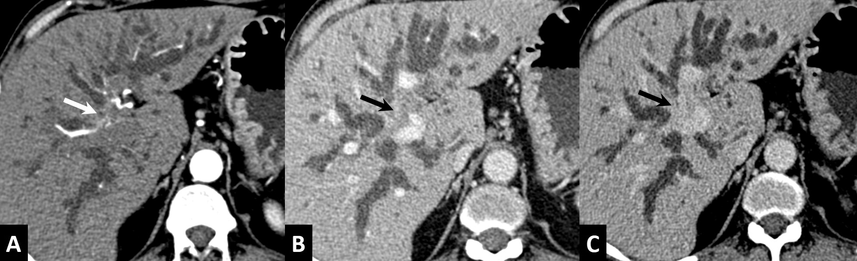

Figure 9 Axial (A) and Coronal (B) images of venous phase of computed tomography scan of periductal infiltrating type of hilar cholangiocarcinoma showing wall thickening and enhancement of proximal common hepatic duct (arrow) causing luminal obstruction.

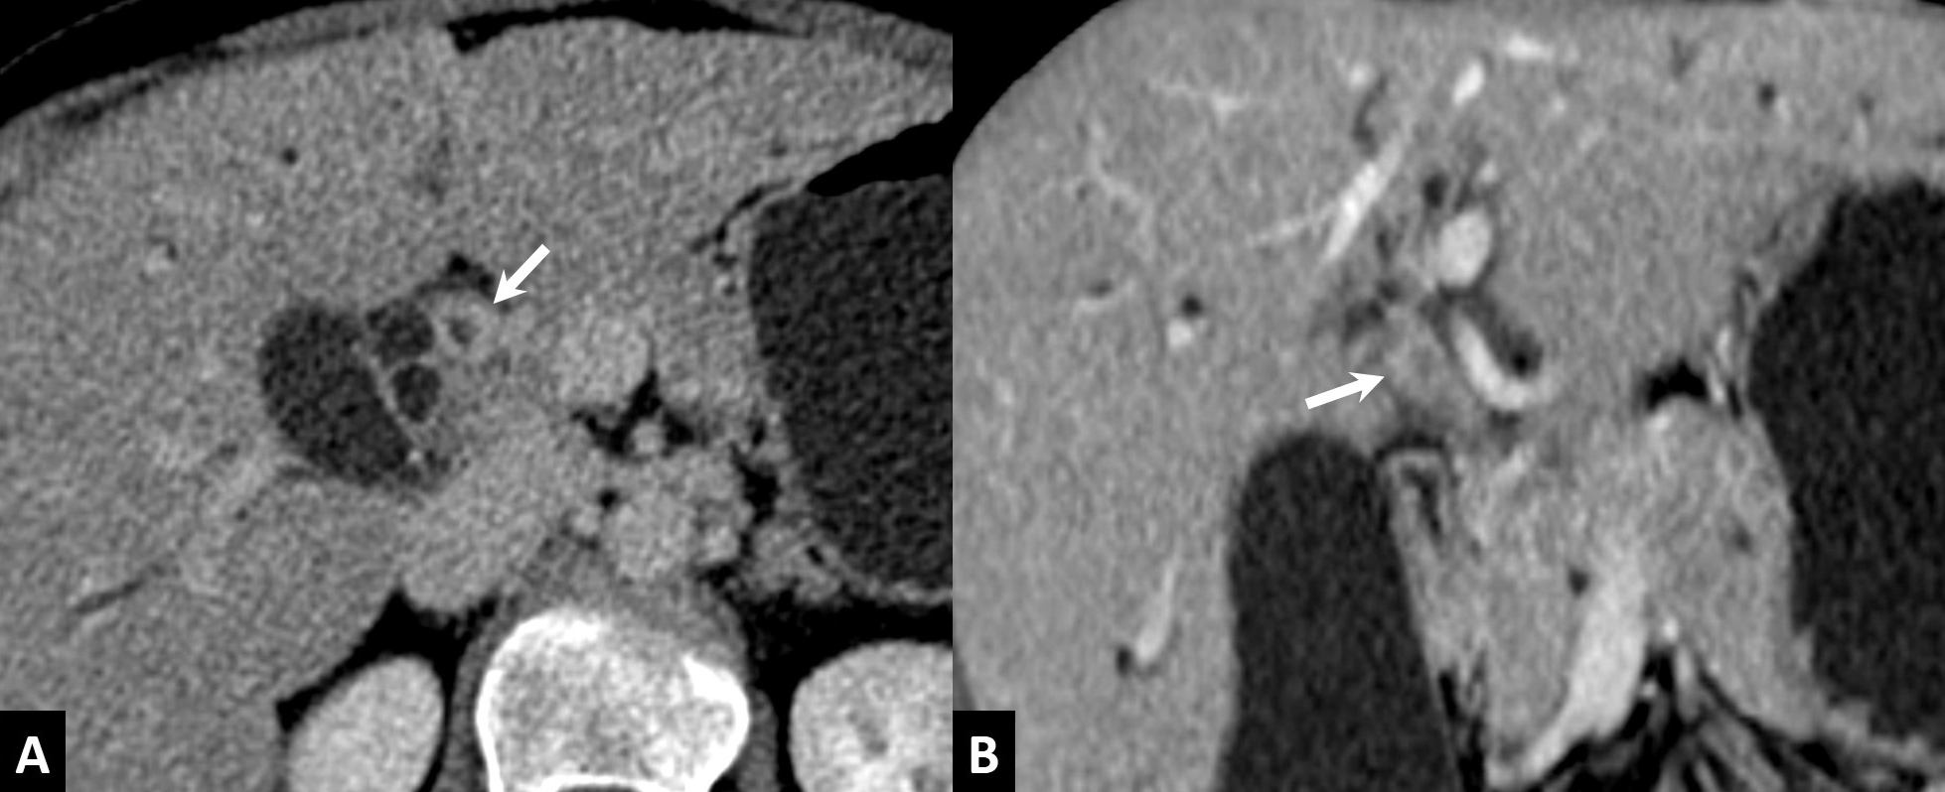

Figure 10 Axial contrast enhanced computed tomography scan in venous phase of papillary type of hilar cholangiocarcinoma showing minimally enhancing intraductal polypoidal lesion (arrow) causing distension of the duct.

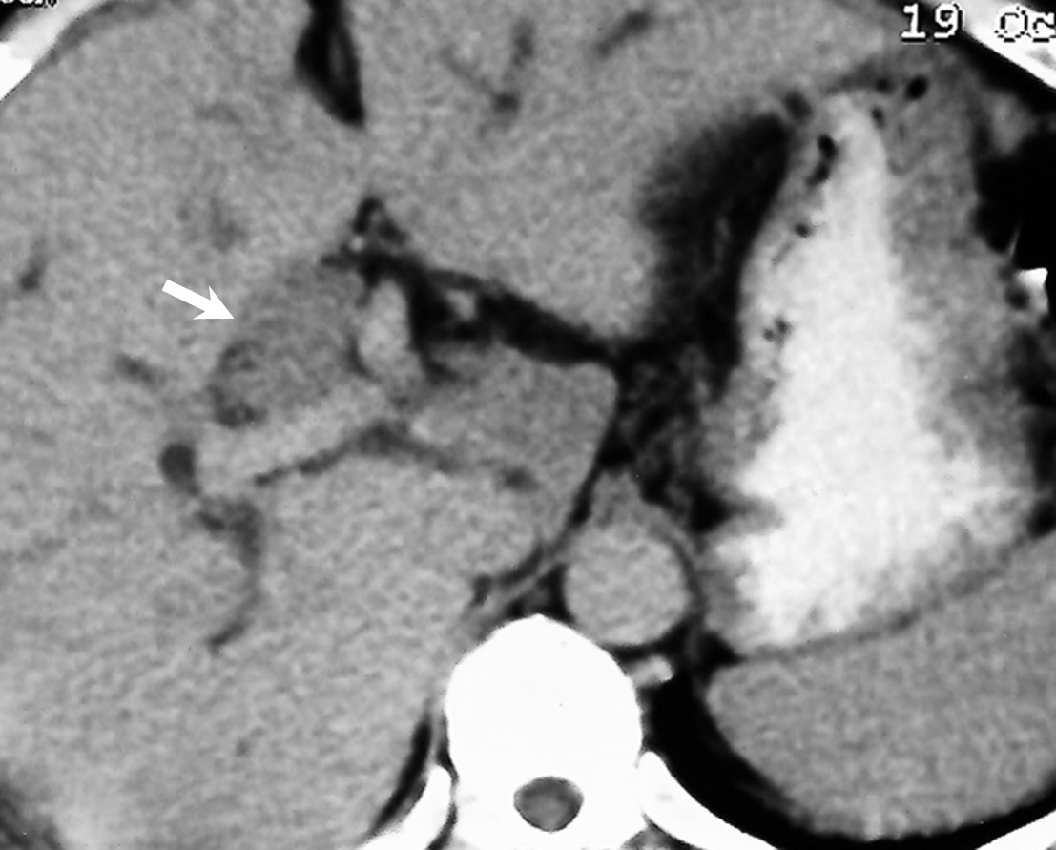

Figure 11 Axial computed tomography images showing atrophy of right lobe (r) due to hilar mass (arrow) in A, and atrophy of left lobe (l) caused by a mass (arrow) in B.

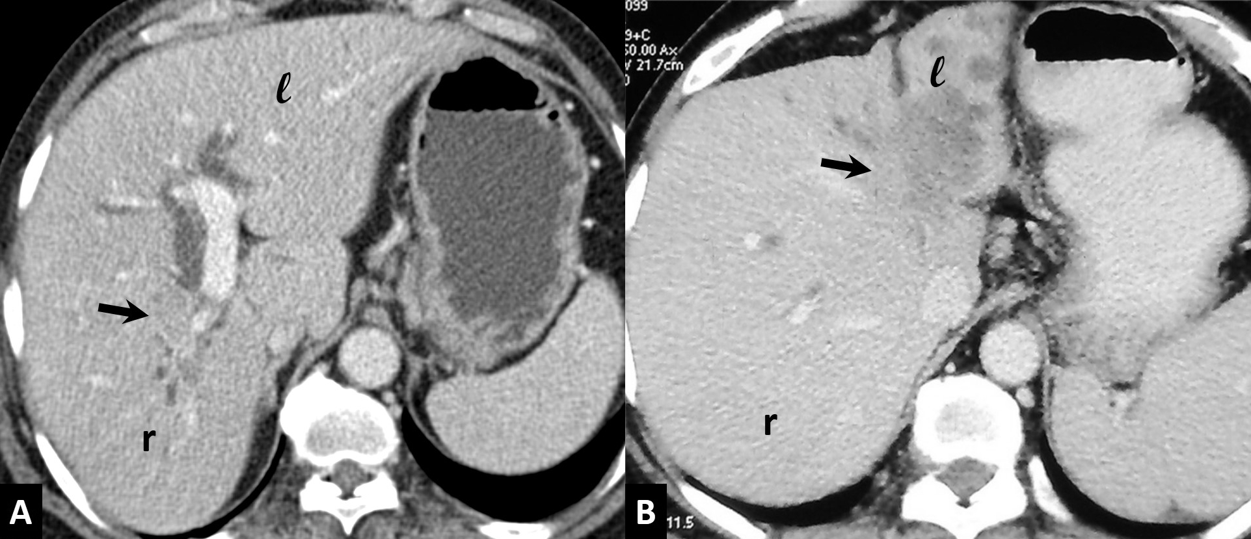

Figure 12 Axial computed tomography scan images showing vascular invasion. A: Small hilar mass (white arrow) abutting right hepatic artery posteriorly; B: Hilar mass (white arrow) encasing right hepatic artery causing irregularity in outline; C: Ill-defined hilar mass (white arrow) encasing portal vein and causing its narrowing (black arrow); D: Multiple collaterals (white arrows) seen in periportal and perigastric location due to portal vein obstruction.

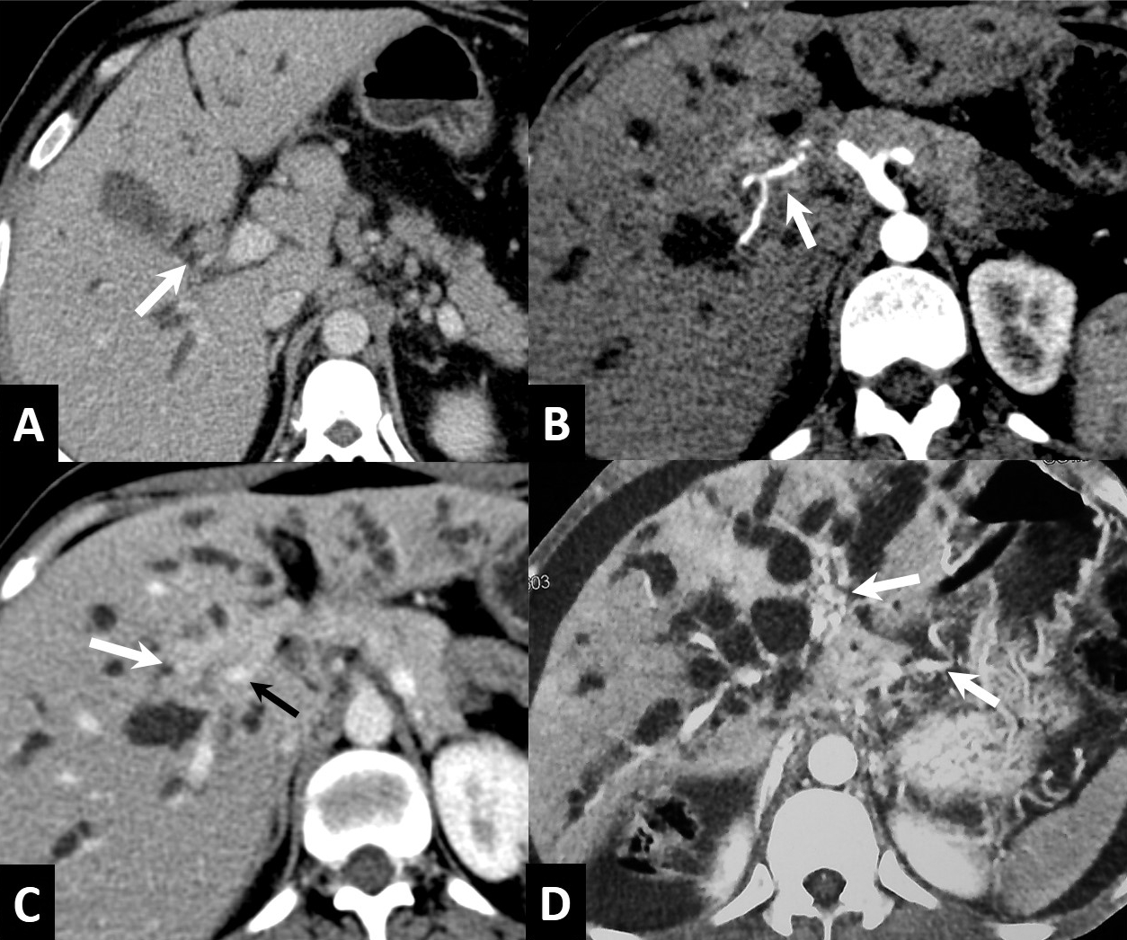

Figure 13 Magnetic resonance cholangio-pancreatography images showing various appearances of hilar cholangiocarcinoma. A: smooth luminal narrowing (arrow); B: Complete hilar obstruction (arrow); C: Irregular asymmetric complete obstruction (arrow); D: Intraluminal filling defect (arrow).

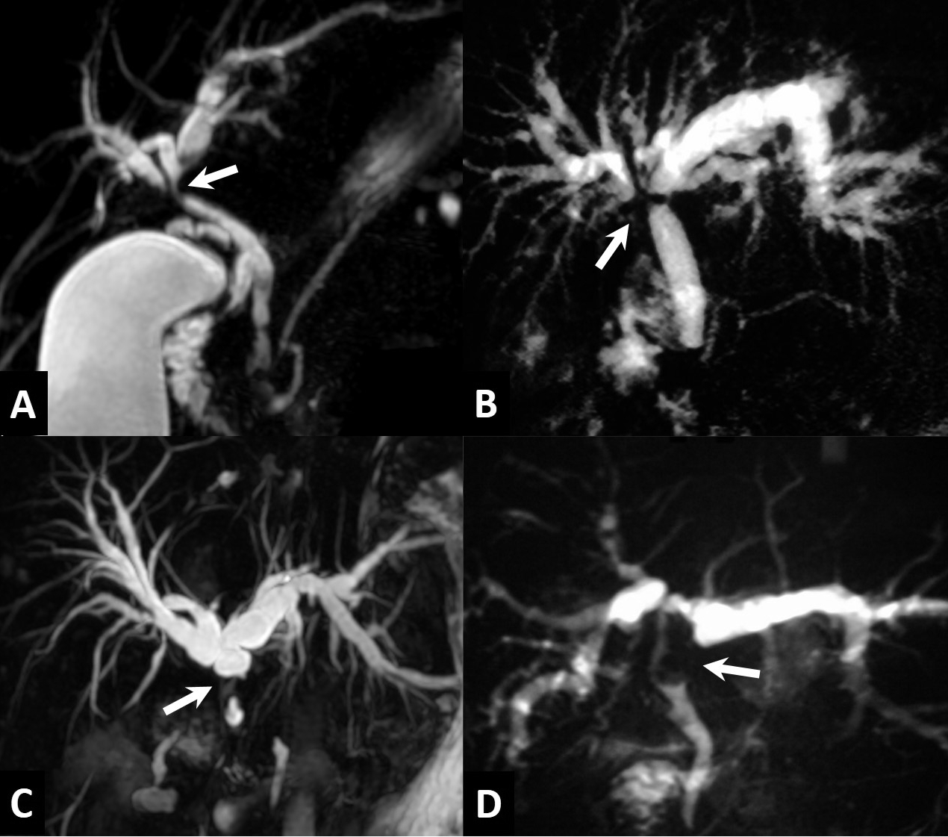

Figure 14 Case of nodular type of hilar cholangiocarcinoma. A: Axial T2-weighted magnetic resonance image show hypointensehilar mass (arrow) with biliary dilatation; B and C: Axial T1-weighted magnetic resonance images in arterial (B) and venous (C) phases showing mildly enhancing ill-defined mass lesion (arrow) encasing right hepatic artery and left portal vein.
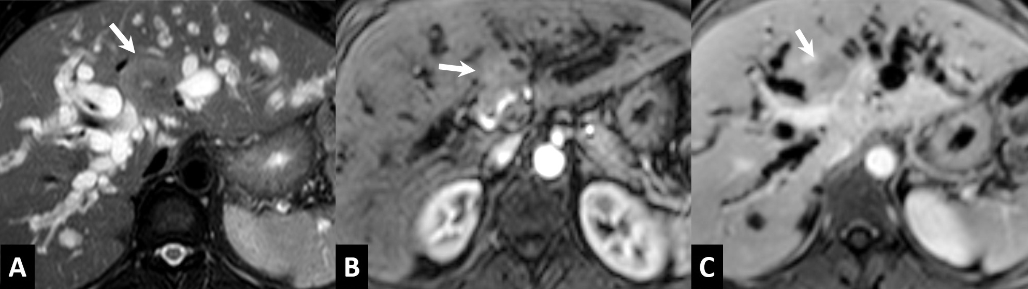

Figure 15 Axial contrast enhanced T1-weighted magnetic resonance images in arterial (A), venous (B) and delayed (C) phases of periductal infiltrating variety of hilar cholangiocarcinoma showing mildly enhancing thick walled proximal hepatic duct in arterial phase (arrow) with increasing contrast enhancement in venous and delayed phases.
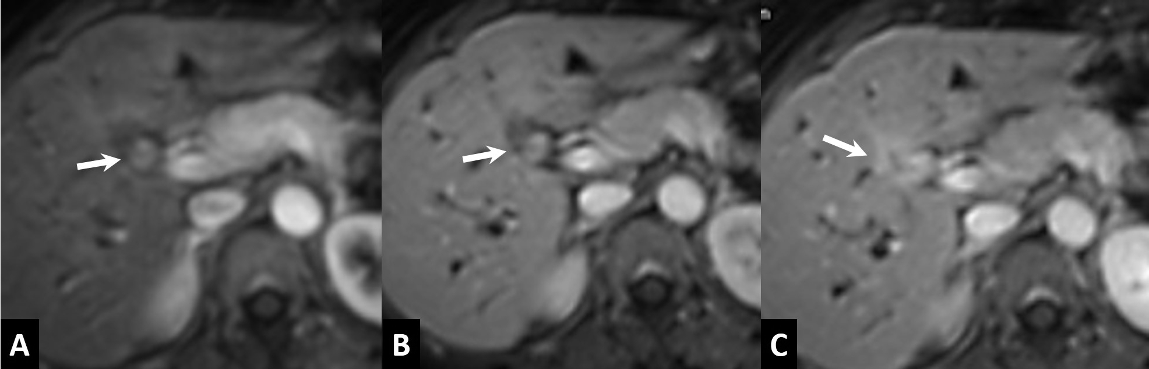

Figure 16 A case of Periductal type of hilar cholangiocarcinoma. A: Axial T1-weighted contrast enhanced magnetic resonance (MR) image in delayed phase showing enhancing periductal lesion (arrow); B and C: Axial diffusion weighted b-800 MR images (B) and ADC map (C) showing diffusion restriction of the lesion
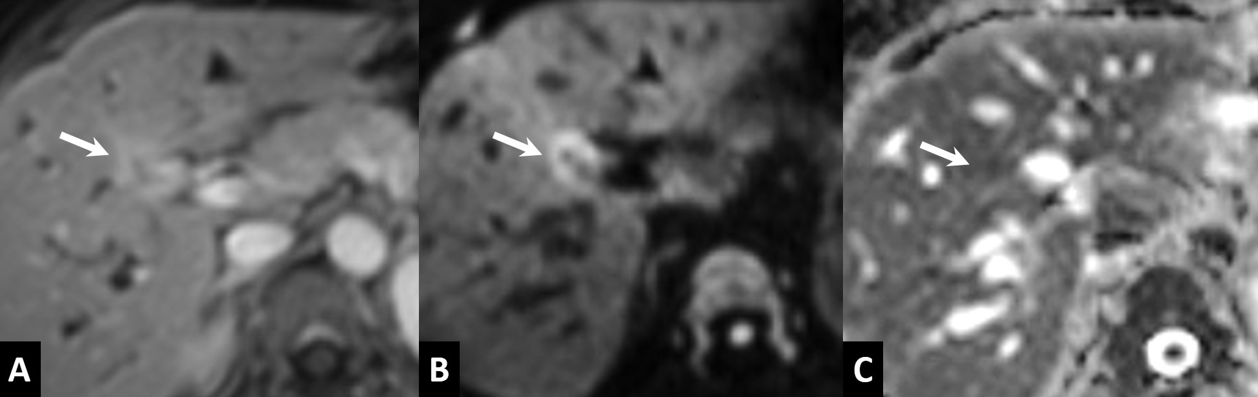

Figure 17 Axial (A) and coronal (B) computed tomography scan of a case of hilar cholangiocarcinoma after endoscopic stenting showing circumferential wall thickening of common hepatic duct around the stent. It would be difficult to differentiate this from reactive thickening.
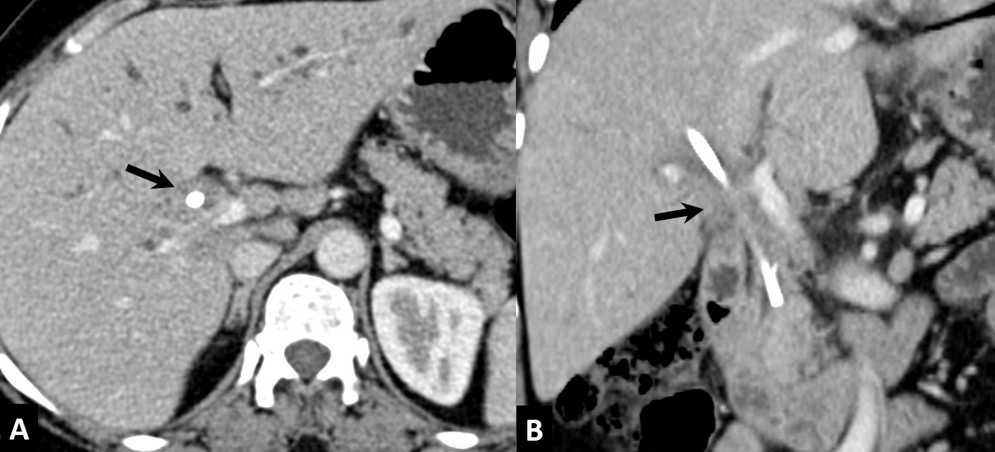

Figure 18 Percutaneous cholangiograms showing complete obstruction of common hepatic duct with patent primary biliary confluence (arrow, A), blocked primary biliary confluence with irregular outline (arrow, B) and intraluminal polypoidal filling defect (arrow, C).
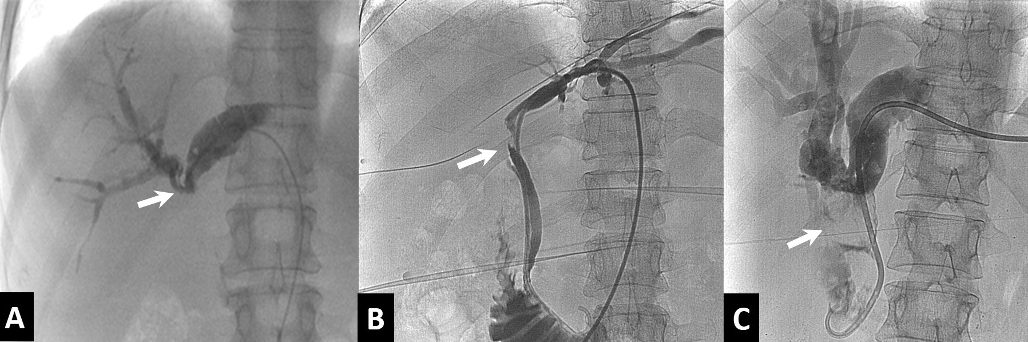

Figure 19 Schematic diagram and magnetic resonance cholangio-pancreatography image of type 1 hilar cholangiocarcinoma.
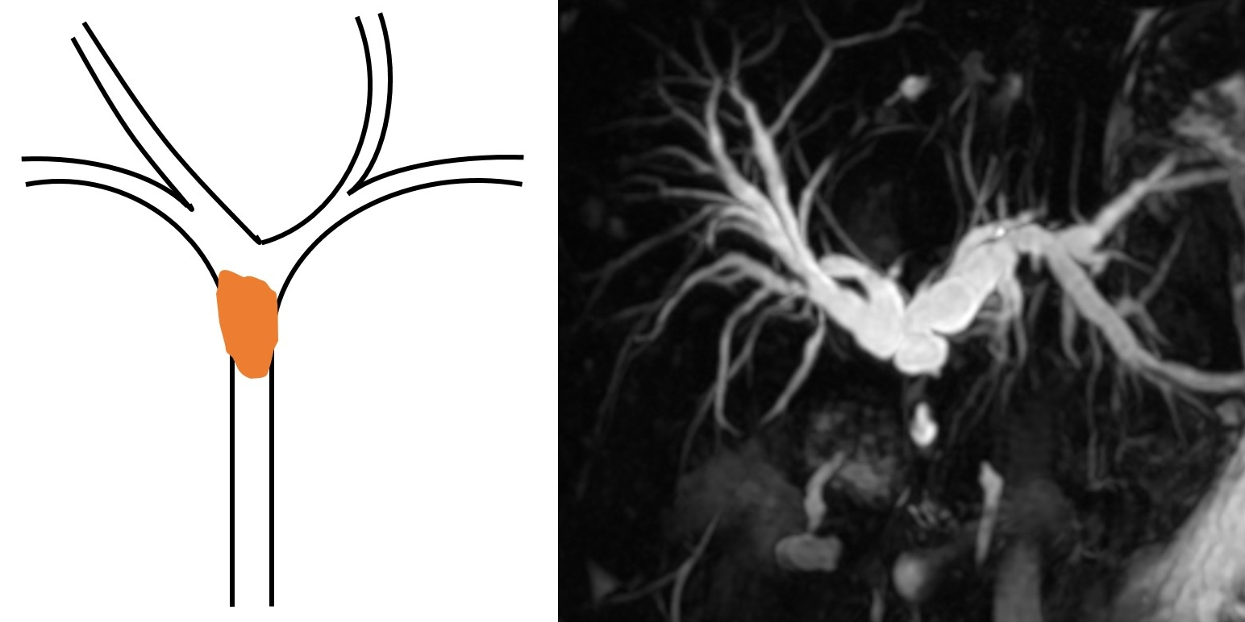

Figure 20 Schematic diagram and magnetic resonance cholangio-pancreatography image of type 2 hilar cholangiocarcinoma.
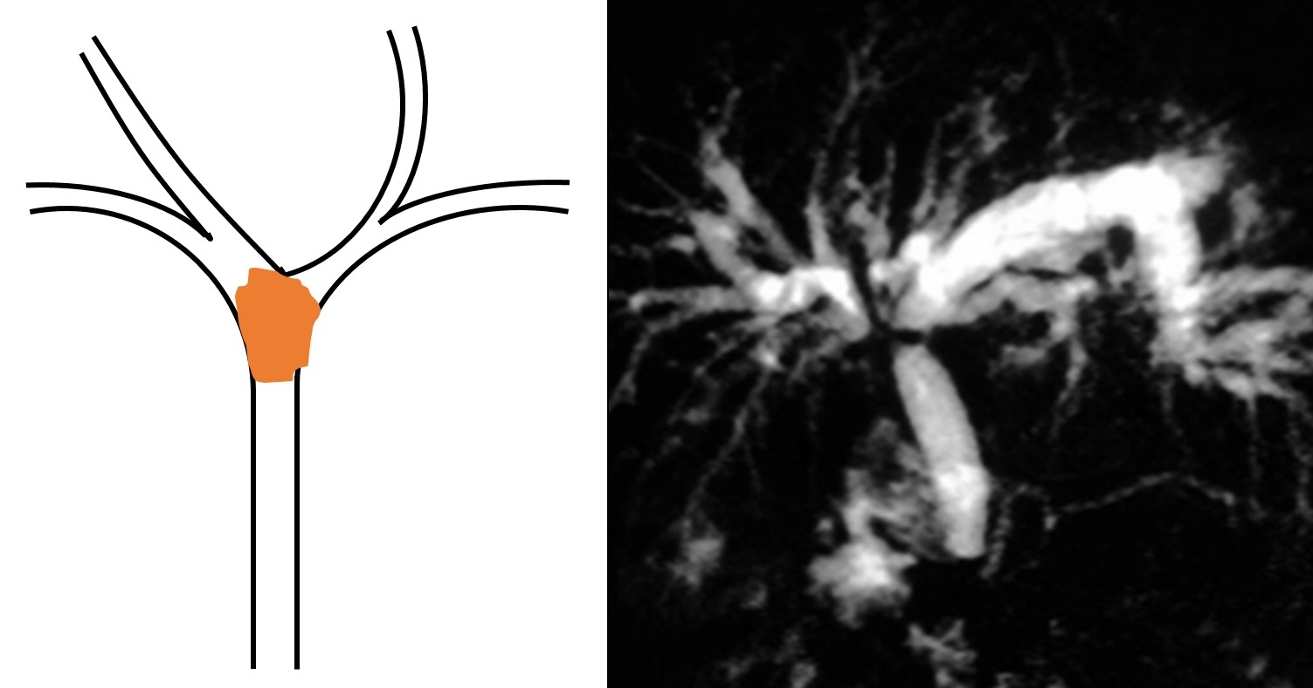

Figure 21 Schematic diagram and magnetic resonance cholangio-pancreatography image of type 3A hilar cholangiocarcinoma.

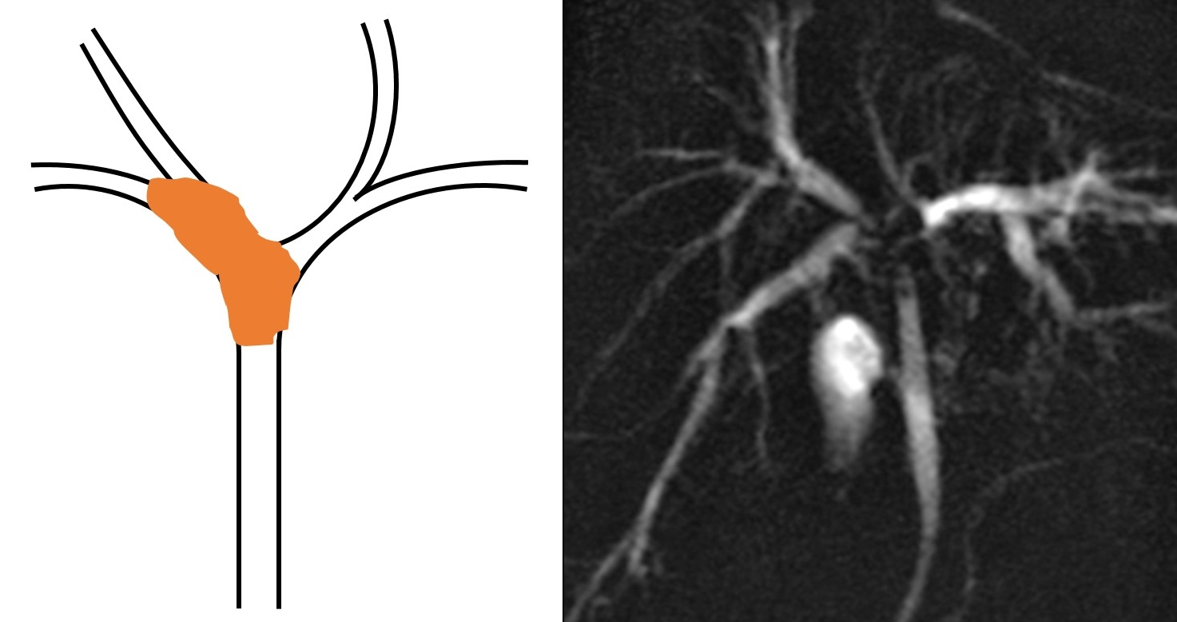

Figure 22 Schematic diagram and magnetic resonance cholangio-pancreatography image of type 3B hilar cholangiocarcinoma.

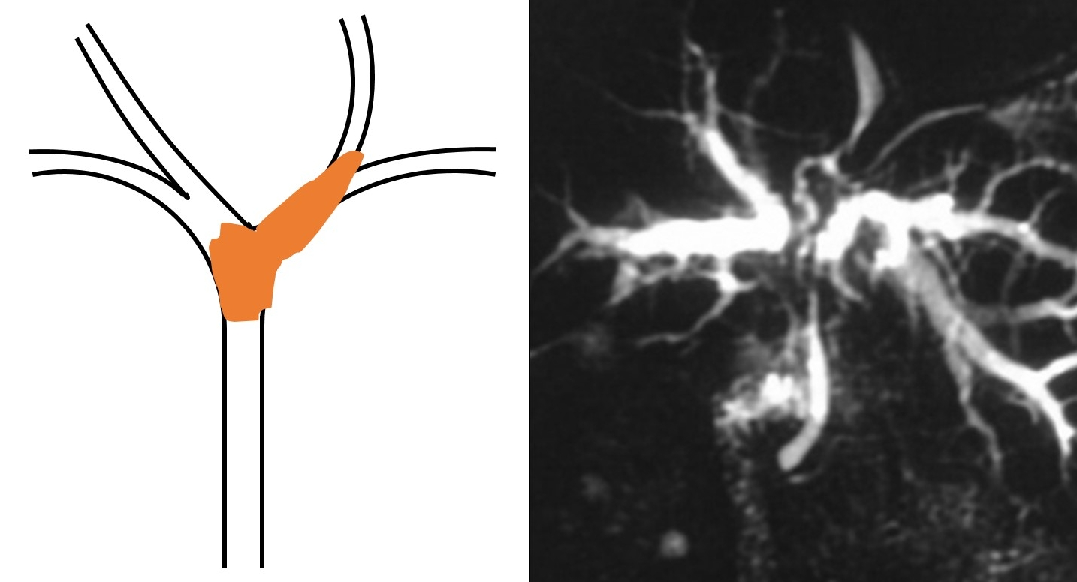

Figure 23 Schematic diagram and hilar cholangiocarcinoma image of type 4 hilar cholangiocarcinoma.

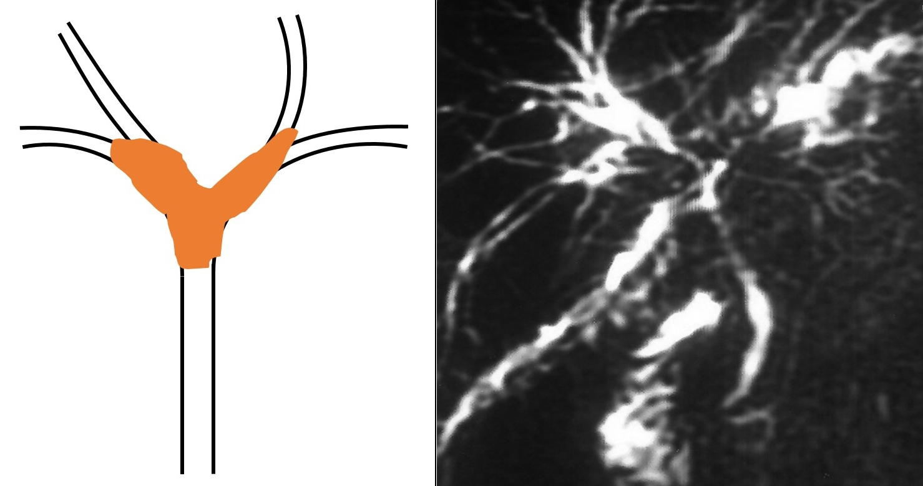

Figure 24 Types of biliary drainages. A: Initial cholangiogram showing dilated intrahepatic bile ducts with hilar obstruction; B: Cholangiogram after placement of ring biliary catheter (Internal-External draimage) showing opacification of bile ducts and duodenum; C: Cholangiogram after placement of external drainage pig-tail catheter.

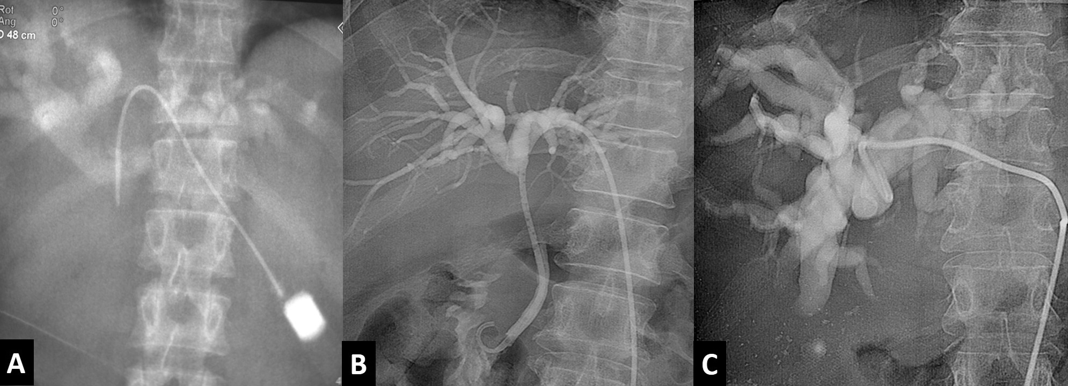

Figure 25 Types of biliary stenting. A: Cholangiogram after placement of unilobar (right sided) biliary metallic stent; B: Cholangiogram after bilobar stent placement showing free flow of contrast into duodenum across the stricture.

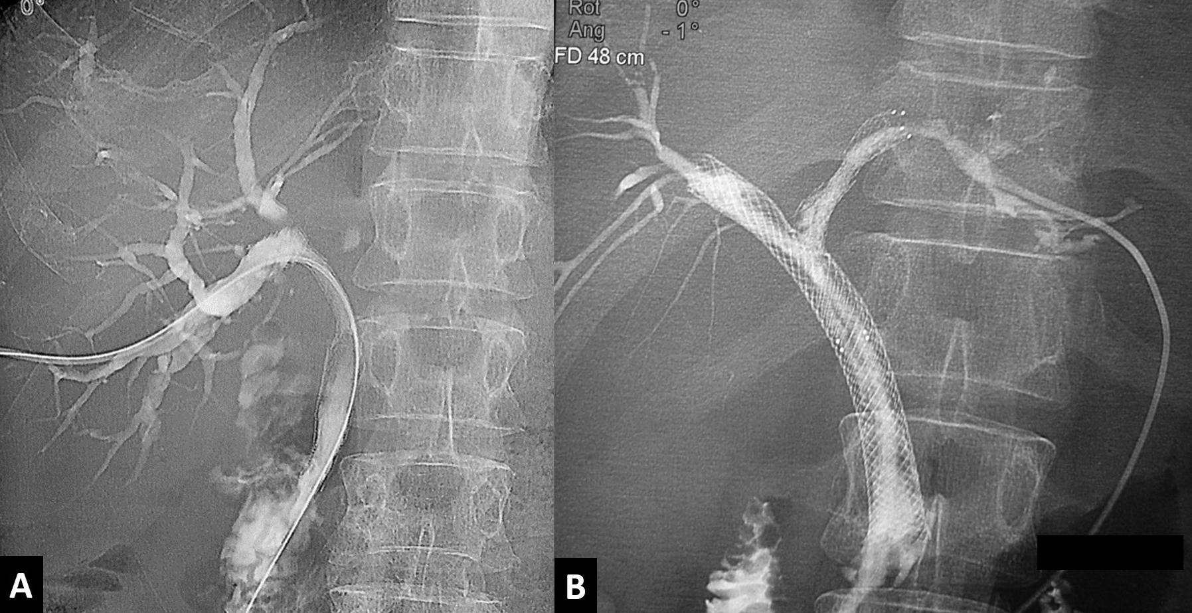

Figure 26 Percutaneous biliary drainage through ring biliary catheter after obstruction of biliary metallic stent due to tumor ingrowth.

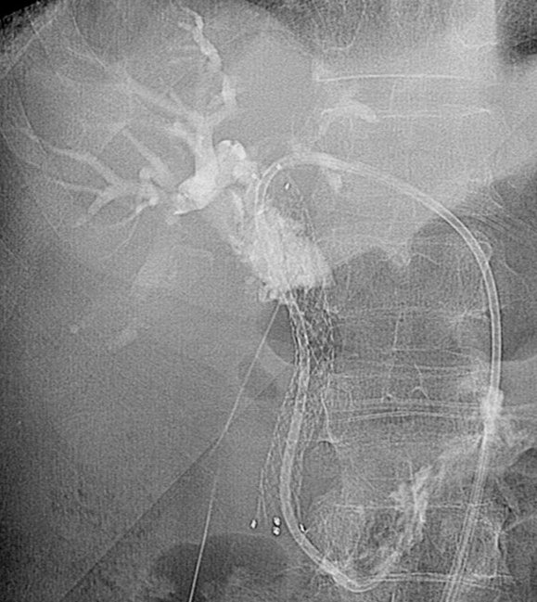

Figure 27 Percutaneous radiofrequency ablation for hilar cholangiocarcinoma. A: Pre-radiofrequency ablation (RFA) image with probe in-situ (arrow); B: Cholangiogram after RFA showing opening of obstruction (arrow).

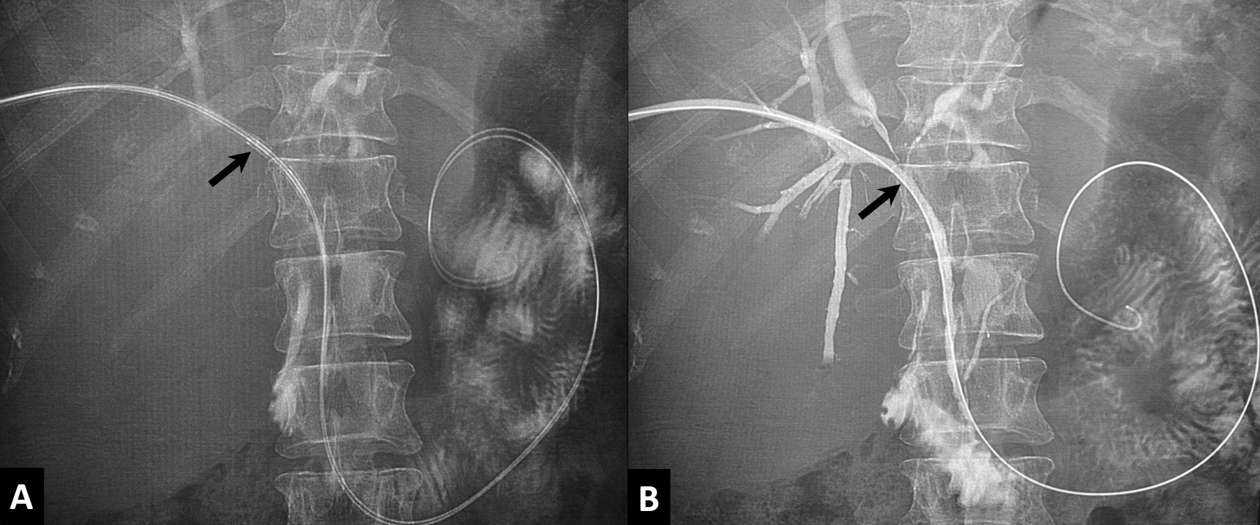

Figure 28 Right portal vein embolization with ipsilateral (A & B) and contralateral (C & D) approaches. A: Right portal venogram with ipsilateral approach. PTBD catheter is seen (arrow); B: Portal venogram after embolization of right portal vein with PVA and glue; C: Right portal venogram with contralateral approach; D: Portal venogram after embolization of right portal vein with glue and vascular plug.
