Name of journal: World Journal of Gastroenterology
ESPS Manuscript NO: 22018
Manuscript Type: ORIGINAL ARTICLE

Observational Study
Clinical features, endoscopic polypectomy and STK11 gene mutation in a nine-month-old Peutz-Jeghers syndrome Chinese infant

Huang ZH et al. Clinical features, polypectomy, STK11 gene mutation

Zhi-Heng Huang, Zai Song, Ping Zhang, Jie Wu, Ying Huang

Zhi-Heng Huang, Jie Wu, Department of Gastroenterology, Children′s Hospital of Fudan University, Shanghai 201102, China

Ying Huang, Department of Gastroenterology, Children’s Hospital of Fudan University, Shanghai 201102, China

Ying Huang, Department of Gastroenterology, Children’s Hospital of Xiamen, Xiamen 361006, Fujian Province, China

Zai Song, Department of Pediatric Surgery, Children’s Hospital of Fudan University, Shanghai 201102, China

Ping Zhang, The Molecular Genetic Diagnosis Center, Shanghai Key Lab of Birth Defects, Translational Medicine Research Center of Children’s Development and Disease, Pediatrics Research Institute, Children’s Hospital of Fudan University, Shanghai 201102, China

Author contributions: Huang ZH and Song Z contributed equally to drafting and revising the manuscript; Song Z contributed to the surgery, Zhang P contributed to the sample analysis; and Wu J contributed to the endoscopic polypectomy; Huang Y contributed to the endoscopic polypectomy, paper design and supervision of the manuscript preparation; all authors contributed to the patient management and approved the final manuscript.

Institutional review board statement: The publication of this manuscript has been approved and reviewed and approved by the Children’s Hospital of Fudan University Review Board.

Informed consent statement: The patient’s parents provided informed written consent prior to study enrollment.

Conflict-of-interest statement: The authors declare no conflicts of interest.

Data sharing statement: No additional data are available.

Open-Access: This article is an open-access article, which was selected by an in-house editor and fully peer-reviewed by external reviewers. It is distributed in accordance with the Creative Commons Attribution Non-commercial (CCBY-NC 4.0) license, which permits others to distribute, remix, adapt, and build upon this work non-commercially as well as license their derivative works on different terms, provided the original work is properly cited and the use is non-commercial. See: http://creativecommons.org/licenses/by-nc/4.0/

Correspondence to: Ying Huang, MD, PhD, Professor, Department of Gastroenterology, Children’s Hospital of Fudan University, No. 399 WanYuan Road, Shanghai 201102, China. yhuang815@163.com
Telephone: +86-21-64931727
Fax: +86-21-64931901

Received: August 8, 2015
Peer-review started: August 11, 2015
First decision: October 14, 2015
Revised: November 11, 2015
Accepted: December 8, 2015
Article in press:
Published online:

Abstract

AIM: To investigate multiple polyps in Chinese Peutz-Jeghers syndrome (PJS) infants.

METHODS: A nine-month-old PJS infant was admitted to our hospital for recurrent prolapsed rectal polyps for one month. The clinical characteristics, a colonoscopic image, the pathological characteristics of the polyps and X-ray images of the intestinal perforation were obtained. STK11 gene analysis was also performed using a DNA sample from this infant.

RESULTS: Here we describe the youngest known Chinese infant with PJS. Five polyps, including a giant polyp of approximately × 2 cm in size, were removed from the infant’s intestine. Laparotomy was performed to repair a perforation caused by pneumoperitoneum. The pathological results showed that this child had PJS. Molecular analysis of the STK11 gene further revealed a novel frameshift mutation (c.64_65het_delAT) in exon 1 in this PJS infant.

CONCLUSION: The appropriate treatment method for multiple polyps in an infant must be carefully considered. Our results also showed that the STK11 gene mutation is the primary cause of PJS.

Key words: Peutz-Jeghers syndrome; Perforation; STK11 gene; Chinese infant; Polyps

© The Author(s) 2015. Published by Baishideng Publishing Group Inc. All rights reserved.

Core tip: This is the first report detailing a nine-month-old Chinese Peutz-Jeghers syndrome (PJS) infant with multiple polyps. A perforation and pneumoperitoneum developed after polypectomy and were followed by sepsis. STK11 gene sequencing and pathology results confirmed that this infant had PJS with a novel, de novo mutation. This article also gives some thoughts to PJS management in children, especially in infants.

Huang ZH, Song Z, Zhang P, Wu J, Huang Y. Clinical features, endoscopic polypectomy and STK11 gene mutation in a nine-month-old Peutz-Jeghers syndrome Chinese infant. World J Gastroenterol 2015; In press

INTRODUCTION
Peutz-Jeghers syndrome (PJS) is a rare autosomal dominant disorder characterized by hamartomatous polyps in the gastrointestinal tract, mucocutaneous pigmentation and an increased risk of cancer^{[1]}. A mutation in the tumor suppressor gene STK11 located on 19p13.3 has been found to be primarily responsible for this disease^{[2]}. Presentation of PJS in infancy is rare. This is the first detailed report of a nine-month-old Chinese PJS infant with multiple polyps. A perforation and pneumoperitoneum developed after polypectomy in this patient, followed by sepsis. The STK11 gene sequencing and pathology results confirmed that this infant had PJS.

MATERIALS AND METHODS
Patient
A nine-month-old infant was admitted to our department with recurrent prolapsed rectal polyps (PRPs) for one month. This infant was female, and she had no family history of PJS.

Polypectomy via colonoscopy
The infant underwent polyp screening, and the polyps were removed during colonoscopy, which was performed using gastrointestinal endoscopy (GIF-XQ260, Olympus, Japan) and an argon plasma coagulation device (VIO200D+APC2, German) with detachable snares (MAJ339, Olympus, Japan). The polyps that were removed were subject to pathological analysis. In our study, polyps > 1 cm were classified as “large”, and those > 2 cm were classified as “giant”.

Sample collection and variant detection
A blood sample was collected, and genomic DNA was extracted according to the STK11 gene testing protocol. All of the STK11 coding exons and its boundary regions were amplified by PCR and analyzed by direct sequencing^{[3]}.

Functional significance prediction and analysis
Three online software packages, including mutation taster (http://mutationtaster.org/) and PolyPhen 2 (http://genetics.bwh.harvard.edu/pph2/), were used to predict the functional significance of the variants.

RESULTS
Clinical characterization and laboratory results
The body weight of this infant was 9.5 kg. She was delivered by cesarean section due to social factors after 40 wk of gestation and had a birth weight of 3500 g. Her chief complaint was recurrent PRPs for one month. The size of the first PRP was similar to that of a pigeon egg. However, the PRP size increased to as large as a chicken egg after one month. Mucocutaneous pigmentation was not detectable in any part of her body. Her complete blood count (CBC) and fecal occult blood test were normal. Her mother was 28 years of age (1 gravida, 1 para), and her father was 31 years of age. She had no brothers or sisters. Both parents were healthy, and neither had a family history of PJS.

Polypectomy
Under general anesthesia, colonoscopic examination revealed five polyps (Figure 1). The first large polyp was located at the outlet of the anus and was approximately 1.5 cm × 1.5 cm in size. The second polyp was small and was located in the sigmoid, with a size of approximately 0.6 cm × 0.8 cm. The third polyp was also small and was located in the sigmoid, with a size of approximately 0.4 cm × 0.5 cm. The fourth polyp was a cucurbit-shaped giant polyp that was located in the descending colon, with a size of × 2 cm. The fifth polyp was also a giant polyp with three lobulations and was located in the transverse colon, with a size of approximately 2.5 cm × 2 cm. All of the polyps were removed smoothly during colonoscopy. The polyps were confirmed as hamartomatous polyps and were pathologically diagnosed as PJS (Figure 2).

Laparotomy
The infant was transferred to the general ward for routine hemostasis with dicynone, p-aminomethyl benzoic acid and supplemental fluid due to fasting. Her blood pressure was normal. The infant had a low fever for approximately 2 hours after polypectomy, and her abdomen was soft. We believed that she had an absorption fever due to the extent of polypectomy. Therefore, no further action was taken. The infant still had a low fever and was slightly agitated after 3 h. Physical examination showed that her abdomen was slightly inflated. Still, no further action was taken. Her temperature increased after 4 h, and physical cooling was performed. The infant became more agitated, and after 6 hours, her abdomen became more inflated. A CBC test was performed and the white blood cell (WBC) count was 3.1 × 10⁹/L and the C-reactive protein (CRP) level was 12 mg/L.
Symptoms of shock were observed in the infant, as evidenced by low spirit and poor peripheral limb circulation after 8 h. A CBC was performed, and the results showed that the WBC was 3.5 × 10⁹/L and the CRP was 68 mg/L. A crystalloid solution was administered quickly to improve the shock symptoms. After approximately 10 hours, the infant underwent abdominal X-ray examination. The X-ray image showed pneumoperitoneum (Figure 3A and B).
The infant immediately underwent emergency surgery. During surgery, a perforation of 0.5 cm² in size was found in the descending colon where the fourth giant polyp was removed. This part of the intestine was resected by anastomosis.

Postoperative course
The infant was transferred to the pediatric intensive care unit for further postoperative support. A CBC test showed that the WBC was 3.0 × 10⁹/L and the CRP was 84 mg/L. The infant was intubated and placed on ventilator support for 4 d. The blood culture was positive for Escherichia coli. Antibiotics, including ceftriaxone, metronidazole, meropenem, and vancomycin, were used for the treatment of sepsis and acute peritonitis. Albumin was used to treat hypoproteinemia caused by inflammatory exudation. Abdominal X-ray showed that the pneumoperitoneum had disappeared at five days after surgery (Figure 3C and D).
The infant was discharged from our hospital when her CBC was nearly normal and her blood culture was negative. The changes in the WBC and CRP that occurred during this period are described in Figure 4.

Mutation analysis
Molecular analysis of the STK11 gene revealed a novel and de novo frameshift mutation (c.64_65het_delAT, p.M22Gfs*140) in exon 1 in this PJS infant (Figure 5). This mutation leads to the partial loss of the kinase domain and the complete loss of the C-terminus, and it has not been previously reported. We also found a SNP (c.920+7G>G/C) in intron 7.

Systematic literature concerning pediatric PJS
A total of 679 papers were identified (PubMed = 183, Embase = 112, Scopus = 297, Cochrane = 0, Web of Science = 87), and 27 papers were considered potentially relevant. All articles discussing PJS in children were retrieved. The criterion for inclusion in the study was a patient age of 0–18 years. Only English-language articles published from 1995, when the first case of neonatal PJS was reported, up to July 31, 2015 were retrieved, and all articles were reviewed independently for suitability (Table 1). The clinical manifestations in PJS vary among patients. In the above-mentioned literature, some children exhibited mucocutaneous pigmentation, abdominal pain, anemia and bloody stool, intussusception or prolapsed rectal polyps. Fernandez et al^{[4]} first to report PJS in a neonate with abdominal distention and bloody stool initially due to multiple polyposis. This patient died at 12 mo of age with multiple complications. Al Faour and Burgmeier respectively reported another neonatae with PJS due to an oblong abdominal mass^{[5,6]}. Those neonates with PJS were diagnosed by pathology but STK11 gene information was not collected for these cases. Some of the retrieved studies focused on the clinical information whereas focused on genetic information related to STK11 and other genes^{[7,8]}. Few studies focused on both clinical features and gene information, and all children in the previous PJS reports were 1 year of age or older^{[9-11]}. Morrison reported a nine-month-old PJS infant with umbilical pigmentation^{[12]}.This infant had a family history of PJS and had a novel mutation (c.88dupG) in exon 1 of the STK11 gene. And in our study, we reported the youngest PJS infant in China with recurrent prolapsed rectal polyps, and her clinical information, laboratory data, image data, pathological images and STK11 gene data were also described in detail.

DISCUSSION
In 1995, Fernandez Seara et al^{[4]} first reported on the occurrence of PJS in a neonate. The serine threonine-protein kinase 11 (STK11) genes responsible for PJS was isolated in 1998.However, there are still few reports of PJS presenting in infants, and there are no relevant reports of this syndrome affecting infants in China. This study presents a nine-month-old Chinese PJS infant with multiple intestinal polyps. To our knowledge, this is the first report to describe the clinical characteristics, colonoscopic findings, pathological results, and surgical treatment of the youngest Chinese infant with PJS and the STK11 gene mutation.
PJS may have varying clinical manifestations, and most clinical complications occur in adults who are twenty to thirty years of age; however, 1/3 of patients are younger than 10^{[13]}. Symptoms of PJS include abdominal pain, rectal bleeding, intussusception, and mucocutaneous pigmentation. The nine-month-old infant in this study suffered recurrent PRPs for one month. No mucocutaneous pigmentation was detectable in any part of the patient’s body, and she only had growing PRPs. Colonoscopy revealed five intestinal polyps, two of which were giant polyps.
For large polyp (≥ 2 cm) removal, endoscopic polypectomy is commonly considered as safe, efficacious and cost-effective in the management of complex colon polyps compared with surgical removal. However, this procedure is not free from complications^{[14]}. For polyps in children, surgical removal may influence physical and psychological development and endoscopic follow up. Endoscopic resection of large polyps, which is minimally invasive, is associated with lower morbidity and mortality rates compared with surgery, and it is not only indicated, it also considered the most appropriate approach. In children, and especially in infants, the lumen size is small and the intestinal wall is thin. Thus, endoscopic polypectomy has a greater risk of perforation in young patients than in adults. For adults, there is still debate as to whether large polyps should be removed under laparoscopy or under colonoscopy^{[15]}. For children, no guidelines are available for removal of a large polyp via laparoscopy, colonoscopy or surgery. We considered that the polyp size, its pedunculated or sessile nature, its location, the age of the child, and the experience of the endoscopist are important factors when selecting between endoscopic or surgical removal of a large polyp^{[16]}. Wiseman et al^{[17]} presented two patients with very large polyps in the proximal colon that were not amenable to colonoscopic removal. These large polyps were removed using minimal-access surgical techniques under laparoscopy. For our patient, surgery may have been the best choice to avoid perforation and sepsis.
Bleeding and perforation are common adverse events in polyposis patients after endoscopy. Bleeding from the large feeding vessels could induce unexpected hypovolemic shock, especially in young toddlers. Perforation can occur during or after resection. Immediate perforation occurs due to deep resection, whereas delayed perforation occurs from a rupture of the wall caused by coagulation necrosis^{[18]}. In our study, the PJS infant had intestinal perforation, serious pneumoperitoneum and sepsis. The large intestines are full of detrimental bacteria, especially Escherichia coli. Migration of Escherichia coli into the blood stream from a perforation site can lead to sepsis. For large polyp removal, careful examination is very important. Performing timely postoperative abdominal examination, abdominal X-ray and ultrasound aids in the early detection of complications. There are less risks of sepsis and other complications if bleeding and perforations are found earlier.
For children with PJS, especially infants, mucocutaneous pigmentation may develop after birth or later. It is difficult to distinguish PJS from other polyp syndromes if mucocutaneous pigmentation presents late. Pathological examination and STK11 gene testing are the gold standards for PJS diagnosis^{[19]}. The patient in this study was initially diagnosed with juvenile polyposis syndrome; however, pathological examination of the polyps led to a diagnosis of PJS. STK11 gene testing further confirmed this diagnosis. This PJS patient had a de novo, novel frameshift STK11 gene mutation. This type of truncating mutation in PJS is associated with the presence of more polyps, as well as increased risks of surgical intervention and cancer^{[20]}. Therefore, additional follow up of this child and similar patients is needed in the future
In conclusion, we have detailed the first case of PJS occurring in a Chinese infant without mucocutaneous pigmentation. For infants with PJS, the treatment strategy should be individualized, and careful postoperative examination should be conducted. Pathological and genetic testing is also indispensable.

COMMENTS
Background
Peutz–Jeghers syndrome (PJS) is an uncommon autosomal dominant inherited disease characterized by the occurrence of hamartomatous polyps in the gastrointestinal tract, mucocutaneous pigmentation, Germline mutations of STK11 gene is responsible for most PJS cases. However, the report of Chinese infant with PJS is rare.

Research frontiers
PJS is associated with STK11 gene mutations which located on chromosome 19p13.3.Germline point mutation are responsible for most patients with PJS and large genomic deletions have also been identified in few patients with PJS. Currently, there is no guideline available on polypectomy by endoscopy or surgical intervention for the children with PJS.

Innovations and breakthroughs
This is the first study to report the youngest PJS infant in China without mucocutaneous pigmentation, and her clinical information, laboratory data, image data, pathological images were also described in detail. STK11 gene sequencing results confirmed that this infant had PJS with a novel, de novo mutation. Further, systematic literature concerning pediatric PJS is analyzed and explained.

Applications
The present study suggested that the patients with multiple polyps, histopathological examination and gene testing are essential. This article also gives some thoughts on management the children, especially infants with PJS cost-effectively.

Terminology
PJS refers to a rare autosomal dominant inherited disorder characterized by gastrointestinal hamartomatous polyposis, mucocutaneous pigmentations, high risk of cancer and germline mutations of STK11 gene is the main cause of PJS.

Peer-review
The authors described a PJS infant with STK11 gene mutation who developed intestinal perforation following endoscopic polypectomy.

REFERENCES
1 Jeghers H, Mckusick VA, Katz KH. Generalized intestinal polyposis and melanin spots of the oral mucosa, lips and digits; a syndrome of diagnostic significance. N Engl J Med 1949; 241: 993, illust; passim [PMID: 15399020 DOI: 10.1056/NEJM194912222412501]
2 Boudeau J, Baas AF, Deak M, Morrice NA, Kieloch A, Schutkowski M, Prescott AR, Clevers HC, Alessi DR. MO25alpha/beta interact with STRADalpha/beta enhancing their ability to bind, activate and localize LKB1 in the cytoplasm. EMBO J 2003; 22: 5102-5114 [PMID: 14517248 DOI: 10.1093/]
3 Yoo JH, Yoo JH, Choi YJ, Kang JG, Sun YK, Ki CS, Lee KA, Choi JR. A novel de novo mutation in the serine-threonine kinase STK11 gene in a Korean patient with Peutz-Jeghers syndrome. BMC Med Genet 2008; 9: 44 [PMID: 18495044 DOI: 10.1186/1471-2350-9-44]
4 Fernandez Seara MJ, Martinez Soto MI, Fernandez Lorenzo JR, Trabazo S, Gamborino E, Forteza Vila J. Peutz-Jeghers syndrome in a neonate. J Pediatr 1995; 126: 965-967 [PMID: 7776109 DOI: 10.1016/S0022-3476(95)70224-5]
5 Al Faour A, Vrsansky P, Abouassi F, Dabbagh H, Gross P, Retbi JM. Peutz-Jeghers colonic tumour in a newborn. Eur J Pediatr Surg 2002; 12: 138-140 [PMID: 12015662 DOI: 10.1055/s-2002-30171]
6 Burgmeier C, Schier F, Staatz G. Gastric outlet obstruction in a neonate because of Peutz-Jeghers syndrome. J Pediatr Surg 2012; 47: e1-e3 [PMID: 22901935 DOI: 10.1016/j.jpedsurg.2012.03.066]
7 Hearle NC, Rudd MF, Lim W, Murday V, Lim AG, Phillips RK, Lee PW, O'donohue J, Morrison PJ, Norman A, Hodgson SV, Lucassen A, Houlston RS. Exonic STK11 deletions are not a rare cause of Peutz-Jeghers syndrome. J Med Genet 2006; 43: e15 [PMID: 16582077 DOI: 10.1136/jmg.2005. 036830]
8 Zuo YG, Xu KJ, Su B, Ho MG, Liu YH. Two novel STK11 mutations in three Chinese families with Peutz-Jeghers syndrome. Chin Med J (Engl) 2007; 120: 1183-1186 [PMID: 17637250]
9 Resta N, Giorda R, Bagnulo R, Beri S, Della Mina E, Stella A, Piglionica M, Susca FC, Guanti G, Zuffardi O, Ciccone R. Breakpoint determination of 15 large deletions in Peutz-Jeghers subjects. Hum Genet 2010; 128: 373-382 [PMID: 20623358 DOI: 10.1007/s00439-010-0859-7]
10 Kuroda Y, Saito T, Nagai J, Ida K, Naruto T, Masuno M, Kurosawa K. Microdeletion of 19p13.3 in a girl with Peutz-Jeghers syndrome, intellectual disability, hypotonia, and distinctive features. Am J Med Genet A 2015; 167A: 389-393 [PMID: 25487640 DOI: 10.1002/ajmg.a.36813]
11 Liu WL, Li F, He ZX, Jiang HY, Ai R, Zhu XP, Chen XX, Ma HW. Identification of a novel de novo STK11 mutation in a Chinese child with Peutz-Jeghers syndrome. J Int Med Res 2011; 39: 2033-2038 [PMID: 22118009 DOI: 10.1177/1473]
12 Morrison PT, Donnelly DE, Morrison PJ. Umbilical pigmentation in Peutz-Jeghers syndrome. Clin Dysmorphol 2014; 23: 114-115 [PMID: 24878829 DOI: 10.1097/MCD.0000000000]
13 Kitagawa S, Townsend BL, Hebert AA. Peutz-Jeghers syndrome. Dermatol Clin 1995; 13: 127-133 [PMID: 7712638 DOI: 10.1038/ajg.2014.95]
14 Aziz Aadam A, Wani S, Kahi C, Kaltenbach T, Oh Y, Edmundowicz S, Peng J, Rademaker A, Patel S, Kushnir V, Venu M, Soetikno R, Keswani RN. Physician assessment and management of complex colon polyps: a multicenter video-based survey study. Am J Gastroenterol 2014; 109: 1312-1324 [PMID: 25001256 DOI: 10.1038/ajg.2014.95]
15 Church JM. Laparoscopic vs. colonoscopic removal of a large polyp. Am J Gastroenterol 2009; 104: 2633-2634 [PMID: 19806099 DOI: 10.1038/ajg.2009.442]
16 Spychalski M, Buczyński J, Cywiński J, Dziki Ł, Langner E, Sygut A, Trzciński R, Dziki A. Large colorectal polyps--endoscopic polypectomy as an alternative to surgery. Pol Przegl Chir 2011; 83: 531-536 [PMID: 22189279 DOI: 10.2478/v10035-011-0084-7]
17 Wiseman J, Emil S. Minimal access surgical management of large juvenile polyps in children. J Pediatr Surg 2009; 44: e9-13 [PMID: 19735807 DOI: 10.1016/j.jpedsurg.]
18 Kaltenbach T, Soetikno R. Endoscopic resection of large colon polyps. Gastrointest Endosc Clin N Am 2013; 23: 137-152 [PMID: 23168124 DOI: DOI: 10.1016/j.giec. 2012.10.005]
19 Beggs AD, Latchford AR, Vasen HF, Moslein G, Alonso A, Aretz S, Bertario L, Blanco I, Bulow S, Burn J, Capella G, Colas C, Friedl W, Moller P, Hes FJ, Jarvinen H, Mecklin JP, Nagengast FM, Parc Y, Phillips RK, Hyer W, Ponz de Leon M, Renkonen-Sinisalo L, Sampson JR, Stormorken A, Tejpar S, Thomas HJ, Wijnen JT, Clark SK, Hodgson SV. Peutz-Jeghers syndrome: a systematic review and recommendations for management. Gut 2010; 59: 975-986 [PMID: 20581245 DOI: 10.1136/gut. 2009.198499]
20 Salloch H, Reinacher-Schick A, Schulmann K, Pox C, Willert J, Tannapfel A, Heringlake S, Goecke TO, Aretz S, Stemmler S, Schmiegel W. Truncating mutations in Peutz-Jeghers syndrome are associated with more polyps, surgical interventions and cancers. Int J Colorectal Dis 2010; 25: 97-107 [PMID: 19727776 DOI: 10.1007/s00384-009-0793-0]
21 Corley DA, Uyeki TM, Cello JP. Gastrointestinal bleeding and gastric outlet obstruction from Peutz-Jeghers polyposis. Diagnosis and treatment. West J Med 1997; 166: 350-352 [PMID: 9217445]
22 Boseto F, Shi E, Mitchell J, Preddy J, Adams S. Gastroduodenal intussusception due to Peutz-Jeghers syndrome in infancy. Pediatr Surg Int 2002; 18: 178-180 [PMID: 11956792 DOI: 10.1007/s003830100693]
23 Homan M, Dolenc Strazar Z, Orel R. Peutz-Jeghers syndrome. A case report. Acta Dermatovenerol Alp Pannonica Adriat 2005; 14: 26-29 [PMID: 15818443]
24 Adolph VR, Bernabe K. Polyps in children. Clin Colon Rectal Surg 2008; 21: 280-285 [PMID: 20011439 DOI: 10.1055/s-0028-1089943]
25 Vidal I, Podevin G, Piloquet H, Le Rhun M, Frémond B, Aubert D, Leclair MD, Héloury Y. Follow-up and surgical management of Peutz-Jeghers syndrome in children. J Pediatr Gastroenterol Nutr 2009; 48: 419-425 [PMID: 19330929 DOI: 10.]
26 Ausavarat S, Leoyklang P, Vejchapipat P, Chongsrisawat V, Suphapeetiporn K, Shotelersuk V. Novel mutations in the STK11 gene in Thai patients with Peutz-Jeghers syndrome. World J Gastroenterol 2009; 15: 5364-5367 [PMID: 19908348 DOI: 10.3748/wjg.15. 5364]
27 Yang HR, Ko JS, Seo JK. Germline mutation analysis of STK11 gene using direct sequencing and multiplex ligation-dependent probe amplification assay in Korean children with Peutz-Jeghers syndrome. Dig Dis Sci 2010; 55: 3458-3465 [PMID: 20393878 DOI: 10.1007/s10620-010-1194]
28 Chen C, Zhang X, Wang F, Liu C, Lu H, Wan H, Wei J, Liu J. One novel deletion and one splicing mutation of the LKB1 gene in two Chinese patients with Peutz-Jeghers syndrome. DNA Cell Biol 2012; 31: 1535-1540 [PMID: 22928647 DOI: 10.1089/dna.2012.1720]
29 Thakkar K, Fishman DS, Gilger MA. Colorectal polyps in childhood. Curr Opin Pediatr 2012; 24: 632-637 [PMID: 22890064 DOI: 10.1097/MOP.0b013e328357419f]
30 Liu D, Guo H, Xu X, Yu Y, Bai Y. Two variants in STK11 gene in Chinese patients with Peutz-Jeghers syndrome. J Genet 2012; 91: 205-208 [PMID: 22942091 DOI: 10.1007/]
31 Goldstein SA, Hoffenberg EJ. Peutz-Jegher syndrome in childhood: need for updated recommendations? J Pediatr Gastroenterol Nutr 2013; 56: 191-195 [PMID: 23325439 DOI: 10.1097/]
32 Zheng B, Pan J, Wang Y, Li M, Lian M, Zheng Y, Jin Y. Analysis of STK11 gene variant in five Chinese patients with Peutz-Jeghers syndrome. Dig Dis Sci 2013; 58: 2868-2872 [PMID: 23892522 DOI: 10.1007/s10620-013-2737-3]
33 Vageli DP, Doukas SG, Markou A. Mismatch DNA repair mRNA expression profiles in oral melanin pigmentation lesion and hamartomatous polyp of a child with Peutz-Jeghers syndrome. Pediatr Blood Cancer 2013; 60: E116-E117 [PMID: 23677888 DOI: 10.1002/pbc.24579]
34 Chae HD, Jeon CH. Peutz-Jeghers syndrome with germline mutation of STK11. Ann Surg Treat Res 2014; 86: 325-330 [PMID: 24949325 DOI: 10.4174/astr.2014.86.6.325]
35 Wang Z, Wu B, Mosig RA, Chen Y, Ye F, Zhang Y, Gong W, Gong L, Huang F, Wang X, Nie B, Zheng H, Cui M, Wang Y, Wang J, Chen C, Polydorides AD, Zhang DY, Martignetti JA, Jiang B. STK11 domain XI mutations: candidate genetic drivers leading to the development of dysplastic polyps in Peutz-Jeghers syndrome. Hum Mutat 2014; 35: 851-858 [PMID: 24652667 DOI: 10.1002/humu.22549]
36 Cohen S, Gorodnichenco A, Weiss B, Lerner A, Ben-Tov A, Yaron A, Reif S. Polyposis syndromes in children and adolescents: a case series data analysis. Eur J Gastroenterol Hepatol 2014; 26: 972-977 [PMID: 24999926 DOI: 10.1097/MEG.0000]
37 Kimura J, Sasaki K, Okabayashi T, Shima Y, Iwata J, Morita S. Duodeno-jejunal Intussusception with Acute Pancreatitis in Peutz-Jeghers Syndrome: The First Case Presentation in Childhood. J Gastrointest Surg 2015; 19: 1922-1924 [PMID: 25895981 DOI: 10.1007/s11605-015-2827-y]
38 Armijo B, Bocklage T, Heideman R. Intratubular Large Cell Hyalinizing Sertoli Cell Tumor of the Testes in a 4-Year-Old Male With Peutz-Jeghers Syndrome. J Pediatr Hematol Oncol 2015; 37: e184-e187 [PMID: 25171448 DOI: 10.1097/MPH.0000000000000243]

P-Reviewer: Urganci N, Watanabe T S-Editor: Qi Y L-Editor: E-Editor:

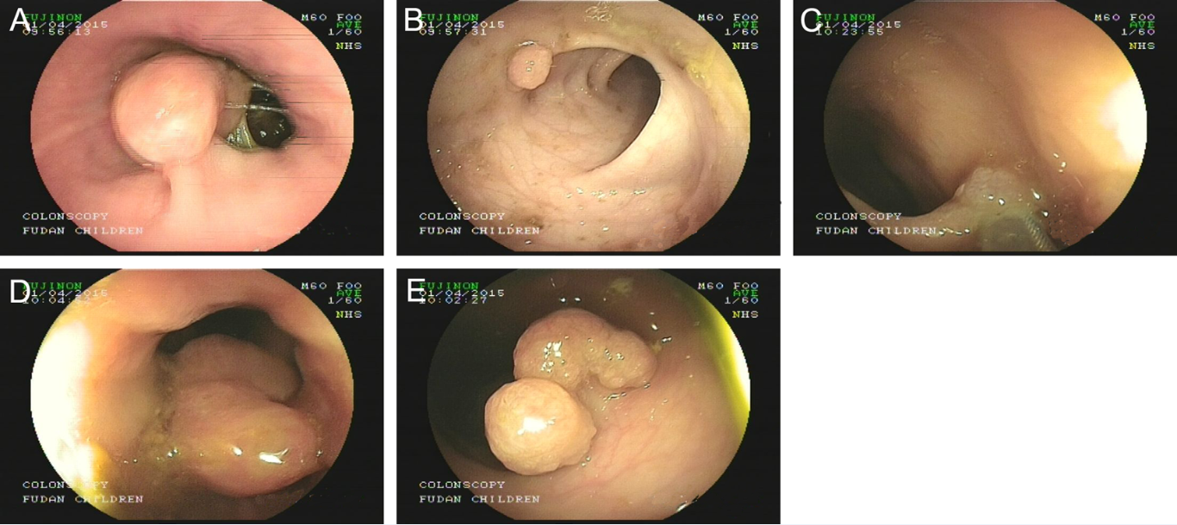Figure 1 Endoscopic image of the five polyps located in different parts of the intestine.

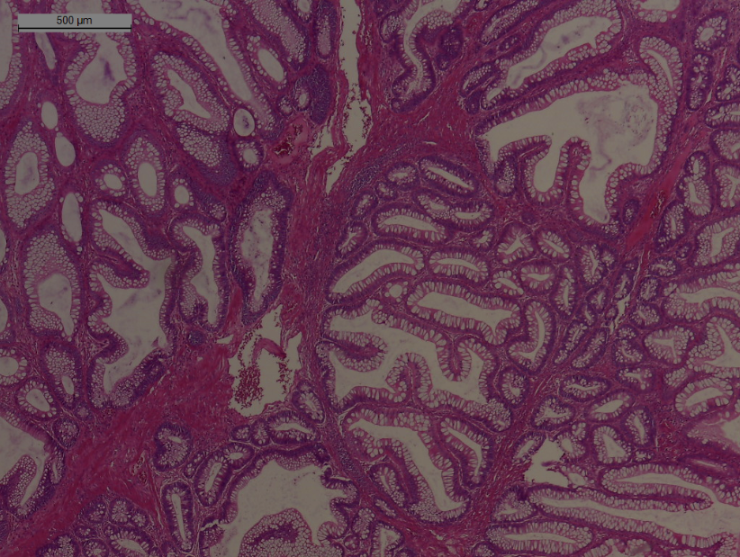
Figure 2 Hematoxylin-eosin staining, showing the pathological characteristics of the hamartomatous polyps in the infant with Peutz-Jeghers syndrome.
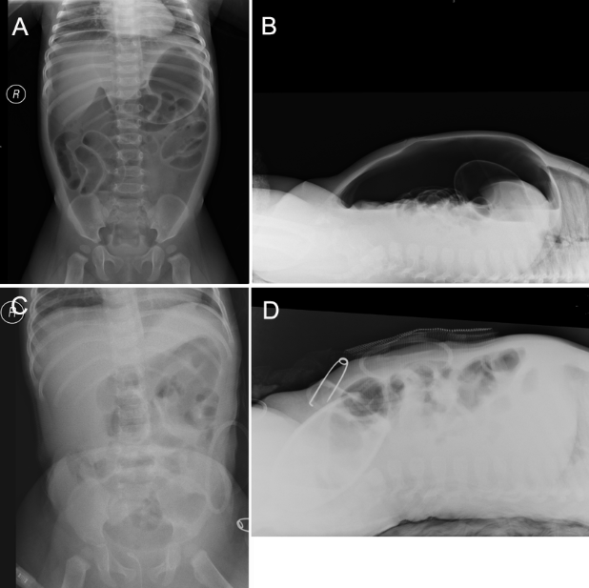
Figure 3 X-ray image of the abdomen. A, B: Show the pneumoperitoneum. C, D: Show recovery of pneumoperitoneum after intestinal repair.
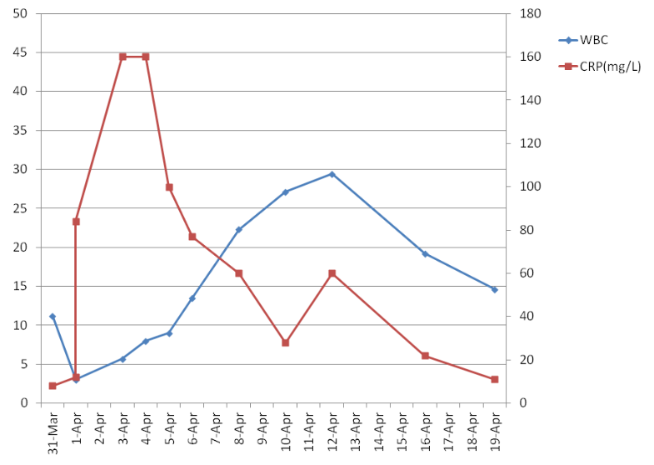
Figure 4 Changes in the white blood cell and C-reactive protein preoperatively and postoperatively.

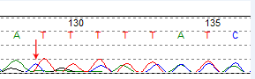
Figure 5 Infant had a frameshift mutation in codon 64 (64_65het_delAT) in exon 1. The arrow indicates the mutation site.

Table 1 Systematic literature reports of pediatric Peutz-Jeghers syndrome
Author | Year | Study type | Country | Age range | Manifestation | Treatment | Gene information
Fernandez et al^{[4]} | 1995 | Case report | Spain | 15 d | PRPs | ED and Died | NA
Corley et al^{[21]} | 1997 | Case report | United States | 15 yr | Gastric outlet obstruction, abdominal pain | ED and OP | NA
AI Four et al^{[5]} | 2002 | Case report | France | 4 d | Abdominal mass | OP | NA
Boseto et al^{[22]} | 2002 | Case report | Australia | 14 mo | Gastric outlet obstruction | OP | NA
Homan et al^{[23]} | 2005 | Case report | Slovenia | 10 yr | Abdominal pain,vomiting, intussusception | OP | NA
Hearle et al^{[74]} | 2006 | Letter | United Kingdom | 1-38 yr | NA | NA | Yes
Zuo et al^{[8]} | 2007 | Article | China | 5-10 yr | MP | NA | Yes
Adolph et al^{[24]} | 2008 | Review | United States | children | MP,intussusception,abdominal pain, etc. | ED and OP | NA
Vidal et al^{[25]} | 2009 | Article | France | 4.8-15.1 yr | MP, PRPs, intussusception, etc. | ED and OP | NA
Ausavarat et al^{[26]} | 2009 | Case report | Thailand | 14 yr | MP,abdominal pain,intestinal obstruction,etc | ED or OP | Yes
Resta et al^{[9]} | 2010 | Article | Italy | 1-17 yr | NA | NA | Yes
Yang et al^{[27]} | 2010 | Article | Korea | 6 mo-13.8 yr | MP, hematochezia, intussusception, anemia,etc | ED or OP | Yes
Liu et al^{[11]} | 2011 | Article | China | 6 yt | MP, abdominal pain, hematochezia | ED and OP | Yes
Burgmeier et al^{[6]} | 2012 | Case report | Germany | 2 d | Vomiting, abdominal mass | OP | NA
Chen et al^{[28]} | 2012 | Article | China | 14 yr | MP | ED | Yes
Thakkar et al^{[29]} | 2012 | Review | United States | children | MP, PRPs, intussusception, etc. | ED and OP | Yes
Liu et al^{[30]} | 2012 | Article | China | 12 and 16 yr | MP, abdominal pain, hematochezia,etc | ED | Yes
Goldstein et al^{[31]} | 2013 | Article | United States | 1-14 yr | MP, PRPs, intussusception, etc. | ED and OP | NA
Zheng et al^{[32]} | 2013 | Article | China | 1-5 yr | MP, abdominal pain | NA | Yes
Vageli et al^{[33]} | 2013 | Case report | Greece | 12 yy | MP | NA | NA
Chae et al^{[34]} | 2014 | Case report | Korea | 12 yr | MP, abdominal pain, anemia | OP | Yes
Morrison et al^{[12]} | 2014 | Case report | United Kingdom | 9 mo | Umbilical pigmentation | NA | Yes
Wang et al^{[35]} | 2014 | Aritcle | China | 1–43 yr | MP, histopathologic examination,etc | ED and OP | Yes
Cohen et al^{[36]} | 2014 | Article | Israel | 4-16 yr | MP, abdominal pain, hematochezia | ED or OP | Yes
Kimura et al^{[37]} | 2015 | Case report | Japan | 13 yr | MP,abdominal pain | OP | NA
Kuroda et al^{[10]} | 2015 | Article | Japan | 12 yr | MP,intellectual disability | ED | Yes
Armijo et al^{[38]} | 2015 | Case report | United States | 4 yr | gynecomastia ,MP,testicular lesions | Orchiectomy | Yes
Our group | 2015 | Article | China | 9 mo | PRPs | ED and OP | Yes

ED: Endoscopy; MP: Mucocutaneous pigmentation; NA: Not available; OP: Operation; PRPs: Prolapsed rectal poly.

