Name of Journal: World Journal of Gastrointestinal Endoscopy
Manuscript NO: 58517
Manuscript Type: LETTER TO THE EDITOR

Real-world clinical data of endoscopy-based cancer detection during the emergency declaration for COVID-19 in Japan

Yoshida S et al. Gastrointestinal endoscopy under the COVID-19 pandemic

Shuntaro Yoshida, Toshihiro Nishizawa, Osamu Toyoshima

Shuntaro Yoshida, Osamu Toyoshima, Department of Gastroenterology, Toyoshima Endoscopy Clinic, Tokyo 157-0066, Japan

Toshihiro Nishizawa, Department of Gastroenterology, International University of Health and Welfare, Narita Hospital, Chiba 2868520, Japan

Author contributions: Yoshida S contributed to data curation and writing original draft; Nishizawa T contributed to writing – review & editing; Toyoshima O contributed to conceptualization, formal analysis, and methodology.

Corresponding author: Osamu Toyoshima, MD, Doctor, Department of Gastroenterology, Toyoshima Endoscopy Clinic, 6-17-5 Seijo, Setagaya-ku, Tokyo 157-0066, Japan. t@ichou.com

Received: July 26, 2020
Revised: August 11, 2020
Accepted: October 5, 2020
Published online:

Abstract
The impact of the coronavirus disease 2019 (COVID-19) pandemic is widespread throughout the world, causing serious damage to healthcare systems. Therefore, we examined the significance of endoscopy based on the recommendation of Asian-Pacific Society for Digestive Endoscopy and Japan Gastroenterological Endoscopy Society during the COVID-19 pandemic by evaluating the details of gastrointestinal endoscopy performed during the declaration of emergency in Japan. We have continued performing gastrointestinal endoscopy at an outpatient clinic that specialized in endoscopic medical care in Tokyo, Japan. During the emergency declaration period, 544 patients underwent gastrointestinal endoscopy. As a control, we investigated 1327 patients who underwent gastrointestinal endoscopy during the same period in 2019. Although the total number of endoscopies during the emergency declaration was halved, the advanced cancer detection rate during the emergency declaration was significantly higher than that in 2019 (P = 0.04). Additionally, no COVID-19 infection was observed in healthcare workers, staff, or patients during this period. It is possible that an outpatient endoscopy units can contribute to the detection of advanced cancer, while the hospital in charge for patients with COVID-19 infection could not perform endoscopy during the declaration of emergency.

Key Words: COVID-19; Pandemics; Gastrointestinal; Endoscopy; Neoplasms; Personal protective equipment

Yoshida S, Nishizawa T, Toyoshima O. Real-world clinical data of endoscopy-based cancer detection during the emergency declaration for COVID-19 in Japan. World J Gastrointest Endosc 2020; In press

Core Tip: It is possible that an outpatient endoscopy units can contribute to the detection of advanced cancer, while the hospital in charge for patients with coronavirus disease 2019 (COVID-19) infection could not perform endoscopy during the declaration of emergency. Gastrointestinal endoscopy may be one of the safety nets in the COVID-19 pandemic to not delay the diagnosis of advanced, life-threatening cancers.
TO THE EDITOR
We read with interest the recent paper by Olszewski et al^{[1]} reporting their best practice outline for endoscopy during the coronavirus disease 2019 (COVID-19) outbreak. As the authors describe, we strongly feel the need to change our practice to incorporate these factors to improve the safety of patients, health care providers, and community as a whole during this disaster.
Our facility is an outpatient clinic that specialized in endoscopic medical care in Tokyo, Japan. We have continued performing gastrointestinal endoscopy according to the recommendations of Asian-Pacific Society for Digestive Endoscopy (APSDE)^{[2]} and Japan Gastroenterological Endoscopy Society (JGES)^{[3]}. We would like to introduce our successful approach.
First, patients were categorized as high-risk or low-risk using the ASPDE and JGES risk assessment at reception and endoscopy was only performed in low-risk patients. Endoscopy was not applicable when any of the following criteria were met: (1) Patients with respiratory infection; (2) Patients with a body temperature ≥ 37.5 °C; (3) Patients who were in close contact with subjects in an endemic area within the last 2 wk; (4) Patients who traveled to endemic areas within the last 2 wk; and (5) Patients complaining of symptoms due to COVID-19 infection.
Second, the indications for endoscopy were limited as follows: Symptomatic patients, patients with abnormalities in other tests, patients with previous appointments, and patients who strongly wished for investigation. A new reservation for asymptomatic patients or surveillance endoscopy was not accepted.
We were focused on preventing COVID-19 infection in healthcare workers using personal protective equipment, including gloves, hairnets, protective eyewear (goggles or face shield), and waterproof gowns. To prevent the inhalation of airborne droplets and aerosolized virus^{[4,5]}, we wore a surgical mask or N95 during the endoscopy procedure. We also applied a surgical mask with a handmade scope insertion port (Figure 1) for patients during the upper-endoscopy procedure. The patients changed their shoes to slippers at the entrance, measured their body temperature, washed their hands and gargled in the washroom, wore a mask, and maintained social distancing.
To improve the environment of the endoscopic room, we ventilated the examination room and the waiting rooms about 6 times/h (about 2 times/h of the outside air volume), installed an air purifier, and employed specialized staff to clean the clinic.
During the emergency declaration period (between April 7th and May 26th in 2020), 544 patients (302 for upper endoscopy and 537 for colonoscopy) underwent gastrointestinal endoscopy. Table 1 shows the comparison of gastrointestinal endoscopy performed in 2020 and the same period in 2019. The total number of endoscopies during the emergency declaration was halved. There was no significant difference in the cancer detection rate between 2019 and 2020. For advanced cancer, the detection rate during the emergency declaration period was higher than that during the same period in the last year (P = 0.04). As a result of the above precautions, no COVID-19 infection was observed in healthcare workers, staff, or patients during this period.
As one of the factors of this higher detection rate in advanced lesion, it may have been possible to enrich cases with findings based on strict adaptation criteria of the endoscope. It is possible that an outpatient endoscopy units can contribute to the detection of advanced cancer, while the hospital in charge for patients with COVID-19 infection could not perform endoscopy during the declaration of emergency.
Gastrointestinal endoscopy based on the recommendations of APSDE and JGES may be one of the safety nets in the COVID-19 pandemic to not delay the diagnosis of advanced, life-threatening cancers. Our clinic was able to play an important role even during the declaration of emergency.

REFERENCES
1 Olszewski T, Grubic AD, Ayazi S, Jobe BA. COVID-19 outbreak and endoscopy: Considerations in patients encountered in a foregut surgery practice. World J Gastrointest Surg 2020; 12: 197-202 [PMID: 32551025 DOI: 10.4240/wjgs.v12.i5.197]
2 Chiu PWY, Ng SC, Inoue H, Reddy DN, Ling Hu E, Cho JY, Ho LK, Hewett DG, Chiu HM, Rerknimitr R, Wang HP, Ho SH, Seo DW, Goh KL, Tajiri H, Kitano S, Chan FKL. Practice of endoscopy during COVID-19 pandemic: position statements of the Asian Pacific Society for Digestive Endoscopy (APSDE-COVID statements). Gut 2020; 69: 991-996 [PMID: 32241897 DOI: 10.1136/gutjnl-2020-321185]
3 Irisawa A, Furuta T, Matsumoto T, Kawai T, Inaba T, Kanno A, Katanuma A, Kawahara Y, Matsuda K, Mizukami K, Otsuka T, Yasuda I, Tanaka S, Fujimoto K, Fukuda S, Iishi H, Igarashi Y, Inui K, Ueki T, Ogata H, Kato M, Shiotani A, Higuchi K, Fujita N, Murakami K, Yamamoto H, Ito T, Okazaki K, Kitagawa Y, Mine T, Tajiri H, Inoue H. Gastrointestinal endoscopy in the era of the acute pandemic of coronavirus disease 2019: Recommendations by Japan Gastroenterological Endoscopy Society (Issued on April 9th , 2020). Dig Endosc 2020; Online ahead of print [PMID: 32335946 DOI: 10.1111/den.13703]
4 Hindson J. COVID-19: faecal-oral transmission? Nat Rev Gastroenterol Hepatol 2020; 17: 259 [PMID: 32214231 DOI: 10.1038/s41575-020-0295-7]
5 Xiao F, Tang M, Zheng X, Liu Y, Li X, Shan H. Evidence for Gastrointestinal Infection of SARS-CoV-2. Gastroenterology 2020; 158: 1831-1833.e3 [PMID: 32142773 DOI: 10.1053/j.gastro.2020.02.055]

Footnotes
Conflict-of-interest statement: The authors disclose no conflicts.

Open-Access: This article is an open-access article that was selected by an in-house editor and fully peer-reviewed by external reviewers. It is distributed in accordance with the Creative Commons Attribution NonCommercial (CC BY-NC 4.0) license, which permits others to distribute, remix, adapt, build upon this work non-commercially, and license their derivative works on different terms, provided the original work is properly cited and the use is non-commercial. See: http://creativecommons.org/Licenses/by-nc/4.0/

Manuscript source: Unsolicited manuscript

Peer-review started: July 26, 2020
First decision: August 9, 2020
Article in press:

Specialty type: Gastroenterology and hepatology
Country/Territory of origin: Japan
Peer-review report’s scientific quality classification
Grade A (Excellent): 0
Grade B (Very good): 0
Grade C (Good): C
Grade D (Fair): 0
Grade E (Poor): 0

P-Reviewer: Lui RN S-Editor: Huang P L-Editor: P-Editor:

Figure Legends
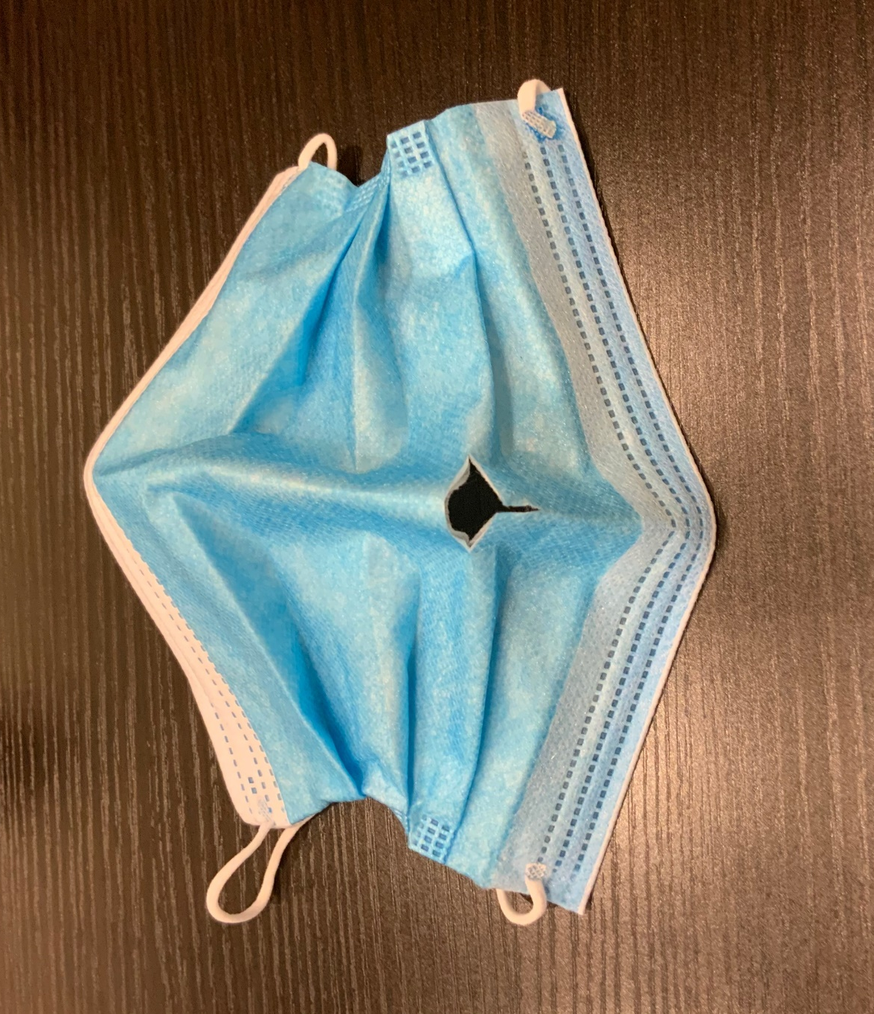
Figure 1 A surgical mask for patient during procedure with a handmade scope insertion port.
Table 1 Comparison of gastrointestinal endoscopy performed in 2019 and 2020
 | 2020 | 2019 | P value
Upper endoscopy, n | 311 | 790
Colonoscopy, n | 233 | 537
Total, n | 544 | 1327
Age (yr ± SD) | 55.2 ± 13.4 | 55.8 ± 13.2 | 0.34
Sex, male (%) | 53.9 | 47.3 | 0.01
All malignancies, n (%) | 6 (1.1) | 8 (0.6) | 0.40
Advanced lesion, n (%) | 5 (0.9) | 2 (0.2) | 0.04
Early lesion, n (%) | 1 (0.2) | 6 (0.5) | 0.66

