Table 1 the size, average age and sex distribution between three types of HEs

Types | Size | Year | Sex
I | 2.07±0.63 | 48.5±21.3 | 2\4
II | 3.68±1.12 | 52.0±11.2 | 6\2
III | 7.73±1.24 | 53.7±8.3 | 0\3
P value | 0 | 0.89 | 0.06

Table 2 The distribution of SMI types between FLLs were significant different (P＜0.05)

group | I | II | III | IV | V | VI | VII
HE(17) | 6(35.2%) | 8(47.1%) | 3(17.6%) | 0(0%) | 0(0%) | 0(0%) | 0(0%)
M(5) | 0(0%) | 4(80%) | 0(0%) | 0(0%) | 0(0%) | 1(20%) | 0(0%)
HCC(5) | 0(0%) | 0(0%) | 0(0%) | 2(40%) | 3(60%) | 0(0%) | 0(0%)
FNH(2) | 0(0%) | 0(0%) | 0(0%) | 0(0%) | 0(0%) | 0(0%) | 2(100%)
HA(1) | 0(0%) | 0(0%) | 0(0%) | 1(100%) | 0(0%) | 0(0%) | 0(0%)
LY(1) | 0(0%) | 0(0%) | 0(0%) | 0(0%) | 0(0%) | 1(100%) | 0(0%)

Table 3 Summary of FLLs’ and the corresponding patients’ characteristics
No. | Clinical  diagnosis | Pathological  diagnosis | SMI type  (I~VII) | size  (cm) | Age  (yr) | sex | other
1 | HE | / | I | 1.7 | 79 | M
2 | HE | / | I | 1.1 | 58 | F
3 | HE | / | I | 2.6 | 54 | M
4 | HE | / | I | 2.5 | 52 | F
5 | HE | / | I | 1.8 | 24 | F | same person
6 | HE | / | I | 2.7 | 24 | F
7 | HE | / | II | 2.3 | 63 | M
8 | HE | / | II | 3.9 | 61 | M | same person
9 | HE | / | II | 4.8 | 61 | M
10 | HE | / | II | 3.7 | 61 | F
11 | HE | / | II | 2.8 | 48 | M | same person
12 | HE | / | II | 3.1 | 48 | M
13 | HE | / | II | 3.1 | 41 | M
14 | HE | / | II | 5.7 | 33 | F
15 | HE | / | III | 6.3 | 63 | F
16 | / | HE | III | 8.4 | 51 | F
17 | / | HE | III | 8.5 | 47 | F
18 | B-M | / | II | 1.4 | 39 | F | same person
19 | B-M | / | II | 2.3 | 39 | F
20 | B-M | / | II | 2.6 | 39 | F
21 | B-M | / | II | 3.3 | 39 | F
22 | P-M | / | VI | 3.9 | 64 | M
23 | / | HCC | IV | 7.4 | 68 | M
24 | / | HCC | IV | 6.1 | 57 | M
25 | / | HCC | V | 2.5 | 60 | M
26 | / | HCC | V | 2.9 | 48 | M | same person
27 | / | HCC | V | 4.7 | 48 | M
28 | / | HA | IV | 5.3 | 41 | M
29 | / | LYM | VI | 5.8 | 71 | M
30 | FNH | / | VII | 4.1 | 62 | F
31 | FNH | / | VII | 4.3 | 39 | F

Figure 1 Type I diffuse dot-like type，male, 52y, diagnosed as hemangioma. (a) Showed a high-echo lesion with clear margin in the right liver lobe ; (b) CDFI showed none blood flow signal of this lesion; (c) SMI showed diffuse dot-like microvascular; (d) contrast enhanced CT showed diffused enhancement of the lesion in the arterial phase.
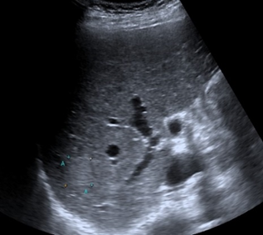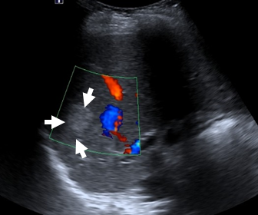
b
a

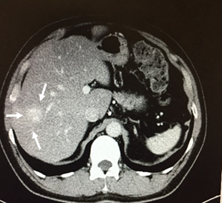
c
d
Figure 2 Type II strip rim type, (a~d) male, 61y, diagnosed as hemangioma. (a) Showed a high-echo lesion with clear margin in the left liver lobe ; (b) CDFI showed interrupted strip blood flow signal around the edge of this lesion; (c) SMI showed relatively continuous strip rim distributed microvascular; (d) contrast enhanced CT showed strip rim enhancement of the lesion in the arterial phase. (e~h) male, 63y, diagnosed as hemangioma. (e) Showed a hypo-echo lesion with clear margin in the left liver lobe ; (f) CDFI showed none blood flow signal of this lesion; (g) SMI showed continuous strip rim microvascular; (h) contrast enhanced CT showed strip rim enhancement of the lesion in arterial phase.
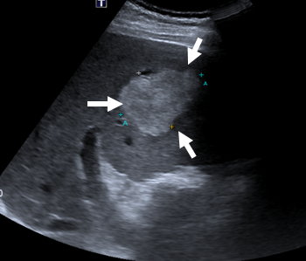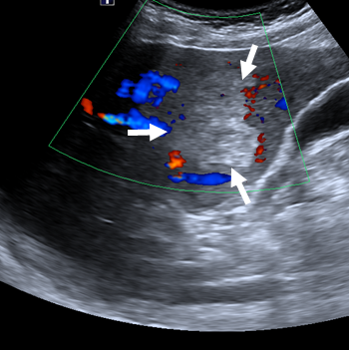
a
b

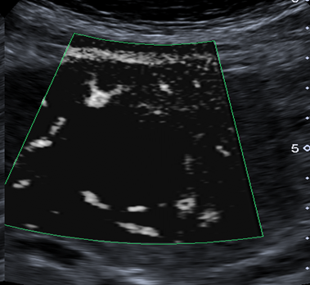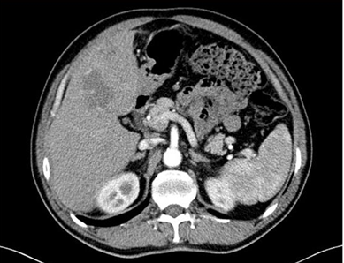
c
dd

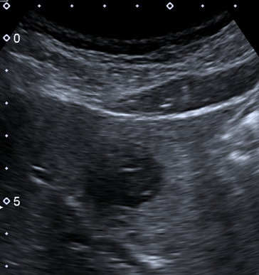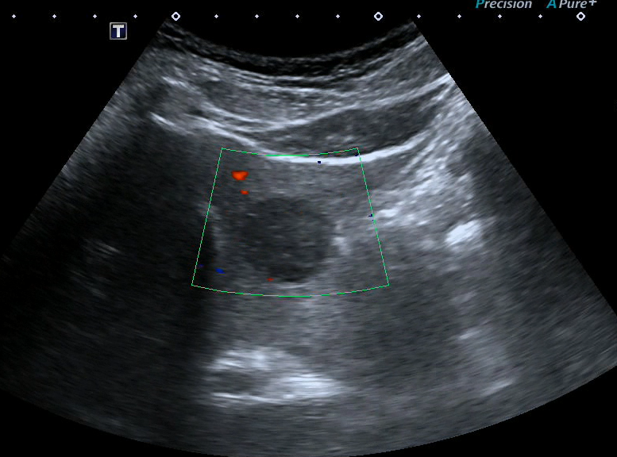
e
f

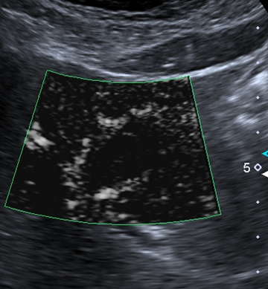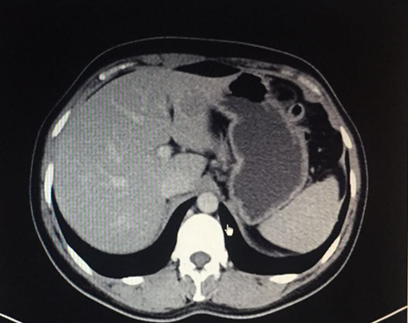
g
h
Figure 3 Type III nodular rim type，female, 51y, diagnosed as hemangioma. (a) Showed a mixed-echo lesion with relatively clear margin in the right liver lobe ; (b) CDFI showed sporadic short strip blood flow signal around the edge of this lesion; (c) SMI showed nodular rim distributed microvascular; (d) contrast enhanced ultrasound showed nodular rim enhancement of the lesion in the arterial phase.

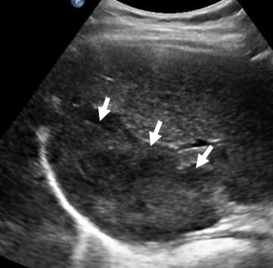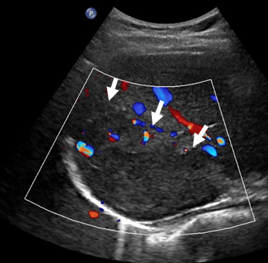
a
b

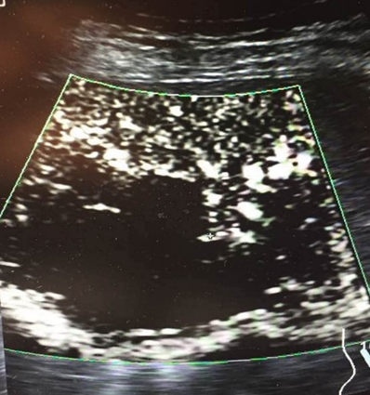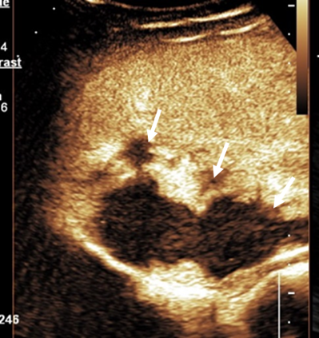
c
d

Figure 4 Type IV diffuse honeycomb type, (a~d) male, 68y, diagnosed as hepatic cellular carcinoma. (a) Showed a mixed-echo lesion with relatively not clear margin in the right liver lobe; (b) SMI showed diffuse honeycomb distributed microvascular; (c) contrast enhanced MRI showed diffuse enhancement of the lesion in the arterial phase; (d) pathology result showed the inter-tumor blood vessels were distributed in a grid pattern like honeycombs. (e~h) male, 41y, diagnosed as hepatic adenoma. (e) Showed a hypo-echo lesion with clear margin in the left liver lobe; (f) SMI showed diffuse honeycomb distributed microvascular; (g) contrast enhanced CT showed diffuse enhancement of the lesion in the arterial phase; (h) pathology result showed the inter-tumor blood vessels were distributed in a grid pattern like honeycombs.

a
b

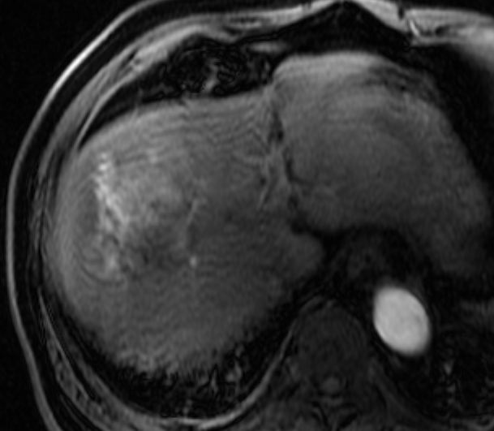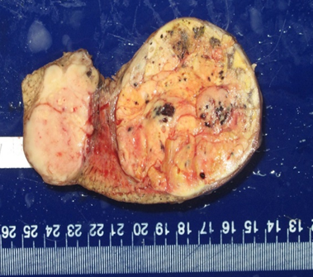
c
d

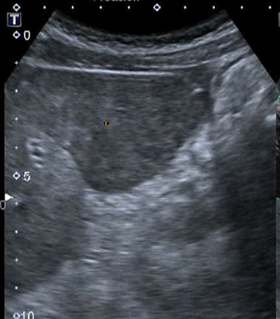
e
f

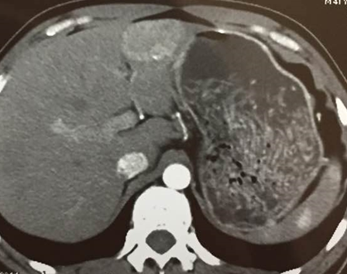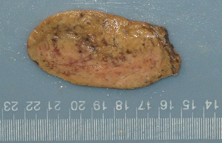
g
h

Figure 5 Type V non-specific type, male, 48y, diagnosed as hepatic cellular carcinoma. (a) Showed a hypo-echo lesion with relatively clear margin in the right liver lobe ; (b) SMI showed strip trunk with tiny branches distributed microvascular; (c) contrast enhanced CT showed diffuse enhancement of the lesion in the arterial phase.
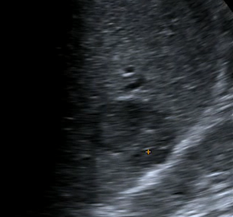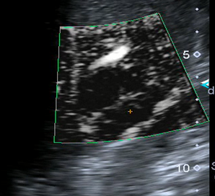
a
b

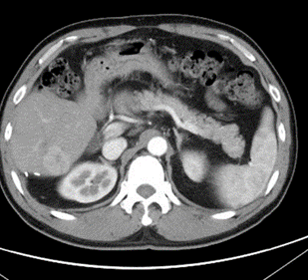
c

Figure 6 Type VI thick rim type, male, 71y, diagnosed as primary hepatic lymphoma. (a) Showed a hypo-echo lesion with relatively clear margin in the left liver lobe; (b) SMI showed thick rim distributed microvascular; (c) contrast enhanced ultrasound showed thick rim enhancement of the lesion in the arterial phase; (d) the general pathology result showed a thick rim distribution of vascular.
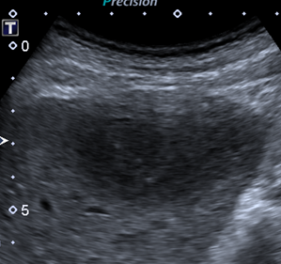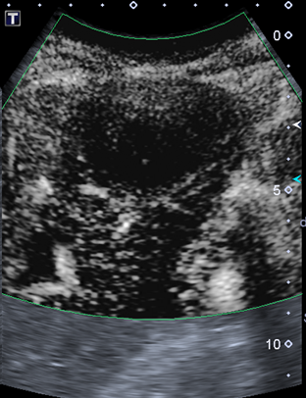
a
b

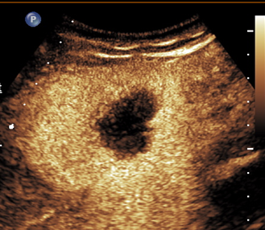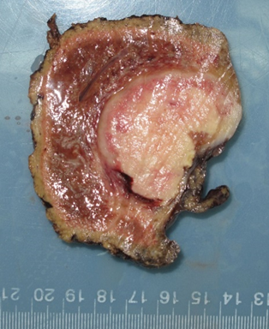
c
d

Figure 7 Type VII spoke-wheel type, female, 39y, diagnosed as focal nodular hyperplasia. (a) Showed a hypo-echo lesion with relatively clear margin in the caudate liver lobe; (b) CDFI showed spoke-wheel blood flow signal of this lesion; (c) SMI showed spoke-wheel distributed microvascular; (d) contrast enhanced CT showed diffuse enhancement with central scar of the lesion in the arterial phase; (e) 3-D vascular remodeling of this lesion was successfully got and showed as spoke-wheel blood flow.

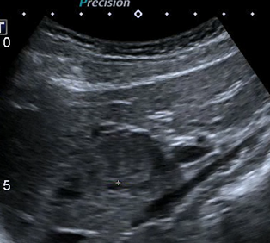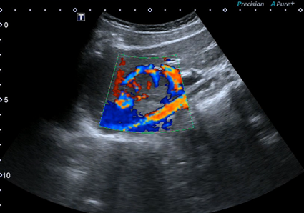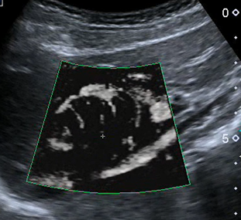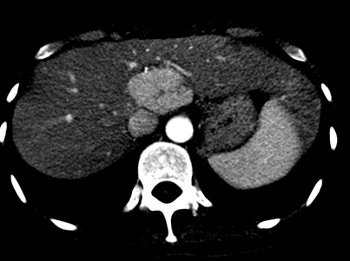
d
c
b
a

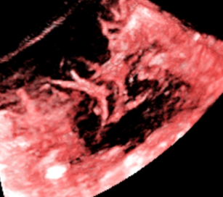
e

Figure 8 the simplified diagram of the 7 SMI types, (1) Type I, diffuse dot-like type; (2)Type II, strip rim type; (3)Type III, nodular rim type; (4)Type IV, diffuse honeycomb type; (5)Type V, non-specific type; (6)Type VI, thick rim type with lymphoma; (7)Type VII, spoke-wheel type.
