Name of journal: World Journal of Gastroenterology
ESPS Manuscript NO: 17248
Columns: ORIGINAL ARTICLE

Retrospective Study
Full-thickness excision using transanal endoscopic microsurgery for treatment of rectal neuroendocrine tumors

Chen WJ et al. Results of a Chinese specialist center

Wei-Jie Chen, Nan Wu, Jiao-Lin Zhou, Guo-Le Lin, Hui-Zhong Qiu

Wei-Jie Chen, Nan Wu, Jiao-Lin Zhou, Guo-Le Lin, Hui-Zhong Qiu, Department of Surgery, Peking Union Medical College Hospital, Peking Union Medical College and Chinese Academy of Medical Sciences, Beijing 100730, China

Author contributions: Chen WJ and Wu N contributed equally to this work, they performed the research and wrote the manuscript; Zhou JL analyzed the data; Lin GL and Qiu HZ designed and supervised the study; all authors have read and approved the final version to be published.

Ethics approval: The study was reviewed and approved by the Peking Union Medical College Hospital Review Board.

Informed consent: All study participants, or their legal guardian, provided informed written consent prior to study enrollment.

Conflict-of-interest: No financial support or incentive has been provided for this manuscript. All authors have no conflicts of interest or financial ties to disclose.

Data sharing: We would share our technical appendix, statistical code, and dataset available from the corresponding author at [guolelin2002@163.com]. Participants gave informed consent for data.

Open-Access: This article is an open-access article which was selected by an in-house editor and fully peer-reviewed by external reviewers. It is distributed in accordance with the Creative Commons Attribution Non Commercial (CC BY-NC 4.0) license, which permits others to distribute, remix, adapt, build upon this work non-commercially, and license their derivative works on different terms, provided the original work is properly cited and the use is non-commercial. See: http://creativecommons.org/licenses/by-nc/4.0/

Correspondence to: Guo-Le Lin, MD, Department of Surgery, Peking Union Medical College Hospital, Peking Union Medical College and Chinese Academy of Medical Sciences, Shuaifuyuan 1, Beijing 100730, China. linguole@126.com
Telephone: +86-10-69152621
Fax: +86-10-69156002
Received: February 25, 2015
Peer-review started: February 26, 2015
First decision: March 26, 2015
Revised: April 9, 2015
Accepted: May 7, 2015

Article in press:
Published online:
Abstract
AIM: To assess the efficacy of full-thickness excision using trans-anal endoscopic microsurgery (TEM) in the treatment of rectal neuroendocrine tumor.

METHODS: We analyzed all data of rectal neuroendocrine tumor patients who underwent local full-thickness excision using TEM between December 2006 and December 2014 at our department. Data collected included patient demographics, tumor characteristics, operative details, postoperative outcomes, pathologic findings, and follow-ups.

RESULTS: Full-thickness excision using TEM procedure was performed as a primary excision (n = 38) or as a complete surgery after incomplete resection by endoscopic polypectomy (n = 21). The average size of a primary tumor was 0.96 ± 0.21 cm, and the average distance of the tumor from the anal verge was 8.4 ± 1.4 cm. The mean duration of the operation was 57.6 ± 13.7 min, and the mean blood loss was 13.5 ± 6.6 mL. No minor morbidities, transient fecal incontinence, or wound dehiscence was found. Histopathologically, all tumors showed typical histology without lymphatic or vessel infiltration, and both deep and lateral surgical margins were completely free of tumors. Among 21 cases of complete surgery after endoscopic polypectomy, 9 were histologically shown to have a residual tumor in the specimens obtained by TEM. No additional radical surgery was performed. No recurrence was noted during the median of 3 years follow-up period.

CONCLUSION: Full-thickness excision using TEM could be a first surgical option for complete removal of upper small rectal neuroendocrine tumors.

Key words: Transanal endoscopic microsurgery; Rectal neuroendocrine tumor; Full-thickness excision; Primary excision; Complete excision; Retrospective study

© The Author(s) 2015. Published by Baishideng Publishing Group Inc. All rights reserved.

Core tip: Rectal neuroendocrine tumor increases quickly and steadily. Although trans-anal endoscopic microsurgery (TEM) was widely used for rectal neoplasms, the application of TEM in the full-thickness excision of rectal neuroendocrine tumor has not been well investigated. We analyzed all data of rectal neuroendocrine tumor patients who underwent local full-thickness excision using TEM as a primary excision or as a complete surgery after incomplete resection by endoscopic polypectomy. The results suggested that full-thickness excision using TEM is a safe, minimally invasive procedure, could achieve complete resection, and might be a first surgical option for complete removal of higher rectal neuroendocrine tumors less than 2 cm.

Chen WJ, Wu N, Zhou JL, Lin GL, Qiu HZ. Full-thickness excision using transanal endoscopic microsurgery for treatment of rectal neuroendocrine tumors. World J Gastroenterol 2015; In press

INTRODUCTION
Rectal neuroendocrine tumor is unusual in the general population, but its incidence increases quickly and steadily worldwide^{[1]}. It has been reported that the age-adjusted incidence of rectal neuroendocrine tumor had increased about ten-fold over the last 35 years^{[2]}. This dramatic increase may be attributable to the introduction of colonoscopic screening and the heightened awareness of the importance of early detection of colorectal disease, as 50% or more of rectal neuroendocrine tumors were diagnosed incidentally^{[3]}.
Surgical removal of a single lesion is the only guaranteed curative option^{[4]}. For small rectal neuroendocrine tumor without blood vessel invasion and metastatic spread, local resection should be adequate^{[5]}. Endoscopic polypectomy has been widely used for treatment of rectal neuroendocrine tumors. However, most neuroendocrine tumors arise from the deep portion of the epithelial glands penetrating the muscularis mucosa into the submucosal layer where the tumor entities form a nodular lesion^{[6-7]}. Hence, the intrinsic limitations of the conventional endoscopic polypectomy result in a high chance of incomplete resection^{[6,8]}. The rate of incomplete resection or unclear surgical margin and curability have been reported up to 24%-42% because of a limited resection up to the submucosal layer and burn effect^{[9-10]}.
With the introduction of trans-anal endoscopic microsurgery (TEM), the clinical efficacy of TEM for benign neoplasm has been widely reported. The TEM procedure provides several advantages over conventional excision by offering much improved visualization, exposure, and access to higher lesions in the rectum^{[11]}. Moreover, the TEM procedure could achieve accurate determination of margins and full-thickness excision with the possibility of suture^{[4]}. Full-thickness excision using TEM enables much larger extent of resection, ensuring more satisfactory oncological results for lesions with malignant potential. However, the application of TEM in the full-thickness excision has not been well investigated. We here report our clinical experiences of the largest cohort of rectal neuroendocrine tumor treated by full-thickness excision using TEM.

MATERIALS AND METHODS
Between December 2006 and December 2014, full-thickness excision using TEM was performed for 59 patients with rectal neuroendocrine tumor at the Peking Union Medical College Hospital. Their clinical data were reviewed retrospectively, including: patient demographics, tumor characteristics, blood loss in operation, operation time, postoperative outcomes, pathological results, and follow-up clinical notes.

Surgical techniques
Routine colonoscopy was performed preoperatively to evaluate the location and size of a lesion, and endoscopic ultrasonography was used to evaluate the invasion depth or the status of vessel and lymph node. The operation was performed under general anesthesia. The positioning of the patient was determined to make the lesion situate at the bottom of the operation field. Before resection, the scheduled resection area, including the tumor and a clearance margin of at least 0.5 cm, was marked by coagulation dots using a needle electrode (Figure 1). Then the full-thickness excision down to the outer fatty tissues was performed. The defect in the rectal wall was closed by a continuous running suture with absorbable thread and silver clips in place of knots. Tight suture in transverse direction was crucial for preventing wound bleeding, dehiscence, and stenosis of the rectal lumen.
The full-thickness excision could also be used to remove the residual tumor after endoscopic polypectomy (Figure 2) or unobtrusive neuroendocrine tumor which arose from the deep portion of the epithelial glands and was diagnosed by transrectal ultrasound (Figure 3). Mark using tattoo or thread knot was strongly recommended during endoscopic polypectomy or diagnosis of unobtrusive tumor to facilitate localization.
Statistical analysis
Data were summarized and analyzed using the Student’s t test, the Fisher’s exact test, and the Chi-square test, which were performed with SPSS statistical software (SPSS Inc., Chicago, IL). Differences associated with a P value less than 0.05 were considered statistically significant. The study was reviewed and approved by the Peking Union Medical College Hospital Review Board. The statistical methods of this study were reviewed by Zhou JL from Peking Union Medical College Hospital.

RESULTS
Patients and demographics
Between December 2006 and December 2014, 59 consecutive patients with rectal neuroendocrine tumor underwent full-thickness excision using TEM (Table 1). The median age at diagnosis was 55 years (range, 31–70 years). Most tumors were diagnosed incidentally (47, 79.7%), and a minority were associated with neuroendocrine tumor syndrome (12, 20.3%). A total of 38 patients underwent TEM as primary tumor excision (primary excision group); the remaining 21 patients underwent complete resection (complete surgery group) after endoscopic polypectomy by gastroenterologists in other hospitals. The histopathological results showed that the tumor was a typical neuroendocrine tumor, and the resection margin was microscopically identified as tumor positive. These patients were referred to us for complete resections.

Tumor characteristics
The characteristics of the removed neoplasms were showed in Table 2. The mean tumor size was 0.96 ± 0.21 cm, the anal verge to the distal tumor margin was 8.4 ± 1.4 cm, and 24 tumors were located on the anterior wall of rectum. In the complete surgery group, the average size of the primary tumor was 0.89 ± 0.19 cm, which was statistically smaller than that in the primary excision group (1.01 ± 0.21, P = 0.04). This might be the reason why endoscopic polypectomy was firstly given.

Surgery
The full-thickness excisions using TEM were performed by the same professional group. The mean surgical duration was 57.6 ± 13.7 min, the average blood loss was 13.5 ± 6.6 mL, and all specimens were integrated. No severe immediate or late complications were noted. Perforation into peritoneal cavity occurred in 2 patients (3.4%) without converting to transabdominal approach. No feces or intestinal juice leak into the peritoneal cavity because of good bowel preparation and prompt suture. Moderate fevers were observed in 8 patients (13.6%) within 3 d after the surgery, the maximum body temperature was 38.2 ℃, and the body temperatures were brought down without giving any antibiotics. Absorption fever might be the cause of the transient moderate fever. No complication of peritonitis, fistula, or fecal incontinence was observed during the hospital stay and follow-up period. Patients started walking on the first postoperative day, and per-oral intaking on second postoperative day. The average hospital stay was 2.7 ± 1.0 days. The Wexner score at 6 months was 4.5 ± 1.4.

Pathological data
All removed neoplasms in the primary excision group were diagnosed as typical neuroendocrine tumors. Among the 21 patients who underwent complete surgery after endoscopic polypectomy, 9 (42.9%) had residual tumor in the mucosal or submucosal layer of the specimen obtained by TEM, but the remaining 12 patients had no histologic evidence of residual tumor. All vertical and lateral surgical margins of specimens were completely free of tumor cells, although total 21 out of 59 tumors developed outside of mucosal layer, 5 tumors infiltrated into muscular layer.

Follow-up
No additional radical surgery was performed on these patients after TEM. They were followed up every 4 or 6 mo thereafter in the outpatient department. Computed tomography, transrectal endoscopy, and ultrasonography were performed. Of the 59 patients, follow-up data was collected for 53 cases. The median follow-up period was 3 years (range, 0.1–8.0 years). No recurrence, no local or distant metastasis was observed.

DISCUSSION
Neuroendocrine tumor is a well-differentiate epithelial neoplasm with predominant neuroendocrine differentiation. It includes tumors previously classified as “carcinoid”, which enriches its largely incorrect benign connotation. According to WHO 2010 classification, the neuroendocrine tumor could be divided as grade G1 tumor (mitotic count < 2 per 10 high-power field and/or Ki67 ≤ 2%) or grade G2 tumor (mitotic count 2-20 per 10 high-power field and/or Ki67 3%-20%)^{[4]}. As the cellular atypia and the proliferative activity are low, rectal neuroendocrine tumor generally has a favorable prognosis, its overall 5-year survival rate was 88.3%^{[12]}. The only guaranteed curative option is complete tumor resection^{[13]}.
For rectal neuroendocrine tumors larger than 2 cm, which are associated with significantly higher proliferative activity and metastatic risks (ranging between 60% and 80%)^{[14]}, are suitable candidates for radical surgery. Conventional anterior resection with total mesorectal excision or abdominoperineal extirpaiton could remove the local lesion and metastasis together when tumors displays metastatic tendencies or for patients with any metastasis at diagnosis^{[4]}. Meanwhile, multidisciplinary treatment options could be offered according to ENETS Consensus Guidelines^{[4]}. For most of the small and well-differentiated neuroendocrine tumors, it is considered that radical surgery carries a higher risk to benefit ratio, local resection is adequate. It is suggested that rectal neuroendocrine tumors that are 1 cm or less in size metastasize in only 3%–9.8% of cases^{[2,15]}, and local resection could provide complete resections. But conventional polypectomy used with virtual coloscopy might be hard to perform complete resection and achieve clear surgical margin, especially when the tumor is sessile or arises from the deep portion (Figure 3). As for rectal neuroendocrine tumors between 1 and 2 cm, the metastatic risk is considered to be between 10% and 15%^{[14]}. Moreover, 76% of these tumors extend to the submucosal area^{[16]}, so the local therapy using conventional endoscopic resection is a matter of debate^{[17-18]}.
TEM was developed by Buess et al^{[11]} in Germany and was introduced into clinical practice in 1983. With a pressure-controlled gas (carbon dioxide) insufflator, an operating rectoscope (either 12 cm or 20 cm in length), and special long-handled surgical instruments for dissection, excision, and suturing, TEM is feasible to reach tumors as high as 20 cm from the anal verge^{[3,13]}. Our previous study approved it, TEM could resect upper rectal neoplasms and be less invasive than traditional trans-anal or tans-sphincter approach^{[19]}. Moreover, the TEM procedure enables the accurate determination of surgical margins by marking the resection area with coagulation dots using a needle electrode before the resection. Under a magnified visual view of up to 6-fold and a broadened operative field by carbon dioxide insufflations, the tumor resection could be performed with safe surgical margins and an accurate surgical plane^{[20]}, and full-thickness suturing could be achieved (Figure 1).
Full-thickness excision using TEM is considered to provide complete resection of local tumor without lymphatic or blood vessel invasion or lymph node metastases. As described in our report, although 35.6% tumors developed outside of mucosal layer, the surgical margins of all specimens were negative. That indicates the effectiveness and the accuracy of the full-thickness excision using TEM. No recurrence was found, and a cure rate of essentially 100% can be anticipated. Besides, 21 patients underwent complete resection after endoscopic polypectomy by gastroenterologists in other hospitals, because the margin of specimen was identified as tumor positive. After full-thickness excision of lesions using TEM, 9 patients had microscopic evidence of residual tumors shown in specimens obtained, and no complication or recurrence was found. Therefore, full-thickness excision using TEM can be an effective option for complete surgery. Localization using tattoo or thread knot is strongly recommended during endoscopic polypectomy to facilitate full-thickness excision. If a mark was not applied at the time of snare polypectomy and the margins were found to be inadequate, the patient must be recalled urgently in order to identify the scar before it fade away^{[21-22]}.
Moreover, full-thickness excision using TEM is a safe procedure. The morbidity of TEM was reported in the literature to be 4% to 29%^{[23-24]}, the most common complications after TEM are bleeding, peritoneal entry, conversion to laparotomy and fecal soiling^{[25]}. But our data, as well as the data by other surgeons presented, attest to full-thickness excision using TEM as being a very safe procedure^{[25-26]}. The blood loss was about 15 mL, electric coagulation and water rinse could provide a clear surgical field. Entry into the peritoneal cavity during TEM was not considered as a complication and not associated with an increased risk of other complications^{[27]}. With the possibility of suture, rectal wall perforations which were considered as the most hazardous complication of local resection could also be tackled without conversion to laparotomy^{[28]}. Achieving watertight intra-rectal repair of defects is crucial for preventing wound bleeding, peritonitis, and fistula^{[29]}. No peritonitis, fistula, or fecal incontinence was observed in our study, the Wexner score at 6 months was 4.5 ± 1.4.
ENETS Consensus Guidelines suggested that neuroendocrine tumor < 1 cm in diameter without muscularis invasion should be given local resection endoscopically, transanal mucosal-muscular resection using a variety of techniques and equipment was suitable for tumor < 1 cm with muscularis invasion or tumor between 1 and 2 cm without muscularis invasion^{[4]}. In our study, the tumor of 12 patients in the completion group was less than 1 cm in diameter and without muscularis invasion. Endoscopic resection with many local transanal techniques (band-snare resection, aspiration lumpectomy) did not achieve negative margin. Therefore, whether that endoscopic resection is suggested for these patients should be reconsidered, full-thickness using TEM as the first surgical choice for these patients might be better. Beside, the guidelines did not give suggests about the tumor between 1 and 2 cm with muscularis invasion. We performed full-thickness excision of these tumors on 5 patients, and the surgical margins of all specimens were negative. Our experience is that for the patients with neuroendocrine tumor less than 2 cm without invasion of lymph nodes or metastasis, full-thickness excision using TEM should be the preferred to perform. Because it enables much larger extent of resection, ensures more satisfactory oncological results for lesions with malignant potential, and do not increase the complications.
With the clinical application of TEM for rectal neoplasms, several reports involving small case series have been published^{[30]}. To our best knowledge, our report is the first and largest to describe the effectiveness of full-thickness excision of rectal neuroendocrine tumor using TEM in China. The largest series in the United States and Japan included 24 patients and 27 patients respectively, but they did not performed full-thickness excisions on all patients^{[11,21]}. The retrospective design and lack of a comparative group are limitations of our study. Although evidence is limited, all the results showed that full-thickness excision using TEM could be a first surgical option for complete removal of rectal neuroendocrine tumors.
In conclusion, TEM is a safe, minimally invasive procedure and the full-thickness excision could achieve complete resection. Therefore, full-thickness excision using TEM could be a first surgical option for complete removal of higher rectal neuroendocrine tumors less than 2 cm.

COMMENTS
Background
Rectal neuroendocrine tumor increases quickly and steadily worldwide, surgical removal of a single lesion is the only guaranteed curative option. With the introduction of trans-anal endoscopic microsurgery (TEM), the clinical efficacy of TEM for benign neoplasm has been widely reported. Full-thickness excision using TEM enables much larger extent of resection, ensuring more satisfactory oncological results for lesions with malignant potential. However, the application of TEM in the full-thickness excision has not been well investigated.

Research frontiers
The TEM procedure provides several advantages over conventional excision by offering much improved visualization, exposure, and access to higher lesions in the rectum. Moreover, the TEM procedure could achieve accurate determination of margins and full-thickness excision with the possibility of suture. We here report our clinical experiences of the largest cohort of rectal neuroendocrine tumor treated by full-thickness excision using TEM.

Innovations and breakthroughs
With the clinical application of TEM for rectal neoplasms, several reports involving small case series have been published. To our best knowledge, our report is the first and largest to describe the effectiveness of full-thickness excision of rectal neuroendocrine tumor using TEM in China. The largest series in the United States and Japan included 24 patients and 27 patients respectively, but they did not performed full-thickness excisions on all patients.

Applications
The study results suggested that full-thickness excision using TEM could be a first surgical option for complete removal of higher rectal neuroendocrine tumors less than 2 cm. TEM is a safe, minimally invasive procedure and the full-thickness excision could achieve complete resection.

Terminology
Neuroendocrine tumors are epithelial neoplasms with predominant neuroendocrine differentiation, occur in most organs of the body, and share common features, such as similar microscopic appearance, special secretory granules, and secretion of biogenic amines and polypeptide hormones. Many are benign, while some are malignant. TEM is an important application of the minimally invasive surgery of the rectum. With a pressure-controlled gas (carbon dioxide) insufflator, an operating rectoscope (either 12 cm or 20 cm in length), and special long-handled surgical instruments, dissection, excision, and suturing could be achieved.

Peer-review
This manuscript analyzed a large number of patients with neuroendocrine tumor compared to the previous papers. Most reviewers found this topic interesting, informative and believed it to bring pleasure to the readers. The manuscript was praised for being well-written and structured.

REFERENCES
1 Tsikitis VL, Wertheim BC, Guerrero MA. Trends of incidence and survival of gastrointestinal neuroendocrine tumors in the United States: a seer analysis. J Cancer 2012; 3: 292-302 [PMID: 22773933 DOI: 10.7150/jca.4502]
2 Scherübl H. Rectal carcinoids are on the rise: early detection by screening endoscopy. Endoscopy 2009; 41: 162-165 [PMID: 19214898 DOI: 10.1055/s-0028-1119456]
3 Choi HH, Kim JS, Cheung DY, Cho YS. Which endoscopic treatment is the best for small rectal carcinoid tumors? World J Gastrointest Endosc 2013; 5: 487-494 [PMID: 24147192 DOI: 10.4253/wjge.v5.i10.487]
4 Caplin M, Sundin A, Nillson O, Baum RP, Klose KJ, Kelestimur F, Plöckinger U, Papotti M, Salazar R, Pascher A. ENETS Consensus Guidelines for the management of patients with digestive neuroendocrine neoplasms: colorectal neuroendocrine neoplasms. Neuroendocrinology 2012; 95: 88-97 [PMID: 22261972 DOI: 000335594]
5 Okamoto Y, Fujii M, Tateiwa S, Sakai T, Ochi F, Sugano M, Oshiro K, Masai K, Okabayashi Y. Treatment of multiple rectal carcinoids by endoscopic mucosal resection using a device for esophageal variceal ligation. Endoscopy 2004; 36: 469-470 [PMID: 15100972 DOI: 10.1055/s-2004-814386]
6 Son HJ, Sohn DK, Hong CW, Han KS, Kim BC, Park JW, Choi HS, Chang HJ, Oh JH. Factors associated with complete local excision of small rectal carcinoid tumor. Int J Colorectal Dis 2013; 28: 57-61 [PMID: 22821140 DOI: 10.1007/s00384-012-1538-z]
7 Sauven P, Ridge JA, Quan SH, Sigurdson ER. Anorectal carcinoid tumors. Is aggressive surgery warranted? Ann Surg 1990; 211: 67-71 [PMID: 2294847]
8 Jeon SM, Cheon JH. Rectal carcinoid tumors: pitfalls of conventional polypectomy. Clin Endosc 2012; 45: 2-3 [PMID: 22741128 DOI: 10.5946/ce.2012.45.1.2]
9 Maeda K, Maruta M, Utsumi T, Sato H, Masumori K, Matsumoto M. Minimally invasive surgery for carcinoid tumors in the rectum. Biomed Pharmacother 2002; 56 Suppl 1: 222s-226s [PMID: 12487287]
10 Kwaan MR, Goldberg JE, Bleday R. Rectal carcinoid tumors: review of results after endoscopic and surgical therapy. Arch Surg 2008; 143: 471-475 [PMID: 18490556 DOI: 143/5/471]
11 Kinoshita T, Kanehira E, Omura K, Tomori T, Yamada H. Transanal endoscopic microsurgery in the treatment of rectal carcinoid tumor. Surg Endosc 2007; 21: 970-974 [PMID: 17285371 DOI: 10.1007/s00464-006-9155-y]
12 Modlin IM, Lye KD, Kidd M. A 5-decade analysis of 13,715 carcinoid tumors. Cancer 2003; 97: 934-959 [PMID: 12569593 DOI: 10.1002/cncr.11105]
13 Ishikawa K, Arita T, Shimoda K, Hagino Y, Shiraishi N, Kitano S. Usefulness of transanal endoscopic surgery for carcinoid tumor in the upper and middle rectum. Surg Endosc 2005; 19: 1151-1154 [PMID: 16021383 DOI: 10.1007/s00464-004-2076-8]
14 Shields CJ, Tiret E, Winter DC. Carcinoid tumors of the rectum: a multi-institutional international collaboration. Ann Surg 2010; 252: 750-755 [PMID: 21037430 DOI: 10.1097/SLA.0b013e3181fb8df6]
15 Onozato Y, Kakizaki S, Iizuka H, Sohara N, Mori M, Itoh H. Endoscopic treatment of rectal carcinoid tumors. Dis Colon Rectum 2010; 53: 169-176 [PMID: 20087092 DOI: 10.1007/DCR.0b013e3181b9db7b]
16 Soga J. Early-stage carcinoids of the gastrointestinal tract: an analysis of 1914 reported cases. Cancer 2005; 103: 1587-1595 [PMID: 15742328 DOI: 10.1002/cncr.20939]
17 Tsukamoto S, Fujita S, Yamaguchi T, Yamamoto S, Akasu T, Moriya Y, Taniguchi H, Shimoda T. Clinicopathological characteristics and prognosis of rectal well-differentiated neuroendocrine tumors. Int J Colorectal Dis 2008; 23: 1109-1113 [PMID: 18594844 DOI: 10.1007/s00384-008-0505-1]
18 Scherübl H. Comment on Ramage et al.: Consensus guidelines for the management of patients with digestive neuroendocrine tumours: well-differentiated colon and rectum tumour/carcinoma. Neuroendocrinology 2008; 87: 31-39. Neuroendocrinology 2008; 88: 157-158 [PMID: 18849621 DOI: 10.1159/000158560]
19 Lin GL, Meng WC, Lau PY, Qiu HZ, Yip AW. Local resection for early rectal tumours: Comparative study of transanal endoscopic microsurgery (TEM) versus posterior trans-sphincteric approach (Mason's operation). Asian J Surg 2006; 29: 227-232 [PMID: 17098653 DOI: S1015-9584(09)60093-2]
20 Demartines N, von Flüe MO, Harder FH. Transanal endoscopic microsurgical excision of rectal tumors: indications and results. World J Surg 2001; 25: 870-875 [PMID: 11572026]
21 Kumar AS, Sidani SM, Kolli K, Stahl TJ, Ayscue JM, Fitzgerald JF, Smith LE. Transanal endoscopic microsurgery for rectal carcinoids: the largest reported United States experience. Colorectal Dis 2012; 14: 562-566 [PMID: 21831099 DOI: 10.1111/j.1463-1318.2011.02726.x]
22 Arolfo S, Allaix ME, Migliore M, Cravero F, Arezzo A, Morino M. Transanal endoscopic microsurgery after endoscopic resection of malignant rectal polyps: a useful technique for indication to radical treatment. Surg Endosc 2014; 28: 1136-1140 [PMID: 24170069 DOI: 10.1007/s00464-013-3290-z]
23 Kim HR, Lee WY, Jung KU, Chung HJ, Kim CJ, Yun HR, Cho YB, Yun SH, Kim HC, Chun HK. Transanal endoscopic microsurgery for the treatment of well-differentiated rectal neuroendocrine tumors. J Korean Soc Coloproctol 2012; 28: 201-204 [PMID: 22993706 DOI: 10.3393/jksc.2012.28.4.201]
24 Serra-Aracil X, Mora-Lopez L, Alcantara-Moral M, Corredera-Cantarin C, Gomez-Diaz C, Navarro-Soto S. Atypical indications for transanal endoscopic microsurgery to avoid major surgery. Tech Coloproctol 2014; 18: 157-164 [PMID: 23813055 DOI: 10.1007/s10151-013-1040-9]
25 Kumar AS, Coralic J, Kelleher DC, Sidani S, Kolli K, Smith LE. Complications of transanal endoscopic microsurgery are rare and minor: a single institution's analysis and comparison to existing data. Dis Colon Rectum 2013; 56: 295-300 [PMID: 23392142 DOI: 10.1097/DCR.0b013e31827163f7]
26 Flexer SM, Durham-Hall AC, Steward MA, Robinson JM. TEMS: results of a specialist centre. Surg Endosc 2014; 28: 1874-1878 [PMID: 24414462 DOI: 10.1007/s00464-013-3407-4]
27 Ramwell A, Evans J, Bignell M, Mathias J, Simson J. The creation of a peritoneal defect in transanal endoscopic microsurgery does not increase complications. Colorectal Dis 2009; 11: 964-966 [PMID: 19175654 DOI: 10.1111/j.1463-1318.2008.01719.x]
28 Allaix ME, Arezzo A, Caldart M, Festa F, Morino M. Transanal endoscopic microsurgery for rectal neoplasms: experience of 300 consecutive cases. Dis Colon Rectum 2009; 52: 1831-1836 [PMID: 19966628 DOI: 10.1007/DCR.0b013e3181b14d2d]
29 Duek SD, Kluger Y, Grunner S, Weinbroum AA, Khoury W. Transanal endoscopic microsurgery for the resection of submucosal and retrorectal tumors. Surg Laparosc Endosc Percutan Tech 2013; 23: 66-68 [PMID: 23386155 DOI: 10.1097/SLE.0b013e3182757860]
30 Léonard D, Colin JF, Remue C, Jamart J, Kartheuser A. Transanal endoscopic microsurgery: long-term experience, indication expansion, and technical improvements. Surg Endosc 2012; 26: 312-322 [PMID: 21898025 DOI: 10.1007/s00464-011-1869-9]

P-Reviewer: Ji Y, Nomiya T, Su CH S-Editor: Qi Y
L-Editor: E-Editor:

Figure 1 Full-thickness excision of a rectal visible neuroendocrine tumor using trans-anal endoscopic microsurgery. A: the tumor and a clearance margin marked by coagulation dots using a needle electrode; B: showed the picture after full-thickness excision with neat surgical margins; C: showed the picture after suturing rectal wall. The leakage from the suture line will be negligible; D: showed the neuroendocrine tumor removed completely with safe surgical margins.
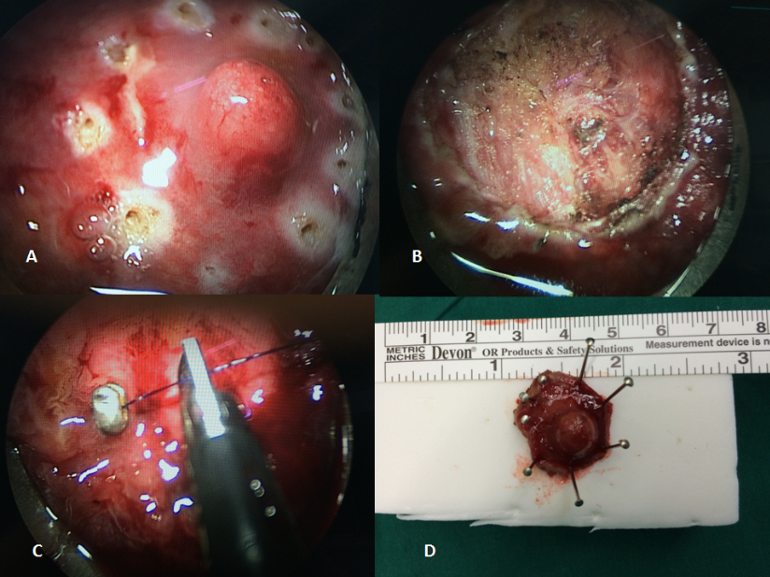

Figure 2 Full-thickness excision of a rectal lesion after incomplete resection. A: the scar site after endoscopic polypectomy where the resection margin was identified as tumor positive; B: showed the fat tissue outside the rectal wall; C: the lesion defect was suturing; D: the specimen obtain by trans-anal endoscopic microsurgery with safe margin.
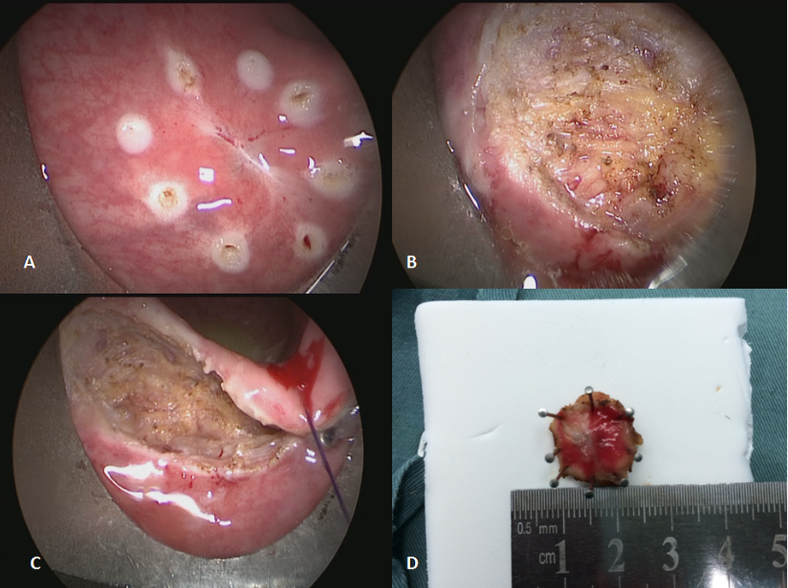

Figure 3 Full-thickness excision of rectal unobtrusive neuroendocrine tumor using trans-anal endoscopic microsurgery. A: the unobtrusive tumor found by trans-rectal ultrasound and marked by thread; B: the defect after full-thickness excision; C: completion of the suturing of the defect of the lesion; D: showed the neuroendocrine tumor removed completely with safe surgical margins.
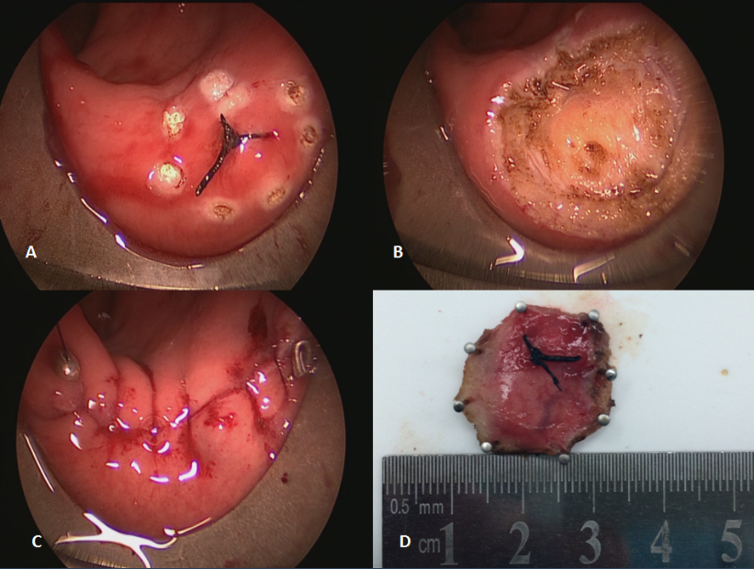
Table 1 Patient and tumor characteristics
 | Total (n = 59) | Purpose of TEM |  | P value
 |  | Primary excision (n = 38) | Completion surgery (n = 21)
Demographics
Male/female (n) | 32/27 | 21/17 | 11/10 | NS
Age (yr)¹ | 55 (31–70) | 47 (31-68) | 53 (35-70) | NS
Tumor
Size of tumor (cm) | 0.96 ± 0.21 | 1.01 ± 0.21 | 0.89 ± 0.19 | 0.04
Location (A/P) | 24/35 | 15/23 | 9/12 | NS
Distance from AV (cm) | 8.4 ± 1.4 | 8.2 ± 1.3 | 8.9 ± 1.4 | NS
Central umbilication (yes/no) | 6/53 | 4/34 | 2/19 | NS
¹Values are median (range). TEM: Transanal endoscopic microsurgery; A: Anterior wall; P: Posterior wall; AV: Anal verge; NS: Not significant.

Table 2 Operative details and pathological findings
 | Total (n = 59) | Purpose of TEM |  | P value
 |  | Primary excision (n = 38) | Completion surgery (n = 21)
Operative details
Surgical duration (min) | 57.6 ± 13.7 | 59.6 ± 10.7 | 54.0 ± 17.7 | NS
Blood loss (mL) | 13.5 ± 6.6 | 13.2 ± 6.2 | 14.0 ± 7.5 | NS
Hospital stay (d) | 2.7 ± 1.0 | 2.5 ± 0.9 | 2.8 ± 1.0 | NS
Wexner score | 4.5 ± 1.4 | 4.2 ± 1.4 | 5.0 ± 1.4 | NS
Size of specimen | 2.3 ± 0.6 | 2.3 ± 0.6 | 2.3 ± 0.5 | NS
Margin(Positive/negative) | 0/59 | 0/38 | 0/21 | NS
Invasion (M/SM/MP) | 26/16/5 | 22/11/5 | 4/5/0¹
Grade (G1/G2) | 35/12 | 28/10 | 7/2¹
¹Nine specimens obtained by TEM had residual tumor. TEM: Transanal endoscopic microsurgery; M: Mucosa; S: Submucosa; MP: Muscularis propria; NS: Not significant.

