Name of Journal: World Journal of Gastrointestinal Endoscopy
Manuscript NO: 80187
Manuscript Type: MINIREVIEWS

Endoscopic fluorescent lymphography for gastric cancer

Calcara C et al. Fluorescence for gastric cancer

Calcedonio Calcara, Sila Cocciolillo, Ylenia Marten Canavesio, Vincenzo Adamo, Silvia Carenzi, Daria Ilenia Lucci, Alberto Premoli

Calcedonio Calcara, Silvia Carenzi, Daria Ilenia Lucci, Alberto Premoli, Digestive Endoscopy Unit, S. Andrea Hospital, Vercelli 13100, Italy

Sila Cocciolillo, Digestive Endoscopy Unit, Padre Pio Hospital, Vasto 66054, Italy

Ylenia Marten Canavesio, Postgraduate School of Gastroenterology, Genova University, Genova 16132, Italy

Vincenzo Adamo, General Surgery Unit, S. Andrea Hospital, Vercelli 13100, Italy

Author contributions: Calcara C and Cocciolillo S wrote the manuscript; Canavesio YM, Adamo V, Carenzi S, Lucci DI and Premoli A reviewed the literature; All authors have read and approved the final version of the manuscript.

Corresponding author: Calcedonio Calcara, MD, Director, Digestive Endoscopy Unit, S. Andrea Hospital, Corso Mario Abbiate No. 21, Vercelli 13100, Italy. calcedonio.calcara@aslvc.piemonte.it

Received: September 20, 2022
Revised: December 18, 2022
Accepted: February 7, 2023
Published online: February 16, 2023
Abstract
Lymphography by radioisotope or dye is a well-known technique for visualizing the lymphatic drainage pattern in a neoplastic lesion and it is in use in gastric cancer. Indocyanine green (ICG) more recently has been validated in fluorescent lymphography studies and is under evaluation as a novel tracer agent in gastric cancer. The amount and dilution of ICG injected as well as the site and the time of the injection are not standardized. In our unit, endoscopic submucosal injections of ICG are made as 0.5 mg in 0.5 mL at four peritumoral sites the day before surgery (for a total of 2.0 mg in 2.0 mL). Detection instruments for ICG fluorescence are evolving. Near-infrared systems integrated into laparoscopic or robotic instruments (near-infrared fluorescence imaging) have shown the most promising results. ICG fluorescence recognizes the node that receives lymphatic flow directly from a primary tumor. This is defined as the sentinel lymph node, and it has a high predictive negative value at the cT1 stage, able to reduce the extent of gastrectomy and lymph node dissection. ICG also enhances the number of lymph nodes detected during extended lymphadenectomy for advanced gastric cancer. Nevertheless, the practical effects of ICG use in a single patient are not yet clear. Standardization of the technique and further studies are needed before fluorescent lymphography can be used extensively worldwide. Until then, current guidelines recommend an extensive lymphadenectomy as the standard approach for gastric cancer with suspected metastasis.

Key Words: Indocyanine green; Fluorescence; Lymphography; Sentinel lymph node; Gastric cancer; Lymphadenectomy

©The Author(s) 2023. Published by Baishideng Publishing Group Inc. All rights reserved.

Citation: Calcara C, Cocciolillo S, Marten Canavesio Y, Adamo V, Carenzi S, Lucci DI, Premoli A. Endoscopic fluorescent lymphography for gastric cancer. World J Gastrointest Endosc 2023; 15(2): 32-43
URL: https://www.wjgnet.com/1948-5190/full/v15/i2/32.htm
DOI: https://dx.doi.org/10.4253/wjge.v15.i2.32

Core Tip: Endoscopic injection of indocyanine green (ICG) the day before surgery is a simple technique that could increase the number of lymph nodes recovered during lymphadenectomy for advanced gastric cancer. In addition, ICG-guided sentinel lymph node detection could reduce unnecessary extensive lymphadenectomy and the amount of gastric resection in early gastric cancer. However, further research is needed to confirm its usefulness in both scenarios. Currently, D1/D2 Lymphadenectomy remains the standard of care for gastric cancer with suspected metastasis. Our review explores this topic in depth and provides practical information for the endoscopic use of ICG.

INTRODUCTION
Lymphography dates back to the 1950s when the first studies were carried out^{[1]}. The term ‘sentinel lymph node’ (SLN) was originally used in 1960^{[2]}. A sentinel node is defined as the node that receives lymphatic flow directly from a primary tumor. The beneficial effects of SLN detection were first published by Morton et al^{[3]} in 1992. They injected isosulfan blue vital dye in a melanoma, with the aim to select and evaluate neoplastic infiltration to the first LN. They demonstrated that if there was no metastasis in the SLN, then metastasis would also be absent in the downstream LNs, thus avoiding unnecessary lymphadenectomy. SLN navigation surgery is a widely accepted technique for malignant melanoma^{[3]} and breast cancer^{[4]}. Several tracer agents have been studied over the past 70 years^{[1,5-7]} and are used for the detection of lymphatic drainage in several digestive surgical settings^{[8,9]}. Studies of lymphatic drainage in gastric cancer have been carried out only relatively recently^{[10]}. The primary outcomes in these studies was an increase in LN harvest^{[11]} and in detection of SLNs^{[12]}.
Historically, a radioisotope (RI) technetium-99 tracer combined with a blue dye was injected endoscopically into the gastric submucosa around the tumor the day before surgery. The radioactivity of the LN was measured during surgery using a hand-held gamma probe^{[5,13]}. This technique has a high detection rate and accuracy^{[14]}. A meta-analysis based on 46 reports that included 2684 patients with gastric cancer using RI and/or dye showed sensitivity, detection rate, negative predictive value and positive predictive value of 87.8%, 97.5%, 91.8% and 38.0%, respectively^{[15]}. The disadvantages of RI are expensive cost and the requirement of a radioactivity-controlled area. While this technique is considered the gold standard, it is rarely performed outside of Eastern Countries, currently.

INDOCYANINE GREEN AS A LYMPHATIC TRACER
Indocyanine green (ICG) is gaining status as the most utilized tracer in surgical practice. ICG is a sterile water-soluble tricarbocyanine dye that rapidly binds to plasma proteins and is subsequently drained by the lymphatic system. The visualization of ICG is difficult for the naked eye when observed in human tissue. However, when excited by near-infrared light at 700–900 nm, ICG emits fluorescence at a wavelength of approximately 820 nm and is easily visualized by various devices^{[16-18]}.
ICG submucosal (SM) or subserosal (SS) injection is virtually free of adverse effects. Although, rare cases of anaphylactic shock have been reported (0.05%-0.4%)^{[19]}. Several methods of ICG mapping exist; they include, naked eye observation under white light by Hiratsuka et al^{[12]} and Ichikura et al^{[10]}, Infra-Red Electronic Endoscopy (IREE); by Nimura et al^{[18]}, Infrared Ray Laparoscopic System (IRLS); by Takahashi et al^{[20]}, and Near-Infrared Fluorescent Imaging (NIFI); by Kusano et al^{[16]} and others. Of note, Hiratsuka's method is no longer used, largely due to its poor contrast, while Nimura's IREE and Takahashi’s IRLS have fallen out of use due to the devices being commercially unavailable but they are still generally considered excellent techniques. Only ICG fluorescent mapping NIFI is currently performed.
ICG was evaluated in surgical management of gastric cancer in order to guide selective lymphadenectomy in intraoperative SLN identification as well as comprehensive lymphadenectomy by increasing the number of total and metastatic LNs retrieved during gastric surgery. Feasibility of ICG lymphography by NIFI was demonstrated in open^{[11]}, laparoscopic^{[21]} and robotic surgeries^{[22]}. Surgeons are able to switch between white light, near-infrared light and a composite vision. Technical details were published by Zhu et al^{[23]}.

RATIONALE FOR LN STAINING IN GASTRIC CANCER
According to the European Society for Medical Oncology gastric cancer treatment guidelines 2022^{[24]}, D1 Lymphadenectomy limited to perigastric LNs and those along the left gastric artery is recommended for early tumors (cT1) that do not meet the criteria for endoscopic resection. However, only 20% of T1 tumors have lymphatic involvement, and this approach resulted in overtreatment for most patients^{[24,25]}. Furthermore, D2 Lymphadenectomy with removal of additional LNs along the hepatic artery, splenic artery and coeliac axis is frequently performed in cT1 gastric cancer due to the difficulty of excluding micrometastases. This has a negative effect on morbidity and quality of life^{[26-28]}. The number of LNs harvested during surgery for advanced gastric tumors was associated with correct staging and better prognosis^{[29-31]}. However, extensive lymphadenectomy is a demanding procedure that carries a high risk of tissue or vascular injury. Therefore, detecting SLN draining in early (cT1) gastric tumors and facilitating the detection of LN in advanced gastric cancer would be beneficial and accepted in the clinical setting^{[11,29,32,33]}.

ICG FLUORESCENCE FOR SLN DETECTION IN GASTRIC CANCER
A pioneer study was conducted by Hiratsuka et al^{[12]} and demonstrated that after peritumoral ICG injection SLN status was able to be visually defined with 100% sensitivity in a T1 group (44 patients) and 88% sensitivity in a T2 group (29 patients). The authors concluded that SLN status could predict the presence of lymphatic metastasis with a high degree of accuracy, especially in patients with T1 gastric cancer.
Two meta-analyses regarding the diagnostic value of ICG for SLN detection in gastric cancer were published in 2018. In the first, Skubleny et al^{[34]} included 643 patients from 10 studies conducted with IREE or NIFI detection devices; among them, 513 (79%) were cT1 patients. Pooled sensitivity and specificity of ICG fluorescence for SLN detection was 87% and 100%, respectively. Metastatic SLNs were retrieved in 18.7% of the enrolled patients. IREE demonstrated a higher diagnostic odds ratio, sensitivity and identification rate than NIFI. In the second meta-analysis, He et al^{[35]} included 13 studies conducted with IREE, IRLS or NIFI devices. Significant heterogeneity among the included studies was found for sensitivity (from 50% to 100%) and for specificity (from 60% to 100%). There was also significant publication bias. An interesting subgroup analysis demonstrated that sensitivity for T1 was much higher than T2-T3. Intraoperative IGC injection was compared with preoperative injection. The sensitivity of the intraoperative injection subgroup was slightly lower than the preoperative injection subgroup (98% vs 99%). SM injections were compared to SS injections. The pooled sensitivity of the SM injection subgroup was considerably higher than that of the SS injection subgroup (98% vs 40%). NIFI also showed a lower sensitivity rate than either IREE or IRLS. Finally, when the ICG concentration of 5.0 mg/mL was compared to a diluted ICG concentration of 0.5 mg/mL or 0.05 mg/mL, the sensitivity of the former was lower than that of the latter (83% vs 98%); this was explained as due to a reduction of ICG fluorescence intensity with the higher concentration (i.e., the “quenching effect”). A comprehensive evaluation of effects of various ICG concentrations for SLN detection was conducted by Kinami et al^{[36]}.
The clinical application of sentinel node biopsy for gastric cancer must still overcome the problem of rapid intraoperative diagnosis of micrometastasis in the SNL. To reduce the rate of false negative findings, Miwa et al^{[37]} suggested “en bloc” dissection of blue dye-stained perigastric SLN according to defined basins in their pilot study. The subsequently identified the SLN at the back table in the surgical suite (ex vivo). This method was termed “lymphatic basin dissection” and is now regarded as the standard method for SLN navigation surgery. A decade after that study, a landmark multicenter research project by Kitagawa et al^{[14]} demonstrated that lymphatic basin dissection with RI+ dye was able to detect the SLN in 97.5% of patients (n = 387/397). The accuracy of nodal evaluation for metastasis was 99% (n = 383/387). There were only four false-negative SLN biopsies, and in all patients with a false-negative intraoperative pathologic diagnosis the metastatic spread was limited to either the SLNs or within the SLN basins. To further limit false negative SLNs, it was suggested that only < 4-5 cm diameter T1 neoplasms be focused on. Another suggestion was to perform nucleic acid amplification, reverse transcription-polymerase chain reaction or immunohistochemistry in association with the intraoperative rapid (hematoxylin and eosin) pathology examination.
Kinami et al^{[38]} described the algorithm for SLN navigation surgery conducted with ICG fluorescence detected by NIFI. The SLN detection is performed first, followed by lymphatic basin dissection, ex vivo identification and biopsy of the SLN(s), and intraoperative rapid pathology. If a metastatic SLN is detected, then a standard gastrectomy with nodal dissection up to D2 is performed; if the SLNs are diagnosed negative, then the extent of gastrectomy is reduced and function-preserving curative gastrectomy is applied (Figure 1).
Oncological effectiveness of the lymphatic basin dissection method for SLN detection has been demonstrated, along with its ability to prolong survival better than total gastrectomy and extensive LN dissection^{[38]}. Importantly, function-preserving curative gastrectomy is safe and well tolerated^{[39,40]} (Figure 2).

ICG FLUORESCENCE FOR LN DETECTION AND MAPPING IN GASTRIC CANCER
An increase of LN detection by ICG fluorescence vs white light has been confirmed in most of studies. Mean retrieval increases have varied from 7.9 LNs/patient^{[41]} to 12.0 LNs/patient^{[42]} and 13.7 LNs/patient^{[22]}. The effects of ICG were also evaluated in a pooled analysis from two randomized controlled trials (FUGES-012 and FUGES-019 studies)^{[43]}. Data from 514 patients showed a significantly increased mean number of LNs retrieved (an increase of 7.9 LNs/patient) in the ICG group compared to the non-ICG group. The sensitivity of fluorescence imaging for detecting all metastatic LN stations was 86.8%. The negative predictive value was 92.2% for non-fluorescent LN stations. Regardless of gastrectomy type, the diagnostic accuracy for detecting all metastatic LN stations in the D1 and D2 Lymphadenectomy for cT1-cT2 disease reached 100%. Kim et al^{[44]} demonstrated that the activation of near-infrared fluorescence increased the detection of LN after a standard lymphadenectomy. A recent meta-analysis demonstrated that ICG was able to increase the mean number of harvested LNs by 6.93 LNs/patient (40.33 vs 33.40)^{[45]}.
Some studies observed an increased number of metastatic LNs detected by ICG^{[46]}, but a meta-analysis did not confirm this^{[45]}. This may be due to metastatic LNs not staining or the presence of lymphatic vessels that are blocked. ICG does not have preferential uptake in metastatic LN, and frequently the overall percentage of fluorescent LNs and the percentage of metastatic fluorescent LNs are similar^{[44]}. In addition, the number of LNs stained by ICG is small compared with the total number of LNs excised and often less than 60%^{[41,22,43]}.
The ability of ICG to visualize the anatomy of gastric lymphatic drainage was specifically evaluated in patients with advanced gastric cancer who underwent extended D2 Lymphadenectomy^{[11]}. During surgery, ICG was injected in 11 patients along the greater and lesser curvatures of the anterior surface of the stomach. ICG stained only 37.8% LNs (260 of 687) removed by D2 Lymphadenectomy. ICG globally stained 30 of 75 (40.0%) metastatic LNs. In 4 out of 8 cases (50.0%), ICG signals were detected in all metastatic LN stations. Overall, ICG stained 21 of 28 metastatic LN stations (75.0%).

CONTROVERSIES FOR ICG USE IN GASTRIC CANCER
The usefulness of ICG fluorescent lymphography in gastric cancer remains controversial. A standardization of ICG concentration and method of injection is lacking. Several studies have proposed various dilutions of injected ICG. Dilutions vary from 5 mg/mL^{[16]}, 1.25 mg/mL^{[47]}, 0.5 mg/mL^{[40]}, and 0.05 mg/mL^{[11,48]}. SM endoscopic preoperative injection and SS or SM intraoperative injection have been compared. Preoperative injection was observed to increase the number of detectable LNs for some authors^{[49]}, while others found that it did not increase the number of detectable LNs^{[50]}. Taken together, these results suggest that preoperative ICG injection the day before surgery may facilitate comprehensive mapping of lymphatic drainage, and an increased concentration of ICG is likely needed for intraoperative injection^{[34,47,49]}. Further research is warranted to definitively answer these questions.
The theory that the absence of metastasis in the SLN corresponds to an absence of metastasis in downstream LNs may not apply to gastric cancer due to the complexity of the lymphatic system of the stomach. It is difficult to accurately visualize the connections between the perigastric lymphatic network and the location of every single LN, which can lead to micrometastases or skip metastasis detection^{[10, 51-53]}. The number of false negative SLNs has been shown to gradually increase from T1 to T3 gastric cancer^{[54]} due to lymphatic obstruction by massive cancerous infiltration^{[43]}. Kitagawa et al^{[14]} suggested that SLN navigation surgery should only be performed on cT1 gastric cancer due to the higher risk of false negatives in cT2 gastric cancer.
SLN detection may avoid the need for an extended lymphadenectomy and limit the area of gastrectomy and preserving the pylorus or allowing a segmental gastrectomy. However, it has been reported that the patient’s quality of life following laparoscopy-assisted pylorus-preserving gastrectomy is equivalent to that following laparoscopy-assisted distal gastrectomy^{[55]}. Similarly, it was reported that patients who received a D3 Lymphadenectomy showed no significant difference in quality of life compared to patients who received a D1 Lymphadenectomy^{[56]}.
A multicenter study by Miyashiro et al^{[57]} (Group multicenter trial JCOG0302) published in 2014 was prematurely suspended due to high false negative SLN detection. However, the authors concluded that false negative SLNs were a consequence of inadequate histological detection (only one slide and hematoxylin and eosin staining) and not due to ICG performance. A meta-analysis showed that the sensitivity of immunohistochemistry plus hematoxylin and eosin was superior to use of hematoxylin and eosin alone (0.99 vs 0.77)^{[35]}. Unfortunately, the use of immunohistochemistry in clinical practice would likely be demanding.
There is little data regarding the effects of neoadjuvant therapy on ICG fluorescence. The histological fibrotic changes following chemotherapy may represent a possible limitation of ICG dissemination in the lymphatic system. Therefore, the intraoperative identification of peritumoral LNs may be impaired^{[41]}.
Finally, it is accepted that ICG fluorescence increases the number of LNs harvested, but the clinical utility is debatable because detection of metastatic LNs did not increase. In addition, an ICG-guided lymphadenectomy is not feasible due to the low percentage of LNs stained. Park et al^{[11]} demonstrated in a series of patients with advanced gastric cancer that ICG detected only 37.8% of the total LNs and only 37.5% of metastatic LN stations were retrieved. This was likely due to obstruction of lymphatic vessels.

ICG FLUORESCENCE FOR GASTRIC CANCER: A WESTERN PERSPECTIVE
The incidence of gastric cancer in western countries is roughly 17%-25% of the incidence in East Asia^{[58]}. Consequently, the experience of Western surgeons, with the exception of a few referral centers, may not be comparable to that in East Asia. In general, the experienced Asiatic surgeons believe that lymphatic mapping is unnecessary if accurate LN dissection and careful harvesting are performed. In advanced gastric cancer, however, mapping with ICG fluorescence could increase the quality of LN dissection in less experienced western centers and this must be considered.
The technique of ICG for SLN detection in gastric cancer is complex and requires training for at least 30 procedures^{[14]}. Unfortunately, the opportunity to learn the SLN navigation surgery technique in Western countries is compromised by the fact that only a reported 20% of gastric cancers in the West are T1 at diagnosis compared to 50% in East Asia^{[59]}.
Historically, western surgeons have less experience with extensive lymphadenectomy for gastric cancer because DII lymphadenectomy became a standard of action only after the follow-up results from the Dutch D1 D2 trial were released^{[60]}. As a consequence, western schools of surgery had less experience with LN mapping and SLN navigation surgery techniques prior to the recent widespread use of ICG. This explains why Eastern surgeons consider ICG to be a mere reintroduction of yet another tracer for gastric surgery, whereas for Westerners it represents an entirely new experience.
Another obstacle encountered when ICG was introduced in gastric cancer was the lack of clear guidance from the literature regarding the best dilution of ICG for the laparoscopic system. Also, since proprietary devices are obviously evolving, the latest version of the Olympus laparoscopic system, the Visera Elite III (Olympus Europa SE & Co.KG, Hamburg, Germany), which was acquired by our unit uses a different technique for NIFI from its predecessor, the Visera Elite II, and likely requires a higher dilution of ICG; we will explore this in the future. In the East, this issue was overcome by the considerable experience of surgeons who have structured customized techniques over the years; it could be the same for western surgeons as they continue increasing their practice. Although there are many useful indications online in the International Society for Fluorescence Guided Surgery (ISFGS) documents^{[61]} our personal experience has led to cautious consideration for gastric cancer because the optimal dilution has not been well defined yet. We advocate that in the future, the ISFGS (https://isfgs.org/) in collaboration with laparoscopic equipment companies will define the best ICG dilution for each proprietary device.

ICG USE FOR GASTRIC CANCER IN CLINICAL PRACTICE
In our surgical unit, ICG fluorescence detection is still primarily performed by video-angiography with the Olympus Visera Elite II. This detection technology is based on the use of two optical filters located, respectively, in the light source and the proprietary ULTRA® infrared optics. These filters cut certain frequencies in the light spectrum that allow the system to detect light emission in the near infrared, a wavelength range from 800 nm to 2500 nm. The filter in the light source blocks the red component of visible light, allowing blue-green and infrared light to pass through, hitting the tissue and being reflected (the infrared is partly reflected and partly penetrates the tissue, reaching the ICG molecules that emit fluorescence). At this point, the filter in the laparoscopic optics blocks the infrared reflection while allowing the blue and green visible light components and fluorescence to pass through, and thereby enabling the two viewing modes (partial white light fluorescence and pure fluorescence) (Figure 3).
ICG is commercially available in 25 mg or 50 mg vials and is with saline-free water diluted in most studies. In our unit, endoscopic SM injection is performed the day before surgery. We inject four boluses, each containing 0.5 mg/0.5 mL of saline-free water, via a sandwich technique. An example of the visual effects of endoscopic injection are shown in Figure 4. Figure 5 illustrates the methods of dilution and injection.

ICG LYMPHOGRAPHY FOR GASTRIC CANCER: WHAT’S NEW
Theoretically, if all SLNs were histologically negative for cancer metastases, then endoscopic mucosal resection (EMR)/endoscopic submucosal dissection (ESD), instead of gastrectomy, may be appropriate for the curative resection of cT1 early gastric cancer that is outside the EMR/ESD criteria. Feasibility and performance of ICG staining after ESD was studied by Roh et al^{[62]}. In their study, SLN-guided lymphadenectomy by ICG fluorescence was evaluated in 98 out of 290 patients who underwent gastrectomy after a non-curative ESD requiring standard lymphadenectomy according to the existing guidelines. ICG stained 8 out of 9 metastatic SLNs. The sensitivity was 88.9%, the negative predictive value was 99.9%, and the positive predictive value was 0.3%. The sensitivity and negative predictive value for detecting SLN metastasis by ICG was 100% if we considered the lymphatic stations because all metastatic stations were detected by at least one SLN stained with ICG. However, only 66% of LNs were stained by ICG, and only 9/4671 metastatic LNs were retrieved. The data are encouraging, but need further confirmation because there are concerns that some metastatic LNs may not be detected.
The SENORITA trial^{[63]} is ongoing. This randomized controlled trial enrolled 580 patients and is confirming the usefulness of SLN navigation surgery for cT1 patients who do not meet the criteria for EMR/ESD. The trial is evaluating whether laparoscopic stomach-preserving surgery with SLN detected by ICG fluorescence achieves similar oncologic outcomes and improved morbidity compared to a standard gastrectomy with D1/D2 Lymphadenectomy. Preliminary data have demonstrated that the organ-preserving surgery was performed in 81.4% of patients, and postoperative complications occurred in 15% of those patients. The SENORITA 2 phase II trial^{[64]} is comparing laparoscopic SLN navigation surgery to laparoscopic standard gastrectomy in patients with early gastric cancer after endoscopic resection.
The combination of laparoscopic SLN biopsy and EMR/ESD for cT1 early gastric cancer is a very attractive novel minimally invasive approach. Non-curative EMR/ESD curative and subsequent laparoscopic limited gastrectomy or full-thickness endoscopic resection combined with SLN navigation surgery has the potential to become the standard minimally invasive surgery for patients with early gastric cancer.

CONCLUSION
ICG fluorescent lymphography is an attractive and feasible option in gastric cancer surgery. Endoscopic SM injection of ICG the day before surgery is a simple and effective approach. Alternatively, intraoperative SS staining is feasible. ICG staining increases LN visualization and increases the number of LNs retrieved during surgery. Currently, ICG staining is encouraged in cases of D1-D2 Lymphadenectomy because it has been shown to facilitate LN dissection and to increase the number of LNs harvested. However, ICG staining does not increase the number of metastatic LNs retrieved. ICG-guided SLN navigation surgery is a promising technique to reduce unnecessary extensive lymphadenectomy and gastric resection in patients with cT1. It may also be useful after a non-curative ESD.
However, further research worldwide and technique standardization are necessary to confirm the utility of ICG staining of SLNs. Current studies typically have small sample sizes, and there is a large number of studies from Asia, which has different experience from other areas due to the higher prevalence of gastric cancer in Asia. Another challenge is the low sensitivity of ICG staining of LNs that are not retrieved, which represents a potential risk of metastasis and prevents an exclusively ICG fluorescence-guided LN dissection. At this time D1/D2 Lymphadenectomy remains the standard of care for patients with gastric cancer with suspected cancer cell metastasis.

ACKNOWLEDGEMENTS
We are grateful to Prof. S. Kinami for his suggestions and for kindly allowing the use of figures from his publications.

REFERENCES
1 Tagliaferro A, Zaccone G. [First experimental and clinical data on the use of angiopac (ethyl diiodostearate); angiography of liver, spleen, placenta and contrast radiography of lymph nodes]. Accad Medica 1952; 67: 348-352 [PMID: 12996232]
2 Gould EA, Winship T, Philbin PH, Kerr HH. Observations on a "sentinel node" in cancer of the parotid. Cancer 1960; 13: 77-78 [PMID: 13828575 DOI: 10.1002/1097-0142(196001/02)13:1<77::aid-cncr2820130114>3.0.co;2-d]
3 Morton DL, Wen DR, Wong JH, Economou JS, Cagle LA, Storm FK, Foshag LJ, Cochran AJ. Technical details of intraoperative lymphatic mapping for early stage melanoma. Arch Surg 1992; 127: 392-399 [PMID: 1558490 DOI: 10.1001/archsurg.1992.01420040034005]
4 Giuliano AE, Kirgan DM, Guenther JM, Morton DL. Lymphatic mapping and sentinel lymphadenectomy for breast cancer. Ann Surg 1994; 220: 391-8; discussion 398-401 [PMID: 8092905 DOI: 10.1097/00000658-199409000-00015]
5 Kim MC, Kim HH, Jung GJ, Lee JH, Choi SR, Kang DY, Roh MS, Jeong JS. Lymphatic mapping and sentinel node biopsy using 99mTc tin colloid in gastric cancer. Ann Surg 2004; 239: 383-387 [PMID: 15075656 DOI: 10.1097/01.sla.0000114227.70480.14]
6 Aoyama T, Fujikawa H, Cho H, Ogata T, Shirai J, Hayashi T, Rino Y, Masuda M, Oba MS, Morita S, Yoshikawa T. A methylene blue-assisted technique for harvesting lymph nodes after radical surgery for gastric cancer: a prospective, randomized, controlled study. Am J Surg Pathol 2015; 39: 266-273 [PMID: 25356528 DOI: 10.1097/PAS.0000000000000336]
7 Mu G, Huang Y, Wei C, Chen Z, Wu X, Qin X, Zeng Y. Para-aortic lymph node tracing and dissection in advanced gastric cancer: Effectiveness of carbon nanoparticles injection through the no. 12b lymph node. J Cancer Res Ther 2020; 16: 238-242 [PMID: 32474507 DOI: 10.4103/jcrt.JCRT_506_19]
8 Kitagawa Y, Fujii H, Mukai M, Kubota T, Ando N, Watanabe M, Ohgami M, Otani Y, Ozawa S, Hasegawa H, Furukawa T, Kumai K, Ikeda T, Nakahara T, Kubo A, Kitajima M. The role of the sentinel lymph node in gastrointestinal cancer. Surg Clin North Am 2000; 80: 1799-1809 [PMID: 11140874 DOI: 10.1016/s0039-6109(05)70262-0]
9 Nagata K, Endo S, Hidaka E, Tanaka J, Kudo SE, Shiokawa A. Laparoscopic sentinel node mapping for colorectal cancer using infrared ray laparoscopy. Anticancer Res 2006; 26: 2307-2311 [PMID: 16821607]
10 Ichikura T, Morita D, Uchida T, Okura E, Majima T, Ogawa T, Mochizuki H. Sentinel node concept in gastric carcinoma. World J Surg 2002; 26: 318-322 [PMID: 11865368 DOI: 10.1007/s00268-001-0226-x]
11 Park JH, Berlth F, Wang C, Wang S, Choi JH, Park SH, Suh YS, Kong SH, Park DJ, Lee HJ, Kwak Y, Kim WH, Yang HK. Mapping of the perigastric lymphatic network using indocyanine green fluorescence imaging and tissue marking dye in clinically advanced gastric cancer. Eur J Surg Oncol 2022; 48: 411-417 [PMID: 34625304 DOI: 10.1016/j.ejso.2021.08.029]
12 Hiratsuka M, Miyashiro I, Ishikawa O, Furukawa H, Motomura K, Ohigashi H, Kameyama M, Sasaki Y, Kabuto T, Ishiguro S, Imaoka S, Koyama H. Application of sentinel node biopsy to gastric cancer surgery. Surgery 2001; 129: 335-340 [PMID: 11231462 DOI: 10.1067/msy.2001.111699]
13 Mochiki E, Kuwano H, Kamiyama Y, Aihara R, Nakabayashi T, Katoh H, Asao T, Oriuchi N, Endo K. Sentinel lymph node mapping with technetium-99m colloidal rhenium sulfide in patients with gastric carcinoma. Am J Surg 2006; 191: 465-469 [PMID: 16531137 DOI: 10.1016/j.amjsurg.2005.09.002]
14 Kitagawa Y, Takeuchi H, Takagi Y, Natsugoe S, Terashima M, Murakami N, Fujimura T, Tsujimoto H, Hayashi H, Yoshimizu N, Takagane A, Mohri Y, Nabeshima K, Uenosono Y, Kinami S, Sakamoto J, Morita S, Aikou T, Miwa K, Kitajima M. Sentinel node mapping for gastric cancer: a prospective multicenter trial in Japan. J Clin Oncol 2013; 31: 3704-3710 [PMID: 24019550 DOI: 10.1200/JCO.2013.50.3789]
15 Ryu KW, Eom BW, Nam BH, Lee JH, Kook MC, Choi IJ, Kim YW. Is the sentinel node biopsy clinically applicable for limited lymphadenectomy and modified gastric resection in gastric cancer? A meta-analysis of feasibility studies. J Surg Oncol 2011; 104: 578-584 [PMID: 21695700 DOI: 10.1002/jso.21995]
16 Kusano M, Tajima Y, Yamazaki K, Kato M, Watanabe M, Miwa M. Sentinel node mapping guided by indocyanine green fluorescence imaging: a new method for sentinel node navigation surgery in gastrointestinal cancer. Dig Surg 2008; 25: 103-108 [PMID: 18379188 DOI: 10.1159/000121905]
17 Miyashiro I, Miyoshi N, Hiratsuka M, Kishi K, Yamada T, Ohue M, Ohigashi H, Yano M, Ishikawa O, Imaoka S. Detection of sentinel node in gastric cancer surgery by indocyanine green fluorescence imaging: comparison with infrared imaging. Ann Surg Oncol 2008; 15: 1640-1643 [PMID: 18379850 DOI: 10.1245/s10434-008-9872-7]
18 Nimura H, Narimiya N, Mitsumori N, Yamazaki Y, Yanaga K, Urashima M. Infrared ray electronic endoscopy combined with indocyanine green injection for detection of sentinel nodes of patients with gastric cancer. Br J Surg 2004; 91: 575-579 [PMID: 15122608 DOI: 10.1002/bjs.4470]
19 Chu W, Chennamsetty A, Toroussian R, Lau C. Anaphylactic Shock After Intravenous Administration of Indocyanine Green During Robotic Partial Nephrectomy. Urol Case Rep 2017; 12: 37-38 [PMID: 28316935 DOI: 10.1016/j.eucr.2017.02.006]
20 Takahashi N, Nimura H, Fujita T, Mitsumori N, Shiraishi N, Kitano S, Satodate H, Yanaga K. Laparoscopic sentinel node navigation surgery for early gastric cancer: a prospective multicenter trial. Langenbecks Arch Surg 2017; 402: 27-32 [PMID: 27999935 DOI: 10.1007/s00423-016-1540-y]
21 Miyashiro I, Kishi K, Yano M, Tanaka K, Motoori M, Ohue M, Ohigashi H, Takenaka A, Tomita Y, Ishikawa O. Laparoscopic detection of sentinel node in gastric cancer surgery by indocyanine green fluorescence imaging. Surg Endosc 2011; 25: 1672-1676 [PMID: 20976497 DOI: 10.1007/s00464-010-1405-3]
22 Kwon IG, Son T, Kim HI, Hyung WJ. Fluorescent Lymphography-Guided Lymphadenectomy During Robotic Radical Gastrectomy for Gastric Cancer. JAMA Surg 2019; 154: 150-158 [PMID: 30427990 DOI: 10.1001/jamasurg.2018.4267]
23 Zhu B, Sevick-Muraca EM. A review of performance of near-infrared fluorescence imaging devices used in clinical studies. Br J Radiol 2015; 88: 20140547 [PMID: 25410320 DOI: 10.1259/bjr.20140547]
24 Lordick F, Carneiro F, Cascinu S, Fleitas T, Haustermans K, Piessen G, Vogel A, Smyth EC; ESMO Guidelines Committee. Electronic address: clinicalguidelines@esmo.org. Gastric cancer: ESMO Clinical Practice Guideline for diagnosis, treatment and follow-up. Ann Oncol 2022; 33: 1005-1020 [PMID: 35914639 DOI: 10.1016/j.annonc.2022.07.004]
25 Hatta W, Gotoda T, Oyama T, Kawata N, Takahashi A, Yoshifuku Y, Hoteya S, Nakamura K, Hirano M, Esaki M, Matsuda M, Ohnita K, Shimoda R, Yoshida M, Dohi O, Takada J, Tanaka K, Yamada S, Tsuji T, Ito H, Hayashi Y, Nakamura T, Shimosegawa T. Is radical surgery necessary in all patients who do not meet the curative criteria for endoscopic submucosal dissection in early gastric cancer? A multi-center retrospective study in Japan. J Gastroenterol 2017; 52: 175-184 [PMID: 27098174 DOI: 10.1007/s00535-016-1210-4]
26 Cuschieri A, Fayers P, Fielding J, Craven J, Bancewicz J, Joypaul V, Cook P. Postoperative morbidity and mortality after D1 and D2 resections for gastric cancer: preliminary results of the MRC randomised controlled surgical trial. The Surgical Cooperative Group. Lancet 1996; 347: 995-999 [PMID: 8606613 DOI: 10.1016/s0140-6736(96)90144-0]
27 Bonenkamp JJ, Hermans J, Sasako M, van de Velde CJ, Welvaart K, Songun I, Meyer S, Plukker JT, Van Elk P, Obertop H, Gouma DJ, van Lanschot JJ, Taat CW, de Graaf PW, von Meyenfeldt MF, Tilanus H; Dutch Gastric Cancer Group. Extended lymph-node dissection for gastric cancer. N Engl J Med 1999; 340: 908-914 [PMID: 10089184 DOI: 10.1056/NEJM199903253401202]
28 Hu Y, Huang C, Sun Y, Su X, Cao H, Hu J, Xue Y, Suo J, Tao K, He X, Wei H, Ying M, Hu W, Du X, Chen P, Liu H, Zheng C, Liu F, Yu J, Li Z, Zhao G, Chen X, Wang K, Li P, Xing J, Li G. Morbidity and Mortality of Laparoscopic Versus Open D2 Distal Gastrectomy for Advanced Gastric Cancer: A Randomized Controlled Trial. J Clin Oncol 2016; 34: 1350-1357 [PMID: 26903580 DOI: 10.1200/JCO.2015.63.7215]
29 Roviello F, Rossi S, Marrelli D, Pedrazzani C, Corso G, Vindigni C, Morgagni P, Saragoni L, de Manzoni G, Tomezzoli A. Number of lymph node metastases and its prognostic significance in early gastric cancer: a multicenter Italian study. J Surg Oncol 2006; 94: 275-80; discussion 274 [PMID: 16917863 DOI: 10.1002/jso.20566]
30 Smith DD, Schwarz RR, Schwarz RE. Impact of total lymph node count on staging and survival after gastrectomy for gastric cancer: data from a large US-population database. J Clin Oncol 2005; 23: 7114-7124 [PMID: 16192595 DOI: 10.1200/JCO.2005.14.621]
31 Gholami S, Janson L, Worhunsky DJ, Tran TB, Squires MH 3rd, Jin LX, Spolverato G, Votanopoulos KI, Schmidt C, Weber SM, Bloomston M, Cho CS, Levine EA, Fields RC, Pawlik TM, Maithel SK, Efron B, Norton JA, Poultsides GA. Number of Lymph Nodes Removed and Survival after Gastric Cancer Resection: An Analysis from the US Gastric Cancer Collaborative. J Am Coll Surg 2015; 221: 291-299 [PMID: 26206635 DOI: 10.1016/j.jamcollsurg.2015.04.024]
32 Kelder W, Nimura H, Takahashi N, Mitsumori N, van Dam GM, Yanaga K. Sentinel node mapping with indocyanine green (ICG) and infrared ray detection in early gastric cancer: an accurate method that enables a limited lymphadenectomy. Eur J Surg Oncol 2010; 36: 552-558 [PMID: 20452171 DOI: 10.1016/j.ejso.2010.04.007]
33 Ohdaira H, Nimura H, Takahashi N, Mitsumori N, Kashiwagi H, Narimiya N, Yanaga K. The possibility of performing a limited resection and a lymphadenectomy for proximal gastric carcinoma based on sentinel node navigation. Surg Today 2009; 39: 1026-1031 [PMID: 19997796 DOI: 10.1007/s00595-009-3993-x]
34 Skubleny D, Dang JT, Skulsky S, Switzer N, Tian C, Shi X, de Gara C, Birch DW, Karmali S. Diagnostic evaluation of sentinel lymph node biopsy using indocyanine green and infrared or fluorescent imaging in gastric cancer: a systematic review and meta-analysis. Surg Endosc 2018; 32: 2620-2631 [PMID: 29484554 DOI: 10.1007/s00464-018-6100-9]
35 He M, Jiang Z, Wang C, Hao Z, An J, Shen J. Diagnostic value of near-infrared or fluorescent indocyanine green guided sentinel lymph node mapping in gastric cancer: A systematic review and meta-analysis. J Surg Oncol 2018; 118: 1243-1256 [PMID: 30380146 DOI: 10.1002/jso.25285]
36 Kinami S, Oonishi T, Fujita J, Tomita Y, Funaki H, Fujita H, Nakano Y, Ueda N, Kosaka T. Optimal settings and accuracy of indocyanine green fluorescence imaging for sentinel node biopsy in early gastric cancer. Oncol Lett 2016; 11: 4055-4062 [PMID: 27313740 DOI: 10.3892/ol.2016.4492]
37 Miwa K, Kinami S, Taniguchi K, Fushida S, Fujimura T, Nonomura A. Mapping sentinel nodes in patients with early-stage gastric carcinoma. Br J Surg 2003; 90: 178-182 [PMID: 12555293 DOI: 10.1002/bjs.4031]
38 Kinami S, Nakamura N, Miyashita T, Kitakata H, Fushida S, Fujimura T, Iida Y, Inaki N, Ito T, Takamura H. Life prognosis of sentinel node navigation surgery for early-stage gastric cancer: Outcome of lymphatic basin dissection. World J Gastroenterol 2021; 27: 8010-8030 [PMID: 35046627 DOI: 10.3748/wjg.v27.i46.8010]
39 Isozaki H, Okajima K, Momura E, Ichinona T, Fujii K, Izumi N, Takeda Y. Postoperative evaluation of pylorus-preserving gastrectomy for early gastric cancer. Br J Surg 1996; 83: 266-269 [PMID: 8689185]
40 Okubo K, Arigami T, Matsushita D, Sasaki K, Kijima T, Noda M, Uenosono Y, Yanagita S, Ishigami S, Maemura K, Natsugoe S. Evaluation of postoperative quality of life by PGSAS-45 following local gastrectomy based on the sentinel lymph node concept in early gastric cancer. Gastric Cancer 2020; 23: 746-753 [PMID: 32086650 DOI: 10.1007/s10120-020-01047-7]
41 Chen QY, Xie JW, Zhong Q, Wang JB, Lin JX, Lu J, Cao LL, Lin M, Tu RH, Huang ZN, Lin JL, Zheng HL, Li P, Zheng CH, Huang CM. Safety and Efficacy of Indocyanine Green Tracer-Guided Lymph Node Dissection During Laparoscopic Radical Gastrectomy in Patients With Gastric Cancer: A Randomized Clinical Trial. JAMA Surg 2020; 155: 300-311 [PMID: 32101269 DOI: 10.1001/jamasurg.2019.6033]
42 Puccetti F, Cinelli L, Genova L, Battaglia S, Barbieri LA, Treppiedi E, Cossu A, Elmore U, Rosati R. Applicative Limitations of Indocyanine Green Fluorescence Assistance to Laparoscopic Lymph Node Dissection in Total Gastrectomy for Cancer. Ann Surg Oncol 2022; 29: 5875-5882 [PMID: 35729291 DOI: 10.1245/s10434-022-11940-3]
43 Zhong Q, Chen QY, Huang XB, Lin GT, Liu ZY, Chen JY, Wang HG, Weng K, Li P, Xie JW, Lin JX, Lu J, Lin M, Huang ZN, Zheng CH, Huang CM. Clinical implications of Indocyanine Green Fluorescence Imaging-Guided laparoscopic lymphadenectomy for patients with gastric cancer: A cohort study from two randomized, controlled trials using individual patient data. Int J Surg 2021; 94: 106120 [PMID: 34543741 DOI: 10.1016/j.ijsu.2021.106120]
44 Kim TH, Kong SH, Park JH, Son YG, Huh YJ, Suh YS, Lee HJ, Yang HK. Assessment of the Completeness of Lymph Node Dissection Using Near-infrared Imaging with Indocyanine Green in Laparoscopic Gastrectomy for Gastric Cancer. J Gastric Cancer 2018; 18: 161-171 [PMID: 29984066 DOI: 10.5230/jgc.2018.18.e19]
45 Pang HY, Liang XW, Chen XL, Zhou Q, Zhao LY, Liu K, Zhang WH, Yang K, Chen XZ, Hu JK. Assessment of indocyanine green fluorescence lymphography on lymphadenectomy during minimally invasive gastric cancer surgery: a systematic review and meta-analysis. Surg Endosc 2022; 36: 1726-1738 [PMID: 35079880 DOI: 10.1007/s00464-021-08830-2]
46 Maruri I, Pardellas MH, Cano-Valderrama O, Jove P, López-Otero M, Otero I, Campo V, Fernández R, Fernández-Fernández N, Sánchez-Santos R. Retrospective cohort study of laparoscopic ICG-Guided Lymphadenectomy in gastric cancer from a Western country center. Surg Endosc 2022; 36: 8164-8169 [PMID: 35486191 DOI: 10.1007/s00464-022-09258-y]
47 Chen QY, Zhong Q, Li P, Xie JW, Liu ZY, Huang XB, Lin GT, Wang JB, Lin JX, Lu J, Cao LL, Lin M, Zheng QL, Tu RH, Huang ZN, Zheng CH, Huang CM. Comparison of submucosal and subserosal approaches toward optimized indocyanine green tracer-guided laparoscopic lymphadenectomy for patients with gastric cancer (FUGES-019): a randomized controlled trial. BMC Med 2021; 19: 276 [PMID: 34702260 DOI: 10.1186/s12916-021-02125-y]
48 Yoshida M, Kubota K, Kuroda J, Ohta K, Nakamura T, Saito J, Kobayashi M, Sato T, Beck Y, Kitagawa Y, Kitajima M. Indocyanine green injection for detecting sentinel nodes using color fluorescence camera in the laparoscopy-assisted gastrectomy. J Gastroenterol Hepatol 2012; 27 Suppl 3: 29-33 [PMID: 22486868 DOI: 10.1111/j.1440-1746.2012.07067.x]
49 Tajima Y, Yamazaki K, Masuda Y, Kato M, Yasuda D, Aoki T, Kato T, Murakami M, Miwa M, Kusano M. Sentinel node mapping guided by indocyanine green fluorescence imaging in gastric cancer. Ann Surg 2009; 249: 58-62 [PMID: 19106676 DOI: 10.1097/SLA.0b013e3181927267]
50 Yano K, Nimura H, Mitsumori N, Takahashi N, Kashiwagi H, Yanaga K. The efficiency of micrometastasis by sentinel node navigation surgery using indocyanine green and infrared ray laparoscopy system for gastric cancer. Gastric Cancer 2012; 15: 287-291 [PMID: 22041868 DOI: 10.1007/s10120-011-0105-6]
51 Arigami T, Natsugoe S, Uenosono Y, Mataki Y, Ehi K, Higashi H, Arima H, Yanagida S, Ishigami S, Hokita S, Aikou T. Evaluation of sentinel node concept in gastric cancer based on lymph node micrometastasis determined by reverse transcription-polymerase chain reaction. Ann Surg 2006; 243: 341-347 [PMID: 16495698 DOI: 10.1097/01.sla.0000201453.65534.f1]
52 Lee SE, Lee JH, Ryu KW, Cho SJ, Lee JY, Kim CG, Choi IJ, Kook MC, Nam BH, Park SR, Lee JS, Kim YW. Sentinel node mapping and skip metastases in patients with early gastric cancer. Ann Surg Oncol 2009; 16: 603-608 [PMID: 19127361 DOI: 10.1245/s10434-008-0283-6]
53 Lee JH, Lee HJ, Kong SH, Park DJ, Lee HS, Kim WH, Kim HH, Yang HK. Analysis of the lymphatic stream to predict sentinel nodes in gastric cancer patients. Ann Surg Oncol 2014; 21: 1090-1098 [PMID: 24276637 DOI: 10.1245/s10434-013-3392-9]
54 Rabin I, Chikman B, Lavy R, Poluksht N, Halpern Z, Wassermann I, Gold-Deutch R, Sandbank J, Halevy A. The accuracy of sentinel node mapping according to T stage in patients with gastric cancer. Gastric Cancer 2010; 13: 30-35 [PMID: 20373073 DOI: 10.1007/s10120-009-0532-9]
55 Tomikawa M, Korenaga D, Akahoshi T, Kohshi K, Sugimachi K, Nagao Y, Tsutsumi N, Takenaka K, Kakeji Y, Hashizume M, Maehara Y. Quality of life after laparoscopy-assisted pylorus-preserving gastrectomy: an evaluation using a questionnaire mailed to the patients. Surg Today 2012; 42: 625-632 [PMID: 22527179 DOI: 10.1007/s00595-012-0182-0]
56 Wu CW, Chiou JM, Ko FS, Lo SS, Chen JH, Lui WY, Whang-Peng J. Quality of life after curative gastrectomy for gastric cancer in a randomised controlled trial. Br J Cancer 2008; 98: 54-59 [PMID: 18182977 DOI: 10.1038/sj.bjc.6604097]
57 Miyashiro I, Hiratsuka M, Sasako M, Sano T, Mizusawa J, Nakamura K, Nashimoto A, Tsuburaya A, Fukushima N; Gastric Cancer Surgical Study Group (GCSSG) in the Japan Clinical Oncology Group (JCOG). High false-negative proportion of intraoperative histological examination as a serious problem for clinical application of sentinel node biopsy for early gastric cancer: final results of the Japan Clinical Oncology Group multicenter trial JCOG0302. Gastric Cancer 2014; 17: 316-323 [PMID: 23933782 DOI: 10.1007/s10120-013-0285-3]
58 Morgan E, Arnold M, Camargo MC, Gini A, Kunzmann AT, Matsuda T, Meheus F, Verhoeven RHA, Vignat J, Laversanne M, Ferlay J, Soerjomataram I. The current and future incidence and mortality of gastric cancer in 185 countries, 2020-40: A population-based modelling study. EClinicalMedicine 2022; 47: 101404 [PMID: 35497064 DOI: 10.1016/j.eclinm.2022.101404]
59 Hamashima C. Cancer screening guidelines and policy making: 15 years of experience in cancer screening guideline development in Japan. Jpn J Clin Oncol 2018; 48: 278-286 [PMID: 29315389 DOI: 10.1093/jjco/hyx190]
60 Songun I, Putter H, Kranenbarg EM, Sasako M, van de Velde CJ. Surgical treatment of gastric cancer: 15-year follow-up results of the randomised nationwide Dutch D1D2 trial. Lancet Oncol 2010; 11: 439-449 [PMID: 20409751 DOI: 10.1016/S1470-2045(10)70070-X]
61 International Society for Fluorescence Guided Surgery ISFGS. Dosing and timing chart on how to use Indocyanine Green (ICG) by procedure. [Internet] [accessed 04 December 2022]. Available from: https://isfgs.org/wp-content/uploads/2021/09/Dosing-Chart-Rev-9-6-21.pdf
62 Roh CK, Choi S, Seo WJ, Cho M, Son T, Kim HI, Hyung WJ. Indocyanine green fluorescence lymphography during gastrectomy after initial endoscopic submucosal dissection for early gastric cancer. Br J Surg 2020; 107: 712-719 [PMID: 32031248 DOI: 10.1002/bjs.11438]
63 An JY, Min JS, Hur H, Lee YJ, Cho GS, Park YK, Jung MR, Park JH, Hyung WJ, Jeong SH, Kim YW, Yoon HM, Eom BW, Kook MC, Han MR, Nam BH, Ryu KW; SEntinel Node ORIented Tailored Approach (SENORITA) Study Group. Laparoscopic sentinel node navigation surgery vs laparoscopic gastrectomy with lymph node dissection for early gastric cancer: short-term outcomes of a multicentre randomized controlled trial (SENORITA). Br J Surg 2020; 107: 1429-1439 [PMID: 32492186 DOI: 10.1002/bjs.11655]
64 Eom BW, Yoon HM, Min JS, Cho I, Park JH, Jung MR, Hur H, Kim YW, Park YK, Nam BH, Ryu KW; Sentinel Node Oriented Tailored Approach (SENORITA) Study Group. Prospective Multicenter Feasibility Study of Laparoscopic Sentinel Basin Dissection after Endoscopic Submucosal Dissection for Early Gastric Cancer: SENORITA 2 Trial Protocol. J Gastric Cancer 2019; 19: 157-164 [PMID: 31245160 DOI: 10.5230/jgc.2019.19.e12]
Footnotes
Conflict-of-interest statement: All the authors report no relevant conflicts of interest for this article.

Open-Access: This article is an open-access article that was selected by an in-house editor and fully peer-reviewed by external reviewers. It is distributed in accordance with the Creative Commons Attribution NonCommercial (CC BY-NC 4.0) license, which permits others to distribute, remix, adapt, build upon this work non-commercially, and license their derivative works on different terms, provided the original work is properly cited and the use is non-commercial. See: https://creativecommons.org/Licenses/by-nc/4.0/

Provenance and peer review: Invited article; Externally peer reviewed.

Peer-review model: Single blind

Peer-review started: September 20, 2022
First decision: November 25, 2022
Article in press: February 7, 2023

Specialty type: Gastroenterology and hepatology
Country/Territory of origin: Italy
Peer-review report’s scientific quality classification
Grade A (Excellent): 0
Grade B (Very good): B
Grade C (Good): C
Grade D (Fair): D
Grade E (Poor): 0

P-Reviewer: Kinami S, Japan; Song J, China S-Editor: Liu GL L-Editor: A P-Editor: Liu GL
Figure Legends
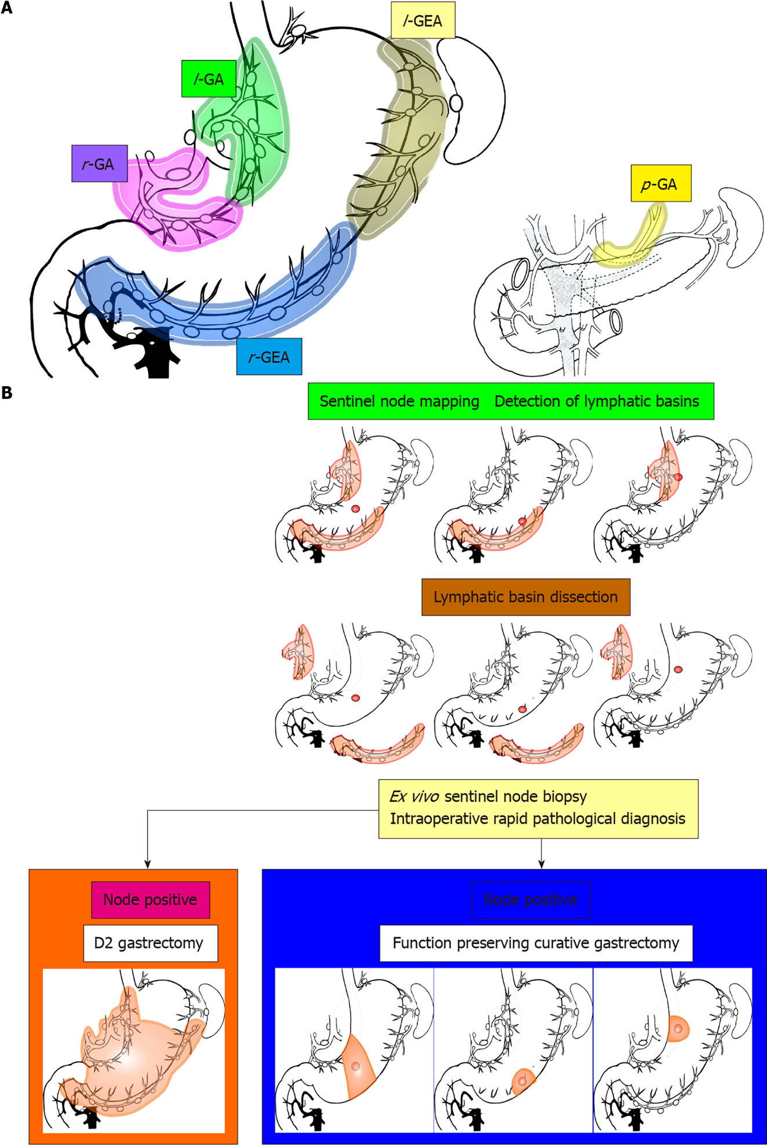
Figure 1 Lymphatic basins, lymphatic compartments, and the strategy of sentinel node navigation surgery. l-GA: Left gastric artery basin; l-GEA: Left gastroepiploic artery basin; p-GA: Posterior gastric artery basin; r-GA: Right gastric artery basin; r-GEA: Right gastroepiploic artery basin. Citation: Kinami S, Nakamura N, Miyashita T, Kitakata H, Fushida S, Fujimura T, Iida Y, Inaki N, Ito T, Takamura H. Life prognosis of sentinel node navigation surgery for early-stage gastric cancer: Outcome of lymphatic basin dissection. World J Gastroenterol 2021; 27(46): 8010-8030. Copyright: The Authors 2021. Published by Baishideng Publishing Group Inc^{[38]}.

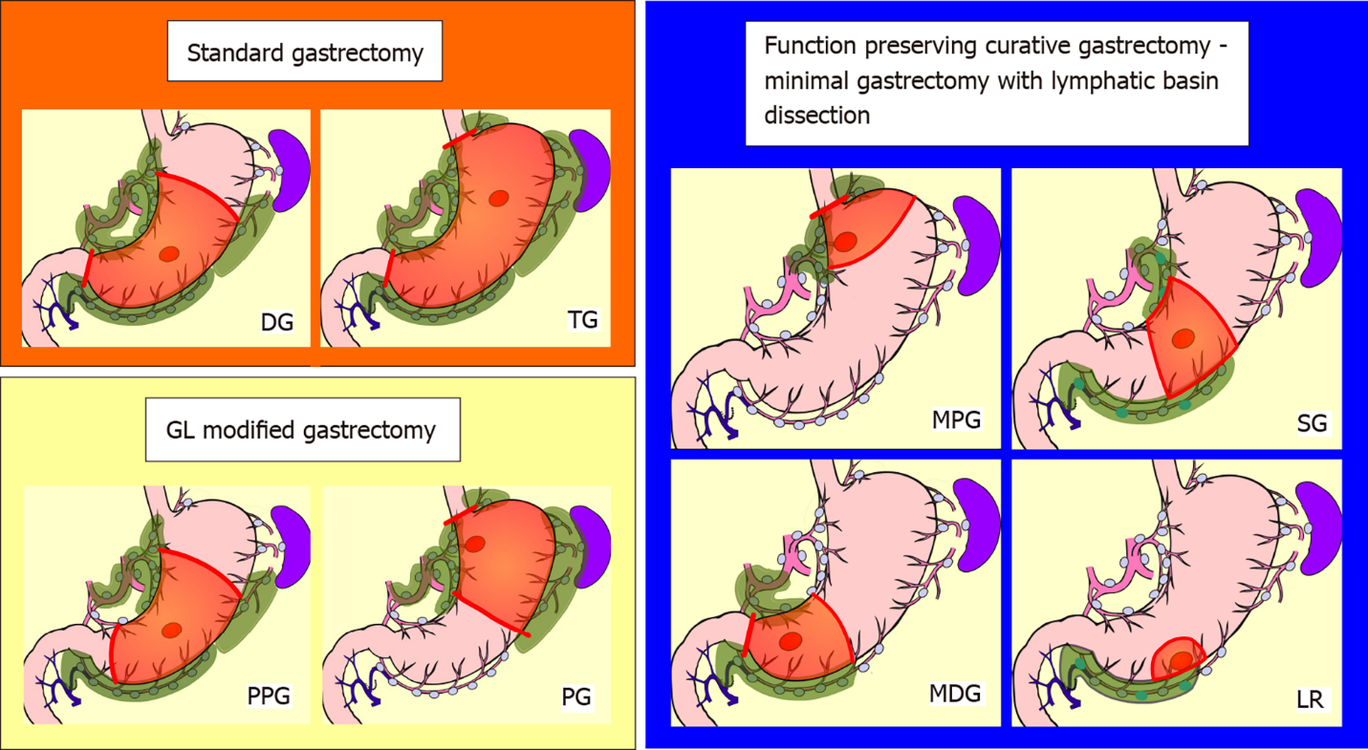
Figure 2 Schemas of standard gastrectomy, modified gastrectomy due to guidelines, and function-preserving curative gastrectomy with lymphatic basin dissection. Red circle: tumor; Green-colored area: extent of lymph node dissection; Orange area: extent of gastrectomy. The extent of nodal dissection in standard gastrectomy and modified gastrectomy according to the guidelines was D1+. In contrast, the extent of nodal dissection in lymphatic basin dissection was defined as D0. DG: Distal gastrectomy; GL: Japanese gastric cancer treatment guidelines; LR: Local resection; MDG: Minidistal gastrectomy; MPG: Mini-proximal gastrectomy; PG: Proximal gastrectomy; PPG: Pylorus-preserving gastrectomy; SG: Segmental gastrectomy; TG: Total gastrectomy. Citation: Kinami S, Nakamura N, Miyashita T, Kitakata H, Fushida S, Fujimura T, Iida Y, Inaki N, Ito T, Takamura H. Life prognosis of sentinel node navigation surgery for early-stage gastric cancer: Outcome of lymphatic basin dissection. World J Gastroenterol 2021; 27(46): 8010-8030. Copyright: The Authors 2021. Published by Baishideng Publishing Group Inc^{[38]}.

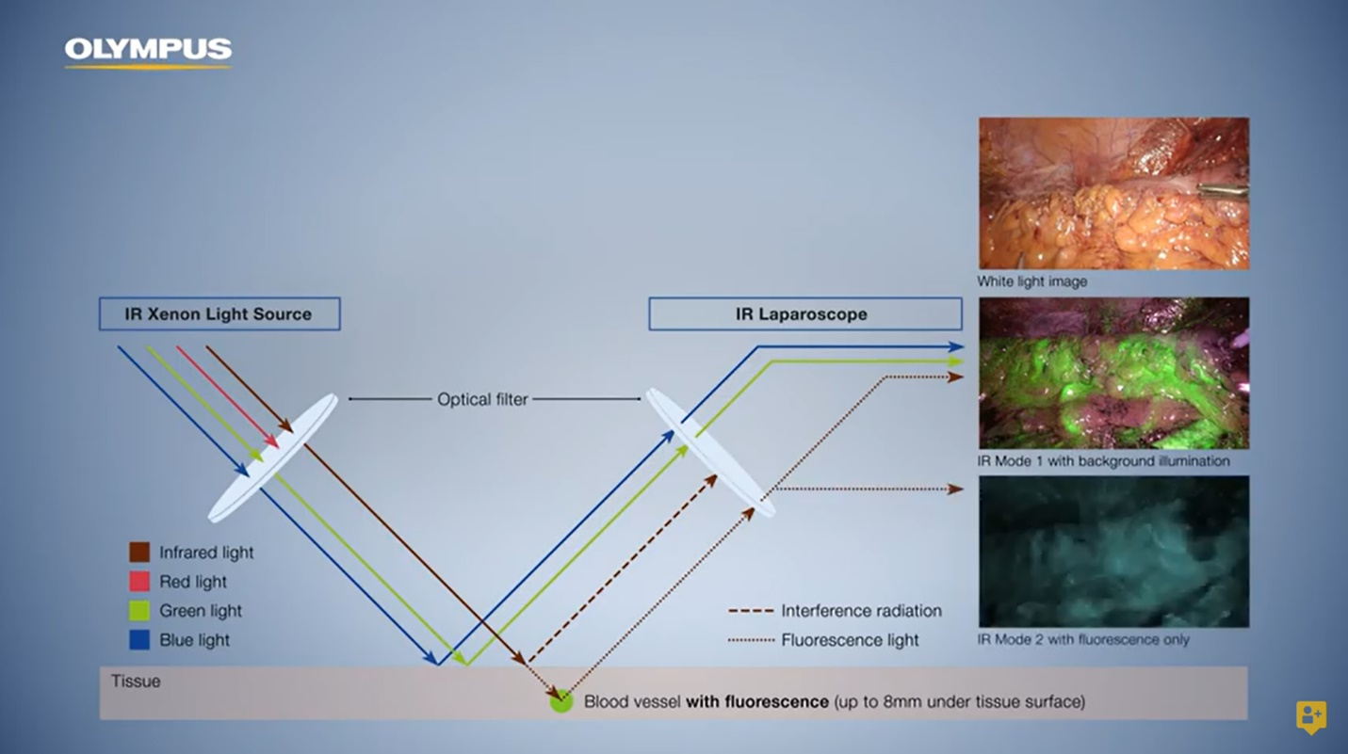
Figure 3 Olympus Visera Elite II near-infrared fluorescence imaging system. Copyright and courtesy of Olympus Europa SE & Co.KG, Hamburg, Germany.

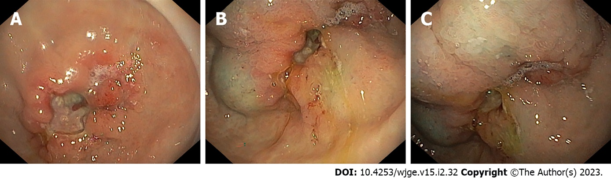
Figure 4 Endoscopic submucosal indocyanine green injection in the stomach. A: Pre-pyloric neoplastic lesion; B: Appearance after two submucosal indocyanine green (ICG) injections; C: Appearance after four circumferential submucosal ICG injections.

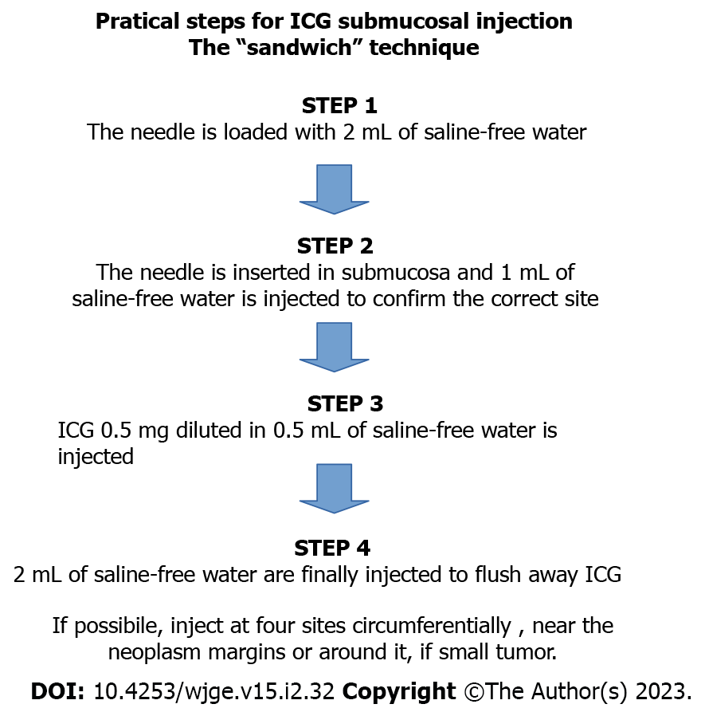
Figure 5 Practical steps for submucosal indocyanine green injection. ICG: Indocyanine green.

Published by Baishideng Publishing Group Inc
7041 Koll Center Parkway, Suite 160, Pleasanton, CA 94566, USA
Telephone: +1-925-3991568
E-mail: bpgoffice@wjgnet.com
Help Desk: https://www.f6publishing.com/helpdesk
https://www.wjgnet.com

© 2023 Baishideng Publishing Group Inc. All rights reserved.

