Name of Journal: World Journal of Stem Cells
Manuscript NO: 88398
Manuscript Type: SCIENTOMETRICS

Research progress and challenges in stem cell therapy for diabetic foot: Bibliometric analysis and perspectives

Shi et al. Stem cells in DF: Progress and challenges

Hong-Shuo Shi, Xin Yuan, Fang-Fang Wu, Xiao-Yu Li, Wei-Jing Fan, Xiao Yang, Xiao-Ming Hu, Guo-Bin Liu

Hong-Shuo Shi, Xin Yuan, Fang-Fang Wu, Xiao-Yu Li, Wei-Jing Fan, Xiao Yang, Xiao-Ming Hu, Guo-Bin Liu, Department of Peripheral Vascular Surgery, Shuguang Hospital Affiliated to Shanghai University of Traditional Chinese Medicine, Shanghai 250021, China

Corresponding author: Hong-Shuo Shi and Guo-Bin Liu.

Author contributions: Liu GB, Yang X, and Fan WJ proposed the research design; Shi HS and Yuan X conducted the literature search, publication screening, and data extraction; Shi HS carried out the data analysis; Wu FF and Li XY conducted manuscript revisions; Hu XM made important contributions to the editing and illustration of this manuscript; The authors collectively contributed to and endorsed the final version of the article.

Corresponding author: Guo-Bin Liu, MD, Doctor, Department of Peripheral Vascular Surgery, Shuguang Hospital Affiliated to Shanghai University of Traditional Chinese Medicine, No. 528 Zhangheng Road, Pudong New Area, Shanghai 250021, China. 15800885533@163.com

Received: September 23, 2023
Revised: December 6, 2023
Accepted: December 28, 2023
Published online: January 26, 2024

Abstract
BACKGROUND
Stem cell therapy has shown great potential for treating diabetic foot (DF).

AIM
To conduct a bibliometric analysis of studies on the use of stem cell therapy for DF over the past two decades, with the aim of depicting the current global research landscape, identifying the most influential research hotspots, and providing insights for future research directions.

METHODS
We searched the Web of Science Core Collection database for all relevant studies on the use of stem cell therapy in DF. Bibliometric analysis was carried out using CiteSpace, VOSviewer, and R (4.3.1) to identify the most notable studies.

RESULTS
A search was conducted to identify publications related to the use of stem cells for DF treatment. A total of 542 articles published from 2000 to 2023 were identified. The United States had published the most papers on this subject. In this field, Iran’s Shahid Beheshti University Medical Sciences demonstrated the highest productivity. Furthermore, Dr. Bayat from the same university has been an outstanding researcher in this field. Stem Cell Research & Therapy is the journal with the highest number of publications in this field. The main keywords were “diabetic foot ulcers,” “wound healing,” and “angiogenesis.”

CONCLUSION
This study systematically illustrated the advances in the use of stem cell therapy to treat DF over the past 23 years. Current research findings suggested that the hotspots in this field include stem cell dressings, exosomes, wound healing, and adipose-derived stem cells. Future research should also focus on the clinical translation of stem cell therapies for DF.

Key Words: Stem cells; Diabetic foot; Bibliometric; CiteSpace; VOSviewer; R-bibliometrix

©The Author(s) 2024. Published by Baishideng Publishing Group Inc. All rights reserved.

Citation: Shi HS, Yuan X, Wu FF, Li XY, Fan WJ, Yang X, Hu XM, Liu GB. Research progress and challenges in stem cell therapy for diabetic foot: Bibliometric analysis and perspectives. World J Stem Cells 2024; 16(1): 33-53
URL: https://www.wjgnet.com/1948-0210/full/v16/i1/33.htm
DOI: https://dx.doi.org/10.4252/wjsc.v16.i1.33

Core Tip: Through the utilization of bibliometric analysis, this study systematically presented the body of research concerning stem cell therapy in diabetic foot cases, while also identifying focal points and burgeoning trends within this domain.

INTRODUCTION
Diabetic foot (DF) is one of the most common complications of diabetes. Once infections and recurrences occur in DF patients, wounds are prone to deteriorate, leading to sepsis and an increased risk of amputation^{[1]}. DF constitutes a significant contributor to disability and mortality among individuals with diabetes^{[2]}, with as many as 20% of diabetic patients requiring hospitalization due to this condition^{[3]}. Evidence indicates that approximately 4%-10% of individuals with type 2 diabetes may experience DF ulcers (DFUs). Furthermore, the risk of mortality within a 5-year period for those affected by DF is notably elevated, as it is 2.5 times higher than the risk among diabetes patients without DF^{[4]}. It is estimated that a diabetes-related amputation is performed every 20 s globally. The annual mortality rate for DFU patients is as high as 11%, and for amputees, it is as high as 22%^{[5]}. Unfortunately, over the past few decades, there has been no improvement in the incidence and disability rates of DF. Traditional DF therapies have also been unsatisfactory. Moreover, standalone interventions or vascular bypass surgeries are inadequate to address the fundamental pathological mechanisms of widespread blood vessel constriction and blockage in DF as well as nerve and tissue impairments^{[6]}.
Currently, most treatment methods for DF mainly target a single factor related to wound healing. Due to advances in regenerative medicine in the clinical setting, there has been widespread interest in the potential impact of stem cells on DF^{[7]}. As a highly promising approach for treating DF^{[8]}, the main advantage of stem cell therapy lies in its ability to comprehensively regulate tissue regeneration by improving the microenvironment^{[9-11]}. The mechanisms that contribute to the effectiveness of stem cell therapy involve promoting the deposition of collagen, instigating the formation of new blood vessels, enhancing lower limb blood flow, and mitigating inflammation^{[12]}.
Bibliometric analysis, which focuses on the systematic and characteristic features of literature, has been widely used to qualitatively and quantitatively analyze scientific literature^{[13,14]}. It has been extensively applied in gynecology^{[15]}, orthopedics^{[16]}, complementary and alternative medicine^{[17]}, and other medical fields. Bibliometrics serves not only as a tool for comprehensively understanding research trends and hotspots within a particular domain but also as a means to assess the distribution of authors, countries/regions, and journals associated with a specific research field. Therefore, bibliometric analysis lays the foundation for future research directions and development^{[18]}. In this study, a scientific knowledge map of stem cell research within the realm of DF was constructed using CiteSpace, VOSviewer, and R (4.3.1). This approach was employed to examine the hotspots and development trends within this field.

MATERIALS AND METHODS
Publication sources and search methods
For this study, the Web of Science Core Collection (WoSCC) database was selected as the publication source. This database is widely used within the academic community and encompasses a range of internationally renowned scientific journals of significant impact and exceptional quality. It provides a comprehensive and standardized dataset for bibliometric analysis^{[19]}. Due to the dynamic nature of the database, the literature search was performed on 1 d (August 1, 2023) to mitigate potential biases arising from rapid updates. The search strategy for this study is presented in Table 1. The publication types included articles and reviews, and the language limitation was set to English.

Publication screening and access
Two researchers (SHS and YX) independently screened the publications for inclusion in this study. The collected literature was exported in two formats: Complete records and references. They were saved as plain text files under the label “download_txt.” The file content included the title, abstract, author information, affiliations, keywords, publication date, and cited references.

Data analysis
All pertinent documents retrieved from the WoSCC database were imported into bibliometrix (based on R 4.3.1.), VOSviewer, and CiteSpace for visualization analysis. Two essential metrics commonly employed to evaluate research performance are the number of publications (Np), which serves as a gauge of productivity, and the number of citations (Nc), which serves as an indicator of impact.
R-bibliometrix is used to conduct bibliometric analysis on leading research nations, institutions, and journals^{[20]}. The primary application of the h-index is to assess researchers’ academic contributions and anticipate their forthcoming scientific accomplishments. The g-index, which is derived from the h-index, can further measure the impact and scholarly achievements of researchers^{[21]}. Moreover, these indices can be obtained to characterize the publication output of a country or region as well as the output of an institution or journal^{[19,22]}.
VOSviewer is a network analysis software for scientometric research that was developed by the Centre for Science and Technology Studies at Leiden University in the Netherlands. It provides visual analysis and allows the creation of maps based on network data. The software enables connections between items through cocitation links, co-occurrence, citations, and bibliographic coupling. VOSviewer offers three types of visual maps: Network; overlay; and density visualization^{[23,24]}.
The CiteSpace software is a citation visualization and analysis tool rooted in scientometrics and data visualization. It was created by Professor Chaomei Chen at Drexel University using the Java programming language^{[25]}. By leveraging data mining, information analysis, and map visualization techniques, it effectively illustrates the architecture, patterns, and dissemination of scientific knowledge^{[26]}.

RESULTS
An overview of stem cells in DF publications
After retrieving and filtering publications from the WoSCC database, a total of 543 publications were included. Among them, 350 articles and 193 reviews were ultimately included in this analysis. The studies were published between 2000 and 2023, and the h-index was 71.
Figure 1 illustrates the geographic distribution of the overall research paper count across all countries and regions. Among the 543 articles, the top two countries accounted for more than half of the total. The United States had the highest number of published papers, followed by China, Iran, England, and Italy.
Between 2000 and 2022, the annual Np increased rapidly and exhibited a polynomial fit, y = 0.1484x² - 593.9x + 594231, R² = 0.9714. The annual cumulative publication volume followed an exponential curve, y = 2E-247e^{0.2843x}, R² = 0.9601 (Figure 2).

Country/region contributions to global publications
The top 10 countries/regions in terms of output are shown in Table 2. The country with the highest number of published papers was the United States (183/543, 33.70%), followed by China (152/543, 27.99%), Iran (35/543, 6.45%), England (33/543, 6.08%), and Italy (28/543, 5.16%). Papers from the United States were cited 9663 times, accounting for 44.84% of the total citations, followed by China (3828; 17.76%) and England (2449; 11.36%). In addition, the United States (46) had the highest h-index, followed by China (32) and England (20). The network (Figure 3A) and density (Figure 3B) maps constructed using VOSviewer also indicated the research influence of the United States and China. As shown in Figure 3C, the largest connected component in the co-occurrence network of countries/regions consisted of 60 nodes and 185 connections (density = 0.01). The purple hue corresponds to the betweenness centrality coefficients of countries/regions, encompassing the United States (0.83), England (0.23), Italy (0.17), and China (0.15). This indicates that these countries/regions assume a ”bridging” role within this domain, and this finding was also confirmed by the multiple-country publication value in Figure 3D.

Analysis of author institution publications
We compiled a list of the 10 institutions with the highest Np (Table 3). These institutions were located in the United States (5/10), China (4/10), and Iran (1/10). The top six institutions in terms of publication ranking included Shahid Beheshti University Medical Sciences (Iran, 13/2.39%), University of Louisville (the United States, 12/2.21%), Army Medical University (China, 12/2.21%), Tongji University (China, 11/2.03%), Chinese Academy of Medical Sciences-Peking Union Medical College (China, 11/2.03%), and Boston University (density = 0.01). Boston University (0.13) and the University of California System (0.13) had the highest centrality, and their nodes were identified by purple circles (Figure 4).

Author analysis and cocitation author analysis.
In 1997, economists Katz and Martin provided a definition for “scientific collaboration,” wherein scholars unite to collaboratively pursue shared scientific objectives^{[27]}. We identified 2798 authors who have published articles on the topic of stem cells in DF research. Figure 5A displays the 10 authors with the highest average annual publication count. Among them, Bayat^{[28]}, Amini^{[29]}, and Tomic-Canic^{[30]} published the highest number of studies (n = 12), followed by Veves (n = 6)^{[31]} and Pastar C (n = 4)^{[32]} (Table 4). Cocitation authors refer to the authors who are cited together in the same article. Figure 5B and C show the network and density maps of cocited authors, respectively. Among the 28753 cocited authors, 173 have been cited together more than 20 times. The top five cocited authors were FALANGA V (n = 151), BREM H (n = 87), ARMSTRONG DG (n = 86), BOULTON AJM (n = 70), and MARSTON WA (n = 59) (Table 4). As shown in Figure 5D, the author with the highest betweenness centrality in terms of citations was FALANGA V (0.36), followed by ARMSTRONG DG (0.21) and BOULTON AJM (0.12).

Journals and cocited journals
Studies related to the use of stem cell therapy in DF patients were published in a total of 280 different journals. The journal Stem Cell Research & Therapy [22/7.86%, impact factor (IF): 7.5, Journal Citation Reports (JCR): Q1) had the highest output quantity; this journal emphasizes basic, clinical, and translational research on stem cell therapy and regenerative medicine. The next most productive journal was International Wound Journal (17/6.07%, IF: 3.1, JCR: Q2). Among the top 10 journals, 8 belonged to the JCR Q1 category, with 9 having an IF exceeding 3 (Table 5). Additionally, Stem Cell Research & Therapy had the highest h-index (Figure 6A) and g-index (Figure 6B).
Among the 4667 cocited journals, 82 journals have been cited more than 100 times. Table 2 shows that Wound Repair and Regeneration (1297/27.79%, IF: 2.9, JCR: Q1) had the highest number of citations, followed by Diabetes Care (951/20.38%, IF: 16.2, JCR: Q1) and Biomaterials (681/14.59%, IF: 14, JCR: Q1). Among the top 10 cocited journals, 8 were in JCR Q1, and they all had an IF exceeding 3 (Table 5 and Figure 6C).
The dual plot of the journals displays the distribution of relationships between them. As shown in Figure 6D, there are primarily four citation pathways, consisting of two orange paths and two green paths. The relevant pathways are listed in Table 6.

Cocited reference analysis
Cocitation describes how often two documents are referenced jointly^{[33]}. Table 7 lists the top 10 referenced articles that were most commonly cocited. Among the 28717 cited articles, 27 articles have been cited more than 30 times. The top six referenced articles have all been cited more than 50 times. The article by Armstrong et al^{[34]} that was published in the New England Journal of Medicine in 2017 had the highest number of cocitations, followed by the article published by Lopes et al^{[35]} in 2018 (Figure 7A). Based on cluster analysis, a total of eight clusters were identified (Figure 7B), indicating the reliability of the clustering results. These clusters primarily included #0 “diabetic foot,” #1 “skin defect,” #2 “low-level laser therapy,” #3 “adipose-derived stem cell therapy for local chronic radiation injury,” #4 “occlusive dressing,” and #5 “exosomes.” In addition, research hotspots can be reflected in the timeline of cocited references. Relatively speaking, cluster #0 “diabetic foot” and cluster #5 “exosomes” were recent hotspots. Furthermore, analysis of citation bursts can accurately identify articles that have garnered significant attention within a particular field. This method can help filter out articles that are likely to have a major impact on future research. The initial instance of a powerful citation burst emerged in 2004^{[36]}, whereas the latest occurrence of a significant citation burst appeared in 2020^{[37]}. Additionally, the study published by Maxson et al^{[38]} in 2012 exhibited the strongest citation burst intensity (10.19)^{[39]} (Figure 7C).

Analysis of co-occurrence keywords
A total of 2380 keywords were derived from the included studies. After excluding keywords that appeared fewer than five times and merging equivalent keywords, a total of 219 keywords were identified. We have displayed the top 20 keywords (Table 8) and built a related network (Figure 8A) and density graphs (Figure 8B). The top five keywords were “diabetic foot ulcers” (253), “wound healing” (130), “mesenchymal stem cells” (98), “stem cells” (78), and “angiogenesis” (75). Figure 8 displays the keyword timeline, illustrating the timeline of keywords in the clusters based on their appearance dates. The color of the keywords matches the cluster label color (Figure 8C). A total of eight clusters were identified: #0 “diabetes mellitus;” #1 ”expression;” #2 “chronic wounds;” #3 “adipose-derived stem cells;” #4 “diabetic foot;” #5 “diabetic wound healing;” #6 “double-blind;” and #7 “biological therapies.” Additionally, Figure 8D displays the top 10 keywords with the highest citation bursts. “Repair” (5.15) had the highest burst strength, followed by “skin” (4.15) and “venous leg ulcers” (3.93). “Endothelial progenitor cells” (2006-2014) and “venous leg ulcers” (2015-2019) have shown prolonged citation bursts, indicating that research in these areas has been attracting an increasing amount of attention from researchers.

DISCUSSION
Stem cell therapy has recently emerged as a novel approach for DF management, as it has exhibited safety and efficacy across preclinical and clinical trials^{[35]}. This study is the first bibliometric analysis on global research related to the use of stem cell therapy for DF. These findings can provide researchers with a systematic and intuitive overview of the overall trends in this field^{[40,41]}.

General information
Based on the information retrieved from the WoSCC database as of August 1, 2023, there have been a total of 982 studies related to stem cell therapy and DF published across 280 academic journals. These studies involve a total of 2798 authors affiliated with 543 institutions across 60 countries/regions. The yearly fluctuations in Np serve as a significant gauge for discerning development trends within this domain^{[42,43]}. The publication trends from 2000 to 2003 indicate a lack of research during this period, suggesting a limited depth of study on stem cell therapy in DF. The year 2004 was a turning point for this topic^{[44]}, as an increasing number of researchers started focusing on the role of stem cell therapy in the treatment of DF. At that time, the number of relevant publications began to show a rapid upward trend.
Through visual analysis of national and institutional distribution, we can see that the United States and China are the leading countries in the research and development of stem cell therapy for DF. Among the top 10 institutions researching this topic, the majority (90%) are located in the United States and China, including the University of Louisville, Army Medical University, and Tongji University. Within the 10 highest-ranked nations, the United States (0.83) demonstrated the strongest centrality and maintained the highest multiple-country publication value, signifying its substantial impact within this area. Other countries, such as China (0.15), England (0.23), and Italy (0.17), also had centrality values exceeding 0.1, suggesting their involvement in international exchanges and collaborations to a certain extent.
Identifying the core authors in this field can help researchers find potential collaborators^{[45]}. Professor Bayat, from Shahid Beheshti University of Medical Sciences in Iran, was the author with the highest number of published papers. He has conducted a series of studies on the mechanisms and therapeutic effects of photobiomodulation in stem cell therapy for DF^{[46,47]}. His research has shown that subjecting diabetic adipose-derived stem cells to photobiomodulation prior to treatment markedly expedites the process of wound healing^{[48]}. Among the cited authors, Vincent Falanga from Boston University School of Medicine has been referenced 151 times and had the largest node in this field. He has conducted several high-quality reviews on the use of stem cells for the treatment of chronic wounds^{[49,50]}.
The analysis of the distribution of academic journals helps to identify the core journals in specific research fields^{[51]}. Multiple studies on the use of stem cells in DF have been published in influential journals such as Stem Cell Research & Therapy and the International Wound Journal. Among the top 10 journals, 8 are classified as JCR Q1, which indicates that the research quality of articles in the field is high. From the perspective of commonly cited academic journals, we can see that most of the research comes from highly influential journals in the field of stem cells or wound repair. The journal dual overlay represents the thematic distribution of academic journals, with four citation paths. This implies that current research related to stem cells and DF is focused not only on basic research but also on translational medical research.

Intellectual base
Analysis of cocited references can provide in-depth insights into the core themes and major discoveries of current research^{[52]}. The primary emphasis of the top 10 most cocited references revolves around the pathological and physiological mechanisms, treatment approaches, and everyday handling of stem cells in the context of DF. The results of citation analysis revealed that the article written by Armstrong et al^{[34]} published in the New England Journal of Medicine in 2017 had the highest frequency of cocitations. This article described the epidemiology and health management of recurrent DFUs and emphasized that the focus of work should be on prevention. Another study published by Lopes et al^{[35]} in 2018, which has a citation count of 32, proposed that stem cell therapy was an effective method for treating DFUs. This suggested that for some patients who do not have other options for vascular reconstruction, stem cell therapy can be considered an alternative to amputation. The most explosive reference was the paper published by Maxson et al^{[38]} in Stem Cells Translational Medicine. This article delineated the function of mesenchymal stem cells (MSCs) in the process of wound healing and elucidated their ability to attract additional host cells and release growth factors and matrix proteins to orchestrate the mending mechanism.
In the clustering analysis of cocited references, there were modules related to occlusive dressing, low-level laser, and exosomes, among others. With the use of advanced techniques, there have been some breakthroughs in the research on stem cells in the field of DF science. Exosomes derived from MSCs carry forward the robust functions of their originating cells. These functions include tasks such as managing inflammation and immune responses, fostering angiogenesis, facilitating cell proliferation and movement, mitigating oxidative stress, and regulating the equilibrium of collagen remodeling^{[53]}. They can potentially avoid the potential risks associated with direct stem cell transplantation. Stem cell-derived exosomes may be a future research trend.
In chronic wounds, stem cell survival without scaffold support is short-lived. Multifunctional hydrogel wound dressings play a crucial role in the healing of skin wounds, as they can sustain stem cell viability for an extended period, provide moisture, and prevent electrolyte and fluid loss in DFUs^{[54]}. Furthermore, photobiomodulation may also play an important role in stem cell applications. The combination of stem cells and photobiomodulation has shown the potential to accelerate the healing process of diabetic wounds^{[47]}.

Hotspots and frontiers
Keywords summarize the research topics and core content. Based on keyword co-occurrence analysis, it is possible to understand the distribution and development of various research hotspots in a specific field^{[55]}. The keyword clustering ultimately identified eight possible research directions, including “diabetes mellitus,” “expression,” “chronic wounds,” “adipose-derived stem cells,” “diabetic foot,” “diabetic wound healing,” “double-blind,” and “biological therapies.” The most common keywords were “diabetic foot ulcers,” “wound healing,” “mesenchymal stem cells,” “stem cells,” and “angiogenesis.” In addition, the most frequently mentioned keywords, included “repair,” “skin,” “venous leg ulcers,” “efficacy,” and “mechanisms.” The aforementioned words indicate that the use of stem cells in DF has not only been examined in basic research studies but has also been investigated in clinical translation studies.
A growing body of research indicates that MSCs are capable of enhancing angiogenesis and epithelial remodeling, engaging in immune regulation, mitigating inflammation, and ultimately contributing to the facilitation of DFU repair. They have become an effective therapeutic approach for treating DF^{[56]}. It is worth noting that controlled studies conducted using animal models indicated that combining stem cells with biostimulants (such as photobiomodulation) can reduce biofilm formation and expedite the healing of infected diabetic wounds^{[57]}. Multiple randomized controlled trials have confirmed that stem cell therapy is a promising treatment for DF, as it can improve healing rates and reduce the amputation rate^{[58]}. There is good clinical evidence promoting the clinical application and translation of stem cell therapy for DF. When selecting clinical stem cell types, considerations should be given to the availability and supply of stem cells, such as ease of acquisition, good manufacturing practices, and broad in vitro proliferative capacity^{[59]}. Because of their convenient procurement, uncomplicated extraction methods, and documented safety profile, adipose-derived stem cells and other stem cell variants have become increasingly popular. Consequently, they have emerged as pivotal areas of concentration within research endeavors^{[60]}. Beyond their regenerative characteristics and capacity to stimulate blood vessel development, stem cells sourced from adipose tissue exhibit a greater content when contrasted with bone marrow aspirate-derived stem cells^{[59]}.
Through the utilization of bibliometric analysis, this study systematically presented the body of research concerning stem cell therapy in DF cases while also identifying focal points and burgeoning trends within this domain. Therefore, we have also depicted the potential mechanism diagram of stem cell research in the field of DF in Figure 9. Nevertheless, there are certain limitations associated with this study. First and foremost, the study’s scope was confined to the WoSCC database for literature screening, potentially resulting in the omission of pertinent articles. This is due to the limitations of current bibliometric software, which makes it difficult to analyze multiple databases simultaneously. Additionally, this study utilized only a few tools, such as VOSviewer, CiteSpace, and R bibliometrics package, which may not fully explain the data. In future research, we intend to explore the use of other tools, such as artificial neural networks, to further analyze and interpret the data.

CONCLUSION
The bibliometric analysis indicated that research on stem cell therapy in DF has been rapidly progressing and holds great prospects for the future. The United States and China are scientific hubs for the research of stem cells in DF. In this field, Iran’s Shahid Beheshti University Medical Sciences demonstrated the highest productivity, with Dr. Bayat from the same university being an outstanding researcher in this domain. The priority topics revolved around dressings, extracellular vesicles, wound healing, and adipose stem cells. The results of these analyses will help researchers understand the current research status and provide hopeful directions for future studies. Future research will also focus on the clinical translation of stem cell therapies for DF.

ARTICLE HIGHLIGHTS
Research background
Stem cell therapy has shown great potential for treating diabetic foot (DF).

Research motivation
There is currently a lack of comprehensive research in this field.

Research objectives
The purpose of this study was to conduct a bibliometric analysis of studies on the use of stem cell therapy for DF over the past two decades, with the aim of depicting the current global research landscape, identifying the most influential research hotspots, and providing insights for future research directions.

Research methods
We searched the Web of Science Core Collection database for all relevant studies on the use of stem cell therapy in DF. Bibliometric analysis was carried out using CiteSpace, VOSviewer, and R (4.3.1) to identify the most notable studies.

Research results
A search was conducted to identify publications related to the use of stem cells for DF treatment. A total of 542 articles published from 2000 to 2023 were identified. The United States had published the most papers on this subject. In this field, Iran’s Shahid Beheshti University Medical Sciences demonstrated the highest productivity. Furthermore, Dr. Bayat from the same university has been an outstanding researcher in this field. Stem Cell Research & Therapy was the journal with the highest number of publications in this field. The main keywords were “diabetic foot ulcers,” “wound healing,” and “angiogenesis.”

Research conclusions
This study systematically illustrated the advances in the use of stem cell therapy to treat DF over the past 23 years. Current research findings suggested that the hotspots in this field included stem cell dressings, exosomes, wound healing, and adipose-derived stem cells.

Research perspectives
Future research should also focus on the clinical translation of stem cell therapies for DF.

REFERENCES
1 Craus S, Mula A, Coppini DV. The foot in diabetes - a reminder of an ever-present risk. Clin Med (Lond) 2023; 23: 228-233 [PMID: 37197806 DOI: 10.7861/clinmed2022-0489]
2 Boulton AJ, Vileikyte L, Ragnarson-Tennvall G, Apelqvist J. The global burden of diabetic foot disease. Lancet 2005; 366: 1719-1724 [PMID: 16291066 DOI: 10.1016/S0140-6736(05)67698-2]
3 Bandyk DF. The diabetic foot: Pathophysiology, evaluation, and treatment. Semin Vasc Surg 2018; 31: 43-48 [PMID: 30876640 DOI: 10.1053/j.semvascsurg.2019.02.001]
4 Fu XL, Ding H, Miao WW, Mao CX, Zhan MQ, Chen HL. Global recurrence rates in diabetic foot ulcers: A systematic review and meta-analysis. Diabetes Metab Res Rev 2019; 35: e3160 [PMID: 30916434 DOI: 10.1002/dmrr.3160]
5 Gallego-Selles A, Martin-Rincon M, Martinez-Canton M, Perez-Valera M, Martín-Rodríguez S, Gelabert-Rebato M, Santana A, Morales-Alamo D, Dorado C, Calbet JAL. Regulation of Nrf2/Keap1 signalling in human skeletal muscle during exercise to exhaustion in normoxia, severe acute hypoxia and post-exercise ischaemia: Influence of metabolite accumulation and oxygenation. Redox Biol 2020; 36: 101627 [PMID: 32863217 DOI: 10.1016/j.redox.2020.101627]
6 Chen L, Zheng B, Xu Y, Sun C, Wu W, Xie X, Zhu Y, Cai W, Lin S, Luo Y, Shi C. Nano hydrogel-based oxygen-releasing stem cell transplantation system for treating diabetic foot. J Nanobiotechnology 2023; 21: 202 [PMID: 37370102 DOI: 10.1186/s12951-023-01925-z]
7 Sun Y, Zhao J, Zhang L, Li Z, Lei S. Effectiveness and safety of stem cell therapy for diabetic foot: a meta-analysis update. Stem Cell Res Ther 2022; 13: 416 [PMID: 35964145 DOI: 10.1186/s13287-022-03110-9]
8 Blumberg SN, Berger A, Hwang L, Pastar I, Warren SM, Chen W. The role of stem cells in the treatment of diabetic foot ulcers. Diabetes Res Clin Pract 2012; 96: 1-9 [PMID: 22142631 DOI: 10.1016/j.diabres.2011.10.032]
9 Chen P, Carville K, Swanson T, Lazzarini PA, Charles J, Cheney J, Prentice J; Australian Diabetes-related Foot Disease Guidelines & Pathways Project. Australian guideline on wound healing interventions to enhance healing of foot ulcers: part of the 2021 Australian evidence-based guidelines for diabetes-related foot disease. J Foot Ankle Res 2022; 15: 40 [PMID: 35610723 DOI: 10.1186/s13047-022-00544-5]
10 Doğruel H, Aydemir M, Balci MK. Management of diabetic foot ulcers and the challenging points: An endocrine view. World J Diabetes 2022; 13: 27-36 [PMID: 35070057 DOI: 10.4239/wjd.v13.i1.27]
11 Eleftheriadou I, Samakidou G, Tentolouris A, Papanas N, Tentolouris N. Nonpharmacological Management of Diabetic Foot Ulcers: An Update. Int J Low Extrem Wounds 2021; 20: 188-197 [PMID: 33073653 DOI: 10.1177/1534734620963561]
12 Yu Q, Qiao GH, Wang M, Yu L, Sun Y, Shi H, Ma TL. Stem Cell-Based Therapy for Diabetic Foot Ulcers. Front Cell Dev Biol 2022; 10: 812262 [PMID: 35178389 DOI: 10.3389/fcell.2022.812262]
13 Ma C, Su H, Li H. Global Research Trends on Prostate Diseases and Erectile Dysfunction: A Bibliometric and Visualized Study. Front Oncol 2020; 10: 627891 [PMID: 33643922 DOI: 10.3389/fonc.2020.627891]
14 Zhang J, Zhang Y, Hu L, Huang X, Liu Y, Li J, Hu Q, Xu J, Yu H. Global Trends and Performances of Magnetic Resonance Imaging Studies on Acupuncture: A Bibliometric Analysis. Front Neurosci 2020; 14: 620555 [PMID: 33551731 DOI: 10.3389/fnins.2020.620555]
15 Huang X, Fan X, Ying J, Chen S. Emerging trends and research foci in gastrointestinal microbiome. J Transl Med 2019; 17: 67 [PMID: 30819194 DOI: 10.1186/s12967-019-1810-x]
16 Qiu Y, Yang W, Wang Q, Yan S, Li B, Zhai X. Osteoporosis in postmenopausal women in this decade: a bibliometric assessment of current research and future hotspots. Arch Osteoporos 2018; 13: 121 [PMID: 30406425 DOI: 10.1007/s11657-018-0534-5]
17 Zhou XC, Huang YB, Liu Z, Wu HJ, Huang HZ, Tian Y, Hong SW, Hu HJ, Lv LJ, Lv ZZ. Bibliometric Analysis of Functional Magnetic Resonance Imaging Studies on Manual Therapy Analgesia from 2002-2022. J Pain Res 2023; 16: 2115-2129 [PMID: 37361428 DOI: 10.2147/JPR.S412658]
18 Song L, Zhang J, Ma D, Fan Y, Lai R, Tian W, Zhang Z, Ju J, Xu H. A Bibliometric and Knowledge-Map Analysis of Macrophage Polarization in Atherosclerosis From 2001 to 2021. Front Immunol 2022; 13: 910444 [PMID: 35795675 DOI: 10.3389/fimmu.2022.910444]
19 Wang S, Zhou H, Zheng L, Zhu W, Zhu L, Feng D, Wei J, Chen G, Jin X, Yang H, Shi X, Lv X. Global Trends in Research of Macrophages Associated With Acute Lung Injury Over Past 10 Years: A Bibliometric Analysis. Front Immunol 2021; 12: 669539 [PMID: 34093568 DOI: 10.3389/fimmu.2021.669539]
20 Arruda H, Silva ER, Lessa M, Proença D Jr, Bartholo R. VOSviewer and Bibliometrix. J Med Libr Assoc 2022; 110: 392-395 [PMID: 36589296 DOI: 10.5195/jmla.2022.1434]
21 Ali MJ. Understanding the 'g-index' and the 'e-index'. Semin Ophthalmol 2021; 36: 139 [PMID: 33952018 DOI: 10.1080/08820538.2021.1922975]
22 Noruzi A, Gholampour B, Gholampour S, Jafari S, Farshid R, Stanek A, Saboury AA. Current and Future Perspectives on the COVID-19 Vaccine: A Scientometric Review. J Clin Med 2022; 11 [PMID: 35160202 DOI: 10.3390/jcm11030750]
23 van Eck NJ, Waltman L. Software survey: VOSviewer, a computer program for bibliometric mapping. Scientometrics 2010; 84: 523-538 [PMID: 20585380 DOI: 10.1007/s11192-009-0146-3]
24 Ma D, Guan B, Song L, Liu Q, Fan Y, Zhao L, Wang T, Zhang Z, Gao Z, Li S, Xu H. A Bibliometric Analysis of Exosomes in Cardiovascular Diseases From 2001 to 2021. Front Cardiovasc Med 2021; 8: 734514 [PMID: 34513962 DOI: 10.3389/fcvm.2021.734514]
25 Synnestvedt MB, Chen C, Holmes JH. CiteSpace II: visualization and knowledge discovery in bibliographic databases. AMIA Annu Symp Proc 2005; 2005: 724-728 [PMID: 16779135]
26 Donnelly JP. A systematic review of concept mapping dissertations. Eval Program Plann 2017; 60: 186-193 [PMID: 27693034 DOI: 10.1016/j.evalprogplan.2016.08.010]
27 Varshney D, Atkins S, Das A, Diwan V. Understanding collaboration in a multi-national research capacity-building partnership: a qualitative study. Health Res Policy Syst 2016; 14: 64 [PMID: 27538447 DOI: 10.1186/s12961-016-0132-1]
28 Bayat M, Albright R, Hamblin MR, Chien S. Impact of Blue Light Therapy on Wound Healing in Preclinical and Clinical Subjects: A Systematic Review. J Lasers Med Sci 2022; 13: e69 [PMID: 37041783 DOI: 10.34172/jlms.2022.69]
29 Amini A, Ghasemi Moravej F, Mostafavinia A, Ahmadi H, Chien S, Bayat M. Photobiomodulation Therapy Improves Inflammatory Responses by Modifying Stereological Parameters, microRNA-21 and FGF2 Expression. J Lasers Med Sci 2023; 14: e16 [PMID: 37583493 DOI: 10.34172/jlms.2023.16]
30 Tomic-Canic M, Burgess JL, O'Neill KE, Strbo N, Pastar I. Skin Microbiota and its Interplay with Wound Healing. Am J Clin Dermatol 2020; 21: 36-43 [PMID: 32914215 DOI: 10.1007/s40257-020-00536-w]
31 Veves A. Repair, regeneration and the future. J Wound Care 2020; 29: 539 [PMID: 33052798 DOI: 10.12968/jowc.2020.29.10.539]
32 Pastar I, Balukoff NC, Marjanovic J, Chen VY, Stone RC, Tomic-Canic M. Molecular Pathophysiology of Chronic Wounds: Current State and Future Directions. Cold Spring Harb Perspect Biol 2023; 15 [PMID: 36123031 DOI: 10.1101/cshperspect.a041243]
33 Yang K, Hu Y, Qi H. Digital Health Literacy: Bibliometric Analysis. J Med Internet Res 2022; 24: e35816 [PMID: 35793141 DOI: 10.2196/35816]
34 Armstrong DG, Boulton AJM, Bus SA. Diabetic Foot Ulcers and Their Recurrence. N Engl J Med 2017; 376: 2367-2375 [PMID: 28614678 DOI: 10.1056/NEJMra1615439]
35 Lopes L, Setia O, Aurshina A, Liu S, Hu H, Isaji T, Liu H, Wang T, Ono S, Guo X, Yatsula B, Guo J, Gu Y, Navarro T, Dardik A. Stem cell therapy for diabetic foot ulcers: a review of preclinical and clinical research. Stem Cell Res Ther 2018; 9: 188 [PMID: 29996912 DOI: 10.1186/s13287-018-0938-6]
36 Badiavas EV, Falanga V. Treatment of chronic wounds with bone marrow-derived cells. Arch Dermatol 2003; 139: 510-516 [PMID: 12707099 DOI: 10.1001/archderm.139.4.510]
37 Raghav A, Khan ZA, Labala RK, Ahmad J, Noor S, Mishra BK. Financial burden of diabetic foot ulcers to world: a progressive topic to discuss always. Ther Adv Endocrinol Metab 2018; 9: 29-31 [PMID: 29344337 DOI: 10.1177/2042018817744513]
38 Maxson S, Lopez EA, Yoo D, Danilkovitch-Miagkova A, Leroux MA. Concise review: role of mesenchymal stem cells in wound repair. Stem Cells Transl Med 2012; 1: 142-149 [PMID: 23197761 DOI: 10.5966/sctm.2011-0018]
39 Zhang P, Lu J, Jing Y, Tang S, Zhu D, Bi Y. Global epidemiology of diabetic foot ulceration: a systematic review and meta-analysis (†). Ann Med 2017; 49: 106-116 [PMID: 27585063 DOI: 10.1080/07853890.2016.1231932]
40 Wallin JA. Bibliometric methods: pitfalls and possibilities. Basic Clin Pharmacol Toxicol 2005; 97: 261-275 [PMID: 16236137 DOI: 10.1111/j.1742-7843.2005.pto_139.x]
41 Peters MD, Godfrey CM, Khalil H, McInerney P, Parker D, Soares CB. Guidance for conducting systematic scoping reviews. Int J Evid Based Healthc 2015; 13: 141-146 [PMID: 26134548 DOI: 10.1097/XEB.0000000000000050]
42 Qin Y, Zhang Q, Liu Y. Analysis of knowledge bases and research focuses of cerebral ischemia-reperfusion from the perspective of mapping knowledge domain. Brain Res Bull 2020; 156: 15-24 [PMID: 31843561 DOI: 10.1016/j.brainresbull.2019.12.004]
43 Gao Y, Shi S, Ma W, Chen J, Cai Y, Ge L, Li L, Wu J, Tian J. Bibliometric analysis of global research on PD-1 and PD-L1 in the field of cancer. Int Immunopharmacol 2019; 72: 374-384 [PMID: 31030093 DOI: 10.1016/j.intimp.2019.03.045]
44 Yamaguchi Y, Yoshida S, Sumikawa Y, Kubo T, Hosokawa K, Ozawa K, Hearing VJ, Yoshikawa K, Itami S. Rapid healing of intractable diabetic foot ulcers with exposed bones following a novel therapy of exposing bone marrow cells and then grafting epidermal sheets. Br J Dermatol 2004; 151: 1019-1028 [PMID: 15541080 DOI: 10.1111/j.1365-2133.2004.06170.x]
45 Kodonas K, Fardi A, Gogos C, Economides N. Scientometric analysis of vital pulp therapy studies. Int Endod J 2021; 54: 220-230 [PMID: 33012010 DOI: 10.1111/iej.13422]
46 Fallahi F, Mostafavinia A, Sharifi Z, Mohaghegh Shalmani L, Amini A, Ahmadi H, Omidi H, Hajihosseintehrani M, Bayat S, Hamblin MR, Chien S, Bayat M. Effects of photobiomodulation on mitochondrial function in diabetic adipose-derived stem cells in vitro. Spectrochim Acta A Mol Biomol Spectrosc 2023; 285: 121835 [PMID: 36116412 DOI: 10.1016/j.saa.2022.121835]
47 Amini A, Pouriran R, Abdollahifar MA, Abbaszadeh HA, Ghoreishi SK, Chien S, Bayat M. Stereological and molecular studies on the combined effects of photobiomodulation and human bone marrow mesenchymal stem cell conditioned medium on wound healing in diabetic rats. J Photochem Photobiol B 2018; 182: 42-51 [PMID: 29604553 DOI: 10.1016/j.jphotobiol.2018.03.010]
48 Amini A, Chien S, Bayat M. Effectiveness of preconditioned adipose-derived mesenchymal stem cells with photobiomodulation for the treatment of diabetic foot ulcers: a systematic review. Lasers Med Sci 2022; 37: 1415-1425 [PMID: 34697696 DOI: 10.1007/s10103-021-03451-6]
49 Otero-Viñas M, Falanga V. Mesenchymal Stem Cells in Chronic Wounds: The Spectrum from Basic to Advanced Therapy. Adv Wound Care (New Rochelle) 2016; 5: 149-163 [PMID: 27076993 DOI: 10.1089/wound.2015.0627]
50 Gould L, Abadir P, Brem H, Carter M, Conner-Kerr T, Davidson J, DiPietro L, Falanga V, Fife C, Gardner S, Grice E, Harmon J, Hazzard WR, High KP, Houghton P, Jacobson N, Kirsner RS, Kovacs EJ, Margolis D, McFarland Horne F, Reed MJ, Sullivan DH, Thom S, Tomic-Canic M, Walston J, Whitney J, Williams J, Zieman S, Schmader K. Chronic wound repair and healing in older adults: current status and future research. Wound Repair Regen 2015; 23: 1-13 [PMID: 25486905 DOI: 10.1111/wrr.12245]
51 Yang F, Dong Y, Bai C, Alzogool M, Wang Y. Bibliometric and visualized analysis of myopic corneal refractive surgery research: from 1979 to 2022. Front Med (Lausanne) 2023; 10: 1141438 [PMID: 37575980 DOI: 10.3389/fmed.2023.1141438]
52 Wang YC, Zhao FK, Liu Q, Yu ZY, Wang J, Zhang JS. Bibliometric analysis and mapping knowledge domain of pterygium: 2000-2019. Int J Ophthalmol 2021; 14: 903-914 [PMID: 34150547 DOI: 10.18240/ijo.2021.06.17]
53 Wu J, Chen LH, Sun SY, Li Y, Ran XW. Mesenchymal stem cell-derived exosomes: The dawn of diabetic wound healing. World J Diabetes 2022; 13: 1066-1095 [PMID: 36578867 DOI: 10.4239/wjd.v13.i12.1066]
54 Chen X, Wu J, Cao X, Jiang H, Wu Z, Zeng Z, Chen H, Zhang J. The role of gel wound dressings loaded with stem cells in the treatment of diabetic foot ulcers. Am J Transl Res 2021; 13: 13261-13272 [PMID: 35035674]
55 Yuan X, Chang C, Chen X, Li K. Emerging trends and focus of human gastrointestinal microbiome research from 2010-2021: a visualized study. J Transl Med 2021; 19: 327 [PMID: 34332587 DOI: 10.1186/s12967-021-03009-8]
56 An T, Chen Y, Tu Y, Lin P. Mesenchymal Stromal Cell-Derived Extracellular Vesicles in the Treatment of Diabetic Foot Ulcers: Application and Challenges. Stem Cell Rev Rep 2021; 17: 369-378 [PMID: 32772239 DOI: 10.1007/s12015-020-10014-9]
57 Amini A, Chien S, Bayat M. Potential of stem cells for treating infected Diabetic Foot Wounds and Ulcers: a systematic review. Mol Biol Rep 2022; 49: 10925-10934 [PMID: 36008608 DOI: 10.1007/s11033-022-07721-6]
58 Huang L, Huang X, Wang Z, Zhang Y. Stem Cell Treatment for Diabetic Foot Ulcers: A Meta-analysis of Randomized Clinical Trials. Adv Skin Wound Care 2023; 36: 234-241 [PMID: 36924415 DOI: 10.1097/01.ASW.0000923320.13406.01]
59 Hassan WU, Greiser U, Wang W. Role of adipose-derived stem cells in wound healing. Wound Repair Regen 2014; 22: 313-325 [PMID: 24844331 DOI: 10.1111/wrr.12173]
60 Elsharkawi M, Ghoneim B, O'Sullivan M, Lowery AJ, Westby D, Tawfick W, Walsh SR. Role of Adipose Derived Stem Cells in Patients with Diabetic Foot Ulcers: Systematic Review and Meta-Analysis of Randomised Controlled Trials. Int J Low Extrem Wounds 2023: 15347346231174554 [PMID: 37170536 DOI: 10.1177/15347346231174554]
61 Li X, Xie X, Lian W, Shi R, Han S, Zhang H, Lu L, Li M. Exosomes from adipose-derived stem cells overexpressing Nrf2 accelerate cutaneous wound healing by promoting vascularization in a diabetic foot ulcer rat model. Exp Mol Med 2018; 50: 1-14 [PMID: 29651102 DOI: 10.1038/s12276-018-0058-5]
62 Everett E, Mathioudakis N. Update on management of diabetic foot ulcers. Ann N Y Acad Sci 2018; 1411: 153-165 [PMID: 29377202 DOI: 10.1111/nyas.13569]
63 Cao Y, Gang X, Sun C, Wang G. Mesenchymal Stem Cells Improve Healing of Diabetic Foot Ulcer. J Diabetes Res 2017; 2017: 9328347 [PMID: 28386568 DOI: 10.1155/2017/9328347]
64 Patel S, Srivastava S, Singh MR, Singh D. Mechanistic insight into diabetic wounds: Pathogenesis, molecular targets and treatment strategies to pace wound healing. Biomed Pharmacother 2019; 112: 108615 [PMID: 30784919 DOI: 10.1016/j.biopha.2019.108615]
65 Moon KC, Suh HS, Kim KB, Han SK, Young KW, Lee JW, Kim MH. Potential of Allogeneic Adipose-Derived Stem Cell-Hydrogel Complex for Treating Diabetic Foot Ulcers. Diabetes 2019; 68: 837-846 [PMID: 30679183 DOI: 10.2337/db18-0699]
66 Li B, Luan S, Chen J, Zhou Y, Wang T, Li Z, Fu Y, Zhai A, Bi C. The MSC-Derived Exosomal lncRNA H19 Promotes Wound Healing in Diabetic Foot Ulcers by Upregulating PTEN via MicroRNA-152-3p. Mol Ther Nucleic Acids 2020; 19: 814-826 [PMID: 31958697 DOI: 10.1016/j.omtn.2019.11.034]

Footnotes
Conflict-of-interest statement: The authors declare having no conflicts of interest in relation to this manuscript.

Supported by: The study was funded by the National Natural Science Foundation of China (82274528); Construction Task Book for the Three-Year Action Plan for Accelerating the Inheritance and Innovative Development of Traditional Chinese Medicine in Shanghai (2021-2023) (ZY(2021-2023)-0211); Shanghai Municipal Health Commission Scientific Research Programme Mission Statement (202240228); Special Youth Project for Clinical Research of Shanghai Municipal Health Commission (20234Y0162); Clinical Research Talent Training Program of Shanghai University of Traditional Chinese Medicine Affiliated Hospital (2023LCRC06); Four Bright Foundations of Shuguang Hospital Affiliated to Shanghai University of Traditional Chinese Medicine (SGKJ-202301); Shanghai Pudong New Area Health and Family Planning Commission’s Pudong Famous TCM Cultivation Program project (PWRZM2020-18).

PRISMA 2009 Checklist statement: The authors have read the PRISMA 2009 Checklist, and the manuscript was prepared and revised according to the PRISMA 2009 Checklist.

Open-Access: This article is an open-access article that was selected by an in-house editor and fully peer-reviewed by external reviewers. It is distributed in accordance with the Creative Commons Attribution NonCommercial (CC BY-NC 4.0) license, which permits others to distribute, remix, adapt, build upon this work non-commercially, and license their derivative works on different terms, provided the original work is properly cited and the use is non-commercial. See: https://creativecommons.org/Licenses/by-nc/4.0/

Provenance and peer review: Unsolicited article; Externally peer reviewed.
Peer-review model: Single blind

Peer-review started: September 23, 2023
First decision: November 22, 2023
Article in press: December 28, 2023

Specialty type: Cell and tissue engineering
Country/Territory of origin: China
Peer-review report’s scientific quality classification
Grade A (Excellent): 0
Grade B (Very good): B
Grade C (Good): C
Grade D (Fair): 0
Grade E (Poor): 0

P-Reviewer: El-Arabey AA, Egypt; Hadjighassem M, Iran S-Editor: Fan JR L-Editor: Filipodia P-Editor: Zhang XD

Figure Legends
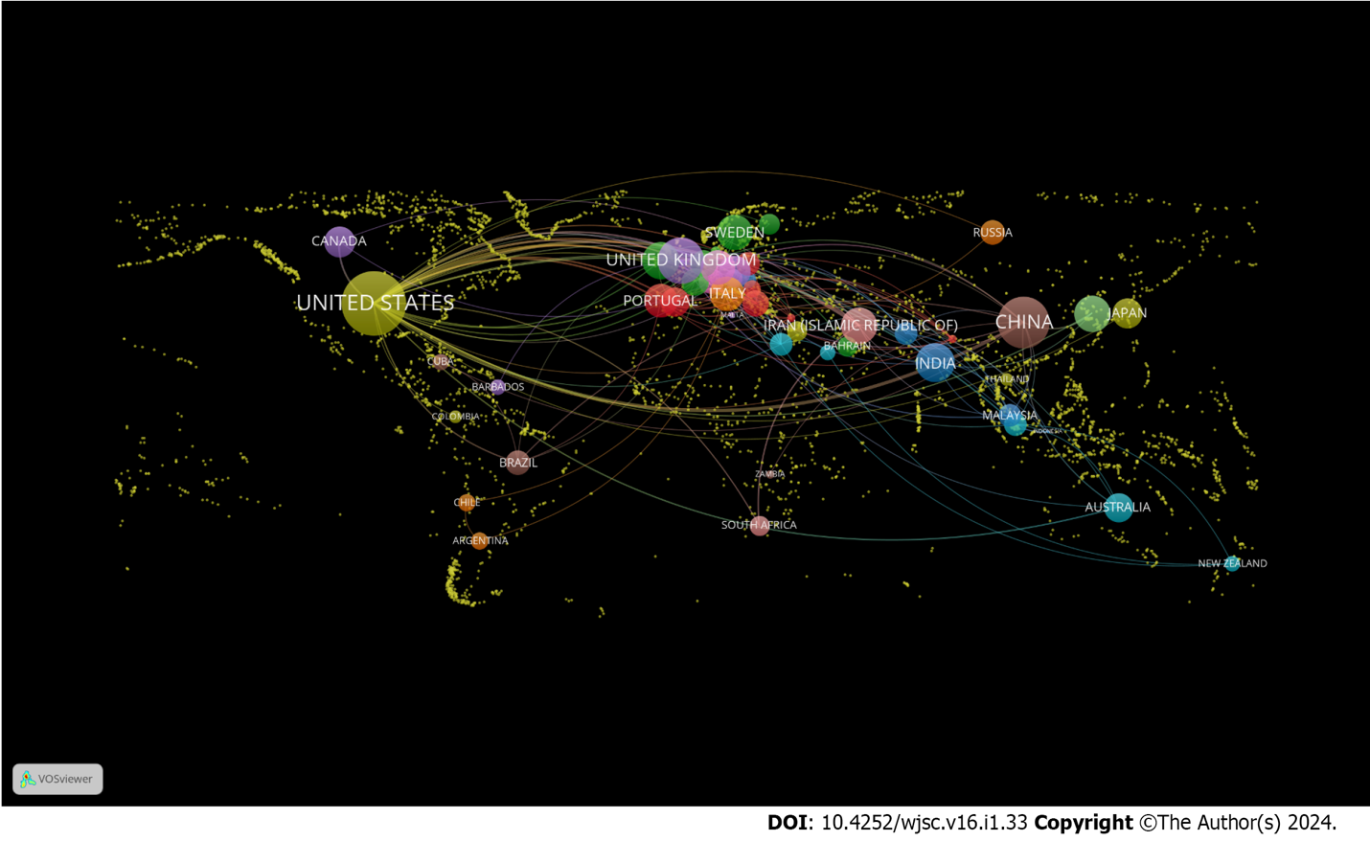
Figure 1 Geographical distribution of publications on stem cells in diabetic foot research.

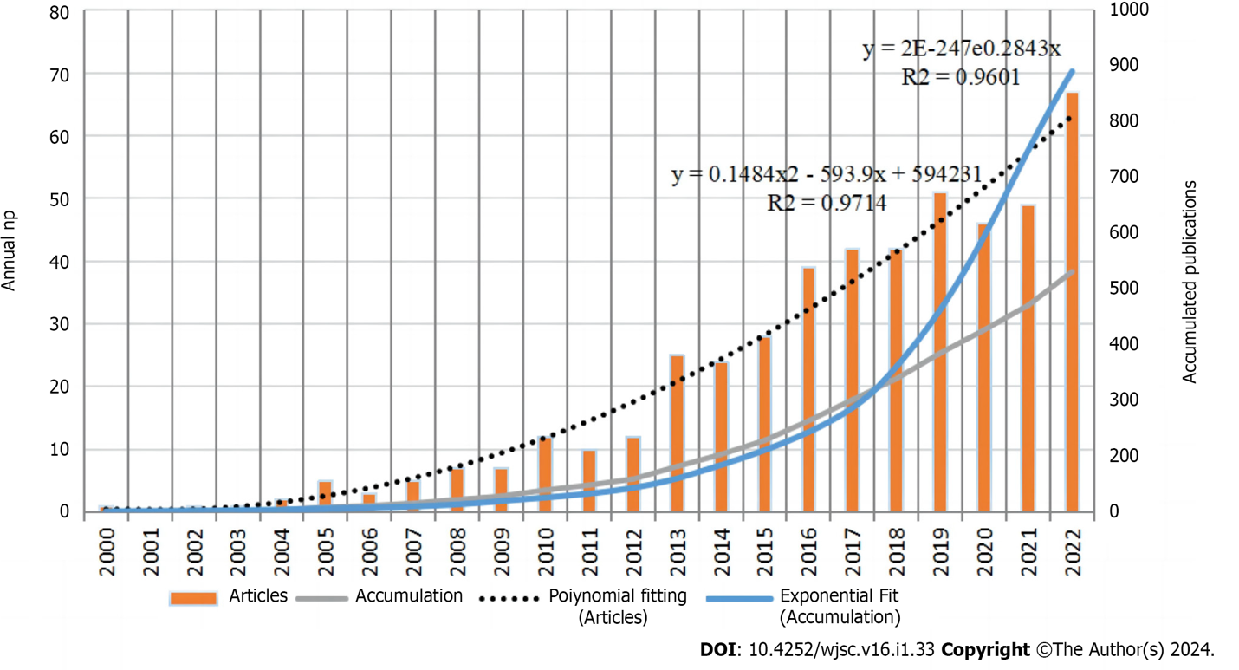
Figure 2 Publication count divided by year over the past 23 years. Np: Number of publications.

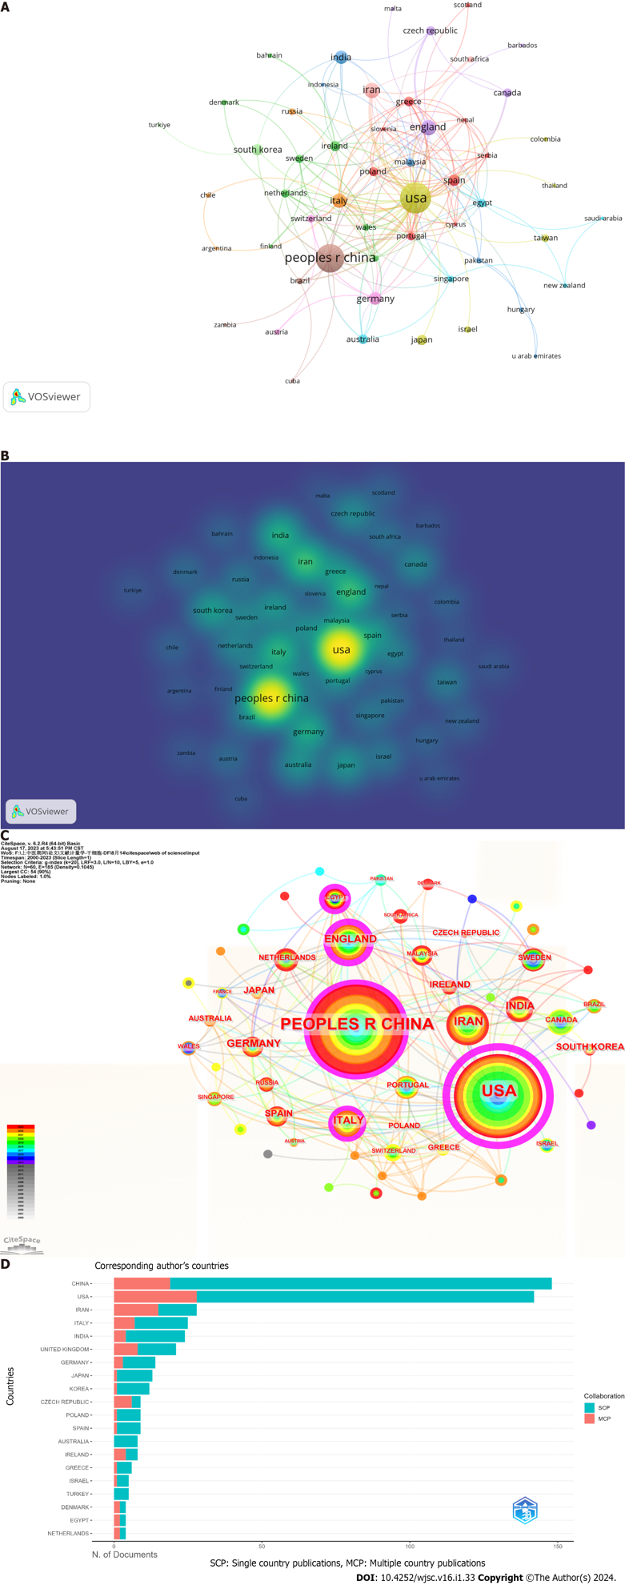
Figure 3 Contributions of different countries to research on stem cells in the diabetic foot field. A: Network visualization of country collaboration; B: Density map of cooperation between countries; C: A network diagram showing international collaborations, with purple circles representing intermediation centrality; D: Top 20 countries for corresponding authors. MCP: Multiple-country publications; SCP: Single-country publications.

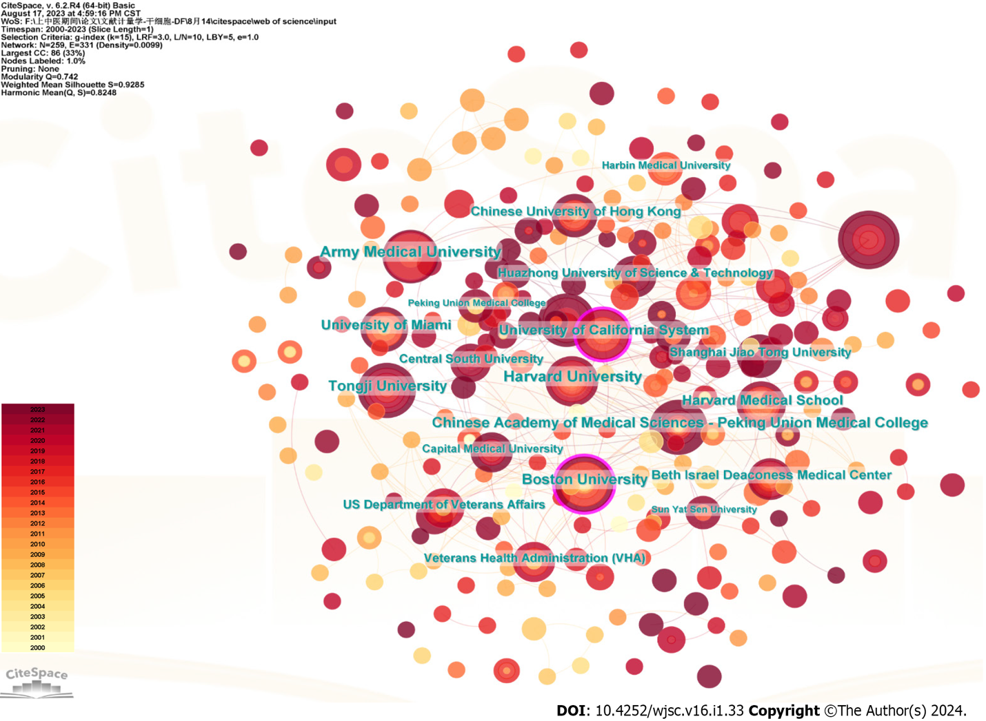
Figure 4 Institutional collaboration network diagram, with purple circles representing intermediation centrality.

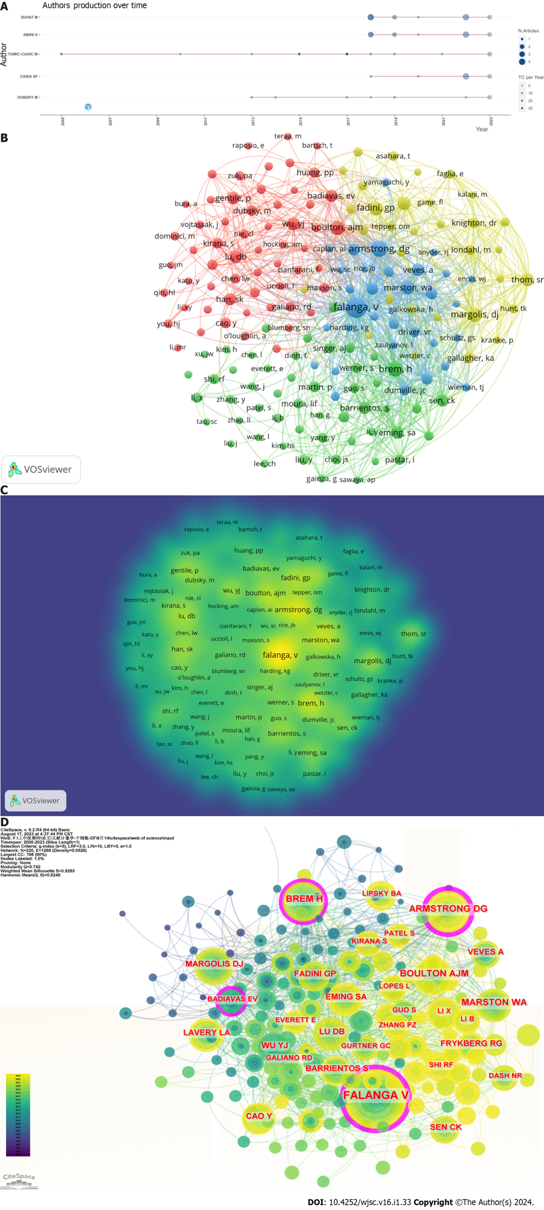
Figure 5 Contributions of different authors to research on stem cells in the diabetic foot field. A: Top 10 authors in terms of average publication count per year; B: Network visualization of country collaboration; C: Density map of cooperation between countries; D: Network diagram showing international collaborations, with purple circles representing intermediation centrality.

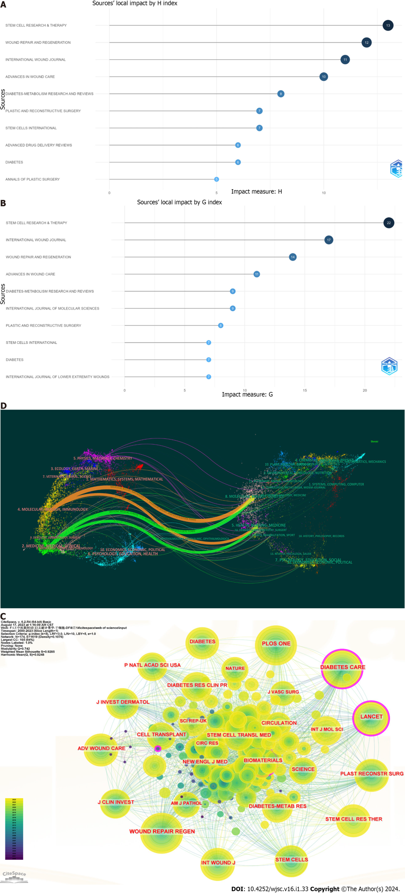
Figure 6 Contributions of different authors to research on stem cells in the diabetic foot field. A: Top 10 journals in terms of h-index; B: Top 10 journals in terms of g-index; C: CiteSpace visualization of cocited journals; D: Biplot overlay of journals on stem cells in the diabetic foot field (left side represents areas covered by citing journals, and the right side represents areas covered by cited journals).

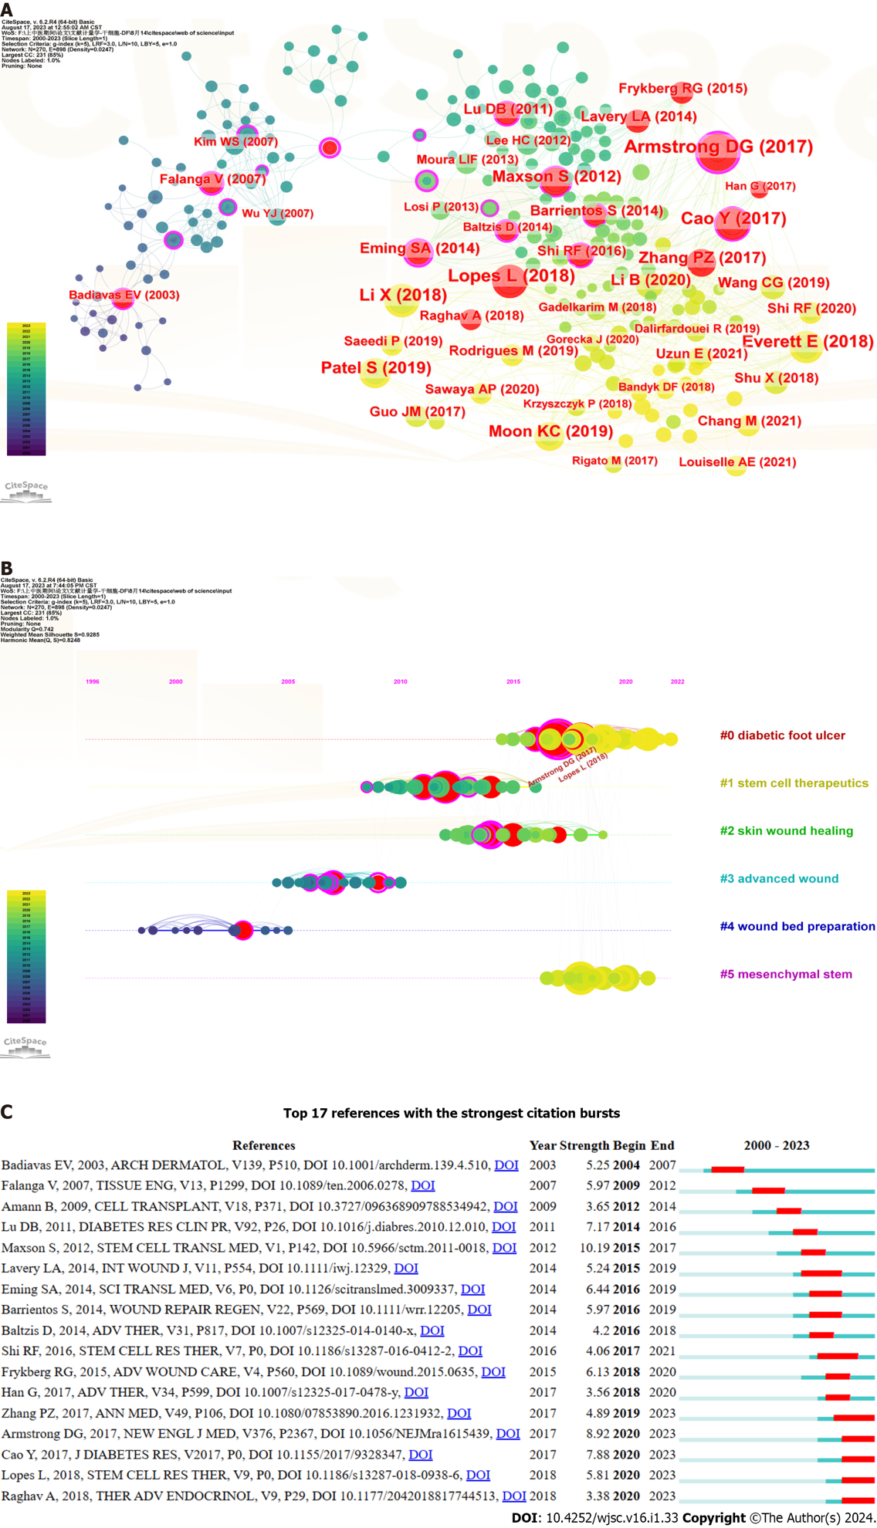
Figure 7 Analysis of cocited references. A: Visualization of cocited references. Nodes represent cocited references, with red circles representing citation bursts references; B: Timeline graph of cluster analysis; C: Top 17 references with the strongest citation bursts.

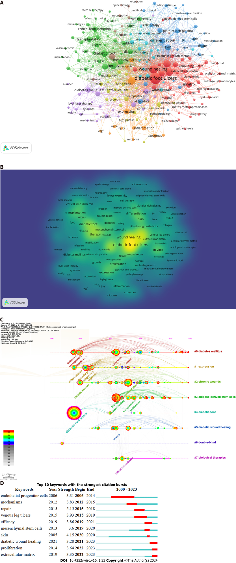
Figure 8 Analysis of keywords. A: Co-occurrence and clustering of keywords; B: Density map of keywords co-occurrence; C: Top 8 cluster timeline distributions; D: Top 17 cocited references with the most citation burstiness.
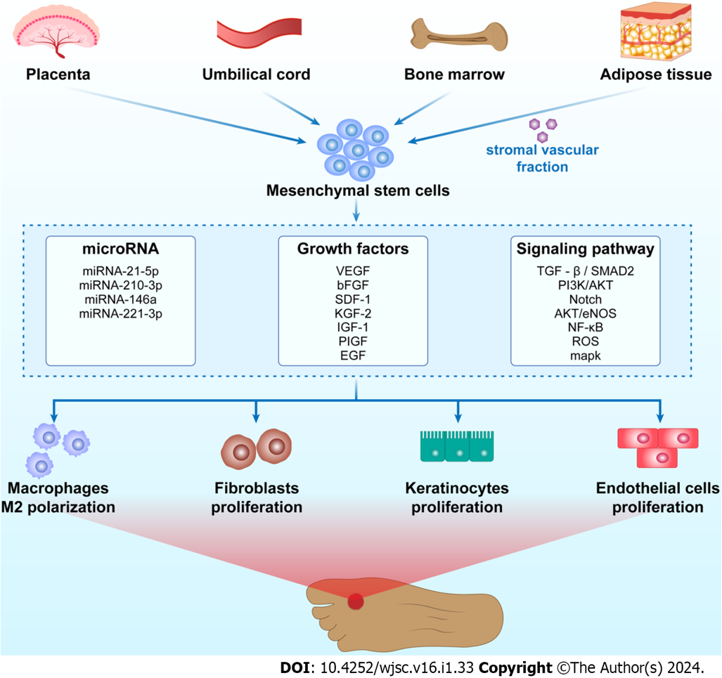
Figure 9 Mechanism diagram of stem cell research in the field of diabetic foot. bFGF: Basic fibroblast growth factor; EGF: Epidermal growth factor; eNOS: Endothelial nitric oxide synthase; IGF: Insulin-like growth factor; KGF: Keratinocyte growth factor; NF-κB: Nuclear factor-kappa B; PI3K: Phosphatidylinositol 3-kinase; PIGF: Phosphorylated insulin-like growth factor; ROS: Reactive oxygen species; SDF: Stromal cell derived factor; TGF-β: Transforming growth factor-β; VEGF: Vascular endothelial growth factor.

Table 1 Literature screening
Set | Publications | Screen
1 | 597 | Topic: (TS=("Stem Cells" OR "Cell, Stem" OR "Cells, Stem" OR "Stem Cell" OR "Progenitor Cells" OR "Cell, Progenitor" OR "Cells, Progenitor" OR "Progenitor Cell" OR "Mother Cells" OR "Cell, Mother" OR "Cells, Mother" OR "Mother Cell" OR "Colony-Forming Unit" OR "Colony Forming Unit" OR "Colony-Forming Units" OR "Colony Forming Units")) AND TS=(“Foot, Diabetic" OR "Diabetic Feet" OR "Feet, Diabetic" OR "Foot Ulcer, Diabetic" OR "Diabetic Foot")
2 | 547 | Types of publications: (ARTICLES OR REVIEWS)
3 | 543 | Languages of publications: (ENGLISH)

Table 2 Top 10 countries/regions with the highest research productivity
No. | Country | Np | Np, % | h-index | Nc | Nc, % | Centrality
1 | United States | 183 | 33.70 | 46 | 9663 | 44.84 | 0.83
2 | China | 152 | 27.99 | 32 | 3828 | 17.76 | 0.15
3 | Iran | 35 | 6.45 | 16 | 901 | 4.18 | 0.03
4 | England | 33 | 6.08 | 20 | 2449 | 11.36 | 0.23
5 | Italy | 28 | 5.16 | 14 | 721 | 3.35 | 0.17
6 | India | 25 | 4.60 | 11 | 1249 | 5.80 | 0.02
7 | Germany | 24 | 4.42 | 13 | 766 | 3.55 | 0.05
8 | South Korea | 16 | 2.95 | 11 | 953 | 4.42 | 0.06
9 | Spain | 16 | 2.95 | 8 | 362 | 1.68 | 0.02
10 | Ireland | 13 | 2.39 | 8 | 981 | 4.55 | 0.09
Np: Number of publications; Nc: Number of citations.

Table 3 Top 10 most productive affiliations
No. | Institutions | Country | Np | Np/N1, % | h-index | Nc | Nc, % | Centrality
1 | Shahid Beheshti University Medical Sciences | Iran | 13 | 2.39 | 8 | 241 | 0.01 | 0
2 | University of Louisville | United States | 12 | 2.21 | 7 | 160 | 0.01 | 0
3 | Army Medical University | China | 12 | 2.21 | 11 | 331 | 0.02 | 0
4 | Tongji University | China | 11 | 2.03 | 10 | 499 | 0.02 | 0.02
5 | Chinese Academy of Medical Sciences-Peking Union Medical College | China | 11 | 2.03 | 6 | 272 | 0.01 | 0.04
6 | Boston University | United States | 11 | 2.03 | 9 | 813 | 0.04 | 0.13
7 | University of California System | United States | 10 | 1.84 | 10 | 386 | 0.02 | 0.13
8 | Harvard University | United States | 10 | 1.84 | 12 | 909 | 0.04 | 0.06
9 | University of Miami | United States | 9 | 1.66 | 8 | 859 | 0.04 | 0
10 | Shanghai Jiao Tong University | China | 7 | 1.29 | 4 | 191 | 0.01 | 0.06
Np: Number of publications; Nc: Number of citations.

Table 4 Top 5 authors and cocited authors with the most publications
No. | Ref. | Np | h-index | Institution | Country | Cocited author | Centrality | Cocitation
1 | Bayat et al^{[28]} | 12 | 7 | Shahid Beheshti University of Medical Sciences | Iran | FALANGA V | 0.36 | 151
2 | Amini et al^{[29]} | 12 | 7 | Shahid Beheshti University of Medical Sciences | Iran | BREM H | 0.12 | 87
3 | Tomic-Canic et al^{[30]} | 12 | 3 | University of Miami | United States | ARMSTRONG DG | 0.21 | 86
4 | Veves et al^{[31]} | 6 | 7 | Harvard Medical School | United States | BOULTON AJM | 0.06 | 70
5 | Pastar et al^{[32]} | 4 | 6 | University of Miami | United States | MARSTON WA | 0.10 | 59
Np: Number of publications.

Table 5 Top 10 journals and cocited journals with the most publications
No. | Journal | Np | IF in 2020 | JCR | Cocited journal | Cocitation, % | IF in 2020 | JCR
1 | Stem Cell Research & Therapy | 22 | 7.5 | Q1 | Wound Repair and Regeneration | 1297 (27.79) | 2.9 | Q1
2 | International Wound Journal | 17 | 3.1 | Q2 | Diabetes Care | 951 (20.38) | 16.2 | Q1
3 | Wound Repair and Regeneration | 14 | 2.9 | Q1 | Biomaterials | 681 (14.59) | 14.0 | Q1
4 | Advances in Wound Care | 11 | 4.9 | Q1 | Journal of Investigative Dermatology | 668 (14.31) | 6.5 | Q1
5 | Diabetes-Metabolism Research and Reviews | 9 | 8.0 | Q2 | PLOS One | 626 (13.41) | 3.7 | Q2
6 | International Journal of Molecular Sciences | 9 | 5.6 | Q1 | Plastic and Reconstructive Surgery | 576 (12.34) | 3.6 | Q1
7 | Frontiers in Endocrinology | 8 | 5.2 | Q1 | International Wound Journal | 575 (12.32) | 3.1 | Q2
8 | Biomedicines | 8 | 4.7 | Q1 | Stem Cell Research & Therapy | 488 (10.46) | 7.5 | Q1
9 | Plastic and Reconstructive Surgery | 8 | 3.6 | Q1 | Stem Cells | 462 (9.90) | 5.2 | Q1
10 | Diabetes | 7 | 7.7 | Q1 | Advances in Wound Care | 457 (9.79) | 4.9 | Q1
IF: Impact factor; JCR: Journal Citation Reports; Np: Number of publications.

Table 6 Paths between citing journals and cited journals
No. | Journal | Cited journal | Path color
1 | MOLECULAR/BIOLOGY/IMMUNOLOGY | MOLECULAR/BIOLOGY/GENETICS | Orange
2 | MOLECULAR/BIOLOGY/IMMUNOLOGY | HEALTH/NURSING/MEDICINE | Orange
3 | MEDICINE/MEDICAL/CLINICAL | MOLECULAR/BIOLOGY/GENETICS | Green
4 | MEDICINE/MEDICAL/CLINICAL | HEALTH/NURSING/MEDICINE | Green

Table 7 Top 10 cocited references referring to cocitations
Ref. | Yr | Journal | DOI | Cocitations | Centrality
Armstrong et al^{[34]} | 2017 | New England Journal of Medicine | 10.1056/NEJMra1615439 | 32 | 0.42
Lopes et al^{[35]} | 2018 | Stem Cell Research & Therapy | 10.1186/s13287-018-0938-6 | 26 | 0.09
Li et al^{[61]} | 2018 | Experimental & Molecular Medicine | 10.1038/s12276-018-0058-5 | 25 | 0.02
Everett and Mathioudakis^{[62]} | 2018 | Annals of the New York Academy of Sciences | 10.1111/nyas.13569 | 25 | 0.09
Cao et al^{[63]} | 2017 | Journal of Diabetes Research | 10.1155/2017/9328347 | 23 | 0.10
Patel et al^{[64]} | 2019 | Biomedicine & Pharmacotherapy | 10.1016/j.biopha.2019.108615 | 22 | 0.04
Moon et al^{[65]} | 2019 | Diabetes | 10.2337/db18-0699 | 20 | 0.06
Maxson et al^{[38]} | 2012 | Stem Cells Translational Medicine | 10.5966/sctm.2011-0018 | 19 | 0.10
Zhang et al^{[39]} | 2017 | Annals of Medicine | 10.1080/07853890.2016.1231932 | 18 | 0.06
Li et al^{[66]} | 2020 | About Molecular Therapy—Nucleic Acids | 10.1016/j.omtn.2019.11.034 | 16 | 0.02

Table 8 Top 20 keywords based on their frequency
No. | Occurrence frequency | Centrality | Yr | Keywords | No. | Occurrence frequency | Centrality | Yr | Keywords
1 | 253 | 0.51 | 2004 | Diabetic foot ulcers | 11 | 47 | 0.04 | 2007 | Expression
2 | 119 | 0.04 | 2011 | Wound healing | 12 | 44 | 0.12 | 2005 | Chronic wounds
3 | 98 | 0.05 | 2013 | Mesenchymal stem cells | 13 | 40 | 0.02 | 2013 | Stem cells
4 | 78 | 0.04 | 2011 | Stem cells | 14 | 38 | 0.08 | 2004 | Diabetes mellitus
5 | 75 | 0.13 | 2006 | Angiogenesis | 15 | 37 | 0.03 | 2005 | Skin
6 | 71 | 0.06 | 2005 | Diabetic foot | 16 | 34 | 0.04 | 2012 | Critical limb ischemia
7 | 57 | 0.06 | 2011 | Therapy | 17 | 33 | 0.03 | 2011 | In vitro
8 | 55 | 0.09 | 2004 | Management | 18 | 32 | 0.02 | 2011 | Stromal cells
9 | 51 | 0.12 | 2006 | Endothelial progenitor cells | 19 | 31 | 0.03 | 2014 | Proliferation
10 | 48 | 0.05 | 2004 | Differentiation | 20 | 30 | 0.02 | 2011 | Foot ulcers

Published by Baishideng Publishing Group Inc
7041 Koll Center Parkway, Suite 160, Pleasanton, CA 94566, USA
Telephone: +1-925-3991568
E-mail: office@baishideng.com
Help Desk: https://www.f6publishing.com/helpdesk
https://www.wjgnet.com

© 2024 Baishideng Publishing Group Inc. All rights reserved.

