Name of Journal: World Journal of Gastroenterology
Manuscript NO: 89528
Manuscript Type: ORIGINAL ARTICLE

Retrospective Study
Predictive value of red blood cell distribution width and hematocrit for short-term outcomes and prognosis in colorectal cancer patients undergoing radical surgery

Peng D et al. Predictive value of RDW

Dong Peng, Zi-Wei Li, Fei Liu, Xu-Rui Liu, Chun-Yi Wang

Dong Peng, Zi-Wei Li, Fei Liu, Xu-Rui Liu, Chun-Yi Wang, Department of Gastrointestinal Surgery, The First Affiliated Hospital of Chongqing Medical University, Chongqing 400016, China

Co-first authors: Dong Peng and Zi-Wei Li.

Author contributions: Peng D and Li ZW have contributed equally to this work. Peng D and Li ZW wrote the original draft; all authors contributed to data collection; Peng D and Liu F contributed to the data analysis; Peng D and Liu XR led the quality assessments; Peng D, Li ZW, and Wang CY revised the manuscript; and all authors have agreed on the journal to which the manuscript will be submitted, gave final approval of the version to be published, and agree to be accountable for all aspects of the work.

Corresponding author: Chun-Yi Wang, MD, PhD, Professor, Department of Gastrointestinal Surgery, The First Affiliated Hospital of Chongqing Medical University, No. 1 Youyi Road, Yuanjiagang, Yuzhong District, Chongqing 400016, China. chunyiwangg@163.com

Received: November 4, 2023
Revised: December 26, 2023
Accepted: March 11, 2024
Published online:

Abstract
BACKGROUND
Previous studies have reported that low hematocrit levels indicate poor survival in patients with ovarian cancer and cervical cancer, the prognostic value of hematocrit for colorectal cancer (CRC) patients has not been determined. The prognostic value of red blood cell distribution width (RDW) for CRC patients was controversial.

AIM
To investigate the impact of RDW and hematocrit on the short-term outcomes and long-term prognosis of CRC patients who underwent radical surgery.

METHODS
Patients who were diagnosed with CRC and underwent radical CRC resection between January 2011 and January 2020 at a single clinical center were included. The short-term outcomes, overall survival (OS) and disease-free survival (DFS) were compared among the different groups. Cox analysis was also conducted to identify independent risk factors for OS and DFS.

RESULTS
There were 4258 CRC patients who underwent radical surgery included in our study. A total of 1573 patients were in the lower RDW group and 2685 patients were in the higher RDW group. There were 2166 and 2092 patients in the higher hematocrit group and lower hematocrit group, respectively. Patients in the higher RDW group had more intraoperative blood loss (P < 0.01) and more overall complications (P < 0.01) than did those in the lower RDW group. Similarly, patients in the lower hematocrit group had more intraoperative blood loss (P = 0.012), longer hospital stay (P = 0.016) and overall complications (P < 0.01) than did those in the higher hematocrit group. The higher RDW group had a worse OS and DFS than did the lower RDW group for tumor node metastasis (TNM) stage I (OS, P < 0.05; DFS, P = 0.001) and stage II (OS, P = 0.004; DFS, P = 0.01) than the lower RDW group; the lower hematocrit group had worse OS and DFS for TNM stage II (OS, P < 0.05; DFS, P = 0.001) and stage III (OS, P = 0.001; DFS, P = 0.001) than did the higher hematocrit group. Preoperative hematocrit was an independent risk factor for OS [P = 0.017, hazard ratio (HR) = 1.256, 95% confidence interval (CI): 1.041-1.515] and DFS (P = 0.035, HR = 1.194, 95%CI: 1.013-1.408).

CONCLUSION
A higher preoperative RDW and lower hematocrit were associated with more postoperative complications. However, only hematocrit was an independent risk factor for OS and DFS in CRC patients who underwent radical surgery, while RDW was not.

Key Words: Colorectal cancer; Red blood cell distribution width; Survival; Short-term outcomes

Peng D, Li ZW, Liu F, Liu XR, Wang CY. Predictive value of red blood cell distribution width and hematocrit for short-term outcomes and prognosis in colorectal cancer patients undergoing radical surgery. World J Gastroenterol 2024; In press

Core Tip: This was the first study to show that low hematocrit could predict worse overall survival and disease-free survival in colorectal cancer (CRC) patients who underwent radical surgery. This study investigated the association between red blood cell distribution width (RDW) or hematocrit and short-term outcomes in CRC patients, which has rarely been reported previously. In conclusion, a preoperative higher RDW and lower hematocrit were associated with more postoperative complications.

INTRODUCTION
According to global cancer statistics^{[1]}, there were approximately 1.93 million new cases and 0.94 million deaths from colorectal cancer (CRC) worldwide in 2020, and the incidence of this disease was estimated to increase in the next decade^{[2,3]}; additionally, CRC will impose a heavy burden on the economy^{[4]}. Radical surgery is the most important treatment for CRC patients^{[5-7]}; however, many patients suffer from postoperative complications and reoccurrence after surgery. To improve the prognosis of CRC patients after surgery, various risk factors for postoperative complications and long-term prognosis have been were identified^{[8,9]}. Many hematological indicators, such as hemoglobin^{[10,11]}, platelet counts^{[12,13]}, and the neutrophil-to-lymphocyte ratio^{[14,15]}, have also been identified because of the convenience of easy access and low cost.
The red blood cell distribution width (RDW) reflects the degree of variation in erythrocyte volume and is usually used to identify different types of anemia^{[16,17]}. Several studies have demonstrated that RDW plays a diagnostic role in CRC patients^{[18-20]}; moreover, many scholars have found that a high RDW is a negative predictor of overall survival (OS) and disease-free survival (DFS) independently^{[21-25]}. The underlying mechanisms are mainly associated with tumor-related chronic inflammation and malnutrition, which accelerate tumor progression while affecting iron metabolism and suppressing the production of red blood cells, further leading to a high RDW. However, a previous study showed the opposite results: RDW was not an independent risk factor^{[26]}. As a result, the prognostic value of RDW for CRC patients is controversial. In addition, few studies have focused on the impact of RDW on the short-term outcomes in CRC patients after radical surgery^{[27]}.
Since tumor-related chronic inflammation could lead to high RDWs, we suspected that hematocrit, another indicator of anemia, might also be related to the prognosis of CRC patients. Although previous studies have reported that low hematocrit levels indicate poor survival in patients with ovarian cancer^{[28]} and cervical cancer^{[29]}, the prognostic value of hematocrit for CRC patients has not been determined. Therefore, this study was to explore the effect of RDW and hematocrit on the outcomes of CRC patients who underwent radical surgery.

MATERIALS AND METHODS
Patients
Patients who were diagnosed with CRC and underwent radical CRC resection were included from January 2011 to January 2020 in our single clinical center. The study was approved by the ethics committee of the First Affiliated Hospital of Chongqing Medical University (2022-K205), and all patients signed informed consent forms. This study was conducted in accordance with the World Medical Association Declaration of Helsinki as well.

Inclusion and exclusion criteria
CRC patients who underwent radical CRC surgery were included (n = 5473). The exclusion criteria were as follows: (1) Non-R0 surgery (n = 25); (2) Incomplete clinical data (n = 849); (3) Incomplete RDW or hematocrit (n = 340); and (4) Patients with preoperative chemotherapy or radiotherapy (n = 41). Finally, a total of 4258 CRC patients were included in this study (Figure 1).

Data collection
The baseline characteristics collected were as follows: Age, sex, body mass index (BMI), smoking, drinking, hypertension, type 2 diabetes mellitus (T2DM), coronary heart disease (CHD), surgical method, tumor location, tumor node metastasis (TNM) stage and tumor size. The short-term outcomes included operation time, intra-operative blood loss, postoperative hospital stay, overall complications and major complications. The long-term prognosis was estimated by OS and DFS. All the data were collected from electronic medical record system, outpatient visit and telephone interviews.

Definitions
Based on the AJCC 8th Edition, we identified the TNM stage^{[30]}. The postoperative complications were classified on the basis of the Clavien-Dindo^{[31]} classification and major complications were ≥ grade III. OS was defined as the time from surgery to death or lost follow-up and DFS was calculated from the date of surgery to the date of recurrence or death.

Treatment and follow-up
All patients underwent radical surgery according to standard principles and R0 resection was confirmed by pathology. Patients were regularly followed up every six months in the first three years and every year in the next years.

Optimal cut-off and groups
The RDW and hematocrit were tested within a week before surgery. The value of RDW and hematocrit was expressed as a percentage. We used X-tile software to identify the optimal cut-off^{[32]}. The optimal cut-off values for RDW and hematocrit were 14.4 and 37.7, respectively. Accordingly, patients were divided into the higher RDW group (RDW > 14.4) and the lower RDW group (RDW ≤ 14.4) as well as the higher hematocrit group (hematocrit > 37.7) and the lower hematocrit group (hematocrit ≤ 37.7).

Statistical analysis
An independent-sample t-test was used to compare the difference continuous variables that were expressed as the mean ± SD. χ² tests or Fisher’s exact tests were used for categorical variables that were expressed as absolute values and percentages. Based on the Kaplan-Meier method, we estimated OS and DFS. In order to compare the OS and DFS between the different groups at different tumor stages, we used log-rank test. To determine independent risk factors for overall complications, logistic regression analysis was conducted. Analysis of Cox regression was conducted to identify independent risk factors for OS and DFS. Statistical significance was determined by a bilateral P value less than 0.05 using SPSS (version 22.0).

RESULTS
Patients
There were 4258 CRC patients who underwent radical surgery included in our study. Patients were divided into different groups according to the optimal cutoff values for RDW and hematocrit. There were 1573 patients in the lower RDW group and 2685 patients in the higher RDW group. The higher RDW group was older (P < 0.01), more likely to be female (P < 0.01), had a lower BMI (P < 0.01), a lower percentage of alcohol consumption (P < 0.01), a higher incidence of T2DM (P = 0.035) and CHD (P < 0.01), and a greater incidence of open surgery (P < 0.01), colon cancer (P < 0.01), TNM stage II (P < 0.01), TNM stage IV (P < 0.01), and tumor size ≥ 5 cm (P < 0.01) (Table 1).
After grouping patients according to hematocrit, there were respectively 2166 and 2092 patients in the higher hematocrit group and lower hematocrit group, respectively. The lower hematocrit group was older (P < 0.01); was more likely to be female (P < 0.01); had a lower BMI (P < 0.01); had a lower rate of smoking (P < 0.01) and drinking (P < 0.01), and had a higher incidence of T2DM (P < 0.01), CHD (P < 0.01), open surgery (P < 0.01), colon cancer (P < 0.01), or TNM stage II-IV (P < 0.01) (Table 2).

Short-term outcomes
Patients in the higher RDW group had greater intraoperative blood loss (P < 0.01) and more overall complications (P < 0.01) than did those in the lower RDW group. Similarly, patients in the lower hematocrit group had more intraoperative blood loss (P = 0.012), longer hospital stays (P = 0.016) and more overall complications (P < 0.01) than did those in the higher hematocrit group (Tables 1 and 2).
Multivariate logistic regression analysis of the overall complications showed that age [P < 0.01, odds ratio (OR) = 1.018, 95% confidence interval (CI): 1.011-1.025], T2DM (P = 0.018, OR = 1.297, 95%CI: 1.045-1.610), smoking (P = 0.004, OR = 1.255, 95%CI: 1.075-1.464), and open surgery (P < 0.01, OR = 2.056, 95%CI: 1.691-2.500) were independent risk factors. However, RDW (P > 0.05) and hematocrit (P > 0.05) were not identified as independent indicators of overall complications (Table 3).

Kaplan-Meier curves for patients in different tumor stages
By observing OS and DFS, the median follow-up time was 35 (1-114) months. Comparing OS and DFS between the higher RDW group and the lower RDW group as well as between the higher hematocrit group and the lower hematocrit group at different TNM stages. The results showed that the higher RDW group had worse OS (Figure 2) and DFS (Figure 3) than did the lower RDW group for TNM stage I (OS, P < 0.05; DFS, P = 0.001) and stage II (OS, P = 0.004; DFS, P = 0.01); moreover, the lower RDW group; the lower hematocrit group had worse OS (Figure 4) and DFS (Figure 5) for TNM stage II (OS, P < 0.05; DFS, P = 0.001) and stage III (OS, P = 0.001; DFS, P = 0.001) than did the higher hematocrit group.

Analysis of Cox regression for OS and DFS
To determine independent risk factors for OS and DFS, Cox analysis was conducted. Independent risk factors for OS included age [P < 0.01, hazard ratio (HR) = 1.038, 95%CI: 1.030-1.046], tumor stage (P < 0.01, HR = 2.167, 95%CI: 1.943-2.416), tumor size (P = 0.014, HR = 1.235, 95%CI: 1.044-1.459), preoperative hematocrit (P = 0.017, HR = 1.256, 95%CI: 1.041-1.515) and overall complications (P < 0.01, HR = 1.608, 95%CI: 1.357-1.904) ; Independent risk factors for DFS included age (P < 0.01, HR = 1.027, 95%CI: 1.020-1.033), tumor stage (P < 0.01, HR = 2.093, 95%CI: 1.900-2.307), preoperative hematocrit (P = 0.035, HR = 1.194, 95%CI: 1.013-1.408) and overall complications (P < 0.01, HR = 1.510, 95%CI: 1.293-1.763). However, RDW was not an independent risk factor for OS (P = 0.396) or DFS (P = 0.308) (Tables 4 and 5).

DISCUSSION
In this retrospective study, 4258 CRC patients who underwent radical surgery were divided into different groups according to the optimal cutoff values for RDW and hematocrit. The prognostic value of the RDM and hematocrit for the short-term outcomes and prognosis (including OS and DFS) was investigated.
In terms of short-term outcomes, previous studies have reported that RDW and hematocrit could predict postoperative complications in brain surgery^{[33]}, cardiac surgery^{[34,35]} and so on, but few studies have focused on CRC patients. In our study, we found that a higher RDW and lower hematocrit were associated with greater intraoperative blood loss and more postoperative complications. Nevertheless, neither RDW nor hematocrit was an independent risk factor for overall complications. However, further studies are needed to validate the roles of RDW and hematocrit in determining surgical complications in CRC patients.
Many studies have shown that RDW is a predictor of the long-term prognosis of CRC patients. Several researchers have conducted a propensity matching score of 5135 CRC patients and found that patients with higher RDWs had worse OS and DFS^{[21]}. However, the study enrolled only patients with TNM stage I-II disease, and multivariate analysis was lacking. One study reported that RDW was a negative predictor of OS and DFS in patients with TNM stage I-III disease^{[22]}, and another study reported that found preoperative RDW could predict the OS^{[24]}; however, the sample sizes of these studies were relatively small, and many confounding factors, such as T2DM and CHD, were missed, which might cause bias. Furthermore, a study of 591 patients revealed that a higher RDW was associated with worse OS in patients with TNM stage I disease; however, RDW was not an independent risk factor^{[25]}.
Most studies have attributed the prognostic value of RDW to tumor-related chronic inflammation^{[25,36,37]}. Tumor development of tumor, reoccurrence, and metastasis have been shown to interact with the systemic inflammatory response^{[38]}, and the latter is associated with overproduction of cytokines such as interleukins and tumor necrosis factor, which might influence iron metabolism and suppress the production of red blood cells^{[39]}. Thus, RDW might represent systemic inflammation and tumor burden. In our study, although the higher RDW group had significantly worse OS and DFS than did the lower RDW group for TNM stage I and stage II disease, RDW could not predict the OS or DFS independently, which was similar to the conclusion conclusions of previous studies^{[26]}.
In contrast, we found that low hematocrit could predict worse OS and DFS in CRC patients after radical surgery. In our study, patients with stage II-III disease were more likely to have worse OS and DFS. The predictive value of hematocrit has been reported for gynaecological tumours^{[28,29]} and renal carcinoma^{[40]}, but the underlying mechanism has remained unclear. The hematocrit was used to measure the volume of red blood cells in whole blood and estimate the oxygen-carrying ability of blood, and a lower hematocrit often indicated anemia. It was also demonstrated that anemia was associated with worse survival in CRC patients after surgery^{[41,42]} because anemia could cause hypoxia, which might promote tumor development^{[43]}. Moreover, the relationship between anemia and tumor-related chronic inflammation, as mentioned above, might further explain the prognostic value of hematocrit.
Interestingly, although both RDW and hematocrit are hematocrit were erythrocyte-related parameters and reflect the status of anemia, we found that hematocrit was an independent risk factor for OS and DFS, while RDW was not. In addition to the bias caused by our research design, there might be several unknown mechanisms that need to be further investigated.
To our knowledge, this was the first study to show that low hematocrit could predict worse OS and DFS in CRC patients after radical surgery. A relatively large sample size of 4258 patients were included in this study. Moreover, we investigated the association between RDW or hematocrit and short-term outcomes in CRC patients, which has rarely been reported previously. This study has several limitations. First, the retrospective nature of this single-center study might cause inaccurate baseline information and bias. Second, chemotherapy information was lacking for TNM III-IV patients, which might affect the analysis of the survival. Therefore, there is a need for multicenter prospective studies to further examine the prognostic role of RDW and hematocrit.

CONCLUSION
In conclusion, a preoperative higher RDW and lower hematocrit were associated with more postoperative complications. However, only hematocrit was an independent risk factor for OS and DFS in CRC patients who underwent radical surgery, while RDW was not.

ARTICLE HIGHLIGHTS
Research background
The prognostic value of red blood cell distribution width (RDW) for colorectal cancer (CRC) patients is controversial and the prognostic value of hematocrit for CRC patients has not been determined.

Research motivation
This was the first study to show that low hematocrit could predict worse overall survival (OS) and disease-free survival (DFS) in CRC patients after radical surgery.

Research objectives
The objective of this study was to explore the effect of RDW and hematocrit on the outcomes of CRC patients who underwent radical surgery.

Research methods
Patients who were diagnosed with CRC and underwent radical CRC resection between January 2011 and January 2020 at a single clinical center were included. An independent-sample t-test was used to compare the difference continuous variables that were expressed as the mean ± SD. χ² tests or Fisher’s exact tests were used for categorical variables that were expressed as absolute values and percentages. The short-term outcomes, OS and DFS were compared among the different groups. To determine independent risk factors for overall complications, logistic regression analysis was conducted. Analysis of Cox regression was conducted to identify independent risk factors for OS and DFS.

Research results
There were 4258 CRC patients who underwent radical surgery included in our study. The higher RDW group had a worse OS and DFS than did the lower RDW group for tumor node metastasis (TNM) stage I (OS, P < 0.05; DFS, P = 0.001) and stage II (OS, P = 0.004; DFS, P = 0.01) than the lower RDW group; the lower hematocrit group had worse OS and DFS for TNM stage II (OS, P < 0.05; DFS, P = 0.001) and stage III (OS, P = 0.001; DFS, P = 0.001) than did the higher hematocrit group. RDW (P > 0.05) and hematocrit (P > 0.05) were not identified as independent indicators of overall complications. Preoperative hematocrit was an independent risk factor for OS [P = 0.017, hazard ratio (HR) = 1.256, 95% confidence interval (CI): 1.041-1.515] and DFS (P = 0.035, HR = 1.194, 95%CI: 1.013-1.408). However, RDW was not an independent risk factor for OS (P = 0.396) or DFS (P = 0.308).

Research conclusions
This was the first study to show that low hematocrit could predict worse OS and DFS in CRC patients after radical surgery. A preoperative higher RDW and lower hematocrit were associated with more postoperative complications. However, only hematocrit was an independent risk factor for OS and DFS in CRC patients who underwent radical surgery, while RDW was not.

Research perspectives
Further multicenter prospective studies are needed to investigate the prognostic role of RDW and hematocrit.

ACKNOWLEDGEMENTS
We acknowledge all the authors whose publications are referred in our article.

REFERENCES
1 Sung H, Ferlay J, Siegel RL, Laversanne M, Soerjomataram I, Jemal A, Bray F. Global Cancer Statistics 2020: GLOBOCAN Estimates of Incidence and Mortality Worldwide for 36 Cancers in 185 Countries. CA Cancer J Clin 2021; 71: 209-249 [PMID: 33538338 DOI: 10.3322/caac.21660]
2 Hossain MS, Karuniawati H, Jairoun AA, Urbi Z, Ooi J, John A, Lim YC, Kibria KMK, Mohiuddin AKM, Ming LC, Goh KW, Hadi MA. Colorectal Cancer: A Review of Carcinogenesis, Global Epidemiology, Current Challenges, Risk Factors, Preventive and Treatment Strategies. Cancers (Basel) 2022; 14 [PMID: 35406504 DOI: 10.3390/cancers14071732]
3 Cheng YX, Tao W, Liu XY, Yuan C, Zhang B, Wei ZQ, Peng D. Hypertension Remission after Colorectal Cancer Surgery: A Single-Center Retrospective Study. Nutr Cancer 2022; 74: 2789-2795 [PMID: 34994247 DOI: 10.1080/01635581.2021.2025256]
4 Yang Y, Han Z, Li X, Huang A, Shi J, Gu J. Epidemiology and risk factors of colorectal cancer in China. Chin J Cancer Res 2020; 32: 729-741 [PMID: 33446996 DOI: 10.21147/j.issn.1000-9604.2020.06.06]
5 Hashiguchi Y, Muro K, Saito Y, Ito Y, Ajioka Y, Hamaguchi T, Hasegawa K, Hotta K, Ishida H, Ishiguro M, Ishihara S, Kanemitsu Y, Kinugasa Y, Murofushi K, Nakajima TE, Oka S, Tanaka T, Taniguchi H, Tsuji A, Uehara K, Ueno H, Yamanaka T, Yamazaki K, Yoshida M, Yoshino T, Itabashi M, Sakamaki K, Sano K, Shimada Y, Tanaka S, Uetake H, Yamaguchi S, Yamaguchi N, Kobayashi H, Matsuda K, Kotake K, Sugihara K; Japanese Society for Cancer of the Colon and Rectum. Japanese Society for Cancer of the Colon and Rectum (JSCCR) guidelines 2019 for the treatment of colorectal cancer. Int J Clin Oncol 2020; 25: 1-42 [PMID: 31203527 DOI: 10.1007/s10147-019-01485-z]
6 Peng D, Liu XY, Cheng YX, Tao W, Cheng Y. Improvement of Diabetes Mellitus After Colorectal Cancer Surgery: A Retrospective Study of Predictive Factors For Type 2 Diabetes Mellitus Remission and Overall Survival. Front Oncol 2021; 11: 694997 [PMID: 34295822 DOI: 10.3389/fonc.2021.694997]
7 Grosek J, Ales Kosir J, Sever P, Erculj V, Tomazic A. Robotic versus laparoscopic surgery for colorectal cancer: a case-control study. Radiol Oncol 2021; 55: 433-438 [PMID: 34051705 DOI: 10.2478/raon-2021-0026]
8 Peng D, Cheng YX, Cheng Y. Improved Overall Survival of Colorectal Cancer under Multidisciplinary Team: A Meta-Analysis. Biomed Res Int 2021; 2021: 5541613 [PMID: 33997003 DOI: 10.1155/2021/5541613]
9 Cheng YX, Tao W, Zhang H, Peng D, Wei ZQ. Does liver cirrhosis affect the surgical outcome of primary colorectal cancer surgery? A meta-analysis. World J Surg Oncol 2021; 19: 167 [PMID: 34107967 DOI: 10.1186/s12957-021-02267-6]
10 Dagmura H, Daldal E, Okan I. The Efficacy of Hemoglobin, Albumin, Lymphocytes, and Platelets as a Prognostic Marker for Survival in Octogenarians and Nonagenarians Undergoing Colorectal Cancer Surgery. Cancer Biother Radiopharm 2022; 37: 955-962 [PMID: 34077677 DOI: 10.1089/cbr.2020.4725]
11 Jiang H, Li H, Li A, Tang E, Xu D, Chen Y, Zhang Y, Tang M, Zhang Z, Deng X, Lin M. Preoperative combined hemoglobin, albumin, lymphocyte and platelet levels predict survival in patients with locally advanced colorectal cancer. Oncotarget 2016; 7: 72076-72083 [PMID: 27765916 DOI: 10.18632/oncotarget.12271]
12 Wallace K, Li H, Brazeal JG, Lewin DN, Sun S, Ba A, Paulos CM, Rachidi S, Li Z, Alekseyenko AV. Platelet and hemoglobin count at diagnosis are associated with survival in African American and Caucasian patients with colorectal cancer. Cancer Epidemiol 2020; 67: 101746 [PMID: 32521488 DOI: 10.1016/j.canep.2020.101746]
13 Erstad DJ, Taylor MS, Qadan M, Axtell AL, Fuchs BC, Berger DL, Clancy TE, Tanabe KK, Chang DC, Ferrone CR. Platelet and neutrophil to lymphocyte ratios predict survival in patients with resectable colorectal liver metastases. Am J Surg 2020; 220: 1579-1585 [PMID: 32580870 DOI: 10.1016/j.amjsurg.2020.05.003]
14 Li Y, Xu T, Wang X, Jia X, Ren M, Wang X. The prognostic utility of preoperative neutrophil-to-lymphocyte ratio (NLR) in patients with colorectal liver metastasis: a systematic review and meta-analysis. Cancer Cell Int 2023; 23: 39 [PMID: 36855112 DOI: 10.1186/s12935-023-02876-z]
15 Cui M, Xu R, Yan B. A persistent high neutrophil-to-lymphocyte ratio predicts poor prognosis in patients with colorectal cancer undergoing resection. Mol Clin Oncol 2020; 13: 63 [PMID: 32963782 DOI: 10.3892/mco.2020.2133]
16 Wang PF, Song SY, Guo H, Wang TJ, Liu N, Yan CX. Prognostic role of pretreatment red blood cell distribution width in patients with cancer: A meta-analysis of 49 studies. J Cancer 2019; 10: 4305-4317 [PMID: 31413750 DOI: 10.7150/jca.31598]
17 Saito H, Shimizu S, Shishido Y, Miyatani K, Matsunaga T, Fujiwara Y. Prognostic significance of the combination of preoperative red cell distribution width and platelet distribution width in patients with gastric cancer. BMC Cancer 2021; 21: 1317 [PMID: 34879841 DOI: 10.1186/s12885-021-09043-5]
18 Yang D, Quan W, Wu J, Ji X, Dai Y, Xiao W, Chew H, Sun Z, Li D. The value of red blood cell distribution width in diagnosis of patients with colorectal cancer. Clin Chim Acta 2018; 479: 98-102 [PMID: 29407693 DOI: 10.1016/j.cca.2018.01.022]
19 Shi C, Xie M, Li L, Li K, Hu BL. The association and diagnostic value of red blood cell distribution width in colorectal cancer. Medicine (Baltimore) 2019; 98: e15560 [PMID: 31083220 DOI: 10.1097/MD.0000000000015560]
20 Huang J, Zhao Y, Liao L, Liu S, Lu S, Wu C, Wei C, Xu S, Zhong H, Liu J, Guo Y, Zhang S, Gao F, Tang W. Evaluation of Red Cell Distribution Width to Lymphocyte Ratio as Potential Biomarker for Detection of Colorectal Cancer. Biomed Res Int 2019; 2019: 9852782 [PMID: 31467924 DOI: 10.1155/2019/9852782]
21 Cheng KC, Lin YM, Liu CC, Wu KL, Lee KC. High Red Cell Distribution Width Is Associated with Worse Prognosis in Early Colorectal Cancer after Curative Resection: A Propensity-Matched Analysis. Cancers (Basel) 2022; 14 [PMID: 35205691 DOI: 10.3390/cancers14040945]
22 Zhang X, Wu Q, Hu T, Gu C, Bi L, Wang Z. Elevated red blood cell distribution width contributes to poor prognosis in patients undergoing resection for nonmetastatic rectal cancer. Medicine (Baltimore) 2018; 97: e9641 [PMID: 29504998 DOI: 10.1097/MD.0000000000009641]
23 Virdee PS, Marian IR, Mansouri A, Elhussein L, Kirtley S, Holt T, Birks J. The Full Blood Count Blood Test for Colorectal Cancer Detection: A Systematic Review, Meta-Analysis, and Critical Appraisal. Cancers (Basel) 2020; 12 [PMID: 32825191 DOI: 10.3390/cancers12092348]
24 Kust D, Lucijanic M, Urch K, Samija I, Celap I, Kruljac I, Prpic M, Lucijanic I, Matesa N, Bolanca A. Clinical and prognostic significance of anisocytosis measured as a red cell distribution width in patients with colorectal cancer. QJM 2017; 110: 361-367 [PMID: 28069908 DOI: 10.1093/qjmed/hcw223]
25 Li Y, Xing C, Wei M, Wu H, Hu X, Li S, Sun G, Zhang G, Wu B, Zhang F, Li Z. Combining Red Blood Cell Distribution Width (RDW-CV) and CEA Predict Poor Prognosis for Survival Outcomes in Colorectal Cancer. J Cancer 2019; 10: 1162-1170 [PMID: 30854125 DOI: 10.7150/jca.29018]
26 Pedrazzani C, Tripepi M, Turri G, Fernandes E, Scotton G, Conci S, Campagnaro T, Ruzzenente A, Guglielmi A. Prognostic value of red cell distribution width (RDW) in colorectal cancer. Results from a single-center cohort on 591 patients. Sci Rep 2020; 10: 1072 [PMID: 31974409 DOI: 10.1038/s41598-020-57721-4]
27 Pilling LC, Atkins JL, Kuchel GA, Ferrucci L, Melzer D. Red cell distribution width and common disease onsets in 240,477 healthy volunteers followed for up to 9 years. PLoS One 2018; 13: e0203504 [PMID: 30212481 DOI: 10.1371/journal.pone.0203504]
28 Chen J, Li Y, Cui H. Preoperative low hematocrit is an adverse prognostic biomarker in ovarian cancer. Arch Gynecol Obstet 2021; 303: 767-775 [PMID: 33011886 DOI: 10.1007/s00404-020-05822-w]
29 Deng Q, Long Q, Liu Y, Yang Z, Du Y, Chen X. Prognostic value of preoperative peripheral blood mean platelet volume/platelet count ratio (MPV/PC) in patients with resectable cervical cancer. BMC Cancer 2021; 21: 1282 [PMID: 34844568 DOI: 10.1186/s12885-021-09016-8]
30 Weiser MR. AJCC 8th Edition: Colorectal Cancer. Ann Surg Oncol 2018; 25: 1454-1455 [PMID: 29616422 DOI: 10.1245/s10434-018-6462-1]
31 Clavien PA, Barkun J, de Oliveira ML, Vauthey JN, Dindo D, Schulick RD, de Santibañes E, Pekolj J, Slankamenac K, Bassi C, Graf R, Vonlanthen R, Padbury R, Cameron JL, Makuuchi M. The Clavien-Dindo classification of surgical complications: five-year experience. Ann Surg 2009; 250: 187-196 [PMID: 19638912 DOI: 10.1097/SLA.0b013e3181b13ca2]
32 Camp RL, Dolled-Filhart M, Rimm DL. X-tile: a new bio-informatics tool for biomarker assessment and outcome-based cut-point optimization. Clin Cancer Res 2004; 10: 7252-7259 [PMID: 15534099 DOI: 10.1158/1078-0432.CCR-04-0713]
33 Flanagan LS, Choi CB, Lemdani MS, Shah A, Parray A, Sukyte-Raube D, Fang CH, Baredes S, Eloy JA. Complication Risk in Ventral Skull Base Surgery Based on Preoperative Hematocrit. Laryngoscope 2022; 132: 1707-1713 [PMID: 34643275 DOI: 10.1002/lary.29893]
34 Liao Y, Zhang R, Shi S, Lin X, Wang Y, Wang Y, Chen W, Zhao Y, Bao K, Zhang K, Chen L, Fang Y. Red blood cell distribution width predicts gastrointestinal bleeding after coronary artery bypass grafting. BMC Cardiovasc Disord 2022; 22: 436 [PMID: 36203150 DOI: 10.1186/s12872-022-02875-4]
35 Lee SI, Lee SY, Choi CH, Park CH, Park KY, Son KH. Relation between changes in red blood cell distribution width after coronary artery bypass grafting and early postoperative morbidity. J Thorac Dis 2018; 10: 4244-4254 [PMID: 30174870 DOI: 10.21037/jtd.2018.06.108]
36 Chen JL, Wu JN, Lv XD, Yang QC, Chen JR, Zhang DM. The value of red blood cell distribution width, neutrophil-to-lymphocyte ratio, and hemoglobin-to-red blood cell distribution width ratio in the progression of non-small cell lung cancer. PLoS One 2020; 15: e0237947 [PMID: 32833961 DOI: 10.1371/journal.pone.0237947]
37 Ide S, Toiyama Y, Okugawa Y, Omura Y, Kitajima T, Fujikawa H, Hiro J, Ohi M, Kusunoki M. Clinical significance of an increased red blood cell distribution width in patients with rectal cancer undergoing chemoradiotherapy followed by surgery. Surg Today 2020; 50: 551-559 [PMID: 31863190 DOI: 10.1007/s00595-019-01933-3]
38 McSorley ST, Johnstone M, Steele CW, Roxburgh CSD, Horgan PG, McMillan DC, Mansouri D. Normocytic anaemia is associated with systemic inflammation and poorer survival in patients with colorectal cancer treated with curative intent. Int J Colorectal Dis 2019; 34: 401-408 [PMID: 30515556 DOI: 10.1007/s00384-018-3211-7]
39 Xanthopoulos A, Giamouzis G, Dimos A, Skoularigki E, Starling RC, Skoularigis J, Triposkiadis F. Red Blood Cell Distribution Width in Heart Failure: Pathophysiology, Prognostic Role, Controversies and Dilemmas. J Clin Med 2022; 11 [PMID: 35407558 DOI: 10.3390/jcm11071951]
40 Cao C, Shou J, Shi H, Jiang W, Kang X, Xie R, Shang B, Bi X, Zhang J, Zheng S, Zhou A, Li C, Ma J. Novel cut-off values of time from diagnosis to systematic therapy predict the overall survival and the efficacy of targeted therapy in renal cell carcinoma: A long-term, follow-up, retrospective study. Int J Urol 2022; 29: 212-220 [PMID: 34847622 DOI: 10.1111/iju.14751]
41 Wilson MJ, van Haaren M, Harlaar JJ, Park HC, Bonjer HJ, Jeekel J, Zwaginga JJ, Schipperus M. Long-term prognostic value of preoperative anemia in patients with colorectal cancer: A systematic review and meta-analysis. Surg Oncol 2017; 26: 96-104 [PMID: 28317592 DOI: 10.1016/j.suronc.2017.01.005]
42 Kwon YH, Lim HK, Kim MJ, Park JW, Ryoo SB, Jeong SY, Park KJ. Impacts of anemia and transfusion on oncologic outcomes in patients undergoing surgery for colorectal cancer. Int J Colorectal Dis 2020; 35: 1311-1320 [PMID: 32363477 DOI: 10.1007/s00384-020-03601-2]
43 Väyrynen JP, Tuomisto A, Väyrynen SA, Klintrup K, Karhu T, Mäkelä J, Herzig KH, Karttunen TJ, Mäkinen MJ. Preoperative anemia in colorectal cancer: relationships with tumor characteristics, systemic inflammation, and survival. Sci Rep 2018; 8: 1126 [PMID: 29348549 DOI: 10.1038/s41598-018-19572-y]

Footnotes
Institutional review board statement: The study was approved by the ethics committee of the First Affiliated Hospital of Chongqing Medical University (2022-K205), this study was conducted in accordance with the World Medical Association Declaration of Helsinki as well.

Informed consent statement: All patients signed informed consent.

Conflict-of-interest statement: All the authors report no relevant conflicts of interest for this article.

Data sharing statement: The datasets used and analyzed during the current study are available from the corresponding author on reasonable request.

Open-Access: This article is an open-access article that was selected by an in-house editor and fully peer-reviewed by external reviewers. It is distributed in accordance with the Creative Commons Attribution NonCommercial (CC BY-NC 4.0) license, which permits others to distribute, remix, adapt, build upon this work non-commercially, and license their derivative works on different terms, provided the original work is properly cited and the use is non-commercial. See: https://creativecommons.org/Licenses/by-nc/4.0/

Provenance and peer review: Unsolicited article; Externally peer reviewed.
Peer-review model: Single blind

Peer-review started: November 4, 2023
First decision: December 7, 2023
Article in press:

Specialty type: Gastroenterology and hepatology
Country/Territory of origin: China
Peer-review report’s scientific quality classification
Grade A (Excellent): 0
Grade B (Very good): B
Grade C (Good): 0
Grade D (Fair): 0
Grade E (Poor): 0

P-Reviewer: Bordonaro M, United States S-Editor: Wang JJ L-Editor: A P-Editor:

Figure Legends
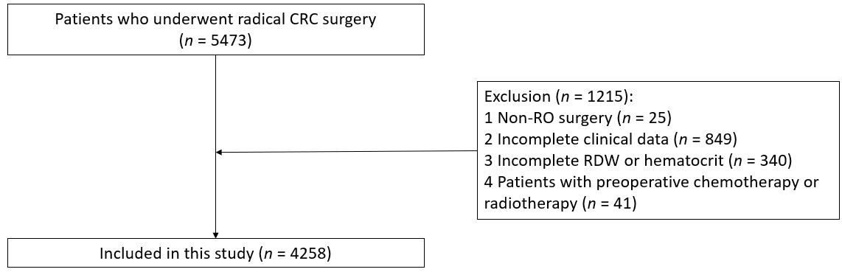
Figure 1 Flow chart of patient selection. CRC: Colorectal cancer; RDW: Red blood cell distribution width.

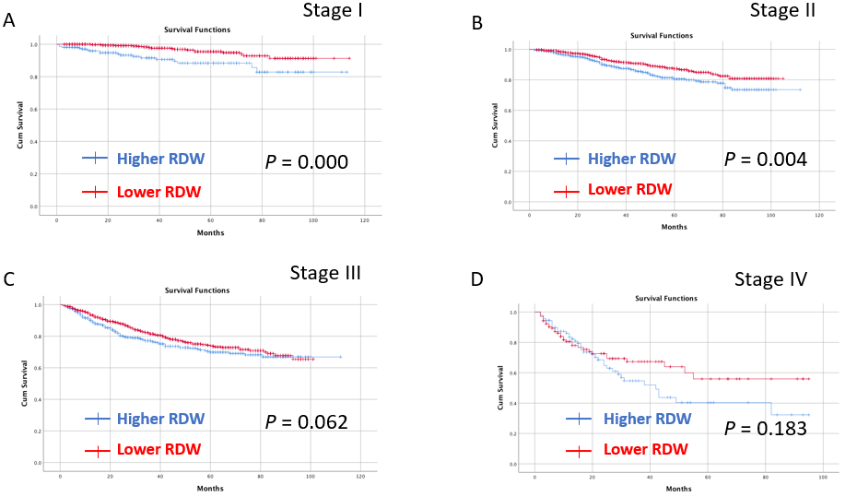
Figure 2 Kaplan-Meier survival curve for the impact of preoperative red blood cell distribution width on the overall survival of patients in tumor node metastasis stage I-IV. A: Kaplan-Meier survival curve for the impact of preoperative red blood cell distribution width (RDW) on the overall survival (OS) of patients in tumor node metastasis (TNM) stage I; B: Kaplan-Meier survival curve for the impact of preoperative RDW on the OS of patients in TNM stage II; C: Kaplan-Meier survival curve for the impact of preoperative RDW on the OS of patients in TNM stage III; D: Kaplan-Meier survival curve for the impact of preoperative RDW on the OS of patients in TNM stage IV. RDW: Red blood cell distribution width.

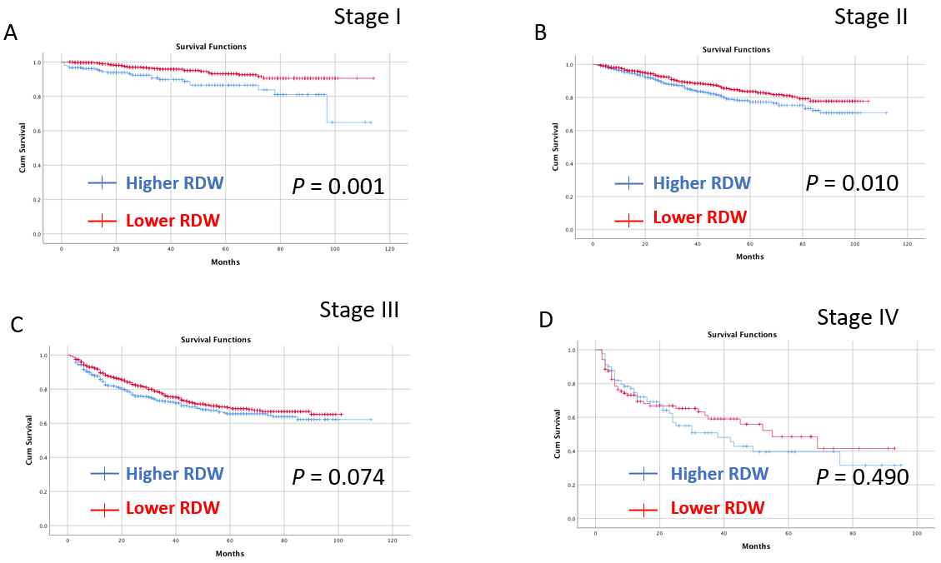
Figure 3 Kaplan-Meier survival curve for the impact of preoperative red blood cell distribution width on the disease-free survival of patients in tumor node metastasis stage I-IV. A: Kaplan-Meier survival curve for the impact of preoperative red blood cell distribution width (RDW) on the disease-free survival (DFS) of patients in tumor node metastasis (TNM) stage I; B: Kaplan-Meier survival curve for the impact of preoperative RDW on the DFS of patients in TNM stage II; C: Kaplan-Meier survival curve for the impact of preoperative RDW on the DFS of patients in TNM stage III; D: Kaplan-Meier survival curve for the impact of preoperative RDW on the DFS of patients in TNM stage IV. RDW: Red blood cell distribution width.

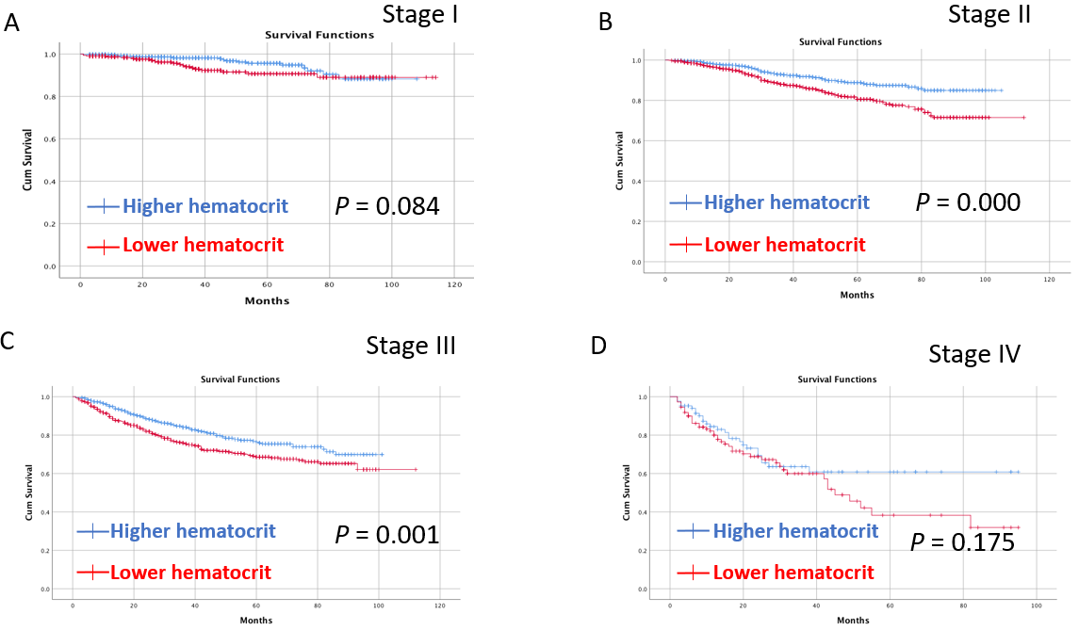
Figure 4 Kaplan-Meier survival curve for the impact of preoperative hematocrit on the overall survival of patients in tumor node metastasis stage I-IV. A: Kaplan-Meier survival curve for the impact of preoperative hematocrit on the overall survival (OS) of patients in tumor node metastasis (TNM) stage I; B: Kaplan-Meier survival curve for the impact of preoperative hematocrit on the OS of patients in TNM stage II; C: Kaplan-Meier survival curve for the impact of preoperative hematocrit on the OS of patients in TNM stage III; D: Kaplan-Meier survival curve for the impact of preoperative hematocrit on the OS of patients in TNM stage IV.

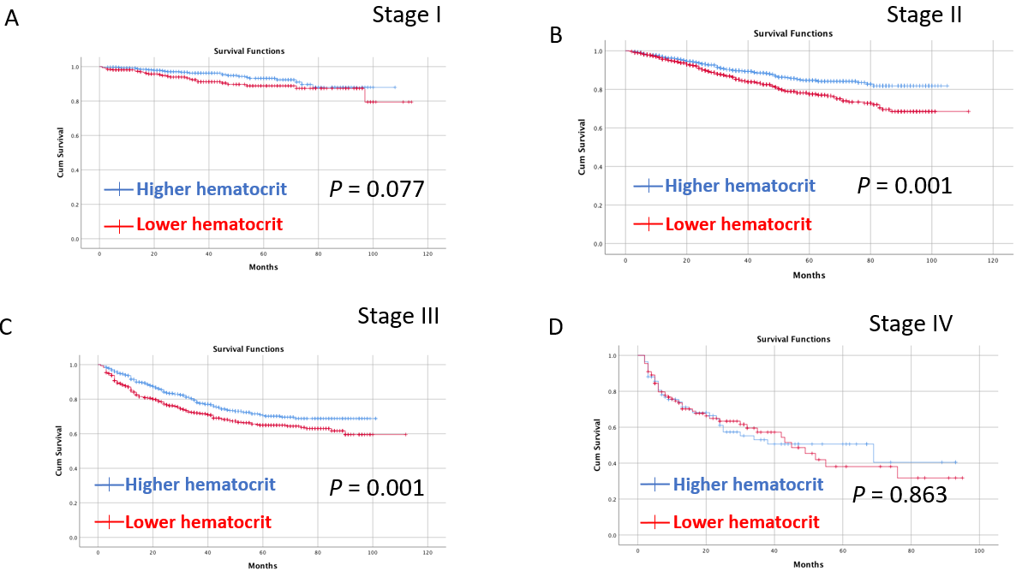
Figure 5 Kaplan-Meier survival curve for the impact of preoperative hematocrit on the disease-free survival of patients in tumor node metastasis stage I-IV. A: Kaplan-Meier survival curve for the impact of preoperative hematocrit on the disease-free survival (DFS) of patients in tumor node metastasis (TNM) stage I; B: Kaplan-Meier survival curve for the impact of preoperative hematocrit on the DFS of patients in TNM stage II; C: Kaplan-Meier survival curve for the impact of preoperative hematocrit on the DFS of patients in TNM stage III; D: Kaplan-Meier survival curve for the impact of preoperative hematocrit on the DFS of patients in TNM stage IV.

Table 1 Comparison between the higher red blood cell distribution width group and the lower red blood cell distribution width group
Characteristics | Higher RDW (n = 1573) | Lower RDW (n = 2685) | P value
RDW | 17.3 ± 3.3 | 13.0 ± 0.6 | < 0.01ª
Age, yr | 64.1 ± 12.8 | 62.2 ± 11.7 | < 0.01ª
Sex |  |  | < 0.01ª
Male | 873 (55.5) | 1640 (61.1)
Female | 700 (44.5) | 1045 (38.9)
BMI, kg/m² | 22.3 ± 3.3 | 22.9 ± 3.1 | < 0.01ª
Smoking | 570 (36.2) | 1047 (39.0) | 0.074
Drinking | 434 (27.6) | 881 (32.8) | < 0.01ª
Hypertension | 434 (27.6) | 679 (25.3) | 0.099
T2DM | 222 (14.1) | 319 (11.9) | 0.035ª
CHD | 90 (5.7) | 91 (3.4) | < 0.01ª
Open surgery | 281 (17.9) | 282 (10.5) | < 0.01ª
Tumor location |  |  | < 0.01ª
Colon | 940 (59.8) | 1068 (39.8)
Rectum | 633 (40.2) | 1617 (60.2)
TNM stage |  |  | < 0.01ª
I | 218 (13.9) | 585 (21.8)
II | 727 (46.2) | 1020 (38.0)
III | 538 (34.2) | 976 (36.4)
IV | 90 (5.7) | 104 (3.8)
Tumor size |  |  | < 0.01ª
< 5 cm | 739 (47.0) | 1716 (63.9)
≥ 5 cm | 834 (53.0) | 969 (36.1)
Operation time (min) | 230.3 ± 81.9 | 225.8 ± 84.1 | 0.087
Blood loss (mL) | 116.4 ± 171.8 | 93.3 ± 131.0 | < 0.01ª
Hospital stay (d) | 11.5 ± 7.7 | 11.2 ± 9.2 | 0.283
Overall complications | 400 (25.4) | 538 (20.0) | < 0.01ª
Major complications | 42 (2.7) | 60 (2.2) | 0.370
ªP value < 0.05.
Variables are expressed as the mean ± SD, n (%). RDW: Red blood cell distribution width; T2DM: Type 2 diabetes mellitus; BMI: Body mass index; CHD: Coronary heart disease; TNM: Tumor node metastasis.

Table 2 Comparison between the higher hematocrit group and the lower hematocrit group
Characteristics | Higher hematocrit (n = 2166) | Lower hematocrit (n = 2092) | P value
Hematocrit | 42.1 ± 3.0 | 32.2 ± 4.4 | < 0.01ª
Age, yr | 61.2 ± 11.3 | 64.6 ± 12.7 | < 0.01ª
Sex |  |  | < 0.01ª
Male | 1580 (72.9) | 933 (44.6)
Female | 586 (27.1) | 1159 (55.4)
BMI, kg/m² | 23.2 ± 3.1 | 22.2 ± 3.2 | < 0.01ª
Smoking | 1023 (47.2) | 594 (28.4) | < 0.01ª
Drinking | 839 (38.7) | 476 (22.8) | < 0.01ª
Hypertension | 540 (24.9) | 573 (27.4) | 0.068
T2DM | 220 (10.2) | 321 (15.3) | < 0.01ª
CHD | 68 (3.1) | 113 (5.4) | < 0.01ª
Open surgery | 222 (10.2) | 341 (16.3) | < 0.01ª
Tumor location |  |  | < 0.01ª
Colon | 782 (36.1) | 1226 (58.6)
Rectum | 1384 (63.9) | 866 (41.4)
TNM stage |  |  | < 0.01ª
I | 485 (22.4) | 318 (15.2)
II | 847 (39.1) | 900 (43.0)
III | 750 (34.6) | 764 (36.5)
IV | 84 (3.9) | 110 (5.3)
Tumor size |  |  | < 0.01ª
< 5 cm | 1415 (65.3) | 1040 (49.7)
≥ 5 cm | 751 (34.7) | 1052 (50.3)
Operation time (min) | 228.1 ± 85.4 | 226.8 ± 81.1 | 0.593
Blood loss (mL) | 96.3 ± 138.0 | 107.6 ± 157.1 | 0.012ª
Hospital stay (d) | 11.0 ± 7.5 | 11.6 ± 9.8 | 0.016ª
Overall complications | 419 (19.3) | 519 (24.8) | < 0.01ª
Major complications | 53 (2.4) | 49 (2.3) | 0.823
ªP value < 0.05.
Variables are expressed as the mean ± SD, n (%). T2DM: Type 2 diabetes mellitus; BMI: Body mass index; CHD: Coronary heart disease; TNM: Tumor node metastasis.

Table 3 Univariate and multivariate logistic regression analysis of the overall complications
Risk factors | Univariate analysis |  | Multivariate analysis
 | OR (95%CI) | P value | OR (95%CI) | P value
Age, yr | 1.024 (1.018-1.030) | < 0.01ª | 1.018 (1.011-1.025) | < 0.01ª
Sex (male/female) | 0.901 (0.777-1.045) | 0.166
BMI, kg/m² | 0.973 (0.951-0.995) | 0.018ª | 0.983 (0.959-1.007) | 0.160
Hypertension (yes/no) | 1.358 (1.158-1.592) | < 0.01ª | 1.128 (0.944-1.347) | 0.186
T2DM (yes/no) | 1.553 (1.270-1.900) | < 0.01ª | 1.297 (1.045-1.610) | 0.018ª
Tumor location (colon/rectum) | 0.966 (0.835-1.117) | 0.638
Tumor stage (IV/III/II/I) | 1.053 (0.963-1.151) | 0.257
Smoking (yes/no) | 1.173 (1.012-1.360) | 0.034ª | 1.255 (1.075-1.464) | 0.004ª
Drinking (yes/no) | 0.989 (0.845-1.157) | 0.893
CHD (yes/no) | 1.807 (1.314-2.484) | < 0.01ª | 1.365 (0.977-1.908) | 0.069
Tumor size (≥ 5/< 5), cm | 1.214 (1.049-1.404) | 0.009ª | 1.059 (0.910-1.234) | 0.459
Surgical methods (open/laparoscopic) | 2.250 (1.860-2.721) | < 0.01ª | 2.056 (1.691-2.500) | < 0.01ª
RDW (lower/higher) | 0.735 (0.634-0.852) | < 0.01ª | 0.887 (0.749-1.050) | 0.163
Hematocrit (lower/higher) | 1.376 (1.189-1.591) | < 0.01ª | 1.165 (0.981-1.383) | 0.082
ªP value < 0.05.
RDW: Red blood cell distribution width; OR: Odds ratio; CI: Confidence interval; BMI: Body mass index; T2DM: Type 2 diabetes mellitus; CHD: Coronary heart disease.

Table 4 Univariate and multivariate analysis of overall survival
Risk factors | Univariate analysis |  | Multivariate analysis
 | HR (95%CI) | P value | HR (95%CI) | P value
Age (yr) | 1.044 (1.036-1.051) | < 0.01ª | 1.038 (1.030-1.046) | < 0.01ª
Sex (female/male) | 0.861 (0.730-1.015) | 0.074
BMI (kg/m²) | 0.959 (0.935-0.984) | 0.001ª | 0.997 (0.972-1.023) | 0.840
T2DM (yes/no) | 1.303 (1.038-1.636) | 0.022ª | 0.941 (0.745-1.189) | 0.610
Tumor site (colon/ rectum) | 1.422 (1.091-1.853) | 0.009ª | 0.984 (0.831-1.165) | 0.851
Tumor stage (IV/III/II/I) | 2.202 (1.979-2.452) | < 0.01ª | 2.167 (1.943-2.416) | < 0.01ª
Smoking (yes/no) | 1.081 (0.918-1.273) | 0.351
Drinking (yes/no) | 1.070 (0.901-1.271) | 0.438
Hypertension (yes/no) | 1.055 (0.879-1.266) | 0.564
CHD (yes/no) | 1.355 (0.939-1.957) | 0.105
Tumor size (≥ 5 cm/< 5 cm) | 1.532 (1.305-1.799) | < 0.01ª | 1.235 (1.044-1.459) | 0.014ª
RDW (lower/higher) | 0.664 (0.565-0.780) | < 0.01ª | 0.925 (0.774-1.107) | 0.396
Hematocrit (lower/higher) | 1.693 (1.437-1.995) | < 0.01ª | 1.256 (1.041-1.515) | 0.017ª
Overall complications (yes/no) | 1.903 (1.611-2.248) | < 0.01^{aa} | 1.608 (1.357-1.904) | < 0.01ª
ªP value < 0.05.
RDW: Red blood cell distribution width; HR: Hazard ratio; CI: Confidence interval; BMI: Body mass index; T2DM: Type 2 diabetes mellitus.

Table 5 Univariate and multivariate analysis of disease-free survival
Risk factors | Univariate analysis |  | Multivariate analysis
 | HR (95%CI) | P value | HR (95%CI) | P value
Age (yr) | 1.031 (1.025-1.038) | < 0.01ª | 1.027 (1.020-1.033) | < 0.01ª
Sex (female/male) | 0.861 (0.730-1.015) | 0.058
BMI (kg/m²) | 0.975 (0.953-0.997) | 0.029ª | 1.003 (0.981-1.026) | 0.784
T2DM (yes/no) | 1.127 (0.911-1.396) | 0.271
Tumor site (colon/ rectum) | 1.126 (0.975-1.300) | 0.107
Tumor stage (IV/III/II/I) | 2.120 (1.926-2.334) | < 0.01ª | 2.093 (1.900-2.307) | < 0.01ª
Smoking (yes/no) | 1.093 (0.944-1.267) | 0.234
Drinking (yes/no) | 1.104 (0.946-1.288) | 0.208
Hypertension (yes/no) | 1.036 (0.879-1.220) | 0.676
CHD (yes/no) | 1.281 (0.917-1.791) | 0.147
Tumor size (≥ 5 cm/< 5 cm) | 1.363 (1.180-1.574) | < 0.01ª | 1.115 (0.962-1.294) | 0.149
RDW (lower/higher) | 0.713 (0.616-0.824) | < 0.01ª | 0.920 (0.783-1.080) | 0.308
Hematocrit (lower/higher) | 1.509 (1.304-1.747) | < 0.01ª | 1.194 (1.013-1.408) | 0.035ª
Overall complications (yes/no) | 1.705 (1.463-1.987) | < 0.01^{aa} | 1.510 (1.293-1.763) | < 0.01ª
ªP value < 0.05.
RDW: Red blood cell distribution width; HR: Hazard ratio; CI: Confidence interval; BMI: Body mass index; T2DM: Type 2 diabetes mellitus; CHD: Coronary heart disease.

