Name of Journal: World Journal of Virology
ESPS Manuscript NO: 19519
Manuscript Type: Original Article

Basic Study
Modelling the prevalence of hepatitis C virus amongst blood donors in Libya: An investigation of providing a preventive strategy

Daw MA et al. Modelling the prevalence of HCV for future prediction and forecasting

Mohamed A Daw, Amira Shabash, Abdallah El-Bouzedi, Aghnya A Dau, Moktar Habas; Libyan Study Group of Hepatitis and HIV

Mohamed A Daw, Amira Shabash, Department of Medical Microbiology, Faculty of Medicine, Tripoli 82668, Libya

Mohamed A Daw, Acting Physician of Internal Medicine, Scientific Coordinator of Libyan National Surveillance Studies of Viral hepatitis and HIV, Tripoli 82668, Libya

Abdallah El-Bouzedi, Department of Laboratory Medicine, Faculty of Biotechnology, Tripoli 82668, Libya

Agnya A Dau, Department of Surgery, Faculty of Medicine, Tripoli Medical Center, Tripoli 82668, Libya

Moktar Habas, Department of Medicine, Faculty of Medicine, Tripoli Central Hospital, Tripoli 82668, Libya

Author contributions: Daw AM designed the study, extracted the data, and drafted and finalised the manuscript; Shabash A and El-Bouzedi A collected the data and contributed to the drafting of the data; Dau AA drafted, analyzed and corrected the manuscript; Habas M collected the data and reviewed the clinical status of all patients; all authors read and approved the final manuscript.

Institutional review board statement: The study was reviewed by the board of Faculty of Medicine Tripoli Libya and found that the utilization and analysis of microbial epidemiological data did not require oversight by Libyan National Ethics committee. Hence then no ethics approval was needed for this study.

Institutional animal care and use committee: We declare that no animals or human volunteers were used in the study.

Conflict-of-interest statement: All authors declared that there is no potential conflict of interests regarding this article.

Data sharing statement: All data will be made freely available via correspondent author e-mail (mohamedadaw@gmail.com). There are no security or licensing related to the study.

Open-Access: This article is an open-access article which was selected by an in-house editor and fully peer-reviewed by external reviewers. It is distributed in accordance with the Creative Commons Attribution Non Commercial (CC BY-NC 4.0) license, which permits others to distribute, remix, adapt, build upon this work non-commercially, and license their derivative works on different terms, provided the original work is properly cited and the use is non-commercial. See: http://creativecommons.org/licenses/by-nc/4.0/

Correspondence to: Mohamed A Daw, FTCDA, MD, MPS, PhD, Professor of Clinical Microbiology and Microbial Epidemiology, Department of Medical Microbiology, Faculty of Medicine, Alfrnaj Road, Tripoli 82668, Libya. mohamedadaw@gmail.com
Telephone: +218-91-2144972
Fax: +218-21-3366218

Received: May 11, 2015
Peer-review started: May 18, 2015
First decision: July 26, 2015
Revised: August 24, 2015
Accepted: September 16, 2015
Article in press:
Published online:

Abstract
AIM: To forecast hepatitis C sero-prevalence among Libyan population using blood donors and applying autoregressiveintegrated moving average (ARIMA)-model to predict future trends and comply with the needed plans to minimize the burden of hepatitis C virus (HCV).

METHODS: HCV positive cases were collected from a total of 1008214 healthy blood volunteers over six years period from 2008 to 2013. Such data was used to construct ARMIA model in order to forecast HCV sero-prevalence among blood donors. The validity of the model was assessed using the mean absolute percentage error between the observed and fitted sero-prevalence. The fitted ARIMA model was used to forecast the incidence of HCV beyond the observed series of the year 2014 and then further till 2055.

RESULTS: The overall prevalence of HCV among blood donors was found to be 1.8%, varied over the study period from 1.7% to 2.5%, though no significant variation was found within each calendar year itself. The ARIMA model constructed showed non-significant auto-correlation of the residuals and the prevalence was steady within the last three years as expressed by goodness-of-fit test. The forecast incidence beyond the observed data showed increasing tendency in hepatitis C sero-positivity in 2014 ranged from 500 to 700 in 10000 population with an overall prevalence of 2.3% to 2.7%. This may be steady extended till 2055 with a minimal periodical variation within a six-year period.

CONCLUSION: The applied model was found to be valuable in evaluating the sero-prevalence of HCV among blood donors and highlights the growing burden of such infection on the Libyan health care system. Such modell may help in assessing the national policies to prevent the evolvement of HCV and plan for a needed future strategies that could target the consequences of such infection.

Key words: Libya; Hepatitis C virus; Blood donors; Autoregressiveintegrated moving average modell

© The Author(s) 2015. Published by Baishideng Publishing Group Inc. All rights reserved.

Core tip: Hepatitis C virus (HCV) has great consequences and overwhelming impacts particularly among developing countries, hence then prediction of such consequences are important for future planning to overcome the impacts of HCV infection. This is an innovative study highlighted the importance of using a modified mathematical modell to forecast and predict the future prevalence and consequence of HCV infection using the data collected form blood banks. The results we allow strategists in health care services to put their policy forward for immediate and long run policies.

Daw MA, Shabash A, El-Bouzedi A, Dau AA, Habas M; Libyan Study Group of Hepatitis and HIV. Modelling the prevalence of hepatitis C virus amongst blood donors in Libya: An investigation of providing a preventive strategy. World J Virol 2015; In press
INTRODUCTION
Hepatitis C virus (HCV) has been known to be one of the leading causes of chronic viral hepatitis with a devastating consequences such as cirrhosis and hepatocellular carcinoma which are the major cause of liver transplantation^{[1]}. The geo-epidemiology of HCV varies greatly and known to be dynamic over time^{[2]} . Indeed, 3% of the world’s population are chronically infected with HCV and over three million new infection occur each year^{[3]}. Africa a long with Asia is the largest reservoir of chronic HCV^{[4,5]}. Even though it varies from one country to another and among the regions within each country^{[2,3]}. The prevalence rates of HCV are the highest in Africa ranging from 1%-26%, as Egypt, Senegal and Cameroon having the highest rates worldwide^{[6]}.
Hepatitis C infection is well documented in Libya and different studies have shown the prevalence of HCV and genotypes involved among Libyans^{[7-9]}. Recently a comprehensive study on over 1% of Libyan population has shown that the prevalence of HCV is 1.2% varying from 0.6% to 2.2% according to the regions within the country^{[10]}. The prevalence indicated an alarming increase of HCV among young generation, particularly within new emerging risk groups in Libyan society such as IVDUs^{[10,11]}. The age and disease progress among the infected individuals will increase and expected complications will develop. This will place an increasing burden on Libyan health care system which is still developing. Hence then studies should be directed to combat such expectation.
An early identification of epidemics of infectious diseases and prediction of their consequent outcomes become an important step toward implementing effective intervention measurements and reducing the resulting mortality and morbidity^{[12]}. Such goals became a challenge to the health care surveillance studies. Mathematical dynamic modelling has contributed greatly in exploring such challenges. Surveillance data however, are usually used for these modelling purposes^{[13]}.
Different statistical models including linear regression and correlation co-efficient have been used for prediction of viral hepatitis. Autoregressive integrated moving average (ARIMA) or Box-jenkins has a potential application in studies of disease dynamics^{[14]}. Helfinstein was the first to show that ARIMA model can be used successfully for forecasting and predicting the different relation among viral infection and associated diseases^{[15]}. Different studies hence then did apply such modelling to detect spike, step and trend changes for hepatitis E, hepatitis B and hepatitis C infection^{[16,17]}. A considerable work has been undertaken to forecast the epidemiology of hepatitis C and different models were used to estimate the burden and complications of such infection^{[18]}. Recently Corson et al^{[19]} have used mathematical model to project the future of HCV among IVDUs and its impact of the future development of HCV morbidity and mortality.
Blood donors are generally considered to be a healthier component of any community and viral hepatitis sero-positivity among them may mirror the sero- prevalence status in general population^{[20]}. In Libya, a study conducted between 1991 and 2001 indicated that the prevalence of HCV ranged from 1.2% to 1.6% among blood donors, this is similar to the prevalence among general population reported in 2014 being 1.2% though it was much higher (20.5%) among hospital personnel^{[7,10]}. Therefore, modelling and forecasting HCV data among blood donors may provide an opportunity for planning and intervention to control HCV infection. In this study we aimed for forecasting the prevalence of HCV trends among blood donors, analysing HCV dynamics and highlighting the need for further intervention strategies.

MATERIALS AND METHODS
Study population
A total of 1008214 healthy individuals aged from 18 to 50 years recruited from three different main blood banks in Tripoli over six years period from 2008-2013 as shown in Table 1. These include Tripoli Central Hospital, Karda Teaching Hospital and Tripoli Reference Laboratory. Each person was subjected to screening for known risk factor associated with blood donation according to the national and international standards applicable in all the three hospitals. Those who were failed to meet the criterions of blood donation were excluded from the study such as those who had previous blood transfusion, Jaundice, history of elucidating drugs and other associated potential risk factors.

Laboratory diagnosis
The laboratory analysis had been carried out using ELISA (Vitros EciQ, Orthodiagnostic- Switzerland), samples were considered to be confirmatory positive according to the manufacturers specifications of ELISA tests. Hepatitis C infection defined as the presence of anti-hepatitis C antibodies in the serum detected by ELISA.

Modelling
The ARIMA model was developed to forecast the incidence of HCV among blood donors in Libya. This was applied using 72 mo from January 2008 to December 2013 and then to forecast the incidence of HCV from January to December 2014 and then to predict the prevalence of HCV from 2008 till 2055 under nonexclusive expectation. The model was constructed using Box and Jenkins. The identification and selection steps for ARIMA was carried via autocorrelation and partial autocorrelation functions. The model parameters were utilized by the maximum likelihood method. Goodness-of-fit among ARIMA models was compared using diagnostic checking such residual analysis and other needed information. The accuracy of model was finally subjected to critical estimation and rigorous checking process to fulfill needed criteria of the model. The details of ARIMA model was recently described by Yu et al^{[21]} 2013 and used by to analyse HIV among Korean population.

Statistical analysis
The data have been analyzed using excel Microsoft program, and the statistic has been done using minitab version 15 and SPSS version 16 windows programs, where P value used to measure the significant difference between HCV and HBV prevalence. We use excel 2007 forecast function to predict the number of infected people. The following equation was used to calculate the expected number of infected persons on each year, 1- Y = 613.2X + 836.5. Y; number of expected infected persons with HCV. X; the serial number for the year calculated from 2008 for example 2009, 2010 serial number are 2 and 3 respectively.

Ethical consideration
The study was reviewed by the board of Faculty of Medicine Tripoli Libya and found that the utilization and analysis of microbial epidemiological data did not require oversight by Libyan National Ethics Committee. Hence then no ethics approval was needed for this study.

RESULTS
A total of 1008214 volunteer blood donors were screened for HCV within six years period from 2008 till 2013. Of those screened 17897 were found to be positive of Anti-HCV antibodies with an overall prevalence of 1.8%. There was no evident monthly difference of HCV among the individuals screened with the same year. Based on year to year analysis, a substantial variation in the sero-prevalence of HCV was observed as shown in Table 2. The highest prevalence rate of HCV was reported in 2008 and 2009 as (2.6%) though it was 1.5% (2010) and 1.7% (for 2011-2013). In the year of 2008, 35869 individuals were reviewed, of them 937 (2.6%) were anti-HCV antibodies positive. During 2009 the number of screened people was doubled, 1713 (2.6%) of them showed anti HCV antibodies positive. On 2010 the number of screened people was 254177 increases seven times over those screened in 2008, the number of HCV antibody positive persons were 3958 (1.5%). In 2011, 3060 (1.7%) were HCV positive. Although 260139 people screened during the year 2012 - the largest number of screened people over the five years period with an equal prevalence rate of 2011 (1.7%) and 2013 (1.7%) as 218836 persons were screened as shown in Table 1.
The data analyzed by applying ARIMA modeling strategy for identification, estimation and then forecasting of the data collected form the voluntary blood donors screened for HCV in main Libyan blood banks. The first stage is building up an estimation model followed by forecasting and model evaluation. The data collected from 2008 till 2013 period was used for constructing the ARIMA model as depicted by Box et al^{[14]}. Figure 1 shows the sample autocorrelation and partial autocorrelation functions (ACF and PACF) for the case structure which allowed one to identify an appropriate ARIMA form to model the stationary series. Small variation was notified though it was not statistically different from zero which confirms the appropriate adequacy of ARIMA model. The modeling forecast for the coming six years was visible with steady increase.
The sample autocorrelation and partial autocorrelation function (ACF and PACF) in Figure 2 showed a good-fit which allow us to determine the appropriate ARIMA model for HCV sero-prevalence among blood donors. The adequacy of the Model was evident as the residuals of autocorrelation has stable variation with insignificant difference (P < 0.05).
The blot of observed verses fitted values indicated that the model provided an excellent fit of the data as shown in Figure 3. The ARIMA model was for forecasting HCV prevalence for 72 mo in six years period from January 2003 to December 2013 (Figure 3). Detailed analysis of observed vs forecasted values of HCV prevalence over the study period showed steady increase with maximum value at 1.8% to 2.01% with increasing tendency beyond the observed series for the short term forecast (January -December 2014 which could reach the maximum of 700; 1000⁻¹ ranging from 2.3% to 2.7%. This was further analysed and used as a basic foundation for estimating the modelled prevalence of HCV among Libyan population till 2055 based on a six-year period as graphically depicted in Figure 4. According to our model, the prevalence of HCV infection will and thus all sequelae of the infection continue to increase steadily in the future.

DISCUSSION
HCV has been known to be an important cause of chronic liver diseases though accurate representative epidemiological data are difficult to gain particularly among developing countries as this infection has been considered to be endemic^{[2]}. Statistical analysis of surveillance data on the prevalence of various infection was shown to be helpful in establishing a found-able hypotheses to highlight and anticipate the dynamics of hepatitis C infection and subsequently implementing the accurate preventive measures and reallocation of the needed resources^{[22]}. ARIMA model is one of the most widely used forecasting technique due to its structured modelling bases and acceptable forecasting performance^{[23]}.
In this study, we developed a calibrated ARIMA model for HCV with an aim of taking full advantage of available epidemiological information from registered blood donors in Libyan blood banks. The overall prevalence of HCV among the blood donors studied was found to be 1.8% ranging from 2.5% in 2008 to 1.7% in 2013. This is in an agreement of with a recent comprehensive study published by our group who reported that the prevalence of HCV among Libyan population varied 1.2% from 0.6% to 2.2%^{[10]}. Comparing such results with regional published data the prevalence of HCV was found to be similar to the neighboring countries, its reported to be 1.6% in Tunis, 1.8% in Algeria, though its higher in (22%) Egypt^{[24,25]}. However, this does not parallel, the prevalence among developed countries such as United States and Germany^{[26,27]}. Hence then, further studies are needed to elucidate the different factors associated with a higher prevalence of HCV among Libyan blood donors.
In our study, the applied model showed an accurate prevalence and dynamics of HCV among blood donors over a six-year period and the forecast over then. This is in agreement with other studies who also declared that such model provide a better forecast than the traditional methods for case notification of an infectious disease^{[28]}. Despite that the prevalence of HCV was steady among the last three years being 1.7% (2011-2013), we predicted an increase in forecast of the year after. This however is a consistent with other studies from China and Latin America who showed the prevalence of HCV is steady or increasing and the number of the infected individuals will increase^{[29,30]}. This suggested that other risk factors are set to play a major role in continued new infection. Further studies are needed to clarify such assumption.
Despite the increase of seropositivity of hepatitis C in this study, we did not predict the burden of HCV infection over the next decades, neither we calculated the estimated number of individuals morbidities associated with HCV. However, different studies have shown that the number of HCV-related cirrhosis is expected to increase by 24% within a decade, though decompensated cirrhosis cases and HCC will increase by 50% within the same period^{[31-33]}. Hence then further studies are needed to elucidate such consequent complications of hepatitis C infection among Libyan populations.
Modeling studies have projected a dismal future for HCV- and related disease burden. In general, these models make forecasts based on current conditions of low rates of screening and treatment and thus do not include a widespread program of identifying and treating the large proportion of undiagnosed HCV-infected individuals^{[34]}. According to the results of our model, the incidence of the more serious outcomes of HCV infection will continue to rise, at least until 2055, unless modified. In our projections of HCV infection to 2055, we did not take into account the effective HCV prevention programs and the possible impact of the use of antiviral medications. Both these developments could have considerable impact on our future projections and thus the prevalence of HCV projected to 2055 may be less than that estimated by our Modell. Furthermore, socio-economic condition of the country should be taken in consideration particularly among the developing countries; Libya is experiencing a major challenge regarding its geographical, political and social-ethnic identity^{[35,36]}. Hence then, future planning regarding infectious disease should be priority^{[37,38]}.
Monitoring HCV sero-positivity among blood donors could be used to evaluate the effectiveness of the national efforts and guide lines to provide a safe blood donation and good blood banking services^{[39]}. In many countries, HCV transmission rates decreased tremendously with the introduction of blood screening^{[40]}. Despite such decline mathematical models still predict a continuing rise in the prevalence of HCV within blood banks^{[41]}. This was evident in our study since increase in HCV sero-prevalence may be contributed to the lack quality assurance within the blood donation system. In Arab countries, blood transfusion is still problem due to lack of organized infrastructure and altruistic volunteers. The main blood sources of blood donation are usually relatives and friends who come on social pressure and in emergency time where questions regarding risk behaviors rarely asked^{[2]}.
Many difficulties surrounding the determination of HCV prevalence using blood donors, since high risk groups including IVDUs are often excluded from blood donation leading to underestimation of the true prevalence of HCV^{[42]}. Nevertheless, our data do not necessarily represent true hepatitis C prevalence among general population and thus are in need of further updating. The applicability and effectiveness of this monitoring system in practical application we conducted is visible in detecting the epidemic situation of HCV in Libya. However, such infection is dynamic and evolving over time. Therefore, the model should be periodically reassessed and updated to maintain long term sustainability and precision. This study highlights the need of preventive initiatives and strategies to be adapted by health care policy makers to indoor hepatitis C infection.
In conclusion, there is an important need for monitoring and predicting the prevalence of HCV to reduce the substantial consequences caused by such infection particularly among the developing countries. The model applied was useful and could be used to monitor and predict the epidemiology of HCV. A better understanding to the epidemiology of HCV allow the health authorities revise and plan for new strategy within the health care system.

ACKNOWLEDGEMENTS
The authors would like to acknowledge the help and assistance of blood banks in Tripoli and Libyan reference laboratory. Further thanks should go to Dr Reiad M Gaja, Department of Statistics, Faculty of Science-Tripoli University for his comments on the model applied.

COMMENTS
Background
Viral hepatitis, particularly hepatitis C virus (HCV) is known to be a serious problem particularly among developing countries. Hence then using a simple and reliable methods for prediction the future consequence of this infection become apriority for researchers and scientific scholars. A reliable data regarding the prevalence HCV among blood donors are available in all blood banks and this could be used to achieve such objectives.

Research frontiers
Studies utilizing blood bank data on the prevalence of HCV, could be used as vehicle data base for future planning. However, such studies are rare and few researchers have focused on using such data as a modell for future planning.

Innovations and breakthroughs
This is a novel study applied a mathematical modell utilizing the basic data from blood banks regarding a potential pathogen such as HCV. This is a rare study which used to predict the prevalence of HCV among the general population over the next fifty years (2008-2055).

Applications
The practical approach of this study allows the strategists and health care system professionals to plan for good intervention and prevention methods not only to minimize the spread of HCV but also to reduce the consequences and complications associated with HCV such as hepatocellular carcinoma and cirrhosis further to other concomitants infections such as hepatitis B virus and human immunodeficiency virus.

Terminology
ARIMA modell, is an autoregressive integrated moving average or Box-jenkins mathematical modell which has a potential application in studying disease dynamics. ARIMA model can be used successfully for forecasting and predicting the different relation among viral infection and associated diseases.

Peer-review
This is a well conducted epidemiologic study carried out in a developing country.
REFERENCES
1 Howell J, Angus P, Gow P. Hepatitis C recurrence: the Achilles heel of liver transplantation. Transpl Infect Dis 2014; 16: 1-16 [PMID: 24372756 DOI: 10.1111/tid.12173]
2 Daw MA, Dau AA. Hepatitis C virus in Arab world: a state of concern. ScientificWorldJournal 2012; 2012: 719494 [PMID: 22629189 DOI: 10.1100/2012/719494]
3 Mohd Hanafiah K, Groeger J, Flaxman AD, Wiersma ST. Global epidemiology of hepatitis C virus infection: new estimates of age-specific antibody to HCV seroprevalence. Hepatology 2013; 57: 1333-1342 [PMID: 23172780 DOI: 10.1002/hep.26141]
4 Karoney MJ, Siika AM. Hepatitis C virus (HCV) infection in Africa: a review. Pan Afr Med J 2013; 14: 44 [PMID: 23560127]
5 Zidan A, Scheuerlein H, Schüle S, Settmacher U, Rauchfuss F. Epidemiological pattern of hepatitis B and hepatitis C as etiological agents for hepatocellular carcinoma in iran and worldwide. Hepat Mon 2012; 12: e6894 [PMID: 23233864 DOI: 10.5812/hepatmon.6894]
6 Jobarteh M, Malfroy M, Peterson I, Jeng A, Sarge-Njie R, Alabi A, Peterson K, Cotten M, Hall A, Rowland-Jones S, Whittle H, Tedder R, Jaye A, Mendy M. Seroprevalence of hepatitis B and C virus in HIV-1 and HIV-2 infected Gambians. Virol J 2010; 7: 230 [PMID: 20843322 DOI: 10.1186/1743-422X-7-230]
7 Daw MA, Elkaber MA, Drah AM, Werfalli MM, Mihat AA, Siala IM. Prevalence of hepatitis C virus antibodies among different populations of relative and attributable risk. Saudi Med J 2002; 23: 1356-1360 [PMID: 12506296]
8 Elasifer HA, Agnnyia YM, Al-Alagi BA, Daw MA. Epidemiological manifestations of hepatitis C virus genotypes and its association with potential risk factors among Libyan patients. Virol J 2010; 7: 317 [PMID: 21073743 DOI: 10.1186/1743-422X-7-317]
9 Alashek WA, McIntyre CW, Taal MW. Hepatitis B and C infection in haemodialysis patients in Libya: prevalence, incidence and risk factors. BMC Infect Dis 2012; 12: 265 [PMID: 23082935 DOI: 10.1186/1471-2334-12-265]
10 Daw MA, El-Bouzedi A. Prevalence of hepatitis B and hepatitis C infection in Libya: results from a national population based survey. BMC Infect Dis 2014; 14: 17 [PMID: 24405790 DOI: 10.1186/1471-2334-14-17]
11 Daw MA, Dau AA, Agnan MM. Influence of healthcare-associated factors on the efficacy of hepatitis C therapy. ScientificWorldJournal 2012; 2012: 580216 [PMID: 23346018 DOI: 10.1100/2012/580216]
12 Rong L, Guedj J, Dahari H, Perelson AS. Treatment of hepatitis C with an interferon-based lead-in phase: a perspective from mathematical modelling. Antivir Ther 2014; 19: 469-477 [PMID: 24434478 DOI: 10.3851/IMP2725]
13 Chatterjee A, Guedj J, Perelson AS. Mathematical modelling of HCV infection: what can it teach us in the era of direct-acting antiviral agents? Antivir Ther 2012; 17: 1171-1182 [PMID: 23186606 DOI: 10.3851/IMP2428]
14 Box GEP, Jenkins GM. Time series analysis, control, and forecasting. San Francisco, CA: Holden Day, 1976: 10
15 Helfenstein U. Box-Jenkins modelling of some viral infectious diseases. Stat Med 1986; 5: 37-47 [PMID: 3961314]
16 Ren H, Li J, Yuan ZA, Hu JY, Yu Y, Lu YH. The development of a combined mathematical model to forecast the incidence of hepatitis E in Shanghai, China. BMC Infect Dis 2013; 13: 421 [PMID: 24010871 DOI: 10.1186/1471-2334-13-421]
17 Sutton AJ, Gay NJ, Edmunds WJ, Hope VD, Gill ON, Hickman M. Modelling the force of infection for hepatitis B and hepatitis C in injecting drug users in England and Wales. BMC Infect Dis 2006; 6: 93 [PMID: 16762050]
18 Akhtar S, Carpenter TE. Stochastic modelling of intra-household transmission of hepatitis C virus: evidence for substantial non-sexual infection. J Infect 2013; 66: 179-183 [PMID: 23103288 DOI: 10.1016/j.jinf.2012.10.020]
19 Corson S, Greenhalgh D, Taylor A, Palmateer N, Goldberg D, Hutchinson S. Modelling the prevalence of HCV amongst people who inject drugs: an investigation into the risks associated with injecting paraphernalia sharing. Drug Alcohol Depend 2013; 133: 172-179 [PMID: 23791029 DOI: 10.1016/j.drugalcdep.2013.05.014]
20 Khodabandehloo M, Roshani D, Sayehmiri K. Prevalence and trend of hepatitis C virus infection among blood donors in Iran: A systematic review and meta-analysis. J Res Med Sci 2013; 18: 674-682 [PMID: 24379843]
21 Yu HK, Kim NY, Kim SS, Chu C, Kee MK. Forecasting the number of human immunodeficiency virus infections in the korean population using the autoregressive integrated moving average model. Osong Public Health Res Perspect 2013; 4: 358-362 [PMID: 24524025 DOI: 10.1016/j.phrp.2013.10.009]
22 Firmino PR, de Mattos Neto PS, Ferreira TA. Correcting and combining time series forecasters. Neural Netw 2014; 50: 1-11 [PMID: 24239986 DOI: 10.1016/j.neunet.2013.10.008]
23 Zhang X, Zhang T, Young AA, Li X. Applications and comparisons of four time series models in epidemiological surveillance data. PLoS One 2014; 9: e88075 [PMID: 24505382 DOI: 10.1371/journal.pone.0088075]
24 Ezzikouri S, Pineau P, Benjelloun S. Hepatitis B virus in the Maghreb region: from epidemiology to prospective research. Liver Int 2013; 33: 811-819 [PMID: 23530901 DOI: 10.1111/liv.12135]
25 Breban R, Doss W, Esmat G, Elsayed M, Hellard M, Ayscue P, Albert M, Fontanet A, Mohamed MK. Towards realistic estimates of HCV incidence in Egypt. J Viral Hepat 2013; 20: 294-296 [PMID: 23490375 DOI: 10.1111/j.1365-2893.2012.01650.x]
26 Sheikh MY, Atla PR, Ameer A, Sadiq H, Sadler PC. Seroprevalence of Hepatitis B and C Infections among Healthy Volunteer Blood Donors in the Central California Valley. Gut Liver 2013; 7: 66-73 [PMID: 23423771]
27 Offergeld R, Ritter S, Hamouda O. [HIV, HCV, HBV and syphilis surveillance among blood donors in Germany 2008-2010]. Bundesgesundheitsblatt Gesundheitsforschung Gesundheitsschutz 2012; 55: 907-913 [PMID: 22842883 DOI: 10.1007/s00103-012-1516-1]
28 Liu Q, Liu X, Jiang B, Yang W. Forecasting incidence of hemorrhagic fever with renal syndrome in China using ARIMA model. BMC Infect Dis 2011; 11: 218 [PMID: 21838933 DOI: 10.1186/1471-2334-11-218]
29 Ji ZH, Li CY, Lv YG, Cao W, Chen YZ, Chen XP, Tian M, Li JH, An QX, Shao ZJ. The prevalence and trends of transfusion-transmissible infectious pathogens among first-time, voluntary blood donors in Xi'an, China between 1999 and 2009. Int J Infect Dis 2013; 17: e259-e262 [PMID: 23195637]
30 Kershenobich D, Razavi HA, Sánchez-Avila JF, Bessone F, Coelho HS, Dagher L, Gonçales FL, Quiroz JF, Rodriguez-Perez F, Rosado B, Wallace C, Negro F, Silva M. Trends and projections of hepatitis C virus epidemiology in Latin America. Liver Int 2011; 31 Suppl 2: 18-29 [PMID: 21651701 DOI: 10.1111/j.1478-3231]
31 Weinmann A, Koch S, Niederle IM, Schulze-Bergkamen H, König J, Hoppe-Lotichius M, Hansen T, Pitton MB, Düber C, Otto G, Schuchmann M, Galle PR, Wörns MA. Trends in epidemiology, treatment, and survival of hepatocellular carcinoma patients between 1998 and 2009: an analysis of 1066 cases of a German HCC Registry. J Clin Gastroenterol 2014; 48: 279-289 [PMID: 24045276 DOI: 10.1097/MCG.0b013e3182a8a793]
32 Pinchoff J, Drobnik A, Bornschlegel K, Braunstein S, Chan C, Varma JK, Fuld J. Deaths among people with hepatitis C in New York City, 2000-2011. Clin Infect Dis 2014; 58: 1047-1054 [PMID: 24523215]
33 Kershenobich D, Razavi HA, Cooper CL, Alberti A, Dusheiko GM, Pol S, Zuckerman E, Koike K, Han KH, Wallace CM, Zeuzem S, Negro F. Applying a system approach to forecast the total hepatitis C virus-infected population size: model validation using US data. Liver Int 2011; 31 Suppl 2: 4-17 [PMID: 21651700 DOI: 10.1111/j.1478-3231.2011.02535.x]
34 Edlin BR, Eckhardt BJ, Shu MA, Holmberg SD, Swan T. Towards a more accurate estimate of the prevalence of hepatitis C in the United States. Hepatology 2015 Jul 14; Epub ahead of print [PMID: 26171595 DOI: 10.1002/hep.27978]
35 Daw MA, El-Bouzedi A, Dau AA. Libyan armed conflict 2011: Mortality, injury and population displacement. African Journal of Emergency Medicine 2015; 2 [DOI: 10.1016/j.afjem.2015.02.002]
36 Daw MA, El-Bouzedi A, Dau AA. The assessment of efficiency and coordination within Libyan Healthcare System during the Armed Conflict-2011. Clinical Epidemiology & Global Health 2015; In press [DOI: 10.1016/j.cegh.2015.07.004]
37 Daw MA, El-Bouzedi A, Dau AA. Geographic distribution of HCV genotypes in Libya and analysis of risk factors involved in their transmission. BMC Res Notes 2015; 8: 367 [PMID: 26293137 DOI: 10.1186/s13104-015-1310-x]
38 Daw MA, El-Bouzedi A. Viral haemorrhagic fever in North Africa; an evolving emergency. J Clin Exp Pathol 2015; 5: 215 [DOI: 10.4172/2161-0681.1000215]
39 Watkins NA, Dobra S, Bennett P, Cairns J, Turner ML. The management of blood safety in the presence of uncertain risk: a United kingdom perspective. Transfus Med Rev 2012; 26: 238-251 [PMID: 22126710 DOI: 10.1016/j.tmrv.2011.09.003]
40 Kim MJ, Park Q, Min HK, Kim HO. Residual risk of transfusion-transmitted infection with human immunodeficiency virus, hepatitis C virus, and hepatitis B virus in Korea from 2000 through 2010. BMC Infect Dis 2012; 12: 160 [PMID: 22817275 DOI: 10.1186/1471-2334-12-160]
41 Lucky TT, Seed CR, Keller A, Lee J, McDonald A, Ismay S, Wand H, Wilson DP. Trends in transfusion-transmissible infections among Australian blood donors from 2005 to 2010. Transfusion 2013; 53: 2751-2762 [PMID: 23461827 DOI: 10.1111/trf.12144]
42 Zou S, Dorsey KA, Notari EP, Foster GA, Krysztof DE, Musavi F, Dodd RY, Stramer SL. Prevalence, incidence, and residual risk of human immunodeficiency virus and hepatitis C virus infections among United States blood donors since the introduction of nucleic acid testing. Transfusion 2010; 50: 1495-1504 [PMID: 20345570 DOI: 10.1111/j.1537-2995.2010.02622.x]

P- Reviewer: Borzio M, Smith MA S- Editor: Gong XM
L- Editor: E- Editor:

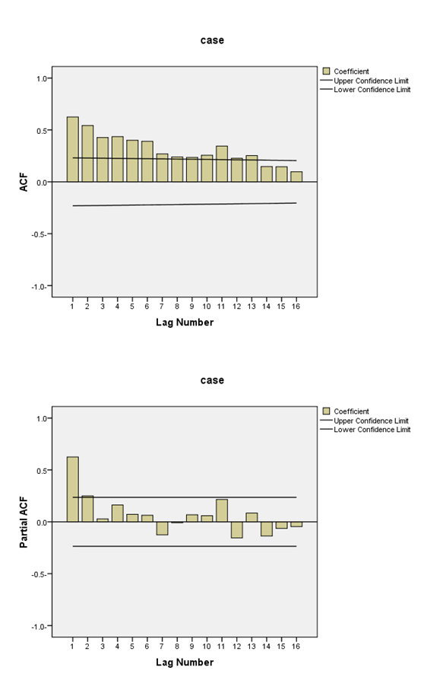
Figure 1 Correlogram and partial correlogram for a case structure control used for ARMIA model. A: ACF; B: Partial ACF. ACF: Autocorrelation function.

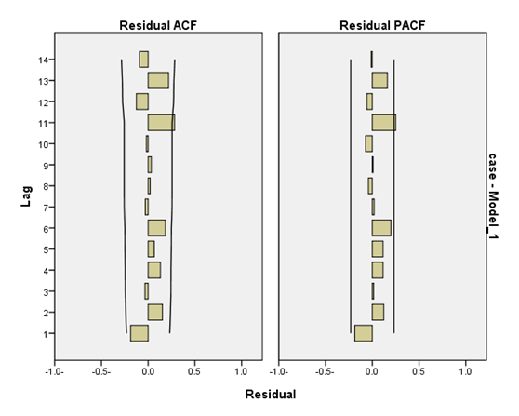
Figure 2 Residual plots for the final ARIMA (2, 1, 7) model of hepatitis C virus sero-prevalence among volunteer blood donors in Libya 2008-2013. A: ACF; B: Partial ACF. Lines indicate 95%CI. ACF: Autocorrelation function.
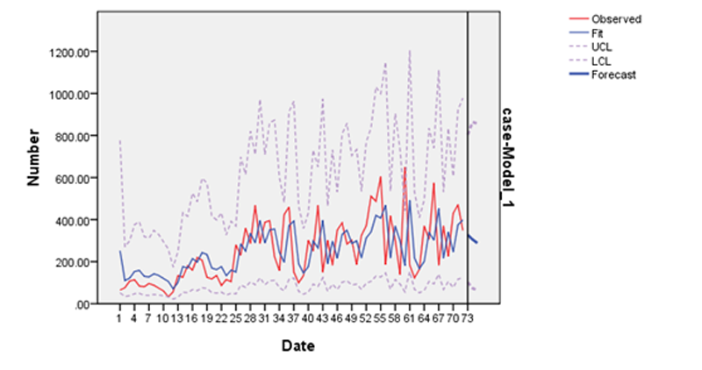
Figure 3 Number of observed and forecasted hepatitis C sero-positive volunteers among blood donors in Libya 2008-2013. Date: Period of observation (months: 2008-2013); Number: Estimated number of HCV sero-positive/month. UCL: Upper confidence limit; LCL: Lower confidence limit.
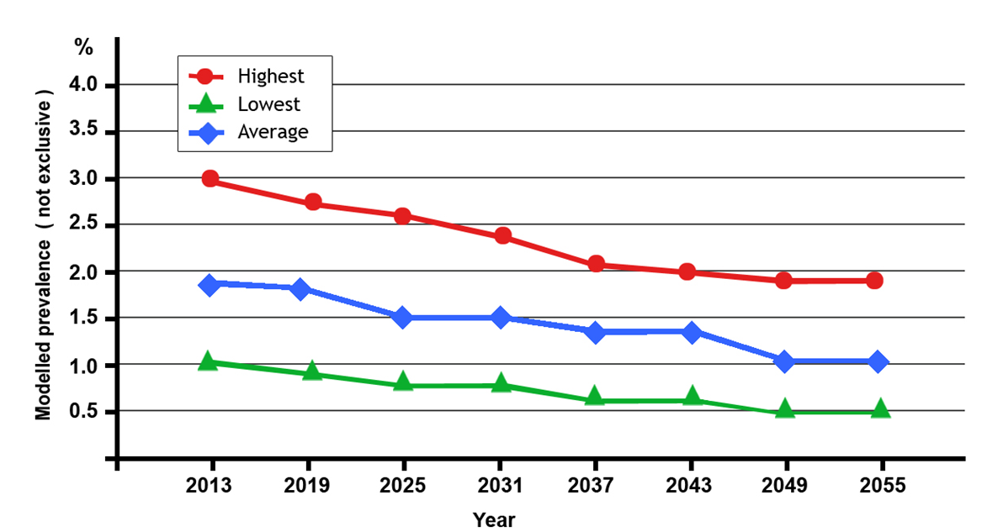
Figure 4 Modeled prevalence (not exclusive¹) of hepatitis C virus by six-year interval, Libya, 2008-2055. ¹Estimates assume stable risk populations and HCV infection risks and do not adjust for treatment. HCV: Hepatitis C virus.

Table 1 Number of blood donors involved in the study, Tripoli, Libya 2008-2013

Study period | No. of volunteers | No. of HCV sero-positive
2008 | 35859 | 937
2009 | 65330 | 1713
2010 | 254177 | 3958
2011 | 173873 | 3060
2012 | 260139 | 4480
2013 | 218836 | 3749
Total | 1008214 | 17897

2011-2013-post revolution years where many Libyan were injured during the Libyan conflict (2011)^{[35]}. HCV: Hepatitis C virus.

Table 2 Sero-prevalence of hepatitis C virus among blood donors, Tripoli-Libya, 2008-2013
Year | Prevalence (%) | ± SD | 95%CI |  | Minimum | Maximum
 |  |  | Lower | Upper
2008 | 2.6 | 1.4 | 2.3 | 2.8 | 2.0 | 3.2
2009 | 2.6 | 1.4 | 1.7 | 3.4 | 1.1 | 4.1
2010 | 1.5 | 0.8 | 1.3 | 1.6 | 0.9 | 2.1
2011 | 1.7 | 0.7 | 1.3 | 2.0 | 0.8 | 2.8
2012 | 1.7 | 1.1 | 0.8 | 2.6 | 0.6 | 2.9
2013 | 1.7 | 1.1 | 0.9 | 2.5 | 0.7 | 2.7
Total | 1.8 | 1.1 | 1.4 | 2.5 | 1.0 | 3.0

