Name of Journal: World Journal of Clinical Cases
Manuscript NO: 83093
Manuscript Type: CASE REPORT

Chronic pulmonary mucormycosis caused by rhizopus microsporus mimics lung carcinoma in an immunocompetent adult: A case report

Guo et al. Chronic pulmonary mucormycosis

Xing-Zi Guo, Liang-Hui Gong, Wen-Xiang Wang, De-Song Yang, Bai-Hua Zhang, Ze-Tao Zhou, Xiao-Hui Yu

Xing-Zi Guo, Department of Gynecologic Oncology, Hunan Cancer Hospital and The Affiliated Cancer Hospital of Xiangya School of Medicine, Central South University, Changsha 410031, Hunan Province, China

Liang-Hui Gong, Wen-Xiang Wang, De-Song Yang, Bai-Hua Zhang, The Second Department of Thoracic Surgery, Hunan Cancer Hospital and The Affiliated Cancer Hospital of Xiangya School of Medicine, Central South University, Changsha 410031, Hunan Province, China

Ze-Tao Zhou, GZMU-GIBH School of Life Sciences, Guangzhou Medical University, Guangzhou 511436, Guangdong Province, China

Xiao-Hui Yu, Department of Pathology, Hunan Cancer Hospital and The Affiliated Cancer Hospital of Xiangya School of Medicine, Central South University, Changsha 410031, Hunan Province, China

Author contributions: Guo XZ, Gong LH, Wang WX, Yang DS, Zhang BH, and Zhou ZT contributed to manuscript writing and editing; Yu XH contributed to conceptualization and supervision; and all authors have read and approved the final manuscript.

Supported by Hunan Provincial Natural Science Foundation of China, No. 2022JJ40247 and No. 2022JJ40256.

Corresponding author: Xiao-Hui Yu, MD, PhD, Doctor, Department of Pathology, Hunan Cancer Hospital and The Affiliated Cancer Hospital of Xiangya School of Medicine, Central South University, Tongzipo Road, Yuelu District, Changsha 410031, Hunan Province, China. yuxiaohui@hnca.org.cn

Received: January 7, 2023
Revised: April 2, 2023
Accepted: April 12, 2023
Published online:

Abstract
BACKGROUND
Pulmonary mucormycosis is a rare but life-threatening invasive fungal infection that mostly affects immunocompromised patients. This disease usually develops acutely and progresses rapidly, often leading to a poor clinical prognosis. Chronic pulmonary mucormycosis is highly unusual in immunocompetent patients.

CASE SUMMARY
A 43-year-old man, who was a house improvement worker with a long history of occupational dust exposure, presented with an irritating cough that had lasted for two months. The patient was previously in good health, without dysglycemia or any known immunodeficiencies. Chest computed tomography revealed a mass in the left lower lobe, measuring approximately 6 cm in diameter, which was suspected to be primary lung carcinoma complicated with obstructive pneumonia. Thoracoscopic-assisted left lower lobectomy was performed, and metagenomic next-generation sequencing detection, along with special pathological staining of surgical specimens, suggested Rhizopus microsporus infection. Postoperatively, the patient's respiratory symptoms were relieved, and no signs of recurrence were found during the six-month follow-up.

CONCLUSION
This article reports a rare case of chronic pulmonary mucormycosis caused by Rhizopus microsporus in a middle-aged male without dysglycemia or immunodeficiency. The patient's surgical outcome was excellent, reaffirming that surgery remains the cornerstone of pulmonary mucormycosis treatment.

Key Words: Rhizopus microsporus; Pulmonary mucormycosis; Immunocompetent patient; Surgical resection; Case report

Guo XZ, Gong LH, Wang WX, Yang DS, Zhang BH, Zhou ZT, Yu XH. Chronic pulmonary mucormycosis caused by rhizopus microsporus mimics lung carcinoma in an immunocompetent adult: A case report. World J Clin Cases 2023; In press

Core Tip: Pulmonary mucormycosis is a rare yet life-threatening invasive fungal infection that typically affects immunocompromised patients. In this report, we present a case of chronic pulmonary mucormycosis in a 43-year-old immunocompetent house improvement worker. The patient initially presented with an irritating cough and a solitary mass in the left lower lobe, which raised concerns of primary lung carcinoma. A successful thoracoscopic-assisted left lower lobectomy was performed, and subsequent metagenomic next-generation sequencing analysis and specialized pathological staining of surgical specimens suggested Rhizopus microsporus as the causative agent of the infection. During a six-month postoperative follow-up, no signs of recurrence were observed.

INTRODUCTION
Pulmonary mucormycosis is a rare but aggressive and life-threatening fungal infection that mainly affects immunocompromised individuals^{[1]}. The most common causative agents are Rhizopus species, particularly Rhizopus microsporus, which belong to the class Zygomycetes^{[2]}. The infection typically occurs in patients with underlying conditions such as diabetes mellitus, hematologic malignancy, and solid organ or stem cell transplant^{[3]}. Pulmonary mucormycosis is an aggressive and rapidly progressive infection that carries a poor clinical prognosis, with a mortality rate as high as 50%-60% worldwide^{[4,5]}. Chronic pulmonary mucormycosis, lasting more than one month, is extremely rare, with most reported cases occurring in patients with diabetes^{[6-10]}. In this case report, we present a rare case of chronic pulmonary mucormycosis caused by Rhizopus microsporus, which mimicked lung carcinoma in an immunocompetent middle-aged male. The patient underwent aggressive surgical resection, and achieved an excellent therapeutic response.

CASE PRESENTATION
Chief complaints
A 43-year-old man from China presented at the hospital with a history of coughing and sputum production for the past two months.

History of present illness
Two months prior to admission to our hospital, the patient visited a local hospital due to an irritative cough with a small amount of white, foamy sputum that lasted for two wk. The patient did not exhibit any obvious indications of accompanying symptoms such as blood in the sputum, fever, night sweats, weight loss, hoarseness, dyspnea, or discomforts. A chest computed tomography (CT) scan revealed a soft tissue mass, approximately 57 mm x 51 mm in size, in the left lower lobe that was suspected to be a fungal infection or tumor. Electronic bronchoscopy showed that the basal branch mucosa of the left lower lobe was swollen and hypertrophic, and the surface was not smooth. No active bleeding or new organisms were found. Bronchial mucosal biopsy revealed chronic inflammatory changes. Acid-fast stains of bronchoalveolar lavage fluid, as well as bacterial and fungal cultures, were negative. Since the specific cause of the symptoms could not be clarified, the patient was treated with empirical anti-infection medication, specifically cephalosporins, in the local hospital for two wk. However, the patient's cough symptoms did not improve significantly. As a result, the patient was admitted to our thoracic medicine department as an outpatient for further diagnosis and treatment.

History of past illness
The patient did not report any prior history of surgeries, trauma, severe infections, or significant medical conditions. Additionally, the patient denied any previous infection with coronavirus disease 2019.

Personal and family history
The patient reported no significant family history of related illnesses. However, it was observed that the patient had been working as a house improvement worker and had a prolonged history of occupational dust exposure.

Physical examination
On physical examination, the patient's height was 176 cm, weight 70 kg, body temperature 36.2 °C, heart rate 94 beats per minute, respiratory rate 20 breaths per minute, and blood pressure 132/87 mmHg. The superficial lymph nodes in the supraclavicular and neck regions were non-palpable, and the chest wall was symmetrical with no deformities. The patient's breathing was regular, and apart from decreased breath sounds in the lower left lung, no other significant abnormalities were noted.

Laboratory examinations
The laboratory test results were as follows: White blood cell count was 9.54 × 10⁹/L, neutrophil percentage was 52%, hemoglobin was 151 g/L, hematocrit was 47.1%, fasting blood glucose was 5.5 mmol/L, total protein level was 81 g/L, and globulin level was 37 g/L. Additionally, twelve tumor markers including AFP, CEA, NSE, CA125, CA15-3, CA242, CA19-9, PSA, f-PSA, FER, β-HCG, and HGH were measured by protein biochip detection in the serum and found to be within the normal range. Pulmonary function test results showed forced vital capacity of 5.18 L (110% predicted) and forced expiratory volume in 1 s of 3.79 L (98% predicted). Other results of routine laboratory examinations were within normal limits, including urine and stool routine, liver and kidney function, and electrolytes. The patient's infectious disease screening, which included hepatitis B, hepatitis C, syphilis, and human immunodeficiencyvirus tests, also showed no abnormalities.

Imaging examinations
The contrast-enhanced chest CT taken at our hospital revealed a 6 cm mass in the left lower lobe, primarily located in the lateral segment (S9) and posterior segment (S10). The mass showed slight enhancement and obstructed the bronchi of the affected lung segments, with the pulmonary vasculature faintly visible within it (Figures 1 and 2). Bronchoscopy revealed narrowed lumens of the left lower lobe's lateral and posterior segmental bronchi, along with congested and swollen mucosa, without any detection of new organisms in the lumen (Figure 3). Magnetic resonance imaging of the head and CT scans of the neck and abdomen showed no abnormalities. The bone scan also had negative results.

MULTIDISCIPLINARY EXPERT CONSULTATION
The patient had undergone bronchoscopy twice at different hospitals, but both procedures failed to confirm the pathological diagnosis by forceps biopsy. The patient declined further biopsies, including percutaneous lung biopsy or endobronchial ultrasound-guided transbronchial needle aspiration (ebus tbna). However, the patient expressed a strong desire for surgery and was willing to accept the risks associated with surgical treatment.
Thoracic medical oncologists organized a multidisciplinary consultation. The experts unanimously recommended respecting the patient's wishes and scheduling a surgical operation to remove the left lower lung within a specific time frame. The mass tissue obtained during the operation would then be used to make a diagnosis and guide subsequent treatment steps. Following the experts’ advice, the patient was transferred to Department of Thoracic Surgery for surgical treatment.

FINAL DIAGNOSIS
Based on the patient's two-month medical history and imaging signs, primary bronchial lung cancer combined with obstructive pneumonia was suspected, and specific infectious lesions could not be entirely ruled out. No sign of distant metastasis of a malignant tumor was detected during the patient's systemic examination. If the mass in the patient's left lower lobe was malignant, the current clinical stage would be cT3N1M0, stage IIIA.

TREATMENT
Due to the large size of the mass, we performed a thoracoscopic-assisted left lower lobectomy through an anterolateral incision approximately 10 cm long in the fourth intercostal space. The thoracoscopic hole was located in the seventh intercostal space on the posterior axillary line. Intraoperative exploration revealed that the visceral and parietal pleura were smooth without nodules, the oblique fissure was well developed, and the mass in the left lower lobe was hard, with the basal segment densely adhered to the lateral chest wall. After separating the adherent tissues, the pulmonary artery, vein, and bronchi belonging to the left lower lobe were exposed sequentially and then closed and separated using the endoscopic linear cutting stapler. During this surgical procedure, we found that the lymph nodes in the lung mass's drainage area were significantly enlarged and hardened, but their adventitia remained intact. Interestingly, these lymph nodes appeared purulent white instead of the conventional carbon black.
The resected left lower lobe was removed from the incision. The mass was firm, approximately 6 cm in diameter, and pale in color when sectioned. Subsequent intraoperative frozen rapid pathological examination results indicated that the mass was a granulomatous inflammatory lesion with no malignant components. It was suspected that this may have been a particular type of infection which needed to be further confirmed by routine pathological examination and special staining. To determine the cause of the granuloma, we excised the clean granuloma tissue approximately 0.5 cm³ in size and sent it for clinical metagenomic next-generation sequencing (mNGS). The 3-h operation went smoothly, and the blood loss was 100 mL. There were no postoperative complications. The drainage tube was removed on the fifth day after the operation, and the patient was discharged one day later.

OUTCOME AND FOLLOW-UP
The results of mNGS analysis for the left lower lobe granuloma were obtained on the second day after the operation. The analysis suggested an infection caused by Rhizopus microsporus, and no other pathogenic microorganisms, including bacteria, viruses, parasites, mycobacteria, mycoplasma, or chlamydia, were detected. The analysis was performed by Precision Genes Technology, Inc. on August 25, 2022.
The postoperative routine pathological examination revealed that the left lower lobe mass was an inflammatory granuloma (Figure 4). Interstitial fibrous tissue hyperplasia, inflammatory cell infiltration, and multinucleated giant cell reaction were all observed under the microscope. In addition, hexamine silver staining of its histological sections revealed broad, right-angled branched aseptate hyphae, strongly suggesting the possibility of pulmonary mucormycosis (Figure 5).
Considering the patient's clinical manifestations, as well as the laboratory, imaging, mNGS, and histopathological examinations, the patient was finally diagnosed with chronic pulmonary mucormycosis caused by Rhizopus microsporus infection, which is very rare in immunocompetent nondiabetic patients.
After surgery, the patient's respiratory symptoms were relieved, and a CT re-examination three and six months after the operation showed that the lungs were in good condition, with no signs of recurrence (Figure 6).

DISCUSSION
Pulmonary mucormycosis represents a group of invasive fungal infections in the lungs caused by members of the order Mucorales, and it has a high mortality rate^{[1,5]}. The causative fungal agent is commonly found on decaying food, soil, and animal excrement. During its asexual reproduction, its hyphae develop sporangium and release spores. Patients often become infected by inhaling these spores into the bronchioles and alveoli^{[1,11]}. Pulmonary mucormycosis is a relatively uncommon opportunistic infection that primarily occurs in immunocompromised populations, with risk factors including diabetes mellitus, hematologic malignancy, neutropenia, or transplantation^{[12,13]}. Very rarely, pulmonary mucormycosis also occurs in immunocompetent individuals and should not be entirely ignored^{[5,11,14,15]}. In our report, we present a case of a 43-year-old Chinese man who developed pulmonary mucormycosis without dysglycemia or any known immunodeficiency. We learned from the consultation that the patient did not wear a mask at work to reduce dust inhalation. Therefore, as a house improvement worker, he may have inhaled mucormycosis spores during his occupational work, which may have induced this pulmonary mucormycosis infection.
The clinical and imaging manifestations of pulmonary mucormycosis are not specific^{[16]}. Most patients present with an acute respiratory infection and have typical symptoms such as fever, cough, chest pain, dyspnea, and hemoptysis. Additionally, a few patients suffer a longer course of the disease and manifest as chronic lung lesions, which need to be differentiated from lung carcinoma^{[17]}. In our case, the patient had a persistent left lower lung mass and mild clinical symptoms characterized by an irritating cough for at least two months. These chronic symptoms led us to consider lung cancer initially, but it was eventually ruled out by thoracoscopic excisional biopsy.
The definitive diagnosis of pulmonary mucormycosis relies on the histopathological finding of mucoraceous hyphae in affected tissues. Its pathological characteristics include broad, aseptate, and ribbon-like hyaline hyphae with wide-angle branching^{[18]}. Although specimen fungal culture allows for species identification, it is time-consuming and has a low positive rate^{[5,19]}. In recent years, polymerase chain reaction and mNGS, especially the latter, have become relatively precise and convenient methods for finding pathogens^{[3,20,21]}. In our case, we first identified the only suspected pathogenic microorganism, Rhizopus microsporus, by mNGS detection of sterile surgical specimens, although its sequence number was only two. Then, the pathologist identified mucoraceous hyphae by special stains. Interestingly, corresponding to the low sequence number of mNGS results, the hyphae in the specimen were sparse, which may also be associated with chronic infection and a good prognosis.
Due to the high mortality rate associated with pulmonary mucormycosis, early identification and treatment of the disease are critical for an improved likelihood of survival. Surgical resection is the cornerstone treatment for pulmonary mucormycosis^{[22]}, and it should be strongly considered when feasible^{[23]}. In addition, timely antifungal therapy with amphotericin B or posaconazole has also been shown to improve outcomes^{[1,24]}. Despite our repeated insistence on the necessity of antifungal therapy, the patient refused any further antifungal treatment postoperatively. The patient cited mild preoperative infection symptoms, satisfactory postoperative recovery, concerns about potential drug side effects, and high follow-up treatment costs as reasons for declining the treatment. Nevertheless, follow-up CT scans of the patient's chest at three and six months after surgery showed satisfactory results without any signs of recurrence.

CONCLUSION
This article reports a rare case of chronic pulmonary mucormycosis caused by Rhizopus microsporus in a middle-aged male without dysglycemia or immunodeficiency. The patient presented with an irritating cough and a solitary left lower lobe mass that lasted for two months, similar to that of lung carcinoma. We performed a lobectomy, and the surgical specimen was subjected to mNGS detection and special pathological staining, which suggested rhizopus microsporus infection. The surgical outcome for the patient was excellent, reaffirming that surgery remains the cornerstone of treatment for pulmonary mucormycosis.

ACKNOWLEDGEMENTS
We would like to thank the patient for his participation and cooperation in this case report.

REFERENCES
1 Agrawal R, Yeldandi A, Savas H, Parekh ND, Lombardi PJ, Hart EM. Pulmonary Mucormycosis: Risk Factors, Radiologic Findings, and Pathologic Correlation. Radiographics 2020; 40: 656-666 [PMID: 32196429 DOI: 10.1148/rg.2020190156]
2 Jeong W, Keighley C, Wolfe R, Lee WL, Slavin MA, Kong DCM, Chen SC. The epidemiology and clinical manifestations of mucormycosis: a systematic review and meta-analysis of case reports. Clin Microbiol Infect 2019; 25: 26-34 [PMID: 30036666 DOI: 10.1016/j.cmi.2018.07.011]
3 Chen L, Su Y, Xiong XZ. Rhizopus microsporus lung infection in an immunocompetent patient successfully treated with amphotericin B: A case report. World J Clin Cases 2021; 9: 11108-11114 [PMID: 35047625 DOI: 10.12998/wjcc.v9.i35.11108]
4 Muthu V, Agarwal R, Dhooria S, Sehgal IS, Prasad KT, Aggarwal AN, Chakrabarti A. Has the mortality from pulmonary mucormycosis changed over time? A systematic review and meta-analysis. Clin Microbiol Infect 2021; 27: 538-549 [PMID: 33418022 DOI: 10.1016/j.cmi.2020.12.035]
5 Lee FY, Mossad SB, Adal KA. Pulmonary mucormycosis: the last 30 years. Arch Intern Med 1999; 159: 1301-1309 [PMID: 10386506 DOI: 10.1001/archinte.159.12.1301]
6 Tojima H, Tokudome T, Otsuka T. [Chronic pulmonary mucormycosis that developed in preexisting cavities caused by tuberculosis in a patient with diabetes mellitus and liver cirrhosis]. Nihon Kyobu Shikkan Gakkai Zasshi 1997; 35: 100-105 [PMID: 9071165]
7 Soltani A, Torabizadeh Z, Akha O, Godazandeh G, Mohammad G. A case of chronic pulmonary mucormycosis with indolent course complicating diabetic ketoacidosis. Respiratory Medicine Extra 2006; 2: 105-107 [DOI:10.1016/j.rmedx.2006.08.001]
8 Matsumura Y, Shibuya J, Kobayashi S, Handa M, Kondo T, Fujimura S. [Chronic pulmonary mucormycosis diagnosed by bronchoscopy: a case report]. Kyobu Geka 1993; 46: 891-894 [PMID: 8377321]
9 Iqbal N, Irfan M, Jabeen K, Kazmi MM, Tariq MU. Chronic pulmonary mucormycosis: an emerging fungal infection in diabetes mellitus. J Thorac Dis 2017; 9: E121-E125 [PMID: 28275494 DOI: 10.21037/jtd.2017.02.31]
10 Agarwal R, Kumar V, Gupta D. Pulmonary mucormycosis: two of a kind. Eur J Intern Med 2006; 17: 63-65 [PMID: 16378892 DOI: 10.1016/j.ejim.2005.08.009]
11 Yang J, Zhang J, Feng Y, Peng F, Fu F. A case of pulmonary mucormycosis presented as Pancoast syndrome and bone destruction in an immunocompetent adult mimicking lung carcinoma. J Mycol Med 2019; 29: 80-83 [PMID: 30553628 DOI: 10.1016/j.mycmed.2018.10.005]
12 Roden MM, Zaoutis TE, Buchanan WL, Knudsen TA, Sarkisova TA, Schaufele RL, Sein M, Sein T, Chiou CC, Chu JH, Kontoyiannis DP, Walsh TJ. Epidemiology and outcome of zygomycosis: a review of 929 reported cases. Clin Infect Dis 2005; 41: 634-653 [PMID: 16080086 DOI: 10.1086/432579]
13 Petrikkos G, Skiada A, Lortholary O, Roilides E, Walsh TJ, Kontoyiannis DP. Epidemiology and clinical manifestations of mucormycosis. Clin Infect Dis 2012; 54 Suppl 1: S23-S34 [PMID: 22247442 DOI: 10.1093/cid/cir866]
14 Ng KL, Huan NC, Nasaruddin MZ, Muhammad NA, Daut UN, Abdul Rahaman JA. Pulmonary mucormycosis masquerading as endobronchial tumour in an immunocompetent pregnant young lady. Respirol Case Rep 2021; 9: e00704 [PMID: 33364028 DOI: 10.1002/rcr2.704]
15 He J, Sheng G, Yue H, Zhang F, Zhang HL. Isolated pulmonary mucormycosis in an immunocompetent patient: a case report and systematic review of the literature. BMC Pulm Med 2021; 21: 138 [PMID: 33906622 DOI: 10.1186/s12890-021-01504-8]
16 Tsyrkunou AV, Ellison RT 3rd, Akalin A, Wiederhold N, Sutton DA, Lindner J, Fan H, Levitz SM, Zivna I. Multifocal Rhizopus microsporus lung infection following brush clearing. Med Mycol Case Rep 2014; 6: 14-17 [PMID: 25379391 DOI: 10.1016/j.mmcr.2014.08.001]
17 Peng M, Meng H, Sun Y, Xiao Y, Zhang H, Lv K, Cai B. Clinical features of pulmonary mucormycosis in patients with different immune status. J Thorac Dis 2019; 11: 5042-5052 [PMID: 32030220 DOI: 10.21037/jtd.2019.12.53]
18 Kantarcioğlu AS, Yücel A, Nagao K, Sato T, Inci E, Ogreden S, Kaytaz A, Alan S, Bozdağ Z, Edali N, Sar M, Kepil N, Oz B, Altas K. A Rhizopus oryzae strain isolated from resected bone and soft tissue specimens from a sinonasal and palatal mucormycosis case. Report of a case and in vitro experiments of yeastlike cell development. Med Mycol 2006; 44: 515-521 [PMID: 16966168 DOI: 10.1080/13693780600764973]
19 Leung CCD, Chan YH, Ho MY, Chan MC, Chen CH, Kwok CT, Yeung YC. First reported case of late recurrence of pulmonary mucormycosis in a renal transplant recipient with poorly controlled diabetes mellitus. Respirol Case Rep 2021; 9: e0877 [PMID: 34795903 DOI: 10.1002/rcr2.877]
20 Sun Y, Li H, Chen J, Ma Z, Han P, Liu Y, Wen J, Ren F, Ma X. Case Report: Metagenomics Next-Generation Sequencing Can Be Performed for the Diagnosis of Disseminated Mucormycosis. Front Med (Lausanne) 2021; 8: 675030 [PMID: 34746163 DOI: 10.3389/fmed.2021.675030]
21 Gu Z, Buelow DR, Petraitiene R, Petraitis V, Walsh TJ, Hayden RT. Quantitative multiplexed detection of common pulmonary fungal pathogens by labeled primer polymerase chain reaction. Arch Pathol Lab Med 2014; 138: 1474-1480 [PMID: 25357108 DOI: 10.5858/arpa.2013-0592-OA]
22 Choi H, Lee H, Jeon K, Suh GY, Shin S, Kim HK, Kim K, Jeong D, Kim H. Factors affecting surgical resection and treatment outcomes in patients with pulmonary mucormycosis. J Thorac Dis 2019; 11: 892-900 [PMID: 31019778 DOI: 10.21037/jtd.2019.01.75]
23 Multani A, Reveron-Thornton R, Garvert DW, Gomez CA, Montoya JG, Lui NS. Cut it out! Thoracic surgeon's approach to pulmonary mucormycosis and the role of surgical resection in survival. Mycoses 2019; 62: 893-907 [PMID: 31173415 DOI: 10.1111/myc.12954]
24 Yuan F, Chen J, Liu F, Dang YC, Kong QT, Sang H. Successful treatment of pulmonary mucormycosis caused by Rhizopus microsporus with posaconazole. Eur J Med Res 2021; 26: 131 [PMID: 34775981 DOI: 10.1186/s40001-021-00602-x]

Footnotes
Informed consent statement: We obtained informed written consent from the patient to publish this case report and any accompanying images.

Conflict-of-interest statement: All the authors report no relevant conflicts of interest for this article.

CARE Checklist (2016) statement: The authors have read the CARE Checklist (2016), and the manuscript was prepared and revised according to the CARE Checklist (2016).

Open-Access: This article is an open-access article that was selected by an in-house editor and fully peer-reviewed by external reviewers. It is distributed in accordance with the Creative Commons Attribution NonCommercial (CC BY-NC 4.0) license, which permits others to distribute, remix, adapt, build upon this work non-commercially, and license their derivative works on different terms, provided the original work is properly cited and the use is non-commercial. See: https://creativecommons.org/Licenses/by-nc/4.0/

Provenance and peer review: Unsolicited article; Externally peer reviewed.

Peer-review model: Single blind

Peer-review started: January 7, 2023
First decision: March 24, 2023
Article in press:

Specialty type: Medicine, research and experimental
Country/Territory of origin: China
Peer-review report’s scientific quality classification
Grade A (Excellent): 0
Grade B (Very good): B, B
Grade C (Good): 0
Grade D (Fair): 0
Grade E (Poor): 0

P-Reviewer: Nasa P, United Arab Emirates; Rotondo JC, Italy S-Editor: Liu XF L-Editor: P-Editor:
Figure Legends
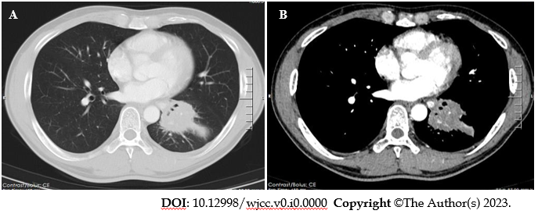
Figure 1 High-resolution chest contrast-enhanced computed tomography. A: Lung window and B: Mediastinal window. A mass in the left lower lobe with a diameter of approximately 6 cm. It was slightly enhanced and mainly located in the lateral segment (S9) and posterior segment (S10). The pulmonary vasculature was still looming in this mass, but there was bronchial occlusion of the affected lung segments.
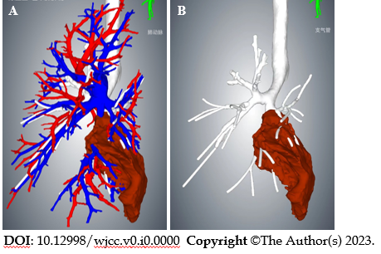
Figure 2 Three-dimensional reconstruction of the chest based on computed tomography images. A: The pulmonary vasculature is visible; and B: The pulmonary vasculature is hidden. The mass volume calculated by 3D reconstruction was 136 mL.
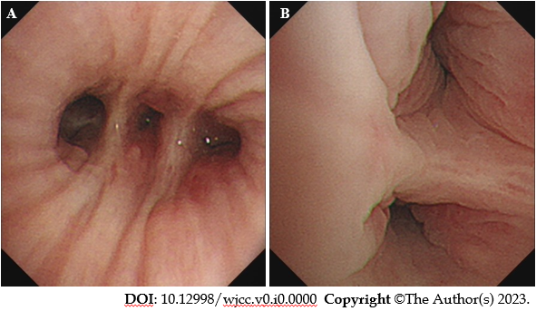
Figure 3 Images during electronic bronchoscopy. A: Bronchoscopy revealed that the lumen of the left lower lobe's lateral and posterior segmental bronchi was narrowed; and B: The mucosa was congested and swollen, and no new organisms were found in the lumen.
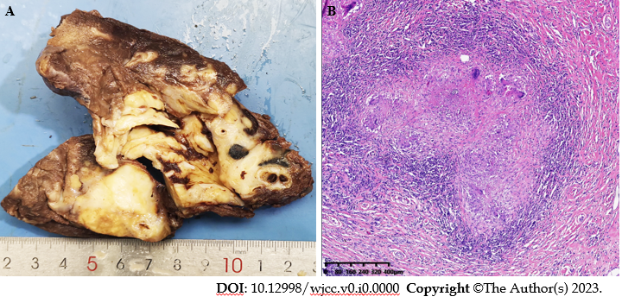
Figure 4 Macroscopic and microscopic features of the left lower lobe mass. A: The mass was firm, approximately 6 cm in diameter, and pale in color when sectioned; and B: Hematoxylin and eosin stained section revealed that the left lower lobe mass was an inflammatory granuloma. Interstitial fibrous tissue hyperplasia, inflammatory cell infiltration, and multinucleated giant cell reaction were all observed under the microscope.
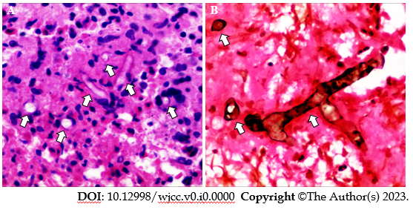
Figure 5 Postoperative histopathological results of the left lower lobe mass. A: Hematoxylin and eosin staining (400 ×); and B: Hexamine silver staining (400 ×), showed broad, right-angled branched aseptate hyphae indicating mucormycosis (marked with white arrows).
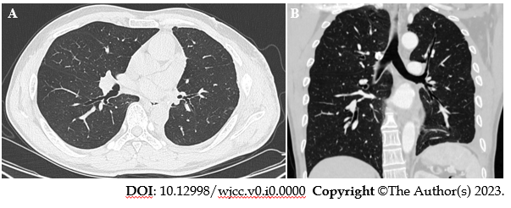
Figure 6 High-resolution chest contrast-enhanced computed tomography. A: Transverse plane; and B: Coronal plane. A re-examination of computed tomography three months after the operation showed that the lungs were in good condition, and no recurrence was found.

