Name of Journal: World Journal of Gastrointestinal Surgery
Manuscript NO: 41340
Manuscript Type: META-ANALYSIS

Systematic review of cystic duct closure techniques in relation to prevention of bile duct leakage after laparoscopic cholecystectomy

van Dijk AH et al. Cystic duct closure in laparoscopic cholecystectomy

Aafke H van Dijk, Stijn van Roessel, Philip R de Reuver, Djamila Boerma, Marja A Boermeester, Sandra C Donkervoort

Aafke H van Dijk, Stijn van Roessel, Marja A Boermeester, Departement of Surgery, Academical Medical Centre, Amsterdam 1105 AZ, The Netherlands

Philip R de Reuver, Department of Surgery, Radboud University Medical Center, Nijmegen 6525 GA, The Netherlands

Djamila Boerma, Department of Surgery, St. Antonius Hospital, Nieuwegein 3435 CM, The Netherlands

Sandra C Donkervoort, Department of Surgery, Onze Lieve Vrouw Gasthuis, Amsterdam 1091 AC, The Netherlands

ORCID number: Aafke H van Dijk (0000-0001-9758-3609); Stijn van Roessel (0000-0002-7891-1467); Philip R de Reuver (0000-0002-8566-4222); Djamila Boerma (0000-0001-9212-1317); Marja A Boermeester (0000-0001-5941-5444); Sandra C Donkervoort (0000-0003-1088-0761).

Author contributions: van Dijk AH, Donkervoort SC, Boerma D, Boermeester MA and de Reuver PR conceptualized and designed the review together; van Dijk AH and van Roessel S carried out analysis; van Dijk AH, van Roessel S and de Reuver PR drafted the manuscript; all authors reviewed and approved the final manuscript as submitted.

Conflict-of-interest statement: No conflicts of interests or disclosures.

PRISMA 2009 Checklist statement: The authors have read the PRISMA 2009 Checklist, and the manuscript was prepared and revised according to the PRISMA 2009 Checklist.

Open-Access: This article is an open-access article which was selected by an in-house editor and fully peer-reviewed by external reviewers. It is distributed in accordance with the Creative Commons Attribution Non Commercial (CC BY-NC 4.0) license, which permits others to distribute, remix, adapt, build upon this work non-commercially, and license their derivative works on different terms, provided the original work is properly cited and the use is non-commercial. See: http://creativecommons.org/licenses/by-nc/4.0/

Manuscript source: Unsolicited manuscript

Correspondence to: Aafke H van Dijk, MD, Research Fellow, Departement of Surgery, Academical Medical Centre, Meibergdreef 9, Amsterdam 1105 AZ, The Netherlands. a.h.vandijk@amc.uva.nl
Telephone: +31-20-5662766

Received: August 2, 2018
Peer-review started: August 3, 2018
First decision: August 8, 2018
Revised: August 18, 2018
Accepted: August 28, 2018
Article in press:
Published online:

Abstract
AIM
To study the effect of different techniques of cystic duct closure on bile leakage after laparoscopic cholecystectomy (LC) for biliary disease.

METHODS
A systematic search of MEDLINE, Cochrane and EMBASE was performed. Rate of cystic duct leakage (CDL) was the primary outcome. Risk of bias was evaluated. Odds ratios were analyzed for comparison of techniques and pooled event rates for non-comparative analyses. Pooled event rates were compared for each of included techniques.

RESULTS
Out of 1491 articles, 38 studies were included. A total of 47491 patients were included, of which 38683 (81.5%) underwent cystic duct closure with non-locking (metal) clips. All studies were of low-moderate methodological quality. Only two studies reported separate data on uncomplicated and complicated gallbladder disease. For overall CDL, an odds ratio of 0.4 (95%CI: 0.06-2.48) was found for harmonic energy vs clip closure and an odds ratio of 0.17 (95%CI: 0.03-0.93) for locking vs non-locking clips. Pooled CDL rate was around 1% for harmonic energy and metal clips, and 0% for locking clips and ligatures.

CONCLUSION
Based on available evidence it is not possible to either recommend or discourage any of the techniques for cystic duct closure during LC with respects to CDL, although data point out a slight preference for locking clips and ligatures vs other techniques. No separate recommendation can be made for complicated gallbladder disease.

Key words: Biliary surgery; Cystic duct leakage; Prevention; Outcomes; Cholecystectomy

© The Author(s) 2018. Published by Baishideng Publishing Group Inc. All rights reserved.

Core tip: Cystic duct leakage (CDL) is an unwanted, potential life threatening complication of laparoscopic cholecystectomy (LC). Several techniques have been described to securely close the cystic duct during cholecystectomy. Based on available evidence from this systematic review, it is not possible to either recommend or discourage any of the techniques for cystic duct closure during LC with respect to CDL, although data point out a slight preference for locking clips and ligatures vs other techniques. No separate recommendation can be made for complicated gallbladder disease.

van Dijk AH, van Roessel S, de Reuver PR, Boerma D, Boermeester MA, Donkervoort SC. Systematic review of cystic duct closure techniques in relation to prevention of bile duct leakage after laparoscopic cholecystectomy. World J Gastrointest Surg 2018; In press

INTRODUCTION
Laparoscopic cholecystectomy (LC) is the standard treatment for gallstone disease and associated with low morbidity and mortality. Cystic duct leakage (CDL) is reported in 0.5%-3% of patients following LC^{[1,2]}. Recent articles show that CDL increases to 4%-7% in patients with complicated gallstone disease, such as cholecystitis, pancreatitis, cholangitis and stones in the common bile duct^{[3–5]}.
Adequate closure of the cystic duct is essential to prevent CDL, especially in patients with complicated gallstone disease having a higher risk of bile leakage. Although CDL is classified as a minor injury of the bile ducts, it is associated with significant re-intervention rate, increased morbidity and even mortality^{[6–8]}. The most common closure technique during LC is by simple (non-locking) metallic clips. Alternatives are locking clips (e.g., Hem-o-Lok®, Teleflex, Wayne, United States; Lapro-Clip®, Medtronic, Minneapolis, United States; Click’aV®, Grena, Nottingham, United Kingdom) or ligatures (e.g., ENDOLOOP®, Ethicon, Somerville, United States)^{[4,5]}. Locking clips differ from metallic clips as they are made of polymers, are usually absorbable and are designed to lock in place with comparable locking pressure and therefore are thought to provide a more secure closure.
With the introduction of vessel sealing devices, such as LigaSureTM (Medtronic, Minneapolis, United States) and the Harmonic scalpel® (Ethicon, Somerville, United States), their feasibility and outcome in closing the cystic duct during LC are of interest. The aim of this systematic review was to assess the risk of CDL and the CDL rate for different techniques of cystic duct closure after LC, both in uncomplicated and complicated gallbladder disease.

MATERIALS AND METHODS
This review was performed according to the Preferred Reporting Items for Systematic Reviews and Meta-Analyses (PRISMA), No review protocol was devised before the commencement of this review^{[9]}.

Eligibility criteria
Studies were eligible for inclusion when: (1) patients receiving LC for gallstone disease were included; (2) the technique of closure of the cystic duct was described; (3) leakage of the cystic duct was described as an outcome; (4) the article reported original data and the full-text was available; and (5) the study included a minimum of 50 patients per closure technique given the estimated low event rate of CDL. Only studies published following the introduction of LC (1985 and later) were included. No further limits, such as study design and language were predefined. The original author was contacted when the full text of an article was not available in the clinical library.

Search
The databases of PubMed/MEDLINE, the Cochrane Library and EMBASE were systematically searched (in July 2018). The complete search is listed in Appendix 1. In summary, the following search terms and synonyms were used; LC, closure of the cystic duct and CDL. All possible techniques of the closure of the cystic duct were also included separately, such as “clips” and “loops”. Free text words were also searched for every keyword. References of the included articles were searched for possible relevant studies.

Selection of studies
Available articles were independently screened for inclusion by two reviewers (van Dijk AH and van Roessel S) on title and abstract. All duplicates were removed. After selection of eligible articles, full-text was assessed independently by both reviewers according to the eligibility criteria.

Collection of data
The following data was extracted from the articles by both reviewers independently; authors, year and country of publication, study design, number of included patients, number of patients with complicated gallstone disease, type of closure technique, failure of closure technique, operating time, duration of hospital stay, leakage of the cystic duct, biloma, bile duct injuries, and intra-abdominal abscesses.
Complicated gallstone disease was defined as patients with cholecystitis, biliary pancreatitis, cholangitis or patients that underwent ERCP prior to LC with or without choledocholithiasis. The failure of the closure technique was defined as the need to use another technique to safely secure the cystic duct during LC, such as placing extra clips or adding a loop. Bile duct injuries were classified according to the Amsterdam classification^{[10]}. Patients who underwent cystic duct closure with an endoloop, a ligature or intracorporeal knot were analyzed in the “ligature” group.
Both reviewers assessed risk of bias. The MINORS score was used to assess bias in non-randomized studies, of which the maximum score is 16^{[11]}. When a study ranked 0-5 points it was listed as high risk of bias, 6-10 as moderate risk of bias and higher than 10 of low risk of bias. For the randomized studies the risk of bias in accordance with the Cochrane Library guideline^{[12]}.

Main outcomes
The main outcome of this study was overall CDL and for the subgroups of uncomplicated and complicated gallbladder disease for each technique used to close the cystic duct during LC. Secondary outcomes were the failure of the technique, defined as the need for another technique to safely close the cystic duct, and the occurrence of short-term complications such as a biloma, bile duct injury or intra-abdominal abscess. Operating time and duration of hospital stay were also collected for comparative studies.

Statistical analysis
A proportion of events and a 95%CI were calculated for the main outcome. Comparative studies were grouped per study design and analyzed with the Peto method using Review Manager by the Cochrane Library (RevMan, version 5.3, the Cochrane Collaboration, 2014). This was displayed in a forest plot. The Peto odds ratio methods is commonly used in rare events and was found to be the best performing method^{[12]}. The non-comparative studies were analyzed using R-biomedical statistics (version 3.1.1) and an estimated pooled event rate was calculated with a random effects model and displayed in a forest plot.
A subgroup analysis was planned for the main outcome in the subgroup of complicated vs non-complicated patients. Data from one single arm of a randomized study was used for meta-analysis, if only one single arm of a study could be included for one of the outcomes. Statistical heterogeneity between studies was assessed by viewing the forest plots and the I² test and shown per study design. An I² test with a value of 45% and lower was considered as low heterogeneity, of 46%-75% of moderate and above 75% as high. To assess publication bias funnel plots were created.

RESULTS
Selection of studies
A total of 1491 articles were defined by searching the databases of MEDLINE, EMBASE and the Cochrane Library. The flow diagram is depicted in Figure 1. After removing 118 duplicates 1271 references were deemed irrelevant after reading the title and abstract. The remaining 102 full texts were assessed for eligibility according to the eligibility criteria. A total of 38 articles met the inclusion criteria and were included in present systematic review. A total of 64 articles were excluded, as they did not meet the inclusion criteria (e.g., case report or conference abstract, see Appendix 2).

Included studies
Of the 38 included studies, 14 were used in the comparative analysis and 24 in the non-comparative analysis. Of the comparative studies, 4 were randomized controlled trials^{[13–16]}, 3 were prospective^{[17–19]} and 7 had a retrospective design^{[20–27]} (Tables 1 and 2). Six studies compared the harmonic energy with metal clips^{[13–15,22,23,26]}, locking vs non-locking clips were the subject of four studies^{[20,21,24,25]} and the other three covered either ligatures^{[16,19]} or a vessel sealing device^{[17,18]}.
Non comparative analysis consisted of data from one single arm of a randomized trial (25), sixteen retrospective studies^{[28–43]} and 7 studies with a prospective design^{[44–50]}. A single arm of an RCT and 5 other studies reported on harmonic energy^{[27–29,44–47]}. Closure with ligatures was described in six articles^{[36–38,48–50]} and the use of metal clips in nine^{[30–33,35,40–43]}. Only one article described locking clips as a closure technique^{[39]} and one study reported on the LigaSure technique^{[34]}. Only one study with a sufficient number of patients on the use of a stapler as closure technique was available^{[28]}.

Risk of bias
Not one of the studies scored higher than 10 on the Minors score. All studies were of low to moderate methodological quality, as shown in Appendix 2A and B. The 5 randomized studies were of a high risk of bias, as shown in Figure 2. The funnel plots in Appendix 4 showed some asymmetry, indicating that publication bias cannot be excluded.

Outcomes
In this review a total of 47491 patients were included, all of which underwent LC. In 38683 (81.5%) patients the cystic duct was closed with (metal, non-locking) clips, a ligature was used in 3604 (7.6%) patients, 1853 (3.9%) patients received locking clips, in 1692 (3.6%) patients the cystic duct was closed by harmonic energy, 1299 received an absorbable clip (2.7%) and 230 (0.5%) cystic ducts were divided by LigaSure. In 130 patients (0.2%) harmonic energy and a ligature were used simultaneously.
The patient and operative characteristics of the comparative analysis are shown in Table 2. Eight of 14 studies included patients with complicated gallstone disease, but none reported separate data on the effect of the used technique in patients with complicated vs uncomplicated gallstone disease. Also, only five studies reported failure of the used technique.
Table 3 shows the clinical outcome of the 14 comparative studies and shows that the morbidity rate after LC is low. Table 4 shows the patient and operative characteristics and clinical outcomes for the non-comparative studies. Eleven of 24 studies did not report patients with complicated gallstone disease and 6 out of 24 did not report failure of the technique. The overall morbidity rate was low.

CDL
The overall incidence of CDL ranged from 0% to 4% in all 38 studies. The pooled CDL rate was around 0%-1% for each of the techniques (Figures 3-8). Figure 3 shows the forest plot of the comparison of harmonic energy vs metal clips for closing the cystic duct in six studies^{[13–15,22,23,26]}. The overall pooled Peto odds ratio for CDL was 0.4 (95%CI: 0.06-2.48), with low heterogeneity. The use of locking clips vs non-locking clips was compared in three studies (Figure 4); the pooled Peto odds ratio was 0.17 (95%CI: 0.03-0.93)^{[20,24,25]}. Figure 5 depicts the CDL rate for closure of the cystic duct by metal (non-locking) clips in 20 studies (also including the relevant single group from the comparative studies) including 38573 patients; the overall pooled event rate is 0.01% (95%CI: 0-0.01)[13–17,19,21–26,30,31,33,35,41–43,51]. Harmonic energy was used to close the cystic duct in 14 non-comparative analysis including 1692 patients (Figure 6); the pooled event rate for CDL was 0.01% (95%CI: 0.01-0.02)^{[13–15,18,22,26–29,44–47]}. The overall pooled CDL event rate after application of a ligature to the cystic duct was 0.00% (95%CI: 0-0.01), calculated from eight studies including 3604 patients (Figure 7)^{[16,36–38,48–50]}. Locking clips were used in four studies (including the relevant group from the comparative studies) (in 1853 patients) to close the cystic duct (Figure 8); the overall pooled event rate of CDL was 0.00% (95%CI: 0-0.01)^{[20,24,25,39]}.

CDL in uncomplicated and complicated disease
Sixteen studies of the 38 studies did not specify whether patients had complicated or uncomplicated disease, and seven studies only included patients with uncomplicated disease. Of the 16 studies that did report on complicated and uncomplicated patients, only 2 specified the outcomes per disease entity. Analysis on effectiveness of various techniques of cystic duct closure in patients with uncomplicated vs in those with complicated gallbladder disease could therefore not be performed.

Operating time and hospital stay
Operating time and hospital stay data are listed in Table 2. Five studies compared harmonic energy with metal clips reported on operating time^{[13–15,23,26]}. In four studies operating time was significantly shorter in the harmonic energy group than in the clip group^{[13–15,23]}. In the remaining study the operating time was non-significantly shorter in the harmonic group^{[26]}. The operating time was significantly shorter in the absorbable clip group compared to non-absorbable clips^{[21]}. In one study locking clips were associated with a significantly shorter duration of surgery compared to non-locking clips in one study^{[25]}.
Hospital stay was discussed in six studies, two randomized, one prospective and 3 retrospective studies^{[13,14,18,21,23,25]}. In the three studies^{[13,14,23]} reporting on the comparison of harmonic energy and metal clips, two studies showed a significantly shorter hospital stay in the harmonic group^{[13,14]}, but in one study the hospital stay was comparable in the harmonic and clip groups^{[23]}.

Failure of technique
Only 4 studies described failure of the harmonic scalpel during surgery, mostly resulting in the need to add either clips or ligatures^{[22,23,29,46]}. The failure of the harmonic scalpel was reported in 24 patients from a total of 352 patients (6.7%). Locking clips failed in 52 patients from a total of 1853 (2.8%) during surgery, reported in 4 studies^{[20,24,25,39]}. In 1270 patients 18 ligatures failed (1.4%), which was reported in three studies^{[19,37,50]}. Failure of closure technique usually meant the need to switch to a different closure technique. None of the studies describing failure of technique noted the consequences of failure, such as an increase in complications.

Short term morbidity
Following closure of the cystic duct with harmonic energy 4 of 863 (0.46%) patients developed a biloma or intra-abdominal abscess. After closure with metallic clips four of 3122 patients (0.13%) were diagnosed with a biloma or abscess, compared to 5 of 907 patients (0.55%) who received a locking clip. After closure with a ligature no biloma or abscess was seen in 1096 patients.
The rate of BDI was reported in 20 studies[13–15,17,18,22,23,25,26,28,29,33–36,42,45,49,50]. Overall, only 20 of 17180 patients were diagnosed with BDI (0.12%). Seven BDI were reported in the harmonic group (7 of 1085 patients, 0.65%), all type D. In the patients who had closure of their cystic duct with metal clips 8 BDI were seen (8 of 13421 patients, 0.06%), of which the severity (type D) was reported in only two patients. Two of 328 patients (0.61%) who received a locking clip were diagnosed with a BDI of unknown severity. Two bile duct injuries were found when LigasureTM was used, one type B and one type D (2 of 230 patients, 0.87%). There was only one bile duct injury, type B, in the patients in whom the cystic duct was closed with a ligature (1 of 2296 patients, 0.04%).

Subgroup analysis
It was not possible to identify the subgroup of patients with the highest incidence of CDL, such as patients with complicated gallstones disease, due to lack of subgroup data. Fifteen studies of the 38 studies did not report whether patients with complicated disease were included, and seven studies only included patients with uncomplicated disease. Of the 16 studies that did report complicated patients, only 2 specified the outcomes per subgroup. Therefore, an analysis of CDL associated with the cystic duct closure technique for high-risk patients was not possible.

DISCUSSION
Based on the available evidence as appraised in this systematic review it is not possible to either recommend or discourage any of the techniques for cystic duct closure during LC with respect to CDL, although the data point out a slight preference for locking clips and ligatures vs harmonic energy or (non-locking) metal clips.
No separate recommendation could be made for complicated gallbladder disease as subgroup analysis was not possible due to a lack of reported data per subgroup of complicated and uncomplicated gallbladder disease. The patient populations of the studies included in this systematic review represented clinical practice and comprised a mix of patients with uncomplicated and complicated biliary disease (such as cholecystitis, pancreatitis, cholangitis and common bile duct stones). Several studies however excluded patients with complicated disease. Also, sample sizes are rarely large enough to allow subgroup analysis. When looking at clinical practice different closure techniques are used for different operative scenarios during LC. For example, it is likely that locking clips were used more often in “difficult cholecystectomies”. Therefore, selection bias most likely affected results per technique. The higher bile duct injury rate in locking clips compared to non-locking metal clips may represent preference of locking clips in difficult cholecystectomies, rather than a technique related effect. Vice versa the low bile duct injury rate when ligatures were used may reflect use of this closure technique in less difficult cholecystectomies, or instead be a true favorable effect of this technique.
It is essential to prevent bile duct injuries, regardless of their nature. Type A bile duct injury (Amsterdam Classification^{[10]}), which includes CDL, is previously classified as “minor” injury. Notwithstanding the classification “minor”, type A injuries can be associated with significant morbidity. A recent article shows that mortality related to a type A leakage is 4.2% and sepsis occurs in 15.7% of patients^{[7]}. Although treatment, mostly endoscopically, is usually successful, it would be more prudent to prevent CDL altogether. Whichever closure technique was used, obtaining a critical view of safety (CVS) remains crucial, as can be seen in the occurrence of type D lesions in either technique.
A previous systematic review on the methods of cystic duct closure has been published in 2010, and included only 3 RCTs^{[52]}. The primary outcomes of their Cochrane review include mortality and short term morbidity, but do not focus on CDL. Since then, two more RCT’s, one prospective study and nine retrospective studies have been published, all of which were included in this systematic review. Present review added important information on CDL after various techniques of cystic duct closure and presented an up-to-date overview of all available evidence on the manner of closure of the cystic duct during LC.
This review is hampered by some important limitations. First, the already mentioned lacks of available studies in literature that supply separate data on complicated and uncomplicated gallbladder disease. Second, different study designs were included, such as RCTs, prospective and retrospective studies, to collect enough evidence in large sample sizes. Third, for the purpose of analysis we lumped some techniques into one group; for example, endoloops and intracorporeal knots were both in the “ligature” group. Fourth, reliable comparison of different techniques of cystic duct closure, with event rates around 1%, needs very large sample sizes per studied technique to show a clinically relevant difference. However, 38683 (81.5%) of the 47491 included patients underwent cystic duct closure with non-locking metal clips, leaving the other techniques of interest possibly underpowered. Also, the Peto odds ratio methods are commonly used in rare events and were used in this review because it was the best performing method for pooling our results. Unfortunately, this method does not allow zero events in a group when using it for a comparative analysis, so some included studies in this review could not be used in the pooled comparative analysis. To review the effect of using Peto odds, the same analysis was performed but with 1 event for every group that originally had no events. This resulted in a slightly higher overall pooled event rate, but the effect was very minimal. So, excluding the studies with zero events from the meta-analysis did not result in a big change in the overall pooled event rate. Finally, most studies did not specify cost per particular technique nor cost-effectiveness. Some techniques were clearly more expensive than others, such as the added costs of clip appliers and disposable scalpels/shears. With the ever increasing expenses of our health care system, the choice for a certain method depends in part on the extra costs incurred vs costs saved.
Our group has advocated to report studies on surgery in gallbladder disease in two different entities, uncomplicated and complicated disease^{[3]}. In patients with complicated disease, LC is anticipated to be more difficult than in uncomplicated patients. Consequently, higher risk of complications during the procedure and postoperatively can be expected. We recently published that the risk of bile leakage, including CDL, in patients with complicated gallstone disease is underestimated in literature^{[3]}. Generally, the rate of CDL is reported between 0.5%-3%, but complicated disease is associated with a CDL rate of 4%-7%^{[1,2]}. Based on this risk difference, patients with a high probability of CDL (difficult cholecystectomy) should be included with sufficient high numbers when investigating which technique is superior in cystic duct closure.
It is remarkable that for such a frequently conducted surgical procedure as LC good quality evidence from high sample size trials is lacking to determine which cystic duct closure technique is superior with respect to prevention of CDL. Studies in large populations of patients undergoing LC with or without a high risk of CDL are needed.

ARTICLE HIGHLIGHTS
Research background
Cystic duct leakage (CDL) is reported in laparoscopic cholecystectomy (LC) in 0.5%-3% of patients, and is even reported to increase to up to 4%-7% in patients with complicated gallstone disease.

Research motivation
Although CDL is classified as a minor injury of the bile ducts, it is associated with significant morbidity and even mortality, so adequate closure of the cystic duct is essential to prevent CDL.

Research objectives
Several techniques are used during cholecystectomy to close the cystic duct, but it is currently unknown which technique has the lowest rate of CDL. The aim of this systematic review was to assess the risk of CDL and the CDL rate for different techniques of cystic duct closure after LC, both in uncomplicated and complicated gallbladder disease.

Research methods
A systematic review and meta-analysis was performed according to PRISMA guidelines. A search of MEDLINE, Cochrane and EMBASE was done. Studies were eligible for conclusion when patients underwent cholecystectomy and methods of closure of the cystic duct were described. The primary outcome was leakage of the cystic duct. The risk of bias was evaluated with the MINORS score for non-randomized studies and the Cochrane Library guide for the randomized studies. Odds ratios were analyzed for comparison of techniques and pooled event rates for non-comparative analyses. Pooled event rates were compared for each of included techniques.

Research results
A total of 1491 articles were found by searching the databases. Out of 1491 articles 102 full texts were screened and 38 articles included. A total of 47491 patients were included, of which 38683 (81.5%) underwent cystic duct closure with non-locking (metal) clips. All studies were of low-moderate methodological quality. Only two studies reported separate data on uncomplicated and complicated gallbladder disease. For overall CDL, an odds ratio of 0.4 (95%CI: 0.06-2.48) was found for harmonic energy vs clip closure and an odds ratio of 0.17 (95%CI: 0.03-0.93) for locking vs non-locking clips. Pooled CDL rate was around 1% for harmonic energy and metal clips, and 0% for locking clips and ligatures.

Research conclusions
Based on the available evidence as appraised in this systematic review it is not possible to either recommend or discourage any of the techniques for cystic duct closure during LC with respect to CDL. The data do point out a slight preference for locking clips and ligatures vs harmonic energy or (non-locking) metal clips. This is the first systematic review on methods of cystic duct closure that focuses on CDL. As CDL is an important and potentially serious complication of cholecystectomy, this subject should warrant further research.

Research perspectives
It is interesting to see that no separate recommendation could be made for complicated gallbladder disease as subgroup analysis was not possible due to a lack of reported data per subgroup of complicated and uncomplicated gallbladder disease. It could be hypothesized that cystic duct closure is especially important in these patients and that data on this subject would be readily available. Future research should therefore focus on good quality evidence from high sample size trials that include patients with both uncomplicated and complicated gallstone disease.

REFERENCES
1 Massoumi H, Kiyici N, Hertan H. Bile leak after laparoscopic cholecystectomy. J Clin Gastroenterol 2007; 41: 301-305 [PMID: 17426471 DOI: 10.1097/MCG.0b013e31802c29f2]
2 Strasberg SM, Hertl M, Soper NJ. An analysis of the problem of biliary injury during laparoscopic cholecystectomy. J Am Coll Surg 1995; 180: 101-125 [PMID: 8000648]
3 Donkervoort SC, Kortram K, Dijksman LM, Boermeester MA, van Ramshorst B, Boerma D. Anticipation of complications after laparoscopic cholecystectomy: prediction of individual outcome. Surg Endosc 2016; 30: 5388-5394 [PMID: 27129543 DOI: 10.1007/s00464-016-4895-9]
4 Hida Y, Okuyama S, Iizuka M, Katoh H. New technique to ligate enlarged cystic duct using a clip applier during laparoscopy: report of a case. Hepatogastroenterology 2002; 49: 926-927 [PMID: 12143243]
5 Abbas IS. Overlapped-clipping, a new technique for ligation of a wide cystic duct in laparoscopic cholecystectomy. Hepatogastroenterology 2005; 52: 1039-1041 [PMID: 16001625]
6 McMahon AJ, Fullarton G, Baxter JN, O'Dwyer PJ. Bile duct injury and bile leakage in laparoscopic cholecystectomy. Br J Surg 1995; 82: 307-313 [PMID: 7795992 DOI: 10.1002/bjs.1800820308]
7 Booij KA, de Reuver PR, Yap K, van Dieren S, van Delden OM, Rauws EA, Gouma DJ. Morbidity and mortality after minor bile duct injury following laparoscopic cholecystectomy. Endoscopy 2015; 47: 40-46 [PMID: 25532112 DOI: 10.1055/s-0034-1390908]
8 Fong ZV, Pitt HA, Strasberg SM, Loehrer AP, Sicklick JK, Talamini MA, Lillemoe KD, Chang DC; California Cholecystectomy Group. Diminished Survival in Patients with Bile Leak and Ductal Injury: Management Strategy and Outcomes. J Am Coll Surg 2018; 226: 568-576.e1 [PMID: 29307612 DOI: 10.1016/j.jamcollsurg.2017.12.023]
9 Moher D, Liberati A, Tetzlaff J, Altman DG; PRISMA Group. Preferred reporting items for systematic reviews and meta-analyses: the PRISMA statement. Int J Surg 2010; 8: 336-341 [PMID: 20171303 DOI: 10.1016/j.ijsu.2010.02.007]
10 Bergman JJ, van den Brink GR, Rauws EA, de Wit L, Obertop H, Huibregtse K, Tytgat GN, Gouma DJ. Treatment of bile duct lesions after laparoscopic cholecystectomy. Gut 1996; 38: 141-147 [PMID: 8566842 DOI: 10.1136/gut.38.1.141]
11 Slim K, Nini E, Forestier D, Kwiatkowski F, Panis Y, Chipponi J. Methodological index for non-randomized studies (minors): development and validation of a new instrument. ANZ J Surg 2003; 73: 712-716 [PMID: 12956787 DOI: 10.1046/j.1445-2197.2003.02748.x]
12 Higgins JPT, Green S. Cochrane Handbook for Systematic Reviews of Interventions Version 5.1.0 [updated March 2011]. Cochrane Collab, 2011. Available from: URL: https://handbook-5-1.cochrane.org/
13 Redwan AA. Single-working-instrument, double-trocar, clipless cholecystectomy using harmonic scalpel: a feasible, safe, and less invasive technique. J Laparoendosc Adv Surg Tech A 2010; 20: 597-603 [PMID: 20629516 DOI: 10.1089/lap.2009.0375]
14 Kandil T, El Nakeeb A, El Hefnawy E. Comparative study between clipless laparoscopic cholecystectomy by harmonic scalpel versus conventional method: a prospective randomized study. J Gastrointest Surg 2010; 14: 323-328 [PMID: 19882194 DOI: 10.1007/s11605-009-1039-8]
15 Bessa SS, Al-Fayoumi TA, Katri KM, Awad AT. Clipless laparoscopic cholecystectomy by ultrasonic dissection. J Laparoendosc Adv Surg Tech A 2008; 18: 593-598 [PMID: 18721011 DOI: 10.1089/lap.2007.0227]
16 Seenu V, Shridhar D, Bal C, Parshad R, Kumar A. Laparascopic cholecystectomy: cystic duct occlusion with titanium clips or ligature? A prospective randomized study. Trop Gastroenterol 2004; 25: 180-183 [PMID: 15912981]
17 Schulze S, Damgaard B, Jorgensen LN, Larsen SS, Kristiansen VB. Cystic duct closure by sealing with bipolar electrocoagulation. JSLS 2010; 14: 20-22 [PMID: 20412641 DOI: 10.4293/108680810X12674612014347]
18 Hüscher CG, Lirici MM, Di Paola M, Crafa F, Napolitano C, Mereu A, Recher A, Corradi A, Amini M. Laparoscopic cholecystectomy by ultrasonic dissection without cystic duct and artery ligature. Surg Endosc 2003; 17: 442-451 [PMID: 12399846 DOI: 10.1007/s00464-002-9068-3]
19 Singal R, Sharma A, Zaman M. The Safety and Efficacy of Clipless versus Conventional Laparoscopic Cholecystectomy - our Experience in an Indian Rural Center. Maedica (Buchar) 2018; 13: 34-43 [PMID: 29868139 DOI: 10.26574/maedica.2018.13.1.44]
20 Matsui Y, Yamaki S, Yamamoto T, Isizaki M, Matsui K, Yanagimoto H, Toyokawa H, Kaibori M, Satoi S, Kwon AH. Absence of cystic duct leakage using locking clips in 1017 cases of laparoscopic cholecystectomy. Am Surg 2012; 78: 1228-1231 [PMID: 23089440]
21 Yang CP, Cao JL, Yang RR, Guo HR, Li ZH, Guo HY, Shao YC, Liu GB. Efficacy of electrocoagulation in sealing the cystic artery and cystic duct occluded with only one absorbable clip during laparoscopic cholecystectomy. J Laparoendosc Adv Surg Tech A 2014; 24: 72-76 [PMID: 24180354 DOI: 10.1089/lap.2013.0193]
22 Wills E, Crawford G. Clipless versus conventional laparoscopic cholecystectomy. J Laparoendosc Adv Surg Tech A 2013; 23: 237-239 [PMID: 23231472 DOI: 10.1089/lap.2012.0387]
23 Gelmini R, Franzoni C, Zona S, Andreotti A, Saviano M. Laparoscopic cholecystectomy with Harmonic scalpel. JSLS 2010; 14: 14-19 [PMID: 20529524 DOI: 10.4293/108680810X12674612014301]
24 Rohatgi A, Widdison AL. An audit of cystic duct closure in laparoscopic cholecystectomies. Surg Endosc 2006; 20: 875-877 [PMID: 16738973 DOI: 10.1007/s00464-004-2253-9]
25 Yano H, Okada K, Kinuta M, Nakano Y, Tono T, Matsui S, Iwazawa T, Kanoh T, Monden T. Efficacy of absorbable clips compared with metal clips for cystic duct ligation in laparoscopic cholecystectomy. Surg Today 2003; 33: 18-23 [PMID: 12560902 DOI: 10.1007/s005950300003]
26 Wu SD, Han JY, Tian Y. Single-incision laparoscopic cholecystectomy versus conventional laparoscopic cholecystectomy: a retrospective comparative study. J Laparoendosc Adv Surg Tech A 2011; 21: 25-28 [PMID: 21194305 DOI: 10.1089/lap.2010.0377]
27 Jain SK, Tanwar R, Kaza RC, Agarwal PN. A prospective, randomized study of comparison of clipless cholecystectomy with conventional laparoscopic cholecystectomy. J Laparoendosc Adv Surg Tech A 2011; 21: 203-208 [PMID: 21375416 DOI: 10.1089/lap.2010.0455]
28 Lee MR, Chun HT, Roh YH, Kim SH, Kim YH, Cho SH, Choi HJ, Jung GJ. Application of an endo-GIA for ligation of the cystic duct during difficult laparoscopic cholecystectomy. Hepatogastroenterology 2011; 58: 285-289 [PMID: 21661383]
29 Tebala GD. Three-port laparoscopic cholecystectomy by harmonic dissection without cystic duct and artery clipping. Am J Surg 2006; 191: 718-720 [PMID: 16647368 DOI: 10.1016/j.amjsurg.2005.07.029]
30 Wise Unger S, Glick GL, Landeros M. Cystic duct leak after laparoscopic cholecystectomy. A multi-institutional study. Surg Endosc 1996; 10: 1189-1193 [PMID: 8939840 DOI: 10.1007/s004649900276]
31 Feussner H, Ungeheuer A, Lehr L, Siewert JR. [Technique of laparoscopic cholecystectomy]. Langenbecks Arch Chir 1991; 376: 367-374 [PMID: 1837814 DOI: 10.1007/BF00186431]
32 Feroci F, Lenzi E, Kröning KC, Scatizzi M. A single-institution review of the absorbable clips used in laparoscopic colorectal and gallbladder surgery: feasibility, safety, and effectiveness. Updates Surg 2011; 63: 103-107 [PMID: 21394536 DOI: 10.1007/s13304-011-0059-6]
33 Lee PC, Lai IR, Yu SC. Minilaparoscopic (needlescopic) cholecystectomy: a study of 1,011 cases. Surg Endosc 2004; 18: 1480-1484 [PMID: 15791373 DOI: 10.1007/s00464-003-8247-1]
34 Lewandowski T, Giaro M, Fiedorowicz W. Application of the LigaSureTM vessel sealing system for closure of the cystic duct during laparoscopic cholecystectomy. Pol Przegl Chir 2006: 797-800
35 Ojima H, Yamauchi H, Yamaki E, Idetu A, Hosouchi Y, Nishida Y, Kuwano H. Management of bile leakage caused by clip displacement from cystic duct stumps. Hepatogastroenterology 2007; 54: 28-31 [PMID: 17419225]
36 Suo G, Xu A. Clipless minilaparoscopic cholecystectomy: a study of 1,096 cases. J Laparoendosc Adv Surg Tech A 2013; 23: 849-854 [PMID: 23980592 DOI: 10.1089/lap.2012.0561]
37 Golash V. An experience with 1000 consecutive cystic duct ligation in laparoscopic cholecystectomy. Surg Laparosc Endosc Percutan Tech 2008; 18: 155-156 [PMID: 18427333 DOI: 10.1097/SLE.0b013e3181685834]
38 Fullum TM, Kim S, Dan D, Turner PL. Laparoscopic "Dome-down" cholecystectomy with the LCS-5 Harmonic scalpel. JSLS 2005; 9: 51-57 [PMID: 15791971 DOI: 10.1016/S0149-7944(01)00530-X]
39 Leung KL, Kwong KH, Lau WY, Chung SC, Li AK. Absorbable clips for cystic duct ligation in laparoscopic cholecystectomy. Surg Endosc 1996; 10: 49-51 [PMID: 8711606 DOI: 10.1007/s004649910012]
40 Sinha R, Chandra S. Cystic duct leaks after laparoendoscopic single-site cholecystectomy. J Laparoendosc Adv Surg Tech A 2012; 22: 533-537 [PMID: 22686183 DOI: 10.1089/lap.2012.0094]
41 Agresta F, Bedin N. Is there still any role for minilaparoscopic-cholecystectomy? A general surgeons' last five years experience over 932 cases. Updates Surg 2012; 64: 31-36 [PMID: 22076602 DOI: 10.1007/s13304-011-0123-2]
42 Ou ZB, Li SW, Liu CA, Tu B, Wu CX, Ding X, Liu ZJ, Sun K, Feng HY, Gong JP. Prevention of common bile duct injury during laparoscopic cholecystectomy. Hepatobiliary Pancreat Dis Int 2009; 8: 414-417 [PMID: 19666412]
43 Dolan S, Khan Z, McNally D, Calvert CH, Moorehead RJ. Laparoscopic cholecystectomy: experience with 303 patients over the initial four years. Ulster Med J 1999; 68: 64-67 [PMID: 10661630]
44 Ramos AC, Ramos MG, Galvão-Neto Mdos P, Marins J, Bastos EL, Zundel N. Total clipless cholecystectomy by means of harmonic sealing. Arq Bras Cir Dig 2015; 28: 53-56 [PMID: 25861071 DOI: 10.1590/S0102-67202015000100014]
45 Patel SD, Patel H, Ganapathi S, Marshall N. Day case laparoscopic cholecystectomy carried out using the harmonic scalpel: analysis of a standard procedure. Surg Laparosc Endosc Percutan Tech 2010; 20: 20-23 [PMID: 20173615 DOI: 10.1097/SLE.0b013e3181cd45f2]
46 Westervelt J. Clipless cholecystectomy: broadening the role of the harmonic scalpel. JSLS 2004; 8: 283-285 [PMID: 15347120]
47 Power C, Maguire D, McAnena OJ, Calleary J. Use of the ultrasonic dissecting scalpel in laparoscopic cholecystectomy. Surg Endosc 2000; 14: 1070-1073 [PMID: 11116422 DOI: 10.1007/s004640000034]
48 Shah JN, Maharjan SB. Clipless laparoscopic cholecystectomy--a prospective observational study. Nepal Med Coll J 2010; 12: 69-71 [PMID: 21222399]
49 Carvalho GL, Silva FW, Silva JS, de Albuquerque PP, Coelho Rde M, Vilaça TG, Lacerda CM. Needlescopic clipless cholecystectomy as an efficient, safe, and cost-effective alternative with diminutive scars: the first 1000 cases. Surg Laparosc Endosc Percutan Tech 2009; 19: 368-372 [PMID: 19851262 DOI: 10.1097/SLE.0b013e3181b7d3c7]
50 Talebpour M, Panahi M. New aspects in laparoscopic cholecystectomy. J Laparoendosc Adv Surg Tech A 2007; 17: 290-295 [PMID: 17570772 DOI: 10.1089/lap.2006.0090]
51 Sinha R, Chandra S. Cystic duct leaks after laparoendoscopic single-site cholecystectomy. J Laparoendosc Adv Surg Tech A 2012; 22: 533-537 [PMID: 22686183 DOI: 10.1089/lap.2012.0094]
52 Gurusamy KS, Bong JJ, Fusai G, Davidson BR. Methods of cystic duct occlusion during laparoscopic cholecystectomy. Cochrane Database Syst Rev 2010; (10): CD006807 [PMID: 20927751 DOI: 10.1002/14651858.CD006807.pub2]

P-Reviewer: Agrawal S, Ashkenazi I, Vagholkar KR, Mayir B S-Editor: Ji FF L-Editor: E-Editor:

Specialty type: Gastroenterology and hepatology
Country of origin: The Netherlands
Peer-review report classification
Grade A (Excellent): 0
Grade B (Very good): B, B
Grade C (Good): C
Grade D (Fair): 0
Grade E (Poor): 0

Figure 1 PRISMA flow diagram of the inclusion process (last search July 5, 2018).

Figure 2 Risk of bias of included randomized comparative studies.

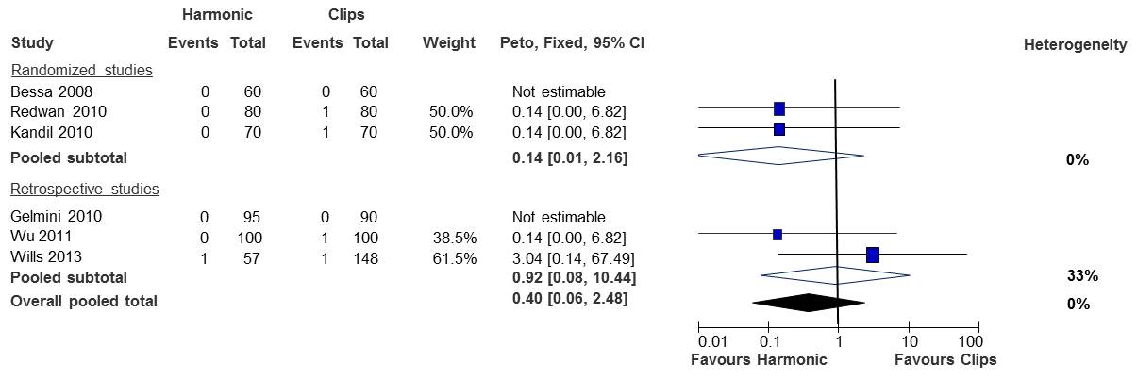
Figure 3 Forest plot on the comparison of harmonic scalpel and metal clips on cystic duct leakage.

Figure 4 Forest plot on the comparison locking and non-locking clips on cystic duct leakage.

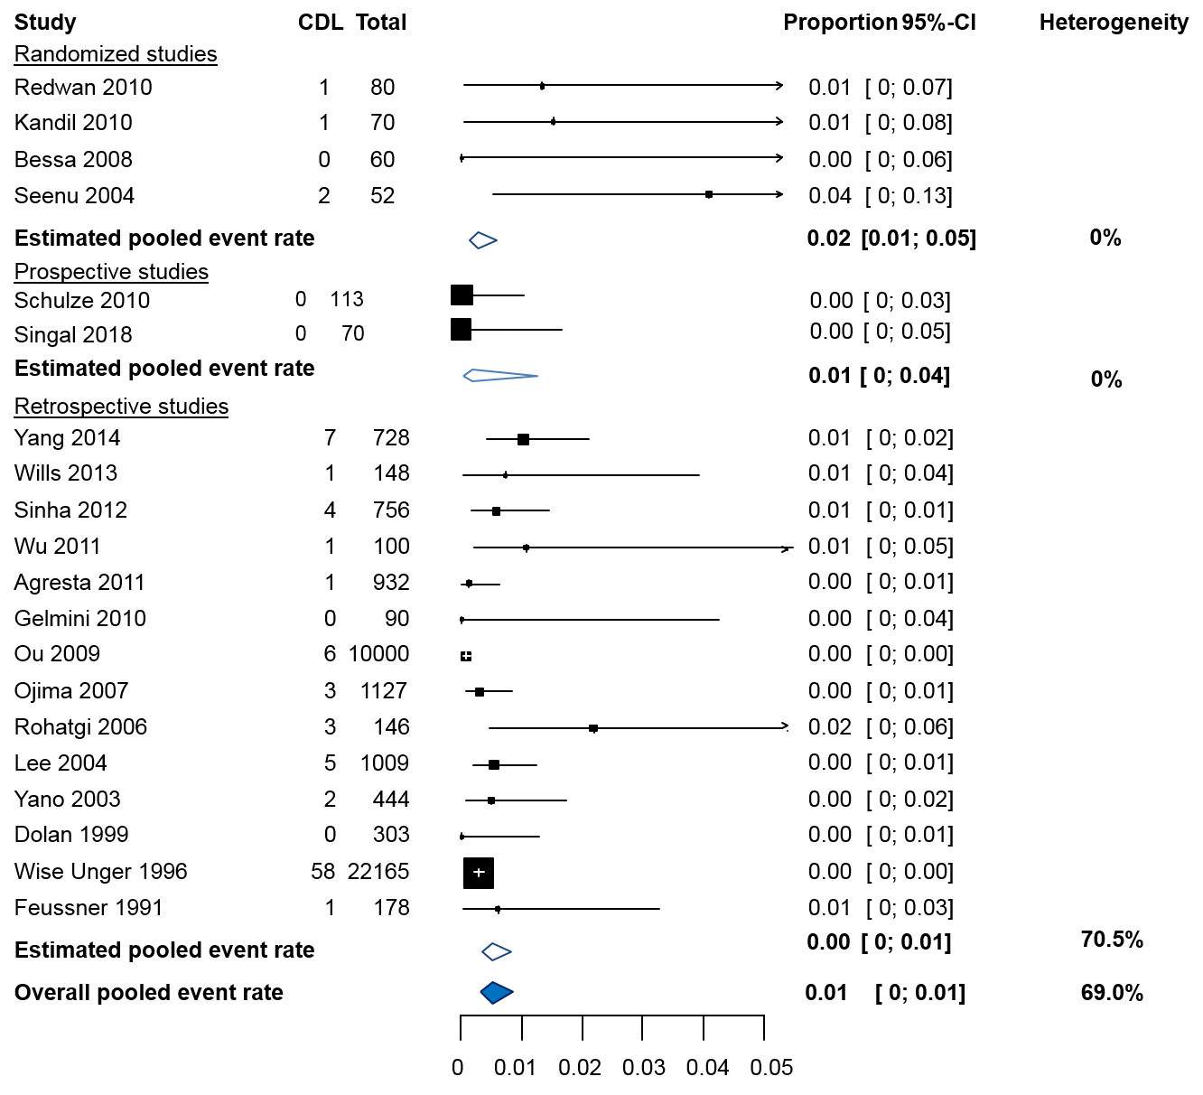

Figure 5 Forest plot of cystic duct leakage following the application of metal clips. CDL: Cystic duct leakage.

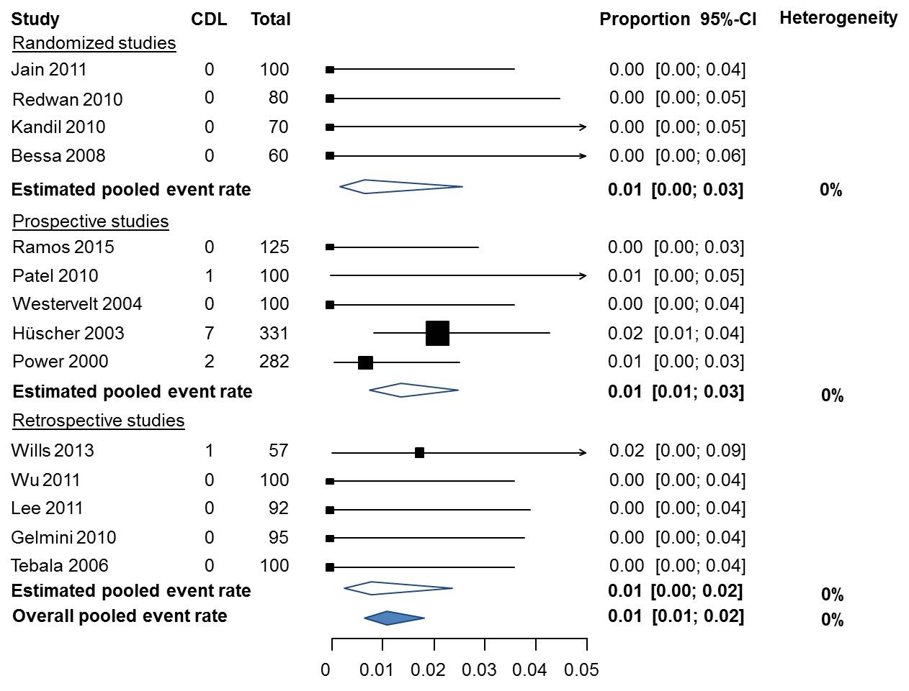
Figure 6 Forest plot of cystic duct leakage following the application of harmonic scalpel/shears. CDL: Cystic duct leakage.

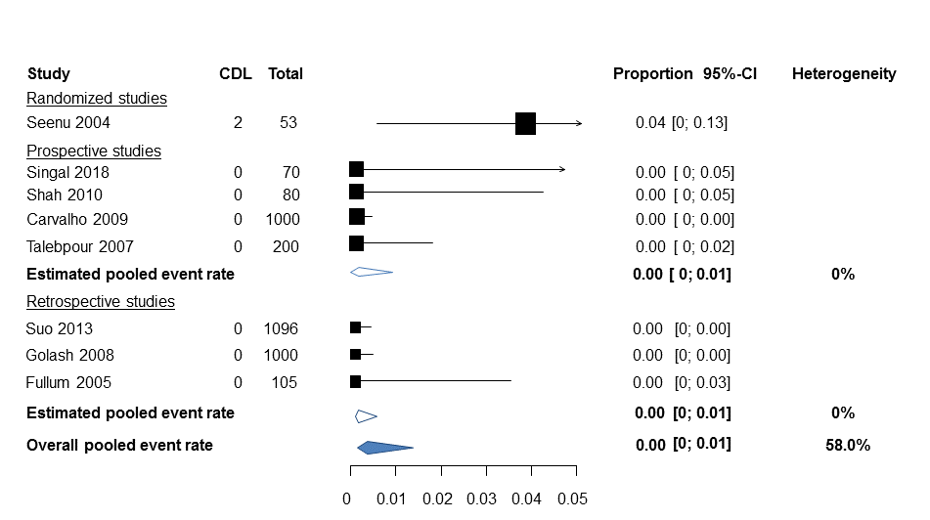
Figure 7 Forest plot of cystic duct leakage following the application of ligature. CDL: Cystic duct leakage.

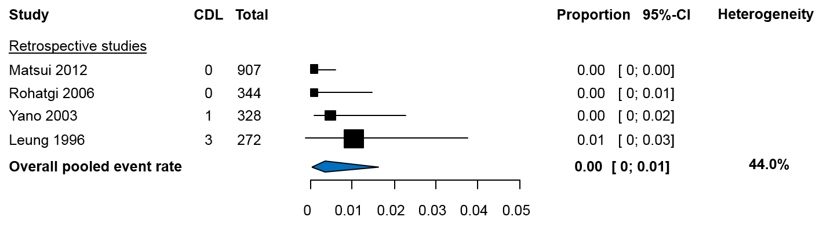
Figure 8 Forest plot of cystic duct leakage following the application of locking clips. CDL: Cystic duct leakage.

Table 1 Characteristics of included comparative studies, descending in year of publication

Study, year, country | Study design | Intervention | Control | Aim study
Jain^{[27]}, 2011, India | RCT | Ultrasonic shears | Electrocautery | To test the benefit of ultrasonic shears in LC
Redwan^{[13]}, 2010, Egypt | RCT | Harmonic shear (Olympus  Keymed Sono surg version G2 220–240V 3A) | Titanium clips | To demonstrate the efficiency and safety of the harmonic scalpel
Kandil^{[14]}, 2010, Egypt | RCT | Harmonic scalpel (Harmonic ACE, Ethicon Endo-Surgery) | Metal clips | To compare metal clips vs the harmonic scalpel on safety and efficacy in LC
Bessa^{[15]}, 2008, Egypt | RCT | Harmonic scalpel (Harmonic ACE, Ethicon Endo-Surgery) | Clip and cautery | To compare the safety and efficacy of the harmonic scalpel vs clip and cautery in LC
Seenu^{[16]}, 2004, India | RCT | Absorbable ligature (Vicryl¹, Ethicon) | Titanium clips (Ligaclip, Ethicon) | To compare postoperative outcomes after occlusion of the cystic duct with tied knots vs titanium clips
Singal^{[19]}, 2018, India | PS | Non-absorbable ligature (Filasilk, Meril) | Titanium clips (Ligaclip, Ethicon) | To study safety and efficacy of silk ligatures compared to clips of closure of the cystic duct
Schulze^{[17]}, 2010, Denmark | PS | LigaSure (ForceTriad system, Valleylab) | Titanium clips | To evaluate the safety of the LigaSure system in cholecystectomy
Hüscher^{[18]}, 2003, Italy | PS | Harmonic shears (Ultracision, Ethicon Endo-Surgery) | Harmonic shears and absorbable endo-loop | To verify the advantages if ultrasonic dissection
Yang^{[21]}, 2014, China | RS | One absorbable clip | Titanium clips | The effectiveness and safety of electrocoagulation after occlusion of the cystic duct and artery with an absorbable clip
Wills^{[22]}, 2013, USA | RS | Harmonic scalpel (Harmonic ACE, Ethicon Endo-Surgery) in pts with a cystic duct > 5 mm | Single surgical clip in pts with cystic duct < 5 mm | The comparison of the Harmonic scalpel vs surgical clips in the occlusion of the cystic duct
Matsui^{[20]}, 2012, Japan | RS | Locking absorbable clips (Laproclip 8 mm, 12mm, Tyco Healthcare)  Locking non-absorbable clip (Hem-o-lok XL, Teleflex Medical) | Endo-loop (SURGITIE, Tyco Healthcare)  Suture  Metallic clip (ENDO CLIP III, Tyco Healthcare) | To evaluate the effect of locking clips on the leakage from the cystic duct in cholecystectomy
Wu^{[26]}, 2011, China | RS | Ultrasonic shears (Harmonic ACE, Ethicon Endo-Surgery) | Clips | To compare conventional LC to SILC
Gelmini^{[23]}, 2010, Italy | RS | Harmonic scalpel (Harmonic - Ethicon Endo Surgery) | Clips | To demonstrate that the harmonic scalpel is safe in LC
Rohatgi^{[24]}, 2006, United Kingdom | RS | Absorbable locking clips (Laproclip, USS-DG, Tyco) | Titanium clips (Ligaclip, Ethicon) | To compare the efficacy of the locking absorbable clip vs clips in LC
Yano, 2003, Japan^{[25]} | RS | Locking absorbable clips (Laproclip, Davis and Geck) | Ligaclip (metal clip, Ethicon) | To assess if locking clips are safer and less invasive than metal Ligaclips
RS: Retrospective studydesign; RCT: Randomized controlled trial; PS: Prospective study design; LC: Laparoscopic cholecystectomy.

Table 2 Patient and operative characteristics of included comparative studies
Study, year, country | No. of patients | No. of complicated cases | Failure of technique in intervention group | Operating time | Hospital stay
 | Harmonic scalpel/ shears vs metal clips
Wills^{[22]}, 2013, United States | 57 vs 148 | NR | 3 | NR | NR
Wu^{[26]}, 2011, China | 100 vs 100 | 0 (exclusion criterium) | NR | Mean in minute (SD)  49.2 (13.8) vs 53.3 (24) | NR
Redwan^{[13]}, 2010, Egypt | 80 vs 80 | NR | NR | Mean in minute (SD)  20 (6.8) vs 45 (6.5) | Mean in days (SD)  1 (0.0) vs 1.5 (0.51)
Kandil^{[14]}, 2010, Egypt | 70 vs 70 | NR | NR | Mean in minute (SD)  33.2 (9.6) vs 51.7 (13.8) | Mean in hours (SD)  23.4 (2.29) vs 267.0 (8.94)
Gelmini^{[23]}, 2010, Italy | 95 vs 90 | 28 vs 22 | 17 | Median in minute (range)  60 (20-140) vs 80 (45-130) | Median in days (range)  2 (1-16) vs 2 (1-12)
Bessa^{[15]}, 2008, Egypt | 60 vs 60 | 0 (exclusion criterium) | NR | Median in minute (range)  32 (18-75) vs 40 (21-85) | NR
 | Absorbable vs non-absorbable clips
Yang^{[21]}, 2014, China | 635 vs 728 | 545 vs 626 | NR | Mean in minute (SD)  41.6 (16.5) vs 58.9 (19.4) | 2.6 (0.4) vs 2.7 (0.6)
 | Locking vs non-locking clips
Matsui^{[20]}, 2012, Japan | 907 vs 110 | 85 (unknown in which group) | 5 | NR | NR per group
Rohatgi^{[24]}, 2006, United Kingdom | 346 vs 148 | NR | 2 | NR | NR
Yano, 2003, Japan^{[25]} | 328 vs 444 | 8 vs 9 | 0 | Mean in minute (SD)  84.6 (1.6) vs 112.7 (2.3) | Mean in days (SD)  7.9 (0.2) vs 8.0 (0.1)
 | Other
Singal^{[19]}, 2018, India | 70 silk ligature vs 70 titanium clips | 0 (exclusion criterium) | 0 | NR | NR in detail (“similar”)
Schulze^{[17]}, 2010, Denmark | 101 Ligasure vs 113 titanium clips | Only elective surgery | NR | NR | NR
Seenu^{[16]}, 2004, India | 53 absorbable ligature vs 52 titanium clips | NR | NR | Mean in minute  78 vs 66 | NR
Hüscher^{[18]}, 2003, Italy | 331 harmonic shears vs 130 harmonic shears + endoloop | 109 vs 68 | NR | Mean in minute  76.8 vs 97.5 | Mean in days  4.3 vs 5.1
NR: Not reported.

Table 3 Clinical outcomes of included comparative studies
Study, year, country |  | No. of patients | Leakage of the cystic duct | Bile duct injury | Biloma | Intra-abdominal abcess
 |  | Harmonic scalpel/ shears vs metal clips
Wills^{[22]}, 2013, United States |  | 57 vs 148 | 1 vs 1 | 1 (D) vs 0 | 1 vs 0 | 0 vs 0
Wu^{[26]}, 2011, China |  | 100 vs 100 | 0 vs 1 | 0 vs 0 | 0 vs 0 | 0 vs 0
Redwan^{[13]}, 2010, Egypt |  | 80 vs 80 | 0 vs 1 | 0 vs 0 | 0 vs 0 | 0 vs 0
Kandil^{[14]}, 2010, Egypt |  | 70 vs 70 | 0 vs 1 | 0 vs 0 | NR | NR
Gelmini^{[23]}, 2010, Italy |  | 95 vs 90 | 0 vs 0 | 0 vs 0 | NR | 2 vs 0
Bessa^{[15]}, 2008, Egypt |  | 60 vs 60 | 0 vs 0 | 0 vs 0 | NR | NR
 |  | Locking absorbable vs locking non-absorbable clips
Yang^{[21]}, 2014, China |  | 635 vs 728 | 0 vs 7 | NR | NR | 1 vs 2
 |  | Locking vs non-locking clips
Matsui^{[20]}, 2012, Japan |  | 907 vs 110 | 0 vs 0 | NR | NR | NR
Rohatgi^{[24]}, 2006, United Kingdom |  | 344 vs 146 | 0 vs 3 | NR | 2 vs 2 | NR
Yano^{[25]}, 2003, Japan |  | 328 vs 444 | 1 vs 2 | 2 vs 4 (severity not reported) | NR | NR
 | Other
Singal^{[19]}, 2018, India |  | 70 silk ligature vs 70 titanium clips | 0 vs 0 | NR | NR | NR
Schulze^{[17]}, 2010, Denmark |  | 101 Ligasure vs 113 titanium clips | 0 vs 0 | 0 vs 0 | NR | NR
Seenu^{[16]}, 2004, India |  | 53 absorbable ligature vs 52 titanium clips | 2 vs 2 | NR | NR | NR
Hüscher^{[18]}, 2003, Italy |  | 331 harmonic shears vs 130 harmonic shears + endoloop | 7 vs 3 | 1 (D) vs 0 | NR | 0 vs 1
Amsterdam classification was used to identify the severity of the bile duct injuries: B: Major bile duct leaks with or without concomitant biliary strictures; C: Bile duct strictures without bile leakage; D: Complete transection of the duct with or without excision of some portion of the biliary tree.

Table 4 Outcomes of non-comparative studies
Study, year, country | Study design | Intervention | No. of patients | No. of complicated cases | CDL | Biloma/abcess | BDI | Failure of technique
Harmonic scalpel/ shears /stapler
Jain^{[27]}, 2011, India | RCT⁵ | Harmonic shears | 100 | 0 (exclusion criterium) | 0 | 0 | NR | NR
Ramos^{[44]}, 2015, Brazil | PS | Harmonic shears | 125 | 0 (exclusion criterium) | 0 | NR | NR | NR
Patel^{[45]}, 2010, United Kingdom | PS | Harmonic scalpel (LCS-5, Ethicon)² | 100 | NR | 1 | NR | 1 (D) | NR
Westervelt^{[46]}, 2004, United States | PS | Harmonic scalpel (unknown) | 100 | NR | 0 | NR | NR | 2
Power^{[47]}, 2000, Ireland | PS | Harmonic scalpel (Ultracision, Ethicon Endo-Surgery) and clip | 282 | 101 | 2 | NR | NR | NR
Lee^{[28]}, 2011, South Korea | RS | Endo-GIA (US Surgical Corp.)¹ | 92¹ | 90 | 0 | NR | 4 (D) | NR
Tebala^{[29]}, 2006, Italy | RS | Harmonic shears (Ultracision, Ethicon Endo- Surgery) | 100 | 0 (exclusion criterium) | 0 | 1/NR | 0 | 2
Ligature
Shah^{[48]}, 2010, Nepal | PS | Intracorporeal single ligation | 80 | 19 | 0 | NR | NR | NR
Carvalh^{[49]}, 2009, Brazil | PS | Surgical knots (2-0 polyester)⁴ | 1000 | NR | 0 | NR | 0 | NR
Talebpour, 2007, Iran^{[50]} | PS | Absorbable sutures  and intracorporeal knots | 200 | 25 | 0 | NR | 1 (B) | 18
Suo^{[36]}, 2013, China | RS | Absorbable thread (VICRYL_ W9215, Ethicon) | 1096 | 296 | 0 | NR /0 | 0 | NR
Golash^{[37]}, 2008, Oman | RS | Intracorporeal ligation (3/0 Vicryl) | 1000 | NR | 0 | NR | NR | 0
Fullum^{[38]}, 2005, United States | RS | Two 2–0 PDS Endoloops (Ethicon Endo-Surgery) | 105 | 22 | 0 | NR | NR | NR
Locking clips
Leung^{[39]}, 1996, Hong Kong | RS | PDS-clip (Ethicon Endo-surgery) | 272 | 94 | 3 | 4 intra-peritoneal collections | NR | 45 (30 in complicated group)
Clips
Sinha^{[40]}, 2012, India | RS | Ligaclip (titanium clip, Ethicon)⁴ | 756 | NR | 4 | NR | NR | NR
Agresta^{[41]}, 2011, Italy | RS | Titanium clips⁴ | 932 | 123 | 1 | NR | NR | NR
Feroci, 2011, Italy^{[32]} | RS | Polymeric absorbable clip | 664 | NR | 0 | 0 | NR | NR
Ou^{[42]}, 2009, China | RS | Clips | 10000 | NR | 6 | NR | 0 | NR
Ojima, 2007, Japan^{[35]} | RS | Clips | 1127 | NR | 3 | NR | 2³ | NR
Lee^{[33]}, 2004, Taiwan | RS | Clips⁴ | 1009 | 78 | 5 | NR/1 | 2 (D) | NR
Dolan^{[43]}, 1999, Nothern Ireland | RS | Titanium clips | 303 | 18 | 0 | 1 / 0 | NR | 0
Wise Unger^{[30]}, 1996, United States | RS | Clips | 22165 | NR | 58 | NR | NR | NR
Feussner^{[31]}, 1991, Germany | RS | Clips | 178 | 28 | 1 | NR | NR | NR
Other
Lewandowski^{[34]}, 2006, Poland | RS | LigaSure (Valleylab) | 129 | NR | 0 | NR | 2 (1B, 1D) | NR
Amsterdam classification was used to identify the severity of the bile duct injuries: B: Major bile duct leaks with or without concomitant biliary strictures; C: Bile duct strictures without bile leakage; D: Complete transection of the duct with or without excision of some portion of the biliary tree. ¹Only in patients with an inflamed an dilated cystic duct (> 1.0 cm); ²Only in patients with an cystic duct < 5 mm; ³severity unknown; ⁴In patients undergoing MLC (mini LC: three ports) or SILC; ⁵Method of closure not described in one study arm, therefore not used as comparative cohort. CDL: Cystic duct leakage; BDI: Bile duct injury; RS: Retrospective study design; PS: Prospective study design; CD: Cystic duct; LC: Laparoscopic cholecystectomy.

