Name of Journal: World Journal of Gastrointestinal Endoscopy
Manuscript NO: 79805
Manuscript Type: MINIREVIEWS

Optimal traction direction in traction-assisted gastric endoscopic submucosal dissection

Nagata M. Optimal traction direction in gastric ESD

Mitsuru Nagata

Mitsuru Nagata, Department of Endoscopy, Shonan Fujisawa Tokushukai Hospital, Fujisawa 251-0041, Kanagawa, Japan

Author contributions: Nagata M has been associated with the conception, drafting of the article, and final approval of the article.

Corresponding author: Mitsuru Nagata, MD, Chief Doctor, Department of Endoscopy, Shonan Fujisawa Tokushukai Hospital, 1-5-1 Tsujidokandai, Fujisawa 251-0041, Kanagawa, Japan. mitsuru10jp@yahoo.co.jp

Received: September 7, 2022
Revised: October 2, 2022
Accepted: October 14, 2022
Published online:

Abstract
Various traction devices have been developed to secure a visual field and sufficient tension at the dissection plane during endoscopic submucosal dissection (ESD). However, few large-scale studies have investigated the effectiveness of traction devices in gastric ESD. Clip-with-line (CWL) is one such traction device that is widely used in cases of gastric ESD. The CONNECT-G trial was the first multicenter randomized controlled trial to compare conventional ESD with CWL-assisted ESD (CWL-ESD) for superficial gastric neoplasms. Overall, no significant intergroup difference was observed in terms of the gastric ESD procedure time. However, subgroup analysis according to lesion location revealed a significant reduction in the procedure time of gastric ESD for the lesion located at the greater curvature of the middle and upper third of the stomach in the CWL-ESD group. In this subgroup analysis, lesion location was categorized as follows: anterior wall, posterior wall, lesser curvature, and greater curvature of the upper, middle, and lower thirds of the stomach. However, the gastric ESD procedure time showed no significant difference, except for lesions located at the greater curvature of the upper and middle thirds of the stomach. The traction direction of CWL in the stomach was limited to the cardia and changed depending on the lesion location. Therefore, outcomes of the CONNECT-G trail suggest that the effectiveness of CWL was influenced by lesion location, i.e., traction direction. Further studies are warranted to investigate the optimal traction direction in gastric ESD.

Key Words: Endoscopic submucosal dissection; ESD; Traction device; Clip-with-line; Traction direction; Vertical traction

Nagata M. Optimal traction direction in traction-assisted gastric endoscopic submucosal dissection. World J Gastrointest Endosc 2022; In press

Core Tip: Various traction devices have been developed for endoscopic submucosal dissection (ESD). However, few traction devices have been validated in large-scale studies thus far. The CONNECT-G trial was the first multicenter randomized controlled trial to compare conventional ESD with clip-with-line-assisted ESD for superficial gastric neoplasms. This study suggested that the effectiveness of traction devices in gastric ESD depends on the traction direction; in addition, the most optimal traction direction is vertical to the gastric wall.

INTRODUCTION
Endoscopic submucosal dissection (ESD) allows en bloc resection of superficial gastric neoplasms. However, gastric ESD is a challenging procedure. Surgeons can use their nondominant hand to generate traction for lesions while they resect using their dominant hand. Meanwhile, endoscopists cannot use their nondominant hand to generate traction because they cannot insert their hand into the stomach. Therefore, endoscopists occasionally cannot secure a visual field and sufficient tension at the dissection plane, resulting in a long ESD procedure time and a high perforation rate. Recently, many traction devices were reported to overcome these problems, but few large-scale studies investigated the effectiveness of traction devices in gastric ESD.

CONNECT-G trial
The CONNECT-G trial was the first multicenter randomized controlled trial to compare conventional ESD with traction-assisted ESD for the treatment of superficial gastric neoplasms^{[1]}. In this study, clip-with-line (CWL) was used as a traction device (Figure 1), and its traction direction is restricted to the direction where the line is drawn^{[2,3]}. The primary endpoint was the mean gastric ESD procedure time, which was 58.1 min in the conventional ESD group and 60.7 min in the CWL-assisted ESD (CWL-ESD) group, with no significant difference (P = 0.45). R0 resection was not statistically significant in both groups (96.8% vs 97.8%, P = 0.45). However, the perforation rate was significantly lower in the CWL-ESD group (0.3% vs 2.2%, P = 0.04), suggesting that CWL may have improved the field of vision and reduced blind submucosal dissection.
For lesions located at the greater curvature of the middle and upper third of the stomach, the CWL-ESD group had a significantly shorter gastric ESD procedure time than the conventional ESD group (57.2 min vs 104.1 min, P = 0.01). This part of the stomach is a challenging area for conventional ESD because it is basically a gravitational lower side, so a mucosal flap is difficult to deploy, and the visual field tends to deteriorate due to fluid retention. Nevertheless, CWL-ESD is particularly useful in this area. In this subgroup analysis, lesion location was divided into the anterior wall, posterior wall, lesser curvature, and greater curvature of the upper, middle, and lower third of the stomach. However, no significant difference was found in the procedure time of gastric ESD, except for lesions located at the greater curvature of the middle and upper third of the stomach.

Traction direction of CWL differs depending on the lesion location and endoscopic position
The results of the CONNECT-G trail suggest that the effectiveness of CWL-ESD varies depending on the lesion location. Traction direction can be classified into five categories (Figure 2)^{[4]}. Since CWL is a per-oral traction device, its traction direction is limited to the cardia and varies depending on the lesion location. Another consideration for the traction direction of CWL is the endoscopic position during submucosal dissection. Because of the large lumen of the stomach, there are two possible endoscopic positions: forward and retroflexed. Therefore, the traction direction also varies depending on the endoscopic position even if the lesion is in the same location. For example, for lesions located at the lesser curvature of the middle third of the stomach, CWL commonly provides a distal traction in retroflexed endoscopic position (Figure 3A) and proximal traction in forward endoscopic position (Figure 3B).

What is the optimal traction direction in gastric ESD?
The optimal traction direction in gastric ESD was not yet fully investigated. However, several studies indicated that a vertical traction is the optimal traction direction. The CONNECT-G trial suggests that CWL is effective for lesions located at the greater curvature of the upper and middle third of the stomach, and vertical traction is frequently performed in this area from an anatomical point of view (Figure 3C). CWL can essentially only provide vertical traction for lesions located at the greater curvature of the stomach, but multidirectional traction devices, such as a spring-and-loop with clip (Figure 4; SLC; S–O clip; Zeon Medical, Tokyo, Japan), may provide a vertical traction for lesions in other areas. The SLC allows the traction direction to be controlled in any direction. This clip was developed as a traction device to provide traction for colorectal ESD. Hence, we have devised a novel usage of the SLC with both forward and retroflexed endoscopic positions for gastric ESD^{[5,6]}. A single-center randomized controlled trial comparing conventional ESD and SLC-assisted ESD (SLC-ESD) was conducted. In SLC-ESD, a vertical traction was selected using the multidirectional traction function. This study demonstrated that the median gastric ESD procedure time was significantly shorter in SLC-ESD than in conventional ESD (29.1 min vs 52.6 min; P = 0.005)^{[7]}. However, SLC-ESD was not associated with a reduction in the gastric ESD procedure time for lesions > 20 mm. As submucosal dissection progresses, the distance between the SLC attachment site and the anchor site diminishes gradually, resulting in weaker traction force due to the spring shortening. For larger lesions, diagonally proximal traction may be preferable to vertical traction to maintain spring extension even as submucosal dissection progresses or an additional SLC should be considered when traction force becomes weaker. Overall, considering the results of these two randomized controlled trials, vertical traction may be the optimal traction direction for most cases of gastric ESD.
It is unclear whether other traction directions are effective in gastric ESD. Especially in distal traction, as the submucosal dissection progresses, the dissection plane falls toward a distal direction, which may be counterproductive because it may not provide an effective tension on the dissection plane. In CWL-ESD, a retroflexed endoscopic position occasionally results in a distal traction, and this position is common in gastric ESD. It is possible that a distal traction was provided for a relatively large number of cases in the CONNECT-G trial, and this could cause no significant difference in gastric ESD procedure time between conventional ESD and CWL-ESD in the total population of the CONNECT-G trial. However, the traction direction and endoscopic position were not reported, so this point should be further investigated.
In CWL-ESD, combined with the pulley method^{[8,9]}, the traction direction can be controlled, and vertical traction can be obtained. Therefore, the pulley method may improve the gastric ESD procedure time in CWL-ESD. However, since the pulley method in gastric ESD has been reported mainly in case series studies or ex-vivo studies, its feasibility and effectiveness should be further investigated.

CONCLUSION
Vertical traction may be the optimal traction direction in traction-assisted ESD for gastric neoplasms. Further studies are needed to investigate the effectiveness of other traction directions.

REFERENCES
1 Yoshida M, Takizawa K, Suzuki S, Koike Y, Nonaka S, Yamasaki Y, Minagawa T, Sato C, Takeuchi C, Watanabe K, Kanzaki H, Morimoto H, Yano T, Sudo K, Mori K, Gotoda T, Ono H; CONNECT-G Study Group. Conventional vs traction-assisted endoscopic submucosal dissection for gastric neoplasms: a multicenter, randomized controlled trial (with video). Gastrointest Endosc 2018; 87: 1231-1240 [PMID: 29233673 DOI: 10.1016/j.gie.2017.11.031]
2 Oyama T, Kikuchi Y, Shimaya S, Tomori T, Hotta K, Miyata Y, Yamada S. Endoscopic mucosal resection using a hooking knife (hooking EMR) [in Japanese]. Stomach Intest 2002; 37: 1151-1161 [DOI: 10.11477/mf.1403104523]
3 Oyama T. Counter traction makes endoscopic submucosal dissection easier. Clin Endosc 2012; 45: 375-378 [PMID: 23251884 DOI: 10.5946/ce.2012.45.4.375]
4 Nagata M. Advances in traction methods for endoscopic submucosal dissection: What is the best traction method and traction direction? World J Gastroenterol 2022; 28: 1-22 [PMID: 35125817 DOI: 10.3748/wjg.v28.i1.1]
5 Nagata M. Modified attachment method using an S-O clip for gastric endoscopic submucosal dissection. VideoGIE 2019; 4: 151-153 [PMID: 31032463 DOI: 10.1016/j.vgie.2018.12.015]
6 Nagata M. Internal traction method using a spring-and-loop with clip (S-O clip) allows countertraction in gastric endoscopic submucosal dissection. Surg Endosc 2020; 34: 3722-3733 [PMID: 32350668 DOI: 10.1007/s00464-020-07590-9]
7 Nagata M, Fujikawa T, Munakata H. Comparing a conventional and a spring-and-loop with clip traction method of endoscopic submucosal dissection for superficial gastric neoplasms: a randomized controlled trial (with videos). Gastrointest Endosc 2021; 93: 1097-1109 [PMID: 33058886 DOI: 10.1016/j.gie.2020.09.049]
8 Li CH, Chen PJ, Chu HC, Huang TY, Shih YL, Chang WK, Hsieh TY. Endoscopic submucosal dissection with the pulley method for early-stage gastric cancer (with video). Gastrointest Endosc 2011; 73: 163-167 [PMID: 21030018 DOI: 10.1016/j.gie.2010.08.041]
9 Ge PS, Thompson CC, Jirapinyo P, Aihara H. Suture pulley countertraction method reduces procedure time and technical demand of endoscopic submucosal dissection among novice endoscopists learning endoscopic submucosal dissection: a prospective randomized ex vivo study. Gastrointest Endosc 2019; 89: 177-184 [PMID: 30148993 DOI: 10.1016/j.gie.2018.08.032]

Footnotes
Conflict-of-interest statement: No financial relationships with a commercial entity producing health-care related products and/or services relevant to this article.

Open-Access: This article is an open-access article that was selected by an in-house editor and fully peer-reviewed by external reviewers. It is distributed in accordance with the Creative Commons Attribution NonCommercial (CC BY-NC 4.0) license, which permits others to distribute, remix, adapt, build upon this work non-commercially, and license their derivative works on different terms, provided the original work is properly cited and the use is non-commercial. See: https://creativecommons.org/Licenses/by-nc/4.0/

Provenance and peer review: Invited article; Externally peer reviewed.
Peer-review model: Single blind

Peer-review started: September 7, 2022
First decision: September 26, 2022
Article in press:

Specialty type: Gastroenterology and hepatology
Country/Territory of origin: Japan
Peer-review report’s scientific quality classification
Grade A (Excellent): 0
Grade B (Very good): B, B
Grade C (Good): 0
Grade D (Fair): 0
Grade E (Poor): 0

P-Reviewer: Guo JT, China; Li S, China S-Editor: Liu JH L-Editor: A P-Editor: Liu JH
Figure Legends
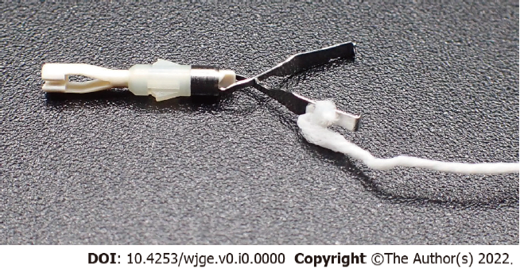
Figure 1 A clip-with-line was made by tying a commercially available dental floss to the arm section of the hemoclip.
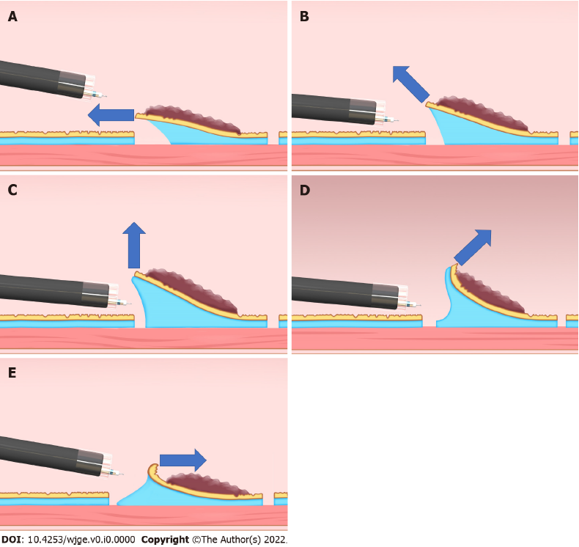
Figure 2 Classification of the traction direction. A: Proximal traction; B: Diagonally proximal traction; C: Vertical traction; D: Diagonally distal traction; E: Distal traction. Citation: Reprinted from Mitsuru Nagata. Advances in traction methods for endoscopic submucosal dissection: What is the best traction method and traction direction? World Journal of Gastroenterology 2022; 28(1): 1–22. Copyright © Mitsuru Nagata 2022. Published by Baishideng Publishing Group Inc.
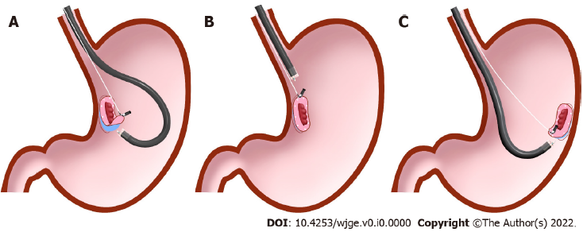
Figure 3 Differences in traction direction depending on the lesion location in clip-with-line–assisted endoscopic submucosal dissection. A: Distal traction; B: Proximal traction; C: Vertical traction. Citation: Reprinted from Mitsuru Nagata. Advances in traction methods for endoscopic submucosal dissection: What is the best traction method and traction direction? World Journal of Gastroenterology 2022; 28(1): 1–22. Copyright © Mitsuru Nagata 2022. Published by Baishideng Publishing Group Inc.
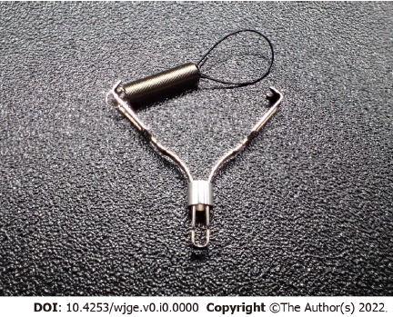
Figure 4 An S–O clip (Zeon Medical, Tokyo, Japan) was made of a 5 mm-long spring and 4 mm-long nylon loop on one side of the clip claws.

