Name of Journal: World Journal of Clinical Cases
Manuscript No: 69094
Manuscript Type: CASE REPORT

Full recovery from chronic headache and hypopituitarism caused by lymphocytic hypophysitis: A case report

Yang MG et al. Lymphocytic hypophysitis with headache

Mao-Guang Yang, Han-Qing Cai, Si-Si Wang, Lin Liu, Chun-Mei Wang

Mao-Guang Yang, Han-Qing Cai, Si-Si Wang, Lin Liu, Department of Endocrinology, The Second Hospital of Jilin University, Changchun 130000, Jilin Province, China

Chun-Mei Wang, Department of Radiology, The First Hospital of Jilin University, Changchun 130000, Jilin Province, China

Author contributions: Wang CM analyzed and interpreted the imaging findings and contributed to the manuscript drafting; Cai HQ contributed to the data curation and proofreading of the manuscript; Wang SS and Liu L were responsible for revising the manuscript for important intellectual content; Yang MG reviewed the literature; Wang CM and Yang MG contributed to the manuscript drafting; and all authors read and approve of the final manuscript.

Supported by the Nature Science Foundation of Jilin Province (No. 2018010113JC).

Corresponding author: Chun-Mei Wang, MA, Chief Doctor, Department of Radiology, The First Hospital of Jilin University, No. 1 Xinmin Avenue, Changchun, 130000, Jilin Province, China. wangcm5413@jlu.edu.cn

Received: June 16, 2021
Revised: July 5, 2021
Accepted: December 25, 2021
Published online:

Abstract
BACKGROUND
Lymphocytic hypophysitis (LYH) is an important condition to consider in the differential diagnosis of patients with a pituitary mass. The main clinical manifestations of LYH include headache, symptoms related to sellar compression, hypopituitarism, diabetes insipidus and hyperprolactinemia. Headache, which is a frequent complaint of patients with LYH, is thought to be related to the occupying effect of the pituitary mass and is rapidly resolved with a good outcome after timely and adequate glucocorticoid treatment or surgery.

CASE SUMMARY
Here, we report a patient with LYH whose initial symptom was headache and whose pituitary function assessment showed the presence of secondary hypoadrenalism, central hypothyroidism and hypogonadotropic hypogonadism. Pituitary magnetic resonance imaging showed symmetrical enlargement of the pituitary gland with suprasellar extension in a dumbbell shape with significant homogeneous enhancement after gadolinium enhancement. The size of the gland was approximately 17.7 mm × 14.3 mm × 13.8 mm. The pituitary stalk was thickened without deviation, and there was an elevation of the optimal crossing. The lesion grew bilaterally toward the cavernous sinuses, and the parasternal dural caudal sign was visible. The patient presented with repeatedly worsening and prolonged headaches three times even though the hypopituitarism had fully resolved after glucocorticoid treatment during this course.

CONCLUSION
This rare headache regression suggests that patients with chronic headaches should also be alerted to the possibility of LYH.

Key words: Lymphocytic hypophysitis; Magnetic resonance imaging; Hypopituitarism; Headache; Glucocorticoid; Case report

Yang MG, Cai HQ, Wang SS, Liu L, Wang CM. Full recovery from chronic headache and hypopituitarism caused by lymphocytic hypophysitis: A case report. World J Clin Cases 2021; In press

Core tip: Lymphocytic hypophysitis (LYH) is an important condition to consider in the differential diagnosis of patients with a pituitary mass, and headache is a frequent complaint of patients with LYH. We present a patient with LYH whose initial symptom was headache and who presented with repeatedly worsening and prolonged headaches three times even though the hypopituitarism was fully resolved after glucocorticoid treatment. This rare headache regression suggests that the cause of headaches in patients with LYH may not be exclusively due to the pituitary mass effect and that patients with chronic headaches should also be alerted to the possibility of LYH.

INTRODUCTION
Histologically, lymphocytic hypophysitis (LYH) is the most common type of primary autoimmune hypophysitis (PAH), accounting for approximately 70% of all causes of PAH, and LYH is characterized by extensive lymphocytic and plasma cell infiltration in the pituitary gland with varying degrees of pituitary dysfunction^{[1-3]}. LYH is a rare disease with an annual incidence of only 1 case per 9 million^{[1,4]}. However, the prevalence of LYH is related to how the diagnosis is made, and the calculation of the incidence of LYH may be inaccurate due to the use of different clinical or pathological diagnostic bases^{[1,5]}. Most LYH patients are young women, and 60% of the cases are diagnosed during pregnancy, especially during the third trimester and early postpartum period^{[6]}. Given its presence as a pituitary adenoma on radiographic images, LYH is misdiagnosed as pituitary adenoma in approximately 40% of patients^{[7]}. This situation represents a common diagnostic dilemma for neurosurgeons with controversial management. Although histopathological examination is the gold standard for the diagnosis of LYH, biopsy and surgery have the potential of adverse events, such as further deterioration of pituitary function^{[8]}. A clinical diagnosis can be made based on a combination of the presenting symptoms, hormonal changes and magnetic resonance imaging (MRI) features^{[9]}. The characteristic manifestations of LYH are often symptoms of sellar mass effects, such as headache, visual field defects, hypopituitarism, diabetes insipidus, and hyperprolactinemia^{[10]}. It has been reported that headaches are often caused by the mass effect of the enlarged pituitary gland and typically resolve permanently after pituitary reduction^{[11,12]}. Here, we report a case of a rare recurrence of headaches following a significant reduction in the pituitary volume with concomitant partial recovery to complete remission of hypopituitarism.

CASE PRESENTATION
Chief complaints
A 56-year-old female patient presented with an intermittent throbbing headache located in the left temporal region. She was admitted to our hospital for neurosurgery.

History of present illness
Two months before hospitalization, the patient did not complain about headache. One month before hospitalization, the headache worsened and became more pronounced at night, and she experienced vision loss with bilateral temporal visual field defects.

History of past illness
The patient had a history of hypertension for more than 20 years. There was no family history of autoimmune disease.

Personal and family history
There was no personal or family history.

Physical examination
The patient presented with a height of 160 cm, a weight of 65 kg, a temperature of 36.5 °C, and a blood pressure of 140/108 mmHg. The clinical neurological examination showed no abnormalities. Our initial clinical diagnosis was cellar area occupancy.

Laboratory examinations
The laboratory data showed a potassium level of 3.2 mmol/L, uroprotein⁺-, and a urinary specific gravity of 1.025. The patient was negative for antinuclear antibodies, immunoglobulin G (IgG), IgM, IgA, and IgG4, which did not support IgG4-related hypophysitis, and no antithyroid antibodies were detected. The remaining biochemical and coagulation test results were unremarkable. The cortisol, adrenocorticotropic hormone (ACTH), follicle-stimulating hormone (FSH), luteinizing hormone (LH), prolactin (PRL), growth hormone (GH), thyroid-stimulating hormone (TSH), free triiodothyronine 3 (FT3), and free triiodothyronine (FT4) levels were measured (Table 1). A water deprivation test was not performed because the patient did not have polyhydramnios or polyuria.

Imaging examinations
The chest computerized tomography was normal. The electrocardiography was characterized by a flat t wave. The MRI of the pituitary gland showed symmetrical enlargement with suprasellar extension in a dumbbell shape with significant homogeneous enhancement after gadolinium enhancement (Figure 1), high signal in the posterior pituitary lobe in the T1 sequence, low signal in the anterior pituitary gland in the T1 sequence and high signal in the T2 sequence. The pituitary stalk was thickened, but not deviated, approximately 3.1 mm at the optic cross and approximately 3.1 mm at the pituitary insertion with an elevation of the optimal crossing (Figure 1). The lesion grew bilaterally toward the cavernous sinuses and encircled the bilateral internal carotid arteries, and the parasternal dural caudal sign was visible (Figure 2), all of which are specific MRI manifestations consistent with LYH. According to the scoring system by Gutenberg et al^{[7]}, our patient was -8, strongly suggesting the diagnosis of LH.

MULTIDISCIPLINARY EXPERT CONSULTATION
Ophthalmologic assistance was requested for the examination, and the assessment suggested temporal visual field defects in both eyes, a corrected visual acuity of 0.5 in the left eye and a visual acuity of 0.8 in the right eye.

FINAL DIAGNOSIS
Considering the rapid progression of hypopituitarism and the combination of the MRI features, laboratory tests, clinical manifestations and epidemiological features, LYH was strongly considered.

TREATMENT
Glucocorticoid therapy was administered in conjunction with an endocrinology consultation, starting with a daily intravenous infusion of 50 mg hydrocortisone. This treatment was changed to 30 mg/d combined with 25 μg/d levothyroxine tablets after 3 d and 20 mg/d after 4 d. The patient's symptoms significantly improved, but the pituitary function did not significantly improve upon reassessment at 1 wk of the steroid treatment. The pituitary-adrenal axis and pituitary-thyroid axis were improved, but the pituitary-gonadal axis did not recover (Table 1). After an evaluation of the pituitary function, the treatment was changed to continuous 120 mg/d- methylprednisolone pulse therapy due to the poor treatment effect and then 80 mg/d after 5 d. Subsequently, pulse therapy was continued for 1 mo and finally discontinued; the headache was significantly relieved, and the visual field returned to normal, suggesting LYH rather than pituitary adenoma.

OUTCOME AND FOLLOW-UP
Repeat pituitary MRI showed a decrease in the size of the suprasellar mass with homogeneous enhancement, thinning and no deviation of the pituitary stalk, no elevation of the chiasm, and no abnormal signal in the cavernous sinus. However, the patient was found to have concomitant glucocorticoid-related diabetes mellitus, was treated with insulin and tested negative for diabetic autoimmune antibodies. Methylprednisolone was continued at 60 mg/d. The dose was reduced to 40 mg/d after 1 wk, and a regimen of 4 mg reduction every 2 wk and discontinuation of levothyroxine tablets was employed. Unfortunately, 6 mo after the diagnosis of LYH, the patient again presented with headaches of the same nature that were worse than before. Ophthalmologic assistance was requested for the examination, and the assessment suggested bilateral refractive error, no abnormalities in the bilateral visual fields and symptomatic treatment. Repeat MRI showed no significant change from the previous MRI. The pituitary function assessment suggested complete recovery of the thyroid and gonadal axes (Table 1), the patient was considered to have no recurrence of LYH, and methylprednisolone was continued with a regimen of 4 mg reduction every 3 wk. The patient's headache worsened for the third time two months later, and she presented with features similar to those previously noted. On examination, she had a full-moon face, centripetal obesity, weight gain and hirsutism. However, repeated pituitary MRI and endocrine function assessment did not show any deterioration. The patient was discharged from the hospital on 6 mg/d methylprednisolone and was instructed to adjust her glucocorticoid dose to 4 mg/d after 1 mo. However, 3 mo later, the patient's headache worsened for the fourth time, with the same features. Repeated pituitary MRI and assessment of the pituitary function showed no significant changes; therefore, LYH was considered stable. Thus, glucocorticoid therapy was stopped, but other treatments, such as glucose-lowering treatments, were continued. Finally, 1 year after the diagnosis, the patient's pituitary function was evaluated to have no abnormalities, and the patient was considered to have completely recovered pituitary function. The patient's headache did not recur (Figure 3).

DISCUSSION
LYH is the most common subtype of PAH and is characterized by diffuse lymphocytic and plasma cell infiltration with fibrosis in the pituitary gland^{[13]}, and the pathological process involves inflammatory changes, edema and enlargement of the pituitary gland, followed by destruction of pituitary cells, parenchymal fibrosis and, ultimately, pituitary atrophy with hypopituitarism^{[5]}. However, the natural course of LYH is poorly understood, and the condition may spontaneously resolve or deteriorate rapidly^{[14]}. In addition, the clinical presentation can widely vary depending on the course of the disease^{[5]}.
However, the most common complaint in 60% of patients with LYH is headache^{[15]}, followed by amenorrhea/erectile dysfunction (59%) and diplopia (27%)^{[9]}. Headache is also the most common complaint in the first neurosurgical consultation, with an incidence of 89%^{[15]}. LYH has been reported to present as frontal, temporal, or occipital headache^{[16-18]}, severe dull or progressive headache^{[18]}, or even trigemino-autonomic cephalalgia^{[17]}. Our patient initially presented with intermittent headaches and later with persistent frontal pain that fluctuated in nature that was characterized by a long duration. The diagnosis of chronic postintracranial disorder headache (CPIDH) is reasonable when the etiologic disease is effectively treated or resolves on its own, but the headache does not resolve or significantly improve after 3 mo^{[19]}. Our patient's headache persisted and repeatedly worsened for more than 8 mo and could be considered CPIDH. It has been suggested that headache is associated with cerebrospinal fluid lymphocytosis, but Honegger et al^{[20]} did not identify a clear correlation between the degree of headache and the cerebrospinal fluid leukocyte count. It has been suggested that pituitary masses causing cavernous sinus involvement and mechanical pulling of the dura are potential pathological mechanisms underlying secondary headaches associated with LYH^{[11]}. Meningeal and dural compression^{[21]} and cavernous sinus involvement that can cause headache^{[22]} are frequently reported. It has also been reported that headache is combined with hyperprolactinemia in 50% of LYH patients^{[19]}, but this was not a problem in our case. It has also been reported that the severity of symptoms and the speed of onset of LYH manifestations are typically not related to the degree of pituitary enlargement and compression of peripheral structures but are related to endocrine cell destruction mediated by autoimmune factors^{[5,22]}, and the long-term chronic headache manifestations in our patient may be related to this pathological feature.
ACTH deficiency is the most common endocrine disorder in LYH (60%), followed by TSH deficiency, gonadotropin deficiency and hyperprolactinemia^{[23]}; thus, the pattern of ACTH > TSH > LH/FSH > GH axis deficiency and the specific vulnerability of ACTH secretion to LYH have been suggested in several reports^{[5,24]}. Our patient exhibited ACTH, TSH, and LH/FSH deficiency, which is consistent with the above reports. Another feature of LYH is that the degree of hypopituitarism is disproportionate to the size of the mass, which is also supported by findings in some cases^{[25]}. One case report describes pituitary inflammation with pituitary enlargement exhibiting hypopituitarism with a long delay in onset^{[26]}. However, this phenomenon was not significantly represented in the present report.
In recent years, the application of MRI in the sellar region has contributed to the feasibility of clinical diagnosis^{[8]} and has become the preferred modality for the study of pituitary lesions. Typical MRI of LYH shows symmetrical enlargement of the pituitary gland with suprasellar extension with marked homogeneous enhancement, thickening of the pituitary stalk without deviation, disappearance of the bright spot of the pituitary gland in the T1 sequence, and the dural tail sign^{[20,27-30]}. A lingual suprasellar and retrosellar extension of the saddle mass in contact with the basal hypothalamus and even infiltration of the basal hypothalamus is a relatively typical finding in granulomatous pituitary inflammation^{[20]}, but this feature was not present in our patient. These features have been confirmed in a larger number of cases, rendering the clinical diagnosis of LYH increasingly simple^{[31]}. However, as an increasing number of cases have been reported, pituitary MRI features, including heterogeneity and ring enhancement, which may also be found on pituitary MRI of LYH, are being updated^{[25]}. Relatively low signals on T1-weighted images and relatively high signals on T2-weighted images may also be MRI manifestations of LYH^{[14]}. The MRI findings of different types of PAH are similar, and it is difficult to differentiate it from pituitary adenoma based only on MRI^{[32]}. The scoring system by Gutenberg et al^{[7]} can distinguish between nonsecretory pituitary tumors and LYH with a sensitivity of 92% and specificity of 99%, which aids in the differential diagnosis of LYH. Our patient's score was -8, favoring a diagnosis of LYH, although granulomatous hypophysitis could also present with similar sellar infiltration; however, granulomatous hypophysitis is very rare and often found by autopsy^{[33]}. The patient did not agree to biopsy of the pituitary gland and pancreas, and case reports of IGg4-related diseases suggest that the pituitary gland is the least involved^{[34]}. Therefore, although it cannot be excluded, it cannot be diagnosed as IGg4-related hypophysitis temporarily according to the corresponding diagnostic criteria^{[34]}. Necrotizing hypophysitis present with a lack of contrast enhancement and sudden-onset hypopituitarism^{[35]}, diabetes insipidus and radiologic findings of the ischemic pituitary are three characteristics of necrotizing hypophysitis^{[35]}. Our patient presented with marked homogeneous anterior pituitary enhancement without ischemic manifestations. Xanthomatous hypophysitis commonly exhibits cystic enlargement and peripheral ring enhancement after contrast^{[36,37]} and is rarely known to improve in response to glucocorticoid therapies^{[38]}. This situation is inconsistent with our patient's findings; thus, necrotizing hypophysitis and xanthomatous hypophysitis were not considered.
The objective of LYH treatment is to rectify the hormone deficiency and relieve the symptoms associated with the effects of the mass. Although glucocorticoids are the preferred pharmacological treatment for LYH, surgery may be considered in the presence of severe neurological or ophthalmic manifestations or the absence of a response to pharmacological treatment^{[39]}. In 2015, Khare et al^{[24]} described 15 patients from western India with pituitary masses that regressed with conservative treatment. Therefore, unless the symptoms are severe or progressively worsen, conservative treatment may be considered^{[40]}. In addition, postoperative hypopituitarism may occur, and deterioration caused by surgery or biopsy may be avoided^{[9]}. Surgical treatment may contribute to the permanent relief of headache, and headache and visual field defects usually improve shortly after surgery^{[12]}. However, considering the risk of hypopituitarism associated with surgery^{[41]}, we did not perform surgery but adhered to long-term glucocorticoid treatment and follow-up, and the outcome was good^{[42]}. Although some patients with LYH may show spontaneous recovery, it is also too late to initiate glucocorticoid therapy 3 mo after symptom onset^{[7,24]}. Our time window for initiating glucocorticoid therapy was 2 mo. Thus, the pituitary function completely recovered, and the headaches, despite the longer duration, were eventually relieved. One study indicates that the first pulse of methylprednisolone was the most effective at less than 6 mo of onset^{[42]}, and Wang et al^{[23]} reported a lower relapse rate associated with longer steroid administration because these authors found a significant difference in relapse rates with steroid drug dose administration times of 6 and < 6 mo. Fortunately, in the absence of significant efficacy with short-term hydrocortisone pulse therapy combined with continuous oral hydrocortisone treatment, the endocrinologist administered long-term methylprednisolone pulse therapy shortly after the onset of the disease to the patient in this case study, and the pituitary function significantly improved until it completely recovered. However, the headache recurred before eventually disappearing completely due to early detection and timely management, and the patient was satisfied with the outcome^{[5]}.

CONCLUSION
This report presents a rare case of LYH in combination with chronic headache despite complete resolution of hypopituitarism. Although the patient experienced long-term recurrent exacerbation of chronic headache, all symptoms eventually resolved in the patient after adequate evaluations of the clinical and MRI features due to early diagnosis and long-term high-dose glucocorticoid therapy.

ACKNOWLEDGEMENTS
We thank the patient and appreciate the help of all family members who participated in this study.

REFERENCES
1 Fukuoka H. Hypophysitis. Endocrinol Metab Clin North Am 2015; 44: 143-149 [PMID: 25732650 DOI: 10.1016/j.ecl.2014.10.011]
2 Glezer A, Bronstein MD. Pituitary autoimmune disease: nuances in clinical presentation. Endocrine 2012; 42: 74-79 [PMID: 22426958 DOI: 10.1007/s12020-012-9654-7]
3 Zhu Q, Qian K, Jia G, Lv G, Wang J, Zhong L, Yu S. Clinical Features, Magnetic Resonance Imaging, and Treatment Experience of 20 Patients with Lymphocytic Hypophysitis in a Single Center. World Neurosurg 2019; 127: e22-e29 [PMID: 30790734 DOI: 10.1016/j.wneu.2019.01.250]
4 Oguz SH, Soylemezoglu F, Sendur SN, Mut M, Oguz KK, Dagdelen S, Erbas T. Clinical Characteristics, Management, and Treatment Outcomes of Primary Hypophysitis: A Monocentric Cohort. Horm Metab Res 2020; 52: 220-227 [PMID: 32268423 DOI: 10.1055/a-1113-7777]
5 Caturegli P, Newschaffer C, Olivi A, Pomper MG, Burger PC, Rose NR. Autoimmune hypophysitis. Endocr Rev 2005; 26: 599-614 [PMID: 15634713 DOI: 10.1210/er.2004-0011]
6 Hashimoto K, Takao T, Makino S. Lymphocytic adenohypophysitis and lymphocytic infundibuloneurohypophysitis. Endocr J 1997; 44: 1-10 [PMID: 9152609 DOI: 10.1507/endocrj.44.1]
7 Gutenberg A, Larsen J, Lupi I, Rohde V, Caturegli P. A radiologic score to distinguish autoimmune hypophysitis from nonsecreting pituitary adenoma preoperatively. AJNR Am J Neuroradiol 2009; 30: 1766-1772 [PMID: 19628625 DOI: 10.3174/ajnr.A1714]
8 Imber BS, Lee HS, Kunwar S, Blevins LS, Aghi MK. Hypophysitis: a single-center case series. Pituitary 2015; 18: 630-641 [PMID: 25534888 DOI: 10.1007/s11102-014-0622-5]
9 Angelousi A, Cohen C, Sosa S, Danilowicz K, Papanastasiou L, Tsoli M, Pal A, Piaditis G, Grossman A, Kaltsas G. Clinical, Endocrine and Imaging Characteristics of Patients with Primary Hypophysitis. Horm Metab Res 2018; 50: 296-302 [PMID: 29458219 DOI: 10.1055/s-0044-101036]
10 Thodou E, Asa SL, Kontogeorgos G, Kovacs K, Horvath E, Ezzat S. Clinical case seminar: lymphocytic hypophysitis: clinicopathological findings. J Clin Endocrinol Metab 1995; 80: 2302-2311 [PMID: 7629223 DOI: 10.1210/jcem.80.8.7629223]
11 Buture A, Gooriah R, Nimeri R, Ahmed F. Current Understanding on Pain Mechanism in Migraine and Cluster Headache. Anesth Pain Med 2016; 6: e35190 [PMID: 27642579 DOI: 10.5812/aapm.35190]
12 Tuğcu B, Gunaldi O, Postalci L, Tanriverdi O, Ofluoglu E, Sever N. Lymphocytic hypophysitis: an underestimated disease affecting the sellar region. Neurol Neurochir Pol 2011; 45: 174-179 [PMID: 21574123 DOI: 10.1016/s0028-3843(14)60030-x]
13 Mittal R, Kalra P, Dharmalingam M, Verma RG, Kulkarni S, Shetty P. Lymphocytic hypophysitis masquerading as pituitary adenoma. Indian J Endocrinol Metab 2012; 16: S304-S306 [PMID: 23565408 DOI: 10.4103/2230-8210.104069]
14 Molitch ME, Gillam MP. Lymphocytic hypophysitis. Horm Res 2007; 68 Suppl 5: 145-150 [PMID: 18174733 DOI: 10.1159/000110611]
15 Kyriacou A, Gnanalingham K, Kearney T. Lymphocytic hypophysitis: modern day management with limited role for surgery. Pituitary 2017; 20: 241-250 [PMID: 27778295 DOI: 10.1007/s11102-016-0769-3]
16 Joshi H, Hikmat M, Devadass AP, Oyibo SO, Sagi SV. Anterior hypopituitarism secondary to biopsy-proven IgG4-related hypophysitis in a young man. Endocrinol Diabetes Metab Case Rep 2019; 2019 [PMID: 30943450 DOI: 10.1530/edm-18-0137]
17 Motte J, Kreitschmann-Andermahr I, Fisse AL, Börnke C, Schroeder C, Pitarokoili K, Müller O, Lukas C, van de Nes J, Buslei R, Gold R, Ayzenberg I. Trigemino-autonomic headache and Horner syndrome as a first sign of granulomatous hypophysitis. Neurol Neuroimmunol Neuroinflamm 2017; 4: e332 [PMID: 28243612 DOI: 10.1212/NXI.0000000000000332]
18 Tao T, Zhang Z, Li H. Lymphocytic hypophysitis associated with Behcet's disease: A case report and review of the literature. Neuro Endocrinol Lett 2018; 39: 43-48 [PMID: 29803206]
19 Diener HC, Johansson U, Dodick DW. Headache attributed to non-vascular intracranial disorder. Handb Clin Neurol 2010; 97: 547-587 [PMID: 20816456 DOI: 10.1016/S0072-9752(10)97050-4]
20 Honegger J, Fahlbusch R, Bornemann A, Hensen J, Buchfelder M, Müller M, Nomikos P. Lymphocytic and granulomatous hypophysitis: experience with nine cases. Neurosurgery 1997; 40: 713-22; discussion 722-3 [PMID: 9092844 DOI: 10.1097/00006123-199704000-00010]
21 Asa SL, Mete O. What's new in pituitary pathology? Histopathology 2018; 72: 133-141 [PMID: 29239033 DOI: 10.1111/his.13295]
22 Falorni A, Minarelli V, Bartoloni E, Alunno A, Gerli R. Diagnosis and classification of autoimmune hypophysitis. Autoimmun Rev 2014; 13: 412-416 [PMID: 24434361 DOI: 10.1016/j.autrev.2014.01.021]
23 Wang S, Wang L, Yao Y, Feng F, Yang H, Liang Z, Deng K, You H, Sun J, Xing B, Jin Z, Wang R, Pan H, Zhu H. Primary lymphocytic hypophysitis: Clinical characteristics and treatment of 50 cases in a single centre in China over 18 years. Clin Endocrinol (Oxf) 2017; 87: 177-184 [PMID: 28423475 DOI: 10.1111/cen.13354]
24 Khare S, Jagtap VS, Budyal SR, Kasaliwal R, Kakade HR, Bukan A, Sankhe S, Lila AR, Bandgar T, Menon PS, Shah NS. Primary (autoimmune) hypophysitis: a single centre experience. Pituitary 2015; 18: 16-22 [PMID: 24375060 DOI: 10.1007/s11102-013-0550-9]
25 Howlett TA, Levy MJ, Robertson IJ. How reliably can autoimmune hypophysitis be diagnosed without pituitary biopsy. Clin Endocrinol (Oxf) 2010; 73: 18-21 [PMID: 20039888 DOI: 10.1111/j.1365-2265.2009.03765.x]
26 Weimann E, Mölenkamp G, Böhles HJ. Diabetes insipidus due to hypophysitis. Horm Res 1997; 47: 81-84 [PMID: 9030972 DOI: 10.1159/000185436]
27 Lee S, Choi JH, Kim CJ, Kim JH. Clinical Interrogation for Unveiling an Isolated Hypophysitis Mimicking Pituitary Adenoma. World Neurosurg 2017; 99: 735-744 [PMID: 27476691 DOI: 10.1016/j.wneu.2016.07.071]
28 Chrisoulidou A, Boudina M, Karavitaki N, Bili E, Wass J. Pituitary disorders in pregnancy. Hormones (Athens) 2015; 14: 70-80 [PMID: 25885105 DOI: 10.1007/BF03401382]
29 Funazaki S, Yamada H, Hara K, Ishikawa SE. Spontaneous pregnancy after full recovery from hypopituitarism caused by lymphocytic hypophysitis. Endocrinol Diabetes Metab Case Rep 2018; 2018 [PMID: 30083350 DOI: 10.1530/EDM-18-0081]
30 Katsiveli P, Sfakiotaki M, Voulgaris N, Papanastasiou L, Kounadi T, Lymperopoulos K, Piaditis G. A complicated case of primary hypophysitis with bilateral intracavernous carotid artery occlusion. Hormones (Athens) 2016; 15: 291-296 [PMID: 27376431 DOI: 10.14310/horm.2002.1657]
31 Lupi I, Cosottini M, Caturegli P, Manetti L, Urbani C, Cappellani D, Scattina I, Martino E, Marcocci C, Bogazzi F. Diabetes insipidus is an unfavorable prognostic factor for response to glucocorticoids in patients with autoimmune hypophysitis. Eur J Endocrinol 2017; 177: 127-135 [PMID: 28626085 DOI: 10.1530/EJE-17-0123]
32 Takahashi Y. Autoimmune hypophysitis: new developments. Handb Clin Neurol 2014; 124: 417-422 [PMID: 25248604 DOI: 10.1016/B978-0-444-59602-4.00029-0]
33 Cheung CC, Ezzat S, Smyth HS, Asa SL. The spectrum and significance of primary hypophysitis. J Clin Endocrinol Metab 2001; 86: 1048-1053 [PMID: 11238484 DOI: 10.1210/jcem.86.3.7265]
34 Bando H, Iguchi G, Fukuoka H, Taniguchi M, Yamamoto M, Matsumoto R, Suda K, Nishizawa H, Takahashi M, Kohmura E, Takahashi Y. The prevalence of IgG4-related hypophysitis in 170 consecutive patients with hypopituitarism and/or central diabetes insipidus and review of the literature. Eur J Endocrinol 2014; 170: 161-172 [PMID: 24165017 DOI: 10.1530/EJE-13-0642]
35 Ćaćić M, Marinković J, Kruljac I, Perić B, Čerina V, Stipić D, Pažanin L, Pećina HI, Vrkljan M. ISCHEMIC PITUITARY APOPLEXY, HYPOPITUITARISM AND DIABETES INSIPIDUS: A TRIAD UNIQUE TO NECROTIZING HYPOPHYSITIS. Acta Clin Croat 2018; 57: 768-771 [PMID: 31168215 DOI: 10.20471/acc.2018.57.04.20]
36 Hanna B, Li YM, Beutler T, Goyal P, Hall WA. Xanthomatous hypophysitis. J Clin Neurosci 2015; 22: 1091-1097 [PMID: 25957783 DOI: 10.1016/j.jocn.2015.01.019]
37 Lin W, Gao L, Guo X, Wang W, Xing B. Xanthomatous Hypophysitis Presenting with Diabetes Insipidus Completely Cured Through Transsphenoidal Surgery: Case Report and Literature Review. World Neurosurg 2017; 104: 1051.e7-1051.e13 [PMID: 28583458 DOI: 10.1016/j.wneu.2017.05.156]
38 Joung JY, Jeong H, Cho YY, Huh K, Suh YL, Kim KW, Bae JC. Steroid responsive xanthomatous hypophysitis associated with autoimmune thyroiditis: a case report. Endocrinol Metab (Seoul) 2013; 28: 65-69 [PMID: 24396654 DOI: 10.3803/EnM.2013.28.1.65]
39 Gubbi S, Hannah-Shmouni F, Stratakis CA, Koch CA. Primary hypophysitis and other autoimmune disorders of the sellar and suprasellar regions. Rev Endocr Metab Disord 2018; 19: 335-347 [PMID: 30547288 DOI: 10.1007/s11154-018-9480-1]
40 Honegger J, Buchfelder M, Schlaffer S, Droste M, Werner S, Strasburger C, Störmann S, Schopohl J, Kacheva S, Deutschbein T, Stalla G, Flitsch J, Milian M, Petersenn S, Elbelt U; Pituitary Working Group of the German Society of Endocrinology. Treatment of Primary Hypophysitis in Germany. J Clin Endocrinol Metab 2015; 100: 3460-3469 [PMID: 26091204 DOI: 10.1210/jc.2015-2146]
41 Tzou SC, Lupi I, Landek M, Gutenberg A, Tzou YM, Kimura H, Pinna G, Rose NR, Caturegli P. Autoimmune hypophysitis of SJL mice: clinical insights from a new animal model. Endocrinology 2008; 149: 3461-3469 [PMID: 18388197 DOI: 10.1210/en.2007-1692]
42 Kristof RA, Van Roost D, Klingmüller D, Springer W, Schramm J. Lymphocytic hypophysitis: non-invasive diagnosis and treatment by high dose methylprednisolone pulse therapy? J Neurol Neurosurg Psychiatry 1999; 67: 398-402 [PMID: 10449568 DOI: 10.1136/jnnp.67.3.398]

Footnotes
Informed consent statement: Informed consent was obtained from the patient.

Conflicts of interest statement: The authors have no conflicts of interest to disclose.

CARE Checklist (2016) statement: The authors read the CARE Checklist (2016), and the manuscript was prepared and revised according to the CARE Checklist (2016).

Open-access: This article is an open-access article that was selected by an in-house editor and fully peer-reviewed by external reviewers. It is distributed in accordance with the Creative Commons Attribution NonCommercial (CC BY-NC 4.0) license, which permits others to distribute, remix, adapt, build upon this work non-commercially, and license their derivative works on different terms, provided the original work is properly cited and the use is non-commercial. See: http://creativecommons.org/Licenses/by-nc/4.0/

Provenance and peer review: Unsolicited article; Externally peer reviewed
Peer-review model: Single blind

Peer-review started: June 16, 2021
First decision: June 25, 2021
Article in press:

Specialty type: Medicine, research and experimental
Country/Territory of origin: China
Peer-review report’s scientific quality classification
Grade A (Excellent): 0
Grade B (Very good): 0
Grade C (Good): C, C
Grade D (Fair): 0
Grade E (Poor): E

P-Reviewer: Kurokawa R, Ulasoglu C S-Editor: Wang JJ L-Editor: A P-Editor:

Figure Legends
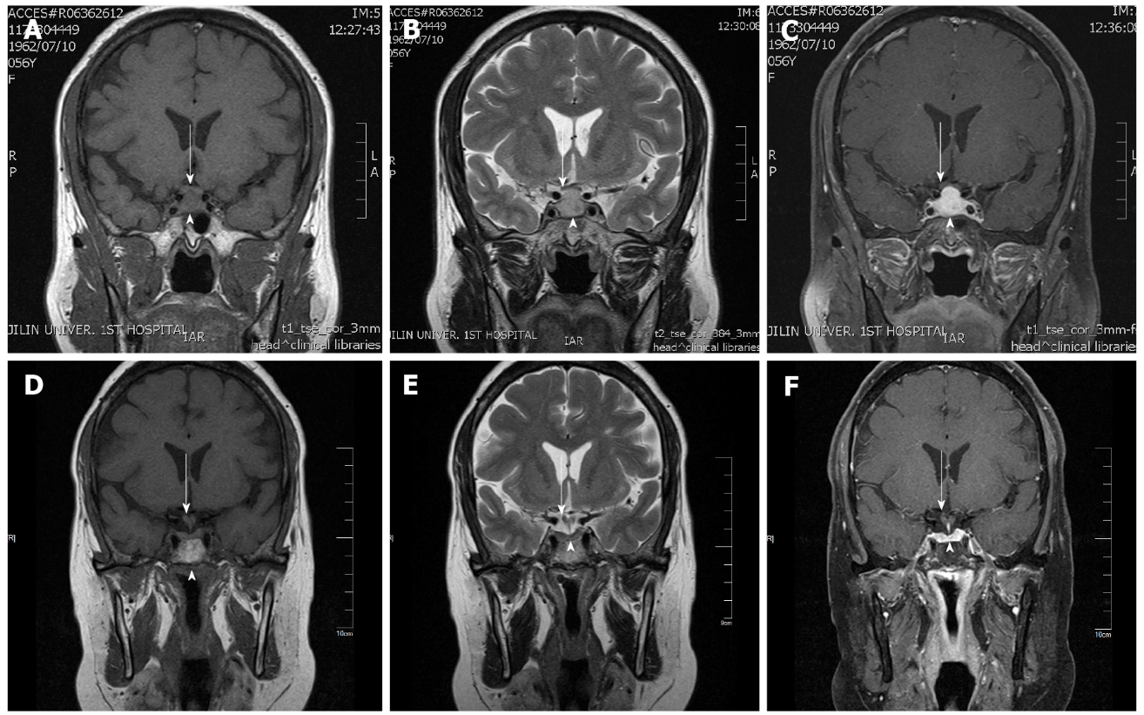
Figure 1 Pretreatment coronal magnetic resonance imaging showing pituitary enlargement (arrowhead) and optic chiasm elevation (arrow). A: In the T1 sequence; B: In the T2 sequence; C: Postgadolinium-enhanced coronal magnetic resonance imaging showing an enlarged pituitary gland with significant homogeneous enhancement (arrowhead) and an elevation of the optic chiasm (arrow); D: Posttreatment coronal magnetic resonance imaging showing an almost normal pituitary gland in the T1 sequence; E: Posttreatment coronal magnetic resonance imaging showing an almost normal pituitary gland in the T2 sequence; F: With gadolinium enhancement in the coronal position.

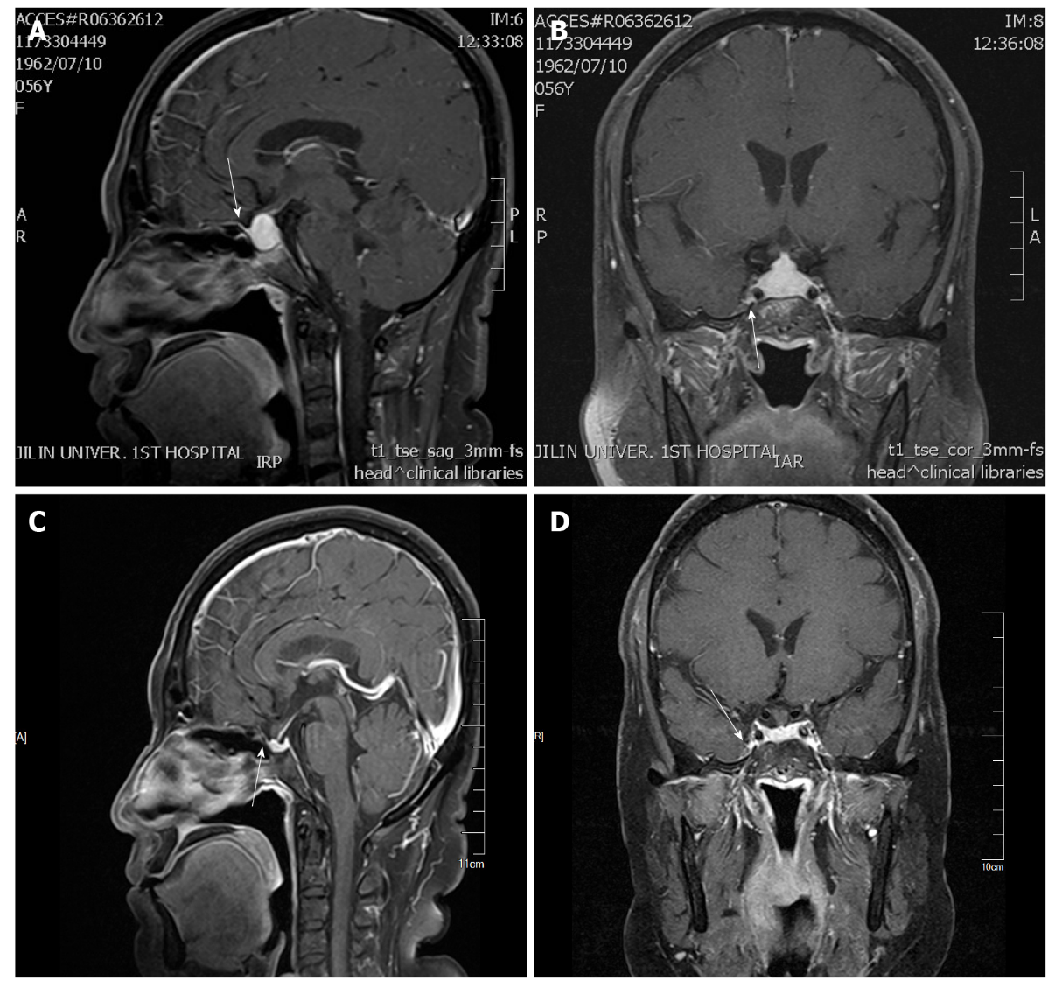
Figure 2 Postgadolinium-enhanced sagittal magnetic resonance imaging. A: Before treatment showing a dural caudal sign (arrow); B: Pretreatment postgadolinium-enhanced coronal magnetic resonance imaging showing no cavernous sinus involvement (arrow); C: Almost disappears after treatment (arrow); D: After treatment postgadolinium-enhanced coronal magnetic resonance imaging showing no cavernous sinus involvement (arrow).

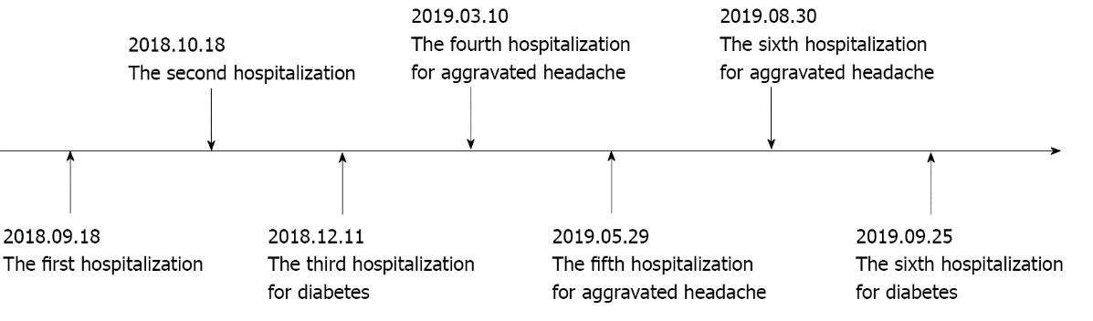
Figure 3 Timeline of the case.

Table 1 Pituitary, cortical, and thyroid hormones
Hormones | ACTH | Cortisol nmol/L | TSH μIU/mL | FT3 pmol/L | FT4 pmol/L | LH mIU/mL | FSH mIU/mL | PRL mIU/L | GH ng/mL
Normal value | 1.6-13.9 | 240-619 | 0.27-4.2 | 3.1-6.8 | 12.0-22.0 | 10.87-58.64 | 16.74-113.6 | 58-416.4 | 0.010-3.607
Onset | - | 124.59 | 0.242 | 3.56 | 6.05 | < 0.2 | 4.31 | 75.8 | 0.142
1 mo | 0.89 | 176.99 | 0.073 | 3.09 | 13.18 | 0.590 | 5.12 | 82.83 | -
3 mo | - | - | 2.29 | 4.08 | 16.05 | 18.38 | 48.89 | 183.19 | -
6 mo | - | - | 0.115 | 3.42 | 21.05 | 26.85 | 56.11 | 397.19 | -
8 mo | - | - | 2.11 | 3.89 | 20.84 | 32.64 | 65.75 | 400.78 | -
11 mo | - | - | 0.634 | 3.77 | 13.82 | 21.49 | 57.79 | 280.57 | -
12 mo | 6.97 | 293.63 | - | - | - | 15.73 | 46.18 | 415.4 | -
ACTH: Adrenocorticotropic hormone; FSH: Follicle-stimulating hormone; LH: Luteinizing hormone; PRL: Prolactin; GH: Growth hormone; TSH: Thyroid-stimulating hormone; FT3: Free triiodothyronine 3; FT4: Free triiodothyronine.

