Name of Journal: World Journal of Gastrointestinal Oncology
Manuscript NO: 75071
Manuscript Type: ORIGINAL ARTICLE

Clinical and Translational Research
Differences of core genes in liver fibrosis and hepatocellular carcinoma: Evidence from integrated bioinformatics and immunohistochemical analysis

Li Y et al. Integrated analysis of core genes in liver fibrosis and HCC

Yue Li, Shou-Li Yuan, Jing-Ya Yin, Kun Yang, Xin-Gang Zhou, Wen Xie, Qi Wang

Yue Li, Kun Yang, Xin-Gang Zhou, Department of Pathology, Beijing Ditan Hospital, Capital Medical University, Beijing 100015, China

Yue Li, Beijing Key Laboratory of Emerging Infectious Diseases, Beijing 100015, China

Shou-Li Yuan, Key Laboratory of Animal Ecology and Conservation Biology, Institute of Zoology, Beijing 100101, China

Jing-Ya Yin, Wen Xie, Qi Wang, Center of Liver Diseases, Beijing Ditan Hospital, Capital Medical University, Beijing 100015, China

Author contributions: Li Y and Yuan SL contributed equally to this work; Wang Q and Xie W designed the research and were co-corresponding authors; Yuan SL, Li Y, Yin JY, Yang K and Zhou XG performed the experiments; Yuan SL and Li Y analyzed the data; Yuan SL, Li Y and Wang Q wrote the manuscript; Yuan SL provided vital reagents and analytical tools; all authors read and approved the final manuscript.

Supported by the Beijing Natural Science Foundation, No. 7222097; Beijing Hospitals Authority the Digestive Medical Coordinated Development Center, No. XXZ0401; National Natural Science Foundation of China, No. 82000555 and No. 81900547; and Beijing Municipal Science and Technology Commission, No. D171100003117005.

Corresponding author: Qi Wang, MD, PhD, Reader (Associate Professor), Center of Liver Diseases, Beijing Ditan Hospital, Capital Medical University, No. 8 East Jingshun Street, Chaoyang District, Beijing 100015, China. wangqidl04@ccmu.edu.cn

Received: January 25, 2022
Revised: May 18, 2022
Accepted: June 26, 2022
Published online: July 15, 2022

Abstract
BACKGROUND
Liver fibrosis and hepatocellular carcinoma (HCC) are common adverse consequences of chronic liver injury. The interaction of various risk factors may cause them to happen. Identification of specific biomarkers is of great significance for understanding the occurrence, development mechanisms, and determining the novel tools for diagnosis and treatment of both liver fibrosis and HCC.

AIM
To identify liver fibrosis-related core genes, we analyzed the differential expression pattern of core genes in liver fibrosis and HCC.

METHODS
Gene expression profiles of three datasets, GSE14323, GSE36411, and GSE89377, obtained from the Gene Expression Omnibus (GEO) database, were analyzed, and differentially expressed genes (DEGs) between patients with liver cirrhosis and healthy controls were identified by screening via R software packages and online tool for Venn diagrams. The WebGestalt online tool was used to identify DEGs enriched in biological processes, molecular functions, cellular components, and Kyoto Encyclopedia of Genes and Genomes pathways. The protein–protein interactions of DEGs were visualized using Cytoscape with STRING. Next, the expression pattern of core genes was analyzed using Western blot and immunohistochemistry in a carbon tetrachloride (CCl₄)-induced liver cirrhosis mouse model and in patient liver samples. Finally, Kaplan-Meier curves were constructed using the Kaplan-Meier plotter online server.

RESULTS
Forty-five DEGs (43 upregulated and 2 downregulated genes) associated with liver cirrhosis were identified from three GEO datasets. Ten hub genes were identified, which were upregulated in liver cirrhosis. Western blot and immunohistochemical analyses of the three core genes, decorin (DCN), dermatopontin (DPT), and SRY-box transcription factor 9 (SOX9), revealed that they were highly expressed in the CCl₄-induced liver cirrhosis mouse model. The expression levels of DCN and SOX 9 were positively correlated with the degree of fibrosis, and SOX 9 level in HCC patients was significantly higher than that in fibrosis patients. However, high expression of DPT was observed only in patients with liver fibrosis, and its expression in HCC was low. The gene expression profiling interactive analysis server (GEPIA) showed that SOX9 was significantly upregulated whereas DCN and DPT were significantly downregulated in patients with HCC. In addition, the Kaplan-Meier curves showed that HCC patients with higher SOX9 expression had significantly lower 5-year survival rate, while patients with higher expression of DCN or DPT had significantly higher 5-year survival rates.

CONCLUSION
The expression levels of DCN, DPT, and SOX9 were positively correlated with the degree of liver fibrosis but showed different correlations with the 5-year survival rates of HCC patients.

Key Words: Liver cirrhosis; Hepatocellular carcinoma; Bioinformatical analysis; Decorin; Dermatopontin; SRY-box transcription factor 9

©The Author(s) 2022. Published by Baishideng Publishing Group Inc. All rights reserved.

Citation: Li Y, Yuan SL, Yin JY, Yang K, Zhou XG, Xie W, Wang Q. Differences of core genes in liver fibrosis and hepatocellular carcinoma: Evidence from integrated bioinformatics and immunohistochemical analysis. World J Gastrointest Oncol 2022; 14(7): 1265-1280
URL: https://www.wjgnet.com/1948-5204/full/v14/i7/1265.htm
DOI: https://dx.doi.org/10.4251/wjgo.v14.i7.1265

Core Tip: GSE14323, GSE36411, and GSE89377 are available from the Gene Expression Omnibus database. Forty-five differentially expressed genes and 10 hub genes were identified between cirrhotic and healthy livers. quantitative polymerase chain reaction, Western blot, and immunohistochemical analyses showed that decorin (DCN), dermatopontin (DPT), and SRY-box transcription factor 9 (SOX9) were highly expressed in the CCl₄-induced cirrhotic mouse model. The expression level of SOX9 was also significantly increased in HCC patients,and was associated with the fibrosis stage.. However, overexpression of DPT was only observed in patients with liver fibrosis. The Kaplan-Meier curves showed that HCC patients with higher SOX9 expression had significantly lower 5-year survival rate, while patients with higher expression of DCN or DPT had higher 5-year survival rates.

INTRODUCTION
Chronic liver infection, including chronic hepatitis B (CHB), chronic hepatitis C, alcoholic liver disease, and non-alcoholic fatty liver disease can all result in liver fibrosis. Primary liver cancer is the seventh most common cancer worldwide^{[1]}. Hepatocellular carcinoma (HCC), which is the dominant type of liver cancer, accounts for approximately 75% of all liver cancers worldwide^{[2]} and is the second most fatal disease in China^{[3]}. Liver cirrhosis is an advanced stage of liver fibrosis and is characterized by limited regeneration capacity and serious complications^{[4]}. Most HCCs develop in the background of chronic liver injury, hepatic inflammation, and liver fibrosis. Unfortunately, to date, there are still no effective treatment strategies for liver cirrhosis, and the limited number of specific biomarkers for HCC related to fibrosis further compounds the problem of its diagnosis and treatment^{[5,6]}.
The pathogenesis of liver fibrosis and HCC is complex as the interaction of many factors may lead to their occurrence. In recent years, with the optimization of gene sequencing platforms, several differentially expressed genes (DEGs) have been identified using bioinformatics analysis^{[7,8]}. To date, there is a huge collection of data stored in the Gene Expression Omnibus (GEO) database of gene expression that can be explored to find the relevant DEGs for a diseased condition. Chan et al^{[9]} identified DEGs between cirrhotic and non-cirrhotic livers using microarray gene analysis. Many human genes may show differential expression patterns and functions with the onset of fibrosis and/or HCC. However, the study by Chan et al^{[9]} was limited by the small sample size, which only included 24 patients with cirrhosis and 16 patients without cirrhosis. The results obtained solely from either bioinformatics or experimental approach may not elucidate relevant DEGs. Hence, integrating bioinformatics methods with experimental techniques may help us to better understand the underlying mechanisms behind fibrosis/HCC pathogenesis.
In this study, we analyzed three databases from GEO, R software packages and online tools to identify DEGs, including upregulated and downregulated genes between liver fibrosis and HCC. The molecular function, cellular component, biological process, and Kyoto Encyclopedia of Genes and Genomes (KEGG) pathways of DEGs were then assessed. We also constructed a protein-protein interaction (PPI) network using Cytoscape for further analysis. Using these methods, hub genes were identified and subjected to KEGG pathway enrichment analysis. Finally, real-time quantitative polymerase chain reaction (qPCR), Western blotting, and immunohistochemistry of the liver tissue samples from mouse model and patients were carried out to identify novel biomarkers of liver fibrosis. Our study identified fibrosis-related core genes and compared their phenotypic differences between liver fibrosis and HCC.

MATERIALS AND METHODS
Patient liver samples collection
Liver tissue samples were collected from 5 healthy controls, 40 patients with CHB (n = 28) and CHB-associated HCC (n = 12) at the Beijing Ditan Hospital, Capital Medical University, Beijing, China. The diagnosis of CHB was based on the “Guidelines on prevention and treatment of chronic hepatitis B in China”^{[10]}. Chronic HBV infection is defined as the persistence of HBsAg in blood serum for at least 6 mo. Patients who were diagnosed for Hepatitis C viral infection, drug-induced liver disease, non-alcoholic liver disease, alcoholic liver disease, autoimmune liver disease, cholestatic liver disease, or hereditary metabolic liver disease were excluded. All samples were analyzed by a clinician and two independent pathologists with no prior knowledge of demographic and clinical data. The degree of liver inflammation and fibrosis were scored according to the METAVIR system^{[11]}, and liver samples were divided into five groups: normal control, fibrosis grade 0 (S0), fibrosis grade 1-2 (S1-2), fibrosis grade 3-4 (S3-4), and HCC group. Meanwhile, we collected the clinical data, including sex, age, HBeAg, HBV DNA, alanine transaminase, aspartate transaminase, total bilirubin, albumin, cholinesterase and alpha-fetoprotein. The study protocol conformed to the ethical guidelines of the 1975 Declaration of Helsinki, as approved by the Ethics Committee of Beijing Ditan Hospital.

Animals
Six-week-old male C57BL/6 mice were purchased from Vital River Laboratory Animal Technology Co., Ltd, Beijing, China. All mice were housed in a specific pathogen free laboratory animal house (Institute of Zoology of Beijing, Chinese Academy of Sciences, China) at 24 ℃ with a 12 h light/dark cycle. All animal studies were approved by the Institutional Animal Care and Use Committee of the Institute of Zoology, Chinese Academy of Sciences.
Twelve male C57BL/6 mice were randomly divided into two groups: control group and carbon tetrachloride (CCl₄)-treated group. To induce liver cirrhosis, CCl₄ (0.5 μL/g) mixed with corn oil was intraperitoneally injected into the mice three times per week for 12 wk. The control group was injected with an equal volume of corn oil. CCl₄ was purchased from Sigma-Aldrich (St. Louis, MO, United States).

Histological and immunohistochemical analysis
For hematoxylin and eosin (HE) staining, Masson’s trichrome staining, and immunohistochemical analysis, liver tissues collected from mouse model or patients were fixed with 4% paraformaldehyde solution and embedded in paraffin. For histological analysis, 5 μm thick sections were stained and observed under 10 × or 20 × objective lens. Masson’s trichrome kit (G1281, Solarbio, Beijing, China) was used according to the manufacturer’s instructions.
For immunohistochemical staining, 5% bovine serum albumin in 0.1% TritonX-100 tris-buffered saline was used as the blocking solution. The samples were incubated overnight at 4 ℃ with anti-decorin (DCN) (ab277636, Abcam), anti-dermatopontin (DPT) (10537-1-AP, Proteintech), and anti-SRY-box transcription factor 9 (SOX9) (ab185966; Abcam) antibodies. After incubation with a peroxidase-conjugated secondary antibody, the signal was visualized using a diaminobenzidine peroxidase substrate kit. The collagen area or positive area of immunohistochemical staining was quantified using ImageJ 1.52a software.

Real-time qPCR
Total RNA from liver tissues was isolated using TRIzolTM reagent (Thermo Fisher Scientific, MA, United States). Isolated RNA was reverse-transcribed into complementary DNA (cDNA) using a high-capacity cDNA reverse transcription kit (Promega, WI, United States). The relative expression of genes was detected by real-time fluorescence qPCR system (Light Cycler 480, Roche, Sweden) with SYBR green master mix (Promega, WI, United States). The primer sequences used in this study were listed in Supplementary Table 1. Statistical significance between the control and CCl₄-treated groups was defined at P < 0.05.

Western blotting
Total protein from liver tissues was extracted using radioimmunoprecipitation assay buffer. The protein concentration of the samples was measured by bicinchoninic acid assay. The same concentration of protein was loaded to 10% sodium dodecyl sulfate polyacrylamide gel and then transferred to a polyvinylidene fluoride membrane. The membranes were incubated overnight at 4℃ in anti-α-SMA (ab5694, Abcam), anti-DCN (ab277636, Abcam), anti-DPT (10537-1-AP, Proteintech), and anti-SOX9 (ab185966, Abcam) antibodies. All signals were visualized by density scanning (Image Quant TL7.0; GE Healthcare Biosciences, Uppsala, Sweden). The intensity of the bands was analyzed using ImageJ 1.52a software.

Microarray and gene expression analysis
The RNA expression data of human cirrhotic and healthy livers were collected from the GEO database (http://www.ncbi.nlm.nih.gov/geo). The GSE14323, GSE36411, and GSE89377 datasets contained gene expression data collected from 41, 21, and 12 cirrhotic and 19, 21, and 13 healthy liver tissues, respectively. The GEOquery R software package was used to download the GEO data and platform information. Then, the gene ID conversion was performed, and the maximum value of genes with the same name was selected. Ggplot2 package was used to plot the boxplot and density of the expression levels for each sample. Ggfortify package was used to perform the principal component analysis (PCA). DEGs between the cirrhosis and healthy liver tissue groups were identified using limma package by limiting the value of adjustment: P-value (adjust. P < 0.05) and the absolute value of logFC (|logFC| > 1.2 or 0.6). A volcano map was generated using the ggplot2 package, and Venn diagram online tool (http://bioinformatics.psb.ugent.be/webtools/Venn/) was used to draw a Venn map. The DEGs were verified using the ONCOMINE server (https://www.Oncomine.org/resource/), which is an online available microarray database^{[12]}.

Gene ontology and pathway enrichment analysis
WebGestalt online tool (http://www.webgestalt.org) was used to identify DEGs enriched in biological processes, molecular functions, cellular component-related pathways, and KEGG pathways. The P-value of less than 0.05 was considered statistically significant.

PPI network construction and identification of hub genes
STRING online database (https://string-db.org/; version 11.5) was used to build the PPI network^{[13]}. The DEGs were submitted to the STRING database to construct the PPI network. Cytoscape (version 3.7.2) was used to draw the PPI network of DEGs, and the cytoHubba plugin was used to identify hub genes^{[14]}.

Gene expression level in HCC and survival analysis
Gene expression profiling interactive analysis (GEPIA) online server (http://gepia.cancer-pku.cn/) was used to analyze the RNA sequencing expression data of tumors and healthy samples from the cancer genome atlas and genotype tissue expression projects^{[15]}. We used this server to check whether the identified hub genes were differentially expressed in HCC tissues. Overall 5-year survival rates according to gene expression were obtained using the Kaplan-Meier Plotter (http://kmplot.com/analysis/index.php?p=service&cancer=liver_rnaseq)^{[16]}.

Statistical analyses
GraphPad Prism 6.0 (GraphPad Software Inc. La Jolla, CA, United States) was used for statistical analysis. Data were presented as mean ± SE or SD (for normally distributed data) or median with interquartile range (for non-normally distributed data). Statistically significant differences were determined using a two-tailed Student’s t-test or analysis of variance (ANOVA). Statistical significance was set and marked as ªP < 0.05, ^{b}P < 0.01, ^{c}P < 0.001, and ^{d}P < 0.0001. Replicates are indicated in the figure legends, and (n) represents the number of experimental replicates.

RESULTS
Identification of DEGs
We analyzed three gene expression datasets, GSE14323, GSE36411, and GSE89377, which included data from 74 cirrhotic and 53 healthy liver tissue samples in total. The analysis of processed sample data showed that the gene expression levels in different samples were primarily the same (Supplementary Figure 1). PCA showed that cirrhotic and healthy groups constituted individual clusters (Supplementary Figure 2). Using limma package, we extracted 553, 148, and 459 DEGs from GSE14323, GSE36411, and GSE89377 datasets, respectively (Figure 1A-C). Using Venn diagram online tool, we identified 45 DEGs (43 upregulated genes and 2 downregulated genes) associated with cirrhosis from the three datasets (Figure 1D, Table 1).

Gene Ontology and KEGG pathway analysis of DEGs
To understand the function of identified DEGs, we carried out Gene Ontology (GO) and KEGG pathways analyses using Webgestalt online server. The GO analysis results were listed according to P-values (Table 2), which showed that DEGs were significantly enriched in extracellular matrix organization (GO: 0030198), extracellular matrix structural constituent (GO: 0005201), collagen-containing extracellular matrix (GO: 0062023), extracellular matrix (GO: 0031012), cell adhesion (GO: 0007155), biological adhesion (GO: 0022610), and taxis (GO: 0042330). KEGG pathway analysis showed that the DEGs involved in the chemokine signaling pathway, focal adhesion, regulation of actin cytoskeleton, leukocyte transendothelial migration, pathways in cancer, and cytokine–cytokine receptor interaction, and arachidonic acid metabolism were highly enriched in patients with liver cirrhosis (Table 3).

PPI network construction and identification of hub genes
PPI network analysis aids in studying the molecular mechanisms of the disease pathogenesis. Using String v11 and Cytoscape software, we constructed a PPI network with 26 nodes and 36 edges (Figure 1E). These genes were upregulated in liver cirrhosis. The top 10 hub genes were identified using the CytoHubba plugin of Cytoscape, which included C-X-C motif chemokine ligand 9 (CXCL9), CXCL10, C-X-C motif chemokine receptor 4 (CXCR4), DCN, DPT, laminin subunit alpha 2 (LAMA2), lumican (LUM), microfibril associated protein 4 (MFAP4), platelet-derived growth factor receptor alpha (PDGFRA), and SOX9 (Figure 1F).

Expression of hub genes in the liver tissue of CCl₄-induced cirrhosis mice
To study the role of the 10 hub genes in liver cirrhosis, we generated a CCl₄-induced liver cirrhosis mouse model (Figure 2A–B). The relative mRNA levels of these genes were shown in Figure 2C. Compared to those in the control group, seven genes (CXCR4, DCN, DPT, LAMA2, LUM, MFAP4, and SOX9) were significantly upregulated in the liver cirrhosis mice, while the expression levels of PDGFRA, CXCL9, and CXCL10 were not significantly different between the two groups. For further validation, we performed Western blotting and immunohistochemical analysis (Figure 2D, Figure 3). These results confirmed that the protein levels of DCN, DPT, and SOX9 were significantly upregulated in the liver tissue of cirrhotic mice.

DCN, DPT and SOX9 expression and liver fibrosis progression in patients
To further explore the relationship between DCN, DPT, and SOX9 protein expression and progression of liver cirrhosis, we collected liver biopsy tissue samples from 5 healthy controls, 28 patients with CHB, and 12 patients with CHB-associated HCC. All liver tissues were divided into 5 groups (normal, S0, S1-2, S3-4, and HCC) according to METAVIR system. The clinical profile of the patients enrolled in the study is summarized in Table 4. The results showed that males were the majority in S3-4 and HCC groups. The age, TBil, ALB, and CHE values in all groups and the AFP value in non-HCC group were in normal distribution, and the median AFP value in the HCC group was higher than the upper limit of normal value. In patients with CHB, HBV DNA was detected as positive, and most ALT and AST levels were elevated, which was consistent with the inflammatory activity of the liver. Most patients with HCC were detected negative for HBV DNA, which is related to antiviral treatment. Liver samples from patients with fibrosis showed increased collagen deposition, inflammatory cell infiltration, or atypical cells viewed with HE and Masson’s trichrome staining (Figure 4).
Immunohistochemical results showed that the expression levels of DCN and SOX9 increased with the aggravation of liver fibrosis (Figure 4, Figure 5A, Figure 5C) and were significantly higher in the HCC group than those in healthy controls and fibrotic groups (Figure 4, Figure 5D, and Figure 5F). Further, compared with healthy controls, DPT expression was significantly increased in patients with liver fibrosis, particularly in the S3-S4 group but extremely reduced in patients with HCC (Figure 5B, Figure 5E). In addition, we found that DCN was mostly expressed in the portal vein region, which was highly consistent with the distribution of collagen fibers, while SOX9 and DPT were mostly expressed in hepatocytes and several other types of cells (Figure 4).

DCN, DPT, and SOX9 expression and survival rate of patients with HCC
Due to the differential expression pattern and distribution, we decided to analyze the correlation between DCN, DPT, and SOX9 expression levels and the survival rate of patients with HCC. The GEPIA server was used to detect the mRNA expression levels in tissues of patients 369 liver hepatocellular carcinoma (LIHC) and 160 normal tissues (Figure 6A-C). The results showed that SOX9 was significantly upregulated whereas DCN and DPT were significantly downregulated in patients with LIHC.
Kaplan-Meier curves, depicting samples from these 369 patients with HCC, showed that the 5-year survival rate of patients with high expression of SOX 9 was significantly reduced, while that of patients with high expression of DCN or DPT was increased (Figure 6D-F).

DISCUSSION
Fibrosis is a common pathological symptom of severe liver damage caused by various chronic liver diseases. The most common primary liver cancer, HCC, occurs most often in people inflicted with chronic liver diseases^{[17]}. Understanding the molecular mechanisms underlying cirrhosis can help in the development of effective treatments. Although bioinformatics tools can be used to study the relationship between gene function, liver fibrosis, and HCC, it is necessary to comprehensively analyze gene expression levels and distribution in the context of disease pathology via in vivo experiments.
GEO is an international public resource bank for high-throughput microarray and next-generation sequencing of functional genome datasets submitted by research groups. In this study, we identified 45 DEGs from GSE14323, GSE36411, and GSE89377 datasets in the GEO database for an in-depth analysis of their biological function. Most of these DEGs have been associated with liver diseases. CXCL9, ENPP2, CH25H, KRT23, IL7R, APOL3, and GSN are involved in HCV or HBV infection^{[18-23]}. AEBP1, C7, and LUM are overexpressed in non-alcoholic steatohepatitis (NASH)^{[24-26]}. CHST4, DEFB1, EFEMP1, MMP7, and SOX9 are associated with cholestasis^{[27-31]}. AKR1B10, CLDN10, DKK3, EPCAM, LGALS4, and ITM2A are upregulated in patients with HCC^{[32-38]}. The combined data-mining of three datasets from different sources yielded 45 DEGs, further indicating that the GEO database is indeed a useful resource for understanding the mechanism of liver diseases and using the GEO database can increase the efficiency of published resources.
Next, for detailed characterization of hub gene functions, we selected three representative genes (DCN, DPT, and SOX9), since their expression was consistently found to be associated with liver cirrhosis. We established a CCl₄-induced mice model and verified their mRNA and protein levels using qPCR, Western blotting, and immunohistochemistry to confirm the expression and main pathophysiological functions. The results confirmed that DCN, DPT, and SOX9 were significantly overexpressed in human and mouse fibrotic liver; however, there were differences in the relationship between their expression levels and the survival rate of patients with HCC.
The DCN gene encodes a member of the small leucine-rich proteoglycan family of proteins, which can act as a tumor repressor in a variety of cancers^{[39]}. DCN is a regulator of matrix assembly and not only targets transforming growth factor-beta 1 (TGF-β1) but is also involved in the maturation of collagen fibrils^{[40,41]}. The enhanced deposition of DCN reflects the stimulatory effect of overproduction of TGF-β1^{[41]}. Dudás et al^{[42]} indicated that high amounts of TGF-β1 colocalize with DCN within the fibrotic areas of the liver using a cohort of liver pathologies, including chronic hepatitis, fibrosis, and cirrhosis, which is consistent with our results. However, contrary to our results, Shang et al^{[43]} found DCN mRNA expression to be downregulated and not upregulated in patients with HCC via gene expression profile analyses. Although GEPIA analysis showed that the mRNA expression level of DCN in ILHC was lower than that normal tissues, the heterogeneity within each group, especially the ILHC group, was very different. In addition, our results were based on immunohistochemical analysis, different from the expression profile of the whole liver tissue used by Shang et al^{[43]}. From the distribution of immunohistochemical sections, we concluded that almost all the increase in DCN expression was localized in the collagen-intensive area of the portal region and not in the hepatic lobule, which indicates that the upregulated DCN significantly represents an increase in matrix assembly. These may partly explain why the increased DCN is not associated with the lower 5-year survival rate of HCC patients, and why the expression pattern of DCN expression analyzed by GEPIA server was different from our study. Considering these inconsistent results, the expression, location and function of DCN deserves further study.
DPT is a downstream target of the vitamin D receptor. Fu et al^{[44]} reported that mRNA expression of DPT was significantly downregulated in HCC, while its protein was weakly expressed in tumorous tissues compared to that in non-tumorous tissues. However, Lefebvre et al^{[45]} suggested that DPT is upregulated in active NASH and fibrosis, and it is necessary for collagen deposition in profibrotic conditions. Our results also confirmed that the expression of DPT increased with the aggravation of liver fibrosis. Interestingly, a previous study showed that DPT interacts with DCN, which influences collagen fibrillogenesis and increases TGF-β1 signaling^{[46]}. Our study identified these two molecules in a combined screening, suggesting that both DPT and DCN play an important role in the occurrence and development of liver fibrosis and HCC. However, the interactions between them needs to be further studied.
During tumorigenesis, SOX9 is upregulated in various tumors and plays an essential role in tumor progression as an oncogene^{[29]}, which regulates cellular proliferation, senescence, and self-renewal and is highly expressed in liver cancer stem cells^{[47]}. In addition, SOX9 was the earliest marker expressed by biliary precursors^{[48]}. It has been confirmed as a transcription factor that regulates bile duct development and contributes to liver regeneration and fibrosis^{[47]}. In this study, we confirmed that SOX9 was positively correlated with the degree of fibrosis, and the high expression of SOX9 indicated a decline in the 5-year survival rate of patients with HCC, which is consistent with the results of other studies. In addition, our results showed that SOX9 was enriched and expressed in bile duct cells in mouse and human fibrotic livers, and the expression levels of SOX9 in hepatocytes were also increased significantly in patients with HCC. This observation can be explained by the fact that SOX9 mediates the transdifferentiation of hepatocytes into bile duct epithelial cells^{[47]}. However, the detailed molecular mechanism of SOX9 overexpression in hepatocytes requires further elucidation.
Our current study has some limitations. First, we only analyzed the transcriptome, and many studies have shown that epigenetic modifications and non-coding RNAs also play an important role in the progression of liver diseases^{[33,49]}. Secondly, the sample size in terms of number of patients was small, and immunohistochemistry was a semi-quantitative method. In addition, although our study had identified the signal transduction pathway involved in liver cirrhosis and HCC, it lacked in-depth analysis on the mechanism of action of these molecules, which needed to be further studied using in vivo studies or knock-out mice.

CONCLUSION
We screened GEO databases and obtained 45 DEGs and 10 hub genes (particularly DCN, DPT, and SOX9) in cirrhotic liver tissues. Upregulated expression of DCN, DPT, and SOX9 was all positively correlated with the degree of fibrosis, but there may be differences between their correlation with the 5-year survival rate of HCC patients.

ARTICLE HIGHLIGHTS
Research background
Liver fibrosis and hepatocellular carcinoma (HCC) are common adverse consequences of chronic liver injury. Establishing more effective biomarkers is important for understanding the pathogenesis, occurrence, development mechanisms of liver fibrosis and HCC, as well as to identify new diagnostic and therapeutic tools.

Research motivation
Bioinformatics has screened out many differentially expressed genes related to liver fibrosis; however, it is unknown whether these genes are different in animal and human liver fibrosis tissues, especially among the different fibrotic degrees. Therefore, we should carefully analyze the research results of bioinformatics.

Research objectives
To identify liver fibrosis-related core genes, we observed and compared the differential expression pattern of core genes in patients with liver fibrosis and HCC.

Research methods
In this study, we analyzed the expression pattern of hub genes of fibrosis and HCC. Bioinformatics analyses, quantitative polymerase chain reaction, Western blot, and immunohistochemistry of liver tissues from mouse model and patients were performed to identify novel biomarkers of liver fibrosis and HCC.

Research results
Ten hub genes (CXCL9, CXCL10, CXCR4, DCN, DPT, LAMA2, LUM, MFAP4, PDGFRA, and SOX9) associated with cirrhosis were screened from GSE14323, GSE36411, and GSE89377 datasets. DCN, DPT, and SOX9 were highly expressed in the CCl₄-induced mouse model of liver cirrhosis and fibrotic patient liver samples, and their expression levels were associated with the degree of fibrosis. In patients with HCC, SOX9 was upregulated, while DCN and DPT were downregulated. However, the 5-year survival rate of HCC patients with high SOX 9 expression was significantly reduced, which is different from DPT or DCN.

Research conclusions
We screened and identified 10 hub genes related to fibrosis. The expression levels of DCN, DPT, and SOX were positively correlated with the degree of liver fibrosis but showed different correlations with the survival rate of patients with HCC.

Research perspectives
The integrated approach of bioinformatics and molecular biology is more efficient to research multi-factorial diseases, such as liver fibrosis and liver cancer. Future studies on the differences on DCN, DPT, and SOX9 expression may help in the better understanding of the mechanisms involved in the development of liver fibrosis and HCC.

REFERENCES
1 Bosetti C, Turati F, La Vecchia C. Hepatocellular carcinoma epidemiology. Best Pract Res Clin Gastroenterol 2014; 28: 753-770 [PMID: 25260306 DOI: 10.1016/j.bpg.2014.08.007]
2 Harris PS, Hansen RM, Gray ME, Massoud OI, McGuire BM, Shoreibah MG. Hepatocellular carcinoma surveillance: An evidence-based approach. World J Gastroenterol 2019; 25: 1550-1559 [PMID: 30983815 DOI: 10.3748/wjg.v25.i13.1550]
3 Chen Z, Xie H, Hu M, Huang T, Hu Y, Sang N, Zhao Y. Recent progress in treatment of hepatocellular carcinoma. Am J Cancer Res 2020; 10: 2993-3036 [PMID: 33042631]
4 Chen W, Zheng R, Baade PD, Zhang S, Zeng H, Bray F, Jemal A, Yu XQ, He J. Cancer statistics in China, 2015. CA Cancer J Clin 2016; 66: 115-132 [PMID: 26808342 DOI: 10.3322/caac.21338]
5 Zhou WC, Zhang QB, Qiao L. Pathogenesis of liver cirrhosis. World J Gastroenterol 2014; 20: 7312-7324 [PMID: 24966602 DOI: 10.3748/wjg.v20.i23.7312]
6 Thomson MJ, Lok AS, Tapper EB. Optimizing medication management for patients with cirrhosis: Evidence-based strategies and their outcomes. Liver Int 2018; 38: 1882-1890 [PMID: 29845749 DOI: 10.1111/liv.13892]
7 Huang X, Li Y, Guo X, Zhu Z, Kong X, Yu F, Wang Q. Identification of differentially expressed genes and signaling pathways in chronic obstructive pulmonary disease via bioinformatic analysis. FEBS Open Bio 2019; 9: 1880-1899 [PMID: 31419078 DOI: 10.1002/2211-5463.12719]
8 Jiang CH, Yuan X, Li JF, Xie YF, Zhang AZ, Wang XL, Yang L, Liu CX, Liang WH, Pang LJ, Zou H, Cui XB, Shen XH, Qi Y, Jiang JF, Gu WY, Li F, Hu JM. Bioinformatics-based screening of key genes for transformation of liver cirrhosis to hepatocellular carcinoma. J Transl Med 2020; 18: 40 [PMID: 32000807 DOI: 10.1186/s12967-020-02229-8]
9 Chan KM, Wu TH, Wu TJ, Chou HS, Yu MC, Lee WC. Bioinformatics microarray analysis and identification of gene expression profiles associated with cirrhotic liver. Kaohsiung J Med Sci 2016; 32: 165-176 [PMID: 27185598 DOI: 10.1016/j.kjms.2016.03.008]
10 Chinese Society of Infectious Diseases, Chinese Medical Association; Chinese Society of Hepatology, Chinese Medical Association. [The guidelines of prevention and treatment for chronic hepatitis B (2019 version)]. Zhonghua Gan Zang Bing Za Zhi 2019; 27: 938-961 [PMID: 31941257 DOI: 10.3760/cma.j.issn.1007-3418.2019.12.007]
11 Bedossa P, Poynard T. An algorithm for the grading of activity in chronic hepatitis C. The METAVIR Cooperative Study Group. Hepatology 1996; 24: 289-293 [PMID: 8690394 DOI: 10.1002/hep.510240201]
12 Rhodes DR, Kalyana-Sundaram S, Mahavisno V, Varambally R, Yu J, Briggs BB, Barrette TR, Anstet MJ, Kincead-Beal C, Kulkarni P, Varambally S, Ghosh D, Chinnaiyan AM. Oncomine 3.0: genes, pathways, and networks in a collection of 18,000 cancer gene expression profiles. Neoplasia 2007; 9: 166-180 [PMID: 17356713 DOI: 10.1593/neo.07112]
13 Szklarczyk D, Gable AL, Lyon D, Junge A, Wyder S, Huerta-Cepas J, Simonovic M, Doncheva NT, Morris JH, Bork P, Jensen LJ, Mering CV. STRING v11: protein-protein association networks with increased coverage, supporting functional discovery in genome-wide experimental datasets. Nucleic Acids Res 2019; 47: D607-D613 [PMID: 30476243 DOI: 10.1093/nar/gky1131]
14 Shannon P, Markiel A, Ozier O, Baliga NS, Wang JT, Ramage D, Amin N, Schwikowski B, Ideker T. Cytoscape: a software environment for integrated models of biomolecular interaction networks. Genome Res 2003; 13: 2498-2504 [PMID: 14597658 DOI: 10.1101/gr.1239303]
15 Tang Z, Li C, Kang B, Gao G, Li C, Zhang Z. GEPIA: a web server for cancer and normal gene expression profiling and interactive analyses. Nucleic Acids Res 2017; 45: W98-W102 [PMID: 28407145 DOI: 10.1093/nar/gkx247]
16 Menyhárt O, Nagy Á, Győrffy B. Determining consistent prognostic biomarkers of overall survival and vascular invasion in hepatocellular carcinoma. R Soc Open Sci 2018; 5: 181006 [PMID: 30662724 DOI: 10.1098/rsos.181006]
17 Müller M, Bird TG, Nault JC. The landscape of gene mutations in cirrhosis and hepatocellular carcinoma. J Hepatol 2020; 72: 990-1002 [PMID: 32044402 DOI: 10.1016/j.jhep.2020.01.019]
18 Marrocco C, Rinalducci S, Mohamadkhani A, D'Amici GM, Zolla L. Plasma gelsolin protein: a candidate biomarker for hepatitis B-associated liver cirrhosis identified by proteomic approach. Blood Transfus 2010; 8 Suppl 3: s105-s112 [PMID: 20606740 DOI: 10.2450/2010.017S]
19 Guzmán-Fulgencio M, Berenguer J, Jiménez-Sousa MA, Pineda-Tenor D, Aldámiz-Echevarria T, García-Broncano P, Carrero A, García-Álvarez M, Tejerina F, Diez C, Vazquez-Morón S, Resino S. Association between IL7R polymorphisms and severe liver disease in HIV/HCV coinfected patients: a cross-sectional study. J Transl Med 2015; 13: 206 [PMID: 26123260 DOI: 10.1186/s12967-015-0577-y]
20 Xiang Y, Tang JJ, Tao W, Cao X, Song BL, Zhong J. Identification of Cholesterol 25-Hydroxylase as a Novel Host Restriction Factor and a Part of the Primary Innate Immune Responses against Hepatitis C Virus Infection. J Virol 2015; 89: 6805-6816 [PMID: 25903345 DOI: 10.1128/JVI.00587-15]
21 Shrivastava S, Meissner EG, Funk E, Poonia S, Shokeen V, Thakur A, Poonia B, Sarin SK, Trehanpati N, Kottilil S. Elevated hepatic lipid and interferon stimulated gene expression in HCV GT3 patients relative to non-alcoholic steatohepatitis. Hepatol Int 2016; 10: 937-946 [PMID: 27193023 DOI: 10.1007/s12072-016-9733-6]
22 Farquhar MJ, Humphreys IS, Rudge SA, Wilson GK, Bhattacharya B, Ciaccia M, Hu K, Zhang Q, Mailly L, Reynolds GM, Ashcroft M, Balfe P, Baumert TF, Roessler S, Wakelam MJO, McKeating JA. Autotaxin-lysophosphatidic acid receptor signalling regulates hepatitis C virus replication. J Hepatol 2017; 66: 919-929 [PMID: 28126468 DOI: 10.1016/j.jhep.2017.01.009]
23 Kinast V, Leber SL, Brown RJP, Vieyres G, Behrendt P, Eßbach C, Strnad P, Vondran FWR, Cornberg M, Wex C, Pietschmann T, Haybaeck J, Todt D, Steinmann E. Identification of Keratin 23 as a Hepatitis C Virus-Induced Host Factor in the Human Liver. Cells 2019; 8 [PMID: 31216713 DOI: 10.3390/cells8060610]
24 Gerhard GS, Hanson A, Wilhelmsen D, Piras IS, Still CD, Chu X, Petrick AT, DiStefano JK. AEBP1 expression increases with severity of fibrosis in NASH and is regulated by glucose, palmitate, and miR-372-3p. PLoS One 2019; 14: e0219764 [PMID: 31299062 DOI: 10.1371/journal.pone.0219764]
25 Wolff G, Taranko AE, Meln I, Weinmann J, Sijmonsma T, Lerch S, Heide D, Billeter AT, Tews D, Krunic D, Fischer-Posovszky P, Müller-Stich BP, Herzig S, Grimm D, Heikenwälder M, Kao WW, Vegiopoulos A. Diet-dependent function of the extracellular matrix proteoglycan Lumican in obesity and glucose homeostasis. Mol Metab 2019; 19: 97-106 [PMID: 30409703 DOI: 10.1016/j.molmet.2018.10.007]
26 Hou W, Janech MG, Sobolesky PM, Bland AM, Samsuddin S, Alazawi W, Syn WK. Proteomic screening of plasma identifies potential noninvasive biomarkers associated with significant/advanced fibrosis in patients with nonalcoholic fatty liver disease. Biosci Rep 2020; 40 [PMID: 31860081 DOI: 10.1042/BSR20190395]
27 Huang CC, Chuang JH, Chou MH, Wu CL, Chen CM, Wang CC, Chen YS, Chen CL, Tai MH. Matrilysin (MMP-7) is a major matrix metalloproteinase upregulated in biliary atresia-associated liver fibrosis. Mod Pathol 2005; 18: 941-950 [PMID: 15696117 DOI: 10.1038/modpathol.3800374]
28 Jinawath N, Chamgramol Y, Furukawa Y, Obama K, Tsunoda T, Sripa B, Pairojkul C, Nakamura Y. Comparison of gene expression profiles between Opisthorchis viverrini and non-Opisthorchis viverrini associated human intrahepatic cholangiocarcinoma. Hepatology 2006; 44: 1025-1038 [PMID: 17006947 DOI: 10.1002/hep.21330]
29 Yovchev MI, Xue Y, Shafritz DA, Locker J, Oertel M. Repopulation of the fibrotic/cirrhotic rat liver by transplanted hepatic stem/progenitor cells and mature hepatocytes. Hepatology 2014; 59: 284-295 [PMID: 23840008 DOI: 10.1002/hep.26615]
30 Lou Y, Tian GY, Song Y, Liu YL, Chen YD, Shi JP, Yang J. Characterization of transcriptional modules related to fibrosing-NAFLD progression. Sci Rep 2017; 7: 4748 [PMID: 28684781 DOI: 10.1038/s41598-017-05044-2]
31 Klag T, Thomas M, Ehmann D, Courth L, Mailänder-Sanchez D, Weiss TS, Dayoub R, Abshagen K, Vollmar B, Thasler WE, Stange EF, Berg CP, Malek NP, Zanger UM, Wehkamp J. β-Defensin 1 Is Prominent in the Liver and Induced During Cholestasis by Bilirubin and Bile Acids via Farnesoid X Receptor and Constitutive Androstane Receptor. Front Immunol 2018; 9: 1735 [PMID: 30100908 DOI: 10.3389/fimmu.2018.01735]
32 Cheung ST, Leung KL, Ip YC, Chen X, Fong DY, Ng IO, Fan ST, So S. Claudin-10 expression level is associated with recurrence of primary hepatocellular carcinoma. Clin Cancer Res 2005; 11: 551-556 [PMID: 15701840]
33 Ding Z, Qian YB, Zhu LX, Xiong QR. Promoter methylation and mRNA expression of DKK-3 and WIF-1 in hepatocellular carcinoma. World J Gastroenterol 2009; 15: 2595-2601 [PMID: 19496188 DOI: 10.3748/wjg.15.2595]
34 Huang GW, Ding X, Chen SL, Zeng L. Expression of claudin 10 protein in hepatocellular carcinoma: impact on survival. J Cancer Res Clin Oncol 2011; 137: 1213-1218 [PMID: 21647678 DOI: 10.1007/s00432-011-0987-z]
35 Bacigalupo ML, Manzi M, Rabinovich GA, Troncoso MF. Hierarchical and selective roles of galectins in hepatocarcinogenesis, liver fibrosis and inflammation of hepatocellular carcinoma. World J Gastroenterol 2013; 19: 8831-8849 [PMID: 24379606 DOI: 10.3748/wjg.v19.i47.8831]
36 Ye X, Li C, Zu X, Lin M, Liu Q, Liu J, Xu G, Chen Z, Xu Y, Liu L, Luo D, Cao Z, Shi G, Feng Z, Deng H, Liao Q, Cai C, Liao DF, Wang J, Jin J, Cao D. A Large-Scale Multicenter Study Validates Aldo-Keto Reductase Family 1 Member B10 as a Prevalent Serum Marker for Detection of Hepatocellular Carcinoma. Hepatology 2019; 69: 2489-2501 [PMID: 30672601 DOI: 10.1002/hep.30519]
37 Zhang Z, Li J, He T, Ouyang Y, Huang Y, Liu Q, Wang P, Ding J. The competitive endogenous RNA regulatory network reveals potential prognostic biomarkers for overall survival in hepatocellular carcinoma. Cancer Sci 2019; 110: 2905-2923 [PMID: 31335995 DOI: 10.1111/cas.14138]
38 Zhang Z, Wen H, Weng J, Feng L, Liu H, Hu X, Zeng F. Silencing of EPCAM suppresses hepatic fibrosis and hepatic stellate cell proliferation in mice with alcoholic hepatitis via the PI3K/Akt/mTOR signaling pathway. Cell Cycle 2019; 18: 2239-2254 [PMID: 31378124 DOI: 10.1080/15384101.2019.1642067]
39 Zhang W, Ge Y, Cheng Q, Zhang Q, Fang L, Zheng J. Decorin is a pivotal effector in the extracellular matrix and tumour microenvironment. Oncotarget 2018; 9: 5480-5491 [PMID: 29435195 DOI: 10.18632/oncotarget.23869]
40 Zhang G, Ezura Y, Chervoneva I, Robinson PS, Beason DP, Carine ET, Soslowsky LJ, Iozzo RV, Birk DE. Decorin regulates assembly of collagen fibrils and acquisition of biomechanical properties during tendon development. J Cell Biochem 2006; 98: 1436-1449 [PMID: 16518859 DOI: 10.1002/jcb.20776]
41 Baghy K, Iozzo RV, Kovalszky I. Decorin-TGFβ axis in hepatic fibrosis and cirrhosis. J Histochem Cytochem 2012; 60: 262-268 [PMID: 22260996 DOI: 10.1369/0022155412438104]
42 Dudás J, Kovalszky I, Gallai M, Nagy JO, Schaff Z, Knittel T, Mehde M, Neubauer K, Szalay F, Ramadori G. Expression of decorin, transforming growth factor-beta 1, tissue inhibitor metalloproteinase 1 and 2, and type IV collagenases in chronic hepatitis. Am J Clin Pathol 2001; 115: 725-735 [PMID: 11345837 DOI: 10.1309/J8CD-E9C8-X4NG-GTVG]
43 Shang YK, Li F, Zhang Y, Liu ZK, Wang ZL, Bian H, Chen ZN. Systems analysis of key genes and pathways in the progression of hepatocellular carcinoma. Medicine (Baltimore) 2018; 97: e10892 [PMID: 29879025 DOI: 10.1097/MD.0000000000010892]
44 Fu Y, Feng MX, Yu J, Ma MZ, Liu XJ, Li J, Yang XM, Wang YH, Zhang YL, Ao JP, Xue F, Qin W, Gu J, Xia Q, Zhang ZG. DNA methylation-mediated silencing of matricellular protein dermatopontin promotes hepatocellular carcinoma metastasis by α3β1 integrin-Rho GTPase signaling. Oncotarget 2014; 5: 6701-6715 [PMID: 25149533 DOI: 10.18632/oncotarget.2239]
45 Lefebvre P, Lalloyer F, Baugé E, Pawlak M, Gheeraert C, Dehondt H, Vanhoutte J, Woitrain E, Hennuyer N, Mazuy C, Bobowski-Gérard M, Zummo FP, Derudas B, Driessen A, Hubens G, Vonghia L, Kwanten WJ, Michielsen P, Vanwolleghem T, Eeckhoute J, Verrijken A, Van Gaal L, Francque S, Staels B. Interspecies NASH disease activity whole-genome profiling identifies a fibrogenic role of PPARα-regulated dermatopontin. JCI Insight 2017; 2 [PMID: 28679947 DOI: 10.1172/jci.insight.92264]
46 Okamoto O, Fujiwara S, Abe M, Sato Y. Dermatopontin interacts with transforming growth factor beta and enhances its biological activity. Biochem J 1999; 337 (Pt 3): 537-541 [PMID: 9895299]
47 Suda H, Yoshii D, Yamamura K, Yokouchi Y, Inomata Y. New insight into reactive ductular cells of biliary atresia provided by pathological assessment of SOX9. Pediatr Surg Int 2014; 30: 481-492 [PMID: 24658905 DOI: 10.1007/s00383-014-3497-7]
48 Furuyama K, Kawaguchi Y, Akiyama H, Horiguchi M, Kodama S, Kuhara T, Hosokawa S, Elbahrawy A, Soeda T, Koizumi M, Masui T, Kawaguchi M, Takaori K, Doi R, Nishi E, Kakinoki R, Deng JM, Behringer RR, Nakamura T, Uemoto S. Continuous cell supply from a Sox9-expressing progenitor zone in adult liver, exocrine pancreas and intestine. Nat Genet 2011; 43: 34-41 [PMID: 21113154 DOI: 10.1038/ng.722]
49 Yang JJ, Tao H, Deng ZY, Lu C, Li J. Non-coding RNA-mediated epigenetic regulation of liver fibrosis. Metabolism 2015; 64: 1386-1394 [PMID: 26362725 DOI: 10.1016/j.metabol.2015.08.004]

Footnotes
Institutional review board statement: The study protocol conforms to the ethical guidelines of the 1975 Declaration of Helsinki as reflected in a priori approval by the Ethics Committee of Beijing Ditan Hospital No. 2021-034-01.

Informed consent statement: Patients were not required to give informed consent to the study because the analysis used anonymous clinical data and liver tissue samples.

Conflict-of-interest statement: All the authors report no relevant conflicts of interest for this article.

Data sharing statement: Publicly available datasets were analyzed in this study, which can be found here: GSE14323, GSE36411 and GSE89377. Technical appendix, statistical code, and data set available from the corresponding author at wangqidl04@ccmu.edu.cn. No additional data are available.

Open-Access: This article is an open-access article that was selected by an in-house editor and fully peer-reviewed by external reviewers. It is distributed in accordance with the Creative Commons Attribution NonCommercial (CC BY-NC 4.0) license, which permits others to distribute, remix, adapt, build upon this work non-commercially, and license their derivative works on different terms, provided the original work is properly cited and the use is non-commercial. See: https://creativecommons.org/Licenses/by-nc/4.0/

Provenance and peer review: Unsolicited article; Externally peer reviewed.
Peer-review model: Single blind

Corresponding Author's Membership in Professional Societies: Beijing Medical Association Hepatology Branch.

Peer-review started: January 25, 2022
First decision: May 9, 2022
Article in press: June 26, 2022

Specialty type: Gastroenterology and hepatology
Country/Territory of origin: China
Peer-review report’s scientific quality classification
Grade A (Excellent): A
Grade B (Very good): B, B
Grade C (Good): 0
Grade D (Fair): 0
Grade E (Poor): 0

P-Reviewer: Mukthinuthalapati VVPK, United States; Papadopoulos VP, Greece; Silva LD, Brazil S-Editor: Gong ZM L-Editor: A P-Editor: Li X

Figure Legends
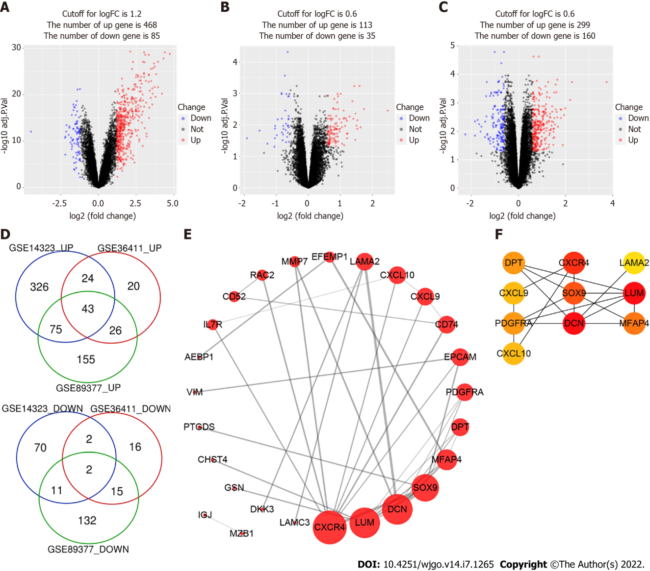
Figure 1 Identification of differentially expressed genes. A-C: The volcano plots of GSE14323, GSE36411 and GSE89377. The red dots and blue dots represent up-regulated and downregulated genes, respectively; D: The Venn diagram software identified 45 common differentially expressed genes (DEGs) in three datasets (GSE14323, GSE36411 and GSE89377), including 43 upregulated genes and 2 downregulated genes; E: protein-protein interaction network of DEGs was constructed by STRING online database and drew by Cytoscape software; F: Top 10 hub genes of DEGs were identified by cytoHubba plug-in of Cytoscape and their importance were represented by their color’s shade.
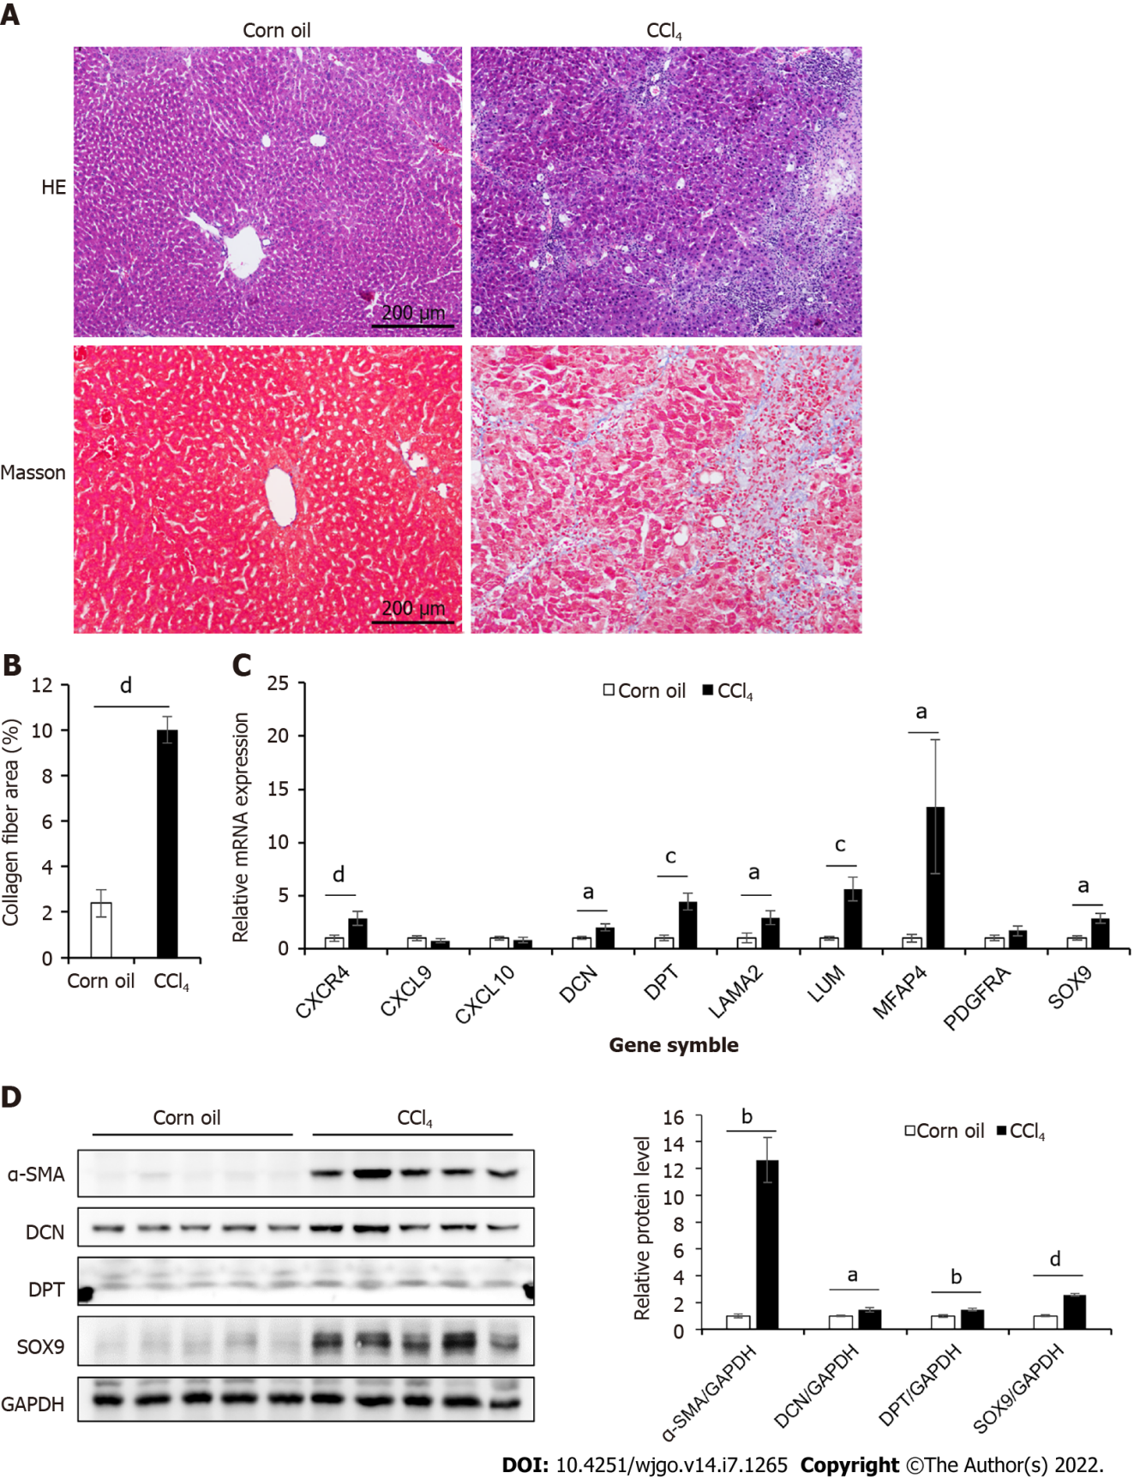
Figure 2 Expression of hub genes in the liver tissue of CCl₄-induced mouse mice. A: Masson’s trichrome and HE staining of control and CCl₄-induced liver cirrhosis mouse liver tissues; B: Collagen area in Masson’s trichrome staining (n = 7 or 8); C: The mRNA expression levels of 10 hub genes of control and CCl₄-induced cirrhosis mouse liver tissues (n = 6); D: The protein expression levels of α-SMA, Decorin (DCN), Dermatopontin (DPT), and SRY-box transcription factor 9 (SOX9) in liver tissues of mice in two groups. The right panel showed the result of quantitative analysis (n = 4). All data were presented as mean ± SE. Two-tailed Student’s t test were performed. ªP < 0.05, ^{b}P < 0.01, ^{c}P < 0.001, ^{d}P < 0.0001.
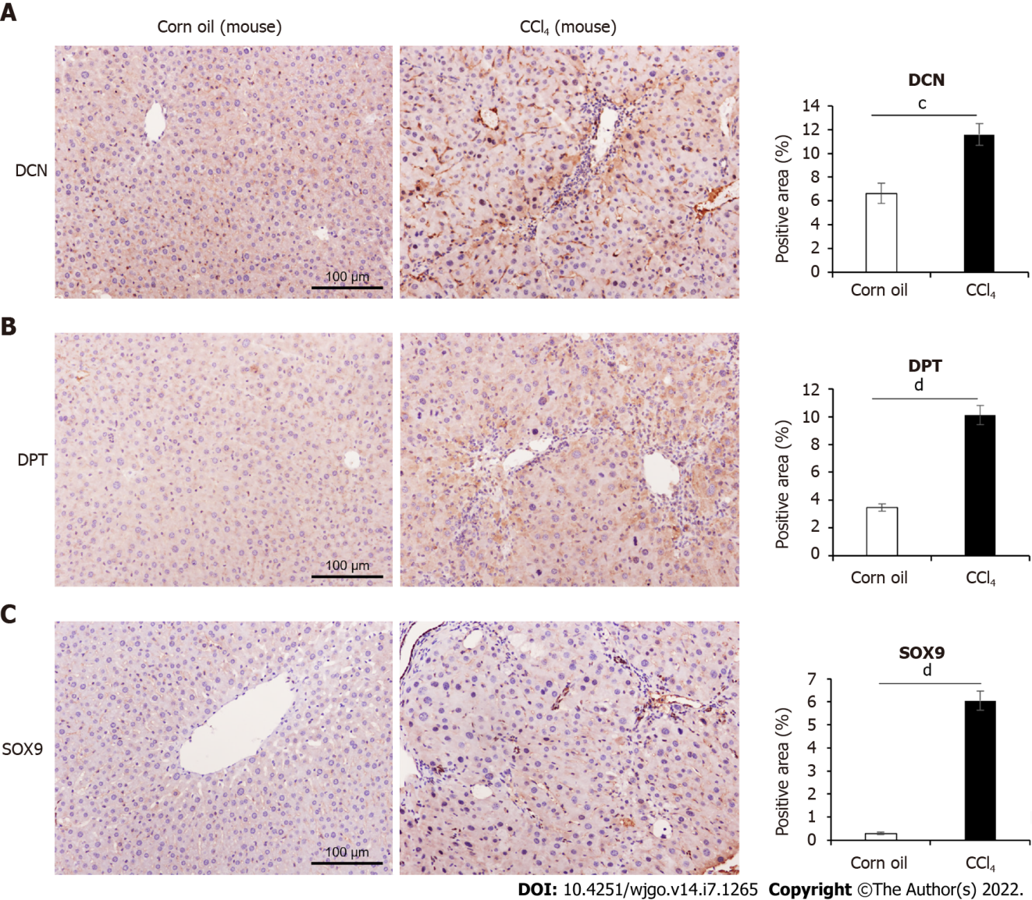
Figure 3 Comparison of decorin, dermatopontin, and SRY-box transcription factor 9 expression in CCl₄-induced mouse model. A: Immunohistochemical (IHC) analyses of the expression of Decorin (DCN) and the percentage of positive area were shown, n = 9 or 11; B: IHC analyses of the expression of Dermatopontin (DPT) and the percentage of positive area were shown (n = 9 or 10); C: IHC analyses of the expression of SRY-box transcription factor 9 (SOX9) and the percentage of positive area were shown (n = 9 or 10). All data were presented as mean ± SE. Two-tailed Student’s t test were performed. ^{c}P < 0.001, ^{d}P < 0.0001.
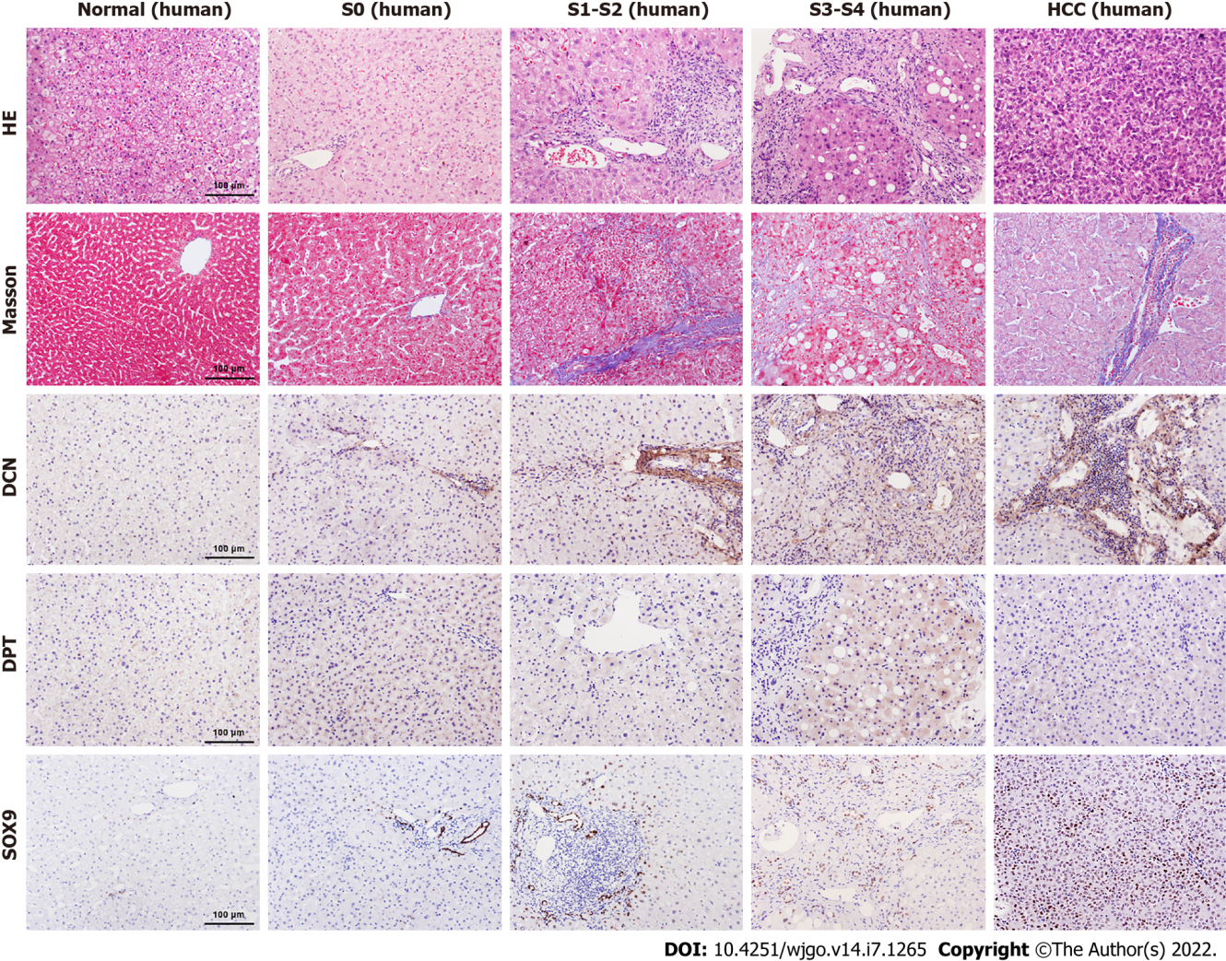
Figure 4 Comparison of decorin, dermatopontin, and SRY-box transcription factor 9 expression in human liver tissues. The expression levels of Decorin (DCN), Dermatopontin (DPT) and SRY-box transcription factor 9 (SOX9) in normal, S0, S1-S2, S3-S4, Hepatocellular carcinoma (HCC) groups were analyzed by immunohistochemistry. The H&E staining and Masson’s trichrome staining were shown also.
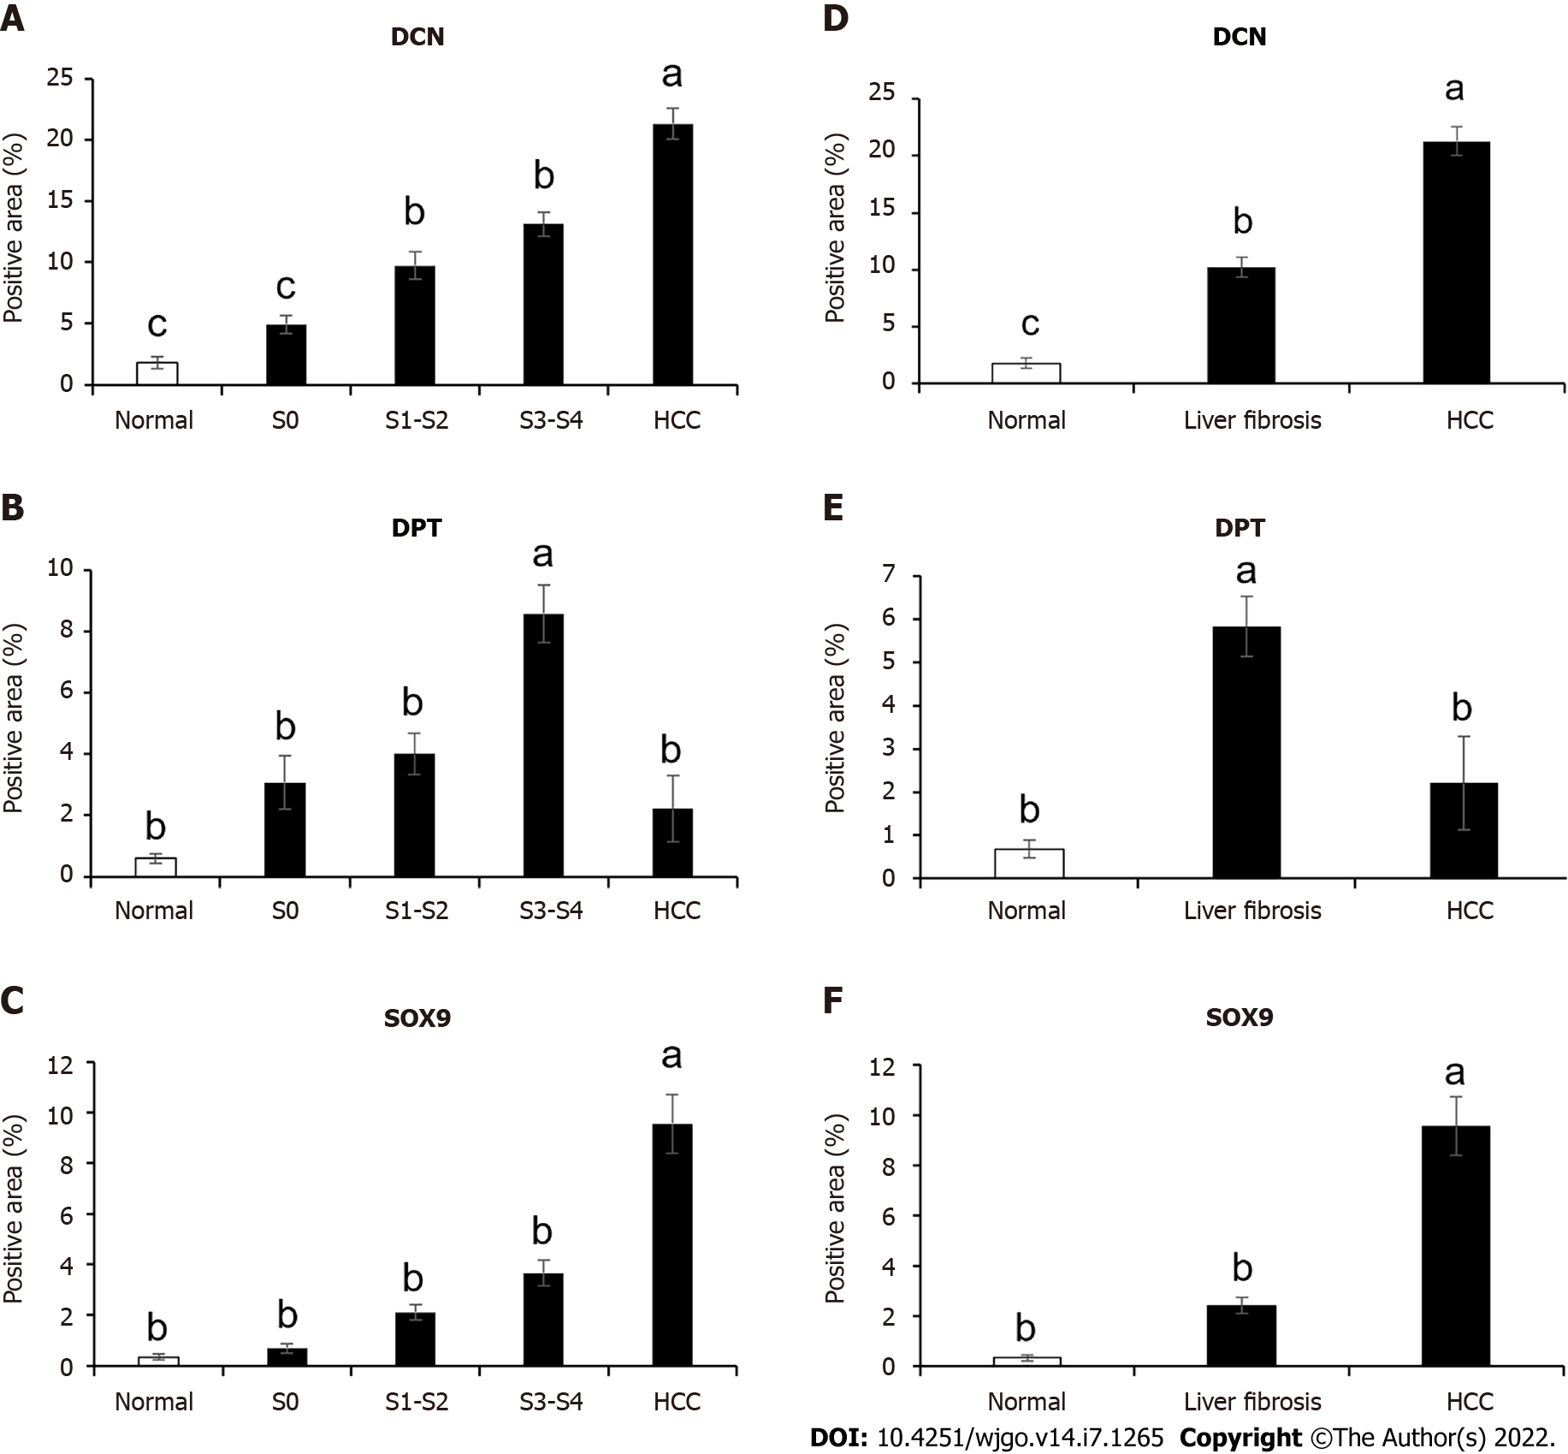
Figure 5 Expression levels analysis of decorin, dermatopontin, and SRY-box transcription factor 9 in human liver tissues. A-C: The percentage of positive area of decorin (DCN) , dermatopontin (DPT) and SRY-box transcription factor 9 (SOX9) among normal (n = 5 or 7), S0 (n = 3 or 4), S1-S2 (n = 10 or 12), S3-S4 (n = 8, 9 or 11) and hepatocellular carcinoma (HCC) (n = 11, 12 or 14) groups were counted; D-F: The percentage of positive area of DCN , DPT and SOX9 in normal (n = 5 or 7), liver fibrosis (n = 22, 23 or 26) and HCC (n = 11, 12 or 14) groups were counted. All data were presented as mean ± SE.One-way ANOVA with multiple comparisons and Tukey’s post-test were performed, ªP < 0.05, ^{b}P < 0.01, ^{c}P < 0.001.
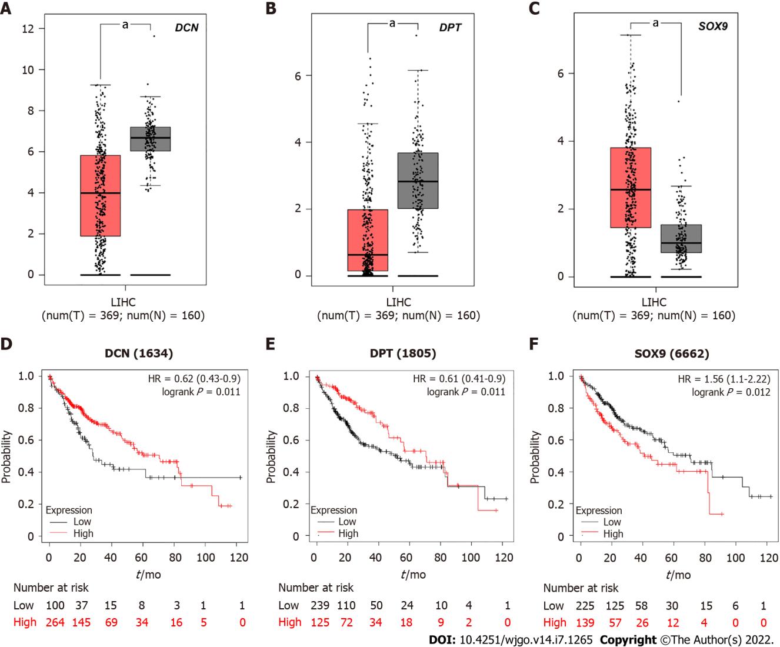
Figure 6 The relationship between decorin, dermatopontin, SRY-box transcription factor 9 expression and survival rate of hepatocellular carcinoma patients. A-C: Decorin (DCN), dermatopontin (DPT), and SRY-box transcription factor 9 (SOX9) were analyzed by gene expression profiling interactive analysis server (GEPIA) to determine their expression level differences between hepatocellular carcinoma (HCC) and normal liver tissues. Red box represents tumor tissue and gray box represents normal tissue; D-F: Prognostic information of hub genes. Kaplan-Meier plotter online tool was used to identify the prognostic information of DCN, DPT and SOX9, which associated with the survival rate of HCC patients (ªP < 0.05).

Table 1 Gene expression profiles of GSE14323, GSE36411 and GSE89377 have 45 differentially expressed genes, including 2 downregulated genes and 43 upregulated genes in the fibrotic liver compared to normal liver
DEGs | Genes
Upregulated | C-X-C chemokine receptor type 4 (CXCR4) | SH3 domain-containing YSC84-like protein 1 (SH3YL1) | Laminins containing the α2 (LAMA2)
 | Lumican (LUM) | DNA-binding protein inhibitor ID-3 (ID3) | Microfibril-associated glycoprotein 4 (MFAP4)
 | Prostaglandin-H2 D-isomerase (PTGDS) | Aldo-keto reductase family 1 member B10 (AKR1B10) | Marginal zone B- and B1-Cell-specific protein (MZB1)
 | Dickkopf-related protein 3 (DKK3) | Ras-related protein Rac2 (RAC2) | Suppressor of lin-12-like protein 3 (SEL1L3)
 | Dermatopontin (DPT) | Annexin A13 (ANXA13) | Defensin Beta 1 (DEFB1)
 | H-2 class II histocompatibility antigen gamma chain (CD74) | CAMPATH-1 antigen (CD52) | Protein unc-93 homolog A (UNC93A)
 | FXYD domain-containing ion transport regulator 2 (FXYD2) | Adipocyte enhancer-binding protein 1 (AEBP1) | Interleukin-7 receptor subunit alpha (IL7R)
 | C-X-C motif chemokine 9 (CXCL9) | C-X-C motif chemokine 10 (CXCL10) | Ribonuclease pancreatic (RNASE1)
 | SRY-Box transcription factor 9 (SOX9) | Gelsolin (GSN) | Carbohydrate sulfotransferase 4 (CHST4)
 | Vimentin (VIM) | Galectin-3-binding protein (LGALS3BP) | Platelet-derived growth factor receptor alpha (PDGFRA)
 | Lectin, galactoside-binding soluble 4 (LGALS4) | Laminin subunit gamma-3 (LAMC3) | Claudin-10 (CLDN10)
 | Joining chain of multimeric IgA and IgM (JCHAIN) | Ectonucleotide pyrophosphatase/phosphodiesterase family member 2 (ENPP2) | Cholesterol 25-hydroxylase (CH25H)
 | Apolipoprotein L3 (APOL3) | Decorin (DCN) | Complement component C7 (C7)
 | Epithelial cell adhesion molecule (EPCAM) | Keratin type I cytoskeletal 23 (KRT23) | EGF-containing fibulin-like extracellular matrix protein 1 (EFEMP1)
 | Matrix metallopeptidase 7 (MMP7)
Downregulated | Small conductance calcium-activated potassium channel protein 2 (KCNN2) | Cytochrome P450 2C19 (CYP2C19)
DEGs: Differentially expressed genes.
Table 2 Gene Ontology analysis of differentially expressed genes (top 10 according to P-value)
Gene set | Description | Count | P value
GO: 0030198 | Extracellular matrix organization | 11 | 3.38E-10
GO: 0043062 | Extracellular structure organization | 11 | 1.56E-9
GO: 0005201 | Extracellular matrix structural constituent | 7 | 7.48E-8
GO: 0062023 | Collagen-containing extracellular matrix | 9 | 1.53E-7
GO: 0031012 | Extracellular matrix | 10 | 1.78E-7
GO: 0007155 | Cell adhesion | 15 | 2.78E-7
GO: 0022610 | Biological adhesion | 15 | 3.00E-7
GO: 0006935 | Chemotaxis | 10 | 0.000001284
GO: 0042330 | Taxis | 10 | 0.000001323
GO: 0005198 | Structural molecule activity | 11 | 0.000001624
Table 3 Kyoto Encyclopedia of Genes and Genomes pathway analysis of differentially expressed genes in fibrotic liver
Gene set | Description | P value | Genes
hsa04062 | Chemokine signaling pathway | 0.00 | CXCR4, CXCL9, CXCL10, RAC2
hsa04510 | Focal adhesion | 0.01 | LAMA2, LAMC3, PDGFRA, RAC2
hsa04810 | Regulation of actin cytoskeleton | 0.01 | CXCR4, GSN, PDGFRA, RAC2
hsa04670 | Leukocyte transendothelial migration | 0.01 | CLDN10, CXCR4, RAC2
hsa05200 | Pathways in cancer | 0.01 | CXCR4, IL7R, LAMA2, LAMC3, PDGFRA, RAC2
hsa05416 | Viral myocarditis | 0.02 | LAMA2
hsa04060 | Cytokine-cytokine receptor interaction | 0.02 | CXCL9, CXCL10, CXCR4, IL7R
hsa00590 | Arachidonic acid metabolism | 0.02 | CYP2C19, PTGDS
hsa04976 | Bile secretion | 0.03 | FXYD2, KCNN2
hsa04024 | cAMP signaling pathway | 0.02 | FXYD2, RAC2, SOX9

Table 4 Clinical and histologic data for healthy controls, chronic hepatitis B and hepatocellular carcinoma patients
 | Control (n = 5) | CHB-S0 (n = 4) | CHB-S1-2 (n = 13) | CHB-S3-4 (n = 11) | HCC (n = 12)
Sex (M/F), n | 3/2 | 2/2 | 6/7 | 8/3 | 11/1
Age, yr, mean ± SD | 41.8 ± 9.5 | 33.0 ± 10.3 | 38.2 ± 8.1 | 40.3 ± 6.1 | 52.8 ± 10.5
HBeAg(+), n | 0 | 2 | 9 | 7 | 3
HBV DNA, logIU/mL, median with IQR | - | 5.5 (2.4, 8.5) | 5.0 (2.5, 7.0) | 4.7 (2.0, 6.6) | 0 (0, 3.0)
ALT, U/L, median with IQR | 19.2 (16.8, 28.7) | 56.6 (45.0, 75.8) | 39.3 (17.9, 66.3) | 51.3 (29.6, 70.0) | 54.7 (24.1, 105.8)
AST, U/L, median with IQR | 20.7 (19.4, 22.5) | 36.3 (27.2, 44.6) | 27.3 (20.9, 39.9) | 31.8 (23.8, 49.7) | 54.8 (27.9, 111.6)
TBil, μmol/L, mean ± SD | 18.9 ± 14.1 | 14.0 ± 4.3 | 12.8 ± 4.9 | 12.9 ± 4.8 | 16.8 ± 14.6
ALB, g/L, mean ± SD | 45.9 ± 4.8 | 47.8 ± 4.3 | 46.5 ± 3.9 | 44.4 ± 5.0 | 41.3 ± 5.3
CHE, IU/L, mean ± SD | 6191.3 ± 1908.0 | 11514.5 ± 3416.1 | 8887.5 ± 1964.8 | 7708.5 ± 2064.4 | 6538.7 ± 7065.7
AFP, ng/ml, mean ± SD or median with IQR | 2.5 ± 1.4 | 2.0 ± 0.8 | 4.7 ± 6.1 | 11.3 ± 22.1 | 37.9 (9.3, 388.9)
F: Female; M: Male; ALT: Alanine transaminase; AST: Aspartate transaminase; TBil: Total bilirubin; ALB: Albumin; CHE: Cholinesterase; AFP: Alpha-fetoprotein; IQR: Interquartile range; HCC: Hepatocellular carcinoma; CHB: Chronic hepatitis B.

Published by Baishideng Publishing Group Inc
7041 Koll Center Parkway, Suite 160, Pleasanton, CA 94566, USA
Telephone: +1-925-3991568
E-mail: bpgoffice@wjgnet.com
Help Desk: https://www.f6publishing.com/helpdesk
https://www.wjgnet.com

© 2022 Baishideng Publishing Group Inc. All rights reserved.

