Name of journal: World Journal of Anesthesiology
ESPS Manuscript NO: 1419
Columns: Diagnostic Advances

Clinical pharmacology of intravenous paracetamol in perinatal medicine

Allegaert K. Perinatal intravenous paracetamol pharmacology

Karel Allegaert

Karel Allegaert, Department of Development and Regeneration, KU Leuven, 3000 Leuven, Belgium

Karel Allegaert, Neonatal Intensive Care Unit, University Hospitals Leuven, 3000 Leuven, Belgium

Author contributions: Allegaert K performed the review, wrote the review and takes the full responsibilities.

Supported by the Fund for Scientific Research, Flanders, Fundamental Clinical Investigatorship, 1800209N

Correspondence to: Karel Allegaert, MD, PhD, Neonatal Intensive Care Unit,
University Hospital, Herestraat 49, 3000 Leuven, Belgium.
karel.allegaert@uzleuven.be

Telephone: +32-16-343850 Fax: +32-16-343209
Received: December 9, 2012 Revised: March 25, 2013
Accepted: April 13, 2013
Published online:

Abstract
Clinical pharmacology aims to predict drug-related effects based on compound and population specific pharmacokinetics (PK, concentration-time), and -dynamics (PD, concentration-effect). Consequently, dosing needs to be based on the physiological characteristics of the individual patient. Pregnancy and early infancy hereby warrant focused assessment. The specific characteristics of both subpopulations will be illustrated based on observations on intravenous (iv) paracetamol PK and PD collected in these specific populations. At delivery, there is a significant higher paracetamol clearance (+ 45%, l/h) when compared to non-pregnant observations. This higher clearance is in part explained by a proportional increase in oxidative metabolite production, but mainly an increase in glucuronidation. When focusing on pharmacodynamics, an association between maternal paracetamol exposure and atopy in infancy and fetal gastroshizis has been reported. In early infancy, paracetamol clearance is significantly lower and mainly depends on size (weight ^{0.75}), while also the distribution volume is higher (l/kg). Reports on hepatic tolerance, haemodynamic stability and impact of body temperature have been published while the concentration effect profile for analgesia seems to be similar between neonates and children. Similar to maternal exposure, there are reports on the association with atopy. Studies on the use of paracetamol to close the patent ductus arteriosus are ongoing. At least, these observations provide evidence on the need to study commonly administered anesthetics in such specific subpopulations with specific focus on both population specific pharmacokinetics and –dynamics to further improve patient tailored pharmacotherapy.

© 2013 Baishideng. All rights reserved.

Key words: Pregnancy; Newborn; Intravenous paracetamol; Pharmacokinetics

Core tip: Although urgently needed to further improve patient tailored pharmacotherapy, data on the clinical pharmacology in pregnant women and young infants are limited, even for commonly used drugs like paracetamol. We summarize the available observations on both pharmacokinetics and –dynamics of intravenous paracetamol in pregnant women and early infancy to illustrate the relevance of subpopulation specific observations. This includes differences in metabolic routes of elimination, in (side)effects (e.g., analgesia, hypotension, atopy) and in potential indications (patent ductus arteriosus).

Allegaert K. Clinical Pharmacology of intravenous paracetamol in perinatal medicine.
World J Anesthesiol 2013;
Available from: URL: http://www.wjgnet.com/esps/
DOI: http://dx.doi.org/10.5313/wja.00.0000

INTRODUCTION
Clinical pharmacology in special populations
The general pharmacokinetic principles of disposition and elimination of drugs apply, irrespective of population specific characteristics^{[1-5]}. However, pregnancy and early infancy warrant a tailored approach. This is because important alterations in physiology affect drug disposition up to clinical relevance. Pregnancy results in extensive alterations in pharmacokinetics (PK, concentration-time profile) with a subsequent extensive inter-individual variability in drug response^{[6-8]}. In general, renal elimination capacity is increased throughout pregnancy (i.e., higher glomerular filtration rate, higher active tubular transport). Similar, the basal metabolic activity is also increased. This commonly results in higher drug metabolism (phase I and phase II processes), although these changes are in part also iso-enzyme specific. This, although rarely, even may result in reduced enzymatic activity (CYP1A2 and CYP2C19) during pregnancy^{[6,8]}. Finally, changes in body weight or binding capacity (protein changes, pH) likely will affect the volume of distribution. Similarly, duration of pregnancy, co-morbidity (e.g., pre-eclampsia) or labor itself may further affect variability in drug disposition^{[6,8]}.
Early infancy is another very specific population. When we consider the physiological changes and the subsequent between individual variability in characteristics, we need to take into account that maturational changes are most prominent in infancy^{[7,9]}. Consequently, drug disposition in early infancy differs substantially from children or adults as a result of these physiology-related maturation in absorption, distribution and subsequent elimination, either through metabolic elimination or through primary renal elimination (ADME, pharmacokinetics)^{[7,9]}. In general, neonates have an overall low clearance capacity. Between subject variability can be explained by covariates such as size, weight organ function, co-administration of drugs, genetic polymorphisms, growth restriction or disease characteristics^{[9]}. Consequently, focused studies in peripartum and in early infancy to unveil clinical relevant covariates are needed^{[8,9]}. This is even true for a commonly administered compound like paracetamol.

Paracetamol
Paracetamol, N-acetyl-P-aminophenol (acetaminophen), is a readily available antipyretic and analgesic agent. It is the most often prescribed drug for treatment of mild to moderate pain or fever in infants, including neonates and can be administered by oral, rectal but also by intravenous route^{[1-5]}. In the therapeutic concentration range, paracetamol is metabolized by the liver to paracetamol-glucuronide (47%-62%) and paracetamol-sulphate (25%-36%) as main metabolites, subsequently eliminated by renal route. Only 1%-4% is excreted unchanged in urine, and about 8%-10% of paracetamol is oxidized to 3-hydroxy-paracetamol and the (hepatic)toxic metabolite N-acetyl-P-benzoquinone-imine^{[3-5]}.
Paracetamol is perceived to have a good efficacy-to-safety ratio as analgesic in a wide range of patient populations^{[10-15]}. However, since paracetamol is one of the most commonly used drugs to treat pain or fever, knowledge on the covariates of paracetamol disposition remains crucial to avoid toxicity through unanticipated variability^{[16-20]}. In addition to oral and rectal formulations, several intravenous (iv) formulations became available more recently^{[21-25]}. Such a formulation enables the administration of paracetamol when the enteral route cannot (yet) be used and should improve the predictability by the reduction in variability related to absorption^{[26-29]}.
Clinical pharmacology aims to predict drug-related effects based on drug, population and patient specific pharmacokinetics (PK, concentration-time), and -dynamics (PD, concentration-effect): drug dosing needs to be based on the physiological characteristics of the individual patient^{[8,9]}. As mentioned earlier, this necessitates focused studies in specific populations, including peripartum and early infancy.
Consequently, we aim to summarize our studies on aspects of PK and PD of intravenous paracetamol either at delivery and in early infancy. For both subpopulations, this will be combined with a topical review on the clinical pharmacology of paracetamol in these patients.

CLINICAL PHARMACOLOGY OF PARACETAMOL AT DELIVERY AND IN POSTPARTUM
Despite pregnancy and peripartum related changes in PK and PD and the clinical relevance to have such data, most of the drugs administered by anaesthetists have not been extensively evaluated in this specific population. This is also true for commonly administered analgesics like iv paracetamol.

Paracetamol pharmacokinetics and metabolism
Following study registration (EudraCT 2010-020164-37) and approval by the Ethics Committee of the University Hospitals Leuven, women who were scheduled to undergo a (semi)elective Caesarean delivery were recruited. The administration of iv paracetamol started with a loading dose of 2 g over 15 min shortly after delivery of the newborn. Blood samples from a dedicated peripheral iv catheter were collected 1, 2, 4 and 6 h after loading dose administration. These samples were centrifuged and plasma was stored at -20°C until high performance liquid chromatography analysis was performed. Using this approach, 36 paracetamol-time profiles following delivery were available for PK analysis^{[14,15]}.
These data were compared to data either published by Gregoire et al^{[30]} in 14 women, and 23 additional PK profiles collected in young female volunteers. As illustrated in Figure 1, there is a significant increase in paracetamol clearance (l/h) in peripartum when compared to non-pregnant PK profiles (median clearance 19.6 compared to 13.3 L/h, + 45%)^{[11,14,21,22]}. Table 1 provides a selective overview on paracetamol clearance estimates reported in different cohorts of adults, including healthy volunteers^{[30,31]}. In essence, this overview suggests that there are additional covariates of paracetamol clearance in adults, including disease severity, age, gender and pregnancy.
More recently and using a more sophisticated population pharmacokinetic modeling approach, we confirmed this a substantially higher paracetamol clearance in women at delivery compared to a subset of the same women 12 wk postpartum^{[6,14]}. More importantly, we were able to document that this increase in total paracetamol clearance at delivery is due to a disproportional increase in glucuronidation clearance and a proportional increase in clearance of unchanged paracetamol and in oxidation clearance without any changes in the absolute sulphation clearance, resulting in a proportional decrease. These pharmacokinetic observations at delivery and in postpartum are of pharmacodynamic (analgesia, toxicity) relevance.
The link between paracetamol plasma concentration and the level of analgesia has not yet been fully described, but McNicol et al^{[18]} recently reported on single dose iv paracetamol or propacetamol for prevention or treatment of postoperative pain based on a systematic review. Paracetamol (iv, 1 g) results in about 4 h of effective (pain relief, opioid sparing) analgesia with a subsequent decrease in effectiveness. Based on the paracetamol disposition (increased clearance) observed at delivery, it might be considered to decrease the time interval between consecutive paracetamol doses (at present guidelines q6h) or increase the dose (at present 1 g) in the immediate postpartum to mimic the time-concentration profile aimed for in the non-pregnant adult. However, such an approach will also results in higher oxidative metabolism (hepatotoxity) during pregnancy and is not without risk, and may explain the specific issues (gastroshizis, atopy of infancy) discussed below^{[32-35]}.

Specific pregnancy related issues as reported in literature
Epidemiological data suggest a link between perinatal paracetamol exposure and the risk to develop asthma^{[32,33]}. This included maternal consumption of acetaminophen during pregnancy. To further illustrate this, the Avon Longitudinal Study explored the impact of both nuclear erythroid 2 p45-related factor 2 polymorphism and glutathione S-transferase (GST, M1, T1, and P1) polymorphisms in the mothers and their infants to search for genotype-phenotype concordances^{[32]}. It was hereby documented that the antioxidant genotype of the infant did not modify associations between infant acetaminophen use and asthma phenotypes. In contrast, the increased risk of asthma and wheezing associated with late gestation acetaminophen exposure in the presence of maternal GSTM1 was further enhanced when GSTM1 was also present in the infant. Consequently, it seems that maternal antioxidant gene polymorphisms modify the relation between prenatal acetaminophen exposure and childhood asthma, strengthening evidence for a causal, polymorphisms related association^{[32,33]}. This fits quite well with the pregnancy related differences in metabolic routes of paracetamol elimination during pregnancy since associated with higher formation of oxidative metabolites^{[14,32,33]}.
A similar illustration, but looking for genotype/phenotype concordance following maternal acetaminophen exposure and fetal gastroshizis has been elaborated by Leeder^{[34,35]}. The author hereby also stressed that besides the maternal compartment, placental transfer and metabolism, fetal drug disposition and the developmental context also contribute to the fetal concentration/time and concentration/effect profile^{[34,35]}.

PARACETAMOL IN EARLY INFANCY
Paracetamol is also commonly prescribed to treat moderate pain in neonates and infants. Similar to other populations, an iv formulation may reduce variability related to absorption, and can be considered when enteral routes are not available ^{[36]}. Aspects of pharmacokinetics and –dynamics of iv paracetamol in (pre)term neonates were collected and reported in literature^{[37-39]}. The PK observations were recently pooled^{[40]}.
Based on this pooled population pharmacokinetic analysis in 943 paracetamol observations from 158 neonates, pharmacokinetic estimates (between-subject variability, %) were central distribution volume 51.9 l/70 kg (21.6%), peripheral distribution volume 22.7 L/70 kg and clearance 5 l/h/70 kg (40%)^{[40]}. Covariates predicted about 61% of the paracetamol clearance variability. Weight was the most important covariate of clearance, with only a very minimal additional contribution of postmenstrual age (2.2%)^{[40]}. We hereby mainly confirmed earlier clearance estimates in a further extended cohort of (pre)term neonates^{[25,36]}.
Paracetamol clearance, described using allometric scaling was one third of the mature value reported in adults (16.2 L/h/70 kg)^{[40]}. Clearance maturation is slow before 40 wk PMA and matures rapidly afterwards with a maturation half-time of 52 wk PMA to reach 90% of adult rates at one year of life (equal to 92 wk PMA). Moreover, when compared to other pediatric populations, the distribution volume is higher in neonates. The increased volume of distribution in neonates supports the use of a larger initial dose (loading dose) of iv paracetamol in neonates if one aims to attain a given threshold paracetamol concentration sooner since a higher distribution volume results in a proportionally lower peak concentration^{[7]}.
The combined observations of clearance and distribution volume result in the advice to consider a loading dose (20 mg/kg) in neonates, followed by 5, 7.5 or 10 mg/kg/6 h in extreme preterm, preterm and term cases respectively. Figure 2 provides the predicted concentration-time profile for a 36 wk postmenstrual age individual patient based on a loading dose of 20 mg/kg, followed by 10 mg/6 h ^{[40]}.
Although these dosing suggestions are higher when compared to the registered dosing, the combined loading dose + maintenance (20 mg/kg, followed by 20-40 mg/kg/24 h) has been evaluated on different pharmacodynamics aspects, including both pain reduction as well as safety (hepatotoxicity, haemodynamics and body temperature)^{[7,10,37-39]}.
There were no signs of hepatic intolerance during and following repeated administration of intravenous paracetamol^{[39]}. In addition and as part of the PARANEO study (www.clinicaltrials.gov, NCT00969176), we reported on the hemodynamics following iv paracetamol (loading dose, 20 mg/kg) administration^{[38]}. In contrast to the negative hemodynamic effects in adult intensive care unit (ICU) patients, there were no hemodynamic alterations in neonates^{[22,38]}. Similarly, neonates remained normothermic, while temperature reduction – most pronounced within the first 2 h after administration - was observed in neonates with fever^{[37]}.
More recently, we also reported on the paracetamol concentration-effect relation in neonates, based on prospective collection in 19/60 neonates included in the PARANEO study received monotherapy with iv paracetamol to treat mild to moderate pain (e.g., alprostadil administration, delivery related trauma)^{[10]}. Using repeated measures ANOVA, there was a trend (P = 0.02) for lower pain scores within 30 min after administration, with a slight increase in pain scores from 5 to 6 h (Figure 3)^{[10]}. Further analysis hereby suggests a similar paracetamol effect compartment concentration in neonates compared to children.

Specific issues reported in literature
In addition to the above mentioned aspects of clinical pharmacology of paracetamol in early infancy, epidemiological data also suggest a link between paracetamol exposure in early infancy and the risk to develop asthma similar to the link between maternal exposure and atopy in early infancy^{[32,33]}. From a safety aspect, we would like to point to the dosage errors (10 fold error) reported following the introduction of the iv paracetamol formulation in neonatal intensive care unit, with serious adverse events in individual cases^{[41]}. These errors re-illustrate the risks associated with the introduction of a new compound in this specific population.
Finally, standard pharmacologic closure of the patent ductus arteriosus currently involves the administration of 1 of 2 cyclooxygenase inhibitors: either indomethacin or ibuprofen. However, both of these drugs can be associated with potentially significant adverse effects. There have been a limited number of case reports describing the association of paracetamol exposure and closure of a patent ductus arteriosus^{[42,43]}. At present, there are some study protocols registered who will focus on this research question in preterm neonates (< 1 500 g). Until such data become available, we consider this a hypothesis in the need for validation before efficacy/ safety comparative trials can be considered.

GENERAL DISCUSSION
Clinical pharmacology aims to predict pharmacokinetics and –dynamics (PK, PD) to improve the effect/side-effect balance in every individual patient. Extensive physiological alterations in pregnancy and postpartum or infancy can lead to clinically relevant changes in drug disposition and subsequent effects. This relates to the metabolic route, the pharmacokinetics (distribution volume and clearance), and the subsequent level of analgesia.
The available data reported on drug disposition in the pregnant and non-pregnant state indicate that these pharmacokinetic differences might be of pharmacodynamic relevance. Therefore, we aimed to perform additional paired PK studies in earlier and later than 3 mo postpartum stages to fully elucidate the way how pregnancy induced paracetamol disposition changes return to pre-pregnancy values^{[6,14]}. We hereby were able to describe that the higher paracetamol clearance ad delivery is mainly due to higher glucuronidation and oxidation. In contrast, in neonates, the glucuronidation capacity is still limited, resulting in proportional higher sulphation and primary renal clearance while the contribution of oxidative metabolites to overall paracetamol clearance remains to be explored (Figure 4)^{[1,6,7,14]}.
Analgesia of paracetamol is mediated through inhibition of prostaglandins synthesis in the central nervous system (cyclo-oxygenase III and IIb). Analgesic effects also involve inhibitory action at the level of spinal nitric oxide and serotonergic pathways^{[1-5]}. Paracetamol is believed to be an effective antipyretic at plasma concentrations between 10 and 20 mg/L and these concentrations have also been suggested to provide analgesia ^{[1-5]}. To result in effective analgesia, this means that the distribution volume needs to be considered to attain a sufficient plasma concentration at the initiation of treatment.
At delivery, the distribution volume (L) is proportionally higher due to the higher body weight at delivery, without additional relative (L /kg) changes. As mentioned earlier, the relation between plasma paracetamol concentration and the level of analgesia has not yet been fully described. Intravenous paracetamol (1 g) provides around 4 h of effective (pain relief, opioid sparing) analgesia with a subsequent decrease in effectiveness to 6 h^{[18]}. Similarly, an intraoperative loading dose of two grams compared to one gram following minor hand or third molar surgery respectively provided better analgesia (VAS score) in the first 24 h after the intervention^{[44]}. The higher distribution volume at delivery supports the use of a loading dose of 2 g instead of the recommended 1 g of iv paracetamol at delivery in the absence of contra-indications. This should be followed by 1 g iv paracetamol q6h to maintain these concentrations within this analgesic range while avoiding both accumulation and overproduction of oxidative metabolites^{[6,14]}.
Adequate management of pain is also in neonates a major issue, not only from an ethical perspective, but also to improve short and long term outcome^{[1,10]}. Effective treatment of pain in this population is still in part hampered due to the limited volume of data on the pharmacokinetics and –dynamics of analgesics prescribed. To a certain extent, this is even true for paracetamol.
Based on their body composition, the distribution volume for paracetamol is proportionally (L /kg) higher in early infancy when compared to children or adults^{[40]}. Similar to the rationale to use a loading dose at delivery, this pharmacokinetic variable supports the use of a loading dose (20 mg/kg). Although only based on a very limited number of observations, we recently were able to document that this loading dose approach does result in effective pain reduction up to 6 h^{[10]}. Based on the lower clearance in early infancy, this loading dose should be followed by a maintenance dose of either 20-40 mg/kg/24 h, divided to result in intermittent administration hereby using a 6-12 h time interval^{[7,40]}.
Obviously, further studies on the pharmacodynamics of paracetamol in early infancy are urgently needed similar to the recent work of Capici et al^{[27]} on the pharmacodynamics of iv paracetamol in children following adeno-tonsillectomy. These authors compared the time until rescue medication after adeno-tonsillectomy in children was needed after paracetamol administration. They hereby were able to document that a 6 h interval of intravenous administration (20 mg/kg) should not be exceeded. The time until rescue medication was needed was shorter after intravenous administration (6 h) compared to rectal (40 mg/kg) administration (10 h), potentially in part reflecting the slower and more variable absorption after rectal administration. Since the time until rescue medication was the main outcome variable of this study, no final conclusions on the safety/effectiveness balance during repeated rectal or intravenous administration of paracetamol can be drawn based on this study. Such studies should result in safer and more effective prescription and use of drugs in early infancy. This even is true for frequently administered drugs like paracetamol since still important issues on its use remain to be unveiled.
REFERENCES
1 Allegaert K, van den Anker J. Pharmacokinetics and pharmacodynamics of intravenous acetaminophen in neonates. Expert Rev Clin Pharmacol 2011; 4: 713-718 [PMID: 22111857 DOI: 10.1586/ecp.11.50]
2 Groudine S, Fossum S. Use of intravenous acetaminophen in the treatment of postoperative pain. J Perianesth Nurs 2011; 26: 74-80 [PMID: 21402280 DOI: 10.1016/j.jopan.2010.11.001]
3 Jahr JS, Lee VK. Intravenous acetaminophen. Anesthesiol Clin 2010; 28: 619-645 [PMID: 21074742 DOI: 10.1016/j.anclin.2010.08.006]
4 Mattia A, Coluzzi F. What anesthesiologists should know about paracetamol (acetaminophen). Minerva Anestesiol 2009; 75: 644-653 [PMID: 19881460]
5 Duggan ST, Scott LJ. Intravenous paracetamol (acetaminophen). Drugs 2009; 69: 101-113 [PMID: 19192939 DOI: 10.2165/00003495-200969010-00007]
6 Kulo A, van Calsteren K, Verbesselt R, Smits A, Devlieger R, de Hoon J, Allegaert K. The impact of Caesarean delivery on paracetamol and ketorolac pharmacokinetics: a paired analysis. J Biomed Biotechnol 2012; 2012: 437639 [PMID: 22675252 DOI: 0.1155/2012/437639]
7 Allegaert K, de Hoon J, Naulaers G, Van De Velde M. Neonatal clinical pharmacology: recent observations of relevance for anaesthesiologists. Acta Anaesthesiol Belg 2008; 59: 283-288 [PMID: 19235528]
8 . Anderson GD. Pregnancy-induced changes in pharmacokinetics: a mechanistic-based approach. Clin Pharmacokin 2005; 44: 989-1008 [PMID 16176115]
9 Smits A, Kulo A, de Hoon JN, Allegaert K. Pharmacokinetics of drugs in neonates: pattern recognition beyond compound specific observations. Curr Pharm Des 2012; 18: 3119-3146 [PMID: 22564304 DOI: 1873-4286/12]
10 Allegaert K, Naulaers G, Vanhaesebrouck S, Anderson BJ. The paracetamol concentration-effect relation in neonates. Paediatr Anaesth 2013; 23: 45-50 [PMID: 23170854 DOI: 10.1111/pan.12076]
11 Owens KH, Medlicott NJ, Zacharias M, Curran N, Chary S, Thompson-Fawcett M, Reith DM. The pharmacokinetic profile of intravenous paracetamol in adult patients undergoing major abdominal surgery. Ther Drug Monit 2012; 34: 713-721 [PMID: 23149443 DOI: 10.1097/FTD.0b013e31826a70ea]
12 Zuppa AF, Hammer GB, Barrett JS, Kenney BF, Kassir N, Mouksassi S, Royal MA. Safety and population pharmacokinetic analysis of intravenous acetaminophen in neonates, infants, children, and adolescents with pain or Fever. J Pediatr Pharmacol Ther 2011; 16: 246-261 [PMID: 22768009 DOI: 10.5863/1551-6776-16.4.246]
13 Mohammed BS, Engelhardt T, Cameron GA, Cameron L, Hawksworth GM, Hawwa AF, McElnay J, Helms PJ, McLay JS. Population pharmacokinetics of single-dose intravenous paracetamol in children. Br J Anaesth 2012; 108: 823-829 [PMID: 22389380 DOI: 10.1093/bja/aes025]
14 Kulo A, Peeters MY, Allegaert K, Smits A, de Hoon J, Verbesselt R, Lewi L, van de Velde M, Knibbe CA. Pharmacokinetics of paracetamol and its metabolites in women at delivery and post-partum. Br J Clin Pharmacol 2013; 75: 850-860 [PMID: 22845052 DOI: 10.1111/j.1365-2125.2012.04402.x]
15 Kulo A, van de Velde M, de Hoon J, Verbesselt R, Devlieger R, Deprest J, Allegaert K. Pharmacokinetics of a loading dose of intravenous paracetamol post caesarean delivery. Int J Obstet Anesth 2012; 21: 125-128 [PMID: 22341787 DOI: 10.1016/j.ijoa.2011.12.007]
16 Tzortzopoulou A, McNicol ED, Cepeda MS, Francia MB, Farhat T, Schumann R. Single dose intravenous propacetamol or intravenous paracetamol for postoperative pain. Cochrane Database Syst Rev 2011; CD007126 [PMID: 21975764 DOI: 10.1002/14651858.CD007126.pub2]
17 Babl FE, Theophilos T, Palmer GM. Is there a role for intravenous acetaminophen in pediatric emergency departments? Pediatr Emerg Care 2011; 27: 496-499 [PMID: 21629146 DOI: 10.1097/PEC.0b013e31821d8629]
18 McNicol ED, Tzortzopoulou A, Cepeda MS, Francia MB, Farhat T, Schumann R. Single-dose intravenous paracetamol or propacetamol for prevention or treatment of postoperative pain: a systematic review and meta-analysis. Br J Anaesth 2011; 106: 764-775 [PMID: 21558067 DOI: 10.1093/bja/aer107]
19 Peacock WF, Breitmeyer JB, Pan C, Smith WB, Royal MA. A randomized study of the efficacy and safety of intravenous acetaminophen compared to oral acetaminophen for the treatment of fever. Acad Emerg Med 2011; 18: 360-366 [PMID: 21496138 DOI: 10.1111/j.1553-2712.2011.01043]
20 Moon YE, Lee YK, Lee J, Moon DE. The effects of preoperative intravenous acetaminophen in patients undergoing abdominal hysterectomy. Arch Gynecol Obstet 2011; 284: 1455-1460 [PMID: 21344260 DOI: 10.1007/s00404-011-1860-7]
21 Liukas A, Kuusniemi K, Aantaa R, Virolainen P, Niemi M, Neuvonen PJ, Olkkola KT. Pharmacokinetics of intravenous paracetamol in elderly patients. Clin Pharmacokinet 2011; 50: 121-129 [PMID: 21241071 DOI: 10.2165/11537240-000000000-00000]
22 de Maat MM, Tijssen TA, Brüggemann RJ, Ponssen HH. Paracetamol for intravenous use in medium--and intensive care patients: pharmacokinetics and tolerance. Eur J Clin Pharmacol 2010; 66: 713-719 [PMID: 20300741 DOI: 10.1007/s00228-010-0806-5]
23 Memis D, Inal MT, Kavalci G, Sezer A, Sut N. Intravenous paracetamol reduced the use of opioids, extubation time, and opioid-related adverse effects after major surgery in intensive care unit. J Crit Care 2010; 25: 458-462 [PMID: 20189753 DOI: 10.1016/j.jcrc.2009.12.012]
24 Wilson-Smith EM, Morton NS. Survey of i.v. paracetamol (acetaminophen) use in neonates and infants under 1 year of age by UK anesthetists. Paediatr Anaesth 2009; 19: 329-337 [PMID: 19335345 DOI: 10.1111/j.1460-9592.2009.02947.x]
25 Palmer GM, Atkins M, Anderson BJ, Smith KR, Culnane TJ, McNally CM, Perkins EJ, Chalkiadis GA, Hunt RW. I.V. acetaminophen pharmacokinetics in neonates after multiple doses. Br J Anaesth 2008; 101: 523-530 [PMID: 18628265 DOI: 10.1093/bja/aen208]
26 Prins SA, Van Dijk M, Van Leeuwen P, Searle S, Anderson BJ, Tibboel D, Mathot RA. Pharmacokinetics and analgesic effects of intravenous propacetamol vs rectal paracetamol in children after major craniofacial surgery. Paediatr Anaesth 2008; 18: 582-592 [PMID: 18482233 DOI: 10.1111/j.1460-9592.2008.02619.x]
27 Capici F, Ingelmo PM, Davidson A, Sacchi CA, Milan B, Sperti LR, Lorini L, Fumagalli R. Randomized controlled trial of duration of analgesia following intravenous or rectal acetaminophen after adenotonsillectomy in children. Br J Anaesth 2008; 100: 251-255 [PMID: 18211998 DOI: 10.1093/bja/aem377]
28 Palmer GM, Chen SP, Smith KR, Hardikar W. Introduction and audit of intravenous paracetamol at a tertiary paediatric teaching hospital. Anaesth Intensive Care 2007; 35: 702-706 [PMID: 17933155]
29 Atef A, Fawaz AA. Intravenous paracetamol is highly effective in pain treatment after tonsillectomy in adults. Eur Arch Otorhinolaryngol 2008; 265: 351-355 [PMID: 17891409 DOI: 10.1007/s00405-007-0451-5]
30 Gregoire N, Hovsepian L, Gualano V, Evene E, Dufour G, Gendron A. Safety and pharmacokinetics of paracetamol following intravenous administration of 5 g during the first 24 h with a 2-g starting dose. Clin Pharmacol Ther 2007; 81: 401-405 [PMID: 17339870 DOI: 10.1038/sj.clpt.6100064]
31 Depré M, van Hecken A, Verbesselt R, Tjandra-Maga TB, Gerin M, de Schepper PJ. Tolerance and pharmacokinetics of propacetamol, a paracetamol formulation for intravenous use. Fundam Clin Pharmacol 1992; 6: 259-262 [PMID: 1487229]
32 Shaheen SO, Newson RB, Ring SM, Rose-Zerilli MJ, Holloway JW, Henderson AJ. Prenatal and infant acetaminophen exposure, antioxidant gene polymorphisms, and childhood asthma. J Allergy Clin Immunol 2010; 126: 1141-8.e7 [PMID: 21051083 DOI: 10.1016/j.jaci.2010.08.047]
33 Lowe AJ, Carlin JB, Bennett CM, Hosking CS, Allen KJ, Robertson CF, Axelrad C, Abramson MJ, Hill DJ, Dharmage SC. Paracetamol use in early life and asthma: prospective birth cohort study. BMJ 2010; 341: c4616 [PMID: 20843914 DOI: 10.1136/bmj.c4616]
34 Leeder JS, Mitchell AA. Application of pharmacogenomic strategies to the study of drug-induced birth defects. Clin Pharmacol Ther 2007; 81: 595-599 [PMID: 17314924 DOI: 10.1038/sj.clpt.6100128]
35 Leeder JS. Developmental pharmacogenetics: a general paradigm for application to neonatal pharmacology and toxicology. Clin Pharmacol Ther 2009; 86: 678-682 [PMID: 19865080 DOI: 10.1038/clpt.2009.195]
36 van den Anker JN, Tibboel D. Pain relief in neonates: when to use intravenous paracetamol. Arch Dis Child 2011; 96: 573-574 [PMID: 21441241 DOI: 10.1136/adc.2011.211060]
37 Hopchet L, Kulo A, Rayyan M, Verbesselt R, Vanhole C, de Hoon JN, Allegaert K. Does intravenous paracetamol administration affect body temperature in neonates? Arch Dis Child 2011; 96: 301-304 [PMID: 21233080 DOI: 10.1136/adc.2010.203778]
38 Allegaert K, Naulaers G. Haemodynamics of intravenous paracetamol in neonates. Eur J Clin Pharmacol 2010; 66: 855-858 [PMID: 20607221 DOI: 10.1007/s00228-010-0860-z]
39 Allegaert K, Rayyan M, De Rijdt T, Van Beek F, Naulaers G. Hepatic tolerance of repeated intravenous paracetamol administration in neonates. Paediatr Anaesth 2008; 18: 388-392 [PMID: 18384338 DOI: 10.1111/j.1460-9592.2008.02535.x]
40 Allegaert K, Palmer GM, Anderson BJ. The pharmacokinetics of intravenous paracetamol in neonates: size matters most. Arch Dis Child 2011; 96: 575-580 [PMID: 21317433 DOI: 10.1136/adc.2010.204552]
41 Dart RC, Rumack BH. Intravenous acetaminophen in the United States: iatrogenic dosing errors. Pediatrics 2012; 129: 349-353 [PMID: 22271694 DOI: 10.1542/peds.2011-2345]
42 Hammerman C, Bin-Nun A, Markovitch E, Schimmel MS, Kaplan M, Fink D. Ductal closure with paracetamol: a surprising new approach to patent ductus arteriosus treatment. Pediatrics 2011; 128: e1618-e1621 [PMID: 22065264 DOI: 10.1542/peds.2011-0359].]
43 Hammerman C, Bin-Nun A, Kaplan M. Managing the patent ductus arteriosus in the premature neonate: a new look at what we thought we knew. Semin Perinatol 2012; 36: 130-138 [PMID: 22414884 DOI: 10.1053/j.semperi.2011.09.023]
44 Cornesse D, Senard M, Hans GA, Ledoux D, Kirsch M, Hick G, Hallet C, Joris J. Comparison between two intraoperative intravenous loading doses of paracetamol on pain after minor hand surgery: two grams versus one gram. Acta Chir Belg 2010; 110: 529-532 [PMID: 21158329]

P-Reviewer Janicki PK S-Editor Gou SX L-Editor E-Editor

Figure 1 Individual clearance paracetamol estimates in young women at delivery compared to similar individual paracetamol clearance estimates in non-pregnant women.
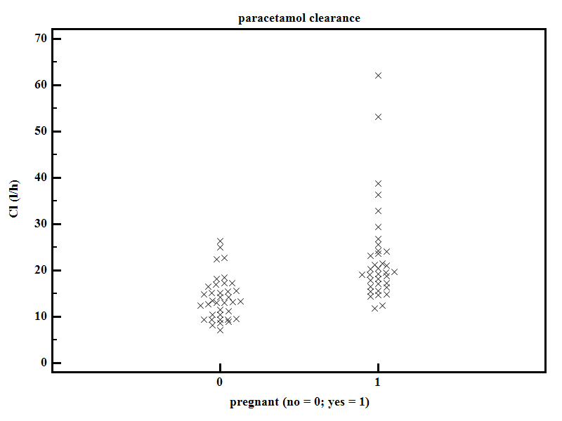

Figure 2 Concentration-time profile estimated based on the pooled pharmacokinetic study in neonates. The profile estimates are based on an initial loading dose (20 mg/kg) of iv paracetamol, followed by 10 mg/kg q6h in a newborn of 36 wk postmenstrual age^{[40]}.

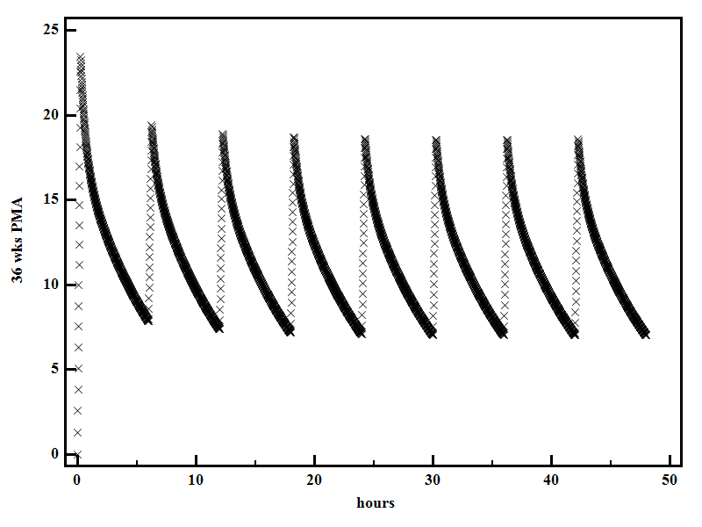

Figure 3 Individual pain scores (Leuven Neonatal Pain Score, range 0-14) as collected following iv paracetamol (20 mg/kg) administration. Only observations in 19/60 treated with iv paracetamol (monotherapy) while included in the PARANEO study were reported^{[10]}.
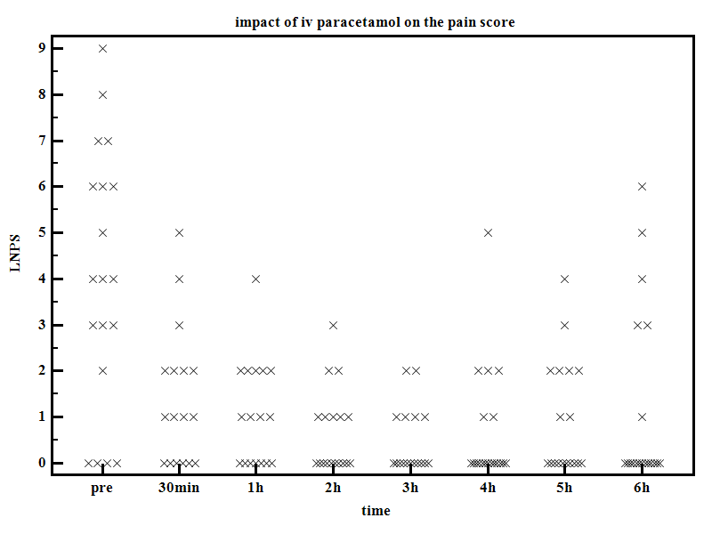

Figure 4 Paracetamol metabolism in the human, hereby indicating the changes in paracetamol drug metabolism at delivery and in early infancy.

paracetamol
OH
O
||
HN
-
C
-
CH
3
O
||
HN
-
C
-
CH
3
Glucuronide
O
||
HN
-
C
-
CH
3
Sulfate
Cysteine & Mercapturic Acid Conjugates
Glutathione
Reactive
Metabolite
(NAPQI)
OH
O
||
HN
-
C
-
CH
3
Cytochrome P450 2E1
Glutathione
Active
Repletion
Process
25%
-
36%
47%
-
62%
4.8%
-
8.0%
absolutely
higher in pregnancy
lower in infancy
higher in pregnancy
unexplored in infancy
proportionally
lower in pregnancy
higher in infancy

Table 1 Median paracetamol clearance estimates as reported in different cohorts of adults
Ref. Dose Adults Paracetamol (L/h)
Owens et al^{[11]} 1 g, repeated q6h 20 patients, major abdominal surgery
Day 1 of surgery 10.8
Day 2 or 3 after surgery 16.65
Kulo et al^{[14]} 2 g iv, followed by 1g, q6h Caesarean delivery, 39 women 21.1 2 g iv, single dose 8/39, paired analysis, 18 wk postpartum 11.7
Liukas et al^{[21]} 1 g, single dose 40 patients, different age cohort, orthopedic surgery
20-40 years, median weight 81 kg 22.3
60-70 years, median weight 83 kg 20.9
70-80 years, median weight 82 kg 16.2
80-90 years, median weight 68 kg 13.5
De Maat et al^{[22]} 1 g iv, repeated dose 38 medium and intensive care unit adult patients 23.65
26/38, medium care 20.84
12/38, intensive care 39.78
Gregoire et al^{[30]} 2 g iv, followed by 1g, q6h 26 healthy male and female volunteers 15.9
Depré et al^{[31]} 0.5 g iv, single dose 12 healthy male volunteers 20.04

