Name of Journal: World Journal of Orthopedics
Manuscript NO: 70415
Manuscript Type: ORIGINAL ARTICLE

Observational Study
Prevalence and factors of work-related musculoskeletal disorders among hand surgeons

Alqahtani SA et al. Musculoskeletal disorders in hand surgeons

Saad M Alqahtani, Mohammad M Alzahrani, Ryan Bicknell, David Pichora

Saad M Alqahtani, Mohammad M Alzahrani, Department of Orthopaedics, Imam Abdulrahman Bin Faisal University, Dammam 34212, Saudi Arabia

Ryan Bicknell, David Pichora, Department of Orthopaedics, Queens University, Kingston K7L 3N6, Ontario, Canada

Author contributions: Alqahtani SM and Alzahrani MM contributed to the concept, design, study execution, manuscript writing and review; Bicknell R and Pichora D contributed to the concept, design, manuscript writing and review.

Corresponding author: Mohammad M Alzahrani, FRCS, MBBS, MSc, Assistant Professor, Department of Orthopaedics, Imam Abdulrahman Bin Faisal University, King Faisal Road, Dammam 34212, Saudi Arabia. mmalzahrani@iau.edu.sa

Received: August 1, 2021
Revised: November 12, 2021
Accepted: April 24, 2022
Published online: May 18, 2022
Abstract
BACKGROUND
The nature of tasks required by hand surgeons require both forceful and repetitive maneuvers, thus subjecting these surgeons to the risk of musculoskeletal (MSK) injuries during their years in practice.

AIM
To assess the prevalence, characteristics and impact of MSK disorders among hand surgeons.

METHODS
A modified version of the physical discomfort survey was sent to surgeons who were members of the American Society for Surgery of the Hand via e-mail. The collected data were analyzed using descriptive statistics, one-way analysis of variance, and Fisher's exact test. P values of < 0.05 were considered statistically significant.

RESULTS
Of the 578 respondents, 60.4% reported that they had sustained a work-related MSK injury, of which the most common diagnoses were lateral elbow epicondylitis (18.7%), low back pain (17.1%) and carpal tunnel syndrome (15.6%). Among those that reported an injury, 73.1 % required treatment and 29.2 % needed time off work as a direct result of their injury. The number of work-related injuries incurred by a surgeon increased significantly with increasing age (P < 0.003), increasing years in practice (P < 0.001) and higher case load (P < 0.05).

CONCLUSION
To our knowledge this study is the first of its kind to assess MSK injuries sustained by Hand surgeons with a high incidence. These results should increase awareness on this aspect and fuel future studies directed at preventing these types of work-related injuries, thus minimizing the financial and psychological burden on these surgeons and the healthcare system.

Key Words: Hand; Surgeon; Prevalence; Musculoskeletal disorders; Occupational injuries

©The Author(s) 2022. Published by Baishideng Publishing Group Inc. All rights reserved.

Citation: Alqahtani SM, Alzahrani MM, Bicknell R, Pichora D. Prevalence and factors of work-related musculoskeletal disorders among hand surgeons. World J Orthop 2022; 13(5): 465-471
URL: https://www.wjgnet.com/2218-5836/full/v13/i5/465.htm
DOI: https://dx.doi.org/10.5312/wjo.v13.i5.465

Core Tip: Work-related musculoskeletal injuries are a common occurrence during the years of practice of hand surgeons. The most common diagnoses were lateral elbow epicondylitis, low back pain and carpal tunnel syndrome. Awareness and knowledge of these injuries can minimize the financial and psychological burden on both surgeons and the healthcare system.
INTRODUCTION
Occupational injuries have gained recent attention in the medical literature, with studies exploring the prevalence of these injuries and possible predisposing factors. While all physicians are at risk of sustaining these injuries, surgeons have been identified as a high-risk group^{[1-6]}.
Musculoskeletal (MSK) disorders have been identified as a common occupational risk for surgeons, which has been referred to as “an impending epidemic”^{[1]}. Their risk of occurrence increases especially when the surgeon in involved in tasks requiring repetitive and forceful movements, as it has been found that the prevalence of these injuries was more than 60% in practicing orthopaedic surgeons of different subspecialties^{[3-5,7-9]}. These injuries involved multiple MSK regions, including the lower back, elbow and wrist, thus requiring a large cohort of these injured surgeons to take time off work as a direct result of their sustained injuries.
Awareness of these MSK disorders and improvements in operative room ergonomics may have a substantial effect on the prevention of their occurrence^{[10-12]}. Unfortunately, this effect isn’t evident from the most recent literature, possibly due to the difficulty in applying some of the proposed ergonomical alterations and recommendations in the operative field^{[10,13,14]}.
We conducted a study exploring prevalence of work-related MSK disorders among hand surgeons, with a goal to identify specific factors predisposing to these injuries and their impact on the surgeon’s practice. Also, we aimed from this study to increase awareness of these types of injuries both to the practicing surgeon and members of the healthcare system in general.

MATERIALS AND METHODS
Members of the American Society for Surgery of the Hand were sent a modified version of the physical discomfort survey via e-mail. The initial email was sent in June 2016, followed by a reminder email in December 2017, and survey collection was closed by June 2017.
Questions pertaining to the surgeons general demographics (e.g., age, gender, hand-dominance, type of practice, number of years in practice and annual caseload), in addition to questions exploring work related MSK injuries were included in the survey. The explored MSK injuries were divided into anatomical regions, including neck, shoulder, elbow/forearm, wrist/hand, hip, knee, foot and ankle, low back. In addition, participants were asked about both treatment required and time off work required due to the reported injuries, if any.

Statistical analyses
The collected data was analyzed using descriptive statistics, one-way analysis of variance, and Fisher's exact test using SPSS statistical package version 24 (SPSS Inc., Chicago, IL). P values of < 0.05 were considered statistically significant.

RESULTS
Five hundred and seventy-eight surgeons completed the survey, with a respondent rate of 16.5%. The majority of respondents were males (84.8%), while 15.2% were females. More than half of the responding surgeons were younger than 55 years, while most have been in practice less than 30 years (Figure 1A and B). The vast majority of surgeons were practicing in an academic, community or private institute.
Concerning work related injuries, 60.4% reported that they had sustained a work-related MSK injury (Table 1), of which the most common diagnoses were lateral elbow epicondylitis (18.7%), low back pain (17.1%) and carpal tunnel syndrome (15.6%) (Figure 2). The number of work-related injuries incurred by a surgeon increased significantly with increasing age (P < 0.003), increasing years in practice (P < 0.001) and higher case load (P < 0.05). No association was found between sustained injuries and sex, hand dominance, nor type of practice.
Among those that reported an injury, 73.1 % required treatment, of which 11.8% required surgical management only, while 31.5% required both surgical and medical management for their injuries (Table 2). The need to undergo treatment or take time off due to the injury was associated with increased number of injuries (P < 0.001). In addition, surgeons were more likely to receive surgical treatment when they were > 56 years of age (P < 0.001) or had been in practice for > 30 years (P < 0.001).
Of the respondents, 29.2% needed time off work as a direct result of their injury (Table 2). We also found that surgeons were more likely to require time off work when they were > 56 years of age (P < 0.001) or had been in practice for > 21 years (P < 0.001).

DISCUSSION
We assessed the prevalence of work-related musculoskeletal injuries sustained by hand surgeons during their career. We found that of those responding to a survey, a high proportion of these surgeons (60.4%) reported a musculoskeletal injury sustained during work. A number of previous studies have assessed this prevalence in different specialties, as Davis et al^{[3]} reported a 44% prevalence of these work-related injuries in the general orthopaedic surgeon cohort. Specifically, Alqahtani et al^{[4,5]} surveyed both the orthopaedic adult reconstructive and the orthopaedic trauma surgeon cohorts and found a similar prevalence of 66% in both studies. Alzahrani et al^{[7]} found that 67% of the 402 orthopaedic pediatric surgeon respondents reported that they sustained a work-related MSK injury.
The most common injuries reported by the surveyed hand surgeons in our cohort were lateral epicondylitis (18.7%) and low back pain (17.1%). We also found a high prevalence of carpal tunnel syndrome which was reported by more than 15% of the respondents. These common pathologies were similar to the previously published studies in different specialities, as low back pain and elbow injuries were the most common reported injuries by the surveyed surgeons.
Increasing age and years in practice were associated with the number of reported injuries in our cohort. We also found that surgeons with a higher case load were more likely to report a work-related MSK injury. Alqahtani et al^{[5]} and Alzahrani et al^{[7]} also found that increasing age and number of years in practice were independently associated with the number of reported MSK injuries in both the orthopaedic trauma and pediatric surgeon populations. In a study of 183 orthopaedic adult reconstruction surgeons, age > 55, practicing for > 20 years and increased case load were found to be associated with requiring time off work due to the sustained injury, but they found that these variables were not associated with the number of reported injuries^{[4]}. In our cohort we found similar results, as time off work was more likely in surgeons older than 56 years and surgeons who have been in practice for more than 21 years.
Identifying this high prevalence of MSK-injuries in practicing surgeons (who responded to the survey) is the first step in exploring factors that can be implemented to aid in reducing the risk of sustaining such injuries. Operative room ergonomics has been identified in recent studies as an area that requires significant improvement, especially in surgeon postures and movements^{[10,14,15]}. These include the use of specific body supports to improve posture and lower extremity compressive stockings to decrease the edema especially in long anticipated cases^{[13,16]}. In addition, making use of certain power tools for screw insertions can help decrease the burden of the repetitive forceful movements required in this this surgeon population^{[8]}. As these factors have been found to possibly improve the surgeons experience in the operating room and decrease the risk of sustaining injuries, we believe that increased focus should be directed to exploring the true effect of these recommendations, in addition to identifying other modifications that may be of benefit to the surgeon and the healthcare system in general in preventing the occurrence of such work-related MSK injuries.
We believe that our study has some limitations that are common with these types of prevalence studies. Recall bias is always a risk in surveys that depend on the respondents ability to recall events or factors that occurred in the past. In addition, while the majority of the surgeons identify their injuries as work-related, other factors that may have come into effect cannot be ruled out. Another weakness is that the survey used was not assessed for validity or reliability, especially the included self-reported measures. It is possible that some deficiency can be identified is such types of surveys, but a validation study would be required to explore these possible missed indicators and can be an area for future research.

CONCLUSION
Our current study has shown a high occurrence of work-related MSK injuries sustained by hand surgeons. Increased awareness and preventative measures are key to minimize the financial and psychological burden on these surgeons and the healthcare system. To our knowledge this study is the first of its kind to assess these types of injuries is this surgeon sub-specialty.

ARTICLE HIGHLIGHTS
Research background
Common tasks required by hand surgeons need both forceful and repetitive maneuvers, which can subject these surgeons to the risk of musculoskeletal injuries during their years in practice.

Research motivation
These injuries can place a physical and psychological burden on the surgeon, which can in turn affect the healthcare system. Therefore, attention should be directed at studying their prevalence and associated factors.

Research objectives
The objective of the study was to assess the prevalence, characteristics and impact of musculoskeletal disorders among hand surgeons.

Research methods
A modified version of the physical discomfort survey was sent to surgeons who were members of the American Society for Surgery of the Hand via e-mail. The collected data were analyzed using descriptive statistics, one-way analysis of variance, and Fisher's exact test. P values of < 0.05 were considered statistically significant.

Research results
Of the 578 respondents, 60.4% reported that they had sustained a work-related musculoskeletal injury, of which the most common diagnoses were lateral elbow epicondylitis, low back pain and carpal tunnel syndrome.

Research conclusions
We have shown a high prevalence of musculoskeletal disorders among hand surgeons, with more than half of the surveyed surgeons reporting a sustained injury.

Research perspectives
These results should increase awareness on this aspect and fuel future studies directed at preventing these types of work-related injuries, thus minimizing the financial and psychological burden on these surgeons and the healthcare system.

REFERENCES
1 Epstein S, Sparer EH, Tran BN, Ruan QZ, Dennerlein JT, Singhal D, Lee BT. Prevalence of Work-Related Musculoskeletal Disorders Among Surgeons and Interventionalists: A Systematic Review and Meta-analysis. JAMA Surg 2018; 153: e174947 [PMID: 29282463 DOI: 10.1001/jamasurg.2017.4947]
2 Vijendren A, Yung M. An overview of occupational hazards amongst UK Otolaryngologists. Eur Arch Otorhinolaryngol 2016; 273: 2825-2832 [PMID: 27048520 DOI: 10.1007/s00405-016-4024-3]
3 Davis WT, Sathiyakumar V, Jahangir AA, Obremskey WT, Sethi MK. Occupational injury among orthopaedic surgeons. J Bone Joint Surg Am 2013; 95: e107 [PMID: 23925752 DOI: 10.2106/JBJS.L.01427]
4 Alqahtani SM, Alzahrani MM, Tanzer M. Adult Reconstructive Surgery: A High-Risk Profession for Work-Related Injuries. J Arthroplasty 2016; 31: 1194-1198 [PMID: 26791046 DOI: 10.1016/j.arth.2015.12.025]
5 AlQahtani SM, Alzahrani MM, Harvey EJ. Prevalence of musculoskeletal disorders among orthopedic trauma surgeons: an OTA survey. Can J Surg 2016; 59: 42-47 [PMID: 26812408 DOI: 10.1503/cjs.014415]
6 Vajapey SP, Li M, Glassman AH. Occupational hazards of orthopaedic surgery and adult reconstruction: A cross-sectional study. J Orthop 2021; 25: 23-30 [PMID: 33897136 DOI: 10.1016/j.jor.2021.03.026]
7 Alzahrani MM, Alqahtani SM, Tanzer M, Hamdy RC. Musculoskeletal disorders among orthopedic pediatric surgeons: an overlooked entity. J Child Orthop 2016; 10: 461-466 [PMID: 27538942 DOI: 10.1007/s11832-016-0767-z]
8 Auerbach JD, Weidner ZD, Milby AH, Diab M, Lonner BS. Musculoskeletal disorders among spine surgeons: results of a survey of the Scoliosis Research Society membership. Spine (Phila Pa 1976) 2011; 36: E1715-E1721 [PMID: 21508887 DOI: 10.1097/BRS.0b013e31821cd140]
9 Wyatt RW, Lin CC, Norheim EP, Przepiorski D, Navarro RA. Occupation-related Cervical Spine Disease in Orthopaedic Surgeons. J Am Acad Orthop Surg 2020; 28: 730-736 [PMID: 32324708 DOI: 10.5435/JAAOS-D-19-00834]
10 Esser AC, Koshy JG, Randle HW. Ergonomics in office-based surgery: a survey-guided observational study. Dermatol Surg 2007; 33: 1304-13; discussion 1313-4 [PMID: 17958581 DOI: 10.1111/j.1524-4725.2007.33281.x]
11 van Veelen MA, Kazemier G, Koopman J, Goossens RH, Meijer DW. Assessment of the ergonomically optimal operating surface height for laparoscopic surgery. J Laparoendosc Adv Surg Tech A 2002; 12: 47-52 [PMID: 11908485 DOI: 10.1089/109264202753486920]
12 Alaqeel M, Tanzer M. Improving ergonomics in the operating room for orthopaedic surgeons in order to reduce work-related musculoskeletal injuries. Ann Med Surg (Lond) 2020; 56: 133-138 [PMID: 32637088 DOI: 10.1016/j.amsu.2020.06.020]
13 Albayrak A, van Veelen MA, Prins JF, Snijders CJ, de Ridder H, Kazemier G. A newly designed ergonomic body support for surgeons. Surg Endosc 2007; 21: 1835-1840 [PMID: 17356937 DOI: 10.1007/s00464-007-9249-1]
14 Lin DW, Bush RW, Earle DB, Seymour NE. Performance and ergonomic characteristics of expert surgeons using a face-mounted display during virtual reality-simulated laparoscopic surgery: an electromyographically based study. Surg Endosc 2007; 21: 1135-1141 [PMID: 17180274 DOI: 10.1007/s00464-006-9063-1]
15 Park A, Lee G, Seagull FJ, Meenaghan N, Dexter D. Patients benefit while surgeons suffer: an impending epidemic. J Am Coll Surg 2010; 210: 306-313 [PMID: 20193893 DOI: 10.1016/j.jamcollsurg.2009.10.017]
16 Lester JD, Hsu S, Ahmad CS. Occupational hazards facing orthopedic surgeons. Am J Orthop (Belle Mead NJ) 2012; 41: 132-139 [PMID: 22530210]
Footnotes
Institutional review board statement: Not applicable as this was a survey.

Informed consent statement: Not applicable as this was a survey.

Conflict-of-interest statement: None conflict of interest pertaining to current study.

Data sharing statement: No additional data are available.

STROBE statement: The authors have read the STROBE Statement - checklist of items, and the manuscript was checked according to the STROBE Statement - checklist of items.

Open-Access: This article is an open-access article that was selected by an in-house editor and fully peer-reviewed by external reviewers. It is distributed in accordance with the Creative Commons Attribution NonCommercial (CC BY-NC 4.0) license, which permits others to distribute, remix, adapt, build upon this work non-commercially, and license their derivative works on different terms, provided the original work is properly cited and the use is non-commercial. See: https://creativecommons.org/Licenses/by-nc/4.0/

Provenance and peer review: Unsolicited article; Externally peer reviewed.
Peer-review model: Single blind

Peer-review started: August 1, 2021
First decision: November 11, 2021
Article in press: April 24, 2022

Specialty type: Orthopedics
Country/Territory of origin: Canada
Peer-review report’s scientific quality classification
Grade A (Excellent): 0
Grade B (Very good): B
Grade C (Good): C
Grade D (Fair): 0
Grade E (Poor): 0

P-Reviewer: Chisthi MM, India; Oley MH, Indonesia S-Editor: Wang JL L-Editor: A P-Editor: Wang JL
Figure Legends
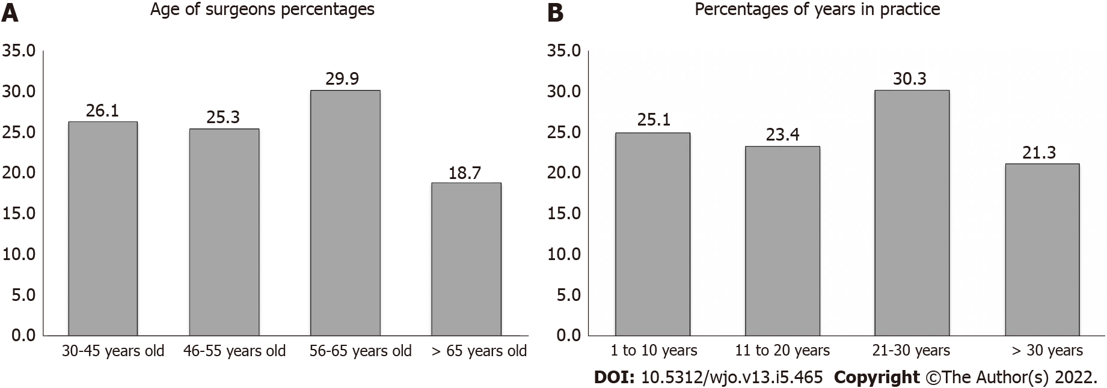
Figure 1 Age distribution, distribution of years in practice among survey participants. A: Age distribution; B: Distribution of years in practice.
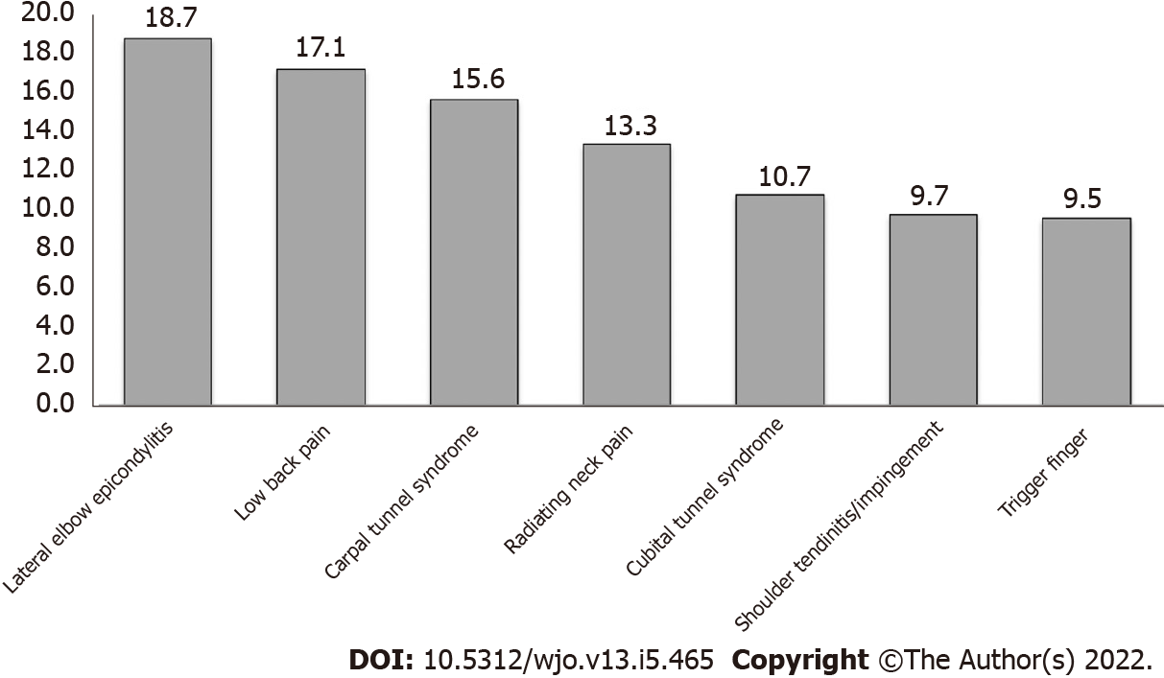
Figure 2 Musculoskeletal disorders and complaints among survey participants.
Table 1 Percentage of surveyed hand surgeons with disorders and their requirement of time off work according to sex, age, hand dominance, type of practice, number of institutes, years in practice and annual caseload, n (%)
 | Number of respondents | Number of respondents with injuries | Number of Injured requiring time off work
Age (yr)
≤ 45 | 151 | 91 (60.3) | 10 (6.6)
46-55 | 146 | 90 (61.6) | 20 (13.7)
56-65 | 173 | 102 (59) | 42 (24.3)
> 65 | 108 | 66 (61.1) | 30 (27.8)
Sex
Male | 490 | 292 (59.6) | 87 (17.8)
Female | 88 | 57 (64.8) | 15 (17)
Hand dominance
Right | 518 | 316 (61) | 92 (17.8)
Left | 60 | 33 (55) | 10 (16.7)
Type of practice
Academic | 171 | 111 (64.9) | 33 (19.3)
Community | 186 | 114 (61.3) | 38 (20.4)
Private | 182 | 99 (54,4) | 27 (14.8)
Other | 39 | 25 (64.1) | 4 (10.3)
Number of institutes
1 | 544 | 329 (60.5) | 98 (18.1)
> 1 | 34 | 20 (58.8) | 4 (11.8)
Years in practice
≤ 10 | 145 | 86 (59.3) | 9 (6.2)
11-20 | 135 | 85 (63) | 20 (14.8)
21-30 | 175 | 103 (58.9) | 38 (21.7)
> 30 | 123 | 75 (61) | 35 (28.5)
Annual caseload
≤ 250 | 110 | 55 (50) | 19 (17.3)
251-500 | 273 | 179 (65.6) | 52 (19)
501-750 | 117 | 65 (55.6) | 19 (16.2)
> 750 | 78 | 50 (64.1) | 12 (15.4)

Table 2 Percentage of surveyed hand surgeons with diagnosed disorders per region and number of respondents requiring treatment, requiring surgical treatment and requiring time-off work due to their musculoskeletal disorders
Region | Percentage of respondents with injuries | Percentage of injured respondents requiring treatment | Percentage of treated respondents requiring surgical treatment | Percentage of treated respondents requiring time-off work
Neck | 30.4 | 13.9 | 3.6 | 4.0
Shoulder | 23.1 | 15.0 | 4.9 | 4.0
Elbow | 26.0 | 13.3 | 2.1 | 1.5
Forearm, wrist and hand | 52.0 | 27.3 | 10.0 | 6.6
Hip and thigh | 6.5 | 3.8 | 1.4 | 1.2
Knee and lower leg | 12.3 | 8.1 | 5.2 | 3.4
Foot and ankle | 9.5 | 6.7 | 1.2 | 1.2
Lower back | 34.5 | 19.4 | 4.2 | 5.7

Published by Baishideng Publishing Group Inc
7041 Koll Center Parkway, Suite 160, Pleasanton, CA 94566, USA
Telephone: +1-925-3991568
E-mail: bpgoffice@wjgnet.com
Help Desk: https://www.f6publishing.com/helpdesk
https://www.wjgnet.com

© 2022 Baishideng Publishing Group Inc. All rights reserved.

