Name of journal: World Journal of Gastroenterology
ESPS Manuscript NO: 14090
Columns: ORIGINAL ARTICLE

Prospective Study
Is endoscopic large balloon dilatation without endoscopic sphincterotomy effective?

Omuta S et al. Is EPLBD without EST effective?

Shigefumi Omuta, Iruru Maetani, Michihiro Saito, Hiroaki Shigoka, Katsushige Gon, Junya Tokuhisa, Mieko Naruki

Shigefumi Omuta, Iruru Maetani, Michihiro Saito, Hiroaki Shigoka, Katsushige Gon, Junya Tokuhisa, Mieko Naruki. Division of Gastroenterology and Hepatology, Department of Internal Medicine, Toho University Ohashi Medical Center, Tokyo 153-8515, Japan

Author contributions: Omuta S analyzed and performed on the interrelation of the data, drafting the article, data collection, conception and design; Maetani I did conception and design, critical revision of the article, data collection; Saito M contributed to treatment of patients, data collection and data amount; Shigoka H collected the data; Gon K, Tokuhisa J and Naruki M contributed to the treatment of patients and data collection; all authors approved the final version of the paper.

Open-Access: This article is an open-access article which was selected by an in-house editor and fully peer-reviewed by external reviewers. It is distributed in accordance with the Creative Commons Attribution Non Commercial (CC BY-NC 4.0) license, which permits others to distribute, remix, adapt, build upon this work non-commercially, and license their derivative works on different terms, provided the original work is properly cited and the use is non-commercial. See: http://creativecommons.org/licenses/by-nc/4.0/

Correspondence to: Iruru Maetani, MD, PhD, Division of Gastroenterology and Hepatology, Department of Internal Medicine, Toho University Ohashi Medical Center, 2-17-6, Ohashi Meguro-ku, Tokyo 153-8515, Japan. mtnir50637@med.toho-u.ac.jp
Telephone: +81-3-34681251
Fax: +81-3-54650210
Received: September 17, 2014
Peer-review started: September 18, 2014
First decision: October 29, 2014
Revised: January 5, 2014
Accepted: February 5, 2015

Article in press:
Published online:

Abstract
AIM: To evaluate endoscopic papillary large balloon dilatation (EPLBD) without endoscopic sphincterotomy, we conducted the prospective study.

METHODS: From July 2011 to August 2013, we prospectively performed EPLBD on 41 patients with naïve papillae. Regarding sphincteroplasty of EPLBD, endoscopic sphincterotomy (EST) was not performed, balloon diameter selection was based on distal common bile duct diameter, inflation of balloon to the desired pressure was performed and then, it was done until desired pressure was achieved. When the balloon waist did not be disappeared, if desired pressure was satisfied, we judged the dilatation as complete. We used a retrieval balloon catheter or mechanical lithotripter (ML) to remove stones and assessed rates of complete stone removal, number of sessions, use of ML, and adverse events. Furthermore we compared the presence or absence of waist disappearance with clinical characteristics and endoscopic outcome.

RESULTS: The mean diameter of the distal/maximum common bile duct was 13.5 ± 2.4 mm/16.4 ± 3.1 mm. The mean maximum transvers-diameter of stones was 13.4 ± 3.4 mm, and the mean number of stones was 3.0 ± 2.4. Complete stone removal was achieved in 97.5% (40/41) of cases, and ML was used in 12.2% (5/41) of cases. The mean number of sessions required was 1.2 ± 0.62. Pancreatitis developed in two patients and perforation in one. The rate of waist disappearance was 73.1% (30/41). No significant differences were noted in procedure time, rate of complete stone removal (100% vs 100%), number of sessions (1.3 vs 1.5, P = 0.22), application of ML (13% vs 9%, P = 0.71), or occurrence of pancreatitis (3.3% vs 9.1%, P = 0.45) between cases with and without waist disappearance.

CONCLUSION: Prior EST to sphincteroplasty may be unnecessary in EPLBD, further investigations are needed to verify the relationship between the presence or absence of waist disappearance.

Key words: Endoscopic papillary large balloon dilatation; Difficult bile duct stone; Endoscopic sphincterotomy; Distal common bile duct; Perforation

© The Author(s) 2015. Published by Baishideng Publishing Group Inc. All rights reserved.

Core tip: Optimal approaches to sphincteroplasty of endoscopic papillary large balloon dilatation (EPLBD) remain controversial. We evaluated sphincteroplasty in EPLBD. We prospectively performed EPLBD on 41 patients with naïve papillae. Regarding sphincteroplasty of EPLBD, endoscopic sphincterotomy (EST) was not performed. We assessed rates of complete stone removal, number of sessions, use of mechanical lithotripter (ML), and adverse events. Complete stone removal was achieved in 97.5% (40/41) of cases, and ML was used in 12.2% (5/41) of cases. The mean number of sessions required was 1.2 ± 0.62. Pancreatitis developed in two patients and perforation in one. Prior EST to sphincteroplasty may be unnecessary in EPLBD.

Omuta S, Maetani I, Saito M, Shigoka H, Gon K, Tokuhisa J, Naruki M. Is endoscopic large balloon dilatation without endoscopic sphincterotomy effective? World J Gastroenterol 2015; In press

INTRODUCTION
Endoscopic sphincterotomy (EST) and endoscopic papillary balloon dilatation (EPBD) are well-established therapies for treating bile duct stones^{[1-6]}. However, removal of duct stones that are multiple, large in size, barrel-shaped, or tapering; or retrieving any size or shape of stone through a tortuous distal common bile duct, remains difficult^{[7]}. Ersoz et al^{[8]} first reported on the utility of endoscopic papillary large balloon dilation (EPLBD) in removing large bile duct stones, with a number of subsequent studies further reporting on the efficacy and safety of the procedure^{[8-26]}. However, opinions differ on whether or not to use an EST incision and the degree of such an incision (small, moderate or large). Meanwhile balloon selection and dilation technique have been widely discussed^{[8-11,13-18,22 26]}. For example, Jeong et al^{[16]} reported that EPLBD using a large size balloon (15-18 mm) without EST was both efficacy and safty. However, given that few other studies have been conducted verifying the utility of this particular technique^{[16,23,25,26]}, we sought to corroborate the results. Regarding sphincteroplasty of EPLBD, EST was not performed, furthermore we improved dilatation technique to become minimal as possible.
Here, to evaluate the efficacy of our proposed procedure, we conducted this study.

MATERIALS AND METHODS
Patients
Study participants were 41 consecutive patients who underwent EPLBD at Toho University Ohashi Medical Center From July 2011 to September 2013. Inclusion criteria were as follows: successful selective biliary cannulation, distal common bile duct ≥ 11 mm in diameter or large bile duct stones (≥ 10 mm in diameter), multiple stones (n > 2), post-gastric reconstruction (BillrothⅠor II or Roux-en-Y).
Exclusion criteria were as follows: coagulopathy (international normalized ratio ≥ 1.5, marked thrombocytopenia (platelets < 50000/mL), need for precutting in order to achieve selective biliary cannulation, acute cholangitis or pancreatitis, previous EST, distal common bile duct > 21 mm in diameter, benign or malignant biliary stricture, or failure to informed consent to the procedure.
All anticoagulant and antiplatelet drugs were discontinued prior to the procedure with temporary heparin substitution as necessary. All patients were sedated via intravenous administration of midazolam (5-10 mg). Scopolamine butyl bromide (20 mg) or glucagon (1 mg) was injected intravenously to inhibit gastrointestinal peristalsis, and each patient received nafamostatmesilate (20 mg/d) for one day prior to endoscopic retrograde cholangiopancreatography (ERCP). Blood samples collected 2 h after ERCP were used to determine complete blood counts and serum amylase levels, and those collected 18-24 h after measured hepatobiliary enzymes and C-reactive protein. We did not place a pancreatic duct stent to prevent pancreatitis.
The protocol adhered to the Helsinki Declaration and was approved in advance by the Institutional Ethical Review Board. The trial was registered with the University Hospital Medical Information Network Clinical Trials Registry (UMIN0000011533). All participants gave written, informed consent beforehand.

Endoscopic procedure
EPLBD was performed with endoscopes (JF-260V™; Olympus, Tokyo, Japan, or ED-530XT8™; Fujinon, Tokyo, Japan), and balloons 5.5 cm in length and 10-12, 12-15, 15-18, or 18-20 mm in diameter (CRE esophageal/pyloric balloon™; Boston Scientific, Natick, MA, USA) were used for dilatation. The pressure was 10-11-12 mm: 3-5-8 atm, 12-13.5-15 mm: 3-4.5-8 atm, 15-16.5-18 mm: 3-4.5-7 atm, 18-19-20 mm: 3-4.5-6 atm, respectively. All ERCPs were performed by an endoscopist with career experience of over 500 ERCPs (Maetani I, Shigoka H, or Omuta S). After accessing the major papilla, the bile duct was cannulated by wire-guided cannulation technique with a catheter (Tandem XL™, Boston Scientific, Natick MA, USA). A cholangiogram was obtained and measured the diameter of the distal common bile duct and stones, correcting for magnification with the external diameter of the distal end of the duodenoscope (JF 260V: 11.3 mm/ED-530XT8: 11.5mm) as a reference.
Balloon diameter selection was determined based on previously described distal common bile duct diameter. And for example, for 15-mm, we selected a 15-18 mm balloon to obtain more large opening of orifice. After removal of the catheter, the balloon was passed over the guidewire and positioned across the major papilla. An assisting endoscopist gradually performed dilatation under endoscopic and fluoroscopic guidance using diluted contrast to inflate the balloon.
Inflation of balloon to the desired pressure was performed, it was done until desired pressure was achieved. And, when the balloon waist did not be disappeared, if desired pressure was satisfied, we judged the dilatation as complete.
When possible, stones were removed using a retrieval balloon (Fusion Quattro™, Cook Medical, Tokyo Japan). When stone removal was not possible with a retrieval balloon, a mechanical lithotripter (ML) (Trapezoid™; Boston Scientific) was used to crush and capture the stones. Within a few days of initial EPLBD, a follow-up cholangiogram was obtained to assess presence of residual stones. If residual stones were detected, a second ERCP session was performed to remove them without an additional sphincteroplasty. Each ERCP session was finished within 60 min.

Evaluation
The primary study endpoint was the rate of complete stone removal. Secondary endpoints were number of ERCP sessions needed, rate of application of ML, and adverse events such as post-ERCP pancreatitis (PEP), bleeding, cholangitis, or perforation within 72 h after EPLBD.
For subgroup analysis, we compared the presence or absence of waist disappearance with clinical characteristics and endoscopic outcome. Complete stone removal was defined as the absence of any filling defect during a final cholangiogram performed endoscopically or through a nasobiliary drainage catheter. PEP was defined as continued abdominal pain ≥ 24 h after ERCP, with a serum amylase level more than three times the upper limit of normal^{[27]}. Bleeding was defined as either or both hematemesis or a melena or hemoglobin drop exceeding 2 g^{[27]}. Cholangitis was defined as increased temperature (over 38 °C for > 24 h) with cholestasis^{[27]}. Perforation was defined as evidence of air or luminal contents outside the gastrointestinal tract^{[27]}. Each adverse event was graded based on values set by the American Society for Gastrointestinal Endoscopy (ASGE)^{[27]}.

Statistical analysis
Data were presented as mean ± SD with ranges. In subgroup analyses, the ² test or Fisher’s exact test for noncontinuous variable and Student’s t-test for continuous variable comparison between two groups were used. Analyses were performed using SPSS 19.0 (SPSS Inc., Chicago IL, USA). A P value less than 0.05 was considered statistically significant.

RESULTS
Baseline characteristics and indications of the 41 consecutive patients enrolled in this study are summarized in Table 1. EPLBD procedure was successfully performed in all patients. Two post-gastric reconstruction patients had undergone a Billroth-II, and one had undergone a Roux-en-Y. A periampullary diverticulum was observed 68.3% (28/41). The mean diameter of the distal/maximum common bile duct was 13.5 ± 2.4 mm/16.4 ± 3.1 mm. The mean maximum transvers-diameter of stones was 13.4 ± 3.4 mm, and the mean number of stones was 3.0 ± 2.4. Endoscopic outcomes are summarized in Table 2. Complete stone removal was achieved in 97.5% of patients (40/41), with a successful stone removal rate during the initial EPLBD of 87.8% (36/41). Thirteen patients required a second session, and one patient required a third session. The mean number of sessions required for complete stone removal was 1.2 ± 0.62. The rate of application of ML was 12.2% (5/41), and the rate of waist disappearance was 73.1% (30/41).
Adverse events are showed in Table 3. Mild PEP occurred in two patients (4.9%), and both were managed successfully with conservative treatment. Perforation developed in one patient who had undergone post-gastric reconstruction (Billroth-II) and did not have a stricture of the distal common bile duct; the balloon waist was disappeared immediately during balloon dilatation. The patient required emergency surgery and stayed in the hospital for six months. After the patient’s condition improved, complete stone removal was achieved using only a retrieval balloon catheter without an additional sphincteroplasty.
On comparing clinical characteristics and endoscopic outcome with the presence or absence of waist disappearance (Table 4), no significant differences were noted in distal common bile duct diameter, procedure time, mean number of sessions required for complete stone removal, application of ML, or occurrence of PEP.

DISCUSSION
Ersoz et al^{[8]} first reported the use of endoscopic sphincterotomy followed by large balloon dilation as an alternative for managing difficult bile duct stones. Their reported overall complete stone removal rate was 100%, with ML application used in 7% and an overall adverse event rate of 15%, including a 3% PEP rate. EPLBD without preceding EST was described in 2009 by Jeong et al^{[16]}, who reported an overall complete stone removal rate of 97%, with a 21% rate of ML application and a 2.6% PEP rate. A summary of the English-language literatures published on EPLBD is shown in Table 5. We conducted research on PubMed/MEDLINE from 2003 to October 2014. A search strategy was used to identify reports of randomized controlled trials and retrospective study and prospective case series in EPLBD with a combination of controlled vocabulary and text words related to (1) endoscopic papillary large balloon dilatation, (2) difficult common bile duct stones, and (3) endoscopic sphincterotomy. Fifteen full papers were identified: eleven retrospective studies, three controlled trials, and a prospective case series^{[8-11,13-18,22- 26]}.
Rates of complete stone removal in the initial session and overall in the present study were 87.8% and 97.5%, respectively. The mean number of sessions required for complete stone removal was 1.2, and the rate of ML application was 12.2%. Our endoscopic outcome is compared with those performed with preceding EST (small to large) in Table 5^{[8-11,13-15,17,18,22,24]}. The rates of complete stone removal in the initial session and overall ranged from 83% to 99% and 95% to 100%, respectively, and the number of sessions required for complete stone removal and rate of ML application ranged from 1.1 to 1.3 and 0% to 27%, respectively. Our endoscopic outcomes were considered equivalent to those in other studies. In studies of balloon dilatation without preceding EST including our study, initial and overall complete stone removal rates ranged from 66% to 93% and 93% to 100%, respectively (Table 5)^{[16,23,25,26]}, and the number of sessions required for complete stone removal and the rate of ML application ranged from 1.1 to 1.4, and 2.5% to 21%, respectively. From the abovementioned outcome regarding efficacy, EPLBD without preceding EST was a satisfactory outcome.
PEP occurred in 4.9% of patients in our study. EPBD has been reported to be associated with more frequent and severe PEP than EST^{[28-30]}. PEP is believed to occur in reaction to the direct physical compression effect of the balloon on the papilla, the pancreatic duct orifice, or pancreatic parenchyma, and stone removal might induce peripapillary edema or spasm of the sphincter^{[21]}. We hypothesize that the relatively low PEP rates seen in the present study may be because the balloon dilatation was minimized, thereby reducing severity of trauma to the papilla. In addition, we used a 15-18 mm balloon rather than a 12-15 mm one when the distal common bile duct was 15 mm, thereby reducing inflation time. Using a larger balloon provided adequate dilatation of the papilla, facilitating stone removal at the orifice. Sugiyama et al^{[31]} reported that age < 60 years and bile duct diameter < 9 mm were independent risk factors for PEP, although we noted no such correspondence in the present study. Attasaranya et al^{[14]} reported low rates of PEP due to the pancreatic duct orifice being separated from the biliary orifice after EST and noted that balloon dilatation forces are directed away from the pancreatic duct. However, their evidence was insufficient to certify the rationale.^{[16]} While PEP occurrence has been found to range from 0% to 7% in cases with preceding EST^{[8-11,13-15,17,18,22,24]}, rates ranged from 0.8% to 5.0% in cases without preceding EST^{[16,23,25,26]}, including the present study (Table 5). We therefore suggest that the efficacy of EST could not be judged based on the rate of occurrence of PEP.
Bleeding occurred less frequently with EPBD than EST (EPBD 0% vs EST 2.0%, P = 0.001)^{[7]}. While rate of bleeding occurrence has been found to range from 0% to 5% in procedures performed after EST^{[8-11,13-15,17,18,22,24]}, rates ranged from 0% to 2% in procedures performed without EST^{[16,23,25,26]}, including the present study. From these findings, we inquire the propriety of EST in EPLBD.
Perforation is considered the most serious adverse events of EPLBD. Park et al^{[32]} reported that stricture of the distal common bile duct was an independent factor predictive of perforation and that, if strong resistance was encountered during balloon inflation, additional pressure should not be applied. EPLBD has been reported to be safe in Billroth II patients^{[25,33]}. Perforation is understood to be caused by looping of the scope, not by the tip of the endoscope itself^{[34]}. When surgery was performed in one patient in the present study, very small stone was found in the retroperitoneal of the dorsal side of the ampulla. This case with Billroth II had no stricture and no resistance on balloon dilatation and the arrival to ampulla of Vater did not have any trouble. Regarding endoscopic procedure, balloon pressure was 3 atm, balloon size was 15-18mm, dilatation time was 125 s (from starting inflation to finishing deflation). When we reviewed this case, because endoscopic procedure did not have the bad matter, therefore we considered that very small stone was pressed into the duct wall during balloon dilatation with surgical finding, resulting in perforation, it is important matter that we should confirm not only a configuration of distal bile duct but also very small stone before EPLBD.
We collected the blood examination, magnetic resonance cholaongiopancreatography and/or abdominal ultrasound to recognize common bile duct stone in every three months. During the median follow-up period of 487 d, no cases of recurrence were noted in our study. One patient died of aspiration pneumonia 156 d after complete stone removal.
We encountered cases where was not disappeared a balloon waist at the dilatation. Lee et al^{[12]} reported a series of endoscopic lithotomy with 100% complete stone removal in spite of a waist disappearance rate of 69%. In the present study, we noted no significant differences in complete stone removal, number of sessions, rate of application of ML, or rate of PEP between cases with and without waist disappearance. Given the relatively small number of cases involved in the present study, further studies in a larger number of patients will be needed to validate these findings.
Lee et al^{[12]} described it was caused scar change of incised orifice, however, this speculation has not been verified.
Several limitations to the present study warrant mention. Our sample size was small and a single center, with no control cases. Endoscopic outcomes were analyzed retrospectively with respect to waist disappearance. Regarding the degree of the waist disappearance, we did not establish a definition and it showed disappearance rate more than 80% in all most cases. In particular, further investigations are needed to verify the relationship between the presence or absence of waist disappearance and outcome. Based on these findings, prior EST to sphincteroplasty may be unnecessary in EPLBD. Further a randomized controlled study is needed to evaluate any differences between prior EST and prior non-EST.

COMMENTS
Background
Ersoz et al first reported on the utility of endoscopic papillary large balloon dilation (EPLBD) in removing large bile duct stones, with a number of subsequent studies further reporting on the efficacy and safety of the procedure. However, opinions differ on whether or not to use an endoscopic sphincterotomy (EST) incision and the degree of such an incision (small, moderate or large).

Research frontiers
Jeong et al reported that EPLBD using a large size balloon (15-18 mm) without EST was both efficacy and safty. However, given that few other studies have been conducted verifying the utility of this particular technique.

Innovations and breakthroughs
Balloon diameter selection was determined based on previously described distal common bile duct diameter. And for example, for 15-mm, a 15-18 mm balloon was selected to obtain more large opening of orifice and inflation of balloon to the desired pressure was performed, it was done until desired pressure was achieved. And, when the balloon waist did not be disappeared, if desired pressure was satisfied, the dilatation was judged as complete. The presence or absence of waist disappearance with clinical characteristics and endoscopic outcome were compared.

Applications
Complete stone removal was achieved in 97.5% of patients (40/41), the mean number of sessions required for complete stone removal was 1.2 ± 0.62. The rate of application of mechanical lithotripter (ML) was 12.2% (5/41), and the rate of waist disappearance was 73.1% (30/41). Mild post- endoscopic retrograde cholangiopancreatography pancreatitis occurred in two patients (4.9%). No significant differences were noted in procedure time, rate of complete stone removal, number of sessions, application of ML, or occurrence of pancreatitis between cases with and without waist disappearance.

Terminology
Prior EST to sphincteroplasty may be unnecessary in EPLBD. Further a randomized controlled study is needed to evaluate any differences between prior EST and prior non-EST. Further investigations are needed to verify the relationship between the presence or absence of waist disappearance and outcome.

Peer-review
In this paper, the authors investigated the efficacy and safety of EPLBD without EST. The topic of this study is interesting.

REFERENCES
1 Sand J, Airo I, Hiltunen KM, Mattila J, Nordback I. Changes in biliary bacteria after endoscopic cholangiography and sphincterotomy. Am Surg 1992; 58: 324-328 [PMID: 1622015]
2 Kurumado K, Nagai T, Kondo Y, Abe H. Long-term observations on morphological changes of choledochal epithelium after choledochoenterostomy in rats. Dig Dis Sci 1994; 39: 809-820 [PMID: 8149847 DOI: 10.1007/BF02087428]
3 Freeman ML, Nelson DB, Sherman S, Haber GB, Herman ME, Dorsher PJ, Moore JP, Fennerty MB, Ryan ME, Shaw MJ, Lande JD, Pheley AM. Complications of endoscopic biliary sphincterotomy. N Engl J Med 1996; 335: 909-918 [PMID: 8782497 DOI: 10.1056/NEJM199609263351301]
4 May GR, Cotton PB, Edmunds SE, Chong W. Removal of stones from the bile duct at ERCP without sphincterotomy. Gastrointest Endosc 1993; 39: 749-754 [PMID: 8293895 DOI: 10.1016/S0016-5107(93)70258-8]
5 Mac Mathuna P, White P, Clarke E, Lennon J, Crowe J. Endoscopic sphincteroplasty: a novel and safe alternative to papillotomy in the management of bile duct stones. Gut 1994; 35: 127-129 [PMID: 8307433 DOI: 10.1136/gut.35.1.127]
6 Mathuna PM, White P, Clarke E, Merriman R, Lennon JR, Crowe J. Endoscopic balloon sphincteroplasty (papillary dilation) for bile duct stones: efficacy, safety, and follow-up in 100 patients. Gastrointest Endosc 1995; 42: 468-474 [PMID: 8566640 DOI: 10.1016/S0016-5107(95)70052-8]
7 Baron TH, Harewood GC. Endoscopic balloon dilation of the biliary sphincter compared to endoscopic biliary sphincterotomy for removal of common bile duct stones during ERCP: a metaanalysis of randomized, controlled trials. Am J Gastroenterol 2004; 99: 1455-1460 [PMID: 15307859 DOI: 10.1111/j.1572-0241.2004.30151.x]
8 Ersoz G, Tekesin O, Ozutemiz AO, Gunsar F. Biliary sphincterotomy plus dilation with a large balloon for bile duct stones that are difficult to extract. Gastrointest Endosc 2003; 57: 156-159 [PMID: 12556775 DOI: 10.1067/mge.2003.52]
9 Maydeo A, Bhandari S. Balloon sphincteroplasty for removing difficult bile duct stones. Endoscopy 2007; 39: 958-961 [PMID: 17701853 DOI: 10.1055/s-2007-966784]
10 Heo JH, Kang DH, Jung HJ, Kwon DS, An JK, Kim BS, Suh KD, Lee SY, Lee JH, Kim GH, Kim TO, Heo J, Song GA, Cho M. Endoscopic sphincterotomy plus large-balloon dilation versus endoscopic sphincterotomy for removal of bile-duct stones. Gastrointest Endosc 2007; 66: 720-76; quiz 768, 771 [PMID: 17905013 DOI: 10.1016/j.gie.2007.02.033]
11 Minami A, Hirose S, Nomoto T, Hayakawa S. Small sphincterotomy combined with papillary dilation with large balloon permits retrieval of large stones without mechanical lithotripsy. World J Gastroenterol 2007; 13: 2179-2182 [PMID: 17465497 DOI: 10.3748/wjg.v13.i15.2179]
12 ) Lee DK, Lee B, Hwhang S, Baik YH, Lee SJ. Endoscopic papillary large balloon dilation after endoscopic sphincterotomy for treatment of large common bile duct stones. Dig Endosc 2007; 19: S52-S56 [PMID: DOI: 10.1111/j.1443-1661.2007.00716.x]
13 Misra SP, Dwivedi M. Large-diameter balloon dilation after endoscopic sphincterotomy for removal of difficult bile duct stones. Endoscopy 2008; 40: 209-213 [PMID: 18264886 DOI: 10.1055/s-2007-967040]
14 Attasaranya S, Cheon YK, Vittal H, Howell DA, Wakelin DE, Cunningham JT, Ajmere N, Ste Marie RW, Bhattacharya K, Gupta K, Freeman ML, Sherman S, McHenry L, Watkins JL, Fogel EL, Schmidt S, Lehman GA. Large-diameter biliary orifice balloon dilation to aid in endoscopic bile duct stone removal: a multicenter series. Gastrointest Endosc 2008; 67: 1046-1052 [PMID: 18178208 DOI: 10.1016/j.gie.2007.08.047]
15 Itoi T, Itokawa F, Sofuni A, Kurihara T, Tsuchiya T, Ishii K, Tsuji S, Ikeuchi N, Moriyasu F. Endoscopic sphincterotomy combined with large balloon dilation can reduce the procedure time and fluoroscopy time for removal of large bile duct stones. Am J Gastroenterol 2009; 104: 560-565 [PMID: 19174779 DOI: 10.1038/ajg.2008.67]
16 Jeong S, Ki SH, Lee DH, Lee JI, Lee JW, Kwon KS, Kim HG, Shin YW, Kim YS. Endoscopic large-balloon sphincteroplasty without preceding sphincterotomy for the removal of large bile duct stones: a preliminary study. Gastrointest Endosc 2009; 70: 915-922 [PMID: 19647241 DOI: 10.1016/j.gie.2007.04.042]
17 Draganov PV, Evans W, Fazel A, Forsmark CE. Large size balloon dilation of the ampulla after biliary sphincterotomy can facilitate endoscopic extraction of difficult bile duct stones. J Clin Gastroenterol 2009; 43: 782-786 [PMID: 19318979 DOI: 10.1097/MCG.0b013e31818f50a2]
18 Kim HG, Cheon YK, Cho YD, Moon JH, Park do H, Lee TH, Choi HJ, Park SH, Lee JS, Lee MS. Small sphincterotomy combined with endoscopic papillary large balloon dilation versus sphincterotomy. World J Gastroenterol 2009; 15: 4298-4304 [PMID: 19750573 DOI: 10.3748/wjg.15.4298]
19 Kurita A, Maguchi H, Takahashi K, Katanuma A, Osanai M. Large balloon dilation for the treatment of recurrent bile duct stones in patients with previous endoscopic sphincterotomy: preliminary results. Scand J Gastroenterol 2010; 45: 1242-1247 [PMID: 20521873 DOI: 10.3109/00365521.2010.495420]
20 Kim HW, Kang DH, Choi CW, Park JH, Lee JH, Kim MD, Kim ID, Yoon KT, Cho M, Jeon UB, Kim S, Kim CW, Lee JW. Limited endoscopic sphincterotomy plus large balloon dilation for choledocholithiasis with periampullary diverticula. World J Gastroenterol 2010; 16: 4335-4340 [PMID: 20818818 DOI: 10.3748/wjg.v16.i34.4335]
21 Youn YH, Lim HC, Jahng JH, Jang SI, You JH, Park JS, Lee SJ, Lee DK. The increase in balloon size to over 15 mm does not affect the development of pancreatitis after endoscopic papillary large balloon dilatation for bile duct stone removal. Dig Dis Sci 2011; 56: 1572-1577 [PMID: 20945093 DOI: 10.1007/s10620-010-1438-4]
22 Stefanidis G, Viazis N, Pleskow D, Manolakopoulos S, Theocharis L, Christodoulou C, Kotsikoros N, Giannousis J, Sgouros S, Rodias M, Katsikani A, Chuttani R. Large balloon dilation vs. mechanical lithotripsy for the management of large bile duct stones: a prospective randomized study. Am J Gastroenterol 2011; 106: 278-285 [PMID: 21045816 DOI: 10.1038/ajg.2010.421]
23 Chan HH, Lai KH, Lin CK, Tsai WL, Wang EM, Hsu PI, Chen WC, Yu HC, Wang HM, Tsay FW, Tsai CC, Chen IS, Chen YC, Liang HL, Pan HB. Endoscopic papillary large balloon dilation alone without sphincterotomy for the treatment of large common bile duct stones. BMC Gastroenterol 2011; 11: 69 [PMID: 21668994 DOI: 10.1186/1471-230X-11-69]
24 Kim TH, Oh HJ, Lee JY, Sohn YW. Can a small endoscopic sphincterotomy plus a large-balloon dilation reduce the use of mechanical lithotripsy in patients with large bile duct stones? Surg Endosc 2011; 25: 3330-3337 [PMID: 21533521 DOI: 10.1007/s00464-011-1720-3]
25 Jang HW, Lee KJ, Jung MJ, Jung JW, Park JY, Park SW, Song SY, Chung JB, Bang S. Endoscopic papillary large balloon dilatation alone is safe and effective for the treatment of difficult choledocholithiasis in cases of Billroth II gastrectomy: a single center experience. Dig Dis Sci 2013; 58: 1737-1743 [PMID: 23392745 DOI: 10.1007/s10620-013-2580-6]
26 Kogure H, Tsujino T, Isayama H, Takahara N, Uchino R, Hamada T, Miyabayashi K, Mizuno S, Mohri D, Yashima Y, Kawakubo K, Sasaki T, Yamamoto N, Nakai Y, Hirano K, Sasahira N, Tada M, Koike K. Short- and long-term outcomes of endoscopic papillary large balloon dilation with or without sphincterotomy for removal of large bile duct stones. Scand J Gastroenterol 2014; 49: 121-128 [PMID: 24164293 DOI: 10.3109/00365521.2013.848470]
27 Cotton PB, Eisen GM, Aabakken L, Baron TH, Hutter MM, Jacobson BC, Mergener K, Nemcek A, Petersen BT, Petrini JL, Pike IM, Rabeneck L, Romagnuolo J, Vargo JJ. A lexicon for endoscopic adverse events: report of an ASGE workshop. Gastrointest Endosc 2010; 71: 446-454 [PMID: 20189503 DOI: 10.1016/j.gie.2009.10.027]
28 Bergman JJ, Rauws EA, Fockens P, van Berkel AM, Bossuyt PM, Tijssen JG, Tytgat GN, Huibregtse K. Randomised trial of endoscopic balloon dilation versus endoscopic sphincterotomy for removal of bileduct stones. Lancet 1997; 349: 1124-1129 [PMID: 9113010 DOI: 10.1016/S0140-6736(96)11026-6]
29 Vlavianos P, Chopra K, Mandalia S, Anderson M, Thompson J, Westaby D. Endoscopic balloon dilatation versus endoscopic sphincterotomy for the removal of bile duct stones: a prospective randomised trial. Gut 2003; 52: 1165-1169 [PMID: 12865276 DOI: 10.1136/gut.52.8.1165]
30 Disario JA, Freeman ML, Bjorkman DJ, Macmathuna P, Petersen BT, Jaffe PE, Morales TG, Hixson LJ, Sherman S, Lehman GA, Jamal MM, Al-Kawas FH, Khandelwal M, Moore JP, Derfus GA, Jamidar PA, Ramirez FC, Ryan ME, Woods KL, Carr-Locke DL, Alder SC. Endoscopic balloon dilation compared with sphincterotomy for extraction of bile duct stones. Gastroenterology 2004; 127: 1291-1299 [PMID: 15520997 DOI: 10.1053/j.gastro.2004.07.017]
31 Sugiyama M, Izumisato Y, Abe N, Masaki T, Mori T, Atomi Y. Predictive factors for acute pancreatitis and hyperamylasemia after endoscopic papillary balloon dilation. Gastrointest Endosc 2003; 57: 531-535 [PMID: 12665764 DOI: 10.1067/S0016-5107(03)00009-9]
32 Park SJ, Kim JH, Hwang JC, Kim HG, Lee DH, Jeong S, Cha SW, Cho YD, Kim HJ, Kim JH, Moon JH, Park SH, Itoi T, Isayama H, Kogure H, Lee SJ, Jung KT, Lee HS, Baron TH, Lee DK. Factors predictive of adverse events following endoscopic papillary large balloon dilation: results from a multicenter series. Dig Dis Sci 2013; 58: 1100-1109 [PMID: 23225136 DOI: 10.1007/s10620-012-2494-8]
33 Choi CW, Choi JS, Kang DH, Kim BG, Kim HW, Park SB, Yoon KT, Cho M. Endoscopic papillary large balloon dilation in Billroth II gastrectomy patients with bile duct stones. J Gastroenterol Hepatol 2012; 27: 256-260 [PMID: 21793902 DOI: 10.1111/j.1440-1746.2011.06863.x]
34 Ciçek B, Parlak E, Di ibeyaz S, Koksal AS, Sahin B. Endoscopic retrograde cholangiopancreatography in patients with Billroth II gastroenterostomy. J Gastroenterol Hepatol 2007; 22: 1210-1213 [PMID: 17688662 DOI: 10.1111/j.1440-1746.2006.04765.x]
P-Reviewer: Tsuyuguchi T, Sun LM, NakaharaK S-Editor: Yu J L-Editor: E-Editor:

A

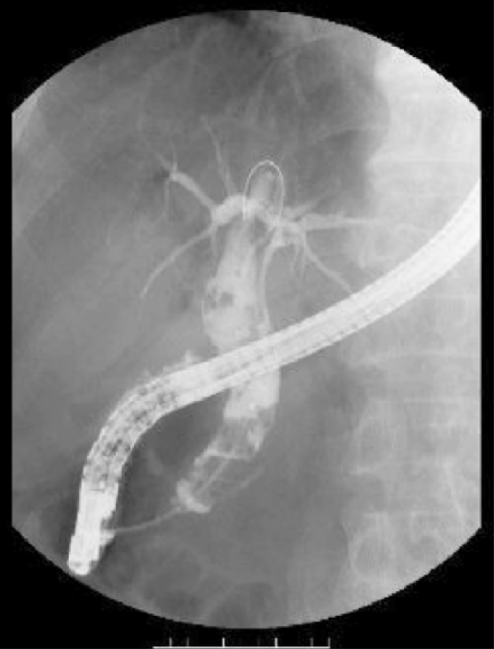

B

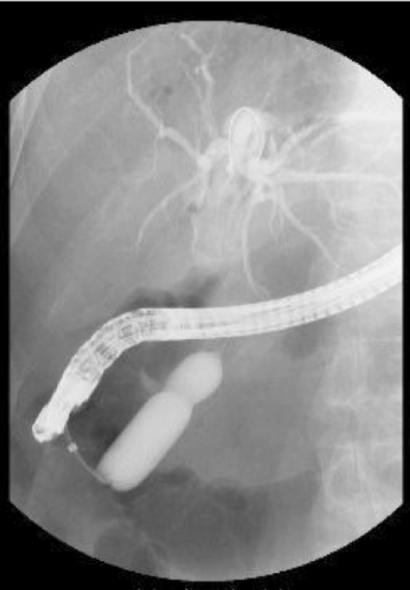
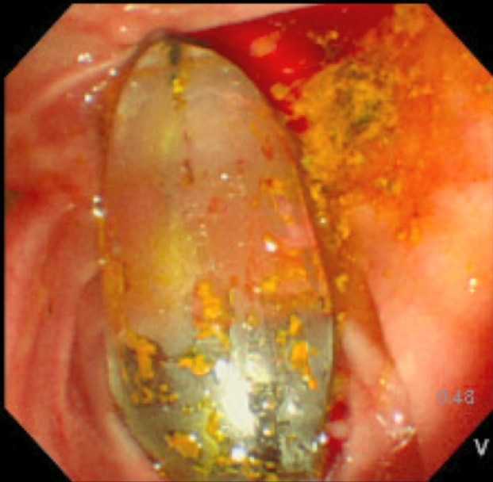
C
D
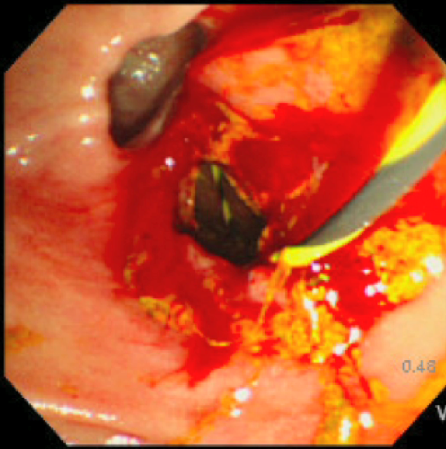
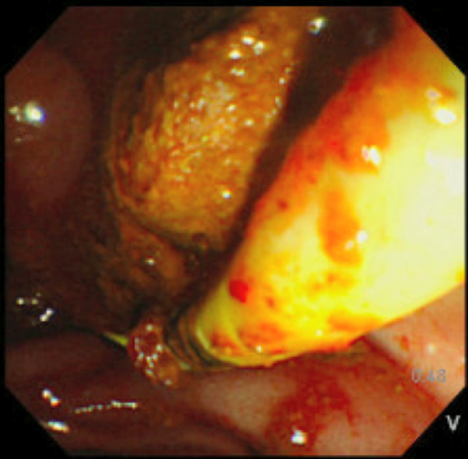
E
Figure 1 Fluoroscopic and endoscopic view showing. A: Multiple large bile duct stones and marked dilation of the common bile duct; B: Endoscopic papillary dilatation with a large (15-18 mm) balloon. Endoscopic sphincterotomy was not performed prior to balloon sphincteroplasty. This case features incomplete disappearance of the waist; C: An inflated balloon; D: A large biliary orifice was obtained; E: Large stones extraction using a retrieval balloon.

Table 1 Baseline characteristics of patients (n = 41) n (%)
Age (yr) | 77.7 ± 10.8
Gender ratio (M:F) | 19:22
Periampullary diverticulum | 28 (68.3)
Previous gastric surgery | 3 (7.3)
Billroth II/ Roux-en-Y reconstruction, n | 2/1
Previous cholecystectomy | 12 (29.2)
Gallbladder stone | 18 (43.9)
Anticoagulant or antiplatelet therapy | 19 (46.3)
Diabetes mellitus | 3 (7.3)
CBD diameter (distal/maximum) (mm) | 13.5 ± 2.4/16.4 ± 3.1
CBD stone diameter (maximum transverse) (mm) | 13.4 ± 3.4
Number of stones | 3.0 ± 2.4
CBD: Common bile duct.

Table 2 Outcome of endoscopic papillary large balloon dilation (n = 41) n (%)
Balloon size
10–12 mm/12–15 mm/15–18 mm/18–20 mm | 10/20/8/3
Distal CBD (balloon diameter)/CBD stone ratio | 1.03 ± 0.15
Maximum CBD/CBD stone ratio | 1.25 ± 0.19
Waist disappearance | 30/41 (73.1)
Procedure time (min) | 44.5 ± 21.2
Complete stone removal | 40/41 (97.5)
Sessions required for complete stone removal | 1.2 ± 0.62
Application of ML | 5/41 (12.2)
Amylase after EPLBD (IU/L) | 427 ± 695
CBD: Common bile duct; ML: Mechanical lithotripsy.

Table 3 Early adverse events of endoscopic papillary large balloon dilation (n = 41) n (%)
Early (< 72 h)
Asymptomatic hyperamylasemia | 2/41 (4.9)
Acute pancreatitis | 2/41 (4.9)
Mild/Moderate/Severe | 2/0/0
Bleeding | 0/41 (0)
Acute cholangitis | 0/41 (0)
Perforation | 1/41 (2.4)

Table 4 Waist disappearance vs waist non disappearance
Variables | Waist disappearance  (n = 30) | Waist non disappearance  (n = 11) | P value
Age (yr) | 77.7 ± 10.8 | 77.5 ± 11.4 | NS
Gender (M:F) | 15:15 | 4:7 | NS
Periampullary diverticulum | 70% (21/30) | 63.6% (7/11) | NS
Distal CBD diameter (mm) | 13.0 ± 2.1 | 14.8 ± 2.9 | NS
Distal CBD diameter/stone ratio | 1.05 ± 0.13 | 1.00 ± 0.21 | NS
Number of stones | 2.8 ± 2.2 | 3.6 ± 2.7 | NS
Procedure time (min) | 43 ± 20 | 49 ± 24 | NS
Sessions required for complete stone clearance | 1.3 ± 0.55 | 1.5 ± 0.68 | NS
Application of ML | 13.3% (4/30) | 9.1% (1/11) | NS
Acute pancreatitis | 3.3% (1/30) | 9.1% (1/11) | NS
NS: Not significant; CBD: Common bile duct; ML: Mechanical lithotripsy.

Table 5 Summary of published series of endoscopic papillary large-balloon dilatation for removal of common bile duct stones n (%)

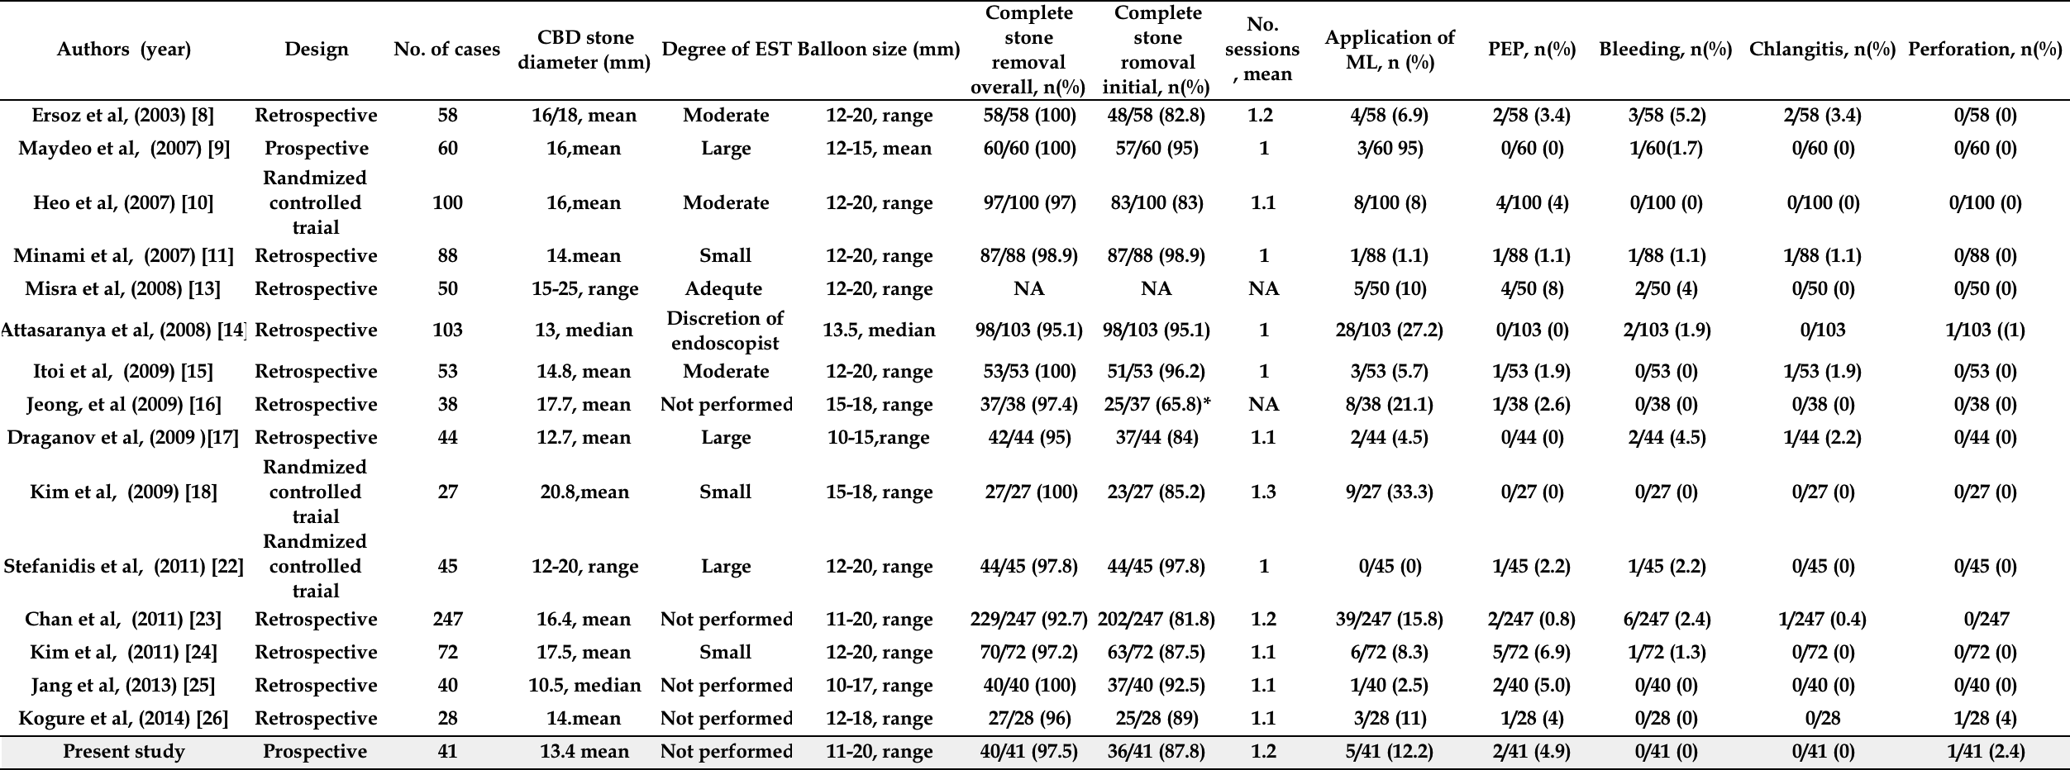
Results was described as large balloon biliary sphinteropalsty alone. NA: Not availiable; CBD: Common bile duct; ML: Mechanical lithotripsy; PEP: Post-retrograde cholangiopancreatography pancreatitis.

