Name of Journal: World Journal of Clinical Cases
Manuscript NO: 70728
Manuscript Type: CASE REPORT

Imaging presentation of biliary adenofibroma: A case report

Li SP et al. Magnetic resonance imaging characteristics of BF

Shao-Peng Li, Peng Wang, Ke-Xue Deng

Shao-Peng Li, Peng Wang, Ke-Xue Deng, Department of Radiology, The First Affiliated Hospital of University of Science and Technology of China (Southern District of Anhui Provincial Hospital), Hefei 230022, Anhui Province, China

Author contributions: All authors conceived the manuscript, supervised the findings of this work; discussed the results; and contributed to the final manuscript; Li SP processed the data; drafted the manuscript; and designed the figures; Wang P contributed to analysis and manuscript preparation and supervise the work; Deng KX was directly responsible for performing the operation, revising the paper; and supervising the work.

Corresponding author: Ke-Xue Deng, MD, Chief Doctor, Department of Radiology, The First Affiliated Hospital of University of Science and Technology of China (Southern District of Anhui Provincial Hospital), No. 1 Tian e hu Road, Shushan District, Hefei 230022, Anhui Province, China. dengkexue-anhui@163.com

Received: August 15, 2021
Revised: November 23, 2021
Accepted: December 22, 2021
Published online:

Abstract
BACKGROUND
Biliary adenofibroma (BF) is a rare benign epithelial tumor with the possibility of malignant transformation. Its main pathological feature is a well-defined cystic or honeycomb mass. BF has no specific clinical manifestations or laboratory and imaging findings; thus, it is easily misdiagnosed before surgery. This report describes a case in which biliary cystadenoma was misdiagnosed preoperatively and BF was diagnosed postoperatively. The imaging features, particularly the magnetic resonance imaging (MRI) features, were analyzed and summarized.

CASE SUMMARY
A 68-year-old Chinese man was admitted to our hospital with a 2-mo history of abdominal discomfort. Following admission to our hospital, laboratory examinations showed normal tumor marker concentrations and liver function. Hepatocellular carcinoma was considered after contrast-enhanced ultrasound examination. MRI suggested the possibility of cystadenoma of the bile duct. However, postoperative pathological examination confirmed the diagnosis of BF. No local recurrence was found 1 mo after surgery.

CONCLUSION
Our objective is to highlight the imaging diagnostic value of BF, especially on an MRI enhanced scan with gadolinium ethoxybenzyl diethylenetriamine pentaacetic acid.

Key Words: Biliary adenofibroma; Magnetic resonance imaging; Gadolinium ethoxybenzyl diethylenetriamine pentaacetic acid; Misdiagnosis; Case report

Li SP, Wang P, Deng KX. Imaging presentation of biliary adenofibroma: A case report. World J Clin Cases 2021; In press

Core Tip: The imaging presentation of biliary adenofibroma is complex and diverse, and the clinical history and laboratory examination were not specific. In this case, magnetic resonance imaging characteristics of biliary adenofibroma, especially enhanced scan with Gd-EOB-DTPA and an intravoxel incoherent motion diffusion-weighted imaging sequence were valuable.

INTRODUCTION
In 1993, Tsui et al^{[1]} were the first to describe biliary adenofibroma (BF), which is a benign, complex, tubulocystic liver tumor with a bland spindle-cell stromal component. BF is a rare disease that is usually misdiagnosed due to its nonspecific clinical symptoms and laboratory examination findings. Imaging [including ultrasound, computed tomography (CT), and magnetic resonance imaging (MRI)] usually reveal a multicystic tumor or complex mass with both solid and cystic components; these findings are very similar to cystadenoma or cystadenocarcinoma^{[2]}, intrahepatic cholangiocarcinoma^{[3]}, liver metastasis^{[4]}, and other lesions. However, the MRI findings have certain characteristics. We herein describe a case in which we analyzed the contrast-enhanced ultrasound and MRI findings of a patient with BF who was misdiagnosed with hepatocellular carcinoma by contrast-enhanced ultrasound and with hepatic cystadenoma by MRI before surgical resection of the lesion. We also summarize the imaging findings of BF in previous literature.

CASE PRESENTATION
Chief complaints
A 68-year-old man reported abdominal discomfort without obvious inducement for 2 mo.

History of present illness
The patient had no other symptoms.

History of past illness
His past medical history indicated hypertension and mild cerebral infarction for more than ten years. After regular drug treatment, these conditions were well controlled.

Personal and family history
He had no personal or family history of other diseases.

Physical examination
On physical examination, there was no tenderness or rebound pain in the abdomen, and percussion pain in the liver area was negative. His blood pressure was 121/75 mmHg, pulse rate was 67 bpm and body temperature was 36.4 ℃.

Laboratory examinations
No abnormal laboratory examinations were observed, including liver function, tumor markers, infection markers, coagulation tests and complete blood count.

Imaging examinations
A plain CT scan at a local hospital showed a space occupying lesion in the left lobe of the liver and the patient was admitted to our hospital for further treatment. Ultrasonography showed hyperechoic nodules in the left lobe of the liver. Following injection of contrast agent, early and obvious enhancement was observed (Figure 1A). Plain MRI showed hypointensity on T1-weighted imaging (T1WI) and hyperintensity on T2-weighted imaging (T2WI). In this case, iterative decomposition of water and fat with echo asymmetry and least square estimation-iron quantification (IDEAL-IQ) and intravoxel incoherent motion diffusion-weighted imaging (IVIM-DWI) sequences were performed. The water phase of the IDEAL-IQ sequence showed that the signal of the lesion was higher than that of the liver. DWI showed moderate hyperintensity and isointensity according to the apparent diffusion coefficient (ADC). The ADC and pure diffusion coefficient (D) values were 2.78 and 2.12 × 10⁻³ mm²/s, respectively, which indicated that there was no obvious limitation in the diffusion of the lesion. There was no significant change in the signal of the lesion in the in-phase and out-phase sequence. The early and late arterial phases showed obvious enhancement of solid components and separation of lesions. The degree of lesion enhancement decreased in the portal phase and delayed scan. In the hepatobiliary phase, enhancement of the bile duct structure was found in the lesion (Figure 1B-H).

FINAL DIAGNOSIS
Pathology confirmed BF (a rare biliary epithelial tumor) in this patient (Figure 2). Microscopy showed irregular hyperplasia of the bile duct with varying amounts of intervening fibrous stroma and inflammatory cell infiltration. Some bile ducts were dilated and the wall thickened, cholestasis was seen in the bile duct. The cells showed no atypia, and some of them showed apocrine secretion.

TREATMENT
The lesion was removed by laparoscopic surgery under general anesthesia.

OUTCOME AND FOLLOW-UP
The patient had no signs of recurrence at the 1-mo postoperative re-examination (Figure 3).

DISCUSSION
Currently, although BFs are classified as benign bile duct tumors and precursors by the 2019 World Health Organization tumor classification system^{[5]}, some cases of BF are characterized by malignant transformation, invasion, and even distant metastasis (Tsui et al^{[1]} first proposed in 1993, postoperative pathology showed malignant transformation in 3 cases^{[6-8]}, 3 cases of biliary adenofibroma with invasive carcinoma^{[9-11]}, 3 cases were complicated with liver tissue invasion^{[12-14]}, 2 cases were complicated with lymph node metastasis^{[15]}, local recurrence occurred in 2 cases^{[16]}). The clinical manifestations and imaging characteristics of BF are nonspecific. A definitive diagnosis is difficult to achieve by preoperative imaging. The diagnosis mainly depends on postoperative pathological examination. Pathologically, the lesions are gray or dark red irregular masses that can show cystic, honeycomb, or solid changes and have a relatively clear boundary and no capsule.
Including the present case, 25 cases of BF have been reported to date (Tsui et al^{[1]} in 1993, Parada et al^{[17]} in 1997, Haberal et al^{[12]} in 2001, Akin et al^{[18]} and Garduño-López et al^{[19]} in 2002, Gurrera et al^{[20]} in 2010, Kai et al^{[6]} and Nguyen et al^{[7]} in 2012, Jacobs et al^{[13]} in 2015, Godambe et al^{[9]}; Thai et al^{[10]} and Thompson et al^{[15]} in 2016, Kaminsky et al^{[8]} and Arnason et al^{[16]} in 2017, Esteban et al^{[11]} in 2018, Sturm et al^{[14]} in 2019), and no differences in sex or age at onset are evident. The mean age at onset is 57.2 ± 17.79 years. Of the 25 cases reported 12 were male and 13 were female. The mean diameter of the lesions was 8.22 ± 4.65 cm. Eight patients presented due to upper abdominal discomfort and pain, one patient had jaundice due to an intrahepatic bile duct lesion, and the remaining 16 patients had no reported abdominal pain and were diagnosed by related examinations. The results of laboratory tests were generally nonspecific. One patient had an elevated carbohydrate antigen 19-9 (CA19-9) concentration^{[19]}, and all of the remaining patients had normal concentrations of tumor markers including alpha fetoprotein, carcinoembryonic antigen, CA19-9, and CA125. Liver function indices were within normal limits. One patient had a history of hepatitis B^{[21]}, but the hepatitis status was not mentioned in the remaining patients. The location of the lesion was the left lobe in 11 patients and the right lobe in 13 patients (the specific location of the liver lesion was not mentioned in the remaining patient). One patient had three lesions^{[16]}, and the remaining patients had single lesions. We carefully reviewed the previous literature (including the imaging findings and intraoperative descriptions of the lesion locations) and found that the most common location of BF was under the liver capsule, as was true in the present case. Thus, the lesion location has a certain particularity.
On plain CT and MRI scans, BF is mainly a cystic lesion containing septal and varied solid components. Only three lesions were described as solid tumors. In the present case, the lesion was small and mainly composed of solid components, and ultrasound showed that it was slightly hyperechoic. Plain MRI showed hypointensity on T1WI and hyperintensity on T2WI. In this case, IDEAL-IQ and IVIM-DWI sequences were performed. The water phase of the IDEAL-IQ sequence showed that the signal of the lesion was higher than that of the liver. DWI showed moderate hyperintensity and isointensity according to the ADC. The ADC and D values were 2.78 and 2.12 × 10⁻³ mm²/s, respectively, which indicated that it was more likely a benign lesion (there was no obvious limitation in the diffusion of the lesion). There was no significant change in the signal of the lesion in the in-phase and out-phase sequence. In previous cases, the bile duct epithelial components of the lesions had no secretory function, but some lesions showed a tendency to enlarge and develop cystic components during the follow-up period^{[21]}. The diameter of the solid lesions in three cases^{[8,10,20]} and the solid lesions in the present case were smaller (4.08 ± 1.16 cm) than the mean diameter of the cystic and solid lesions (7.00 ± 3.03 cm). Therefore, whether the bile duct epithelial components in BF have a secretory function requires further study. The intrahepatic bile duct was dilated in only one case (the lesion was located within the bile duct). Enhanced CT and MRI scans showed enhancement of the solid components and septa of the lesions; one report described a wash-in and wash-out enhancement pattern in the literature^{[8]}. Gd-EOB-DTPA (Primovist, Bayer Schering, Pharma AG, Berlin), a hepatocyte-specific contrast agent, was used in this case. The early and late arterial phases showed obvious enhancement of solid components and separation of lesions. Areas of abnormal perfusion could be seen around the lesion. The degree of lesion enhancement decreased in the portal phase and delayed scan, and the areas of abnormal perfusion disappeared. A similar enhancement pattern was seen on contrast-enhanced ultrasound. In one case, the lesion displaced the hepatic vein^{[14]}, and in another case, the lesion was accompanied by adjacent hepatic tissue invasion^{[12]}, indicating malignancy. In two cases, enlarged lymph nodes were found in the hepatic hilum, and postoperative pathological examination showed metastasis^{[15]}. The remaining reports did not mention imaging signs of a malignant tumor, although pathological examination after surgical resection of the lesions showed that the lesions were combined with cytological atypia or invasive cancer and even exhibited distant metastasis.
Pathological examination revealed that the fibrous tissue matrix of the tumor showed the histological pattern of a partially cystic bile duct. The bile pigment component in the tumor duct indicated direct continuity between the lesion and the biliary system, although postoperative pathology showed that the lesion was not clearly connected with the bile duct^{[6,21]}. Primovist is a hepatobiliary-specific contrast agent that can show the biliary system in the hepatobiliary phase. In this case, enhancement of the bile duct structure was found in the lesion in the hepatobiliary phase, suggesting that the lesion was closely related to the intrahepatic bile duct system; postoperative pathology also showed a bile duct structure and intrabiliary cholestasis. In a previous report, MRI failed to show a relationship between biliary duct adenofibroma and the intrahepatic bile duct. The author speculated that because most of the lesions were located under the liver capsule and the terminal bile duct was slender, it was difficult to show the relationship between the lesion and the bile duct by conventional MRI scanning sequences. Primovist-enhanced MRI, especially hepatobiliary phase images, was a good supplement.

CONCLUSION
BF is a rare biliary tumor that exhibits malignant transformation and usually occurs under the liver capsule. The lesions are mostly cystic and solid. On enhanced scans, the solid part can show a wash-in and wash-out enhancement pattern, and enhancement can be seen in the separation of lesions. The hepatobiliary phase of Primovist-enhanced MRI can better show the lesions and intrahepatic bile duct structure, providing more clues and value for the diagnosis. BF can be treated by surgical resection, but regular postoperative review is needed to identify recurrence or distant metastasis, such as that to the lung.

REFERENCES
1 Tsui WM, Loo KT, Chow LT, Tse CC. Biliary adenofibroma. A heretofore unrecognized benign biliary tumor of the liver. Am J Surg Pathol 1993; 17: 186-192 [PMID: 8422113]
2 Lewin M, Mourra N, Honigman I, Fléjou JF, Parc R, Arrivé L, Tubiana JM. Assessment of MRI and MRCP in diagnosis of biliary cystadenoma and cystadenocarcinoma. Eur Radiol 2006; 16: 407-413 [PMID: 15983777 DOI: 10.1007/s00330-005-2822-x]
3 Nakanuma Y, Tsutsui A, Ren XS, Harada K, Sato Y, Sasaki M. What are the precursor and early lesions of peripheral intrahepatic cholangiocarcinoma? Int J Hepatol 2014; 2014: 805973 [PMID: 24860673 DOI: 10.1155/2014/805973]
4 Zucchetti BM, Shimada A, Siqueira LT. Peliosis Hepatis Simulates Liver Metastases. J Glob Oncol 2018; 4: 1-3 [PMID: 30241218 DOI: 10.1200/JGO.2016.008839]
5 Nagtegaal ID, Odze RD, Klimstra D, Paradis V, Rugge M, Schirmacher P, Washington KM, Carneiro F, Cree IA; WHO Classification of Tumours Editorial Board. The 2019 WHO classification of tumours of the digestive system. Histopathology 2020; 76: 182-188 [PMID: 31433515 DOI: 10.1111/his.13975]
6 Kai K, Yakabe T, Kohya N, Miyoshi A, Iwane S, Mizuta T, Miyazaki K, Tokunaga O. A case of unclassified multicystic biliary tumor with biliary adenofibroma features. Pathol Int 2012; 62: 506-510 [PMID: 22726072 DOI: 10.1111/j.1440-1827.2012.02830.x]
7 Nguyen NT, Harring TR, Holley L, Goss JA, O'Mahony CA. Biliary adenofibroma with carcinoma in situ: a rare case report. Case Reports Hepatol 2012; 2012: 793963 [PMID: 25374710 DOI: 10.1155/2012/793963]
8 Kaminsky P, Preiss J, Sasatomi E, Gerber DA. Biliary adenofibroma: A rare hepatic lesion with malignant features. Hepatology 2017; 65: 380-383 [PMID: 27631648 DOI: 10.1002/hep.28818]
9 Godambe A, Brunt EM, Fulling KH, Reza Kermanshahi T. Biliary Adenofibroma with Invasive Carcinoma: Case Report and Review of the Literature. Case Rep Pathol 2016; 2016: 8068513 [PMID: 26885426 DOI: 10.1155/2016/8068513]
10 Thai E, Dalla Valle R, Evaristi F, Silini EM. A case of biliary adenofibroma with malignant transformation. Pathol Res Pract 2016; 212: 468-470 [PMID: 26778388 DOI: 10.1016/j.prp.2015.12.015]
11 Esteban M, Amin J, Hertl M, Jakate S, Singh A. Double Trouble: A Rare Case of Concurrent Biliary Adenofibroma and Hepatobiliary Mucinous Cystic Neoplasm. ACG Case Rep J 2018; 5: e72 [PMID: 30370311 DOI: 10.14309/crj.2018.72]
12 Haberal AN, Bilezikci IB, Demirhan B, Karakayali H, Haberal M. Malignant transformation of biliary adenofibroma: a case report. Turk J Gastroenterol 2001; 12: 149-153
13 Jacobs MA, Lanciault C, Weinstein S. Incidental biliary adenofibroma with dysplastic features. BJR Case Rep 2015; 1: 20150100 [PMID: 30363187 DOI: 10.1259/bjrcr.20150100]
14 Sturm AK, Welsch T, Meissner C, Aust DE, Baretton G. A case of biliary adenofibroma of the liver with malignant transformation: a morphomolecular case report and review of the literature. Surg Case Rep 2019; 5: 104 [PMID: 31236706 DOI: 10.1186/s40792-019-0661-2]
15 Thompson SM, Zendejas-Mummert B, Hartgers ML, Venkatesh SK, Smyrk TC, Mahipal A, Smoot RL. Malignant transformation of biliary adenofibroma: a rare biliary cystic tumor. J Gastrointest Oncol 2016; 7: E107-E112 [PMID: 28078134 DOI: 10.21037/jgo.2016.09.14]
16 Arnason T, Borger DR, Corless C, Hagen C, Iafrate AJ, Makhlouf H, Misdraji J, Sapp H, Tsui WM, Wanless IR, Zuluaga Toro T, Lauwers GY. Biliary Adenofibroma of Liver: Morphology, Tumor Genetics, and Outcomes in 6 Cases. Am J Surg Pathol 2017; 41: 499-505 [PMID: 28266931 DOI: 10.1097/PAS.0000000000000773]
17 Parada LA, Bardi G, Hallén M, Hägerstrand I, Tranberg KG, Mitelman F, Johansson B. Monosomy 22 in a case of biliary adenofibroma. Cancer Genet Cytogenet 1997; 93: 183-184 [PMID: 9078308 DOI: 10.1016/s0165-4608(96)00224-5]
18 Akin O, Coskun M. Biliary adenofibroma with malignant transformation and pulmonary metastases: CT findings. AJR Am J Roentgenol 2002; 179: 280-281 [PMID: 12076957 DOI: 10.2214/ajr.179.1.1790280]
19 Garduño-López AL, Mondragón-Sánchez R , Bernal-Maldonado R, Hinojosa-Becerril CA, Meneses-García A. A case of biliary adenofibroma of the liver causing elevated serum CA 19-9 Levels. Rev Oncol 2002; 4: 271-273 [DOI:10.1007/bf02710070]
20 Gurrera A, Alaggio R, Leone G, Aprile G, Magro G. Biliary adenofibroma of the liver: report of a case and review of the literature. Patholog Res Int 2010; 2010: 504584 [PMID: 21151526 DOI: 10.4061/2010/504584]
21 Lee S, Kim KW, Jeong WK, Yu E, Jang KT. Magnetic Resonance Imaging Findings of Biliary Adenofibroma. Korean J Gastroenterol 2019; 74: 356-361 [PMID: 31870142 DOI: 10.4166/kjg.2019.74.6.356]

Footnotes
Informed consent statement: Informed consent was obtained from the patient for publication of this report and any accompanying images and has been filed with the hospital ethics committee.

Conflict-of-interest statement: The authors declare that they have no conflict of interest.

CARE Checklist (2016) statement: The authors have read the CARE Checklist (2016), and the manuscript was prepared and revised according to the CARE Checklist (2016).

Open-Access: This article is an open-access article that was selected by an in-house editor and fully peer-reviewed by external reviewers. It is distributed in accordance with the Creative Commons Attribution NonCommercial (CC BY-NC 4.0) license, which permits others to distribute, remix, adapt, build upon this work non-commercially, and license their derivative works on different terms, provided the original work is properly cited and the use is non-commercial. See: https://creativecommons.org/Licenses/by-nc/4.0/

Provenance and peer review: Unsolicited article; Externally peer reviewed.
Peer-review model: Single blind

Peer-review started: August 15, 2021
First decision: November 11, 2021
Article in press:

Specialty type: Radiology, nuclear medicine and medical imaging
Country/Territory of origin: China
Peer-review report’s scientific quality classification
Grade A (Excellent): 0
Grade B (Very good): 0
Grade C (Good): C, C
Grade D (Fair): 0
Grade E (Poor): 0

P-Reviewer: Pop TL, Wang J S-Editor: Ma YJ L-Editor: A P-Editor: Ma YJ
Figure Legends
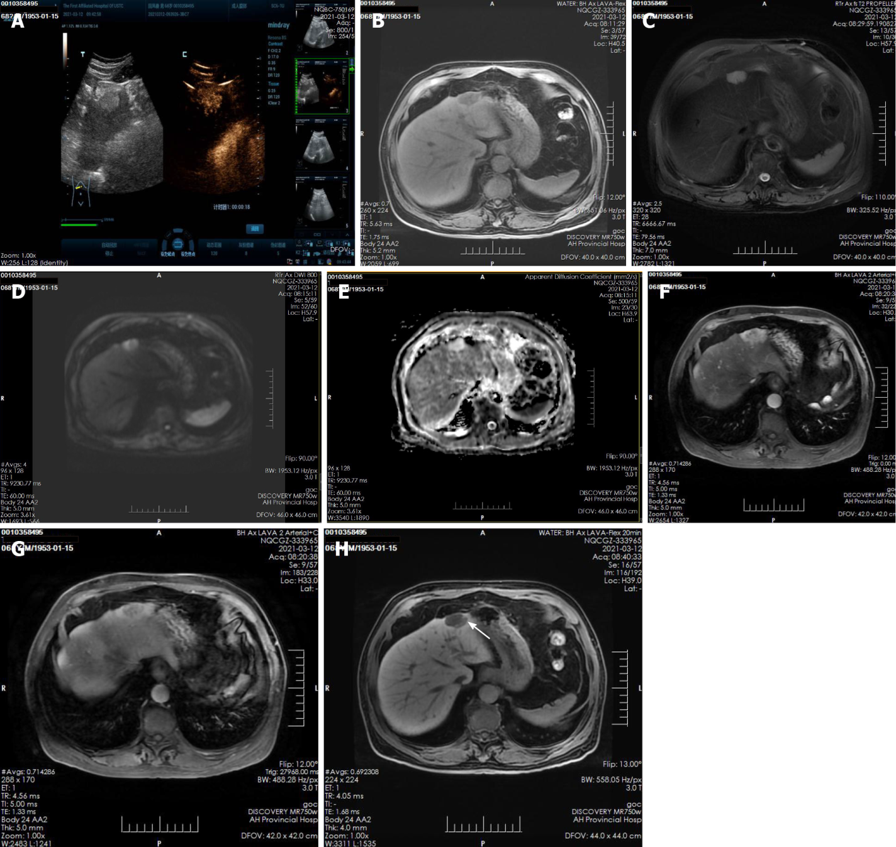
Figure 1 Imaging findings in a 68-year-old man with biliary adenofibroma. A: Ultrasonography showed hyperechoic nodules in the left lobe of the liver, after injection of contrast agent, it showed early and obvious enhancement; B and C: Plain magnetic resonance imaging (MRI) scan showed hypointensity on T1-weighted imaging (T1WI) and hyperintensity on T2-weighted imaging (T2WI); D and E: Diffusion-weighted imaging (DWI) showed moderate hyperintensity and isointensity on ADC; F-H: Enhanced MRI scan showed obvious enhancement of solid components and separation of lesions in the arterial phase, the degree of lesion enhancement decreased in the portal phase, in the hepatobiliary phase, enhancement of the bile duct structure was found in the lesion (white arrow).

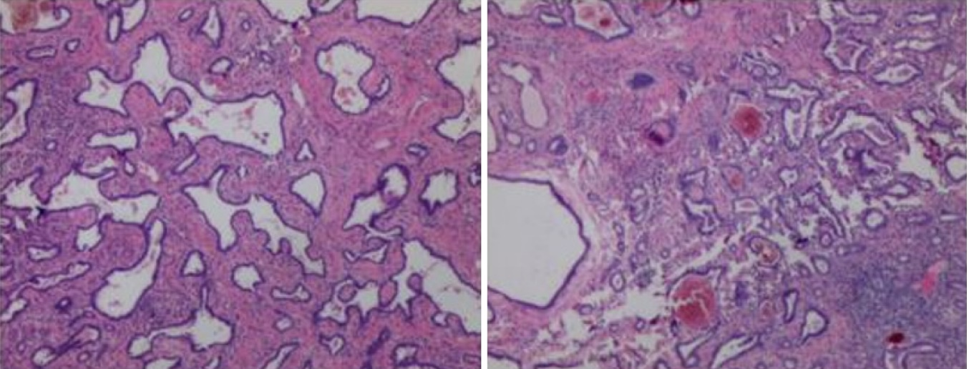
Figure 2 Postoperative pathology. Hematoxylin and eosin staining (100 ×) microscopy showed irregular hyperplasia of the bile duct with varying amounts of intervening fibrous stroma and inflammatory cell infiltration. Some bile ducts were dilated and the wall thickened, cholestasis can be seen in the bile duct. The cells showed no atypia, and some of them showed apocrine secretion. These results were consistent with the presentation of biliary adenofibroma.

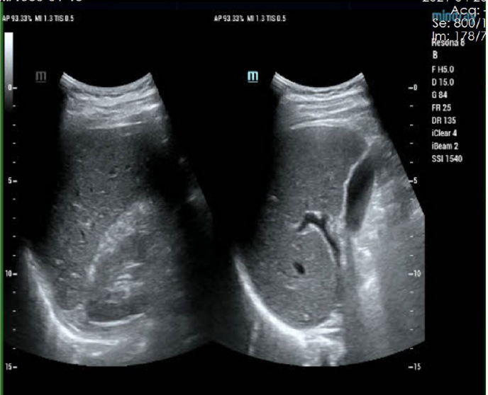
Figure 3 Postoperative re-examination images. Ultrasound examination indicates uniform echogenicity of liver parenchyma with no obvious abnormal echogenicity.

