Name of Journal: World Journal of Gastroenterology
Manuscript NO: 58648
Manuscript Type: OPINION REVIEW

Gastric acid level of humans must decrease in the future

Fujimori S. Future of gastric acid

Shunji Fujimori

Shunji Fujimori, Department of Gastroenterology, Chiba Hokusoh Hospital, Nippon Medical Scool, Inzai 270-1694, Chiba, Japan

Author contributions: Fujimori S contributed to the writing this paper.

Corresponding author: Shunji Fujimori, MD, PhD, AGAF. Director, Department of Gastroenterology, Chiba Hokusoh Hospital, Nippon Medical Scool, 1715 Kamagari, Inzai 270-1694, Chiba, Japan. s-fujimori@nms.ac.jp

Received: August 2, 2020
Revised: October 24, 2020
Accepted: November 2, 2020
Published online: November 21, 2020

Abstract
Proton pump inhibitors strongly inhibit gastric acid production, but digestion problems do not generally arise. We can intake almost ordinary food even after total gastrectomy. Small intestine itself can digest and absorb food using various digestive enzymes without digestion in the stomach. The pH level of gastric acid in humans is much lower than that of most animals, and very close to that of carrion-eating animals called scavengers. It is assumed that ancient humans became bipedal approximately 4 million years ago. It was difficult for humans, who just started unstable bipedal locomotion, to catch quadrupedal-walking animals that can move faster, without special hunting tools. They may have eaten remaining carcasses, which is mainly the leftovers of carnivora species, as animal-derived food. The benefit to produce a volume of gastric acid for humans is carrion eating, in which disinfection by gastric acid is important. Humans produce a high concentration of gastric acid to enable consumption of a diet containing some bacteria and support this lifestyle by consuming significant energy to protect themselves from gastric acid. Now, the opportunity for strong deleterious bacteria to enter the gastrointestinal tract has decreased because of the organized clean environment. If this hygienic environment is maintained for a long time, our gastric acid level must be decreased gradually.

Key Words: Gastric acid; Proton pump inhibitor; Digestion; Scavenger; Carrion eating; Ancient humans

Citation: Fujimori S. Gastric acid level of humans must decrease in the future. World J Gastroenterol 2020; 26(43): 6706-6709
URL: https://www.wjgnet.com/1007-9327/full/v26/i43/6706.htm
DOI: https://dx.doi.org/10.3748/wjg.v26.i43.6706

Core Tip: We can intake almost ordinary food even after total gastrectomy. Small intestine itself can digest and absorb food without digestion in the stomach. The pH level of gastric acid in humans is much lower than that of most animals, and very close to that of carrion-eating animals. The benefit to produce a volume of gastric acid for humans is carrion eating, in which disinfection by gastric acid is important. Now, we have decreased risk of food poisoning because of clean environment. If this hygienic environment is maintained for a long time, our gastric acid level must be decreased gradually.
INTRODUCTION
In recent years, the number of patients with reflux esophagitis has increased due to life-span extension and food satiation, and proton pump inhibitors (PPIs), strong acid reducers, are increasingly prescribed. People are concerned about side effects of PPIs associated with the increase in the number of prescription^{[1]}. However, it is generally understood that PPIs are relatively safe; PPIs strongly inhibit gastric acid production, but digestion problems do not generally arise, with some impaired absorption of vitamin B12. We discuss gastric acid in humans by focusing on why strong inhibition of gastric acid does not significantly affect digestion.

Gastric acid in humans
Digestion by gastric acid and pepsin is potent and can completely decompose animal-derived food. However, the decomposition takes time. For example, a snake swallows a whole animal and digests it at a gastric acid level (pH 1.5-2.0), the same as that in humans, but it takes approximately one week for the digestion process, depending on the size of the swallowed animal^{[2,3]}. Modern humans maintain food in the stomach for approximately four hours, and there is a limitation to the digestive ability of the stomach^{[4]}. The less cooked food that might have been served by ancient people would need more than four hours to digest in the stomach. Of course, the digestion time in the stomach in the ancient period might have been longer than that in present time, but strong digestive ability of the small intestine in modern humans is not necessary if digestion in the stomach is adequate.
We can intake almost ordinary food even after total gastrectomy, although we need to take food in small increments since the stomach cannot hold food. We are able to do so because the small intestine can digest and absorb food using various digestive enzymes without digestion in the stomach. Although impaired absorption of vitamins and minerals occurs due to the evolved absorption system of humans, the small intestine can still digest food. We captured how solid food is digested in the small intestine using capsule endoscopy and found that not only carbohydrates and meat but also the cytoplasm of plants are absorbed in the small intestine^{[5]}. In other words, we endoscopically confirmed that the passage of current formed food through the stomach does not influence digestion in the small intestine. Because a patient who takes PPIs does not have any major digestive/absorption problems, the importance of gastric acid in the digestive system of humans is thought to be low. Nevertheless, the gastric acid level of humans is considerably high compared to that of many other animals^{[6]}.
The pH of gastric acid in humans is 1.5-2.0. According to a report summarized by Beasley et al^{[6]}, the pH level is much lower than that of most animals, including anthropoids (≥ 3.0), and very close to that of carrion-eating animals called scavengers, such as falconine birds and vultures^{[6]}. This report shows a trend that pH in the stomach is the highest in herbivores and decreases in order of carnivores, omnivores, and scavengers (Figure 1). The pH of humans is lower among omnivores and equal to scavengers. Herbivores eat raw plants that are protected by sunlight and antibacterial agents produced from the plant, therefore have less-toxic bacteria. Also, normal carnivores eat non-festering meat that is freshly killed. Carrion that is left over of such carnivores has no small highly virulent bacteria and carrion-eating needs a system to disinfect the bacteria. It has been thought that one of the disinfection system is the strong acid in the stomach. Living organisms use great energy to produce gastric acid. First, they need energy to produce gastric acid itself^{[7]}. In addition, they need to protect the gastric mucosa from gastric acid, protect against back-flow of gastric fluid in the esophagogastric junction, and neutralize gastric acid immediately in the duodenum for protection^{[8,9]}. The benefit of the effort to produce gastric acid for humans is carrion eating, in which disinfection by gastric acid is important.
It is assumed that ancient humans became bipedal approximately 4 million years ago^{[10]}. It was difficult for humans, who just started unstable bipedal locomotion without special hunting tools, to catch quadrupedal walking animals that can move faster. They may have eaten remaining carcasses, which is mainly the leftovers of carnivora species (bone marrow), as animal-derived food^{[11]}. This hypothesis has been proven from bone-destroying stone artifacts. In other words, humans may have survived and developed as a carrion-eating animal. To enable this method of subsistence, humans needed enhanced bactericidal power, and individuals adopted increased gastric acid levels, which is preserved in modern humans. This high gastric acid level enables relatively long-term use of animal-derived food, which is difficult to preserve, and may support a wide variety of dietary habits of humans as omnivores.

CONCLUSION
As stated above, humans have adjusted to the environment as omnivorous mammals that can consume carrion. Humans produce a high concentration of gastric acid to enable consumption of a diet containing some bacteria and support this lifestyle by spending significant energy to protect themselves from gastric acid. We have decreased the opportunity for strong deleterious bacteria to enter the gastrointestinal tract because of the organized clean environment, especially in developed countries. If this hygienic environment is maintained for a long time, our gastric acid level must be decreased gradually, with some modification in the absorption system.

REFERENCES
1 Nehra AK, Alexander JA, Loftus CG, Nehra V. Proton Pump Inhibitors: Review of Emerging Concerns. Mayo Clin Proc 2018; 93: 240-246 [PMID: 29406201 DOI: 10.1016/j.mayocp.2017.10.022]
2 Yonezawa H, Nonaka T, Uchikoba T, Hattori S, Ohno M, Kaneda M. Isolation and characterization of pepsinogen from Trimeresurus flavoviridis (Habu snake). J Biochem 2000; 127: 755-760 [PMID: 10788783 DOI: 10.1093/oxfordjournals.jbchem.a022667]
3 Secor SM. Gastric function and its contribution to the postprandial metabolic response of the Burmese python Python molurus. J Exp Biol 2003; 206: 1621-1630 [PMID: 12682094 DOI: 10.1242/jeb.00300]
4 Pathikonda M, Sachdeva P, Malhotra N, Fisher RS, Maurer AH, Parkman HP. Gastric emptying scintigraphy: is four hours necessary? J Clin Gastroenterol 2012; 46: 209-215 [PMID: 21959322 DOI: 10.1097/MCG.0b013e31822f3ad2]
5 Fujimori S. Capsule endoscopy for investigating the digestion process. VideoGIE 2020; 5: 14-15 [PMID: 31922073 DOI: 10.1016/j.vgie.2019.10.009]
6 Beasley DE, Koltz AM, Lambert JE, Fierer N, Dunn RR. The Evolution of Stomach Acidity and Its Relevance to the Human Microbiome. PLoS One 2015; 10: e0134116 [PMID: 26222383 DOI: 10.1371/journal.pone.0134116]
7 Scott DR, Helander HF, Hersey SJ, Sachs G. The site of acid secretion in the mammalian parietal cell. Biochim Biophys Acta 1993; 1146: 73-80 [PMID: 8382956 DOI: 10.1016/0005-2736(93)90340-6]
8 Szabo S. Mechanisms of gastric mucosal injury and protection. J Clin Gastroenterol 1991; 13 Suppl 2: S21-S34 [PMID: 1885900 DOI: 10.1097/00004836-199112002-00005]
9 Allen A, Flemström G. Gastroduodenal mucus bicarbonate barrier: protection against acid and pepsin. Am J Physiol Cell Physiol 2005; 288: C1-19 [PMID: 15591243 DOI: 10.1152/ajpcell.00102.2004]
10 Richmond BG, Strait DS. Evidence that humans evolved from a knuckle-walking ancestor. Nature 2000; 404: 382-385 [PMID: 10746723 DOI: 10.1038/35006045]
11 Mann NJ. A brief history of meat in the human diet and current health implications. Meat Sci 2018; 144: 169-179 [PMID: 29945745 DOI: 10.1016/j.meatsci.2018.06.008]

Footnotes
Conflict-of-interest statement: The author declares no conflict of interest.

Open-Access: This article is an open-access article that was selected by an in-house editor and fully peer-reviewed by external reviewers. It is distributed in accordance with the Creative Commons Attribution NonCommercial (CC BY-NC 4.0) license, which permits others to distribute, remix, adapt, build upon this work non-commercially, and license their derivative works on different terms, provided the original work is properly cited and the use is non-commercial. See: http://creativecommons.org/Licenses/by-nc/4.0/

Manuscript source: Unsolicited manuscript

Corresponding Author's Membership in Professional Societies: American Gastroenterological Association, No. 326349; and The Japanese Society of Gastroenterology, No. 020689.

Peer-review started: August 2, 2020
First decision: October 18, 2020
Article in press: November 2, 2020

Specialty type: Gastroenterology and hepatology
Country/Territory of origin: Japan
Peer-review report’s scientific quality classification
Grade A (Excellent): 0
Grade B (Very good): B, B
Grade C (Good): C, C
Grade D (Fair): 0
Grade E (Poor): 0

P-Reviewer: Chen YD, Shi H, Tang ST, Yang L S-Editor: Zhang L L-Editor: A P-Editor: Wang LL

Figure Legends
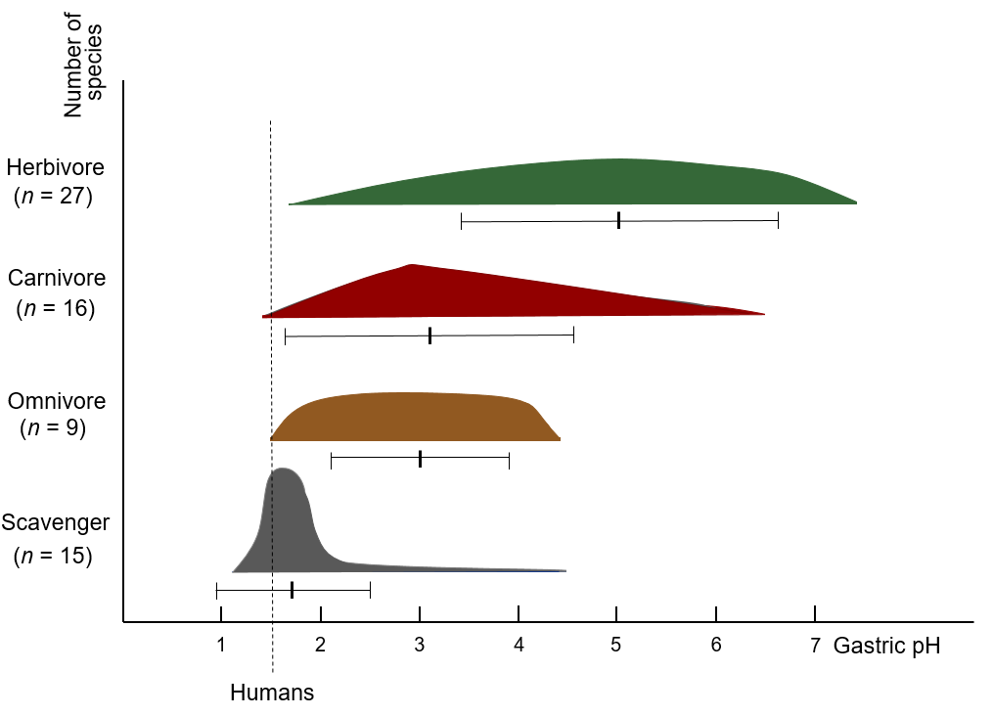
Figure 1 pH of mammals and avian species according to feeding habit. Forty-two mammals and 25 avian species except human summarized by Beasley et al^{[6]} were categorized in herbivore, carnivore, omnivore, and scavenger and the distribution of species against pH in the stomach was expressed in a scheme. The scheme was deformed due to its large variance. mean ± SD of the pH is inserted below.

