Name of journal: World Journal of Gastroenterology
ESPS Manuscript NO: 7712
Columns: TOPIC HIGHLIGHT

WJG 20th Anniversary Special Issues (13): Gastrointestinal endoscopy

Utility of endoscopic ultrasound in patients with portal hypertension

Hammoud GM et al. Utility of EUS in patients with PH

Ghassan M Hammoud, Jamal A Ibdah

Ghassan M Hammoud, Jamal A Ibdah, Division of Gastroenterology and Hepatology, University of Missouri, Columbia, MO 65212, United States

Author contributions: Hammoud GM wrote the manuscript; Ibdah JA edited the manuscript.

Correspondence to: Jamal A Ibdah, MD, PhD, Professor, Director, Division of Gastroenterology and Hepatology, University of Missouri, 1100 Virginia Ave Rm 1093, Columbia, MO 65212, United States. ibdahj@health.missouri.edu

Telephone: +1-573-8827349 Fax: +1-573-8844595
Received: November 28, 2013 Revised: March 22, 2014
Accepted: June 14, 2014

Published online:

Abstract
Endoscopic ultrasound (EUS) has revolutionized the diagnostic and therapeutic approach to patients with gastrointestinal disorders. Its application in patients with liver disease and portal hypertension is increasing. Patients with chronic liver disease are at risk for development of portal hypertension sequale such as ascites, spontaneous bacterial peritonitis and gastroesophageal varices. Bleeding esophageal and gastric varices are among the most common causes of mortality in patients with cirrhosis. Thus, early detection and treatment improve the outcome in this population. EUS can improve the detection and diagnosis of gastroesophageal varices and collateral veins and can provide endoscopic therapy of gastroesophageal varices such as EUS-guided sclerotherapy of esophageal collateral vessels and EUS-guided cynoacrylate (Glue) injection of gastric varices. EUS can also provide knowledge on the efficacy of pharmacotherapy of portal hypertension. Furthermore, EUS can provide assessment and prediction of variceal recurrence after endoscopic therapy and assessment of portal hemodynamics such as E-Flow and Doppler study of the azygous and portal veins. Moreover, EUS-guided fine needle aspiration may provide cytologic diagnosis of focal hepatic tumors and analysis of free abdominal fluid. Using specialized EUS-guided needle biopsy, a sample of liver tissue can be obtained to diagnose and evaluate for chronic liver disease. EUS-guided fine needle injection can be used to study portal vein pressure and hemodynamics, and potentially could be used to assist in exact measurement of portal vein pressure and placement of intrahepatic portosystemic shunt.

© 2014 Baishideng Publishing Group Inc. All rights reserved.

Key words: Endoscopic ultrasound; Cirrhosis; Portal hypertension; Gastroesophageal varices; Cyanoacrylate; Hepatocellular carcinoma; Fine needle aspiration

Core tip: This review provides an up-to-date summary of published studies and case reports on the utilization of endoscopic ultrasound in patients with advanced liver disease and portal hypertension. We highlight the significance of portal hypertension and the potential application of endoscopic ultrasound, endoscopic ultrasound (EUS)-guided fine needle aspiration, and EUS-guided injection in the management of portal hypertension. In addition, we highlight the utilization of EUS in the diagnosis and management of gastroesophageal varices. This review also provides insights on the limitation of endoscopic ultrasound in patients with portal hypertension.

Hammoud GM, Ibdah JA. Utility of endoscopic ultrasound in patients with portal hypertension. World J Gastroenterol 2014; In press

INTRODUCTION
Endoscopic ultrasound (EUS) has provided a great insight on our understanding of the complex vascular structural changes associated with portal hypertension. Its ability to define the internal anatomy and mucosal vascular changes related to portal hypertension is magnificent. These changes may not be readily seen on direct forward viewing upper endoscope in early stages of advanced liver disease. EUS combines endoscopy and ultrasound to obtain images and provide detailed information about the digestive tract and the surrounding tissue and organs. The combined utilization of EUS with color or flow Doppler technique enhanced the study of the venous anatomy of the distal esophagus. These include detection of so called "deep varices", assessment of the thickness of gastric wall, differentiation between thickened folds and varices or detection of subclinical amounts of ascitic fluid. Using the high-frequency (20 MHz) ultrasound catheter probes, or miniprobes, may add further evaluation and understanding of the venous anatomy at the distal esophagus in patients with portal hypertension. EUS-guided injection of cyanoacrylate in perforating feeding veins in gastric varices seems to be a safe therapy. EUS-guided portal vein catheterization is a novel approach for portal angiography and portal vein pressure measurement^{[1,2]}. The use of elastography in conjunction with EUS imaging of the liver for HCC screening or surveillance is promising.
In this review, we opted to highlight the utility of endoscopic ultrasound in patients with portal hypertension. Articles for this review were selected from MEDLINE review of English-language articles as well as relevant textbooks. Furthermore, references were reviewed to retrieve additional articles related to this field.

ANATOMY OF THE PORTAL VENOUS SYSTEM AND ENDOSONOGRAPHIC VISUALIZATION
The portal vein forms behind the head of the pancreas at the level of the second lumbar vertebra through the confluence of the superior mesenteric vein (SMV) and splenic vein (SV). The length of the portal vein is approximately 6-8 cm with a mean diameter of 1.09 cm. This may significantly increase in patients with portal hypertension. The portal vein is best imaged using EUS at the duodenal bulb although can be seen from the stomach. The splenic vein drains the lower esophagus (esophageal veins), stomach (short gastric and left gastro-epiploic veins), pancreas (pancreas veins) and first portion of the duodenum. The splenic vein diameter is less than 0.45 cm. The splenic vein could be larger and tortuous in patients with portal hypertension. The splenic vein is best visualized at the gastric body/fundus and can be traced from the splenic hilum to the confluence of the portal vein. The azygous vein (AV) which plays an important role in portosystemic shunting, draining the gastroesophageal varices to the superior vena cava, is visualized on EUS images at the central mediastinum to the right of the spine between the descending abdominal aorta and spine. Varices are visualized on endoscopic ultrasound images as anechoic submucosal structures that possess flow signals on Doppler flow study. These appear as a conglomerate of round, oval or tubular veins, with or without adjacent periesophageal or paraesophageal collateral veins.

DIAGNOSIS OF PORTAL HYPERTENSION
Portal hypertension is a progressive complication of cirrhosis which is the end stage of any chronic liver disease. Portal hypertension can result from an increase in resistance to portal flow and/or increase in portal venous flow in the setting of cirrhosis. It is a pathologic increase in portal venous pressure gradient between the portal vein and the inferior vena cava. This is defined as increase in portal venous pressure gradient (HVPG) more than 5 mmHg. HVPG is an invasive but precise and indirect measurement of portal venous pressure gradient. This is a procedure that requires catheterization of the hepatic veins through the internal jugular or femoral vein route. HVPG is obtained by subtracting the free hepatic venous pressure (FHVP) from the wedged hepatic venous pressure (WHVP), i.e.,: [HVPG = WHVP – FHVP]. Gastroesophageal varices form only when the HVPG is more than 10 mmHg^{[3]}. This is known as a clinically significant portal hypertension; CSPH^{[4,5]} and bleed only when the HVPG exceeds 12 mmHg^{[6,7]}. It is important to realize that not every patient with HVPG more than 12 mmHg bleeds from varices. Other factors such as Child-Turcotte-Pugh (CTP) score (Table 1), the size of the varix and presence of red wale marking on the varix such as hematocystic spots and the blue colored varices are all prognostic indicators of first variceal hemorrhage^{[8-10]}.

ANATOMY OF THE DISTAL ESOPHAGUS AND PROXIMAL STOMACH IN PORTAL HYPERTENSION
The venous anatomy of the lower esophagus and upper stomach has been described into four layers: intraepithelial channels, superficial venous plexus, deep venous plexus and adventitial veins^{[11,12]}. The superficial venous plexus communicate with the deep venous plexus periesophageal collateral veins (peri-ECV) and paraesophageal collateral veins (para-ECV) through the perforating veins (PV) (Figure 1A). The perforating connecting veins are located within the submucosal layer of the esophageal wall. In patients with portal hypertension all of these veins are significantly dilated. These dilated submucosal veins can be readily seen on upper endopscopy as columns of dilated veins (Figure 1B). However, the deep venous plexus such as the periesophageal and paraesophageal veins are not seen on conventional endoscopy (Figure 1A).
Gastric varices are classified according to Sarin classification as gastroesophageal or isolated gastric varices^{[13]}. Type 1 gastroesophageal varices (lesser curve varices) are the most common (75%). Type 2 gastroesophageal varices, which extend to greater curvature, bleed often (55%) and are associated with high mortality (Figure 1C and D). These veins meet the upper end of the cardia of the stomach and drain into the left gastric and short gastric veins. Type 1 isolated gastric varices are only fundal varices, with a high (78%) incidence of bleeding. Type 2 isolated gastric varices are in the distal stomach or proximal duodenum.
Portal hypertension may also be seen with other two forms of macroscopically visible mucosal changes within the gastric mucosa that are seen by a careful upper gastrointestinal endoscopy and meticulous histological assessment of patients with cirrhosis^{[14]}. These are portal hypertensive gastropathy (PHG) and gastric antral vascular ectasia (GAVE). PHG involves the proximal stomach and is classified as either mild or severe. Mild portal hypertensive gastropathy is characterized by a snakeskin or mosaic appearance (cobblestone) of the proximal gastric mucosa. Severe portal hypertensive gastropathy is characterized by a background cobblestone appearance with superimposed red or brown spots and is associated with a higher risk of bleeding^{[15]}. Histological features of these lesions characterized by the presence of spindle cell proliferation and fibrohyalinosis^{[16]}. On the other hand, GAVE which may be present in patients with or without liver disease are dilated and ectatic blood vessels that are commonly seen at the distal stomach in the absence of a background of cobblestone and may not directly related to portal hypertension^{[17]}. These can be either punctate-type (the so called honeycomb) or striped-type (the so called watermelon stomach)^{[18]}. Their histologic features are primarily the presence of thrombi. Portal hypertensive duodenoapthy can manifest with several endoscopic features such as erythema, erosions, ulcers, telangiectasia, exaggerated villous pattern, duodenal varices, and mixed lesions^{[19]}. Portal hypertensive enteropathy and colopathy have also been described.

EUS IN PORTAL HYPERTENSION
Early detection of portal hypertension and the presence of gastroesophageal varices is the mainstay in the management of portal hypertension. Once gastroesophageal varices are detected and assessed based on its risks of bleeding such as size of varices and presence of red wale markings, intervention is applied. Either pharmacotherapy and/or endoscopic band ligation is considered based on whether primary prophylaxis (no previous variceal bleeding) or secondary prophylaxis (previous variceal bleeding) is encountered. Earlier studies revealed EUS was inferior to endoscopy in detecting and grading esophageal varices^{[20,21]}. However, with improved instrumentation and increased availability and training in the field of endosonography, EUS has enhanced the diagnostic and therapeutic approach to patients with portal hypertension.
Endoscopic ultrasound with its ability to provide both endoscopic and ultrasonographic visualization has expanded the diagnostic and therapeutic armamentarium in patients with portal hypertension (Table 2). Endoscopic ultrasound has been used to study gastroesophageal varices and to identify high risks of bleeding by determining the size of the varix on cross-sectional imaging^{[22]}. EUS has a higher sensitivity for detection of varices than gastroduodenoscopy. While a careful examination of the gastroesophageal junction (GEJ) by esophagogastroduodenoscopy can detect almost all cases of large esophageal varices, small varices may not be readily seen and gastric varices may not be easily detected. In a study by Choudhuri et al^{[21]} to evaluate the cross-sectional venous anatomy around the gastroesophageal junction using EUS in different grades of esophageal varices. Forty-five percent of patients with small varices were seen while all 30 (100%) patients with large varices were noted. However, gastric varices were detected significantly more often by EUS (66%) compared with endoscopy (17; 34%, P < 0.005). In a study by Faigel et al^{[23]}. Paraesophageal varices were detected in 97% of cirrhotic patients (n = 66) and 3% of control patients (n = 32) (P < 0.001) and were a more sensitive predictor of cirrhosis than varices at endoscopy (74%, P < 0.0001). Lee et al^{[24]} compared 52 cirrhotic and 166 dyspeptic patients to assess gastroesophageal varices and extraluminal venous abnormalities sonographically. EUS identified esophageal varices endoscopically in 53.8% with good correlation with EGD (r = 0.855, P < 0.001). EUS detected gastric varices sonographically in 30.8%, compared with 17.3% detected by EGD. Extraluminal venous abnormalities were detected in 92% of patients with cirrhosis. Endoscopic ultrasound is capable of providing visualization of vascular and structural changes within and outside the esophageal, gastric and rectal wall in patients with portal hypertension. The early detection of gastroesophageal varices may potentially reduce the need for liver biopsy indicating underlying cirrhosis if the underlying etiology is known. These changes related to early formation and engorgement of collateral vessels in the distal esophagus, azygous vein, proximal stomach and splenic vein are not seen at conventional endoscopy. In a study of 16 children, median age 13 mo (range, 7-88 mo), being assessed for intestinal transplant underwent simultaneous EGD and EUS to evaluate for portal hypertension if combined liver-intestine transplantation is needed. In 56.2% of patients the results of EGD and EUS were concordant for the detection of gastroesophageal varices. In seven patients, gastroesophageal varices were only identified by EUS and liver biopsy was avoided in four of these cases^{[25]}. In patients with portal hypertension, EUS reveals the presence of collateral vessels within and outside the esophageal wall such as esophageal varices, periesophageal collateral veins, paraesophageal collateral veins, and perforating veins^{[20]} (Figure 1). Collateral esophageal veins demonstrated by radial EUS in patients with portal hypertension correspond to collateral veins identified histopathologically^{[26]}. Collateral deep veins were also associated with recurrence of varices seen on high frequency (20 MHz) ultrasound catheter probe while the presence of veins at the gastroesophageal junction did not correlate with recurrence^{[27]}. Para-ECV which are detected on EUS after endoscopic sclerotherapy for esophageal varices correlates with varices recurrence^{[28]}. The presence of severe cardial submucosal veins and severe-grade perforating veins seen on high frequency ultrasound catheter probe before endoscopic variceal ligation were useful for predicting the likelihood of recurrence of esophageal varices^{[22]}. Sato et al^{[29]} found that the presence of patent inflowing perforating veins on endoscopic color Doppler ultrasonography before and after endoscopic injection sclerotherapy was predictive of early variceal recurrence.
EUS provides a reliable and unique assessment of gastric varices and allows visualization of the left gastric vein. The diameter of the left gastric vein is associated with variceal size^{[30]}. The presence of a rapid hepatofugal flow velocity of 12 cm/s in the left gastric vein seen under color Doppler EUS examination may have a high risk of an early recurrence of esophageal varices treated with either esophageal band ligation or sclerotherapy^{[31]}.
EUS can improve the detection of gastroesophageal varices and can provide an assessment to the efficacy of therapy in these patients. Indeed, endoscopic Doppler ultrasound can assist in differentiating gastric varices from other gastric submucosal lesions and enlarged gastric folds and preclude biopsy in these cases. In a study of eight patients with uncertain gastric submucosal lesions seen on EGD, EUS-guided Doppler US probe revealed 6 cases of gastric varices, one case of gastrointestinal stromal tumor and one case of Menetrier’s disease^{[32]}. EUS-guided therapeutic intervention is one of the mainstays in treatment of portal hypertension. Varices can be seen on echosonographic images as dilated anechoic rounded or tubular structures can be targeted using endoscopic-guided fine needle injection with a sclerosing agent or a coil. Fundal varices are so large in caliber and thus when they rupture, massive bleeding is encountered. These veins cannot be treated effectively using band ligation. The treatment of this condition calls for complete thrombosis of all varicose veins and/or perforating veins. EUS-guided cyanoacrylate injection and/or cyanoacrylate with coiling with precise injection in the perforating veins deems a useful measured in eradicating gastric varices^{[33-35]}. EUS-guided coil application required fewer endoscopies and tended to have fewer adverse events compared with EUS-guided cyanoacrylate injection although larger comparative studies are needed^{[35]}. In a randomized controlled trial by de Paulo et al^{[36]} of 50 cirrhotic patients with esophageal varices, endoscopic sclerotherapy and EUS-guided sclerotherapy were equally effective in eradicating esophageal varices, with similar mean numbers of sessions and times to eradication.
Fine-needle aspiration under EUS guidance may be useful in the diagnosis of focal liver lesions and early hepatocellular carcinoma (HCC) in patients with portal hypertension and evaluation of perihepatic adenopathy^{[37,38]}. EUS can also provide some option of treatment to patients with hepatocellular carcinoma difficult to treat with percutaneous local treatment. Endoscopic ultrasound-guided ethanol injection for hepatocellular carcinoma^{[39]} and EUS-guided Nd:YAG laser ablation of a hepatocellular carcinoma in the caudate lobe are feasible treatment options^{[40]}. In addition to providing imaging of tumors and enhancing TNM staging, EUS also provide guidance for fine needle aspiration and biopsies of undiagnosed masses and lymph node suspicious for metastasis. Moreover, EUS plays a role in evaluating biliary tract diseases in patients with cirrhosis such as cholelithiasis, choledocholithiasis, choledochocele or sphincter of Oddi dysfunction.
Endosonographers have pushed the limit of the use of EUS. Novel techniques in portal vein catheterization and portal vein pressure measurement have been studied. EUS-guided portal vein catheterization appears to be feasible, safe, and can be used for portal angiography and portal vein pressure measurements in several porcine model^{[1,2,41]}. Post mortem examination revealed no active bleeding and no damage to the liver^{[41]}. Very few adverse events were encountered. The ability to access the portal vein through the stomach or duodenum may provide potential future therapeutic use such as the direct injection of thrombolytic or thrombotic agents, and the direct placement of EUS-guided intrahepatic portosystemic shunt^{[42]}.

CONCLUSION
Endoscopic ultrasonography has played an important role in the diagnostic and therapeutic armamentarium of gastrointestinal and pancreaticobiliary disease. Its use in patients with liver disease and portal hypertension is expanding with the increasing availability of the instrument worldwide and improved understanding and training in endosonography. Portal hypertension is a progressive complication of cirrhosis and is a major cause for mortality in patients with cirrhosis. Using endoscopic ultrasound, endosonographers are able to recognize early changes of portal hypertension and provide accurate assessment and plan for early therapeutic intervention. EUS combined with color Doppler imaging and fine needle aspiration and injection can provide early detection and therapy of gastroesophageal varices, and ascites. Moreover, it can evaluate the efficacy of pharmacotherapy applied to portal hypertension and may provide early detection of focal liver tumors. The future use of EUS in hepatology is expanding and endoscopic ultrasound continues to have a role in this field.

REFERENCES
1 Lai L, Poneros J, Santilli J, Brugge W. EUS-guided portal vein catheterization and pressure measurement in an animal model: a pilot study of feasibility. Gastrointest Endosc 2004; 59: 280-283 [PMID: 14745408]
2 Giday SA, Clarke JO, Buscaglia JM, Shin EJ, Ko CW, Magno P, Kantsevoy SV. EUS-guided portal vein catheterization: a promising novel approach for portal angiography and portal vein pressure measurements. Gastrointest Endosc 2008; 67: 338-342 [PMID: 18226699 DOI: 10.1016/j.gie.2007.08.037]
3 Groszmann RJ, Garcia-Tsao G, Bosch J, Grace ND, Burroughs AK, Planas R, Escorsell A, Garcia-Pagan JC, Patch D, Matloff DS, Gao H, Makuch R. Beta-blockers to prevent gastroesophageal varices in patients with cirrhosis. N Engl J Med 2005; 353: 2254-2261 [PMID: 16306522 DOI: 10.1056/NEJMoa044456]
4 Peck-Radosavljevic M, Angermayr B, Datz C, Ferlitsch A, Ferlitsch M, Fuhrmann V, Häfner M, Kramer L, Maieron A, Payer B, Reiberger T, Stauber R, Steininger R, Trauner M, Thurnher S, Ulbrich G, Vogel W, Zoller H, Graziadei I. Austrian consensus on the definition and treatment of portal hypertension and its complications (Billroth II). Wien Klin Wochenschr 2013; 125: 200-219 [PMID: 23579878 DOI: 10.1007/s00508-013-0337-z]
5 de Franchis R. Updating consensus in portal hypertension: report of the Baveno III Consensus Workshop on definitions, methodology and therapeutic strategies in portal hypertension. J Hepatol 2000; 33: 846-852 [PMID: 11097497]
6 Ripoll C, Groszmann R, Garcia-Tsao G, Grace N, Burroughs A, Planas R, Escorsell A, Garcia-Pagan JC, Makuch R, Patch D, Matloff DS, Bosch J. Hepatic venous pressure gradient predicts clinical decompensation in patients with compensated cirrhosis. Gastroenterology 2007; 133: 481-488 [PMID: 17681169 DOI: 10.1053/j.gastro.2007.05.024]
7 Garcia-Tsao G, Groszmann RJ, Fisher RL, Conn HO, Atterbury CE, Glickman M. Portal pressure, presence of gastroesophageal varices and variceal bleeding. Hepatology 1985; 5: 419-424 [PMID: 3873388]
8 North Italian Endoscopic Club for the Study and Treatment of Esophageal Varices. Prediction of the first variceal hemorrhage in patients with cirrhosis of the liver and esophageal varices. A prospective multicenter study. N Engl J Med 1988; 319: 983-989 [PMID: 3262200 DOI: 10.1056/NEJM198810133191505]
9 Merli M, Nicolini G, Angeloni S, Rinaldi V, De Santis A, Merkel C, Attili AF, Riggio O. Incidence and natural history of small esophageal varices in cirrhotic patients. J Hepatol 2003; 38: 266-272 [PMID: 12586291]
10 Beppu K, Inokuchi K, Koyanagi N, Nakayama S, Sakata H, Kitano S, Kobayashi M. Prediction of variceal hemorrhage by esophageal endoscopy. Gastrointest Endosc 1981; 27: 213-218 [PMID: 6975734]
11 Kitano S, Terblanche J, Kahn D, Bornman PC. Venous anatomy of the lower oesophagus in portal hypertension: practical implications. Br J Surg 1986; 73: 525-531 [PMID: 3730783]
12 Hashizume M, Kitano S, Sugimachi K, Sueishi K. Three-dimensional view of the vascular structure of the lower esophagus in clinical portal hypertension. Hepatology 1988; 8: 1482-1487 [PMID: 3192160]
13 Sarin SK, Lahoti D, Saxena SP, Murthy NS, Makwana UK. Prevalence, classification and natural history of gastric varices: a long-term follow-up study in 568 portal hypertension patients. Hepatology 1992; 16: 1343-1349 [PMID: 1446890]
14 Lingenfelser T, Krige JE. The stomach in cirrhosis. The legend of Proteus retold. J Clin Gastroenterol 1993; 17: 92-96 [PMID: 8409328]
15 Stewart CA, Sanyal AJ. Grading portal gastropathy: validation of a gastropathy scoring system. Am J Gastroenterol 2003; 98: 1758-1765 [PMID: 12907330 DOI: 10.1111/j.1572-0241.2003.07595.x]
16 Payen JL, Calès P, Voigt JJ, Barbe S, Pilette C, Dubuisson L, Desmorat H, Vinel JP, Kervran A, Chayvialle JA. Severe portal hypertensive gastropathy and antral vascular ectasia are distinct entities in patients with cirrhosis. Gastroenterology 1995; 108: 138-144 [PMID: 7806035]
17 Spahr L, Villeneuve JP, Dufresne MP, Tassé D, Bui B, Willems B, Fenyves D, Pomier-Layrargues G. Gastric antral vascular ectasia in cirrhotic patients: absence of relation with portal hypertension. Gut 1999; 44: 739-742 [PMID: 10205216]
18 Ito M, Uchida Y, Kamano S, Kawabata H, Nishioka M. Clinical comparisons between two subsets of gastric antral vascular ectasia. Gastrointest Endosc 2001; 53: 764-770 [PMID: 11375585 DOI: 10.1067/mge.2001.113922]
19 Barakat M, Mostafa M, Mahran Z, Soliman AG. Portal hypertensive duodenopathy: clinical, endoscopic, and histopathologic profiles. Am J Gastroenterol 2007; 102: 2793-2802 [PMID: 17900330 DOI: 10.1111/j.1572-0241.2007.01536.x]
20 Caletti G, Brocchi E, Baraldini M, Ferrari A, Gibilaro M, Barbara L. Assessment of portal hypertension by endoscopic ultrasonography. Gastrointest Endosc 1990; 36: S21-S27 [PMID: 2184082]
21 Choudhuri G, Dhiman RK, Agarwal DK. Endosonographic evaluation of the venous anatomy around the gastro-esophageal junction in patients with portal hypertension. Hepatogastroenterology 1996; 43: 1250-1255 [PMID: 8908559]
22 Konishi Y, Nakamura T, Kida H, Seno H, Okazaki K, Chiba T. Catheter US probe EUS evaluation of gastric cardia and perigastric vascular structures to predict esophageal variceal recurrence. Gastrointest Endosc 2002; 55: 197-203 [PMID: 11818922 DOI: 10.1067/mge.2002.121338]
23 Faigel DO, Rosen HR, Sasaki A, Flora K, Benner K. EUS in cirrhotic patients with and without prior variceal hemorrhage in comparison with noncirrhotic control subjects. Gastrointest Endosc 2000; 52: 455-462 [PMID: 11023560]
24 Lee YT, Chan FK, Ching JY, Lai CW, Leung VK, Chung SC, Sung JJ. Diagnosis of gastroesophageal varices and portal collateral venous abnormalities by endosonography in cirrhotic patients. Endoscopy 2002; 34: 391-398 [PMID: 11972271 DOI: 10.1055/s-2002-25286]
25 McKiernan PJ, Sharif K, Gupte GL. The role of endoscopic ultrasound for evaluating portal hypertension in children being assessed for intestinal transplantation. Transplantation 2008; 86: 1470-1473 [PMID: 19034020 DOI: 10.1097/TP.0b013e3181891d63]
26 Irisawa A, Shibukawa G, Obara K, Saito A, Takagi T, Shishido H, Odajima H, Abe M, Sugino T, Suzuki T, Kasukawa R, Sato Y. Collateral vessels around the esophageal wall in patients with portal hypertension: comparison of EUS imaging and microscopic findings at autopsy. Gastrointest Endosc 2002; 56: 249-253 [PMID: 12145605]
27 Irisawa A, Saito A, Obara K, Shibukawa G, Takagi T, Shishido H, Sakamoto H, Sato Y, Kasukawa R. Endoscopic recurrence of esophageal varices is associated with the specific EUS abnormalities: severe periesophageal collateral veins and large perforating veins. Gastrointest Endosc 2001; 53: 77-84 [PMID: 11154493 DOI: 10.1067/mge.2001.108479]
28 Irisawa A, Obara K, Bhutani MS, Saito A, Shishido H, Shibukawa G, Takagi T, Yamamoto G, Seino O, Shishido F, Kasukawa R, Sato Y. Role of para-esophageal collateral veins in patients with portal hypertension based on the results of endoscopic ultrasonography and liver scintigraphy analysis. J Gastroenterol Hepatol 2003; 18: 309-314 [PMID: 12603532]
29 Sato T, Yamazaki K, Toyota J, Karino Y, Ohmura T, Akaike J. Endoscopic ultrasonographic evaluation of hemodynamics related to variceal relapse in esophageal variceal patients. Hepatol Res 2009; 39: 126-133 [PMID: 19208033 DOI: 10.1111/j.1872-034X.2008.00415.x]
30 Hino S, Kakutani H, Ikeda K, Uchiyama Y, Sumiyama K, Kuramochi A, Kitamura Y, Matsuda K, Arakawa H, Kawamura M, Masuda K, Suzuki H. Hemodynamic assessment of the left gastric vein in patients with esophageal varices with color Doppler EUS: factors affecting development of esophageal varices. Gastrointest Endosc 2002; 55: 512-517 [PMID: 11923763]
31 Kuramochi A, Imazu H, Kakutani H, Uchiyama Y, Hino S, Urashima M. Color Doppler endoscopic ultrasonography in identifying groups at a high-risk of recurrence of esophageal varices after endoscopic treatment. J Gastroenterol 2007; 42: 219-224 [PMID: 17380280 DOI: 10.1007/s00535-006-1992-x]
32 Wong RC, Farooq FT, Chak A. Endoscopic Doppler US probe for the diagnosis of gastric varices (with videos). Gastrointest Endosc 2007; 65: 491-496 [PMID: 17321253 DOI: 10.1016/j.gie.2006.11.017]
33 Romero-Castro R, Pellicer-Bautista FJ, Jimenez-Saenz M, Marcos-Sanchez F, Caunedo-Alvarez A, Ortiz-Moyano C, Gomez-Parra M, Herrerias-Gutierrez JM. EUS-guided injection of cyanoacrylate in perforating feeding veins in gastric varices: results in 5 cases. Gastrointest Endosc 2007; 66: 402-407 [PMID: 17643723 DOI: 10.1016/j.gie.2007.03.008]
34 Binmoeller KF, Weilert F, Shah JN, Kim J. EUS-guided transesophageal treatment of gastric fundal varices with combined coiling and cyanoacrylate glue injection (with videos). Gastrointest Endosc 2011; 74: 1019-1025 [PMID: 21889139 DOI: 10.1016/j.gie.2011.06.030]
35 Romero-Castro R, Ellrichmann M, Ortiz-Moyano C, Subtil-Inigo JC, Junquera-Florez F, Gornals JB, Repiso-Ortega A, Vila-Costas J, Marcos-Sanchez F, Muñoz-Navas M, Romero-Gomez M, Brullet-Benedi E, Romero-Vazquez J, Caunedo-Alvarez A, Pellicer-Bautista F, Herrerias-Gutierrez JM, Fritscher-Ravens A. EUS-guided coil versus cyanoacrylate therapy for the treatment of gastric varices: a multicenter study (with videos). Gastrointest Endosc 2013; 78: 711-721 [PMID: 23891417 DOI: 10.1016/j.gie.2013.05.009]
36 de Paulo GA, Ardengh JC, Nakao FS, Ferrari AP. Treatment of esophageal varices: a randomized controlled trial comparing endoscopic sclerotherapy and EUS-guided sclerotherapy of esophageal collateral veins. Gastrointest Endosc 2006; 63: 396-402; quiz 463 [PMID: 16500386 DOI: 10.1016/j.gie.2005.10.039]
37 Bissonnette J, Paquin S, Sahai A, Pomier-Layrargues G. Usefulness of endoscopic ultrasonography in hepatology. Can J Gastroenterol 2011; 25: 621-625 [PMID: 22059170]
38 Thuluvath PJ. EUS-guided FNA could be another important tool for the early diagnosis of hepatocellular carcinoma. Gastrointest Endosc 2007; 66: 274-276 [PMID: 17643699 DOI: 10.1016/j.gie.2006.12.045]
39 Nakaji S, Hirata N, Iwaki K, Shiratori T, Kobayashi M, Inase M. Endoscopic ultrasound (EUS)-guided ethanol injection for hepatocellular carcinoma difficult to treat with percutaneous local treatment. Endoscopy 2012; 44 Suppl 2 UCTN: E380 [PMID: 23139031 DOI: 10.1055/s-0032-1309918]
40 Di Matteo F, Grasso R, Pacella CM, Martino M, Pandolfi M, Rea R, Luppi G, Silvestri S, Zardi E, Costamagna G. EUS-guided Nd: YAG laser ablation of a hepatocellular carcinoma in the caudate lobe. Gastrointest Endosc 2011; 73: 632-636 [PMID: 21030019 DOI: 10.1016/j.gie.2010.08.019]
41 Giday SA, Ko CW, Clarke JO, Shin EJ, Magno P, Jagannath SB, Buscaglia JM, Kantsevoy SV. EUS-guided portal vein carbon dioxide angiography: a pilot study in a porcine model. Gastrointest Endosc 2007; 66: 814-819 [PMID: 17905028 DOI: 10.1016/j.gie.2007.05.056]
42 Buscaglia JM, Dray X, Shin EJ, Magno P, Chmura KM, Surti VC, Dillon TE, Ducharme RW, Donatelli G, Thuluvath PJ, Giday SA, Kantsevoy SV. A new alternative for a transjugular intrahepatic portosystemic shunt: EUS-guided creation of an intrahepatic portosystemic shunt (with video). Gastrointest Endosc 2009; 69: 941-947 [PMID: 19327481 DOI: 10.1016/j.gie.2008.09.051]

P-Reviewers: Anand BS, La Mura V S-Editor: Gou SX L-Editor: E-Editor:

Figure 1 Anatomy of the distal esophagus and proximal stomach in portal hypertension. A: Radial echoendoscope shows esophageal varices, periesophageal varices and paraesophgaeal varices with associated perforating vein; B: Upper endoscopy: Large esophageal varices extending to the cardia; C: Upper endoscopy: Type-2 large gastroesophageal varices; D: Radial echoendoscope shows large gastric and perigastric collaterals.

A B
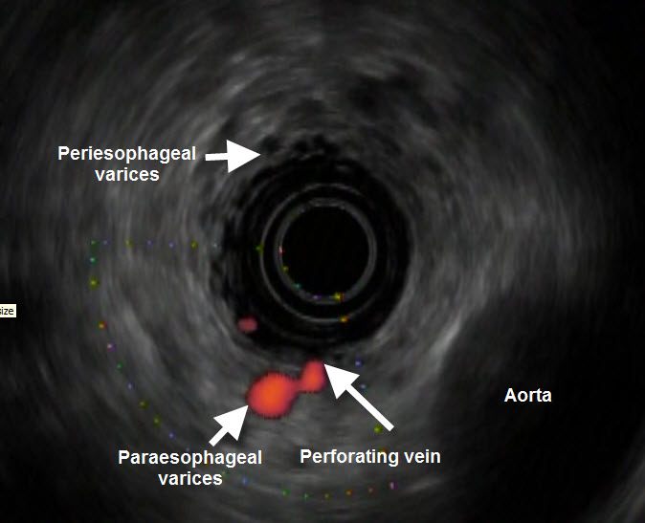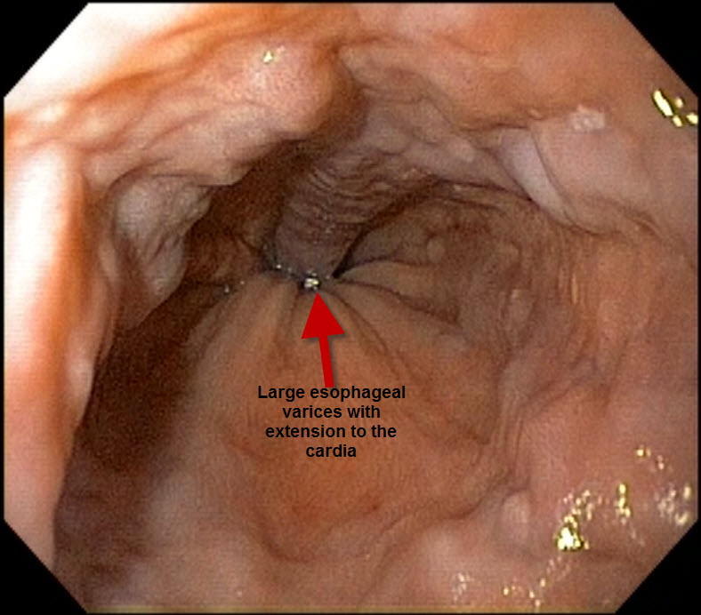
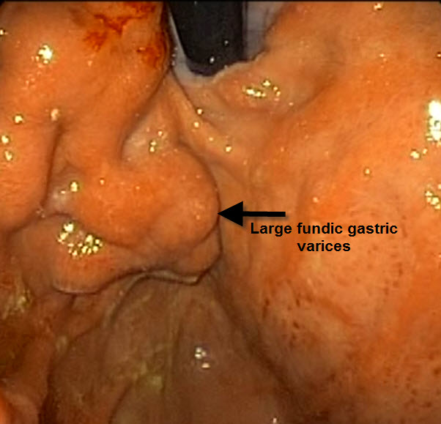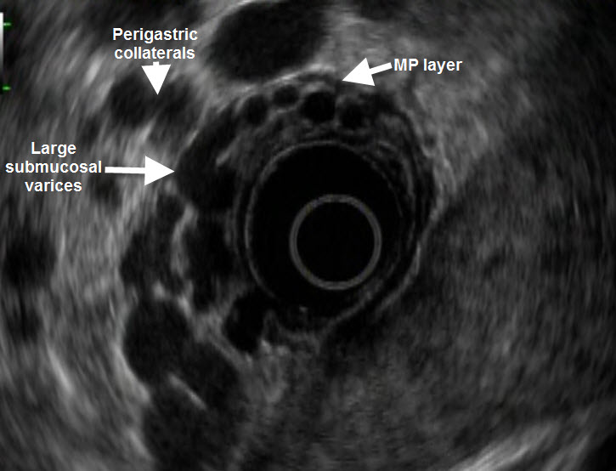
C D

Table 1 Child-Turcotte-Pugh classification of the severity of cirrhosis
Points¹ | 1 | 2 | 3
Ascites | None | Mild/moderate | Tense
Encephalopathy | None | Grade 1-2 | Grade 3-4
Bilirubin (mg/dL) | < 2 | 2-3 | > 3
Albumin (g/dL) | > 3.5 | 2.3-3.5 | < 2.8
INR | < 1.7 | 1.7-2.3 | > 2.3
¹5-6 points: Child A; 7-9 points: Child B; 10-15 points: Child C. INR: International normalised ratio.

Table 2 Summary of the use of endoscopic ultrasound in portal hypertension
Diagnosis of gastroesophageal varices
Visualization of collateral veins
Endoscopic ultrasound-guide therapy of gastroesophageal varices such as sclerotherapy and cyanoacrylate injection
Assessment of variceal recurrence and rebleeding
Evaluation of efficacy of pharmacotherapy
Assessment of portal hemodynamics
Tissue and fluid acquisition of ascites and focal liver lesions

