Name of Journal: World Journal of Gastrointestinal Surgery
Manuscript NO: 86989
Manuscript Type: META-ANALYSIS

Recent evidence for subcutaneous drains to prevent surgical site infections after abdominal surgery: A systematic review and meta-analysis

Ishinuki T et al. Evidence for subcutaneous drains for SSIs

Tomohiro Ishinuki, Hiroji Shinkawa, Keita Kouzu, Seiichi Shinji, Erika Goda, Toshio Ohyanagi, Masahiro Kobayashi, Motomu Kobayashi, Katsunori Suzuki, Yuichi Kitagawa, Chizuru Yamashita, Yasuhiko Mohri, Junzo Shimizu, Motoi Uchino, Seiji Haji, Masahiro Yoshida, Hiroki Ohge, Toshihiko Mayumi, Toru Mizuguchi

Tomohiro Ishinuki, Toru Mizuguchi, Department of Nursing, Surgical Sciences, Sapporo Medical University, Sapporo 060-8556, Hokkaido, Japan

Hiroji Shinkawa, Department of Hepatobiliary-Pancreatic Surgery, Osaka Metropolitan University Graduate School of Medicine, Abeno-Ku 545-0051, Japan

Keita Kouzu, Department of Surgery, National Defense Medical College, Tokorozawa 359-8513, Japan

Seiichi Shinji, Department of Gastrointestinal and Hepato-Biliary-Pancreatic Surgery, Nippon Medical School, Tokyo 113-8602, Japan

Erika Goda, Department of Nursing, Japan Health Care University, Sapporo 062-0053, Japan

Toshio Ohyanagi, Department of Liberal Arts and Sciences, Center for Medical Education, Sapporo Medical University, Sapporo 060-8556, Japan

Masahiro Kobayashi, Department of Clinical Pharmacokinetics, Research and Education Center for Clinical Pharmacy, Kitasato University, Tokyo 108-8641, Japan

Motomu Kobayashi, Department of Anesthesiology, Hokushinkai Megumino Hospital, Eniwa 061-1395, Japan

Katsunori Suzuki, Department of Infectious Disease Medicine, School of Medicine, University of Occupational and Environmental Health, Kitakyushu 807-8555, Japan

Yuichi Kitagawa, Department of Gastrointestinal Surgery, National Center for Geriatrics and Gerontology, Obu 474-8511, Japan

Chizuru Yamashita, Department of Anesthesiology and Critical Care Medicine, Fujita Health University, Toyoake 470-1192, Japan

Yasuhiko Mohri, Department of Gastrointestinal Surgery, Mie Prefectural General Medical Center, Yokkaich 510-8561, Japan

Junzo Shimizu, Department of Surgery, Toyonaka Municipal Hospital, Toyonaka 560-8565, Japan

Motoi Uchino, Department of Gastroenterological Surgery, Hyogo Medical University, Nishinomiya 663-8501, Japan

Seiji Haji, Department of Surgery, Soseikai General Hospital, Kyoto 612-8473, Japan

Masahiro Yoshida, Department of Hepato-Biliary-Pancreatic & Gastrointestinal Surgery, International University of Health and Welfare, Ichikawa 272-0827, Japan

Hiroki Ohge, Department of Infectious Disease, Hiroshima University Hospital, Hiroshima 734-8551, Japan

Toshihiko Mayumi, Department of Intensive Care Unit, Chukyo Hospital, Japan Community Health Care Organization, Nagoya 457-8510, Japan

Author contributions: Ishinuki T conducted the acquisition of data, abstract evaluation, full-text evaluation, interpretation of data, result discussion, and drafting the article; Shinkawa H conducted the acquisition of data, interpretation of data, and drafting the article; Kouzu K conducted the acquisition of data, abstract evaluation, and result discussion; Shinji S conducted the acquisition of data bias evaluation; Goda E conducted the full-text evaluation and graphic design; Ohyanagi T conducted statistical analyses and graphic design; Kobayashi Ma conducted the acquisition of data and bias evaluation; Kobayashi Mo conducted the abstract evaluation and bias evaluation; Suzuki K conducted the abstract evaluation and interpretation of data; Kitagawa Y conducted the full-text evaluation and bias evaluation; Yamashita C conducted the abstract evaluation and bias evaluation; Mohri Y conducted the full-text evaluation and bias evaluation; Shimizu J conducted the abstract evaluation and bias evaluation; Uchino M conducted the full-text evaluation and graphic design; Haji S conducted the full-text evaluation; Yoshida M conducted the interpretation of data and statistical analyses; Ohge H conducted result discussion; Mayumi T conducted a design of the review and result discussion; Mizuguchi T conducted conception of the review and result discussion.

Supported by Grants-in-Aid from JSPS KAKENHI, No. JP 21K10715 and No. JP 20K10404; Northern Advancement Center for Science & Technology, No. T-2-2; the Yasuda Medical Foundation, No. 31010316; the Okawa Foundation for Information and Telecommunications, No. 41111042; Taiju Life Social Welfare Foundation, No. 50811490; Japan Keirin Autorace Foundation, No. 2023M-378; Project Mirai Cancer Research Grants, No. 31010269; Takahashi Industrial and Economic Research Foundation, No. 50411278; Sapporo Doto Hospital, No. 50311211; Noguchi Hospital, No. 40310551; Doki-kai Tomakomai Hospital, No. 40710739; and Tsuchida Hospital, No. 50811478.

Corresponding author: Toru Mizuguchi, MD, PhD, Doctor, Professor, Surgical Oncologist, Department of Nursing, Surgical Sciences, Sapporo Medical University, S1, W17, Chuo-Ku, Sapporo 060-8556, Hokkaido, Japan. tmizu@sapmed.ac.jp

Received: July 26, 2023
Revised: October 23, 2023
Accepted: November 27, 2023
Published online: December 27, 2023

Abstract
BACKGROUND
Surgical site infections (SSIs) increase mortality, hospital stays, additional medical treatment, and medical costs. Subcutaneous drains prevent SSIs in gynecological and breast surgeries; however, their clinical impact in abdominal surgery remains unclear.

AIM
To investigate whether subcutaneous drains were beneficial in abdominal surgery using a systematic review and meta-analysis.

METHODS
The database search used PubMed, MEDLINE, and the Cochrane Library. The following inclusion criteria were set for the systematic review: (1) Randomized controlled trial studies comparing SSIs after abdominal surgery with or without subcutaneous drains; and (2) Studies that described clinical outcomes, such as SSIs, seroma formation, the length of hospital stays, and mortality.

RESULTS
Eight studies were included in this meta-analysis. The rate of total SSIs was significantly lower in the drained group (54/771, 7.0%) than in the control group (89/759, 11.7%), particularly in gastrointestinal surgery. Furthermore, the rate of superficial SSIs was slightly lower in the drained group (31/517, 6.0%) than in the control group (49/521, 9.4%). No significant differences were observed in seroma formation between the groups. Hospital stays were shorter in the drained group than in the control group.

CONCLUSION
Subcutaneous drains after abdominal surgery prevented SSIs and reduced hospital stays but did not significantly affect seroma formation. The timing of drain removal needs to be reconsidered in future studies.

Key Words: Abdominal surgery; Mortality; Seroma formation; Subcutaneous drain; Surgical site infections

©The Author(s) 2023. Published by Baishideng Publishing Group Inc. All rights reserved.

Citation: Ishinuki T, Shinkawa H, Kouzu K, Shinji S, Goda E, Ohyanagi T, Kobayashi M, Kobayashi M, Suzuki K, Kitagawa Y, Yamashita C, Mohri Y, Shimizu J, Uchino M, Haji S, Yoshida M, Ohge H, Mayumi T, Mizuguchi T. Recent evidence for subcutaneous drains to prevent surgical site infections after abdominal surgery: A systematic review and meta-analysis. World J Gastrointest Surg 2023; 15(12): 2879-2889
URL: https://www.wjgnet.com/1948-9366/full/v15/i12/2879.htm
DOI: https://dx.doi.org/10.4240/wjgs.v15.i12.2879

Core Tip: This review supports the beneficial effects of subcutaneous drains after abdominal surgery. Subcutaneous drains may not prevent seroma formation. Most studies removed drains within 3 d regardless of the amount of fluid discharge. The timing of drain removal may affect the clinical outcome. Nevertheless, subcutaneous drains can prevent surgical site infections and shorten the length of hospital stays after abdominal surgery.

INTRODUCTION
Surgical site infections (SSIs) are a common complication after gastrointestinal surgery and increase patient mortality^{[1,2]}. They were previously reported to occur in approximately 20% of patients after colorectal and hepatobiliary surgeries^{[3-5]}. SSIs prolong hospital stays and increase additional medical management with high medical costs^{[6]}. Therefore, their prevention during the perioperative period after surgery is essential.
Fluid collection in subcutaneous tissue is a risk factor for the development of SSIs through its provision of an environment for bacterial growth^{[7]}. The Centers for Disease Control and Prevention guidelines recommend the use of preoperative antimicrobial agents, the removal of serous fluid with drains, including negative pressure wound therapy, and antibacterial-coated absorbent sutures for the prevention of SSIs^{[8]}. The World Health Organization global guidelines also recommend the use of negative pressure wound therapy and antibacterial, absorbent sutures in any surgical procedure^{[9]}. Subcutaneous drains are commonly used after gynecological and breast surgeries^{[10]}; however, conflicting findings have been reported on their clinical impact on SSIs after abdominal surgery^{[11-15]}.
The majority of previous studies that examined the clinical benefits of subcutaneous drains were retrospective analyses without cause responsiveness. Therefore, further evidence is needed from randomized controlled trials (RCTs). This systematic review and meta-analysis were designed to compare clinical outcomes among subcutaneous drained and control groups after abdominal surgery.

MATERIALS AND METHODS
Search strategy
The review followed the statement of Preferred Reporting Items for Systematic Reviews and Meta-analyses^{[16]}. The protocol was registered in INPLASY (INPLASY No. 202350115). Ethical approval was not required for this review because of the observational meta-analysis. The protocol was augmented and evaluated with the peer review of electronic search strategies guidelines before performing the search^{[17]}. A comprehensive literature search was conducted using PubMed, MEDLINE, and the Cochrane Library for articles published between January 1, 1999 and April 1, 2023, and the search strategy is described in Supplementary Table 1.

Screening and eligibility
Five independent authors (Ishinuki T, Kouzu K, Kobayashi Mo, Suzuki K, and Yamashita C) reviewed the title and abstract of each article based on the following criteria: (1) RCT studies published in 1999 or thereafter; (2) Patients underwent abdominal surgery, defined as gastrointestinal, hepatobiliary, and hernia repair surgery; (3) Comparisons between subcutaneous drains and no subcutaneous drains; and (4) Incidence of SSIs was presented. Exclusion criteria were duplicate studies and studies in the same database or population. In the case of a conflict of agreement among authors, a group consensus was used to reach acceptance or rejection. Six authors (Ishinuki T, Goda E, Kitagawa Y, Mohri Y, Uchino M, and Haji S) reviewed the full texts of studies that passed the first screening. In addition, references were checked to ensure that all studies were included in eligible studies.

Data selection and quality assessment
Data selection was performed by four independent authors (Ishinuki T, Shinkawa H, Suzuki K, and Yoshida M). A data entry form was prepared in advance. The following information was selected: study details (title, first author, journal name, and year of publication), study design (purpose, study period, eligibility and exclusion criteria, age, and total number of participants), interventions delivered (procedure, surgical site, type of drain, timing of drain removal, length of hospital stays, and type of antimicrobial agents), and study results [number of SSIs, type of SSI (superficial or deep/organ), number of seroma formed, sample size, and P value]. The authors independently assessed the risk of bias for studies using the criteria outlined in the Cochrane Handbook for Systematic Reviews of Interventions and Cochrane’s effective practice and organization of care guidance, such as random sequence generation, allocation concealment, blinding of participants, blinding of personnel, blinding of outcome assessments, incomplete outcome data, selective reporting, and other bias^{[18]}. Conflicts of opinion among authors were discussed with all authors, and a consensus was reached.

Statistical analysis
The primary outcome was the rate of SSIs, including individual superficial or deep/organ SSIs. Secondary outcomes were the rate of seroma formation, the length of hospital stays, and mortality. Dichotomous data were analyzed for risk ratios using a random effects model and the Mantel-Haenszel method. Continuous data, such as the length of hospital stays, were analyzed using non-parametric tests^{[19-21]}. Data were presented as means with standard deviations using a random effects model. Median and interquartile range data were calculated as means and standard deviations^{[22]}. In addition, a subgroup analysis of SSIs was performed according to each type of drain or surgical site. Data synthesis and statistical analyses were performed with Review Manager (version 5.4; The Nordic Cochrane Centre, The Cochrane Collaboration, Copenhagen, Denmark).

RESULTS
Findings
The Preferred Reporting Items for Systematic Reviews and Meta-analyses flow diagram for this review is shown in Figure 1. Database search results showed that 9462 studies were eligible, with two additional studies being added to the references. We excluded 834 studies because of duplication, and 8621 were excluded after the screening of titles and abstracts. As a result, nine studies were reviewed as full texts^{[11,19-21,23-27]}. Eight studies were ultimately included in the meta-analysis^{[11,19-21,23-26]} after the exclusion of one study without SSI data^{[27]}. The bias summary is shown in Supplementary Figure 1.

Summary and characteristics of studies
A summary of data in each study is shown in Table 1. Five studies disclosed the outcomes of superficial or deep/organ SSIs^{[19,23,24,26]}. Three studies reported the number of seromas formed^{[21,24,25]}, and three described the length of hospital stays^{[19-21]}. Although three studies discussed mortality^{[19,25,26]}, only one mortality occurred in the drained group; therefore, a further analysis of mortality was impossible^{[25,26]}.
The characteristics of each study are shown in Supplementary Table 2. There were three studies on lower gastrointestinal surgery^{[21,24,26]}, one on hepatobiliary surgery^{[19]}, three on mixed surgery^{[11,20,23]}, and one on hernia repair^{[25]}. The types of drains were the Redon drain^{[23]}, Hemovac drain^{[11]}, Blake drain^{[19,26]}, Penrose drain^{[24]}, and Tubular drain^{[25]}. Two studies did not specify the type of drain used^{[20,21]}. The timing of drain removal ranged between 2-5 postoperative days or when the drainage volume was less than 40 mL/day. Cefuroxime and metronidazole were used in one study^{[23]}, cefazoline in three^{[11,19,25]}, cefmetazole in one^{[24]}, ampicillin/sulbactam in one^{[21]}, and flomoxef in one^{[26]}. One study did not describe the type of antibiotic prophylaxis^{[20]}. An intent-to-treat analysis was performed in three out of seven studies^{[19,23,25]}.

Results on the primary outcome
The rate of total SSIs was significantly lower in the drained group (54/771, 7.0%) than in the control group (89/759, 11.7%) without heterogeneity (I² = 0%) [risk ratio (RR): 0.63, 95% confidence interval (95%CI): 0.45-0.87, P = 0.005] (Figure 2A). Furthermore, the rate of superficial SSIs was slightly lower in the drained group (31/517, 6.0%) than in the control group (49/521, 9.4%) (RR: 0.64, 95%CI: 0.37-1.11, P = 0.11) (Figure 2B). In addition, no significant differences were observed in deep/organ SSIs between the groups (Figure 2C). Publication bias of the SSIs was assessed by the funnel plot (Supplementary Figure 2).

Results on secondary outcomes
No significant differences were observed in seroma formation between the drained and control groups (RR: 1.21, 95%CI: 0.65-2.26, P = 0.54) (Figure 3). However, the length of hospital stays significantly differed (mean difference: -1.34, 95%CI: -2.33 to -0.34, P = 0.008) (Figure 4). Publication bias of the seroma formation and the hospital stays were assessed by the funnel plot (Supplementary Figures 3 and 4, respectively).

Results of subgroup analyses
The results of subgroup analyses of the types of drains are shown in Figure 5. SSIs with the Blake drain (RR: 0.56, 95%CI: 0.24-1.29, P = 0.18) and other closed suction methods (RR: 0.71, 95%CI: 0.47-1.07, P = 0.52) did not significantly differ from those with the control, whereas SSIs using passive drainage significantly decreased more than with the control (RR: 0.33, 95%CI: 0.11-0.99, P = 0.05) (Figure 5). The results of subgroup analyses of surgical procedures are shown in Figure 6. Subcutaneous drains in gastrointestinal surgery decreased SSIs more than the control (RR: 0.48, 95%CI: 0.26-0.88, P = 0.02), whereas those in the hepatobiliary surgery (RR: 0.82, 95%CI: 0.37-1.83, P = 0.63), mixed surgery (RR: 0.64, 95%CI: 0.33-1.24, P = 0.22), and hernia repair surgery (RR: 0.80, 95%CI: 0.25-2.57, P = 0.71) did not (Figure 6).

DISCUSSION
We identified eight RCTs that compared SSIs after abdominal surgery with or without subcutaneous drains. Although the rate of total SSIs was significantly lower in the drained group than in the control group, no significant differences were observed in superficial or deep/organ SSIs because of statistical power. According to the surgical site, drains effectively prevented SSIs in gastrointestinal surgery. No significant differences were observed in SSIs among the drain types examined. We also showed that seroma formation did not significantly differ between the drained and control groups. On the other hand, subcutaneous drains effectively reduced hospital stays.
Subcutaneous drains remove interstitial fluid from a wound thereby reducing the risk of SSIs^{[28]}. Watanabe et al^{[26]} showed the benefits of subcutaneous drains in preventing SSIs after colorectal surgery, and putative reasons for reducing SSIs were proposed. The first reason is the specific shape of the drain itself. The classic shape of a subcutaneous drain is a tube with multiple small holes^{[11,21,23,25]}. This drain type may damage the hypodermis because of high negative pressure from the holes^{[29]}. The Blake drain is a closed suction drain made of a silicone elastomer with a solid core in the center and four slits along the sides. Since the Blake drain was developed to drain without causing tissue damage, it may be more beneficial than other drains^{[26]}. Therefore, this review investigated whether the Blake drain significantly reduced SSIs; however, no significant differences were observed between the drain types examined. The small holes of a drain may become blocked with fat tissue during the flow of fluid, which eventually prevents drainage^{[30]}. Therefore, drainage methods that are less likely to become blocked need to be developed.
The second proposed reason is the timing of drain removal. Long-term drain placement may increase the risk of contamination^{[26]}. A previous study published in 2004 reported a high infection rate associated with drain placement^{[31]}. On the other hand, studies published from the 2010s demonstrated that a sufficiently long drain time, such as longer than 72 h, prevented wound infection^{[12,30]}. The majority of studies analyzed in the present study removed drains within 72 h, which may have been too short to prevent superficial infection^{[11,19,21,23,24]}. Nakayama et al^{[19]} also reported that the timing of drain removal was too early to detect clinical effects and showed that 41% of SSIs occurred within 72 h of drain removal. Watanabe et al^{[26]} removed drains 120 h after surgery and found no incidence of SSIs. Therefore, the timing of drain removal needs to be investigated in further studies.
Although subcutaneous drains significantly decreased the rate of total SSIs, no significant differences were observed in the rate of superficial or deep/organ SSIs. Since two previous studies did not describe data on superficial or deep/organ SSIs, the statistical power in the subgroup analysis may have been lower than that in the total analysis^{[11,25]}. The present study also examined clinical effects, which were slightly better in the drained group than in the control group. This result may be attributed to improvements in drain materials and management.
This review showed that the effectiveness of subcutaneous drains was dependent on the surgical site. The usefulness of subcutaneous drains for the prevention of SSIs has been demonstrated in cholecystectomy^{[32]} and gastrointestinal surgery^{[11,23]}. Baier et al^{[23]} reported no benefit of subcutaneous drains in the abdominal field. On the other hand, Kaya et al^{[11]} showed a significant reduction in SSIs after surgery for colorectal malignancies and lower abdominal incisions in their subgroup analysis. Previous studies also found that drains prevented SSIs in contaminated surgery, such as lower gastrointestinal surgery^{[33,34]}. The present results provide support for the use of drains in lower gastrointestinal surgery.
The meta-analysis showed that subcutaneous drains did not significantly prevent seroma formation. Westphalen et al^{[25]} noted that seroma formation mostly occurred after drain removal. The peak incidence of seroma formation was previously reported to be approximately 2 wk after surgery, at which time the majority of drains had already been removed^{[35-37]}. Shima et al^{[12]} demonstrated that the timing of drain removal in breast cancer surgery was important to avoid wound complications. They found that seroma formation may be prevented when subcutaneous drains were removed after 7 d or later without an increase in SSIs. Therefore, the timing of drain removal needs to be individually selected for specific surgical procedures.
The use of subcutaneous drains affects the length of hospital stays. The length of hospital stays is a socioeconomic factor that is increased by any complication^{[21]}. Hospital stays were prolonged by SSIs, large seromas, hematomas, and other complications^{[21]}. Therefore, the prevention of SSIs by appropriately placing a subcutaneous drain may shorten hospital stays.
To ensure the quality of evidence, this review performed a meta-analysis of RCTs only. However, the interpretation of the present results was limited. The small number of studies included and insufficient published data affected the statistical results obtained. Therefore, a subgroup analysis of factors, such as the material of the drain and the timing of drain removal, was not possible. In addition, surgical techniques may have improved over the study period. Furthermore, putative adverse effects, such as pain, cosmetic evaluations, and management costs, were not analyzed due to the lack of data. It was not possible to investigate a publication bias due to the lack of sufficiently large publications to estimate. A limitation of the present study was that some factors may not have been included in the analysis, such as the age of patients, preoperative conditions, the length of surgery, the surgical technique, and the surgeon’s experience.

CONCLUSION
In conclusion, the present study supports the use of subcutaneous drains to prevent SSIs and shorten the length of hospital stays after abdominal surgery. On the other hand, subcutaneous drains may not prevent seroma formation. Several specific clinical outcomes, such as the timing of drain removal, pain control, cosmetic evaluations, medical cost, and the quality of life of patients need to be clarified in future studies.

ARTICLE HIGHLIGHTS
Research background
Surgical site infections (SSIs) are a common complication after gastrointestinal surgery and result in a worse clinical prognosis for the patients. Subcutaneous drains are commonly used after abdominal surgery to prevent SSIs. Nevertheless, further evidence is needed about subcutaneous drains. Therefore, this systematic review and meta-analysis were designed to compare clinical outcomes among subcutaneous drains and control groups after abdominal surgery.

Research motivation
There is a shortage of evidence as to whether subcutaneous draining is beneficial in preventing the development of SSIs, and the results are different in each of the previous studies.

Research objectives
The objective for this review was to determine whether subcutaneous drainage is beneficial in preventing the development of SSIs.

Research methods
Independent authors reviewed the previous studies and data selection. The primary outcome was the rate of SSIs, including individual superficial or deep/organ SSIs. Secondary outcomes were the rate of seroma formation, the length of hospital stays, and mortality. Data were presented as means with standard deviations using a random effects model.

Research results
We identified eight RCTs that compared SSIs after abdominal surgery with or without subcutaneous drains. Although the rate of total SSIs was significantly lower in the drained group than in the control group, no significant differences were observed in superficial or deep/organ SSIs because of statistical power. According to the surgical site, drains effectively prevented SSIs in gastrointestinal surgery. No significant differences were observed in SSIs among the drain types examined. We also showed that seroma formation did not significantly differ between the drained and control groups. On the other hand, subcutaneous drains effectively reduced hospital stays.

Research conclusions
This review supports the use of subcutaneous drains to prevent SSIs and shorten the length of hospital stays after abdominal surgery. On the other hand, subcutaneous drains may not prevent seroma formation.

Research perspectives
Impact of subcutaneous drains for pain control, cosmetic evaluations, medical cost, and the quality of life of patients need to be clarified.

REFERENCES
1 Mangram AJ, Horan TC, Pearson ML, Silver LC, Jarvis WR. Guideline for Prevention of Surgical Site Infection, 1999. Centers for Disease Control and Prevention (CDC) Hospital Infection Control Practices Advisory Committee. Am J Infect Control 1999; 27: 97-132; quiz 133-4; discussion 96 [PMID: 10196487]
2 Kirkland KB, Briggs JP, Trivette SL, Wilkinson WE, Sexton DJ. The impact of surgical-site infections in the 1990s: attributable mortality, excess length of hospitalization, and extra costs. Infect Control Hosp Epidemiol 1999; 20: 725-730 [PMID: 10580621 DOI: 10.1086/501572]
3 Romy S, Eisenring MC, Bettschart V, Petignat C, Francioli P, Troillet N. Laparoscope use and surgical site infections in digestive surgery. Ann Surg 2008; 247: 627-632 [PMID: 18362625 DOI: 10.1097/SLA.0b013e3181638609]
4 Nagino M, Ebata T, Yokoyama Y, Igami T, Sugawara G, Takahashi Y, Nimura Y. Evolution of surgical treatment for perihilar cholangiocarcinoma: a single-center 34-year review of 574 consecutive resections. Ann Surg 2013; 258: 129-140 [PMID: 23059502 DOI: 10.1097/SLA.0b013e3182708b57]
5 Uchiyama K, Ueno M, Ozawa S, Kiriyama S, Kawai M, Hirono S, Tani M, Yamaue H. Risk factors for postoperative infectious complications after hepatectomy. J Hepatobiliary Pancreat Sci 2011; 18: 67-73 [PMID: 20676699 DOI: 10.1007/s00534-010-0313-1]
6 Haruki K, Shiba H, Fujiwara Y, Furukawa K, Wakiyama S, Ogawa M, Ishida Y, Misawa T, Yanaga K. Negative impact of surgical site infection on long-term outcomes after hepatic resection for colorectal liver metastases. Anticancer Res 2013; 33: 1697-1703 [PMID: 23564818]
7 Panici PB, Zullo MA, Casalino B, Angioli R, Muzii L. Subcutaneous drainage vs no drainage after minilaparotomy in gynecologic benign conditions: a randomized study. Am J Obstet Gynecol 2003; 188: 71-75 [PMID: 12548198 DOI: 10.1067/mob.2003.103]
8 Berríos-Torres SI, Umscheid CA, Bratzler DW, Leas B, Stone EC, Kelz RR, Reinke CE, Morgan S, Solomkin JS, Mazuski JE, Dellinger EP, Itani KMF, Berbari EF, Segreti J, Parvizi J, Blanchard J, Allen G, Kluytmans JAJW, Donlan R, Schecter WP; Healthcare Infection Control Practices Advisory Committee. Centers for Disease Control and Prevention Guideline for the Prevention of Surgical Site Infection, 2017. JAMA Surg 2017; 152: 784-791 [PMID: 28467526 DOI: 10.1001/jamasurg.2017.0904]
9 World Health Organization. Global Guidelines for the Prevention of Surgical Site Infection, second edition. Dec 1, 2018. [cited 15 June 2023]. Available from: https://www.who.int/publications/i/item/9789241550475
10 Xue DQ, Qian C, Yang L, Wang XF. Risk factors for surgical site infections after breast surgery: a systematic review and meta-analysis. Eur J Surg Oncol 2012; 38: 375-381 [PMID: 22421530 DOI: 10.1016/j.ejso.2012.02.179]
11 Kaya E, Paksoy E, Ozturk E, Sigirli D, Bilgel H. Subcutaneous closed-suction drainage does not affect surgical site infection rate following elective abdominal operations: a prospective randomized clinical trial. Acta Chir Belg 2010; 110: 457-462 [PMID: 20919669 DOI: 10.1080/00015458.2010.11680655]
12 Shima H, Kutomi G, Sato K, Kuga Y, Wada A, Satomi F, Uno S, Nisikawa N, Kameshima H, Ohmura T, Mizuguchi T, Takemasa I. An Optimal Timing for Removing a Drain After Breast Surgery: A Systematic Review and Meta-Analysis. J Surg Res 2021; 267: 267-273 [PMID: 34171562 DOI: 10.1016/j.jss.2021.05.031]
13 Al-Inany H, Youssef G, Abd ElMaguid A, Abdel Hamid M, Naguib A. Value of subcutaneous drainage system in obese females undergoing cesarean section using pfannenstiel incision. Gynecol Obstet Invest 2002; 53: 75-78 [PMID: 11961377 DOI: 10.1159/000052996]
14 Magann EF, Chauhan SP, Rodts-Palenik S, Bufkin L, Martin JN Jr, Morrison JC. Subcutaneous stitch closure vs subcutaneous drain to prevent wound disruption after cesarean delivery: a randomized clinical trial. Am J Obstet Gynecol 2002; 186: 1119-1123 [PMID: 12066083 DOI: 10.1067/mob.2002.123823]
15 Ramsey PS, White AM, Guinn DA, Lu GC, Ramin SM, Davies JK, Neely CL, Newby C, Fonseca L, Case AS, Kaslow RA, Kirby RS, Rouse DJ, Hauth JC. Subcutaneous tissue reapproximation, alone or in combination with drain, in obese women undergoing cesarean delivery. Obstet Gynecol 2005; 105: 967-973 [PMID: 15863532 DOI: 10.1097/01.AOG.0000158866.68311.d1]
16 Moher D, Liberati A, Tetzlaff J, Altman DG; PRISMA Group. Preferred reporting items for systematic reviews and meta-analyses: the PRISMA statement. PLoS Med 2009; 6: e1000097 [PMID: 19621072 DOI: 10.1371/journal.pmed.1000097]
17 McGowan J, Sampson M, Salzwedel DM, Cogo E, Foerster V, Lefebvre C. PRESS Peer Review of Electronic Search Strategies: 2015 Guideline Statement. J Clin Epidemiol 2016; 75: 40-46 [PMID: 27005575 DOI: 10.1016/j.jclinepi.2016.01.021]
18 Higgins JP, Savović J, Page MJ, Elbers RG, Sterne JA. Assessing risk of bias in a randomized trial. In: Cochrane Handbook for Systematic Reviews of Interventions. 8th ed. Higgins JPT, Thomas J, Chandler J, Cumpston M, Li T, Page MJ, Welch VA, editor. Hoboken: Wiley, 2019 [DOI: 10.1002/9781119536604.ch8]
19 Nakayama H, Takayama T, Okubo T, Higaki T, Midorikawa Y, Moriguchi M, Aramaki O, Yamazaki S. Subcutaneous drainage to prevent wound infection in liver resection: a randomized controlled trial. J Hepatobiliary Pancreat Sci 2014; 21: 509-517 [PMID: 24519844 DOI: 10.1002/jhbp.93]
20 Arer IM, Yabanoglu H, Aytac HO, Ezer A. The effect of subcutaneous suction drains on surgical site infection in open abdominal surgery A prospective randomized study. Ann Ital Chir 2016; 87: 49-55 [PMID: 27025777]
21 Lauscher JC, Schneider V, Lee LD, Stroux A, Buhr HJ, Kreis ME, Ritz JP. Necessity of subcutaneous suction drains in ileostomy reversal (DRASTAR)-a randomized, controlled bi-centered trial. Langenbecks Arch Surg 2016; 401: 409-418 [PMID: 27138020 DOI: 10.1007/s00423-016-1436-x]
22 Wan X, Wang W, Liu J, Tong T. Estimating the sample mean and standard deviation from the sample size, median, range and/or interquartile range. BMC Med Res Methodol 2014; 14: 135 [PMID: 25524443 DOI: 10.1186/1471-2288-14-135]
23 Baier PK, Glück NC, Baumgartner U, Adam U, Fischer A, Hopt UT. Subcutaneous Redon drains do not reduce the incidence of surgical site infections after laparotomy. A randomized controlled trial on 200 patients. Int J Colorectal Dis 2010; 25: 639-643 [PMID: 20140620 DOI: 10.1007/s00384-010-0884-y]
24 Numata M, Godai T, Shirai J, Watanabe K, Inagaki D, Hasegawa S, Sato T, Oshima T, Fujii S, Kunisaki C, Yukawa N, Rino Y, Taguri M, Morita S, Masuda M. A prospective randomized controlled trial of subcutaneous passive drainage for the prevention of superficial surgical site infections in open and laparoscopic colorectal surgery. Int J Colorectal Dis 2014; 29: 353-358 [PMID: 24385026 DOI: 10.1007/s00384-013-1810-x]
25 Westphalen AP, Araújo AC, Zacharias P, Rodrigues ES, Fracaro GB, Lopes Filho Gde J. Repair of large incisional hernias. To drain or not to drain. Randomized clinical trial. Acta Cir Bras 2015; 30: 844-851 [PMID: 26735057 DOI: 10.1590/S0102-865020150120000009]
26 Watanabe J, Ota M, Kawamoto M, Akikazu Y, Suwa Y, Suwa H, Momiyama M, Ishibe A, Watanabe K, Masui H, Nagahori K. A randomized controlled trial of subcutaneous closed-suction Blake drains for the prevention of incisional surgical site infection after colorectal surgery. Int J Colorectal Dis 2017; 32: 391-398 [PMID: 27783162 DOI: 10.1007/s00384-016-2687-2]
27 Peiper C, Conze J, Ponschek N, Schumpelick V. Value of subcutaneous drainage in repair of primary inguinal hernia. A prospective randomized study of 100 cases. Chirurg 1997; 68: 63-67 [PMID: 9132351 DOI: 10.1007/s001040050151]
28 Colli A, Camara ML. First experience with a new negative pressure incision management system on surgical incisions after cardiac surgery in high risk patients. J Cardiothorac Surg 2011; 6: 160 [PMID: 22145641 DOI: 10.1186/1749-8090-6-160]
29 Braakenburg A, Obdeijn MC, Feitz R, van Rooij IA, van Griethuysen AJ, Klinkenbijl JH. The clinical efficacy and cost effectiveness of the vacuum-assisted closure technique in the management of acute and chronic wounds: a randomized controlled trial. Plast Reconstr Surg 2006; 118: 390-7; discussion 398-400 [PMID: 16874208 DOI: 10.1097/01.prs.0000227675.63744.af]
30 Tsujita E, Yamashita Y, Takeishi K, Matsuyama A, Tsutsui S, Matsuda H, Taketomi A, Shirabe K, Ishida T, Maehara Y. Subcuticular absorbable suture with subcutaneous drainage system prevents incisional SSI after hepatectomy for hepatocellular carcinoma. World J Surg 2012; 36: 1651-1656 [PMID: 22411085 DOI: 10.1007/s00268-012-1524-1]
31 Liu CL, Fan ST, Lo CM, Wong Y, Ng IO, Lam CM, Poon RT, Wong J. Abdominal drainage after hepatic resection is contraindicated in patients with chronic liver diseases. Ann Surg 2004; 239: 194-201 [PMID: 14745327 DOI: 10.1097/01.sla.0000109153.71725.8c]
32 Chowdri NA, Qadri SA, Parray FQ, Gagloo MA. Role of subcutaneous drains in obese patients undergoing elective cholecystectomy: a cohort study. Int J Surg 2007; 5: 404-407 [PMID: 17720642 DOI: 10.1016/j.ijsu.2007.05.011]
33 Kumar S, Chatterjee S, Gupta S, Satpathy A, Chatterjee S, Ray U. Role of subcutaneous closed vacuum drain in preventing surgical site infection in emergency surgery for perforative peritonitis: A randomized control study. Bangladesh Journal of Medical Science 2017; 16: 85-90 [DOI: 10.3329/bjms.v16i1.31138]
34 Pan HD, Wang L, Peng YF, Li M, Yao YF, Zhao J, Zhan TC, Du CZ, Gu J. Subcutaneous vacuum drains reduce surgical site infection after primary closure of defunctioning ileostomy. Int J Colorectal Dis 2015; 30: 977-982 [PMID: 25700809 DOI: 10.1007/s00384-015-2168-z]
35 Baroudi R, Ferreira CA. Seroma: how to avoid it and how to treat it. Aesthet Surg J 1998; 18: 439-441 [PMID: 19328174 DOI: 10.1016/s1090-820x(98)70073-1]
36 Nahas FX, Ferreira LM, Ghelfond C. Does quilting suture prevent seroma in abdominoplasty? Plast Reconstr Surg 2007; 119: 1060-4; discussion 1065-6 [PMID: 17312514 DOI: 10.1097/01.prs.0000242493.11655.68]
37 Bercial ME, Sabino Neto M, Calil JA, Rossetto LA, Ferreira LM. Suction drains, quilting sutures, and fibrin sealant in the prevention of seroma formation in abdominoplasty: which is the best strategy? Aesthetic Plast Surg 2012; 36: 370-373 [PMID: 21858593 DOI: 10.1007/s00266-011-9807-8]
Footnotes
Conflict-of-interest statement: All authors have nothing to disclose.

PRISMA 2009 Checklist statement: The authors have read the PRISMA 2009 Checklist, and the manuscript was prepared and revised according to the PRISMA 2009 Checklist.

Open-Access: This article is an open-access article that was selected by an in-house editor and fully peer-reviewed by external reviewers. It is distributed in accordance with the Creative Commons Attribution NonCommercial (CC BY-NC 4.0) license, which permits others to distribute, remix, adapt, build upon this work non-commercially, and license their derivative works on different terms, provided the original work is properly cited and the use is non-commercial. See: https://creativecommons.org/Licenses/by-nc/4.0/

Provenance and peer review: Invited article; Externally peer reviewed.
Peer-review model: Single blind

Peer-review started: July 26, 2023
First decision: October 9, 2023
Article in press: November 27, 2023

Specialty type: Gastroenterology and hepatology
Country/Territory of origin: Japan
Peer-review report’s scientific quality classification
Grade A (Excellent): 0
Grade B (Very good): B, B, B
Grade C (Good): C, C
Grade D (Fair): D
Grade E (Poor): E

P-Reviewer: Jiang L, China; Manesis EK, Greece; Meng Y, China; Valek V, Czech Republic; Osman Nuri Dilek, Turkey S-Editor: Lin C L-Editor: Filipodia P-Editor: Yuan YY

Figure Legends
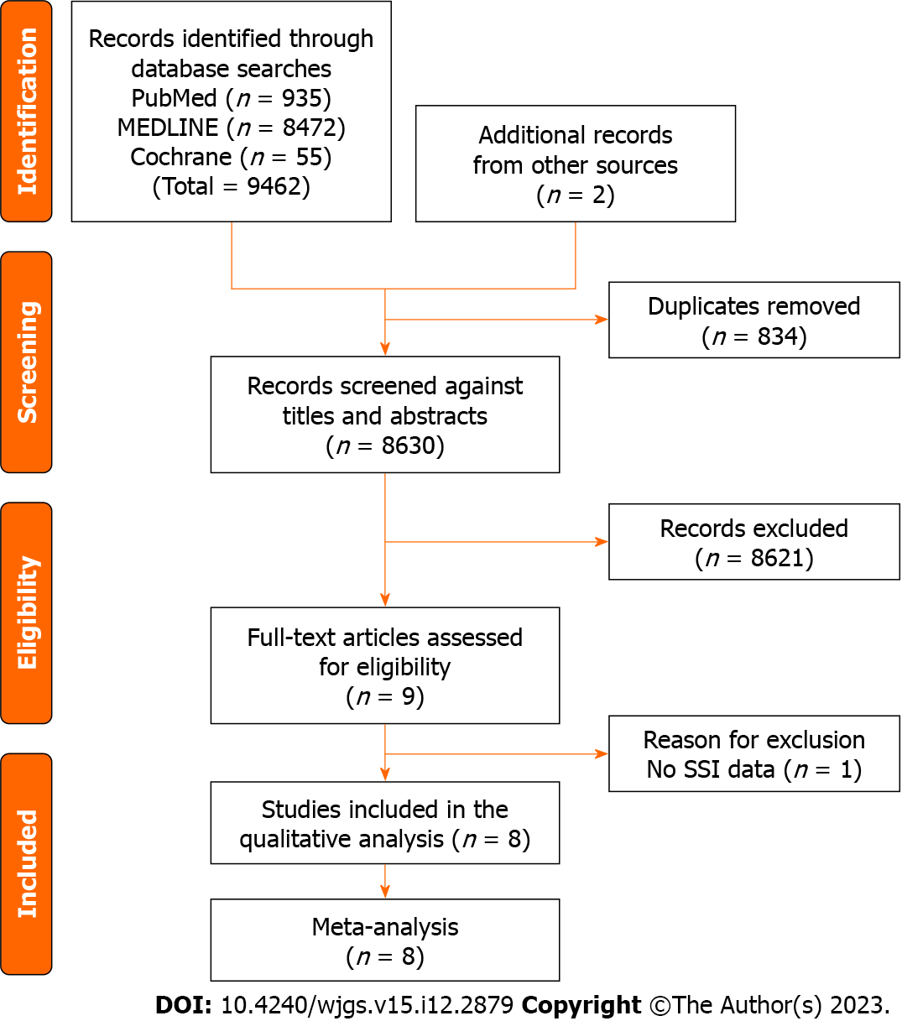
Figure 1 Flow diagram of systematic reviews and meta-analyses. SSI: Surgical site infection.

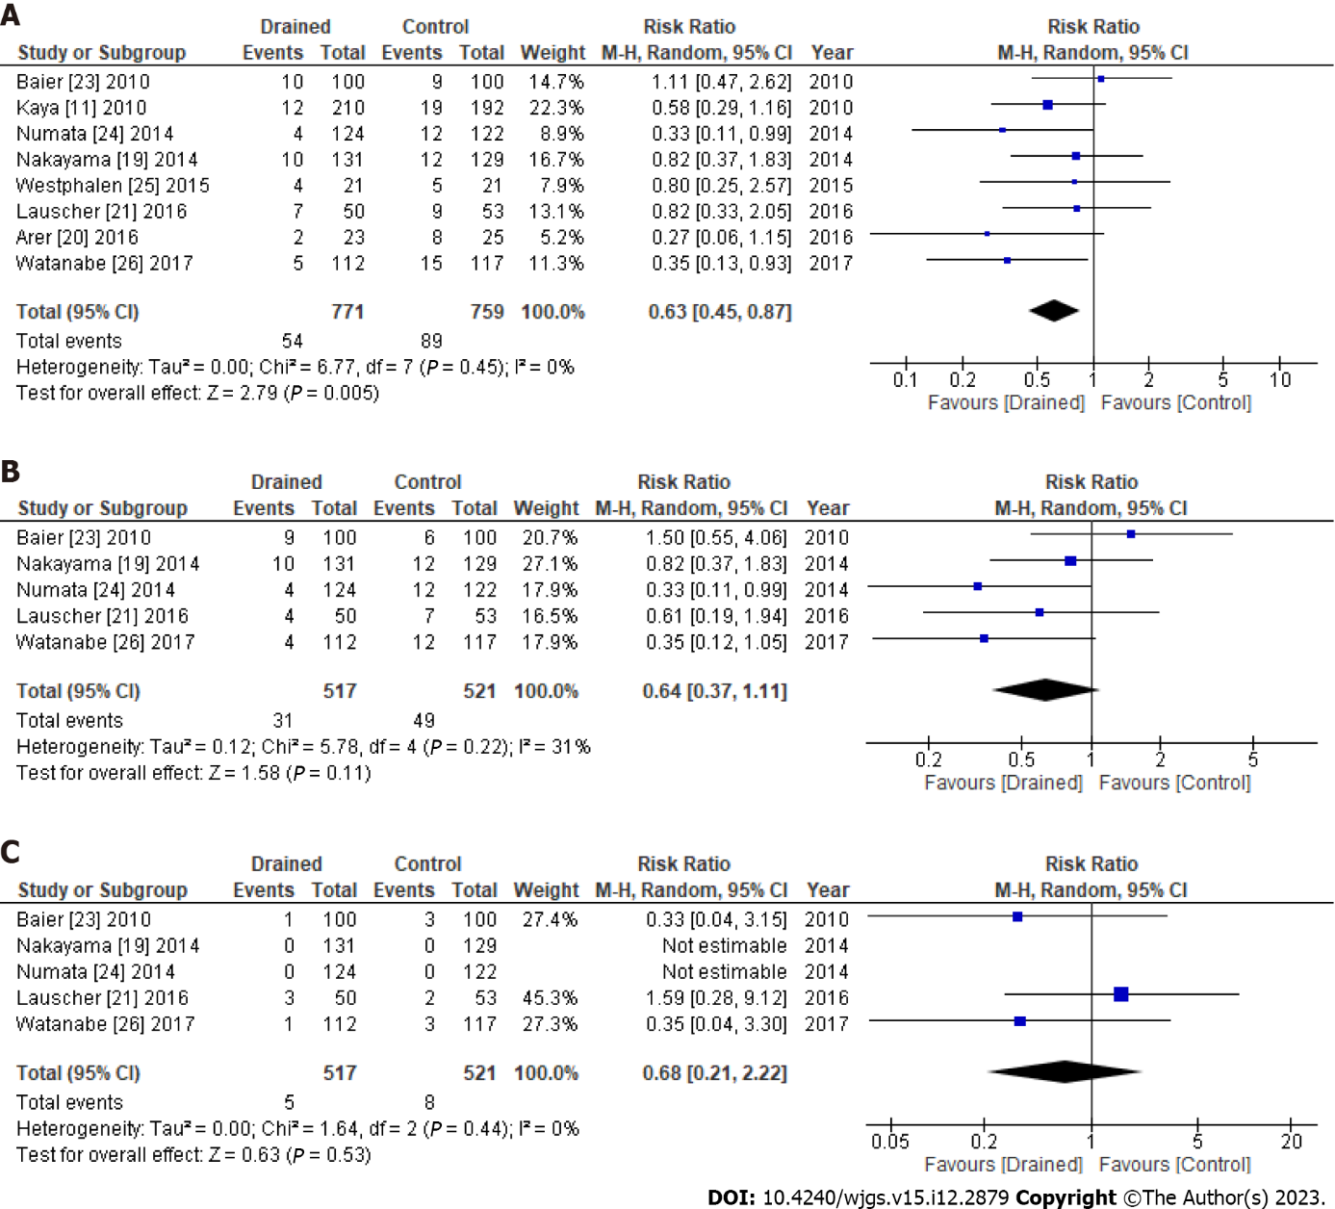
Figure 2 Surgical site infections in the subcutaneous drain group vs the control group after abdominal surgery. A: Total surgical site infections; B: Superficial surgical site infections; C: Deep surgical site infections. CI: Confidence interval.

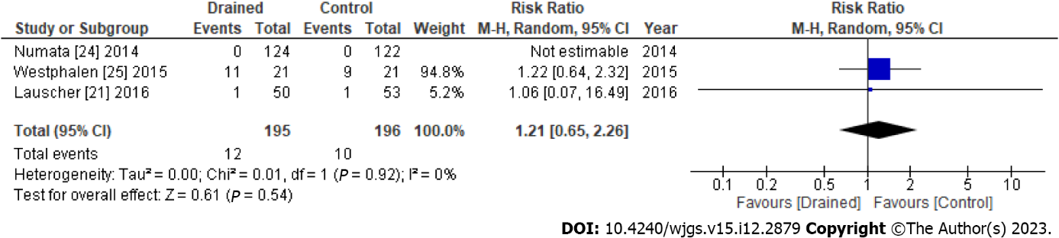
Figure 3 Seroma formation in the subcutaneous drain group vs the control group after abdominal surgery. CI: Confidence interval.

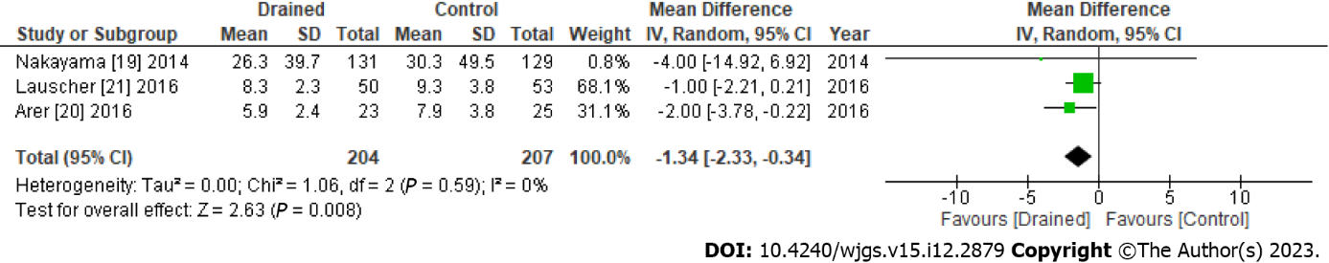
Figure 4 Hospital stays in the subcutaneous drain group vs the control group after abdominal surgery. CI: Confidence interval.

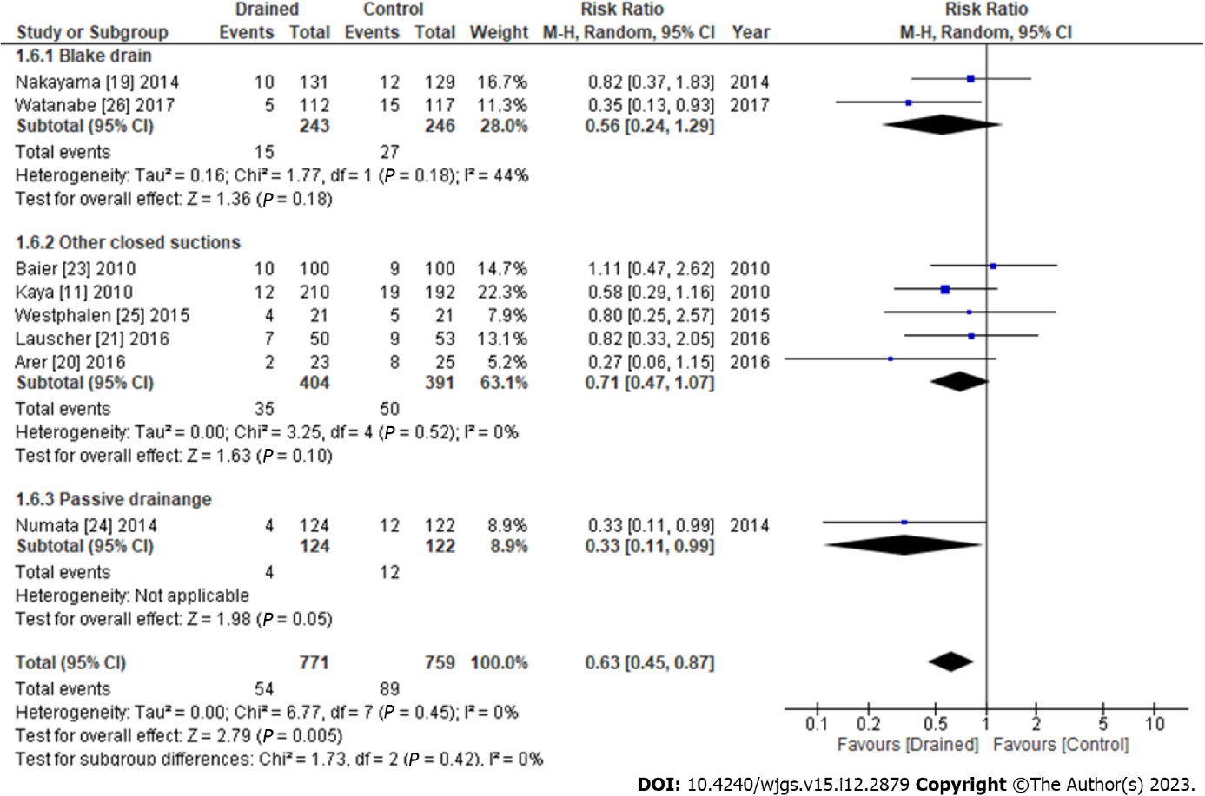
Figure 5 Subgroup analysis of surgical site infections depending on drain types. CI: Confidence interval.

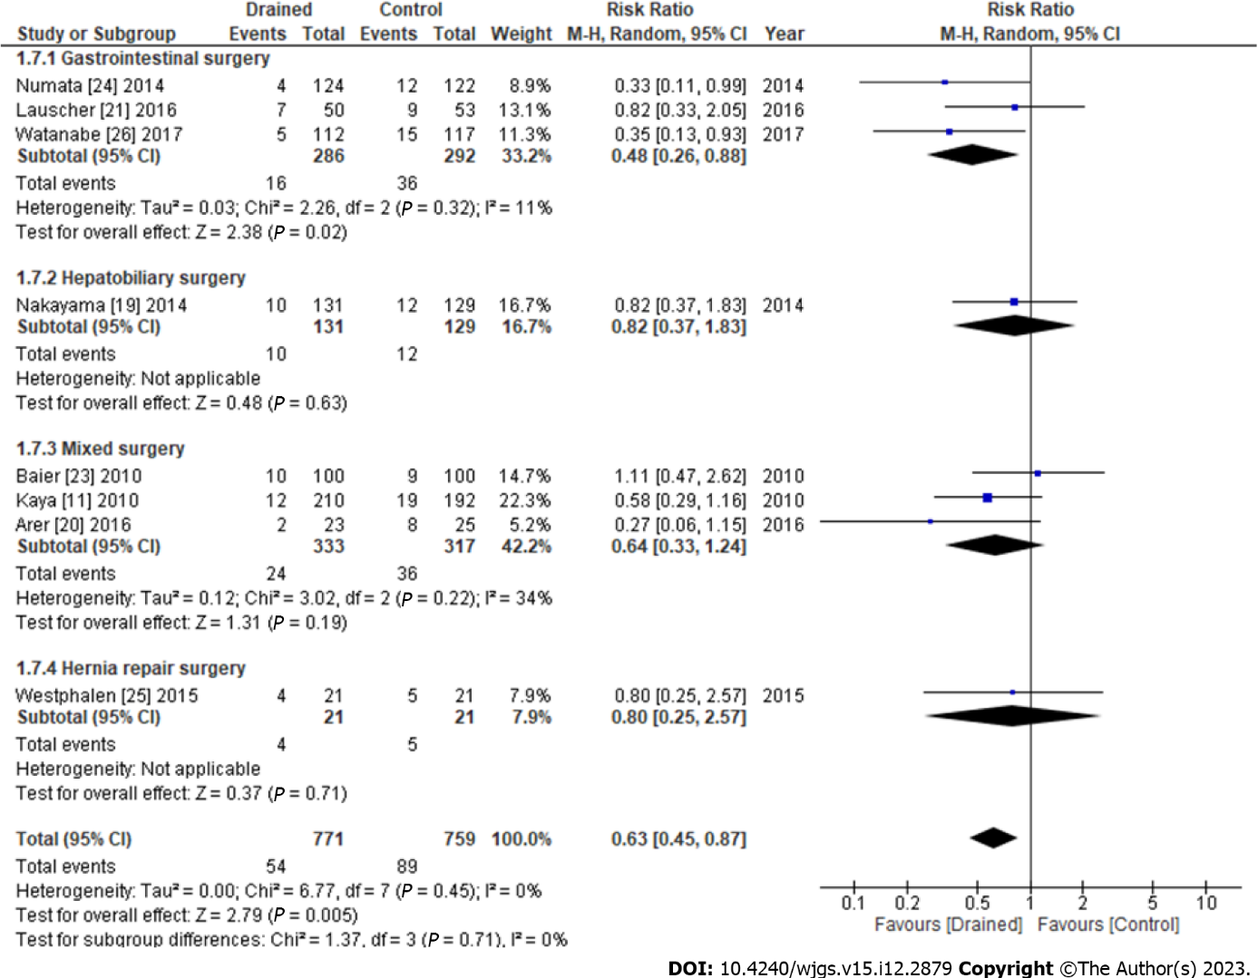
Figure 6 Subgroup analysis of surgical site infections depending on surgical procedures. CI: Confidence interval.

Table 1 Summary of clinical outcomes in each study for the subcutaneous drain group vs the control group after abdominal surgery
Ref. | Year | Drained, n | Control, n | Total SSI, n | Superficial SSI, n | Deep/organ SSI, n | Seroma, n | Hospital stay, mean ± SD | Mortality, n
Baier et al^{[23]} | 2010 | 100 | 100 | 10:9 | 9:6 | 1:3 | ND | ND | ND
Kaya et al^{[11]} | 2010 | 210 | 192 | 12:19 | ND | ND | ND | ND | ND
Nakayama et al^{[19]} | 2014 | 131 | 129 | 10:12 | 10:12 | 0:0 | ND | 26.3 ± 39.7 : 30.3 ± 49.5 | 1:0
Numata et al^{[24]} | 2014 | 124 | 122 | 4:12 | 4:12 | 0:0 | 0:0 | ND | ND
Westphalen et al^{[25]} | 2015 | 21 | 21 | 4:5 | ND | ND | 11:9 | ND | 0:0
Arer et al^{[20]} | 2016 | 23 | 25 | 2:8 | ND | ND | ND | 5.9 ± 2.4 : 7.9 ± 3.8 | ND
Lauscher et al^{[21]} | 2016 | 50 | 53 | 7:9 | 4:7 | 3:2 | 1:1 | 8.3 ± 2.3 : 9.3 ± 3.8 | ND
Watanabe et al^{[26]} | 2017 | 112 | 117 | 5:15 | 4:12 | 1:3 | ND | ND | 0:0
ND: Not described; SD: Standard deviation; SSI: Surgical site infection.

Published by Baishideng Publishing Group Inc
7041 Koll Center Parkway, Suite 160, Pleasanton, CA 94566, USA
Telephone: +1-925-3991568
E-mail: bpgoffice@wjgnet.com
Help Desk: https://www.f6publishing.com/helpdesk
https://www.wjgnet.com

© 2023 Baishideng Publishing Group Inc. All rights reserved.

