Name of Journal: World Journal of Gastroenterology
Manuscript NO: 69063
Manuscript Type: ORIGINAL ARTICLE

Basic Study
Recombinant protein Schistosoma japonicum-derived molecule attenuates dextran sulfate sodium-induced colitis by inhibiting miRNA-217-5p to alleviate apoptosis

Zhang LC et al. rSj16 attenuates colitis by alleviating apoptosis

Li-Chao Zhang, Xiao-Ying Wu, Rui-Bing Yang, Fang Chen, Jia-Hua Liu, Yun-Yi Hu, Zhong-Dao Wu, Li-Fu Wang, Xi Sun

Li-Chao Zhang, Rui-Bing Yang, Jia-Hua Liu, Yun-Yi Hu, Zhong-Dao Wu, Xi Sun, Department of Parasitology of Zhongshan School of Medicine, Sun Yat-sen University, Guangzhou 510000, Guangdong Province, China

Xiao-Ying Wu, Department of Gastroenterology, Third Affiliated Hospital of Sun Yat-sen University, Guangzhou 510630, Guangdong Province, China

Fang Chen, School of Medicine, South China University of Technology, South China University of Technology, Guangzhou 510000, Guangdong Province, China

Lifu Wang, Key Laboratory of Tropical Disease Control, Ministry of Education, Sun Yat-sen University, Guangzhou 510080, Guangdong Province, China

Author contributions: Sun X contributed to the experiment design; Wu ZD, Yang RB, and Chen F contributed to the experiment implementation; Liu JH and Hu YY analyzed the data; Zhang LC and Wang LF conceived the experiments, performed the experiments, and wrote the manuscript; all authors participated in critical revision of the manuscript and approved the final manuscript.

Supported by the National Natural Science Foundation of China, No. 81902081 and No. 81871682; the Natural Science Foundation of Guangdong Province, No. 2020A1515011573 and No. 2019A1515012068; China Postdoctoral Science Foundation, No. 2018M640858 and No. 2019T120771; Fundamental Research Funds for the Central Universities, No. 19ykpy170, No. 17ykpy09 and No. 19ykpy29; National Science and Technology Major Project, No. 2018ZX10101002-001; the 111 Project, No. B12003; and the Natural Science Foundation of Guangdong Province, No. 2021A1515010976.

Corresponding author: Li-Fu Wang, DO, Research Scientist, Key Laboratory of Tropical Disease Control, Ministry of Education, Sun Yat-sen University, No. 74 Zhongshan Road, Guangzhou 510080, Guangdong Province, China. wanglf99999@163.com

Received: June 16, 2021
Revised: July 9, 2021
Accepted: November 29, 2021
Published online: December 14, 2021

Abstract
BACKGROUND
Inflammatory bowel disease (IBD) affects millions of people worldwide and has emerged as a growing problem in industrialized nations. The lack of therapeutic targets has limited the treatment of IBD. Studies found that parasitic nematode infections can ameliorate clinical and experimental colitis. Our previous study found that rSj16, a 16-kDa secreted protein of Schistosoma japonicum produced by Escherichia coli, has protective effects on dextran sulfate sodium (DSS)-induced colitis in mice. Apoptosis is an important factor in the pathogenesis of colitis. However, it is not clear whether the effect of rSj16 on colitis is related to apoptosis.

AIM
To investigate whether the protective effects of rSj16 on colitis is related to apoptosis and its mechanism.

METHODS
In-vivo, colitis was induced by DSS. The severity of colitis was assessed. WB was used to detect the changes of apoptosis-related genes in colon tissues. Q-PCR was used to detect the changes of miRNA-217-5p and HNF1B. In-vitro, WB was used to detect the changes of apoptosis-related genes in intestinal epithelial cells. TUNNEL staining and flow cytometry were used to detect cell apoptosis.

RESULTS
rSj16 attenuates clinical activity in DSS-induced colitis mice. TUNNEL staining and WB results showed that apoptosis was increased in colon tissue after treatment with DSS, and the apoptosis of colon tissue was significantly reduced after treatment with rSj16. Compared with normal mice, the expression of miR-217-5p was increased in colon tissue of DSS-induced colitis mice. In addition, the miR-217-5p target gene hnf1b was decreased after administration of DSS. After treatment with rSj16, the expression of miR-217-5p was decreased and the expression of HNF1B was increased compared with the DSS-treated group. When Etoposide was used in combination with miR-217-5p mimic on MODE-K cells, the expression of cleaved-Caspase-3 and Bax was increased, and Bcl-2 was decreased compared with only Etoposide treatment, the expression of HNF1B was significantly reduced, suggesting that miR-217-5p acts as a pro-apoptotic in colon epithelial cells and down-regulates the target gene hnf1b. After rSj16 administration in MODE-K cells, miR-217-5p expression was significantly decreased, HNF1B expression was increased, and apoptosis was reduced.

CONCLUSION
The protective effects of rSj16 on colitis is related to apoptosis and miRNA-217-5p may be a further target for therapeutic intervention against IBD.

Key Words: Schistosoma japonicum; rSj16; Inflammatory bowel disease; Apoptosis; miRNA-217-5p

©The Author(s) 2021. Published by Baishideng Publishing Group Inc. All rights reserved.

Citation: Zhang LC, Wu XY, Yang RB, Chen F, Liu JH, Hu YY, Wu ZD, Wang LF, Sun X. Recombinant protein Schistosoma japonicum-derived molecule attenuates dextran sulfate sodium-induced colitis by inhibiting miRNA-217-5p to alleviate apoptosis. World J Gastroenterol 2021; 27(46): 7982-7994
URL: https://www.wjgnet.com/1007-9327/full/v27/i46/7982.htm
DOI: https://dx.doi.org/10.3748/wjg.v27.i46.7982

Core Tip: The lack of therapeutic targets has limited the treatment of inflammatory bowel disease (IBD). Parasitic nematode infections can ameliorate clinical and experimental colitis. Our previous study found that rSj16, a 16-kDa secreted protein of Schistosoma japonicum produced by Escherichia coli, has protective effects on dextran sulfate sodium (DSS)-induced colitis in mice. We found that rSj16 can inhibit DSS-induced apoptosis in the colons of mice with colitis. In addition, we found that the inhibitory effect of rSj16 on apoptosis was associated with decreased miR-217-5p, and that hepatocyte nuclear factor 1 beta was increased after treatment with rSj16. These results highlight a novel therapeutic target that may be used to treat IBD.

INTRODUCTION
Inflammatory bowel disease (IBD) affects millions of people worldwide and has emerged as a growing problem in industrialized nations^{[1]}. The two distinct forms of IBD, ulcerative colitis and Crohn’s disease, are characterized by intermittent, chronic or progressive inflammation^{[2]}. The etiologies of both forms are multifactorial, including immunoregulatory factors, genetic susceptibility, environmental changes, and abnormalities of gut microbiota. Traditional treatments for IBD include 5-aminosalicylic acid agents, steroids, and antimicrobials. However, as these drugs have limitations and many patients cannot achieve remission, a research focus in this field is to devise biological therapies for the treatment of IBD.
Recent studies have demonstrated that helminth Schistosoma can protect against IBD. In a DSS-induced mouse colitis model, an attenuated inflammatory response was found in those infected with Schistosoma japonicum (S. japonicum)^{[3]}. Schistosoma mansoni (S. mansoni) egg antigen has a beneficial modulatory effect in a DSS-induced mice colitis model^{[4]}. In adult male mice with colitis, S. mansoni infection modulates the colitis mice immune system, suppressing colitis and limiting dysbiosis of intestinal microbiome^{[5]}. Infection with S. mansoni also attenuates disease in rats with trinitrobenzene sulfonic acid (TNBS)-induced colitis^{[6]}. Our previous study confirmed that exosomes derived from dendritic cells treated with S. japonicum soluble egg antigen attenuate DSS-induced colitis in mice^{[7]}. Furthermore, we have also shown that rSj16 has protective effects on DSS-induced mouse colitis^{[8]}.
Apoptosis is an important factor in the pathogenesis of colitis. Abnormal apoptosis of intestinal epithelial cells (IECs) is frequently found in IBD^{[9,10]}. IEC apoptosis results in disruption of intestinal barrier integrity, and may allow the infiltration of bacteria, triggering an inflammatory cascade^{[11]}. Aberrant IEC apoptosis stimulates the production of tumor necrosis factor-alpha (TNF-α) and interferon gamma (IFN-γ), both of which further induce IEC apoptosis^{[12]}. MicroRNAs are critical post-transcriptional regulators of gene expression and key mediators of pathophysiology of inflammatory bowel disease (IBD)^{[13]}. However, the molecular basis of IEC apoptosis in the pathogenesis of IBD remains unclear.
MicroRNAs (miRNAs) are small non-coding RNAs that are about 22 nucleotides long. MiRNAs negatively regulate gene expression at the post-transcriptional or translational level by complementary binding to the 3′-untranslated region(UTR). MiRNAs control genes involved in cellular processes such as inflammation, cell-cycle regulation, stress response, differentiation, apoptosis, and migration^{[14,15]}. Studies have shown that miRNAs play an important role in IBD. For example, miR-301a promotes intestinal mucosal inflammation by inducing IL-17A and TNF-α in IBD^{[16]}. MiR-31 is increased in colon tissues of patients with IBD, reduces inflammatory signaling and promotes colon regeneration^{[17]}. Myeloid-derived miR-223 Limits intestinal inflammation by constraining the nlrp3 inflammasome^{[18]}. Upregulation of miR-665 promotes apoptosis and colitis in inflammatory bowel disease by repressing the endoplasmic reticulum stress components XBP1 and ORMDL3^{[19]}. In Shamran’s study, miR-217 may induce Sirt-1 and provide protection against intestinal inflammation^{[20]}. The hepatocyte nuclear factor (HNF) superfamily of transcription factors is essential for the development and maintenance of a variety of humans and mice tissues, and is further classified into four families, HNF1, FOXA, HNF4, and ONECUT, based on their functional domains. In gut, HNFs are expressed in IECs, which regulate a variety of physiological functions, including differentiation, barrier function, and metabolism^{[21]}. Hepatic nuclear factor-4α (HNF4α) mRNA level was also downregulated in mouse model of ileitis (SAMP) compared with control mice^{[22]}. Hepatocyte nuclear factor-1beta (HNF1B) is the most important liver-specific transcription factor, with responsibility for sequence-specific DNA binding. HNF1B is reportedly a target of miR-217, with a role in circ-TTBK2- and miR-217-mediated modulation of malignant glioma progression^{[23]}.
In this study, we investigate whether the protective effects of rSj16 on colitis is related to apoptosis and its mechanism. miRNA may function through regulating the expression of encoding genes in IBD^{[16]}. We explore the relationship between rSj16, miR-217-5p and IBD, providing theoretical support for the clinical application of rSj16 in the treatment of IBD.

MATERIALS AND METHODS
Animals and ethics
Male BALB/c mice (aged 6 wk, 18-20 g) were purchased from the Experimental Animal Center of Guangdong. All animal experimental procedures were approved by the Medical Research Ethics Committee of Sun Yat-sen University (SYSU-IACUC-2019-B517) and conformed to the Chinese National Institute of Health Guide for the Care and Use of Laboratory Animals.

Induction and treatment of colitis
Recombinant protein (rSj16) was expressed and purified as described previously^{[8]}. A total of 15 mice were randomly assigned to three groups. Acute colitis was induced by administering water with 3% (wt/vol) DSS (36–50 kDa; MP Biomedicals, Illkirch, France) to mice over a period of 7 d. The control mice (n = 5) received drinking water. Over the same period, rSj16 was administered to the colitis mice (n = 5) via intraperitoneal (i.p.) injection (100 μg per mouse) on each day from 1 to 7. Control groups (n = 5) received the same volume of vehicle (phosphate buffered saline; PBS) over the same time frame. The mice were fed standard mouse chow.

Clinical scoring
During treatment, mice were observed daily. Changes in body weight, occurrence of diarrhea and bleeding were recorded. Blood in the feces was determined using a Hemoccult assay kit (Nanjing Jiancheng Bio-engineering Institute, China). A clinical disease score (disease activity index, DAI) was evaluated based on weight loss, diarrhea, and bleeding as described previously^{[8]}.

Macroscopic assessment and histologic analysis
Mice were sacrificed on day 7. Colon length was measured, and the macroscopic scores of colons were assessed by an independent observer who was blinded to treatment status^{[7]}. The colons were fixed in 4% formaldehyde and then embedded in paraffin. Colon sections were prepared and stained with hematoxylin and eosin (H & E). Histopathological scores were determined in a blinded fashion, according to the criteria described in our previous study.

Cell culture and treatment
Mouse intestinal epithelial cell line, MODE-K cells were purchased from the BeNa Culture Collection (BNCC, China). The cells were cultured with Dulbecco’s modified eagle medium (DMEM) (Gibco; Thermo Fisher Scientific, Inc.) supplemented with 10% fetal bovine serum (FBS) (Gibco; Thermo Fisher Scientific, Inc.), 100 IU/mL penicillin and 100 mg/mL streptomycin (Invitrogen; Thermo Fisher Scientific, Inc.), incubated in a 5% CO₂ environment at 37 °C. The cells were seeded one day prior to transfection in 12-well cell culture plates. Cells were incubated in a serum-free medium for starvation overnight, then stimulated with miRNA mimic (Assay ID: MIMAT0000679) or mimic control (50 nM, Ruibo, Guangzhou, China) using RNAi MAX (Invitrogen, United States). MiRNA mimics are miRNAs that mimic endogenous miRNAs and can be synthesized by chemical synthesis to enhance the function of endogenous miRNAs.

Flow cytometry
MODE-K cells were seeded in 6-well plates and treated with mimic control, miRNA mimic, miRNA mimic + Etoposide (MedChemExpress, United States, 25 μM)^{[24]}, and miRNA mimic + Etoposide + rSj16 (4 μg/mL) for 48 h. Adherent and floating cells were collected and resuspended in 100 μl binding buffer. Each group of cells was stained with 2 μl Annexin-V FITC and propidium iodide (PI, BD Biosciences) at room temperature for 15 min. Samples were analyzed using a CytoFLEX S flow cytometer (Beckman Coulter, United States).

Western blot
MODE-K cells were homogenized with a protein extraction reagent buffer (RIPA; Beyotime Institute of Biotechnology) containing protease and phosphatase inhibitors. Protein concentration was measured using the bicinchoninic acid assay (Beyotime Institute of Biotechnology, China). Equal amounts of proteins were separated by 10% SDS-PAGE and transferred to a polyvinylidene fluoride blotting membrane (GE Healthcare Life Sciences, UK). The membrane was blocked by 10% milk. The membrane was incubated with a primary antibody (proteintech cleaved-Caspase3, Cat No. 19677-1-AP; Bax, Cat No. 50599-2-Ig; Bcl-2, Cat No. 12789-1-AP; HNF1B, Cat No. 12533-1-AP; GAPDH Sigma-Aldrich G9295) diluted 1:1,000 overnight at 4 °C, followed by incubation with the secondary antibody (ProteinTech Group, Inc.; anti-mouse, cat. no. SA00001-1; anti-rabbit, cat. no. SA00001-2) diluted 1:2000 at room temperature for 2 h. Immunodetection was performed using enhanced chemiluminescence reagent (Thermo Fisher Scientific, Inc.) and visualized using chemiluminescence gel imaging system (Tanon-5200 Multi, Shanghai China). ImageJ (×64) software (National Institutes of Health) was used to quantify the results^{[25]}.

TUNEL staining method
MODE-K cells treated with mimic control, miRNA mimic, miRNA mimic + Etoposide, and miRNA mimic + Etoposide + rSj16 were inoculated into 24-well plates for 48 h then fixed with 4% paraformaldehyde for 15 min at room temperature. Diluted TUNEL staining fluid (Beyotime Institute of Biotechnology) was added to cells and colon histological sections according to the manufacturer’s instructions. PBS was used to wash cells, followed by DNA staining with DAPI at room temperature for 10 min, and the staining was observed using a Leica DMI4000B fluorescence microscope (magnification, ×10), positive cells were quantified by Image J software.

RNA extraction and quantitative reverse-transcription PCR
Total RNA was harvested using TRIzol according to manufacturer’s instructions, including MODE-K cells and 50 mg mouse colon tissue samples. Complementary DNA (cDNA) was synthesized from 1.0 μg of total RNA with oligo (dT) primers using a cDNA Synthesis Kit (Takara, Japan). The expression of mRNA and miRNA was determined using a SYBR Green Master Mix kit (Takara, Japan), primer sequences are shown in Table 1. GAPDH or U6 were used as an internal control, and the fold change was calculated by the 2^{-ΔΔCT} method.

Dual-luciferase reporter assay
HEK 293T cells were transfected using the HNF1B UTR reporter plasmid together with miR-217-5p mimic or control mimic for 48 h using Lipofectamine® 3000 (Invitrogen; Thermo Fisher Scientific, Inc). Following this period, cells were lysed using the Dual-Glo® Reagent (Dual-Glo® Luciferase Assay System; Promega Corporation). Renilla luciferase assay substrate and firefly luciferase detection reagent were added and luciferase activities were detected using the Infinite F500 Multimarker Analyser (TECAN, Austria) according to the manufacturer’s instructions. Renilla luciferase was used as an internal reference, with luciferase activity normalized to Renilla luciferase activity^{[26]}.

Statistical analysis
All data are expressed as means ± SD. Results were compared between the two groups using an unpaired two-sample t-test. Multiple comparisons between more than two groups were analysed by one-way ANOVA test or Kruskal–Wallis test (non-parametric). The value of P < 0.05 was considered statistically significant.

RESULTS
rSj16 protects against acute DSS-induced colitis
As found in our previous study^{[8]}, after DSS administration, the mice lost weight over time. At the same time, the DAI of mice with colitis also increased with time. After treatment with rSj16, body weight loss and DAI were both significantly alleviated in mice with colitis (Figure 1A and B). Colon length was significantly reduced by application of DSS, and was restored after rSj16 treatment (Figure 1C and D). Mean colon macroscopic scores were significantly suppressed in DSS + rSj16 group compared with DSS + PBS group (Figure 1E). Additionally, H&E histopathology results showed that treatment with rSj16 significantly reduced inflammation (Figure 1F). Consistent with this, histopathological scores after treatment with rSj16 + DSS were significantly lower than after treatment with DSS + PBS (Figure 1G and Table 2).

rSj16 inhibit DSS induced apoptosis of colon epithelial cells
IEC apoptosis is increased in affected areas of IBD^{[27]}, leading to the disruption of intestinal barrier integrity that may allow bacteria to penetrate into the intestinal wall from the intestinal cavity and trigger an inflammatory cascade, including the production of pro-inflammatory cytokines, to remove the invading bacteria^{[28,29]}. In the present study, to investigate the mechanism by which rSj16 alleviates DSS-induced acute colitis, 3% DSS was administered to mice daily for 7 d, and western blot was performed to detect the apoptosis of colon epithelial cells in mice. As shown in Figure 2A, the pro-apoptotic protein cleaved-Caspase-3 and Bax were increased, while the anti-apoptotic protein Bcl-2 was decreased after treatment with DSS + PBS compared with the Water + PBS, indicating that DSS can induce apoptosis of colon epithelial cells. In addition, pro-apoptotic Bax was decreased and anti-apoptotic protein Bcl-2 was increased after treatment with rSj16 + DSS compared with DSS + PBS. These results demonstrate that rSj16 may significantly inhibit DSS-induced colon epithelial cells apoptosis (Figure 2A). TUNEL staining, indicating apoptosis, was increased in colon tissue and the number of TUNEL positive cells decreased significantly after administration of rSj16 (Figure 2B).

rSj16 inhibits the expression of miR-217-5p in the colon of mice with DSS-induced colitis
Research has shown that down-regulation of miR-217-5p may reduce the apoptosis of cardiomyocyte derived cell lines^{[30]}. We found that, compared with Water-treated mice, the expression of miR-217-5p was increased in colon tissue of mice with DSS-induced colitis. In addition, the miR-217-5p target gene hnf1b was decreased after administration of DSS. After treatment with rSj16, the expression of miR-217-5p was decreased and the expression of hnf1b was increased compared with the DSS-treated group (Figure 3A and B). Pearson’s correlation coefficient analysis showed a negative correlation between miR-217-5p and HNF1B in in colon tissue of mice (r = -0.3463, P < 0.05) (Figure 3C). Western blot results also indicated that HNF1B was decreased after DSS treatment, and was increased after rSj16 treatment compared with DSS-treated group (Figure 3D and E).
In order to verify whether miR-217-5p regulates the expression of HNF1B, we generated a luciferase reporter plasmid contained 3'- UTR of HNF1B and located on both sides of the binding site of miR-217-5p. Relative luciferase activity of the reporter containing the predicted miR-217-5p binding sites for 3′UTR of HNF1B mRNA transcript was significantly reduced when co-transfected with miR-217-5p mimic compared with a control mimic (Figure 3F). Studies have shown that miRNA-217-5p is closely related to apoptosis^{[24,31]}. Etoposide (an apoptosis inducer) was used to induce the apoptosis of MODE-K, and qPCR results showed that increased miRNA-217-5p expression, and decreased miR-217-5p target gene hnf1b expression in the process of apoptosis. However, rSj16 may inhibit the expression of miR-217-5p, and increase the expression of hnf1b (Figure 3G and H).

rSj16 anti-apoptotic action via regulation of miR-217-5p/HNF1B axis
We further verified the role of miR-217-5p in the process of apoptosis, and the mechanism of rSj16 in regulating apoptosis. Western blot showed that when Etoposide was used in combination with miR-217-5p mimic on MODE-K cells, the expression of cleaved-Caspase-3 and Bax was increased, and Bcl-2 was decreased compared with only Etoposide treatment, and the expression of HNF1B was significantly reduced. These results indicate that miR-217-5p acts as a pro-apoptotic in colon epithelial cells and down-regulates the target gene hnf1b. In addition, the expression of cleaved-Caspase-3 and Bax was decreased, while Bcl-2 and HNF1B were increased in mice treated with Etoposide + miR-217-5p + rSj16 compared with Etoposide + miR-217-5p (Figure 4A and B). TUNEL staining of MODE-K after treatment of Etoposide, Etoposide + miR-217-5p, and Etoposide + miR-217-5p + rSj16, showed that the number of TUNEL positive cells increased with Etoposide + miR-217-5p and decreased after treatment with rSj16 (Figure 4C and D). Flow cytometry results also showed that miR-217-5p could obviously promote MODE -K apoptosis. However, rSj16 could significantly inhibit MODE -K apoptosis induced by Etoposide and miR-217-5p. (Figure 4E and F).

DISCUSSION
IBD encompasses Crohn’s disease, ulcerative colitis and IBD-unclassified. Although newer treatments have increased the chances of remission, most IBD patients cannot maintain remission, and death is not an infrequent outcome of IBD^{[32,33]}. Therefore, it is very important to explore the pathogenesis of IBD and to find effective therapeutic targets. We have found that rSj16 (a 16-kDa secreted protein of Schistosoma japonicum) has protective effects on DSS-induced mouse colitis. Body weight loss was alleviated in mice with colitis after treatment with rSj16. DAI (evaluated based on weight loss, diarrhea, and bleeding) also alleviated in colitis mice after treatment with rSj16. The results of colon length, mean colon macroscopic scores (assessed by hyperemia, wall thickening, ulceration, inflammation extension, and damage), H&E, and histopathological scores (based on extent of inflammation, neutrophil and lympho-histiocyte infiltration, crypt damage, crypt abscess formation, sub-mucosal edema, goblet cell loss, and reactive epithelial hyperplasia displayed) indicate that rSj16 protects against acute DSS-induced colitis.
Apoptosis is an important factor in the pathogenesis of colitis. DSS has been shown to initially cause damage in the colon by inhibition of proliferation and induction of apoptosis^{[34]}. In the present study, we found significant apoptosis of colon epithelial cells after DSS administration in mice, and inhibition of the DSS-induced apoptosis after administration of rSj16. Therefore, we hypothesized that rSj16 alleviates DSS-induced colitis, in part by regulating apoptosis.
In recent years, miRNAs have become the key biomarkers and novel therapeutic targets in IBD^{[16,35]}. MiR-217-5p plays dual roles in regulating cell survival and apoptosis. Flum et al reported that miR-217-5p could induce apoptosis by regulating multiple target genes involved in the ERK-MAPK signaling pathway including PRKCI, BAG3, ITGAV, and MAPK1^{[24]}. Gao et al indicated that upregulation of miR-217-5p significantly inhibited TGF-β1-induced proliferation, migration, extracellular matrix (ECM) deposition, and promoted apoptosis in airway smooth muscle cells^{[36]}. However, Yi et al indicated that upregulation of miR-217-5p improved cell viability and attenuated cell apoptosis in SH-SY5Y cells subjected to oxygen–glucose deprivation/reperfusion^{[37]}. The specific regulatory mechanism between miR-217-5p and apoptosis needs to be further studied. In our study, miRNA miR-217-5p was expressed at a high level in IBD mice colon tissues, and was decreased significantly following treatment with rSj16. After inducing MODE-K apoptosis, miR-217-5p expression was significantly increased, after rSj16 treatment, miR-217-5p expression was significantly reduced. Therefore, we hypothesized that miR-217-5p is involved in the protective effects of rSj16 on colitis. Bcl-2, caspase-3, and Bax play key roles in cell apoptosis^{[38]}. Caspase-3 is a marker of apoptosis because its activity is required for major apoptosis-related morphological and biochemical events, and its activation and function are regulated by the Bcl-2 family of proteins, among other molecules^{[39]}. In the present study, after overexpression of miR-217-5p in MODE-K cells, cleaved-Caspase-3 and Bax expression were increased, but Bcl-2 was reduced, suggesting that miR-217-5p plays a pro-apoptotic role in MODE-K cells. After rSj16 treatment, the miR-217-5p, cleaved- Caspase-3 and Bax expression were decreased, but Bcl-2 was increased, indicating that rSj16 could reduce the apoptosis. Results showed that miR-217-5p aggravated MODE-K cells apoptosis and rSj16 could significantly inhibit the apoptosis by inhibiting miRNA-217-5p expression.
MiRNAs exert pro-apoptotic functions by regulating the expression of target genes^{[40]}. hnf1b acts as an oncogene in various tumors, is overexpressed in human prostate cancer and could promote tumor cell proliferation^{[41]}. Early deletion of HNF1B results in a decrease in the number of pancreatic multipotent progenitor cells due to reduced proliferation and increased apoptosis^{[42]}. In our study, we found that hnf1b is the direct target gene of miR-217-5p. In the present study, we found that DSS may induce apoptosis of colon epithelial cells, with increased expression of miR-217-5p and decreased expression of its target gene hnf1b. We speculated that miR-217-5p/HNF1B was involved in DSS-induced apoptosis of colon epithelial cells. Subsequently, we induced apoptosis and overexpression of miR-217-5p in MODE-K cells. After treatment with rSj16, the expression of miR-217-5p in tissues and MODE-K cells was decreased, the expression of its target gene hnf1b was increased, and the apoptosis of MODE-K cells significantly reduced. The results suggested that miR-217-5p exerted pro-apoptotic functions by regulating expression of the target gene hnf1b.
As for the limitations of the study, because rSj16 affects the progress of the disease through multiple pathways, we only explore one of them, suggesting that miR-217-5p/HNF1B axis could be used as a potential target for the treatment of enteritis. In addition, rSj16 may attenuate IBD through other pathways which we didn’t make a comprehensive exposition, it is still worth exploring. Next, we will conduct a more comprehensive study on the treatment of IBD with rSj16, to provide more possibilities for the development of colitis drugs.

CONCLUSION
In conclusion, rSj16 attenuates IBD in mice by regulating the miR-217-5p/ HNF1B axis to reduce colon epithelial cell apoptosis. These data indicated that miR-217-5p and HNF1B may be potential biomarkers to improve the accuracy of IBD diagnosis and treatment, and that rSj16 may have potential for clinical drug development.

ARTICLE HIGHLIGHTS
Research background
Inflammatory bowel disease (IBD) encompasses Crohn’s disease, ulcerative colitis and IBD-unclassified. Although newer treatments have increased the chances of remission, most IBD patients cannot maintain remission, and death is not an infrequent outcome of IBD. Therefore, it is very important to explore the pathogenesis of IBD and to find effective therapeutic targets.

Research motivation
Exploring the pathogenesis of IBD and to find effective therapeutic targets.

Research objectives
To apoptosis and its mechanism.

Research methods
In-vivo, after DSS inducing colitis. The severity of colitis was assessed. WB was used to detect the changes of apoptosis-related genes in colon tissues. In-vitro, WB, Qpcr and tunel was used to detect the changes of apoptosis.

Research results
rSj16 attenuates clinical activity in DSS-induced colitis mice. rSj16 could reduce the expression of miR-217-5p in MODE-K cells. rSj16 could regulate the apoptosis of MODE-K cells.

Research conclusions
rSj16 attenuates IBD in mice by regulating the miR-217-5p/ HNF1B axis.

Research perspectives
miR-217-5p and HNF1B may be potential biomarkers to improve the accuracy of IBD diagnosis and treatment, and that rSj16 may have potential for clinical drug development.

REFERENCES
1 Molodecky NA, Soon IS, Rabi DM, Ghali WA, Ferris M, Chernoff G, Benchimol EI, Panaccione R, Ghosh S, Barkema HW, Kaplan GG. Increasing incidence and prevalence of the inflammatory bowel diseases with time, based on systematic review. Gastroenterology 2012; 142: 46-54.e42; quiz e30 [PMID: 22001864 DOI: 10.1053/j.gastro.2011.10.001]
2 Kaplan GG. The global burden of IBD: from 2015 to 2025. Nat Rev Gastroenterol Hepatol 2015; 12: 720-727 [PMID: 26323879 DOI: 10.1038/nrgastro.2015.150]
3 Liu Y, Ye Q, Liu YL, Kang J, Chen Y, Dong WG. Schistosoma japonicum attenuates dextran sodium sulfate-induced colitis in mice via reduction of endoplasmic reticulum stress. World J Gastroenterol 2017; 23: 5700-5712 [PMID: 28883695 DOI: 10.3748/wjg.v23.i31.5700]
4 Hasby EA, Hasby Saad MA, Shohieb Z, El Noby K. FoxP3 + T regulatory cells and immunomodulation after Schistosoma mansoni egg antigen immunization in experimental model of inflammatory bowel disease. Cell Immunol 2015; 295: 67-76 [DOI: 10.1016/j.cellimm.2015.02.013]
5 Floudas A, Aviello G, Schwartz C, Jeffery IB, O'Toole PW, Fallon PG. Schistosoma mansoni Worm Infection Regulates the Intestinal Microbiota and Susceptibility to Colitis. Infect Immun 2019; 87 [PMID: 31138616 DOI: 10.1128/IAI.00275-19]
6 Moreels TG, Nieuwendijk RJ, De Man JG, De Winter BY, Herman AG, Van Marck EA, Pelckmans PA. Concurrent infection with Schistosoma mansoni attenuates inflammation induced changes in colonic morphology, cytokine levels, and smooth muscle contractility of trinitrobenzene sulphonic acid induced colitis in rats. Gut 2004; 53: 99-107 [PMID: 14684583 DOI: 10.1136/gut.53.1.99]
7 Wang L, Yu Z, Wan S, Wu F, Chen W, Zhang B, Lin D, Liu J, Xie H, Sun X, Wu Z. Exosomes Derived from Dendritic Cells Treated with Schistosoma japonicum Soluble Egg Antigen Attenuate DSS-Induced Colitis. Front Pharmacol 2017; 8: 651 [PMID: 28959207 DOI: 10.3389/fphar.2017.00651]
8 Wang L, Xie H, Xu L, Liao Q, Wan S, Yu Z, Lin D, Zhang B, Lv Z, Wu Z, Sun X. rSj16 Protects against DSS-Induced Colitis by Inhibiting the PPAR-α Signaling Pathway. Theranostics 2017; 7: 3446-3460 [PMID: 28912887 DOI: 10.7150/thno.20359]
9 Kiesslich R, Duckworth CA, Moussata D, Gloeckner A, Lim LG, Goetz M, Pritchard DM, Galle PR, Neurath MF, Watson AJ. Local barrier dysfunction identified by confocal laser endomicroscopy predicts relapse in inflammatory bowel disease. Gut 2012; 61: 1146-1153 [PMID: 22115910 DOI: 10.1136/gutjnl-2011-300695]
10 Qiu W, Wu B, Wang X, Buchanan ME, Regueiro MD, Hartman DJ, Schoen RE, Yu J, Zhang L. PUMA-mediated intestinal epithelial apoptosis contributes to ulcerative colitis in humans and mice. J Clin Invest 2011; 121: 1722-1732 [PMID: 21490394 DOI: 10.1172/JCI42917]
11 Günther C, Neumann H, Neurath MF, Becker C. Apoptosis, necrosis and necroptosis: cell death regulation in the intestinal epithelium. Gut 2013; 62: 1062-1071 [PMID: 22689519 DOI: 10.1136/gutjnl-2011-301364]
12 Lin W, Ma C, Su F, Jiang Y, Lai R, Zhang T, Sun K, Fan L, Cai Z, Li Z, Huang H, Li J, Wang X. Raf kinase inhibitor protein mediates intestinal epithelial cell apoptosis and promotes IBDs in humans and mice. Gut 2017; 66: 597-610 [PMID: 26801887 DOI: 10.1136/gutjnl-2015-310096]
13 Kalla R, Ventham NT, Kennedy NA, Quintana JF, Nimmo ER, Buck AH, Satsangi J. MicroRNAs: new players in IBD. Gut 2015; 64: 504-517 [PMID: 25475103 DOI: 10.1136/gutjnl-2014-307891]
14 Di Leva G, Garofalo M, Croce CM. MicroRNAs in cancer. Annu Rev Pathol 2014; 9: 287-314 [PMID: 24079833 DOI: 10.1146/annurev-pathol-012513-104715]
15 Shin VY, Chu KM. MiRNA as potential biomarkers and therapeutic targets for gastric cancer. World J Gastroenterol 2014; 20: 10432-10439 [PMID: 25132759 DOI: 10.3748/wjg.v20.i30.10432]
16 He C, Shi Y, Wu R, Sun M, Fang L, Wu W, Liu C, Tang M, Li Z, Wang P, Cong Y, Liu Z. miR-301a promotes intestinal mucosal inflammation through induction of IL-17A and TNF-α in IBD. Gut 2016; 65: 1938-1950 [PMID: 26338824 DOI: 10.1136/gutjnl-2015-309389]
17 Tian Y, Xu J, Li Y, Zhao R, Du S, Lv C, Wu W, Liu R, Sheng X, Song Y, Bi X, Li G, Li M, Wu X, Lou P, You H, Cui W, Sun J, Shuai J, Ren F, Zhang B, Guo M, Hou X, Wu K, Xue L, Zhang H, Plikus MV, Cong Y, Lengner CJ, Liu Z, Yu Z. MicroRNA-31 Reduces Inflammatory Signaling and Promotes Regeneration in Colon Epithelium, and Delivery of Mimics in Microspheres Reduces Colitis in Mice. Gastroenterology 2019; 156: 2281-2296.e6 [PMID: 30779922 DOI: 10.1053/j.gastro.2019.02.023]
18 Neudecker V, Haneklaus M, Jensen O, Khailova L, Masterson JC, Tye H, Biette K, Jedlicka P, Brodsky KS, Gerich ME, Mack M, Robertson AAB, Cooper MA, Furuta GT, Dinarello CA, O'Neill LA, Eltzschig HK, Masters SL, McNamee EN. Myeloid-derived miR-223 regulates intestinal inflammation via repression of the NLRP3 inflammasome. J Exp Med 2017; 214: 1737-1752 [PMID: 28487310 DOI: 10.1084/jem.20160462]
19 Li M, Zhang S, Qiu Y, He Y, Chen B, Mao R, Cui Y, Zeng Z, Chen M. Upregulation of miR-665 promotes apoptosis and colitis in inflammatory bowel disease by repressing the endoplasmic reticulum stress components XBP1 and ORMDL3. Cell Death Dis 2017; 8: e2699 [PMID: 28333149 DOI: 10.1038/cddis.2017.76]
20 Shamran H, Singh NP, Zumbrun EE, Murphy A, Taub DD, Mishra MK, Price RL, Chatterjee S, Nagarkatti M, Nagarkatti PS, Singh UP. Fatty acid amide hydrolase (FAAH) blockade ameliorates experimental colitis by altering microRNA expression and suppressing inflammation. Brain Behav Immun 2017; 59: 10-20 [PMID: 27327245 DOI: 10.1016/j.bbi.2016.06.008]
21 Lussier CR, Brial F, Roy SA, Langlois MJ, Verdu EF, Rivard N, Perreault N, Boudreau F. Loss of hepatocyte-nuclear-factor-1alpha impacts on adult mouse intestinal epithelial cell growth and cell lineages differentiation. PLoS One 2010; 5: e12378 [PMID: 20808783 DOI: 10.1371/journal.pone.0012378]
22 Holton NW, Singhal M, Kumar A, Ticho AL, Manzella CR, Malhotra P, Jarava D, Saksena S, Dudeja PK, Alrefai WA, Gill RK. Hepatocyte nuclear factor-4α regulates expression of the serotonin transporter in intestinal epithelial cells. Am J Physiol Cell Physiol 2020; 318: C1294-C1304 [PMID: 32348179 DOI: 10.1152/ajpcell.00477.2019]
23 Zheng J, Liu X, Xue Y, Gong W, Ma J, Xi Z, Que Z, Liu Y. TTBK2 circular RNA promotes glioma malignancy by regulating miR-217/HNF1β/Derlin-1 pathway. J Hematol Oncol 2017; 10: 52 [PMID: 28219405 DOI: 10.1186/s13045-017-0422-2]
24 Flum M, Kleemann M, Schneider H, Weis B, Fischer S, Handrick R, Otte K. miR-217-5p induces apoptosis by directly targeting PRKCI, BAG3, ITGAV and MAPK1 in colorectal cancer cells. J Cell Commun Signal 2018; 12: 451-466 [DOI: 10.1007/s12079-017-0410-x]
25 Zheng M, Karki R, Vogel P, Kanneganti TD. Caspase-6 Is a Key Regulator of Innate Immunity, Inflammasome Activation, and Host Defense. Cell 2020; 181: 674-687.e13 [PMID: 32298652 DOI: 10.1016/j.cell.2020.03.040]
26 Wang L, Liao Y, Yang R, Yu Z, Zhang L, Zhu Z, Wu X, Shen J, Liu J, Xu L, Wu Z, Sun X. Sja-miR-71a in Schistosome egg-derived extracellular vesicles suppresses liver fibrosis caused by schistosomiasis via targeting semaphorin 4D. J Extracell Vesicles 2020; 9: 1785738 [PMID: 32944173 DOI: 10.1080/20013078.2020.1785738]
27 Di Sabatino A, Ciccocioppo R, Luinetti O, Ricevuti L, Morera R, Cifone MG, Solcia E, Corazza GR. Increased enterocyte apoptosis in inflamed areas of Crohn's disease. Dis Colon Rectum 2003; 46: 1498-1507 [PMID: 14605569 DOI: 10.1007/s10350-004-6802-z]
28 Zhang J, Xu M, Zhou W, Li D, Zhang H, Chen Y, Ning L, Zhang Y, Li S, Yu M, Chen Y, Zeng H, Cen L, Zhou T, Zhou X, Lu C, Yu C, Li Y, Sun J, Kong X, Shen Z. Deficiency in the anti-apoptotic protein DJ-1 promotes intestinal epithelial cell apoptosis and aggravates inflammatory bowel disease via p53. J Biol Chem 2020; 295: 4237-4251 [PMID: 32075910 DOI: 10.1074/jbc.RA119.010143]
29 Liu Y, Peng J, Sun T, Li N, Zhang L, Ren J, Yuan H, Kan S, Pan Q, Li X, Ding Y, Jiang M, Cong X, Tan M, Ma Y, Fu D, Cai S, Xiao Y, Wang X, Qin J. Epithelial EZH2 serves as an epigenetic determinant in experimental colitis by inhibiting TNFα-mediated inflammation and apoptosis. Proc Natl Acad Sci U S A 2017; 114: E3796-E3805 [PMID: 28439030 DOI: 10.1073/pnas.1700909114]
30 Qi Y, Zhang K, Li P, Wu Z. Down-regulating miR-217-5p Protects Cardiomyocytes against Ischemia/Reperfusion Injury by Restoring Mitochondrial Function via Targeting SIRT1. Inflammation 2021; 44: 383-396 [PMID: 33064238 DOI: 10.1007/s10753-020-01343-5]
31 Gong X, Zhu Z. Long Noncoding RNA HOTAIR Contributes to Progression in Hepatocellular Carcinoma by Sponging miR-217-5p. Cancer Biother Radiopharm 2020; 35: 387-396 [PMID: 32315535 DOI: 10.1089/cbr.2019.3070]
32 Olén O, Askling J, Sachs MC, Neovius M, Smedby KE, Ekbom A, Ludvigsson JF. Mortality in adult-onset and elderly-onset IBD: a nationwide register-based cohort study 1964-2014. Gut 2020; 69: 453-461 [PMID: 31092591 DOI: 10.1136/gutjnl-2018-317572]
33 Ng SC, Shi HY, Hamidi N, Underwood FE, Tang W, Benchimol EI, Panaccione R, Ghosh S, Wu JCY, Chan FKL, Sung JJY, Kaplan GG. Worldwide incidence and prevalence of inflammatory bowel disease in the 21st century: a systematic review of population-based studies. Lancet 2017; 390: 2769-2778 [PMID: 29050646 DOI: 10.1016/S0140-6736(17)32448-0]
34 Renes IB, Verburg M, Van Nispen DJ, Taminiau JA, Büller HA, Dekker J, Einerhand AW. Epithelial proliferation, cell death, and gene expression in experimental colitis: alterations in carbonic anhydrase I, mucin MUC2, and trefoil factor 3 expression. Int J Colorectal Dis 2002; 17: 317-326 [PMID: 12172925 DOI: 10.1007/s00384-002-0409-4]
35 Park JH, Peyrin-Biroulet L, Eisenhut M, Shin JI. IBD immunopathogenesis: A comprehensive review of inflammatory molecules. Autoimmun Rev 2017; 16: 416-426 [PMID: 28212924 DOI: 10.1016/j.autrev.2017.02.013]
36 Gao Y, Wang B, Luo H, Zhang Q, Xu M. miR-217 represses TGF-β1-induced airway smooth muscle cell proliferation and migration through targeting ZEB1. Biomed Pharmacother 2018; 108: 27-35 [PMID: 30212709 DOI: 10.1016/j.biopha.2018.09.030]
37 Yi Z, Shi Y, Zhao P, Xu Y, Pan P. Overexpression of miR-217-5p protects against oxygen-glucose deprivation/reperfusion-induced neuronal injury via inhibition of PTEN. Hum Cell 2020; 33: 1026-1035 [PMID: 32683553 DOI: 10.1007/s13577-020-00396-w]
38 Moon DO, Park SY, Heo MS, Kim KC, Park C, Ko WS, Choi YH, Kim GY. Key regulators in bee venom-induced apoptosis are Bcl-2 and caspase-3 in human leukemic U937 cells through downregulation of ERK and Akt. Int Immunopharmacol 2006; 6: 1796-1807 [PMID: 17052670 DOI: 10.1016/j.intimp.2006.07.027]
39 Kuo WT, Shen L, Zuo L, Shashikanth N, Ong MLDM, Wu L, Zha J, Edelblum KL, Wang Y, Wang Y, Nilsen SP, Turner JR. Inflammation-induced Occludin Downregulation Limits Epithelial Apoptosis by Suppressing Caspase-3 Expression. Gastroenterology 2019; 157: 1323-1337 [PMID: 31401143 DOI: 10.1053/j.gastro.2019.07.058]
40 Xu P, Wu Q, Lu D, Yu J, Rao Y, Kou Z, Fang G, Liu W, Han H. A systematic study of critical miRNAs on cells proliferation and apoptosis by the shortest path. BMC Bioinformatics 2020; 21: 396 [DOI: 10.1186/s12859-020-03732-x]
41 Wang J, He C, Gao P, Wang S, Lv R, Zhou H, Zhou Q, Zhang K, Sun J, Fan C, Ding G, Lan F. HNF1B-mediated repression of SLUG is suppressed by EZH2 in aggressive prostate cancer. Oncogene 2020; 39: 1335-1346 [PMID: 31636385 DOI: 10.1038/s41388-019-1065-2]
42 De Vas MG, Kopp JL, Heliot C, Sander M, Cereghini S, Haumaitre C. Hnf1b controls pancreas morphogenesis and the generation of Ngn3 + endocrine progenitors. Development 2015; 142: 871-882 [PMID: 25715395 DOI: 10.1242/dev.110759]

Footnotes
Institutional review board statement: The study was reviewed and approved by the Sun Yat-sen University Institutional Review Board.(Approval No. SYSU-IACUC-2019-B517).

Conflict-of-interest statement: The authors declare no competing interests.

Data sharing statement: No additional data are available.

ARRIVE guidelines statement: I have read the ARRIVE Guidelines, and the manuscript was prepared and revised according to the ARRIVE Guidelines.

Open-Access: This article is an open-access article that was selected by an in-house editor and fully peer-reviewed by external reviewers. It is distributed in accordance with the Creative Commons Attribution NonCommercial (CC BY-NC 4.0) license, which permits others to distribute, remix, adapt, build upon this work non-commercially, and license their derivative works on different terms, provided the original work is properly cited and the use is non-commercial. See: https://creativecommons.org/Licenses/by-nc/4.0/

Provenance and peer review: Unsolicited article; Externally peer reviewed.
Peer-review model: Single blind

Peer-review started: June 16, 2021
First decision: June 30, 2021
Article in press: November 29, 2021

Specialty type: Medicine, research and experimental
Country/Territory of origin: China
Peer-review report’s scientific quality classification
Grade A (Excellent): 0
Grade B (Very good): B, B, B
Grade C (Good): C
Grade D (Fair): 0
Grade E (Poor): 0

P-Reviewer: Prasetyo EP, Saber A, Yang X S-Editor: Wang LL L-Editor: A P-Editor: Wang LL

Figure Legends
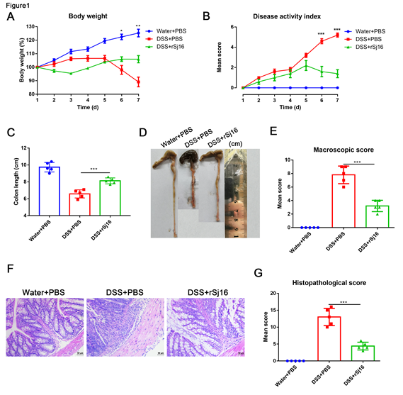
Figure 1 rSj16 protects against acute dextran sulfate sodium-induced colitis. A: Daily changes in body weight [dextran sulfate sodium (DSS) + rSj16 vs DSS + PBS]; B: Changes in DAI (DSS + rSj16 vs DSS + PBS); C and D: Colon lengths were measured and recorded; E: Macroscopic appearance of the colons; F: The histopathological changes in the colons were examined by H&E staining (20×); G: Histopathological scores of the colons were determined. DSS: Dextran Sulfate Sodium Salt. Statistical analysis was performed using one-way ANOVA. Data are presented as means ± SD; ªP < 0.05, ^{b}P < 0.01, ^{c}P < 0.001.

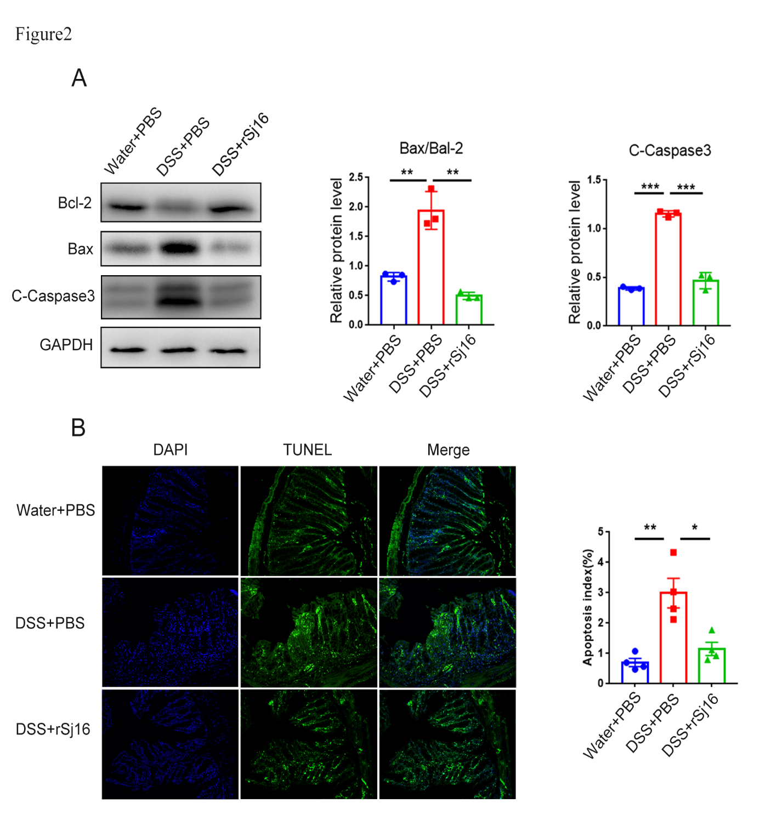
Figure 2 rSj16 inhibits dextran sulfate sodium induced apoptosis of colon epithelial cells. A: Western blot analysis for the expression of apoptosis relative proteins, including Bcl-2, Bax and cleaved-Caspase3; B: The apoptosis of colon tissue of mice treated with dextran sulfate sodium (DSS) + PBS and DSS + rSj16 was detected by TUNEL assay (20×), TUNEL positive cells were apoptotic cells, the number of TUNEL positive cells was quantified. TUNEL: Terminal deoxynucleotidyl transferase-mediated dUTP nick end labeling. Statistical analysis was performed using one-way ANOVA (A) and Kruskal–Wallis test (non-parametric) (B). Data are presented as means ± SD; ªP < 0.05, ^{b}P < 0.01, ^{c}P < 0.001.

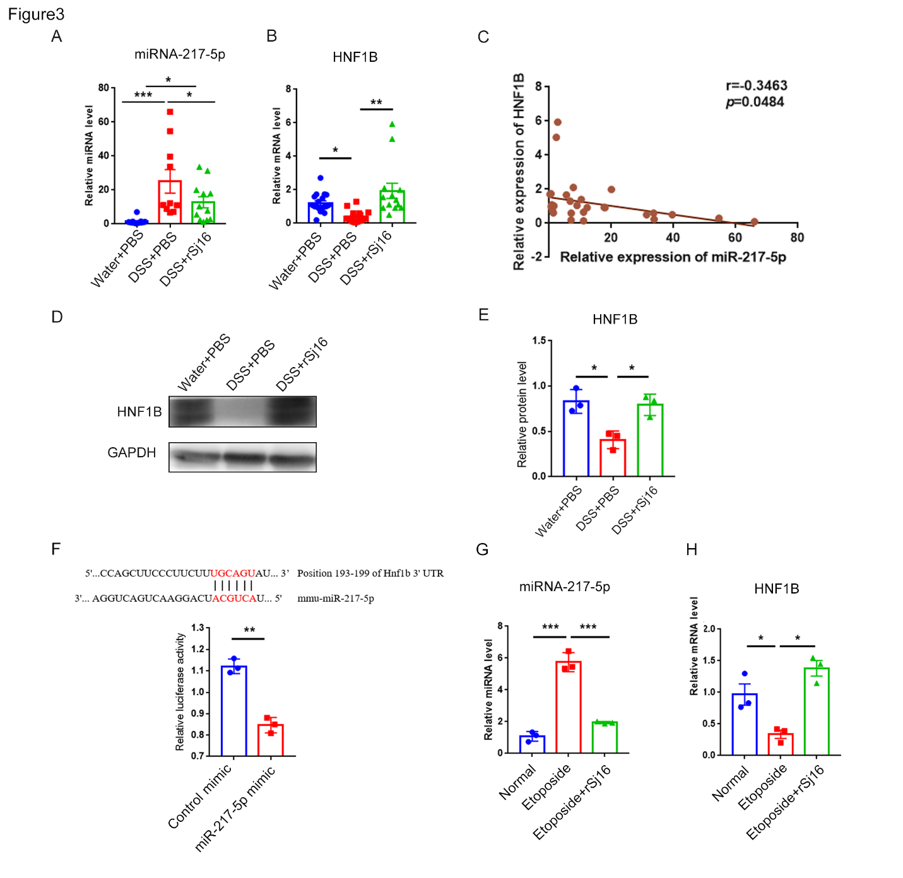
Figure 3 rSj16 can inhibit the expression of miR-217-5p in the colon of mice with dextran sulfate sodium-induced inflammatory bowel disease. A and B: Relative RNA expression of miR-217-5p and hnf1b in colon tissue of mice; data were normalized to levels detected in colon tissue of mice after treatment with Water and PBS (control) group; C: Pearson’s correlation coefficient analysis showed a negative correlation between miR-217-5p and HNF1B in colon tissue of mice (r = -0.3463, P < 0.05); D and E: Western blot was used to detect the expression of HNF1B in protein levels; F: The wild-type HNF1B -3′- untranslated region (UTR) was cloned into psi-CHECK-2 to predict the binding site of miR-217-5p in the 3′-UTR of hnf1b gene. Dual-luciferase reporter assay was performed on HEK 293Tcells transfected with HNF1B UTR reporter plasmid together with miR-217-5p mimic or control mimic; G and H：MODE-K cells were treated with Etoposide or Etoposide + rSj16. The expression of miR-217-5p and hnf1b were determined using quantitative PCR. HNF1B: Hepatic nuclear factor-1beta. Statistical analysis was performed using one-way ANOVA (B and E) and Kruskal–Wallis test (non-parametric) (A), and unpaired two-sample t-test (F, G and H). Data are presented as means ± SD; ªP < 0.05, ^{b}P < 0.01, ^{c}P < 0.001.

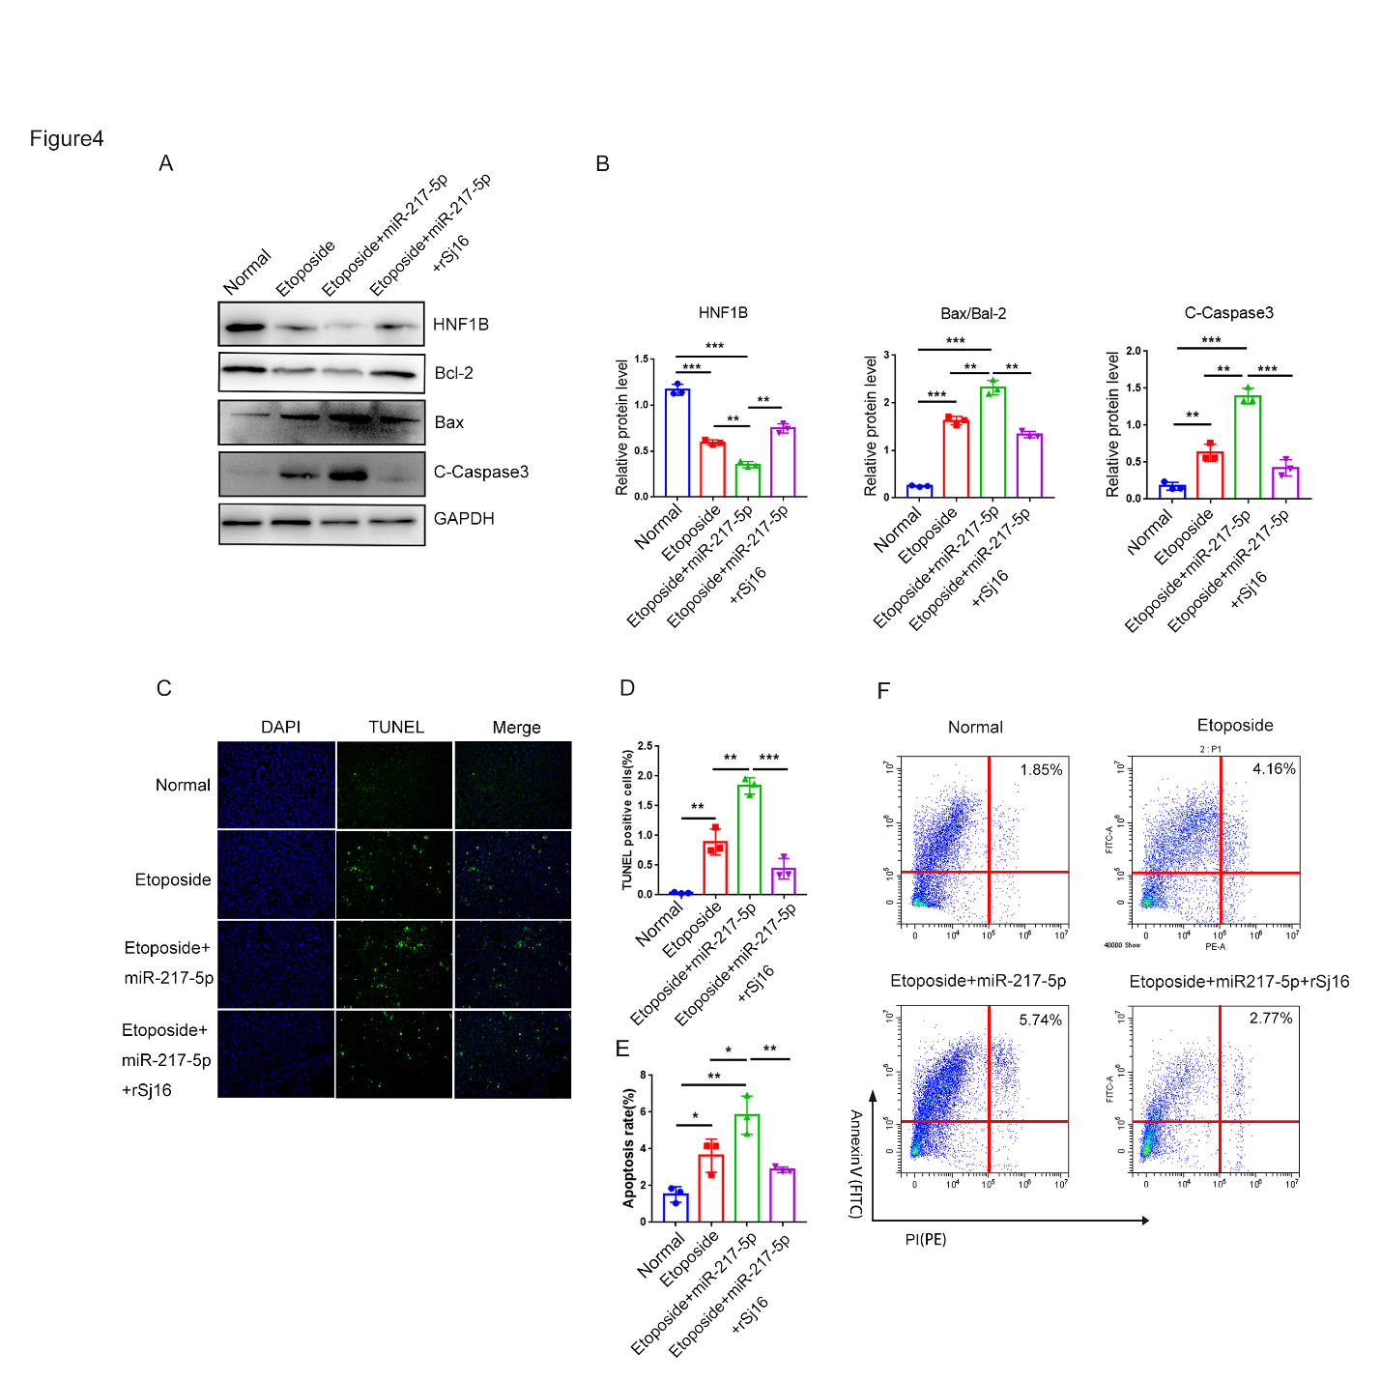
Figure 4 rSj16 have anti-apoptotic action by regulating the miR-217-5p/HNF1B axis. A and B: MODE-K cells were treated with Etoposide, Etoposide + miR-217-5p, and Etoposide + miR-217-5p + rSj16. The expression of apoptosis relative proteins, including Bcl-2, Bax and cleaved-Caspase3 was analyzed by Western blotting; C and D: The apoptosis of MODE-K cells was detected by TUNEL assay after treatment with Etoposide + miR-217-5p, and Etoposide + miR-217-5p + rSj16 (10×), TUNEL positive cells were apoptotic cells, the number of TUNEL positive cells was quantified; E and F: Flow cytometry analysis of MODE-K cells treated with Etoposide + miR-217-5p, and Etoposide + miR-217-5p + rSj16. Statistical analysis was performed using one-way ANOVA. PI: propidium iodide. Data are presented as means ± SD; ªP < 0.05, ^{b}P < 0.01, ^{c}P < 0.001.

Table 1 Quantitative real time PCR primer sequences
Gene | Forward (5’-3’) | Reverse (5’-3’)
hnf1b | CCCATCCTCAAAGAGCTCCA | AGAGGTGGGATTGGTTCAGG
GAPDH(Mouse) | ACTCCACTCACGGCAAATTC | TCTCCATGGTGGTGAAGACA
miR-217-5p | UACUGCAUCAGGAACUGACUGGA | mRQ3' Primer (Takara, Kyoto, Japan)
U6 | Takara, Kyoto, Japan | Takara, Kyoto, Japan

Table 2 Values of the evaluation indexes
 | Body weight loss on day 7 (%) (mean ± SD) | DAI on day 7 (mean ± SD) | Colon length (mean ± SD) | Macroscopic scores (mean ± SD) | Histopathological scores (mean ± SD) | n
Water + PBS | 125.30 ± 6.30 | 0.00 ± 0.00 | 9.70 ± 0.56 | 0.00 ± 0.00 | 0.00 ± 0.00 | 5
DSS + PBS | 89.11 ± 8.02 | 5.20 ± 0.45 | 6.58 ± 0.48 | 7.8 ± 1.30 | 13.00 ± 2.55 | 5
DSS + rSj16 | 106.00 ± 5.97 | 1.40 ± 0.89 | 8.12 ± 0.35 | 3.20 ± 0.84 | 4.4 ± 1.14 | 5
DSS: Dextran sulfate sodium.

Published by Baishideng Publishing Group Inc
7041 Koll Center Parkway, Suite 160, Pleasanton, CA 94566, USA
Telephone: +1-925-3991568
E-mail: bpgoffice@wjgnet.com
Help Desk: https://www.f6publishing.com/helpdesk
https://www.wjgnet.com

© 2021 Baishideng Publishing Group Inc. All rights reserved.

