Name of Journal: World Journal of Gastroenterology
Manuscript NO: 38160
Manuscript Type: ORIGINAL ARTICLE

Prospective Study
Hepatocellular carcinoma or interferon-based therapy history attenuates sofosbuvir/ribavirin for Japanese genotype 2 hepatitis C virus

Yada M et al. SOF/RBV for GT2-HCV in Japan

Masayoshi Yada, Masayuki Miyazaki, Kosuke Tanaka, Akihide Masumoto, Kenta Motomura

Masayoshi Yada, Masayuki Miyazaki, Kosuke Tanaka, Akihide Masumoto, Kenta Motomura, Department of Hepatology, Iizuka Hospital, Iizuka, Fukuoka 820-8505, Japan

ORCID number: Masayoshi Yada (0000-0002-1129-5380); Masayuki Miyazaki (0000-0002-4192-8150); Kosuke Tanaka (0000-0003-1472-0597); Akihide Masumoto (0000-0003-4929-6271); Kenta Motomura (0000-0002-7515-099X).

Author contributions: Yada M and Motomura K wrote the paper; Yada M, Miyazaki M, Tanaka K, and Motomura K analyzed the data; Masumoto A supervised writing of the paper; all authors contributed to the manuscript.

Institutional review board statement: The study protocol conformed to the ethical guidelines of the 1975 Declaration of Helsinki, as reflected in a priori approval by the Ethics Committee of Iizuka Hospital (Approve No. 26282).

Informed consent statement: Written informed consent was obtained from all patients.

Conflict-of-interest statement: The authors have no disclosures to report.

Data sharing statement: No additional data are available.

Open-Access: This article is an open-access article which was selected by an in-house editor and fully peer-reviewed by external reviewers. It is distributed in accordance with the Creative Commons Attribution Non Commercial (CC BY-NC 4.0) license, which permits others to distribute, remix, adapt, build upon this work non-commercially, and license their derivative works on different terms, provided the original work is properly cited and the use is non-commercial. See: http://creativecommons.org/licenses/by-nc/4.0/

Manuscript source: Unsolicited manuscript

Correspondence to: Masayoshi Yada, MD, PhD, Doctor, Department of Hepatology, Iizuka Hospital, 3-83 Yoshio-machi, Iizuka, Fukuoka 820-8505, Japan. myadah1@aih-net.com
Telephone: +81-948-223800
Fax: +81-948-295744

Received: February 5, 2018
Peer-review started: February 5, 2018
First decision: February 26, 2018
Revised: February 26, 2018
Accepted: March 7, 2018
Article in press:
Published online:

Abstract
AIM
To investigate the real-world efficacy and safety of sofosbuvir/ribavirin (SOF/RBV) therapy for Japanese patients with genotype 2 hepatitis C virus (GT2-HCV).

METHODS
A total of 182 patients with GT2-HCV infection who received SOF/RBV therapy for 12 wk at our hospital were enrolled. The patients comprised 122 men and 60 women (age range: 17-84 years; mean age ± SD: 60.1 ± 12.1 years). Relationships between virological response and clinical data were examined by logistic regression analyses.

RESULTS
The proportions of patients with liver cirrhosis and history of hepatocellular carcinoma (HCC) were 29.0% and 17.3%, respectively. The proportion of patients with prior interferon (IFN)-based therapy was 25.6%. SOF/RBV therapy rapidly decreased HCV RNA levels. Several patients required RBV dose reduction because of anemia or fatigue. Four patients discontinued the therapy. The rates of sustained virological response at 12 wk after the end of treatment were 87.9% (intention to treat: 160/182) and 94.1% (per protocol: 159/169). Multivariate analyses showed that history of HCC or IFN-based therapy independently reduced the efficacy of SOF/RBV therapy.

CONCLUSION
SOF/RBV therapy for GT2-HCV is safe, highly tolerated, and effective. History of HCC or IFN-based therapy independently reduces the efficacy of this treatment.

Key words: Sofosbuvir; Ribavirin; Genotype 2; Hepatitis C virus; Interferon-based therapy; Hepatocellular carcinoma

© The Author(s) 2018. Published by Baishideng Publishing Group Inc. All rights reserved.

Core tip: The real-world efficacy of sofosbuvir/ribavirin therapy for genotype 2 hepatitis C virus infection in Japan is high. Sofosbuvir/ribavirin therapy is safe and highly tolerated. History of hepatocellular carcinoma or interferon-based therapy independently reduces the efficacy of sofosbuvir/ribavirin therapy. Progressive liver fibrosis may attenuate the antiviral effect of sofosbuvir/ribavirin therapy.

Yada M, Miyazaki M, Tanaka K, Masumoto A, Motomura K. Hepatocellular carcinoma or interferon-based therapy history attenuates sofosbuvir/ribavirin for Japanese genotype 2 hepatitis C virus. World J Gastroenterol 2018; In press

INTRODUCTION
Hepatitis C virus (HCV) infection is a leading cause of chronic hepatitis, liver cirrhosis (LC), and hepatocellular carcinoma (HCC). In Global hepatitis report 2017^{[1]}, World Health Organization (WHO) described that 71 million persons were living with chronic HCV infection in 2015 (the global prevalence of HCV infection was 1.0%). Approximately 399000 people died each year from HCV, mostly from LC and HCC. In 2011, Japanese estimated number of persons with chronic HCV infection was 1.25 million containing 64% with genotype 1B and 35% with genotype 2, respectively^{[2]}. WHO targets 80% of persons with HCV will be treated by 2030^{[1]}. Combination therapy with peg-interferon (PEG-IFN) and ribavirin (RBV) was the first-line therapy for genotype 2 HCV (GT2-HCV) infection, but only 80% of patients achieved elimination of HCV with this treatment^{[3]}. The introduction of direct-acting antiviral agents has drastically improved the efficacy of treatments for chronic HCV infection. In Japan, telaprevir (TVR), a first-generation NS3/4A protease inhibitor for GT2-HCV, was approved for clinical use in 2013. Patients received TVR (750 mg, every 8 h) for 12 wk and PEG-IFN/RBV for 24 wk. The sustained virological response (SVR) rate in patients receiving triple therapy (TVR/PEG-IFN/RBV) was reported to be 85%^{[4]}.
Subsequently, combination therapy with NS5B RNA-dependent RNA polymerase inhibitor sofosbuvir (SOF) and RBV for patients with GT2-HCV infection was approved for clinical use in June 2015. This therapy showed improved efficacy and was well tolerated in a phase 3 trial^{[5]}. We conducted a prospective study to investigate the efficacy and safety of SOF/RBV therapy for Japanese patients with GT2-HCV infection in a real-world clinical setting.

MATERIALS AND METHODS
Patients
A total of 182 patients with chronic GT2-HCV infection who received SOF/RBV therapy at Iizuka Hospital from September 2015 to January 2017 were enrolled. The patients comprised 122 men and 60 women with an age range of 17-86 years (mean ± SD: 60.1 ± 14.1 years). HCV genotype was determined by sequencing the NS5B region of the HCV genome. The results revealed 109 patients with genotype 2A and 70 patients with genotype 2B. Genotype was not determined in 3 patients. Presence of resistance-associated substitution (RAS) was analyzed by sequence determination around S282 in the NS5B region of the HCV genome. Two single nucleotide polymorphisms (SNPs), rs8099917 in the interleukin-28B (IL28B) locus associated with interferon (IFN) therapy^{[6]} and rs1127354 in the inosine triphosphate pyrophosphatase (ITPA) locus associated with RBV-induced hemolytic anemia^{[7-9]}, were analyzed. fibrosis (FIB)-4 index was calculated as a noninvasive marker of liver fibrosis: FIB-4 index = age (years) × aspartate aminotransferase (IU/L)/[platelet count × 10⁹/L × (alanine aminotransferase IU/L)^{1/2}]. FIB-4 index of > 3.25 was defined as progressive fibrosis, based on a previous report^{[10]}.

Treatment regimen
SOF (Sovaldi®, Gilead Sciences Inc., Durham, NC, United States) was administered orally at a dose of 400 mg once daily, and RBV (Rebetol®, MSD, Tokyo, Japan or Copegus®, Chugai, Shizuoka, Japan) was administered orally at a dose of 200-1000 mg for 12 wk. The starting RBV dose was determined by body weight (600 mg for < 60 kg; 800 mg for 60-80 kg; 1000 mg for > 80 kg) (Figure 1).

Evaluation of virological response
HCV RNA levels were measured by a COBAS TaqMan test (Roche Diagnostics, Tokyo, Japan) with a lower limit of quantitation of 1.2 logIU/mL. HCV RNA was measured at screening, at day 1 and weeks 4, 8, and 12 of treatment, and at 12 wk after the end of treatment. The primary endpoint was the rate of SVR at 12 wk after the end of treatment (SVR12), defined as undetectable serum HCV RNA at this time point. Relapse and breakthrough were defined based on the guidelines of the American Association for the Study of Liver Diseases^{[11]}.

Safety assessments
Safety evaluations included reported adverse events and serious adverse events, clinical laboratory tests, and physical examinations.

Statistical analysis
Statistical analyses were performed using JMP software version 8.0.2 (SAS Institute Inc., Cary, NC, United States). Hemoglobin levels and estimated glomerular filtration rate were compared by the Tukey honestly significant difference test. Categorical data were compared by Chi-squared test. To identify independent factors predicting non-SVR, sex, age, liver cirrhosis, and variables with values of P < 0.05 in univariate analyses were entered into a multiple logistic regression analysis. Values of P < 0.05 were considered statistically significant.

RESULTS
Patient characteristics
The pretreatment characteristics of all patients enrolled in the study are presented in Table 1. There were 48 patients (26.4%) with LC, 43 (23.7%) with history of IFN-based therapy, and 28 (15.4%) with history of HCC. Presence of the SNPs in IL28B (rs8099917) and ITPA (rs1127354) was examined in 174 of 182 patients. HCV RAS of S282 in the NS5B domain was not detected in the 138 patients examined by the RAS test.

Treatment outcomes
Of the 182 patients, 178 (97.8%) completed the treatment. The causes of treatment discontinuation were fatigue (n = 1; 0.5%) and self-withdrawal (n = 3; 1.6%). The rates of SVR12 were 87.9% [intention to treat (ITT): 160/182] and 94.1% [per protocol (PP): 159/169]. SVR12 was not evaluated in 12 patients (6.7%) because of dropout from the study (Figure 2).
Hemoglobin levels during the treatment period were significantly reduced until 4 wk after the start of administration (Figure 3A). CC of the ITPA allele strongly contributed to anemia (Figure 3B). Twenty-nine (15.9%) of 182 patients needed RBV dose reduction because of anemia, but no patients discontinued the treatment for this reason. Although SOF and RBV cannot be used in patients with decreased renal function and we were concerned about SOF/RBV therapy decreasing the renal function of our patients, the estimated glomerular filtration rate did not change significantly during the treatment period (Figure 3C).

Factors contributing to SVR in the PP analysis
In the PP analysis, 13 of 182 patients who discontinued treatment and/or were not evaluated for SVR12 were excluded (Figure 2A). One hundred twenty three of 169 patients (72.8%) achieved rapid virological response (RVR), defined as undetectable serum HCV RNA after 4 wk of treatment. In univariate analyses, history of IFN-based therapy, LC, and history of HCC reduced the virological response, while age (≥ 70 years), sex, FIB-4 index, IL28B SNP, ITPA SNP, HCV genotype, pretreatment viral load, RBV dose reduction, and RVR had no effect on the treatment efficacy (Figures 4 and 5). The SNPs of IL28B and ITPA were determined for 161 patients in the PP analysis. The HCV viral genotype was determined in 166 patients. Multivariate analysis showed that history of HCC or IFN-based therapy was independently related to non-SVR (Table 2).

Assessment of patients with history of HCC
We assessed 29 patients with history of HCC. We ascertained that their HCC was not detected by dynamic computed tomography or dynamic magnetic resonance imaging before initiation of SOF/RBV therapy. We compared alpha fetoprotein (AFP), latest therapy for HCC, and HCC recurrence within 1 year after the end of SOF/RBV therapy according to SVR or non-SVR (Table 3). The AFP level did not differ significantly between the two groups. Patients achieving SVR tended to be treated by surgical resection or radiofrequency ablation, and also tended to have no HCC recurrence.

DISCUSSION
Combination therapy with SOF/RBV was the first IFN-free therapy for GT2-HCV infection approved for clinical use in Japan. In a phase 3 trial, 97% of patients achieved SVR12 and no patients discontinued the treatment^{[5]}. Thus, we expected high efficacy and tolerability, and conducted a prospective study in a real-world clinical practice setting to investigate the efficacy and safety of this combination therapy for Japanese patients with GT2-HCV infection.
Hemoglobin levels rapidly reduced until 4 wk after the start of treatment. ITPA CC allele significantly contributed to anemia in this therapy, similar to the case for combination therapy of PEG-IFN and RBV^{[7-9]}. Therefore, patients with the ITPA CC allele should be monitored frequently for their hemoglobin levels until 4 wk after the start of treatment. Despite our concern that SOF and RBV may decrease renal function of the patients, renal function degeneration was not observed in any of the patients. Many elderly patients (27.4% were aged ≥ 70 years) and cirrhotic patients (26.6% had liver cirrhosis) were enrolled in this study. Thus, the present findings demonstrate that SOF/RBV therapy is safe and highly tolerated regardless of age and LC.
The ITT rate in this study was low compared with the rates in phase 3 clinical trials of SOF/RBV for Japanese^{[5]} and European^{[12]} patients with GT2-HCV infection. The reason for the difference was that SVR12 could not be evaluated in 12 patients (6.7%) because of dropout from the study. It is important to monitor carcinogenesis after virus elimination, and it is therefore necessary to provide patients with instructions that promote periodic examinations. Meanwhile, the PP rate was almost equal to the rates in the phase 3 clinical trial of SOF/RBV for Japanese patients with GT2-HCV infection^{[5]} and in real-world cohorts in North America and Europe^{[13]}. This finding shows that SOF/RBV therapy for Japanese patients with GT2-HCV infection is highly effective in real-world clinical practice.
In a meta-analysis, Rangnekar et al^{[14]} reported that IL28B SNP was predictor of SVR in Caucasian patients with GT2-HCV infection receiving PEG-IFN/RBV for 24 wk. In contrast, IL28B SNP was not associated with SVR in Asian patients with GT2-HCV infection. This study also showed Japanese IL28B SNP had no relation to efficacy of SOF/RBV for GT2-HCV infection. Morisco et al^{[15]} reported RVR was the only independent predictive factor of SVR in triple therapy (TVR/PEG-IFN/RBV) regardless of LC. In the present study, RVR did not affect efficacy of SOF/RBV for GT2-HCV infection. The multivariate regression analysis showed that history of HCC or IFN-based therapy was independently related to non-SVR. LC also reduced the efficacy in univariate analyses. It was previously reported that the efficacy of IFN-based therapy was inferior in LC patients^{[16,17]}. Furthermore, it was reported that patients with progressive liver fibrosis have a high probability of hepatocellular carcinogenesis^{[18-21]}. Prenner et al^{[22]} reported that presence of active HCC at the start of direct acting antivirals, including SOF/RBV therapy, decreased the SVR rate. In our study, the proportion of non-SVR patients treated by surgical resection or radiofrequency ablation tended to be lower than the proportion of non-SVR patients treated by transcatheter arterial chemoembolization or radiation for bone metastasis. Meanwhile, the rate of HCC recurrence within 1 year tended to be higher in non-SVR patients than that in SVR patients. These findings show a high probability that active HCC was not detected by dynamic computed tomography or dynamic magnetic resonance imaging at the start of SOF/RBV therapy. Prenner et al^{[22]} discussed that a putative biological explanation could be inadequate drug delivery by decreased blood flow or local fibrosis arising from HCC treatment. The present results suggested that liver fibrosis attenuated the antiviral effect of SOF/RBV in patients with history of IFN-based therapy or HCC. Although the FIB-4 index, a fibrosis marker^{[10]}, had no effect on efficacy in the present study, the reason was unclear. History of IFN-based therapy and LC had no significant effect on SOF/RBV therapy in the phase 3 clinical trial for European patients with GT2-HCV infection^{[12]}. However, it was reported that LC and lower serum albumin decreased the SVR rate in the real-world cohorts in North America and Europe^{[13]}. Treatment-experienced patients tended to have ineffective outcomes in that study. These findings were similar to those in the present study. The real-world studies included larger populations of LC (26.6% in the present study and 26.8% in the North American and European study) than the phase 3 trials (11% in the Japanese trial^{[5]} and 15% in the European trial^{[12]}. Our study also enrolled patients with history of HCC (15.9%) and elderly patients aged ≥ 70 years (27.4%). It is suggested that the real-world studies enrolled more patients with severe fibrosis than the phase 3 clinical trials. As viral breakthrough did not occur in any of the non-SVR patients and all of these patients had relapses, it is suggested that SOF/RBV therapy was not ineffective for these patients. Extension of the treatment period for patients with history of IFN-based therapy, HCC, or LC should be considered to increase the efficacy of the therapy. As active HCC not detected by imaging was probably related to non-SVR, monitoring is required for carcinogenesis and recurrence of HCC after the end of SOF/RBV therapy, especially in non-SVR patients.
In conclusion, SOF/RBV therapy for Japanese patients with GT2-HCV infection is safe, highly tolerated, and effective. History of HCC or IFN-based therapy independently reduces the efficacy of the treatment.

ARTICLE HIGHLIGHTS
Research background
Combination therapy with peg-interferon (PEG-IFN) and ribavirin (RBV) was the first-line therapy for genotype 2 hepatitis C virus (HCV) infection, but only 80% of patients achieved elimination of HCV with this treatment. The introduction of direct-acting antiviral agents has drastically improved the efficacy of treatments for chronic HCV infection. Combination therapy with NS5B RNA-dependent RNA polymerase inhibitor sofosbuvir (SOF) and RBV for patients with genotype 2 hepatitis C virus (GT2-HCV) infection was approved for clinical use in June 2015.

Research motivation
This therapy showed improved efficacy and was well tolerated in a phase 3 trial. However, predictive factor of sustained virological response (SVR) is not unclear.

Research objectives
We conducted a prospective study to investigate the efficacy and safety of sofosbuvir/ribavirin (SOF/RBV) therapy for Japanese patients with GT2-HCV infection in a real-world clinical setting.

Research methods
A total of 182 patients with GT2-HCV infection who received SOF/RBV therapy for 12 wk at our hospital were enrolled. The patients comprised 122 men and 60 women (age range: 17-84 years; mean age ± SD: 60.1 ± 12.1 years). One hundred sixty nine of 182 patients completed 12 wk treatment and were examined their virological response. To investigate predictive factors of SVR, we examined the relationships between virological response and clinical data by logistic regression analyses.

Research results
The rates of SVR at 12 wk after the end of treatment were 87.9% (intention to treat: 160/182) and 94.1% (per protocol: 159/169). Multivariate analyses showed that history of hepatocellular carcinoma (HCC) or IFN-based therapy independently reduced the efficacy of SOF/RBV therapy.

Research conclusions
This study showed Japanese IL28B single nucleotide polymorphisms had no relation to efficacy of SOF/RBV for GT2-HCV infection. Morisco et al^{[15]} reported rapid virological response (RVR) was the only independent predictive factor of SVR in triple therapy (Telaprevir/PEG-IFN/RBV) regardless of cirrhosis. In the present study, RVR did not affect efficacy of SOF/RBV for GT2-HCV infection. The multivariate regression analysis showed that history of HCC or IFN-based therapy was independently related to non-SVR. In our study, the proportion of non-SVR patients treated by surgical resection or radiofrequency ablation tended to be lower than the proportion of non-SVR patients treated by transcatheter arterial chemoembolization or radiation for bone metastasis. Meanwhile, the rate of HCC recurrence within 1 year tended to be higher in non-SVR patients than that in SVR patients.

Research perspectives
Prenner et al^{[22]} reported that presence of active HCC at the start of direct acting antivirals, including SOF/RBV therapy, decreased the SVR rate. As active HCC not detected by imaging was probably related to non-SVR, monitoring is required for carcinogenesis and recurrence of HCC after the end of SOF/RBV therapy, especially in non-SVR patients.

ACKNOWLEDGMENTS
We are grateful to Y. Ishibashi for assistance with manuscript preparation.
REFERENCES
1 World Health Organization. Global hepatitis report, 2017. 2017 Available from: URL: http://www.who.int/hepatitis/publications/global-hepatitis-report2017/en/
2 Liakina V, Hamid S, Tanaka J, Olafsson S, Sharara AI, Alavian SM, Gheorghe L, El Hassan ES, Abaalkhail F, Abbas Z, Abdou A, Abourached A, Al Braiki F, Al Hosani F, Al Jaberi K, Al Khatry M, Al Mulla MA, Al Quraishi H, Al Rifai A, Al Serkal Y, Alam A, Alashgar HI, Alawadhi S, Al-Dabal L, Aldins P, Alfaleh FZ, Alghamdi AS, Al-Hakeem R, Aljumah AA, Almessabi A, Alqutub AN, Alswat KA, Altraif I, Alzaabi M, Andrea N, Assiri AM, Babatin MA, Baqir A, Barakat MT, Bergmann OM, Bizri AR, Blach S, Chaudhry A, Choi MS, Diab T, Djauzi S, El Khoury S, Estes C, Fakhry S, Farooqi JI, Fridjonsdottir H, Gani RA, Ghafoor Khan A, Goldis A, Gottfredsson M, Gregorcic S, Hajarizadeh B, Han KH, Hasan I, Hashim A, Horvath G, Hunyady B, Husni R, Jafri W, Jeruma A, Jonasson JG, Karlsdottir B, Kim DY, Kim YS, Koutoubi Z, Lesmana LA, Lim YS, Löve A, Maimets M, Makara M, Malekzadeh R, Matičič M, Memon MS, Merat S, Mokhbat JE, Mourad FH, Muljono DH, Nawaz A, Nugrahini N, Priohutomo S, Qureshi H, Rassam P, Razavi H, Razavi-Shearer D, Razavi-Shearer K, Rozentale B, Sadik M, Saeed K, Salamat A, Salupere R, Sanai FM, Sanityoso Sulaiman A, Sayegh RA, Schmelzer JD, Sibley A, Siddiq M, Siddiqui AM, Sigmundsdottir G, Sigurdardottir B, Speiciene D, Sulaiman A, Sultan MA, Taha M, Tarifi H, Tayyab G, Tolmane I, Ud Din M, Umar M, Valantinas J, Videčnik-Zorman J, Yaghi C, Yunihastuti E, Yusuf MA, Zuberi BF, Gunter J. Historical epidemiology of hepatitis C virus (HCV) in select countries - volume 3. J Viral Hepat 2015; 22 Suppl 4: 4-20 [PMID: 26513445 DOI: 10.1111/jvh.12475]
3 Sato K, Hashizume H, Yamazaki Y, Horiguchi N, Kakizaki S, Takagi H, Mori M; Gunma Liver Study Group. Response-guided peginterferon-alpha-2b plus ribavirin therapy for chronic hepatitis C patients with genotype 2 and high viral loads. Hepatol Res 2012; 42: 854-863 [PMID: 22487210 DOI: 10.1111/j.1872-034X.2012.00997.x]
4 Kumada H, Sato K, Takehara T, Nakamuta M, Ishigami M, Chayama K, Toyota J, Suzuki F, Nakayasu Y, Ochi M, Yamada I, Okanoue T. Efficacy of telaprevir-based therapy for difficult-to-treat patients with genotype 2 chronic hepatitis C in Japan. Hepatol Res 2015; 45: 745-754 [PMID: 25196718 DOI: 10.1111/hepr.12416]
5 Omata M, Nishiguchi S, Ueno Y, Mochizuki H, Izumi N, Ikeda F, Toyoda H, Yokosuka O, Nirei K, Genda T, Umemura T, Takehara T, Sakamoto N, Nishigaki Y, Nakane K, Toda N, Ide T, Yanase M, Hino K, Gao B, Garrison KL, Dvory-Sobol H, Ishizaki A, Omote M, Brainard D, Knox S, Symonds WT, McHutchison JG, Yatsuhashi H, Mizokami M. Sofosbuvir plus ribavirin in Japanese patients with chronic genotype 2 HCV infection: an open-label, phase 3 trial. J Viral Hepat 2014; 21: 762-768 [PMID: 25196837 DOI: 10.1111/jvh.12312]
6 Tanaka Y, Nishida N, Sugiyama M, Kurosaki M, Matsuura K, Sakamoto N, Nakagawa M, Korenaga M, Hino K, Hige S, Ito Y, Mita E, Tanaka E, Mochida S, Murawaki Y, Honda M, Sakai A, Hiasa Y, Nishiguchi S, Koike A, Sakaida I, Imamura M, Ito K, Yano K, Masaki N, Sugauchi F, Izumi N, Tokunaga K, Mizokami M. Genome-wide association of IL28B with response to pegylated interferon-alpha and ribavirin therapy for chronic hepatitis C. Nat Genet 2009; 41: 1105-1109 [PMID: 19749757 DOI: 10.1038/ng.449]
7 Fellay J, Thompson AJ, Ge D, Gumbs CE, Urban TJ, Shianna KV, Little LD, Qiu P, Bertelsen AH, Watson M, Warner A, Muir AJ, Brass C, Albrecht J, Sulkowski M, McHutchison JG, Goldstein DB. ITPA gene variants protect against anaemia in patients treated for chronic hepatitis C. Nature 2010; 464: 405-408 [PMID: 20173735 DOI: 10.1038/nature08825]
8 Ochi H, Maekawa T, Abe H, Hayashida Y, Nakano R, Kubo M, Tsunoda T, Hayes CN, Kumada H, Nakamura Y, Chayama K. ITPA polymorphism affects ribavirin-induced anemia and outcomes of therapy--a genome-wide study of Japanese HCV virus patients. Gastroenterology 2010; 139: 1190-1197 [PMID: 20637204 DOI: 10.1053/j.gastro.2010.06.071]
9 Thompson AJ, Fellay J, Patel K, Tillmann HL, Naggie S, Ge D, Urban TJ, Shianna KV, Muir AJ, Fried MW, Afdhal NH, Goldstein DB, McHutchison JG. Variants in the ITPA gene protect against ribavirin-induced hemolytic anemia and decrease the need for ribavirin dose reduction. Gastroenterology 2010; 139: 1181-1189 [PMID: 20547162 DOI: 10.1053/j.gastro.2010.06.016]
10 Sterling RK, Lissen E, Clumeck N, Sola R, Correa MC, Montaner J, S Sulkowski M, Torriani FJ, Dieterich DT, Thomas DL, Messinger D, Nelson M; APRICOT Clinical Investigators. Development of a simple noninvasive index to predict significant fibrosis in patients with HIV/HCV coinfection. Hepatology 2006; 43: 1317-1325 [PMID: 16729309 DOI: 10.1002/hep.21178]
11 Ghany MG, Strader DB, Thomas DL, Seeff LB; American Association for the Study of Liver Diseases. Diagnosis, management, and treatment of hepatitis C: an update. Hepatology 2009; 49: 1335-1374 [PMID: 19330875 DOI: 10.1002/hep.22759]
12 Zeuzem S, Dusheiko GM, Salupere R, Mangia A, Flisiak R, Hyland RH, Illeperuma A, Svarovskaia E, Brainard DM, Symonds WT, Subramanian GM, McHutchison JG, Weiland O, Reesink HW, Ferenci P, Hézode C, Esteban R; VALENCE Investigators. Sofosbuvir and ribavirin in HCV genotypes 2 and 3. N Engl J Med 2014; 370: 1993-2001 [PMID: 24795201 DOI: 10.1056/NEJMoa1316145]
13 Welzel TM, Nelson DR, Morelli G, Di Bisceglie A, Reddy RK, Kuo A, Lim JK, Darling J, Pockros P, Galati JS, Frazier LM, Alqahtani S, Sulkowski MS, Vainorius M, Akushevich L, Fried MW, Zeuzem S; HCV-TARGET Study Group. Effectiveness and safety of sofosbuvir plus ribavirin for the treatment of HCV genotype 2 infection: results of the real-world, clinical practice HCV-TARGET study. Gut 2017; 66: 1844-1852 [PMID: 27418632 DOI: 10.1136/gutjnl-2016-311609]
14 Rangnekar AS, Fontana RJ. IL-28B polymorphisms and the response to antiviral therapy in HCV genotype 2 and 3 varies by ethnicity: a meta-analysis. J Viral Hepat 2013; 20: 377-384 [PMID: 23647954 DOI: 10.1111/jvh.12039]
15 Morisco F, Masarone M, Rosato V, Camera S, Granata R, Tartaglione MT, Coppola C, Coppola N, Salomone-Megna A, Gentile I, De Luna A, Federico A, Precone D, Claar E, Abenavoli L, Persico M. Impact of Telaprevir in HCV Patients with Cirrhosis and RVR: Real-Life Data from Boceprevir or Telaprevir based "Triple Therapy" Experience in Southern Italy. Rev Recent Clin Trials 2016; 11: 306-316 [PMID: 26672601]
16 Kaserer K, Fiedler R, Steindl P, Müller CH, Wrba F, Ferenci P. Liver biopsy is a useful predictor of response to interferon therapy in chronic hepatitis C. Histopathology 1998; 32: 454-461 [PMID: 9639122]
17 Akuta N, Suzuki F, Kawamura Y, Yatsuji H, Sezaki H, Suzuki Y, Hosaka T, Kobayashi M, Kobayashi M, Arase Y, Ikeda K, Kumada H. Predictors of viral kinetics to peginterferon plus ribavirin combination therapy in Japanese patients infected with hepatitis C virus genotype 1b. J Med Virol 2007; 79: 1686-1695 [PMID: 17854035 DOI: 10.1002/jmv.20979]
18 Zaman SN, Melia WM, Johnson RD, Portmann BC, Johnson PJ, Williams R. Risk factors in development of hepatocellular carcinoma in cirrhosis: prospective study of 613 patients. Lancet 1985; 1: 1357-1360 [PMID: 2861313]
19 Shiffman ML. Natural history and risk factors for progression of hepatitis C virus disease and development of hepatocellular cancer before liver transplantation. Liver Transpl 2003; 9: S14-S20 [PMID: 14586890 DOI: 10.1053/jlts.2003.50254]
20 Ikeda M, Fujiyama S, Tanaka M, Sata M, Ide T, Yatsuhashi H, Watanabe H. Risk factors for development of hepatocellular carcinoma in patients with chronic hepatitis C after sustained response to interferon. J Gastroenterol 2005; 40: 148-156 [PMID: 15770398 DOI: 10.1007/s00535-004-1519-2]
21 Tokita H, Fukui H, Tanaka A, Kamitsukasa H, Yagura M, Harada H, Okamoto H. Risk factors for the development of hepatocellular carcinoma among patients with chronic hepatitis C who achieved a sustained virological response to interferon therapy. J Gastroenterol Hepatol 2005; 20: 752-758 [PMID: 15853990 DOI: 10.1111/j.1440-1746.2005.03800.x]
22 Prenner SB, VanWagner LB, Flamm SL, Salem R, Lewandowski RJ, Kulik L. Hepatocellular carcinoma decreases the chance of successful hepatitis C virus therapy with direct-acting antivirals. J Hepatol 2017; 66: 1173-1181 [PMID: 28161470 DOI: 10.1016/j.jhep.2017.01.020]
P-Reviewer: Abenavoli L, Dogan UB, El-Shabrawi MHF, Esmat S, Waheed Y S-Editor: Wang XJ
L-Editor: E-Editor:

Specialty type: Gastroenterology and hepatology
Country of origin: Japan
Peer-review report classification
Grade A (Excellent): A
Grade B (Very good): B, B, B
Grade C (Good): C
Grade D (Fair): 0
Grade E (Poor): 0

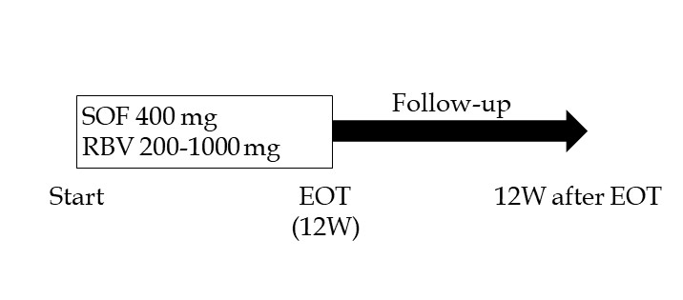
Figure 1 Treatment regimen of sofosbuvir and ribavirin. SOF: Sofosbuvir; RBV: Ribavirin; EOT: End of treatment; 12W: 12 wk.

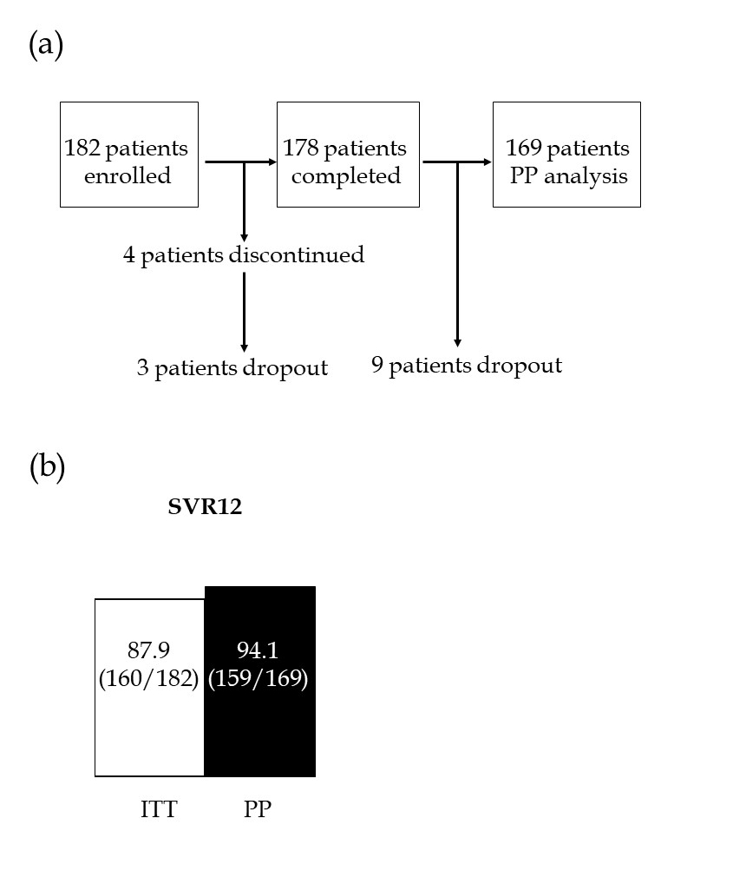
Figure 2 Flow sheet of this study (A) and virological response rates for combination therapy with sofosbuvir and ribavirin (B). The rates of sustained virological response at 12 wk after the end of treatment are shown for intention to treat and per protocol analyses. PP: Per protocol; ITT: Intention to treat; SVR12: Sustained virological response at 12 wk after the end of treatment.

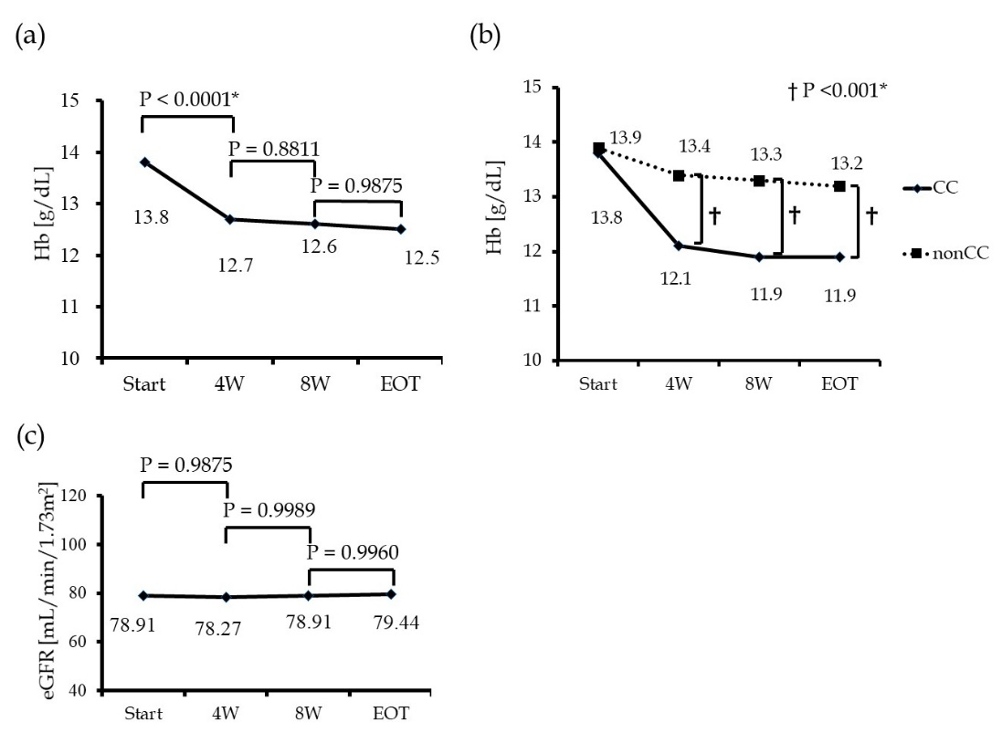

Figure 3 Hemoglobin levels in all patients during combination therapy with sofosbuvir and ribavirin (A), hemoglobin levels in 175 patients categorized by inosine triphosphate pyrophosphatase single nucleotide polymorphism rs1127354 (CC or non CC) (B), and estimated glomerular filtration rate levels in all patients during sofosbuvir/ribavirin therapy (C). Hb: Hemoglobin; 4W: 4 wk; 8W: 8 wk; EOT: End of treatment; eGFR: Estimated glomerular filtration rate. ªP < 0.05, significant difference.

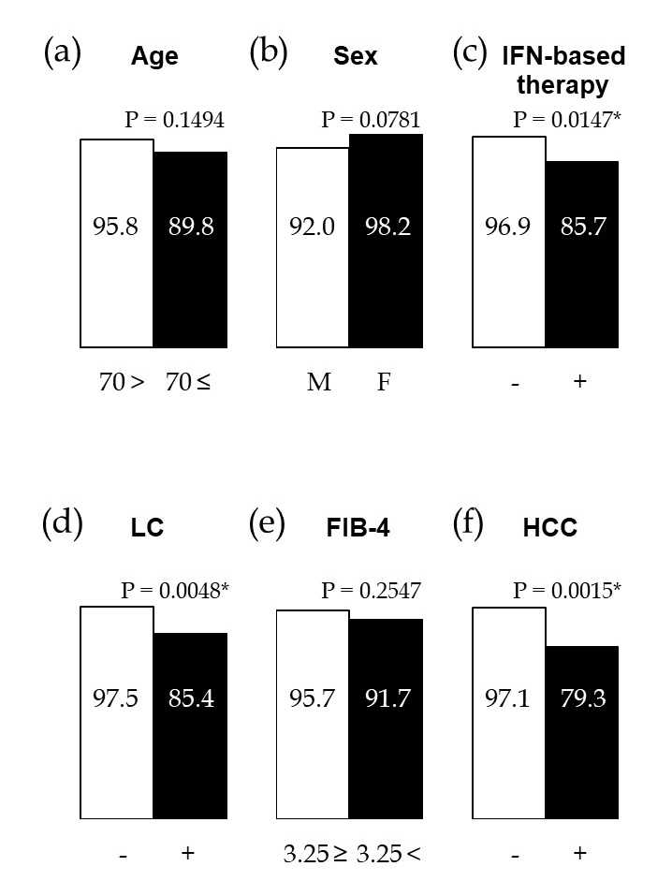

Figure 4 Virological response in patients with sofosbuvir and ribavirin (SOF/RBV) combination therapy categorized by patient characteristics. A: Age (< 70 or ≥ 70 yr); B: Sex (male or female); C: History of interferon-based therapy (− or +); D: Liver cirrhosis (− or +); E: Fibrosis-4 index (≤ 3.25 or > 3.25); F: History of hepatocellular carcinoma (− or +). ªP < 0.05: Significant difference. M: Male; F: Female; IFN: Interferon; LC: Liver cirrhosis; FIB: Fibrosis; HCC: Hepatocellular carcinoma.

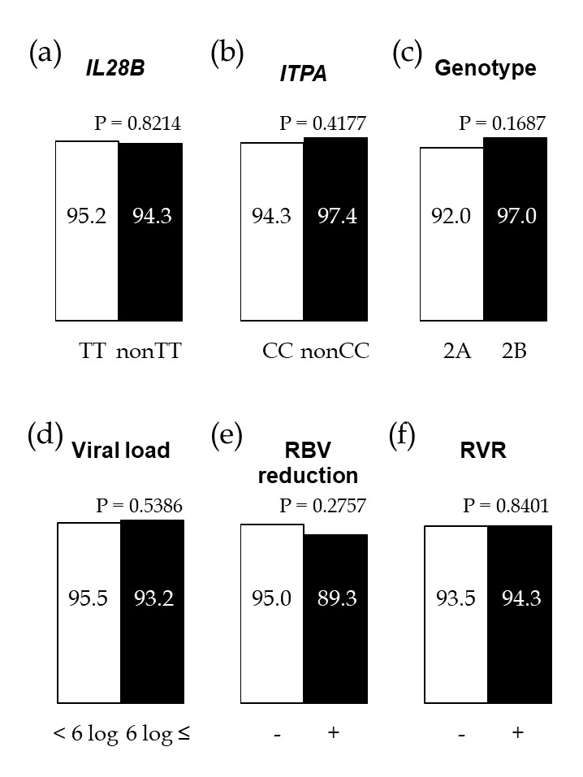
Figure 5 Virological response in patients with sofosbuvir and ribavirin combination therapy categorized by single nucleotide polymorphisms related to anti-hepatitis C virus therapy, pretreatment viral status, ribavirin dose, and rapid virological response. A: IL28B single nucleotide polymorphisms rs8099917 (TT or non TT); B: ITPA single nucleotide polymorphisms rs1127354 (CC or non CC); C: Hepatitis C virus genotype (2A or 2B); D: Pretreatment viral load (< 6 logIU/mL or ≥ 6 logIU/mL); E: ribavirin dose reduction (− or +); F: Rapid virological response (− or +). ªP < 0.05: Significant difference. IL28B: Interleukin-28B; ITPA: Inosine triphosphate pyrophosphatase; RBV: Ribavirin; RVR: Rapid virological response.
Table 1 Pretreatment characteristics of the patients (n = 182)
Pretreatment characteristics | values
Age¹, yr | 60.1±14.1
Age ≥ 70 yr | 27.4%
Sex, M : F | 122:60
Body height¹, cm | 163.0 ± 8.9
Body weight¹, kg | 62.3 ± 12.1
Liver cirrhosis | 26.6%
History of HCC | 15.9%
FIB-4 index² | 2.63 (0.45-19.03)
FIB-4 index > 3.25 | 40.7%
Wisteria floribunda agglutinin+-Mac-2 binding protein² | 1.94 (0.20-18.51)
Hyaluronic acid², ng/mL | 97.4 (10.0-2750.0)
History of IFN-based therapy | 23.6%
IL28B-SNP rs8099917 TT/non TT | 136/38/8
ITPA-SNP rs1127354 CC | 129/45/8
HCV genotype 2A/2B/ND | 109/70/3
HCV RNA², logIU/mL | 6.1 (1.2-7.6)
HCV RNA > 6 logIU/mL | 58.8%
White blood cell count², /mm³ | 4575 (1700-12010)
Hemoglobin², g/dL | 13.7 (10.1-17.6)
Platelet count², /mm³ | 165 (38-389) × 10³
Aspartate aminotransferase², IU/L | 41 (14-336)
Alanine aminotransferase², IU/L | 40 (5-391)
Albumin², g/dL | 4.0 (2.6-5.0)
Total bilirubin², mg/dL | 0.8 (0.3-3.0)
Blood urea nitrogen², mg/dL | 13 (5-28)
Creatinine², mg/dL | 0.71 (0.32-1.23)
Estimated glomerular filtration rate², mL/min/1.73 m² | 78.9 (42.6-164.2)

¹Mean ± SD; ²Median (range). M: Male; F: Female; HCC: Hepatocellular carcinoma; FIB: Fibrosis; IL28B: Interleukin-28B; SNP: Single nucleotide polymorphisms; ITPA: Inosine triphosphate pyrophosphatase; HCV: Hepatitis C virus.

Table 2 Factors contributing to sustained virological response in the per protocol analysis
 | Univariate |  |  | Multivariate
 | Odds ratio | 95%CI | P value | Odds ratio | 95%CI | P value
Age, ≥ 70 yr | 2.61 | 0.70, 9.82 | 0.1494
Sex, male | 4.76 | 0.85, 88.89 | 0.0781
History of IFN-based therapy | 5.12 | 1.39, 20.98 | 0.0147ª | 7.05 | 1.65, 36.08 | 0.0084ª
Liver cirrhosis | 6.72 | 1.78, 32.29 | 0.0048ª | 2.13 | 0.31, 14.34 | 0.4315
FIB-4 index, > 3.25 | 2.11 | 0.58, 8.54 | 0.2546
History of HCC | 8.87 | 2.36, 37.04 | 0.0015ª | 7.67 | 1.30, 60.30 | 0.0233ª
IL28B-SNP, non TT | 1.21 | 0.17, 5.55 | 0.8214
ITPA-SNP, non CC | 0.45 | 0.02, 2.63 | 0.4177
HCV genotype, 2A | 2.78 | 0.67, 18.84 | 0.1687
Viral load, ≥ 6 logIU/mL | 1.53 | 0.41, 7.31 | 0.5478
RBV dose reduction | 2.29 | 0.47, 8.89 | 0.2757
Rapid virological response | 0.86 | 0.22, 4.15 | 0.8401
ªP < 0.05, significant difference. IFN: Interferon; FIB: Fibrosis; HCC: Hepatocellular carcinoma; IL28B: Interleukin-28B; SNP: Single nucleotide polymorphisms; ITPA: Inosine triphosphate pyrophosphatase; HCV: Hepatitis C virus; RBV: Ribavirin.

Table 3 Assessment of patients with history of hepatitis C virus
 | SVR (n = 23) | Non SVR (n = 6) | P value
Alpha fetoprotein | 9.6 (1.7-348.9) | 5.3 (2.6-65.7) | 0.2815
Latest treatment for HCC  Surgical resection or Radiofrequency ablation  Transcatheter arterial chemoembolization  Radiation for bone metastasis | 73.9% (17)  26.1% (6)  0% (0) | 66.6% (6)  16.7% (1)  16.7% (1) | 0.2558
Recurrent HCC within 1 yr from the end of SOF/RBV | 65. 2% (15) | 83.3% (5) | 0.6328
SVR: Sustained virological response; HCC: Hepatocellular carcinoma; SOF/RBV: sofosbuvir/ribavirin.

