Name of Journal: World Journal of Clinical Cases
Manuscript NO: 57163
Manuscript Type: CASE REPORT

New treatment of patellar instability after total knee arthroplasty: A case report and review of literature

Shen XY et al. New treatment of patellar instability

Xian-Yue Shen, Jian-Lin Zuo, Jian-Peng Gao, Tong Liu, Jian-Lin Xiao, Yan-Guo Qin

Xian-Yue Shen, Jian-Lin Zuo, Jian-Peng Gao, Tong Liu, Jian-Lin Xiao, Department of Orthopedics, China-Japan Union Hospital of Jilin University, Changchun 130033, Jilin Province, China

Xian-Yue Shen, Yan-Guo Qin, Department of Orthopedics, The Second Hospital of Jilin University, Changchun 130041, Jilin Province, China

Author contributions: Shen XY, Gao JP, Xiao JL, and Zuo JL were the clinicians involved in patient diagnostics, management, therapy, and follow-up; Shen XY reviewed the literature and wrote the draft; Qin YG and Xiao JL contributed to reviewing the literature and manuscript drafting; Xiao JL and Zuo JL analyzed and interpreted the imaging findings; Xiao JL and Qin YG was responsible for the critical revision of the manuscript for relevant intellectual content; All of the authors approved the final version of the paper prior to submission.

Corresponding author: Jian-Lin Xiao, MD, PhD, Chief Doctor, Postdoc, Department of Orthopaedics, China-Japan Union Hospital of Jilin University, No. 126 Xiantai Street, Changchun 130033, Jilin Province, China. xiaojianlin10@jlu.edu.cn

Received: June 4, 2020
Revised: September 19, 2020
Accepted: September 28, 2020
Published online: November 6, 2020

Abstract
BACKGROUND
Patellar instability is an uncommon complication after total knee arthroplasty (TKA). Partial lateral patella facetectomy (LPF) with lateral retinaculum release treatment of patellar instability is rarely reported.

CASE SUMMARY
We present a case of patellar instability 8 mo after primary TKA. Treatment of this complication was adapted to address the cause of the dislocation. To eliminate patellar instability, we restored the vastus medialis and performed LPF with lateral retinaculum release. We achieved normal patellar tracking. Clinical and radiographic evaluations at the 1-year postoperative follow-up were satisfactory.

CONCLUSION
LPF with lateral retinaculum release represents a promising option to restore central patellar tracking in patients with patellar instability after TKA in cases without component malposition.

Key Words: Total knee arthroplasty; Patellar instability; Lateral patella facetectomy; Complication; Case report

Shen XY, Zuo JL, Gao JP, Liu T, Xiao JL, Qin YG. New treatment of patellar instability after total knee arthroplasty: A case report and review of literature. World J Clin Cases 2020; 8(21): 5487-5493 URL: https://www.wjgnet.com/2307-8960/full/v8/i21/5487.htm DOI: https://dx.doi.org/10.12998/wjcc.v8.i21.5487

Core Tip: Patellar instability is an uncommon complication after total knee arthroplasty (TKA). We report a case who had patellar instability 8 mo after primary TKA, and skyline view revealed a lateral shift of the patella. To eliminate patellar instability, we restored the vastus medialis and performed partial lateral patella facetectomy with lateral retinaculum release. This report is the first to describe successful treatment of patellar instability after TKA by lateral patella facetectomy with lateral retinaculum release. This procedure represents a promising option to restore central patellar tracking in patients with patellar instability after TKA.
INTRODUCTION
Total knee arthroplasty (TKA) is an effective surgical procedure; however, a range of complications can occur. Patellar instability is a serious complication of TKA that may require revision surgery^{[1-3]}. Patients with patellar instability after TKA present with anterior knee pain, giving-way, and functional limitation. Risk factors for patellar instability after TKA include surgical technique, prosthetic causes, and soft-tissue imbalance^{[4]}. Management of patellar instability after TKA requires surgery^{[2,5-8]}. Implant revision is required when patellar instability is related to prosthetic malposition. For soft-tissue imbalance, reconstruction of the medial patellofemoral ligament with lateral retinaculum release represents an effective treatment option.
Reports describing management of patellar instability after TKA using partial lateral patella facetectomy (LPF) with lateral retinaculum release has not been previously reported. Here, we present a case of patellar instability after TKA due to rupture of the vastus medialis that was treated by vastus medialis restoration and partial LPF with lateral retinaculum release. To our knowledge, this is first published report of patellar instability after TKA treated with LPF with lateral retinaculum release.

CASE PRESENTATION
Chief complaints
An 84-year-old female experienced severe anterior right knee pain 8 mo after TKA. In January 2018, the patient was referred to our department for therapy.

History of present illness
The patient was diagnosed with bilateral knee osteoarthritis and underwent right primary TKA in November 2016. Physical examination prior to primary TKA revealed a decrease in range of motion to 15°-50°. Figure 1 shows preoperative anteroposterior and lateral radiographs of the right knee and full-length weight-bearing radiographs of the lower extremities. The patient underwent posterior stabilized TKA with patellar denervation using the medial parapatellar approach. After implantation, functional patellar tracking was assessed by the surgeon (Prof. JLZ) using the “no thumb technique”. Lateral release was not performed. Range of motion and isometric quadriceps exercises were initiated immediately, and weight-bearing was allowed on postoperative day 1. Postoperatively, range of motion improved to 0°-120°. Eight months after surgery, the patient experienced severe anterior right knee pain.

History of past illness
The patient had medical history of hypertension (American Society of Anesthesiologists physical status classification II due to hypertension).

Physical examination
Physical examination revealed patellar instability of the right knee, especially when the knee was in the flexion position, and that quadriceps strength was obviously lower in the right knee compared to the left. Clinical examination showed a limited range of motion.

Imaging examinations
Radiographs did not demonstrate any obvious fractures or prosthetic malposition. Weight-bearing full length X-rays of the lower extremity demonstrated a well-restored mechanical axis. Skyline view revealed a lateral shift of the patella (Figure 2).

FINAL DIAGNOSIS
As there were no structural imbalances or weakness in the injured knee, we diagnosed lateral patellar dislocation after TKA due to soft-tissue imbalance.

TREATMENT
We intended to stabilize the patella by medial patellofemoral ligament (MPFL) reconstruction combined with lateral retinaculum release. Exposure occurred through the same incision used for primary TKA, and the patella was everted and displaced laterally. During surgery, we found rupture of the vastus medialis, damage to the patella articular cartilage, and osteophyte formation in the lateral patella (Figure 3). In addition, the patella was small and thin and not suitable for patellar resurfacing. Therefore, we tentatively adopted a more targeted surgical method. We restored the vastus medialis, partially resected the lateral patella, and released the lateral retinaculum. Functional patellar tracking was confirmed throughout the range of motion. The operation took about 40 min.

OUTCOME AND FOLLOW-UP
This case shows that LPF with release of lateral retinaculum is effective in the treatment of patellar dislocation after TKA. The patient underwent clinical (Hospital for Special Surgery Clinical Score) and radiographic (anteroposterior, lateral, and skyline views) evaluation during 1-year of follow-up with no complaints of knee pain or subluxation. At the 1-year of follow-up, the patient was able to walk with a crutch, had active range of motion was 0°-110°, and had the Hospital for Special Surgery Clinical Score of 85.

DISCUSSION
TKA is a well-established procedure that is effective for the treatment of advanced knee joint arthritis. Management of the patellofemoral joint in TKA remains controversial but has an important impact on outcomes^{[9]}. Inappropriate management of the patellofemoral joint may lead to a series of complications. Risk factors for patellofemoral joint instability in TKA include component positioning and limb alignment, component design, patellar preparation, and soft-tissue balancing^{[1]}.
To our knowledge, we are the first to report on the use of LPF with lateral retinaculum release for the treatment of patellar instability after TKA. In the present case, the patient had a small thin patella; therefore, she had undergone primary TKA with denervation instead of patella resurfacing, which may have led to patellar fracture^{[10]}. Postoperatively, the femoral and tibial components were aligned and stable and tracking of the patella was normal^{[11-14]}. After 8 mo, the patient experienced severe anterior right knee pain. We diagnosed lateral patellar dislocation. We speculated that nonresurfacing of the patella and soft-tissue imbalance contributed to patellofemoral instability in this patient. Seo et al^{[15]} reported no significant clinical and radiological differences in patients with resurfaced vs nonresurfaced patellae; however, several meta-analyses have revealed a higher risk for reoperation in patients with nonresurfaced patellae^{[9,16-18]}. The patient underwent primary TKA by a medial parapatellar approach, which may have damaged the vastus medialis, resulting in soft-tissue imbalance.
MPFL reconstruction and distal realignment of the patella represents an effective treatment option for patellar instability after TKA^{[2,8,19-21]}. Carmont et al^{[22]} and Goto et al^{[21]} achieved good results using MPFL for patellar dislocation due to rupture of the medial structures after TKA. Similarly, Nakajima et al^{[8]} reported satisfactory outcomes after adopting an Elmslie-Trillat procedure in combination with extensive lateral release to treat patellar instability after primary TKA in cases without component malposition (Table 1).
In this patient, we tentatively adopted a novel surgical approach to stabilize effectively the patella. We reconstructed the vastus medialis and performed partial LPF in combination with lateral retinaculum release. Patella facetectomy was first introduced by O’Donoghue^{[23]}; subsequently, partial LPF was reported as an effective treatment for patellofemoral osteoarthritis, especially for alleviating anterior knee pain^{[24-29]}. However, clinical evidence supporting the use of this method in the treatment of patellar instability after TKA is lacking. A number of studies showed that lateral retinaculum release is beneficial for correcting patellar maltracking^{[2,30-33]}. The present case provides clinical evidence supporting the use of partial LPF in combination with lateral retinaculum release for the treatment of patellar instability after TKA.

CONCLUSION
In conclusion, to the authors’ knowledge, this report is the first to describe successful treatment of patellar instability after TKA by LPF with lateral retinaculum release. This procedure represents a promising option to restore central patellar tracking in patients with patellar instability after TKA.

REFERENCES
1 Song SJ, Detch RC, Maloney WJ, Goodman SB, Huddleston JI 3rd. Causes of instability after total knee arthroplasty. J Arthroplasty 2014; 29: 360-364 [PMID: 23896358 DOI: 10.1016/j.arth.2013.06.023]
2 van Gennip S, Schimmel JJ, van Hellemondt GG, Defoort KC, Wymenga AB. Medial patellofemoral ligament reconstruction for patellar maltracking following total knee arthroplasty is effective. Knee Surg Sports Traumatol Arthrosc 2014; 22: 2569-2573 [PMID: 23108684 DOI: 10.1007/s00167-012-2269-y]
3 Archibeck MJ, White RE Jr. What's new in adult reconstructive knee surgery. J Bone Joint Surg Am 2005; 87: 1656-1666 [PMID: 15995137 DOI: 10.2106/JBJS.E.00364]
4 Motsis EK, Paschos N, Pakos EE, Georgoulis AD. Review article: Patellar instability after total knee arthroplasty. J Orthop Surg (Hong Kong) 2009; 17: 351-357 [PMID: 20065379 DOI: 10.1177/230949900901700322]
5 Malo M, Vince KG. The unstable patella after total knee arthroplasty: etiology, prevention, and management. J Am Acad Orthop Surg 2003; 11: 364-371 [PMID: 14565758 DOI: 10.5435/00124635-200309000-00009]
6 Rosenberg AG, Jacobs JJ, Saleh KJ, Kassim RA, Christie MJ, Lewallen DG, Rand JA, Rubash HE. The patella in revision total knee arthroplasty. J Bone Joint Surg Am 2003; 85-A Suppl 1: S63-S70 [PMID: 12540672 DOI: 10.2106/00004623-200300001-00012]
7 Whiteside LA. Distal realignment of the patellar tendon to correct abnormal patellar tracking. Clin Orthop Relat Res 1997; 284-289 [PMID: 9372779 DOI: 10.1097/00003086-199711000-00028]
8 Nakajima A, Watanabe H, Rokkaku T, Koda M, Yamada T, Murakami M. The Elmslie-Trillat procedure for recurrent patellar subluxation after total knee arthroplasty. J Arthroplasty 2010; 25: 1170.e1-1170.e5 [PMID: 20888547 DOI: 10.1016/j.arth.2009.09.008]
9 Abdel MP, Parratte S, Budhiparama NC. The patella in total knee arthroplasty: to resurface or not is the question. Curr Rev Musculoskelet Med 2014; 7: 117-124 [PMID: 24706154 DOI: 10.1007/s12178-014-9212-4]
10 Lie DT, Gloria N, Amis AA, Lee BP, Yeo SJ, Chou SM. Patellar resection during total knee arthroplasty: effect on bone strain and fracture risk. Knee Surg Sports Traumatol Arthrosc 2005; 13: 203-208 [PMID: 15127185 DOI: 10.1007/s00167-004-0508-6]
11 Pulavarti RS, Raut VV, McLauchlan GJ. Patella denervation in primary total knee arthroplasty - a randomized controlled trial with 2 years of follow-up. J Arthroplasty 2014; 29: 977-981 [PMID: 24291230 DOI: 10.1016/j.arth.2013.10.017]
12 Beaupre L, Secretan C, Johnston DW, Lavoie G. A randomized controlled trial comparing patellar retention vs patellar resurfacing in primary total knee arthroplasty: 5-10 year follow-up. BMC Res Notes 2012; 5: 273 [PMID: 22676495 DOI: 10.1186/1756-0500-5-273]
13 Xie X, Pei F, Huang Z, Tan Z, Yang Z, Kang P. Does patellar denervation reduce post-operative anterior knee pain after total knee arthroplasty? Knee Surg Sports Traumatol Arthrosc 2015; 23: 1808-1815 [PMID: 25758982 DOI: 10.1007/s00167-015-3566-z]
14 Li T, Zhou L, Zhuang Q, Weng X, Bian Y. Patellar denervation in total knee arthroplasty without patellar resurfacing and postoperative anterior knee pain: a meta-analysis of randomized controlled trials. J Arthroplasty 2014; 29: 2309-2313 [PMID: 24582160 DOI: 10.1016/j.arth.2014.01.024]
15 Seo SS, Kim CW, Moon SW. A Comparison of Patella Retention vs Resurfacing for Moderate or Severe Patellar Articular Defects in Total Knee Arthroplasty: Minimum 5-year Follow-up Results. Knee Surg Relat Res 2011; 23: 142-148 [PMID: 22570825 DOI: 10.5792/ksrr.2011.23.3.142]
16 Chen K, Li G, Fu D, Yuan C, Zhang Q, Cai Z. Patellar resurfacing vs nonresurfacing in total knee arthroplasty: a meta-analysis of randomised controlled trials. Int Orthop 2013; 37: 1075-1083 [PMID: 23529719 DOI: 10.1007/s00264-013-1866-9]
17 Patel K, Raut V. Patella in total knee arthroplasty: to resurface or not to--a cohort study of staged bilateral total knee arthroplasty. Int Orthop 2011; 35: 349-353 [PMID: 20559832 DOI: 10.1007/s00264-010-1063-z]
18 Yim SJ, Jang MS, Kim WJ, Lee SH, Kang HK. The Effect of Electrocautery around the Patellar Rim in Patellar Non-Resurfacing Total Knee Arthroplasty. Knee Surg Relat Res 2012; 24: 104-107 [PMID: 22708111 DOI: 10.5792/ksrr.2012.24.2.104]
19 Lamotte A, Neri T, Kawaye A, Boyer B, Farizon F, Philippot R. Medial patellofemoral ligament reconstruction for patellar instability following total knee arthroplasty: A review of 6 cases. Orthop Traumatol Surg Res 2016; 102: 607-610 [PMID: 27317639 DOI: 10.1016/j.otsr.2016.03.018]
20 Csintalan RP, Latt LD, Fornalski S, Raiszadeh K, Inacio MC, Fithian DC. Medial patellofemoral ligament (MPFL) reconstruction for the treatment of patellofemoral instability. J Knee Surg 2014; 27: 139-146 [PMID: 24227396 DOI: 10.1055/s-0033-1360652]
21 Goto T, Hamada D, Iwame T, Suzue N, Takeuchi M, Egawa H, Sairyo K. Medial patellofemoral ligament reconstruction for patellar dislocation due to rupture of the medial structures after total knee arthroplasty: a case report and review of the literature. J Med Invest 2014; 61: 409-412 [PMID: 25264063 DOI: 10.2152/jmi.61.409]
22 Carmont MR, Crane T, Thompson P, Spalding T. Medial patellofemoral ligament reconstruction for subluxating patellofemoral arthroplasty. Knee 2011; 18: 130-132 [PMID: 20619661 DOI: 10.1016/j.knee.2010.02.011]
23 O'Donoghue DH. Facetectomy. South Med J 1972; 65: 645-654 [PMID: 5032362 DOI: 10.1097/00007611-197206000-00001]
24 Yuenyongviwat V, Iamthanaporn K, Hongnaparak T. Lateral facetectomy decreased patellofemoral contact pressure in total knee replacement: A cadaveric study. J Clin Orthop Trauma 2017; 8: 82-84 [PMID: 28360504 DOI: 10.1016/j.jcot.2016.07.007]
25 Wetzels T, Bellemans J. Patellofemoral osteoarthritis treated by partial lateral facetectomy: results at long-term follow up. Knee 2012; 19: 411-415 [PMID: 21596570 DOI: 10.1016/j.knee.2011.04.005]
26 Montserrat F, Alentorn-Geli E, León V, Ginés-Cespedosa A, Rigol P. Treatment of isolated patellofemoral osteoarthritis with lateral facetectomy plus Insall's realignment procedure: long-term follow-up. Knee Surg Sports Traumatol Arthrosc 2013; 21: 2572-2577 [PMID: 23389560 DOI: 10.1007/s00167-013-2431-1]
27 Zhang LZ, Zhang XL, Jiang Y, Wang Q, Chen YS, Shen H. Lateral patellar facetectomy had improved clinical results in patients with patellar-retaining total knee arthroplasty. J Arthroplasty 2012; 27: 1442-1447 [PMID: 22325960 DOI: 10.1016/j.arth.2011.12.018]
28 Pagenstert G, Seelhoff J, Henninger HB, Wirtz DC, Valderrabano V, Barg A. Lateral patellar facetectomy and medial reefing in patients with lateral facet syndrome after patellar-retaining total knee arthroplasty. J Arthroplasty 2014; 29: 2156-2162 [PMID: 25070901 DOI: 10.1016/j.arth.2014.06.014]
29 Lakstein D, Naser M, Adar E, Atoun E, Edelman A, Hendel D. Partial lateral patellar facetectomy as an alternative to lateral release in Total Knee Arthroplasty (TKA). J Arthroplasty 2014; 29: 2146-2149 [PMID: 25064018 DOI: 10.1016/j.arth.2014.06.013]
30 Roth S, Madarevic T, Vukelic L, Roth A, Gudac Madarevic D, Cicvaric T. Influence of arthroscopic lateral release on functional recovery in adolescents with recurrent patellar dislocation. Arch Orthop Trauma Surg 2013; 133: 1441-1445 [PMID: 23852589 DOI: 10.1007/s00402-013-1805-7]
31 Unal B, Hinckel BB, Sherman SL, Lattermann C. Comparison of Lateral Retinaculum Release and Lengthening in the Treatment of Patellofemoral Disorders. Am J Orthop (Belle Mead NJ) 2017; 46: 224-228 [PMID: 29099880]
32 Menschik F, Landsiedl F. [Results of isolated lateral retinaculum release as a treatment method in patello-femoral dysfunction]. Z Orthop Ihre Grenzgeb 1992; 130: 218-222 [PMID: 1642038 DOI: 10.1055/s-2008-1040142]
33 Frosch S, Balcarek P, Walde TA, Schüttrumpf JP, Wachowski MM, Ferleman KG, Stürmer KM, Frosch KH. [The treatment of patellar dislocation: a systematic review]. Z Orthop Unfall 2011; 149: 630-645 [PMID: 21544786 DOI: 10.1055/s-0030-1250691]

Footnotes
Informed consent statement: The patient consented to the publication of this study.

Conflict-of-interest statement: The authors declare no conflicts of interest.

CARE Checklist (2016) statement: The authors have read the CARE Checklist (2016), and the manuscript was prepared and revised according to the CARE Checklist (2016).

Open-Access: This article is an open-access article that was selected by an in-house editor and fully peer-reviewed by external reviewers. It is distributed in accordance with the Creative Commons Attribution NonCommercial (CC BY-NC 4.0) license, which permits others to distribute, remix, adapt, build upon this work non-commercially, and license their derivative works on different terms, provided the original work is properly cited and the use is non-commercial. See: http://creativecommons.org/Licenses/by-nc/4.0/

Manuscript source: Unsolicited manuscript

Peer-review started: June 11, 2020
First decision: September 13, 2020
Article in press: September 28, 2020

Specialty type: Medicine, research and experimental
Country/Territory of origin: China
Peer-review report’s scientific quality classification
Grade A (Excellent): 0
Grade B (Very good): 0
Grade C (Good): C
Grade D (Fair): 0
Grade E (Poor): 0

P-Reviewer: Nikolopoulos DD S-Editor: Zhang L L-Editor: Filipodia P-Editor: Wang LL

Figure Legends
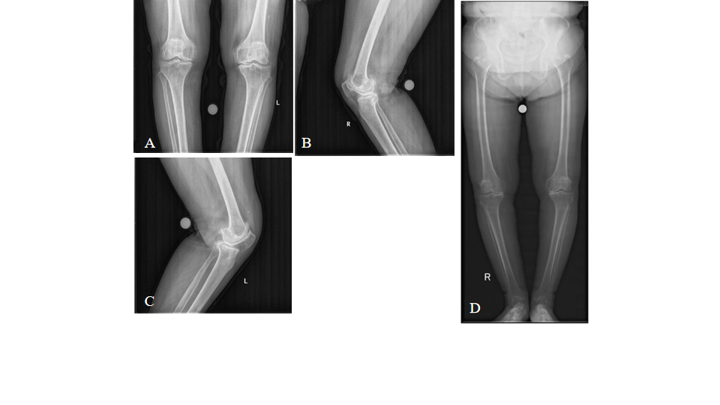
Figure 1 Primary total knee arthroplasty. A: Preoperative radiographs, anteroposterior view; B and C: Lateral views; and D: Full length weight-bearing of the lower extremities.

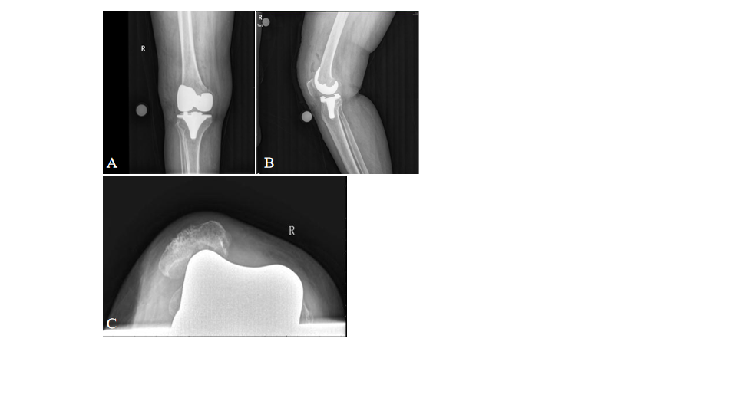
Figure 2 Primary total knee arthroplasty. A: Postoperative radiographs of the right knee, anteroposterior view; B: Lateral view; and C: Skyline view.

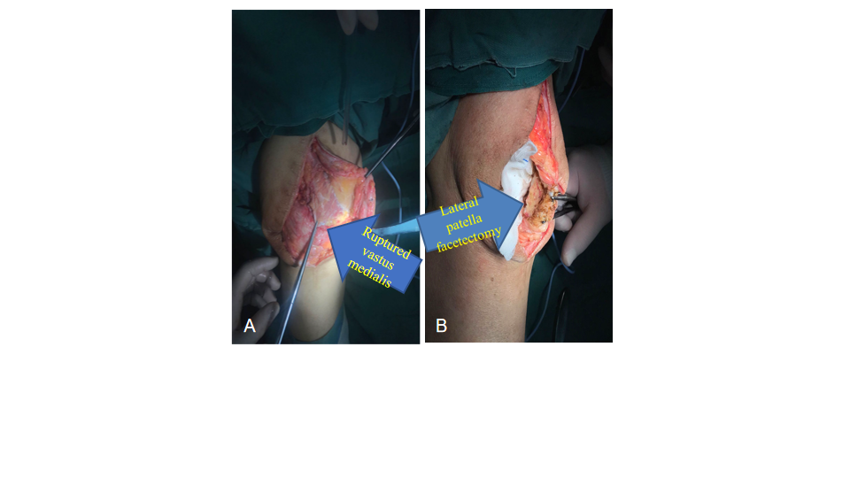
Figure 3 Reoperation. A: An intraoperative view of the ruptured vastus medialis; B: Partial lateral facetectomy.
Table 1 Published literature describing treatment for patellar instability after total knee arthroplasty
Ref. | Year | Case | Surgical technique | Follow-up | Outcome | Complication
Nakajima et al^{[8]} | 2010 | 1 | Elmslie-Trillat procedure with lateral release | 12 mo | Good | None
van Gennip et al^{[2]} | 2012 | 9 | 7 MPFL reconstruction with lateral release, 2 MPFL reconstruction with lateral release and tibial tuberosity transfer | Mean 33 mo | Generally good | One report of subluxation
Goto et al^{[21]} | 2014 | 1 | MPFL reconstruction and lateral release | 12 mo | Good | None
Lamotte et al^{[19]} | 2016 | 6 | 5 MPFL reconstruction with additional procedure, 1 TKA revision | Mean 23 mo | Good | None
Current study | 2019 | 1 | Partial LPF with lateral retinaculum release | 12 mo | Good | None
LPF: Lateral patella facetectomy; MPFL: Medial patellofemoral ligament; TKA: Total knee arthroplasty.

