Name of Journal: World Journal of Meta-Analysis
Manuscript NO: 81275
Manuscript Type: META-ANALYSIS

Vitamin D deficiency among outpatients and hospitalized patients with diabetic foot ulcers: A systematic review and meta-analysis

Mirghani HO. Vitamin D status and DFUs

Hyder Osman Mirghani

Hyder Osman Mirghani, Department of Internal Medicine, Faculty of Medicine, University of Tabuk, Saudi Arabia, Tabuk 3378, Saudi Arabia

Author contributions: Mirghani HO contributed to the concept and design, literature search, data analysis and interpretation, and manuscript drafting.

Corresponding author: Hyder Osman Mirghani, MD, Professor, Internal Medicine, Faculty of Medicine, University of Tabuk, Saudi Arabia, Prince Fahd Bin Sultan Street, Tabuk 3378, Saudi Arabia. s.hyder63@hotmail.com

Received: December 24, 2022
Revised: March 27, 2023
Accepted: May 6, 2023
Published online: June 18, 2023

Abstract
BACKGROUND
The definition of diabetic foot syndrome (DFS) varies depending on the location and resources. Few classifications are available according to the indication. DF ulcers and vitamin D deficiency are common diseases among patients with diabetes. Previous literature has shown an association between DF ulcer (DFU) and vitamin D deficiency. However, the available meta-0analysis was limited by substantial bias.

AIM
To investigate the association between DFUs and vitamin D levels.

METHODS
We searched PubMed, MEDLINE, and Cochrane Library, EBSCO, and Google Scholar for studies comparing vitamin D levels and DF. The keywords DFU, DFS, diabetic septic foot, vitamin D level, 25-hydroxy vitamin D, vitamin D status, and vitamin D deficiency were used. The search engine was set for articles published during the period from inception to October 2022. A predetermined table was used to collect the study information.

RESULTS
Vitamin D level was lower among patients with DFU compared to their counterparts [odds ratio (OR): -5.77; 95% confidence interval (CI): -7.87, -3.66; χ² was 84.62, mean difference, 9; I² for heterogeneity, 89%; P < 0.001 and P for overall effect < 0.001]. The results remained robust for hospitalized patients (OR: -6.32 95%CI: -11.66, -0.97; χ² was 19.39; mean difference, 2; I² for heterogeneity, 90%; P = 0.02).

CONCLUSION
Vitamin D was lower among outpatients and hospitalized patients with DFUs. Further larger randomized controlled trials are needed.

Key Words: Vitamin D deficiency; Diabetic foot ulcer; Outpatient; Hospitalized patients; Diabetic foot syndrome

©The Author(s) 2023. Published by Baishideng Publishing Group Inc. All rights reserved.

Citation: Mirghani HO. Vitamin D deficiency among outpatients and hospitalized patients with diabetic foot ulcers: A systematic review and meta-analysis. World J Meta-Anal 2023; 11(5): 218-227
URL: https://www.wjgnet.com/2308-3840/full/v11/i5/218.htm
DOI: https://dx.doi.org/10.13105/wjma.v11.i5.218

Core Tip: This is the first study to assess the relationship between diabetic foot ulcer and vitamin D deficiency, avoiding the bias of the two published meta-analyses.

INTRODUCTION
Diabetes mellitus (DM) is an epidemic globally. DM is a morbid disease with many complications including microvascular and microvascular disease. Diabetic foot syndrome (DFS) is defined as peripheral neuropathy, limited joint mobility, peripheral arterial disease, immunopathy, ulceration, and Charcot arthropathy^{[1]}. The combination of FS elements provides an environment for unrecognized injury, foot infection, and possible amputation^{[2]}. DFS is characterized by peripheral arterial disease, but the symptoms are masked by the accompanying peripheral neuropathy. The pathology varies from pre-ulcerative callouses, ulceration, and necrosis developing at the site of high pressure (deformities of the toes and feet). Patient education and feet inspection are mandatory because repetitive trauma might pass unnoticed due to the loss of pain sensation^{[3]}. DFS is a common complication of diabetes with a great economic burden; DTS substantially affects the patient's quality of life and leads to premature death. In addition, patients with DFS are prone to psychiatric disease^{[4]}.
There are nearly 40 classifications for DFS, with wide variation depending on the availability of resources and geographical variations. It is recommended to use classification in light of specific indications. Few classifications have been validated for use; the site, ischemia, neuropathy, bacterial infection, area, and depth (SINBAD) is six questions with yes or no answers with a maximum of six points. SINBAD score is better for communication between clinicians^{[5]}. While, the Infectious Diseases Society of America/International Working Group on Diabetic Foot, and wound depth, ischemia, and foot infection scoring are better for infection and perfusion respectively^{[6,7]}. The spectrum of DFS varies from minor erythema to tissue necrosis and lower limb deformity and amputation ^{[8]}. The mortality of DFS is comparable to breast and lung cancer. Five-year mortality for minor and major amputations, Charcot, and DF ulcer (DFU) were 56.6%, 46.2%, 30.5%, 29%, respectively. The pooled mortality from breast, all cancer, and lung cancer were 9%, 30%, and 80% respectively^{[9]}.
The lifetime of developing FUs among patients with diabetes varies between 19% and 34% with nearly two-thirds of recurrence in 5 years, and 1 in 5 patients with moderate to severe FUs resulting in amputation. The majority of lower extremities amputations are preceded by FUs and three amputations occur every minute due to diabetes. Patients with FUs had a 2.5 times mortality rate compared to their counterparts^{[10,11]}.
25-hydroxyvitamin D (25(OH)D) is present in almost all immune cells and is a major immunomodulatory hormone. In addition, the vitamin is a potent endothelial membrane stabilizer^{[12]}. Due to its anti-inflammatory effects, the active form of vitamin D plays an important role in inflammatory diseases including rheumatic disorders, and a growing piece of evidence is present regarding its effects on infectious diseases^{[13]}. Vitamin D deficiency is common; larger studies suggest that in Europe, 40% and 13% of the population are vitamin D-deficient and severely deficient, respectively^{[14]}. Vitamin D deficiency is associated with vascular diseases including DM, hypertension, and dyslipidemias^{[15]}.
The small number of included studies, including studies published by the same authors and including poster presentations^{[16,17]}, limits the previous meta-analysis on vitamin D deficiency and diabetic septic foot. Therefore, this meta-analysis investigated vitamin D levels among patients with the diabetic septic foot.

MATERIALS AND METHODS
Eligibility criteria
The studies were eligible if they compared the level of vitamin D among patients with DFU and their counterparts without DFUs and they are randomized controlled trials or case-control studies, prospective and retrospective cohorts, and cross-sectional studies. Case reports, case series, and animal and experimental studies were excluded.

Outcomes measures
The primary outcome was the level of vitamin D among patients with DFUs.

Vitamin D assessment methods
Vitamin D measurement varied between the included studies. References 18, 19, 21, and 23 used the enzyme-linked immunosorbent assay; references 20, 22, and 25 used radioimmunoassays; references 24, 26, and 28 used the electrochemiluminescence immunoassay; reference 27 used liquid chromatography-tandem mass spectrometry; and reference 29 used the chemiluminescence assay.

Setting and DFU definition
All of the studies used outpatients except 18, 24, 28, and 29, in which hospitalized patients were included.

Information sources and search
The researcher searched PubMed, MEDLINE, and Cochrane Library, EBSCO, and Google Scholar using the keywords DFU, DFS, diabetic septic foot, vitamin D level, 25-hydroxy vitamin D, vitamin D status, and vitamin D deficiency. The search engine was set for articles published during the period from inception to October 2022. A predetermined table was used to collect study information including author name, year of publication, country, age, sex, patient’s number in the control and interventional groups, duration of diabetes, hemoglobin A1c (HbA1c) in the intervention and control groups, vitamin D level among patients with FUs and control groups (Figure 1 and Tables 1-3.)

Data analysis
The RevMan (version 5.4) system for meta-analysis was used, and the data were all continuous. We pooled data from 12 studies to compare vitamin D levels among patients with and without diabetic septic foot; a subanalysis was done to compare vitamin D among hospitalized patients. Random effect was used because significant heterogeneity was observed. Funnel plots were used to assess lateralization. P < 0.05 was considered statistically significant.

RESULTS
The current meta-analysis included 12 studies including 7619 patients. The included studies were seven cross-sectional, three prospective, and two retrospective studies; nine were published in Asia and three were from Europe^{[18-29]}. The included studies were of good quality as assessed by the Newcastle Ottawa Scale^{[30]}. Vitamin D was lower among patients with DFUs [odds ratio (OR): -5.77, 95% confidence interval (CI): -7.87, -3.66; χ² was 84.62; mean difference, 9; I² for heterogeneity, 89%; P < 0.001, and P for overall effect < 0.001] (Figure 2). Vitamin D level was low when a subanalysis was conducted including only hospitalized patients with diabetes septic foot (OR: -6.32; 95%CI: -11.66, -0.97; χ² was 19.39; mean difference, 2; I² for heterogeneity, 90%; P = 0.02) (Figure 3). Vitamin D level was lower among patients with DFUs after including studies that controlled for age, sex, duration of diabetes, and HbA1c (OR: -6.32; 95%CI: -923, -3.42; χ² was 18.72; mean difference, 4; I² for heterogeneity, 79%; P < 0.001) (Figure 4).

DISCUSSION
In the present meta-analysis, vitamin D levels were lower among patients with DFUs compared to their counterparts without FUs (OR: -5.77; 95%CI, -7.87, -3.66). There were no differences between hospitalized patients and outpatients. The results remained robust when including studies that controlled for age, sex, duration of diabetes, and HbA1c. The quality of the included studies was good^{[30]}. The current findings were in line with a narrative review including three studies^{[31]}. The present findings were similar to the first meta-analysis published by Dai and colleagues in 2019. Dai et al^{[16]} found an association between vitamin D levels and DFUs. However, Kota et al^{[32]} included studies published by the same authors and some were poster presentations. Yammine et al^{[33]} found similar results. Importantly, Yammine and colleagues included poster presentations, studies published by the same authors, and studies that assessed Charcot’s joints^{[34]}. In addition, the previous meta-analysis included Zubair et al^{[35]} study in which vitamin D median was reported and not the mean ± standard deviation. A recently published meta-analysis reported similar findings to our results. However, the substantial heterogeneity including posters, research by the same authors, and different primary outcomes limited their results^{[17]}. The main strength of this meta-analysis is the subanalysis on vitamin D among hospitalized patients. Although a single measurement is not enough during stress, the results remain robust even among admitted patients^{[36]}.
Vitamin D has been considered a magic bullet and cures many chronic disorders. However, the results were obtained from observational studies. The findings of lower FUs among patients with higher vitamin D may not prove causality. Other confounders might explain the lower vitamin D levels among patients with DFUs including a healthier diet, good exposure to sunlight, and physical activity^{[37,38]}. In addition, vitamin D improves glycemic control among patients with diabetes^{[39,40]}. Thus, high vitamin D may indirectly protect against DFUs by improving glycemic control.
Osteoblasts (bone formation) and osteoclasts (bone resorption) orchestrate bone remodeling. Osteoclasts genesis activation is through receptor activator of tumor necrosis factor (RANK-osteoprotegerin), ultimately leading to osteolysis and destruction of bone tissue. This pathway is of great therapeutic and clinical implications. Medications that influence different levels of RANK-osteoprotegerin are bisphosphonates, calcitonin, and denosumab. Denosumab is encouraging for the treatment of Charcot diabetic foot. However, bisphosphonates have been evaluated recently due to the adverse events. Calcitonin efficacy is limited^{[41,42]}.

In this review, some of the included studies were not matched for age, duration of diabetes, duration of diabetes, or HbA1c. The young age of control subjects, their good glycemic control, and the short duration of diabetes might increase their risk of DFUs.

Vitamin D supplementation and diabetic septic foot
Although, the association between low vitamin D levels and diabetic septic foot was documented. However, the effect of vitamin D therapy on DFUs is unclear. In addition, it is not clear if the relationship is correlated or causal^{[43]}. A double-blinded randomized controlled trial showed that high-dose vitamin D supplementation (170 μg/d) was superior to low doses (20 μg/d) on diabetic ulcer healing^{[44]}. A recent review showed that vitamin D improved diabetic septic foot healing, an effect mediated by the remodeling and proliferation of cells involved. In addition, vitamin D suppresses proinflammatory responses, enhances antimicrobial peptides, and enhances anti-inflammatory effects^{[45]}. The review by Papaioannou and colleagues, which included 34 studies^{[46]}, supported the above findings. A randomized controlled trial published in Asia showed that vitamin D supplementation reduced ulcer length, width, and depth^{[47]}. A recent review of the literature concluded that vitamin D supplementation might slow the progression of neural damage. In addition to the adjuvant role in neuropathic pain and cardiovascular autonomic neuropathy among patients with type 2 diabetes^{[48]}.
The current meta-analysis strength is that we included observational studies excluding poster presentations, studies published by the same authors, and studies that used the median of vitamin D. The limitation of this study was the substantial heterogeneity.

CONCLUSION
Vitamin D levels were lower among patients with DFUs compared to their counterparts without ulcers. A low level was observed among hospitalized patients. Randomized control trials investigating the association of vitamin D and DFs and assessing the role of vitamin D supplementation are needed.

ARTICLE HIGHLIGHTS
Research background
Vitamin D deficiency is associated with various disorders ranging from glycemic control to cancer and suicide. Diabetic foot syndrome (DFS) is a common disorder with high morbidity and mortality. The association of DF ulcers (DFUs) with vitamin D deficiency was documented. However, the available meta-analyses were limited by bias and few included studies.

Research motivation
Diabetes mellitus (DM) is approaching an epidemic, the disease is associated with vascular and neuropathic complications. Most people with diabetes are not approaching the recommended targets for cardiovascular risk factors with increasing FUs. DFUs are a preventable disease and vitamin D deficiency is promising. Despite the association of vitamin D deficiency and DM and its complications. However, a cause and effect were not confirmed. In addition, vitamin D supplementation is not without complications and vitamin D is readily synthesized by sun exposure. We included vitamin D supplementation to address this issue.

Research objectives
To assess vitamin D levels among patients with diabetic septic foot and the role of vitamin D supplementation in the treatment of DFS.

Research methods
We searched four databases and included studies other than case reports, perspectives, opinions, and editorials. The studies were included if they assessed the relationship between diabetic foot ulcers and vitamin D levels. The most recent RevMan system was used for data analysis.

Research results
Evidence from observational studies confirmed the association between vitamin D deficiency and diabetic foot ulcers, both among outpatients and hospitalized patients, the associations remained robot after controlling for demographic factors, the duration since the diagnosis of type 2 diabetes, and glycated hemoglobin (odds ratio: -6.32, 95% confidence interval: -923, -3.42).

Research conclusions
Vitamin D deficiency was associated with DFUs, and vitamin D supplementation was effective in slowing the progress. Various therapies along the RANK-osteoprotegerin pathway are promising.
Research perspectives
The question of vitamin D and the optimal effective dose is elucidated. In addition, future therapies along the RANK-osteoprotegerin might address this dangerous diabetes complication.

ACKNOWLEDGEMENTS
The author would like to acknowledge the Saudi Digital Library for the free access of the databases.

REFERENCES
1 Lavery LA, Oz OK, Bhavan K, Wukich DK. Diabetic Foot Syndrome in the Twenty-First Century. Clin Podiatr Med Surg 2019; 36: 355-359 [PMID: 31079602 DOI: 10.1016/j.cpm.2019.02.002]
2 Rümenapf G, Morbach S, Rother U, Uhl C, Görtz H, Böckler D, Behrendt CA, Hochlenert D, Engels G, Sigl M; Kommission PAVK und Diabetisches Fußsyndrom der DGG e. V. [Diabetic foot syndrome-Part 1 : Definition, pathophysiology, diagnostics and classification]. Chirurg 2021; 92: 81-94 [PMID: 33170315 DOI: 10.1007/s00104-020-01301-9]
3 Morbach S, Lobmann R, Eckhard M, Müller E, Reike H, Risse A, Rümenapf G, Spraul M. Diabetic Foot Syndrome. Exp Clin Endocrinol Diabetes 2021; 129: S82-S90 [PMID: 33352597 DOI: 10.1055/a-1284-6412]
4 Navarro-Flores E, Cauli O. Quality of Life in Individuals with Diabetic Foot Syndrome. Endocr Metab Immune Disord Drug Targets 2020; 20: 1365-1372 [PMID: 32003676 DOI: 10.2174/1871530320666200128154036]
5 Ince P, Abbas ZG, Lutale JK, Basit A, Ali SM, Chohan F, Morbach S, Möllenberg J, Game FL, Jeffcoate WJ. Use of the SINBAD classification system and score in comparing outcome of foot ulcer management on three continents. Diabetes Care 2008; 31: 964-967 [PMID: 18299441 DOI: 10.2337/dc07-2367]
6 Mills JL Sr, Conte MS, Armstrong DG, Pomposelli FB, Schanzer A, Sidawy AN, Andros G; Society for Vascular Surgery Lower Extremity Guidelines Committee. The Society for Vascular Surgery Lower Extremity Threatened Limb Classification System: risk stratification based on wound, ischemia, and foot infection (WIfI). J Vasc Surg 2014; 59: 220-34.e1-2 [PMID: 24126108 DOI: 10.1016/j.jvs.2013.08.003]
7 Monteiro-Soares M, Boyko EJ, Jeffcoate W, Mills JL, Russell D, Morbach S, Game F. Diabetic foot ulcer classifications: A critical review. Diabetes Metab Res Rev 2020; 36 Suppl 1: e3272 [PMID: 32176449 DOI: 10.1002/dmrr.3272]
8 Pérez-Panero AJ, Ruiz-Muñoz M, Cuesta-Vargas AI, Gónzalez-Sánchez M. Prevention, assessment, diagnosis and management of diabetic foot based on clinical practice guidelines: A systematic review. Medicine (Baltimore) 2019; 98: e16877 [PMID: 31464916 DOI: 10.1097/MD.0000000000016877]
9 Martins-Mendes D, Monteiro-Soares M, Boyko EJ, Ribeiro M, Barata P, Lima J, Soares R. The independent contribution of diabetic foot ulcer on lower extremity amputation and mortality risk. J Diabetes Complications 2014; 28: 632-638 [PMID: 24877985 DOI: 10.1016/j.jdiacomp.2014.04.011]
10 Edmonds M, Manu C, Vas P. The current burden of diabetic foot disease. J Clin Orthop Trauma 2021; 17: 88-93 [PMID: 33680841 DOI: 10.1016/j.jcot.2021.01.017]
11 Armstrong DG, Swerdlow MA, Armstrong AA, Conte MS, Padula WV, Bus SA. Five year mortality and direct costs of care for people with diabetic foot complications are comparable to cancer. J Foot Ankle Res 2020; 13: 16 [PMID: 32209136 DOI: 10.1186/s13047-020-00383-2]
12 Charoenngam N, Holick MF. Immunologic Effects of Vitamin D on Human Health and Disease. Nutrients 2020; 12 [PMID: 32679784 DOI: 10.3390/nu12072097]
13 Ao T, Kikuta J, Ishii M. The Effects of Vitamin D on Immune System and Inflammatory Diseases. Biomolecules 2021; 11 [PMID: 34827621 DOI: 10.3390/biom11111624]
14 Amrein K, Scherkl M, Hoffmann M, Neuwersch-Sommeregger S, Köstenberger M, Tmava Berisha A, Martucci G, Pilz S, Malle O. Vitamin D deficiency 2.0: an update on the current status worldwide. Eur J Clin Nutr 2020; 74: 1498-1513 [PMID: 31959942 DOI: 10.1038/s41430-020-0558-y]
15 Gouni-Berthold I, Berthold HK. Vitamin D and Vascular Disease. Curr Vasc Pharmacol 2021; 19: 250-268 [PMID: 32183681 DOI: 10.2174/1570161118666200317151955]
16 Dai J, Jiang C, Chen H, Chai Y. Vitamin D and diabetic foot ulcer: a systematic review and meta-analysis. Nutr Diabetes 2019; 9: 8 [PMID: 30858355 DOI: 10.1038/s41387-019-0078-9]
17 Lin J, Mo X, Yang Y, Tang C, Chen J. Association between vitamin D deficiency and diabetic foot ulcer wound in diabetic subjects: A meta-analysis. Int Wound J 2023; 20: 55-62 [PMID: 35567425 DOI: 10.1111/iwj.13836]
18 Afarideh M, Ghanbari P, Noshad S, Ghajar A, Nakhjavani M, Esteghamati A. Raised serum 25-hydroxyvitamin D levels in patients with active diabetic foot ulcers. Br J Nutr 2016; 115: 1938-1946 [PMID: 27153203 DOI: 10.1017/S0007114516001094]
19 Çağlar S, Çağlar A, Pilten S, Albay C, Beytemur O, Sarı H. Osteoprotegerin and 25-hydroxy vitamin D levels in patients with diabetic foot. Eklem Hastalik Cerrahisi 2018; 29: 170-175 [PMID: 30376802 DOI: 10.5606/ehc.2018.60797]
20 Dai J, Yu M, Chen H, Chai Y. Association Between Serum 25-OH-Vitamin D and Diabetic Foot Ulcer in Patients With Type 2 Diabetes. Front Nutr 2020; 7: 109 [PMID: 32984392 DOI: 10.3389/fnut.2020.00109]
21 Danny Darlington CJ, Suresh Kumar S, Jagdish S, Sridhar MG. Evaluation of Serum Vitamin D Levels in Diabetic Foot Infections: A Cross-Sectional Study in a Tertiary Care Center in South India. Iran J Med Sci 2019; 44: 474-482 [PMID: 31875082 DOI: 10.30476/ijms.2018.44951]
22 Feldkamp J, Jungheim K, Schott M, Jacobs B, Roden M. Correction: Severe Vitamin D3 Deficiency in the Majority of Patients with Diabetic Foot Ulcers. Horm Metab Res 2018; 50: e9 [PMID: 30060287 DOI: 10.1055/a-0661-2290]
23 Gupta B, Singh SK. Invitro study of role of vitamin d on macrophages dysfunction in patients with diabetic foot infection. Int J Adv Res 2016; 4: 1633-1637‏ [DOI: 10.21474/IJAR01/753]
24 Tang W, Chen L, Ma W, Chen D, Wang C, Gao Y, Ran X. Association between vitamin D status and diabetic foot in patients with type 2 diabetes mellitus. J Diabetes Investig 2022; 13: 1213-1221 [PMID: 35191197 DOI: 10.1111/jdi.13776]
25 Tiwari S, Pratyush DD, Gupta SK, Singh SK. Vitamin D deficiency is associated with inflammatory cytokine concentrations in patients with diabetic foot infection. Br J Nutr 2014; 112: 1938-1943 [PMID: 25331710 DOI: 10.1017/S0007114514003018]
26 Todorova AS, Jude EB, Dimova RB, Chakarova NY, Serdarova MS, Grozeva GG, Tsarkova PV, Tankova TI. Vitamin D Status in a Bulgarian Population With Type 2 Diabetes and Diabetic Foot Ulcers. Int J Low Extrem Wounds 2022; 21: 506-512 [PMID: 33094656 DOI: 10.1177/1534734620965820]
27 Tsitsou S, Dimosthenopoulos C, Eleftheriadou I, Andrianesis V, Tentolouris N. Evaluation of Vitamin D Levels in Patients With Diabetic Foot Ulcers. Int J Low Extrem Wounds 2023; 22: 27-35 [PMID: 33390083 DOI: 10.1177/1534734620984584]
28 Wang F, Zhou L, Zhu D, Yang C. A Retrospective Analysis of the Relationship Between 25-OH-Vitamin D and Diabetic Foot Ulcer. Diabetes Metab Syndr Obes 2022; 15: 1347-1355 [PMID: 35535217 DOI: 10.2147/DMSO.S358170]
29 Xiao Y, Wei L, Xiong X, Yang M, Sun L. Association Between Vitamin D Status and Diabetic Complications in Patients With Type 2 Diabetes Mellitus: A Cross-Sectional Study in Hunan China. Front Endocrinol (Lausanne) 2020; 11: 564738 [PMID: 33042022 DOI: 10.3389/fendo.2020.564738]
30 Lo CK, Mertz D, Loeb M. Newcastle-Ottawa Scale: comparing reviewers' to authors' assessments. BMC Med Res Methodol 2014; 14: 45 [PMID: 24690082 DOI: 10.1186/1471-2288-14-45]
31 Macido A. Diabetic Foot Ulcers and Vitamin D Status: A Literature Review. SAGE Open Nurs 2018; 4: 2377960818789027 [PMID: 33415199 DOI: 10.1177/2377960818789027]
32 Kota SK, Meher LK, Jammula S, Modi KD. Inflammatory markers in diabetic foot and impact of vitamin D deficiency. Endocr Abstr 2013; 32: P384 [DOI: 10.1530/endoabs.32.P384]
33 Yammine K, Hayek F, Assi C. Is there an association between vitamin D and diabetic foot disease? A meta-analysis. Wound Repair Regen 2020; 28: 90-96 [PMID: 31633861 DOI: 10.1111/wrr.12762]
34 Greenhagen RM, Frykberg RG, Wukich DK. Serum vitamin D and diabetic foot complications. Diabet Foot Ankle 2019; 10: 1579631 [PMID: 30815231 DOI: 10.1080/2000625X.2019.1579631]
35 Zubair M, Malik A, Meerza D, Ahmad J. 25-Hydroxyvitamin D [25(OH)D] levels and diabetic foot ulcer: is there any relationship? Diabetes Metab Syndr 2013; 7: 148-153 [PMID: 23953180 DOI: 10.1016/j.dsx.2013.06.008]
36 Quraishi SA, Camargo CA Jr. Vitamin D in acute stress and critical illness. Curr Opin Clin Nutr Metab Care 2012; 15: 625-634 [PMID: 23075939 DOI: 10.1097/MCO.0b013e328358fc2b]
37 Gaudet M, Plesa M, Mogas A, Jalaleddine N, Hamid Q, Al Heialy S. Recent advances in vitamin D implications in chronic respiratory diseases. Respir Res 2022; 23: 252 [PMID: 36117182 DOI: 10.1186/s12931-022-02147-x]
38 Pop TL, Sîrbe C, Benţa G, Mititelu A, Grama A. The Role of Vitamin D and Vitamin D Binding Protein in Chronic Liver Diseases. Int J Mol Sci 2022; 23 [PMID: 36142636 DOI: 10.3390/ijms231810705]
39 Li X, Liu Y, Zheng Y, Wang P, Zhang Y. The Effect of Vitamin D Supplementation on Glycemic Control in Type 2 Diabetes Patients: A Systematic Review and Meta-Analysis. Nutrients 2018; 10 [PMID: 29562681 DOI: 10.3390/nu10030375]
40 Lee CJ, Iyer G, Liu Y, Kalyani RR, Bamba N, Ligon CB, Varma S, Mathioudakis N. The effect of vitamin D supplementation on glucose metabolism in type 2 diabetes mellitus: A systematic review and meta-analysis of intervention studies. J Diabetes Complications 2017; 31: 1115-1126 [PMID: 28483335 DOI: 10.1016/j.jdiacomp.2017.04.019]
41 Shofler D, Hamedani E, Seun J, Sathananthan A, Katsaros E, Liggan L, Kang S, Pham C. Investigating the Use of Denosumab in the Treatment of Acute Charcot Neuroarthropathy. J Foot Ankle Surg 2021; 60: 354-357 [PMID: 33472754 DOI: 10.1053/j.jfas.2020.09.018]
42 Greco T, Mascio A, Comisi C, Polichetti C, Caravelli S, Mosca M, Mondanelli N, Troiano E, Maccauro G, Perisano C. RANKL-RANK-OPG Pathway in Charcot Diabetic Foot: Pathophysiology and Clinical-Therapeutic Implications. Int J Mol Sci 2023; 24 [PMID: 36769345 DOI: 10.3390/ijms24033014]
43 Smith K, Hewlings S. Correlation between vitamin D levels and hard-to-heal wounds: a systematic review. J Wound Care 2021; 30: S4-S10 [PMID: 34120468 DOI: 10.12968/jowc.2021.30.Sup6.S4]
44 Halschou-Jensen PM, Sauer J, Bouchelouche P, Fabrin J, Brorson S, Ohrt-Nissen S. Improved Healing of Diabetic Foot Ulcers After High-dose Vitamin D: A Randomized Double-blinded Clinical Trial. Int J Low Extrem Wounds 2021: 15347346211020268 [PMID: 34213957 DOI: 10.1177/15347346211020268]
45 Kurian SJ, Miraj SS, Benson R, Munisamy M, Saravu K, Rodrigues GS, Rao M. Vitamin D Supplementation in Diabetic Foot Ulcers: A Current Perspective. Curr Diabetes Rev 2021; 17: 512-521 [PMID: 33045979 DOI: 10.2174/1573399816999201012195735]
46 Papaioannou I, Pantazidou G, Kokkalis Z, Georgopoulos N, Jelastopulu E. Vitamin D Deficiency in Elderly With Diabetes Mellitus Type 2: A Review. Cureus 2021; 13: e12506 [PMID: 33564514 DOI: 10.7759/cureus.12506]
47 Razzaghi R, Pourbagheri H, Momen-Heravi M, Bahmani F, Shadi J, Soleimani Z, Asemi Z. The effects of vitamin D supplementation on wound healing and metabolic status in patients with diabetic foot ulcer: A randomized, double-blind, placebo-controlled trial. J Diabetes Complications 2017; 31: 766-772 [PMID: 27363929 DOI: 10.1016/j.jdiacomp.2016.06.017]
48 Putz Z, Tordai D, Hajdú N, Vági OE, Kempler M, Békeffy M, Körei AE, Istenes I, Horváth V, Stoian AP, Rizzo M, Papanas N, Kempler P. Vitamin D in the Prevention and Treatment of Diabetic Neuropathy. Clin Ther 2022; 44: 813-823 [PMID: 35428527 DOI: 10.1016/j.clinthera.2022.03.012]

Footnotes
Conflict-of-interest statement: The authors have no conflicts of interest to declare.

PRISMA 2009 Checklist statement: The author has read the PRISMA 2009 Checklist, and the manuscript was prepared and revised according to the PRISMA 2009 Checklist.

Open-Access: This article is an open-access article that was selected by an in-house editor and fully peer-reviewed by external reviewers. It is distributed in accordance with the Creative Commons Attribution NonCommercial (CC BY-NC 4.0) license, which permits others to distribute, remix, adapt, build upon this work non-commercially, and license their derivative works on different terms, provided the original work is properly cited and the use is non-commercial. See: https://creativecommons.org/Licenses/by-nc/4.0/

Provenance and peer review: Invited article; Externally peer reviewed.
Peer-review model: Single blind

Peer-review started: December 24, 2022
First decision: February 28, 2023
Article in press: May 6, 2023

Specialty type: Endocrinology and metabolism
Country/Territory of origin: Saudi Arabia
Peer-review report’s scientific quality classification
Grade A (Excellent): 0
Grade B (Very good): 0
Grade C (Good): C
Grade D (Fair): 0
Grade E (Poor): E

P-Reviewer: de Melo FF, Brazil; Greco T, Italy S-Editor: Liu JH L-Editor: Filipodia P-Editor: Yu HG
Figure Legends
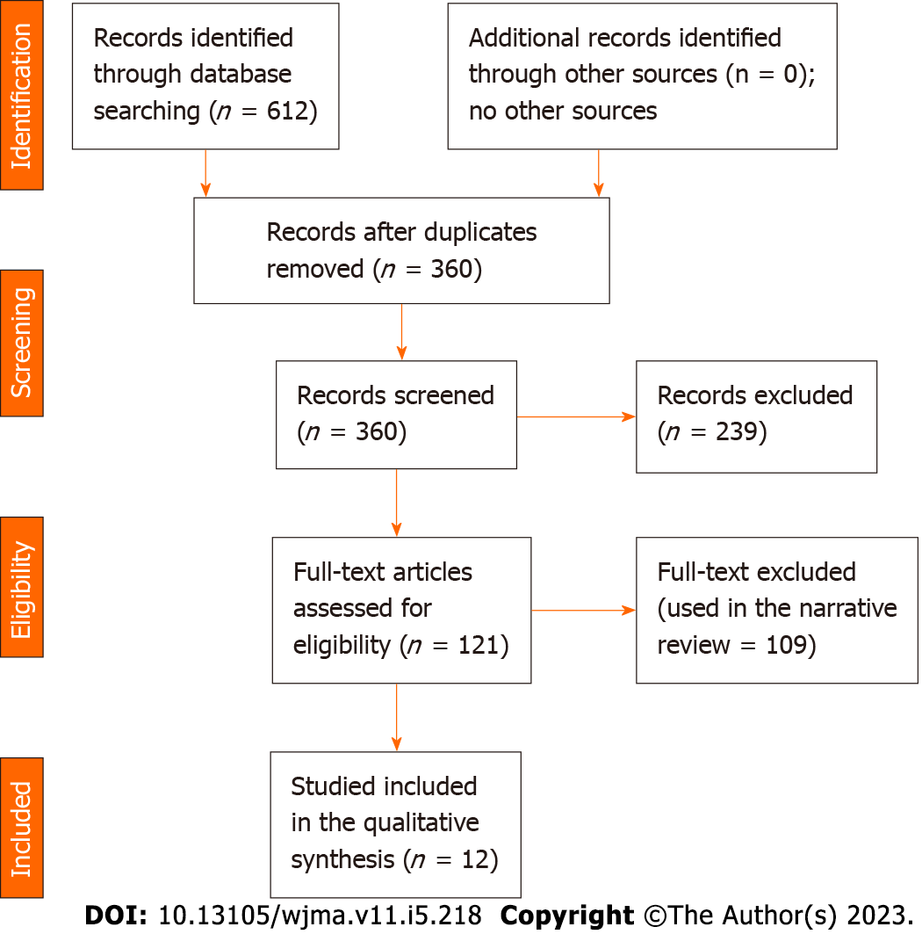
Figure 1 Vitamin D levels among diabetic patients with and without diabetic foot ulcer.

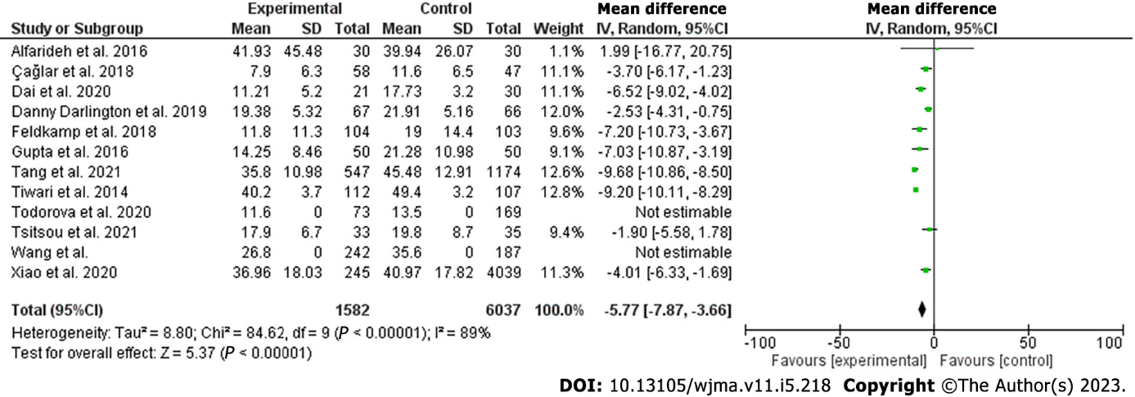 Figure 2 Vitamin D level among diabetic patients with and without septic foot.

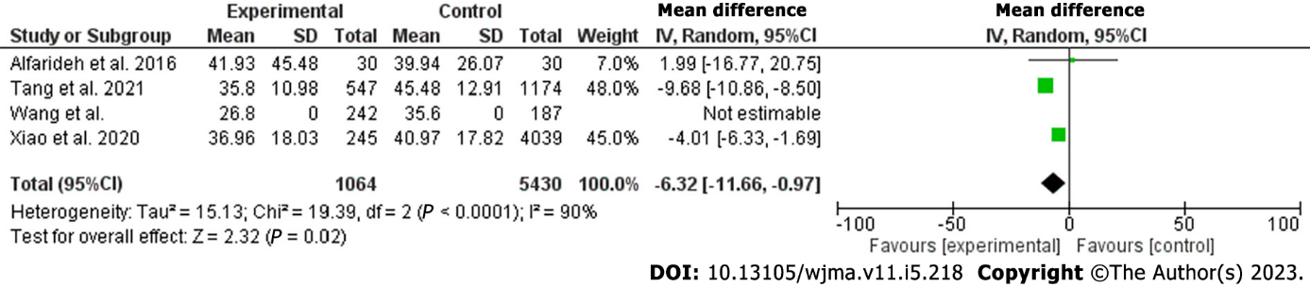 Figure 3 Vitamin D level among diabetic patients with and without septic foot (hepatized).

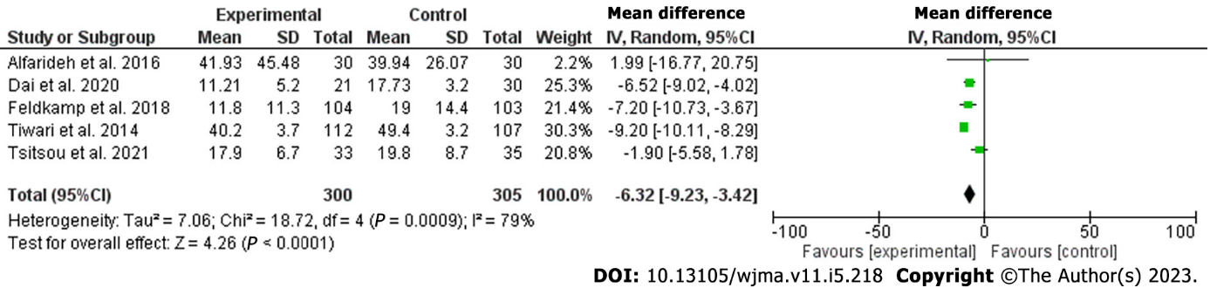
Figure 4 Vitamin D level among diabetic patients with and without septic foot (controlling for age, sex, duration of diabetes, and hemoglobin).

Table 1 Basic characteristics of patients with and without diabetic foot ulcers
Ref. | Study type | Country | Duration | Diabetes | Control | Results
Afarideh et al^{[18]}, 2016 | Cross-sectional, 30, and 30 | Iran | - | 41.93 ± 45.48 | 39.94 ± 26.07 | Non-significant, 0.487
Çağlar et al^{[19]}, 2018 | Prospective, 58 interventions and 47 controls | Turkey | 12 mo | 7.9 ± 6.3 | 11.6 ± 6.5 | Lower among diabetes, < 0.001
Dai et al^{[20]}, 2020 | Prospective, 21, and 30 | China | 9 mo | 11.21 ± 5.20 | 17.73 ± 3.20 | Lower among diabetes, < 0.001
Danny Darlington et al^{[21]}, 2019 | Cross-sectional, 67, and 66 | India | - | 19.38 ± 5.32 | 21.91 ± 5.16 | No significant difference, 0.306
Feldkamp et al^{[22]}, 2018 | Cross-sectional , 104, and 103 | Germany | - | 11.8±11.3 | 19 ± 14.4 | Lower among diabetes, < 0.001
Gupta et al^{[23]}, 2016 | Retrospective, 50, and 50 | India | - | 14.25 ± 8.46 | 21.28 ± 10.98 | Lower among diabetes, < 0.001
Tang et al^{[24]}, 2021 | Prospective, 547, and 1174 | China | 8 yr | 35.8 ± 10.98 | 45.48 ± 12.91 | Lower among diabetes, < 0.001
Tiwari et al^{[25]}, 2014 | Cross-sectional, 112 cases, 107 controls | India | - | 40.2 ± 3.7 | 49.4 ± 3.2 | Lower among diabetes, 0.06
Todorova et al^{[26]}, 2020 | Cross-sectional, 73, and 169 | Bulgaria | - | 11.6 | 13.5 | Lower among diabetes, 0.001
Tsitsou et al^{[27]}, 2021 | Cross-sectional, 33, and 35 | Greece | - | 17.9 ± 6.7 | 19.8 ± 8.7 | Non-significant, 0.329
Wang et al^{[28]}, 2022 | Retrospective, 242, 187 | China | 34 mo | 26.89 | 35.64 | Lower among diabetes, < 0.001
Xiao et al^{[29]}, 2020 | Cross-sectional, 245, and 4039 | China | - | 36.96 ± 18.03 | 40.97 ± 17.82 | Lower among diabetes, 0.001

Table 2 Age, sex, duration of diabetes, and hemoglobin of patients with and without diabetic foot ulcers
Ref. | Study type | Country | Age | Sex | DM duration | HbA1c
Afarideh et al^{[18]}, 2016 | Cross-sectional, 30, and 30 | Iran | Matched | Matched | Matched | Matched
Çağlar et al^{[19]}, 2018 | Prospective, 58 interventions and 47 controls | Turkey | Controls younger | Matched | Controls newly diagnosed | Matched
Dai et al^{[20]}, 2020 | Prospective, 21, and 30 | China | Matched | Matched | Matched | Matched
Danny Darlington et al^{[21]}, 2019 | Cross-sectional, 67, and 66 | India | Matched | Matched | Matched | Poor glycemic among foot ulcer
Feldkamp et al^{[22]}, 2018 | Cross-sectional, 104, and 103 | Germany | Matched | Matched | Matched | Matched
Gupta et al^{[23]}, 2016 | Retrospective, 50, and 50 | India | Control was younger | Males high among DM | Lon among diabetes | Poor glycemic among foot ulcer
Tang et al^{[24]}, 2021 | Prospective, 547, and 1174 | China | Control was younger | Higher females in control | Lon among diabetes | Matched
Tiwari et al^{[25]}, 2014 | Cross-sectional, 112 cases, 107 controls | India | Matched | Matched | Matched | Matched
Todorova et al^{[26]}, 2020 | Cross-sectional, 73, and 169 | Bulgaria | Control was younger | Matched | Matched | NA
Tsitsou et al^{[27]}, 2021 | Cross-sectional, 33, and 35 | Greece | Matched | Matched | Matched | Matched
Wang et al^{[28]}, 2022 | Retrospective, 242, 187 | China | Control was younger | Males higher among DM | Lon among diabetes | NA
Xiao et al^{[29]}, 2020 | Cross-sectional, 245, and 4039 | China | Matched | Females more | Matched | Poor glycemic among foot ulcer
DM: Diabetes mellitus; HbA1c: Hemoglobin A1c; NA: Not available.

Table 3 Newcastle Ottawa scale risk of bias of the included studies
Ref. | Country | Selection bias | Comparability bias | Outcome | Total score
Afarideh et al^{[18]}, 2016 | Iran | 4 | 2 | 2 | 8
Çağlar et al^{[19]}, 2018 | Turkey | 4 | 2 | 2 | 8
Dai et al^{[20]}, 2020 | China | 4 | 2 | 2 | 8
Danny Darlington et al^{[21]}, 2019 |  | 4 | 1 | 2 | 7
Feldkamp et al^{[22]}, 2018 | India | 4 | 2 | 2 | 8
Gupta et al^{[23]}, 2016 | Germany | 4 | 2 | 2 | 8
Tang et al^{[24]}, 2021 | India | 4 | 2 | 2 | 8
Tiwari et al^{[25]}, 2014 | China | 4 | 1 | 2 | 7
Todorova et al^{[26]}, 2020 | India | 4 | 2 | 2 | 8
Tsitsou et al^{[27]}, 2021 | Bulgaria | 4 | 1 | 2 | 7
Wang et al^{[28]}, 2022 | Greece | 4 | 2 | 2 | 8
Xiao et al^{[29]}, 2020 | China | 4 | 1 | 2 | 7

Published by Baishideng Publishing Group Inc
7041 Koll Center Parkway, Suite 160, Pleasanton, CA 94566, USA
Telephone: +1-925-3991568
E-mail: bpgoffice@wjgnet.com
Help Desk: https://www.f6publishing.com/helpdesk
https://www.wjgnet.com

© 2023 Baishideng Publishing Group Inc. All rights reserved.

