Name of journal: World Journal of Hepatology
ESPS Manuscript NO: 7881
Columns: CASE REPORT

Portal vein thrombosis with protein C-S deficiency in a non-cirrhotic patient

Rodríguez-Leal GA et al. PVT in a non-cirrhotic patient

Gustavo A Rodríguez-Leal, Segundo Morán, Roberto Corona-Cedillo, Rocío Brom-Valladares

Gustavo A Rodríguez-Leal, Segundo Morán, Laboratory of Gastrohepatology Research, Hospital de Pediatría, CMN Siglo XXI, Mexican Institute of Social Security, Delegación Cuauhtémoc, CP 06720, México

Gustavo A Rodríguez-Leal, Gastroenterology Department, Médica Sur Clinic and Foundation, Ciudad de México, DF 14050, México

Roberto Corona-Cedillo, Rocío Brom-Valladares, Radiology Department, Médica Sur Clinic and Foundation, Ciudad de México, DF 14050, México

Author contributions: Rodríguez-Leal GA drafted the manuscript, provided patient details and made the suggested revisions; Morán S assisted in drafting the manuscript, reviewed the manuscript and made suggestions on revisions, and assisted with journal submission; Corona-Cedillo R and Brom-Valladares R reviewed the manuscript and made suggestions on revisions, and provided the radiologic material and comments.

Correspondence to: Segundo Morán, MD, Laboratory of Gastrohepatology Research, Hospital de Pediatría, CMN Siglo XXI, Mexican Institute of Social Security, Av Cuauhtémoc 330, Colonia Doctores, Delegación Cuauhtémoc, CP 06720, México. segundomoran@hotmail.com

Telephone: +52-55-56276900; Fax : +52-55-57610952
Received: December 4, 2013 Revised: March 11, 2014
Accepted: May 28, 2014

Published online:

Abstract
There are several conditions that can lead to portal vein thrombosis (PVT), including including infection, malignancies, and coagulation disorders. Anew condition of interest is protein C and S deficiencies, associated with hypercoagulation and recurrent venous thromboembolism. We report the case of a non-cirrhotic 63-year-old male diagnosed with acute superior mesenteric vein thrombosis and PVT and combined deficiencies in proteins C and S, recanalized by short-term low molecular heparin plus oral warfarin therapy.

© 2014 Baishideng Publishing Group Inc. All rights reserved.

Key words: Portal vein thrombosis; Mesenteric venous thrombosis; Protein C and S deficiency; Anticoagulant therapy; Transient elastography

Core tip: Abdominal pain, diarrhea, rectal bleeding, abdominal distention, ascites, anorexia, fever, lactacidosis, sepsis, and splenomegaly are common features of acute portal vein thrombosis. Etiological factors in non-cirrhotic portal vein thrombosis patients are prothrombotic states and local factors, although more than one factor is often identified. Our patient, a 63-year-old man, without personal or familial history of venous thromboembolism developed portal and mesenteric vein thrombosis after an acute gastrointestinal infection by Escherichia coli. Clinicians need to be aware of this potential complication in patients with persistent abdominal pain and ascites after abdominal infections.

Rodríguez-Leal GA, Morán S, Corona-Cedillo R, Brom-Valladares R. Portal vein thrombosis with protein C-S deficiency in a non-cirrhotic patient. World J Hepatol 2014; In press

INTRODUCTION
Portal vein thrombosis (PVT) is defined as complete or partial obstruction of blood flow in the portal vein, associated with a thrombus in the vasal lumen^{[1]}. The first case of PVT was reported in 1868 by Balfour and Stewart, in a patient showing splenomegaly, ascites, and variceal dilatation^{[2]}. PVT is rare in the general population having been reported with mean age-standarized incidence and prevalence rates of 0.7 and 3.7 per 100000 inhabitants, respectively^{[3]} . However among patients with cirrhosis, these rates jump to between 4.4%-15%, and cause about 5%-10% of overall cases of portal hypertension^{[4]}. Some 22%-70% of patients without cirrhosis demonstrate prothrombotic states and local factors are present in 10%–50%^{[3-5]}, although more than one factor is often identified^{[6]}. PVT also shows different clinical presentations in acute vs chronic onset patients and collateral circulation, both its development and extent. Intestinal congestion and ischemia, with abdominal pain, diarrhea, rectal bleeding, abdominal distention, nausea, vomiting, anorexia, fever, lactacidosis, sepsis, and splenomegaly are common in acute PVT. More difficult to diagnose, chronic PVT can be completely asymptomatic, or present splenomegaly, pancytopenia, varices, and, on rare occasion, ascites^{[2]}.
PVT is classified into four categories: (1) thrombosis confined to the portal vein beyond the confluence of the splenic and superior mesenteric vein (SMV); (2) extension of thrombus into the SMV, but with patent mesenteric vessels; (3) diffuse thrombosis of splanchnic venous system, but with large collaterals; and (4) extensive splanchnic venous thrombosis, but with only fine collaterals. Currently this anatomical classification is mainly used to determine operability, but it may also have etiological and prognostic relevance, since patients with thrombus interference with mesenteric vasculature risk bowel infarction and have a lower risk of variceal bleeding than those with isolated PVT. In all cases, patients with PVT should be tested for an underlying thrombophilic condition^{[6]}. Hereditary thrombophilias known to predispose for PVT include mutations of the prothrombin, or factor V, genes, and deficiency of one of the natural anticoagulant proteins C, S, or antithrombin. Fisher et al^{[7]} in a study with twenty-nine adult patients with portal hypertension caused by PVT, found that 18 patients (62%) had deficiencies in one or more of the natural anticoagulant proteins, and six had combined deficiency of all three proteins. Of these, eight cases (28%) had combined C and S protein deficiency, nine (31%) had C protein and antithrombin deficiency, seven (24%) showed protein S and antithrombin deficiency, and six cases (21%),as mentioned, had combined deficiency of all three proteins. Due to increased use and improvement of non-invasive imaging techniques in diagnostic evaluation of abdominal pain, acute portomesenteric venous obstruction is an increasingly recognized disorder^{[1,2,4,5]}.

CASE REPORT
The patient was a 63-year-old man with glaucoma treated with timolol and latanoprost. He had undergone a resection of thyrogloid cyst 50 years previously. There was no personal history of venous thromboembolism and familial history was unrevealed. No abdominal trauma was reported. The patient had developed an acute gastrointestinal infection by Escherichia coli three months before admission, and received treatment with ciprofloxacin. Since that infection, he had felt intermittent mesogastric abdominal pain after meals, nausea and diarrhea, that increased in frequency 2 wk before admission, when he also noted increased abdominal girdle and periphereal edema. He did not note mucus or blood in feces. On admission, the patient had a fever 39 ºC and blood pressure of 100/70 mmHg. He was alert and oriented without signs of encephalopathy. His bowel sounds were hypoactive and minimal epimesogastric tenderness was present with no rebound tenderness. He had non-tense ascites and edema in the lower extremities. Heart, lungs, throat and skin were unremarkable. Laboratory studies showed a hematocrit of 42.2%, mean corpuscular volume of 87 fl, and a sedimentation rate of 51%, white cell count of 6.8/mm³, neutrophils 65.6%, lymphocytes 19.0%, monocytes 15.1%, eosinophils 0.3%, platelet count 271/mm³, prothrombin time 10.6 s, 97.6%, INR 0.96. Serum chemistry values and urine test were normal. Liver function test showed: albumin 3.3 g/dL; total bilirrubin 1.94 mg/dL; ALT 51 U/L; AST 40U/L; alkaline phosphatase was 96 (32-91 U/L); lactic dehydrogenase was 251 U/L (98-192 U/L); g-glutamyl transpeptidase was 139 U/L (7-50 U/L). Amylase 44 U/L, Lipase 23 U/L. Viral B and C antibodies were negative. Tumoral markers CA-19-9, ACE, AFP were negative. His antiphospholipid antibodies and cardiolipin antibodies were negative. A thrombophilia workup, not including screening for JAK2V617F mutation, revealed normal homocysteine blood levels; C-reactive protein levels was 216.5 (0-7.4 mg/L); D-dimer was 5770 (0-199 ng/mL); fibrinogen levels was 443 (177-410 mg/dL); low levels and little activity of the protein C antigen [protein C antigen level, 39%; protein C activity, 54% (normal 70%-140%)] and protein S antigen [protein S antigen level, 59%; protein C activity, 30% (normal 65%-140%)] were found; antithrombin III levels were 89% (normal 75%-125%). Factor V Leiden mutation was homozygote. His father was dead and his mother and sister neglected screening. Hematological, urine, ascites fluid and pharyngeal cultures were negative. Upper endoscopy revealed mild portal hypertensive gastropathy without gastric and esophageal varices. Ultrasonography of the abdomen showed that the portal vein could not be identified in the porta hepatis, which was occupied by several abnormal tubular structures suggestive of cavernous transformation (Figure 1A). The computed tomography scan of the abdomen showed cavernous transformation following PVT. The portal venous thrombus extended from the superior mesenteric vein (Figure 2). A transient elastography (TE) (Fibroscan) was abnormal with stiffness 7.4 kPa. We treated the patient with low molecular weight heparin (enoxaparine, 1 mg/kg) during the first week and chronic anticoagulation therapy (warfarin 2.5 mg/d, INR 2-3) to date. A new Doppler ultrasound, five months after admission, improved his portal flow with complete recanalization and without ascites (Figure 1B). The patient is asymptomatic three years after hospital discharge.

DISCUSSION
In recent years, PVT has increasingly been diagnosed by wide use of ultrasound-Doppler equipment. When cirrhosis is not present, the lifetime risk of getting PVT in the general population is reported to be 1%^{[8,9]}. Currently recognized etiologies can be divided into 2 categories: thrombophilic disorders and thromboses thought to be caused from local factors (Table 1).
Protein C is a thrombin-dependent anticoagulant enzyme known to deactivate coagulation cofactors V and VIa and to stimulate fibrinolysis^{[10]}. Protein C deficiency, often inherited as an autosomal dominant trait, is a risk factor for venous thrombosis.
The prevalence of protein C deficiency, as indicated solely by plasma level, is 1 in 200-500 persons in the general population. However, this number is unreliable as many affected individuals remain asymptomatic throughout their lives. However, protein C deficiency is present in approximately 2%-5% patients presenting VTE. Severe homozygous or compound heterozygous protein C deficiency is found in 1 in 500000-750000 live births. Protein S deficiency occurs in 1.35% of the patients with venous thrombosis.
There is evidence to suggest that thrombosis in unusual sites, such as cerebral sinus venous thrombosis, mesenteric vein thrombosis, portal vein thrombosis, and suprahepatic vein thrombosis (Budd–Chiari syndrome), in young individuals is associated with inherited thrombophilia.
Liver function impairment, which can be a result of portal vein thrombosis, cannot account for the low C and S protein levels in our patient, as the levels of other function tests and indirect markers of liver fibrosis (TE) were abnormal.
It is not known whether the unexplained bout of abdominal pain and diarrhea which occurred three months before our patient, was due to thrombosis, to a resolutive episode of intestinal ischaemia secondary to mesenteric vein thrombosis, or to an unrelated illness, although abdominal pain, diarrhea, abdominal distention, nausea, anorexia, and fever are common in acute PVT^{[4]}.
In Mexico, Majluf-Cruz A et al^{[11]}, studied 36 patients who had thrombosis-related portal hypertension and found an incidence of 30% of protein C deficiency, whereas 9% had protein S deficiency in patients with primary thrombophilia^{[12]}. Similarly in Mexican patients with non-cirrhotic PVT, 31% had protein C deficiency^{[13]}. However, a French study has found a high number of patients with non-cirrhotic PVT showed Protein S deficiency^{[14]} and in a study from UK, protein S deficiency was found in 38% of patients with PVT^{[15]}. Other cases have also reported C and S protein deficiencies in patients with idiopathic portal hypertension accompanied by PVT^{[16,17]}. Valla et al^{[14]}, argue that C and S protein deficiencies do not explain the majority of idiopathic portal thrombosis. Nevertheless, we agree with others that measurements of C and S proteins should be performed in patients with portal thrombosis when no overt cause is located. However, since a low number of cases of PVT may be due to underlying hereditary anticoagulant protein deficiency, this can only be confirmed by careful investigation of background of family members, preferably including both parents. When studies of the parents is not feasible, another possibility might be screening siblings, which could be used for both diagnostic and counseling purposes. Lastly, the recent use of gene sequencing in the elucidation of anticoagulant protein gene mutations may now allow determination of whether such anticoagulant deficiencies in PVT are truly primary or not^{[18]}. Some possible mechanisms for reduction in concentrations of procoagulant and anticoagulant proteins in patients with portal vein thrombosis are shown in Table 2.
Visualization of abnormalities associated with PVT is crucial to diagnosis and appropriate intervention. Cavernous transformation of the portal vein occurs in one-third of patients after portal vein thrombosis. An ultrasonographically diagnostic triad would consist of: (1) failure of visualization of the extra-hepatic portal vein; (2) demonstration of high-level echoes in the region of the porta hepatis (the “diamond sign”); and (3) visualization of multiple serpiginous vascular channels around the portal vein^{[19]}.Dynamic contrast-enhanced CT is the best means of diagnosing PVT and evaluating possible causative diseases. The findings of PVT in a dynamic CT include: filling defect partially or totally occluding the vessel lumen and rim enhancement of the vessel wall^{[20]}. Signs and symptoms of PVT may be subtle or nonspecific and are secondary to the underlying illness. On the other hand, presence of a well-developed cavernoma usually indicates an old thrombosis. A previous PVT, however, can be associated with a recently superimposed thrombus, which is then responsible for the acute manifestations which lead to imaging studies. An abdominal MRI may prove more useful than Doppler ultrasound in identifying venous collateral development and cavernoma^{[21]}. An important step in PVT is to disclose malignancy. We only performed some tumoral markers (CA-19-9, ACE, AFP), but screening for JAK2V617F in order to discard myeloproliferative neoplasms and PET-scan were not performed. TE is a non-invasive technique to assess liver fibrosis, which assesses liver fibrosis by calculating the velocity of a low-frequency transient shear wave produced by a mechanical probe that is placed directly on the skin of the patient. Liver stiffness is expressed in kilo Pascal (kPa). The method is easy to learn (the procedure can be performed by a technical assistant), and results are immediately available. One meta-analysis evaluating the predictive performance of TE in patients with chronic liver disease suggests the optimal cut-off value for the diagnosis of significant fibrosis is 7.65 kPa and for cirrhosis 13.01 kPa^{[22]}. In our patient, stiffness of 7.4 kPa was highly predictive for significant fibrosis (F ≥ 2). There is no data on the use of TE in PVT, but this method may be useful to determine liver fibrosis in these patients. Complications during follow-up frequently include: esophageal and gastric varices, portal hypertensive gastropathy and bleeding. Portal hypertensive gastropathy is reported to be 44% in patients without cancer and cirrhosis, as was the case with our patient^{[23]}. Therefore, it would be wise to screen all PVT patients endoscopically. Although spontaneous resolution of PVT has been reported in the literature, a specific therapeutic management strategy is necessary. The goal of treatment is similar in acute and chronic PVT, and includes correction of causal factors, prevention of thrombosis extension and achievement of portal vein patency. Currently, anticoagulant therapy is the best way to obtain portal vein recanalization; however, its application is not universally accepted. No controlled trial has been performed on the use of anticoagulants in acute PVT^{[24]}. After 6 mo of therapy, complete recanalization has been reported in about 50% of patients, with good outcomes in mesenteric vein involvement, and very few complications. What is certain is that, in acute PVT onset, the sooner the treatment is given, the better the prognosis; the rate of recanalization is about 69% if anticoagulation is begun within the first week after diagnosis, while it falls to 25% when begun in the second week^{[25]}. Thrombolytic therapy may also be effective, but efficacy is significantly lower and mortality increases compared to conservative treatment^{[26]}. Surgical thrombectomy is usually not recommended. Other approaches, such as transyugular intrahepatic portosystemic shunt, should be reserved for liver transplant patients developing acute PVT or as an alternative when anticoagulation fails^{[4]}. In non-cirrhotic and non-neoplastic patients, PVT has shown promising results with overall survival at 1 year and 5 years of 92% and 76% respectively^{[3,23,27,28]} .
In conclusion, our case shows that PVT can be provoked by C and S protein deficiency and that the PVT can be recanalized by short-term low molecular heparin plus oral warfarin therapy. Although the evidence is not definitive, existing literature supports the idea that the risk-benefit ratio favors anticoagulation in chronic non-cirrhotic PVT.

comments
Case characteristics
Upon admission the patient felt intermittent colicky abdominal pain and non-bloody diarrhea after meals with increased abdominal girdle and peripheral edema at physical examination.

Clinical diagnosis
The patient presented with non-tense ascites and imaging evidence of portal vein thrombosis on a background of non-liver disease.

Differential diagnosis
Differential diagnosis was performed between inherited versus acquired disorders of coagulation in portal vein thrombosis using ultrasound Doppler, dynamic computer tomography (CT) and specific laboratory tests.

Laboratory diagnosis
A thrombophilia workup, not including screening for JAK2V617F mutation, revealed normal homocysteine blood levels; C-reactive protein levels were 216.5 (0-7.4 mg/L); D-dimer was 5770 (0-199 ng/mL); fibrinogen levels was 443 (177-410 mg/dL); low levels and little activity of the protein C antigen [protein C antigen level, 39%; protein C activity, 54% (normal 70%-140%)] and protein S antigen [protein S antigen level, 59%; protein C activity, 30% (normal 65%-140%)] and homozygote factor V Leiden mutation was found; abnormal liver function tests (albumin 3.3 g/dL; total bilirrubin 1.94 mg/dL; ALT 51 U/L (31-45 U/L); alkaline phosphatase 96 (32-91 U/L); lactic dehydrogenase 251 U/L (98-192 U/L); g-glutamyl transpeptidase 139 U/L (7-50 U/L) were found; antithrombin III levels, viral B and C antibodies ,CA-19-9, ACE, AFP, antiphospholipid antibodies and cardiolipin antibodies were normal or negative.

Imaging diagnosis
Liver Doppler ultrasound showed a thrombus in the portal vein that was corroborated by CT image indicating portal venous thrombosis and evidence of cavernous transformation.

Pathologic diagnosis
Histologic examination was not indicated.

Treatment
The patient was treated with low molecular weight heparin (enoxaparine, 1mg/kg) during the first week and chronic anticoagulation therapy (warfarin 2.5 mg/day, INR 2-3) to date.

Experiences and lessons
Even if Doppler ultrasound or abdominal CT play a key role in the diagnosis of PVT, the protocol to find the etiology of the thrombosis may be complex.

Peer review
This manuscript is interesting and presents a remarkable presentation about diagnosis and management of portal vein thrombosis associated with C and S protein deficiency in a non-cirrhotic patient. A minor comment is that malignancy screening was not thorough enough.

REFERENCES
1 Kocher G, Himmelmann A. Portal vein thrombosis (PVT): a study of 20 non-cirrhotic cases. Swiss Med Wkly 2005; 135: 372-376 [PMID: 16106327]
2 Wang JT, Zhao HY, Liu YL. Portal vein thrombosis. Hepatobiliary Pancreat Dis Int 2005; 4: 515-518 [PMID: 16286254]
3 Plessier A, Darwish-Murad S, Hernandez-Guerra M, Consigny Y, Fabris F, Trebicka J, Heller J, Morard I, Lasser L, Langlet P, Denninger MH, Vidaud D, Condat B, Hadengue A, Primignani M, Garcia-Pagan JC, Janssen HL, Valla D. Acute portal vein thrombosis unrelated to cirrhosis: a prospective multicenter follow-up study. Hepatology 2010; 51: 210-218 [PMID: 19821530 DOI: 10.1002/hep.23259]
4 Ponziani FR, Zocco MA, Campanale C, Rinninella E, Tortora A, Di Maurizio L, Bombardieri G, De Cristofaro R, De Gaetano AM, Landolfi R, Gasbarrini A. Portal vein thrombosis: insight into physiopathology, diagnosis, and treatment. World J Gastroenterol 2010; 16: 143-155 [PMID: 20066733 DOI: 10.3748/wjg.v16.i2.143]
5 Janssen HL, Wijnhoud A, Haagsma EB, van Uum SH, van Nieuwkerk CM, Adang RP, Chamuleau RA, van Hattum J, Vleggaar FP, Hansen BE, Rosendaal FR, van Hoek B. Extrahepatic portal vein thrombosis: aetiology and determinants of survival. Gut 2001; 49: 720-724 [PMID: 11600478 DOI: 10.1136/gut.49.5.720]
6 Denninger MH, Chaït Y, Casadevall N, Hillaire S, Guillin MC, Bezeaud A, Erlinger S, Briere J, Valla D. Cause of portal or hepatic venous thrombosis in adults: the role of multiple concurrent factors. Hepatology 2000; 31: 587-591 [PMID: 10706547 DOI: 10.1002/hep.510310307]
7 Fisher NC, Wilde JT, Roper J, Elias E. Deficiency of natural anticoagulant proteins C, S, and antithrombin in portal vein thrombosis: a secondary phenomenon? Gut 2000; 46: 534-539 [PMID: 10716684 DOI: 10.1136/gut.46.4.534]
8 Webster GJ, Burroughs AK, Riordan SM. Review article: portal vein thrombosis -- new insights into aetiology and management. Aliment Pharmacol Ther 2005; 21: 1-9 [PMID: 15644039 DOI: 10.1111/j.1365-2036.2004.02301.x]
9 Ogren M, Bergqvist D, Björck M, Acosta S, Eriksson H, Sternby NH. Portal vein thrombosis: prevalence, patient characteristics and lifetime risk: a population study based on 23,796 consecutive autopsies. World J Gastroenterol 2006; 12: 2115-2119 [PMID: 16610067]
10 Clouse LH, Comp PC. The regulation of hemostasis: the protein C system. N Engl J Med 1986; 314: 1298-1304 [PMID: 3010107 DOI: 10.1056/NEJM198605153142006]
11 Majluf-Cruz A, Hurtado Monroy R, Sansores García L, Labardini-Méndez J. The incidence of protein C deficiency in thrombosis-related portal hypertension. Am J Gastroenterol 1996; 91: 976-980 [PMID: 8633591]
12 Ruiz-Argüelles GJ, López-Martínez B, Valdés-Tapia P, Gómez-Rangel JD, Reyes-Núñez V, Garcés-Eisele J. Primary thrombophilia in Mexico. V. A comprehensive prospective study indicates that most cases are multifactorial. Am J Hematol 2005; 78: 21-26 [PMID: 15609280 DOI: 10.1002/ajh.20233]
13 Orozco H, Guraieb E, Takahashi T, Garcia-Tsao G, Hurtado R, Anaya R, Ruiz-Arguelles G, Hernandez-Ortiz J, Casillas MA, Guevara L. Deficiency of protein C in patients with portal vein thrombosis. Hepatology 1988; 8: 1110-1111 [PMID: 3262079 DOI: 10.1002/hep.1840080522]
14 Valla D, Casadevall N, Huisse MG, Tulliez M, Grange JD, Muller O, Binda T, Varet B, Rueff B, Benhamou JP. Etiology of portal vein thrombosis in adults. A prospective evaluation of primary myeloproliferative disorders. Gastroenterology 1988; 94: 1063-1069 [PMID: 3345875]
15 Aiach M, Borgel D, Gaussem P, Emmerich J, Alhenc-Gelas M, Gandrille S. Protein C and protein S deficiencies. Semin Hematol 1997; 34: 205-216 [PMID: 9241706]
16 Hwang S, Kim do Y, Kim M, Chon YE, Lee HJ, Park YN, Park JY, Ahn SH, Han KH, Chon CY. [Deficiencies in proteins C and S in a patient with idiopathic portal hypertension accompanied by portal vein thrombosis]. Korean J Hepatol 2010; 16: 176-181 [PMID: 20606502 DOI: 10.3350/kjhep.2010.16.2.176]
17 Das SK, Ray A, Jana CK, Banerjee N, Khaskil S. Chronic portal vein thrombosis due to combined deficiency of protein C and protein S. J Indian Med Assoc 2011; 109: 753-754 [PMID: 22482325]
18 Johnson NV, Khor B, Van Cott EM. Advances in laboratory testing for thrombophilia. Am J Hematol 2012; 87 Suppl 1: S108-S112 [PMID: 22473489 DOI: 10.1002/ajh.23186]
19 Ueno N, Sasaki A, Tomiyama T, Tano S, Kimura K. Color Doppler ultrasonography in the diagnosis of cavernous transformation of the portal vein. J Clin Ultrasound 1997; 25: 227-233 [PMID: 9314103 DOI: 10.1002/(SICI)1097-0096(199706)25:5<227::AID-JCU2>3.0.CO; 2-F]
20 Lee HK, Park SJ, Yi BH, Yeon EK, Kim JH, Hong HS. Portal vein thrombosis: CT features. Abdom Imaging 2008; 33: 72-79 [PMID: 17694406 DOI: 10.1007/s00261-007-9200-x]
21 Smith CS, Sheehy N, McEniff N, Keogan MT. Magnetic resonance portal venography: use of fast-acquisition true FISP imaging in the detection of portal vein thrombosis. Clin Radiol 2007; 62: 1180-1188 [PMID: 17981166 DOI: 10.1016/j.crad.2007.06.007]
22 Friedrich-Rust M, Ong MF, Martens S, Sarrazin C, Bojunga J, Zeuzem S, Herrmann E. Performance of transient elastography for the staging of liver fibrosis: a meta-analysis. Gastroenterology 2008; 134: 960-974 [PMID: 18395077 DOI: 10.1053/j.gastro.2008.01.034]
23 Sogaard KK, Astrup LB, Vilstrup H, Gronbaek H. Portal vein thrombosis; risk factors, clinical presentation and treatment. BMC Gastroenterol 2007; 7: 34 [PMID: 17697371 DOI: 10.1186/1471-230X-7-34]
24 DeLeve LD, Valla DC, Garcia-Tsao G. Vascular disorders of the liver. Hepatology 2009; 49: 1729-1764 [PMID: 19399912 DOI: 10.1002/hep.22772]
25 Turnes J, García-Pagán JC, González M, Aracil C, Calleja JL, Ripoll C, Abraldes JG, Bañares R, Villanueva C, Albillos A, Ayuso JR, Gilabert R, Bosch J. Portal hypertension-related complications after acute portal vein thrombosis: impact of early anticoagulation. Clin Gastroenterol Hepatol 2008; 6: 1412-1417 [PMID: 19081529 DOI: 10.1016/j.cgh.2008.07.031]
26 Malkowski P, Pawlak J, Michalowicz B, Szczerban J, Wroblewski T, Leowska E, Krawczyk M. Thrombolytic treatment of portal thrombosis. Hepatogastroenterology 2003; 50: 2098-2100 [PMID: 14696472]
27 Hall TC, Garcea G, Metcalfe M, Bilku D, Dennison AR. Management of acute non-cirrhotic and non-malignant portal vein thrombosis: a systematic review. World J Surg 2011; 35: 2510-2520 [PMID: 21882035 DOI: 10.1007/s00268-011-1198-0]
28 Amitrano L, Guardascione MA, Scaglione M, Pezzullo L, Sangiuliano N, Armellino MF, Manguso F, Margaglione M, Ames PR, Iannaccone L, Grandone E, Romano L, Balzano A. Prognostic factors in noncirrhotic patients with splanchnic vein thromboses. Am J Gastroenterol 2007; 102: 2464-2470 [PMID: 17958760 DOI: 10.1111/j.1572-0241.2007.01477.x]

P-Reviewers: Kobyliak NK, Wong GLH, Wong GLH S-Editor: Ma YJ L-Editor: E-Editor:

Table 1 Hypercoagulable etiologies
Thrombophilic disorders |  | Local factors
Inherited disorders | Acquired disorders | Inflammatory | Related to surgery
Factor V Leyden mutation | Myeloproliferative disorders | Cirrhosis | Post liver trasplant
Prothrombin mutation | Malignancy | Sepsis | Splenectomy
Antithrombin III | Antiphospholipid syndrome | Pancreatitis/cholecystitis | Colectomy
Protein C deficiency | Anticardiolipin antibody | Diverticulitis | Umbilical vein catheterization
Protein S deficiency | Paroxysmal nocturnal hemoglobinuria | Appendicitis | Portocaval shunting
 | Hyperhomocystein-emia | Peptic ulcer disease
 | Oral contraception pills | Inflammatory bowel disease
 | Pregnancy/post-partum | Blunt abdominal trauma

Table 2 Proposed mechanism for reduction in concentrations of procoagulant and anticoagulant proteins in patients with portal vein thrombosis
Hereditary or acquired thrombophilia
Reduced hepatic blood flow
Reduced synthesis
Portal hypertension
Portosystemic shunting
Clearance or consumption
Portal pyaemia or other local inflammatory disease
Portal vein thrombosis
Reduced levels of procoagulant and anticoagulant proteins

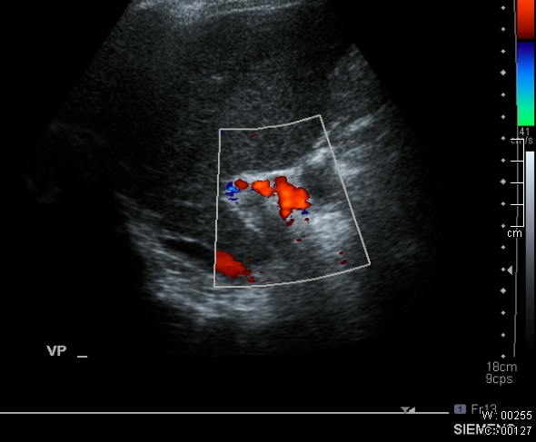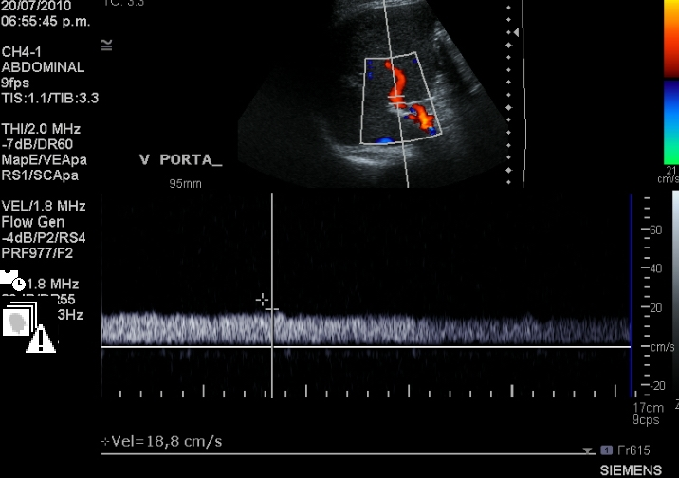
A B
Figure 1 Doppler ultrasound. A: Liver Doppler ultrasound. The image shows the thrombus in the portal vein; B: Doppler ultrasound, performed 4 mo after discharge, revealed that the portal vein thrombi had disappeared and a smooth bloodstream was observed in the portal vein.

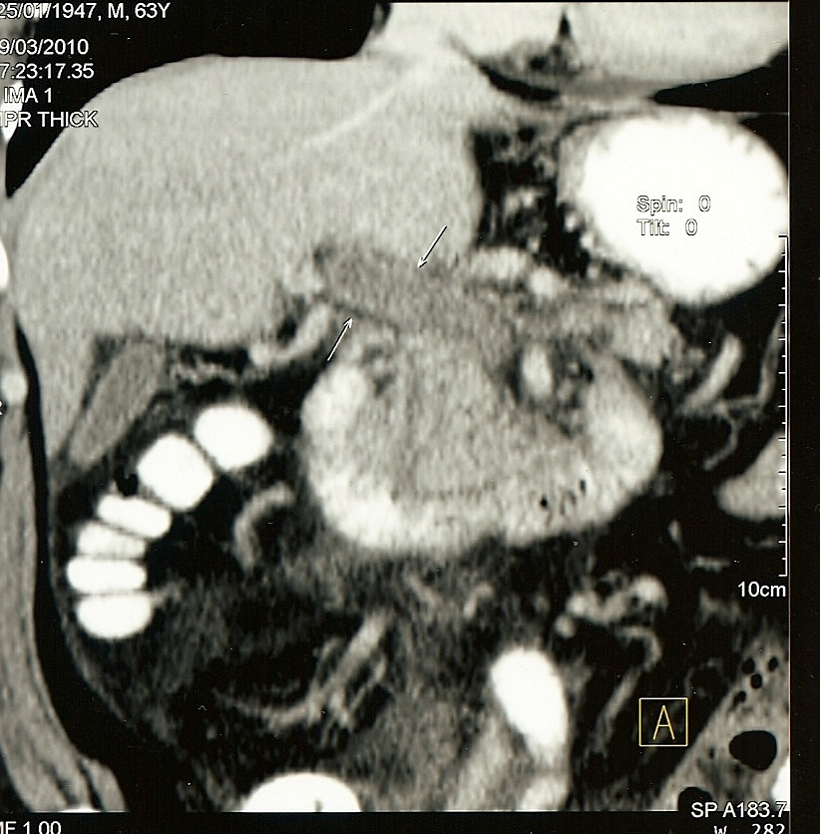
Figure 2 Coronal reconstruction of contrast-enhanced computed tomography image with arrows indicating portal venous thrombosis and evidence of cavernous transformation

