Name of Journal: World Journal of Clinical Cases
Manuscript NO: 67473
Manuscript Type: CASE REPORT

Ductal breast carcinoma metastasized to the rectum: A case report and review of the literature

Ban B et al. Ductal breast carcinoma metastasized to the rectum

Bo Ban, Kai Zhang, Jian-Nan Li, Tong-Jun Liu, Jian Shi

Bo Ban, Kai Zhang, Jian-Nan Li, Tong-Jun Liu, Jian Shi, Department of General Surgery, The Second Hospital of Jilin University, Changchun 130041, Jilin Province, China

Author contributions: Ban B was the patient’s surgeon, reviewed the literature and contributed to manuscript drafting; Shi J, Li JN, Zhang K and Liu TJ were responsible for the revision of the manuscript for important intellectual content; All authors issued final approval for the version to be submitted.

Supported by Science and Technology Development Project of Jilin Province, No. 2020SCZT079.

Corresponding author: Jian Shi, MD, PhD, Surgical Oncologist, Department of General Surgery, The Second Hospital of Jilin University, No. 218 Ziqiang Street, Nanguan District, Changchun 130041, Jilin Province, China. dr.shi@live.cn

Received: April 25, 2021
Revised: July 8, 2021
Accepted: August 24, 2021
Published online: December 26, 2021

Abstract
BACKGROUND
Gastrointestinal (GI) metastasis from breast cancer (BC) is rarely encountered in clinical practice. Nonspecific symptoms and long intervals make early diagnosis difficult. Therefore, increased awareness of GI metastasis secondary to BC and a deep understanding of the clinical and pathological features, and intervention for GI metastasis are fundamental to avoid delay in correct diagnosis and management.

CASE SUMMARY
The present report discusses the case of a Chinese female patient aged 36 years. The patient presented with difficult defecation along with bloody stools and hypogastralgia. In 2015, she had undergone right modified radical mastectomy and axillary lymph node dissection in another hospital to treat the infiltrating ductal breast carcinoma pT1N1M0. The presenting symptoms were investigated by colonoscopy, which indicated a circumferential stricture in the lower rectum at 3 cm from the anal edge. Further investigation with positron emission tomography–computed tomography revealed an uptake of fluorodeoxyglucose within the distal rectum as well as in the left acetabulum. The samples from laparoscopic exploration were biopsied, which revealed metastases of bc. Immunohistochemical analysis of the tumor confirmed that the patient had rectal metastasis of infiltrating ductal BC.

CONCLUSION
Rectal metastasis should be considered when patients with a history of BC present with changed bowel habits.

Key Words: Breast cancer; Ductal carcinoma; Rectal metastases; Case report

©The Author(s) 2021. Published by Baishideng Publishing Group Inc. All rights reserved.

Citation: Ban B, Zhang K, Li JN, Liu TJ, Shi J. Ductal breast carcinoma metastasized to the rectum: A case report and review of literature . World J Clin Cases 2021; 9(36): 11346-11354
URL: https://www.wjgnet.com/2307-8960/full/v9/i36/11346.htm
DOI: https://dx.doi.org/10.12998/wjcc.v9.i36.11346

Core Tip: Rectal metastasis of infiltrating ductal breast cancer has a low incidence. For patients with a history of breast cancer with digestive complaints, bowel metastasis must be considered.

INTRODUCTION
Breast cancer (bc) is the most frequent malignant tumor among women and is associated with significant morbidity and mortality rates^{[1]}. Metastatic tumors account for 30% of BC cases with a 5-year survival rate of 22%, and those metastatic cases are responsible for 90% of bc deaths^{[2]}. BC metastasis includes contiguous, lymphatic and hematogenous forms of spread. While hematogenous spread of BC can target any site, the most common sites are bone, lung, liver and brain^{[3]}. Metastasis to the gastrointestinal (GI) tract, and retroperitoneal organs is rare, and to the distal rectum is remarkably rare^{[4,5]}. The differentiation of bowel metastasis from BC and primary intestinal tumor is difficult since there are nontypical, diverse symptoms and long disease-free duration of BC. The present report discusses the case of a Chinese woman aged 36 years who presented with bloody stools and hypogastralgia and was diagnosed with rectal metastases of infiltrating ductal BC. In addition, a review of the literature published in the English language is also presented.

CASE PRESENTATION
Chief complaints
A 36-year-old Chinese woman presented with a complaint of difficult defecation, along with bloody stools and hypogastralgia. The symptoms had appeared 2 mo earlier and had progressively worsened within 2 wk, which led to hospitalization for a complete medical examination.

History of present illness
A patient with no history of colorectal surgery or irradiation presented with clinical symptomatology characterized by difficult defecation, bloody stools, and hypogastralgia.

History of past illness
In 2015, the patient had undergone right modified radical mastectomy and axillary lymph node dissection in another hospital for the treatment of infiltrating ductal breast carcinoma pT1N1M0. Her histopathological examination had revealed an infiltrating ductal BC 1.5 cm in size and histological grade 2. Moreover, among the 20 lymph nodes resected, four were infiltrated with cancer cells. Immunohistochemical staining revealed a positive estrogen receptor (ER) rate of 70%, positive progesterone receptor (PR) rate of 70%, and positive Ki-67 rate of 15%–30%. Furthermore, human epidermal growth factor receptor 2 (Her-2) was negative and E-cadherin was positive (Figure 1). DM was not detected at the time of diagnosis. Postoperatively, the patient underwent six cycles of adjuvant chemotherapy (TC protocol), followed by endocrine therapy with tamoxifen (20 mg/d). The patient discontinued the endocrine therapy after 1 year.

Personal and family history
The patient denied any family history of BC or rectal cancer.

Physical examination
The patient’s vital signs were as follows: body temperature, 36.3°C; heart rate, 74 beats/min; blood pressure, 116/76 mmHg; respiratory rate, 15 breaths/min; and in-room oxygen saturation, 100%. Abdominal examination revealed no obvious abnormality. However, digital rectal examination revealed a tumor with a smooth surface at the knee–chest position, which was located 3 cm above the anal edge. It was a circumferential tumor with swelling. The tumor root could not be moved with palpation. No pus or dark-red blood residue was observed on the glove after rectal examination.

Laboratory examinations
Results of routine laboratory tests were normal. Blood analysis revealed no abnormality in any of the blood counts. White blood cell count was 5.9 × 10⁹ cells/L (normal limit: 3.5 × 10¹²–9.5 × 10¹² cells/L), red blood cell count was 4.27 × 10¹² cells/L (normal limit: 3.80 × 10¹²–5.10 × 10¹² cells/L), and platelet count was 313 × 10⁹ cells/L (normal limit: 125 × 10⁹–350 × 10⁹ cells/L). However, both carbohydrate antigen (CA)-125 and CA-153 were elevated, with values of 41.10 U/mL (normal range: 0–35 U/mL) and 36.80 U/mL (normal range: 0–31.3 U/mL), respectively.

Imaging examinations
Colonoscopic examination revealed a circumferential stricture in the lower rectum at a distance of 3 cm from the anal edge. Its surface was smooth and red, which was suggestive of a submucosal tumor (Figure 2A). Multiple biopsies of the tumor were performed, which detected no malignancy. The patient was recommended to undergo positron emission tomography–computed tomography (PET-CT) for further investigation, which revealed an uptake of fluorodeoxyglucose within the left acetabulum and distal rectum, with the maximal standardized uptake values of 5.5 and 11.2, respectively, suggesting suspicious metastasis at these positions (Figure 2B and 2C).

FINAL DIAGNOSIS
In the laparoscopic exploration, a circumferential tumor was detected in the distal rectum, following which a biopsy of the tumor was performed. Fast frozen pathology of the specimen revealed that the tumor was morphologically consistent with ductal breast carcinoma and that nests of tumor cells extensively infiltrated the muscular layer. Tumor cells were PR and ER positive, with a positivity rate of 90% for both (Figure 3). In contrast, the background rectal epithelial cells tested PR and ER negative. Since the patient had a history of ductal BC, she was intraoperatively diagnosed with BC rectal metastasis. Given that the tumor had caused bleeding and incomplete intestinal obstruction, which were surgical indications, a colostomy was performed laparoscopically. The surgical dissected biopsy revealed a neoplasm in the submucosal layer, while no abnormality was observed in the mucosal layer. Further immunohistochemical analysis of the tumor-infiltrating part was performed, and the results confirmed this rare metastasis. In addition, the tumor cells tested positive for cytokeratin (CK)7, GATA3, P120 and E-cadherin and negative for CK20, caudal type homeobox (CDX)2 and stabilin (STAB)2 (Figure 4).

TREATMENT
No special event was noted after surgery. At 12 d after surgery, the patient was discharged from hospital. Afterwards, local radiotherapy was given to a total dose of 39 Gy in 13 sessions of 3 Gy, and a chemotherapy plan of gemcitabine combined with cisplatin was also applied.

OUTCOME AND FOLLOW-UP
The patient was followed-up for 10 mo after discharge from hospital. Tamoxifen administration was continued, and she remained in a stable condition.

DISCUSSION
GI metastasis from breast carcinoma is rare and has been reported to occur in 6%–18% of disseminated BC patients^{[6]}. Metastasis may occur in all the regions of the GI tract, with the rectum being an infrequently affected site^{[7]}. Infiltrating ductal cancer is the most frequently occurring subtype of BC, and accounts for 75% of all primary BC^{[1]}. However, it metastasizes to the GI tract at a rate of only 0.2%, in contrast to the 4.5% metastatic rate of invasive lobular carcinoma^{[8,9]}. Infiltrating lobular carcinoma, which accounts for only 12% of all primary BC cases, contributes 64% of the GI metastases from primary BC^{[10]}. The different clinical metastatic patterns between infiltrating ductal carcinoma and infiltrating lobular carcinoma may be interpreted based on unique biological and histological characteristics. E-cadherin, the molecule responsible for intercellular adhesion, is present in ductal carcinoma but absent in lobular carcinoma, which possibly explains the different metastatic patterns^{[11]}. Typically, the venous vertebral plexus (Batson’s plexus) is the probable route for BC metastasis through the veins. This plexus extends from the skull to the scrum without any valves, thereby providing an unrestricted channel for the transport of the metastatic emboli into the ribs, the distant organs, and the vertebral bones^{[12]}.
Early diagnosis is challenging for several reasons. First, the tumors metastasizing from primary BC to the GI tract manifest no specific symptoms. Montagna et al^{[8]} reviewed 40 patients, among whom, 80% complained of vomiting, nausea, stomach ache, altered bowel habits, fatigue, and unsuspected weight loss; all of which are commonly observed symptoms in primary as well as secondary intestinal tumors. McLemore et al^{[10]} studied 12 001 patients with BC, and metastasis detected in 11 patients remained undiagnosed until an exploratory laparotomy was conducted. Second, the long disease-free interval of BC renders the early diagnosis of metastasis difficult. Therefore, exploring the history of BC is crucial for establishing the diagnosis of bowel metastasis. As suggested by Schwarz et al^{[13]}, the median interval from BC to GI metastasis was between 0.25 and 12.5 years (median: 6 years). McLemore et al^{[10]} reported an average interval of 7 years. López Deogracias et al^{[14]} presented a case with invasive lobular carcinoma developing a metastatic rectal lesion, which caused urethral dilation 15 years later. Mistrangelo et al^{[15]} presented a patient who developed sigmoid colon metastasis from primary lobular BC after an interval of 25 years; the longest so far among the reported cases. In our case, the disease-free interval was 4 years and the time for the occurrence of metastasis was inside the highest risk window. Therefore, it is critical to include the possibility of intestinal metastasis in the early diagnosis of cases presenting with digestive complaints along with a history of BC.
At the early stage of metastasis, the general endoscopic appearance is normal mucosa, as the lesions often involve the submucosal layer rather than the mucosal layer. Therefore, superficial biopsy seems to have a limited role. Szabó et al^{[16]} reported a case of infiltrating lobular carcinoma mimicking Crohn’s disease, for which biopsy suggested necrosis and not cancer. However, the histopathological examinations conducted after surgery indicated terminal ileal metastasis of invasive lobular carcinoma. Carcoforo et al reported the case of a female patient aged 73 years with no history of cancer, who presented with vomiting, nausea and abdominal pain. Colonoscopy revealed a stricture at 15 cm on the top of the anal verge. Moreover, negative results were obtained in repeated biopsies, while biopsies combined with exploratory laparotomy revealed intestinal metastases of invasive BC^{[17]}. Deep biopsy or endoscopic ultrasound-guided fine-needle aspiration may be conducive to prompt an accurate diagnosis of GI tract metastasis. Matsumoto et al^{[18]} reported the case of an 84-year-old woman with progressive dysphagia. Her endoscopy revealed esophageal stenosis located 30 cm away from the incisors, although no abnormality was observed in the overlying mucosa. In addition, no abnormality was detected in the biopsies. Finally, esophageal metastasis from BC was confirmed through fine-needle biopsy cytology conducted endoscopically under the guidance of ultrasound. Late metastasis may affect all the intestinal layers and manifest in linitis plastica lesions, ulcers, and bleeding, thus mimicking primary intestinal tumor or inflammatory bowel disease^{[16,19]}.
The radiologist plays a crucial role in examining the patients with BC for detecting metastasis. In abdominal CT, the common identifications are mural thickening, bowel dilation, rigidity of the colorectum, and linitis-plastica-type lesion of the stomach^{[20]}. These macroscopic characteristics are nonspecific and indistinguishable from lowly differentiated cancer that is observed frequently in the stomach. Magnetic resonance imaging (MRI), in comparison, provides better soft-tissue contrast and a high-level description of the various histological layers of the GI wall. In a study by Lau et al^{[21]}, concentric mural thickening was concluded as the MRI feature of breast metastases to the rectum, while eccentric wall thickening and an obvious invasive margin were reported as the more frequently observed features in primary rectal carcinoma. PET-CT could be used to detect DM, such as in the case analyzed in the present study, as PET-CT presents high specificity and sensitivity in the detection of DM compared to conventional imaging^{[22]}. However, PET-CT is not the preferred diagnostic tool in BC due to its low sensitivity and specificity, which are in the range of 48%–96% and 73%–100%, respectively^{[23]}.
Immunohistochemistry plays a decisive role in the establishment of a diagnosis. CK7 and CK20 are two effective cytokeratins among the 20 intermediate filament subtypes. CK7 expression is observed in glandular and ductal epithelial tissues in breast and lung cancers. CK20 positivity is observed in the GI epithelium^{[24]}. CK7 positivity and CK20 negativity favor metastasis, as in our case, while a CK7⁻/CK20⁺ pattern is suggestive of a large bowel primary tumor^{[14,25]}. CDX2 is the caudal homeobox gene that encodes the transcription factor (TF), which plays a vital role in intestinal epithelial differentiation and proliferation. CDX2 may be expressed in gastric cancer, primary urinary bladder adenocarcinoma, and mucinous ovarian adenocarcinoma^{[26]}. Bayrak et al^{[24]} analyzed 118 colorectal, 59 gastric and 32 pancreatic adenocarcinoma resection specimens and concluded that in colorectal adenocarcinoma, CDX2 expression and the CK7⁻/CK20⁺ pattern were highly sensitive and specific. SATB2, a recently described transcriptional regulator, is reported as a highly specific and sensitive marker of colorectal cancer (CRC)^{[27]}. Magnusson et al^{[28]} reported that SATB2 plus CD20⁺ could detect > 95% of the CRC cases. E-cadherin, the transmembrane glycoprotein, regulates intercellular adhesion in a calcium-dependent manner and participates in the adhesion of epithelial cells^{[29]}. E-cadherin has also been frequently used as a marker to distinguish ductal carcinoma from the lobular one. E-cadherin is expressed within the cell membrane in most ductal carcinomas. On the contrary, E-cadherin is absent in several lobular carcinomas^{[30]}. P120 catenin is stained intensely in the membrane of ductal carcinomas and strongly and diffusely stained in the cytoplasm of lobular carcinomas. Furthermore, 10%–16% of ductal carcinomas test negative for E-cadherin, and in these cases, P120 catenin maintains its membrane localization^{[30,31]}. GATA3, one of the TF proteins, plays a vital role in enhancing the differentiation and proliferation of mammary ductal epithelial cells. GATA3 is regarded as the most sensitive single marker of invasive BC, with an estimated expression rate of > 90%. When confronting a neoplasm with unclear origin, particularly in the case of BC, routine assessment of GATA3 is recommended^{[32]}. In the present report, negativity for both CDX2 and STAB2, along with a CK7⁺/CK20⁻ profile assisted in excluding the diagnosis of primary tumor of the rectum. Positivity for E-cadherin, P120 and GATA3 indicates metastasis of infiltrating ductal BC. In addition, for the original breast carcinoma treated 3 years ago in our case, 70% ER and PR positive rates were observed, while for the rectal metastatic lesion, the rates were 90%. This difference has also been reported by other reviewers, which suggests that BC presents with different biological features in the primary tumors compared to metastases^{[33,34]}.
The cases with GI tract metastases are frequently treated with systemic treatment (endocrine therapy and/or chemotherapy), as the GI metastasis is generally associated with extensive metastases^{[35]}. However, the unique role of surgical intervention cannot be ignored. Surgical intervention includes GI resection, diverting ostomy, and GI bypass. In patients with GI metastasis alone, radical surgical resection along with systemic treatment is reported to have a better prognosis^{[10]}. In the patients presenting disseminated disease, surgery has no prolonging effect on the overall survival, although these patients do benefit from palliative surgery, as reported previously, for relief from the symptoms^{[10]}. Typically, perforation, bleeding, and intestinal obstruction are the surgical indications for such cases, and surgery should, therefore, be performed to avoid severe complications and improve supportive care. Moreover, surgery plays a crucial role in obtaining a timely and accurate diagnosis of bowel metastasis, as stated earlier. In summary, for such cases, the decision for surgery should be undertaken on the basis of the general condition, symptoms, clinical presentations, and a quality-of-life assessment. In our case, the metastatic tumor had caused bleeding and incomplete intestinal obstruction which were surgical indications. Therefore, colostomy was performed along with chemotherapy, endocrine treatment, and radiotherapy. This therapeutic strategy was expected to achieve long-term survival.

CONCLUSION
BC has been shown to metastasize to the GI tract, although it may have a long interval. We should also be aware that the presenting symptoms can be nonspecific and it may be difficult to diagnose metastasis on biopsy or endoscopy. Comprehensive analysis of imaging manifestations is helpful in correct diagnosis. Histopathology and immunohistochemistry play important roles in the verification of metastasis while excluding primary rectal cancer. Surgery also plays a unique and important role in its diagnosis and treatment.

REFERENCES
1 Coughlin SS. Epidemiology of Breast Cancer in Women. Adv Exp Med Biol 2019; 1152: 9-29 [PMID: 31456177 DOI: 10.1007/978-3-030-20301-6_2]
2 Harbeck N, Penault-Llorca F, Cortes J, Gnant M, Houssami N, Poortmans P, Ruddy K, Tsang J, Cardoso F. Breast cancer. Nat Rev Dis Primers 2019; 5: 66 [PMID: 31548545 DOI: 10.1038/s41572-019-0111-2]
3 Wang L, Zhang S, Wang X. The Metabolic Mechanisms of Breast Cancer Metastasis. Front Oncol 2020; 10: 602416 [PMID: 33489906 DOI: 10.3389/fonc.2020.602416]
4 Taal BG, den Hartog Jager FC, Steinmetz R, Peterse H. The spectrum of gastrointestinal metastases of breast carcinoma: II. The colon and rectum. Gastrointest Endosc 1992; 38: 136-141 [PMID: 1568609 DOI: 10.1016/s0016-5107(92)70378-2]
5 Taal BG, den Hartog Jager FC, Steinmetz R, Peterse H. The spectrum of gastrointestinal metastases of breast carcinoma: I. Stomach. Gastrointest Endosc 1992; 38: 130-135 [PMID: 1568608 DOI: 10.1016/s0016-5107(92)70377-0]
6 Invento A, Mirandola S, Pellini F, Pollini GP, Grigolato D. Breast cancer and gastrointestinal metastasis. A case report and review of the literature. Ann Ital Chir 2018; 89: 153-156 [PMID: 29848817]
7 Bamias A, Baltayiannis G, Kamina S, Fatouros M, Lymperopoulos E, Agnanti N, Tsianos E, Pavlidis N. Rectal metastases from lobular carcinoma of the breast: report of a case and literature review. Ann Oncol 2001; 12: 715-718 [PMID: 11432633 DOI: 10.1023/a:1011192827710]
8 Montagna E, Pirola S, Maisonneuve P, De Roberto G, Cancello G, Palazzo A, Viale G, Colleoni M. Lobular Metastatic Breast Cancer Patients With Gastrointestinal Involvement: Features and Outcomes. Clin Breast Cancer 2018; 18: e401-e405 [PMID: 28778379 DOI: 10.1016/j.clbc.2017.07.003]
9 Haberstich R, Tuech JJ, Wilt M, Rodier JF. Anal localization as first manifestation of metastatic ductal breast carcinoma. Tech Coloproctol 2005; 9: 237-238 [PMID: 16328121 DOI: 10.1007/s10151-005-0235-0]
10 McLemore EC, Pockaj BA, Reynolds C, Gray RJ, Hernandez JL, Grant CS, Donohue JH. Breast cancer: presentation and intervention in women with gastrointestinal metastasis and carcinomatosis. Ann Surg Oncol 2005; 12: 886-894 [PMID: 16177864 DOI: 10.1245/ASO.2005.03.030]
11 Critchley AC, Harvey J, Carr M, Iwuchukwu O. Synchronous gastric and colonic metastases of invasive lobular breast carcinoma: case report and review of the literature. Ann R Coll Surg Engl 2011; 93: e49-e50 [PMID: 21943448 DOI: 10.1308/147870811X582800]
12 Carpenter K, Decater T, Iwanaga J, Maulucci CM, Bui CJ, Dumont AS, Tubbs RS. Revisiting the Vertebral Venous Plexus-A Comprehensive Review of the Literature. World Neurosurg 2021; 145: 381-395 [PMID: 33049379 DOI: 10.1016/j.wneu.2020.10.004]
13 Schwarz RE, Klimstra DS, Turnbull AD. Metastatic breast cancer masquerading as gastrointestinal primary. Am J Gastroenterol 1998; 93: 111-114 [PMID: 9448188 DOI: 10.1111/j.1572-0241.1998.111_c.x]
14 López Deogracias M, Flores Jaime L, Arias-Camisón I, Zamacola I, Murillo Guibert J, Suescun García R, Querejeta Usabiaga J, Martínez García F. Rectal metastasis from lobular breast carcinoma 15 years after primary diagnosis. Clin Transl Oncol 2010; 12: 150-153 [PMID: 20156785 DOI: 10.1007/S12094-010-0481-0]
15 Mistrangelo M, Cassoni P, Mistrangelo M, Castellano I, Codognotto E, Sapino A, Lamanna G, Cravero F, Bianco L, Fora G, Sandrucci S. Obstructive colon metastases from lobular breast cancer: report of a case and review of the literature. Tumori 2011; 97: 800-804 [PMID: 22322849 DOI: 10.1700/1018.11099]
16 Szabó J, Falkus B, Simon E, Brünner S, Baranyay F. [Late gastrointestinal metastases of invasive lobular breast carcinoma mimicking Crohn's disease]. Orv Hetil 2010; 151: 1666-1671 [PMID: 20860963 DOI: 10.1556/OH.2010.28927]
17 Carcoforo P, Raiji MT, Langan RC, Lanzara S, Portinari M, Maestroni U, Palini GM, Zanzi MV, Bonazza S, Pedriali M, Feo CV, Stojadinovic A, Avital I. Infiltrating lobular carcinoma of the breast presenting as gastrointestinal obstruction: a mini review. J Cancer 2012; 3: 328-332 [PMID: 22866167 DOI: 10.7150/jca.4735]
18 Matsumoto Y, Matsukawa H, Seno H, Ono S. Education and imaging. Gastrointestinal: breast cancer metastasis to the esophagus diagnosed using endoscopic ultrasound-guided fine-needle aspiration. J Gastroenterol Hepatol 2015; 30: 233 [PMID: 25619234 DOI: 10.1111/jgh.12819]
19 Matsuda I, Matsubara N, Aoyama N, Hamanaka M, Yamagishi D, Kuno T, Tsukamoto K, Yamano T, Noda M, Ikeuchi H, Tomita N, Hirota S. Metastatic lobular carcinoma of the breast masquerading as a primary rectal cancer. World J Surg Oncol 2012; 10: 231 [PMID: 23114188 DOI: 10.1186/1477-7819-10-231]
20 Winston CB, Hadar O, Teitcher JB, Caravelli JF, Sklarin NT, Panicek DM, Liberman L. Metastatic lobular carcinoma of the breast: patterns of spread in the chest, abdomen, and pelvis on CT. AJR Am J Roentgenol 2000; 175: 795-800 [PMID: 10954469 DOI: 10.2214/ajr.175.3.1750795]
21 Lau LC, Wee B, Wang S, Thian YL. Metastatic breast cancer to the rectum: A case report with emphasis on MRI features. Medicine (Baltimore) 2017; 96: e6739 [PMID: 28445295 DOI: 10.1097/MD.0000000000006739]
22 Pesapane F, Downey K, Rotili A, Cassano E, Koh DM. Imaging diagnosis of metastatic breast cancer. Insights Imaging 2020; 11: 79 [PMID: 32548731 DOI: 10.1186/s13244-020-00885-4]
23 Warning K, Hildebrandt MG, Kristensen B, Ewertz M. Utility of 18FDG-PET/CT in breast cancer diagnostics--a systematic review. Dan Med Bull 2011; 58: A4289 [PMID: 21722539]
24 Bayrak R, Haltas H, Yenidunya S. The value of CDX2 and cytokeratins 7 and 20 expression in differentiating colorectal adenocarcinomas from extraintestinal gastrointestinal adenocarcinomas: cytokeratin 7-/20+ phenotype is more specific than CDX2 antibody. Diagn Pathol 2012; 7: 9 [PMID: 22268990 DOI: 10.1186/1746-1596-7-9]
25 Chu P, Wu E, Weiss LM. Cytokeratin 7 and cytokeratin 20 expression in epithelial neoplasms: a survey of 435 cases. Mod Pathol 2000; 13: 962-972 [PMID: 11007036 DOI: 10.1038/modpathol.3880175]
26 Yu J, Li S, Xu Z, Guo J, Li X, Wu Y, Zheng J, Sun X. CDX2 inhibits epithelial-mesenchymal transition in colorectal cancer by modulation of Snail expression and β-catenin stabilisation via transactivation of PTEN expression. Br J Cancer 2021; 124: 270-280 [PMID: 33239678 DOI: 10.1038/s41416-020-01148-1]
27 Hoskoppal D, Epstein JI, Gown AM, Arnold Egloff SA, Gordetsky JB, Shi CJ, Giannico GA. SATB2 protein expression by immunohistochemistry is a sensitive and specific marker of appendiceal and rectosigmoid well differentiated neuroendocrine tumours. Histopathology 2020; 76: 550-559 [PMID: 31595536 DOI: 10.1111/his.14012]
28 Magnusson K, de Wit M, Brennan DJ, Johnson LB, McGee SF, Lundberg E, Naicker K, Klinger R, Kampf C, Asplund A, Wester K, Gry M, Bjartell A, Gallagher WM, Rexhepaj E, Kilpinen S, Kallioniemi OP, Belt E, Goos J, Meijer G, Birgisson H, Glimelius B, Borrebaeck CA, Navani S, Uhlén M, O'Connor DP, Jirström K, Pontén F. SATB2 in combination with cytokeratin 20 identifies over 95% of all colorectal carcinomas. Am J Surg Pathol 2011; 35: 937-948 [PMID: 21677534 DOI: 10.1097/PAS.0b013e31821c3dae]
29 Margan MM, Cimpean AM, Ceausu AR, Raica M. Differential Expression of E-Cadherin and P-Cadherin in Breast Cancer Molecular Subtypes. Anticancer Res 2020; 40: 5557-5566 [PMID: 32988879 DOI: 10.21873/anticanres.14568]
30 Bonacho T, Rodrigues F, Liberal J. Immunohistochemistry for diagnosis and prognosis of breast cancer: a review. Biotech Histochem 2020; 95: 71-91 [PMID: 31502889 DOI: 10.1080/10520295.2019.1651901]
31 Venhuizen JH, Span PN, van den Dries K, Sommer S, Friedl P, Zegers MM. P120 Catenin Isoforms Differentially Associate with Breast Cancer Invasion and Metastasis. Cancers (Basel) 2019; 11 [PMID: 31569498 DOI: 10.3390/cancers11101459]
32 Aphivatanasiri C, Li J, Chan R, Jamidi SK, Tsang JY, Poon IK, Shao Y, Tong J, To KF, Chan SK, Tam F, Cheung SY, Shea KH, Tse GM. Combined SOX10 GATA3 is most sensitive in detecting primary and metastatic breast cancers: a comparative study of breast markers in multiple tumors. Breast Cancer Res Treat 2020; 184: 11-21 [PMID: 32737715 DOI: 10.1007/s10549-020-05818-9]
33 Guarneri V, Giovannelli S, Ficarra G, Bettelli S, Maiorana A, Piacentini F, Barbieri E, Dieci MV, D'Amico R, Jovic G, Conte P. Comparison of HER-2 and hormone receptor expression in primary breast cancers and asynchronous paired metastases: impact on patient management. Oncologist 2008; 13: 838-844 [PMID: 18650259 DOI: 10.1634/theoncologist.2008-0048]
34 Lower EE, Glass EL, Bradley DA, Blau R, Heffelfinger S. Impact of metastatic estrogen receptor and progesterone receptor status on survival. Breast Cancer Res Treat 2005; 90: 65-70 [PMID: 15770528 DOI: 10.1007/s10549-004-2756-z]
35 Tang T, Zhang L, Li C, Zhou T. Gastric and adrenal metastasis from breast cancer: Case report and review of literature. Medicine (Baltimore) 2020; 99: e18812 [PMID: 32011488 DOI: 10.1097/MD.0000000000018812]

Footnotes
Informed consent statement: Informed written consent was obtained from the patient for publication of this report and any accompanying images.

Conflict-of-interest statement: The authors declare that they have no conflicts of interest.

CARE Checklist (2016) statement: The authors have read the CARE Checklist (2016), and the manuscript was prepared and revised according to the CARE Checklist (2016).

Open-Access: This article is an open-access article that was selected by an in-house editor and fully peer-reviewed by external reviewers. It is distributed in accordance with the Creative Commons Attribution NonCommercial (CC BY-NC 4.0) license, which permits others to distribute, remix, adapt, build upon this work non-commercially, and license their derivative works on different terms, provided the original work is properly cited and the use is non-commercial. See: http://creativecommons.org/Licenses/by-nc/4.0/

Provenance and peer review: Unsolicited article; Externally peer reviewed.
Peer-review model: Single blind

Peer-review started: April 25, 2021
First decision: June 24, 2021
Article in press: August 24, 2021

Specialty type: Gastroenterology and hepatology
Country/Territory of origin: China
Peer-review report’s scientific quality classification
Grade A (Excellent): 0
Grade B (Very good): B
Grade C (Good): C, C
Grade D (Fair): 0
Grade E (Poor): E

P-Reviewer: Al Khader A, Fakhr I, Lieto E S-Editor: Ma YJ L-Editor: Kerr C P-Editor: Liu JH

Figure Legends
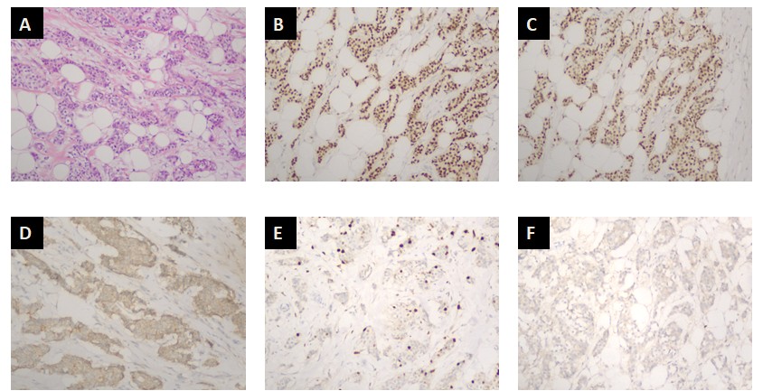
Figure 1 Histopathology and immunohistochemical findings of cancer in the right breast (100×). A: Hematoxylin and eosin (HE) staining. HE staining for the resected tumor samples suggested invasive ductal breast cancer; B: Estrogen-receptor-positive rate was 70% in all cancer cells; C: Progesterone-receptor-positive rate was 70% in all cancer cells; D: E-cadherin positivity; E: Ki67 positive rate was 15% in all cancer cells; F: Her2 negativity.
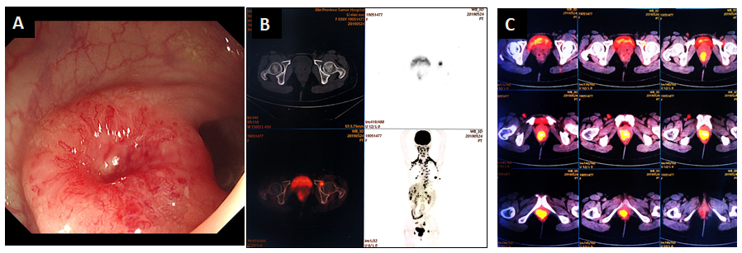
Figure 2 Results of positron emission tomography–computed tomography (PET-CT) and colonoscopy. A: Colonoscopy results indicated a lower rectal swelling, with a red and smooth surface located at 3 cm on the top of the anal verge, which suggested a submucosal tumor; B: Upper left part: local destruction of the bone cortex; lower left part: PET-CT images depicting uptake of fluorodeoxyglucose (FDG) within the left acetabulum, with the maximal standardized value of uptake (SUVmax) equal to 5.5; C: PET-CT image depicting FDG uptake in the distal rectum, with SUVmax 11.2.
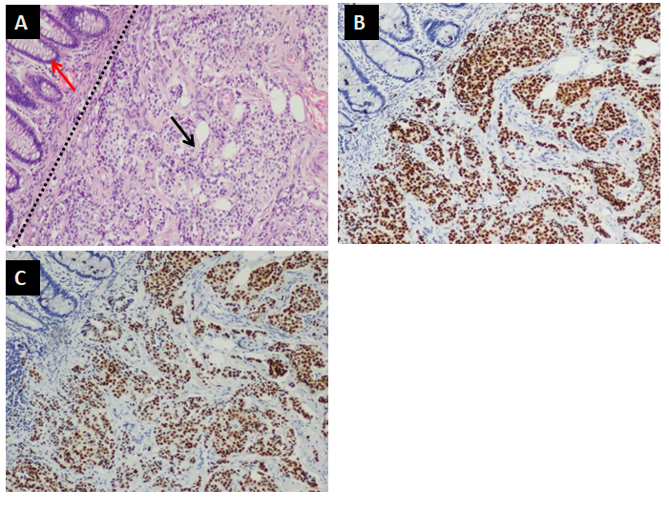
Figure 3 Fast-frozen pathology of the specimen (100×). A–C: Top left corner: Normal rectal mucosal layer; bottom right corner: tumor infiltrating layer. A: Sections under hematoxylin and eosin (staining suggested that cancer cells had invaded the submucosal layer; B: Estrogen-receptor-positive rate was 90% in all cancer cells; C: Progesterone-receptor-positive rate was 90% in all cancer cells.
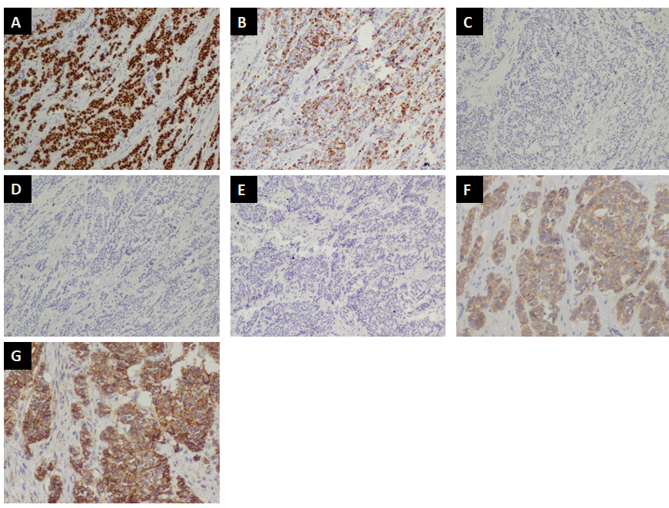
Figure 4 Further immunohistochemical analysis of tumor-infiltrating region (A–E: 100×; F, G: 200×). A: GATA3 was positive; B: Cytokeratin (CK)7 was positive; C: CK20 was negative; D: Caudal type homeobox 2 was negative; E: Stabilin 2 was negative; F: E-cadherin was positive; G: P120 exhibited membrane staining.

Published by Baishideng Publishing Group Inc
7041 Koll Center Parkway, Suite 160, Pleasanton, CA 94566, USA
Telephone: +1-925-3991568
E-mail: bpgoffice@wjgnet.com
Help Desk: https://www.f6publishing.com/helpdesk
https://www.wjgnet.com

© 2021 Baishideng Publishing Group Inc. All rights reserved.

