Name of Journal: World Journal of Gastroenterology
Manuscript NO: 56234
Manuscript Type: OPINION REVIEW

How an endoscopy unit was converted to an intensive care unit during COVID-19 emergency?

Mirante VG et al. Endoscopy unit changes during COVID-19

Vincenzo Giorgio Mirante, Giorgio Mazzi, Gerolamo Bevivino, Francesca Parmeggiani, Giorgio Iori, Giuliana Sereni, Veronica Iori, Romano Sassatelli

Vincenzo Giorgio Mirante, Gerolamo Bevivino, Francesca Parmeggiani, Giorgio Iori, Giuliana Sereni, Veronica Iori, Romano Sassatelli, Gastroenterology and Digestive Endoscopy Unit, Azienda USL-IRCCS di Reggio Emilia, Reggio Emilia 42100, Italy

Giorgio Mazzi, Local Health Direction, Azienda USL-IRCCS di Reggio Emilia, Reggio Emilia 42100, Italy

Author contributions: Mirante VG, Mazzi G, Bevivino G, Parmeggiani F, and Sassatelli R designed, conceived, and drafted the manuscript; Iori G, Iori V, and Sereni G revised the manuscript for important intellectual content; Mirante VG is the guarantor of the manuscript.

Corresponding author: Vincenzo Giorgio Mirante, MD, Doctor, Gastroenterology and Digestive Endoscopy Unit, Azienda USL-IRCCS di Reggio Emilia, No. 80 Viale Risorgimento, Reggio Emilia 42100, Italy. v.mirante@libero.it

Received: May 6, 2020
Revised: May 22, 2020
Accepted: July 30, 2020
Published online:

Abstract
In March 2020, coronavirus disease 19 (COVID-19) became a global pandemic, with Italy being one of the most affected countries in the world. The large number of patients needing hospitalization in the intensive care unit has required serious efforts by the Italian national health system to promptly respond to this unexpected emergency. In this paper we report how, in a heavily COVID-19-affected area of Northern Italy, a Gastroenterology and Digestive Endoscopy Unit was partially converted to an intensive care unit. Moreover, we describe in detail the organizational and structural changes needed to avoid transmission of severe acute respiratory syndrome coronavirus 2 in our ward. The effectiveness of these measures has been certified by the absence of infected personnel.

Key words: COVID-19; Digestive endoscopy; Intensive care unit; Gastroenterology; SARS-CoV-2; Endoscopy unit

Mirante VG, Mazzi G, Bevivino G, Parmeggiani F, Iori G, Sereni G, Iori V, Sassatelli R. How an endoscopy unit was converted to an intensive care unit during COVID-19 emergency? World J Gastroenterol 2020; In press

Core tip: In this article, we report our experience in a heavily coronavirus disease 19 affected area. Within our Endoscopy Unit, structural and organizational changes have been required after the spread of the disease to temporarily increase the capacity of the intensive care unit. Moreover, specific procedures concerning the management and paths dedicated to patients have been adopted. Finally, appropriate behavioral strategies have been established for healthcare professionals. The effectiveness of these measures has been certified by the absence of infected personnel.
INTRODUCTION
In December 2019, a new type of coronavirus, named severe acute respiratory syndrome coronavirus 2 (SARS-CoV-2), was identified in Wuhan, the largest city in the Hubei Province of China^{[1,2]}. The clinical presentation of SARS-CoV-2 disease coronavirus disease 19 (COVID-19) ranges from asymptomatic to very severe pneumonia with acute respiratory distress syndrome, septic shock, and multiorgan failure, which may result in death^{[3]}. Gastrointestinal symptoms, such as diarrhea, nausea, vomiting, and abdominal discomfort, are less frequent but can precede typical respiratory presentation^{[4]}. Diagnosis is possible through the identification of SARS-CoV-2 ribonucleic acid by polymerase chain reaction of nasopharyngeal and oropharyngeal swab^{[5]}, detection of serum immunoglobulin M and immunoglobulin G antibodies^{[6]}, or detection of typical ground-glass opacities/interstitial pneumonia by chest computed tomography scan^{[7]}.
SARS-CoV-2 is highly contagious and is transmitted from person-to-person through inhalation of large respiratory droplets^{[8]}. Other transmission pathways are contact with contaminated surfaces or inhalation during aerosol-generating medical procedures, such as upper endoscopy. Moreover, researchers have detected SARS-CoV-2 in stool samples and in lower gastrointestinal tract specimens, suggesting that there might be fecal-oral transmission^{[9]}.
COVID-19 has rapidly spread throughout China and caused an increasing number of cases and deaths worldwide. On March 11, 2020, after the first 118000 cases in 114 countries, the World Health Organization declared the COVID-19 outbreak a pandemic^{[10]}.

SARS-CoV-2 DISEASE IN ITALY: GENERAL HEALTHCARE MEASURES
The first case of COVID-19 in Italy was reported on February 21, 2020, after the admission of a 38-year-old man into an intensive care unit (ICU) for severe pneumonia at Codogno Hospital (Lombardy, Italy). Since then, the number of cases identified in Italy has dramatically increased, mainly in some regions of Northern Italy, such as Lombardy and Emilia Romagna. Currently, Italy is one of the most affected European countries, accounting for high rates of deaths and confirmed cases requiring hospitalization for COVID-19^{[11]}. Moreover, the very high number of patients requiring intensive care has been a serious concern due to the shortage of ICU beds and ventilators^{[12]}.
Starting from March 10, the Italian Government imposed a nationwide state of emergency with lockdown and self-isolation measures to counteract the spread of COVID-19. At the same time, to prevent the probable unjustified contagion for healthcare professionals and among patients, hospitals have progressively reduced all ordinary activities. Finally, when ICU admissions quickly increased, each regional healthcare system increased the number of ICU beds and reduced the number of beds available for other urgent or elective hospitalizations.

EXPERIENCE OF A DIGESTIVE ENDOSCOPY UNIT IN A TERTIARY REFERRAL HOSPITAL IN NOTHERN ITALY
At the time of writing this paper, the province of Reggio Emilia (Emilia Romagna, Italy; 533000 inhabitants) had 2800 SARS-CoV-2 infections^{[13]}. The Arcispedale Santa Maria Nuova (ASMN) is a tertiary referral hospital in Reggio Emilia. In early March 2020, the Gastroenterology and Digestive Endoscopy Unit promptly and partially turned into an ICU. Here, we report our experience by describing the structural measures and organizational changes adopted.

Structural measures
Our Gastroenterology and Digestive Endoscopy Unit is located inside the new Oncological and Hematological Center of the ASMN. The Unit has five endoscopic rooms, including one that is equipped with a mobile X-ray angiography system (Discovery™ IGS 740; GE Healthcare, Chicago, IL, United States) (Figure 1), a large recovery area, an endoscope reprocessing and storage area, a reception and waiting zone, different rooms for interview or clinical examination, and support rooms, for a total surface of nearly 1550 m² (Figure 2). The recovery area is equipped with wall medical air and wall oxygen supply, wall suction, and a medical gas and vacuum system with a standard comparable to what is defined for an ICU (Figure 3A and B). Moreover, a centralized system to monitor patients’ vital functions is also available in the recovery room.
In early March 2020, the ICU of the ASMN hospital required a substantial increase of bed availability. For this purpose, on March 18, our unit was partially converted in that the recovery area and the two facing endoscopic rooms were replaced with 14 ICU beds (Figure 4A and B) dedicated to patients who need tracheal intubation and intensive care support. Inside this new ICU, a negative pressure (-5 Pa) is maintained. The remaining three endoscopic rooms are currently working. The room equipped with the Discovery system (Hybrid Operative Room) is dedicated to hepatobiliary diagnostic and therapeutic procedures. Another endoscopic room was converted to a new recovery area (Figure 4C). The last one is currently being used for all other non-hepatobiliary endoscopic examinations. A U-shaped pathway with a single entrance/exit door to the structure has been created (Figure 5).

Organizational changes
All upper endoscopic procedures are considered aerosol-generating procedures, and healthcare operators working in the endoscopy unit are at high risk of exposure to the virus^{[14]}. Moreover, according to detection in the samples of stool and lower gastrointestinal tract, the risk of possible exposure to SARS-Cov-2 is also high in lower endoscopy.
To prevent SARS-CoV-2 transmission and according to the above-mentioned structural changes, since early March, our activities have been progressively reduced to a minimum. For example, elective endoscopic procedures and colorectal cancer screening have been temporarily suspended. As the British Society of Gastroenterology suggests, only urgent and emergency endoscopies have been performed in order to treat patients with acute upper and lower bleeding, obstructions, foreign bodies ingestion, jaundice, acute suppurative cholangitis, or other not deferrable benign and malignant gastrointestinal diseases^{[15]}.
Access to the endoscopic unit is limited to healthcare staff and patients. The body temperature of all operators is checked daily before they enter the hospital. All inpatient-scheduled exams are performed only after screening for COVID-19 or a chest computed tomography scan. All patients undergoing an emergency procedure have at least a chest X-ray. All outpatients are investigated to determine if they or their family members have a fever or respiratory symptoms, or if they have had direct contact with a case of COVID-19. In cases of doubtful clinical or radiological data, the patient is considered positive for COVID-19. In cases of positive or suspicious patients, the indication is always revised and the exam is performed only if it is confirmed as non-postponable. All patients referred to our unit wear a facial mask. Positive or highly suspicious COVID-19 patients have direct access to the endoscopic room; At the end of the examination, patients remain in the room until they can return to the ward. For negative patients, the new recovery room is used. In this room, the presence of more than two patients is not allowed in order to avoid close contact (< 2 m).
Our unit includes 13 doctors. During the COVID emergency, endoscopic activity is performed by 9 gastroenterologists. 4 doctors have been temporarily assigned to medical departments for the management of COVID patients who do not require intensive care. Some nurses of endoscopic staff are working in the new ICU. Only anesthesiologists work in the new intensive care unit.
The number of operators in the endoscopic rooms is reduced to the bare minimum. When tracheal intubation is required, only the anesthesiologist and one nurse stay inside the endoscopy room during the maneuver. If required, each endoscopic examination can be assessed remotely in real time by an expert operator. The use of such personal protective equipment as waterproof gowns, gloves, hairnet, medical mask, filtering face piece 2/3 respirators, and eye protection (i.e. goggles or disposable face shield) is regulated according to the indications released by national and international authorities^{[16,17]} and scientific societies^{[18]}. The whole staff has been trained or retrained on hygiene measures as well as donning and doffing of personal protective equipment^{[19]}. After endoscopy, healthcare professionals remove all protective clothing and appropriately clean their hands before leaving the endoscopic room. The surgical mask is required in the remaining area.
Precautions are adopted to prevent contamination among operators. In the Endoscopy unit, only strictly necessary operators are required, and the others remain at home. Outside the endoscopy rooms, it is forbidden to be in close contact with other operators and it is advisable to keep a minimum distance of 2 m. Each workstation, including a computer and chair, is exclusively used by a single operator and is disinfected before and after its use with chlorine-based solutions. Each operator just uses a personal phone. Disinfection of the phone is recommended at least at the beginning and end of the day. Finally, the frequent use of alcoholic disinfectant gels and hand hygiene are encouraged. Currently, no healthcare professional in the Digestive Endoscopy Unit has developed symptoms or tested positive for COVID-19. Our hospital provides a psychological assistance and mental health care services for medical staff. Currently, no doctor and no nurses among our staff needed such support.

CONCLUSION
COVID-19 is a significant global public health concern. Due to the large number of patients requiring hospitalization or intensive care, national health systems are at high risk of breakdown. The growing number of hospitalized patients may exceed the capacity of healthcare assistance and hospital bed availability, especially in the ICU. Here, we report our experience in a heavily COVID-19-affected area. Within our Endoscopy Unit, structural and organizational changes have been required after the spread of the disease. This new setting was created to obtain a temporary increase in the capacity of the ICU. Moreover, specific procedures concerning the management and paths dedicated to patients have been adopted. Finally, appropriate behavioral strategies have been established for healthcare professionals. The effectiveness of these measures has been certified by the absence of infected personnel, to date. In conclusion, during the COVID-19 emergency, any effort has to be considered. Clear and accurate indications to manage this emergency in an Endoscopy Unit are absolutely necessary.

REFERENCES
1 World Health Organization. Novel coronavirus – China. Geneva, Switzerland: World Health Organization. https://www.who.int/csr/don/12-january-2020-novel-coronavirus-china/en/
2 Zhu N, Zhang D, Wang W, Li X, Yang B, Song J, Zhao X, Huang B, Shi W, Lu R, Niu P, Zhan F, Ma X, Wang D, Xu W, Wu G, Gao GF, Tan W; China Novel Coronavirus Investigating and Research Team. A Novel Coronavirus from Patients with Pneumonia in China, 2019. N Engl J Med 2020; 382: 727-733 [PMID: 31978945 DOI: 10.1056/NEJMoa2001017]
3 Novel Coronavirus Pneumonia Emergency Response Epidemiology Team. Vital surveillances: the epidemiological characteristics of an outbreak of 2019 novel coronavirus diseases (COVID-19)—China, 2020. China CDC Weekly. Available from: http://weekly.chinacdc.cn/en/article/id/e53946e2-c6c4-41e9-9a9b-fea8db1a8f51
4 Wang D, Hu B, Hu C, Zhu F, Liu X, Zhang J, Wang B, Xiang H, Cheng Z, Xiong Y, Zhao Y, Li Y, Wang X, Peng Z. Clinical Characteristics of 138 Hospitalized Patients With 2019 Novel Coronavirus-Infected Pneumonia in Wuhan, China. JAMA 2020 [PMID: 32031570 DOI: 10.1001/jama.2020.1585]
5 Centers for Disease Control and Prevention. Interim Guidelines for Collecting, Handling, and Testing Clinical Specimens from Persons Under Investigation (PUIs) for Coronavirus Disease 2019 (COVID-19). 2020 Feb 14. Available from: https://www.cdc.gov/coronavirus/2019-nCoV/lab/guidelines-clinical-specimens.html
6 Guo L, Ren L, Yang S, Xiao M, Chang, Yang F, Dela Cruz CS, Wang Y, Wu C, Xiao Y, Zhang L, Han L, Dang S, Xu Y, Yang Q, Xu S, Zhu H, Xu Y, Jin Q, Sharma L, Wang L, Wang J. Profiling Early Humoral Response to Diagnose Novel Coronavirus Disease (COVID-19). Clin Infect Dis 2020 [PMID: 32198501 DOI: 10.1093/cid/ciaa310]
7 Li Y, Xia L. Coronavirus Disease 2019 (COVID-19): Role of Chest CT in Diagnosis and Management. AJR Am J Roentgenol 2020; 214: 1280-1286 [PMID: 32130038 DOI: 10.2214/AJR.20.22954]
8 Lai CC, Shih TP, Ko WC, Tang HJ, Hsueh PR. Severe acute respiratory syndrome coronavirus 2 (SARS-CoV-2) and coronavirus disease-2019 (COVID-19): The epidemic and the challenges. Int J Antimicrob Agents 2020; 55: 105924 [PMID: 32081636 DOI: 10.1016/j.ijantimicag.2020.105924]
9 Wang J, Zhao S, Liu M, Zhao Z, Xu Y, Wang P, Lin M, Xu Y, Huang B, Zuo X, Chen Z, Bai F, Cui J, Lew AM, Zhao J, Zhang Y, Luo HB, Zhang Y. ACE2 expression by colonic epithelial cells is associated with viral infection, immunity and energy metabolism. Preprint 2020. [DOI: 10.1101/2020.02.05.20020545]
10 World Health Organization. Coronavirus disease (COVID-2019) situation report-50. Available from: https://www.who.int/docs/default-source/coronaviruse/situation-reports/20200310-sitrep-50-covid-19.pdf?sfvrsn=55e904fb_2
11 World Health Organization. Coronavirus disease (COVID-19) Situation Dashboard. Available from: https://experience.arcgis.com/experience/685d0ace521648f8a5beeeee1b9125cd
12 SIIAARTI. Clinical ethics recommendations for the allocation of intensive care treatments, in exceptional, resource-limited circumstances. Available from: http://www.siaarti.it/SiteAssets/News/COVID19%20-%20documenti%20SIAARTI/SIAARTI%20-%20Covid-19%20-%20Clinical%20Ethics%20Reccomendations.pdf
13 Dipartimento della Protezione Civile. COVID-19 Italia-Monitoraggio della situazione. Available from: http://opendatadpc.maps.arcgis.com/apps/opsdashboard/index.html#/b0c68bce2cce478eaac82fe38d4138b1
14 Parodi SM, Liu VX. From Containment to Mitigation of COVID-19 in the US. JAMA 2020 [PMID: 32167525 DOI: 10.1001/jama.2020.3882]
15 British Society of Gastroenterology. Endoscopy activity and COVID-19: BSG and JAG guidance. Available from: https://www.bsg.org.uk/covid-19-advice/endoscopy-activity-and-covid-19-bsg-and-jag-guidance/
16 World Health Organization. Rational Use of Personal Protective Equipment for Coronavirus Disease (COVID-19): Interim Guidance, 27 February 2020. Geneva: World Health Organization; 2020. Available from: https://extranet.who.int/iris/restricted/handle/10665/331215
17 Gruppo di Lavoro ISS Prevenzione e Controllo delle Infezioni. Indicazioni ad interim per un utilizzo razionale delle protezioni per infezione da SARS-COV-2 nelle attività sanitarie e sociosanitarie (assistenza a soggetti affetti da covid-19) nell’attuale scenario emergenziale SARS-COV-2. Available from: https://www.epicentro.iss.it/coronavirus/pdf/rapporto-covid-19-2-2020.pdf
18 ESGE and ESGENA Position Statement on gastrointestinal endoscopy and the COVID-19 pandemic. Update 1 (18.03.2020). Available from: https://www.esge.com/esge-and-esgena-position-statement-on-gastrointestinal-endoscopy-and-the-covid-19-pandemic/
19 Example of Safe Donning and Removal of Personal Protective Equipment (PPE). Available from: https://www.cdc.gov/infectioncontrol/guidelines/isolation/appendix/ppe.html

Footnotes
Conflict-of-interest statement: The authors have no conflicts of interest.

Open-Access: This article is an open-access article that was selected by an in-house editor and fully peer-reviewed by external reviewers. It is distributed in accordance with the Creative Commons Attribution Non Commercial (CC BY-NC 4.0) license, which permits others to distribute, remix, adapt, build upon this work non-commercially, and license their derivative works on different terms, provided the original work is properly cited and the use is non-commercial. See: http://creativecommons.org/licenses/by-nc/4.0/

Manuscript source: Unsolicited manuscript

Corresponding Author's Membership in Professional Societies: Associazione Italiana Gastroenterologi e Endoscopisti Digestivi Ospedalieri.

Peer-review started: May 6, 2020
First decision: May 15, 2020
Article in press:

Specialty type: Gastroenterology and Hepatology
Country/Territory of origin: Italy
Peer-review report’s scientific quality classification
Grade A (Excellent): 0
Grade B (Very good): B
Grade C (Good): 0
Grade D (Fair): D
Grade E (Poor): 0

P-Reviewer: Fogli L, Osawa S S-Editor: Zhang L L-Editor: E-Editor:
Figure Legends
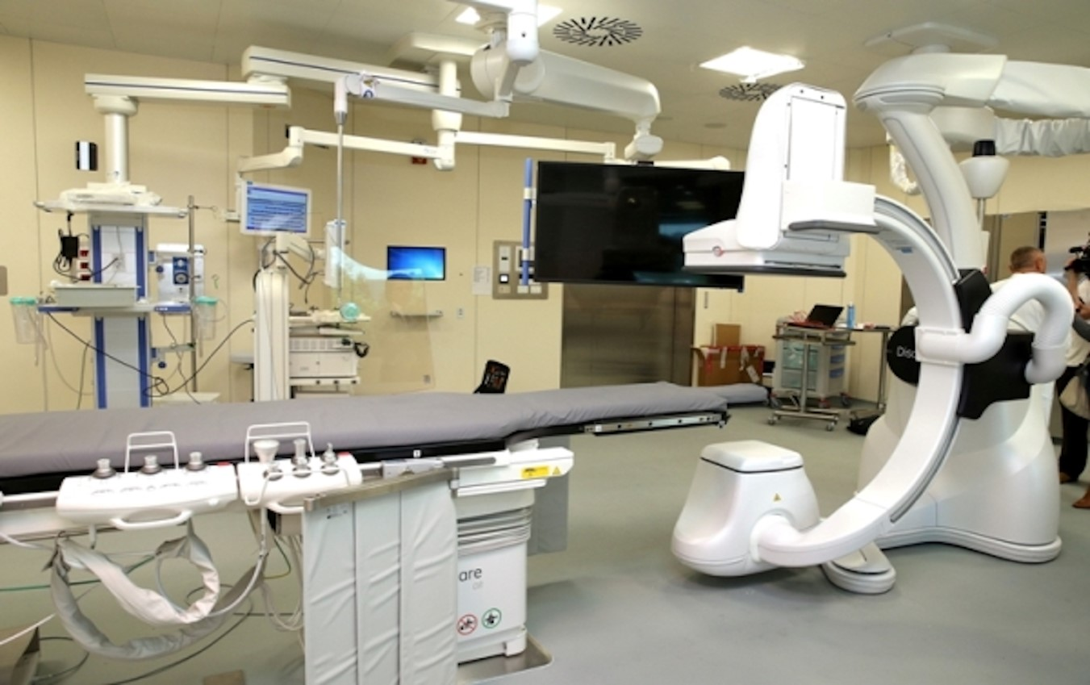
Figure 1 The hybrid room with Discovery™ IGS 740. The Discovery system has a wide bore C-arm, and the combination of this with a large detector enables extremely high-quality imaging, including three-dimensional imaging.

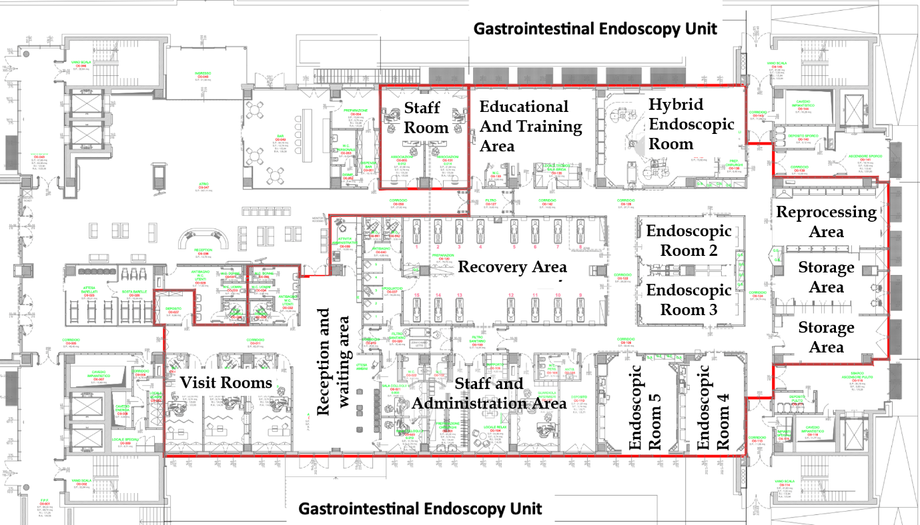
Figure 2 Map of the Gastrointestinal Endoscopy Unit. The Gastroenterology and Digestive Endoscopy Unit is on the ground floor of the new Oncological and Hematological Center of the Arcispedale Santa Maria Nuova. Here, the map of the Unit is shown inside the red box.

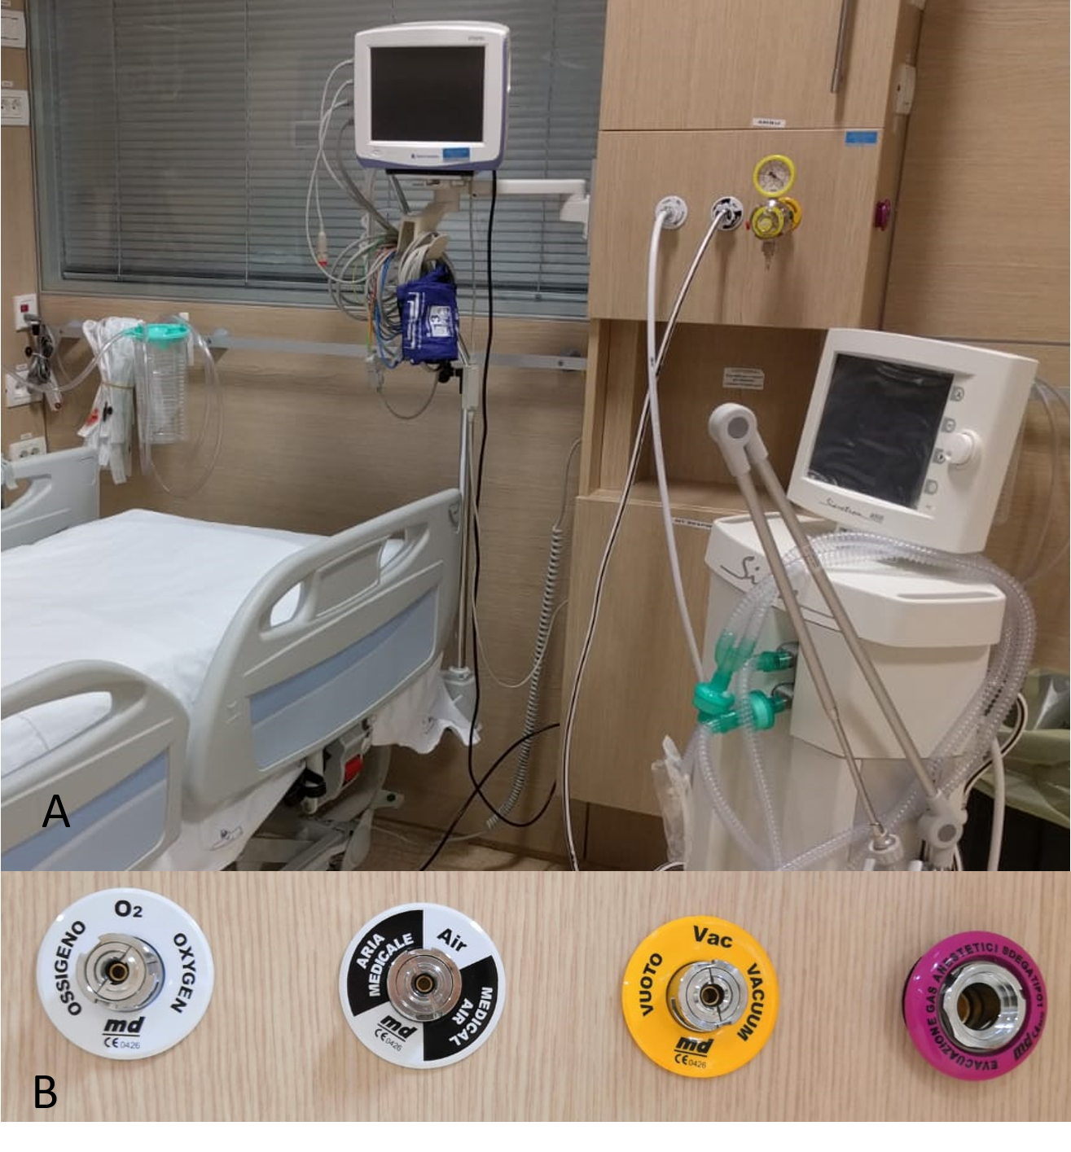
Figure 3 Equipment in the recovery room. A: The recovery room is equipped with medical air and wall oxygen supply, wall suction, and a medical gas and vacuum system; and B: Details of the wall devices.

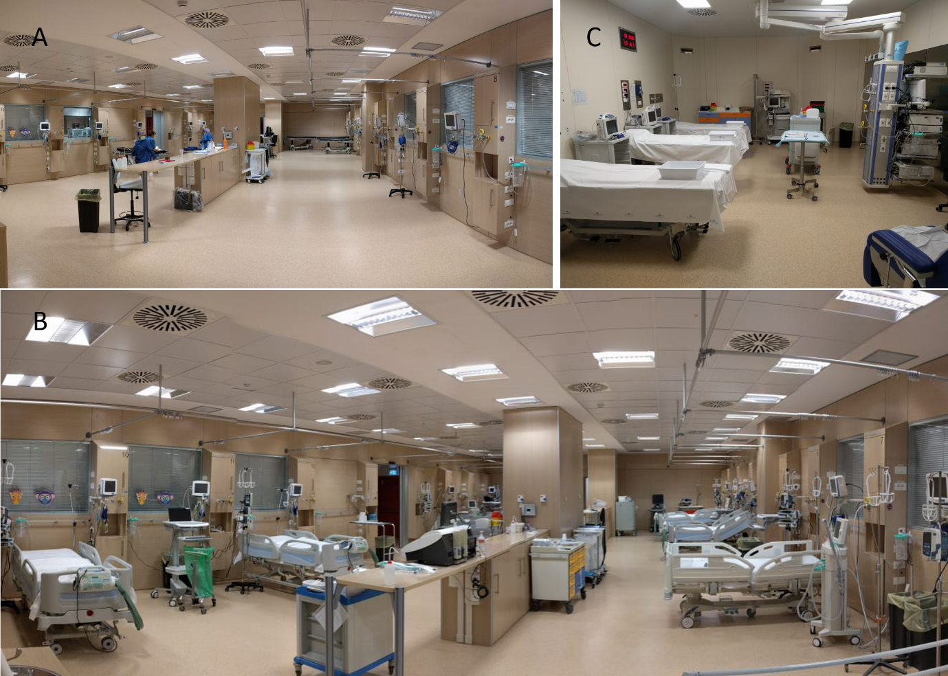
Figure 4 Structural changes. A: Original recovery room without beds; B: New intensive care unit derived from a recovery room with beds and monitors; and C: New recovery room derived from an endoscopy room.
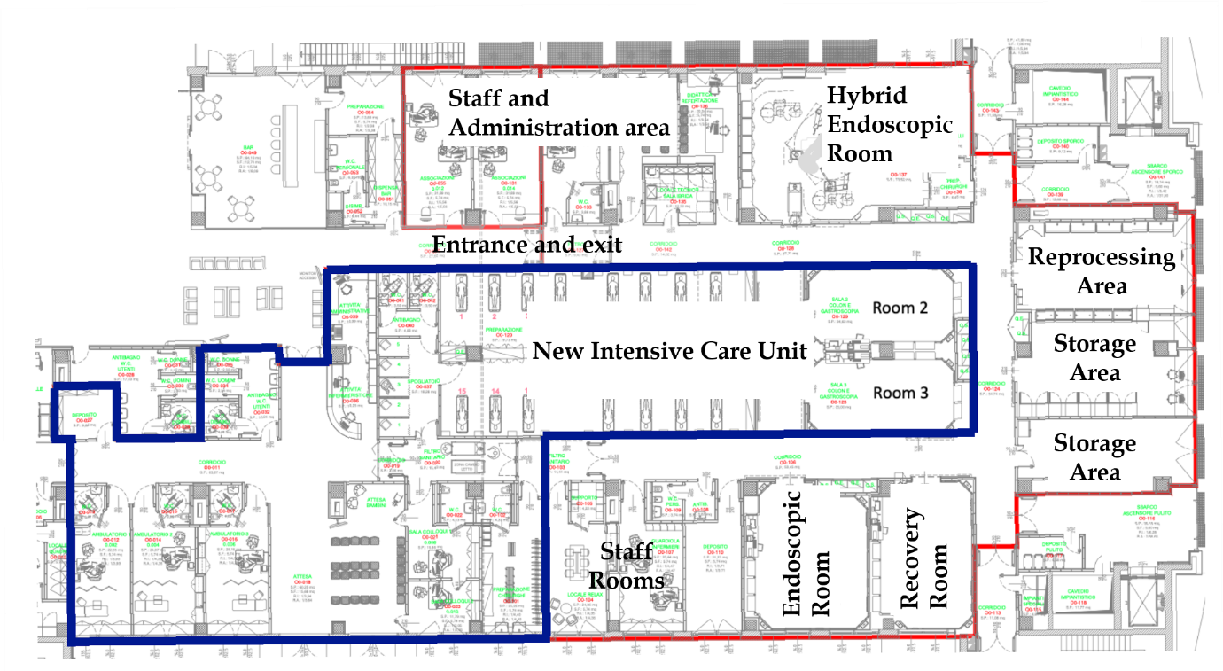
Figure 5 Map of the new Gastrointestinal Endoscopy Unit. The new intensive care unit is shown inside the blue box. The new Endoscopy Unit with a U-shape pathway is shown outside the blue box.

