Name of Journal: World Journal of Gastrointestinal Oncology
Manuscript NO: 57981
Manuscript Type: ORIGINAL ARTICLE

Retrospective Study
Subtotal gastrectomy combined with chemotherapy: An effective therapy for patients with circumscribed Borrmann type IV gastric cancer

Huang HB et al. Effective therapy for circumscribed Borrmann IV

Hai-Bo Huang, Zi-Ming Gao, An-Qi Sun, Wei-Tian Liang, Kai Li

Hai-Bo Huang, Zi-Ming Gao, An-Qi Sun, Wei-Tian Liang, Kai Li, Department of Surgical Oncology and General Surgery, Key Laboratory of Precision Diagnosis and Treatment of Gastrointestinal Tumors, Ministry of Education, The First Affiliated Hospital of China Medical University, Shenyang 110001, Liaoning Province, China

Author contributions: Huang HB and Li K designed the research; Gao ZM and Li K treated the patients and collected the material and clinical data from the patients; Huang HB and Sun AQ performed the assays; Liang WT and Huang HB analyzed the data; Huang HB wrote the paper.

Corresponding author: Kai Li, PhD, Professor, Department of Surgical Oncology and General Surgery, Key Laboratory of Precision Diagnosis and Treatment of Gastrointestinal Tumors, Ministry of Education, The First Affiliated Hospital of China Medical University, No. 155 Nanjing Street, Shenyang 110001, Liaoning Province, China. cmu_likai@163.com

Received: July 26, 2020
Revised: August 20, 2020
Accepted: September 25, 2020
Published online: November 15, 2020

Abstract
BACKGROUND
Although Borrmann type IV (B-4) gastric cancer has a higher mortality rate and presents distant metastasis easily, especially peritoneal metastasis, when diagnosed, some B-4 patients were found to have no distant metastasis by preoperative detection and underwent curative surgery, which was defined as circumscribed B-4 in our study. In this study, we focused on the circumscribed B-4 patients without distant metastasis during surgery to identify factors related to prognosis and postoperative peritoneal cavity metastasis (PPCM), which is important for selecting an appropriate therapeutic strategy.

AIM
To identify factors related to the prognosis and PPCM of B-4 patients.

METHODS
A total of 117 B-4 patients who underwent gastrectomy between January 2005 and December 2012 were included in this study. Survival analysis was performed using Kaplan–Meier analysis and Cox multivariate models. Pearson correlation analyses were performed to identify the factors related to PPCM. All statistical analyses were performed using SPSS 20.0.

RESULTS
Lymph node status, gastrectomy type, and postoperative chemotherapy were independent prognostic factors in 117 circumscribed B-4 patients. Subtotal gastrectomy combined with chemotherapy could significantly improve the long-term survival time. Six patients who were diagnosed with pN0 and received the combination therapy had a 3-year survival rate of 100% and a median survival of 77.7 mo. Even for patients with metastatic lymph nodes (n = 13), the combination therapy also increased the 3-year overall survival rate to 57.1%. In addition, positive lymph node status was the only factor (P = 0.005) correlated with PPCM in certain B-4 patients, and chemotherapy was useful for suppressing PPCM in patients with subtotal gastrectomy but not in those with total gastrectomy.

CONCLUSION
Lymph node status is an independent prognostic factor for circumscribed B-4 patients. In addition, subtotal gastrectomy and postoperative chemotherapy could effectively improve prognosis and even suppress PPCM.

Key Words: Gastric cancer; Circumscribed; Borrmann type IV; Prognosis; Subtotal gastrectomy; Chemotherapy

Citation: Huang HB, Gao ZM, Sun AQ, Liang WT, Li K. Subtotal gastrectomy combined with chemotherapy: An effective therapy for patients with circumscribed Borrmann type IV gastric cancer. World J Gastrointest Oncol 2020; 12(11): 1325-1335 URL: https://www.wjgnet.com/1948-5204/full/v12/i11/1325.htm DOI: https://dx.doi.org/10.4251/wjgo.v12.i11.1325

Core Tip: This is a retrospective study to evaluate the factors related to prognosis and prognostic postoperative peritoneal cavity metastasis for circumscribed Borrmann type IV (B-4) patients. We reported that lymph node metastatic status, gastrectomy type, and postoperative chemotherapy were the independent prognostic factors. Subtotal gastrectomy combined with chemotherapy could significantly improve the long-term survival time of circumscribed B-4 patients. And chemotherapy was also useful for suppressing postoperative peritoneal cavity metastasis in patients with subtotal gastrectomy. We believe that our study makes a significant contribution to the literature because it recommended reasonable treatment schedules for the B-4 patients, which can increase survival time to a certain extent.
INTRODUCTION
Gastric cancer (GC) is the fourth most common malignancy and the second most frequent cause of cancer-related death worldwide, with approximately 951600 new cases and 723100 deaths every year^{[1-3]}. Borrmann type IV (B-4) GC, as an aggressive type of GC, accounts for approximately 10% of all GC cases in Asia^{[4, 5]}. B-4 lesions are characterized as lesions that diffusely infiltrate the gastric wall without ulceration or elevation. Compared with other types of GC, the occurrence rates of serosal invasion, positive lymph nodes, and distant metastasis in B-4 patients are higher.
Currently, surgery with chemotherapy is the major treatment method for advanced GC, which significantly improves the rate of long-term overall survival (OS). However, many B-4 patients are not suitable for surgical treatment at the time of diagnosis, and the 3-year OS rate of B-4 patients is only approximately 15%-20%^{[6-8]}. Studies on the clinicopathology and prognosis of B-4 patients have had controversial findings^{[4,8-12]}. Some B-4 patients were found to have no distant metastasis by preoperative detection and underwent curative surgery, which was defined as circumscribed B-4 in our study. Circumscribed B-4 accounts for relatively fewer cases of B-4 patients, and the clinicopathological characteristics and prognostic analysis of these patients would help us to understand the recurrence and metastasis of GC. There is no related research, especially for circumscribed B-4 patients.
In this study, we aimed to identify the factors related to prognosis and postoperative peritoneal cavity metastasis (PPCM) for circumscribed B-4 patients and to further explore the appropriate therapeutic strategies.

MATERIALS AND METHODS
Patient selection
A total of 1803 patients were diagnosed with GC and underwent gastrectomy at the First Affiliated Hospital of China Medical University from January 2005 to December 2012. Among them, 117 circumscribed B-4 patients were included in our analysis. The inclusion criteria for the patients were as follows: (1) B-4 gastric lesions and no distant metastasis were confirmed by preoperative detection and histopathology postoperatively; (2) Gastrectomy, including subtotal or total, was performed without neoadjuvant therapy; and (3) Detailed clinicopathological and follow-up data could be obtained for each patient. This study was approved by the Ethics Committee of China Medical University, and informed consent was obtained from the patients.

Data collection
The following data were collected: Age, gender, tumor size, tumor location, radical degree (R0/R1), histological type (well/poor), tumor invasion depth (pT), lymph node status (pN), lymphatic vessel infiltration, subtotal/total gastrectomy, postoperative chemotherapy, PPCM, and overall survival time. Of these, highly or moderately differentiated adenocarcinoma was classified as the well differentiated histological type, while others were classified as the poorly differentiated histological type. Selection indication of chemotherapy for GC patients was based on the National Comprehensive Cancer Network (NCCN) Guidelines. The adjuvant chemotherapy regimen was FOLFOX6 in postoperative 6 mo, including 5-fluorouracil and platinum. Completion degree of chemotherapy was heterogeneous, with eight or less cycles. Follow-up was completed by December 2017, and stage was classified according to the 8th edition of the American Joint Committee on Cancer (AJCC) classification system.

Statistical analysis
Continuous variables are expressed as the mean ± standard deviation (SD), and categorical variables are expressed as frequencies. We performed multivariate analyses with the Cox proportional hazards model to identify independent prognostic factors. In addition, Kaplan-Meier analysis and the log-rank test were also used to evaluate the prognostic difference between groups. Pearson correlation analyses were performed for related factors of PPCM. The above statistical analyses were performed using SPSS 20.0, and P < 0.01 was considered statistically significant.

RESULTS
Baseline clinicopathological characteristics
A total of 117 patients were diagnosed with circumscribed B-4 GC and finally included in our analyses. As shown in Table 1, the mean age of the patients was 57.55 years, and the mean diameter of tumors was 7.81 cm. According to TNM stage, there were 27 cases of stage II and 90 cases of stage III. Of these, 81 (69.2%) patients had stage pT4, and 65 (55.6%) had stage pN3. A total of 116 patients received D2 lymphadenectomy, and the other one underwent D2+ lymphadenectomy. None of the 117 patients had distant metastasis, and cytology result of peritoneal lavage fluid was negative in our study.

Results of univariate and multivariate prognostic analyses
According to the Cox analysis, gastrectomy type (P = 0.003), pN stage (P = 0.000), and postoperative chemotherapy (P = 0.007) were crucial for predicting the prognosis of these circumscribed B-4 patients (Table 2). As shown in Figure 1A, the prognosis of patients who underwent subtotal gastrectomy was better than that of patients who underwent total gastrectomy (P = 0.000). After screening out patients with lower-middle lesions, the prognostic superiority of subtotal gastrectomy was consistent (Figure 1B). Notably, patients with a higher pN stage always had a worse prognosis (Figure 1C), but the prognostic value of pT stage was not significant (Figure 1D). In addition, as shown in Figure 1E, postoperative chemotherapy improved the long-term survival rate of circumscribed B-4 patients (P = 0.000).

Role of postoperative chemotherapy in the circumscribed B-4 patient cohort
The survival curves of chemotherapy for subtotal or total gastrectomy are shown in Figure 2A-B. We revealed that circumscribed B-4 patients who underwent subtotal gastrectomy gained more benefit from postoperative chemotherapy (P = 0.003) than those who underwent total gastrectomy (P = 0.04). But therapeutic duration of chemotherapy was not the prognostic factor for circumscribed B-4. In addition, the efficacy of chemotherapy also seemed to be associated with patient age, and patients younger than 65 years had a better prognosis than the others (Figure 2C).

Survival results of the 117 B-4 patients according to therapeutic strategy
The prognostic results, including the median survival (MS) and 3-year OS rate, are shown in Figure 2. There was an obvious prognostic tendency of the different groups. For circumscribed B-4 patients with gastrectomy, postoperative chemotherapy could significantly increase the MS time, regardless of lymph node metastasis. Notably, we revealed that circumscribed B-4 patients (n = 6) who were diagnosed with pN0 and finally underwent subtotal gastrectomy and chemotherapy had a 3-year OS rate of 100% and a median survival of 77.7 mo. Even for patients with metastatic lymph nodes (n = 13), combination therapy also increased the 3-year OS rate to 57.1% and the MS to 51.0 mo.

Analysis of circumscribed B-4 patients with PPCM
Peritoneal metastasis is the most common type of GC metastasis. In our analysis, 79 (67.5%) patients were diagnosed with peritoneal cavity metastasis (PPCM) after gastrectomy, 11 (9.4%) had liver metastasis, and 5 (4.3%) had lung metastasis. We selected the other 22 patients without postoperative metastasis as a non-PPCM group. Positive pN stage was the only factor (P = 0.005) correlated with PPCM in circumscribed B-4 patients by Pearson correlation analyses (Table 3). Notably, there was no difference in the PPCM rate between different pT stages (pT3 vs pT4). In addition, although chemotherapy did not seem to be associated with PPCM according to the results shown in Table 3, we further explored the association of chemotherapy and PPCM in different gastrectomy types. As shown in Table 4, postoperative chemotherapy was useful for suppressing PPCM in patients with subtotal gastrectomy (P = 0.018) but not in those with total gastrectomy (P = 0.281).

DISCUSSION
In this study, we first defined B-4 patients without distant metastasis as circumscribed B-4 patients. By multivariate analysis, we revealed that subtotal/total gastrectomy, pN stage, and postoperative chemotherapy were independent prognostic factors for these patients. pN stage, but not pT stage, was crucial for predicting the prognosis of circumscribed B-4 patients. In a previous study, we suggested classifying B-4 patients into pT4b stage according to prognosis.^{[4]} According to the statistical analysis, subtotal gastrectomy combined with chemotherapy can effectively improve the prognosis of circumscribed B-4. Even for the patients (n = 13) with positive pN, the combination therapy also improved the 3-year OS rate to 57.1%.
Surgical resection remains the main therapeutic method for GC, but the role of curative resection in B-4 is controversial^{[10,13,14]}. Luo et al^{[8]} and Kim et al^{[10]} reported that the 3- to 5-year OS of curative (R0) patients was higher than that of noncurative patients, but surgical curability was not an independent predictor of prognosis, particularly for B-4 patients. In addition, studies found that total gastrectomy had no advantages of long-term prognosis and led to nutritional deficiency and worse quality of life for advanced GC compared with subtotal gastrectomy^{[15-20]}. In our analysis, we also found that no survival benefit existed in the R0 patients compared with the R1 patients, and subtotal gastrectomy could significantly improve the prognosis of circumscribed B-4 patients compared with total gastrectomy. The pathological features of B-4 GC suggested that the lesion invaded the whole layers of the gastric wall, and even if there was no venous or lymphatic infiltration, some micrometastases had occurred before macroscopic distant metastasis. Thus, it is difficult to restrict metastasis and improve survival by surgical resection. The results from circumscribed B-4 patients provided more evidence for this conclusion.
Considering the limited effect of surgery, adjuvant chemotherapy was also found to be beneficial for survival in advanced GC. In a meta-analysis, 5-FU plus oxaliplatin (OXA) and 5-FU plus docetaxel (DOC) were recommended as postoperative chemotherapy regimens for advanced GC according to the efficacy^{[21]}. In this study, chemotherapy, including 5-FU and platinum, significantly improved the prognosis of local B-4, serving as one of the independent factors, even for patients who were older than 65 years. Notably, as shown in Supplementary Table 1, significant differences in age and pT stage existed between the chemotherapy and nonchemotherapy groups (P < 0.01). Thus, we revealed that elderly patients with advanced GC stage seem to have a lower tendency to receive postoperative chemotherapy in the clinic, which should be rectified according to our conclusions. In addition, studies found that although S-1 or S-1/cisplatin might have positive effects against B-4, the prognostic role of neoadjuvant chemotherapy did not reach the expected survival rate, with a median survival of only 17.3 mo and a 3-year OS rate of 24.5%^{[22-24]}. Therefore, neoadjuvant chemotherapy was not included and analyzed in our study.
Above all, as shown in Figure 2, the survival time and OS rates of the two groups were significantly different, and there was an obvious tendency. Subtotal gastrectomy with chemotherapy improved the median survival of negative and positive pN patients to 77.7 mo and 51.0 mo, respectively. Thus, for advanced GC patients, after confirmation as circumscribed B-4, we recommend striving for subtotal gastrectomy and performing postoperative chemotherapy, especially for the lower 1/3-1/2 lesions, regardless of whether the patient has lymph node metastases.
Additionally, our results showed that positive pN was correlated with the occurrence of PPCM in circumscribed B-4 patients, which indicated that lymph node metastasis was an important course for peritoneal metastasis. Some newly developed methods like endoscopic ultrasound guided fine needle aspiration may provide cytological confirmation for lymph node and other metastases^{[25-27]}. Of course, serosal invasion and the shedding of cancer cells are also important routes for peritoneal metastasis.
There were also some limitations in our study. First, this is a retrospective, single-center and small-sample study, which reduced the significance of our study. For example, only one patient was divided in a group, as shown in Figure 3. Second, no data of neoadjuvant or targeted therapy were referred to in our study. Thus, a prospective study on a larger scale is necessary in the future.

CONCLUSION
Lymph node metastasis is an independent risk factor for poor prognosis in circumscribed B-4 patients. Subtotal gastrectomy combined with postoperative chemotherapy could significantly improve the long-term OS rate and median survival time for circumscribed B-4 patients.

ARTICLE HIGHLIGHTS
Research background
Borrmann type IV (B-4) gastric cancer (GC) accounts for about 10% of all GC cases in Asia. Some B-4 patients were found to have no distant metastasis by preoperative detection and underwent curative surgery, which was defined as circumscribed B-4 in our study.

Research motivation
Research of clinicopathological characteristics and prognosis in B-4 is rare, especially for the circumscribed B-4 patients.

Research objectives
In this study, we aimed to identify the factors related to prognosis and postoperative peritoneal cavity metastasis (PPCM) for circumscribed B-4 patients and to further explore the appropriate therapeutic strategies.

Research methods
A total of 117 circumscribed B-4 patients were included in this study. Survival analysis and Pearson correlation analyses were performed to identify the factors related to prognosis.

Research results
Subtotal gastrectomy combined with chemotherapy could significantly improve the long-term survival time for circumscribed B-4. Positive lymph node staus was the only factor correlated with PPCM, and chemotherapy was useful for suppressing PPCM in patients with subtotal gastrectomy but not in those with total gastrectomy.

Research conclusions
Lymph node status is an independent prognostic factor for circumscribed B-4 patients. Subtotal gastrectomy and chemotherapy could effectively improve prognosis and suppress PPCM.

Research perspectives
This study recommended reasonable treatment schedules for circumscribed B-4 patients, but a multi-center study on a larger scale is necessary in the future.

REFERENCES
1 Torre LA, Bray F, Siegel RL, Ferlay J, Lortet-Tieulent J, Jemal A. Global cancer statistics, 2012. CA Cancer J Clin 2015; 65: 87-108 [PMID: 25651787 DOI: 10.3322/caac.21262]
2 Ferro A, Peleteiro B, Malvezzi M, Bosetti C, Bertuccio P, Levi F, Negri E, La Vecchia C, Lunet N. Worldwide trends in gastric cancer mortality (1980-2011), with predictions to 2015, and incidence by subtype. Eur J Cancer 2014; 50: 1330-1344 [PMID: 24650579 DOI: 10.1016/j.ejca.2014.01.029]
3 Sak K. A Hypothetical Approach on Gender Differences in Cancer Diagnosis. J Transl Int Med 2019; 7: 90-92 [PMID: 31637178 DOI: 10.2478/jtim-2019-0020]
4 Huang JY, Wang ZN, Lu CY, Miao ZF, Zhu Z, Song YX, Xu HM, Xu YY. Borrmann type IV gastric cancer should be classified as pT4b disease. J Surg Res 2016; 203: 258-267 [PMID: 27363630 DOI: 10.1016/j.jss.2016.04.026]
5 An JY, Kang TH, Choi MG, Noh JH, Sohn TS, Kim S. Borrmann type IV: an independent prognostic factor for survival in gastric cancer. J Gastrointest Surg 2008; 12: 1364-1369 [PMID: 18516653 DOI: 10.1007/s11605-008-0516-9]
6 Dong RZ, Guo JM, Zhang ZW, Zhou YM, Su Y. Prognostic impact and implications of extracapsular lymph node spread in Borrmann type IV gastric cancer. Oncotarget 2017; 8: 97593-97601 [PMID: 29228635 DOI: 10.18632/oncotarget.18400]
7 Li C, Oh SJ, Kim S, Hyung WJ, Yan M, Zhu ZG, Noh SH. Macroscopic Borrmann type as a simple prognostic indicator in patients with advanced gastric cancer. Oncology 2009; 77: 197-204 [PMID: 19729977 DOI: 10.1159/000236018]
8 Luo Y, Gao P, Song Y, Sun J, Huang X, Zhao J, Ma B, Li Y, Wang Z. Clinicopathologic characteristics and prognosis of Borrmann type IV gastric cancer: a meta-analysis. World J Surg Oncol 2016; 14: 49 [PMID: 26912240 DOI: 10.1186/s12957-016-0805-9]
9 Zhu YL, Yang L, Sui ZQ, Liu L, Du JF. Clinicopathological features and prognosis of Borrmann type IV gastric cancer. J BUON 2016; 21: 1471-1475 [PMID: 28039710]
10 Kim EY, Yoo HM, Song KY, Park CH. Limited significance of curative surgery in Borrmann type IV gastric cancer. Med Oncol 2016; 33: 69 [PMID: 27251378 DOI: 10.1007/s12032-016-0783-3]
11 Yook JH, Oh ST, Kim BS. Clinicopathological analysis of Borrmann type IV gastric cancer. Cancer Res Treat 2005; 37: 87-91 [PMID: 19956485 DOI: 10.4143/crt.2005.37.2.87]
12 Kim DY, Kim HR, Kim YJ, Kim S. Clinicopathological features of patients with Borrmann type IV gastric carcinoma. ANZ J Surg 2002; 72: 739-742 [PMID: 12534387 DOI: 10.1046/j.1445-2197.2002.02523.x]
13 Yoshikawa T, Tsuburaya A, Kobayashi O, Sairenji M, Motohashi H, Noguchi Y. Should scirrhous gastric carcinoma be treated surgically? Clinical experiences with 233 cases and a retrospective analysis of prognosticators. Hepatogastroenterology 2001; 48: 1509-1512 [PMID: 11677997]
14 Pedrazzani C, Marrelli D, Pacelli F, Di Cosmo M, Mura G, Bettarini F, Rosa F, de Manzoni G, Roviello F. Gastric linitis plastica: which role for surgical resection? Gastric Cancer 2012; 15: 56-60 [PMID: 21717092 DOI: 10.1007/s10120-011-0063-z]
15 Jang YJ, Park MS, Kim JH, Park SS, Park SH, Kim SJ, Kim CS, Mok YJ. Advanced gastric cancer in the middle one-third of the stomach: Should surgeons perform total gastrectomy? J Surg Oncol 2010; 101: 451-456 [PMID: 19924722 DOI: 10.1002/jso.21431]
16 Sugoor P, Shah S, Dusane R, Desouza A, Goel M, Shrikhande SV. Proximal gastrectomy versus total gastrectomy for proximal third gastric cancer: total gastrectomy is not always necessary. Langenbecks Arch Surg 2016; 401: 687-697 [PMID: 27143021 DOI: 10.1007/s00423-016-1422-3]
17 Bozzetti F. Total versus subtotal gastrectomy in cancer of the distal stomach: facts and fantasy. Eur J Surg Oncol 1992; 18: 572-579 [PMID: 1478289]
18 Liu Z, Feng F, Guo M, Liu S, Zheng G, Xu G, Lian X, Fan D, Zhang H. Distal gastrectomy versus total gastrectomy for distal gastric cancer. Medicine (Baltimore) 2017; 96: e6003 [PMID: 28151896 DOI: 10.1097/MD.0000000000006003]
19 Jentschura D, Winkler M, Strohmeier N, Rumstadt B, Hagmüller E. Quality-of-life after curative surgery for gastric cancer: a comparison between total gastrectomy and subtotal gastric resection. Hepatogastroenterology 1997; 44: 1137-1142 [PMID: 9261613]
20 Davies J, Johnston D, Sue-Ling H, Young S, May J, Griffith J, Miller G, Martin I. Total or subtotal gastrectomy for gastric carcinoma? A study of quality of life. World J Surg 1998; 22: 1048-1055 [PMID: 9747165 DOI: 10.1007/s002689900515]
21 Sun J, Ren Z, Sun X, Hou H, Li K, Ge Q. Efficacy and safety comparison of chemotherapies for advanced gastric cancer: A network meta-analysis. Oncotarget 2017; 8: 39673-39682 [PMID: 28562333 DOI: 10.18632/oncotarget.17784]
22 Kinoshita T, Sasako M, Sano T, Katai H, Furukawa H, Tsuburaya A, Miyashiro I, Kaji M, Ninomiya M. Phase II trial of S-1 for neoadjuvant chemotherapy against scirrhous gastric cancer (JCOG 0002). Gastric Cancer 2009; 12: 37-42 [PMID: 19390930 DOI: 10.1007/s10120-008-0496-1]
23 Iwasaki Y, Sasako M, Yamamoto S, Nakamura K, Sano T, Katai H, Tsujinaka T, Nashimoto A, Fukushima N, Tsuburaya A; Gastric Cancer Surgical Study Group of Japan Clinical Oncology Group. Phase II study of preoperative chemotherapy with S-1 and cisplatin followed by gastrectomy for clinically resectable type 4 and large type 3 gastric cancers (JCOG0210). J Surg Oncol 2013; 107: 741-745 [PMID: 23400787 DOI: 10.1002/jso.23301]
24 Mohri J, Katada C, Ueda M, Sugawara M, Yamashita K, Moriya H, Komori S, Hayakawa K, Koizumi W, Atsuda K. Predisposing Factors for Chemotherapy-induced Nephrotoxicity in Patients with Advanced Esophageal Cancer Who Received Combination Chemotherapy with Docetaxel, Cisplatin, and 5-fluorouracil. J Transl Int Med 2018; 6: 32-37 [PMID: 29607302 DOI: 10.2478/jtim-2018-0007]
25 Uberoi AS, Bhutani MS. Has the role of EUS in rectal cancer staging changed in the last decade? Endosc Ultrasound 2018; 7: 366-370 [PMID: 30531023 DOI: 10.4103/eus.eus_36_18]
26 Mizuno S, Nakai Y, Isayama H, Suzuki T, Saito K, Uchino R, Takahara N, Kogure H, Tada M, Koike K. EUS-FNA of gastric cancer metastatic to the head of pancreas using a forward oblique viewing echoendoscope in a case with Roux-en-Y anatomy. Endosc Ultrasound 2018; 7: 420-421 [PMID: 29536952 DOI: 10.4103/eus.eus_107_17]
27 Yang F, Wang H, Liu X, Ge N, Guo J, Wang S, Song X, Cao L, Sun S. EUS-guided fine-needle technique-derived cancer organoids: A tailored "Shennong deity" for every patient with cancer. Endosc Ultrasound 2019; 8: 73-75 [PMID: 31006704 DOI: 10.4103/eus.eus_13_19]

Footnotes
Institutional review board statement: This study was reviewed and approved by the Ethics Committee of First Affiliated Hospital of China Medical University.

Informed consent statement: Written informed consent was obtained from each patient.

Conflict-of-interest statement: All authors declare no conflicts of interest.

Data sharing statement: No additional data are available.

Open-Access: This article is an open-access article that was selected by an in-house editor and fully peer-reviewed by external reviewers. It is distributed in accordance with the Creative Commons Attribution NonCommercial (CC BY-NC 4.0) license, which permits others to distribute, remix, adapt, build upon this work non-commercially, and license their derivative works on different terms, provided the original work is properly cited and the use is non-commercial. See: http://creativecommons.org/Licenses/by-nc/4.0/

Manuscript source: Unsolicited manuscript

Peer-review started: July 26, 2020
First decision: August 9, 2020
Article in press: September 25, 2020

Specialty type: Oncology
Country/Territory of origin: China
Peer-review report’s scientific quality classification
Grade A (Excellent): 0
Grade B (Very good): 0
Grade C (Good): C
Grade D (Fair): 0
Grade E (Poor): 0

P-Reviewer: Arigami T S-Editor: Gao CC L-Editor: Wang TQ P-Editor: Li JH

Figure Legends
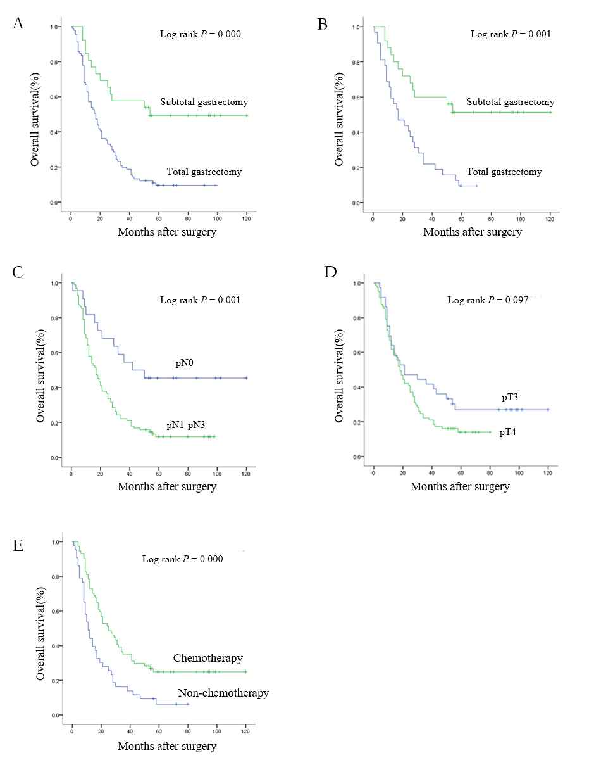
Figure 1 Survival curves of 117 patients according to the independent prognostic factors. A: Subtotal vs total gastrectomy; B: Subtotal vs total gastrectomy (lower-middle lesions); C: Lymph node status (pN stage); D: Tumor invasion depth (pT stage); E: Postoperative chemotherapy. pN: Lymph node status; pT: Tumor invasion depth.
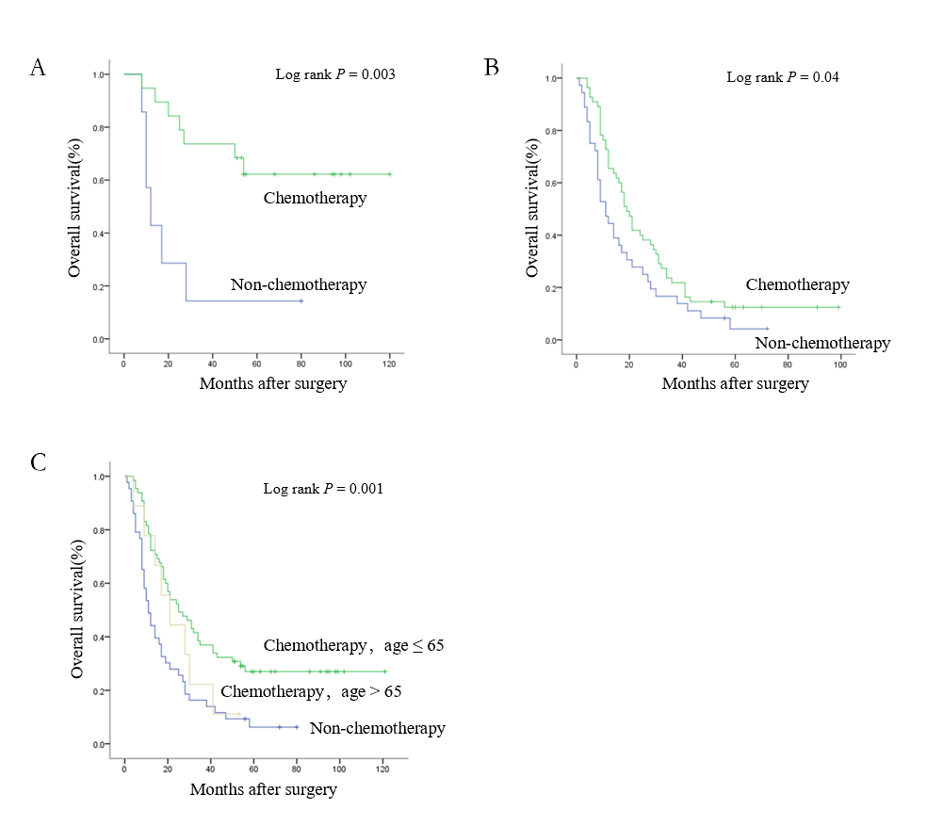
Figure 2 Survival curves of chemotherapy for different Borrmann type IV patients. A: Patients with subtotal gastrectomy; B: Patients with total gastrectomy; C: Patients of different ages.
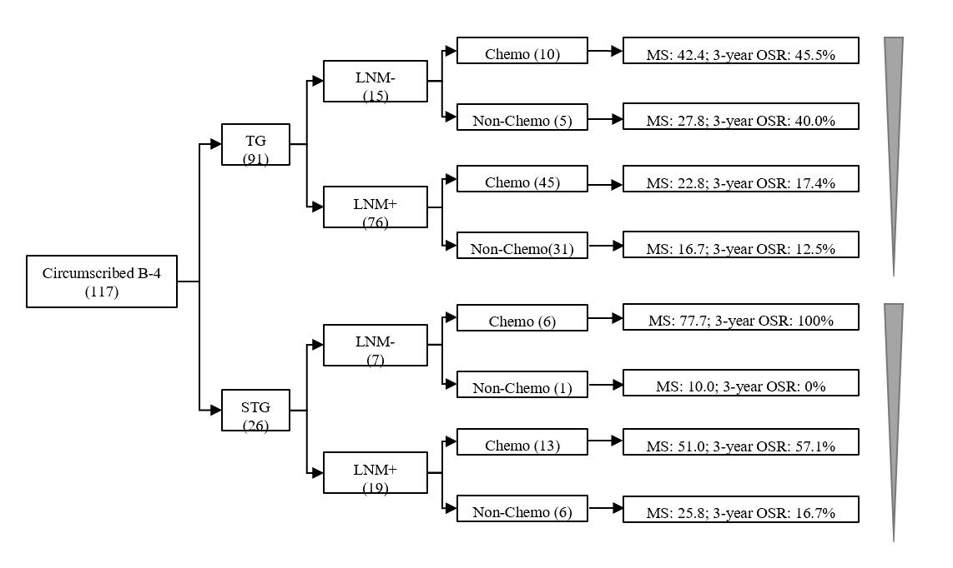
Figure 3 Mean survival and 3-yr overall survival rates of different groups of 117 patients according to Cox multivariate analysis. TG: Total gastrectomy; STG: Subtotal gastrectomy; LNM: Lymph node metastasis; Chemo: Chemotherapy; MS: Median survival (mo); OSR: Overall survival rate.
Table 1 Main clinicopathological characteristics of patients with circumscribed Borrmann type IV gastric cancer
Variable | B-4 patients (n = 117)
Age (yr) | 57.55 ± 10.69
Gender
Male | 75
Female | 42
Diameter (cm) | 7.81 ± 3.07
Tumor location
Upper 1/3–1/2 (U or MU) | 22
Lower 1/3–1/2 (M or L or ML) | 59
Total (LAU or LMU) | 36
Radical degree
R0 | 45
R1+ | 72
Histological type
Well | 8
Poor | 109
pT stage
pT3 | 36
pT4 | 81
pN stage
pN0 | 22
pN1 | 15
pN2 | 15
pN3 | 65
Venous/lymphatic infiltration
Yes | 74
No | 43
Gastrectomy type
Subtotal gastrectomy | 26
Total gastrectomy | 91
Adjuvant chemotherapy
Yes | 74
No | 43
U: Upper; M: Middle; L: Lower; pT: Tumor invasion depth; pN: Lymph node status.
Table 2 Cox univariate and multivariate analyses of circumscribed Borrmann type IV patients
Variable | Univariate analysis |  | Multivariate analysis
 | HR (95% CI) | P value | HR (95% CI) | P value
Age (yr) | 1.012 (0.992-1.033) | 0.226
Gender | 0.969 (0.638-1.470) | 0.881
Diameter (cm) | 1.086 (1.013-1.164) | 0.02
Tumor location | 1.206 (0.879-1.655) | 0.246
Radical degree | 1.575 (0.687-3.612) | 0.283
Histological type | 0.708 (0.310-1.620) | 0.414
pT stage | 1.422 (1.021-1.982) | 0.037
pN stage | 1.482 (1.224-1.794) | 0.000 | 1.433 (1.179-1.742) | 0.000
Venous/lymphatic infiltration | 0.934 (0.615-1.418) | 0.748
Gastrectomy type | 0.330 (0.182-0.595) | 0.000 | 0.400 (0.219-0.728) | 0.003
Postoperative chemotherapy | 0.482 (0.320-0.727) | 0.001 | 0.564 (0.373-0.853) | 0.007
HR: Hazard ratio; CI: Confidence interval; pT: Tumor invasion depth; pN: Lymph node status.
Table 3 Factors associated with postoperative peritoneal cavity metastasis in Borrmann type IV patients
Variable | PPCM (79) | Non-PPCM (22) | Pearson P value
Tumor location |  |  | 0.497
Upper 1/3–1/2 (U or MU) | 13 | 4
Lower 1/3–1/2 (M or L or ML) | 41 | 13
Total (LAU or LMU) | 25 | 5
Radical degree |  |  | 0.107
R0 | 28 | 12
R1+ | 51 | 10
Gastrectomy type |  |  | 0.112
Subtotal gastrectomy | 13 | 7
Total gastrectomy | 66 | 15
Venous/lymphatic infiltration |  |  | 0.416
Yes | 50 | 16
No | 29 | 6
pT stage |  |  | 0.559
pT3 | 23 | 5
pT4 | 56 | 17
pN stage |  |  | 0.005^{b}
pN0 | 9 | 8
pN1-3 | 70 | 14
Chemotherapy |  |  | 0.105
Yes | 46 | 17
No | 33 | 5
^{b}P < 0.01. PPCM: Postoperative peritoneal cavity metastasis; U: Upper; M: Middle; L: Lower; pT: Tumor invasion depth; pN: Lymph node status.

Table 4 Role of chemotherapy in suppressing postoperative peritoneal cavity metastasis in patients who underwent different gastrectomy procedures
 | Subtotal gastrectomy (20) |  |  | Total gastrectomy (81)
 | PPCM (13) | Non-PPCM (7) | Pearson P value | PPCM (66) | Non-PPCM (15) | Pearson P value
Chemotherapy | 4 | 6 | 0.018ª | 45 | 8 | 0.281
Non-chemotherapy | 9 | 1 |  | 21 | 7
ªP < 0.05. PPCM: Postoperative peritoneal cavity metastasis.

