Name of Journal: World Journal of Gastroenterology
Manuscript NO: 59445
Manuscript Type: ORIGINAL ARTICLE

Basic Study
Effect of acetyl-L-carnitine on hypersensitivity in acute recurrent caerulein-induced pancreatitis and microglial activation along the brain’s pain circuitry

McIlwrath SL et al. Microglial activation during recurrent caerulein pancreatitis

Sabrina L McIlwrath, Marlene E Starr, Abigail E High, Hiroshi Saito, Karin N Westlund

Sabrina L McIlwrath, Karin N Westlund, Research Service, New Mexico Veterans Affairs Healthcare System, Albuquerque, NM 87108, United States

Marlene E Starr, Hiroshi Saito, Department of Surgery, University of Kentucky, Lexington, KY 40536, United States

Abigail E High, College of Liberal Arts, University of Texas, Austin, TX 78712, United States

Karin N Westlund, Department of Anesthesiology and Critical Care Medicine, University of New Mexico Health Sciences Center, Albuquerque, NM 87131, United States

Author contributions: McIlwrath SL performed the animal experiments, data analysis, produced the figures, wrote the manuscript; Starr ME assisted with animal caerulein dosing and read the manuscript; High AE analyzed the microglial morphology the brain sections; Saito H designed the study, read and edited this manuscript; Westlund KN designed the study, read and edited this manuscript; all authors discussed the results, commented on the manuscript, and approved the final version of the article.

Supported by United States Department of Veterans Affairs, VA Merit Grant, No. BX002695; and United States National Institute of Health, No. R01AG055359, No. R01GM126181 and No. R01NS39041-15.

Corresponding author: Sabrina L McIlwrath, PhD, Senior Scientist, Research Service, New Mexico Veterans Affairs Healthcare System, 1501 San Pedro SE, Albuquerque, NM 87108, United States. sabrina.mcilwrath@va.gov

Received: September 11, 2020
Revised: December 8, 2020
Accepted: January 15, 2021
Published online: March 7, 2021

Abstract
BACKGROUND
Acute pancreatitis (AP) and recurring AP are serious health care problems causing excruciating pain and potentially lethal outcomes due to sepsis. The validated caerulein- (CAE) induced mouse model of acute/recurring AP produces secondary persistent hypersensitivity and anxiety-like behavioral changes for study.

AIM
To determine efficacy of acetyl-L-carnitine (ALC) to reduce pain-related behaviors and brain microglial activation along the pain circuitry in CAE-pancreatitis.

METHODS
Pancreatitis was induced with 6 hly intraperitoneal (i.p.) injections of CAE (50 µg/kg), 3 d a week for 6 wk in male C57BL/6J mice. Starting in week 4, mice received either vehicle or ALC until experiment’s end. Mechanical hypersensitivity was assessed with von Frey filaments. Heat hypersensitivity was determined with the hotplate test. Anxiety-like behavior was tested in week 6 using elevated plus maze and open field tests. Microglial activation in brain was quantified histologically by immunostaining for ionized calcium-binding adaptor molecule 1 (Iba1).

RESULTS
Mice with CAE-induced pancreatitis had significantly reduced mechanical withdrawal thresholds and heat response latencies, indicating ongoing pain. Treatment with ALC attenuated inflammation-induced hypersensitivity, but hypersensitivity due to abdominal wall injury caused by repeated intraperitoneal injections persisted. Animals with pancreatitis displayed spontaneous anxiety-like behavior in the elevated plus maze compared to controls. Treatment with ALC resulted in increased numbers of rearing activity events, but time spent in “safety” was not changed. After all the abdominal injections, pancreata were translucent if excised at experiment’s end and opaque if excised on the subsequent day, indicative of spontaneous healing. Post mortem histopathological analysis performed on pancreas sections stained with Sirius Red and Fast Green identified wide-spread fibrosis and acinar cell atrophy in sections from mice with CAE-induced pancreatitis that was not rescued by treatment with ALC. Microglial Iba1 immunostaining was significantly increased in hippocampus, thalamus (intralaminar nuclei), hypothalamus, and amygdala of mice with CAE-induced pancreatitis compared to naïve controls but unchanged in the primary somatosensory cortex compared to naïves.

CONCLUSION
CAE-induced pancreatitis caused increased pain-related behaviors, pancreatic fibrosis, and brain microglial changes. ALC alleviated CAE-induced mechanical and heat hypersensitivity but not abdominal wall injury-induced hypersensitivity caused by the repeated injections.

Key Words: Acute recurrent pancreatitis; Neuropathic pain; Mechanical hypersensitivity; Heat hypersensitivity; Anxiety-like behavior; Ionized calcium-binding adaptor molecule 1

©The Author(s) 2021. Published by Baishideng Publishing Group Inc. All rights reserved.

Citation: McIlwrath SL, Starr ME, High AE, Saito H, Westlund KN. Effect of acetyl-L-carnitine on hypersensitivity in acute recurrent caerulein-induced pancreatitis and microglial activation along the brain’s pain circuitry. World J Gastroenterol 2021; 27(9): 794-814
URL: https://www.wjgnet.com/1007-9327/full/v27/i9/794.htm
DOI: https://dx.doi.org/10.3748/wjg.v27.i9.794

Core Tip: The caerulein- (CAE) induced pancreatitis model requiring 6 wk of repeated injections is a model of recurrent acute bouts of pancreatitis that causes pancreatic tissue damage and fibrosis. Control repeated i.p. saline injections alone caused abdominal wall injury and hindpaw secondary mechanical hypersensitivity. Treatment with acetyl-L-carnitine significantly attenuated CAE-induced hypersensitivity without alleviating pancreatic histological disruption. Mice with CAE-induced pancreatitis with secondary mechanical and heat hypersensitivity had elevated plus maze anxiety-like behavior. Post-mortem analysis revealed microglial morphology changes indicative of activation in amygdala, hippocampus, hypothalamus, and thalamus, but not in primary somatosensory cortex. These data suggest that activated microglia in these brain regions contribute to chronic hypersensitivity and anxiety-like behaviors in mice with CAE-induced pancreatitis.
INTRODUCTION
Pancreatitis is a progressive disease that when developing from acute to chronic pancreatitis increases the risk for pancreatic cancer^{[1-5]}. A recent meta-analysis reported 10% of patients with acute and 36% with recurrent acute pancreatitis (AP) develop chronic pancreatitis^{[6,7]}. This multifactorial disorder has a complex etiology including gene mutations/heritable factors, gallstones, poor and/or high fat diet, smoking, and regular alcohol consumption^{[8-10]}. The recurrent inflammation of the pancreas results in progressive pancreatic insufficiency and replacement of exocrine parenchyma with fibrotic tissue and adipocytes. Chief complaint of patients with pancreatitis is intractable abdominal pain, present in approximately 90% of patients^{[11,12]}. At present there is no cure for pancreatitis and pain management remains inadequate, yet pain which is the main cause of reduced quality of life is often ignored and neglected by specialists since it is poorly understood^{[13-15]}.
In the past, pain due to pancreatitis has been attributed to inflammation and distension pressure within the pancreas. Relieving pancreatic tissue pressure provides post-surgical pain relief, but no long-term pain relief^{[16]}. More recently, studies have shown that severity of pancreatitis induced pain is independent of abdominal findings in clinical patients^{[14,17]}. Pancreatitis pain is initially driven by peripheral inflammation, mitochondrial dysfunction in acinar cells, and release of reactive oxygen species^{[18-20]}. The result is pathological activation of innervating sensory neurons and a vicious cycle of neurogenic inflammation^{[21]}. Pre-treatment with acetyl-L-carnitine (ALC), a neutraceutical antioxidant and mitochondrial enhancer, has been shown to prevent biochemical and histological evidence of AP^{[22]}. ALC is a free radical scavenger that can potentially repair oxidized polyunsaturated fatty acids esterified in membrane phospholipids^{[23,24]}. With progression to recurrent acute and chronic pancreatitis, associated nerve pain becomes neuropathic and clinical study has demonstrated attenuation by pregabalin, the conventional pharmacological intervention for neuropathic pain^{[25]}. Concurrent neuroplastic changes in the spinal cord and along the brain pain neuraxis cause a transition to central sensitization^{[26,27]}.
Microglia are resident immune cells in the central nervous system. After activation through neurochemical communication among neurons and glial cells, microglia can phagocytose cell debris and/or invading foreign cells, as well as activate circulating immune cells^{[28-31]}. Microglial communication with neurons in the spinal cord has been identified as central in establishing and maintaining neuropathic pain^{[27,32]}. Release of brain-derived neurotrophic factor from activated microglia in the spinal cord causes a neuronal anion shift that contributes to central sensitization^{[33]}. In neuropathic pain models, ligating either spinal nerves or parts of the sciatic nerve induces selective microglial activation in the spinal cord but reportedly not in supraspinal regions 2 wk after nerve injury^{[34,35]}. Four weeks after partial sciatic nerve ligation, however, migrated M2 bone-marrow derived microglia were localized in the amygdala concurrent with anxiety-like behavior^{[36]}. Several studies using a chemically induced rat model of pancreatitis have demonstrated that activated spinal microglia are involved in the establishment and maintenance of hypersensitivity^{[27,31]}. In clinical patients with chronic pancreatitis cortical reorganization within the pain neuraxis has been reported^{[37,38]}. However, the role of microglia in this process is not yet understood.
In the present study we utilized a modified caerulein- (CAE) induced recurrent AP model^{[39-42]}. This model causes pancreatic dysregulation of digestive enzymes, oxidative stress, fibrosis, acinar cell death, infiltration of inflammatory cells, leading to edema and fibrosis in mice^{[19,20,40,42]}. In male C57BL/6J mice the CAE-induced pancreatitis model produces secondary hypersensitivity and anxiety-like behavioral changes. Morphological changes indicative of microglial activation in pain and anxiety-related brain regions were quantified after 6 wk of CAE-induced recurrent AP. Efficacy of ALC treatment to alleviate these symptoms in the last 3 wk of CAE-induced pancreatitis was determined.

MATERIALS AND METHODS
Animals
All animal procedures were conducted in accordance with the guidelines for the ethical treatment of experimental animals published by the Internal Association for the Study of Pain and approved by the University of Kentucky Institutional Animal Care and Use Committee. A total of 27 male 16- to 26-week-old C57BL/6J mice (The Jackson Laboratory, Bar Harbor, MA, United States) were used. All animals were maintained on a 12/12 h light/dark cycle with up to 5 animals in each pressurized intraventilated cage in a temperature (21-23 ºC) and humidity (30%-70%) controlled room. Animals were given water and food ad libitum.
Body weight was measured daily to ascertain well-being. After 5 wk of repeated daily intraperitoneal injections, uninjected naïve control group animals weighed significantly more than the 3 other experimental groups whose body weight had plateaued (naïve control = 31.2 ± 0.5 g, VEH (vehicle) + ALC = 28.4 ± 0.7 g, CAE + VEH = 28.9 ± 0.8 g, CAE + ALC = 28.7 ± 0.5 g, P < 0.05 two-way ANOVA with Newman-Keuls post hoc test) (Supplementary Figure 1).

CAE-induced persistent pancreatitis model
Animals were randomly divided into 4 groups: CAE + VEH had CAE-induced pancreatitis and saline treatment, CAE + ALC had CAE-induced pancreatitis and ALC treatment, VEH + ALC control animals received saline injections and ALC treatment, and naïve controls which received no injections at all. Recurrent AP was induced using CAE, similar to previous description^{[39,41-43]}. In brief, animals received 6 hly intraperitoneal (i.p.) injections of 100 µL of 0.9% sterile saline containing 50 μg/kg CAE (American Peptide, Sunnyvale, CA, United States) 3 times a week (Monday, Wednesday, Friday) for a total duration of 6 wk using a 1 mL syringe with a 1/2 inch long 27 gauge needle. Control vehicle animals were injected with the same volume of 0.9% saline vehicle^{[41]}. Naïve control animals were not injected.

ALC treatment
In the present study we tested the efficacy of ALC post-treatment to reduce pain-related behaviors. Three weeks after the start of the CAE injections, animals received i.p. injections twice daily of either 50 µL 0.9% saline (VEH) or ALC (100 mg/kg per injection for a total daily dose of 200 mg/kg; Sigma-Aldrich, St. Louis, MO, United States). Injections continued in weeks 4-6 until experiment’s end. A previous study demonstrated the efficacy of ALC pre-treatment given daily (200 mg/kg body weight, i.p.) for 7 d to prevent acute CAE-induced pancreatitis^{[22]}. It has been shown that 100 mg/kg body weight results in a peak plasma carnitine concentration 3 h post and is completely removed within 24 h after administration^{[44]}.

Behavioral assessments
Animals were acclimated in their home cage to the behavior testing room for 1 h prior to starting experiments. Reflexive mechanical and heat assays were conducted weekly. Mechanical and heat sensitivity was tested several consecutive days in the week prior to the first CAE injection and baseline measurements were recorded when sensitivity measures were stable. The elevated plus maze and open field test were performed only once at the end of the experiment.

Mechanical withdrawal threshold measurement using von Frey filaments on hindpaws
The up-down method was used to determine mechanical sensitivity of the hindpaws^{[45]}. Briefly, animals were placed on an elevated Teflon screen mesh (3 mm² holes) in individual clear lucite boxes and the hind paw glabrous skin was probed using a graded series of calibrated von Frey filaments (0.4, 0.6, 1.0, 2.0, 4.0, 6.0, 8.0, 15.0 g or 3.9, 5.9, 9.8, 19.6, 39.2, 58.8, 98.0 mN). Withdrawal of the foot was considered a positive response. An algorithm was used to determine the mechanical sensitivity threshold for experimental group comparisons.

Hotplate test
Heat sensitivity was determined using a hot plate analgesiometer apparatus set at 50 ºC (Columbus Instruments, Columbus, OH, United States). Animals were placed individually on the hotplate (25.4 cm × 25.4 cm heated surface) surrounded by a 30 cm high Plexiglas barrier. The latency until a nocifensive response (shaking or licking the paw, jumping, or running) occurred was recorded. Animals were immediately removed after the initial response. A mandatory cut-off time of 25 s prevented burn injury but was never employed. The heat sensitivity test was performed 3 times at 20 min intervals and latencies averaged.

Elevated plus maze test
The elevated plus maze consists of 2 closed (safe) and 2 open (threatening environment) arms and is widely used to measure anxiety-like behavior. The mouse is placed in the center of the elevated 4-arm maze and video recorded in isolation for 5 min (300 s) for post hoc analysis. Fear/anxiety-like behavior is determined by the number of open and closed arm entries, total open and closed arm occupancy, and by the number of exploratory rearing events. Anxiety-like behavior is related to open arm avoidance and reduced rearing events^{[46]}. This test was consistently performed in all mice before the open field assay.

Open field exploratory behavior test
Exploratory behaviors were measured using the Flexfield Animal Activity System (San Diego Instruments, San Diego, CA, United States) that consisted of a Plexiglas chamber (40 cm × 40 cm × 36 cm) equipped with a Photobeam Activity System (PAS) coupled to a Compaq 486 computer (Hewlett Packard, Palo Alto, CA, United States). An array of 16 evenly spaced infrared photobeam sensors in the X- and Y-axis (total of 32 sensors) was arranged at a distance of 1.25 cm above the chamber’s floor. Obstruction of these light beams allowed the PAS software to localize the animal within the two-dimensional space to follow the animal’s movement, distance traveled, and resting time within the chamber. A second array of 16 beams per axes was located 8 cm above the chamber’s floor. Obstruction of these light beams indicated that the animal had moved in the z-axis, i.e., rearing on its hindlegs^{[47]}. Animals were tested after 6 wk of CAE injections with and without ALC treatment. Each session lasted for 45 min and data were collected in 5 min intervals to determine: (1) Number and duration of rearing events, (2) Active time vs rest time, (3) Overall distance traveled, (4) Time spent in the central vs peripheral areas of the chamber.

Histology
At experiment’s end, animals were deeply anesthetized with inhalant isoflurane (4%-5% in 1 L O₂) and euthanized by exsanguination through transcardial perfusion with heparinized 0.9% saline. The pancreas was excised and the animal perfused with 4% buffered paraformaldehyde (PFA). Whole mount pancreas tissue was photographed floating in 0.9% saline in a petridish with charcoal-stained sylgard covered bottom (Sigma, St. Louis, MO, United States). Tissue from cohort 2 was then immersed in 4% PFA overnight, embedded in paraffin, 5 μm sections cut and mounted on glass slides for microscopy. Sections were deparaffinized and reacted with Sirius Red and Fast Green^{[48]}. Brightfield images were taken at 100 × magnification using a Zeiss AxioCam ICc 1 camera mounted on an Axio Observer Z1 microscope (Carl Zeiss Microscopy, White Plains, NY, United States). Semiquantitative histopathological scores on a scale of 1 (no damage) to 5 (severe damage) were made by three observers blinded to experimental groups. Scores were then averaged and graphed.
Brains were cryoprotected with 30% sucrose, stored at -80 ºC, and sectioned (40 µm). Free floating sections were incubated for 30 min in 0.5% fresh sodium borohydride to break aldehyde bonds for improved antigen retrieval and to reduce background staining. Tissue was reacted with rabbit anti-Iba1 (ionized calcium-binding adaptor molecule 1) antibody (1:60000; Wako Chemicals United States, Richmond, VA, United States; Cat. #019-19741) overnight and visualized using the Pierce DAB substrate kit according to manufacturer instructions (ThermoFisher Scientific, Waltham, MA, United States). Images were taken of a brain slice at bregma -2.18 mm (interaural 1.62 mm) at 200 × magnification using a Nikon E1000 microscope (Nikon Instruments, Melville, NY, United States) and ACT1 software. Photomicrographs were analyzed with NIH ImageJ.

Microglial histological analysis
Histological analysis of the histological section taken at bregma -2.18 mm (interaural 1.62 mm) was conducted by a scientist blinded to experimental groups. Brain microglia were identified based on Iba1 immunoreactivity in 4 naïve control and 5 CAE + VEH animals. Microglial morphology was quantified from 10-20 cells per brain from each animal by measuring somal and convex hull area, the smallest convex polygon needed to surround the whole cell shape, soma and processeser^{[49]}. The somal area was outlined using the wand tool in NIH ImageJ. The microglial convex hull area, the smallest convex polygon needed to surround the entire cell (soma and processes) was drawn by hand. Area and intensity of staining were measured using NIH ImageJ.

Statistical analysis
All data are presented as the mean ± SE of the mean. Behavioral data and histopathological scores were compared using two-way ANOVA and Newman-Keuls Multiple Comparison post-hoc testing, one-way ANOVA or Student’s t-test where appropriate. Microglial histological data were compared using Student’s t-test. A P value of P < 0.05 was considered significant.

RESULTS
Behavioral responses to mechanical and heat stimuli
CAE-induced pancreatitis caused secondary mechanical and heat hypersensitivity on the hindpaws (Figure 1). At baseline, mechanical withdrawal thresholds were not different between groups (Figure 1A). After 3 wk of a 3 × a week treatment regimen of 6 hly CAE injections, the force needed to elicit a hindpaw withdrawal response was significantly reduced in CAE + VEH (0.2 ± 0.1 g) and CAE + ALC (0.2 ± 0.1 g) groups, in comparisons to VEH + ALC (1.3 ± 0.1 g, P < 0.05) and naïve controls (2.3 ± 0.5 g, P < 0.0001; two-way ANOVA with Newman-Keuls post hoc test). However, using saline alone in this injection scheme was also able to cause significant mechanical hypersensitivity in VEH+ALC mice compared to naïve controls (P < 0.05). At the 6-wk timepoint, CAE + ALC and VEH + ALC mice had received twice daily ALC injections (i.p.) for 3 wk while CAE + VEH animals were given twice daily saline injections. ALC attenuated mechanical hypersensitivity in animals with CAE-induced pancreatitis while it did not alter mechanical withdrawal thresholds of VEH + ALC mice. Mechanical withdrawal thresholds of CAE + VEH (0.1 ± 0.1 g, P < 0.001), CAE + ALC (0.9 ± 0.2 g, P < 0.05), and VEH + ALC (1.1 ± 0.2 g, P < 0.05) were still significantly reduced compared to naïve controls (2.0 ± 0.4 g, two-way ANOVA with Newman-Keuls post hoc test). However, CAE + VEH responded to significantly lower mechanical stimuli compared to VEH + ALC (P < 0.05). Similarly, heat response latencies using the hotplate test were not different at baseline (Figure 1B). At the 3 wk timepoint, response latencies of both CAE + VEH (12.2 ± 1.1 s) and CAE + ALC (12.2 ± 0.8 s) were significantly reduced compared to VEH + ALC (17.2 ± 0.1 s, P < 0.0001) and naïve control (17.6 ± 1.1 s, P < 0.0001; two-way ANOVA with Newman-Keuls post hoc test). At the 6-week timepoint, response latencies of CAE + VEH (10.4 ± 0.4 s) were significantly lower compared to all other experimental groups. Treatment with ALC significantly attenuated heat response latencies in CAE + ALC animals (13.4 ± 0.9 s) compared to the untreated CAE + VEH group (P < 0.05, two-way ANOVA with Newman-Keuls post hoc test), however response was still significantly reduced compared to the two control groups (VEH + ALC = 15.5 ± 1.0 s; naïve control = 16.8 ± 0.8 s; P < 0.01, two-way ANOVA with Newman-Keuls post hoc test).

Anxiety-like responses
In week 6, anxiety-like behavior was determined using the elevated plus maze (Figure 2). The CAE + VEH mice spent significantly more time in the closed arm (252.2 ± 3.8 s; P < 0.05) and significantly less in the center and open arm areas (center = 26.6 ± 3.5 s; open arm = 21.3 ± 4.3 s; P < 0.05) compared to uninjected naïve control animals (Figure 2A). This behavior was not different from the CAE + ALC group (closed arm = 240.7 ± 11.6 s; center = 32.4 ± 5.9 s; open arm = 26.8 ± 6.9 s) when compared to both control groups (VEH + ALC: closed arm = 209.5 ± 18.9s; center = 47.0 ± 9.7 s; open arm = 43.5 ± 10.8 s; naïve control: closed arm = 199.1 ± 14.3 s; center = 45.6 ± 4.9 s; open arm = 55.4 ± 13.0 s). No group differences were determined in the number of times animals entered the different zones of the elevated plus maze (Figure 2C). However, mice in the CAE + VEH group reared significantly less in the closed arm (Figure 2B) when compared to both control groups (CAE + VEH = 8.2 ± 1.6; VEH + ALC = 13.5 ± 3.7; naïve control = 13.6 ± 1.6, P < 0.01, one-way ANOVA) which was alleviated in the treatment group with ALC (14.3 ± 1.9).
In the open field test, all repeatedly injected animal groups, including those receiving saline, displayed altered behavior compared to uninjected naïve control animals. Compared to the other groups, naïve control mice traveled a significantly greater ambulatory distance (naïve control = 9466 ± 208, VEH + ALC = 7019 ± 720; CAE + VEH = 6592 ± 340; CAE + ALC = 6517 ± 817; P < 0.05, one-way ANOVA), reared significantly more often (naïve control = 176 ± 11, VEH + ALC = 97 ± 24; CAE + VEH = 102 ± 8; CAE + ALC = 116 ± 27; P < 0.05, one-way ANOVA), and spent significantly less time resting (naïve control = 282 ± 20 s, VEH + ALC = 579 ± 78 s; CAE + VEH = 606 ± 37 s; CAE + ALC = 588 ± 98 s; P < 0.05, one-way ANOVA). Thigmotaxis, a tendency to stay in the periphery close to the walls typically interpreted as an anxiety measure, was not detected in experimental groups.

Pancreas morphology
In both cohorts, pancreata were excised after perfusion with heparinized 0.9% saline and photographed floating in 0.9% saline (Figure 3A). Pancreas dissection occurred either one day (Figure 3A, top row) or two days (Figure 3A, bottom row) after the final CAE injection day. On day 1 after the final CAE injections, pancreata excised from animals with CAE-induced pancreatitis were significantly more translucent compared to both control groups (Figure 3B). The charcoal stained sylgard filling in the dissection dish was more readily visible through the translucent tissue, and tissue brightness was reduced in pancreata from mice with CAE-induced pancreatitis (CAE + VEH = 146 ± 8 arbitrary units (a.u.); CAE + ALC = 151 ± 7 a.u.) compared to the two control groups (VEH + ALC = 171 ± 3 a.u.; naïve control = 194 ± 4 a.u., P < 0.01, one-way ANOVA, Tukey post hoc test). Treatment with ALC thus did not prevent the effect of CAE-induced pancreatitis when observed immediately post-treatment. However, when animals were dissected on day 2 after the final CAE injection, this translucence was significantly improved in pancreata from mice with CAE-induced pancreatitis (CAE + VEH = 192 ± 6 a.u.; CAE + ALC = 202 ± 3 a.u.). No difference of tissue opacity was determined in pancreata dissected on day 2 during group comparison (Figure 3C).
Histological staining of pancreatic tissue sections using Sirius Red and Fast Green (Figure 3D) identified extensive fibrosis and acinar cell atrophy in pancreata from mice of both groups with CAE-induced pancreatitis (Figure 3D). Histopathological scores of pancreatic tissue sections (Figure 3E) were significantly higher in CAE + VEH (CAE + VEH = 4.7 ± 0.4 a.u.) compared to both control groups (naïve control = 1.8 ± 0.2, VEH + ALC = 1.9 ± 0.7). While treatment with ALC reduced tissue damage (CAE + ALC = 3.8 ± 0.6 a.u.), the histopathological score remained significantly increased compared to both control groups and was not significantly different from the CAE + VEH group.

Histologically determined microglial responses
Post-mortem immunohistochemical detection of Iba1 staining, a biomarker for microglia and macrophages, was used to study several different higher brain regions involved in pain processing and anxiety. Due to the limited efficacy of ALC to reduce pain- and anxiety-related behaviors, the histological study was conducted solely on brain sections from animals with CAE-induced pancreatitis and naïve controls. Microglial morphology was quantified by measuring somal and convex hull area, the smallest convex polygon needed to surround the whole cell shape, soma and processes^{[49]}, and intensity of Iba1 immunostaining. In the following histological figures (Figures 4-8), the mouse brain atlas section at bregma -2.18 mm, interaural 1.62 mm^{[50,51]} is shown as a reference with the analyzed area outlined in yellow.
Immunohistochemical localization of the microglial biomarker Iba1 in the basolateral (BLA) amygdala (Figure 4A) is shown in sample brain sections from naïve controls (Figure 4B) and CAE + VEH (Figure 4C). The microglial convex [Figure 4D; CAE + VEH (n = 59) = 2157 ± 89 µm², naïve control (n = 52) = 1493 ± 89 µm², P < 0.001, Student’s t-test] and somal areas (Figure 4F; CAE + VEH = 38.0 ± 1.4 µm², naïve control = 32.2 ± 1.7 µm², P < 0.01, Student’s t-test) in CAE + VEH animals were significantly increased compared to controls. However, while microglial staining intensity for Iba1 was significantly increased when comparing the convex area (Figure 4E; CAE + VEH = 206 ± 1, naïve control = 181 ± 1, P < 0.001, Student’s t-test), the somas alone were not different (Figure 4G and Supplementary Table 1).
The analyzed area in the dentate gyrus of the hippocampus (Figure 5A) and sample histological images are shown in the top of Figure 5. Microglial convex [CAE + VEH (n = 57) = 2355 ± 117 µm², naïve control, (n = 54) = 1833 ± 86 µm², P < 0.001] and somal areas (CAE + VEH = 38.5 ± 1.2 µm², naïve control = 33.1 ± 2.2 µm², P < 0.05) were significantly increased in the dentate gyrus of CAE + VEH animals compared to naïve controls (Figure 5). However, staining intensity for Iba1 was not different between groups (Figure 5D and F and Supplementary Table 1).
In the central lateral (CL)/paraventricular thalamus, the convex and somal areas were both significantly increased after CAE-induced pancreatitis (Figure 6C and E; convex area: CAE + VEH = 2674 ± 143 µm², naïve control = 2201 ± 108 µm², P < 0.01; somal area: CAE + VEH = 36.9 ± 1.3 µm², naïve control = 24.9 ± 1.2 µm², P < 0.001). The Iba1 staining intensity in the convex area was significantly increased while the soma in CAE-induced pancreatitis animals had decreased staining compared to naïve controls (Figure 6D and F; convex staining: CAE + VEH = 211 ± 1, naïve control = 192 ± 1, P < 0.001; somal staining: CAE + VEH = 36.9 ± 1.3, naïve control = 24.9 ± 1.2, P < 0.001).
In the arcuate hypothalamic (Arc)/dorsomedial nuclei, both convex hull and somal area were significantly increased after CAE-induced pancreatitis (Figure 7C and E: convex area: CAE + VEH = 2512 ± 122 µm², naïve control = 1941 ± 101 µm², P < 0.01; somal area: CAE + VEH = 35.7 ± 1.7 µm², naïve control = 28.6 ± 1.3 µm², P < 0.001), while Iba1 staining intensity was not different (Figure 7D and F and Supplementary Table 1).
Surprisingly, microglia in the primary sensory cortex (S1) after CAE-induced pancreatitis had significantly smaller somal areas compared to naïve controls (Figure 8E; CAE + VEH = 37.2 ± 1.0 µm², naïve control = 42.4 ± 1.7 µm², P < 0.01) and were otherwise not different from naïve controls (Supplementary Table 1).
The number of microglia was not different between the two groups in any of the sampled brain regions (amygdala, hippocampus, thalamus, hypothalamus, primary sensory cortex).

DISCUSSION
The present study identified microglial activation in supraspinal regions of the central nervous system in mice with CAE-induced recurrent AP pain and anxiety-like behaviors which were attenuated by ALC. Recurrent bouts of AP were modeled by repeated CAE injections into the abdomen^{[39-42]} which caused extensive fibrosis and acinar cell atrophy in the pancreas. The number of weekly injection days in the present study was increased from the commonly used two to three days as the observed effect was too unstable using only two weekly injection days based on a previous report^{[41]}. However, 3 wk of repeated control saline vehicle injections were also able to induce secondary mechanical and heat hypersensitivity measured on the hindpaws when compared to naïve control animals, despite conscious attempts to avoid repeated injections at the same site. This suggests that while the CAE-induced pancreatitis model induces inflammation in the pancreas^{[52,53]}, repeated abdominal injections alone can cause a painful, structural injury in the abdominal wall^{[54]}. This chronic abdominal wall pain caused weight loss (Supplementary Figure 1) and induced pain-related behaviors that were similar to animals injected with CAE. Clinical reports estimate that approximately 2% of emergency room patients have abdominal wall pain caused by incisional or abdominal wall hernias which usually have a small trigger point^{[54,55]}. These patients are typically treated with lidocaine and analgesics to block the development of chronic pain suggesting a potentially similar pain mechanism may contribute to hypersensitivity caused by repeated abdominal injection in the CAE-induced pancreatitis model^{[53,56]}.
The CAE-induced pancreatitis model produced secondary mechanical and heat hypersensitivity measured on the hindpaws which was attenuated by prolonged post treatment with the nutraceutical ALC in weeks 4-6. A previous study demonstrated that daily 7-d pre-treatment with ALC prior to induction of AP with CAE alleviated biochemical and histological symptoms^{[22]}. ALC acts not only as an antioxidant but also increases/restores mitochondrial function in models of AP^{[23,24]}. Other studies using CAE to induce pancreatitis have shown mitochondrial damage in parenchymal acinar cells and the release of reactive oxygen species^{[18-20]}. Part of the pathogenesis of pancreatitis includes mitochondrial dysfunction and endoplasmatic reticulum stress which can progress to pancreatic cell death, fat vacuolization/necrosis, and fibrosis also observed here, symptoms of chronic pancreatitis^{[57,58]}. Treatment with ALC attenuated pain-related behaviors, reducing them to the level equivalent to control animals injected with vehicle. The remaining hypersensitivity may reflect the contribution of the abdominal wall injury induced by the repeated i.p. injections needed for the CAE-induced pancreatitis model. However, since pancreatic tissue damage was not significantly improved in CAE-ALC mice compared to CAE-VEH animals, this may be an indicator of the low efficacy of ALC in this long-term model.
In the present study we used two different tests of anxiety-like behaviors in the CAE-induced recurrent AP model and received differing results. Anxiety-like behaviors were measured in both ALC and vehicle treated mice with CAE-induced pancreatitis with the elevated plus maze. However, only the number of rearing events was restored in the CAE + ALC group, likely due to the reduced hypersensitivity. The decrease in rearing events in the CAE-induced pancreatitis group is likely relevant to gravity pressure increase in abdominal hypersensitivity that is relieved by the ALC, rather than anxiety level. No differences were detected between the two control groups, VEH + ALC and naïve controls. However, in the open field test and all animals that received repeated injections had altered general ambulatory behavior compared to naïve control mice, while none displayed thigmotaxis, i.e., avoidance of the arena center, an indicator of anxiety-like behavior. Differences in ambulatory behavior measured in the open field test is interpreted to be associated with abdominal wall injury pain caused by the repeated injections.
In the present study the elevated plus maze may have presented a more challenging situation to the animals. The plus maze is well established as a test well suited for the detection of anxiety-like behavior^{[59]}. The use of this test in the recurrent AP model in week 6 may have been too early to detect anxiety-like behavior clearly. It is reported that anxiety- and depression like behavior develop 6-8 wk after induction of animal models of chronic pain^{[60]}. In many sciatic neuropathic pain models, pain behaviors resolve within 3-4 wk, so that anxiety- and depression-like behaviors have not yet developed sufficiently and pain is not yet chronic^{[61,62]}. Implication of developing anxiety is that the recurrent bouts in the conditions reported here are approaching a chronic pancreatitis state. Pancreatitis is a progressive disease and despite the unwanted abdominal wall pain induced by repeated CAE or saline injections, the CAE model of acute and recurrent AP adapted here is progressing to chronic pancreatitis^{[1-3,39-41,63]}.
In the present study of persistent pancreatitis, whole pancreas tissue translucence was used as an indirect measure of tissue healing since serum lipase levels are only elevated in patients with AP and normal in chronic pancreatitis^{[64]}. Pancreata excised one day post final CAE injections at experiment’s end were translucent, a sign we have previously reported for a model of chronic pancreatitis^{[58]}. Two days after the final CAE injections, spontaneous healing even in the absence of pharmacological intervention was detectable as tissue opacity returned to normal. Pancreatic tissue regeneration after a single day of repeated CAE injections was demonstrated by reduced inflammatory cells within 2 d and healthy pancreatic morphology 7 d after injections^{[65]}. In the present study, extensive fibrosis and acinar atrophy was detected in pancreata collected 2 d after the final CAE injections. The 3-wk treatment with ALC was not able to protect from CAE-induced pancreatic tissue damage, thus suggesting ongoing inflammation and tissue disruption in the pancreas was contributing to behavioral hypersensitivity.
Constant peripheral activation of nociceptors can lead to central sensitization, increase of ascending pain transmission and activation of numerous higher pain modulation center, as well as decreased descending pain inhibition and neurogenic inflammation. It is this combination that makes understanding the transition from acute to chronic pancreatitis pain so difficult to investigate and mitigate^{[66-68]}. The present investigation focused on microglial activation as an indicator of regional central sensitization caused by persistent pancreatitis pain in the CAE-induced mouse model at 6 wk. Microglia had significantly increased Iba1 immunostaining with increased somal and convex areas, as well as a ramified appearance after 6 wk of untreated inflammation in the pancreas. These resident immune cells in the central nervous system have multiple functions including potential to increase neuronal activation. In their activated, pro-inflammatory M1 phenotype, they release cytokines and chemokines to attract other immune cells that alter neurogenesis and synaptic connectivity; while the invading macrophage M2 phenotype is anti-inflammatory^{[28-30,69]}. Previous reports demonstrated activated microglia in the spinal cord after 3-4 wk of experimental pancreatitis^{[27,31]}. Studies on somatic pain have identified activated microglia in the spinal cord of rats as early as 3-7 d after partial sciatic nerve ligation. However, reports on supraspinal regions are controversial with some finding no activated microglia^{[32,34,70]}, while others have found activated microglia^{[71,72]}. This may be due to the post injury time point studied or indicative of differences between somatic and visceral pain related stress mechanisms^{[73,74]}.
Here we demonstrated that microglial activation in the CAE-induced pancreatitis model occurs at several sites within the brain associated with pain modulation and affective disorders. The spinothalamic tract relays noxious information to the thalamic ventral posterolateral (VPL) nucleus. However, cognitive awareness of deep tissue and organ interoception is “silent” until inflammation, chemical or mechanical distention initiates a visceral pain sensation as experienced by many patients with pancreatitis. Pain arising from inflamed viscera is relayed not only to the VPL but also to brainstem sites, the ventromedial, intralaminar CL, and parafascicular thalamic nuclei^{[75,76]}. The CL has connectivity with the parietal/frontal cortex playing a role in arousal and excitability, responding to a variety of stimuli including intrapancreatic bradykinin, intraperitoneal dilute acetic acid, noxious colorectal distention, and greater splanchnic nerve electrical stimulation^{[76]}. Electrophysiological studies have revealed that CL in particular receives information about pancreatic pain when it is stimulated by noxious input^{[76]}. In fact, most CL neurons (93%) have increased responsivity to noxious bradykinin stimulation of the pancreas but do not respond to somatic stimuli. Responses of some CL and other intralaminar thalamic neurons are reported that have both visceral and somatosensory input when a cutaneous search stimuli is used as the initial search stimulus^{[77-79]}. Activated microglia have been detected in the thalamus of patients with chronic lower back pain^{[80]}. The activated microglia in the CL thalamus of CAE-induced pancreatitis are reflective of this noxious stimulation.
Neural circuitry remodeling during chronic pain is accompanied by comorbid anxiety and depression^{[67,71]}. Brain remodeling during chronic pain recruits limbic and reward/aversion circuitries, integral components of the chronic pain syndrome that provide an emotional context and suffering^{[81]}. This includes the amygdala which is comprised of several nuclei of which the BLA, central (CeA) and lateral (LA) are centrally involved in modulating pain, emotional processing, the emotional aspect of pain, and neuropsychiatric disorders^{[82]}. Activated microglia release pro-inflammatory cytokines and chemokines, contributing to physiological, as well as brain circuitry activation alterations during the chronification of pain^{[69]}. Activated microglia provide indication that these limbic brain regions are activated by the ongoing pancreatic pain.
The spinoparabrachial pathway relays noxious information to the CeA, also called the nociceptive amygdala, where strengthening of this synaptic connection has been shown to contribute to neuropathic somatic pain^{[70,83,84]}. However, the CeA forms a circuit with LA/BLA that has been shown to modulate pain related behaviors and affective behaviors. Activated microglia within the BLA in the CAE pancreatitis model may be an indirect indicator of dysfunctional neuronal activity within the BLA or the driving force for neuronal hyperexcitability through pro-inflammatory mediator release and thus contributing to anxiety-like behavior after 6 wk (Figure 4). Increased neuronal activity within the BLA has been recorded during chronic visceral hypersensitivity in rats^{[85]}. During somatic neuropathic pain, the excitability of the synaptic connection from BLA to CeA has been shown to be increased and the reduction of this dysfunctional hyperexcitability alleviated pain-related behaviors^{[84]}. In contrast, the inhibitory BLA-prefrontal cortex connection is increased during persistent pain which impairs emotion-based decision making, decreasing the ability to assess risk-benefit outcomes^{[82,86]}. Most recently it was demonstrated that the BLA encodes the negative affective quality of chronic pain as opposed to only mediating the withdrawal from a noxious stimulus^{[87]}.
The BLA has direct, excitatory synaptic connections to the hippocampus, a brain structure involved in emotionality, learning, and memory^{[88]}. In the spared-nerve injury rodent model pain behaviors were correlated with increased pro-inflammatory cytokines in the hippocampus^{[89]}. Activated microglia as seen in our experiments in the dentate gyrus (Figure 5) could be contributing to this and result in aberrant behaviors. Chronic mild stress exposure causes hippocampal microglia activation and increased pro-inflammatory mediators concurrent with anxiety- and depression-like behaviors^{[90]}. Activated hippocampal microglia during sciatic nerve injury induced chronic stress have been proposed to suppress neurogenesis in the dentate gyrus^{[72]}. Animals in the present study were unintentionally stressed by the repeated abdominal injections, possibly directly contributing to microglial activation in the hippocampus. Hippocampal abnormalities have been reported in an animal model of peripheral neuropathic pain^{[91]}. In a previous study, persistent neuropathic pain influenced ability of animals to adapt to environmental demands suggesting impaired cognitive ability^{[92]}. In patients with chronic back pain, the hippocampal volume was shown to be decreased using magnetic resonance imaging (MRI)^{[93]}. These patients also had altered connectivity of amygdala, medial prefrontal cortex/anterior cingulate gyrus, and hippocampus evident with MRI have been demonstrated to be correlated with pain level and duration contributing not only to the chronification of pain but also to the development of comorbid anxiety^{[94-96]}.
Absence of microglial activation in S1 cortex in CAE-induced pancreatitis in the present study may be indicative of its normalized neural activity in persistent pain. This is in contrast to acute pain models which found increased neuronal activity at rest in the barrel field of S1 after chronic constriction of the infraorbital trigeminal nerve branch using the immunohistochemical neuronal activity biomarkers cFOS and pERK^{[97]}. However, decreased regional cerebral blood flow, an indirect measure of neuronal activity, has been recorded in the cortex of clinical patients with longstanding trigeminal neuropathic pain reportedly associated with grey matter volume decrease in these regions^{[98,99]}. Youssef et al^{[100]} reported decreased regional cerebral blood flow in patients with chronic posttraumatic neuropathy compared to healthy subjects using the more accurate arterial spin labeling MRI technique, suggesting that dysfunctional central changes and loss of descending inhibition may be essential for maintenance of chronic pain^{[101]}.
Chronic pain can also be amplified through physiological stress caused by aberrant hypothalamic signaling^{[102]}. Observed activated microglia in Arc and dorsomedial nuclei (DM) may be indicative of reduced descending pain control as has been reported in an arthritis model when the DM is activated^{[103]}. Nociceptive spinal projection neurons synapse in the hypothalamus and thalamus^{[104]}. Thalamus and hypothalamus are reciprocally connected. Excitatory connectivity from midline hypothalamic Arc and DM to the paraventricular nucleus in the thalamus also contributes to fear and anxiety-like behaviors. During chronic stress, the paraventricular nucleus regulates hypothalamic-pituitary-adrenal (HPA) axis and stress hormone release via CeA^{[105]}. Activation of Arc neurons can suppress pain responses to acute noxious stimulation in rats^{[106]}. However, enhanced synaptic connectivity was identified in hypersensitive rats with chemically induced persistent pancreatitis^{[107]}. Patients with fibromyalgia suffering from chronic wide-spread pain were reported to have aberrant activation of the HPA axis. Their cortisol levels were significantly higher after stress tests than in healthy subjects, demonstrating dysfunction of the HPA axis in chronic pain^{[108]}.

CONCLUSION
The findings presented here identify multiple contributors to the CAE-induced recurrent AP model. These include continued activation of pro-nociceptive signaling caused by the repeated abdominal injections themselves, continued inflammation and resulting tissue damage in the pancreas, and activation of microglia in brain sites that signal persistent pain. Treatment with ALC significantly attenuated CAE-induced hypersensitivity but did not attenuate pancreatic histopathology. The activation of supraspinal microglia in pain and anxiety brain circuitry may be major contributors to the enhancement and perpetuation of a chronic pain state.

ARTICLE HIGHLIGHTS
Research background
Pancreatitis is a multifactorial, progressive disease developing from acute to recurring and chronic pancreatitis with increased risk of pancreatic cancer. Chief clinical complaint is intractable abdominal pain that does not respond to medication/narcotics.

Research motivation
Pancreatitis-induced pain is driven by peripheral tissue damage, inflammation, and oxidative stress. This abdominal pain is only poorly alleviated with present pharmacological interventions, including opioid analgesics, which pose a high risk of addiction and other serious adverse events such as bowel dysfunction, increasing of abdominal pain, and respiratory suppression.

Research objectives
The present investigation had two aims: (1) can the antioxidant and mitochondrial enhancer ALC attenuate pain- and anxiety-like behavioral changes during 6 wk of recurrent acute pancreatitis; and (2) does recurrent acute pancreatitis activate brain microglia along the pain neuraxis and contribute to central sensitization and the initiation/maintenance of chronic pain.

Research methods
The CAE-induced pancreatitis model with progression to chronic pancreatitis was employed in male C57BL/6J mice to investigate pain- and anxiety-like behaviors during a 6-week time course and the efficacy of ALC to alleviate them determined. Post-mortem analysis of microglial activation in pain- and anxiety-related brain regions from naïve animals was compared to vehicle-treated mice with CAE-induced pancreatitis.

Research results
The persistent recurring pancreatitis model induces mechanical and heat hypersensitivity, as well as pain related anxiety measures. Vehicle-treated animals with CAE-induced pancreatitis developed pain- and anxiety-like behaviors. Treatment with ALC attenuated hypersensitivity but had limited efficacy in reducing anxiety-like behaviors. Activated microglial were identified in hippocampus, thalamus, hypothalamus and amygdala of vehicle-treated mice with CAE-induced pancreatitis, but not in the somatosensory cortex.

Research conclusions
Acute recurrent pancreatitis is accompanied by brain microglia activation along the limbic pain- and anxiety-neuraxis in response to the persisting pancreatic pain.

Research perspectives
Pharmacological approaches to reduce microglial activation may identify novel non-opioid approaches for pain treatment during pancreatitis.

ACKNOWLEDGEMENTS
We would like to thank Dr. Zhang L from the University of Kentucky for the Iba1 immunohistochemistry and digital imaging of the brain sections.

REFERENCES
1 Howes N, Neoptolemos JP. Risk of pancreatic ductal adenocarcinoma in chronic pancreatitis. Gut 2002; 51: 765-766 [PMID: 12427771 DOI: 10.1136/gut.51.6.765]
2 Malka D, Hammel P, Maire F, Rufat P, Madeira I, Pessione F, Lévy P, Ruszniewski P. Risk of pancreatic adenocarcinoma in chronic pancreatitis. Gut 2002; 51: 849-852 [PMID: 12427788 DOI: 10.1136/gut.51.6.849]
3 Nøjgaard C, Becker U, Matzen P, Andersen JR, Holst C, Bendtsen F. Progression from acute to chronic pancreatitis: prognostic factors, mortality, and natural course. Pancreas 2011; 40: 1195-1200 [PMID: 21926938 DOI: 10.1097/MPA.0b013e318221f569]
4 Yadav D, Lowenfels AB. The epidemiology of pancreatitis and pancreatic cancer. Gastroenterology 2013; 144: 1252-1261 [PMID: 23622135 DOI: 10.1053/j.gastro.2013.01.068]
5 Ahmed Ali U, Issa Y, Hagenaars JC, Bakker OJ, van Goor H, Nieuwenhuijs VB, Bollen TL, van Ramshorst B, Witteman BJ, Brink MA, Schaapherder AF, Dejong CH, Spanier BW, Heisterkamp J, van der Harst E, van Eijck CH, Besselink MG, Gooszen HG, van Santvoort HC, Boermeester MA; Dutch Pancreatitis Study Group. Risk of Recurrent Pancreatitis and Progression to Chronic Pancreatitis After a First Episode of Acute Pancreatitis. Clin Gastroenterol Hepatol 2016; 14: 738-746 [PMID: 26772149 DOI: 10.1016/j.cgh.2015.12.040]
6 Machicado JD, Yadav D. Epidemiology of Recurrent Acute and Chronic Pancreatitis: Similarities and Differences. Dig Dis Sci 2017; 62: 1683-1691 [PMID: 28281168 DOI: 10.1007/s10620-017-4510-5]
7 Sankaran SJ, Xiao AY, Wu LM, Windsor JA, Forsmark CE, Petrov MS. Frequency of progression from acute to chronic pancreatitis and risk factors: a meta-analysis. Gastroenterology 2015; 149: 1490-1500.e1 [PMID: 26299411 DOI: 10.1053/j.gastro.2015.07.066]
8 Coté GA, Yadav D, Slivka A, Hawes RH, Anderson MA, Burton FR, Brand RE, Banks PA, Lewis MD, Disario JA, Gardner TB, Gelrud A, Amann ST, Baillie J, Money ME, O'Connell M, Whitcomb DC, Sherman S; North American Pancreatitis Study Group. Alcohol and smoking as risk factors in an epidemiology study of patients with chronic pancreatitis. Clin Gastroenterol Hepatol 2011; 9: 266-73; quiz e27 [PMID: 21029787 DOI: 10.1016/j.cgh.2010.10.015]
9 Nitsche C, Simon P, Weiss FU, Fluhr G, Weber E, Gärtner S, Behn CO, Kraft M, Ringel J, Aghdassi A, Mayerle J, Lerch MM. Environmental risk factors for chronic pancreatitis and pancreatic cancer. Dig Dis 2011; 29: 235-242 [PMID: 21734390 DOI: 10.1159/000323933]
10 Whitcomb DC. Genetic risk factors for pancreatic disorders. Gastroenterology 2013; 144: 1292-1302 [PMID: 23622139 DOI: 10.1053/j.gastro.2013.01.069]
11 Lieb JG 2nd, Forsmark CE. Review article: pain and chronic pancreatitis. Aliment Pharmacol Ther 2009; 29: 706-719 [PMID: 19284407 DOI: 10.1111/j.1365-2036.2009.03931.x]
12 Goulden MR. The pain of chronic pancreatitis: a persistent clinical challenge. Br J Pain 2013; 7: 8-22 [PMID: 26516493 DOI: 10.1177/2049463713479230]
13 Gachago C, Draganov PV. Pain management in chronic pancreatitis. World J Gastroenterol 2008; 14: 3137-3148 [PMID: 18506917 DOI: 10.3748/wjg.14.3137]
14 Wilcox CM, Yadav D, Ye T, Gardner TB, Gelrud A, Sandhu BS, Lewis MD, Al-Kaade S, Cote GA, Forsmark CE, Guda NM, Conwell DL, Banks PA, Muniraj T, Romagnuolo J, Brand RE, Slivka A, Sherman S, Wisniewski SR, Whitcomb DC, Anderson MA. Chronic pancreatitis pain pattern and severity are independent of abdominal imaging findings. Clin Gastroenterol Hepatol 2015; 13: 552-60; quiz e28-9 [PMID: 25424572 DOI: 10.1016/j.cgh.2014.10.015]
15 Olesen SS, Krauss T, Demir IE, Wilder-Smith OH, Ceyhan GO, Pasricha PJ, Drewes AM. Towards a neurobiological understanding of pain in chronic pancreatitis: mechanisms and implications for treatment. Pain Rep 2017; 2: e625 [PMID: 29392239 DOI: 10.1097/PR9.0000000000000625]
16 Ebbehøj N, Borly L, Madsen P, Svendsen LB. Pancreatic tissue pressure and pain in chronic pancreatitis. Pancreas 1986; 1: 556-558 [PMID: 3562446 DOI: 10.1097/00006676-198611000-00015]
17 Frøkjær JB, Olesen SS, Drewes AM. Fibrosis, atrophy, and ductal pathology in chronic pancreatitis are associated with pancreatic function but independent of symptoms. Pancreas 2013; 42: 1182-1187 [PMID: 24048457 DOI: 10.1097/MPA.0b013e31829628f4]
18 Eşrefoğlu M, Gül M, Ateş B, Selimoğlu MA. Ultrastructural clues for the protective effect of melatonin against oxidative damage in cerulein-induced pancreatitis. J Pineal Res 2006; 40: 92-97 [PMID: 16313504 DOI: 10.1111/j.1600-079X.2005.00288.x]
19 Kim H. Cerulein pancreatitis: oxidative stress, inflammation, and apoptosis. Gut Liver 2008; 2: 74-80 [PMID: 20485614 DOI: 10.5009/gnl.2008.2.2.74]
20 Yu JH, Kim H. Oxidative stress and inflammatory signaling in cerulein pancreatitis. World J Gastroenterol 2014; 20: 17324-17329 [PMID: 25516643 DOI: 10.3748/wjg.v20.i46.17324]
21 Liddle RA, Nathan JD. Neurogenic inflammation and pancreatitis. Pancreatology 2004; 4: 551-9; discussion 559-60 [PMID: 15550764 DOI: 10.1159/000082180]
22 Arafa HM, Hemeida RA, Hassan MI, Abdel-Wahab MH, Badary OA, Hamada FM. Acetyl-L-carnitine ameliorates caerulein-induced acute pancreatitis in rats. Basic Clin Pharmacol Toxicol 2009; 105: 30-36 [PMID: 19371263 DOI: 10.1111/j.1742-7843.2009.00399.x]
23 Liu J, Head E, Kuratsune H, Cotman CW, Ames BN. Comparison of the effects of L-carnitine and acetyl-L-carnitine on carnitine levels, ambulatory activity, and oxidative stress biomarkers in the brain of old rats. Ann N Y Acad Sci 2004; 1033: 117-131 [PMID: 15591009 DOI: 10.1196/annals.1320.011]
24 Biczo G, Vegh ET, Shalbueva N, Mareninova OA, Elperin J, Lotshaw E, Gretler S, Lugea A, Malla SR, Dawson D, Ruchala P, Whitelegge J, French SW, Wen L, Husain SZ, Gorelick FS, Hegyi P, Rakonczay Z Jr, Gukovsky I, Gukovskaya AS. Mitochondrial Dysfunction, Through Impaired Autophagy, Leads to Endoplasmic Reticulum Stress, Deregulated Lipid Metabolism, and Pancreatitis in Animal Models. Gastroenterology 2018; 154: 689-703 [PMID: 29074451 DOI: 10.1053/j.gastro.2017.10.012]
25 Olesen SS, Bouwense SA, Wilder-Smith OH, van Goor H, Drewes AM. Pregabalin reduces pain in patients with chronic pancreatitis in a randomized, controlled trial. Gastroenterology 2011; 141: 536-543 [PMID: 21683078 DOI: 10.1053/j.gastro.2011.04.003]
26 Drewes AM, Krarup AL, Detlefsen S, Malmstrøm ML, Dimcevski G, Funch-Jensen P. Pain in chronic pancreatitis: the role of neuropathic pain mechanisms. Gut 2008; 57: 1616-1627 [PMID: 18566105 DOI: 10.1136/gut.2007.146621]
27 Liu PY, Lu CL, Wang CC, Lee IH, Hsieh JC, Chen CC, Lee HF, Lin HC, Chang FY, Lee SD. Spinal microglia initiate and maintain hyperalgesia in a rat model of chronic pancreatitis. Gastroenterology 2012; 142: 165-173.e2 [PMID: 21963786 DOI: 10.1053/j.gastro.2011.09.041]
28 Kreutzberg GW. Microglia: a sensor for pathological events in the CNS. Trends Neurosci 1996; 19: 312-318 [PMID: 8843599 DOI: 10.1016/0166-2236(96)10049-7]
29 González-Scarano F, Baltuch G. Microglia as mediators of inflammatory and degenerative diseases. Annu Rev Neurosci 1999; 22: 219-240 [PMID: 10202538 DOI: 10.1146/annurev.neuro.22.1.219]
30 Fields RD, Stevens-Graham B. New insights into neuron-glia communication. Science 2002; 298: 556-562 [PMID: 12386325 DOI: 10.1126/science.298.5593.556]
31 Liu PY, Lee IH, Tan PH, Wang YP, Tsai CF, Lin HC, Lee FY, Lu CL. P2X7 Receptor Mediates Spinal Microglia Activation of Visceral Hyperalgesia in a Rat Model of Chronic Pancreatitis. Cell Mol Gastroenterol Hepatol 2015; 1: 710-720.e5 [PMID: 28210704 DOI: 10.1016/j.jcmgh.2015.07.008]
32 Keller AF, Beggs S, Salter MW, De Koninck Y. Transformation of the output of spinal lamina I neurons after nerve injury and microglia stimulation underlying neuropathic pain. Mol Pain 2007; 3: 27 [PMID: 17900333 DOI: 10.1186/1744-8069-3-27]
33 Coull JA, Beggs S, Boudreau D, Boivin D, Tsuda M, Inoue K, Gravel C, Salter MW, De Koninck Y. BDNF from microglia causes the shift in neuronal anion gradient underlying neuropathic pain. Nature 2005; 438: 1017-1021 [PMID: 16355225 DOI: 10.1038/nature04223]
34 Zhang F, Vadakkan KI, Kim SS, Wu LJ, Shang Y, Zhuo M. Selective activation of microglia in spinal cord but not higher cortical regions following nerve injury in adult mouse. Mol Pain 2008; 4: 15 [PMID: 18423014 DOI: 10.1186/1744-8069-4-15]
35 Burke NN, Geoghegan E, Kerr DM, Moriarty O, Finn DP, Roche M. Altered neuropathic pain behaviour in a rat model of depression is associated with changes in inflammatory gene expression in the amygdala. Genes Brain Behav 2013; 12: 705-713 [PMID: 23957449 DOI: 10.1111/gbb.12080]
36 Sawada A, Niiyama Y, Ataka K, Nagaishi K, Yamakage M, Fujimiya M. Suppression of bone marrow-derived microglia in the amygdala improves anxiety-like behavior induced by chronic partial sciatic nerve ligation in mice. Pain 2014; 155: 1762-1772 [PMID: 24907405 DOI: 10.1016/j.pain.2014.05.031]
37 Olesen SS, Frøkjær JB, Lelic D, Valeriani M, Drewes AM. Pain-associated adaptive cortical reorganisation in chronic pancreatitis. Pancreatology 2010; 10: 742-751 [PMID: 21273802 DOI: 10.1159/000321644]
38 Olesen SS, Hansen TM, Graversen C, Valeriani M, Drewes AM. Cerebral excitability is abnormal in patients with painful chronic pancreatitis. Eur J Pain 2013; 17: 46-54 [PMID: 22508470 DOI: 10.1002/j.1532-2149.2012.00155.x]
39 Elsässer HP, Haake T, Grimmig M, Adler G, Kern HF. Repetitive cerulein-induced pancreatitis and pancreatic fibrosis in the rat. Pancreas 1992; 7: 385-390 [PMID: 1594561 DOI: 10.1097/00006676-199205000-00017]
40 Otsuki M, Yamamoto M, Yamaguchi T. Animal models of chronic pancreatitis. Gastroenterol Res Pract 2010; 2010: 403295 [PMID: 21197438 DOI: 10.1155/2010/403295]
41 Nakamura Y, Kanai T, Saeki K, Takabe M, Irie J, Miyoshi J, Mikami Y, Teratani T, Suzuki T, Miyata N, Hisamatsu T, Nakamoto N, Yamagishi Y, Higuchi H, Ebinuma H, Hozawa S, Saito H, Itoh H, Hibi T. CCR2 knockout exacerbates cerulein-induced chronic pancreatitis with hyperglycemia via decreased GLP-1 receptor expression and insulin secretion. Am J Physiol Gastrointest Liver Physiol 2013; 304: G700-G707 [PMID: 23449669 DOI: 10.1152/ajpgi.00318.2012]
42 Neuschwander-Tetri BA, Burton FR, Presti ME, Britton RS, Janney CG, Garvin PR, Brunt EM, Galvin NJ, Poulos JE. Repetitive self-limited acute pancreatitis induces pancreatic fibrogenesis in the mouse. Dig Dis Sci 2000; 45: 665-674 [PMID: 10759232 DOI: 10.1023/a:1005423122127]
43 Hyun JJ, Lee HS. Experimental models of pancreatitis. Clin Endosc 2014; 47: 212-216 [PMID: 24944983 DOI: 10.5946/ce.2014.47.3.212]
44 Rebouche CJ. Kinetics, pharmacokinetics, and regulation of L-carnitine and acetyl-L-carnitine metabolism. Ann N Y Acad Sci 2004; 1033: 30-41 [PMID: 15591001 DOI: 10.1196/annals.1320.003]
45 Chaplan SR, Bach FW, Pogrel JW, Chung JM, Yaksh TL. Quantitative assessment of tactile allodynia in the rat paw. J Neurosci Methods 1994; 53: 55-63 [PMID: 7990513 DOI: 10.1016/0165-0270(94)90144-9]
46 Walf AA, Frye CA. The use of the elevated plus maze as an assay of anxiety-related behavior in rodents. Nat Protoc 2007; 2: 322-328 [PMID: 17406592 DOI: 10.1038/nprot.2007.44]
47 File SE, Lippa AS, Beer B, Lippa MT. Animal tests of anxiety. Curr Protoc Pharmacol 2005; Chapter 5: Unit 5.38 [PMID: 22294128 DOI: 10.1002/0471141755.ph0538s27]
48 Segnani C, Ippolito C, Antonioli L, Pellegrini C, Blandizzi C, Dolfi A, Bernardini N. Histochemical Detection of Collagen Fibers by Sirius Red/Fast Green Is More Sensitive than van Gieson or Sirius Red Alone in Normal and Inflamed Rat Colon. PLoS One 2015; 10: e0144630 [PMID: 26673752 DOI: 10.1371/journal.pone.0144630]
49 Fernández-Arjona MDM, Grondona JM, Granados-Durán P, Fernández-Llebrez P, López-Ávalos MD. Microglia Morphological Categorization in a Rat Model of Neuroinflammation by Hierarchical Cluster and Principal Components Analysis. Front Cell Neurosci 2017; 11: 235 [PMID: 28848398 DOI: 10.3389/fncel.2017.00235]
50 Franklin K, Paxinos G. The mouse brain in sterotaxic coordinates. 1st ed. San Diego, USA: Academic Press, 1996
51 Rosen GD, La Porte NT, Diechtiareff B, Pung CJ, Nissanov J, Gustafson C, Bertrand L, Gefen S, Fan Y, Tretiak OJ, Manly KF, Park MR, Williams AG, Connolly MT, Capra JA, Williams RW. Informatics center for mouse genomics: the dissection of complex traits of the nervous system. Neuroinformatics 2003; 1: 327-342 [PMID: 15043219 DOI: 10.1385/NI:1:4:327]
52 Niederau C, Ferrell LD, Grendell JH. Caerulein-induced acute necrotizing pancreatitis in mice: protective effects of proglumide, benzotript, and secretin. Gastroenterology 1985; 88: 1192-1204 [PMID: 2984080 DOI: 10.1016/s0016-5085(85)80079-2]
53 Aghdassi AA, Mayerle J, Christochowitz S, Weiss FU, Sendler M, Lerch MM. Animal models for investigating chronic pancreatitis. Fibrogenesis Tissue Repair 2011; 4: 26 [PMID: 22133269 DOI: 10.1186/1755-1536-4-26]
54 Suleiman S, Johnston DE. The abdominal wall: an overlooked source of pain. Am Fam Physician 2001; 64: 431-438 [PMID: 11515832]
55 Koop H, Koprdova S, Schürmann C. Chronic Abdominal Wall Pain. Dtsch Arztebl Int 2016; 113: 51-57 [PMID: 26883414 DOI: 10.3238/arztebl.2016.0051]
56 Lerch MM, Gorelick FS. Models of acute and chronic pancreatitis. Gastroenterology 2013; 144: 1180-1193 [PMID: 23622127 DOI: 10.1053/j.gastro.2012.12.043]
57 Saluja A, Dudeja V, Dawra R, Sah RP. Early Intra-Acinar Events in Pathogenesis of Pancreatitis. Gastroenterology 2019; 156: 1979-1993 [PMID: 30776339 DOI: 10.1053/j.gastro.2019.01.268]
58 Zhang LP, Kline RH 4th, Deevska G, Ma F, Nikolova-Karakashian M, Westlund KN. Alcohol and high fat induced chronic pancreatitis: TRPV4 antagonist reduces hypersensitivity. Neuroscience 2015; 311: 166-179 [PMID: 26480812 DOI: 10.1016/j.neuroscience.2015.10.028]
59 Ramos A, Pereira E, Martins GC, Wehrmeister TD, Izídio GS. Integrating the open field, elevated plus maze and light/dark box to assess different types of emotional behaviors in one single trial. Behav Brain Res 2008; 193: 277-288 [PMID: 18590774 DOI: 10.1016/j.bbr.2008.06.007]
60 Yalcin I, Bohren Y, Waltisperger E, Sage-Ciocca D, Yin JC, Freund-Mercier MJ, Barrot M. A time-dependent history of mood disorders in a murine model of neuropathic pain. Biol Psychiatry 2011; 70: 946-953 [PMID: 21890110 DOI: 10.1016/j.biopsych.2011.07.017]
61 Hasnie FS, Wallace VC, Hefner K, Holmes A, Rice AS. Mechanical and cold hypersensitivity in nerve-injured C57BL/6J mice is not associated with fear-avoidance- and depression-related behaviour. Br J Anaesth 2007; 98: 816-822 [PMID: 17478455 DOI: 10.1093/bja/aem087]
62 Pitzer C, La Porta C, Treede RD, Tappe-Theodor A. Inflammatory and neuropathic pain conditions do not primarily evoke anxiety-like behaviours in C57BL/6 mice. Eur J Pain 2019; 23: 285-306 [PMID: 30098102 DOI: 10.1002/ejp.1303]
63 Barcelon EE, Cho WH, Jun SB, Lee SJ. Brain Microglial Activation in Chronic Pain-Associated Affective Disorder. Front Neurosci 2019; 13: 213 [PMID: 30949019 DOI: 10.3389/fnins.2019.00213]
64 Munhoz-Filho CH, Batigália F, Funes HL. Clinical and therapeutic correlations in patients with slight acute pancreatitis. Arq Bras Cir Dig 2015; 28: 24-27 [PMID: 25861064 DOI: 10.1590/S0102-67202015000100007]
65 Lugea A, Nan L, French SW, Bezerra JA, Gukovskaya AS, Pandol SJ. Pancreas recovery following cerulein-induced pancreatitis is impaired in plasminogen-deficient mice. Gastroenterology 2006; 131: 885-899 [PMID: 16952557 DOI: 10.1053/j.gastro.2006.06.023]
66 Heinricher MM. Pain Modulation and the Transition from Acute to Chronic Pain. Adv Exp Med Biol 2016; 904: 105-115 [PMID: 26900066 DOI: 10.1007/978-94-017-7537-3_8]
67 Boadas-Vaello P, Homs J, Reina F, Carrera A, Verdú E. Neuroplasticity of Supraspinal Structures Associated with Pathological Pain. Anat Rec (Hoboken) 2017; 300: 1481-1501 [PMID: 28263454 DOI: 10.1002/ar.23587]
68 Ji RR, Nackley A, Huh Y, Terrando N, Maixner W. Neuroinflammation and Central Sensitization in Chronic and Widespread Pain. Anesthesiology 2018; 129: 343-366 [PMID: 29462012 DOI: 10.1097/ALN.0000000000002130]
69 Wieseler-Frank J, Maier SF, Watkins LR. Immune-to-brain communication dynamically modulates pain: physiological and pathological consequences. Brain Behav Immun 2005; 19: 104-111 [PMID: 15664782 DOI: 10.1016/j.bbi.2004.08.004]
70 Ikeda H, Mochizuki K, Murase K. Astrocytes are involved in long-term facilitation of neuronal excitation in the anterior cingulate cortex of mice with inflammatory pain. Pain 2013; 154: 2836-2843 [PMID: 23988365 DOI: 10.1016/j.pain.2013.08.023]
71 Takeda K, Muramatsu M, Chikuma T, Kato T. Effect of memantine on the levels of neuropeptides and microglial cells in the brain regions of rats with neuropathic pain. J Mol Neurosci 2009; 39: 380-390 [PMID: 19653132 DOI: 10.1007/s12031-009-9224-5]
72 Egorova E, Starinets A, Tyrtyshnaia A, Ponomarenko A, Manzhulo I. Hippocampal Neurogenesis in Conditions of Chronic Stress Induced by Sciatic Nerve Injury in the Rat. Cells Tissues Organs 2019; 207: 58-68 [PMID: 31284284 DOI: 10.1159/000501236]
73 Tramullas M, Finger BC, Moloney RD, Golubeva AV, Moloney G, Dinan TG, Cryan JF. Toll-like receptor 4 regulates chronic stress-induced visceral pain in mice. Biol Psychiatry 2014; 76: 340-348 [PMID: 24331544 DOI: 10.1016/j.biopsych.2013.11.004]
74 Taylor AM, Castonguay A, Taylor AJ, Murphy NP, Ghogha A, Cook C, Xue L, Olmstead MC, De Koninck Y, Evans CJ, Cahill CM. Microglia disrupt mesolimbic reward circuitry in chronic pain. J Neurosci 2015; 35: 8442-8450 [PMID: 26041913 DOI: 10.1523/JNEUROSCI.4036-14.2015]
75 Monconduit L, Bourgeais L, Bernard JF, Villanueva L. Convergence of cutaneous, muscular and visceral noxious inputs onto ventromedial thalamic neurons in the rat. Pain 2003; 103: 83-91 [PMID: 12749962 DOI: 10.1016/s0304-3959(02)00418-9]
76 Ren Y, Zhang L, Lu Y, Yang H, Westlund KN. Central lateral thalamic neurons receive noxious visceral mechanical and chemical input in rats. J Neurophysiol 2009; 102: 244-258 [PMID: 19369360 DOI: 10.1152/jn.90985.2008]
77 Albe-Fessard D, Berkley KJ, Kruger L, Ralston HJ 3rd, Willis WD Jr. Diencephalic mechanisms of pain sensation. Brain Res 1985; 356: 217-296 [PMID: 3896408 DOI: 10.1016/0165-0173(85)90013-x]
78 Honda CN, Perl ER. Functional and morphological features of neurons in the midline region of the caudal spinal cord of the cat. Brain Res 1985; 340: 285-295 [PMID: 2411353 DOI: 10.1016/0006-8993(85)90925-4]
79 Berkley KJ, Benoist JM, Gautron M, Guilbaud G. Responses of neurons in the caudal intralaminar thalamic complex of the rat to stimulation of the uterus, vagina, cervix, colon and skin. Brain Res 1995; 695: 92-95 [PMID: 8574654 DOI: 10.1016/0006-8993(95)00828-e]
80 Loggia ML, Chonde DB, Akeju O, Arabasz G, Catana C, Edwards RR, Hill E, Hsu S, Izquierdo-Garcia D, Ji RR, Riley M, Wasan AD, Zürcher NR, Albrecht DS, Vangel MG, Rosen BR, Napadow V, Hooker JM. Evidence for brain glial activation in chronic pain patients. Brain 2015; 138: 604-615 [PMID: 25582579 DOI: 10.1093/brain/awu377]
81 Ossipov MH, Morimura K, Porreca F. Descending pain modulation and chronification of pain. Curr Opin Support Palliat Care 2014; 8: 143-151 [PMID: 24752199 DOI: 10.1097/SPC.0000000000000055]
82 Thompson JM, Neugebauer V. Amygdala Plasticity and Pain. Pain Res Manag 2017; 2017: 8296501 [PMID: 29302197 DOI: 10.1155/2017/8296501]
83 Neugebauer V. Amygdala pain mechanisms. Handb Exp Pharmacol 2015; 227: 261-284 [PMID: 25846623 DOI: 10.1007/978-3-662-46450-2_13]
84 Ji G, Zhang W, Mahimainathan L, Narasimhan M, Kiritoshi T, Fan X, Wang J, Green TA, Neugebauer V. 5-HT_{2C} Receptor Knockdown in the Amygdala Inhibits Neuropathic-Pain-Related Plasticity and Behaviors. J Neurosci 2017; 37: 1378-1393 [PMID: 28011743 DOI: 10.1523/JNEUROSCI.2468-16.2016]
85 Xiao Y, Chen X, Zhang PA, Xu Q, Zheng H, Xu GY. TRPV1-mediated presynaptic transmission in basolateral amygdala contributes to visceral hypersensitivity in adult rats with neonatal maternal deprivation. Sci Rep 2016; 6: 29026 [PMID: 27364923 DOI: 10.1038/srep29026]
86 Ji G, Sun H, Fu Y, Li Z, Pais-Vieira M, Galhardo V, Neugebauer V. Cognitive impairment in pain through amygdala-driven prefrontal cortical deactivation. J Neurosci 2010; 30: 5451-5464 [PMID: 20392966 DOI: 10.1523/JNEUROSCI.0225-10.2010]
87 Corder G, Ahanonu B, Grewe BF, Wang D, Schnitzer MJ, Scherrer G. An amygdalar neural ensemble that encodes the unpleasantness of pain. Science 2019; 363: 276-281 [PMID: 30655440 DOI: 10.1126/science.aap8586]
88 Yang Y, Wang JZ. From Structure to Behavior in Basolateral Amygdala-Hippocampus Circuits. Front Neural Circuits 2017; 11: 86 [PMID: 29163066 DOI: 10.3389/fncir.2017.00086]
89 Del Rey A, Yau HJ, Randolf A, Centeno MV, Wildmann J, Martina M, Besedovsky HO, Apkarian VA. Chronic neuropathic pain-like behavior correlates with IL-1β expression and disrupts cytokine interactions in the hippocampus. Pain 2011; 152: 2827-2835 [PMID: 22033365 DOI: 10.1016/j.pain.2011.09.013]
90 Wang YL, Han QQ, Gong WQ, Pan DH, Wang LZ, Hu W, Yang M, Li B, Yu J, Liu Q. Microglial activation mediates chronic mild stress-induced depressive- and anxiety-like behavior in adult rats. J Neuroinflammation 2018; 15: 21 [PMID: 29343269 DOI: 10.1186/s12974-018-1054-3]
91 Mutso AA, Radzicki D, Baliki MN, Huang L, Banisadr G, Centeno MV, Radulovic J, Martina M, Miller RJ, Apkarian AV. Abnormalities in hippocampal functioning with persistent pain. J Neurosci 2012; 32: 5747-5756 [PMID: 22539837 DOI: 10.1523/JNEUROSCI.0587-12.2012]
92 Montes Angeles CD, Andrade Gonzalez RD, Hernandez EP, García Hernández AL, Pérez Martínez IO. Sensory, Affective, and Cognitive Effects of Trigeminal Injury in Mice. J Oral Maxillofac Surg 2020; 78: 2169-2181 [PMID: 32866484 DOI: 10.1016/j.joms.2020.07.212]
93 Apkarian AV, Sosa Y, Sonty S, Levy RM, Harden RN, Parrish TB, Gitelman DR. Chronic back pain is associated with decreased prefrontal and thalamic gray matter density. J Neurosci 2004; 24: 10410-10415 [PMID: 15548656 DOI: 10.1523/JNEUROSCI.2541-04.2004]
94 Baliki MN, Petre B, Torbey S, Herrmann KM, Huang L, Schnitzer TJ, Fields HL, Apkarian AV. Corticostriatal functional connectivity predicts transition to chronic back pain. Nat Neurosci 2012; 15: 1117-1119 [PMID: 22751038 DOI: 10.1038/nn.3153]
95 Mutso AA, Petre B, Huang L, Baliki MN, Torbey S, Herrmann KM, Schnitzer TJ, Apkarian AV. Reorganization of hippocampal functional connectivity with transition to chronic back pain. J Neurophysiol 2014; 111: 1065-1076 [PMID: 24335219 DOI: 10.1152/jn.00611.2013]
96 Vachon-Presseau E, Centeno MV, Ren W, Berger SE, Tétreault P, Ghantous M, Baria A, Farmer M, Baliki MN, Schnitzer TJ, Apkarian AV. The Emotional Brain as a Predictor and Amplifier of Chronic Pain. J Dent Res 2016; 95: 605-612 [PMID: 26965423 DOI: 10.1177/0022034516638027]
97 Thibault K, Rivière S, Lenkei Z, Férézou I, Pezet S. Orofacial Neuropathic Pain Leads to a Hyporesponsive Barrel Cortex with Enhanced Structural Synaptic Plasticity. PLoS One 2016; 11: e0160786 [PMID: 27548330 DOI: 10.1371/journal.pone.0160786]
98 Gustin SM, Peck CC, Cheney LB, Macey PM, Murray GM, Henderson LA. Pain and plasticity: is chronic pain always associated with somatosensory cortex activity and reorganization? J Neurosci 2012; 32: 14874-14884 [PMID: 23100410 DOI: 10.1523/JNEUROSCI.1733-12.2012]
99 Obermann M, Rodriguez-Raecke R, Naegel S, Holle D, Mueller D, Yoon MS, Theysohn N, Blex S, Diener HC, Katsarava Z. Gray matter volume reduction reflects chronic pain in trigeminal neuralgia. Neuroimage 2013; 74: 352-358 [PMID: 23485849 DOI: 10.1016/j.neuroimage.2013.02.029]
100 Youssef AM, Gustin SM, Nash PG, Reeves JM, Petersen ET, Peck CC, Murray GM, Henderson LA. Differential brain activity in subjects with painful trigeminal neuropathy and painful temporomandibular disorder. Pain 2014; 155: 467-475 [PMID: 24269492 DOI: 10.1016/j.pain.2013.11.008]
101 Henderson LA, Peck CC, Petersen ET, Rae CD, Youssef AM, Reeves JM, Wilcox SL, Akhter R, Murray GM, Gustin SM. Chronic pain: lost inhibition? J Neurosci 2013; 33: 7574-7582 [PMID: 23616562 DOI: 10.1523/JNEUROSCI.0174-13.2013]
102 Crofford LJ. Chronic Pain: Where the Body Meets the Brain. Trans Am Clin Climatol Assoc 2015; 126: 167-183 [PMID: 26330672]
103 Pinto-Ribeiro F, Amorim D, David-Pereira A, Monteiro AM, Costa P, Pertovaara A, Almeida A. Pronociception from the dorsomedial nucleus of the hypothalamus is mediated by the rostral ventromedial medulla in healthy controls but is absent in arthritic animals. Brain Res Bull 2013; 99: 100-108 [PMID: 24121166 DOI: 10.1016/j.brainresbull.2013.10.001]
104 Dado RJ, Katter JT, Giesler GJ Jr. Spinothalamic and spinohypothalamic tract neurons in the cervical enlargement of rats. I. Locations of antidromically identified axons in the thalamus and hypothalamus. J Neurophysiol 1994; 71: 959-980 [PMID: 8201436 DOI: 10.1152/jn.1994.71.3.959]
105 Hsu DT, Kirouac GJ, Zubieta JK, Bhatnagar S. Contributions of the paraventricular thalamic nucleus in the regulation of stress, motivation, and mood. Front Behav Neurosci 2014; 8: 73 [PMID: 24653686 DOI: 10.3389/fnbeh.2014.00073]
106 Hamba M. Effects of lesion and stimulation of rat hypothalamic arcuate nucleus on the pain system. Brain Res Bull 1988; 21: 757-763 [PMID: 3219607 DOI: 10.1016/0361-9230(88)90043-3]
107 Zheng H, Zhu HY, Zhang XY, Wang M, Xiao Y, Xu GY, Jiang XH. Upregulation of cystathionine β-synthetase in the arcuate nucleus produces pain hypersensitivity via PKC upregulation and GluN2B phosphorylation in rats with chronic pancreatitis. Sheng Li Xue Bao 2016; 68: 575-584 [PMID: 27778022]
108 McBeth J, Chiu YH, Silman AJ, Ray D, Morriss R, Dickens C, Gupta A, Macfarlane GJ. Hypothalamic-pituitary-adrenal stress axis function and the relationship with chronic widespread pain and its antecedents. Arthritis Res Ther 2005; 7: R992-R1000 [PMID: 16207340 DOI: 10.1186/ar1772]

Footnotes
Institutional animal care and use committee statement: This study was reviewed and approved by the Institutional Animal Care and Use Committee of the University of Kentucky (IACUC Protocol No. 2010-0736). The animal care facility of the University of Kentucky is accredited by AALAC.

Conflict-of-interest statement: The authors have nothing to disclose. This communication does not necessarily reflect the views of the Department of Veterans Affairs or the United States government.

Data sharing statement: No additional data are available.

ARRIVE guidelines statement: The authors have read the ARRIVE guidelines, and the manuscript was prepared and revised according to the ARRIVE guidelines.

Open-Access: This article is an open-access article that was selected by an in-house editor and fully peer-reviewed by external reviewers. It is distributed in accordance with the Creative Commons Attribution NonCommercial (CC BY-NC 4.0) license, which permits others to distribute, remix, adapt, build upon this work non-commercially, and license their derivative works on different terms, provided the original work is properly cited and the use is non-commercial. See: http://creativecommons.org/Licenses/by-nc/4.0/

Manuscript source: Unsolicited manuscript

Peer-review started: September 11, 2020
First decision: November 25, 2020
Article in press: January 15, 2021

Specialty type: Gastroenterology and hepatology
Country/Territory of origin: United States
Peer-review report’s scientific quality classification
Grade A (Excellent): 0
Grade B (Very good): B, B
Grade C (Good): 0
Grade D (Fair): 0
Grade E (Poor): 0

P-Reviewer: Rakonczay Jr. Z S-Editor: Gao CC L-Editor: A P-Editor: Liu JH

Figure Legends
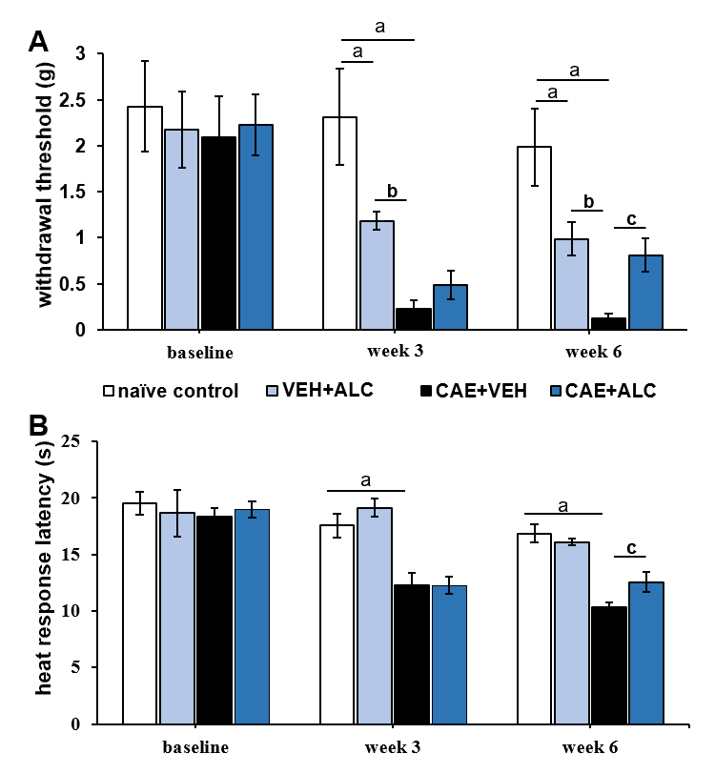
Figure 1 Caerulein-induced pancreatitis produced secondary hypersensitivity of the hindpaws that was attenuated by treatment with acetyl-L-carnitine. A: Mechanical withdrawal thresholds were significantly reduced after 3 wk of caerulein (CAE) injections indicating hypersensitivity and remained reduced after 6 wk of CAE injections; B: Response latencies to heat stimulation in the hotplate test were significantly reduced after 3 and 6 wk of CAE injections. Concurrent treatment with acetyl-L-carnitine (ALC) during the last 3 wk attenuated mechanical and heat hypersensitivity. n = 6/group; ªP < 0.05 compared to naïve control; ^{b}P < 0.05 compared to VEH + ALC; ^{c}P < 0.05 compared to CAE + ALC; two-way ANOVA with Newman-Keuls post hoc test. ALC: Acetyl-L-carnitine; CAE: Caerulein; VEH: Vehicle.
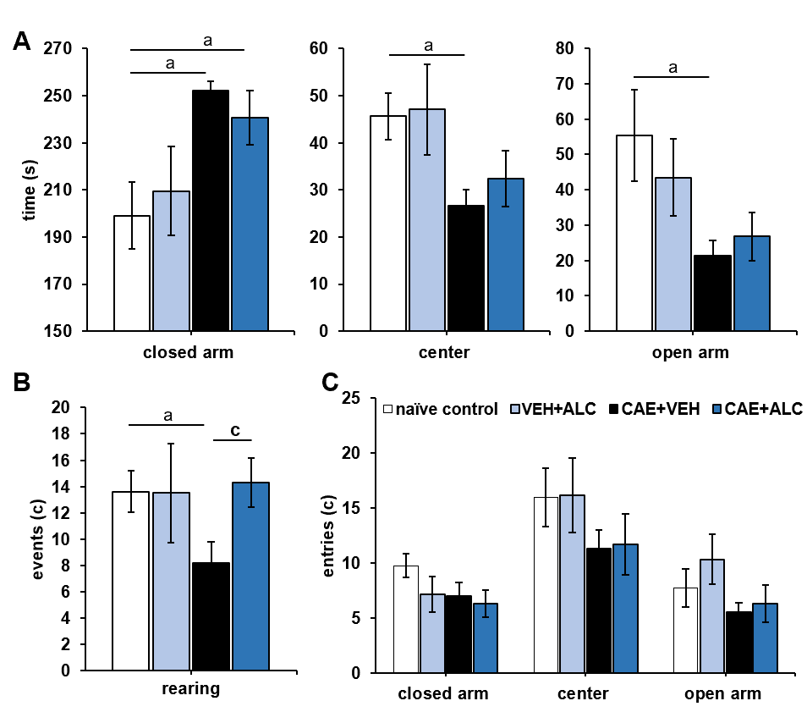
Figure 2 Anxiety-like behavior was measured in week 6 of caerulein-induced pancreatitis but acetyl-L-carnitine treatment only increased the number of rearing events. A: Mice with caerulein- (CAE) induced pancreatitis spent significantly more time in the closed arm, and less in the center and open arm of the plus maze compared to naïve control animals. Treatment with acetyl-L-carnitine (ALC) had no effect; B: Mice with CAE-induced pancreatitis reared significantly less compared to naïve control animals. This was alleviated after 3 wk of treatment with ALC; C: No differences were detected between groups in the number of entries to the different zones of the elevated plus maze. n = 6/group; ªP < 0.05 compared to naïve control; ^{c}P < 0.05 compared to CAE + ALC; two-way ANOVA with Newman-Keuls post hoc test. ALC: Acetyl-L-carnitine; CAE: Caerulein; VEH: Vehicle.
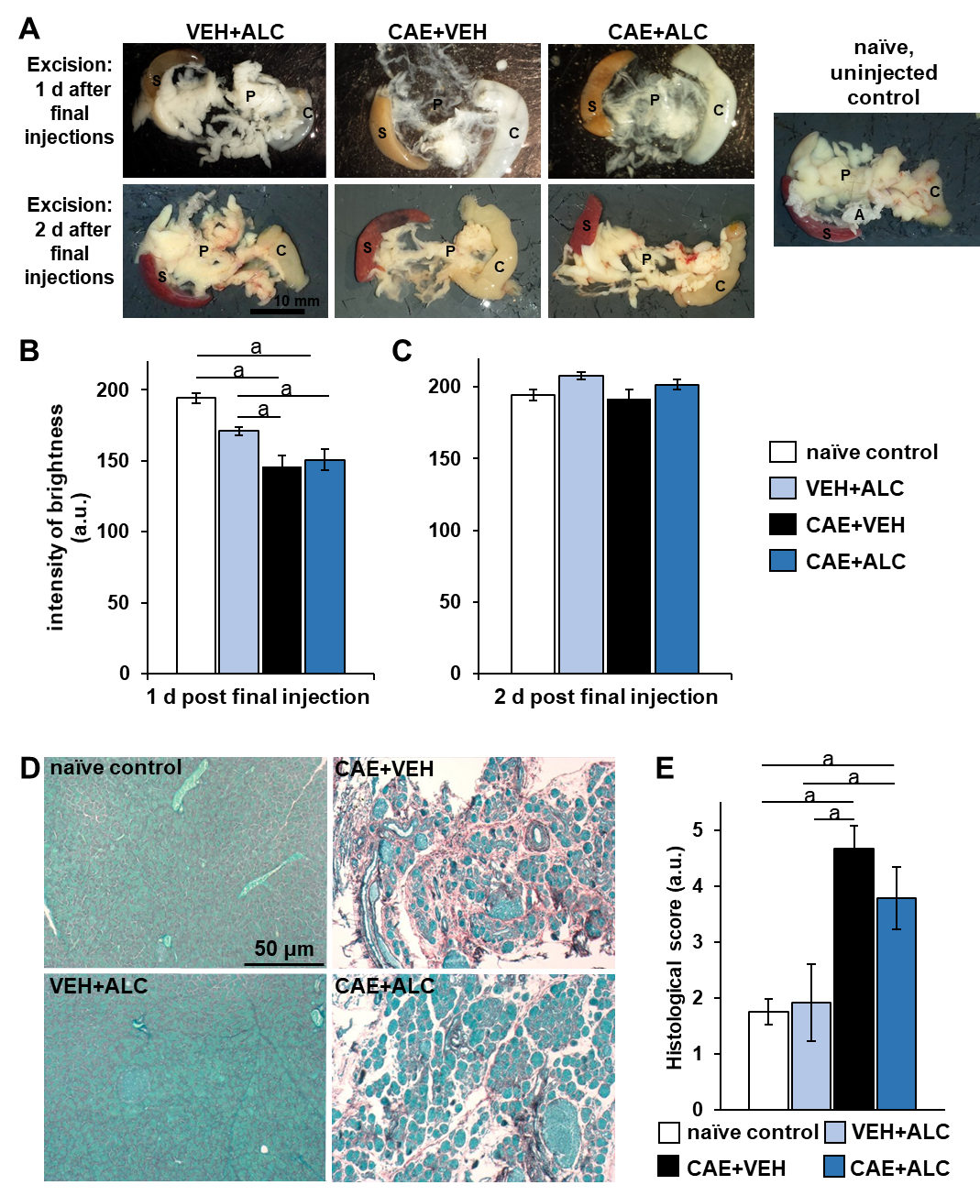
Figure 3 Caerulein-induced pancreatitis caused tissue translucence of the pancreas that was reversed within 2 d in the absence of pharmacological intervention as well fibrosis and acinar cell atrophy. A: Top row shows pancreata excised at experiments end in week 6, one day after the final injections. Bottom row shows pancreata excised at experiments end two days after final injections. On the far right is an opaque pancreas from a naïve control animal that was never injected; B: Tissue from caerulein (CAE) + vehicle (VEH) and CAE + acetyl-L-carnitine (ALC) were significantly darker, revealing the charcoal stained sylgard in the dissection dish below, shining through the translucent pancreas compared to naïve controls when excised 1 d after the last injection days in week 6. Naïve control n = 6; VEH + ALC n = 3 / timepoint; CAE + VEH n = 3/timepoint; CAE + ALC n = 3/timepoint; C: No group differences were noted on day 2 post final injection day in week 6; D: Pancreatic tissue sections stained with Sirius Red and Fast Green identified wide-spread fibrosis (red) and atrophy of the acinar parenchymal tissue only in CAE + VEH and CAE + ALC samples. Scale bar 50 μm; E: Average scores (1 = no damage to 5 = severe damage) of Sirius Red and Fast Green-stained pancreatic tissue sections were significantly higher in CAE + VEH and CAE + ALC samples compared to both control groups. Naïve control n = 4; VEH + ALC n = 4; CAE + VEH n = 3; CAE + ALC n = 3; ªP < 0.05; two-way ANOVA with Newman-Keuls post hoc test. A: Adiposita; C: Colon; P: Pancreas; S: Spleen; ALC: Acetyl-L-carnitine; CAE: Caerulein; VEH: Vehicle.
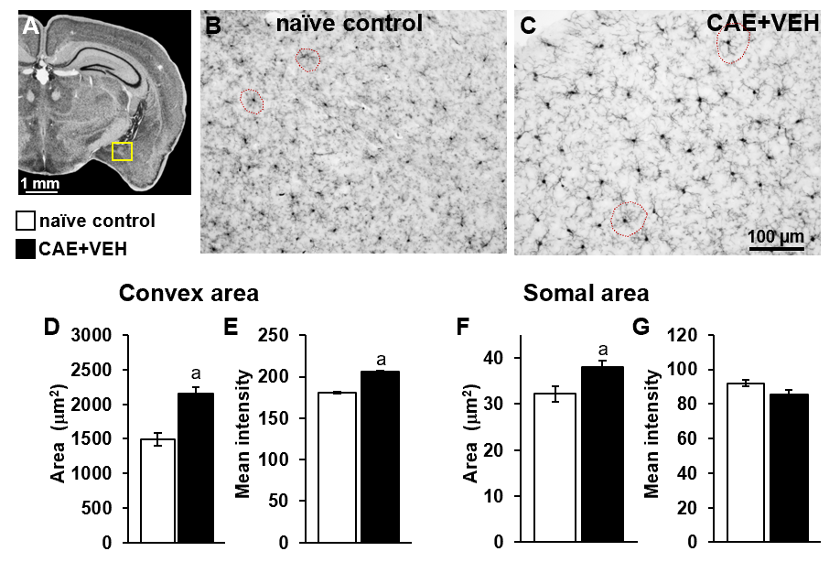
Figure 4 Microglia in the basolateral amygdala were activated only in mice with caerulein-induced pancreatitis. A: Overview of the mouse brain shown at bregma -2.18 mm, interaural 1.62 mm^{[50,51]}. The quantified area, the basolateral amygdala (BLA), is outlined in yellow; B and C: Examples of BLA from naïve control and vehicle treated caerulein- (CAE) induced pancreatitis mice were stained for ionized calcium-binding adaptor molecule 1; D and E: The convex area, the hull region of the microglia (samples outlined in red in B and C), was significantly enlarged and more intensely stained in mice with CAE-induced pancreatitis; F and G: Similarly, the somal area was significantly enlarged in tissue from mice with CAE-induced pancreatitis, though, the intensity of staining was not different. Naïve control n = 4, CAE + VEH n = 5, ªP < 0.05 Student’s t-test. CAE: Caerulein; VEH: Vehicle.
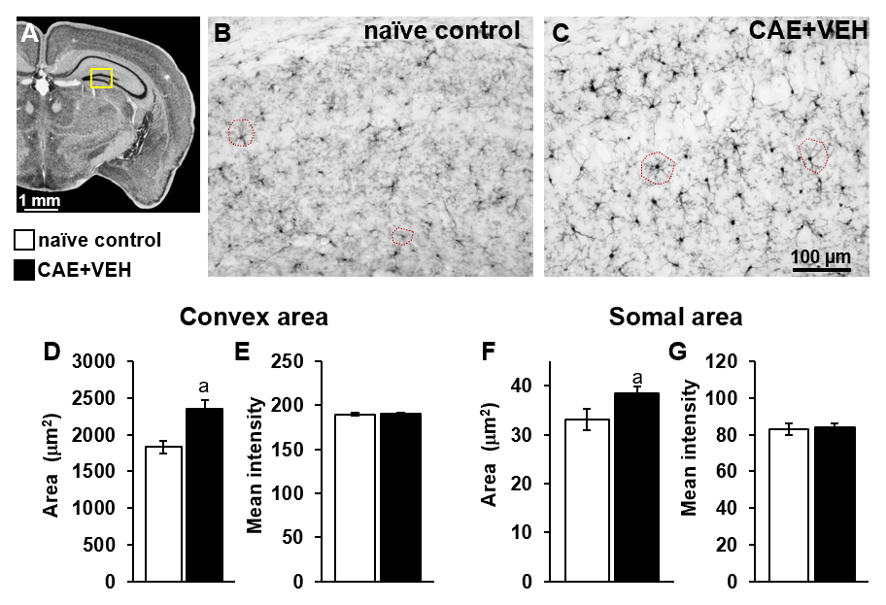
Figure 5 Enlarged microglial cells were measured in the dentate gyrus of mice with caerulein-induced pancreatitis compared to control samples. A: The analyzed area is outlined in yellow in an overview of the mouse brain at bregma -2.18 mm, interaural 1.62 mm^{[50,51]}; B and C: Microglia in the dentate gyrus of naïve control and in the caerulein- (CAE) induced pancreatitis mice were measured; D-G: Microglial convex (examples circled in red in B and C) and (F) somal area were significantly enlarged after 6 wk of CAE-induced pancreatitis while (E and G) intensity of ionized calcium-binding adaptor molecule 1 immunoreactivity was unchanged. Naïve control n = 4, CAE + VEH n = 5, ªP < 0.05 Student’s t-test. CAE: Caerulein; VEH: Vehicle.
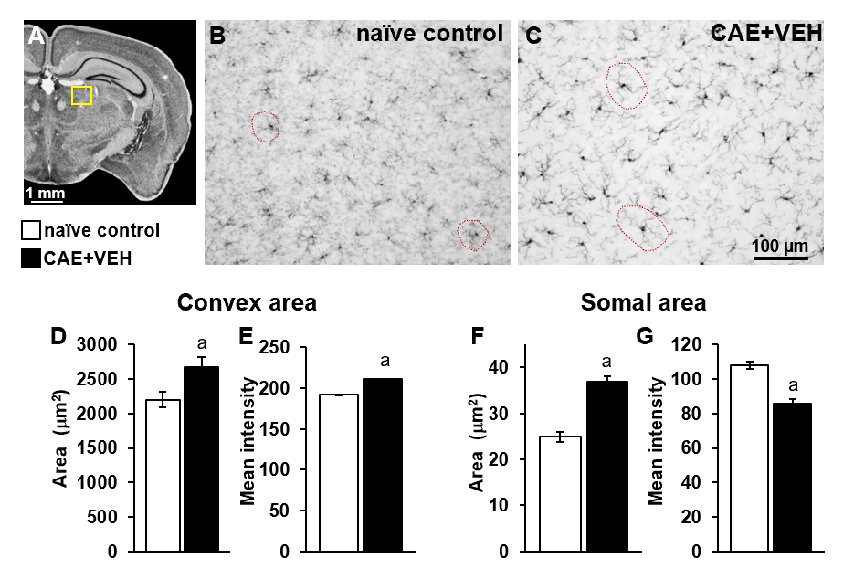
Figure 6 In the central lateral and paraventricular thalamic nuclei, microglial areas in mice with caerulein-induced pancreatitis were enlarged. A: An overview of the mouse brain at bregma -2.18 mm, interaural 1.62 mm^{[50,51]} is shown with the analyzed central lateral and paraventricular thalamic nuclei thalamic area analyzed outlined in yellow. B and C: Examples of microglia of naïve control and caerulein- (CAE) induced pancreatitis mice with sample convex areas circled in red; D and E: Microglial convex area and ionized calcium-binding adaptor molecule 1 (Iba1) staining intensity were significantly enhanced in animals with CAE-induced pancreatitis; F and G: Similarly, somal areas were significantly enlarged, yet, their Iba1 staining intensity was decreased. Naïve control n = 4, CAE + VEH n = 5, ªP < 0.05 Student’s t-test. CAE: Caerulein; VEH: Vehicle.
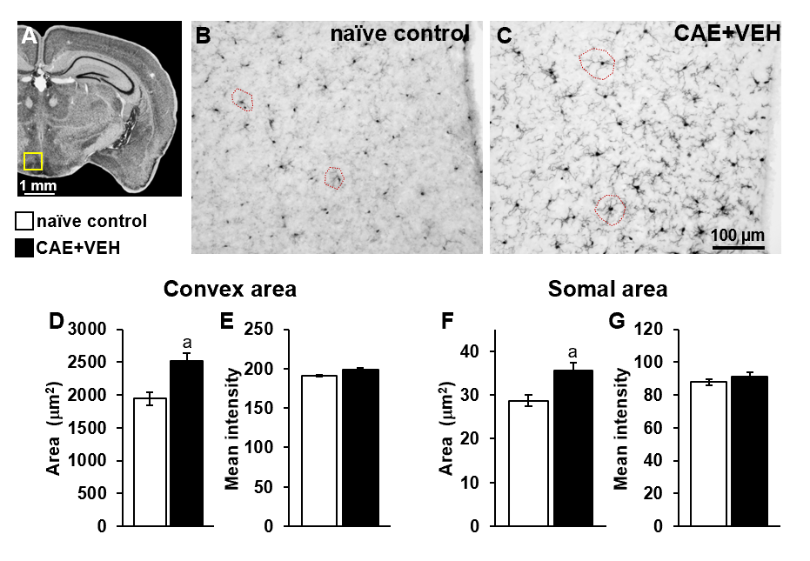
Figure 7 In the hypothalamic arcuate and dorsomedial nuclei, enlarged microglia were measured in mice with caerulein-induced pancreatitis. A: The analyzed area is outlined in yellow in an overview of the mouse brain at bregma -2.18 mm, interaural 1.62 mm^{[50,51]}; B-D and F: Microglia in arcuate and dorsomedial nuclei of naïve control and (C) caerulein- (CAE) induced pancreatitis mice had (D) significantly different convex (samples circled in red in B and C) and (F) somal areas; E and G: Intensity of ionized calcium-binding adaptor molecule 1 immunoreactivity was not different. Naïve control n = 4, CAE + VEH n = 5, ªP < 0.05 Student’s t-test. CAE: Caerulein; VEH: Vehicle.
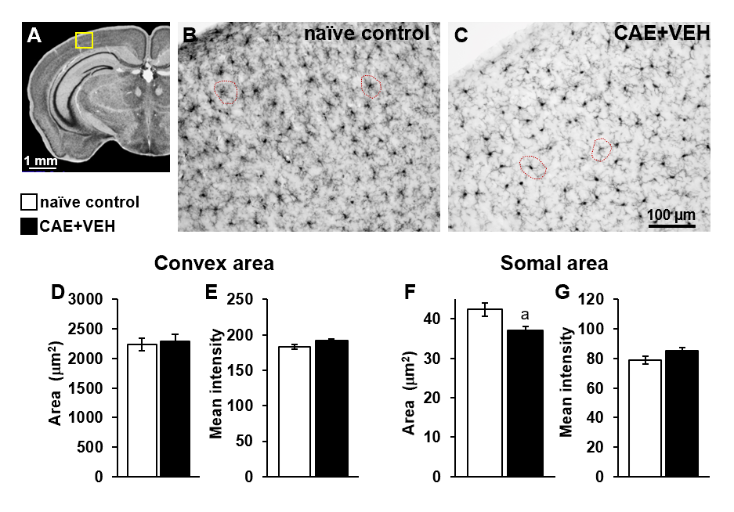
Figure 8 Microglia in the primary somatosensory cortex of mice with caerulein-induced pancreatitis were similar to those from controls. A: The analyzed area is outlined in yellow in an overview of the mouse brain at bregma -2.18 mm, interaural 1.62 mm^{[50,51]}. B-E: Microglia in (B) naïve control and (C) caerulein- (CAE) induced pancreatitis mice had (D) similar convex areas and (E) staining intensity for ionized calcium-binding adaptor molecule 1 (Iba1); F and G: In fact, their somal areas were significantly decreased in animals with CAE-induced pancreatitis compared to naïve mice, and their Iba1 staining intensity was not different. Naïve control n = 4, CAE + VEH n = 5, ªP < 0.05 Student’s t-test. CAE: Caerulein; VEH: Vehicle.

Published by Baishideng Publishing Group Inc
7041 Koll Center Parkway, Suite 160, Pleasanton, CA 94566, USA
Telephone: +1-925-3991568
E-mail: bpgoffice@wjgnet.com
Help Desk: https://www.f6publishing.com/helpdesk
https://www.wjgnet.com

© 2021 Baishideng Publishing Group Inc. All rights reserved.

