Name of Journal: World Journal of Orthopedics
ESPS Manuscript NO: 28835
Manuscript Type: Original Article

Case Control Study
Digital templating in total hip arthroplasty: Additional anteroposterior hip view increases the accuracy

Stigler SK et al. Accuracy of digital templating in cementless THA

Sophia K Stigler, Franz J Müller, Sebastian Pfaud, Michael Zellner, Bernd Füchtmeier

Sophia K Stigler, Franz J Müller, Sebastian Pfaud, Michael Zellner, Bernd Füchtmeier, Clinic for Trauma, Orthopaedic and Sports Medicine, Hospital Barmherzige Brüder, 93049 Regensburg, Germany

Author contributions: Stigler SK collected, analysed the data and wrote the manuscript; Müller FJ contributed in final editing of the manuscript; Stigler SK, Müller FJ, Pfaud S, Zellner M corrected the manuscript; Füchtmeier B designed and supervised the study, acquired the data; all authors approved the definite version of the manuscript.

Institutional review board statement: Institutional review board approval.

Informed consent statement: An informed consent statement was given.

Conflict-of-interest statement: All authors declare that there is no conflict of interest. For this work no benefits in any form were received.

Data sharing statement: No data sharing is required.

Open-Access: This article is an open-access article which was selected by an in-house editor and fully peer-reviewed by external reviewers. It is distributed in accordance with the Creative Commons Attribution Non Commercial (CC BY-NC 4.0) license, which permits others to distribute, remix, adapt, build upon this work non-commercially, and license their derivative works on different terms, provided the original work is properly cited and the use is non-commercial. See: http://creativecommons.org/licenses/by-nc/4.0/

Manuscript source: Unsolicited manuscript

Correspondence to: Dr. med. Franz Müller, habil., Clinic for Trauma, Orthopaedic and Sports Medicine, Hospital Barmherzige Brüder, Prüfeninger Str. 86, 93049 Regensburg, Germany. franz.mueller@barmherzige-regensburg.de
Telephone: +49-941-3692251
Fax: +49-941-3692255

Received: July 17, 2016
Peer-review started: July 18, 2016
First decision: September 2, 2016
Revised: September 21, 2016
Accepted: December 1, 2016
Article in press:
Published online:

Abstract
AIM
To analyze planning total hip arthroplasty (THA) with an additional anteroposterior hip view may increases the accuracy of preoperative planning in THA.

METHODS
We conducted prospective digital planning in 100 consecutive patients: 50 of these procedures were planned using pelvic overview only (first group), and the other 50 procedures were planned using pelvic overview plus antero-posterior (a.p.) hip view (second group). The planning and the procedure of each patient were performed exclusively by the senior surgeon. Fifty procedures with retrospective analogues planning were used as the control group (group zero). After the procedure, the planning was compared with the eventually implanted components (cup and stem). For statistic analysis the ² test was used for nominal variables and the t-test was used for a comparison of continuous variables.

RESULTS
Preoperative planning with an additional a.p. hip view (second group) significantly increased the exact component correlation when compared to pelvic overview only (first group) for both the acetabular cup and the femoral stem (76% cup and 66% stem vs 54% cup and 32% stem). When considering planning ± 1 size, the accuracy in the second group was 96% (48 of 50 patients) for the cup and 94% for the stem (47 of 50 patients). In the analogue control group (group zero), an exact correlation was observed in only 1/3 of the cases.

CONCLUSION
Digital THA planning performed by the operating surgeon and based on additional a.p. hip view significantly increases the correlation between preoperative planning and eventual implant sizes.

Key words: Digital; Templating; Preoperative planning; Hip view; Total hip arthroplasty

© The Author(s) 2016. Published by Baishideng Publishing Group Inc. All rights reserved.

Core tip: Preoperative planning is an essential practice carried out prior to total hip arthroplasty (THA). However, the accuracy of digital preoperative planning in THA is variable and often lacks sufficient precision. Our prospective study analysed that preoperative planning with an additional a.p. hip view significantly increased the exact component correlation when compared to pelvic overview only for both the acetabular cup and the femoral.

Stigler SK, Müller FJ, Pfaud S, Zellner M, Füchtmeier B. Digital templating in total hip arthroplasty: Additional anteroposterior hip view increases the accuracy. World J Orthop 2016; In press

INTRODUCTION
Preoperative planning for elective total hip arthroplasty (THA) is of paramount importance, irrespective of the level of difficulty. Not only does it prevent complications, but it also helps to optimise important geometric parameters such as leg length, centre of rotation, and femoro-acetabular offset adjustment by determining such components^{[1-4]}.
Previously, conventional X-ray images and measuring templates were used for this purpose. However, according to the literature, these practices resulted in low levels of correlation with the sizes of the eventually implanted devices in most cases^{[2]}. With the increasing use of digital radiography, more and more digital planning software programmes are being offered, which, in theory, should deliver higher precision. However, it has been reported that there were only a few cases for which digital planning has resulted in more than low correlation between planning and implanted sizes^{[4-6]}.
Therefore, we conducted a comparative case-control study based on the null hypothesis that planning precision regarding the eventually implanted components can be increased with an additional antero-posterior (a.p) hip view. This was based on the fact that the a.p. hip view with a central X-ray beam (directed to the proximal femur) reduces parallax shifts and rotational deviations^{[7]}.

MATERIALS AND METHODS
Since 2014, we have exclusively performed preoperative THA planning in our hospital using digital software (MediCAD, HECTEC GmbH, Landshut, Germany). The digital planning has been performed using a 17-inch LCD screen with a resolution of at least 1.024 × 768 pixels.
We used three groups for this comparative study: The first group included digital planning in 50 consecutive patients (who underwent surgery in 2015) using digital pelvic overview only (Figure 1). The second group also included digital planning in 50 consecutive patients (within the same year), but with an additional a.p. hip view for planning (Figure 2). All X-ray examinations (pelvic overview) were performed using a standardised technique with the patients in the supine position with a film-focus distance of 115 cm, a 10- to 15-degree internal rotation of the hip joint, and the central X-ray beam directed to the pubic symphysis.
A 25-mm external calibration marker (scaling sphere) was used for planning in both groups, and it was placed laterally from the hip joint requiring surgery or centred between the legs at the joint level at the height of the trochanter major. Moreover, surgeries in both groups were exclusively performed by the senior consultant surgeon who operated on the patients on the following day. Access to the hip was achieved exclusively in the lateral position using the minimally invasive technique according to Bertin and Röttinger^{[8]}. The planning steps were performed according to the procedure described by Bono^{[3]}, Dastane et al^{[9]}, and Unnanuntana et al^{[10]} (Figures 1 and 2).
Fifty consecutive patients with analogue planning (who underwent surgery the year before the digital software had become available) served as the control group (group zero). Here, the individual planning steps had been performed according to Eggli et al^{[11]}.
The indications for the 150 patients who received a cementless THA for both acetabular cup and femoral stem were primary osteoarthritis (n = 133), avascular femoral head necrosis (n = 11), and dysplasia (n = 6). The exclusion criteria were as follows: history of cemented or hybrid arthroplasty, additional osteotomies, and revision surgery for any reason.
Preoperative planning, surgical reports, and postoperative X-ray (within 6 wk) for the first and second group were performed prospectively, and group zero was evaluated retrospectively. The cup component was a Fitmore or an Allofit press-fit cup (Zimmer, Freiburg, Germany), and the stem was a CLS Spotorno (Zimmer), exclusively in all three of the groups. The study was approved by the local ethics committee.

Statistical analysis
SPSS version 23 (SPSS, Chicago, IL, United States) was used for statistical analysis. Descriptive analysis was performed by determination of values, averages, and standard deviations. Differences were compared using the ² test for nominal variables. The t-test was used for a comparison of continuous variables. A P value of < 0.05 was set as the significance threshold.

RESULTS
Among the 150 patients who underwent cementless THA, 63 were female, 87 were male, and the mean age was 63 years (30 to 83). No patient received bilateral THA. The descriptive data (sex, age, BMI, indications, and duration of surgery) within the three groups were not significantly different (P > 0.05).
For all 150 patients, no major postoperative complications - e.g., periprosthetic fracture, fracture of the trochanter tip, or hip dislocation - were documented.

Acetabular cup size
The exact acetabular cup sizes within the three groups are shown in Table 1. The size increments within the two cups are 2 mm. Within the second group, including additional a.p. hip view, a total of 48 out of 50 (96%) were predicted within ± one size without a significant difference between both of the utilised components (Allofit or Fitmore). The results for exact size accuracy between the three groups were significantly different (P = 0.02).

Femoral stem size
The exact femoral stem sizes within the three groups are shown in Table 2. The increments of the femoral stems are between 1 and 1.25 mm. Within the second group that included an additional a.p. hip view, a total of 47 out of 50 (94%) were predicted within a one size deviation. The results for exact size accuracy between the first and the second group were significantly different (P < 0.001).

Centre of rotation
A distance of ≤ 5 mm between the vertical and horizontal centre of rotation after implantation when compared to the scheduled position was found in a total of 48% (n = 24) of patients in group zero and in a total of 72% (n = 36) of patients in the digital group. The planning accuracy difference between both groups was significantly different (P = 0.014).

Femoral and hip offset
A femoral offset of ≤ 5 mm when compared to the scheduled position was found in a total of 68% (n = 34) in the analogue planning group and in a total of 70% (n = 35) in the digital group. The hip offset was scheduled ≤ 5 mm in 50% of patients (n = 25) of both groups (both with analogue and digital planning).

Actetabular cup inclination
The mean inclination angle of the acetabular cup was 44.5° (SD ± 4.2°) in group zero and 45° (SD ± 5.8°) in the digital planning group, and there was no significant difference between the two groups.
A total of 88% of the prostheses (n = 44) in the analogue planning group and 92% (n = 46) in the digital planning group were implanted at angles between 30° und 50°.

Leg length difference
The mean postoperative leg length difference (LLD) was 4.6 mm in the analogue planning group (SD ± 5.0 mm) and 2.7 mm in the digital planning group (SD ± 3.4 mm). A total of 80% of patients in group zero and 90% in the digital planning group had postoperative leg length differences of < 10 mm.

DISCUSSION
This study covers multiple aspects of preoperative planning: Although several studies of analogue planning have been previously reported ^{[11,12]}, our study offers an additional direct comparison with digital planning. Few studies have compared analogue and digital planning procedures. Surprisingly, their results varied: González Della Valle et al^{[13]} demonstrated that analogue planning resulted in a higher planning accuracy for both cup and femoral stem. However, The et al^{[1]} concluded that digital planning was superior to analogue planning in regard to both components. In contrast, Gamble et al^{[6]} found a significantly higher accuracy only for the acetabular cup when digital planning was used, whereas identical results were achieved with femoral stems. The results of the latter study are similar to ours: We also found an equally low exact precision (32%) for the femoral stem with both analogue and digital planning (when only a pelvic overview was used). However, in total, our data clearly showed that analogue planning offered the lowest levels of results for both exact precision and deviation by one size.
However, digital planning of the acetabular cup resulted in a clearly higher exact size determination (54%) in our study when compared to the results of other recent studies that reported an accuracy of only 34% to 42%^{[4,6,10]}. Nevertheless, this result is still not satisfactory for several reasons: first, whether the scaling sphere was actually placed in the correct plane cannot be retrospectively evaluated^{[14]}. Accordingly, inaccurate positioning and an inappropriately rotated femur have detrimental effects on X-ray imaging quality and, thus, on planning precision. The femoral stem component is more prone to such effects than the cup^{[15]}. This may explain the lower planning accuracy with regard to the stem component. In our study, it was more common that a smaller-than-needed size of the femoral stem component was selected (though the difference was only one size) when compared to a larger-than-needed size (40% vs 20%). Kniesel et al^{[16]} reported similar results. In their evaluation of different calibration methods, Franken et al^{[17]} also found that there was a tendency to underestimate the real dimensions when the reference sphere was placed in the centre between the patient’s legs. Furthermore bone density is a crucial criterion when selecting the stem component: It is common that larger components are selected for patients with lower bone density^{[4]}.
Second, we were able to demonstrate for the first time that the exact correlation between planning and eventually implanted components (cup and stem) can be significantly increased to more than 2/3 of the cases with an additional a.p. hip view. When a size deviation of ± one size is also taken into account, an accuracy level of above 90% can be achieved for both the cup and the stem. Hip view with central X-ray beam targeting the proximal femur results in the minimisation of parallax shifts with reduction of rotational deviations^{[7]}, which may explain the higher planning precision. However, there are no data currently available with regard to an additional centred hip view for component planning.
In additional to component selection, it is clear that leg length difference is another very important preoperative planning parameter, even though a maximum clinical difference of 10 mm is generally considered to be acceptable^{[18]}. The validation of different measurement methods for leg length differences has been the subject of multiple studies, with various results. Meermans et al^{[19]} found that the horizontal line through the teardrops offers a more accurate reference marker when compared to the line between the two ischial tuberosities. However, Tripuraneni et al^{[20]} concluded that the teardrop line is most commonly prone to measurement errors and that the obturator line would be the most accurate reference. In our study, the biischial line was used as an anatomical landmark for LLD assessment. We found a significant difference in planning accuracy in favour of the digital method: 90% of the patients showed a postoperative leg length difference of less than 10 mm, which is in line with the results reported in the studies of Unnanuntana et al^{[10]} or González Della Valle et al^{[21]}. However, it must be emphasised that complete compensation of leg length differences is not always practical and necessary, particularly in elderly patients with scoliotic deformities.
With regard to offset, analogue and digital procedures were found to be equivalent in terms of planning and correlation with implant positions. The digital method was significantly superior to the analogue method in terms of planning vertical and horizontal positions of the rotation centre. Good results were achieved for both cup planning and implantation when the inclination angle was within the “safe zone” (30°-50°) according to Lewinnek et al^{[22]}. This was observed in both groups. Implantation outside of this range is known to promote abrasion and prosthesis loosening in the mid and long term^{[23]}.
Finally, it is necessary to address the weaknesses of the present study: Digital planning was performed by the senior surgeon who then also operated the patients. Hence, it is possible that the use of the initially scheduled component size was “enforced” during surgery. However, severe post-surgery complications, e.g., hip dislocation, periprosthetic fractures or stem loosening were reported in none of the 100 patients with digital planning and implantation. Conversely, a common sentiment in the literature is that planning should be performed by the operating surgeon^{[1,18]}, and this procedure has been propagated by the authors in those studies.
Moreover, an advancement of the digital two-dimensional planning is already underway using a three-dimensional CT. However, this method can expose patients to high levels of radiation and is probably not necessary for most THA patients with osteoarthritis^{[24]}. In contrast, the addition of the a.p hip view confers a negligible radiation exposure of only 0.05 mSv. Because our study exclusively investigated cementless total hip arthroplasties, the results cannot be completely transferred to cemented THA or to other components. To date, it also remains unclear if the commonly occurring minor differences between planning and surgery cause long-term clinical consequences. Studies on this aspect are not available yet and are needed.
In conclusion, the digital planning of cementless THA performed by the surgeon based on additional antero-posterior hip view significantly increases the correlation between preoperative planning and eventual implant sizes. Therefore, we recommend that it should be implemented as a standard in preoperative planning.

COMMENTS
Background
Digital preoperative planning is an essential practice in total hip arthroplasty (THA). However, the accuracy is variable and often insufficient.

Research frontiers
The current research hotspot is the analysis and the improvement of preoperative planning in THA.

Innovations and breakthroughs
This case-control study could represent that digital THA planning performed by the operating surgeon and based on additional antero-posterior hip view increases the accuracy of preoperative planning in THA.

Applications
An additional antero-posterior hip view should be implemented as a standard in preoperative planning.

Peer-review
The authors present a nice prospective study about accuracy in digital planning of cementless total hip replacement.

REFERENCES
1 The B, Verdonschot N, van Horn JR, van Ooijen PM, Diercks RL. Digital versus analogue preoperative planning of total hip arthroplasties: a randomized clinical trial of 210 total hip arthroplasties. J Arthroplasty 2007; 22: 866-870 [PMID: 17826278 DOI: 10.1016/j.arth.2006.07.013]
2 Knight JL, Atwater RD. Preoperative planning for total hip arthroplasty. Quantitating its utility and precision. J Arthroplasty 1992; 7 Suppl: 403-409 [PMID: 1431923 DOI: 10.1016/s0883-5403(07)80031-3]
3 Bono JV. Digital templating in total hip arthroplasty. J Bone Joint Surg Am 2004; 86-A Suppl 2: 118-122 [PMID: 15691116]
4 Efe T, El Zayat BF, Heyse TJ, Timmesfeld N, Fuchs-Winkelmann S, Schmitt J. Precision of preoperative digital templating in total hip arthroplasty. Acta Orthop Belg 2011; 77: 616-621 [PMID: 22187836]
5 The B, Diercks RL, van Ooijen PM, van Horn JR. Comparison of analog and digital preoperative planning in total hip and knee arthroplasties. A prospective study of 173 hips and 65 total knees. Acta Orthop 2005; 76: 78-84 [PMID: 15788312 DOI: 10.1080/00016470510030364]
6 Gamble P, de Beer J, Petruccelli D, Winemaker M. The accuracy of digital templating in uncemented total hip arthroplasty. J Arthroplasty 2010; 25: 529-532 [PMID: 19493647 DOI: 10.1016/j.arth.2009.04.011]
7 Bunke J, Delorme S, Kamm KF, Kooijman H, Lorenz A. Physical-technical principles of image creation. In: Schmidt T, Aichinger H, editors. Manual of diagnostic radiology. Radiation physics, radiation biology, radiation protection. Heidelberg: Springer, 2003: 1-159 [DOI: 10.1007/978-3-642-55825-2_1]
8 Bertin KC, Röttinger H. Anterolateral mini-incision hip replacement surgery: a modified Watson-Jones approach. Clin Orthop Relat Res 2004; (429): 248-255 [PMID: 15577495 DOI: 10.1097/01.blo.0000150294.81825.8c]
9 Dastane M, Dorr LD, Tarwala R, Wan Z. Hip offset in total hip arthroplasty: quantitative measurement with navigation. Clin Orthop Relat Res 2011; 469: 429-436 [PMID: 20844997 DOI: 10.1007/s11999-010-1554-7]
10 Unnanuntana A, Wagner D, Goodman SB. The accuracy of preoperative templating in cementless total hip arthroplasty. J Arthroplasty 2009; 24: 180-186 [PMID: 18534455 DOI: 10.1016/j.arth.2007.10.032]
11 Eggli S, Pisan M, Müller ME. The value of preoperative planning for total hip arthroplasty. J Bone Joint Surg Br 1998; 80: 382-390 [PMID: 9619923 DOI: 10.1302/0301-620x.80b3.7764]
12 Miashiro EH, Fujiki EN, Yamaguchi EN, Chikude T, Rodrigues LH, Fontes GM, Rosa FB. Preoperative planning of primary total hip arthroplasty using conventional radiographs. Rev Bras Ortop 2014; 49: 140-148 [PMID: 26229790 DOI: 10.1016/j.rboe.2014.03.019]
13 González Della Valle A, Comba F, Taveras N, Salvati EA. The utility and precision of analogue and digital preoperative planning for total hip arthroplasty. Int Orthop 2008; 32: 289-294 [PMID: 17404731 DOI: 10.1007/s00264-006-0317-2]
14 Kirschner S, Hamann C, Handreka S, Günther KP, Hartmann A. [Templating and radiological outcome monitoring for elective total hip arthroplasty. Applied quality management principles for safe patient care]. Unfallchirurg 2011; 114: 776-785 [PMID: 21870133 DOI: 10.1007/s00113-011-2029-3]
15 White SP, Bainbridge J, Smith EJ. Assessment of magnification of digital pelvic radiographs in total hip arthroplasty using templating software. Ann R Coll Surg Engl 2008; 90: 592-596 [PMID: 18831869 DOI: 10.1308/003588408X318101]
16 Kniesel B, Konstantinidis L, Hirschmüller A, Südkamp N, Helwig P. Digital templating in total knee and hip replacement: an analysis of planning accuracy. Int Orthop 2014; 38: 733-739 [PMID: 24162155 DOI: 10.1007/s00264-013-2157-1]
17 Franken M, Grimm B, Heyligers I. A comparison of four systems for calibration when templating for total hip replacement with digital radiography. J Bone Joint Surg Br 2010; 92: 136-141 [PMID: 20044692 DOI: 10.1302/0301-620x.92b1.22257]
18 Bertz A, Indrekvam K, Ahmed M, Englund E, Sayed-Noor AS. Validity and reliability of preoperative templating in total hip arthroplasty using a digital templating system. Skeletal Radiol 2012; 41: 1245-1249 [PMID: 22588597 DOI: 10.1007/s00256-012-1431-4]
19 Meermans G, Malik A, Witt J, Haddad F. Preoperative radiographic assessment of limb-length discrepancy in total hip arthroplasty. Clin Orthop Relat Res 2011; 469: 1677-1682 [PMID: 20878559]
20 Tripuraneni KR, Archibeck MJ, Junick DW, Carothers JT, White RE. Common errors in the execution of preoperative templating for primary total hip arthroplasty. J Arthroplasty 2010; 25: 1235-1239 [PMID: 20022456 DOI: 10.1016/j.arth.2009.10.004]
21 González Della Valle A, Slullitel G, Piccaluga F, Salvati EA. The precision and usefulness of preoperative planning for cemented and hybrid primary total hip arthroplasty. J Arthroplasty 2005; 20: 51-58 [PMID: 15660060 DOI: 10.1016/j.arth.2004.04.016]
22 Lewinnek GE, Lewis JL, Tarr R, Compere CL, Zimmerman JR. Dislocations after total hip-replacement arthroplasties. J Bone Joint Surg Am 1978; 60: 217-220 [PMID: 641088]
23 Kennedy JG, Rogers WB, Soffe KE, Sullivan RJ, Griffen DG, Sheehan LJ. Effect of acetabular component orientation on recurrent dislocation, pelvic osteolysis, polyethylene wear, and component migration. J Arthroplasty 1998; 13: 530-534 [PMID: 9726318 DOI: 10.1016/s0883-5403(98)90052-3]
24 Steinberg EL, Shasha N, Menahem A, Dekel S. Preoperative planning of total hip replacement using the TraumaCad™ system. Arch Orthop Trauma Surg 2010; 130: 1429-1432 [PMID: 20069428 DOI: 10.1007/s00402-010-1046-y]

P- Reviewer: Anand A, Zak L S- Editor: Gong XM
L- Editor: E- Editor:

Table 1 Accuracy of acetabular cup
Preoperative planning  vs implant used | Group zero  n = 50 | First group  n = 50 | Second group  n = 50
- 2 sizes smaller | - | - | -
- 1 size smaller | 6 (12%) | 8 (16%) | 5 (10%)
Exact size | 17 (34%) | 27 (54%) | 38 (76%)
+ 1 size larger | 15 (30%) | 12 (24%) | 5 (10%)
+ 2 sizes larger | 9 (18%) | 2 (4%) | 2 (4%)
+ 3 sizes larger | 2 (4%) | 1 (2%) | -
+ 4 sizes larger | 1 (2%) | - | -

Table 2 Accuracy of femoral stem
Preoperative planning  vs implant used | Group zero  n = 50 | First group  n = 50 | Second group  n = 50
- 2 sizes smaller | 1 (2%) | 3 (6%) | 3 (6%)
- 1 size smaller | 11 (22%) | 20 (40%) | 9 (18%)
Exact size | 16 (32%) | 16 (32%) | 33 (66%)
+ 1 size larger | 17 (34%) | 10 (20%) | 5 (10%)
+ 2 sizes larger | 5 (10%) | 1 (2%) | -

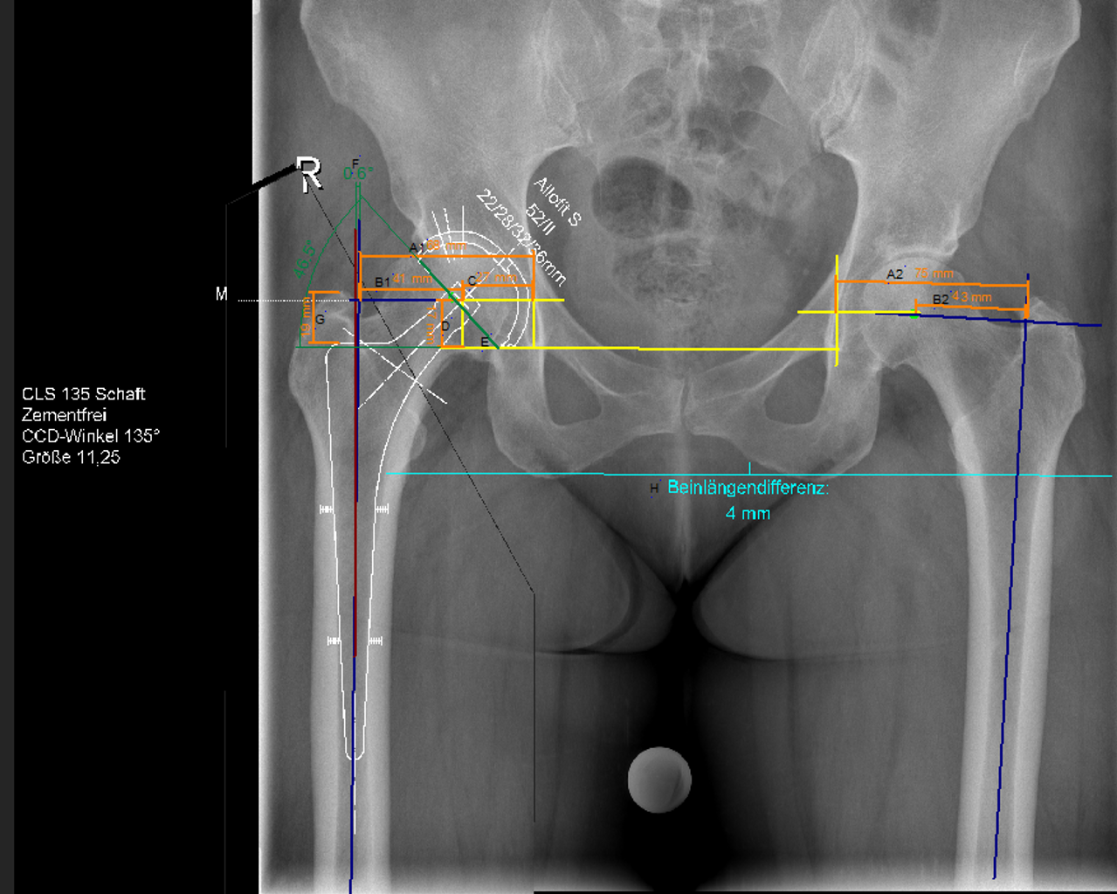
Figure 1 Digital planning of cup and stem for total hip arthroplasty of the right side (group 1). A1: Hip offset: Perpendicular line from the teardrops through the centre of rotation to the femoral shaft axis, i.e., line B1 + C; A2: Contralateral hip offset; B1: Femoral offset: Perpendicular line from the centre of rotation to the axis of the femur; B2: Contralateral femoral offset; C: Horizontal position of the centre of rotation: Distance determined by the centre of rotation and one line perpendicular to the teardrops drawn through the centre of the teardrop; D: Vertical position of the centre of rotation: Line determined by the inter-teardrop line and the centre of rotation; E: Inclination angle: Angle determined by the inter-teardrop line and one axis extending through the cup opening; F: Stem orientation: Angle between femoral shaft axis and implant shaft axis; G: Implantation depth: Line between the upper edge of the prosthesis and the tip of the greater trochanter; H: Leg length difference: Quantified by subtracting the perpendicular distance from the biischial line to the proximal corner of the minor trochanters of both sides. (Measurements according to Bono, Dastane, Unnanuntana, Eggli^{[3,9-11]}).

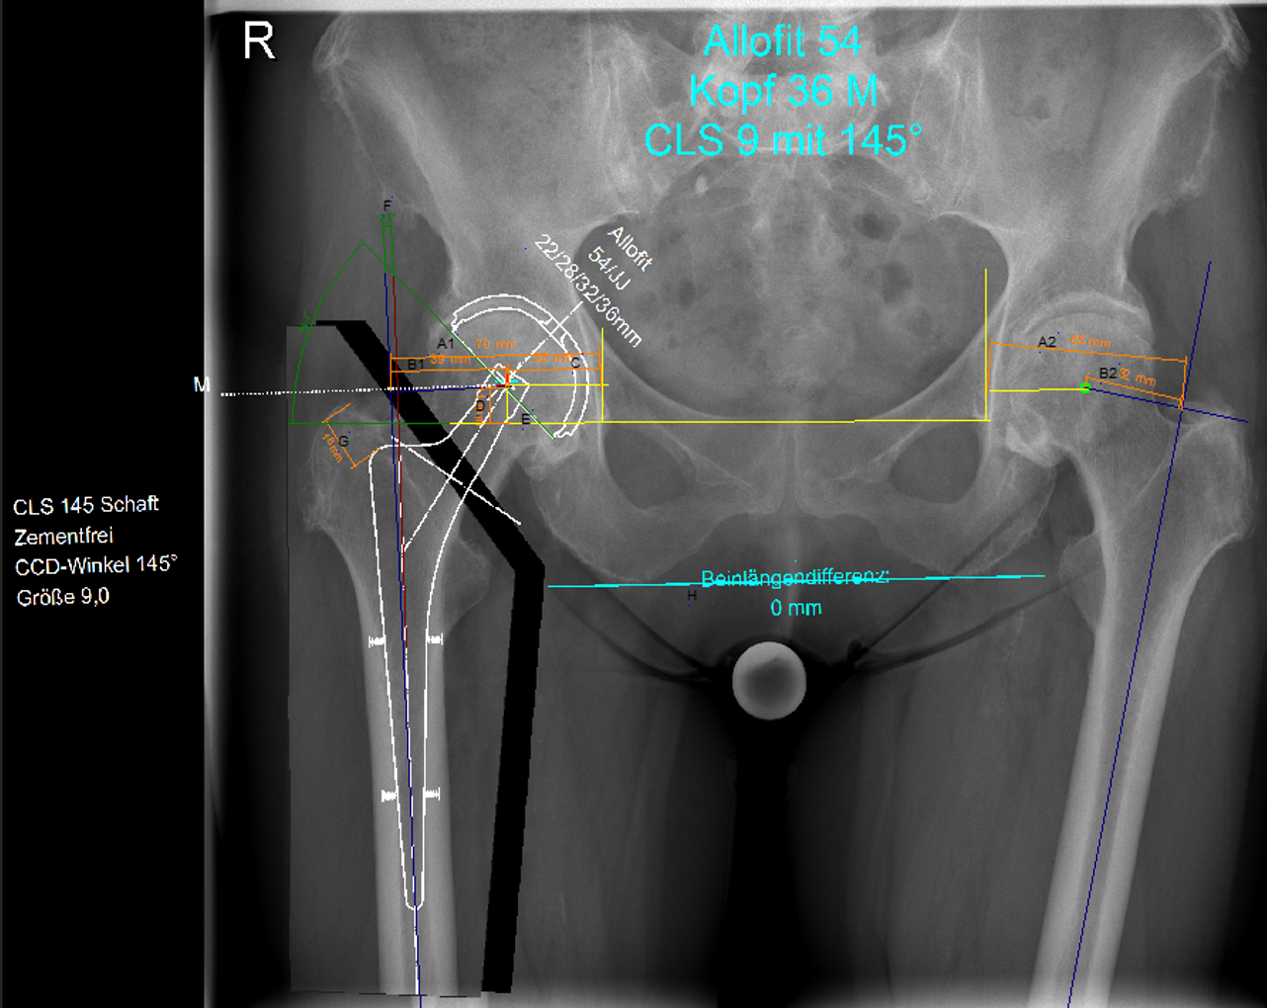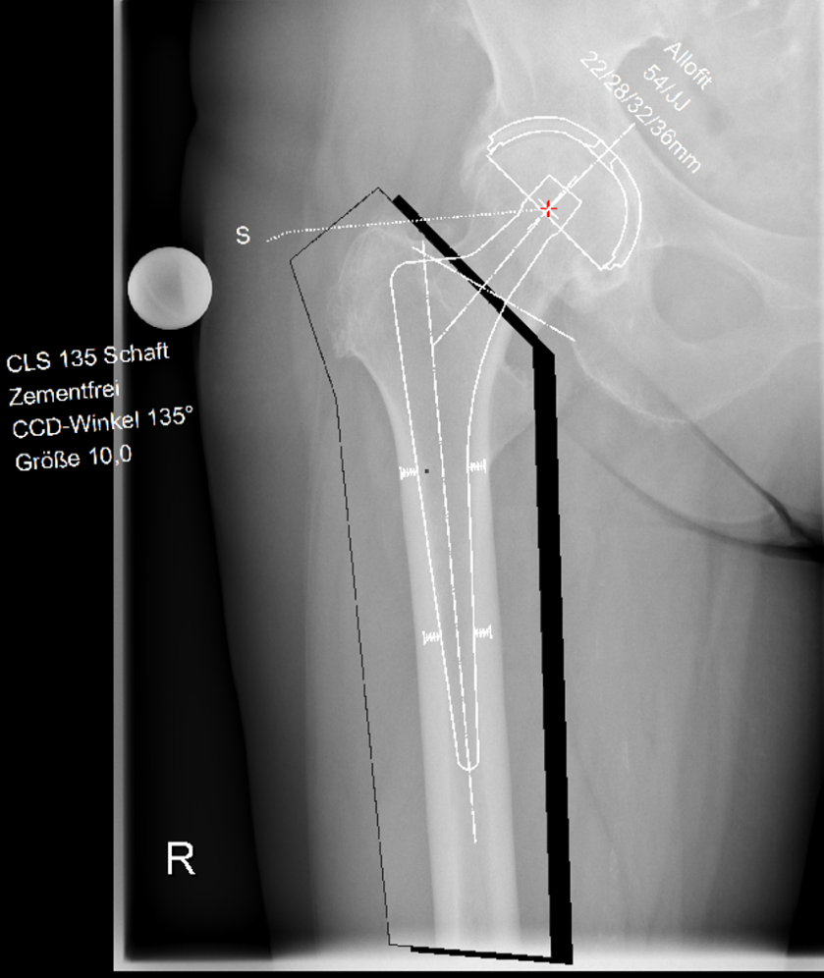
A B
Figure 2 Pelvic overview plus antero-posterior hip view (group 2). A: Digital planning of cup and stem for total hip arthroplasty of the right side; B: Additional antero-posterior hip view for planning. With this true antero-posterior view of the hip, planning is more accurate.

