Name of Journal: World Journal of Clinical Cases
Manuscript NO: 61358
Manuscript Type: CASE REPORT

Radiological insights of ectopic thyroid in the porta hepatis: A case report and review of the literature

Chooah O et al. Ectopic thyroid in the porta hepatis

Outesh Chooah, Jing Ding, Jing-Le Fei, Fang-Yi Xu, Ting Yue, Cai-Ling Pu, Hong-Jie Hu

Outesh Chooah, Jing Ding, Jing-Le Fei, Fang-Yi Xu, Ting Yue, Cai-Ling Pu, Hong-Jie Hu, Department of Radiology, Sir Run Run Shaw Hospital, School of Medicine, Zhejiang University, Hangzhou 310016, Zhejiang Province, China

Author contributions: Hu HJ and Ding J made and interpreted the imaging findings; Xu FY, Fei JL, and Pu CL performed the research; Chooah O and Yue T analyzed the data; Chooah O wrote and proofread the manuscript; Hu HJ revised and reviewed the manuscript.

Supported by the Key Research and Development Program of Zhejiang Province, No. 2019C03064; and Program Co-sponsored by Province and Ministry, No. WKJ-ZJ-1926.

Corresponding author: Hong-Jie Hu, MD, Chief Doctor, Director, Department of Radiology, Sir Run Run Shaw Hospital, School of Medicine, Zhejiang University, No. 3 Qingchun East Road, Hangzhou 310016, Zhejiang Province, China. hongjiehu@zju.edu.cn

Received: December 4, 2020
Revised: January 5, 2021
Accepted: February 22, 2021
Published online:

Abstract
BACKGROUND
Ectopic thyroid is defined as a rare developmental anomaly where thyroid tissues are atypically found in locations other than its normal anatomical position: Anterolateral to the second, third, and fourth tracheal cartilages. An intemperate descent or a migration failure of the thyroid anlage results in sub-diaphragmatic thyroid ectopia, a sparse clinical entity.

CASE SUMMARY
This case portrays a 63-year-old female patient presenting with chronic abdominal discomfort at a local hospital whereby a computed tomography (CT) scan revealed a well-defined mass in the hepatic entrance. For further examination, the patient underwent a CT scan with contrast, magnetic resonance imaging (MRI), and CT-angiography (CTA) at our department. The CT scan showed a well-defined and high attenuated mass measuring 43 mm × 38 mm in the hepatic entrance with calcification. The CTA revealed an additional finding: Blood supply to the mass from the right hepatic artery. MRI of the upper abdomen demonstrated a mass with mixed signal intensity on T1 and T2 weighted images in the hepatic entrance. The patient underwent surgery with resection of the mass which was sent for histopathology. Ectopic thyroid at the level of porta hepatis with nodules was the definitive diagnosis since histopathological report revealed presence of thyroid tissue in the resected liver mass.

CONCLUSION
This case delivers a rare insight of pre-operative radiological imaging of an ectopic thyroid located in the liver. These findings can aid in narrowing down potential differential diagnosis when managing a patient with those subsequent findings.

Key Words: Ectopic thyroid; Porta hepatis; Computed tomography; Computed tomography angiography; Magnetic resonance imaging; Case report

Chooah O, Ding J, Fei JL, Xu FY, Yue T, Pu CL, Hu HJ. Radiological insights of ectopic thyroid in the porta hepatis: A case report and review of the literature. World J Clin Cases 2021; In press

Core Tip: Thyroid ectopia specifically at the porta hepatis level is quite a rare clinical entity without any conclusive protocol for radiological diagnosis. This paper reviews the limited corresponding literature as well as the presentation of a clinical case in order to help physicians alongside radiologists to minimize misinterpretations and misdiagnosis of ectopic thyroid. This paper will hopefully contribute to the spectrum of information by portraying computed tomography, magnetic resonance imaging, computed tomography angiography, and histopathology amongst a plethora of other data that will contribute in the optimization of the prevalence in conjunction with the management of thyroid ectopia.

INTRODUCTION
Ectopic thyroid is a rare developmental anomaly defined as the atypical presence of thyroid tissues in locations other than its normal anatomical position of being anterolateral to the second, third, and fourth tracheal cartilages^{[1]}. Statistically, it is prevalent in 1 per 100000-300000 persons and it has been reported that 1 in 4000-8000 patients suffering from thyroid disease have this condition^{[2]}.
The thyroid gland is embryonically the premier endocrine gland that develops on the 24th day of gestation^{[3]}. It is made up of two distinct types of cells, namely, thyroid follicular cells, responsible for the production of thyroid hormones, and parafollicular or C cells that produce calcitonin^{[4]}. According to several reports, a consensual hypothesis for the formation of sub-diaphragmatic thyroid ectopia is the failure of migration or the intemperate descent of the thyroid anlage^{[3,5,6]}. Other studies have shown that abdominal ectopic thyroid may also be due to the common embryologic origin from the foregut endoderm shared by the thyroid as well as the gastro-intestinal tract, the pancreas, and the liver^{[7,8]}. Clinical literature pertaining to abdominal thyroid ectopia is limited, which can be explained by the fact that the majority of patients with this condition are mostly asymptomatic and may present as an incidental finding or as an emergency. Clinicians may also misdiagnose an ectopic thyroid as a neoplasm of adjacent tissues or lipoma or cyst^{[9]}. This case highlights the imaging features of ectopic thyroid in the liver by presenting the subsequent imaging observations made in computed tomography (CT), magnetic resonance imaging (MRI), and CT-angiography (CTA). This report is aimed to optimize the clinician’s as well as the radiologist’s diagnostic prospect when encountering thyroid ectopia.

CASE PRESENTATION
Chief complaints
A 63-year-old Chinese woman presented to our department after the discovery of a mass in the hepatic portal entrance on a CT scan at a local hospital.

History of present illness
The patient initially visited the local hospital with complaints of chronic intermittent abdominal discomfort. A CT scan of the gallbladder, liver, pancreas, and spleen was consequently performed. A mass in the hepatic portal entrance was noted and the case was referred to our hospital for further investigation. Physical examination was unremarkable, preliminary blood tests and tumor markers were within normal limits. The patient had no known liver diseases. For additional work-up, the patient underwent CT with contrast, MRI, and CTA at our department.

Laboratory examinations
Histopathological report concluded that the mass resected from the liver lobe consisted of thyroid and liver tissue as portrayed in Figure 1A-C. Immunohistochemical studies for thyroid transcription factor 1 and thyroglobulin were both positive as shown in Figure 1D and E.

Imaging examinations
A non-enhanced CT scan revealed a well-circumscribed, heterogeneous and high attenuation mass in comparison to the liver parenchyma with calcification. A contrast- enhanced CT scan of the abdomen and pelvic area revealed a group of high density (compared to the surrounding liver parenchyma) nodules with exhibition of well-defined borders in the hepatic entrance with calcification and an expansive size of 43 mm × 38 mm. The lesion was greatly enhanced in the arterial phase and there was prolonged enhancement in the venous phase with decreasing attenuation, as shown in Figure 2.
On CTA, in the hepatic entrance, a mass with low attenuation alongside calcification in the middle was observed. In the arterial phase, the mass was supplied by a blood vessel branching from the right hepatic artery as shown in Figure 3.
MRI of the upper abdomen demonstrated subsequent enhancement in the hepatic entrance with mixed signal intensity in the observed mass on both T1 and T2 weighted images. The mass was demarcated from the surface of the liver and there was diminished signal intensity in the arterial phase and in the venous phase, as shown in Figure 4.

FINAL DIAGNOSIS
On the basis of the above findings, a definitive diagnosis of ectopic thyroid in the porta hepatis with nodules was established.

TREATMENT
The patient underwent surgery with resection of multiple nodules in the hepatic entrance. The surgical intervention revealed a single mass with a clear surface membrane measuring 30 mm in the hepatic entrance. The mass was interlinked with the right hepatic artery, the right branch of hepatic portal vein, and the common hepatic duct. Blood supply was observed from the right hepatic artery. The mass was sent for a histopathological study.

OUTCOME AND FOLLOW-UP
Postoperatively, the patient had an uneventful recovery. A one-year follow-up showed that the patient’s thyroid function was within normal limits.

DISCUSSION
Lingual thyroid is the most common type of ectopic thyroid, accounting for almost 90% of reported cases^{[6]}. While reviewing the English literature available when this paper was being written, occurrences of ectopic thyroid in other distant locations (though very rare in incidence) were documented, which consist of the following sites: The mediastinum^{[10]}, heart^{[11]}, ascending aorta^{[12]}, thymus^{[13]}, esophagus^{[14]}, duodenum^{[15]}, gallbladder^{[5]}, stomach bed^{[16]}, pancreas^{[17]}, mesentery of the small intestine^{[18]}, porta hepatis^{[1]}, adrenal gland^{[19]}, ovary^{[20]}, fallopian tube^{[21]}, uterus^{[22]}, and vagina^{[23]}.
The prevalence of ectopic thyroid is approximately 1 per 100000-300000 persons^{[24]}. Ma et al^{[17]} reported a predominance of the clinical entity in women as early as the 30th week of gestation to 76 years of age. The first case of ectopic thyroid was reported in 1869 by Hickman^{[25]} and up to present, only 700 cases approximately have been documented worldwide, which makes this pathologic developmental condition a rarity. The occurrence of thyroid tissue in the liver has been explained as an arrest of migration^{[6]} of the thyroid from the common embryologic origin: The foregut endoderm^{[9]}. Additionally, excessive descent of the thyroglossal duct remnants has also been suggested for the aberrant development of ectopic thyroid in distant locations^{[26]} such as the gallbladder^{[5]}, stomach bed^{[16]}, porta hepatis^{[1]}, and adrenal gland^{[19]}.
From a genetic perspective, mutations in regulatory genes also play a vital role during thyroid embryonic development^{[4,27]}. A mutation in transcription factors such as FOXE1, PAX8, NKX2-1, and TITF-1 may be involved in thyroid dysgenesis^{[2,28]}.
At present, true prevalence of ectopic thyroid cannot be evaluated due to the fact that most patients are asymptomatic and the majority of cases are incidental findings. For symptomatic patients, clinical management usually depends on the age of the patient, thyroid function tests (TFT), severity of the symptoms, histopathological examinations, size of the mass, and complications of the ectopic mass (ulceration, bleeding, cystic degeneration, or malignancy)^{[10,29-32]}. For intra-abdominal thyroid, the symptoms may vary from abdominal pain to diarrhea, and generalized weakness due to a porta hepatis mass^{[33]}. This case report contributes to this statement by presenting a patient with an initial chief complaint of chronic abdominal discomfort, which is a non-specific symptom. However, the assortment of tests and procedures identified the cause to be secondary to a mass within the liver consistent with thyroid ectopia in the porta hepatis. Detection for thyroid ectopia in formerly asymptomatic patients is mostly possible when demands for thyroid hormones increase, e.g., during pregnancy/puberty (physiologic conditions) and trauma/infections (pathologic conditions)^{[3]}. Hence, individuals having ectopic thyroid often suffer from hypothyroidism (33%-62% of patients^{[34]}) while hyperthyroidism is rare^{[6]}.
Malignant transformation is relatively sparse (< 1%) and appears with distinct histotypes: Mixed follicular and papillary, follicular, papillary, medullary, and Hurthle cell^{[29]}.
When a differential diagnosis of thyroid ectopia is considered in a patient, it is important to perform a TFT to assess the serum levels of T3, T4, TSH, and thyroglobulin in order to evaluate the thyroid status of the patient. Positive staining results for thyroid transcription factor-1 (TTF-1) and thyroglobulin (TGB) are histopathologically suggestive of thyroid tissue^{[17]}. The case documented in this report correlates with the results of the aforementioned reference with strong expression for TTF-1 and TGB altogether.
Ultrasound is the first imaging modality favored in the initial assessment of a case suspected to be an ectopic thyroid^{[17]}. It is non-invasive, available in many health institutions, cost-effective, and quick and does not expose the patient to ionizing radiation, hence accessible to a wide array of patients^{[3]}. The sensitivity is further improved by the incorporation of color Doppler that aids in showing hypervascularity through peripheral or internal color flow signals^{[35]}. From literature study, a hyperechoic mass^{[17]} or heterogeneous mass^{[8,29]} is usually observed. B-flow imaging (BFI) is an innovative ultrasound modality that offers direct visualization of blood reflectors compared to Doppler technology and is adequate in the analysis of complex hemodynamics. BFI technique is beneficial to identify twinkling sign patterns for the analysis of thyroid nodules^{[36-38]}.
CT is the second mode of imaging for diagnostic workup as it delineates the mass from other anatomic locations, which is helpful in a pre-surgical evaluation^{[10,31,35]}. Contrast CT usually shows an intensely enhancing mass as compared to non-enhanced CT that basically demonstrates high attenuation (due to the intrinsic iodine content) in relation to surrounding tissues^{[3,6,17]}. The masses in the porta hepatis portray solid or semi-solid masses with cystic lesions^{[1,5,39]} with a well circumscribed border and calcifications^{[1]}.
CTA provides valuable input in determining vascularization patterns and can also be used for pre-operative embolization in order to minimize risk of hemorrhage during a surgical procedure^{[40]}.
Notably, MRI is another radiological approach that helps in localizing ectopic tissue and provides a detailed picture of the mass in contrast to the tissues surrounding it. Presentations of thyroid ectopia on MRI are, however, not uniform^{[1,5,41]} as they depend on the gelatinous material^{[42]}.
According to a plethora of literature, it has been shown that radionuclide imaging is also a useful diagnostic tool when ectopy is considered as a differential diagnosis^{[3,6,17,24]}. Thyroid scintigraphy consisting of technetium-99m pertechnetate (Tc-99m), iodine-131 (I-131), and I-123 can be used to identify ectopic thyroid tissue and to detect other locations having thyroid tissue in case of dual ectopia, and furthermore can also show the presence or absence of thyroid in its normal anatomical location, which is essential for pre-operative assessment. Tc-99m is usually preferred^{[3,29]} as it yields better quality of image, delivers a lower radiation dose, and is cheaper compared to I-131. Also, it is widely accessible; waiting time post-administration is lesser and it can safely be used in children. However, it should be emphasized that due to the radiation burden on a patient, scintigraphy should be considered only if the normal thyroid is not visualized on ultrasound or in cases of hypothyroidism^{[43]}.
Additionally, fine needle aspiration cytology is a valuable diagnostic tool for differentiation between a malignant and benign lesion prior to surgery^{[6]}. Last but not least, immunohistochemistry showing positive staining for TTF-1 and TGB is important for diagnosis of thyroid ectopia.
The most appropriate management of this entity has not yet been established; however, a mass in the porta hepatis may also be suggestive of fibroma, lymphoma, lipoma, hemangioma, dermoid cyst, lymphangioma, squamous cell carcinoma, and a variety of complications such as bleeding, cystic degeneration, or malignancy. Hence, surgical excision is recommended^{[9,17]}.
We searched the PubMed database for articles published up to the year 2018 (when the patient was first admitted). The search had the following keywords: “Ectopic thyroid” and “porta hepatis”, altogether. There were a total of 11 retrieved articles, out of which only 5 had proper radiological imaging description of cases in the porta hepatis. These findings have been tabulated (Table 1) for a better comparison. The present case has the same findings as most cases except for that reported by Strohschneider et al^{[39]}. However, presentations on MRI were not mentioned as it was either not widespread during the 1990s or mostly because presentations on MRI are not uniform, showing low to high signal intensity on either T1 or T2 weighted imaging depending on the gelatinous material content, hence making it the least used imaging modality in thyroid ectopia. Apart from CT images that have been rightfully displayed in ectopic thyroid papers, the authors advocate a novel imaging modality for thyroid ectopia: CTA. We believe that CTA will play its part in narrowing down the differential diagnosis amongst a plethora of other hepatic clinical abnormalities based on abnormal hepatic arterial circulation (as shown in Figure 3). Hence, CTA can preferentially be advised as a radiological work-up as compared to MRI and will consequently reduce time consumption, human resources in a clinical setting, and most importantly, the financial burden on a patient. This report is the only one that has altogether documented the CT, CTA, and MRI findings of thyroid ectopia. The authors believe that it will help in lessening the differential diagnosis whereby conditions such as fibroma, lymphoma, lipoma, hemangioma, dermoid cyst, lymphangioma, and squamous cell carcinoma are considered. This will lead to a better representation of incidence of ectopic thyroid cases in the liver as well as minimize misdiagnosis and hopefully facilitate the selection process for patients who have to undergo scintigraphy and eventually surgical resection.

CONCLUSION
The objective of this case report with literature review is to help clinicians with a preliminary identification and diagnosis as well as a consideration for a differential diagnosis of ectopic thyroid in a patient presenting with a mass in the porta hepatis. The rarity of this case in clinical set-ups and academic literature has led to many misinterpretations of thyroid ectopia. The authors believe that this paper will hopefully provide them with the necessary spectrum of information, more specifically radiological insights, of this pathology in order to send for the proper laboratory work-up and to use the appropriate imaging modalities so as to optimize treatment and management of ectopic thyroid in the porta hepatis in symptomatic as well as asymptomatic patients.

REFERENCES
1 Ghanem N, Bley T, Altehoefer C, Högerle S, Langer M. Ectopic thyroid gland in the porta hepatis and lingua. Thyroid 2003; 13: 503-507 [PMID: 12855019 DOI: 10.1089/105072503322021188]
2 Yoon JS, Won KC, Cho IH, Lee JT, Lee HW. Clinical characteristics of ectopic thyroid in Korea. Thyroid 2007; 17: 1117-1121 [PMID: 17887928 DOI: 10.1089/thy.2007.0004]
3 Ibrahim NA, Fadeyibi IO. Ectopic thyroid: etiology, pathology and management. Hormones (Athens) 2011; 10: 261-269 [PMID: 22281882 DOI: 10.14310/horm.2002.1317]
4 De Felice M, Di Lauro R. Thyroid development and its disorders: genetics and molecular mechanisms. Endocr Rev 2004; 25: 722-746 [PMID: 15466939 DOI: 10.1210/er.2003-0028]
5 Liang K, Liu JF, Wang YH, Tang GC, Teng LH, Li F. Ectopic thyroid presenting as a gallbladder mass. Ann R Coll Surg Engl 2010; 92: W4-W6 [PMID: 20500998 DOI: 10.1308/147870810X12659688852473]
6 Noussios G, Anagnostis P, Goulis DG, Lappas D, Natsis K. Ectopic thyroid tissue: anatomical, clinical, and surgical implications of a rare entity. Eur J Endocrinol 2011; 165: 375-382 [PMID: 21715415 DOI: 10.1530/EJE-11-0461]
7 Cassol CA, Noria D, Asa SL. Ectopic thyroid tissue within the gall bladder: case report and brief review of the literature. Endocr Pathol 2010; 21: 263-265 [PMID: 20714829 DOI: 10.1007/s12022-010-9130-y]
8 Salam M, Mohideen A, Stravitz RT. Ectopic thyroid presenting as a liver mass. Clin Gastroenterol Hepatol 2012; 10: xxx [PMID: 22230166 DOI: 10.1016/j.cgh.2012.01.002]
9 Fernandez HT, Kim PTW, Cimo M, Goldstein RM. A mass in the porta hepatis: A rare presentation of ectopic thyroid. Int J Hepatobil Pancreat Dis 2016; 6: 14-17
10 Carannante F, Frasca L, Depalma M, Longo F, Crucitti P. Ectopic thoracic thyroid removed by uniportal VATS approach. A case report. Int J Surg Case Rep 2019; 61: 111-114 [PMID: 31357100 DOI: 10.1016/j.ijscr.2019.07.027]
11 Comajuan SM, Ayerbe JL, Ferrer BR, Quer C, Camazón NV, Sistach EF, Capllonch FG, Baliarda XR, Tudela VV. An intracardiac ectopic thyroid mass. Eur J Echocardiogr 2009; 10: 704-706 [PMID: 19491134 DOI: 10.1093/ejechocard/jep061]
12 Ozpolat B, Dogan OV, Gökaslan G, Erekul S, Yücel E. Ectopic thyroid gland on the ascending aorta with a partial pericardial defect: report of a case. Surg Today 2007; 37: 486-488 [PMID: 17522766 DOI: 10.1007/s00595-006-3439-7]
13 Spinner RJ, Moore KL, Gottfried MR, Lowe JE, Sabiston DC Jr. Thoracic intrathymic thyroid. Ann Surg 1994; 220: 91-96 [PMID: 8024364 DOI: 10.1097/00000658-199407000-00013]
14 Salam MA. Ectopic thyroid mass adherent to the oesophagus. J Laryngol Otol 1992; 106: 746-747 [PMID: 1402373 DOI: 10.1017/s0022215100120778]
15 Takahashi T, Ishikura H, Kato H, Tanabe T, Yoshiki T. Ectopic thyroid follicles in the submucosa of the duodenum. Virchows Arch A Pathol Anat Histopathol 1991; 418: 547-550 [PMID: 2058089 DOI: 10.1007/BF01606506]
16 Ciçek Y, Taşçi H, Gökdoğan C, Oneş S, Göksel S. Intra-abdominal ectopic thyroid. Br J Surg 1993; 80: 316 [PMID: 8386058 DOI: 10.1002/bjs.1800800315]
17 Ma A, Liu H. Ectopic thyroid of the pancreas: A case report and literature review. Medicine (Baltimore) 2017; 96: e8707 [PMID: 29381957 DOI: 10.1097/MD.0000000000008707]
18 Güngör B, Kebat T, Ozaslan C, Akilli S. Intra-abdominal ectopic thyroid presenting with hyperthyroidism: report of a case. Surg Today 2002; 32: 148-150 [PMID: 11998943 DOI: 10.1007/s005950200008]
19 Hagiuda J, Kuroda I, Tsukamoto T, Ueno M, Yokota C, Hirose T, Deguchi N. Ectopic thyroid in an adrenal mass: a case report. BMC Urol 2006; 6: 18 [PMID: 16899136 DOI: 10.1186/1471-2490-6-18]
20 Roth LM, Miller AW 3rd, Talerman A. Typical thyroid-type carcinoma arising in struma ovarii: a report of 4 cases and review of the literature. Int J Gynecol Pathol 2008; 27: 496-506 [PMID: 18753973 DOI: 10.1097/PGP.0b013e31816a74c6]
21 Hoda SA, Huvos AG. Struma salpingis associated with struma ovarii. Am J Surg Pathol 1993; 17: 1187-1189 [PMID: 8214265 DOI: 10.1097/00000478-199311000-00013]
22 Yilmaz F, Uzunlar AK, Sögütçü N. Ectopic thyroid tissue in the uterus. Acta Obstet Gynecol Scand 2005; 84: 201-202 [PMID: 15683386 DOI: 10.1111/j.0001-6349.2005.0255d.x]
23 Kurman RJ, Prabha AC. Thyroid and parathyroid glands in the vaginal wall: report of a case. Am J Clin Pathol 1973; 59: 503-507 [PMID: 4692979 DOI: 10.1093/ajcp/59.4.503]
24 Santangelo G, Pellino G, De Falco N, Colella G, D'Amato S, Maglione MG, De Luca R, Canonico S, De Falco M. Prevalence, diagnosis and management of ectopic thyroid glands. Int J Surg 2016; 28 Suppl 1: S1-S6 [PMID: 26708843 DOI: 10.1016/j.ijsu.2015.12.043]
25 Hickman W. Congenital tumor of the base of the tongue, pressing down the epiglottis on the larynx and causing death by suffocation sixteen hours after birth. Trans Pathol Soc Lond 1869; 20: 160-161
26 Harach HR. Ectopic thyroid tissue adjacent to the gallbladder. Histopathology 1998; 32: 90-91 [PMID: 9522226 DOI: 10.1046/j.1365-2559.1998.0241g.x]
27 Gillam MP, Kopp P. Genetic regulation of thyroid development. Curr Opin Pediatr 2001; 13: 358-363 [PMID: 11717563 DOI: 10.1097/00008480-200108000-00013]
28 Batsakis JG, El-Naggar AK, Luna MA. Thyroid gland ectopias. Ann Otol Rhinol Laryngol 1996; 105: 996-1000 [PMID: 8973289 DOI: 10.1177/000348949610501212]
29 Guerra G, Cinelli M, Mesolella M, Tafuri D, Rocca A, Amato B, Rengo S, Testa D. Morphological, diagnostic and surgical features of ectopic thyroid gland: a review of literature. Int J Surg 2014; 12 Suppl 1: S3-11 [PMID: 24887357 DOI: 10.1016/j.ijsu.2014.05.076]
30 Talwar N, Mohan S, Ravi B, Andley M, Kumar A. Lithium-induced enlargement of a lingual thyroid. Singapore Med J 2008; 49: 254-255 [PMID: 18363010]
31 Chawla M, Kumar R, Malhotra A. Dual ectopic thyroid: case series and review of the literature. Clin Nucl Med 2007; 32: 1-5 [PMID: 17179793 DOI: 10.1097/01.rlu.0000249590.70176.58]
32 Douglas PS, Baker AW. Lingual thyroid. Br J Oral Maxillofac Surg 1994; 32: 123-124 [PMID: 8199145 DOI: 10.1016/0266-4356(94)90144-9]
33 Jamshidi M, Kasirye O, Smith DJ. Ectopic thyroid nodular goiter presenting as a porta hepatis mass. Am Surg 1998; 64: 305-306 [PMID: 9544138]
34 Adelchi C, Mara P, Melissa L, De Stefano A, Cesare M. Ectopic thyroid tissue in the head and neck: a case series. BMC Res Notes 2014; 7: 790 [PMID: 25376176 DOI: 10.1186/1756-0500-7-790]
35 Ohnishi H, Sato H, Noda H, Inomata H, Sasaki N. Color Doppler ultrasonography: diagnosis of ectopic thyroid gland in patients with congenital hypothyroidism caused by thyroid dysgenesis. J Clin Endocrinol Metab 2003; 88: 5145-5149 [PMID: 14602741 DOI: 10.1210/jc.2003-030743]
36 Napolitano G, Romeo A, Bianco A, Gasperi M, Zeppa P, Brunese L. B-flow twinkling sign in preoperative evaluation of cervical lymph nodes in patients with papillary thyroid carcinoma. Int J Endocrinol 2013; 2013: 203610 [PMID: 23878537 DOI: 10.1155/2013/203610]
37 Brunese L, Romeo A, Iorio S, Napolitano G, Fucili S, Biondi B, Vallone G, Sodano A. A new marker for diagnosis of thyroid papillary cancer: B-flow twinkling sign. J Ultrasound Med 2008; 27: 1187-1194 [PMID: 18645077 DOI: 10.7863/jum.2008.27.8.1187]
38 Brunese L, Romeo A, Iorio S, Napolitano G, Fucili S, Zeppa P, Vallone G, Lombardi G, Bellastella A, Biondi B, Sodano A. Thyroid B-flow twinkling sign: a new feature of papillary cancer. Eur J Endocrinol 2008; 159: 447-451 [PMID: 18644823 DOI: 10.1530/EJE-07-0891]
39 Strohschneider T, Timm D, Worbes C. [Ectopic thyroid gland tissue in the liver]. Chirurg 1993; 64: 751-753 [PMID: 8222936]
40 Wong RJ, Cunningham MJ, Curtin HD. Cervical ectopic thyroid. Am J Otolaryngol 1998; 19: 397-400 [PMID: 9839916 DOI: 10.1016/s0196-0709(98)90044-8]
41 Sekine S, Nagata M, Hamada H, Watanabe T. Heterotopic thyroid tissue at the porta hepatis in a fetus with trisomy 18. Virchows Arch 2000; 436: 498-501 [PMID: 10881745 DOI: 10.1007/s004280050479]
42 Tada A, Tanaka T, Takamoto A, Yanai H, Sato S, Kanazawa S. Ectopic thyroid tissue in the adrenal gland: CT and MRI findings. Diagn Interv Imaging 2016; 97: 373-375 [PMID: 26493761 DOI: 10.1016/j.diii.2015.06.025]
43 Lim-Dunham JE, Feinstein KA, Yousefzadeh DK, Ben-Ami T. Sonographic demonstration of a normal thyroid gland excludes ectopic thyroid in patients with thyroglossal duct cyst. AJR Am J Roentgenol 1995; 164: 1489-1491 [PMID: 7754899 DOI: 10.2214/ajr.164.6.7754899]

Footnotes
Informed consent statement: Written informed consent was obtained from the patient for publication of this report and any accompanying images.

Conflict-of-interest statement: The authors declare that they have no conflicts of interest to report.

CARE Checklist (2016) statement: The authors have read the CARE Checklist (2016), and the manuscript was prepared according to the CARE Checklist (2016).

Open-Access: This article is an open-access article that was selected by an in-house editor and fully peer-reviewed by external reviewers. It is distributed in accordance with the Creative Commons Attribution NonCommercial (CC BY-NC 4.0) license, which permits others to distribute, remix, adapt, build upon this work non-commercially, and license their derivative works on different terms, provided the original work is properly cited and the use is non-commercial. See: http://creativecommons.org/Licenses/by-nc/4.0/

Manuscript source: Unsolicited manuscript

Peer-review started: December 4, 2020
First decision: December 21, 2020
Article in press:

Specialty type: Gastroenterology and hepatology
Country/Territory of origin: China
Peer-review report’s scientific quality classification
Grade A (Excellent): 0
Grade B (Very good): 0
Grade C (Good): C
Grade D (Fair): 0
Grade E (Poor): E

P-Reviewer: Do SI, Torres US S-Editor: Zhang H L-Editor: Wang TQ P-Editor:
Figure Legends
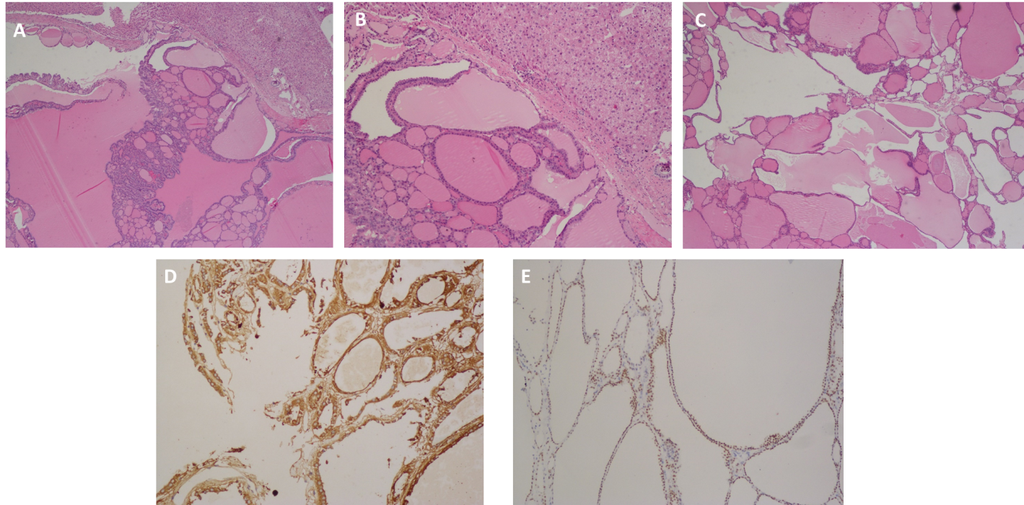
Figure 1 Histopathology examination. A: Hematoxylin-eosin (H&E) staining revealed ectopic thyroid tissue within the liver tissue. Normal liver tissue was seen at the top section of the microphotograph (40 × magnification); B: H&E staining showing ectopic thyroid tissue within the liver with follicles of varying size with liver tissue in the upper top section (100 × magnification); C: H&E staining showing thyroid nodule hypertrophy with follicles of varying size (400 × magnification); D: Confirmation of thyroid tissue by immunoreactivity for thyroglobulin (400 × magnification); E: Confirmation of thyroid tissue by immunoreactivity for thyroid transcription factor 1 (400 × magnification).
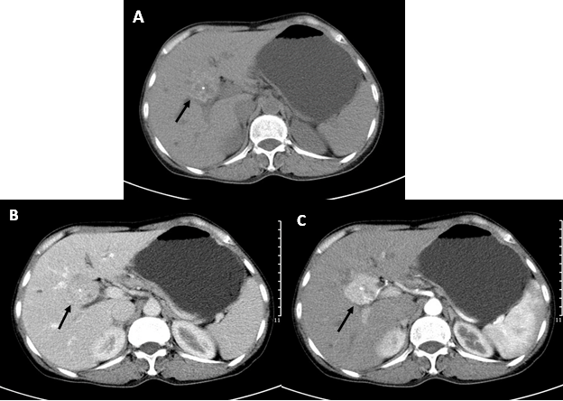
Figure 2 Abdominal axial computed tomography scan findings. A: Non-enhanced computed tomography (CT) showed a heterogeneous and well-circumscribed and high-density mass with calcification (black arrow); B and C: Contrast-enhanced CT showed a group of high density nodules with exhibition of well-defined borders in the hepatic entrance with calcification (black arrow) and an expansive size of 43 mm × 38 mm, as well as an intensely enhancing mass in the arterial phase with decreasing intensity in the venous phase.
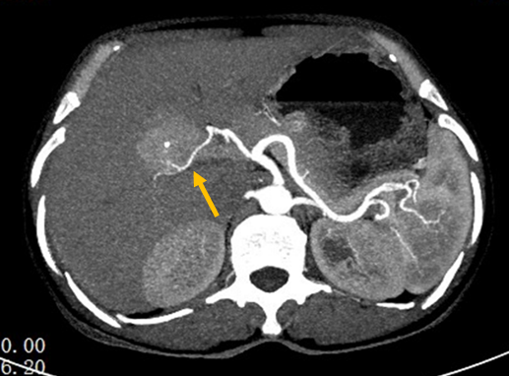
Figure 3 Axial computed tomography angiography findings. Widened image thickness construct in arterial phase depicting the right hepatic artery supplying the lesion (yellow arrow).
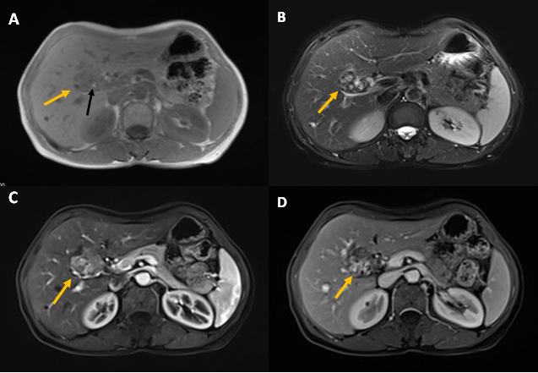
Figure 4 Axial magnetic resonance imaging findings. A: In-phase T1-weighted imaging showing a low signal intensity well-circumscribed lesion in the portal entrance (yellow arrow) with a hyper-intensity spot (black arrow); B: T2-weighted imaging; C: Arterial phase of contrast-enhanced magnetic resonance imaging (DCE-MRI); D: Hepatic phase of DCE-MRI depicting mixed signal intensity (yellow arrows).
Table 1 Review of published literature showing radiological imaging of ectopic thyroid in the porta hepatis
Ref. | Radiological imaging findings
Strohschneider et al^{[39]} | Unenhanced CT: Hyperdense, well-defined mass in comparison to the normal parenchyma
Jamshidi et al^{[33]} | Contrast-enhanced CT: Hyperdense appearance compared to normal liver parenchyma
Ghanem et al^{[1]} | Unenhanced CT: Inhomogeneous, slightly attenuated, lobulated, well-circumscribed, isodense and hypodense mass compared to the liver tissue with some calcifications. Contrast-enhanced CT: Inhomogeneous contrast enhancement
Salam et al^{[8]} | Contrast-enhanced CT: Mass adjacent to the portal vein enhanced in the arterial phase and washed out in the portal phase
Fernandez et al^{[9]} | Contrast-enhanced CT: Heterogeneously enhancing mass
Present case | Non-enhanced CT: Heterogenous, well-circumscribed, high density mass compared to liver parenchyma with calcification. Contrast-enhanced CT: Well-circumscribed, intensely enhancing mass in the arterial phase with decreasing intensity in the venous phase alongside calcification  CT Angiography (widened image thickness construct): Right hepatic artery supplying the lesion shown clearly in arterial phase  MRI: Well-demarcated mass with enhancement on T1 and T2 weighted imaging with mixed signal intensity. Diminished signal intensity in both arterial and venous phases
CT: Computed tomography; MRI: Magnetic resonance imaging.

