Name of Journal: World Journal of Gastroenterology
Manuscript NO: 71770
Manuscript Type: CASE REPORT

Gallbladder Burkitt’s lymphoma mimicking gallbladder cancer: A case report

Hosoda K et al. Gallbladder Burkitt’s lymphoma

Kiyotaka Hosoda, Akira Shimizu, Koji Kubota, Tsuyoshi Notake, Hikaru Hayashi, Koya Yasukawa, Kentaro Umemura, Atsushi Kamachi, Takamune Goto, Hidenori Tomida, Shiori Yamazaki, Yuri Narusawa, Naoko Asano, Takeshi Uehara, Yuji Soejima

Kiyotaka Hosoda, Akira Shimizu, Koji Kubota, Tsuyoshi Notake, Hikaru Hayashi, Koya Yasukawa, Kentaro Umemura, Atsushi Kamachi, Takamune Goto, Hidenori Tomida, Shiori Yamazaki, Yuji Soejima, Division of Gastroenterological, Hepato-Biliary-Pancreatic, Transplantation and Pediatric Surgery, Department of Surgery, Shinshu University School of Medicine, Matsumoto 390-8621, Japan

Yuri Narusawa, Naoko Asano, Takeshi Uehara, Department of Laboratory Medicine, Shinshu University School of Medicine, Matsumoto 390-8621, Japan

Author contributions: Hosoda K, Kubota K, Notake T, Hayashi H, Umemura K, Kamachi A, Goto T, Tomida H, and Yamazaki S were the patient’s hepato-biliary-pancreatic surgeons, they reviewed the literature and contributed to manuscript drafting; Narusawa Y, Asano N, and Uehara T were involved in pathology evaluation; Shimizu A and Soejima Y were responsible for revising the manuscript for important intellectual content; all the authors provided final approval for the version of the manuscript to be submitted.

Corresponding author: Akira Shimizu, MD, PhD, Associate Professor, Division of Gastroenterological, Hepato-Biliary-Pancreatic, Transplantation and Pediatric Surgery, Department of Surgery, Shinshu University School of Medicine, 3-1-1 Asahi, Matsumoto 390-8621, Japan. ashimizu@shinshu-u.ac.jp

Received: October 1, 2021
Revised: November 23, 2021
Accepted: January 19, 2022
Published online:

Abstract
BACKGROUND
Malignant lymphoma is a rare form of gallbladder malignancy. Most of these malignancies are diffuse large B-cell lymphomas or mucosa-associated lymphoid tissue-type lymphomas; however, Burkitt’s lymphoma of the gallbladder is extremely rare, and only two previous reports are available in the literature. Herein, we report a rare case of Burkitt’s lymphoma of the gallbladder mimicking gallbladder adenocarcinoma.

CASE SUMMARY
An 83-year-old man with no abdominal complaints was found to have a gallbladder tumor and periportal lymph node enlargement on computed tomography (CT) performed for hypertension screening. His laboratory data revealed slightly elevated serum levels of carcinoembryonic antigen and soluble interleukin 2 receptor. Imaging examinations revealed two irregular and contrast-enhanced masses extending into the gallbladder lumen, but these did not infiltrate the serosa. Moreover, a periportal lymph node had enlarged to 30 mm. Based on these findings, we diagnosed the patient as having gallbladder adenocarcinoma with lymph node metastasis, which was treated using bile duct resection with gallbladder bed resection and periportal lymph node dissection. However, the patient was finally diagnosed as having Burkitt’s lymphoma. Although the surgical margin was pathologically negative, recurrence was noted at the hepatic radical margin and superior pancreaticoduodenal lymph nodes on positron emission tomography/CT soon after discharge. Thus, he was referred to a hematologist and started receiving treatment with reduced-dose cyclophosphamide, doxorubicin, vincristine, and prednisone.

CONCLUSION
Burkitt’s lymphoma can occur in the gallbladder. Biopsy can be useful in cases with findings suggestive of gallbladder malignant lymphoma.

Key Words: Gallbladder; Malignant lymphoma; Burkitt’s lymphoma; Gallbladder cancer; Lymphadenopathy; Case report

Hosoda K, Shimizu A, Kubota K, Notake T, Hayashi H, Yasukawa K, Umemura K, Kamachi A, Goto T, Tomida H, Yamazaki S, Narusawa Y, Asano N, Uehara T, Soejima Y. Gallbladder Burkitt’s lymphoma mimicking gallbladder cancer: A case report. World J Gastroenterol 2022; In press

Core Tip: Malignant lymphoma is a rare form of gallbladder malignancy, and Burkitt’s lymphoma of the gallbladder is especially rare, with only two previous reports available in the literature. We report a case of gallbladder Burkitt’s lymphoma that was preoperatively indistinguishable from gallbladder carcinoma. Unfortunately, the patient had lymphoma recurrence immediately after the surgery because of delayed chemotherapy initiation owing to postoperative complications due to an extended surgery. Although accurate preoperative diagnosis of gallbladder malignant lymphoma is quite difficult, some findings are suggestive of gallbladder malignant lymphoma, and hence, biopsy is recommended in these cases.

INTRODUCTION
Malignant lymphoma of the gallbladder is extremely rare^{[1-4]}. In almost all cases of this malignancy, patients are diagnosed as having gallbladder adenocarcinoma or cholecystitis at the time of surgery, and preoperative diagnosis is extremely difficult. Although several reports have documented malignant lymphomas of the gallbladder, most of these malignancies are diffuse large B-cell lymphomas and mucosa-associated lymphoid tissue-type lymphomas (MALTomas)^{[2,4,5]}, and only two reports have previously documented Burkitt’s lymphoma of the gallbladder^{[6,7]}. Herein, we report the case of a patient with Burkitt’s lymphoma of the gallbladder mimicking gallbladder adenocarcinoma.

CASE PRESENTATION
Chief complaints
An 83-year-old man with no abdominal complaints was found to have a gallbladder tumor along with periportal lymph node enlargement and was admitted to our institution for further investigation.

History of present illness
The tumor was detected during contrast-enhanced computed tomography (CT) performed for a detailed examination of hypertension.

History of past illness
The patient had a history of cerebral artery stenosis and paroxysmal atrial fibrillation.

Personal and family history
No personal and family history.

Physical examination
Abdominal examination revealed no palpable mass or tenderness.

Laboratory examinations
Laboratory examinations performed upon admission revealed mild to moderate renal dysfunction (creatinine: 1.21 mg/dL) and slightly elevated levels of serum carcinoembryonic antigen and serum soluble interleukin 2 receptor (6.1 ng/mL and 635 IU/mL, respectively). Other laboratory data were within normal limits.

Imaging examinations
A contrast-enhanced abdominal CT scan revealed two irregular and highly contrast-enhanced masses at the neck and body of the gallbladder as well as periportal lymph node enlargement, measuring 30 mm × 20 mm in diameter and consistent with gallbladder cancer lymph node metastasis (Figure 1). Magnetic resonance imaging revealed that the tumor signal was hypointense on T1-weighted imaging and hyperintense on T2-weighted and diffusion-weighted imaging (Figure 2). Positron emission tomography (PET) revealed increased ¹⁸F-fluorodeoxyglucose uptake in the tumor (Figure 3). Endoscopic ultrasonography (EUS) showed a heterogeneous echoic mass extending into the lumen, but it did not infiltrate the serosa (Figure 4).

FINAL DIAGNOSIS
The final diagnosis was gallbladder adenocarcinoma with lymph node metastasis.

TREATMENT
On the basis of these findings, the patient underwent bile duct resection with gallbladder bed resection and periportal lymph node dissection. The surgical findings revealed the gallbladder tumor was relatively softer than ordinary gallbladder cancers. The swollen lymph node was firm but did not invade the portal vein. However, the patient developed severe aspiration pneumonia and bile leakage after the surgery, which were treated conservatively. The patient was discharged 2 mo after the surgery.

OUTCOME AND FOLLOW-UP
Histologic examination revealed periportal lymphadenopathy and two tumors at the neck and body of the gallbladder, measuring 27 mm × 20 mm and 20 mm × 18 mm in diameter, respectively. Histological findings also showed monotonous lymphoid cells with hemophagocytosis by macrophages. Immunohistochemical staining for markers showed the presence of CD10, BCL6, and c-Myc and the absence of BCL2. The Ki-67 index was > 80% (Figure 5). Therefore, the patient was finally diagnosed as having Burkitt’s lymphoma. Although the surgical margin was pathologically negative, recurrence was noted at the hepatic radical margin and superior pancreaticoduodenal lymph nodes on PET-CT immediately after discharge. Thus, he was referred to a hematologist and started receiving treatment with reduced-dose cyclophosphamide, doxorubicin, vincristine, and prednisone.

DISCUSSION
Malignant lymphoma of the gallbladder is a rare form of gallbladder malignancy, which accounts for 0.1%-0.2% of all gallbladder cancers^{[1-3]}. In previous reports, most of these malignancies were documented to be diffuse large B-cell lymphomas and MALTomas^{[2,4]}, and only two reports had documented Burkitt’s lymphoma of the gallbladder^{[6,7]}. Compared to previous cases, the present case yielded some interesting clinical and imaging findings.
First, this is potentially the first reported case of “primary” gallbladder Burkitt’s lymphoma. According to the diagnostic criteria of primary gastrointestinal lymphoma (Table 1) defined by Dawson et al^{[8]} and Lewin et al^{[9]}, the previous two cases were diagnosed as “secondary” gallbladder Burkitt’s lymphoma because they included extra-gallbladder lesions, such as duodenal, hepatic, or central nervous system lesions. In contrast, in the present case, the tumor was localized in the gallbladder and a periportal lymph node. Although no gastrointestinal symptoms were observed because the primary site was the gallbladder, other criteria were fulfilled. Therefore, the patient was diagnosed as having “primary” gallbladder Burkitt’s lymphoma, and the case was considered novel.
Second, gallbladder Burkitt’s lymphoma can present as a localized disease that mimics gallbladder cancer. The imaging features of malignant lymphoma were reported by Ono et al^{[3]}, who reported that high-grade malignant lymphomas showed solid and bulky masses or irregular wall thickening. In addition, because Burkitt’s lymphoma is a highly aggressive and rapidly progressive disease, some extranodal sites are generally involved at the time of diagnosis^{[10]} and tumor localization around the primary lesion is rare^{[11]}. In this case, the malignancy was localized in the body of the gallbladder and a periportal lymph node. Since these findings were consistent with the imaging findings of gallbladder adenocarcinoma, we could not confirm a preoperative diagnosis of malignant lymphoma.
Unfortunately, the patient had lymphoma recurrence 2 mo after the surgery because the introduction of chemotherapy had to be delayed owing to postoperative complications. Burkitt’s lymphoma is a highly aggressive disease, but it is highly sensitive to chemotherapy. Therefore, chemotherapy has the highest priority in the treatment of Burkitt’s lymphoma^{[10]}, and we should have introduced chemotherapy as soon as possible after the surgery. If we had been aware of the possibility of gallbladder malignant lymphoma, we could have avoided the extended procedure and could have initiated chemotherapy at the appropriate time.
Although the accurate preoperative diagnosis of gallbladder malignant lymphoma is quite difficult^{[2,12]}, some previous reports^{[3,12,13]} have suggested the possibility of a precise preoperative diagnosis based on imaging findings. Specifically, Ono et al^{[3]} showed that the signal intensity of the gallbladder wall on T2-weighted imaging is more hypointense in malignant lymphoma than in carcinoma. In addition, Kato et al^{[12]} reported the usefulness of an internal partially low echo in distinguishing malignant lymphoma from carcinoma. On a retrospective review of the present case, although no obvious differences were observed in the intensity of T2-weighted imaging when compared to that of gallbladder cancers, EUS revealed an internal partially low echo of the tumor. Furthermore, in this case, a discrepancy existed in that no serosal invasion was observed despite the size of the tumor and presence of lymphadenopathy. We think this might be a characteristic finding that distinguishes gallbladder malignant lymphoma from carcinoma.
Nevertheless, a biopsy examination seems the best diagnostic technique in the present case, considering the possibility of malignant lymphoma, and hence, biopsy should be planned for patients with the above imaging findings.

CONCLUSION
Burkitt’s lymphoma can occur in the gallbladder. Therefore, this disease should be considered in the differential diagnosis of a gallbladder tumor, and biopsy can be useful in facilitating the early introduction of chemotherapy in cases with suggestive imaging findings.

REFERENCES
1 Yasuma T, Yanaka M. Primary sarcoma of the gallbladder--report of three cases. Acta Pathol Jpn 1971; 21: 285-304 [PMID: 4937525 DOI: 10.1111/j.1440-1827.1971.tb00125.x]
2 Jelic TM, Barreta TM, Yu M, Frame JN, Estallila OC, Mellen PF, Newman SS, Chang HH. Primary, extranodal, follicular non-Hodgkin lymphoma of the gallbladder: case report and a review of the literature. Leuk Lymphoma 2004; 45: 381-387 [PMID: 15101728 DOI: 10.1080/10428190310001597919]
3 Ono A, Tanoue S, Yamada Y, Takaji Y, Okada F, Matsumoto S, Mori H. Primary malignant lymphoma of the gallbladder: a case report and literature review. Br J Radiol 2009; 82: e15-e19 [PMID: 19095809 DOI: 10.1259/bjr/30768802]
4 Ayub A, Rehmani S, Al-Ayoubi AM, Lewis E, Santana-Rodríguez N, Raad W, Bhora F, Kim G. Primary Non-Hodgkin's Lymphoma of the Gallbladder: A Population-based Analysis. Anticancer Res 2017; 37: 2581-2586 [PMID: 28476830 DOI: 10.21873/anticanres.11602]
5 Mani H, Climent F, Colomo L, Pittaluga S, Raffeld M, Jaffe ES. Gall bladder and extrahepatic bile duct lymphomas: clinicopathological observations and biological implications. Am J Surg Pathol 2010; 34: 1277-1286 [PMID: 20679881 DOI: 10.1097/PAS.0b013e3181e9bb8b]
6 Doherty B, Palmer W, Cvinar J, Sadek N. A Rare Case of Systemic Adult Burkitt Lymphoma Presenting as Acute Acalculous Cholecystitis. ACG Case Rep J 2019; 6: e00048 [PMID: 31616732 DOI: 10.14309/crj.0000000000000048]
7 Repine TB, DeArmond G, López JD. Unusual sites of metastatic malignancy: case 2. Burkitt's lymphoma involving the gallbladder. J Clin Oncol 2004; 22: 5014-5015 [PMID: 15611517 DOI: 10.1200/jco.2004.11.026]
8 Dawson IM, Cornes JS, Morson BC. Primary malignant lymphoid tumours of the intestinal tract. Report of 37 cases with a study of factors influencing prognosis. Br J Surg 1961; 49: 80-89 [PMID: 13884035 DOI: 10.1002/bjs.18004921319]
9 Lewin KJ, Ranchod M, Dorfman RF. Lymphomas of the gastrointestinal tract: a study of 117 cases presenting with gastrointestinal disease. Cancer 1978; 42: 693-707 [PMID: 354774 DOI: 10.1002/1097-0142(197808)42:2<693::aid-cncr2820420241>3.0.co;2-j]
10 Crombie J, LaCasce A. The treatment of Burkitt lymphoma in adults. Blood 2021; 137: 743-750 [PMID: 33171490 DOI: 10.1182/blood.2019004099]
11 Čubranić A, Golčić M, Fučkar-Čupić D, Brozović B, Gajski D, Brumini I. BURKITT LYMPHOMA IN GASTROINTESTINAL TRACT: A REPORT OF TWO CASES. Acta Clin Croat 2019; 58: 386-390 [PMID: 31819338 DOI: 10.20471/acc.2019.58.02.25]
12 Kato H, Naganuma T, Iizawa Y, Kitagawa M, Tanaka M, Isaji S. Primary non-Hodgkin's lymphoma of the gallbladder diagnosed by laparoscopic cholecystectomy. J Hepatobiliary Pancreat Surg 2008; 15: 659-663 [PMID: 18987940 DOI: 10.1007/s00534-007-1283-9]
13 Gupta P, Marodia Y, Bansal A, Kalra N, Kumar-M P, Sharma V, Dutta U, Sandhu MS. Imaging-based algorithmic approach to gallbladder wall thickening. World J Gastroenterol 2020; 26: 6163-6181 [PMID: 33177791 DOI: 10.3748/wjg.v26.i40.6163]

Footnotes
Informed consent statement: Written informed consent was obtained from the patient for the publication of this report and any accompanying images.

Conflict-of-interest statement: The authors declare that they have no conflicts of interest.

CARE Checklist (2016) statement: The authors have read the CARE Checklist (2016), and the manuscript was prepared and revised according to the CARE Checklist (2016).

Open-Access: This article is an open-access article that was selected by an in-house editor and fully peer-reviewed by external reviewers. It is distributed in accordance with the Creative Commons Attribution NonCommercial (CC BY-NC 4.0) license, which permits others to distribute, remix, adapt, build upon this work non-commercially, and license their derivative works on different terms, provided the original work is properly cited and the use is non-commercial. See: https://creativecommons.org/Licenses/by-nc/4.0/

Provenance and peer review: Unsolicited article; Externally peer reviewed.

Peer-review model: Single blind

Peer-review started: October 1, 2021
First decision: November 7, 2021
Article in press:

Specialty type: Gastroenterology and hepatology
Country/Territory of origin: Japan
Peer-review report’s scientific quality classification
Grade A (Excellent): A
Grade B (Very good): B
Grade C (Good): 0
Grade D (Fair): 0
Grade E (Poor): 0

P-Reviewer: Gupta P, Zhu CF S-Editor: Fan JR L-Editor: A P-Editor: Fan JR
Figure Legends
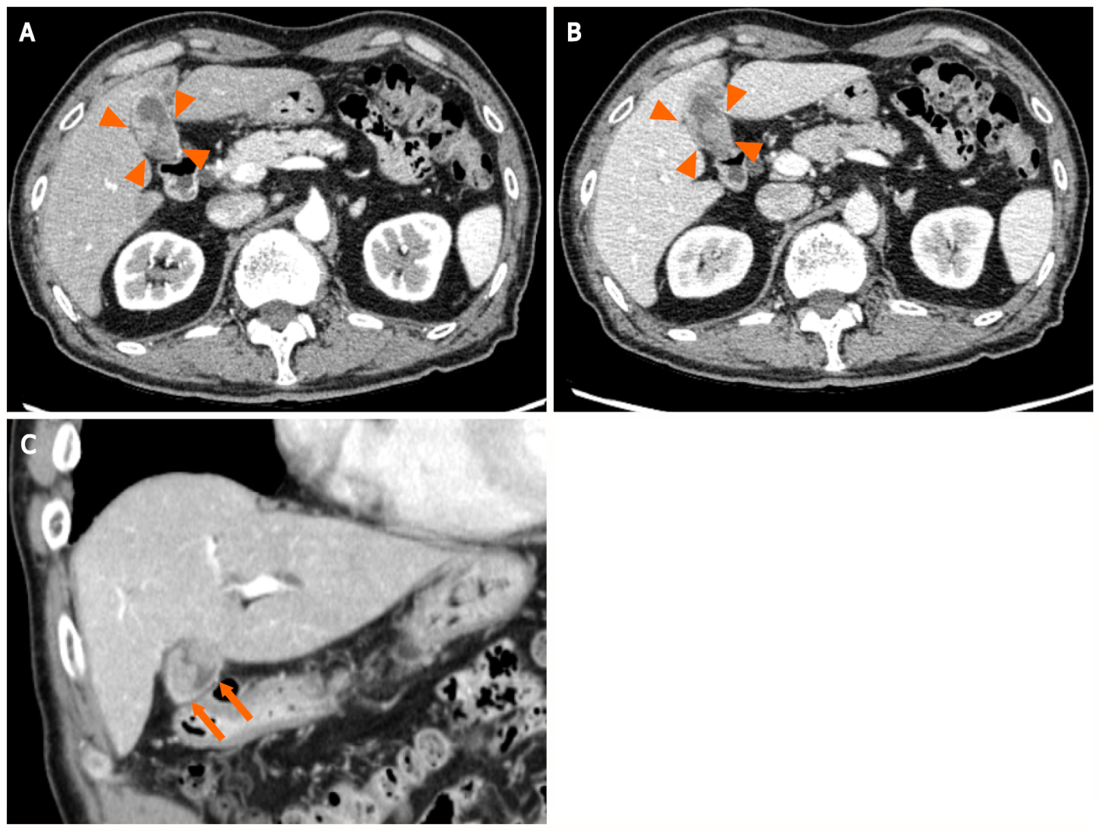
Figure 1 A contrast-enhanced abdominal computed tomography scan shows two irregular and highly contrast-enhanced masses (arrowheads and arrow) at the neck and body of the gallbladder as well as periportal lymph node enlargement, which is consistent with gallbladder cancer lymph node metastasis. A: Axial section image in the early phase showing neck of the gallbladder; B: Axial section image in the delayed phase showing neck of the gallbladder in the delayed phase; C: Coronal sectional image showing body of the gallbladder.
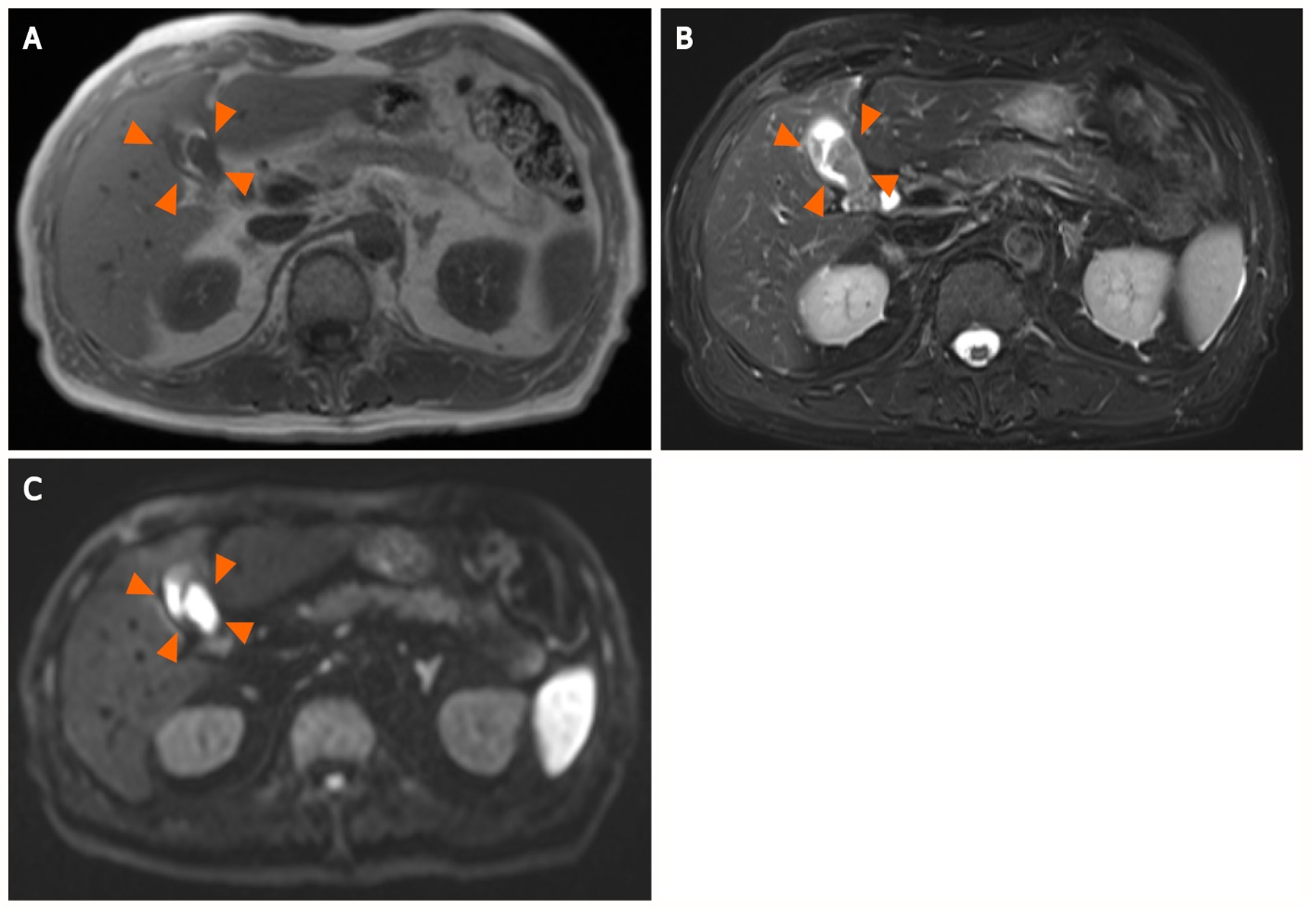
Figure 2 Magnetic resonance imaging reveals a hypointense tumor signal. A: T1-weighted imaging (arrowheads); B: A hyperintense signal on T2-weighted imaging (arrowheads); C: Diffusion-weighted imaging (arrowheads).
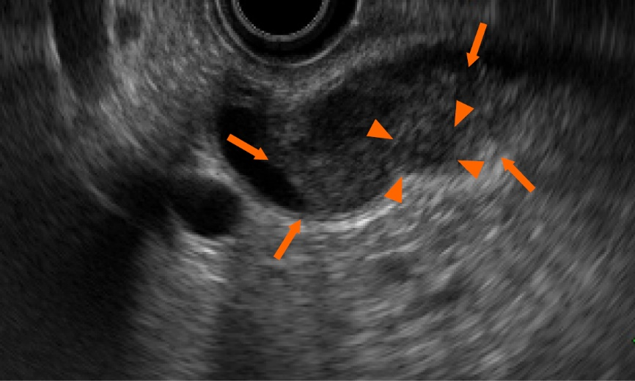
Figure 3 Endoscopic ultrasonography shows a heterogeneous echoic mass (arrows) with internal partially low echo (arrowheads). The mass extends into the lumen but does not infiltrate the serosa.
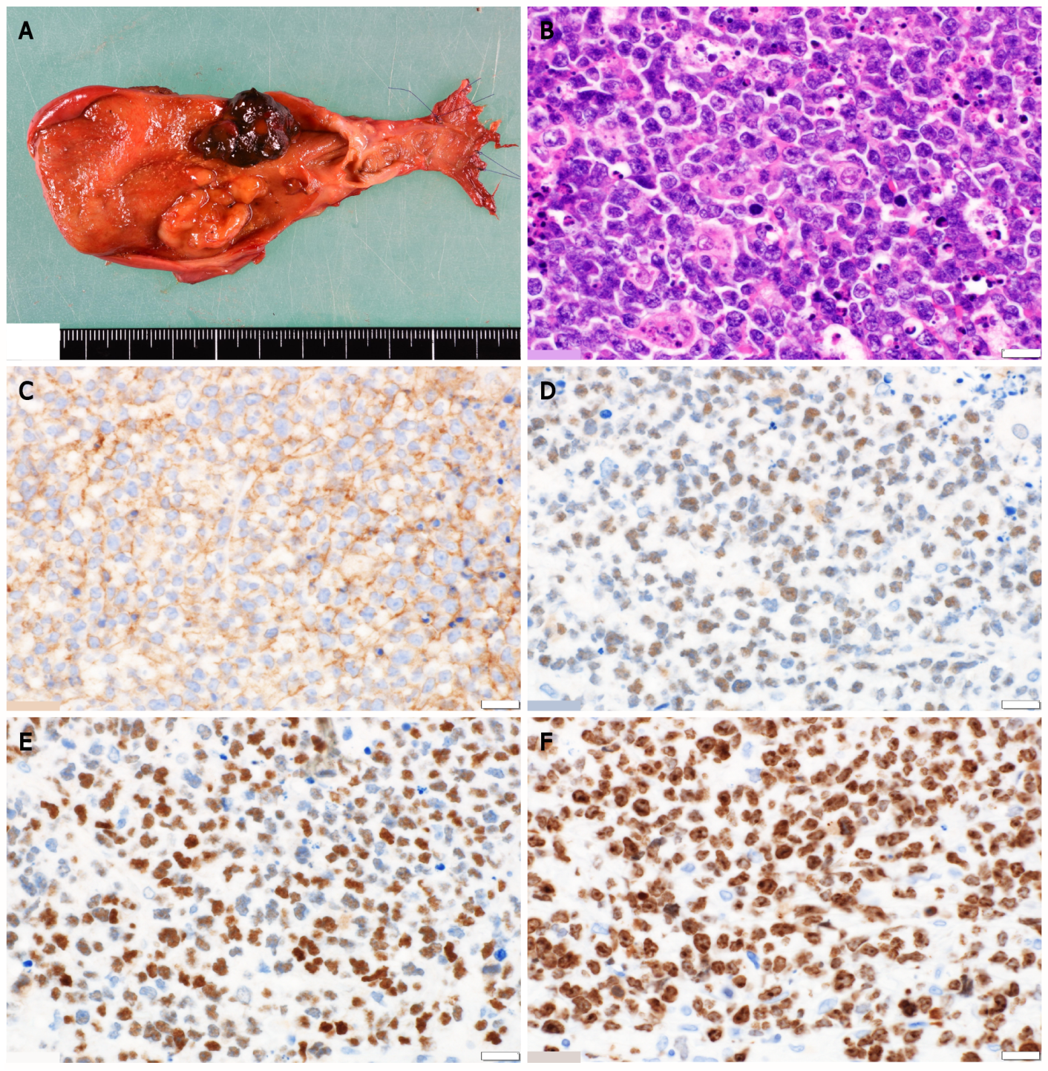
Figure 4 Histologic examination. A: Periportal lymphadenopathy and two tumors at the neck and body of the gallbladder, measuring 27 mm × 20 mm and 20 mm × 18 mm in diameter, respectively; B: Histological findings reveal monotonous lymphoid cells with hemophagocytosis by macrophages; C-E: Immunohistochemical staining for markers shows the presence of CD10 (C), BCL6 (D), and c-Myc (E) and the absence of BCL2; F: The Ki-67 index is > 80%. The white scale bars represent 1 mm.
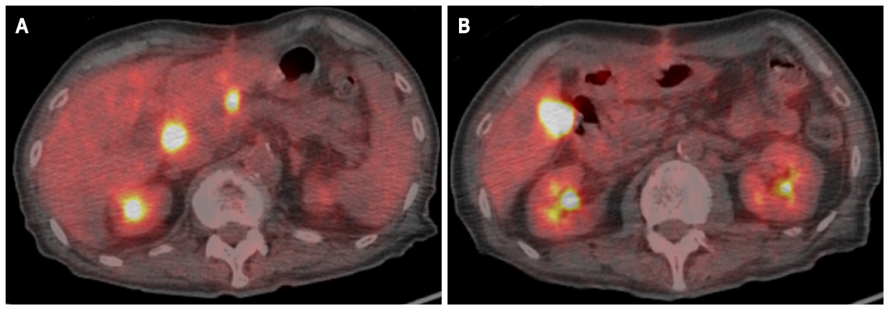
Figure 5 Positron emission tomography reveals increased ¹⁸F-fluorodeoxyglucose uptake at the superior pancreaticoduodenal lymph nodes and hepatic radical margin. A: Superior pancreaticoduodenal lymph nodes; B: Hepatic radical margin.
Table 1 Diagnostic criteria for gastrointestinal malignant lymphoma
Ref. | Diagnostic criteria
Dawson et al^{[8]} | Absence of palpable superficial lymphadenopathy
 | Absence of obvious enlargement of mediastinal lymph nodes
 | Normal level of total and differential white blood cell counts
 | The bowel lesion predominating and the only lymph node obviously affected being those in its immediate neighborhood
 | Absence of tumor in the liver and spleen
Lewin et al^{[9]} | Exhibiting gastroinetstinal symptoms or predominant lesions in the gastrointestinal tract

