Name of Journal: World Journal of Gastroenterology
ESPS Manuscript NO: 25957
Manuscript Type: ORIGINAL ARTICLE

Basic study
Protein and gene expression characteristics of heterogeneous nuclear ribonucleoprotein H1 in esophageal squamous cell carcinoma

Sun YL et al. Overexpression of HNRNPH1 in ESCC

Yu-Lin Sun, Fei Liu, Fang Liu, Xiao-Hang Zhao

Yu-Lin Sun, Fei Liu, Fang Liu, Xiao-Hang Zhao, State Key Laboratory of Molecular Oncology, National Cancer Center/Cancer Hospital, Chinese Academy of Medical Sciences & Peking Union Medical College, Beijing 100021, China

Author contributions: Sun YL and Zhao XH designed the study; Liu F, Sun YL and Liu F performed the research; Sun YL analyzed and mined data, and wrote the manuscript; Zhao XH supervised this work.

Supported by the Natural Science Foundation of China, No. 81572840 and No. 81572365; the State Key Project for Basic Research, No. 2014CBA02002; and National High-tech R & D Program, No. 2012AA020206.

Institutional review board statement: All routine colonic biopsy specimens and blood samples from the patients were taken after informed consent and ethical permission was obtained for participation in the study.

Institutional animal care and use committee statement: This study is not involved in animal experiments.

Conflict-of-interest statement: To the best of our knowledge, no conflict of interest exists.

Data sharing statement: Technical appendix and dataset available from the corresponding author. Participants gave informed consent for data sharing. No additional data are available.

Open-Access: This article is an open-access article which was selected by an in-house editor and fully peer-reviewed by external reviewers. It is distributed in accordance with the Creative Commons Attribution Non Commercial (CC BY-NC 4.0) license, which permits others to distribute, remix, adapt, build upon this work noncommercially, and license their derivative works on different terms, provided the original work is properly cited and the use is non-commercial. See: http://creativecommons.org/licenses/by-nc/4.0/

Manuscript source: Unsolicited manuscript

Correspondence to: Xiao-Hang Zhao, MD PhD, Professor, State Key Laboratory of Molecular Oncology, National Cancer Center/Cancer Hospital, Chinese Academy of Medical Sciences & Peking Union Medical College, Panjiayuan Nanli 17, Chaoyang District, Beijing 100021, China. zhaoxh@cicams.ac.cn
Telephone: +86-10-67709015
Fax: +86-10-87778360

Received: March 26, 2016
Peer-review started: March 28, 2014
First decision: May 12, 2016
Revised: May 16, 2016
Accepted: June 2, 2016
Article in press:
Published online:

Abstract
AIM: To investigate the expression characteristics of heterogeneous nuclear ribonucleoprotein H1 (HNRNPH1) mRNA and protein in cell lines and tissues of esophageal squamous cell carcinoma (ESCC).

METHODS: Western blotting was used to demonstrate the expression of HNRNPH1 protein in 7 ESCC cell lines and 30 paired fresh tissue specimens. The subcellular localization of HNRNPH1 was determined by immunofluorescence in ESCC cells. The RNA sequencing data from 87 patients with ESCC were obtained from the cancer genome atlas (TCGA). And the expression and clinical characteristics analysis of different transcript variants of HNRNPH1 was evaluated in this dataset. In addition, immunohistochemistry was also carried out to detect the expression of HNRNPH1 protein in 125 patients.

RESULTS: The expression of HNRNPH1 protein varied across different ESCC cell lines. It exclusively restricted to the nucleus of the ESCC cells. For the two transcript variants of HNRNPH1 gene, variant 1 was constitutively expressed and not changed during tumorigenesis. However, variant 2 was barely expressed in the non-tumorous tissues, and it dramatically increased in ESCC (P = 0.0026). The high levels of variant 2 were associated with poorer differentiated tumors (P = 0.0287). Furthermore, in paired fresh tissue specimens, HNRNPH1 protein was overexpressed in 73.3% (22/30) of neoplastic tissues. In addition, it was significantly upregulated in ESCC with strong staining of 43.2% (54/125) in tumor tissues and 22.4% (28/125) in matched non-cancerous tissues (P = 0.0005). Positive HNRNPH1 expression was significantly associated with poor tumor differentiation degree (P = 0.0337).

CONCLUSION: The different alternative transcript variants of HNRNPH1 had different expression changes during tumorigenesis. Its mRNA and protein was overexpressed in ESCC, and associated with poorer differentiation of tumor cells. These findings might highlight the potential of HNRNPH1 in the therapy and diagnosis of ESCC.

Key words: Heterogeneous nuclear ribonucleoprotein H1; Esophageal squamous cell carcinoma; Alternative transcript variants; Biomarker

© The Author (s) 2016. Published by Baishideng Publishing Group Inc. All rights reserved.

Core tip: Heterogeneous nuclear ribonucleoprotein H1 (HNRNPH1) is an evolutionarily conserved splicing factor. It is involved in alternative splicing, polyadenylation, mRNA export and translation. This study firstly investigated the expression, localization and clinical significance of HNRNPH1 in esophageal squamous cell carcinoma (ESCC). We found that this gene possesses two alternative transcript variants; one was constitutively expressed, while the other was regulated and dramatically increased in ESCC. HNRNPH1 protein was also overexpressed in ESCC tissues. Strong HNRNPH1 levels were significantly associated with poorer tumor differentiation and alternative splicing of apoptosis-related genes. It suggests that HNRNPH1 is a potential diagnostic biomarker and therapeutic target in ESCC.

Sun YL, Liu F, Liu F, Zhao XH. Protein and gene expression characteristics of heterogeneous nuclear ribonucleoprotein H1 in esophageal squamous cell carcinoma. World J Gastroenterol 2016; In press
INTRODUCTION
Esophageal cancer is the third most commonly diagnosed cancer and the fourth leading cause of cancer death in China^{[1]}. It was estimated that 477900 new cases and 375000 deaths occurred in 2015, accounting for about 13.3% of all cancer deaths. The predominant histological subtype in China is esophageal squamous cell carcinoma (ESCC).
Under the various environmental exposures and genetic factors, ESCC develops through progression from normal esophageal epithelium to dysplasia, early stage and then advanced stage esophageal carcinoma with an accumulation of numerous genetic and epigenetic abnormalities^{[2]}. Currently, the alternations of thousands of genes had been found in ESCC. Nascent transcripts that are produced by RNA polymerase II undergo precursor mRNA splicing to generate mature mRNAs. During this process, heterogeneous nuclear ribonucleoproteins (hnRNPs) family plays critical roles. In addition, hnRNPs also act as trans-factors in regulating alternative splicing, gene expression, mRNA export, localization, translation, and stability^{[3]}. In human, hnRNPs family consists of at least 20 abundant, major hnRNP proteins and other less abundant, minor hnRNP proteins^{[3]}. Most of major hnRNP proteins had been identified to be overexpressed in ESCC tissues by proteomic analysis^{[4-7]}. Immunohistochemical staining showed that HNRNPB1 was a potential diagnostic marker for squamous cell carcinoma of various organs, including ESCC^{[8]}.
Our previous proteomic study found that a major hnRNP protein, HNRNPH1, was upregulated approximately 8.4-fold in ESCC. Its overexpression was also observed by the other proteomic study in ESCC^{[5]}. HNRNPH1 was first purified in 1994 as an abundant component of hnRNP complexes^{[9]}. It is ubiquitously expressed in various human tissues and binds only to poly (rG) sequence^{[9,10]}. HNRNPH1 is demonstrated to stimulate pre-mRNA cleavage and polyadenylation, and it is an important determinant of alternative splicing^{[11-17]}. At the present, the relevant reports about HNRNPH1 and cancer are still very limited. Upregulation of HNRNPH1 is found in pancreatic adenocarcinoma, hepatocellular carcinoma, gastric carcinoma, head and neck carcinomas and colon cancer^{[18,19]}. However, the aberrant expression of HNRNPH1 was not verified and evaluated in large-scale clinical samples. In this study, we investigated the expression and clinical significance of HNRNPH1 mRNA and protein in ESCC using RNA sequencing dataset from the cancer genome atlas (TCGA), western blotting and immunohistochemical staining assays.

MATERIALS AND METHODS
Cell lines and cell cultures
The human ESCC cell lines KYSE30, KYSE140, KYSE170, KYSE180, KYSE410 and KYSE510 were the gifts from Dr Y. Shimada at Hyogo College of Medicine. EC0156 was established by our laboratory^{[20]}. EC0156 was cultured in Dulbecco's modified Eagle's medium supplemented with 10% fetal calf serum, 100 U/ml penicillin and 100 μg/ml streptomycin (Gibco, NY, United States). The other cell lines were cultured in RPMI‑1640 medium. All the cells were incubated at 37 ˚C in a humidified atmosphere of 5% CO₂.

Clinical specimen collection and preparation
Surgical tissues from ESCC patients were collected after obtaining informed consent and approval from the Institutional Review Board of the Cancer Hospital of Chinese Academy of Medical Sciences (Beijing, China). A total of 30 fresh tumor and paired adjacent non-tumor esophagus tissue samples were collected from patients (25 male, 5 female; median age, 58 ± 10 SD; range 32–72 years) undergoing resection during the period from January 2005 to January 2009. All patients were diagnosed by two senior pathologists without chemo/radiotherapy before surgical operation. The tissue samples were collected and washed right after surgical resection. They were then snap-frozen in liquid nitrogen immediately and stored at -80 °C.
For immunohistochemical staining, 50 formalin-fixed, paraffin-embedded tissues specimens were collected from surgically resected ESCC in Cancer Hospital of CAMS from January 1999 to 2009. In addition, a tissue microarray that contained 75 ESCC cases were purchased from Shanghai Outdo Biotech Co., Ltd (Shanghai, China).

Proteins extraction
The cells in exponential phase of growth were harvested using a protein lysis buffer (pH 7.4) containing 50 mmol/L Tris-HCl, 150 mmol/L NaCl, 1% NP-40, 0.1% SDS and protease inhibitor cocktail (Roche Diagnostics, Mannheim, Germany). In addition, subcellular protein extraction were performed using ProteoExtractTM Subcellular Proteome Extraction Kit (Calbiochem, Germany) according to the manufacturer’s guidelines. Fresh tissue samples were homogenized and the proteins were extracted using the protein lysis buffer described above. The protein content was determined by Coomassie Plus Protein Assay (Pierce, Rockford, IL).

Western blot analysis
Approximately 15 μg of total proteins or subcellular proteins were diluted in Laemmli buffer containing 10% β-Mercaptoethanol and boiled at 95 °C for 10 min. Samples were subjected to sodium dodecyl sulfate-polyacrylamide gel electrophoresis (SDS-PAGE) and then transferred to polyvinylidene difluoride membranes. After blocking, the membranes were incubated with anti-HNRNPH1 (ab10374, Abcam, Cambridge, United Kingdom), anti-Lamin B, anti-AIF (Santa Cruz Biotech., CA) and anti-β-actin (Sigma-Aldrich, MO) antibodies. Following intensive washing, the membranes were developed with horseradish peroxidase conjugated second antibodies (Jackson Immunoresearch Lab., West Grove, PA) and visualized using an enhanced chemiluminescence system (Santa Cruz Biotech., CA). The upregulation or downregulation of HNRNPH1 was defined as higher or lower relative band intensity in tumors compared with their paired adjacent normal tissues.

Immunofluorescence staining
EC0156 cells were grown in 0.01% poly-l-Lysine coated slices for 24 h. After fixed with 4% paraformaldehyde for 30 min at room temperature and washed three times with PBS (pH 7.4), the cells were blocked with 1% BSA and 0.1% Triton X-100 for 30 min at room temperature. Washed cells were incubated for 30 min with rabbit anti-HNRNPH1 antibody. Then the cells were incubated in the dark for 60 min with Alexa Fluor 488-conjugated goat anti-rabbit secondary IgG (Life Technologies). The fluorescence signals were captured under a Nikon E400 Fluorescent microscope (Nikon Instech Co., Tokyo, Japan).

Immunohistochemistry
The tissue array and paraffin-embedded ESCC and their matched adjacent normal tissues were incubated with HNRNPH1 or control antibodies. After washing with 1× PBS, slices were reacted with the biotin-labeled second antibody and then visualized using an ultrasensitive streptavidin-peroxidases system (Maxim Biotech, Fuzhou, China). Semi-quantitative analysis of the HNRNPH1 immunoreaction was quantified as described previously^{[21]}. A staining index was used in which 0 was considered negative, 1-4 was weak, and > 4 was considered strong expression.

TCGA RNA sequencing data mining and statistical analysis
The ESCC transcriptome dataset was obtained from The Cancer Genome Atlas (TCGA). The normalized transcripts (isoforms) sequencing data from 11 non-tumor tissues and 87 tumor tissues were available. The expression of two HNRNPH1 transcripts and their clinical significance was analyzed. Mann-Whitney U test was used to compare the RPKM (Reads per kilobase of transcript per million reads mapped) between two groups. Spearman rank correlation analysis was used to calculate the correlation coefficient of two transcripts. P values < 0.05 were considered significant. All analyses were performed using Graphpad prism 6.0 (GraphPad Software Inc., La Jolla, CA).

RESULTS
expression and localization of HNRNPH1 protein in ESCC cell lines
We firstly observed the levels of HNRNPH1 protein in several ESCC cell lines. As shown in Figure 1A, HNRNPH1 expression varied across different ESCC cells, with KYSE30, KYSE140, KYSE410, KYSE170 and EC0156 showing relatively high expression, whereas KYSKE180 and KYSE510 showing relatively low expression levels. Next, many members in HNRNP family shuttle rapidly between the nucleus and cytoplasm. The shuttling capacity of HNRNPH1, however, remains unknown. We investigated the subcellular localization of HNRNPH1 via two methods. The immunofluorescence staining showed that it localized in the nucleus except for nucleolus (Figure 1B). The western blotting analysis of subcellular protein further showed that HNRNPH1 was strictly nuclear (Figure 1C). Thus, HNRNPH1 protein is ubiquitously expressed and exclusively sequestered to the nucleus in the ESCC cells.

HNRNPH1 mRNAs are up-regulated in ESCC tissues
Based on the NCBI RNA reference sequences collection (RefSeq) database (hg19), HNRNPH1 gene has two transcript variants, NM_001257293 (variant 1) and NM_005520 (variant 2). They are differed in the 5' UTR region, but encode the same protein (Figure 2A). According to the TCGA RNA sequencing gene isoforms data from ESCC patients (n = 87), we compared the abundance of these two variants between tumor and non-tumor tissues. In the non-tumorous tissues (n = 11), variant 1 was constitutively expressed, whereas most of samples barely expressed variant 2. However, in the tumor tissues, the expression of variant 1 had no alteration (P = 0.3211), whereas variant 2 was significantly up-regulated (P = 0.0026, Figure 2B). Because the samples in TCGA consist of different races, we compared the difference of variant 1 and 2 in Asian and Caucasian. The white/Caucasian had slightly higher levels of HNRNPH1, but there was no significant difference between them (Figure 2B). In addition, the expression of variant 1 was not correlated with that of variant 2 in tumor tissues (P = 0.1201, R = -0.1679; Figure 2C), suggesting that the two variants of HNRNPH1 are regulated by different mechanisms and display different expression characteristics.
Furthermore, we investigated the clinicopathological significance of variant 1 and 2 mRNA levels in Asian. The correlation between variant 1 and clinical features was not observed (Figure 2D). However, the levels of variant 2 were higher in poorly differentiated tumor (P = 0.0287; Figure 2E). Moreover, all of the cases were dichotomized into two groups, high level group and low level group, by the median RPKM values in tumor tissues. Unfortunately, we did not find that the variant 2 expression was associated with the overall survival of ESCC patients (Figure 3). Therefore, it seems that the variant 1 of HNRNPH1 is constitutively expressed, whereas variant 2 expression is modulated. Variant 2 is more associated with tumorigenesis in ESCC.

HNRNPH1 protein is overexpressed in ESCC tissues
To confirm the observation at mRNA levels, the protein expression of HNRNPH1 in ESCC patients was analyzed using western blotting and immunohistochemical staining assays. Firstly, western blotting results revealed that HNRNPH1 was overexpressed in 73.3% (22/30) of neoplastic tissues, compared with the non-tumorous esophageal mucosal tissues (Figure 4A and B).
Furthermore, immunohistochemistry was used to evaluate the expression of HNRNPH1 in more detail in 125 paired ESCC and non-neoplastic esophageal mucosa. The staining of HNRNPH1 was confined to the nuclei in the tumor and non-tumor cells (Figure 5). HNRNPH1 was strongly stained in 43.2% (54/125) of tumor tissues, while in 22.4% (28/125) of matched non-cancerous tissues. In addition, the weak expression of HNRNPH1 in tumor was 17.6% (22/125), while that was 35.2% (44/125) in normal esophageal epithelia. The upregulation of HNRNPH1 in tumor tissues was statistically significant (P = 0.0005). The correlations between the clinicopathologic characteristics of ESCC patients and the expression of HNRNPH1 in their tumors are summarized in Table 1. Its high expression in ESCC correlated significantly with the poorer tumor differentiation degree (P = 0.0337). However, no correlation was found between its expression and age, gender and lymph node metastasis (P﹥0.05). The trends were consistent with the results demonstrated at the mRNA levels. Taken together, these findings suggest that HNRNPH1 is overexpressed in ESCC and its high expression reflects the worse biological behaviors of tumors.

HNRNPH1 regulates the cell proliferation and apoptosis-related genes in ESCC
The previous study showed that HNRNPH1 modulates the alternative splicing of apoptotic mediators Bcl-x and A-raf^{[18]}. To further clarify the biological significance of HNRNPH1 in ESCC, we performed the correlation analysis between variant 2 of HNRNPH1 and the alternative transcripts of these genes. In addition, the cell proliferation marker, MKI67 which encodes Ki-67 protein, was also included. As shown in Figure 6A and 6B, variant 2 was positively correlated with the expression of MKI67 (Rho = 0.3101, P = 0.0035) and the prominent transcript of A-raf (Rho = 0.2787, P = 0.0090). Moreover, variant 2 was reversely correlated with the pro-apoptotic transcript of Bcl-X (Bcl-X (S), Rho = -0.2349, P = 0.0285; Figure 6C). Therefore, the overexpression of variant 2 of HNRNPH1 contributes to cell growth and anti-apoptosis in ESCC.

DISCUSSION
Human HNRNPH1 gene is mapped to the reverse strand at 5q35.3. It encodes two transcript variants based on the annotation of NCBI RefSeq hg19. Variant 1 possesses 14 exons, whereas variant 2 has 13 exons (Figure 2A). They are differed at the 5’UTR region but encoding the same protein. Until now, there were no studies describing the expression characteristics of these two variants. Our results showed that variant 1 is constitutively expressed, and it is not regulated by the disordered signal transduction networks during carcinogenesis. Meanwhile, variant 2 is barely expressed in normal tissues. It is consistent with the previous findings that the expression of HNRNPH1 was unaffected by treatment with two second messengers and seven cytokines in normal human keratinocytes^{[10]}. In addition, we found that variant 2 is significantly overexpressed in ESCC and correlated with the poorer tumor differentiation. These results suggest that the transcript variant 1 of HNRNPH1 is responsible for maintaining its invariable intracellular levels, whereas variant 2 is regulated and responds to tumorigenesis. It unravels a new mechanism for the gene expression regulation of HNRNPH1.
HNRNPH1 protein has three RNA binding domains, a glycine-tyrosine-arginine-rich (GYR) domain and a C-terminus glycine-rich domain. The central GYR domain is responsible for its nuclear localization^{[22]}. HNRNPH1 can shuttle between the nucleus and cytoplasm^{[22]}. In some cases of pancreatic, rectal, liver, gastric and lung cancer, strong cytoplasmic staining of HNRNPH1 was observed^{[19]}. However, in head and neck cancer, HNRNPH1 was only overexpressed in the nuclei^{[18]}. Our results showed that HNRNPH1 was restricted only to nucleus in ESCC. Therefore, the localization of HNRNPH1 may be tissue or cell-dependent.
Furthermore, HNRNPH1 is an evolutionarily conserved splicing factor, and it plays a dual role of activation and inhibition in pre-mRNA processing, polyadenylation, mRNA export and translation. It can act as a component in the intronic splicing enhancer complex to stimulate gene splicing, including c-src, MAP kinase activating death domain (MADD), macrophage stimulating 1 receptor (MST1R)^{[13,17]}. In addition, it can be recruited to the exonic splicing silencer to regulate the alternative splicing of tropomyosin, collagen-like tail subunit (COLQ), muscle nicotinic acetylcholine receptor alpha subunit, fibroblast growth factor receptor 2 etc^{[11,12,16,23,24]}. HNRNPH1 can cooperate with the other hnRNP proteins to stimulate the polyadenylation through a direct interaction with poly (A) polymerase^{[25]}. Moreover, it also binds some mRNAs to inhibit their nuclear export^{[26]}. In amyotrophic lateral sclerosis (ALS) and frontotemporal dementia (FTD), the RNA foci that result from GGGGCC (G4C2) intronic repeat expansion within C9ORF72 sequester HNRNPH1 and other RNA binding proteins, leading to neurotoxicity^{[27]}. In view of these functions, the aberrant expression of HNRNPH1 will alter cell phenotype. Apoptosis is significantly activated once HNRNPH1 is depleted. Experiments showed that inhibition of HNRNPH1 induces apoptosis by activation of caspase-3, PARP cleavage, and 10-fold increases in DNA fragmentation, whereas its transient overexpression protects against etoposide-induced apoptosis^{[18]}. The anti-apoptotic role of HNRNPH1 may result from its substrates, A-raf and Bcl-X^{[18,28]}. Bcl-X encodes two isoforms with different functions. The longer isoform Bcl-X (L) which was translated from transcripts uc002wwl.2 and uc002wwn.2 acts as an apoptotic inhibitor, whereas the shorter form Bcl-X (S) which was translated from transcript uc002wwm.2 acts as an apoptotic activator. It also maintains p53 pre-mRNA 3'-end processing to contribute to p53-mediated apoptosis^{[15]}. In this study, we observed that the mRNAs and proteins of HNRNPH1 are all increased in ESCC. And increased HNRNPH1 levels promote cell proliferation and inhibit apoptosis partially via upregulating the pro-proliferative and anti-apoptotic transcripts of MKI67 and A-raf, and restraining the pro-apoptotic transcripts of Bcl-X. These findings indicate that it may enhance the chemoresistance of ESCC cells.
In conclusion, our results demonstrated that HNRNPH1 had two transcript variants. One is constitutively expressed, and the other is regulated. The regulated mRNA variant led to the overexpression of HNRNPH1 protein in ESCC. Its expression was restricted to nucleus and associated with poorer differentiation of tumor cells. Our study investigated the aberrant expression of HNRNPH1 in ESCC for the first time. And it might highlight the potential of HNRNPH1 in the therapy and diagnosis of ESCC.

COMMENTS
Background
Esophageal squamous cell carcinoma (ESCC) is the third most commonly diagnosed cancer and the fourth leading cause of cancer death in China. Currently, thousands of gene alternations had been found in ESCC, including heterogeneous nuclear ribonucleoprotein H1 (HNRNPH1). It is an evolutionarily conserved splicing factor that is involved in alternative splicing, polyadenylation, mRNA export and translation.

Research frontiers
Those previous proteomic study found that HNRNPH1 was upregulated approximately 8.4-fold in ESCC. It was also observed by the other proteomic study in ESCC. However, the relevant reports about HNRNPH1 and cancer are still very limited.

Innovations and breakthroughs
This study firstly investigated the expression, localization and clinical significance of HNRNPH1 in cell lines and clinical specimens of ESCC using RNA sequencing dataset, western blotting, immunofluorescence and immunohistochemistry staining.

Applications
HNRNPH1 has two alternative transcript variants; one was constitutively expressed, while the other was regulated and dramatically increased in ESCC. HNRNPH1 protein was also overexpressed in ESCC tissues. Strong HNRNPH1 levels were significantly associated with poorer tumor differentiation. It may be a potential diagnostic biomarker and therapeutic target in ESCC.

Terminology
Heterogeneous nuclear ribonucleoproteins (hnRNPs) family plays critical roles on precursor mRNA splicing, alternative splicing, gene expression, mRNA export, localization, translation, and stability regulation. In human, hnRNPs family consists of at least 20 abundant, major hnRNP proteins and other less abundant, minor hnRNP proteins. HNRNPH1 is an ubiquitously expressed major hnRNP protein and binds only to poly (rG) sequence.

Peer-review
This manuscript clearly demonstrated overexpression of HNRNPH1 in human ESCC and its association with poor differentiation. The overexpression of HNRNPH1 was associated with the alternative splicing of some proliferation and apoptosis related genes. Overall the presentation is well organized and data convincing. However, the functional consequence of HNRNPH1 overexpression in human ESCC still need further exploitation.

REFERENCES
1 Chen W, Zheng R, Baade PD, Zhang S, Zeng H, Bray F, Jemal A, Yu XQ, He J. Cancer statistics in China, 2015. CA Cancer J Clin 2016; 66: 115-132 [PMID: 26808342 DOI: 10.3322/caac.21338]
2 Li SQ, Li F, Xiao Y, Wang CM, Tuo L, Hu J, Yang XB, Wang JS, Shi WH, Li X, Cao XF. Comparison of long non-coding RNAs, microRNAs and messenger RNAs involved in initiation and progression of esophageal squamous cell carcinoma. Mol Med Rep 2014; 10: 652-662 [PMID: 24888564 DOI: 10.3892/mmr.2014.2287]
3 Chaudhury A, Chander P, Howe PH. Heterogeneous nuclear ribonucleoproteins (hnRNPs) in cellular processes: Focus on hnRNP E1's multifunctional regulatory roles. RNA 2010; 16: 1449-1462 [PMID: 20584894 DOI: 10.1261/rna.2254110]
4 Fan NJ, Gao CF, Wang CS, Zhao G, Lv JJ, Wang XL, Chu GH, Yin J, Li DH, Chen X, Yuan XT, Meng NL. Identification of the up-regulation of TP-alpha, collagen alpha-1 (VI) chain, and S100A9 in esophageal squamous cell carcinoma by a proteomic method. J Proteomics 2012; 75: 3977-3986 [PMID: 22583932 DOI: 10.1016/j.jprot.2012.05.008]
5 Pawar H, Kashyap MK, Sahasrabuddhe NA, Renuse S, Harsha HC, Kumar P, Sharma J, Kandasamy K, Marimuthu A, Nair B, Rajagopalan S, Maharudraiah J, Premalatha CS, Kumar KV, Vijayakumar M, Chaerkady R, Prasad TS, Kumar RV, Kumar RV, Pandey A. Quantitative tissue proteomics of esophageal squamous cell carcinoma for novel biomarker discovery. Cancer Biol Ther 2011; 12: 510-522 [PMID: 21743296 DOI: 10.4161/cbt.12.6.16833]
6 Du XL, Hu H, Lin DC, Xia SH, Shen XM, Zhang Y, Luo ML, Feng YB, Cai Y, Xu X, Han YL, Zhan QM, Wang MR. Proteomic profiling of proteins dysregulted in Chinese esophageal squamous cell carcinoma. J Mol Med (Berl) 2007; 85: 863-875 [PMID: 17318615 DOI: 10.1007/s00109-007-0159-4]
7 Kashyap MK, Harsha HC, Renuse S, Pawar H, Sahasrabuddhe NA, Kim MS, Marimuthu A, Keerthikumar S, Muthusamy B, Kandasamy K, Subbannayya Y, Prasad TS, Mahmood R, Chaerkady R, Meltzer SJ, Kumar RV, Rustgi AK, Pandey A. SILAC-based quantitative proteomic approach to identify potential biomarkers from the esophageal squamous cell carcinoma secretome. Cancer Biol Ther 2010; 10: 796-810 [PMID: 20686364]
8 Sueoka E, Sueoka N, Goto Y, Matsuyama S, Nishimura H, Sato M, Fujimura S, Chiba H, Fujiki H. Heterogeneous nuclear ribonucleoprotein B1 as early cancer biomarker for occult cancer of human lungs and bronchial dysplasia. Cancer Res 2001; 61: 1896-1902 [PMID: 11280744]
9 Matunis MJ, Xing J, Dreyfuss G. The hnRNP F protein: unique primary structure, nucleic acid-binding properties, and subcellular localization. Nucleic Acids Res 1994; 22: 1059-1067 [PMID: 7512260]
10 Honoré B, Rasmussen HH, Vorum H, Dejgaard K, Liu X, Gromov P, Madsen P, Gesser B, Tommerup N, Celis JE. Heterogeneous nuclear ribonucleoproteins H, H', and F are members of a ubiquitously expressed subfamily of related but distinct proteins encoded by genes mapping to different chromosomes. J Biol Chem 1995; 270: 28780-28789 [PMID: 7499401]
11 Masuda A, Shen XM, Ito M, Matsuura T, Engel AG, Ohno K. hnRNP H enhances skipping of a nonfunctional exon P3A in CHRNA1 and a mutation disrupting its binding causes congenital myasthenic syndrome. Hum Mol Genet 2008; 17: 4022-4035 [PMID: 18806275 DOI: 10.1093/hmg/ddn305]
12 Chen CD, Kobayashi R, Helfman DM. Binding of hnRNP H to an exonic splicing silencer is involved in the regulation of alternative splicing of the rat beta-tropomyosin gene. Genes Dev 1999; 13: 593-606 [PMID: 10072387]
13 Chou MY, Rooke N, Turck CW, Black DL. hnRNP H is a component of a splicing enhancer complex that activates a c-src alternative exon in neuronal cells. Mol Cell Biol 1999; 19: 69-77 [PMID: 9858532]
14 Bagga PS, Arhin GK, Wilusz J. DSEF-1 is a member of the hnRNP H family of RNA-binding proteins and stimulates pre-mRNA cleavage and polyadenylation in vitro. Nucleic Acids Res 1998; 26: 5343-5350 [PMID: 9826757]
15 Decorsière A, Cayrel A, Vagner S, Millevoi S. Essential role for the interaction between hnRNP H/F and a G quadruplex in maintaining p53 pre-mRNA 3'-end processing and function during DNA damage. Genes Dev 2011; 25: 220-225 [PMID: 21289067 DOI: 10.1101/gad.607011]
16 Rahman MA, Azuma Y, Nasrin F, Takeda J, Nazim M, Bin Ahsan K, Masuda A, Engel AG, Ohno K. SRSF1 and hnRNP H antagonistically regulate splicing of COLQ exon 16 in a congenital myasthenic syndrome. Sci Rep 2015; 5: 13208 [PMID: 26282582 DOI: 10.1038/srep13208]
17 Lefave CV, Squatrito M, Vorlova S, Rocco GL, Brennan CW, Holland EC, Pan YX, Cartegni L. Splicing factor hnRNPH drives an oncogenic splicing switch in gliomas. EMBO J 2011; 30: 4084-4097 [PMID: 21915099 DOI: 10.1038/emboj.2011.259]
18 Rauch J, O'Neill E, Mack B, Matthias C, Munz M, Kolch W, Gires O. Heterogeneous nuclear ribonucleoprotein H blocks MST2-mediated apoptosis in cancer cells by regulating A-Raf transcription. Cancer Res 2010; 70: 1679-1688 [PMID: 20145135 DOI: 10.1158/0008-5472.CAN-09-2740]
19 Honoré B, Baandrup U, Vorum H. Heterogeneous nuclear ribonucleoproteins F and H/H' show differential expression in normal and selected cancer tissues. Exp Cell Res 2004; 294: 199-209 [PMID: 14980514 DOI: 10.1016/j.yexcr.2003.11.011]
20 Xu Y, Zhou L, Huang J, Liu F, Yu J, Zhan Q, Zhang L, Zhao X. Role of Smac in determining the chemotherapeutic response of esophageal squamous cell carcinoma. Clin Cancer Res 2011; 17: 5412-5422 [PMID: 21676925 DOI: 10.1158/1078-0432.CCR-11-0426]
21 Liu F, Sun YL, Xu Y, Liu F, Wang LS, Zhao XH. Expression and phosphorylation of stathmin correlate with cell migration in esophageal squamous cell carcinoma. Oncol Rep 2013; 29: 419-424 [PMID: 23229199 DOI: 10.3892/or.2012.2157]
22 Van Dusen CM, Yee L, McNally LM, McNally MT. A glycine-rich domain of hnRNP H/F promotes nucleocytoplasmic shuttling and nuclear import through an interaction with transportin 1. Mol Cell Biol 2010; 30: 2552-2562 [PMID: 20308327 DOI: 10.1128/MCB.00230-09]
23 Sohail M, Cao W, Mahmood N, Myschyshyn M, Hong SP, Xie J. Evolutionarily emerged G tracts between the polypyrimidine tract and 3' AG are splicing silencers enriched in genes involved in cancer. BMC Genomics 2014; 15: 1143 [PMID: 25523808 DOI: 10.1186/1471-2164-15-1143]
24 Mauger DM, Lin C, Garcia-Blanco MA. hnRNP H and hnRNP F complex with Fox2 to silence fibroblast growth factor receptor 2 exon IIIc. Mol Cell Biol 2008; 28: 5403-5419 [PMID: 18573884 DOI: 10.1128/MCB.00739-08]
25 Millevoi S, Decorsière A, Loulergue C, Iacovoni J, Bernat S, Antoniou M, Vagner S. A physical and functional link between splicing factors promotes pre-mRNA 3' end processing. Nucleic Acids Res 2009; 37: 4672-4683 [PMID: 19506027 DOI: 10.1093/nar/gkp470]
26 Kim DH, Langlois MA, Lee KB, Riggs AD, Puymirat J, Rossi JJ. HnRNP H inhibits nuclear export of mRNA containing expanded CUG repeats and a distal branch point sequence. Nucleic Acids Res 2005; 33: 3866-3874 [PMID: 16027111 DOI: 10.1093/nar/gki698]
27 Lee YB, Chen HJ, Peres JN, Gomez-Deza J, Attig J, Stalekar M, Troakes C, Nishimura AL, Scotter EL, Vance C, Adachi Y, Sardone V, Miller JW, Smith BN, Gallo JM, Ule J, Hirth F, Rogelj B, Houart C, Shaw CE. Hexanucleotide repeats in ALS/FTD form length-dependent RNA foci, sequester RNA binding proteins, and are neurotoxic. Cell Rep 2013; 5: 1178-1186 [PMID: 24290757 DOI: 10.1016/j.celrep.2013.10.049]
28 Garneau D, Revil T, Fisette JF, Chabot B. Heterogeneous nuclear ribonucleoprotein F/H proteins modulate the alternative splicing of the apoptotic mediator Bcl-x. J Biol Chem 2005; 280: 22641-22650 [PMID: 15837790 DOI: 10.1074/jbc.M501070200]

P-Reviewer: Chen XL S-Editor: Ma YJ L-Editor: E-Editor:

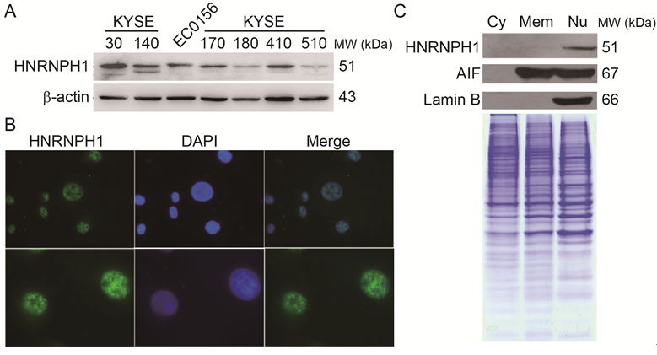
Figure 1 expression and localization of heterogeneous nuclear ribonucleoprotein H1 in esophageal squamous cell carcinoma cells. A: Protein levels of HNRNPH1 were revealed by western blots in seven ESCC cell lines. The β-actin protein was used as a loading control; B: Immunofluorescent visualization of HNRNPH1 in EC0156 cells; C: Subcellular protein levels of HNRNPH1 in EC0156 were revealed by Western blots. Lamin B is the specific marker for the nuclear proteins. AIF is a maker for the intracellular membrane and nuclear proteins. Coomassie blue-stained SDS-PAGE gel was used as the loading control. HNRNPH1: heterogeneous nuclear ribonucleoprotein H1; ESCC: esophageal squamous cell carcinoma.

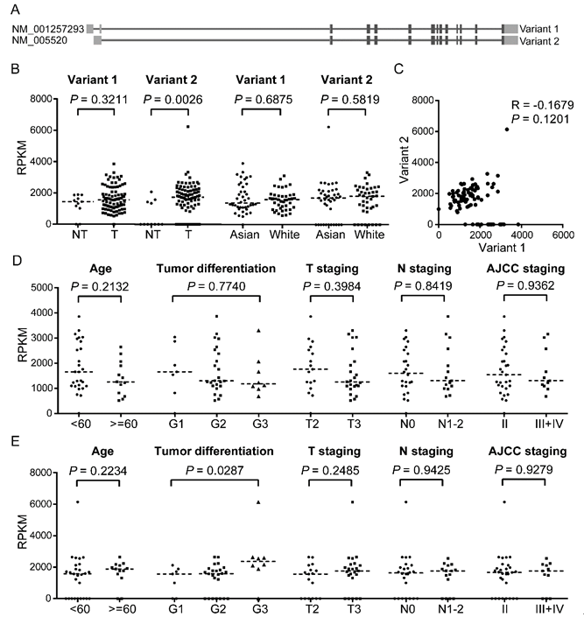
Figure 2 Expression and clinicopathological characteristics of heterogeneous nuclear ribonucleoprotein H1 mRNA presented in the cancer genome atlas RNA sequencing dataset. A: Transcript models for HNRNPH1 in hg19 visualized in the NCBI RefSeq. Human HNRNPH1 is encoded on the reverse strand. Two transcript variants were transcribed with different 5’UTR region. The light grey represents untranslated region, while dark grey represents the coding region; B: These two transcripts had different expression pattern in ESCC. NT, non-tumor tissues (n = 11); T, tumor tissues (n = 87); C: The correlation analysis between variant 1 and 2 in the tumor tissues of ESCC (n = 87). Pearson correlation coefficients were calculated between their mRNA abundances. D-E: The clinicopathological characteristics analysis of variant 1 (D) and variant 2 (E) expression in the Asian ESCC cases (n = 40). T staging, tumor invasive depth; N staging, lymph node metastasis; AJCC staging, the 7th edition cancer staging of American Joint Committee on Cancer. HNRNPH1: heterogeneous nuclear ribonucleoprotein H1; ESCC: esophageal squamous cell carcinoma.

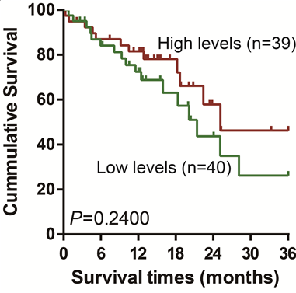
Figure 3 Kaplan–Meier curves of esophageal squamous cell carcinoma patients with low and high levels of variant 2 transcript of heterogeneous nuclear ribonucleoprotein H1 (n = 79). All of the cases were dichotomized into two groups, high level group and low level group, by the median RPKM values in tumor tissues. Log-rank test was used to compare the survival curves (P = 0.2400). HNRNPH1: heterogeneous nuclear ribonucleoprotein H1; ESCC: esophageal squamous cell carcinoma.

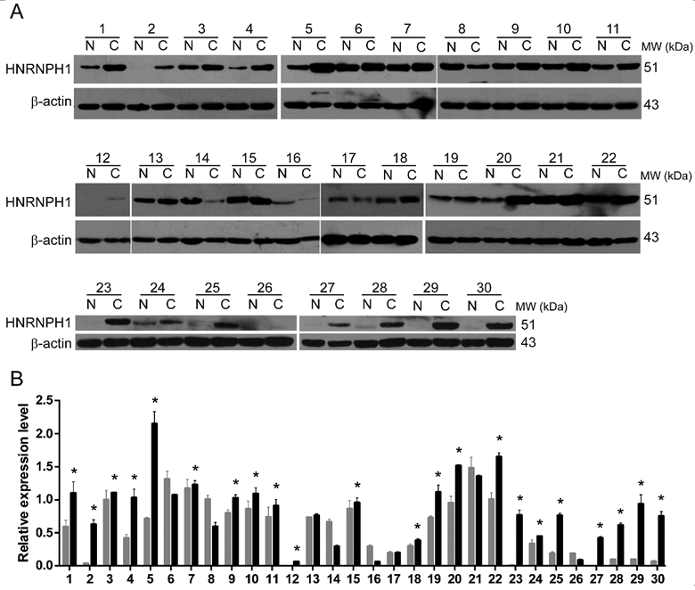
Figure 4 Western blotting analysis of HNRNPH1 in paired ESCC specimens. A: Representative western blotting images of tumor (C) and matched adjacent non-tumor esophageal mucosal tissues (N) from 30 patients with ESCC. β-actin protein levels are shown as a loading control. The patients were coded from 1 to 30. B: Densitometric analysis of 30 ESCC cases. The gray and black bars represent the relative band intensity of HNRNPH1 in non-tumor (N) or tumor (C) tissues. Each data point represents the mean ± SD derived from three independent experiments. The asterisks on the top of the bars marked the cases that overexpressed HNRNPH1 in tumor tissues.

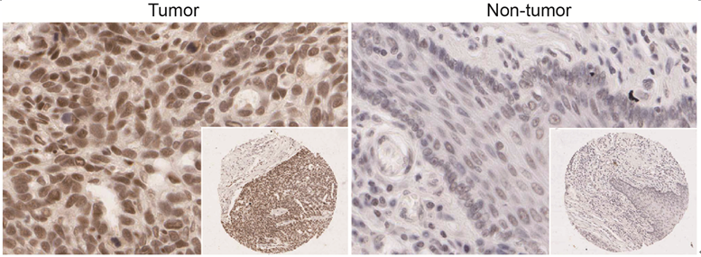
Figure 5 Representative immunohistochemistry staining of heterogeneous nuclear ribonucleoprotein H1 in the tumor and non-tumor tissues from a esophageal squamous cell carcinoma patient. HNRNPH1 was mainly localized to the nuclei. The images are shown at high magnification (x 400), and the lower right panels are × 40 magnification. HNRNPH1: heterogeneous nuclear ribonucleoprotein H1; ESCC: esophageal squamous cell carcinoma.

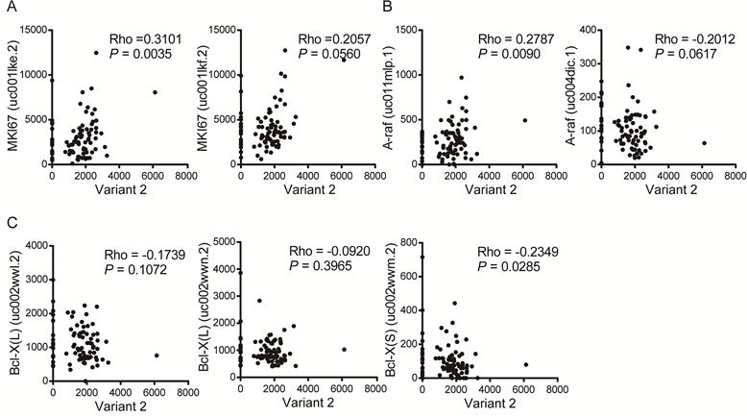
Figure 6 Expression levels of transcript variant 2 of heterogeneous nuclear ribonucleoprotein H1 were associated with the alternative splicing of proliferation- and apoptosis-related genes in esophageal squamous cell carcinoma. A: The correlation analysis between variant 2 and the two transcripts of MKI67 gene; B: The correlation analysis between variant 2 and A-raf gene; C: The correlation analysis between variant 2 and Bcl-X gene. HNRNPH1: heterogeneous nuclear ribonucleoprotein H1; ESCC: esophageal squamous cell carcinoma.

Table 1 Expression of heterogeneous nuclear ribonucleoprotein H1 protein and its clinical significance in 125 esophageal squamous cell carcinoma specimens
Characteristics | All cases (n) | HNRNPH1 |  |  | P value¹
 |  | Negative (%) | Weak (%) | Strong (%)
Tissues
Normal | 125 | 53 (42.4) | 44 (35.2) | 28 (22.4) | 0.0005
Cancer | 125 | 49 (39.2) | 22 (17.6) | 54 (43.2)
Age (yr) |  |  |  |  | 0.5422
≥ 60 | 71 | 26 (36.6) | 16 (22.5) | 29 (40.8)
< 60 | 54 | 23 (42.6) | 6 (11.1) | 25 (46.3)
Gender |  |  |  |  | 0.9615
Male | 90 | 34 (37.8) | 17 (18.9) | 39 (43.3)
Female | 35 | 15 (42.9) | 5 (14.2) | 15 (42.9)
Tumor differentiation |  |  |  |  | 0.0652
Well | 29 | 15 (51.7) | 5 (17.2) | 9 (31.1)
Moderately | 72 | 26 (36.1) | 16 (22.2) | 30 (41.7)
Poorly | 24 | 8 (33.3) | 1 (4.2) | 15 (62.5)
Tumor differentiation |  |  |  |  | 0.0337
Well + moderately | 101 | 41 (40.6) | 21 (20.8) | 39 (38.6)
poorly | 24 | 8 (33.3) | 1 (4.2) | 15 (62.5)
Lymph Node Metastasis² |  |  |  |  | 0.1839
Present | 42 | 14 (33.3) | 9 (21.4) | 19 (45.2)
Not Present | 36 | 18 (50.0) | 7 (19.4) | 11 (30.6)
¹The strong expression of HNRNPH1 was compared with negative and weak expression; ²Only 78 cases have the information of lymph node metastasis. HNRNPH1: heterogeneous nuclear ribonucleoprotein H1; ESCC: esophageal squamous cell carcinoma.

