Name of journal: World Journal of Radiology
ESPS Manuscript NO: 9188
Columns: Review

Vascular anomalies: A pictorial review of nomenclature, diagnosis and treatment

Nosher JL et al. Pictorial review of vascular anomalies

John L Nosher, Philip G Murillo, Mark Liszewski, Vyacheslav Gendel, Christopher E Gribbin

John L Nosher, Philip G Murillo, Mark Liszewski, Vyacheslav Gendel, Christopher E Gribbin, Department of Radiology, Rutgers Medical School, Robert Wood Johnson University Hospital, New Brunwick, NJ 08901, United States

Author contributions: All authors contributed textual and illustrative material to this paper.

Correspondence to: John L Nosher, MD, Department of Radiology, Rutgers Medical School, Robert Wood Johnson University Hospital, 1 Robert Wood Johnson Place, MEB404, New Brunswick, NJ 08901, United States. vgendel@gmail.com
Telephone: +1-732-8283000

Received: January 25, 2014 Revised: July 13, 2014
Accepted: July 25, 2014

Published online:

Abstract
Vascular anomalies, including vascular malformations and tumors, are frequently straightforward to detect; however, accurate diagnosis and appropriate treatment are often challenging. Misdiagnosis of these lesions can lead clinicians in the wrong direction when treating these patients, which can have unfavorable results. This review presents an overview of the classification systems that have been developed for the diagnosis of vascular lesions with a focus on the imaging characteristics. Pictorial examples of each lesion on physical examination, as well as non-invasive and minimally invasive imaging are presented. An overview of the endovascular treatment of these lesions is also given. In some cases, vascular anomalies may be associated with an underlying syndrome and several of the most commonly encountered syndromes are discussed. Understanding of the classification systems, familiarity with the treatment options and knowledge of the associated syndromes are essential for all physicians working with this patient population. The approach to the described entities necessitates an organized multi-disciplinary team effort, with diagnostic imaging playing an increasingly important role in the proper diagnosis and a combined interventional radiologic and surgical treatment method showing promising results.

© 2014 Baishideng Publishing Group Co., Limited. All rights reserved.

Key words: Vascular malformation; Lymphatic malformation; Overgrowth syndromes; Arteriovenous malformation; Hemangioma

Core tip: Accurate diagnosis and appropriate treatment of vascular anomalies are challenging endeavors. This review presents a summary of the classification systems for vascular anomalies, a review of endovascular treatment options, and a brief look at several associated syndromes. Understanding of the diagnosis and treatment of these lesions is essential for all physicians working with this patient population.

Nosher JL, Murillo PG, Liszewski M, Gendel V, Gribbin CE. Vascular anomalies: A pictorial review of nomenclature, diagnosis and treatment. World J Radiol 2014; In press

INTRODUCTION
Anatomist and obstetrician William Hunter first described vascular anomalies in the mid-18th century in the context of iatrogenic creation of arteriovenous fistulas by phlebotomists^{[1]}. Over the next century, description of these and more complex vascular lesions was furthered by the work of Dupuytren, Virchow, and others but the lack of a cohesive system of classification led to confusion, hampering further understanding of these entities. Since that time, categorization of these lesions has advanced from primitive descriptions and disorganized nomenclatures to a more a structured catalogue of classification. Mulliken and Glowacki pioneered this transformation^{[2]}, while the Hamburg classification system further refined it^{[3]}.
Early attempts at classification were based on the pathological appearance of the lesions without consideration for underlying biologic behavior. Terms such as “erectile tumors,” “naevus maternus,” and “stigma metrocelis” were applied without clear delineation^{[2]}. It wasn’t until 1982, when Mulliken and Glowacki introduced a classification system rooted in the pathophysiology of these lesions that much of the confusion surrounding these lesions was clarified^{[2]}. This system divided vascular anomalies into two categories: vascular tumors (hemangiomas) and vascular malformations. This standard was adopted by the International Society for the Study of Vascular Anomalies (ISSVA)^{[3, 4]} and continues to be embraced by many clinicians in current practice. Subsequent modifications to this classification system have included the addition of other rare vascular tumors distinct from hemangiomas, including tufted angioma, Kaposiform hemangioendothelioma, angiosarcoma and others. With these additions, vascular anomalies continue to be divided into two categories: vascular tumors, which include hemangiomas, and vascular malformations. Several years later, the Hamburg classification system adopted an embryologic perspective to further aid in the classification of vascular malformations^{[3]}. Lesions are identified first based on the prevailing vascular structure involved- arterial, venous, lymphatic, or capillary, also considering arteriovenous shunting and combined vascular defects^{[3]}. The embryological background of the lesion is then considered for additional delineation^{[5]}. Extratruncular lesions result from developmental arrest in the early reticular embryonic stage, prior to the development of vascular trunks. Extratruncular malformations may be infiltrating and diffuse or limited and localized. Truncular lesions result from a defect occurring during the stage of fetal development following the reticular stage, as the vascular trunks are developing. Truncular forms develop from stenosis or obstruction of vascular trunks, with resulting hypoplasia, or dilatation of vascular trunks, which in turn may be localized or diffuse^{[6]}.

VASCULAR TUMORS
In their seminal paper, Mulliken and Glowacki^{[2]}, reported vascular tumors – then referred to as hemangiomas – to demonstrate specific mitotic activity and eventual involution, setting them apart from vascular malformations. Much has been discovered about vascular tumors, and while beyond the scope of this discussion, this information encompasses a variety of different entities. These include but are not limited to infantile hemangiomas and rapidly involuting and noninvoluting congenital hemangiomas, as well as more aggressive tumors, such as tufted angiomas, Kaposiform hemangioendotheliomas, and angiosarcomas.
Infantile hemangiomas are the most common tumor of infancy and childhood affecting up to 12% of children with a female preponderance^{[7, 8]}. Histologically, these lesions stain positively for glucose transporter-1 protein (GLUT-1). Tumors typically appear between 2 wk and 2 mo of life and follow a proliferating phase, an involuting phase, and a state of complete involution^{[9, 10]}.
Congenital hemangiomas are tumors that demonstrate intrauterine development with growth completed at birth^{[11]}. These lesions more commonly affect the extremities, close to the joint, or on the head and neck, close to the ear^{[12]}. In contrast to infantile hemangiomas, these lesions stain negative for GLUT-1^{[11, 12]}. Lesions are divided into two categories based on biologic activity: rapidly involuting congenital hemangiomas (RICHs) and noninvoluting congenital hemangiomas (NICHs). RICHs typically regress within 6-14 mo while NICHs do not regress and have a tendency for progression, usually leading to surgical excision^{[12]}.
Kaposiform hemangioendothelioma (Figure 1) is a rare vascular neoplasm, which usually arises in the skin and infiltrates into the deeper tissues over time. Most cases are associated with consumptive coagulopathy or Kasabach-Merritt Syndrome, as well as lymphangiomatosis^{[13]}.

VASCULAR MALFORMATIONS
Vascular malformations are structural lesions resulting from errors of vascular morphogenesis^{[2]}. Differentiation of vascular malformations into high flow, low flow or mixed lesions is critical in developing treatment strategies. The distinction of truncal from extratruncal may provide insight in predicting response to treatment.

IMAGING OF VASCULAR ANOMALIES
Several noninvasive imaging modalities are useful in characterizing vascular anomalies, contributing information about lesion size, flow characteristics and relationship to adjacent structures^{[14]}. Conventional radiography plays a minor role, though may be valuable in defining bone and joint involvement and presence of phleboliths^{[14]} (Figure 2A). Contrast enhanced computed tomography (CT) and CT angiograph are useful in evaluating osseous involvement and phleboliths, but also provides information about enhancement, thrombosis, calcification, vascular anatomy and involvement of adjacent structures^{[14]}. The use of ionizing radiation and relatively limited ability to provide information about flow dynamics decreases its usefulness. For these reasons ultrasonography (US) and magnetic resonance imaging (MRI) are the primary noninvasive imaging modalities used in the evaluation of vascular anomalies^{[15]}.
US is indispensable in the evaluation of superficial vascular lesions given its low cost, ease of use, high temporal and spatial resolution, and ability to evaluate flow dynamics^{[14, 16]}. With US, hemangiomas are reliably differentiated from vascular malformations based on depiction of a well-circumscribed solid mass^{[16]}. Hemangiomas and high-flow vascular malformations, including arteriovenous malformations (AVMs) and arteriovenous fistulae (AVFs), demonstrate arterial and venous waveforms on pulsed Doppler US, but are differentiated based on a lack of associated mass in AVMs and AVFs^{[15, 16]}. AVMs and AVFs will contain multiple enlarged subcutaneous arteries and veins on grey scale and color Doppler US with associated low-resistance arterial and venous waveforms on pulsed Doppler US^{[15, 16]}. Low-flow vascular malformations, including venous and lymphatic malformations, can be differentiated from high flow lesions based on Doppler analysis. Venous malformations contain enlarged subcutaneous vessels without an associated mass, are compressible and demonstrate venous flow on color and pulsed Doppler US^{[16]}. Lymphatic malformations are characterized by macrocystic or microcystic spaces with or without debris separated by septae. On color and pulsed Doppler US these cysts will contain no flow, however the septa may contain small arteries and veins^{[16]}. US is limited in its ability to evaluate deep lesions and lesions that involve bone^{[14]}.
MRI is the most valuable modality for imaging vascular anomalies due to its superior contrast resolution, ability to characterize flow dynamics, depiction of deep and adjacent structures and lack of ionizing radiation^{[14]}. Most information needed to characterize a vascular anomaly can be obtained from T1-weighted, fat saturated T2-weighted and gradient echo MR sequences^{[15]}. Basic MR imaging protocols should include each of these sequences in the axial plane along with fast spin echo T2-weighted images in the coronal and sagittal planes^{[15, 17]}. Dynamic contrast-enhanced MRI can provide supporting information about flow dynamics^{[18]} and may also be employed. On MRI, hemangiomas will appear as a mass^{[15, 19]} with flow voids and intermediate signal on T1-weighted images, flow voids and high signal on T2-weigted images, high signal within vessels on gradient echo sequences and arterial enhancement on contrast enhanced images^{[15, 19]}. High-flow vascular malformations including AVMs and AVFs will also demonstrate flow voids and intermediate signal on T1-weighted images, flow voids and high signal on T2-weigted images, high signal within vessels on gradient echo sequences and arterial enhancement on contrast enhanced images, but no associated soft tissue mass^{[14-19]}. Low flow lesions including venous malformations and lymphatic malformations can also be differentiated based on MRI. Venous malformations will appear as multiple serpentine tubular structures or amorphous dilated channels containing intermediate signal on T1 weighted images, high signal on T2 weighted images, intermediate signal on gradient echo sequences and delayed enhancement on dynamic contrast enhanced MRI^{[14-19]}. Flow voids are not seen within venous malformations due to a lack of fast-flowing blood. Lymphatic malformations are characterized by micro- or macrocystic spaces that often contain fluid-fluid levels due to hemorrhage or proteinaceous material within the cysts^{[15]} (Figures 3-5). Cysts will often be hyperintense on T2-weighted images, hypointense on T1 weighted images (though may be iso- to hyperintense depending on proteinaceous contents), and will not enhance^{[15, 19]}. When microcystic, the cystic spaces may not be visible with the fibrovascular stroma seen as regions of intermediate signal on T1-weighted images and high signal on T2-weighted images with associated enhancement on post-contrast images (Figure 2).

Low-Flow Vascular Malformations
Capillary malformations present as flat pink or red macules that do not involute. These lesions result from abnormal morphogenesis of superficial dermal blood vessels, which lead to ectatic papillary dermal capillaries and postcapillary venules^{[20]}. Histologically, these lesions stain positive for fibronectin, von Willebrand factor, and collagenous basement membrane proteins^{[21]}. Particularly, in port wine stains, there is increased expression of vascular endothelial growth factor VEGF-A as well as its most active receptor VEGF-R2, which is suggestive of an underlying mechanism for pathogenesis^{[22]}. These lesions occur in 0.3% of newborns without preponderance for gender^{[23]}. Detection typically occurs at birth, although acquired capillary malformations are rarely identified. Capillary malformations can be seen with several different syndromes as described later.

LYMPHATIC MALFORMATIONS
Lymphatic malformations arise from abnormal development of the lymphatic system during the early phases of angiogenesis and may be diffuse, often described as lymphedema, or localized, commonly described as a lymphangioma^{[20]}. These malformations are typically large, spongy masses that are non-tender. These lesions can affect any area of the body, but there is a propensity for the head and neck, where they are often referred to as cystic hygromas^{[20]}. Sixty five to 75% of lesions present at birth whereas the remainder of cases appear within 2 years of age^{[24]}. While most lesions are sporadic, some are occur as part of syndromes, such as CLOVES (Figure 3). Complications of these lesions may include bleeding or infection for superficial lesions and encroachment on other anatomic structures such as airways or abdominal viscera for deep lesions.
Lymphatic malformations may be macrocystic (Figures 4, 5), consisting of lymphatic spaces arbitrarily defined as greater than two centimeters in diameter, microcystic, or a combination of macrocystic and microcystic. As these lesions are commonly encountered in infants and children ultrasound plays an important role in the diagnosis, staging, and treatment of lymphatic malformations. MR is useful in determining the type and anatomic relationships of lesions but often requires sedation or general anesthesia in children.

Treatment
Sclerotherapy is the primary form of treatment of macrocystic lymphatic malformations. Lesions are punctured under ultrasound guidance and accessed with 3 to 8 French multiholed drainage catheters. The entire contents of the cysts are aspirated and then 25% to 50% of the volume replaced with a sclerosant. The sclerosant is instilled for several hours and then aspirated. Some remove the catheters at this time and re-access the malformation as required, while others leave the catheters in place for serial sclerosis over 24-48 h. Many sclerosants have been described (Table 1), including doxycycline, sodium tetradecyl sulfate (Sotradecol, STS), ethanol, bleomycin, and OK-432 (picibanil). Using bleomycin as a sclerotherapy agent in macrocystic lymphatic malformations has been reported as successful in up to 72% of patients^{[25, 26]}. Using OK-432 (picibanil) has shown success in up to 66.5% of patients, while using doxycycline (Figures 5, 6) has demonstrated success in up to 93%of patients^{[27]}.

Low-Flow Venous Malformations
Venous malformations result from abnormal sprouting or branching during embryonic development. Venous malformations may be focal, multifocal or diffuse and infiltrative. These dysmorphic vascular channels are lined with flattened endothelium^{[2, 20]} and defective smooth muscle, leading to progressive expansion under hydrostatic pressure. Stasis promotes in-situ thrombosis and lysis. Patients present most often with swelling and pain, worse as the day progresses and exacerbated in the standing position. On physical examination there may be an associated dermal capillary malformation. Clinically, these lesions appear as a soft, compressible, blue mass typically within the cutaneous tissues of the face, trunk, and limbs, although involvement of the viscera and bones has also been described^{[28, 29]} (Figure 7). It should be noted that two thirds of all vascular malformations are venous predominant^{[30]}. Although it is felt that there is no gender predisposition, one series did find a female preponderance^{[29, 31]}.

Treatment
Low flow venous malformations may be treated by compression, surgical excision or sclerosis. Treatment should be reserved for symptomatic or cosmetically disfiguring malformations (Figure 8). Sclerosing agents, which comprise the main form of treatment, include STS, polidocanol, and absolute alcohol. Overall, good to excellent results with sclerotherapy have been reported in 53%-100% patients, depending on the size and definition of the treated lesion^{[14, 32-36]}. Technical success rates using absolute alcohol have been reported in up to 95% with no evidence of recurrence^{[32]}. Studies looking at STS have reported moderate to excellent clinical results in 68%-86% of patients^{[33, 37, 38]}. Polidocanol has shown a treatment benefit in 78%-100% of patients^{[33, 39, 40]}.
Access to the venous vascular malformation is generally achieved by direct puncture, utilizing ultrasound guidance. A butterfly needle is frequently utilized for more superficial malformations. Venography is then performed, and the volume of contrast administered to fill the malformation is noted. The appearance of any outflow into the deep venous structures is also noted. The malformation is emptied of as much blood as possible to increase contact of the sclerosant with the vein wall. Compression of previously visualized outflow veins is applied with tourniquets or direct pressure (Figure 9). Sclerosant is then injected, generally at a volume of 50-60% of that which was noted to fill the malformation with contrast. Foam sclerotherapy is ideal for treatment of low flow venous vascular malformations (Figure 10). The sclerosant 3% STS is combined on a one-to-one basis with non-ionic contrast, for a final concentration of 1.5%, and is then foamed according to Tessari’s method^{[41]} with 4 parts of air, or an O2/CO2 mixture, with one part sclerosant. Foaming the sclerosant increases the surface contact of the foam micelles with the endothelium of the malformation (Figure 9). Depending upon the size of the malformation, additional access is obtained and the process is repeated. Large truncular malformations may require coil embolization or balloon occlusion of larger outflow veins, in addition to sclerotherapy.

HIGH FLOW VASCULAR MALFORMATIONS
High flow vascular malformations exhibit variable presentation dependent on location (Figures 11, 12). Superficial lesions may present as a warm painless mass with palpable bruit and associated dilated veins. Skin erosion and bleeding is possible (Figure 12). Deeper lesions may present with steal phenomena as the malformation deprives blood flow from downstream structures. Staging of these lesions can be accomplished by scoring according to the Schobinger clinical staging system^{[20, 42]}. Within this system, stage I describes a phase of quiescence where there is a cutaneous blush and skin warmth. In stage II, there is expansion with a darkening blush, lesion pulsation, as well as a bruit or palpable thrill. Stage III is defined by destruction, namely pain, dystrophic skin changes, ulceration, distal ischemia, and steal. Finally, stage IV is marked by decompensation or high output cardiac failure.
High flow vascular malformations include macrofistulas, or truncular malformations, that consist of single or multiple arteries directly communicating with outflow veins without an interposed high resistance capillary system. In contrast, arteriovenous malformations, which are often extratruncular, consist of a low resistance nidus recruiting blood supply from numerous regional inflow arteries and draining by multiple outflow veins.

Treatment
Macrofistulous malformations are treated by coil occlusion of the fistula at the distal arterial end of the communication. Accurate oversizing of the coils is essential to eliminate systemic embolization of the coil. The use of detachable coils, released only when satisfactory placement is achieved, may increase the safety of the procedure (Figure 13). In addition to coils, occlusion devices such as the Amplatzer occluder device (St. Jude Medical, Plymouth, MN, United States) may be considered.
The goal in the treatment of high flow arteriovenous vascular malformations is eradication of the nidus. This is best accomplished with a liquid embolic agent, which will penetrate the feeding vessels into the nidus. A coaxial guiding and microcatheter system is advanced toward the nidus and repeat angiography is performed to determine the volume of embolic agent required to penetrate and fill the nidus.
Particulate agents, such as polyvinyl alcohol (PVA)^{[43, 44]} may be used independently or in conjunction with liquid embolic agents. Particulate agents do not generally provide complete occlusion, and recanalization may occur (Figure 14).
A commonly employed embolic agent is n-butyl cyanoacrylate (n-BCA), commonly referred to as "glue." n-BCA is a non-adherent liquid in a nonionic environment that rapidly polymerizes in an ionic environment. Polymerization rate is decreased by mixing with increasing volumes of Ethiodol, permitting progressively distal penetration. Selecting the ideal ratio of n-BCA/ethiodol permits polymerization to occur within the nidus of the AVM rather than the feeding artery (Figure 15).
An alternative to n-BCA as a liquid embolic agent is Onyx (ev3 Endovascular, Inc., Plymouth, MN, United States)^{[45-47]}. Distal microcatheter placement is essential. The technique of delivery of Onyx differs from glue in that a "plug" of Onyx is first formed around the tip of the microcatheter, preventing retrograde flow after the agent is forced in the direction of the nidus (Figure 15).
Absolute alcohol is an extremely effective alternative liquid agent, which causes protein denaturation and endothelial cell destruction (Figure 16). The treatment success rate of using ethanol in arteriovenous malformations has been reported up to 68% in certain small series^{[48]}. Its efficacy decreases with decreasing concentration, making it difficult to mix with contrast agents and still achieve the same result. It has a greater tendency for peripheral penetration and a higher incidence of non-target injury such as skin necrosis, nerve injury and related complications (Figure 12). Using a balloon occlusion catheter during ethanol delivery may decrease the incidence of complications. Acute pulmonary hypertension, right heart strain, and sudden death during the administration of alcohol have been reported, urging careful monitoring of pulmonary arterial pressures during procedures involving alcohol sclerosis^{[49-51]}.

SYNDROMES ASSOCIATED WITH VASCULAR MALFORMATIONS
While most vascular malformations occur sporadically, some are associated with known syndromes. In some syndromes, the vascular malformation is the predominant source of morbidity, while in the majority of syndromes, the vascular malformation is present in association with other components, which produce the more significant pathology. When considered from the point of view of the vascular malformation, syndromes associated with vascular malformations may be classified according to their flow characteristics. Syndromes involving predominantly the head and neck or characterized by capillary malformations only are well described within the literature and are not included in this review.

Syndromes associated with high flow and mixed vascular malformations
Hereditary hemorrhagic telangiectasia S
Hereditary hemorrhagic telangiectasia (HHT) is an autosomal dominant disorder involving mutations in the transforming growth factor-beta (TGF-b) signaling pathway resulting in irregular cytoskeletal architecture and abnormal vascular tubule formation characterized by telangiectasias and fistulous malformations. Incidence is estimated to be between 1 in 5000 to 8000 with males and females affected equally^{[52, 53]}. Onset of symptoms most commonly occurs within the second and third decades of life. Telangiectasias are seen on mucosal surfaces and associated with epistaxis and gastrointestinal bleeding. Arteriovenous fistulas, particularly in the lung, liver, brain and gastrointestinal tract are a major source of morbidity and mortality.
While 30% of patients with HHT have pulmonary arteriovenous fistulas, 80% of pulmonary arteriovenous fistulas occur in patients with HHT. As these fistulas act as right to left shunts, patients can present with hypoxia, stroke or brain abscess and less frequently hemoptysis or hemothorax. Lesions may be single or multiple. Simple lesions consist of fistulas between a single segmental branch of the pulmonary artery and the pulmonary vein, or complex with multiple segmental pulmonary artery branches supplying the fistula. Fistulas with arterial supply greater than 3 mm in diameter are considered at greatest risk of complication.
Surgical resection of pulmonary arteriovenous fistulas has currently been replaced by transcatheter occlusion. Superselective catheterization of the feeding pulmonary arterial branch close to the site of arteriovenous communication is required for placement of coils. Coil size selection, usually 20% larger than the target artery, is critical to avoid systemic coil embolization. Complete occlusion of each feeding artery is critical. Occasionally, occlusion of the aneurysmal draining vein can precede arterial occlusion in order to prevent systemic coil loss (Figure 17). Success of coil embolization approaches 80% but recanalization of the occluded artery or recruitment of additional feeding arterial supply results in recurrence of the fistula in up to 25% of patients, necessitating retreatment^{[54]}. Careful follow-up of patients, therefore, is essential. Detachable coils or use of the Amplatzer occluder device may increase the safety of the procedure in select cases.

Parkes Weber syndrome
Parkes Weber Syndrome is an OSCVA syndrome^{[55]} (Overgrowth Syndrome with Complex Vascular Anomalies), characterized by extremity overgrowth and vascular anomaly. In contrast to the Klippel Trenaunay syndrome, venous abnormalities are associated with high flow arteriovenous malformations within the hypertrophied extremity. A third component of the syndrome is a cutaneous capillary malformation. Arteriovenous fistulas may form around the time of puberty, and exacerbation of the vascular abnormalities is associated with trauma (Figure 17).

PTEN Hamartoma Syndrome
PTEN mutations promote stimulaton of angiogenesis by the Akt/mTOR pathway^{[56]}. PTEN Hamartoma Syndrome (PHTS) usually involves cutaneous lesions, capillary or capillary venous malformations, typically small deep tissue vascular malformations, and multiple high flow AVMs, associated with hamartomatous lesions^{[55]}. Occasionally, lymphatic and venous malformations may be present. High flow AVMs may be present in the limbs, paraspinal region and dura. They are frequently intramuscular and associated with ectopic fat. The hamartomatous lesion, comprised of vascular clusters, fibrous tissue, large veins and fat, has been termed PTEN hamartoma of soft tissue (PHOST). Cowden syndrome, Bannayan-Riley-Ruvacalba syndrome (BRRS) and some instances of Proteus syndrome are classified together with PHTS. More extensive high flow AVMs are occasionally seen in the BRRS.

Syndromes associated with low flow vascular malformations
Klippel trenaunay syndrome
Klippel trenaunay syndrome (KTS) is another OSCVA syndrome with extremity overgrowth, associated with a superficial vascular stain, venous malformations, and usually partial aplasia of the deep venous system. The syndrome may also involve lymphatic anomalies. The vascular venous vascular malformations in KTS are characterized as truncal malformations, and may be related to persistence of the embryonic dorsal vein system in the lateral aspect of the extremity (lateral marginal vein in the lower extremity). Large varicosities may result in venous thrombosis and pulmonary embolism. Coagulopathy and gram-negative sepsis are also complications. Limb gigantism is especially prominent when there is an associated lymphatic malformation. MRI is the mainstay of imaging in KTS, with sonography reserved for guiding interventions and for distinguishing venous from lymphatic components of malformations (Figures 18, 19). Catheter based venography is occasionally needed to determine the presence, absence or partial aplasia of the deep venous system, when this is not obvious on other imaging modalities.

CLOVES Syndrome
The congenital lipomatous overgrowth, vascular malformations, epidermal nevi, and scoliosis and other skeletal deformities (CLOVES) syndrome consists of truncal lipomatosis, vascular malformations, and acral/musculoskeletal anomalies. The lipomatous lesions are often infiltrative and tend to recur following resection. Skeletal overgrowth and malformation are common in the extremities, as is scoliosis. Vascular lesions include capillary, lymphatic, venous and arteriovenous malformations (Figures 3, 19). In contrast to the Proteus and BRRS syndrome there is no mental impairment. Treatment includes sclerotherapy of lymphatic and venous malformations and resection of lipomatous lesions^{[55]}.

Blue rubber bleb nevus syndrome
This syndrome consists of venous malformations of the skin and those within the gastrointestinal tract. The skin lesions are comprised of a compressible blue subcutaneous nodule, representing a cutaneous venous malformation. Clinical consequences generally result from gastrointestinal venous malformations, which may lead to occult or frank gastrointestinal bleeding.

Maffucci syndrome
In this syndrome, enchondromas are found in coexistence with venous malformations. There is a high frequency of malignant transformation of the enchondromas into chondrosarcomas.

Generalized Lymphatic Anomaly and Gorham-Stout disease
Generalized Lymphatic Anomaly (GLA) and Gorham-Stout Disease (GSA) are two different disorders of the lymphatic system with overlapping features^{[57]}. GLA is synonymous with “generalized cystic lymphangiomatosis”, “cystic angiomatosis” and “lymphangiomatosis,” though the term GLA is preferred based on the ISSVA classification system. GLA is a multisystem disorder characterized by dilated lymphatic vessels^{[58, 59]}. Features of GLA may include splenic cysts, hepatic cysts, pleural effusions, and macrocytic lymphatic malformations, which may involve several organ systems, including bone^{[57-59]}. On imaging, osseous lesions in GLA are seen as lucent lesions within the medullary cavity on radiography and display hyperintensity on T2-weighted MR imaging, but do not demonstrate cortical destruction^{[57, 60]}. Numerous bones are typically affected in GLA, and the axial and appendicular skeleton are both affected with similar frequency^{[57]}. In cases of osseous involvement, patients may present with pain and pathologic fracture (Figure 20).
Gorham-Stout disease, which has been called “vanishing bone disease,” is also a vascular anomaly of the lymphatics characterized by proliferation of lymphatic vessels within bone, resulting in progressive bony destruction^{[61]}. Though the skeletal system is the primary site of disease in GSD, extra-osseous findings are also seen in GSD and include pleural effusions, splenic cysts, hepatic cysts, and infiltrating soft tissue abnormalities, which may extend from the bone into the adjacent soft tissues^{[57]}. On imaging, osseous lesions are lytic, as in GLA, but are characterized by progressive osseous resorption and cortical destruction. On MRI, osseous lesions in GSD are most frequently accompanied by infiltrating soft tissue signal that is iso-to hypointense to muscle on T1-weighted images, hyperintense and heterogeneous on T2 weighted images, and enhances with contrast^{[57, 62]}. Infiltrative soft tissue is less common in GLA, which is seen in a minority of cases^{[57]}. Unlike GLA, which affects the appendicular and axial skeleton with similar frequency, the axial skeleton is more commonly affected in GSD, with appendicular involvement seen in a minority of cases^{[57]}. Macrocytic lymphatic malformations are infrequently seen in GSD^{[57]}. As in GLA, patients with GSD may present with pain and pathologic fracture.

CONCLUSION
Accurate diagnosis of vascular malformations and their associated syndromes is often challenging but crucial in the formulation of appropriate treatment. The approach to the described entities requires an organized multi-disciplinary team effort, with diagnostic imaging playing an increasingly important role in the proper diagnosis and a combined interventional radiologic and surgical treatment method showing promising results.

REFERENCES
1Yaşargil MG. Microneurosurgery: AVM of the Brain, History, Embryology, Pathological Considerations, Hemodynamics, Diagnostic Studies, Microsurgical Anatomy. Vol. IIIA: Thieme, 1987
2 Mulliken JB, Glowacki J. Hemangiomas and vascular malformations in infants and children: a classification based on endothelial characteristics. Plast Reconstr Surg 1982; 69: 412-422 [PMID: 7063565 DOI: 10.1097/00006534-198203000-00002]
3 Belov S. Anatomopathological classification of congenital vascular defects. Semin Vasc Surg 1993; 6: 219-224 [PMID: 8305976]
4 Enjolras O, Wassef M, Chapot R. Color atlas of vascular tumors and vascular malformations. New York: Cambridge University Press, 2007: 1–11
5 Lee BB, Laredo J, Lee TS, Huh S, Neville R. Terminology and classification of congenital vascular malformations. Phlebology 2007; 22: 249-252 [PMID: 18274331 DOI: 10.1258/026835507782655236]
6 Lee BB, Lardeo J, Neville R. Arterio-venous malformation: how much do we know? Phlebology 2009; 24: 193-200 [PMID: 19767485 DOI: 10.1258/phleb.2009.009032]
7 Bree AF, Siegfried E, Sotelo-Avila C, Nahass G. Infantile hemangiomas: speculation on placental trophoblastic origin. Arch Dermatol 2001; 137: 573-577 [PMID: 11346335 DOI: 10-1001/pubs.Arch]
8 Chiller KG, Passaro D, Frieden IJ. Hemangiomas of infancy: clinical characteristics, morphologic subtypes, and their relationship to race, ethnicity, and sex. Arch Dermatol 2002; 138: 1567-1576 [PMID: 12472344 DOI: 10.1001/archderm.138.12.1567]
9 Moore CW, Lowe LH. Caffey’s Pediatric Diagnostic Imaging. Philadelphia, PA, Mosby Elsevier, 2008: 1929-1948
10 Haggstrom AN, Drolet BA, Baselga E, Chamlin SL, Garzon MC, Horii KA, Lucky AW, Mancini AJ, Metry DW, Newell B, Nopper AJ, Frieden IJ. Prospective study of infantile hemangiomas: clinical characteristics predicting complications and treatment. Pediatrics 2006; 118: 882-887 [PMID: 16950977 DOI: 10.1542/peds.2006-0413]
11 Krol A, MacArthur CJ. Congenital hemangiomas: rapidly involuting and noninvoluting congenital hemangiomas. Arch Facial Plast Surg 2005; 7: 307-311 [PMID: 16172338 DOI: 10.1001/archfaci.7.5.307]
12 Mulliken JB, Enjolras O. Congenital hemangiomas and infantile hemangioma: missing links. J Am Acad Dermatol 2004; 50: 875-882 [PMID: 15153887 DOI: 10.1016/j.jaad.2003.10.670]
13 Fernández Y, Bernabeu-Wittel M, García-Morillo JS. Kaposiform hemangioendothelioma. Eur J Intern Med 2009; 20: 106-113 [PMID: 19327597 DOI: 10.1016/j.ejim.2008.06.008]
14 Hyodoh H, Hori M, Akiba H, Tamakawa M, Hyodoh K, Hareyama M. Peripheral vascular malformations: imaging, treatment approaches, and therapeutic issues. Radiographics 2005; 25 Suppl 1: S159-S171 [PMID: 16227489 DOI: 10.1148/rg.25si055509]
15 Donnelly LF, Adams DM, Bisset GS. Vascular malformations and hemangiomas: a practical approach in a multidisciplinary clinic. AJR Am J Roentgenol 2000; 174: 597-608 [PMID: 10701595 DOI: 10.2214/ajr.174.3.1740597]
16 Paltiel HJ, Burrows PE, Kozakewich HP, Zurakowski D, Mulliken JB. Soft-tissue vascular anomalies: utility of US for diagnosis. Radiology 2000; 214: 747-754 [PMID: 10715041 DOI: 10.1148/radiology.214.3.r00mr21747]
17 Rak KM, Yakes WF, Ray RL, Dreisbach JN, Parker SH, Luethke JM, Stavros AT, Slater DD, Burke BJ. MR imaging of symptomatic peripheral vascular malformations. AJR Am J Roentgenol 1992; 159: 107-112 [PMID: 1609682 DOI: 10.2214/ajr.159.1.1609682]
18 van Rijswijk CS, van der Linden E, van der Woude HJ, van Baalen JM, Bloem JL. Value of dynamic contrast-enhanced MR imaging in diagnosing and classifying peripheral vascular malformations. AJR Am J Roentgenol 2002; 178: 1181-1187 [PMID: 11959728 DOI: 10.2214/ajr.178.5.1781181]
19 Meyer JS, Hoffer FA, Barnes PD, Mulliken JB. Biological classification of soft-tissue vascular anomalies: MR correlation. AJR Am J Roentgenol 1991; 157: 559-564 [PMID: 1872245 DOI: 10.2214/ajr.157.3.1872245]
20 Garzon MC, Huang JT, Enjolras O, Frieden IJ. Vascular malformations: Part I. J Am Acad Dermatol 2007; 56: 353-70; quiz 371-4 [PMID: 17317485 DOI: 10.1016/j.jaad.2006.05.069]
21 Finley JL, Clark RA, Colvin RB, Blackman R, Noe J, Rosen S. Immunofluorescent staining with antibodies to factor VIII, fibronectin, and collagenous basement membrane protein in normal human skin and port wine stains. Arch Dermatol 1982; 118: 971-975 [PMID: 6816146 DOI: 10.1001/archderm.1982.01650240015012]
22 Vural E, Ramakrishnan J, Cetin N, Buckmiller L, Suen JY, Fan CY. The expression of vascular endothelial growth factor and its receptors in port-wine stains. Otolaryngol Head Neck Surg 2008; 139: 560-564 [PMID: 18922344 DOI: 10.1016/j.otohns.2008.07.015]
23 Kanada KN, Merin MR, Munden A, Friedlander SF. A prospective study of cutaneous findings in newborns in the United States: correlation with race, ethnicity, and gestational status using updated classification and nomenclature. J Pediatr 2012; 161: 240-245 [PMID: 22497908 DOI: 10.1016/j.jpeds.2012.02.052]
24 Redondo P. [Classification of vascular anomalies (tumours and malformations). Clinical characteristics and natural history]. An Sist Sanit Navar 2004; 27 Suppl 1: 9-25 [PMID: 15148508]
25 Sainsbury DC, Kessell G, Fall AJ, Hampton FJ, Guhan A, Muir T. Intralesional bleomycin injection treatment for vascular birthmarks: a 5-year experience at a single United Kingdom unit. Plast Reconstr Surg 2011; 127: 2031-2044 [PMID: 21532430 DOI: 10.1097/PRS.0b013e31820e923c]
26 Acevedo JL, Shah RK, Brietzke SE. Nonsurgical therapies for lymphangiomas: a systematic review. Otolaryngol Head Neck Surg 2008; 138: 418-424 [PMID: 18359347 DOI: 10.1016/j.otohns.2007.11.018]
27 Nehra D, Jacobson L, Barnes P, Mallory B, Albanese CT, Sylvester KG. Doxycycline sclerotherapy as primary treatment of head and neck lymphatic malformations in children. J Pediatr Surg 2008; 43: 451-460 [PMID: 18358281 DOI: 10.1016/j.jpedsurg.2007.10.009]
28 Dubois J, Soulez G, Oliva VL, Berthiaume MJ, Lapierre C, Therasse E. Soft-tissue venous malformations in adult patients: imaging and therapeutic issues. Radiographics 2001; 21: 1519-1531 [PMID: 11706222 DOI: 10.1148/radiographics.21.6.g01nv031519]
29 Mazoyer E, Enjolras O, Bisdorff A, Perdu J, Wassef M, Drouet L. Coagulation disorders in patients with venous malformation of the limbs and trunk: a case series of 118 patients. Arch Dermatol 2008; 144: 861-867 [PMID: 18645137 DOI: 10.1001/archderm.144.7.861]
30 Eifert S, Villavicencio JL, Kao TC, Taute BM, Rich NM. Prevalence of deep venous anomalies in congenital vascular malformations of venous predominance. J Vasc Surg 2000; 31: 462-471 [PMID: 10709058 DOI: 10.1067/mva.2000.101464]
31 Boon LM, Mulliken JB, Enjolras O, Vikkula M. Glomuvenous malformation (glomangioma) and venous malformation: distinct clinicopathologic and genetic entities. Arch Dermatol 2004; 140: 971-976 [PMID: 15313813 DOI: 10.1001/archderm.140.8.971]
32 Lee BB, Do YS, Byun HS, Choo IW, Kim DI, Huh SH. Advanced management of venous malformation with ethanol sclerotherapy: mid-term results. J Vasc Surg 2003; 37: 533-538 [PMID: 12618688 DOI: 10.1067/mva.2003.91]
33 Legiehn GM, Heran MK. Venous malformations: classification, development, diagnosis, and interventional radiologic management. Radiol Clin North Am 2008; 46: 545-97, vi [PMID: 18707962 DOI: 10.1016/j.rcl.2008.02.008]
34 Goyal M, Causer PA, Armstrong D. Venous vascular malformations in pediatric patients: comparison of results of alcohol sclerotherapy with proposed MR imaging classification. Radiology 2002; 223: 639-644 [PMID: 12034929 DOI: 10.1148/radiol.2233010025]
35 Rautio R, Saarinen J, Laranne J, Salenius JP, Keski-Nisula L. Endovascular treatment of venous malformations in extremities: results of sclerotherapy and the quality of life after treatment. Acta Radiol 2004; 45: 397-403 [PMID: 15323391 DOI: 10.1080/02841850410004913]
36 Rimon U, Garniek A, Galili Y, Golan G, Bensaid P, Morag B. Ethanol sclerotherapy of peripheral venous malformations. Eur J Radiol 2004; 52: 283-287 [PMID: 15544907 DOI: 10.1016/j.ejrad.2003.09.010]
37 Tan KT, Kirby J, Rajan DK, Hayeems E, Beecroft JR, Simons ME. Percutaneous sodium tetradecyl sulfate sclerotherapy for peripheral venous vascular malformations: a single-center experience. J Vasc Interv Radiol 2007; 18: 343-351 [PMID: 17377179 DOI: 10.1016/j.jvir.2006.12.735]
38 O'Donovan JC, Donaldson JS, Morello FP, Pensler JM, Vogelzang RL, Bauer B. Symptomatic hemangiomas and venous malformations in infants, children, and young adults: treatment with percutaneous injection of sodium tetradecyl sulfate. AJR Am J Roentgenol 1997; 169: 723-729 [PMID: 9275886 DOI: 10.2214/ajr.169.3.9275886]
39 Pascarella L, Bergan JJ, Yamada C, Mekenas L. Venous angiomata: treatment with sclerosant foam. Ann Vasc Surg 2005; 19: 457-464 [PMID: 15981122 DOI: 10.1007/s10016-005-4656-z]
40 Jain R, Bandhu S, Sawhney S, Mittal R. Sonographically guided percutaneous sclerosis using 1% polidocanol in the treatment of vascular malformations. J Clin Ultrasound 2002; 30: 416-423 [PMID: 12210459 DOI: 10.1002/jcu.10091]
41 Tessari L, Cavezzi A, Frullini A. Preliminary experience with a new sclerosing foam in the treatment of varicose veins. Dermatol Surg 2001; 27: 58-60 [PMID: 11231246 DOI: 10.1111/j.1524-4725.2001.00192.x]
42 Kohout MP, Hansen M, Pribaz JJ, Mulliken JB. Arteriovenous malformations of the head and neck: natural history and management. Plast Reconstr Surg 1998; 102: 643-654 [PMID: 9727427]
43 Simons ME. Peripheral vascular malformations: diagnosis and percutaneous management. Can Assoc Radiol J 2001; 52: 242-251 [PMID: 11512297]
44 Patel AA, Solomon JA, Soulen MC. Pharmaceuticals for Intra-arterial Therapy. Semin Intervent Radiol 2005; 22: 130-138 [PMID: 21326683 DOI: 10.1055/s-2005-871868]
45 Vanninen RL, Manninen I. Onyx, a new liquid embolic material for peripheral interventions: preliminary experience in aneurysm, pseudoaneurysm, and pulmonary arteriovenous malformation embolization. Cardiovasc Intervent Radiol 2007; 30: 196-200 [PMID: 17205359 DOI: 10.1007/s00270-006-0071-2]
46 Castaneda F, Goodwin SC, Swischuk JL, Wong GC, Bonilla SM, Wang MJ, Abdel-Sayed PS. Treatment of pelvic arteriovenous malformations with ethylene vinyl alcohol copolymer (Onyx). J Vasc Interv Radiol 2002; 13: 513-516 [PMID: 11997360 DOI: 10.1016/S1051-0443(07)61532-2]
47 Rautio R, Haapanen A. Transcatheter embolization of a renal artery aneurysm using ethylene vinyl alcohol copolymer. Cardiovasc Intervent Radiol 2007; 30: 300-303 [PMID: 17206392 DOI: 10.1007/s00270-005-0238-2]
48 Do YS, Yakes WF, Shin SW, Lee BB, Kim DI, Liu WC, Shin BS, Kim DK, Choo SW, Choo IW. Ethanol embolization of arteriovenous malformations: interim results. Radiology 2005; 235: 674-682 [PMID: 15858106 DOI: 10.1148/radiol.2352040449]
49 Shin BS, Do YS, Lee BB, Kim DI, Chung IS, Cho HS, Kim MH, Kim GS, Kim CS, Byun HS, Shin SW, Park KB. Multistage ethanol sclerotherapy of soft-tissue arteriovenous malformations: effect on pulmonary arterial pressure. Radiology 2005; 235: 1072-1077 [PMID: 15833991 DOI: 10.1148/radiol.2353040903]
50 Ko JS, Kim JA, Do YS, Kwon MA, Choi SJ, Gwak MS, Lee JJ, Yang M. Prediction of the effect of injected ethanol on pulmonary arterial pressure during sclerotherapy of arteriovenous malformations: relationship with dose of ethanol. J Vasc Interv Radiol 2009; 20: 39-45; quiz 45 [PMID: 19028113 DOI: 10.1016/j.jvir.2008.10.012]
51 Chapot R, Laurent A, Enjolras O, Payen D, Houdart E. Fatal cardiovascular collapse during ethanol sclerotherapy of a venous malformation. Interv Neuroradiol 2002; 8: 321-324 [PMID: 20594492]
52 Dakeishi M, Shioya T, Wada Y, Shindo T, Otaka K, Manabe M, Nozaki J, Inoue S, Koizumi A. Genetic epidemiology of hereditary hemorrhagic telangiectasia in a local community in the northern part of Japan. Hum Mutat 2002; 19: 140-148 [PMID: 11793473 DOI: 10.1002/humu.10026]
53 Schoen FJ. Cotran RS, Vinay K, Collins T. Robbins Pathologic Basis of Disease. 5th. WB Saunders; 1994: 509.
54 Woodward CS, Pyeritz RE, Chittams JL, Trerotola SO. Treated pulmonary arteriovenous malformations: patterns of persistence and associated retreatment success. Radiology 2013; 269: 919-926 [PMID: 23912618 DOI: 10.1148/radiol.13122153]
55 Alomari AI. Characterization of a distinct syndrome that associates complex truncal overgrowth, vascular, and acral anomalies: a descriptive study of 18 cases of CLOVES syndrome. Clin Dysmorphol 2009; 18: 1-7 [PMID: 19011570 DOI: 10.1097/MCD.0b013e328317a716]
56 Iacobas, I and Burrows, P. PTEN: Structure, Mechanisms-of-Action, Role in Cell Signaling and Regulation. 2013; Nova Science: 215-217.
57 Lala S, Mulliken JB, Alomari AI, Fishman SJ, Kozakewich HP, Chaudry G. Gorham-Stout disease and generalized lymphatic anomaly--clinical, radiologic, and histologic differentiation. Skeletal Radiol 2013; 42: 917-924 [PMID: 23371338 DOI: 10.1007/s00256-012-1565-4]
58 Wunderbaldinger P, Paya K, Partik B, Turetschek K, Hörmann M, Horcher E, Bankier AA. CT and MR imaging of generalized cystic lymphangiomatosis in pediatric patients. AJR Am J Roentgenol 2000; 174: 827-832 [PMID: 10701634 DOI: 10.2214/ajr.174.3.1740827]
59 Rasalkar DD, Chu WC. Generalized cystic lymphangiomatosis. Pediatr Radiol 2010; 40 Suppl 1: S47 [PMID: 20574655 DOI: 10.1007/s00247-010-1694-7]
60 Boyle WJ. Cystic angiomatosis of bone. A report of three cases and review of the literature. J Bone Joint Surg Br 1972; 54: 626-636 [PMID: 4639439]
61 Mavrogenis AF, Zambirinis CP, Dimitriadis PA, Tsakanikas A, Papagelopoulos PJ. Gorham-Stout disease. J Surg Orthop Adv 2010; 19: 85-90 [PMID: 20727303]
62 Ozbayrak M, Yilmaz MH, Kantarci F, Ozer H, Harmanci K, Babacan M, Dervisoglu S. A case of an idiopathic massive osteolysis with skip lesions. Korean J Radiol 2013; 14: 946-950 [PMID: 24265571 DOI: 10.3348/kjr.2013.14.6.946]

P-Reviewer: Behr GG S-Editor: Wen LL L-Editor: E-Editor:

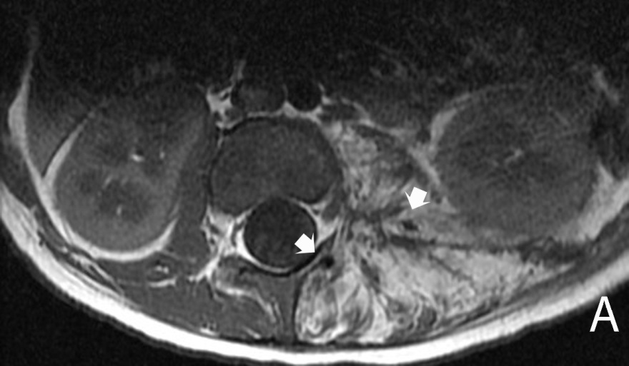

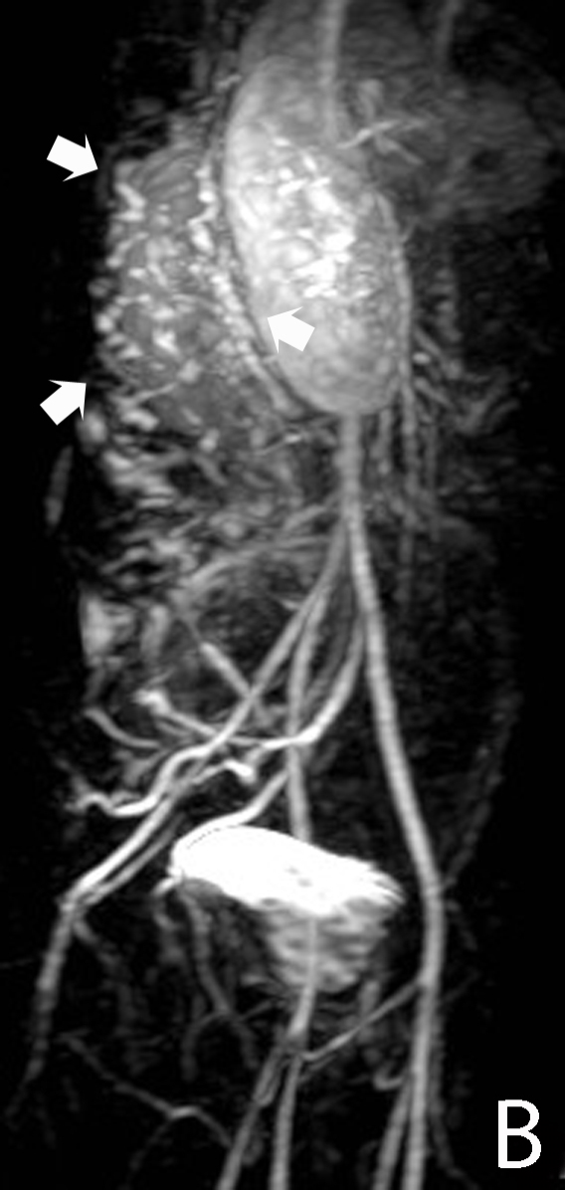

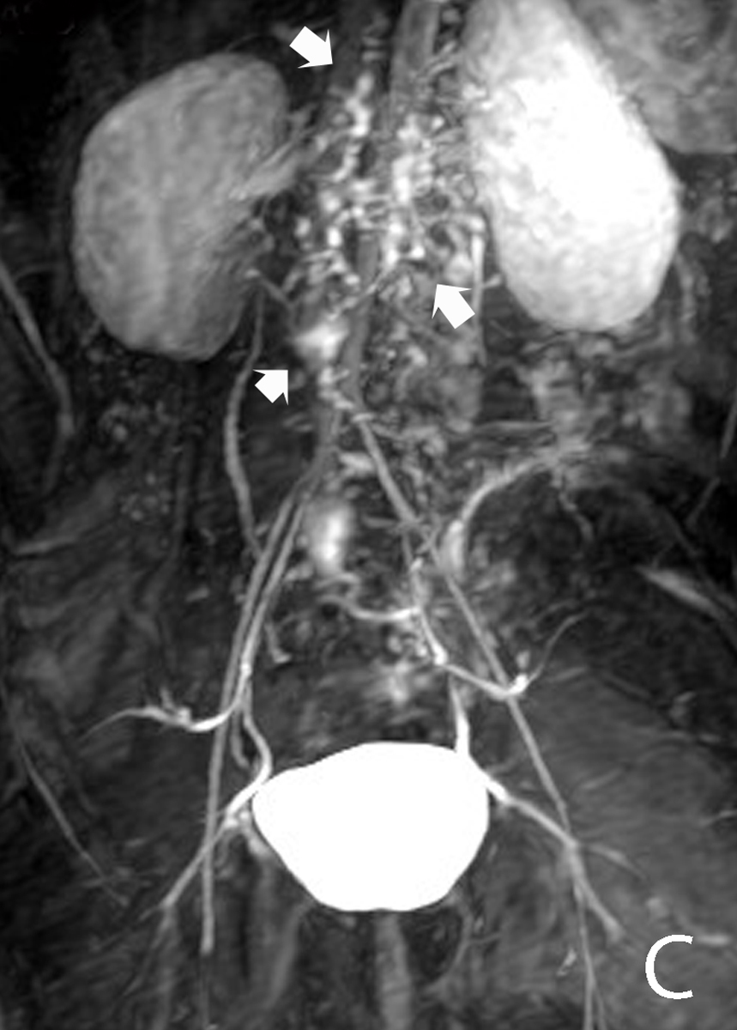
Figure 1 Kaposiform hemangioendothelioma. A: Magnetic resonance (MR) of the retroperitoneum demonstrating infiltrative tumor with fat and interspersed signal void (arrows) consistent with high flow arterial signal; B, C: MR angiogram demonstrating arteriovenous shunting within the tumor (arrows).

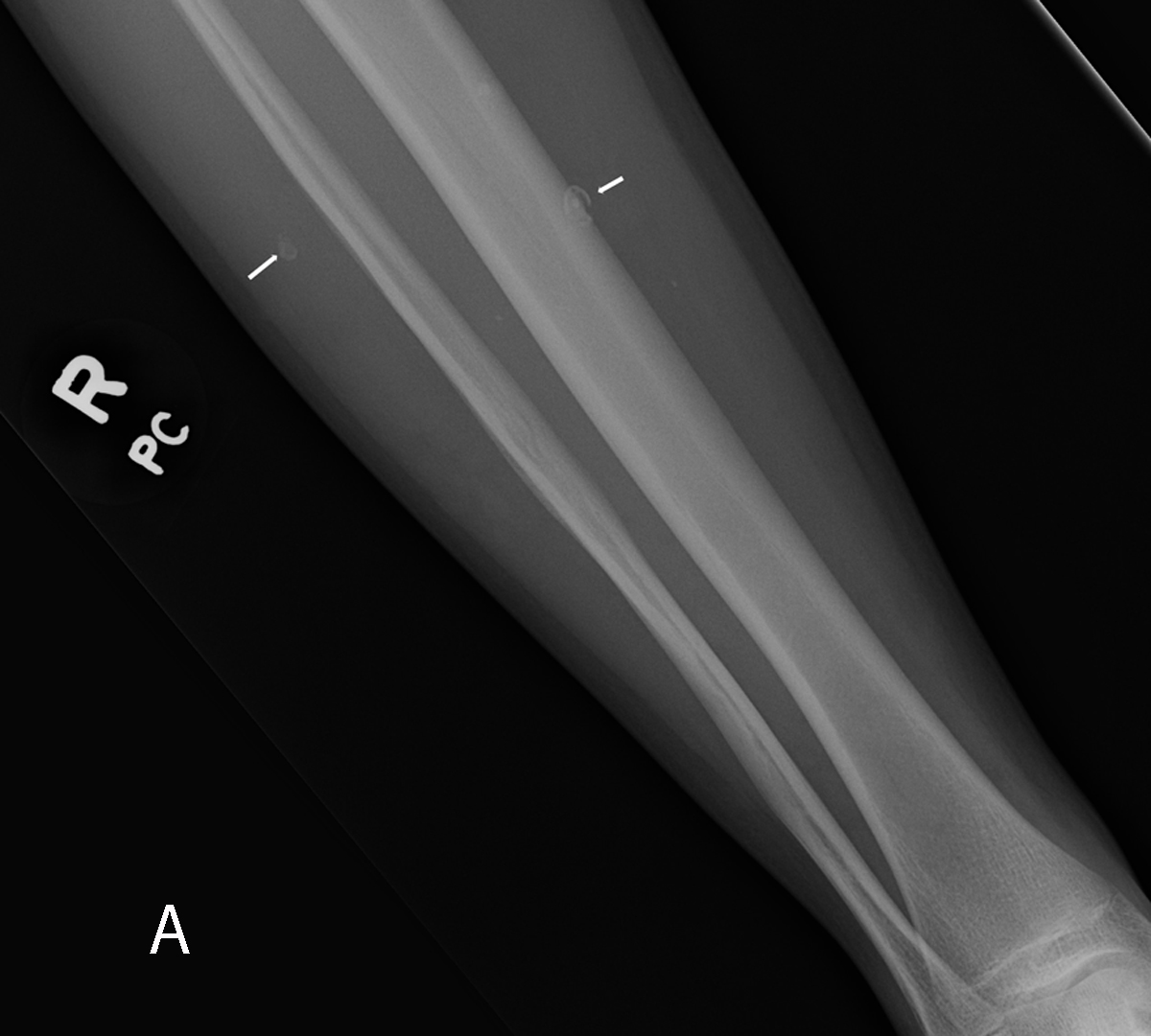

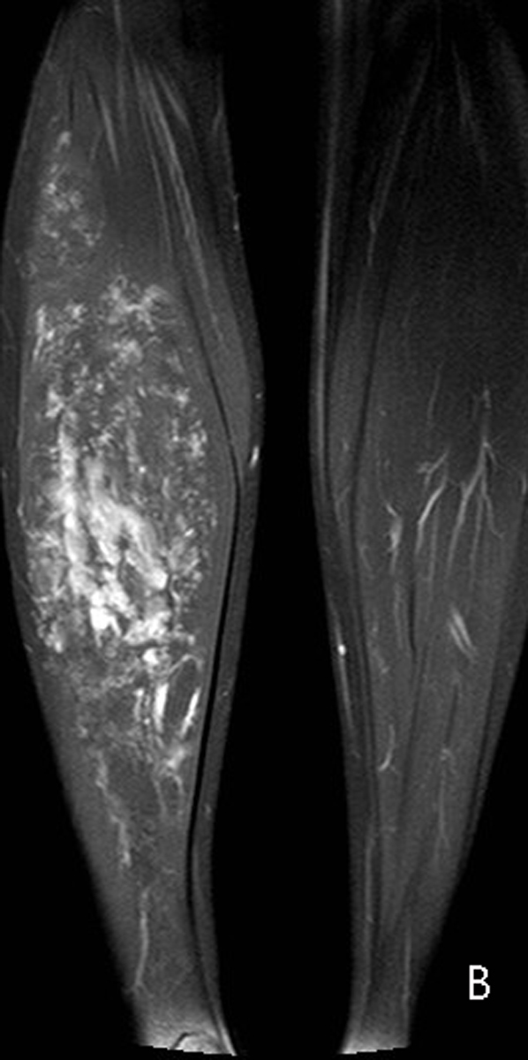
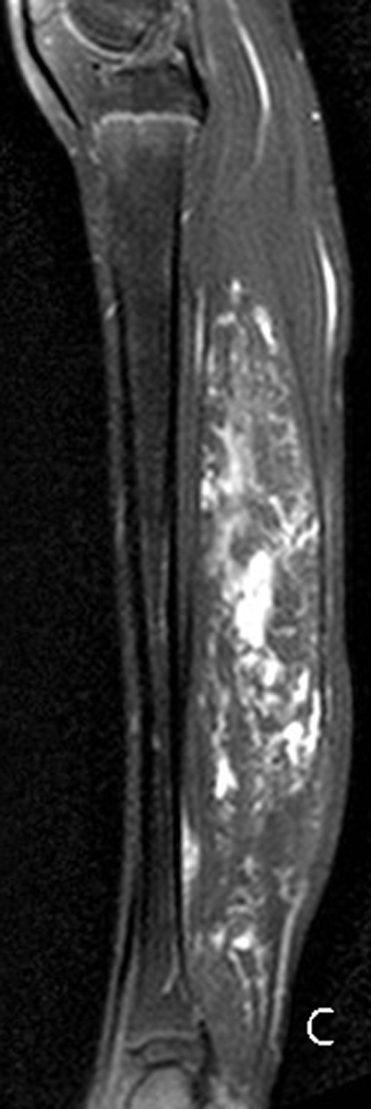

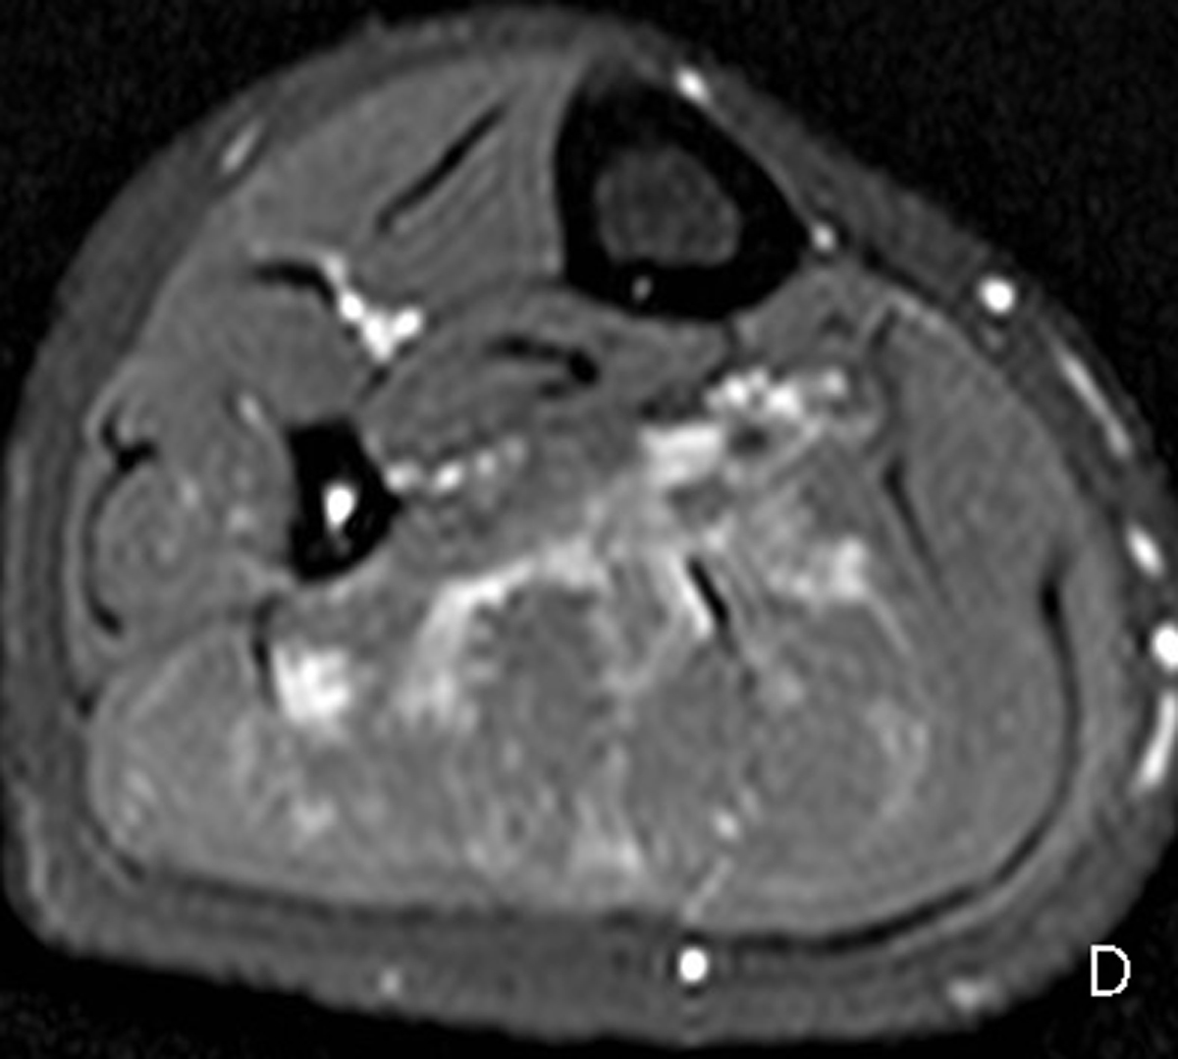
Figure 2 Low flow extratruncular venous malformation. Radiograph of the right lower leg (A) demonstrates phleboliths within the soft tissues (arrows). T2-weighted magnetic resonance images in the coronal (B), sagittal (C), and axial (D) planes demonstrate hyperintense signal within the gastrocnemius muscle due to infiltrative low flow extratruncular venous malformation.

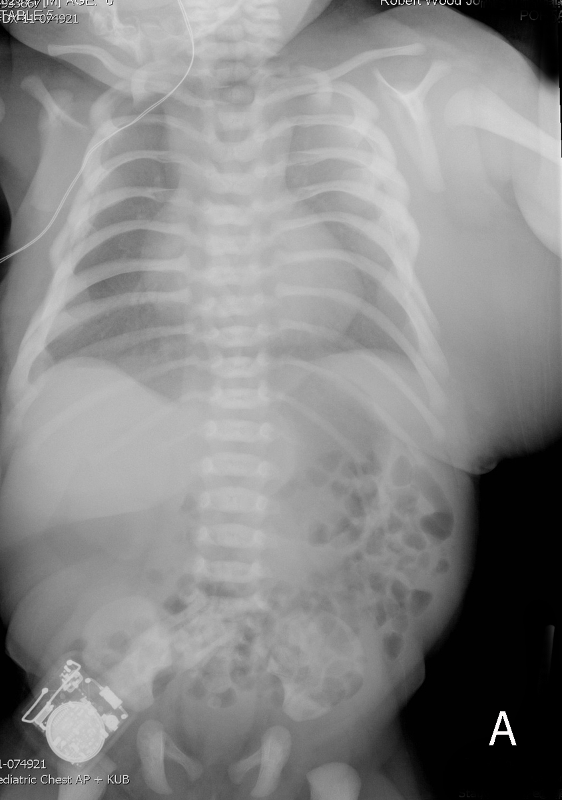
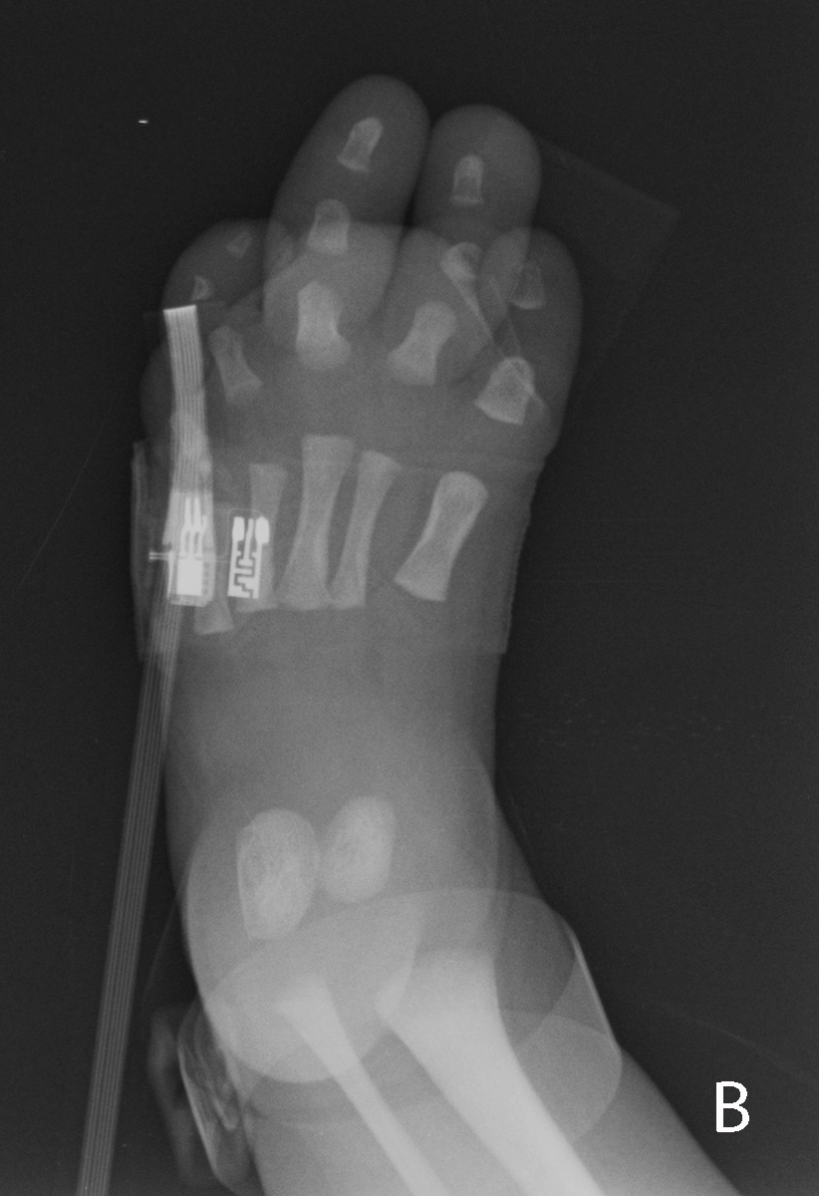
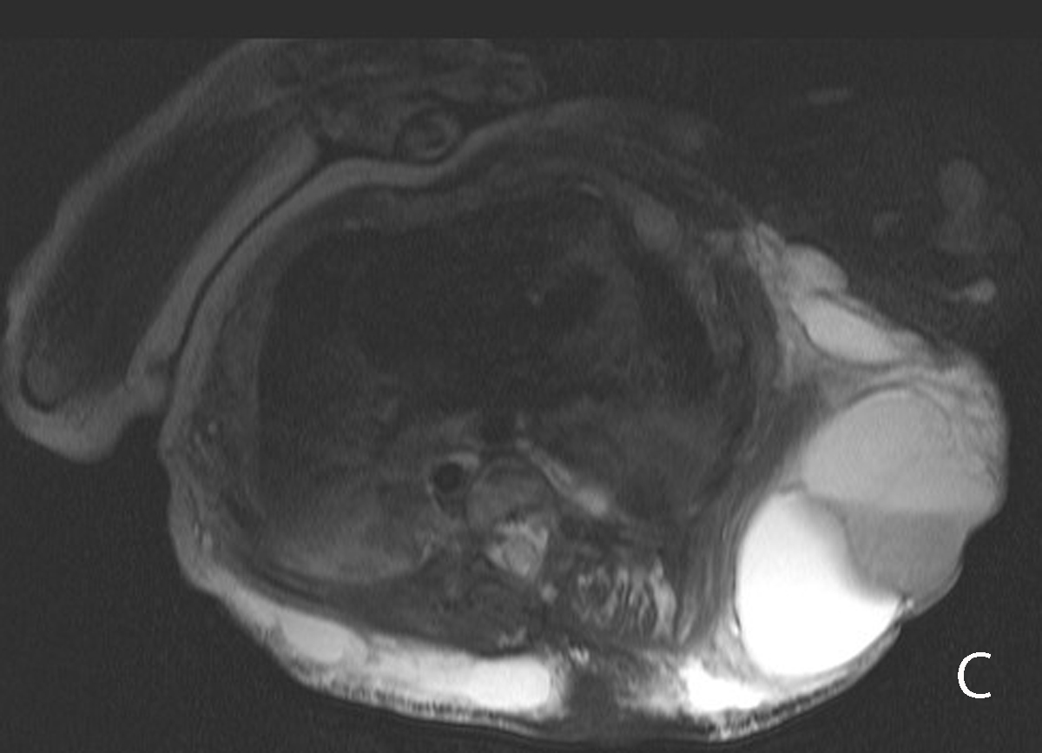

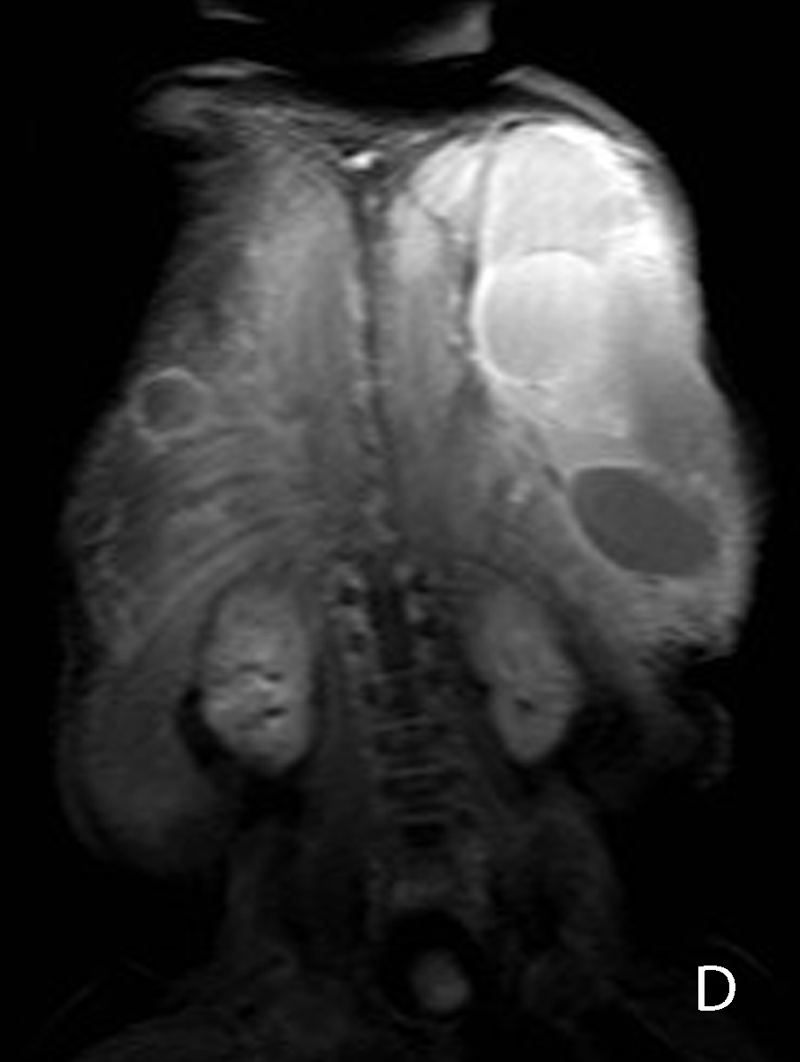
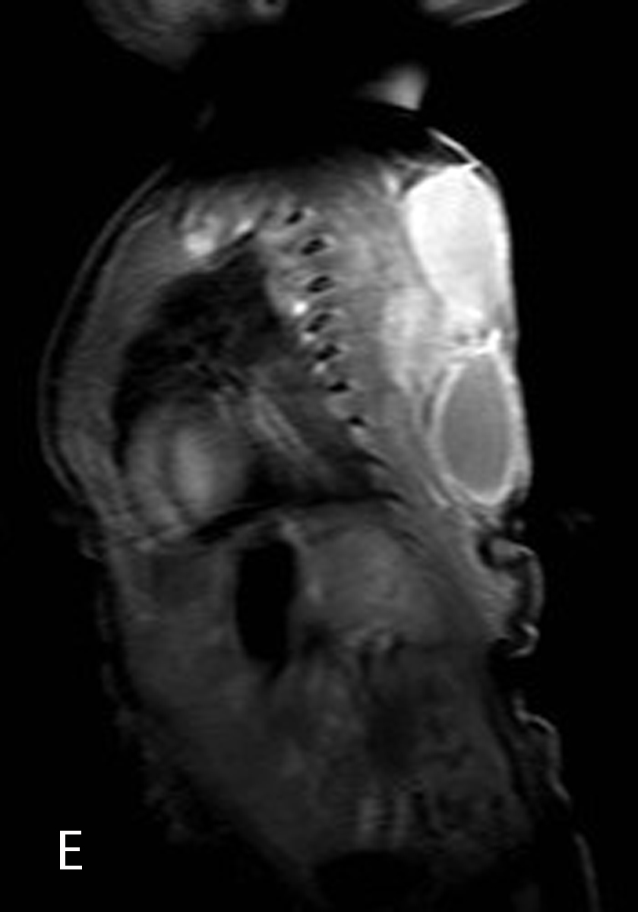

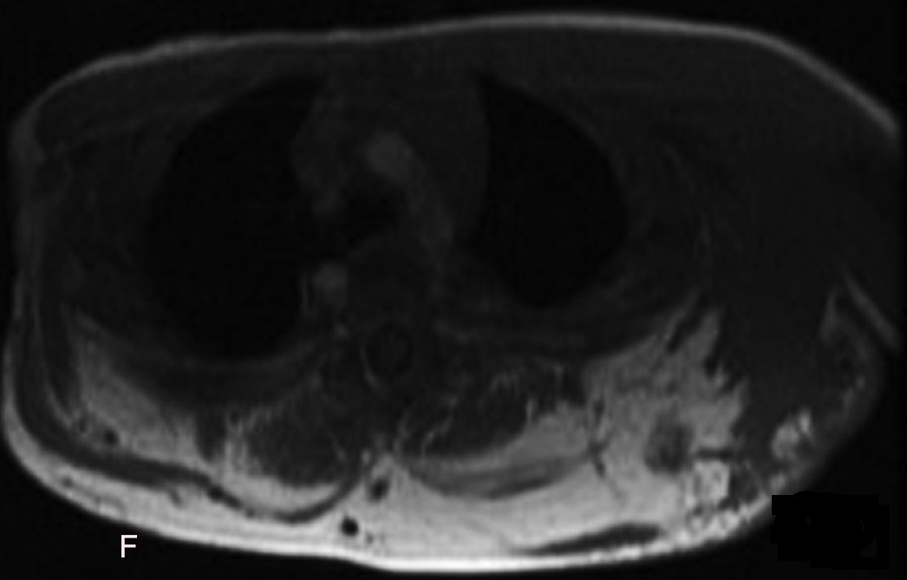
Figure 3 Three-month-old child with CLOVES syndrome. Radiograph of the chest and abdomen (A) demonstrates large soft tissue mass within the left chest and upper abdominal wall. Radiograph of the foot (B) demonstrates overgrowth of the third and fourth digits. Fat suppressed T2 weighted magnetic resonance (MR) images in axial (C), coronal (D) and sagittal (E) planes show the large soft tissue mass within the chest wall contains several loculations, some of which demonstrate hypointense fluid-fluid levels due to hemorrhage. T1 weighted MR image in the axial plane (F) confirms lipomatous overgrowth admixed with muscle.

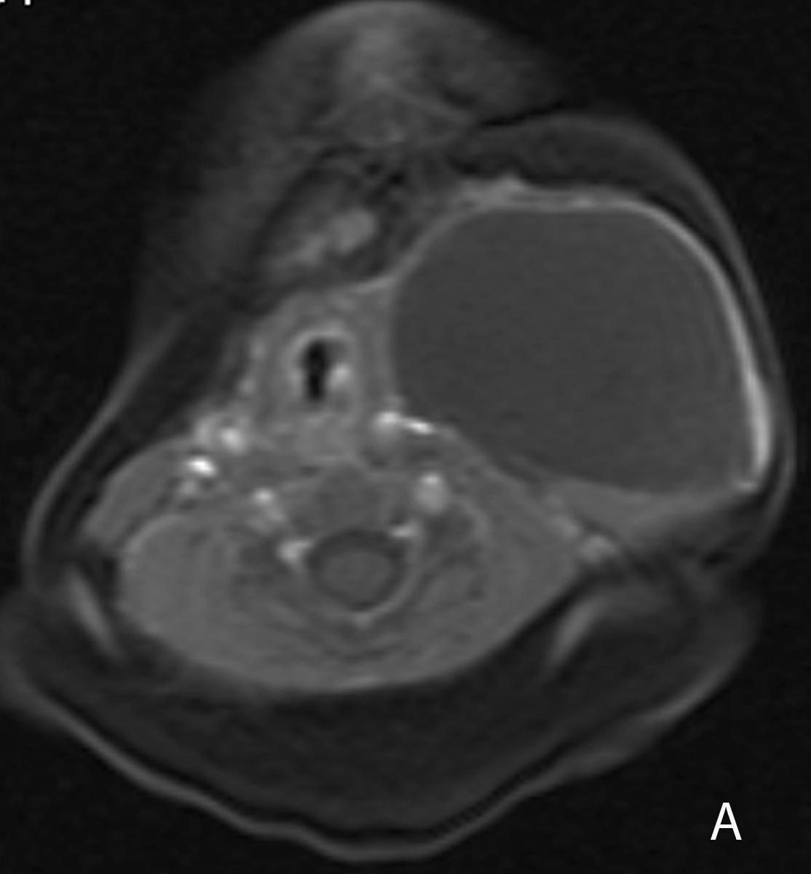

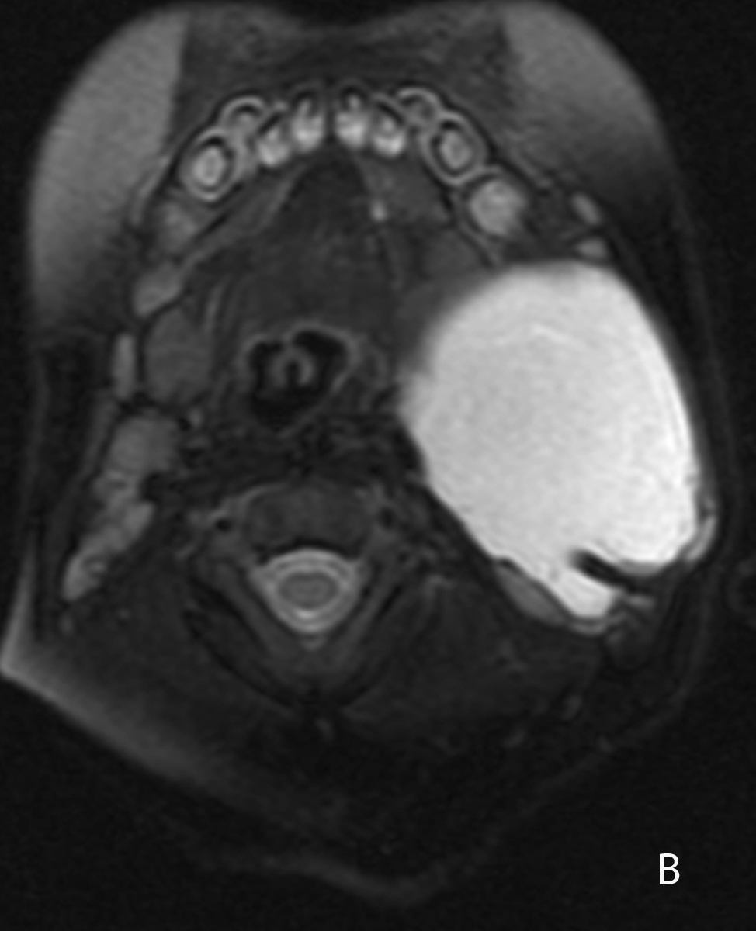

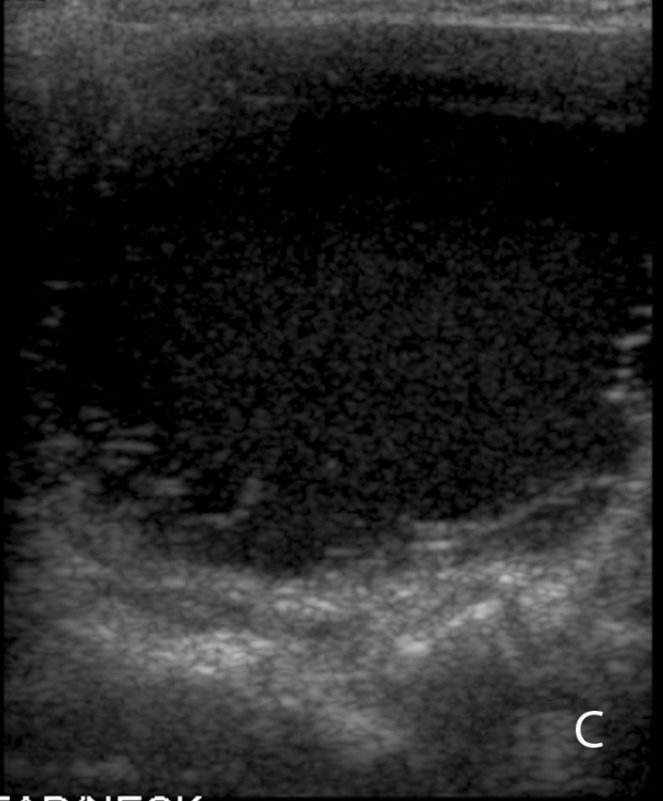
Figure 4 Cervicothoracic macrocystic lymphatic malformation. T1- (A) and T2-weigthed (B) fat suppressed magnetic resonance images (MRI) demonstrate a macrocyst within the left neck that is predominantly hypointense on T1-weighted image and hyperintense on T2-weighted image. Trace blood products layering within the posterior aspect of the cyst are hyperintense on the T1 weighted image (arrow) and hypointense on the T2 weighted image (arrow). Transverse ultrasound (C) demonstrates a predominantly anechoic macrocyst with layering low-level echoes, corresponding to blood products seen on MRI.

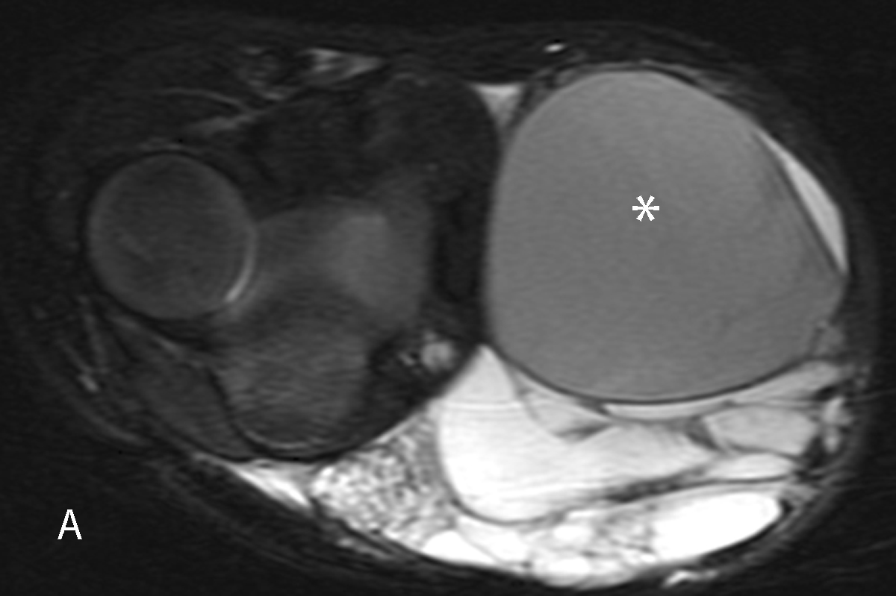

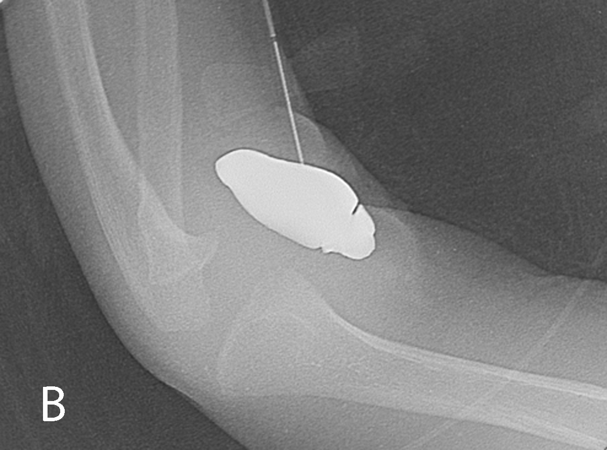

Figure 5 Macrocystic lymphatic malformation with hemorrhage. Axial fat suppressed T2 weighted magnetic resonance image of the elbow (A) demonstrates a predominantly hyperintense malformation with hypointense hemorrhage in a loculation (*). Direct access to the malformation is obtained with a 22-gauge needle for sclerosis (B), subsequently performed with doxycycline.

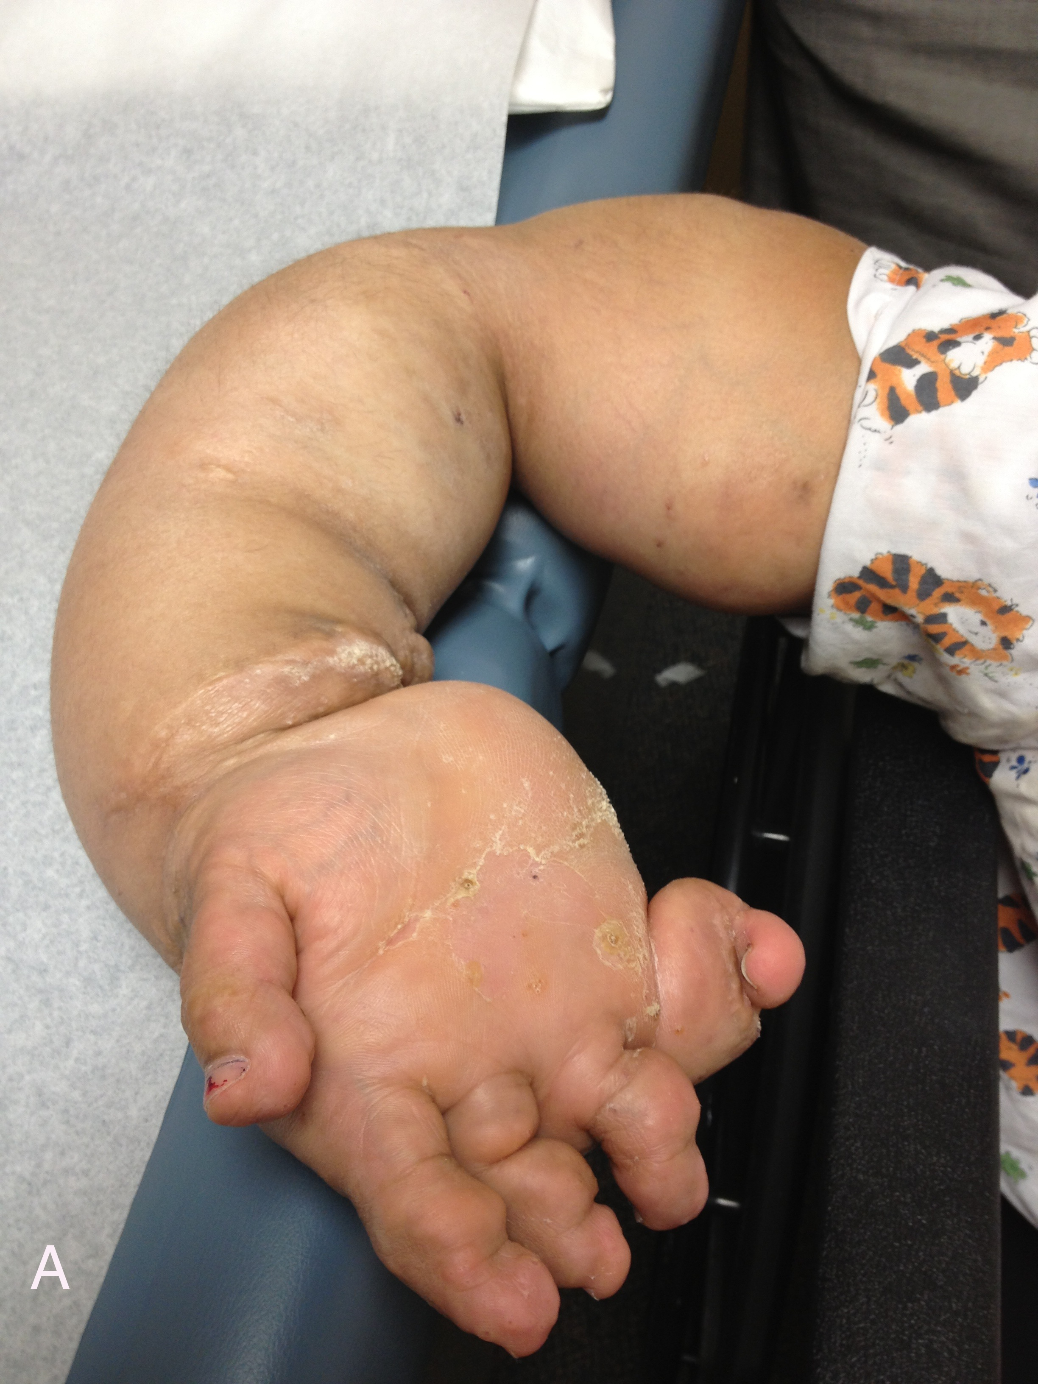

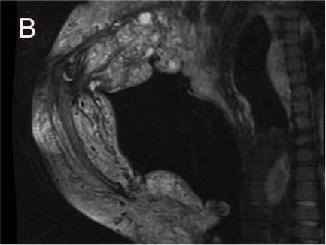

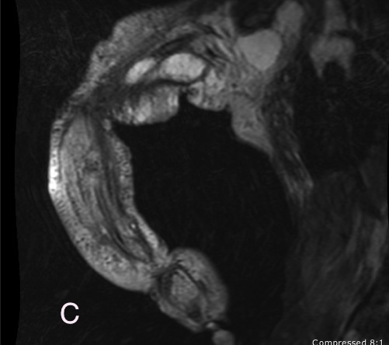

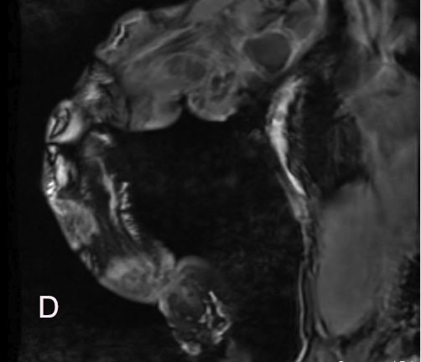

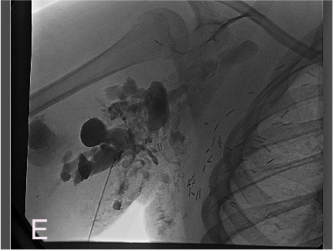
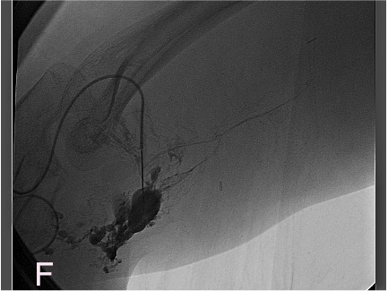
Figure 6 Ten-year-old girl with CLOVES syndrome. Photograph (A) demonstrates right upper extremity overgrowth. Pre-treatment coronal MR images of the right upper extremity (B, C, D) demonstrate a large, combined macro/microcystic lymphatic malformation with venous lakes in the axilla and evidence of lipomatous overgrowth. Angiographic images (E, F) demonstrate direct puncture of the malformation followed by sclerosis with doxycycline.

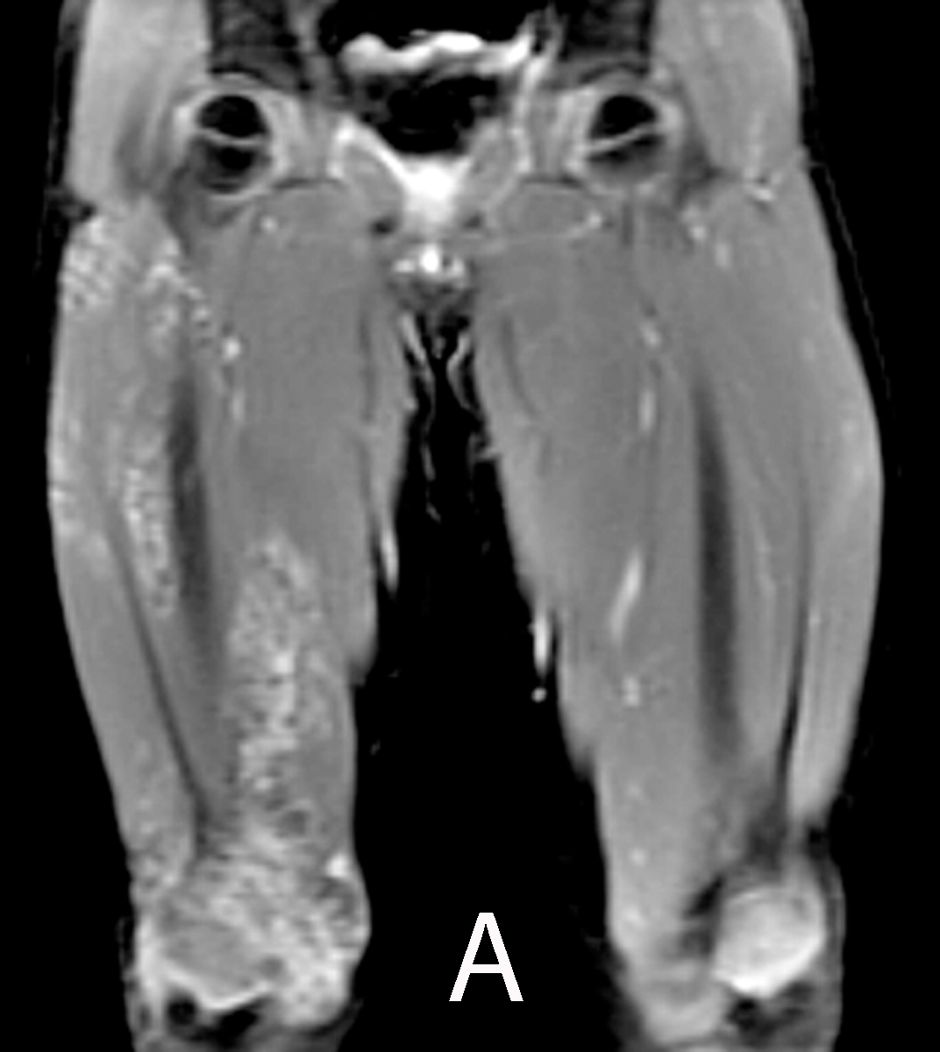

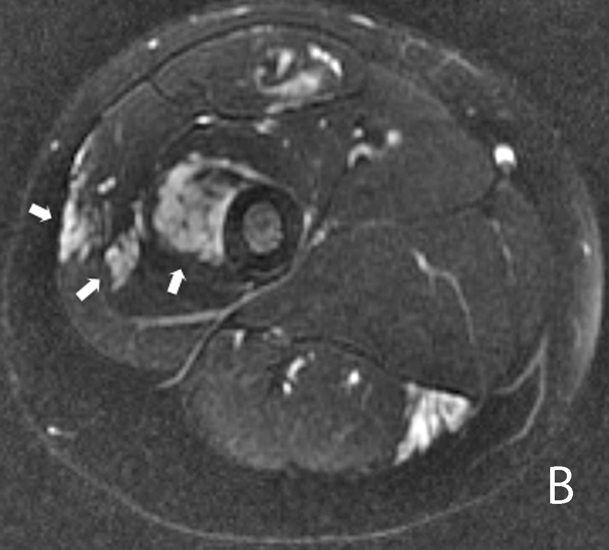

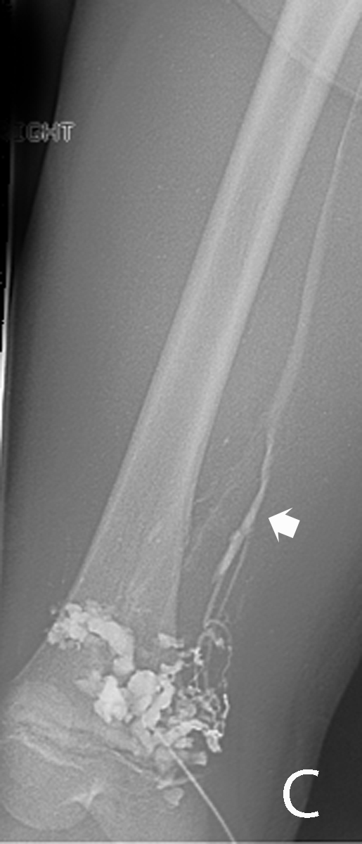

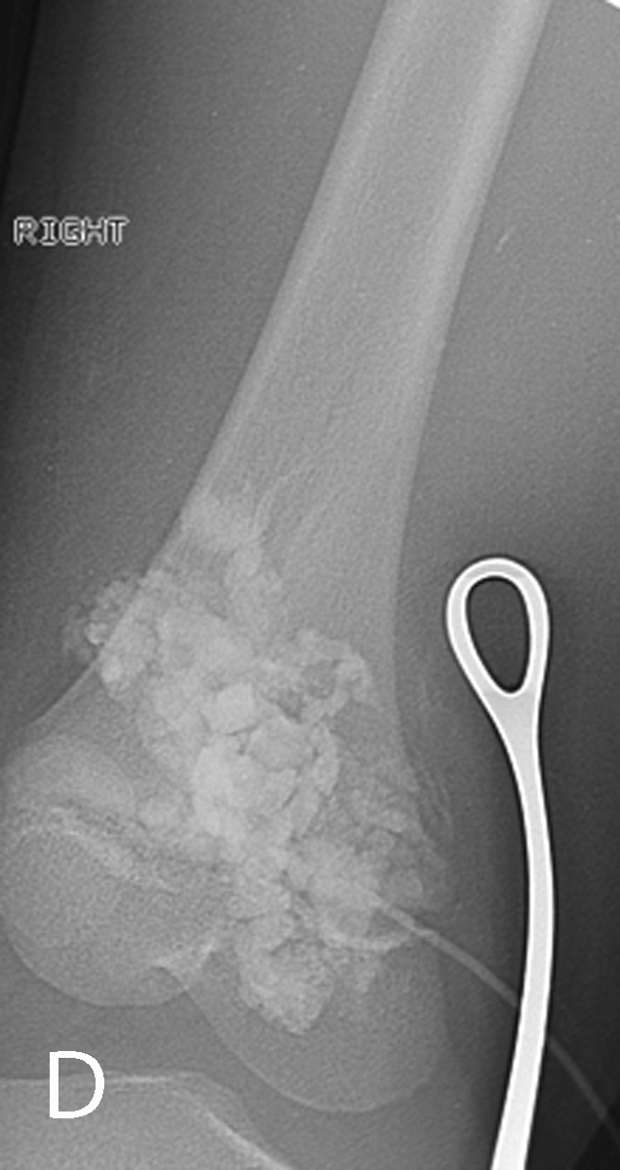
Figure 7 Infiltrative extratruncular low flow vascular malformation of the right leg. Coronal (A) and axial (B) T2-weighted magnetic resonance images demonstrate a high signal intensity infiltrative lesion (arrows). Venography (C) demonstrates filling of the malformation with outflow communication to the femoral vein (arrow). Sclerosis was subsequently performed utilizing 3% STS opacified with contrast (D) with compression of the outflow vein using metal forceps.

Figure 8 Superficial low flow venous malformation. This soft compressible mass with nodular purple skin discoloration in the buttock is typical of a superficial low flow venous malformation.
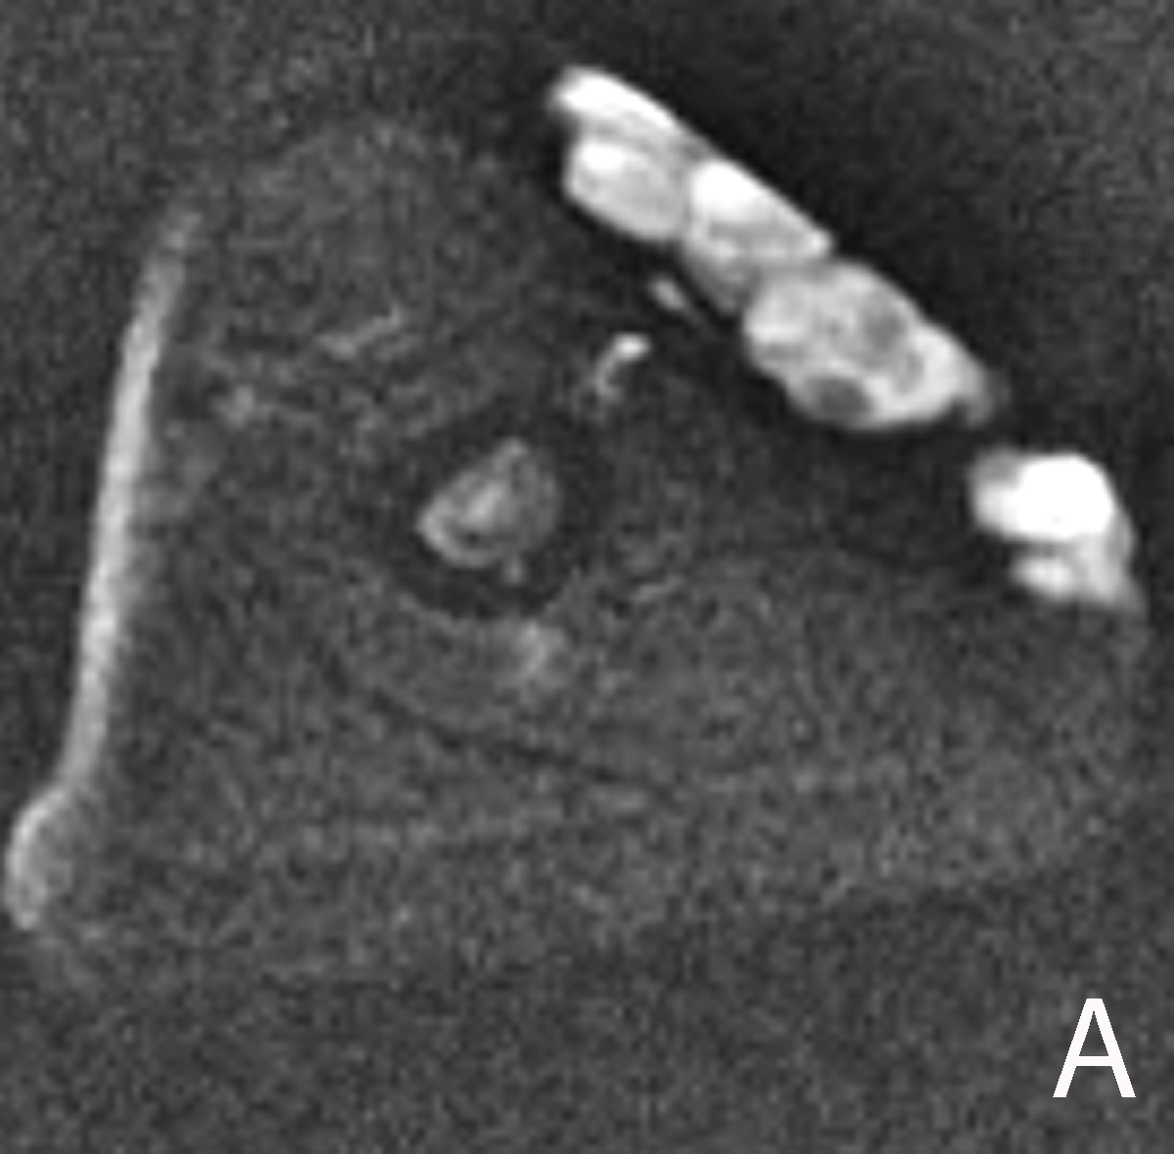
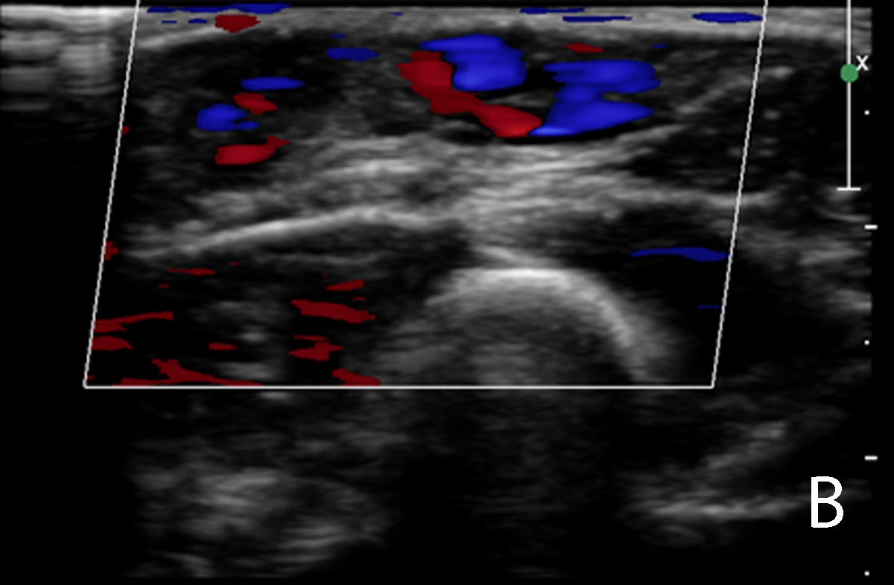
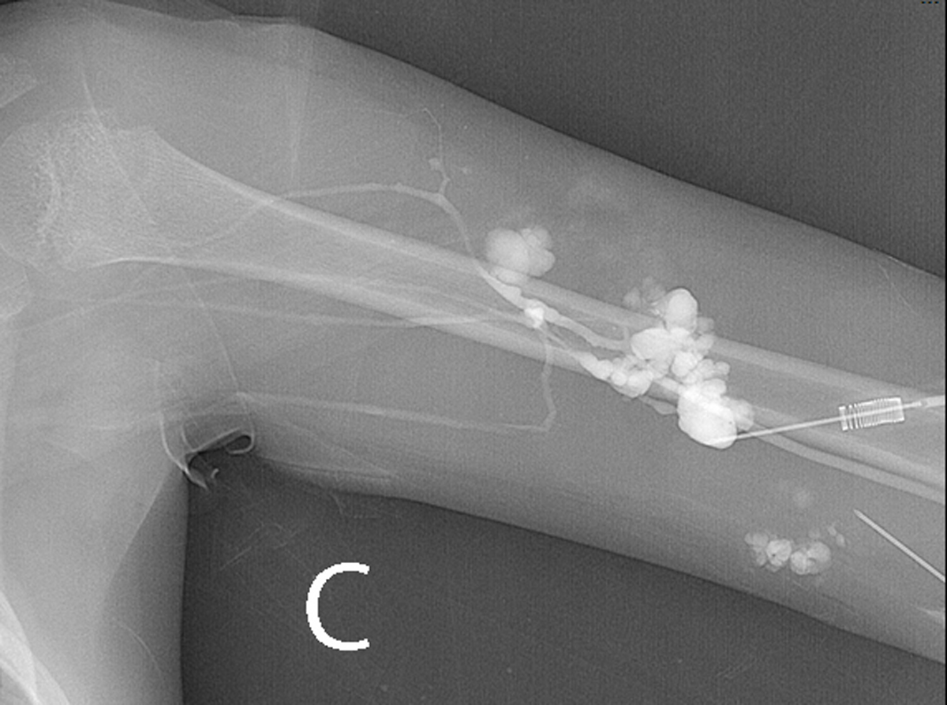
Figure 9 Foaming the sclerosant increases the surface contact of the foam micelles with the endothelium of the malformation. Axial T2 magnetic resonance demonstrating high signal intensity subcutaneous low flow venous malformation of the left upper arm (A). The lower signal small round structure likely represents a phlebolith. Color Doppler ultrasound demonstrates low flow signal in the venous malformation (B). Venography prior to sclerotherapy with tourniquet in place on upper arm demonstrates the venous malformation with no filling of normal deep venous drainage (C). A few faint radio-opaque phleboliths are seen in the venographic image.
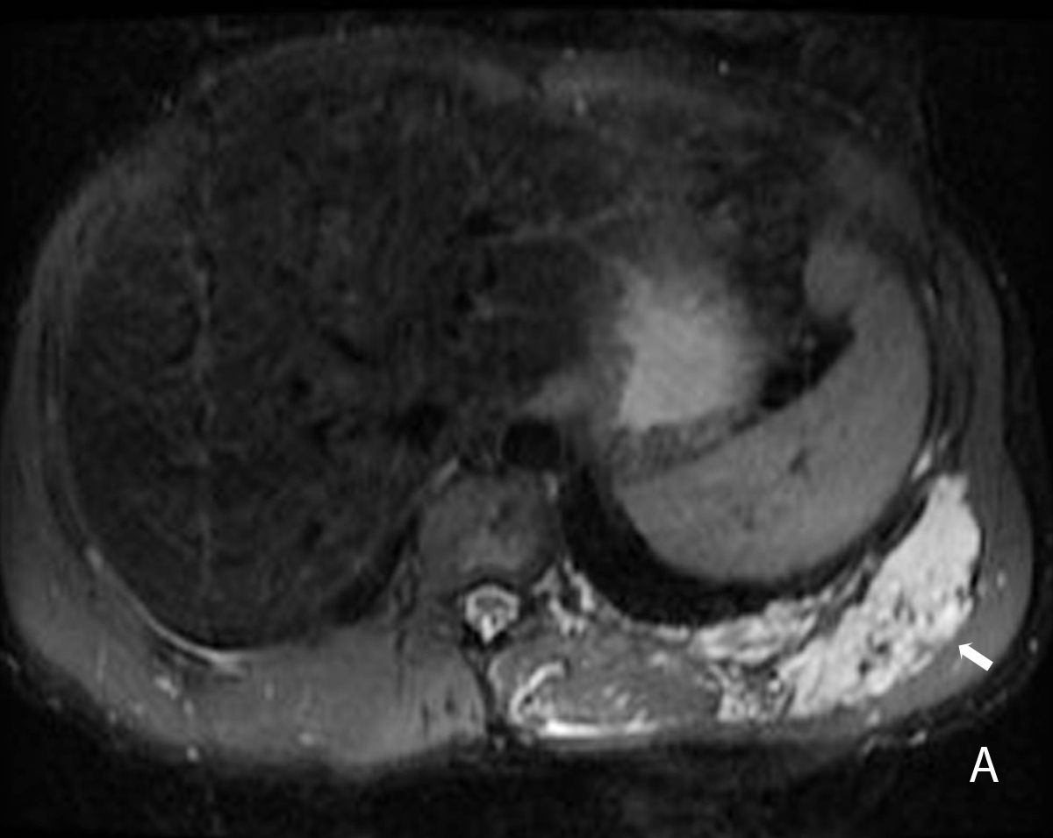
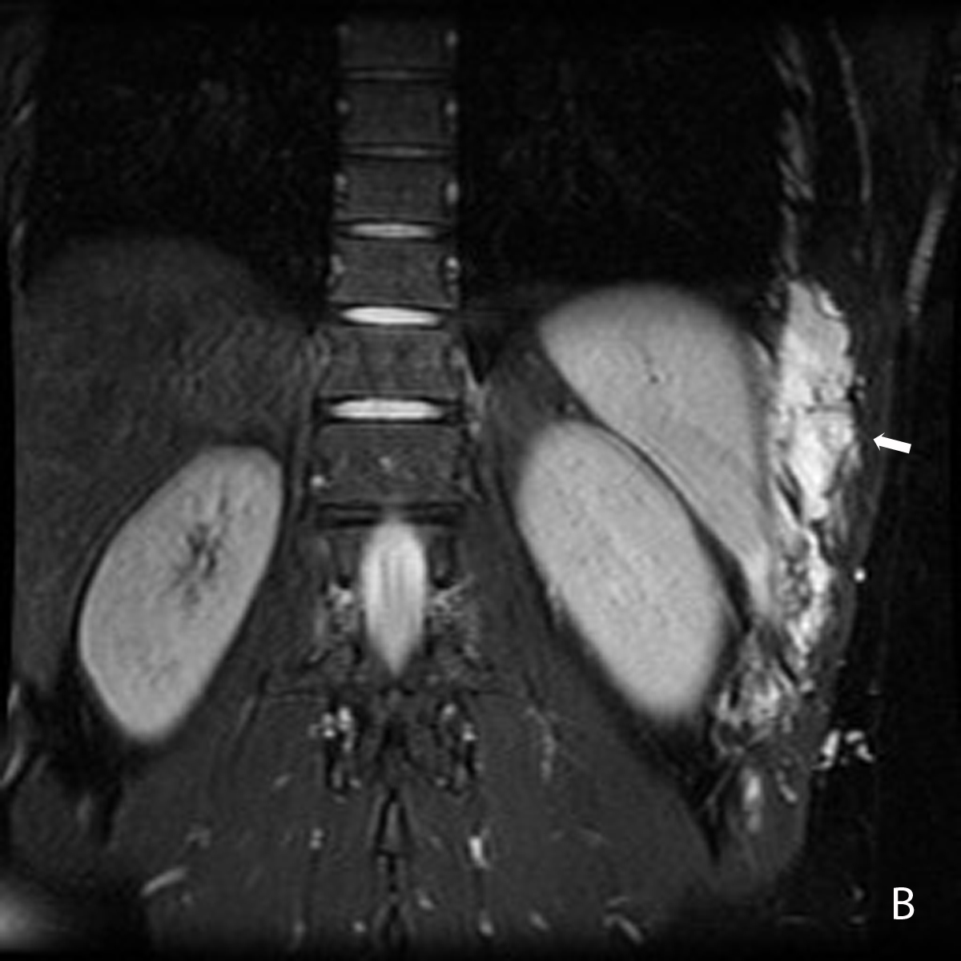
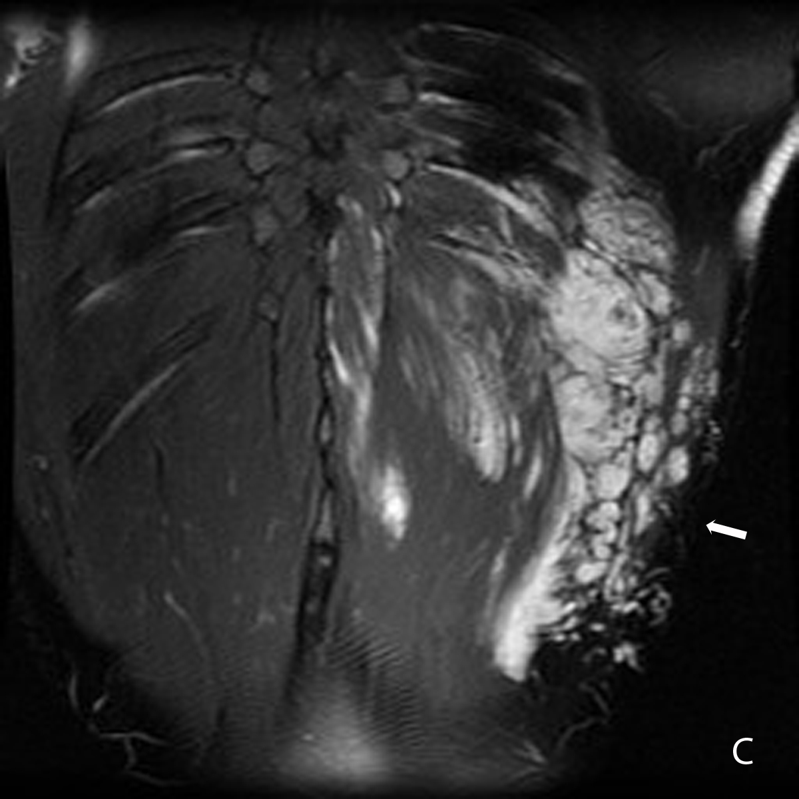
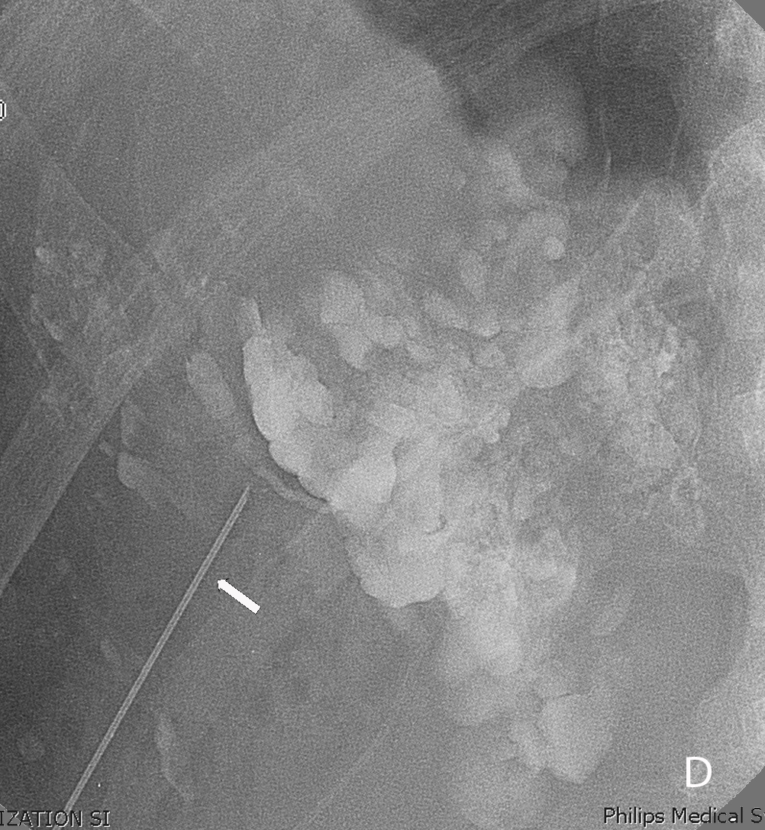
Figure 10 Foam sclerotherapy is ideal for treatment of low flow venous vascular malformations. Axial and coronal T2 weighted magnetic resonance images demonstrate a low flow venous malformation of the chest and upper abdominal wall (A, B, C). Direct access venography with a 22-gauge needle shows foamed STS opacified with contrast filling the malformation (D).

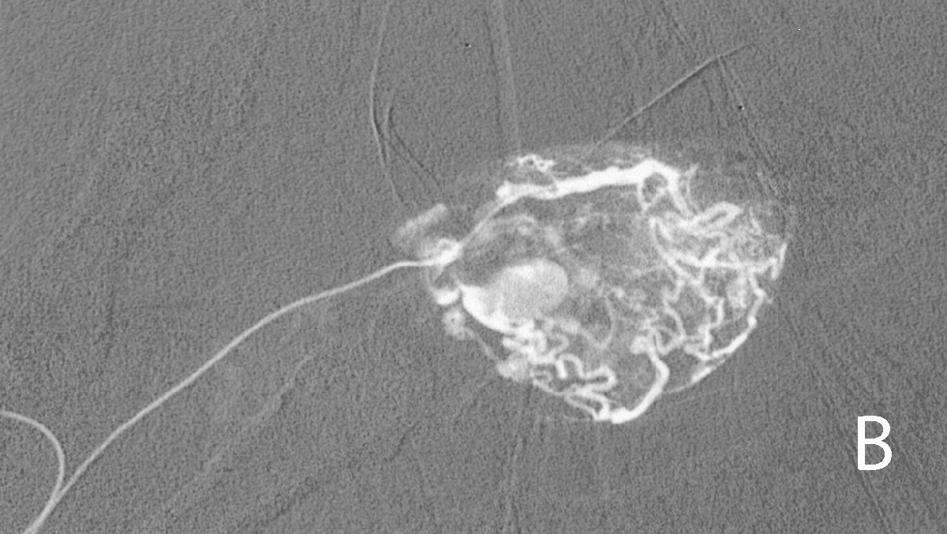

Figure 11 High flow arteriovenous malformation of second digit. This patient scheduled for amputation due to intractable pain under went alcohol embolization as a last resort prior to surgery. Digital arteriography with a microcatheter in the lateral digital artery with the tip at the level of the middle phalanx demonstrating filling of the nidus of the malformation (A, B, C). Following embolizaton, there is stasis of flow in the malformation (D). The medial digital artery remained patent with preservation of arterial flow to the digit.

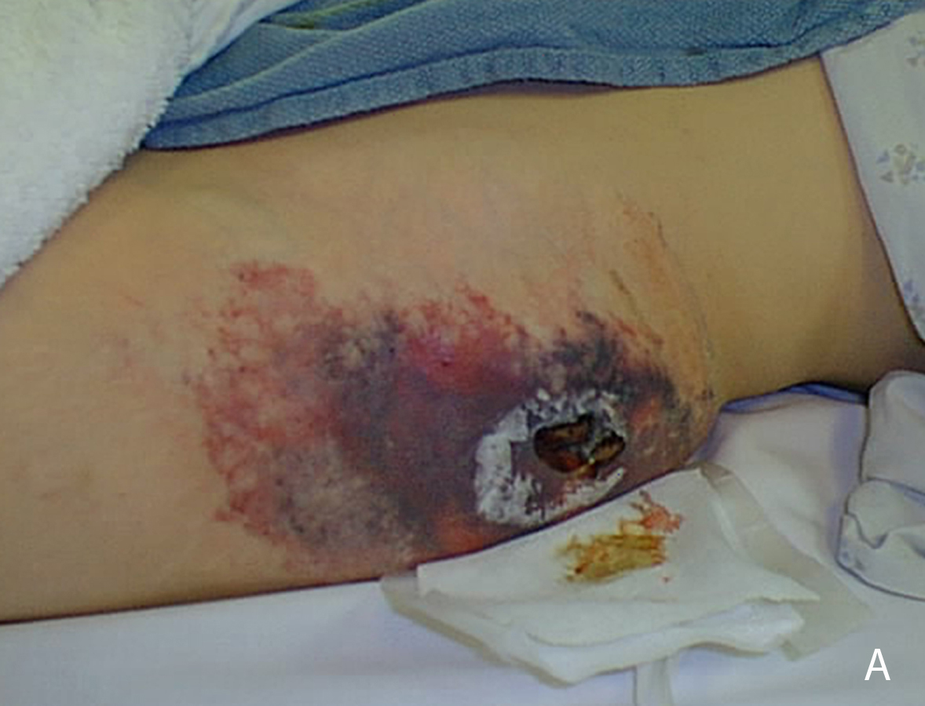

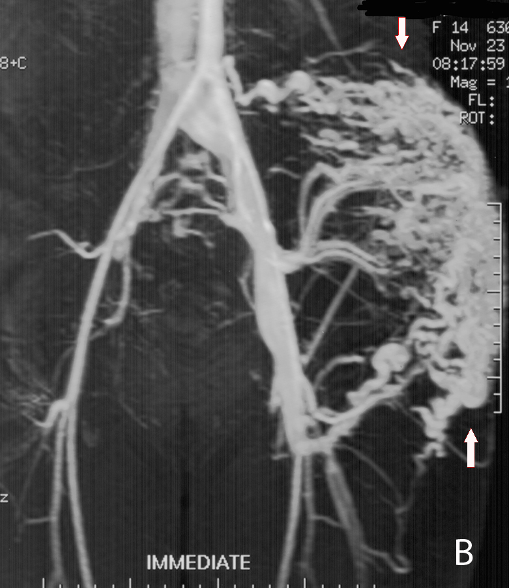
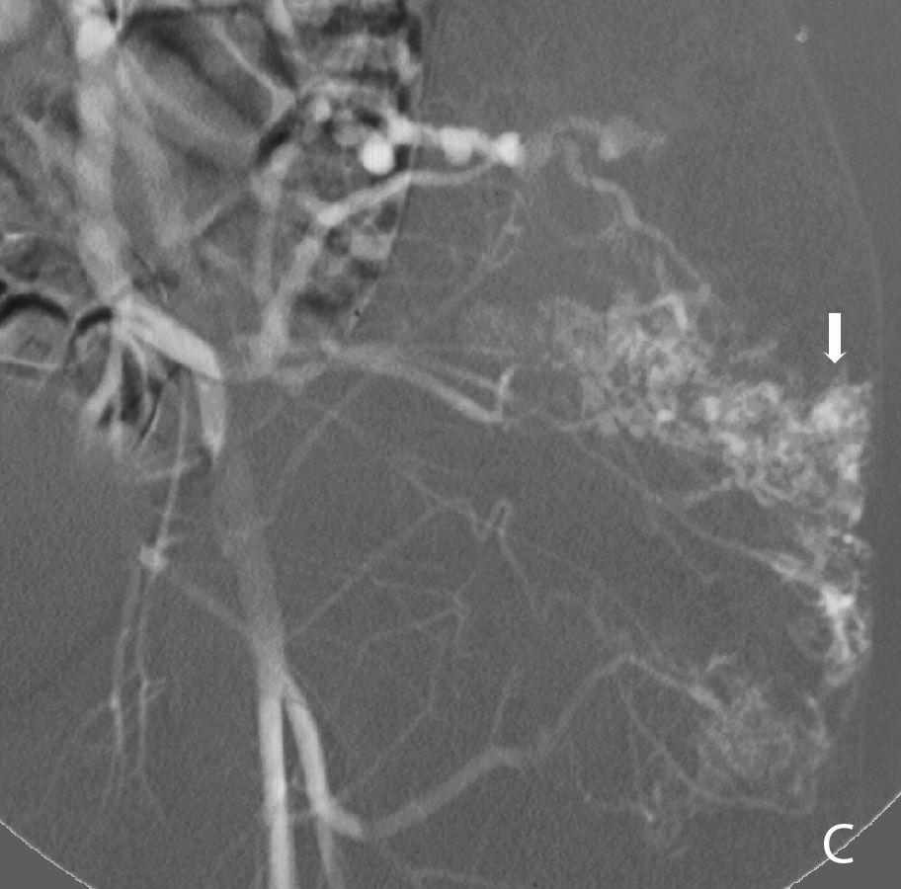

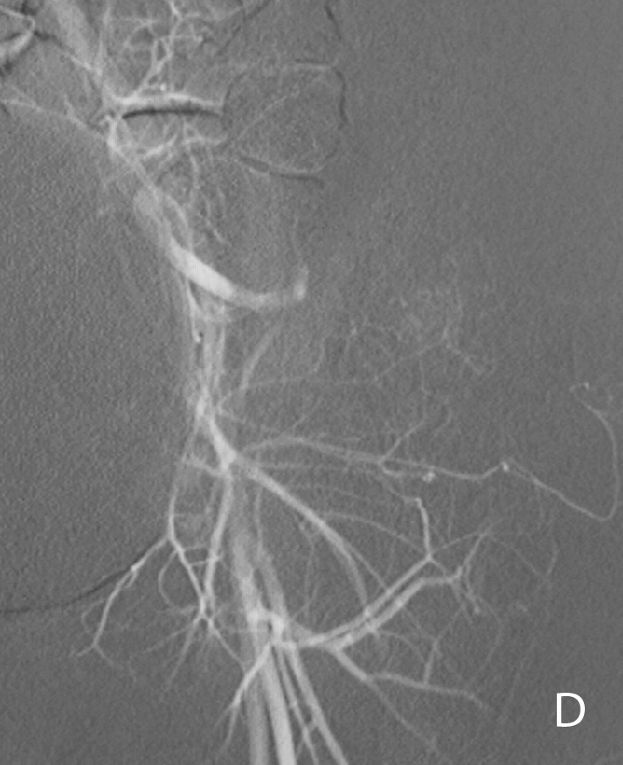
Figure 12 Superficial lesions may present as a warm painless mass with palpable bruit and associated dilated veins. High flow arteriovenous malformation with extensive skin breakdown in the region of this superficial malformation (A). Magnetic resonance angiogram demonstrates a high flow arteriovenous malformation with arteriovenous shunting (B). Left internal iliac arteriogram demonstrating filling of the nidus of the malformation (arrow) (C). Arteriography following alcohol embolization shows eradication of the nidus of the malformation (D). As the malformation was located in subcutaneous fat, it was resected en block and skin grafts were created to bridge the area of skin breakdown.

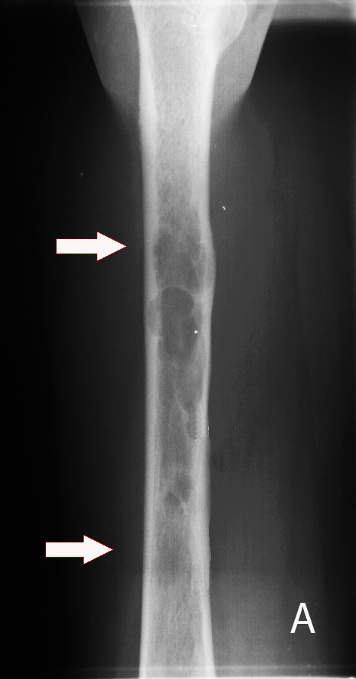

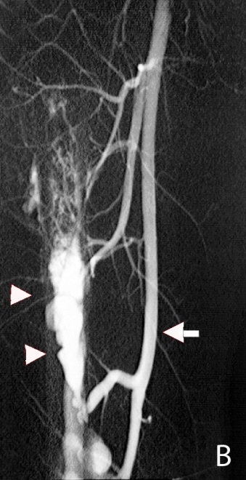

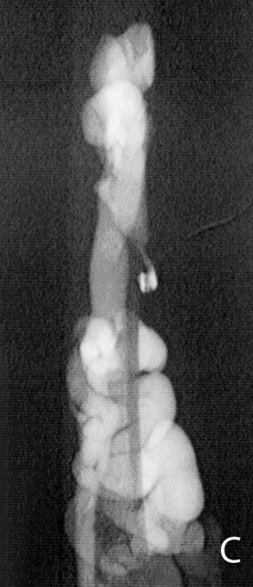

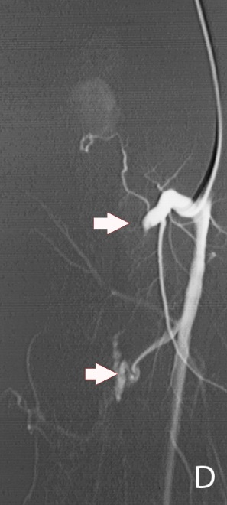

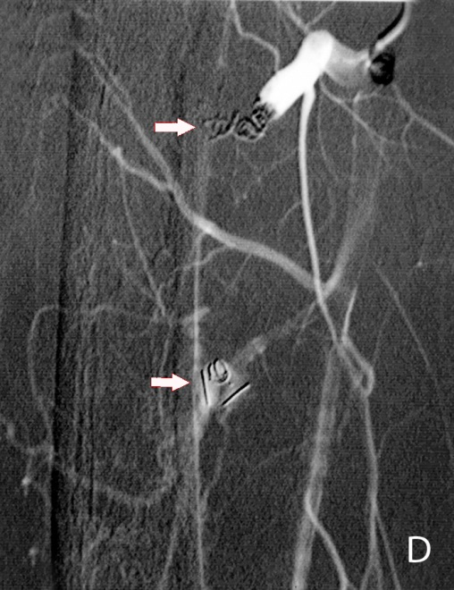
E
Figure 13 The use of detachable coils, released only when satisfactory placement is achieved, may increase the safety of the procedure. Radiograph of the mid-diaphysis of the femur demonstrates a region of endosteal erosion (arrows) (A). Arteriography demonstrates a multifistulous malformation with arterial supply from two muscular branches of the superficial femoral artery (arrow) with early filling of intraosseous venous drainage (arrowheads) (B, C). Occlusion of the feeding arteries was accomplished with large coils (arrowheads) eliminating the fistulous communications (D, E).

Figure 14 Particulate agents do not generally provide complete occlusion, and recanalization may occur. High flow arteriovenous malformation with nidus and venous aneurysm originating from branches of the left internal iliac artery (A). Following superseletive catheterization of the feeding branch of the inferior gluteal artery there is demonstration of the nidus and venous aneurysm (B). Following particulate embolization with PVA, there is occlusion of the nidus. Surgical clips are seen overlying internal iliac artery branches from previous unsuccessful attempts at surgical treatment (C).

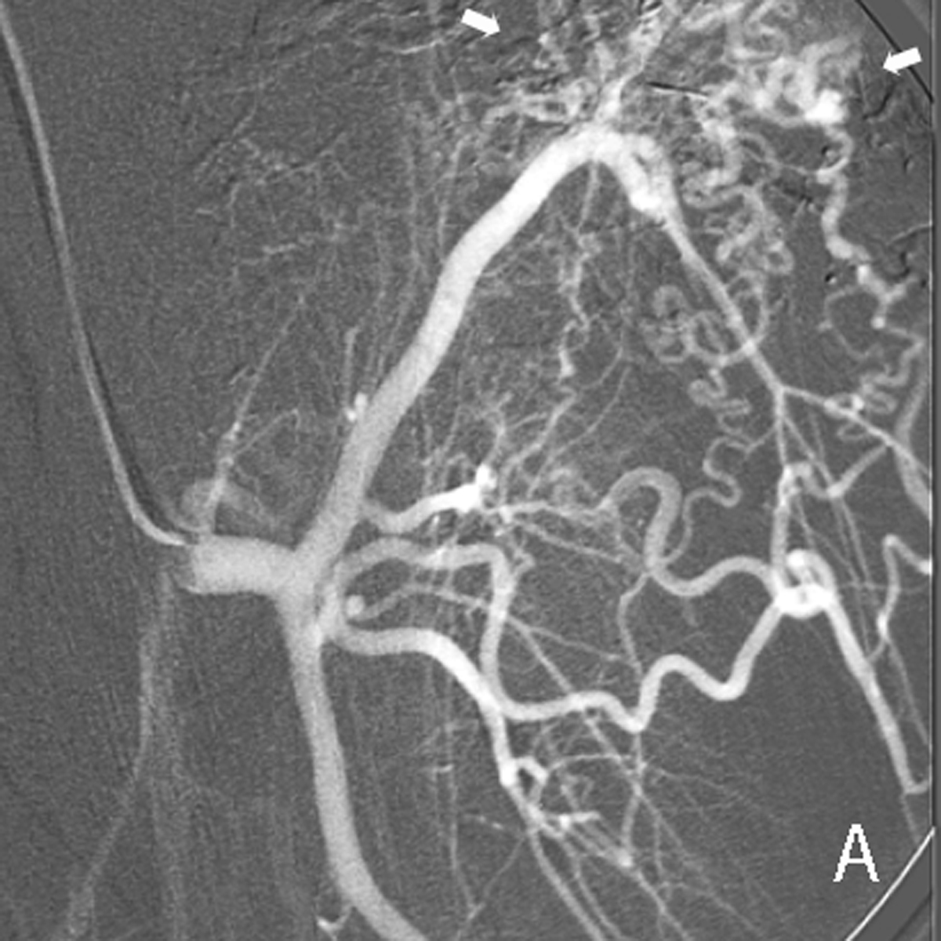

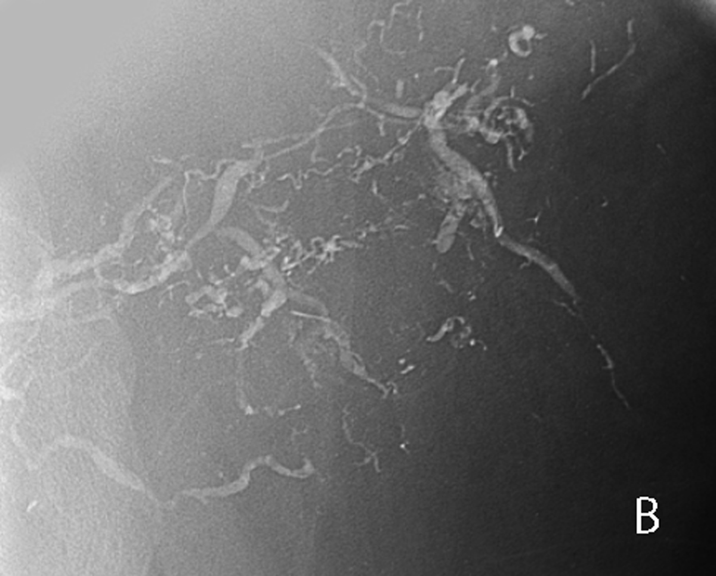

Figure 15 Arteriogram of high flow arteriovenous malformation. A: Arteriogram demonstrates nidus (arrows) of a high flow arteriovenous malformation of the abdominal wall, supplied in part by a muscular branch of the circumflex femoral artery; B: The lesion was treated twice, initially with Onyx, then with n-BCA glue, seen within the arterial feeders of the malformation on post-embolization imaging.
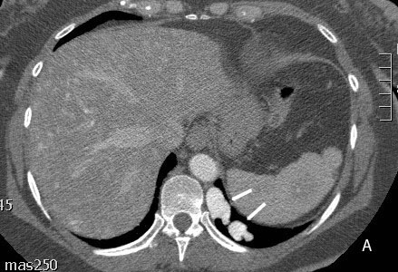
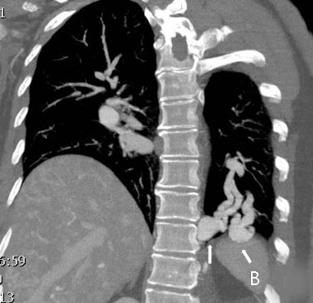
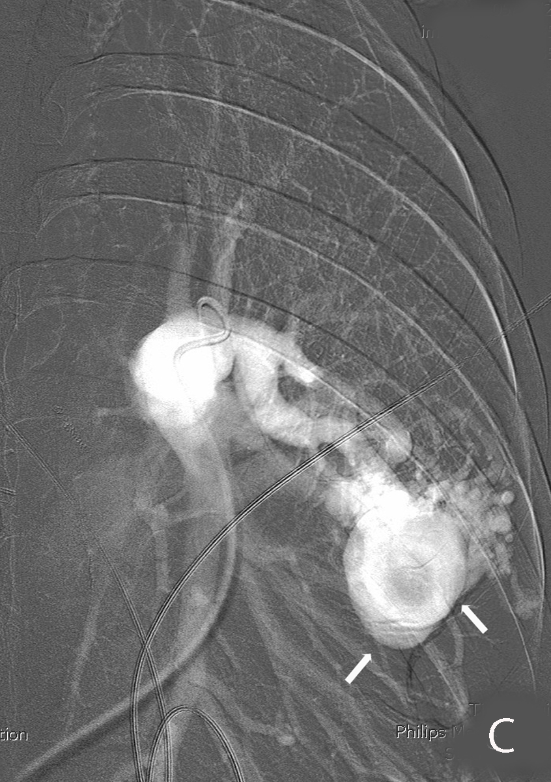
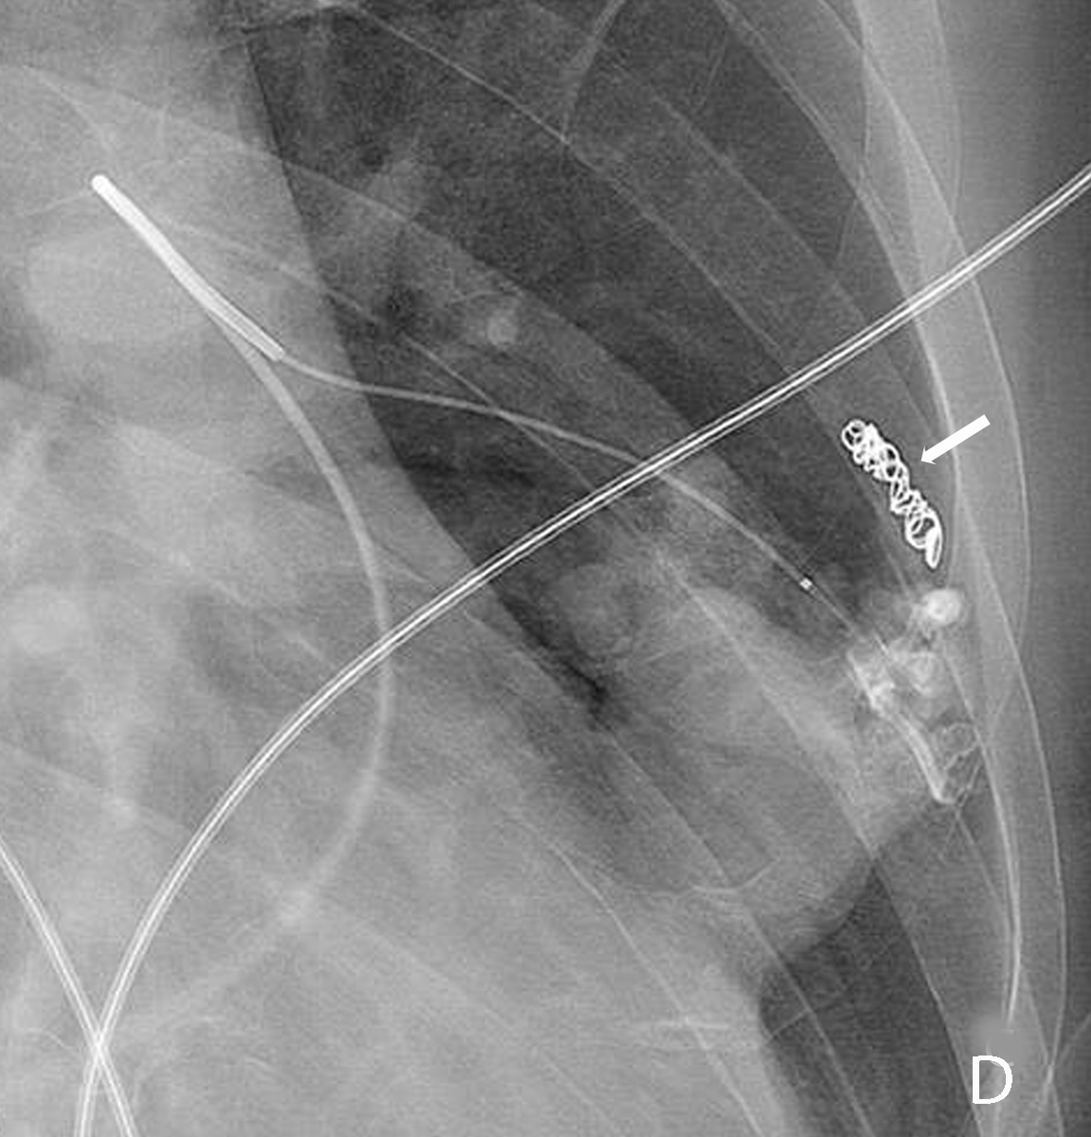
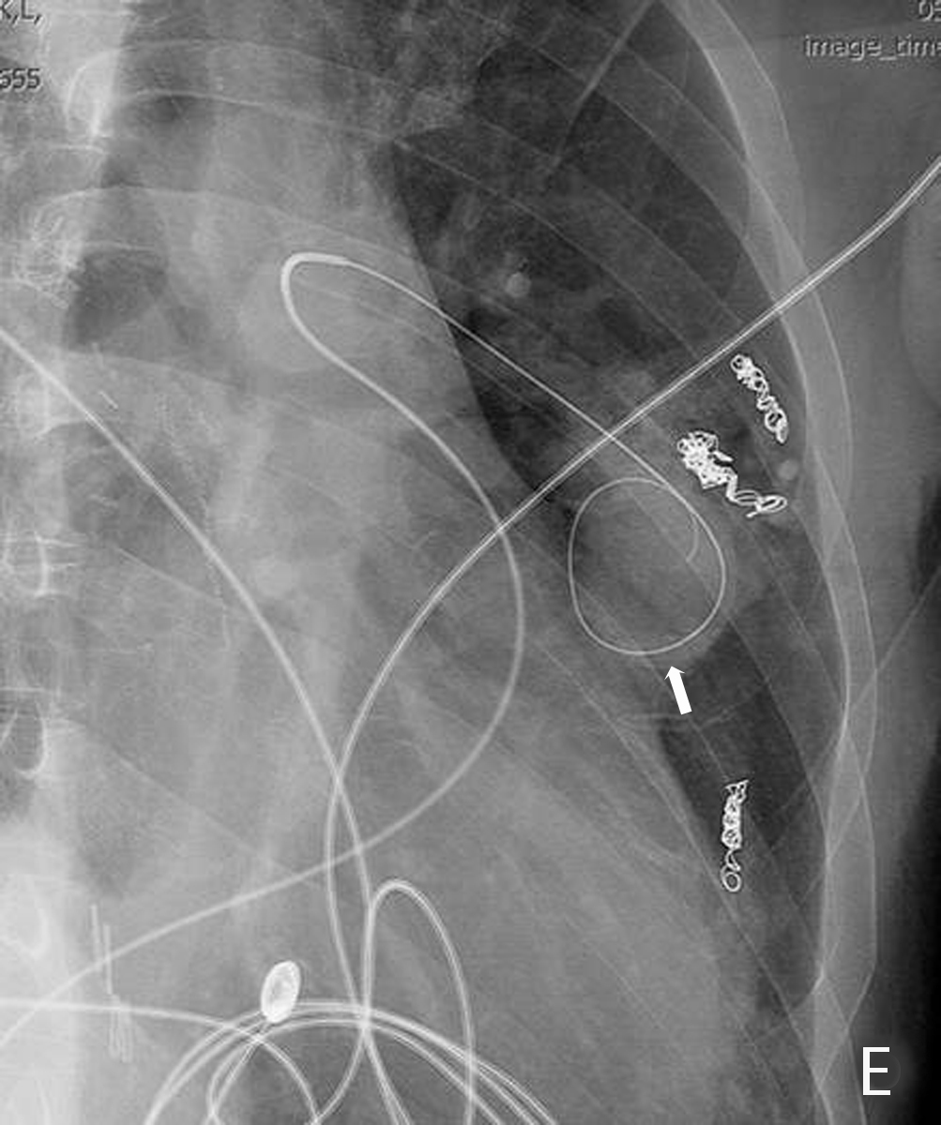
Figure 16 This patient with hereditary hemorrhagic telangiectasia presented with an abnormal chest radiograph. A computed tomography angiogram was performed for further evaluation. Axial CTA demonstrates a left lower lobe high flow vascular malformation (arrows) (A). Coronal reconstruction demonstrates several branches of the left lower lobe pulmonary artery feeding the malformation (arrows) (B). Sequential coil embolization of pulmonary arterial branches feeding the malformation was performed (C). A framing coil was then placed in the venous aneurysm (D) followed by coil occlusion of the venous aneurysm and each of the remaining pulmonary arterial feeding branches (E).

Figure 17 Venogram of low flow venous malformation in Parkes Weber Syndrome. Right lower extremity venogram demonstrates extensive low flow venous malformation in a patient with the Parkes Weber syndrome (A). Right lower extremity arteriogram demonstrating tibial artery shunting to the venous malformation (arrows) (B, C).
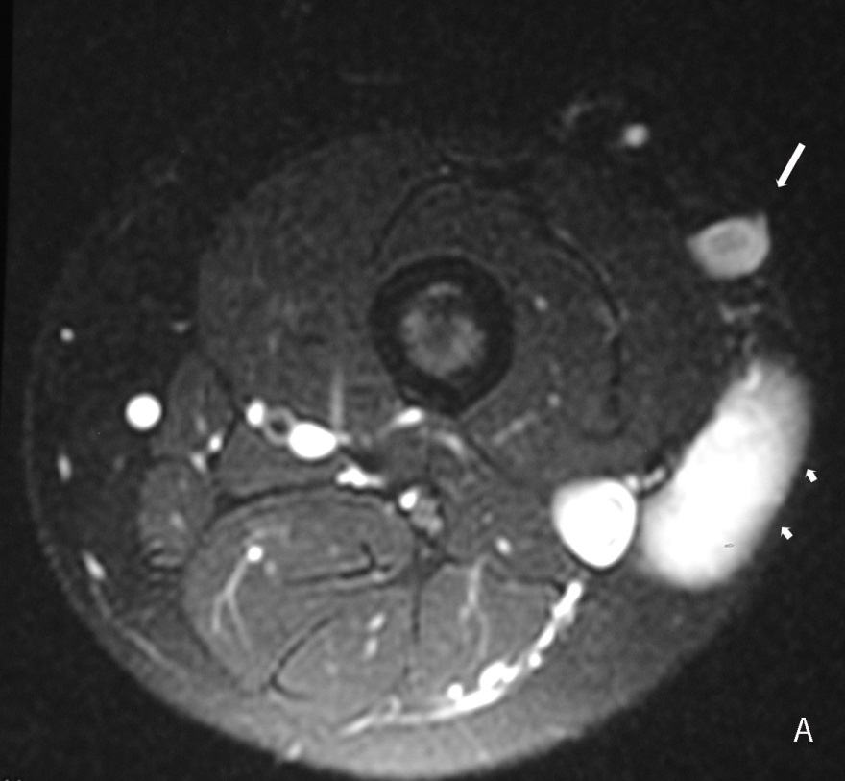

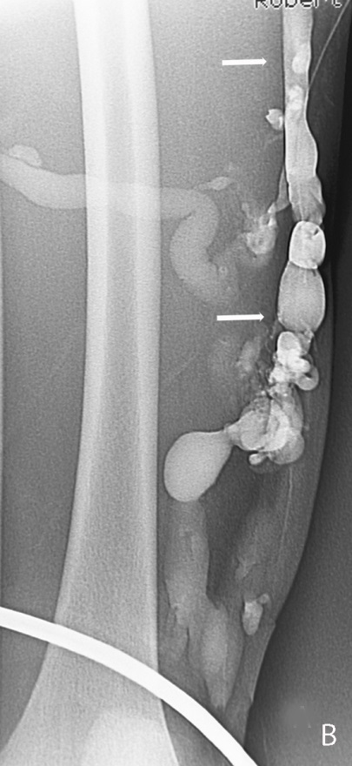

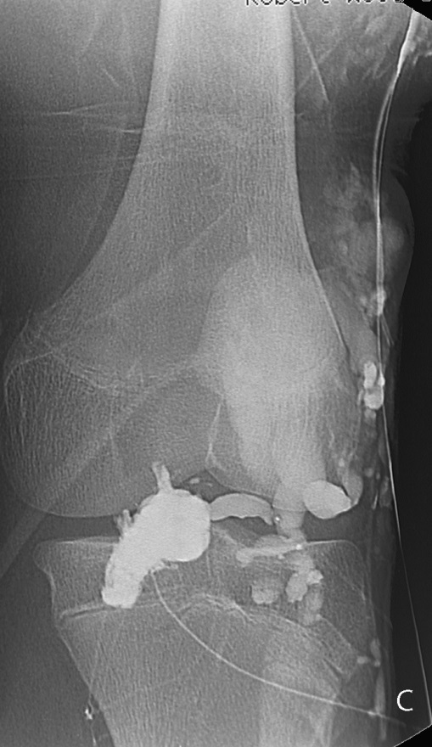
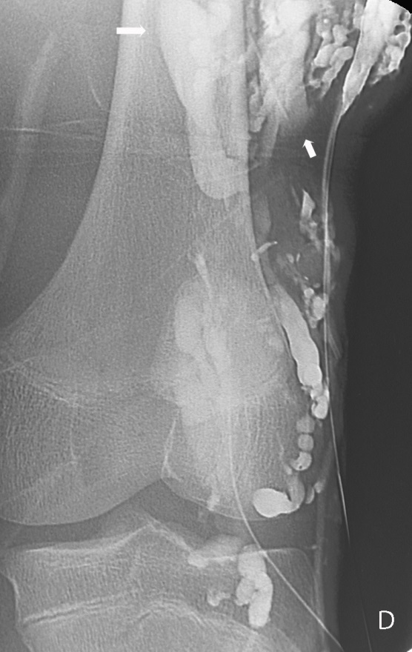
Figure 18 Klippel Trenaunay Syndrome. Axial T2 weighted fat suppressed magnetic resonance image of the thigh (A) in a patient with Klippel Trenaunay syndrome demonstrates a lateral embryonic vein (arrows) and venous malformation (short arrows). Lower extremity venogram demonstrates the lateral embryonic vein (arrows) (B). Direct puncture venography prior to alcohol sclerotherapy demonstrates progressive filling of the low flow truncular venous malformation (arrows) (C, D).

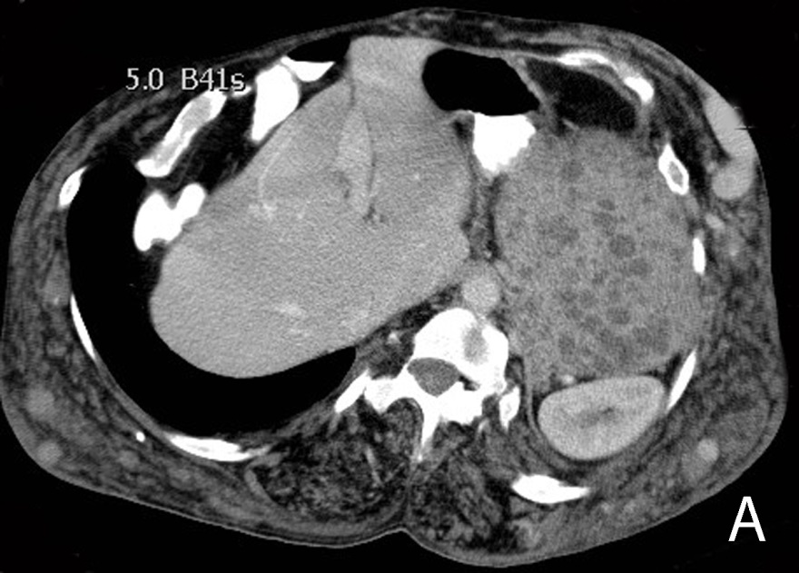

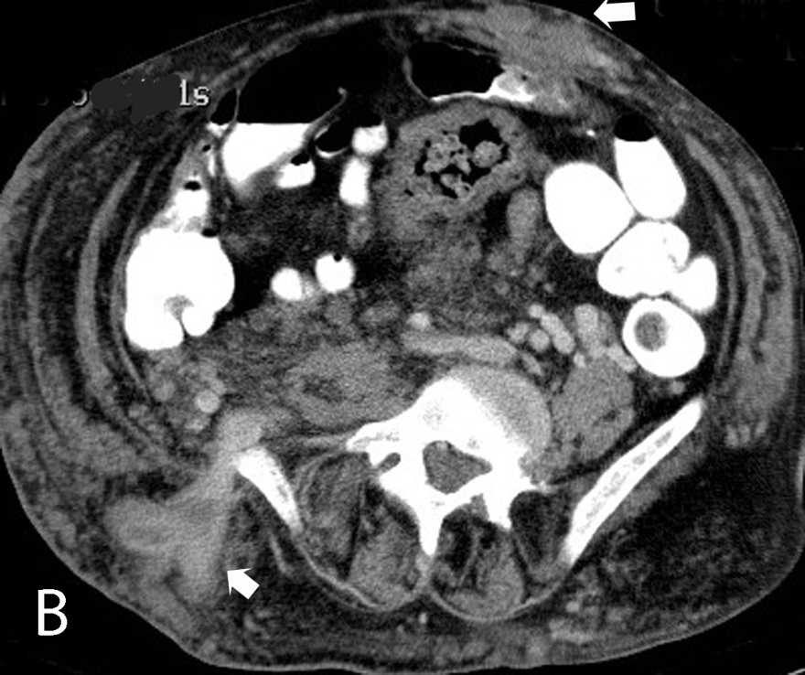

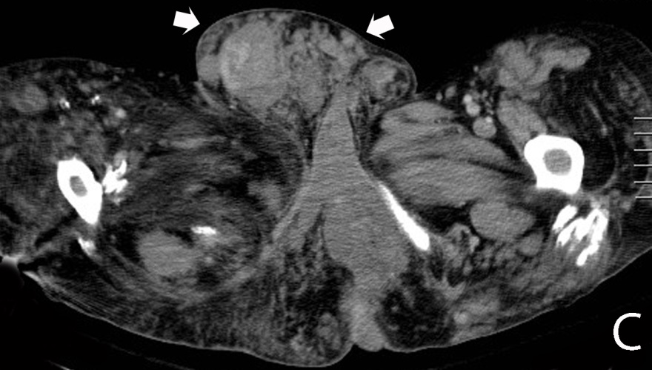
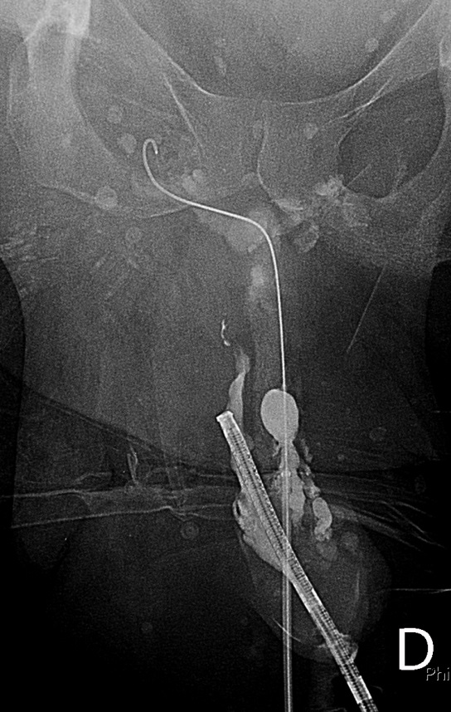
Figure 19 Klippel Trenaunay Syndrome. CT scan of the abdomen in a patient with the Klippel Trenaunay syndrome demonstrating extensive venous malformation in the abdominal wall (arrows) as well as venous malformations in the spleen (asterisk) (A, B). CT scan of the pelvis demonstrating extensive venous malformation in the inguinal canal and scrotum (arrows) (C). Sclerotherapy was performed through the dorsal vein of the penis to treat intractable urethral hemorrhage (D).
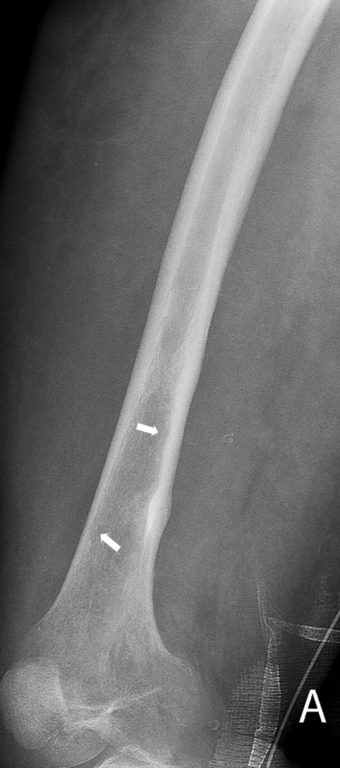
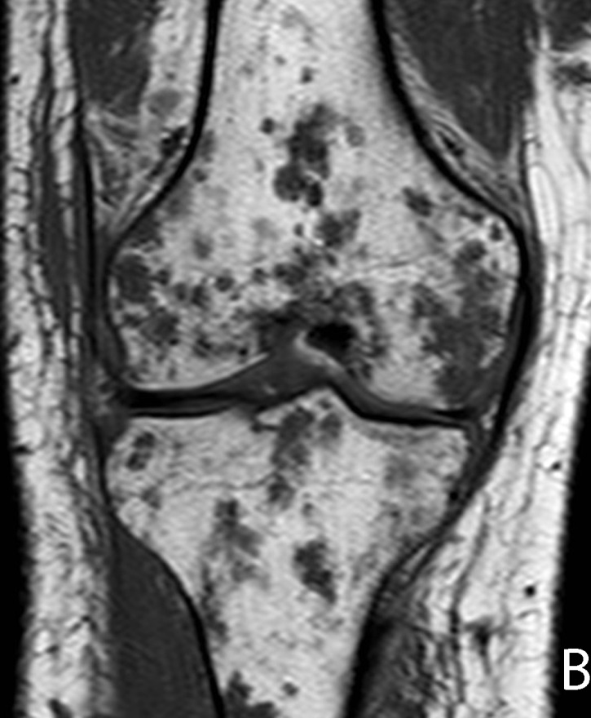
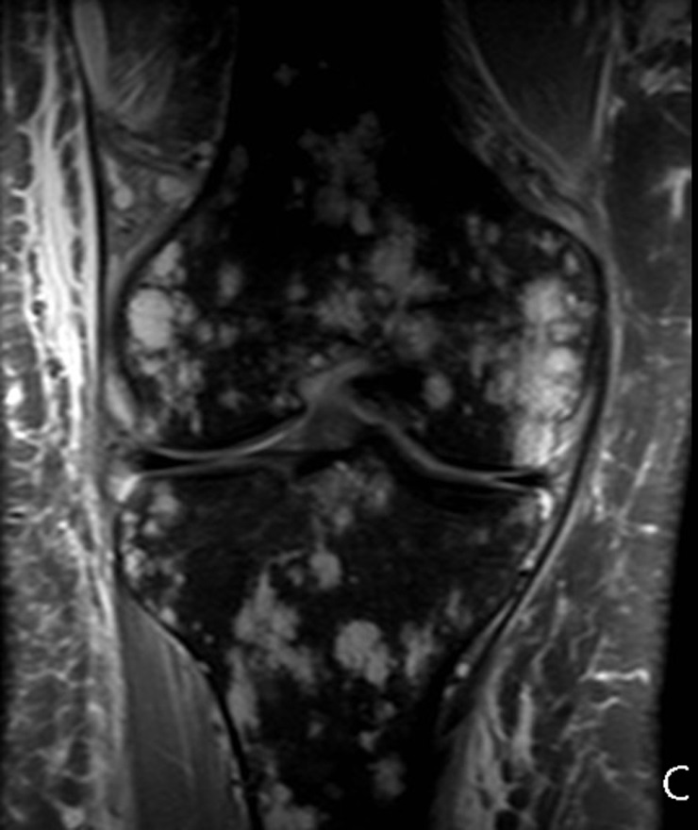

Figure 20 21-year-old man, who presented with pain and swelling of his leg. Radiograph of the femur demonstrates cortical erosion of the distal femur (arrows) (A). T1 weighted coronal magnetic resonance (MR) of the knee demonstrates innumerable focal lesions in the tibia and femur (B). These lesions are high signal intensity on T2 weighted coronal MR (C), however no contrast enhancement was seen within the lesions. Biopsy of the femur demonstrated a lymphatic microcystic lymphatic malformation.

Table 1 Commonly used sclerosants and liquid embolic agents
Sclerosants and liquid embolic agents | Comments
Sodium tetradecyl sulfate (STS, Sotradecol) | Combined with non-ionic contrast for final concentration of 1.5%; foamed according to Tessari’s method^{[39]}
Doxycycline | 10 mg/mL, maximum dose 1000 mg
Ethanol | 95% concentration; Risk of systemic toxicity increases with doses > 1 mL/kg or total volume > 60 mL
Bleomycin | 0.3 – 0.5 mg/kg
OK-432/Picibanil | 1-3 intralesional injections of 0.2 mL each dose at 0.01 mg/kg
Polidocanol | 0.5 – 1.0% concentration; Inject 0.1 – 0.3 mL for a total administered dose of 10 mL
n-BCA glue | Combined with Ethiodol for polymerization
Onyx | Dissolved with DMSO and tantalum; three different concentrations (6%, 6.5%, 8%)

